Case study

Mortality and Morbidity in Extremely Preterm Infants: A Retrospective Case Analysis and Literature Review.

.
ABSTRACT

Aims: To describe mortality and morbidity among preterm infants who died during hospitalization in a Moroccan tertiary center and to contextualize findings with the literature.
Study Design: Retrospective case analysis and literature review.
Setting & Period: NICU, HMIMV, Rabat, Morocco; 2019–2025.
Methods: Fourteen in-hospital deaths among preterm infants were reviewed. Maternal factors, gestational age, birth weight, complications, and timing of death were abstracted.
Results: Infections were the leading attribution (8/14; 57%), followed by respiratory distress syndrome (3/14; 21%) and congenital anomalies (3/14; 21%). Early deaths (<7 days) were 3/14 (21%); late deaths (≥7 days) 11/14 (79%). All RDS-related deaths occurred early, whereas infection- and anomaly-related deaths occurred late.
Conclusion: Mortality among extremely/very preterm infants remains high. The predominance of late, infection-related deaths contrasts with many high-income reports and underscores priorities such as antenatal corticosteroids, Kangaroo Mother Care, early breastfeeding, and infection prevention.

Keywords: preterm birth; neonatal mortality; very preterm; infection; respiratory distress syndrome; Morocco.
1. INTRODUCTION
Preterm birth remains the leading cause of neonatal mortality worldwide. According to the 2024 UN-IGME estimates [1], recent progress in reducing newborn deaths has slowed and large disparities persist between high- and low-income settings. Within this context, we describe mortality and morbidity among preterm infants who died during hospitalization in a Moroccan tertiary center and contextualize these findings with the literature, with particular attention to the timing and primary attributions of death.
Preterm birth is defined as delivery before 37 completed weeks of gestation [2]. Outcomes for extremely preterm and very low birth weight infants vary widely across settings due to differences in resources, perinatal practices, and postnatal care capacity [3]. These differences can influence both the distribution of primary attributions of death (e.g., respiratory distress syndrome vs. infection) and the timing of mortality within the neonatal period.
Despite a growing body of global data, evidence from North African tertiary centers remains limited, and many reports aggregate survivors and non-survivors, obscuring patterns specific to in-hospital deaths. To address this gap, we conducted a retrospective case analysis in the neonatal intensive care unit (NICU) of Hôpital d’Enfants HMIMV, Rabat (2019–2025), focusing on preterm infants who died during hospitalization. Our objectives were to characterize maternal and neonatal profiles, identify the primary attributions of death, and examine their timing, thereby highlighting pragmatic opportunities for quality improvement in similar resource-constrained settings.

2. MATERIAL AND METHODS

This retrospective descriptive study was conducted in the Neonatology Department of HMIMV, Rabat, Morocco, between January 2019 and March 2025. Fourteen in-hospital deaths among preterm infants were identified from hospital records. Given the rarity of these events and feasibility constraints, a retrospective design was chosen to ensure complete case capture and to provide a baseline for quality-improvement work.
Inclusion and exclusion criteria
We included all preterm infants (gestational age <37 completed weeks) admitted to the unit who died before discharge during their index hospitalization in the study period. We excluded term infants, out-of-hospital deaths, and cases with missing essential data on gestational age or outcome. When multiple admissions occurred for the same infant, only the terminal admission was considered.
Data collection and variables
For each case, maternal and neonatal variables were extracted from the medical record using a standardized sheet. Maternal variables included age, parity, history of miscarriage/abortion, prior preterm birth, hypertensive disorders of pregnancy (including preeclampsia), and infections. Mode of delivery (vaginal or cesarean) and its indication were recorded. Neonatal variables included gestational age (completed weeks), birth weight, anthropometric measurements, and Apgar scores at 1 and 5 minutes. Neonatal complications assessed were respiratory distress syndrome (RDS), sepsis, necrotizing enterocolitis (NEC), intraventricular hemorrhage (IVH), congenital anomalies, and metabolic disorders.
Death attribution and timing
For reporting consistency across tables and text, each death was assigned a primary attribution based on the treating team’s documentation and grouped into three categories: (i) infection (suspected/confirmed sepsis, pneumonia, or meningitis), (ii) respiratory distress syndrome (RDS), and (iii) congenital anomalies (structural or chromosomal). Timing of death was summarized in two ways: (a) a dichotomous classification—early (<7 completed days of life) versus late (≥7 days)—and (b) finer descriptive bands to aid interpretation: <24 hours, 1–6 days, and ≥7 days. When the exact hour of death was unavailable, timing was assigned using the best available documentation in the chart.
Statistical analysis and comparative context
The primary analysis was descriptive. Categorical variables are presented as counts and percentages; continuous variables as means with standard deviations or medians with interquartile ranges, as appropriate. Denominators reflect available data (fields missing in the chart were excluded from percentage calculations). No formal hypothesis testing was performed. To situate our findings, we narratively compared patterns with selected published series from Ethiopia, Tunisia, Ghana, Trinidad and Tobago, and cohorts from high-income countries.
Ethics
This retrospective analysis used anonymized data. The institutional review board approved the study protocol and granted a waiver of individual informed consent due to the retrospective design and use of de-identified records.

3. RESULTS

Cohort overview. Fourteen preterm infants died during their hospital stay. The mean gestational age was 29.4 weeks (range 27–33) and the mean birth weight was 1,350 g (range 900–1,900). Baseline characteristics are summarized in Table 1. Figure 1 shows the relationship between gestational age, birth weight, and cause of death.
Attribution of death. Infections were the leading attribution, accounting for 8 of 14 deaths (57%). Three deaths (21%) were linked primarily to respiratory distress syndrome, and three (21%) to congenital anomalies. Additional major complications documented were necrotizing enterocolitis in 2 infants (14%), intraventricular hemorrhage in 1 (7%), and a metabolic disorder in 1 (7%) (Table 2; Table 2a).
Temporal pattern. Deaths before day 7 numbered 3/14 (21%), whereas 11/14 (79%) occurred on or after day 7 (Table 3).
Cause-by-timing view. All deaths attributed to respiratory distress syndrome occurred within the first week; infection-related deaths and deaths associated with congenital anomalies occurred from day 7 onward.
Context. The prominence of late, infection-related deaths contrasts with many reports from high-income settings and resembles patterns described in comparable low- and middle-income hospitals.
Figures:
Figure 1. Relationship between gestational age, birth weight, and cause of death (n=14). Each point represents a preterm infant. Colors indicate main cause: RDS, infections, or anomalies.
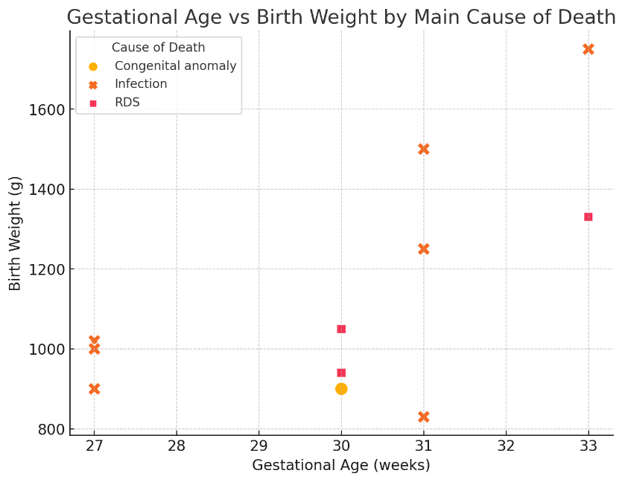
Figure 2. Gestational age by maternal age category. Boxplot showing lower GA at birth in infants of mothers ≥35 years.
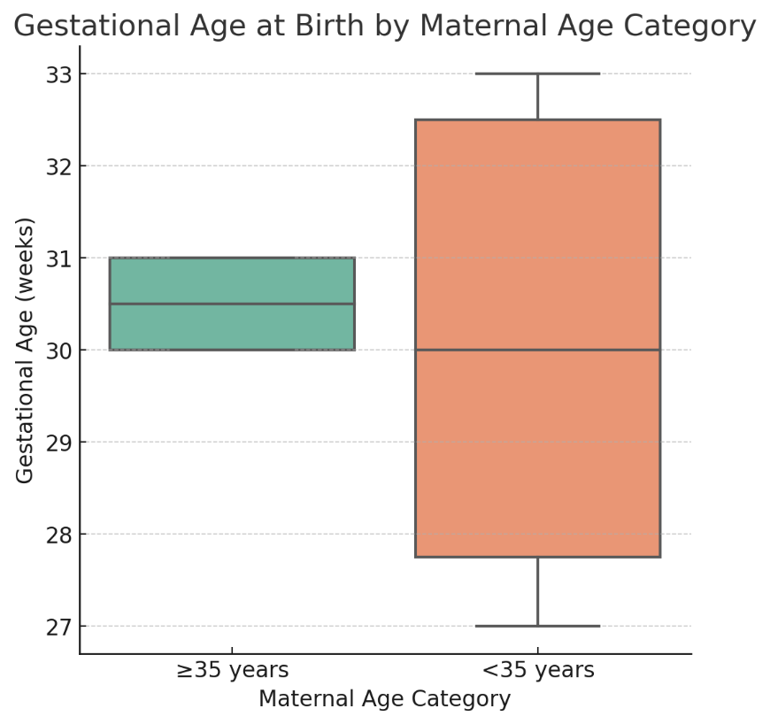
Tables
Table 1. Baseline characteristics of preterm infants (N=14).
Variable | Findings
Mean gestational age (weeks) | 29.4 (range: 27–33)
Extremely preterm (<28 weeks) | 5 (36%)
Very preterm (28–31 weeks) | 7 (50%)
Moderate preterm (32–34 weeks) | 2 (14%)
Mean birth weight (g) | 1350 (range: 900–1900)
VLBW (<1500 g) | 9 (64%)
Male: Female | ≈ 1:1
Maternal age ≥35 years | 4 (29%)

Table 2. Primary causes of death among preterm infants (N=14).
Primary cause of death | n | %
Infections (late-onset sepsis/HCAP/CLABSI, etc.) | 8 | 57.1
Respiratory distress syndrome (RDS) | 3 | 21.4
Congenital anomalies | 3 | 21.4

Table 2a. Associated complications recorded in the cohort (N=14).

Associated complication | n | %
Necrotizing enterocolitis (NEC) | 2 | 14.3
Intraventricular hemorrhage (IVH) | 1 | 7.1
Metabolic disorder | 1 | 7.1

Abbreviations: RDS, respiratory distress syndrome; NEC, necrotizing enterocolitis; IVH, intraventricular hemorrhage.

Table 3. Timing of death by cause.
Cause of death | Early (<7 days) | Late (≥7 days) | Total
RDS | 3 | 0 | 3
Infections | 0 | 8 | 8
Congenital anomalies | 0 | 3 | 3
Total | 3 | 11 | 14

4. Discussion

This retrospective case analysis provides insights into the mortality and morbidity associated with extreme prematurity. In our cohort, the majority were born before 30 weeks and weighed <1500 g (Table 1), confirming immaturity and very low birth weight as major predictors of neonatal death [3, 5].
Etiology of Death and Timing
The causes of death reflect a dual burden. RDS predominated at the lowest gestational ages and birth weights; infections occurred later among moderately preterm infants; and congenital anomalies contributed across groups (Tables 2–3). Figure 1 confirms this etiologic shift: RDS in the most immature, infections among those who survived longer, and anomalies across groups. These findings are consistent with reports from Ethiopia (RDS and asphyxia as predictors [5]) and Tunisia (nosocomial infections in late deaths [7]). Similar patterns have been reported in Caribbean LMIC settings, including Trinidad and Tobago [14]. By contrast, high-income cohorts report substantially higher survival at 25 weeks with widespread use of antenatal corticosteroids and surfactant [3,9]; results from large HIC cohorts such as EPIPAGE-2 therefore differ [13].
Maternal Risk Factors
Maternal age was an important determinant. In our series, 29% of mothers were ≥35 years (Table 1). Figure 2 shows their infants had lower gestational ages, likely linked to hypertensive disorders, preeclampsia, and placental abnormalities. This matches previous studies reporting increased prematurity risk in mothers >40 and <17 years [6, 7]. Limited antenatal care and socio-economic factors also play key roles in LMICs [8].
Clinical and Public Health Implications
Our findings highlight that early deaths are mostly due to immaturity, while late deaths are preventable. Priorities include antenatal corticosteroids, early non-invasive ventilation, Kangaroo Mother Care, breastfeeding, and infection prevention [9,11,12]. Strengthening perinatal networks and access to evidence-based interventions is essential to reduce mortality gaps between low- and high-resource settings. This pattern is consistent with global evidence on the burden and preventability of neonatal sepsis [10].

5. CONCLUSION

This retrospective case analysis shows that most in-hospital deaths among extremely/very preterm infants occurred after the first week of life and were predominantly attributed to infections (8/14; 57%), whereas respiratory distress syndrome accounted for fewer cases and occurred exclusively in the early period. These findings—together with the birth-weight and gestational-age profiles—highlight opportunities to reduce late mortality through pragmatic, high-impact measures: timely antenatal corticosteroids, Kangaroo Mother Care, early and exclusive breastfeeding support, rigorous infection-prevention practices (hygiene bundles, catheter care, antibiotic stewardship), and context-adapted respiratory management. Strengthening documentation and audit processes will also enable better surveillance of early versus late outcomes and evaluation of targeted quality-improvement interventions.

ACKNOWLEDGEMENTS

The authors would like to thank the medical and nursing staff of the Neonatology Department at the Mohammed V Military Teaching Hospital, Rabat, Morocco, for their valuable contribution to the care of preterm infants and for their assistance in data collection. No external funding was received for this work.

Competing interests
The authors declare no conflict of interest.

Authors’ Contributions
M. Afroukh designed the study, collected the clinical and epidemiological data, and drafted the first version of the manuscript. E. Bahous contributed to the clinical analyses, data interpretation, and manuscript revision. R. Abilkacime supervised the study, validated the methodology, and provided critical revision of the manuscript. All authors read and approved the final version of the manuscript.

Consent (where applicable)

Not applicable. Individual consent was not required as data were collected retrospectively and anonymized.

Ethical approval (where applicable)

The study protocol was approved by the institutional review board; individual informed consent was waived due to the retrospective, anonymized design.

Definitions, Acronyms, Abbreviations
GA: Gestational Age;
BW: Birth Weight;
VLBW: Very Low Birth Weight (<1500 g);
ELBW: Extremely Low Birth Weight (<1000 g);
RDS: Respiratory Distress Syndrome;
NEC: Necrotizing Enterocolitis;
IVH: Intraventricular Hemorrhage;
KMC: Kangaroo Mother Care;
NICU: Neonatal Intensive Care Unit.
HAP/HCAP: Hospital-Acquired Pneumonia;
CLABSI: Central Line–Associated Bloodstream Infection.

Disclaimer (Artificial intelligence)

Author(s) hereby declare that NO generative AI technologies such as Large Language Models (ChatGPT, COPILOT, etc.) and text-to-image generators have been used during the writing or editing of this manuscript.
References

- United Nations Inter-agency Group for Child Mortality Estimation (UN IGME). Levels and Trends in Child Mortality 2023. New York: UNICEF; 2024. Available from: https://data.unicef.org/resources/levels-and-trends-in-child-mortality-2023/
- World Health Organization. Preterm birth – Fact sheet. Geneva: WHO; 2023 May 10. Available from: https://www.who.int/news-room/fact-sheets/detail/preterm-birth
- Stoll BJ, Hansen NI, Bell EF, et al. Neonatal outcomes of extremely preterm infants from the NICHD Neonatal Research Network. Pediatrics. 2010;126(3):443–56. doi:10.1542/peds.2009-2959
- Edwards EM, Ehret DEY, Soll RF, Horbar JD, et al. Survival of infants born at 22 to 25 weeks’ gestation receiving care in the NICU: 2020–2022. Pediatrics. 2024;154(4):e2024065963. doi:10.1542/peds.2024-065963
- Girma B, Tsegaye B, Alemayehu T, Wondimu M. Survival and predictors of mortality among preterm neonates: a 5-year cohort study in Northern Ethiopia. Front Pediatr. 2023;10:1083749. doi:10.3389/fped.2022.1083749
- Tirore LL, Abate AT, Tesfaye Z, et al. Incidence of mortality and its predictors among preterm neonates admitted to the NICU of NEMMCSH. BMC Pediatr. 2024;24:92. doi:10.1186/s12887-024-04992-9
- Chioukh FZ, Ben Ameur K, Ben Miled N, et al. Extremely preterm infants in Tunisia: Where are we now? Tunis Med. 2018;96(8–9):510–13. PMID: 30430530. Available from: https://latunisiemedicale.com/index.php/tunismed/article/view/3434
- Agbeno EK, Osarfo J, Ashong J, et al. Determinants of preterm survival in a tertiary hospital in Ghana: a ten-year review. PLoS One. 2021;16(1):e0246005. doi:10.1371/journal.pone.0246005
- Sweet DG, Carnielli V, Greisen G, et al. European Consensus Guidelines on the Management of Respiratory Distress Syndrome—2019 Update. Neonatology. 2019;115(4):432–50. doi:10.1159/000499361
- Shane AL, Sánchez PJ, Stoll BJ. Neonatal sepsis. Lancet. 2017;390(10104):1770–80. doi:10.1016/S0140-6736(17)31002-4
- Roberts D, Brown J, Medley N, Dalziel SR. Antenatal corticosteroids for accelerating fetal lung maturation for women at risk of preterm birth. Cochrane Database Syst Rev. 2017;3:CD004454. doi:10.1002/14651858.CD004454.pub3
- Conde-Agudelo A, Díaz-Rossello JL. Kangaroo Mother Care to reduce morbidity and mortality in low birthweight infants. Cochrane Database Syst Rev. 2016;8:CD002771. doi:10.1002/14651858.CD002771.pub4
- Ancel PY, Goffinet F, Kuhn P, et al. Survival and morbidity of preterm children born at 22 through 34 weeks’ gestation in France in 2011: results of the EPIPAGE-2 cohort study. JAMA Pediatr. 2015;169(3):230–8. doi:10.1001/jamapediatrics.2014.3351
- Cupen K, Barran A, Singh V, Dialsingh I. Risk factors associated with preterm neonatal mortality: a case study using data from Mt. Hope Women’s Hospital in Trinidad and Tobago. Children (Basel). 2017;4(12):108. doi:10.3390/children4120108

