Case report

Management of Calcium hydroxide extrusion complication in a mandibular molar: A case report

Abstract

Calcium hydroxide is a commonly used intracanal medicament in endodontics due to its antimicrobial properties, ability to induce hard tissue formation, and role in controlling inflammation within the root canal system. Typically applied as a temporary dressing prior to permanent obturation, non-setting Calcium hydroxide paste is often delivered through a pressure syringe system for ease of placement. However, inadvertent over-extrusion of calcium hydroxide beyond the apex can result in severe inflammatory reactions, including pain, swelling, soft tissue blanching, and tissue necrosis, occasionally resembling Nicolau syndrome.
This report presents a 38-year-old female patient who developed severe pain, intraoral and extraoral swelling, and reduced mouth opening and mastication, following an attempted root canal treatment of the left mandibular first molar in a private dental clinic. Clinical evaluation revealed positive percussion of the involved tooth, gingival inflammation, blanching of adjacent soft tissues, and tender submandibular glands. Radiographic evaluation showed radiopaque material extruded beyond the apical region, consistent with overextension of Calcium hydroxide medicament.
The patient was managed through a structured, systematic approach involving careful canal debridement, systematic irrigation, antimicrobial therapy, and anti-inflammatory medicaments including Triple Antibiotic Paste (TAP) and Dexamethasone. Following these interventions, the extruded material gradually resorbed, as observed radiographically, and the patient’s symptoms-including pain, swelling, and difficulty in function resolved completely.
This case highlights the potential complications of calcium hydroxide extrusion during root canal therapy and underscores the importance of precise medicament placement. Clinicians should remain vigilant for signs of medicament-induced tissue injury and adopt a careful, stepwise approach to prevent and manage such complications.
Key words : Calcium hydroxide" "endodontics" "therapy, treatment" "inflammation

Introduction

Calcium hydroxide-Ca(OH)₂, remains one of the most trusted intracanal medicaments in endodontics because of its potent antimicrobial action, ability to neutralize bacterial endotoxins, and capacity to induce hard tissue formation. Its high alkalinity promotes protein denaturation, enzyme inhibition, and microbial death, which are essential for effective canal disinfection. However, these same properties make calcium hydroxide irritating to periapical tissues when inadvertently extruded beyond the apex [1].
Apical extrusion of calcium hydroxide is a well-documented iatrogenic complication that may occur due to over-instrumentation, excessive pressure during delivery, or misjudgement of working length. Studies have reported that extrusion leads to a robust inflammatory response characterized by pain, swelling, and sometimes edema of adjacent soft tissues [2,3]. Experimental models demonstrate that the high pH of calcium hydroxide causes local necrosis and cytokine release, which can trigger neurogenic inflammation and potentially injure nearby neurovascular structures [4]. Clinical reports further confirm that patients may experience acute pain within hours of extrusion, often requiring analgesics, and that soft-tissue swelling may persist for several days before subsiding [5].

Alternative medicaments such as triple antibiotic paste (TAP) have been investigated, especially when prolonged calcium hydroxide therapy is contraindicated or ineffective. In diabetic patients, TAP has been shown to reduce inter-appointment flare-ups and pain episodes more effectively than calcium hydroxide [6].
Randomized clinical trials comparing TAP, calcium hydroxide, and other medicaments found comparable antibacterial efficacy but suggested that TAP may produce fewer inflammatory complications [7].

Steroids have also been evaluated as adjuncts to reduce the inflammatory cascade and postoperative pain following root canal treatment. Systematic reviews indicate that corticosteroids administered either pre- operatively or intracanal can significantly lower postoperative pain intensity and improve patient comfort [8]. Also, studies reveal that preparing the canal non-traumatically will reduce the likelihood of extruded endodontic material into the peri radicular region [9].

Thorough patient counselling, radiographic verification of working length, and controlled delivery techniques are critical to minimize extrusion-related complications. The intracanal medicaments should consist of a radiopaque agent and it is recommended to fill the entire root canal system within its confines. If extruded periapically, there is an increased incidence of swelling, delayed periapical healing, nerve paraesthesia and other complications [10]. The treatment plan for an extrusion case, that considers all the above stated, is key to a successful outcome.

Case Presentation

A 38 year old female patient reported with severe pain and swelling in relation to the left mandibular first molar. Upon history taking, it was revealed that a root canal treatment was attempted one week back in a private dental clinic elsewhere on the tooth of interest and a paste was injected into the canals, following which the patient started experiencing gradually increasing pain (continuous) and swelling in the area with difficulty in opening the mouth and chewing of food. The patient complained of inhibited daily activities and sleep and depended on medication, due to the aforementioned.

Examination and Investigation

Upon clinical examination, there was swelling-extraoral and intraoral in relation to the left mandibular first molar (36). The tooth was positive to vertical and horizontal percussion with gingival inflammation and blanching of soft tissues of the vestibule region. The submandibular glands were tender and a temporary filling material was present on the occlusal surface of the tooth (Figure 1).

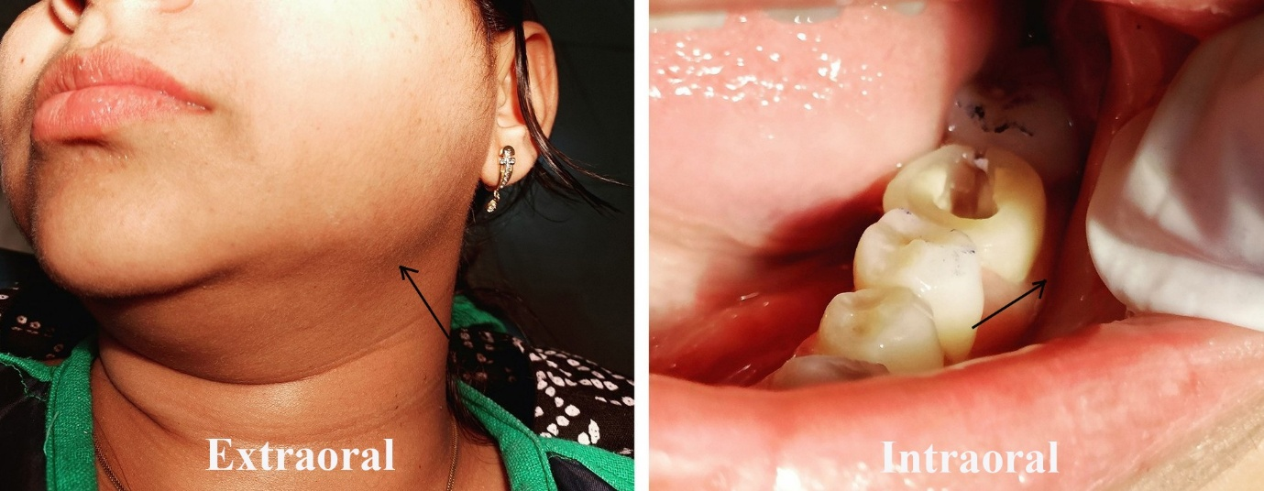
FIGURE 1: Pre operative images exhibiting swelling

Radiographic assessment using periapical radiovisiography of the tooth revealed conjoined and scattered radiopaque structures in the apical region of the mesial and distal roots suggestive of apical extrusion of Calcium hydroxide medicament as well as periapical radiolucencies.

Treatment

The tooth (36) was assessed and isolated followed by the modification of the access cavity. The occlusal reduction was done and the orifices were determined and widened, occlusal reduction was done followed by working length determination (Mesiobuccal-19.0 mm, Mesiolingual-19.5 mm and Distal-21.5 mm). Cleaning and Shaping of canals using hand files (Dentsply M-Access K files) and rotary files (NeoEndo NeoBlue) upto size #25 and 4% taper, along with gentle irrigation with 5.25% Sodium hypochlorite, normal saline (0.9%) using a 27G side vented needle was done. EDTA was used for removal of smear layer. A cotton plug and temporary restoration was given (Cavit G). A combination drug-Tab.Zerodol SP (Aceclofenac 100mg+Serratiopeptidase 15mg+Paracetamol 325mg) was advised along with post operative instructions and patient was recalled the subsequent day.
In the next appointment, irrigation using the same protocol was performed and a steroid paste combination of Dexamethasone (0.5 mg Tab.) and Propylene glycol was manually prepared and placed into the canals using a 27G side vented needle with minimal pressure to avoid apical extrusion. The priority was rapid control of inflammation to relieve pain and reduce tissue pressure. A temporary restoration was placed and patient recalled after 3 days.
In the following appointment, upon examination the pain and swelling had decreased considerably. The same irrigation protocol was followed. Triple Antibiotic Paste (TAP)- standard ratio of 1:1:1 by weight, with Propylene glycol was manually prepared and placed into the canals using a lentulo spiral and a temporary restoration was placed. The patient was recalled after 1 week.
In final appointment, upon examination-the patient was completely asymptomatic and the swelling was null. Irrigation was done as aforementioned and obturation was done using 25 4% gutta percha cones (NeoEndo) and sealer (Dentsply AH Plus) using cold lateral condensation method and the coronal seal was established using a composite restoration (Ivoclar Vivadent).
The Radiographic evaluation comparison from the first till the final visit, revealed the gradual decrease of the radioopaque extruded Calcium hydroxide medicament, until complete dissipation. This is represented in Figure 2.

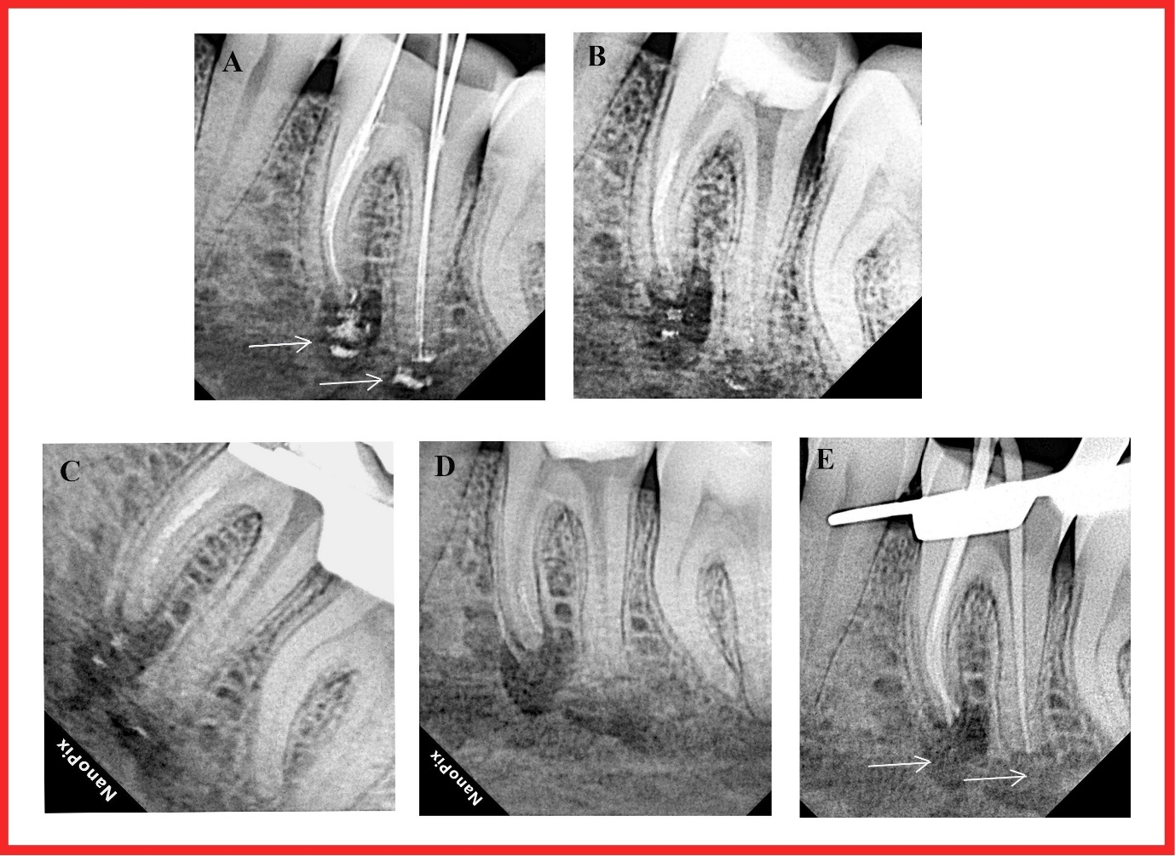
FIGURE 2: Radiographic evaluation of the treatment progression. A- shows the extruded Calcium hydroxide on the first visit along with periapical radiolucency, B to E-shows the gradual decrease in the extruded Calcium hydroxide medicament which completely dissipates by the final visit. (Depicted by white arrows)

Discussion

Calcium hydroxide continues to be one of the most commonly employed intracanal medicaments in clinical endodontic practice [11]. Despite its widespread use, the extrusion of calcium hydroxide into periapical tissues remains a significant clinical complication. The host reaction to Calcium hydroxide extrusion into the soft tissue or blood vessels can range from a minor inflammatory reaction to serious sequelae, including tissue necrosis and paresthesia. This depends on the amount of material that is extruded into the periapical region and volume of material in contact with vascular and neural tissues [12]. Accordingly, preoperative radiographic assessment, verification of apical constriction, and cautious delivery techniques are essential preventive measures.
When extrusion occurs, management should follow a conservative and systematic approach. The first step is to remove as much extruded material as possible without causing further apical displacement. Systematic irrigation with Sodium hypochlorite and normal saline, use of EDTA to eliminate the smear layer, is to be done accordingly along with use of side-vented needles and negative-pressure irrigation to minimize the risk of periapical extrusion and to facilitate effective debridement of the apical region. Controlled apical re-instrumentation may be performed to regain patency and ensure thorough canal cleaning.

Adjunctive pharmacologic measures can aid in mitigating inflammatory sequelae. Intracanal corticosteroids have been demonstrated to reduce the release of pro-inflammatory mediators and limit vascular permeability. Studies show that corticosteroids have a postoperative pain-reducing effect in endodontic patients, and the choice of drug regimens could be an important predictor of pain reduction [13]. This intervention is particularly valuable in cases presenting with acute pain or swelling, as rapid symptom control improves patient comfort and facilitates subsequent canal disinfection.

Eradication of residual microorganisms is equally important, as extrusion may leave infected tissue in areas that are otherwise difficult to access. Triple Antibiotic Paste (TAP), comprising metronidazole, ciprofloxacin, and minocycline, provides broad-spectrum antimicrobial coverage against resistant endodontic pathogens. Khan et al. (2023) reported that TAP demonstrated superior pain control and microbial reduction compared to calcium hydroxide in teeth with symptomatic apical periodontitis, especially in the early post-treatment period [11]. Sequential use of intracanal corticosteroids followed by TAP provides a synergistic effect, combining early anti-inflammatory control with comprehensive microbial elimination.

Generally, three types of vehicles are used for Ca(OH)₂ paste preparation: viscous, aqueous, and oily. There is a great deal of disparity among the use of an optimum medium for Ca(OH)₂ that would aid in diminishing postoperative pain. According to Estrela et al., when calcium hydroxide distilled water (aqueous vehicle) paste was used, the liberation of Ca²⁺ and OH⁻ ions was faster and more significant, indicating their rapid action in reducing pain [14]. Another study by Gomes et al. found that oily vehicles boost the antibacterial properties of Ca(OH)₂ against E. faecalis and other microorganisms, showing greater zones of microbial inhibition with oily vehicles than those with aqueous and viscous vehicles. This disparity in the literature provides inconclusive information regarding which vehicles are better suited to aid adequate microbial reduction and pain prevention [14]. In another study, the vehicle application in mixing Calcium hydroxide has been evidenced to have an effect on its functioning [15].

Recent clinical reports further support a stepwise, minimally invasive strategy. Almaslamani et al. (2024) described a case of inferior alveolar nerve injury caused by calcium hydroxide extrusion during root canal treatment. The patient experienced severe pain and paresthesia in the lower right lip following the procedure. Conservative management with non-steroidal anti-inflammatory drugs and vitamin B complex injections led to complete resolution of symptoms after two years [16]. Similarly, Ali et al. (2024) reported a case of inferior alveolar nerve paresthesia following calcium hydroxide extrusion. Non-surgical treatment with steroids and pregabalin resulted in complete recovery over a four-year period [17]. These cases emphasize the importance of conservative management, careful monitoring, and avoidance of surgical intervention, unless absolutely necessary.

Conclusion

Calcium hydroxide extrusion is an infrequent but significant complication in endodontic practice, with the potential to cause acute pain, soft tissue inflammation, and, in some cases, neurovascular involvement. Prevention remains the cornerstone of management and relies on careful preoperative assessment, accurate determination of working length, controlled delivery of medicaments, and avoidance of excessive pressure during placement. When extrusion occurs, a systematic, conservative approach is essential. Thorough mechanical and chemical debridement, combined with appropriate irrigation techniques, minimizes the presence of residual material while avoiding further extrusion.
Adjunctive intracanal corticosteroids can provide prompt relief of pain and swelling, improving patient comfort during the acute phase, though their role is supportive rather than curative. Sequential placement of Triple Antibiotic Paste ensures broad-spectrum antimicrobial coverage, particularly in areas where residual infection may persist due to anatomical complexities or compromised tissue. Close clinical and radiographic follow-up is crucial to monitor resolution of the extruded material and confirm periapical healing.
Overall, a structured, stepwise strategy that combines meticulous technique, judicious pharmacologic intervention, and consistent monitoring leads to favourable outcomes. However, high-quality prospective studies are still needed to define optimal protocols for medicament sequencing, dosage, and duration in these challenging cases, particularly in patients with systemic conditions or extensive periapical involvement.

Additional Information
Disclosures
Consent: Informed consent for treatment and open access publication was obtained or waived by all participants in this study.
Conflicts of interest: There are no conflicts of interest.
Ethical Approval:
As per international standards or university standards written ethical approval has been collected and preserved by the author(s).

Disclaimer (Artificial intelligence)
Author(s) hereby declare that NO generative AI technologies such as Large Language Models (ChatGPT, COPILOT, etc.) and text-to-image generators have been used during the writing or editing of this manuscript.

References

- Tripathi S, Tripathi P, Misra P: Accidental extrusion of calcium hydroxide into the inferior alveolar canal during endodontic treatment: a case report. J Pharm Bioallied Sci. 2025, 17(Suppl 2):1984-1987.
- Kasapoğlu MB: Inferior alveolar nerve injury due to the extrusion of calcium hydroxide during endodontic treatment: a case report. Aust Endod J. 2022, 48(2):342-346.
- Siqueira JF, Lopes HP: Mechanisms of antimicrobial activity of calcium hydroxide: a critical review. Int Endod J. 1999, 32(5):361-369.
- Safavi KE, Nichols FC: Effect of calcium hydroxide on bacterial lipopolysaccharide . J Endod. 1993, 19(2):76- 78.
- Olsen JJ, Thorn JJ, Korsgaard N, Pinholt EM. Nerve lesions following apical extrusion of non-setting calcium hydroxide: a systematic case review and report of two cases. J Craniomaxillofac Surg. 2013, 41(6):254-259.
- Kasapoğlu, Metin & Doğancalı, Gülce: Effect of calcium hydroxide and triple antibiotic paste as intracanal medicaments on the incidence of inter-appointment flare-up in diabetic patients: an in vivo study. J Conserv Dent. . 2014, 17(3):208-211.
- Tirukkolluru C, Thakur S: Comparative evaluation of triple antibiotic paste, propolis with moxifloxacin, and calcium hydroxide as intracanal medicaments against Streptococcus spp. and Enterococcus faecalis in type II diabetes mellitus patients: a randomized clinical trial. Contemp Clin Dent. 2020, 11(3):318-323.
- Suneelkumar C, Subha A, Gogala D: Effect of preoperative oral corticosteroids on pain after root canal treatment: a systematic review and meta-analysis of randomized controlled trials. International Endodontic Journal. 2018, 51(8):862-873.
- Shahravan A, Jalali S, Mozaffari B, Pourdamghan N: Overextension of nonsetting calcium hydroxide in endodontic treatment: literature review and case report. Iran Endod J. 2012, 7(2):102-108.
- Khandelwal, Akshay & Teja, Kavalipurapu & Jose, Jerry & Palanivelu, Ajitha: Non-Surgical Management of Iatrogenic Extrusion of Calcium Hydroxide Based Intracanal Medicament in Clinical Endodontics -A Case Report. Journal of Evolution of Medical and Dental Sciences. 2021, 10(33):6000-6002.
- Khan AM, Gangoo IKA, Ali NA, et al.: The effect of calcium hydroxide, triple antibiotic paste and chlorhexidine on pain in teeth with symptomatic apical periodontitis: a randomized controlled trial. Int J Environ Res Public Health. 2023, 20(4):3091.
- Gluskin AH, Lai G, Peters CI, Peters OA: The double-edged sword of calcium hydroxide in endodontics: precautions and preventive strategies for extrusion injuries into neurovascular anatomy. J Am Dent Assoc. 2020, 151:317-326.
- Shamszadeh S, Shirvani A, Eghbal MJ, Asgary S: Efficacy of Corticosteroids on Postoperative Endodontic Pain: A Systematic Review and Meta-analysis. J Endod. 2018, 44(7):1057-1065.
- Aneja K, Gupta A, Abraham D, Aggarwal V, Sethi S, Chauhan P, Singh A, Kurian AH, Jala S. Influence of vehicle for calcium hydroxide on postoperative pain: a scoping review. J Dent Anesth Pain Med. 2022, 22(2):75-86.
- Sadaf Ujjan, Nourain Saeed, Saba Parveen Soomro, Faryal Manzoor, Permanand Malhi and Zafar Iqbal: Evaluation of Post-operative Pain by using Calcium Hydroxide Based Root Canal Sealer: A Clinical Study. Journal of Pharmaceutical Research International. 2021, 33(42A):397–401.
- Almaslamani M, Alhassawi S, Prasad P, Alshayeb M: Diagnosis and Management of Inferior Alveolar Nerve Injury Caused by Calcium Hydroxide Extrusion during Root Canal Treatment: Case Report. J Pharm Bioallied Sci. 2024, 16(Suppl 5):4900-4904.
- Ali A, Tok S, Bakhsh A, Martins J, Arslan H. Non-surgical management of paresthesia induced by calcium hydroxide extrusion: a case report with a 4-year follow-up. Rev Port Estomatol Med Dent Cir Maxilofac. 2024, 65:40-45.

