Case Report

Cystic hygroma in early pregnancy with spontaneous miscarriage: a case report

ABSTRACT

Aims: To report a rare case of first-trimester cystic hygroma and emphasize its diagnostic and prognostic implications.
Case presentation: A 42-year-old nulliparous woman with a history of miscarriage and first-degree consanguinity was admitted at 10 weeks of gestation for vaginal bleeding and lower abdominal pain. Ultrasound examination revealed a missed miscarriage associated with a multiloculated cervical/nuchal cystic hygroma. The pregnancy ended in spontaneous miscarriage within hours of admission. Genetic testing was declined.
Conclusion: First-trimester cystic hygroma is a rare anomaly with a poor prognosis, frequently associated with chromosomal aneuploidy and structural malformations. Early ultrasound detection and genetic evaluation are essential for accurate diagnosis, appropriate counseling, and guiding parental decisions, particularly in resource-limited settings.

Keywords: Cystic hygroma, lymphatic malformation, nuchal translucency, chromosomal abnormalities, Turner syndrome, prenatal diagnosis, case report

1. INTRODUCTION

Cystic hygroma (CH) is a congenital lymphatic malformation defined by multiloculated cystic structures, most commonly located in the fetal cervical region [1,2]. It results from abnormal lymphatic development and failed connection of the jugular lymph sacs to the venous system during early embryogenesis [3]. The reported prevalence varies from 1 in 268 to 1 in 800 pregnancies depending on gestational age and population studied [1,6].
CH is strongly associated with chromosomal abnormalities, most notably Turner syndrome and trisomies 21, 18, and 13 [7–9]. Structural anomalies, especially congenital heart defects, are frequent comorbidities [10]. Prognosis is generally poor, with high rates of miscarriage, intrauterine death, and perinatal mortality [2,3]. However, in euploid fetuses without additional malformations, survival with normal development is possible, although uncommon [13].
Advances in prenatal imaging and genetics have refined early diagnosis. High-resolution first-trimester ultrasound differentiates CH from isolated nuchal translucency, the latter carrying a comparatively better prognosis [2,13]. Genetic testing using chromosomal microarray (CMA) and, more recently, exome sequencing (WES) can identify submicroscopic copy number variations and pathogenic variants not detected by conventional karyotype [12]. Such approaches expand the etiological spectrum beyond aneuploidy, implicating monogenic disorders and syndromic associations.
The present report describes a rare case of first-trimester CH in a woman with advanced maternal age and consanguinity, culminating in spontaneous miscarriage. The case highlights diagnostic and prognostic challenges in low-resource settings and underscores the importance of integrating ultrasound findings with genetic evaluation when available [9,12].

2. CASE PRESENTATION

A 42-year-old nulliparous woman with a history of miscarriage and first-degree consanguinity presented to the emergency department at 10 weeks’ gestation with vaginal bleeding and lower abdominal pain. She was hemodynamically stable and afebrile. Gynecological examination revealed a moderate amount of reddish intrauterine bleeding with a cervix dilated to 2 cm.
Transabdominal ultrasound demonstrated a missed miscarriage (crown–rump length consistent with ~10 weeks) associated with a multiloculated, septated retro- and posterolateral cervical/nuchal cystic mass, consistent with cystic hygroma. No ascites, pleural or pericardial effusion were identified at that time. Shortly after admission, the patient experienced a spontaneous miscarriage. The macroscopic fetus exhibited a large cervical cystic mass with generalized soft-tissue edema (anasarca).
Genetic testing (karyotyping or microarray) was proposed but declined by the patient. The ultrasound descriptors used are consistent with criteria distinguishing septated cystic hygroma from isolated nuchal translucency, which carry different prognostic implications [2,13].

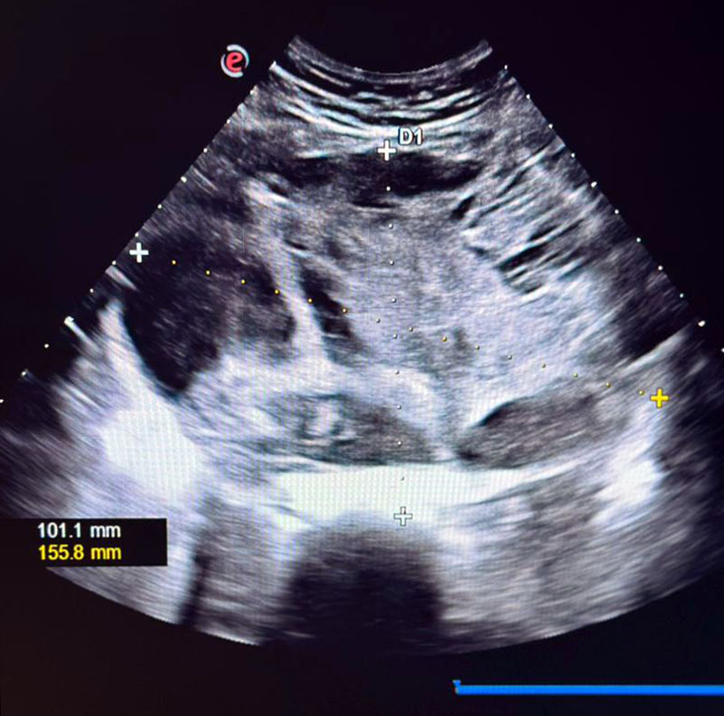

Figure 1. First-trimester ultrasound showing a multiloculated cystic cervical/nuchal mass consistent with cystic hygroma (transverse view, measurements indicated).
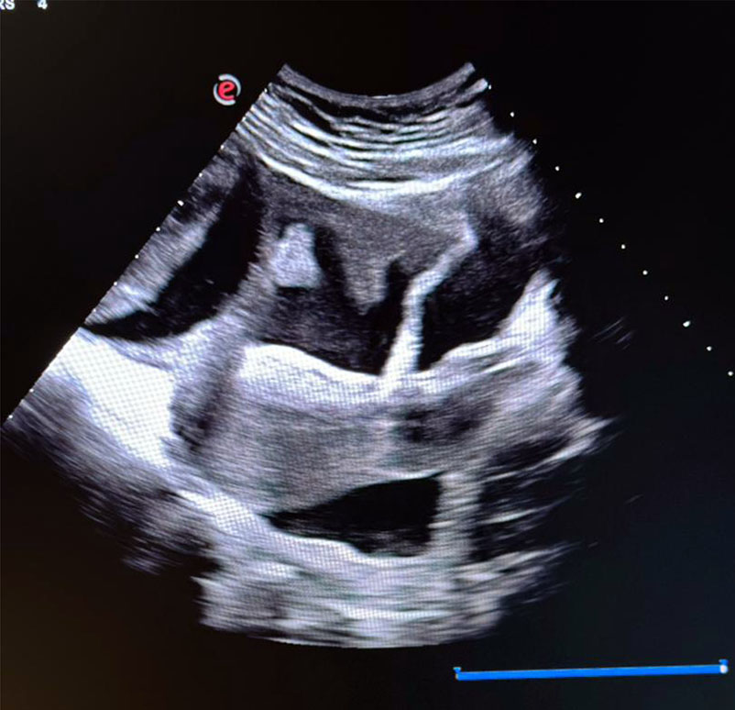

Figure 2. Sagittal ultrasound image demonstrating septated cystic hygroma extending posteriorly.

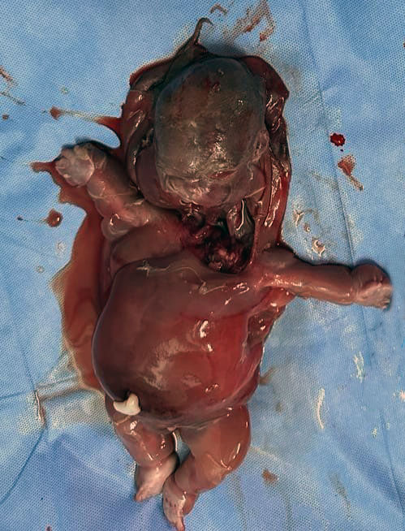
Figure 3. Post-miscarriage macroscopic image of the fetus with a large cervical cystic hygroma and generalized edema (anasarca).

3. DISCUSSION

First-trimester cystic hygroma (CH) is a marker of adverse pregnancy outcome, with chromosomal abnormalities reported in 50–60% of cases, most commonly Turner syndrome and trisomies 21, 18, and 13 [1–3]. The presence of septations and generalized edema, as in our case, is strongly predictive of progression to hydrops and fetal demise [4,5]. Recent population-based studies confirm that prognosis is particularly poor when CH is diagnosed before 12 weeks, with spontaneous miscarriage or intrauterine fetal death occurring in the majority of cases [6,7].
Consanguinity, as observed in our patient, represents an additional risk factor due to autosomal recessive inheritance and has been associated with higher rates of congenital anomalies [8]. In resource-limited countries where genetic testing is often declined or unavailable, documentation of consanguinity in association with adverse fetal outcomes is essential for epidemiological reporting and counseling [9].
Differentiation between CH and increased nuchal translucency (NT) is critical. While both present as cystic structures in the fetal neck, CH typically appears as a multiloculated septated mass extending laterally and posteriorly, whereas NT corresponds to a simple fluid collection behind the fetal neck [2,13]. This distinction is clinically important since NT is associated with better outcomes when isolated, whereas CH carries a markedly higher risk of aneuploidy, structural anomalies, and perinatal mortality [11,12].
Cytogenetic testing remains the cornerstone of etiological evaluation. Conventional karyotype allows the detection of common aneuploidies, but chromosomal microarray (CMA) has superior diagnostic yield by identifying submicroscopic copy number variants [12]. Moreover, exome sequencing (WES) is increasingly used to detect pathogenic variants in monogenic disorders presenting with CH [12]. In the recent series by Zheng et al., combining karyotype, CMA, and WES increased diagnostic yield up to 20% beyond conventional cytogenetics [12]. However, in low-resource settings, ultrasound remains the main diagnostic tool, and management often relies on counseling based on imaging findings alone [9].
The overall prognosis of CH is unfavorable, but outcome depends on the presence of associated abnormalities. In euploid fetuses without additional malformations, survival rates of up to 40–50% have been reported [6]. Nevertheless, in cases complicated by hydrops or generalized edema, mortality approaches 100% [5]. Early detection through first-trimester ultrasound therefore plays a crucial role in parental counseling, guiding decisions regarding genetic testing, pregnancy continuation, and follow-up strategies [3,6].
Our case illustrates the clinical challenges encountered when genetic testing is declined. Advanced maternal age, first-degree consanguinity, and generalized edema all supported the likelihood of an underlying genetic etiology. This emphasizes the importance of multidisciplinary management integrating maternal-fetal medicine specialists, geneticists, and neonatologists whenever available. In contexts where resources are limited, detailed ultrasound assessment and transparent counseling remain the cornerstone of care [9].

4. CONCLUSION

First-trimester cystic hygroma is a rare but severe anomaly, strongly associated with chromosomal abnormalities and poor pregnancy outcomes [1–3]. The presence of consanguinity and advanced maternal age in our patient may have contributed to the unfavorable prognosis [8]. This case highlights the importance of early ultrasound detection, systematic search for associated anomalies, and offering genetic testing whenever possible [3,12]. In low-resource contexts, careful ultrasound assessment and thorough counseling remain essential for parental decision-making.

DEFINITIONS, ACRONYMS, ABBREVIATIONS.
19. CH: Cystic Hygroma
NT: Nuchal Translucency
US: Ultrasound
SA: Semaines d’Aménorrhée (Weeks of Amenorrhea)
CNV: Copy Number Variation
PND: Prenatal Diagnosis

CONSENT

Written informed consent was obtained from the patient for the publication of this case report and any accompanying images. A copy of the written consent is available for review by the editorial office/chief editor/editorial board members of this journal.

ETHICAL APPROVAL
Not applicable. Written informed consent for publication was obtained from the patient.

Disclaimer (Artificial intelligence)

The authors declare that no generative AI technologies were used during the writing or editing of this manuscript.

REFERENCES

- Malone FD, Ball RH, Nyberg DA, et al. First-trimester septated cystic hygroma: prevalence, natural history, and pediatric outcome. Obstet Gynecol. 2005;106(2):288-94. doi:10.1097/01.AOG.0000173318.54978.1f
- Scholl J, Durfee SM, Russell MA, et al. First-trimester cystic hygroma: relationship of nuchal translucency thickness and outcomes. Obstet Gynecol. 2012;120(3):551-9. doi:10.1097/AOG.0b013e318264f829
- Malone FD, D’Alton ME, Craigo SD, et al. Fetal cystic hygroma. Fetal Diagn Ther. 2021;48(12):842-52. doi:10.1159/000518354
- Wall E, Cnota JF, Crombleholme TM, et al. Outcomes from a 15-year review of cystic hygroma. Am J Obstet Gynecol. 2024;230(1):74.e1-74.e8. doi:10.1016/j.ajog.2023.11.742
- Noia G, Pellegrino M, Masini L, et al. Fetal cystic hygroma: the importance of natural history. Eur J Obstet Gynecol Reprod Biol. 2013;170(2):407-13. doi:10.1016/j.ejogrb.2013.07.036
- Wang MJ, Bazan M, Hsieh T, et al. Perinatal outcomes of cystic hygroma: a systematic review and meta-analysis. Am J Obstet Gynecol MFM. 2025;7(3):101704. doi:10.1016/j.ajogmf.2025.101704
- Schreurs L, Lannoo L, De Catte L, et al. First-trimester cystic hygroma colli: retrospective analysis in a tertiary center. Eur J Obstet Gynecol Reprod Biol. 2018;231:60-4. doi:10.1016/j.ejogrb.2018.10.019
- Bittles AH, Black ML. Consanguinity, human evolution, and complex diseases. Proc Natl Acad Sci U S A. 2010;107 Suppl 1:1779-86. doi:10.1073/pnas.0906079106
- Howarth ES, Draper ES, Budd JLS, et al. Population-based study of the outcome following the prenatal diagnosis of cystic hygroma. Prenat Diagn. 2005;25(4):286-91. doi:10.1002/pd.1100
- Gedikbasi A, Oztarhan K, Aslan G, et al. Multidisciplinary approach in cystic hygroma: Prenatal diagnosis, outcome, and postnatal follow-up. Pediatr Int. 2009;51(5):670-7. doi:10.1111/j.1442-200X.2009.02846.x
- Chen YN, Chen CP, Lin CJ, et al. Prenatal ultrasound evaluation and outcome of pregnancy with fetal cystic hygromas and lymphangiomas. J Med Ultrasound. 2017;25(1):12-5. doi:10.1016/j.jmu.2017.02.001
- Zheng Y, Xu F, Liu C, et al. Clinical application of karyotype analysis, CMA and WES in prenatal diagnosis of fetal cystic hygroma. Front Genet. 2023;14:1130282. doi:10.3389/fgene.2023.1130282
- Ducarme G, Graesslin O, Alanio E, et al. Hyperclarté nucale et hygroma cervical au premier trimestre de la grossesse: diagnostic prénatal et devenir néonatal. Gynecol Obstet Fertil. 2005;33(10):750-4. doi:10.1016/j.gyobfe.2005.07.031

