Case report

Intracardiac Thrombi in Children: A Five-Case Series and Literature Review

.
ABSTRACT

Aims: The study reports a pediatric series of intracardiac thrombi and to discuss their clinical, diagnostic, and therapeutic aspects in the light of current literature.
Study Design: Case series and literature review.
Place and Duration of Study: Department of Pediatrics, Children’s Hospital, Rabat, Morocco, 2023–2024.
Methodology: We retrospectively analyzed five pediatric patients aged 3 months to 13 years who were diagnosed with intracardiac thrombi of various etiologies. Clinical data, laboratory tests, imaging results, therapeutic strategies, and outcomes were collected from medical records.
Results: The series included five children: one adolescent with hyperhomocysteinemia complicated by a left ventricular thrombus, a premature infant with a central venous catheter and right atrial thrombus, a 7-month-old with severe heart failure and left ventricular thrombus, a teenager with Behçet’s disease and right ventricular thrombus, and an infant with protein C/S deficiency and left ventricular thrombus. Management relied mainly on anticoagulation with low-molecular-weight heparin and vitamin K antagonists, alongside etiological treatments when indicated. Outcomes were variable: two patients died, two showed favorable recovery, and one was lost to follow-up.
Conclusion: Intracardiac thrombi in children are rare but potentially fatal conditions. Early recognition using echocardiography and timely initiation of anticoagulation are essential to prevent embolic complications. Prognosis depends on underlying pathology and rapid multidisciplinary management. Preventive strategies should address modifiable risk factors such as catheterization and uncorrected coagulation disorders.

Keywords: Intracardiac thrombus; children; anticoagulation; echocardiography; hypercoagulability; congenital disorders; case series.

1. INTRODUCTION

Intracardiac thrombi are rare but serious conditions in the pediatric population, with potentially life-threatening consequences due to systemic or pulmonary embolism [1–3]. Their true prevalence remains difficult to establish, as most data come from adult cohorts and pediatric cases are reported mainly as isolated observations or small series [4,5]. Nevertheless, improvements in echocardiography and cardiac magnetic resonance imaging have enhanced the recognition of these thrombi in children [6,7].
The pathogenesis is explained by Virchow’s triad, which combines endothelial injury, blood stasis, and hypercoagulability [8,9]. In children, several predisposing factors have been identified, including congenital heart disease, dilated cardiomyopathy, systemic inflammatory disorders such as Behçet’s disease, and hematological abnormalities like protein C or S deficiency or hyperhomocysteinemia [10–13]. Iatrogenic causes, particularly central venous catheters, are also major contributors in neonates and infants [14,15].
Diagnostic confirmation relies primarily on transthoracic echocardiography (TTE), which is widely available and non-invasive [16]. Transesophageal echocardiography (TEE) and cardiac MRI provide additional accuracy in evaluating thrombus size, mobility, and risk of embolization [17,18].
Management is not standardized in pediatrics and is often extrapolated from adult guidelines. Anticoagulation with unfractionated heparin, low-molecular-weight heparin (LMWH), or vitamin K antagonists remains the mainstay of therapy [19,20]. Surgical thrombectomy may be considered in selected cases with large, mobile, or refractory thrombi [21]. Despite these measures, prognosis remains guarded, and mortality is high in infants with severe underlying disease [22,23].
Recent reviews stress the importance of early recognition and multidisciplinary management to improve outcomes [24–26]. The aim of this article is to present five pediatric cases of intracardiac thrombi of diverse etiologies and to discuss their clinical, diagnostic, and therapeutic implications in the light of current literature.

2. CASE PRESENTATION

Case 1. A 13-year-old boy with hyperhomocysteinemia presented with asthenia and dyspnea. TTE demonstrated left ventricular dysfunction with global hypokinesia and a large intraventricular thrombus. He was treated with LMWH, heart failure therapy, and folate supplementation. Follow-up TTE confirmed thrombus resolution.
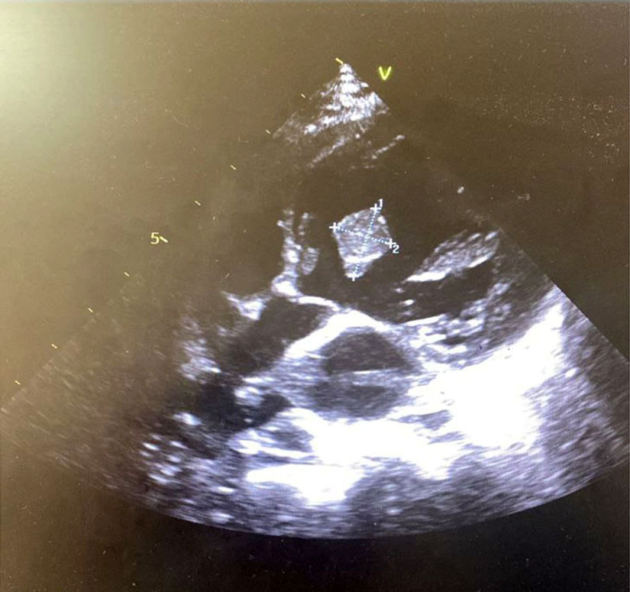
Figure 1. Transthoracic echocardiography (parasternal long-axis view) in Case 1 showing a well-defined echogenic intracavitary mass in the left ventricle, consistent with thrombus.
Case 2. A 3-month-old premature infant with central venous catheterization was admitted for respiratory distress and poor feeding. Echocardiography confirmed a right atrial thrombus associated with dilated cardiomyopathy. Despite anticoagulation and supportive care, the patient died. Original echocardiographic images were not available from archives. However, TTE (subcostal four-chamber view) revealed a right atrial echogenic mass adherent to the atrial wall, consistent with thrombus.
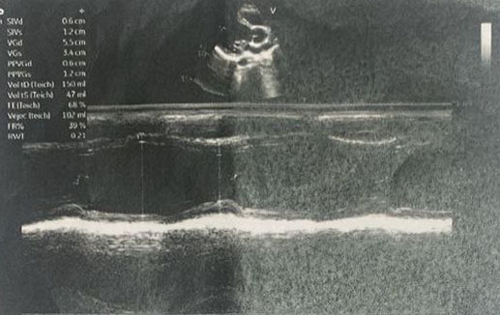
Figure 2. Transthoracic echocardiography (subcostal four-chamber view) in Case 2 demonstrating a right atrial echogenic mass adherent to the atrial wall, consistent with thrombus. (Original images not available; description provided in lieu of figure.)
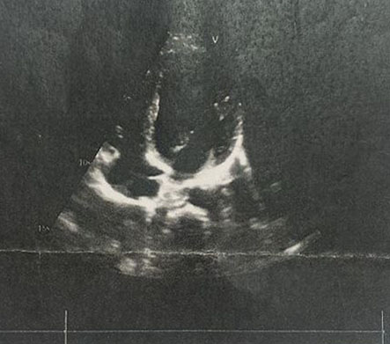
Case 3. A 7-month-old boy presented with fever, hemoptysis, and severe heart failure. TTE identified a large left ventricular thrombus with severe systolic dysfunction. Despite management with diuretics, digoxin, and LMWH, the infant died.
Figure 3. Transthoracic echocardiography (M-mode) in Case 3 showing left ventricular dilatation and impaired systolic function, providing a substrate for thrombus formation.
Case 4. A 13-year-old boy with Behçet’s disease and poor treatment adherence presented with chest pain. Echocardiography demonstrated a right ventricular thrombus. He received anticoagulation and immunosuppressive therapy, with partial thrombus regression on follow-up. Original echocardiographic images were not available. TTE (apical four-chamber view) showed a homogeneous echogenic mass in the right ventricle, attached to the free wall, suggestive of thrombus.
Figure 4. Transthoracic echocardiography (apical four-chamber view) in Case 4 demonstrating a large echogenic mass in the right ventricle attached to the free wall, consistent with thrombus. (Original images not available; description provided in lieu of figure.)
Case 5. A 13-month-old girl with protein C/S deficiency presented with recurrent respiratory infections. Echocardiography revealed a left ventricular thrombus. She was treated with LMWH and supportive care. The thrombus persisted on follow-up, and the patient was lost to follow-up. Original echocardiographic images were not available. TTE (parasternal long-axis view) revealed a homogeneous echogenic mass in the left ventricle, consistent with thrombus.
Figure 5. Transthoracic echocardiography (parasternal long-axis view) in Case 5 showing a homogeneous echogenic mass within the left ventricle, consistent with thrombus formation. (Original images not available; description provided in lieu of figure.)

3. discussion

The five cases illustrate diverse clinical and etiological settings of intracardiac thrombi in children. Predisposing factors included coagulation disorders (hyperhomocysteinemia, protein C/S deficiency), systemic inflammatory disease (Behçet’s disease), cardiomyopathy, and central venous catheterization [1–4]. These risk factors are consistent with Virchow’s triad in pediatric thrombosis [5,6].
Clinical presentation was nonspecific, ranging from respiratory distress to chest pain. This variability is consistent with literature where thrombi often remain silent until complications occur [7,8]. Echocardiography was the cornerstone of diagnosis. TTE was systematically performed as the first-line investigation. When image quality was limited, TEE was considered, and in selected cases cardiac MRI was used for further evaluation [9–11]. This multimodal imaging pathway allowed reliable confirmation of thrombi and guided management.
Management relied mainly on anticoagulation with LMWH, supplemented by supportive or disease-specific therapies. Vitamin K antagonists or direct oral anticoagulants may be used in older children [12,13]. Surgery is reserved for refractory cases with large or mobile thrombi but carries significant risk [14]. Outcomes remain variable, particularly in infants with hemodynamic compromise [15,16].
Preventive strategies include careful monitoring of central venous catheters and early screening for thrombophilia in unexplained cases [17]. Multidisciplinary management involving cardiology, hematology, and intensive care teams is essential.
Our series contributes to limited pediatric data, highlighting diverse etiologies and outcomes. It underscores the importance of early recognition, multimodal imaging, and timely anticoagulation to reduce morbidity and mortality.

4. Conclusion

Intracardiac thrombi in children are rare but life-threatening. Echocardiography remains the cornerstone of diagnosis. Early recognition, identification of risk factors, and prompt anticoagulation are essential. A multidisciplinary approach is critical to improving prognosis. Surgical thrombectomy may be considered in selected cases with large, mobile, or refractory thrombi. Despite these measures, prognosis remains guarded, and mortality is high in infants with severe underlying disease

Consent

Written informed consent for publication was obtained from the parents of all patients, including permission to use de-identified echocardiographic images. For cases where original images were not available (Cases 2, 4, and 5), detailed textual descriptions of echocardiographic findings were provided instead, with parental consent for publication.

Ethical approval

Ethical approval was not required for this retrospective case series, as per institutional policy. Written informed consent for participation and publication, including images and case details, was obtained from the parents of all patients.

Definitions, Acronyms, Abbreviations

CVC: Central Venous Catheter
ETT: Transthoracic Echocardiography
ETO: Transesophageal Echocardiography
HBPM / LMWH: Low-Molecular-Weight Heparin
HTAP / PH: Pulmonary Hypertension
INR: International Normalized Ratio
IT: Tricuspid Insufficiency
IM: Mitral Insufficiency
MRI: Magnetic Resonance Imaging
RCF: Fetal Heart Rate (Rythme Cardiaque Fœtal)
SD: Standard Deviation
VKA: Vitamin K Antagonist

Disclaimer (Artificial intelligence)

Author(s) hereby declare that NO generative AI technologies such as Large Language Models (ChatGPT, COPILOT, etc.) and text-to-image generators have been used during the writing or editing of this manuscript.

References

- Reyes, J. A., Dipchand, A. I., & Chiasson, D. A. (2022). Paediatric dilated cardiomyopathy with and without endocardial fibroelastosis–a pathological analysis of 89 explants. Cardiology in the Young, 32(7), 1041-1047.
- Payne, J. H., & Vora, A. J. (2007). Thrombosis and acute lymphoblastic leukaemia. British journal of haematology, 138(4), 430-445.
- Andrew M, David M, Adams M, Ali K, Anderson R, Barnard D, et al. Venous thromboembolic complications in children: first analyses of the Canadian registry of venous thromboembolic complications. Blood. 1994;83(5):1251-1257. PMID: 8118019
- Lassandro, G., Palmieri, V. V., Palladino, V., Amoruso, A., Faienza, M. F., & Giordano, P. (2020). Venous thromboembolism in children: from diagnosis to management. International Journal of Environmental Research and Public Health, 17(14), 4993.
- Monagle P, Adams M, Mahoney M, Ali K, Barnard D, Bernstein M, et al. Outcome of pediatric thromboembolic disease: a report from the Canadian Childhood Thrombophilia Registry. Pediatr Res. 2000;47(6):763-766. doi:10.1203/00006450-200006000-00012
- Goldenberg NA, Bernard TJ, Fullerton HJ, Gordon A, DeVeber G. Antithrombotic treatments, outcomes, and prognostic factors in childhood cerebral sinovenous thrombosis. Blood. 2009;114(24):5143-5150. doi:10.1182/blood-2009-07-234229
- Monagle P, Chalmers E, Chan A, DeVeber G, Kirkham F, Massicotte P, et al. Antithrombotic therapy in neonates and children: American College of Chest Physicians Evidence-Based Clinical Practice Guidelines (9th Edition). Chest. 2012;141(2 Suppl):e737S-801S. doi:10.1378/chest.11-2308
- Albisetti M. Congenital prothrombotic disorders in children with venous and arterial thromboses. Acta Haematol. 2007;117(3):149-155. doi:10.1159/000097462
- John JB, Cron SG, Kung GC, Mott AR. Intracardiac thrombi in pediatric patients: presentation profiles and clinical outcomes. Pediatr Cardiol. 2007;28(3):213-220. doi:10.1007/s00246-005-1068-3
- Van Ommen CH, Heijboer H, Büller HR, Hirasing RA, Heijmans HS, Peters M. Venous thromboembolism in childhood: a prospective two-year registry in The Netherlands. J Pediatr. 2001;139(5):676-681. doi:10.1067/mpd.2001.118192
- Nowak-Göttl U, von Kries R, Göbel U. Neonatal symptomatic thromboembolism in Germany: two year survey. Arch Dis Child Fetal Neonatal Ed. 1997;76(3):F163-167. doi:10.1136/fn.76.3.F163
- Rajpurkar M, Warrier I, Chitlur M, Lusher JM. Thrombosis in children: current perspectives. Haemophilia. 2002;8(1):125-135. doi:10.1046/j.1365-2516.2002.00593.x
- Bosch A, Monagle P, Mackie I, et al. Management of venous thromboembolism in children: current recommendations and future directions. Ther Clin Risk Manag. 2020;16:165-180. doi:10.2147/TCRM.S246153
- De Rose DU, Mecarini F, Campanale CM, Pugnaloni F, Passarella C, Secinaro A, Bracaglia G, Luciani M, Toscano A, Capolupo I, Dotta A. Management of intracardiac thrombosis in newborns: a case series and narrative review. Front Cardiovasc Med. 2025;12:1659312. doi:10.3389/fcvm.2025.1659312
- Goldenberg NA, Knapp-Clevenger R, Manco-Johnson MJ. Elevated plasma factor VIII and D-dimer levels as predictors of poor outcomes of thrombosis in children. N Engl J Med. 2004;351(11):1081-1088. doi:10.1056/NEJMoa040836
- İrdem A, Başpınar O, Kervancıoğlu M, Kılınç M. Intracardiac thrombus in children with dilated cardiomyopathy. Turk Kardiyol Dern Ars. 2014;42(2):161-167. doi:10.5543/tkda.2014.81593
- Çetin İİ, Ekici F, Ünal S, Kocabaş A, Sahin S, Uysal Yazıcı M, Ayar G. Intracardiac thrombus in children: the fine equilibrium between the risk and the benefit. Pediatr Hematol Oncol. 2014;31(5):481-487. doi:10.3109/08880018.2014.919546

