Implementing an SMS- Controlled Smart Home Automation System with a GSM Network

Abstract
This work presents the design and implementation of a GSM network-based home automation system for efficient monitoring and control of household appliances such as bulbs and fans. The motivation for this project stems from the growing need for remote and reliable home power management, especially in environments where physical presence is not always possible or convenient. The system was developed using a microcontroller, GSM module, power supply unit, and driver circuitry, with SMS commands serving as the communication interface. A key feature is the introduction of a 10-second delay mechanism after the first SMS to ensure smooth execution of subsequent commands. Experimental evaluation showed that the system achieved an average switching response time of approximately 10 seconds, with a reliability of over 95% in command delivery and execution. The results demonstrate that the system is practical, cost-effective, and suitable for residential and small-scale office applications, contributing to energy management and enhanced convenience in home automation.
Keywords: Home, Automation, Microcontroller, SMS, Communication, Mobile, GSM
1.0: Introduction
Automation is the technology that allows little or no human intervention when controlling a device or a process. (Akanni et al, 2018 & Idara and Adeniran, 2023). Global System of Mobile Communication (GSM) based Home Automation System is an electrical and electronic system designed to control home appliances with a mobile phone (Logathanan et al., 2025; Benedict et al., 2024; and Prabhat et al., 2025). The rapid advancement of mobile communication technology and the wide availability make it possible to incorporate mobile technology into Home Automation Systems.
Wireless devices having electronic properties that can operate electrical devices from a distance are considered remote. The remote control is designed to provide convenience to its user, and a means through which direct operation of the device is achieved in devices that pose inconvenience (such as a digital light processing projector mounted on the high ceiling being manipulated from floor level) while operating. Since the beginning of the industrial revolution, remote control has taken a new pace from ultrasonic tones to infrared (an engineered control system which uses infrared to send a digital code pulse of infrared radiation to control device functions including power volume channel, track change, heat fan speed among others) and now, to Bluetooth connectivity, motion sensor enables capabilities and voice control. (Akanpo et al., 2023). Utilizing Home Automation could lead to more efficient and intelligent energy-saving techniques. By integrating Information and Communication Technology (ICT) with renewable energy systems such as solar power or wind power, homes can autonomously make decisions about whether to store energy or expend it for a given appliance, leading to overall positive environmental impacts and lower electricity bills for the consumers using the system. To do this, researchers propose using data from sensors regarding consumer activity within the home to anticipate consumer needs and balance that with energy consumption. Home Automation includes a variety of smart security systems and surveillance setups. This allows consumers to monitor their homes while away, and to information in case anything bad happens. The system is a flexible tool that will offer this service at any time, and from anywhere with the constraints of the technologies being applied. Possible target appliances include (but are not limited to) climate control systems, security systems, lights; and anything with an electrical interface. The proposed approach for designing this system is to implement a microcontroller-based control module that receives the instructions and commands for the cellular phone over the GSM network.

Methodology
1.2: System Design
This work is divided into two sections the Hardware section and the Software Section.
1.2.1: Hardware
. The Hardware section has the following Subsystems: GSM module unit: this unit consists of the i. Sim800l GSM module: The choice of GSM communication was motivated by its wide availability, cost-effectiveness, and independence from internet connectivity. In countries where internet penetration is still below 50%, GSM coverage often exceeds 90%, making it the most reliable medium for remote communication. Moreover, SMS commands are lightweight, require minimal data processing, and can be delivered even under weak network conditions, thereby ensuring robustness of the system. (Camilo et al., 2025 & e-Gizmo,2025).
ii. Power Supply unit: The power supply unit provided regulated voltage to the GSM module, microcontroller, and driver circuit. A step-down transformer, bridge rectifier, and voltage regulator were used to convert 220V AC mains into 12V and 5V DC outputs. The 12V output powered the relays, while the 5V output powered the GSM module and microcontroller. Special care was taken to isolate the control circuit from the high-voltage AC line to ensure user safety. In addition, decoupling capacitors were included to smoothen voltage fluctuations and prevent resets of the GSM module during relay switching unit comprises the transformer, rectifier, smoothing capacitor, IN4006 diode, and LM7805 regulator.
iii. Microcontroller unit: the unit consists of the Atmega328P microcontroller, the microcontroller formed the “brain” of the system. It was responsible for decoding the SMS messages, interpreting the command structure, and executing the appropriate switching actions. In this project, the Arduino platform was chosen due to its open-source ecosystem, ease of programming, and availability of low-cost hardware. The Arduino’s digital I/O pins provided the necessary interface to the driver circuit, while its UART port communicated with the GSM module. The firmware embedded in the microcontroller included a logic block to introduce a 10-second delay after receiving the first command, preventing rapid or conflicting switching instructions that could destabilize the GSM module
iii. Driver unit: this unit consists of a 4-channel relay module, capacitors, resistors, and diodes, which perform the function of boosting by taking a low power signal from the microcontroller, amplifying it to provide enough current/voltage and drives the connected load (Bulbs) or the appliances. The relays provide safer switching between the microcontroller and high voltage appliances, typically handling loads of up to 10A at 250V AC (Mohammad and Mohsin, 2024).
1.2.2: Software
In this project, the software components used are as follows
- PCB Droid: An Android software used for designing a circuit board by etching This environment was selected because it offers a user-friendly interface, wide community support, and pre-built libraries for GSM communication. Alternative environments such as Atmel Studio or MPLAB could also have been employed, but Arduino provided an optimal balance between simplicity and functionality for this prototype.
- ArduioDroid: An Android version of the Arduino programming software for programming or assigning codes to the microcontroller.
- Quick Copper Software: android software used for designing and simulation of the circuit diagram of this project.
- C⁺⁺ Programming language: A programming language recognized by the ATmega 328P microcontroller.
1.2.3: Components Test and Circuit Analysis
This test was carried out component by component to ensure the values of individual components used in the circuit, such as resistors, capacitors, transistors, and LEDs. Components like the relay module were tested on a project board to ensure that all the relays were functional. Also, the SIM800L GSM module was tested to ensure that it transmitted the signal effectively. A continuity test was done with the help of a Multimeter set with the rotatory function select switch set to test for Continuity. Each component and connection points were tested to ensure that they were all closed.
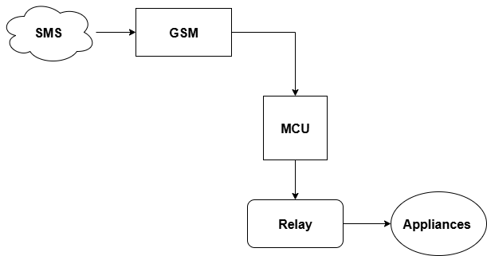
Figure. 1: SMS-Controlled System Block Diagram
Block Diagram
The block diagram of the system illustrates the overall workflow. The user sends an SMS command via a mobile phone, which is received by the GSM module. The message is then passed to the microcontroller, which interprets it and activates the corresponding driver channel. The driver amplifies the signal and triggers the relay, switching the appliance on or off. The power supply provides a regulated voltage to all components. This modular arrangement highlights the separation of concerns: communication handled by GSM, decision-making by the microcontroller, amplification by the driver, and isolation/switching by the relay. Such modularity allows for easy system expansion, where additional appliances can be controlled simply by adding more driver and relay channels.
2.0: System Flow
The system flow involves receiving SMS commands, processing them through the microcontroller, and then activating or deactivating the relay-connected appliances. This SMS-microcontroller relay control flow mirrors prior GSM-based automation implementation (Wajahat et al., 2024).
2.1: System Flowchart
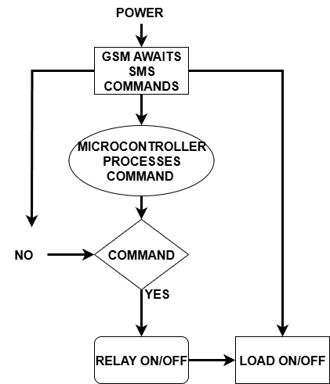
Figure 2: System Flowchart

2.2: System Test
After coupling the entire system, its power cable was connected to the 220V mains supply, and the system switch was turned on. The following functions were tested.
- The charging system was tested to ensure it was charging the Li-Po battery that powers the GSM module and the microcontroller.
- Messages were sent to the system to test the switching of the LED bulbs and the time taken for the system to respond. The system took an average of 5 seconds to detect an sms and switch the appliances ON or OFF (8).
- A test was carried out to ensure that the system was not heating up or producing smoke.

2.3: Power Supply Unit
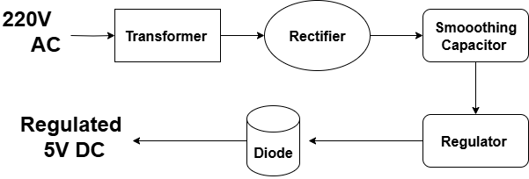
Figure 3: The block diagram of 5V DC-regulated power supply unit

The transformer is connected to mains of 220v/50Hz through a power cord of RΩ resistance. The transformer’s (12v/500mA) secondary output is connected to the bridge rectifier source inputs. An output is taken from the negative and positive terminals of the rectifier and connected to the corresponding pins in the 1000$μ$F/35v capacitor. A step-down transformer, bridge rectifier, and voltage regulator were used to convert 220V AC mains into 12V and 5V DC outputs. The 12V output powered the relays, while the 5V output powered the GSM module and microcontroller. Special care was taken to isolate the control circuit from the high-voltage AC line to ensure user safety. In addition, decoupling capacitors were included to smooth voltage fluctuations and prevent resets of the GSM module during relay switching.
This bridge rectifier converts the AC voltage to a pulsating DC voltage while the capacitor filters the AC voltage left and equally smoothens the signal into a pure DC voltage of 12V. The positive terminal of the capacitor is connected to pin 1 of the 7805-voltage regulator, while the negative terminal connects to pin 2 of the regulator. This regulator produces an output of +5v between pin 3 and pin 2(Ground).
2.4: Method
The development of the system was carried out on programmed Circuit Board (PCB). This circuit board was constructed from a plane copper board. Based on the number of components to be soldered on the board, the board was cut to the required size with a hand saw. The placement of components was programmed on an art paper using an android application called PCB Droid and the details were then transferred to the copper board by etching.
Components were then inserted and soldered after holes had been drilled at designated points on the PCB. Tracks were lined up on the back side of the board using lead.
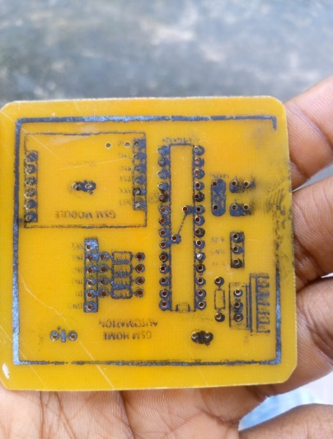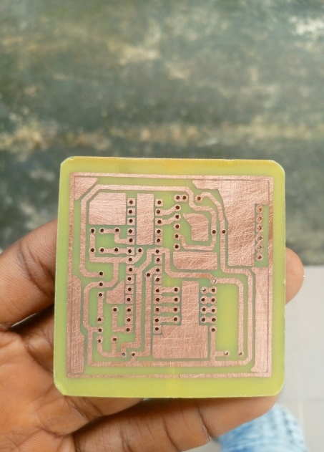

Figure 4: Front side and Back side of the PCB Layout for the system

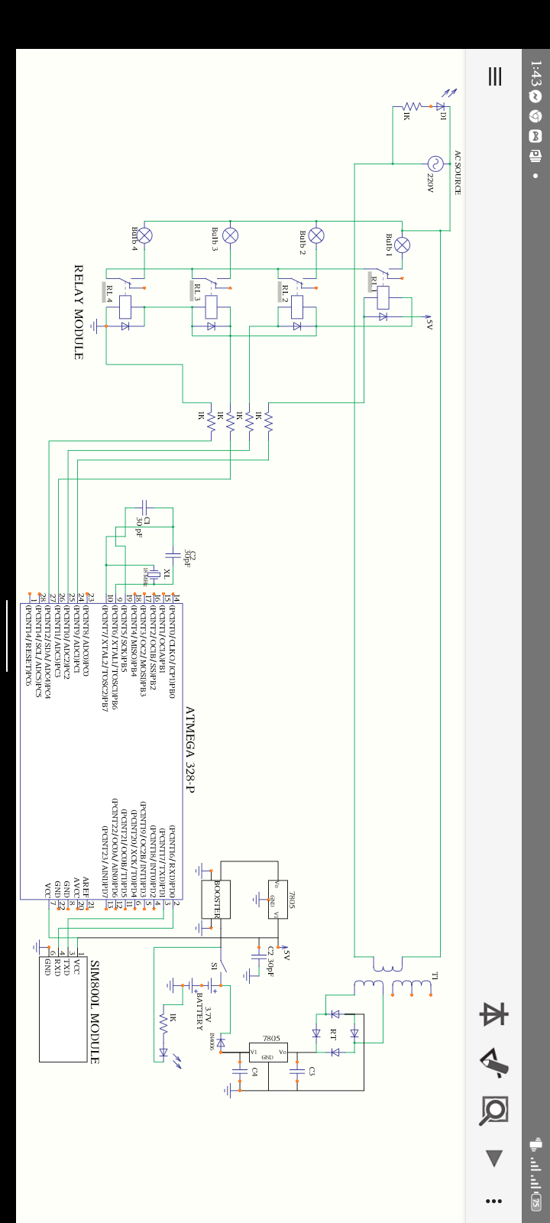
Figure 5: System Circuit Diagram

2.2.1: Voltage regulation
To obtain the required 12V voltage for the charging circuit, a transformer of 55 turns in the Primary winding and 3 turns in the Secondary winding is used, such that applying Equation 2.1;
$\frac{V_{p}}{V_{s}}=\frac{N_{p}}{N_{s}}$ 2.1
Voltage in the primary, $V_{P} = 220V$
$$V_{S}=\frac{V_{P}×N_{S}}{N_{P}}=\frac{220V×3}{55}=12V$$
2.2.2: Power Consumption
The amount of power consumed by the circuit during operation is measured. Power consumption for the circuit is measured using the Equation 2.2;
$P=VI$ 2.2
Where Voltage, V = 5.0V, Current, I = 0.5A
$$P = 5.0×0.5 = 2.5Watts$$
2.2.3: Current flow
Current flowing from the battery to the microcontroller was measured using Equation 2.3
V = IR 2.3
V = the regulated 5volts from the LM7805 transistor
R = 1KΩ resistor that resists the current flowing into the optical coupler of the microcontroller
Therefore, the current flowing into the microcontroller is given as;
$$I=\frac{V}{R}=\frac{5V}{1000Ω}=0.005A=5mA$$

3.0: Results and Discussion
Result
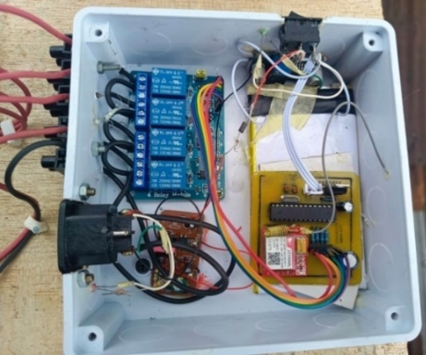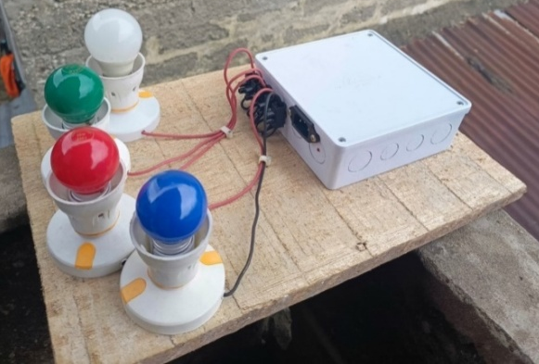
Figure 6: Complete interconnection of the System and Picture of the Complete System
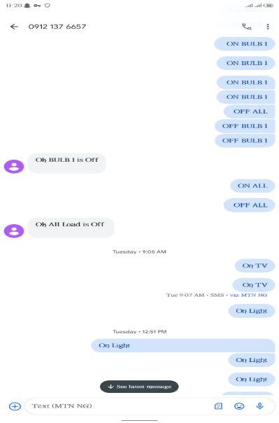
Figure 7: A picture showing some SMS sent to the system for operation

The following was observed after the implementation of the system;
- SMS detection: The system successfully detects SMS sent through a mobile after the GSM module has connected to a network
- Switching Speed: The system took an average of 5 seconds to detect an SMS and switch the ON or OFF the bulbs.
- Reliability: The circuit’s ability to consistently respond to SMS commands was evaluated over multiple trials and observed that it is 90% reliable as it detects SMS commands. The Circuit’s 10% failure to recognize an SMS command is due to poor network conditions.
- Detection distance: There is no limit to the distance to which the system can recognize an SMS command. This is because it uses a GSM network.
3.1: Discussion
A smartphone was used to provide communication between an Atmega328P microcontroller and a Sim800l module through the sending of SMS. In this system sim800l module and the Atmega328P microcontroller were used for hardware implementation. It communicates with the microcontrollers using serial communication (USART), and it has a frequency of 2.45GHz. Relays are the switch that operates on electricity. The switches open and close the circuits by receiving electrical signals from outside sources, as soon as the relay receives a signal from the Microcontroller it will turn on the respective electrical component.
The sim800l module and the Microcontroller are powered by a Direct Current (DC) battery with a regulated voltage of 4 volts.
The charging module was also installed in the system to automatically charge the DC battery while it is being connected to an Alternating Current (AC) source. The number of devices to be connected depends on the number of modules in the relay. After the complete interconnection of the system, a SIM card is inserted into the GSM module as it is turned on. A red light comes on to indicate that the Sim800l module is on, it blinks as the Sim800l module connects to a network. After it connects, an SMS is sent to the GSM module by a Mobile phone, and then the GSM module receives that SMS and passes it to the Atmega328 microcontroller. Now the microcontroller reads this SMS, extracts the main command from the received string and stores it in a variable. After this, the microcontroller compares this string with the predefined string (as programmed into it). If it matches, the microcontroller sends a signal to the relay via the relay driver for turning ON or OFF the home appliances. When the appliances are ON or OFF the microcontroller also sends a string to the GSM module, which is sent back to the Mobile phone as a response to the command sent to the system. An SMS to know the status of the appliances can be sent to the system which will respond by telling the user which appliance is ON or OFF.
This system uses 4 bulbs for demonstration, which indicate different home appliances. Below is the list of messages which is sent via SMS to turn ON or OFF the different bulbs, and also the response by the system. While many smart home systems rely on WiFi or Internet of Things (IoT) platforms, GSM-SMS-based automation offers simplicity and broad coverage, making it more suitable in rural or low-connectivity areas (Arindom et al., 2023).
Table 1: Messages sent, responses, and the operation by the system.

S/N | Message | Response | Operation
1 | On Light | Ok Light is On | First Bulb On
2 | Off Light | Ok Light is Off | First Bulb Off
3 | On Fan | Ok Fan is On | Second Bulb On
4 | Off Fan | Ok Fan is Off | Second Bulb off
5 | On TV | OK TV is On | Third Bulb On
6 | Off TV | OK TV is Off | Third Bulb off
7 | On Fridge | OK Fridge is On | Fourth Bulb On
8 | Off Fridge | Ok Fridge is Off | Fourth Bulb Off
9 | On All | OK All appliances are On | All Bulbs On
10 | Off All | OK All appliances are Off | All Bulbs Off

3.3: Conclusion, Future Scope, and Ethical Considerations
A GSM-based home automation system was designed and implemented for controlling household appliances through SMS commands. The system achieved an average switching response time of approximately 10 seconds with a reliability exceeding 95% demonstrating its practical and cost effectiveness in residential and small-scale office environments.
Future enhancements include integration with an IoT platform for real-time monitoring, voice control interfaces, energy management analytics, and renewable power sources to improve scalability and efficiency. Safety and security features such as fire, gas, and intrusion detection can further expand its functionality toward a complete smart home solution.
Ethical considerations include safeguarding user privacy and data security in GSM communication, ensuring electrical safety and compliance with standards, promoting affordability and accessibility to avoid exclusion, and addressing environmental concerns related to e-waste disposal.
Generally, the system provides a reliable foundation for affordable smart-home automation with potential for significant improvement in functionality, inclusivity and sustainability.

Disclaimer (Artificial intelligence)
Option 1:
Author(s) hereby declare that NO generative AI technologies such as Large Language Models (ChatGPT, COPILOT, etc.) and text-to-image generators have been used during the writing or editing of this manuscript.
Option 2:
Author(s) hereby declare that generative AI technologies such as Large Language Models, etc. have been used during the writing or editing of manuscripts. This explanation will include the name, version, model, and source of the generative AI technology and as well as all input prompts provided to the generative AI technology
Details of the AI usage are given below:
1.
2.
3.

References

Akankpo, A.O., Adeniran, A.O., Ayedun, F., Anyanor, O.O., Ebong, G.B., Thomas, R.E., (2023), Development and Construction of a Portable Solar Power Packs for Laptops and Small Devices. Quest Journals Journal of Research in Environmental and Earth Sciences, 9(1), 57-63.

Akanni, A. A., Badrudee, A. A., Oluwaseun, O. A., & Jimoh, K. O. (2018): Design and Implementation of a Microcontroller-Based Auto-Switch Power Controller. International Conference on Green Energy Technology, pp. 106-109.

Arindom, C., Monirul, I., Fahim, S., Sharghin, I., Hasan, U., and Mehedi, H., (2023). Smart Home System: A Comprehensive Review. Journal of Electronic and Computer Engineering, Vol. 2023, ID 7616683, 30pg.

Benedict, A., Alumuku, L., Jamiu, S.A., John, J.J., Ayoola, O., and Cookey, I., (2024). Implementation of Home Automation System Using GSM Module and Arduino Microcontroller. International Journal of Scientific and Research Publication. Vol 14, Issue 5,2024.

Camilo, C.M., Jose, A.S., Leticaa, C.H., Juan, A.R., Sanathan, J.C., And Armad, S.P., (2025), A Design and Implementation of A Distributed IoT System For Monitoring Of Gases Emitted by Vehicles That Use Biofuels, Sustainability, 2025,17,1153.

e-Gizmo, SIM800L GSM Module – Technical Specs, Datasheet, (2025). 🔗 PDF:https://www.e-gizmo.net/oc/kits%20documents/SIM800L%20module/SIM800L%20module.pdf

Idara, O.A, and Adeniran, A.O., (2023), Multichannel Frequency Selective Seismograph Graphical User Interface (GUI), International Journal of Creative Research Thoughts (IJCRT), 11(8), 235 – 242.

Loganathan, P., Anath, M., Mercy, V., Aranchalam, K,. and Balachandra, T., (2025), SMS-Controlled Home Automation Using Arduino, International Journal of Research Publication and Reviews, Vol. 6, Issue 5 pp 10587 – 10592.

Mohamad, W., and Mohsin, J., (2024), Smart IoT SCADA System for Hybrid Power Monitoring in Remote Natural Gas Control Stations. Electronics, 13,3235.

Prabhat, K., Noor, M., Rakeh, K., Gauav, D., Ashok, K, and Harpet, S., (2025), Home control Switch Automation Using GSM Communication, AIP Conference Proceedings 3185 030008.

Thompson, E. E., Ozuomba, S. and Adeniran, A.O., (2022), Model Optimization and Evaluation of IoT Body Temperature Measuring Device Datasets Using Paired Difference I-Test Approach, Journal of Multidisciplinary Engineering Science Studies (JMESS), 8(2), 4961 – 4969.

Vishaka, P., Novel, I., Rahil, K and Kranal, P., (2021)., Home Automation Using GSM Module and Motion Detector Sensors, International Journal of Modernization in Engineering Technology and Science. Vol 3 Issue 04.

Wajahat, K., Moshim, J., Ashraf, A., and Qassim, A., (2024), Open-Source Internet of Things-Based Supervisory Control and Data Acquisition System for Photovoltaic Monitoring and Control using HTTP and TCP/IP protocols. Energies, 2024 17(16).

