Temperature, Field Protection, and Bioplastic Biopesticide Treatments Shape Mango Postharvest Disease Dynamics: An Integrated Univariate and Multivariate Analysis

.
ABSTRACT

Aims: This study evaluated the effects of storage temperature, field protection, and postharvest treatments on mango disease severity and incidence.
Study Design: A factorial experiment was conducted using three treatments: water (T0), bioplastic (T1), and a bio-bactericide combining bioplastic and essential oils (T2). Two field histories were considered, namely fruits that had been protected in the orchard (B1) and fruits that had not been protected (B2). Storage was carried out at two contrasting temperatures, 8 °C and 30 °C. Disease severity, scored on a 0–9 scale and converted to percentages, and incidence, expressed as the percentage of infected fruits, were monitored weekly from S0 to S8.
Methodology: Lemongrass (Cymbopogon citratus) essential oil was extracted via steam distillation from plant material. Bioplastic matrices were synthesized from native potato starch. The essential oil was subsequently encapsulated within the bioplastic using mechanical agitation followed by extrusion processing to formulate the biopesticide
The data were analyzed using descriptive statistics, factorial ANOVA, and principal component analysis (PCA). Tables and figures were prepared to illustrate temporal dynamics and treatment effects.
Results: At 8 °C, the bio-bactericide (T2) almost completely suppressed disease in B1 and substantially reduced severity and incidence in B2. At 30 °C, T2 delayed symptom onset but did not prevent convergence to high severity and incidence by week 8. The bioplastic film alone (T1) was largely ineffective, showing patterns similar to the water control (T0). PCA separated treatments along PC1, which represented overall disease burden, and PC2, which represented the timing of onset, highlighting the strong influence of temperature and field protection.
Conclusion: Bio-bactericides are highly effective under cool storage, especially when combined with field protection, but under warm conditions they primarily delay disease progression. Cold storage therefore remains indispensable for reliable postharvest control.

Keywords: Mango, postharvest disease, severity, incidence, biopesticides, bioplastic, PCA, integrated management

1. INTRODUCTION

Mango (Mangifera indica L.) is one of the most widely cultivated and commercially traded tropical fruits worldwide, with annual production exceeding 55 million tons 1 (Gidado et al., 2025). Its economic and nutritional value is considerable, but its preservation remains a major challenge due to its climacteric nature and high susceptibility to postharvest diseases, particularly anthracnose caused by Colletotrichum gloeosporioides (Fayera et abdo, 2022). These pathogens, combined with unfavorable storage conditions, lead to postharvest losses estimated between 25% and 40% in many producing countries (Nakahara et al., 2013).

Conventional control methods rely on synthetic fungicides and chemical waxes. While these approaches are effective, they raise growing concerns regarding chemical residues, pathogen resistance, and environmental impact (Nga et Bac, 2021). In this context, natural and sustainable alternatives, such as edible coatings based on biopolymers and the incorporation of essential oils, are emerging as promising solutions. Bioplastics derived from starch, for example, offer a semi-permeable barrier that regulates gas exchange and limits water loss, while essential oils such as citronella (Cymbopogon citratus) have demonstrated antifungal and antibacterial properties (He et al., 2025).

In parallel, integrated field management, including control of fruit flies and bacterial diseases—plays a critical role in reducing the initial inoculum. The effectiveness of postharvest treatments therefore depends strongly on their combination with appropriate cultural practices and optimal storage conditions, particularly refrigeration (Gidado et al., 2025).

The objective of this study is to evaluate the combined effect of field management, bioplastic coatings, and storage conditions on the severity and incidence of postharvest mango diseases.

2. methodology

2.1 Bio-bactericide Production

The essential oil of lemongrass was extracted by steam distillation from plant material collected across five regions of Mali. The yield was evaluated, and the minimum inhibitory concentration (MIC) was determined following the methods described by Aktar et al. (2008) Adhikary et al., 2025; Majewska et al., 2019 ; Mukarram, et al., 2022). Bioplastic was produced from potato starch according to the protocol outlined by Keshav (2016); Singh et al., 2025; Choubey et al., 2023), with the addition of 1% glycerol to impart plastic properties. The essential oil was encapsulated within the bioplastic through agitation and extrusion, then granulated (Worku et al., 2025; Albuquerque et al., 2022).
.
2.2 Experimental design

The experimental setup involved 120 crates of mangoes divided into two main blocks: those treated in the field (TC) and those untreated (NTC). Each block was subjected to three post-harvest treatments—washing with distilled water (T0), coating with bioplastic (T1), and treatment with the formulated bio-bactericide (T2). The crates were stored under two conditions: ambient temperature at 30°C, and cold storage at 8°C. The design followed a randomized complete block structure with ten replicates per treatment.

2.3 Data collection and analysis
Disease assessments were performed weekly from S0 to S8, corresponding to the number of weeks of incubation after treatment.

2.3.1 Data collection
Observations were conducted over an eight-week period, with weekly assessments under each storage temperature condition. The evaluation focused on the number of rotten mangoes and the total surface area of disease spots, following the method described by Lakshmi et al. (2011). Data were initially entered into Excel. Disease incidence and symptom severity were calculated using the following formulas:
% Incidence = (Number of infected fruits / Total number of fruits) × 100
Severity = (Sum of all disease spots) / (Number of fruits × Maximum disease rating) × 100 (Lakshmi et al., 2011).

Disease severity refers to the extent of symptomatic tissue damage caused by a specific pathogen, typically quantified using a standardized ordinal scale based on visual assessment of lesion coverage, fruit decay, and tissue necrosis. In this study, severity was evaluated using a 0–9 scale, where:
- 0 = no visible symptoms
- 1–3 = mild symptoms (≤10% surface affected)
- 4–6 = moderate symptoms (10–50% surface affected)
- 7–9 = severe symptoms (>50% surface affected or extensive rot) (Lakshmi et al., 2011).

2.3.2 Data analysis

The collected data were first tested for homogeneity of variance. Where this assumption was not met, the square root transformation was applied prior to conducting analysis of variance (ANOVA) using SAS software version 9.2 (SAS Institute, 1999). Whenever the calculated F-value was statistically significant, treatment means were compared using Fisher’s protected Least Significant Difference (LSD) test. Factorial ANOVA was applied to test the effects of temperature, treatment, block, and incubation week, as well as their interactions. Principal component analysis (PCA) was performed on standardized severity and incidence values across weeks to capture both overall disease burden and timing of onset. Graphical representations included line plots for temporal dynamics and a biplot for multivariate separation.

3. results and discussion

3.1 Results

3.1.1 Main effects and interactions

The ANOVA results revealed that all main factors treatment, storage temperature, and duration significantly influenced both disease incidence and severity in mangoes (Table 1). The bio-fungicide (T2) consistently reduced symptoms more effectively than the bioplastic alone (T1), especially under cold storage (8 °C). Storage temperature had the strongest individual effect, confirming its critical role in postharvest disease control.

Table 1. Analysis of variance (ANOVA) for disease incidence and severity in mangoes
Sources of variation | Degrees of Freedom | Mean squares
Sources of variation | Degrees of Freedom | Incidence (%) | Severity
Blocks (Field-treated and non-treated ) | 1 | 8.77*** | 2.91***
Storage conditions | 1 | 61.67*** | 7.94***
Blocks* Storage conditions | 1 | 4.80*** | 0.33***
Treatments | 2 | 25.90*** | 17.16***
Blocks*Traitements | 2 | 0.56*** | 2.91***
Treatments*Storage conditions | 2 | 1.39*** | 4.21***
Storage duration | 3 | 14.83*** | 2.52***
Sotorage conditions*Blocks | 3 | 0.044NS | 0.02NS
Storage duration*Sturage conditions | 3 | 0.02NS | 0.11**
Storage conditions*Treatments | 6 | 0.25*** | 0.30***
Blocks*Storage conditions*Storage duration | 3 | 0.53*** | 0.22***
Storage conditions*treatments*Storage duration | 6 | 0.93*** | 0.50***
Significance levels: ***Highly significant at P < 0.0001 **Significant at P < 0.001 NS = Not significant at P > 0.05

Significant interactions between treatment and temperature, as well as between treatment and time, highlight that efficacy depends on both environmental conditions and storage duration. While some interactions (e.g., duration × Blocks (Management of bio aggressors) were not significant, the overall model supports the combined use of bioactive coatings and cold storage as a promising strategy for sustainable mango preservation. Storage at 8 °C consistently reduced disease progression compared to 30 °C.

The boxplot of transformed disease severity (√x) showed that treated mangoes maintained higher selectivity over time, particularly under thermal stress, highlighting the protective role of the bioactive coating (Figure 1). These findings support the combined use of natural antifungal agents and cold storage as a promising strategy for sustainable postharvest disease management.
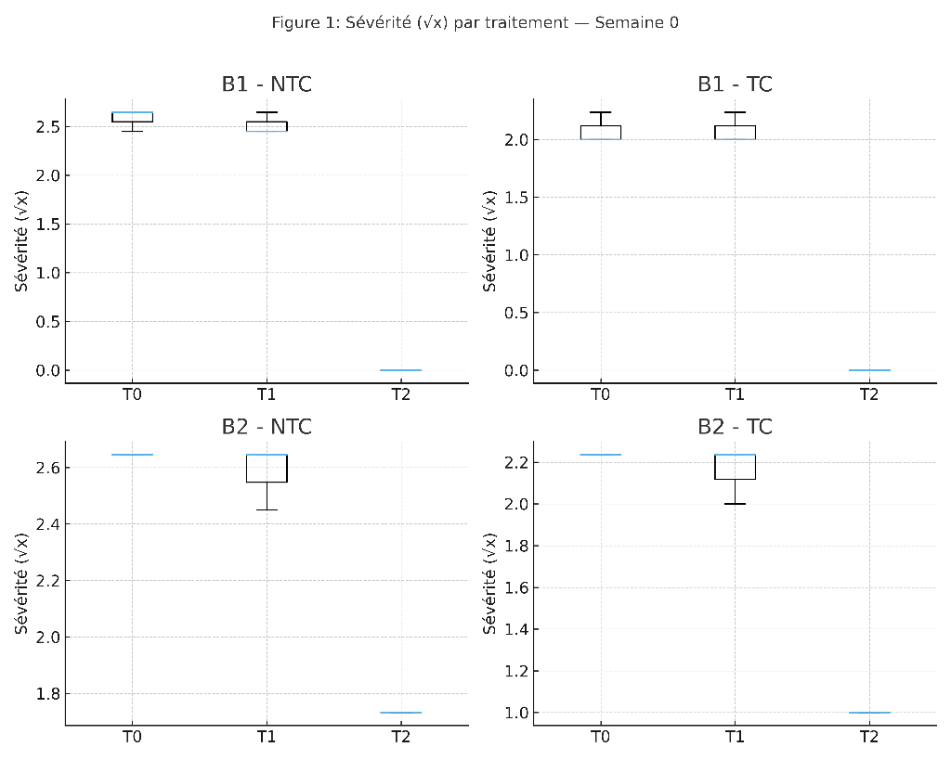
Figure 1: Boxplots of transformed disease severity (√x) in mangoes according to postharvest treatments (T0: water, T1: potato-based bioplastic, T2: bioplastic + lemongrass essential oil), separated by storage block (B1: 8 °C; B2: 30 °C) and field management (Field treated mangoes (TC) vs Field non-treated mangoes (NTC)), at each conservation week. Boxes represent interquartile ranges, the line indicates the median, and dots show outliers.

3.1.2 Temporal Evolution of Disease Severity and Incidence

The progression of postharvest disease symptoms over time revealed clear and consistent differences between treatments. Across the eight-week storage period (Figure 2, Figure 3), T0 (water) led to a rapid and sustained increase in both severity and incidence. Symptoms intensified early, reaching a plateau by week 6, indicating that untreated mangoes are highly susceptible to pathogen development under ambient conditions. T1 (bioplastic alone) showed intermediate behavior. Initially similar to T0, its curve began to flatten around week 4, suggesting a partial delay in symptom progression. However, the absence of antimicrobial properties limited its effectiveness, and severity remained relatively high by week 8. In contrast, T2 (bioplastic + citronella essential oil) maintained near-zero levels of severity and incidence throughout most of the storage period. The divergence from T0 and T1 became evident from week 3 onward, with T2 showing a delayed onset and significantly reduced symptom expression. This sustained suppression highlights the dual protective effect of T2, combining physical barrier and biochemical inhibition.

Together, these results demonstrate that T2 is the most effective postharvest treatment, particularly when integrated with cold storage and field management. Its ability to simultaneously limit infection and symptom development positions it as a promising strategy for reducing postharvest losses in mango production.

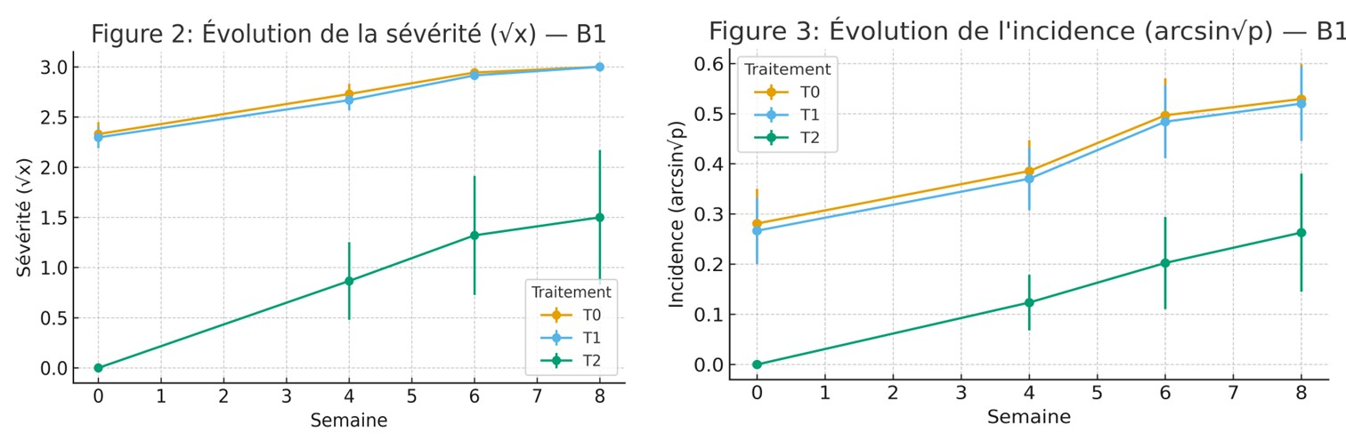
Figure 3. Temporal evolution (mean ± standard error) of transformed disease incidence (arcsin√p) in mangoes according to postharvest treatments, shown separately for B1 (8 °C) and B2 (30 °C).
Figure 2. Temporal evolution (mean ± standard error) of transformed disease severity (√x) in mangoes according to postharvest treatments, shown separately for B1 (8 °C) and B2 (30 °C).l

3.1.3 Effect of Postharvest Treatments on Disease Severity and Incidence in Stored Mangoes

Tukey’s tests (p < 0.05) confirmed that T2 differed significantly from T0 and T1 in most cases (Table 2), with larger gaps observed at weeks 6 and 8.

Table 2. Effect of Postharvest Treatments on Disease Severity and Incidence in Stored Mangoes
Treatments | Impact on mango diseases in storage
Treatments | Severity (%) | Incidence (%)
Water (T0) | 7.33ª | 20.10ª
Bioplastic (T1) | 7.65ª | 20.15ª
Biopesticide (T2) | 3.38^{b} | 08.90^{b}

Results demonstrate that disease severity in mangoes was reduced by 12.8% with the bioplastic treatment (T1) and by 44.4% with the bio-fungicide (T2), compared to the water treated control (Table 2). A similar trend was observed for disease incidence, which dropped by 4.7% and 43.2% with T1 and T2, respectively. These findings highlight the superior performance of the bio-fungicide, especially under challenging postharvest conditions, and underscore its potential as a sustainable alternative to conventional treatments.

3.1.4 Relationship Between Incidence and Severity

Figure 4 presents the relationship between disease incidence (arcsin√p) and severity (√x) in postharvest mangoes (r_s > 0.8), analyzed separately for each storage condition

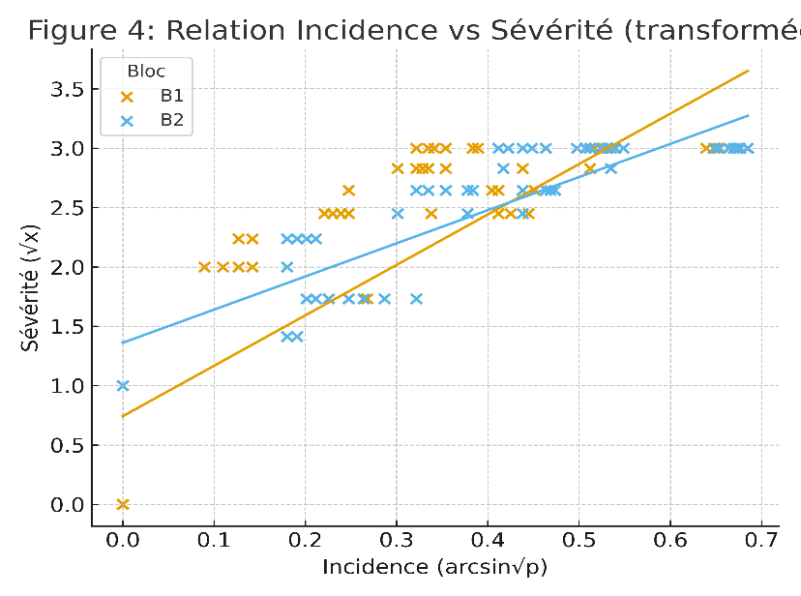
Figure 4. Relationship between disease incidence (arcsin√p) and severity (√x) in mangoes, with fitted regression lines for each storage block. Orange crosses and line represent Block B1 (8 °C); blue crosses and line represent Block B2 (30 °C).

Disease severity and incidence were strongly correlated (r_s > 0.8). The fitted regression lines reveal distinct epidemiological dynamics between the two temperature regimes. In Block B1 (8 °C), the moderate slope of the regression line indicates a restrained increase in severity as incidence rises. This pattern suggests that cold storage not only reduces the frequency of infection but also limits symptom intensity, reflecting the suppressive effect of low temperature on pathogen development. Conversely, Block B2 (30 °C) exhibits a steeper slope and greater data dispersion, indicative of a more aggressive disease trajectory. Under warm conditions, even slight increases in incidence are associated with sharp rises in severity, pointing to a more virulent expression of symptoms. This thermal amplification aligns with previous findings on the role of temperature in accelerating respiration, senescence, and fungal proliferation (Gidado et al., 2025).

These results confirm that storage temperature is a key determinant of postharvest disease dynamics. Cold storage stabilizes the incidence–severity relationship, while warm conditions exacerbate disease expression. This distinction reinforces the importance of integrated management strategies that combine field practices, surface treatments, and optimal storage conditions.

3.1.5 Multivariate Patterns of Disease Progression

Principal component analysis (PCA) further captured the complex interplay between storage conditions, field management, and postharvest treatments (Figure 5). The first two components explained 94.7% of the total variance, with PC1 alone accounting for 85.0%, indicating a dominant axis of disease pressure across treatments.

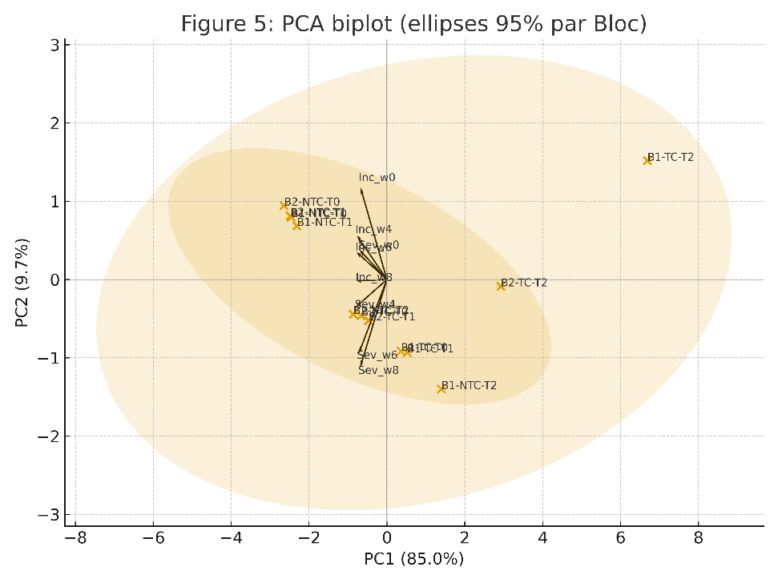
Figure 5. Principal component analysis (PCA) biplot illustrating postharvest disease dynamics in mangoes. Vectors represent severity and incidence, with treatment combinations plotted across PC1 (85.0%) and PC2 (9.7%). B2+NTC+T0 clusters in the upper right quadrant, indicating high disease pressure, while B1+TC+T2 clusters near the origin, reflecting low severity and incidence.

The untreated combination (B2+NTC+T0) clustered distinctly in the upper right quadrant, aligned with vectors for severity and incidence. This positioning reflects high disease burden and early symptom onset, confirming that warm storage without field protection or antimicrobial coating leads to rapid and widespread infection. In contrast, the integrated strategy (B1+TC+T2) occupied the lower left quadrant, near the origin, where disease vectors exert minimal influence. This cluster represents mangoes stored at 8 °C, treated with citronella-infused bioplastic, and supported by field management, a combination that consistently suppressed both incidence and severity. Intermediate treatments such as B1+TC+T1 and B2+NTC+T2 fell between these extremes, bending inward toward the center of the biplot. Their trajectories suggest partial mitigation, either through temperature or coating, but lacking the full synergy observed in the triple-integrated approach.

The orientation of vectors, radiating outward for disease metrics and inward for protective treatments, reinforces the continuum of postharvest outcomes. PCA not only distinguished treatment efficacy but also revealed how timing, storage, and surface protection converge to shape disease dynamics.

4. DISCUSSION

Our results clearly demonstrate that temperature is the dominant factor shaping mango postharvest disease dynamics, with cold storage (8 °C) consistently reducing both incidence and severity compared to ambient storage (30 °C). This finding aligns with recent reports emphasizing the central role of low-temperature storage in slowing fruit respiration, delaying senescence, and suppressing pathogen development (Gidado et al., 2024). Cold storage has long been recognized as indispensable for tropical fruit preservation, but our data highlight how its benefits are amplified when combined with field protection and bioactive coatings.

The superior performance of the bioplastic enriched with citronella essential oil (T2) under cold storage conditions underscores the synergistic effect of combining physical barriers with antimicrobial compounds. Essential oils such as citronella, lemongrass, and thyme have been widely documented for their antifungal activity against Colletotrichum gloeosporioides and other postharvest pathogens (Dadbin et al., 2025; Dhall, 2013). However, their efficacy is often temperature-dependent. At 30 °C, T2 delayed symptom onset but ultimately failed to prevent disease progression, echoing findings in citrus and apple where essential oils lose stability and antimicrobial potency under warm conditions (Gómez-Contreras et al., 2021; Dikaram et al., 2002). This suggests that while essential oils are promising, their volatility and degradation at higher temperatures limit their standalone effectiveness.

By contrast, the bioplastic alone (T1) was largely ineffective, confirming that physical coatings without antimicrobial activity cannot provide sufficient protection. Similar conclusions have been drawn in other fruit systems, where starch- or chitosan-based films without bioactive additives offered only marginal benefits (Krishnan et al., 2025). This reinforces the view that edible coatings must be functionalized with antifungal agents to achieve meaningful disease suppression.

Field protection (B1) also emerged as a critical factor, consistently improving outcomes across treatments. This finding resonates with the broader literature on integrated pest and disease management, which emphasizes that postharvest interventions are most effective when combined with orchard-level practices that reduce initial inoculum (Droby et al., 2009; Bautista-Baños et al., 2013). Recent studies in mango and papaya confirm that integrating preharvest sanitation, biological control, and postharvest coatings yields superior results compared to single interventions (Lawal et al., 2025; Tenea et al., 2025).

The multivariate analysis (PCA) provided further insight into these interactions, separating treatment combinations along two axes: overall disease burden (PC1) and timing of onset (PC2). The clustering of B1+TC+T2 near the origin, contrasted with B2+NTC+T0 in the upper right quadrant, illustrates the continuum of outcomes from integrated to neglected management. This pattern mirrors recent multivariate studies in strawberries and citrus, where PCA effectively distinguished protective strategies from high-risk scenarios (Tenea et al., 2025; Lui et al., 2025). Such analyses underscore the value of multivariate tools in capturing the complexity of postharvest disease dynamics.

Taken together, our findings reinforce three key messages. First, cold storage remains indispensable for reliable postharvest control of mango diseases. Second, bioactive coatings enriched with essential oils can substantially enhance protection, but their efficacy is strongly temperature-dependent. Third, integration across the value chain, from field protection to storage, is essential, as no single intervention is sufficient on its own. These insights are consistent with the growing consensus that sustainable postharvest management requires a systems approach, embedding natural antimicrobials within broader quality management frameworks (Combrink et al., 1994; Ferdousi et al. 2024; Feyera et al., 2022).

4. Conclusion

This study demonstrates that the combination of field management (TC), bioplastic coating enriched with citronella essential oil (T2), and cold storage at 8 °C constitutes a highly effective strategy for reducing postharvest mango decay. These findings reinforce the growing interest in natural and sustainable alternatives to synthetic fungicides, while highlighting the need for an integrated approach.
From a practical standpoint, the results offer concrete opportunities to improve the mango value chain in tropical regions, where postharvest losses remain a major barrier to competitiveness.

DISCLAIMER (Artificial intelligence)

Author(s) hereby declare that NO generative AI technologies such as Large Language Models (ChatGPT, COPILOT, etc.) and text-to-image generators have been used during the writing or editing of this manuscript.

References

- Gidado, M.J., Ahmad Anas Nagoor Gunny, A.A.N., Gopinath, S.C.B., Adam, T., Mohamed Mydin M. Abdul Kader, M.M.M., Oyeniyi, O.A. (2025). The Effects of Storage Conditions on Postharvest Physiology of Fruits. Proceedings of the 4th International Conference on Biomass Utilization and Sustainable Energy; ICoBiomasSE; 2–3 September; Penang, Malaysia (pp.425-439)
https://www.researchgate.net/publication/392908013

- Feyera, M., Abdo, T. (2022). Post Harvest Treatments and Shelf Life of Some Tropical Fruit. Journal of Advances in Biology & Biotechnology, 25 (9), pp.48-55. ⟨hal-05196665⟩

- Nakahara K, Alzoreky NS, Yoshihashi T, Nguyen HT, Trakoontivakorn G. (2013). Chemical composition and antifungal activity of essential oil from Cymbopogon nardus (citronella grass). Japan Agricultural Research Quarterly: JARQ; 37(4):249-52. DOI: 10.6090/jarq.37.249.

- Nga, N., Bac, N. (2021). Effects of Chitosan-Plant Extract Coatings on the Postharvest Quality of Mango Fruits (Mangifera indica) with Anthracnose Disease. Vietnam Journal of Agricultural Sciences, 4(4), 1293–1302. https://doi.org/10.31817/vjas.2021.4.4.08

- Lili, He, Yun, Z., Min, Y., Jun-jie, Z, Li-hong, T.,Yun-ha, Y., Li-ming, F., Fa-wu, S., Qi-bin, C. Antifungal Activity of Cymbopogon Citratus Essential Oils from Different Habitats Against Botrytis Cinerea. Available at SSRN: https://ssrn.com/abstract=4074553 or http://dx.doi.org/10.2139/ssrn.4074553

- Aktar, M. S., Degaga, B., & Azam, M. S. (2008). Antimicrobial activity of essential oils extracted from medicinal plants. Journal of Microbiology and Antimicrobials, 1(3), 28–34. t http://www.journalissues.org/IBSPR/

- Adhikary, K., Barman, S., Banerjee, P., Mondal, P., Dam, B., Misra, A., Mandal, N. C., Mukherjee, D., Bandyopadhyay, B., & Maiti, R. (2025). Characterization and antimicrobial activity of essential oils extracted from lemongrass (Cymbopogon flexuosus) using microwave-assisted hydro distillation. Zeitschrift für Naturforschung C, 80(5–6), 201–211. https://doi.org/10.1515/znc-2024-0095

- Majewska, E., Mariola Koz owska, Eliza Gruczy ska-S kowska, Dorota Kowalska, Katarzyna Tarnowska (2019). Lemongrass (Cymbopogon citratus) Essential Oil: Extraction, Composition, Bioactivity and Uses for Food Preservation : A Review, Pol. J. Food Nutr. Sci., 69(4): 327-341 DOI: 10.31883/pjfns/113152 http://journal.pan.olsztyn.pl

- Mukarram, M., Choudhary, S., Khan, M. A., Poltronieri, P., Khan, M. M. A., Ali, J., Kurjak, D., & Shahid, M. (2022). Lemongrass essential oil components with antimicrobial and anticancer activities. Antioxidants, 11(1), 20. https://doi.org/10.3390/antiox11010020

- Keshav, S. (2016). Production of bioplastics. University of Mauritius Faculty of Engineering Department of Chemical Engineering Chemical and Environmental Engineering, Dissertation thesis 87 p.

- Singh, D. A. K. ., Sharma, P., Shrivastav, M., Chaudhary, R., Chauhan, P., Sanskriti, & Banerjee, A. (2025). PRODUCTION OF BIODEGRADABLE PLASTIC FILM FROM POTATO AND SAGO STARCH. Journal of Microbiology, Biotechnology and Food Sciences, 14(4), e11143. https://doi.org/10.55251/jmbfs.11143

- Choubey, V., Smriti, A., Fatma, E., Rajak, S. K., & Suman, R. (2023). Production of bio-plastic from potato starch. The Pharma Innovation Journal, 12(11), 1312–1316. https://www.thepharmajournal.com/archives/2023/vol12issue11/PartP/12-10-270-891.pdf

- Worku, B. M., Shibeshi, N. T., Zhiyuan, T., Cho, J.-Y., & Eun, J.-B. (2025). Encapsulated essential oils in protein–polysaccharide biopolymers: Characteristics and applications in the biomedical and food industries. Food Science and Biotechnology, 34, 851–869. https://doi.org/10.1007/s10068-024-01724-8
- Albuquerque, P. M., Azevedo, S. G., Andrade, C. P., D’Ambros, N. C. S., Pérez, M. T. M., & Manzato, L. (2022). Biotechnological applications of nanoencapsulated essential oils: A review. Polymers, 14(24), 5495. https://doi.org/10.3390/polym14245495

- Lakshmi, B. K. M., Reddy P. N., Prasad R. O. (2011). Cross-infection Potential of Colletotrichum gloeosporioides Penz. Isolates Causing Anthracnose in Subtropical Fruit Crops. Tropical Agricultural Research, 22(2): 183-193. https://tar.sljol.info/articles/2827/files/submission/proof/2827-1-9858-1-10-20110221.pdf

- SAS, Institute Inc 1990. SAS procedure guide version 6 edition. SAS Institute Inc, Car, NC, 705 pp.

- Dadbin M, Soltanpour M, Khodaie L, Islambulchilar M. Chemical composition, antimicrobial, antioxidant, and toxicity of essential oils as food preservatives . J Res Pharm. 2025; 29(4): 1379-1418. https://doi.org/10.12991/jrespharm.1653671

- Dhall RK. Advances in edible coatings for fresh fruits and vegetables: a review (2013). Crit Rev Food Sci Nutr. 53(5):435-50. doi: 10.1080/10408398.2010.541568. PMID: 23391012.

- Gómez-Contreras, P.; Figueroa-Lopez, K.J.; Hernández-Fernández, J.; Cortés Rodríguez, M.; Ortega-Toro, R. (2021)Effect of Different Essential Oils on the Properties of Edible Coatings Based on Yam (Dioscorea rotundata L.) Starch and Its Application in Strawberry (Fragaria vesca L.) Preservation. Appl. Sci. 2021, 11, 11057. https://doi.org/ 10.3390/app112211057

- Dikaram NKB, Joyce DC, Terry LA. (2002). Biocontrol activity and induced resistance as a possible mode of action for Aureobasidium pullulans against grey mould of strawberry fruit. Australas. Plant Pathol. 31:223–29 https://doi.org/10.1146/annurev-phyto-021722-035135

- Krishnan, R. R., Olasupo, A. D., Patel, K. H., et al. (2025). Edible biopolymers with functional additives coatings for postharvest quality preservation in horticultural crops: A review. Frontiers in Sustainable Food Systems, 9, 1569458. https://doi.org/10.3389/fsufs.2025.1569458

- Droby, S., Michael Wisniewski ^{b}, Dumitru Macarisin (2009). Twenty years of postharvest biocontrol research: Is it time for a new paradigm? Postharvest Biology and Technology 52(2): 137-145 https://doi.org/10.1016/j.postharvbio.2008.11.009

- Bautista-Baños, Silvia, Sivakumar, Dharini, Bello-Pérez, Arturo, Villanueva, Ramón Hernández-López, Mónica (2013). A review of the management alternatives for controlling fungi on papaya fruit during the postharvest supply chain. Crop Protection 49:8–20 DOI:10.1016/j.cropro.2013.02.011

- Lawal, H., Gaddafi, M. S., Jamiu, A. M., et al. (2025). Biocontrol and nanotechnology strategies for postharvest disease management in fruits and vegetables: A comprehensive review. Foods, 14(16), 2782. https://doi.org/10.3390/foods14162782

- Tenea, G. N., Reyes, P., & Flores, C. (2025). Crosslinking bacterial postbiotics for microbial and quality control of strawberries postharvest: PCA and metagenomic evidence. Frontiers in Microbiology, 16, 1570312. https://doi.org/10.3389/fmicb.2025.1570312

- Liu, S., Yuling Cai, Ying Lou, Yan Zhao, Mingfeng Cao, Ping Li, Qing Gu (2025). Understanding citrus aroma: Changes induced by postharvest treatments of fresh fruit. Postharvest Biology and Technology Volume 224, 113491 https://doi.org/10.1016/j.postharvbio.2025.113491

- Combrink, J.C., Benic, L.M., Lotz, E., Truter, A.B. (1994). Integrated management of postharvest fruit quality . Acta Hortic. 368, 657-666 DOI: 10.17660/ActaHortic. https://doi.org/10.17660/ActaHortic.1994.368.78

- Ferdousi, J., Hossain, I., Saha, S.R., Rob, M., Afroz, T., Pramanick, S., Islam, R., Nath, D.D. (2024). Posthavest physiology of fruit and vegetables and their management technology: A review . The Journal of Animal and Plant Sciences 34(2):2024 DOI:10.36899/JAPS.2024.2.0717

