Original Research Article
Food Security Implications of Traditional Maize Storage Methods: A Case Study of Market Traders in the Volta Region, Ghana

ABSTRACT

Maize storage is important for ensuring food security in Sub-Saharan African countries, due to changes in seasonal production and the risk of crop failure. In Ghana, market traders and farmers store maize in traditional structures, such as silos, granaries, sacks or bags, baskets, and cribs made from locally available materials. The choice of storage methods impacts the quantity and quality of maize. Despite the importance of storage, post-harvest losses remain a challenge, limiting maize availability. We argue that increasing maize production alone is insufficient to ensure food availability. Storage is important for improving food security. However, there is limited empirical evidence on the contributions of existing storage methods in reducing post-harvest losses. This study examines the food security implications of traditional maize storage methods among traders in Ho municipality of Ghana’s Volta Region. A structured questionnaire was randomly administered to 138 maize traders in March 2024. The questions focused on the storage methods, duration, moisture content, maize quality and quantity, sales frequency, and storage and transportation losses. The study is rooted in the indigenous knowledge systems theory, the post-harvest loss theory, and the food security framework to explain the food security implications of the traditional maize storage methods. We found that respondents (84%) bagged maize and packed it on pallets in wooden rooms, while 81% did so in concrete rooms. Despite bagging, maize remained susceptible to post-harvest losses, highlighting the need for improved storage technologies. Due to a lack of moisture meters, 71% of respondents stored maize at 14.1% to 15.0% moisture content, resulting in a limited shelf life of approximately 15 weeks. All traders reported insect infestations during storage, with 62% using phosphine gas (Phostoxin) for fumigation. Traders showed good interest in improving storage practices to reduce post-harvest losses. For this interest, gender education and capacity building were key for their decision-making. These findings emphasize the need to develop and implement policies, adopt improved storage technologies, and strengthen capacity-building programs to reduce post-harvest losses and enhance regional food security.

Keywords: Traditional storage methods; maize; food security; market traders; Ghana

JEL codes of classification: Q10, Q13, Q17, Q18, O13.

1. INTRODUCTION

Past studies demonstrate that maize storage is important for food security in Sub-Saharan African countries, including Ghana (Mutiga et al., 2019). Changes in seasonal production of maize and the risk of crop failure necessitate effective storage to ensure food security (Mlambo et al., 2017). Farmers and traders have developed various storage structures using locally available materials (Manandhar et al., 2018). Common storage options include mud silos, granaries, sacks or bags, baskets, and cribs. Other storage methods include underground pits, wooden or mud silos, or simply using rooms or sheds (Abdulai & Abdulai, 2023). In Ghana, traders sometimes rent small community warehouses, empty homes, or individual rooms in rural areas as collection points. They sometimes use centralized urban warehouses during harvest seasons. Sun-drying, storage in woven baskets, and the use of organic pest repellents were storage practices passed down and used across generations. The choice of storage method depends on the market conditions, the produce handling procedures, and the storage duration (Mangnus & Van Westen, 2018).
Indigenous knowledge systems (IKS) theory emphasizes the significance of traditionally established, adaptive knowledge acquired through years of learning and interaction with the local environment (Alessa et al., 2016; Kom & Nethengwe, 2024). In Ghana, traditional storage methods remain the dominant means of preserving maize among market traders (Adams et al., 2024). Although historically and culturally significant, traditional storage methods demonstrate different levels of effectiveness in spoilage prevention. Irrespective of the choice of storage method, the post-harvest loss (PHL) theory asserts that the preservation of grain quality relies on dryness, cold temperatures, protection from pests and rodents, among others (Nath et al., 2024). PHL are commonly ascribed to pest infestations, high moisture content, and inadequate aeration. PHL management is important for effective maize storage, whether on farms, in markets, or in warehouses (Dijkink et al., 2022). Therefore, ignoring it might lead to maize shortages and reduced economic returns for traders.
Past studies indicate that effective maize storage methods enhance food system resilience within the food security framework (FSF), particularly regarding the pillars of availability and stability (Haji & Himpel, 2024). Storage ensures that maize remains accessible across time and space, even during lean periods (Kirui et al., 2025). Before market liberalization in Ghana, maize traders stored grain for only short periods before delivering it to the state-run marketing board. However, in recent years, liberalization has introduced more dynamic and uncertain market conditions, compelling traders to adopt more flexible and strategic storage methods (Alawode & Chiamaka, 2024). Maize traders now adjust their decisions based on real-time demand, selling immediately when buyers are available and storing maize when market opportunities are limited (Kiriinya, 2024). Sometimes, maize is intentionally stored for months in anticipation of price increases, highlighting the critical role of storage in stabilizing maize supply and buffering seasonal fluctuations. A concrete example is in China, where Luo et al. (2022) documented the “scientific grain storage project,” a government initiative that improved household storage conditions, reduced maize losses by 60%, saved 33 kg per household, and lowered the storage loss rate from 2.85% to 0.87%.
Maize production alone does not guarantee food availability, as post-harvest losses remain a major challenge. Studies indicate that poor storage facilities account for 15% to 70% of annual maize losses, largely due to pests and unfavorable storage conditions (Boullouz et al., 2022). Improved storage is therefore critical for enhancing food security. However, access to conventional storage technologies remains limited among traders. While indigenous knowledge and traditional storage methods offer alternatives, their effectiveness is not well understood. Moreover, the storage practices of maize traders in the selected markets have not been adequately documented, and few theoretical studies link traditional storage methods to food security outcomes. Traditional storage methods are increasingly recognized for their potential to strengthen food security, justifying further investigation. This study examines the food security implications of traditional maize storage methods among traders in the Ho Municipality of Ghana’s Volta Region. The findings are expected to provide relevant insights for market actors, guide policy and interventions aimed at improving maize storage. The study will contribute to the broader literature on IKS, PHL, and FSF, enriching theoretical discussions on the role of maize storage in strengthening food security.
2. LITERATURE REVIEW

2.1 Theoretical review

2.2 Indigenous Knowledge Systems (IKS) Theory
The IKS theory emphasizes local, community-derived knowledge that has evolved over generations within particular cultural and ecological settings (Mehdipour et al., 2025). It is a cumulative body of knowledge, practice, and belief passed down orally, rooted in cultural traditions, and adapted to local ecological conditions (Nwankwo, 2025). The theory recognizes the significance of traditional post-harvest techniques and food preservation technologies in agricultural fields.
In the context of traditional maize storage, IKS is evident in practices such as sun-drying maize to reduce moisture content and using neem leaves (Azadirachta indica A. Juss.) or ash to control pests. Communities also build granaries, earthen silos, and clay pots that suit local climate conditions. These storage structures and or methods, refined over generations by communities such as those in the Ho Municipality of Ghana, demonstrate the contribution of IKS to historical food preservation and resilience in food systems (Figure 1).

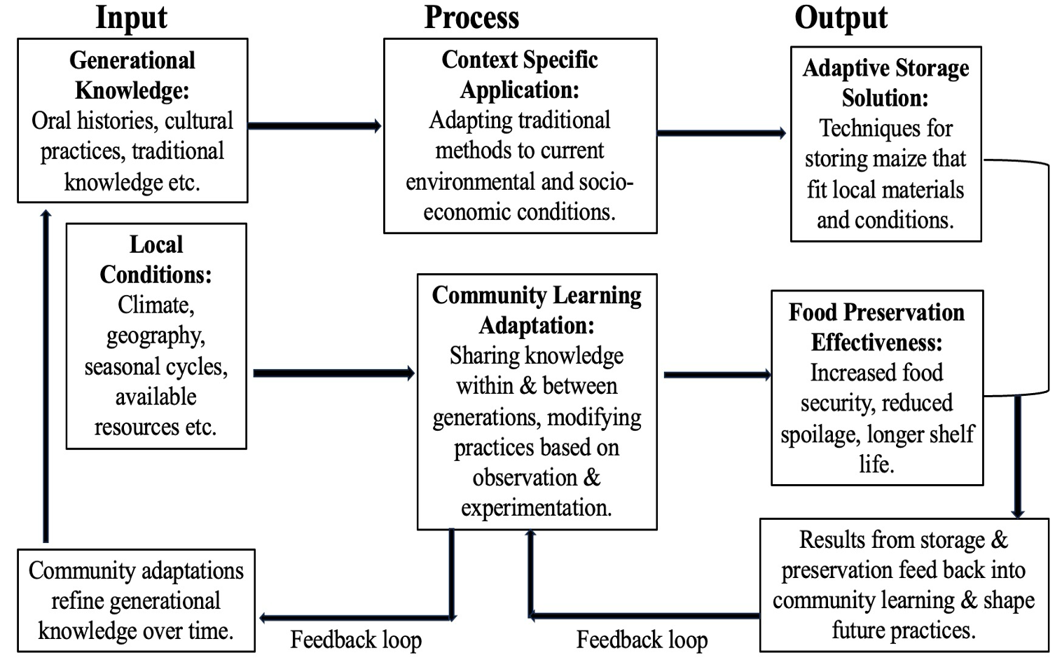

Fig. 1. Indigenous Knowledge Systems Theory Framework

Past studies document various indigenous post-harvest protection measures, such as biological repellents and structural storage techniques practiced by farmers to manage storage pests sustainably (Abebe, 2023). In Nigeria, farmers continue to hang maize over fires or store maize in earthen pots, cribs, and rhombuses to extend shelf life (Sugh et al., 2020). Therefore, IKS theory supports our study by recognizing these historic traditional methods as valid, adaptive systems that can enhance food security, rather than old-fashioned approaches to be discarded.
The general indigenous knowledge systems theoretical equation is illustrated below:

$$\begin{aligned}\text{Effectiveness of IKS}=f\left(TK×LA×CP×EC\right)\#(1)\end{aligned}$$
Where:
Traditional knowledge (TK) = Accumulated generational wisdom.
Local adaptation (LC) = Degree of context-specific modification.
Community practice (CP) = Level of community implementation.
Environmental context (EC) = Suitability to local conditions.

Therefore, the indigenous knowledge systems application equation for maize storage is expressed as:

$$\begin{aligned}{\text{Storage success of IKS}}_{\text{success}}=α_{1}SD+α_{2}NPC+α_{3}TS+α_{4}CK+ ε \#(2)\end{aligned}$$
Where:
IKS_{success} = Success of Indigenous knowledge systems.
Sun drying (SD) = Moisture content reduction effectiveness.
Natural pest control (NPC) = Use of neem leaves/ash effectiveness.
Traditional structures (TS) = Quality of silos, jute sacks, polywoven bags etc.
Community knowledge (CK) = Level of traditional knowledge application.
α₁, α₂, α₃, α₄ = Effectiveness coefficients.
ε = Error term.

2.3 Post-Harvest Loss (PHL) Theory and Food Security Framework (FSF)
Post-harvest loss (PHL) theory focuses on the processes or the post-harvest chain stages and factors affecting agricultural produce after harvesting (Kader, 2005). The African Post-Harvest Loss Information System (APHLIS) indicated that grain loss occurs from harvesting, transportation to household, handling, drying, threshing/shelling, winnowing, farm storage, transportation to the market, market storage, processing, and marketing among others, till the grain reaches the final consumer (APHLIS, 2017). However, maize loss in storage has received a lot of attention (Olorunfemi & Kayode, 2021). Inadequate infrastructure and poor storage technologies significantly reduced maize availability (Tadesse, 2020). Insects, rodents, termites, pests, birds, and high moisture content caused storage losses (Kitaba & Kuma, 2024). Among storage pests, weevils and large grain borers are the most destructive (Abebe & Dako, 2024), and account for nearly 25% of storage losses (Adarkwah et al., 2022). Maize stored at high moisture content is subject to mold and fungal growth, as well as the risk of mycotoxin and aflatoxin contamination (Penagos-Tabares et al., 2025).
Recent studies highlight the effectiveness of hermetic storage and other post-harvest technologies in reducing maize losses and improving food security. In Tanzania, hermetic storage increased stored maize quantities by 40% and reduced household food insecurity by 43% (Zacharia et al., 2024), while in Rwanda, adoption of hermetic storage boosted farmer incomes by alleviating storage losses (Baidhe et al., 2024). Similarly, Lakshmi et al. (2020) found that mechanized shellers, airtight storage, and drying tarpaulins significantly reduced storage losses. In contrast, poor post-harvest practices often lead to mold, pest infestation, and spoilage, lowering the quantity and quality of maize available for household consumption and markets (Figure 2). Ovharhe et al. (2021) emphasizes that low-cost, locally adaptable storage technologies can substantially reduce PHL, and frameworks often recommend interventions such as affordable cooling or drying to extend shelf life. However, despite their practical value, PHL theories have been critiqued for prioritizing technical solutions while under-representing local knowledge and contexts. Therefore, integrating PHL theory with IKS offers a more holistic approach, balancing technical efficiency with socio-cultural and environmental relevance.
The general PHL equation is represented as:
$$\begin{aligned}\text{Total Loss}=\sum_{i}{\left(LS_{i}⋅LR_{i}\right)}\#(3)\end{aligned}$$
Where:
Loss stage, $i$ = Different stages (storage, handling, transport, processing).
Loss rate, $i$ = Loss percentage at each stage.
Total loss = Sum of losses at each stage (LS) multiplied by the loss rate (LR) at that stage.
Therefore, the storage-specific PHL equation is expressed as:

$$\begin{aligned}Storage loss, SL=γ_{1}ML+γ_{2}PD+γ_{3}PhD+γ_{4}QD+υ\#(4)\end{aligned}$$
Where:
Moisture loss (ML) = Weight loss due to drying/moisture changes.
Pest damage (PD) = Losses from insects, rodents, and birds.
Physical damage (PhD) = Mechanical damage during storage.
Quality degradation (QD) = Nutritional/aesthetic quality decline.
γ₁, γ₂, γ₃, γ₄ = Loss impact coefficients.
υ = Random error term.

The PHL prevention equation is expressed as:
$$\begin{aligned}Loss reduction, LR=δ_{1}TMSM+δ_{2}MT+δ_{3}HA+ω \#(5)\end{aligned}$$
Where:
TMSM = Traditional maize storage methods.
MT = Traditional methods.
HA = Hybrid approaches.
ω = Error term.

The Food and Agriculture Organization (FAO) defines food security through availability, access, utilization, and stability (Amir & Khan, 2024). Building on this framework, hermetic technologies and other storage innovations have been shown to significantly reduce losses, thereby enhancing food stability and access (Oyewole et al., 2025). The food security framework (FSF) provides a useful lens for understanding how traditional storage methods impact maize availability for trade and consumer access through more reliable market supplies. It emphasizes the safety and quality of stored maize, which ensures stability in maintaining stocks over time, especially during off-season periods. Our study is therefore grounded in these FSF pillars, linking storage practices directly to the availability, accessibility, and stability of maize in local and regional markets (Figure 2). Accordingly, the food security implications are defined using the following:
Availability: The physical presence of maize.
Access: Market traders and consumers affording or obtaining maize.
Utilization: Safe and nutritious maize consumption.
Stability: A consistent maize supply over time.
The concept grew to include individual and household access to food, alongside the quality and nutritional value of that food. This evolution led to the 1996 World Food Summit’s definition, which emphasizes physical and economic access to adequate, safe, and nutritious food for an active and healthy life (Hendriks & Babu, 2024; World Bank Group, 2024). In general, the food security equation is represented as:
Food security = f(Availability × Access × Utilization × Stability) (6)

Therefore, the detailed food security equation is expressed as:

$$\begin{aligned}Food security index, FSI=β_{1}A+β_{2}Ac+β_{3}U+β_{4}S+μ\#(7)\end{aligned}$$
Where:
Availability (A) = Physical presence of maize (quantity stored successfully).
Access (Ac) = Physical access by traders and consumers.
Utilization (U) = Safety and nutritional quality of stored maize for consumption.
Stability (S) = Consistency of supply over time.
β₁, β₂, β₃, and β₄ = Impact coefficients for each dimension.
μ = Error term.

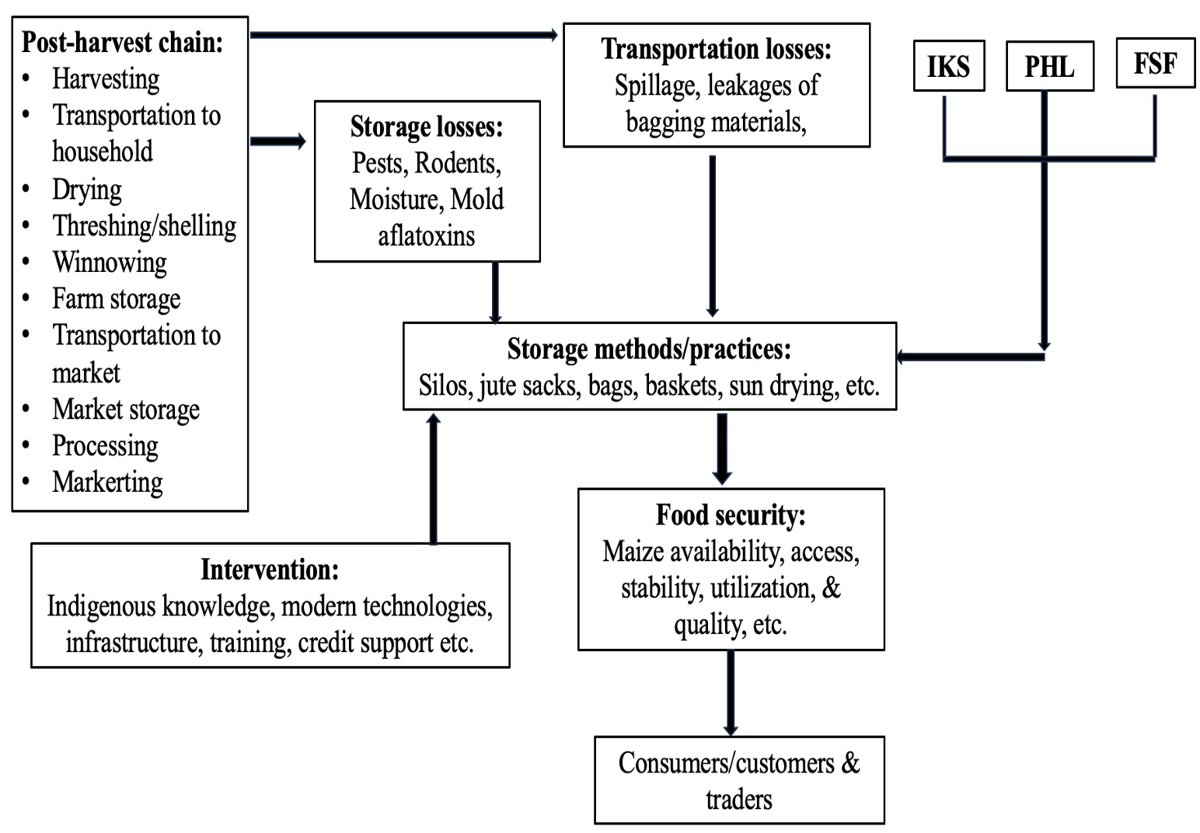

Fig. 2. Post-Harvest Grain (Maize) Losses and Food Security Framework

3. METHODOLOGY

3.1 Study Area

The study was conducted in Ho Municipality, situated in the Volta Region of Ghana (Figure 3). Ho serves as the capital city of the Volta Region. According to Ghana Districts (n.d.), the municipality lies between Latitudes 6° 20' N and 6° 55' N and Longitudes 0° 12' E and 0° 53' E. The Ho municipality is bordered to the south by the Adaklu and Agortime-Ziope Districts, to the north and west by the Ho West District, and to the east by the Republic of Togo. It has a total land area of 2,361 square kilometers, constituting 11.5% of the region’s entire land area. It has a population of about 180,420, constituting 10.9% of the region’s total population. Approximately 115,261, or 68.6% of the 168,019 municipal households, are engaged in agriculture (Ghana Statistical Service, 2021).

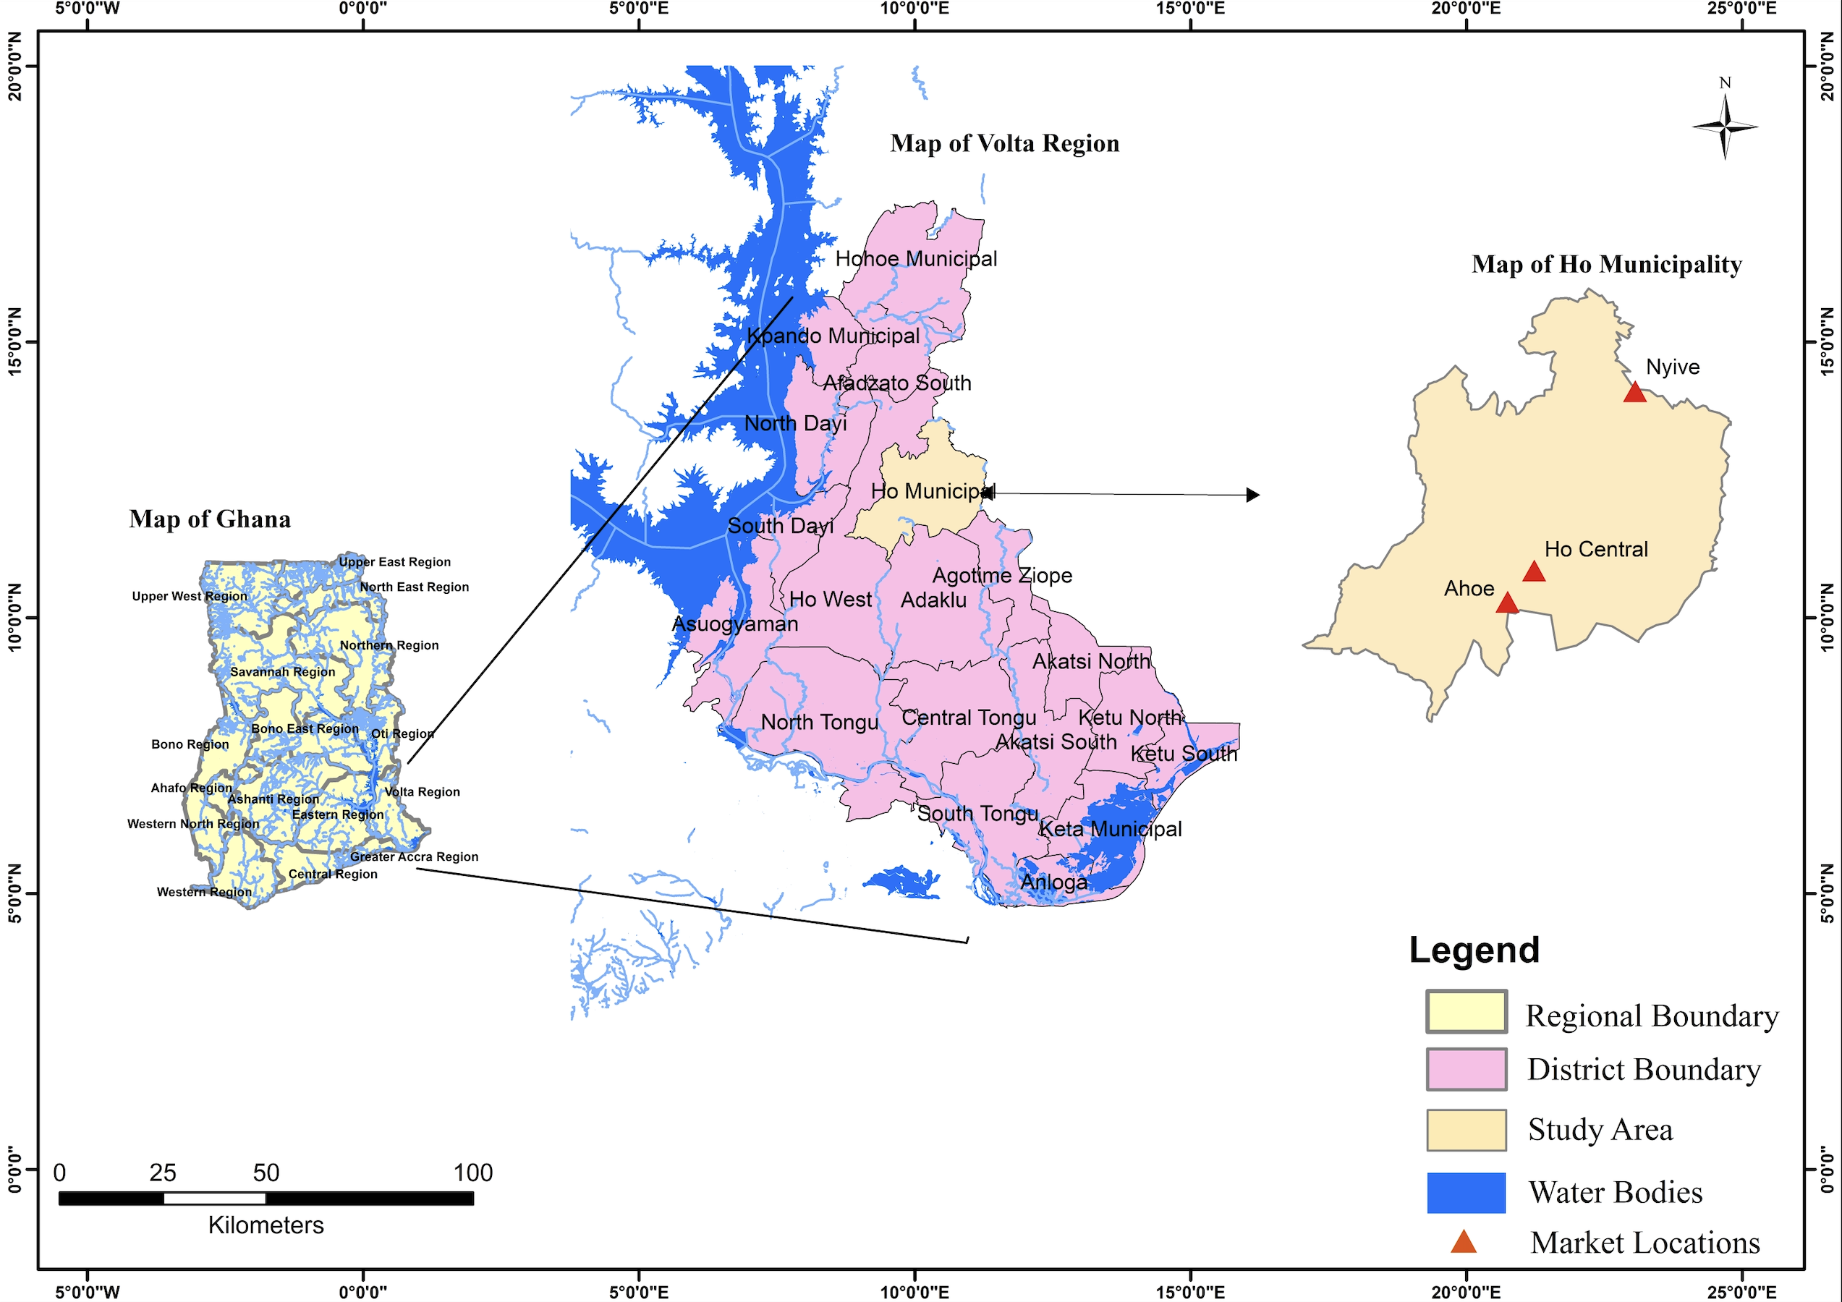
Fig. 3. Study Area Map
The climate supports agricultural production, with monthly temperatures ranging from 22°C to 32°C and annual extremes between 16.5°C and 37.8°C. The region experiences two rainy seasons: the major season from March to June, peaking at 192 mm in June, and the minor season from July to November, with a low of 20.1 mm in November. Annual rainfall varies from 20.1 mm to 192 mm, fostering maize cultivation (GSS, 2020).
Farmers, traders, dealers, cooperative societies, and government agencies such as the Ghana Food Distribution Corporation and the Grains Development Board undertake storage of maize. Maize farmers usually double as traders and store maize at the home level in indigenous structures such as bamboo baskets, mud structures, jute sacks, and bags (Ankrah et al., 2023). The containers are made with a variety of locally available materials and differ in design, shape, size, and function. The materials include paddy straw, wood, bamboo, and mud bricks, among others. These materials are user-friendly and are associated with scientific reasoning that dates back to the very earliest periods of known history. There is evidence of ash, sand, and herbs used in ancient civilizations, which have been credited with mystical power for increasing storage life (Babu & Rampal, 2024).
Maize traders shell and store maize in sealed facilities with appropriate pesticide treatment. All harvested maize is initially sun-dried on the farm and then stored either on the farm or at home. Sometimes, maize is partially dried in the field through delayed harvesting or by stacking cobs on platforms. However, this initial drying is usually insufficient for long-term storage, prompting traders to use drying platforms for further drying. Some traders also pay to have their maize dried with mechanical dryers owned by private individuals or the Ministry of Food and Agriculture.
Traders source maize from their own farms, middlemen, retailers, and pre-harvest agreements with farmers, often supplying industrial processors, schools, and other institutions. They also buy and store maize in anticipation of higher prices. However, poor drying and storage practices expose maize to pests such as rodents and weevils, leading to PHL. To reduce these risks, traders clean, dry, bag, fumigate, and tightly seal maize before storage, typically stacking 50–150 kg poly-woven bags on pallets in warehouses to protect against damage.
3.2 Data Collection and Analysis
In February 2024, a preliminary survey was conducted among maize traders in local street markets to observe storage practices and gather relevant information. Most traders were also maize farmers, and storage methods were largely non-mechanized. Some transported and sold maize across nearby districts such as Adaklu, Agortime-Ziope, Ho West, and even to Togo. Based on these observations, Ho Central/Ho Asigame, Ahoe, and Nyive markets were purposively selected for the study. Using a KoboToolbox questionnaire, data was collected in March 2024 from 138 randomly sampled traders, with support from trained enumerators. To validate findings, interviews were also conducted with the Municipal Directorate of Agriculture, opinion leaders, and market queens. All respondents gave informed consent and were assured of anonymity and confidentiality.
The questionnaire was divided into two sections. The first section discussed the socio-demographic characteristics of respondents, including age, gender, education, and duration of maize trade. The second section focused on pertinent problems that market traders faced with maize storage methods. A Likert scale and multiple-choice response questions were presented to traders to ascertain their storage methods, storage duration, moisture content, and sales frequency. Storage and transportation losses were also verified.
The data was coded and analyzed with Microsoft Excel and Statistical Package for Social Scientists (SPSS) to produce tables and charts for descriptive statistics (frequencies and percentages). Past studies have employed the IKS theory, PHL theory, and the FSF to examine the role of indigenous knowledge in innovative agricultural production systems. Additionally, these studies analyzed how farmers integrate these practices to enhance food security within agri-food systems (Kom et al., 2024; Magocha et al., 2019). Similarly, our study employs the IKS theory, PHL theory, and the FSF to explain how traditional maize storage methods impact food security among maize traders in Ho Municipality of Ghana.
The GSS emphasizes maize production and its role in national food security (Abdulai et al., 2017). Maize cultivation constitutes part of a mixed farming system rather than a specialized commercial venture. Maize trading is subject to seasonal changes, complicating the establishment of a consistent number of traders at any specific moment. Therefore, there is no clear publicly accessible estimate for the total number of maize traders or data that categorizes dealers by crop in the Ho Municipality. Consequently, we utilized 115,261, or 68.6%, of the 168,019 municipal household population to determine our sample size, employing the Yamane formula, as illustrated below for the study.

$$\begin{aligned}n=\frac{N}{1+Ne^{2}}\#(8)\end{aligned}$$
Where:
$n$ represents the required sample size.
$N$ is the total population size (115,261).
$e$ is the desired margin of error (8.5%).

Therefore,
$$n=\frac{115,261}{1+115,261×{\left(0.085\right)}^{2}}=\frac{115,261}{1+833.5827}=\frac{115,261}{834.5827}≈138.1≈138$$

4. RESULTS AND DISCUSSION

4.1 Socio-demographic characteristics of the respondents

Table 1 represents the socio-demographic characteristics of the respondents. The results showed that 69% of the respondents were in the age groups of 31-40 and 41-50 years, with an average age of 41 years. This result means that respondents are in their productive age and might recognize more the risks associated with post-harvest losses. This result highlights the need for targeting this age group with training and resources for improved storage, which might reduce post-harvest loss and food insecurity. Ngowi and Selejio (2019) determined that in Tanzania, empowering elderly farmers with training and resources improved maize storage practices and reduced post-harvest losses.
With regard to gender distribution, the findings indicated that about 72% were female. This finding means that females were involved more in managing and operating maize enterprises. They might be operating as wives or daughters of male business owners, suggesting a power imbalance or a lack of ownership. This might restrict women’s decision-making power. Moreover, a proportion of the women independently owned and operated maize trading enterprises, highlighting the need to recognize and empower women as key actors in the maize trade. Feliu and Lansberg (2022) determined that in Nepal, asset ownership affected women’s decision-making capacity.
In terms of education, the results indicated that respondents (51%) had primary and secondary education. It means that maize traders were literate and could read and write. They might help disseminate new technologies, keep records, and adopt improved storage practices. However, about half (47%) of the respondents had no formal education. This indicates high illiteracy level among traders. It implies that these traders cannot read and write, highlighting the need for gender-sensitive training on storage methods and technologies. Yadav et al. (2021) identified that in Lao-Vietnamese border, education helped traders to navigate complex logistics and market dynamics.
About 52% of the respondents had been in the maize trade for nearly 20 years. This suggests that maize traders might have substantial experience with storage methods, seasonal market trends, pest control and post-harvest losses. This accumulated knowledge might position traders as valuable actors in improving maize storage practices and market dynamics. Saars et al. (2024) found that long-term engagement in maize trade improved traders’ understanding of market dynamics and storage techniques.

Table 1. Socio-demographic characteristics of respondents
Variable | Category | Frequency | Percentage %
Age (years) | 20-30 | 17 | 12
Age (years) | 31-40 | 67 | 49
Age (years) | 41-50 | 28 | 20
Age (years) | 51-60 | 21 | 15
Age (years) | Above 60 | 5 | 4
Gender | Female | 99 | 72
Gender | Male | 39 | 28
Educational Level | No formal | 65 | 47
Educational Level | Primary/Basic | 51 | 37
Educational Level | Secondary | 19 | 14
Educational Level | Tertiary | 3 | 2
Trade Duration (years) | < 5 years | 8 | 6
Trade Duration (years) | 5-10 | 37 | 27
Trade Duration (years) | 11-20 | 71 | 52
Trade Duration (years) | Above 20 years | 21 | 15

4.2 Respondents’ Storage Structures and Bagging Materials
The results showed that respondents (65%) stored maize more in sacks and bags (Table 2). About 57% of them stored maize in polywoven bags. Another 32% used jute sacks to store maize. About 30% stored maize in baskets. This implies that maize traders might have seen these structures as efficient and readily available to obtain. This finding reflects traders’ reliance on indigenous knowledge, highlighting the need for modern storage infrastructure support.
Table 2. Respondents’ storage structures and bagging materials

Variable |  | Category | Frequency | Percentage %
Type of storage structures | Sacks/bags |  | 89 | 65
Type of storage structures | Baskets |  | 41 | 30
Type of storage structures | Roof storage |  | - | -
Type of storage structures | Jerri can |  | 8 | 6
Type of storage structures | Wooden/mud Silos |  | - | -
Type of storage structures | Cribs |  | - | -
Bagging Materials | Jute sacks |  | 44 | 32
Bagging Materials | Polywoven bags |  | 79 | 57
Bagging Materials | Hermetic bags |  | 15 | 11

4.3 Respondents’ Quantity of Maize Obtained for Storage and Sales
To ascertain how much maize traders usually secured for their trade, we asked the respondents about the quantity of maize that they often obtain for storage and onward sales. The results indicated that 52% of the respondents obtained about 40 bags of maize for storage and onward sales (Table 3). This suggests that maize traders lacked the storage capacity to handle quantities beyond this threshold. Additionally, limited financial resources might have constrained respondents’ ability to purchase and store more maize for future sales. These limitations point to a need for access to credit and improved storage infrastructure. Mekonnen et al. (2024) found that building traders’ capacity and finances contributed to resilient food systems and long-term food security.
Table 3. Respondents’ quantity of maize obtained for storage and sales

Variable | Category | Frequency | Percentage %
Number of Bags | < 40 | 71 | 52
Number of Bags | 40-99 | 39 | 28
Number of Bags | 100-199 | 21 | 15
Number of Bags | 200-300 | 7 | 5
Number of Bags | Above 300 | - | -

4.4 Traditional Maize Storage Methods Used Among Traders
To establish the storage methods that traders use, we asked the respondents about their storage methods by providing the following options for them to choose: (1) I bag maize and pack it on pallets in wooden rooms at the market center; (2) I bag maize, pack it on pallets under shade, and cover it at the market center with tarpaulin; (3) I bag maize and pack it on pallets in concrete rooms at the market center; (4) I treat maize before bagging and packing on pallets for storage; (5) I dry maize before bagging and packing on pallets for storage. Considering these storage methods, the respondents were asked to make applicable choices (Likert-scale questions), where 1 indicates strong disagreement and 5 being strong agreement.
The results indicated that respondents (84%) agreed and strongly agreed that they bagged maize and packed it on pallets in wooden rooms at the market centers (Figure 4). It means that traders might have recognized the risk of contamination and possible PHL in storage. This finding suggests the need for improving pest management practices among traders to ensure food safety. This finding aligns with the PHL theory. Cheruiyot et al. (2024) found that training maize traders in Meru County of Kenya on effective pest management strategies, such as regular inspection for signs of pests, improved food safety.
Another 81% of the respondents agreed to have bagged maize and packed it on pallets in concrete rooms. It means that traders were willing to invest in proper storage facilities to maintain the quality of maize. They might have recognized that the use of pallets and concrete rooms could improve efficiency in the storage process. In line with the PHL theory, maize traders used this method to keep grains cool and reduce the risk of spoilage and contamination. This result agrees with the findings of Akowuah et al. (2015), who found that storing maize in concrete rooms helped maintain a stable, cooler temperature, thereby reducing the incidence of fungi.
Respondents (57%) agreed that they dried maize before bagging and packing it on pallets for storage. It means that traders were willing to adopt improved storage methods to protect maize quality. They recognized that drying reduces moisture content, prevents mold growth and maintains maize quality. Bakhtavar et al. (2019), in Faisalabad, Pakistan, found that adequate drying of maize reduced moisture content and the risk of spoilage and contamination.
About 60% of traders did not treat maize with chemicals before storage. This might leave maize vulnerable to insect infestations and mold, compromising quality and safety. This highlights the need for proper treatment methods, such as fumigation or the use of insect-resistant bags. Similarly, Ngowi and Selejio (2019) found that educating farmers in Tanzania on chemical treatment improved maize quality and reduced PHL.
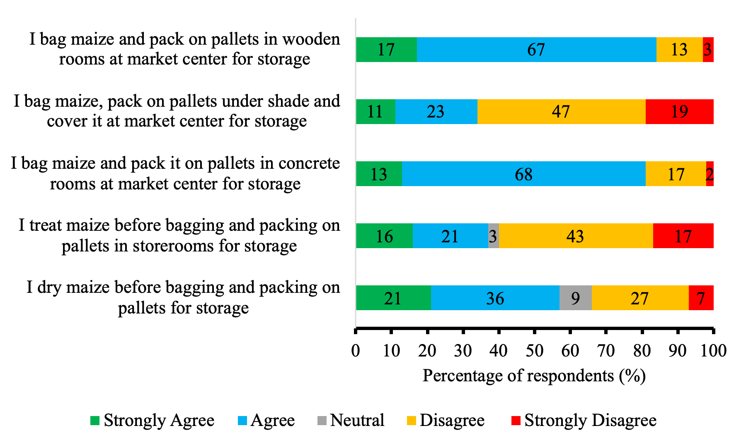
Fig. 4. Maize Storage Methods

4.5 Duration of Maize in Storage and Sales Frequency
To clarify storage duration, we asked the respondents about the duration of maize in their store(s). We provided the following options for them to choose from: (1) less than 1 week; (2) 1-4 weeks; (3) 5-10 weeks; (4) 11-15 weeks; (5) 16-20 weeks; and (6) above 20 weeks.
We found that respondents (63%) kept maize in storage for nearly 15 weeks (Table 4). It means that traders might face maize shortage due to the short shelf life. However, proper storage conditions could extend shelf life, preserve maize quality, and availability. Traders could keep maize in storage for a longer period with adequate storage support. This might stabilize maize supply and minimize the risks of mold growth, insect infestations, and quality loss. This finding corroborates with the results of Walker et al. (2018), who found that extended storage time had positive and negative effects on maize quality.
We further asked the respondents to indicate how often they sell out stored maize. Again, we offered the following options for them to choose from: less than 1 week, 2-3 weeks, 4-6 weeks, 7-9 weeks, and above 9 weeks.

We found that respondents (50%) took about six weeks to sell all the stored maize (Table 4). Others (18%) reported that it takes even longer, with some (11%) stating that it could take up to eleven weeks or more to sell all their stored maize. This discrepancy in selling times might be due to market demand, pricing fluctuations, and individual sales strategies employed. Despite the varying selling times, we argued that selling stored maize might be a time-consuming process that requires patience and persistence. This finding highlights the need for ready markets. This result corresponds with Marson (2022), who emphasized the importance of market access and consumer demand in influencing storage turnover and income flow for traders.

Table 4. Respondents’ maize duration in storage and sales frequency

Variable | Category | Frequency | Percentage %
Maize Storage Duration (Weeks) | < 1 Week | 9 | 7
Maize Storage Duration (Weeks) | 1-4 | 24 | 17
Maize Storage Duration (Weeks) | 5-10 | 28 | 20
Maize Storage Duration (Weeks) | 11-15 | 59 | 43
Maize Storage Duration (Weeks) | 16-20 | 18 | 13
Frequency of Sale of Maize | < 1 Week | 17 | 12
Frequency of Sale of Maize | 2-3 | 23 | 17
Frequency of Sale of Maize | 4-6 | 69 | 50
Frequency of Sale of Maize | 7-9 | 18 | 13
Frequency of Sale of Maize | Above 9 | 11 | 8

4.6 Moisture Content of Maize
We tried to clarify the moisture content at which traders store maize by asking the respondents a multiple-choice response question: At what moisture level do you store your maize? We provided the following options for them to choose from: (1) Less than 13.0%, (2) 13.0-14.0%, (3) 14.1-15.0%, (4) 15.1-16.0% (5) Above 16.0%.
About 71% stored maize at a 14.1-15.0% moisture level (Figure 5). Others (44%) sometimes stored maize at 15.1-16.0% moisture levels. It means that these traders might not have had moisture meters readily available to ensure that maize was dried to the optimum moisture content level of 13-14%. Our interview revealed that traders relied on the practice of cracking open some of the grains with their teeth to observe the moisture level, highlighting indigenous knowledge.
However, about 23% of traders stored maize at the optimum moisture level of 13.0-14.0%. This finding shows that traders might have owned and used moisture meters and mechanical dryers. It is possible that these traders might have employed the services of the regional department of food and agriculture and other private owners for drying maize with mechanical dryers and checking the moisture level at a fee. This suggests that maize stored at optimum moisture level may remain viable in storage, with minimal occurrences of mold development and caking, aligning with the findings of Zheng et al. (2024).

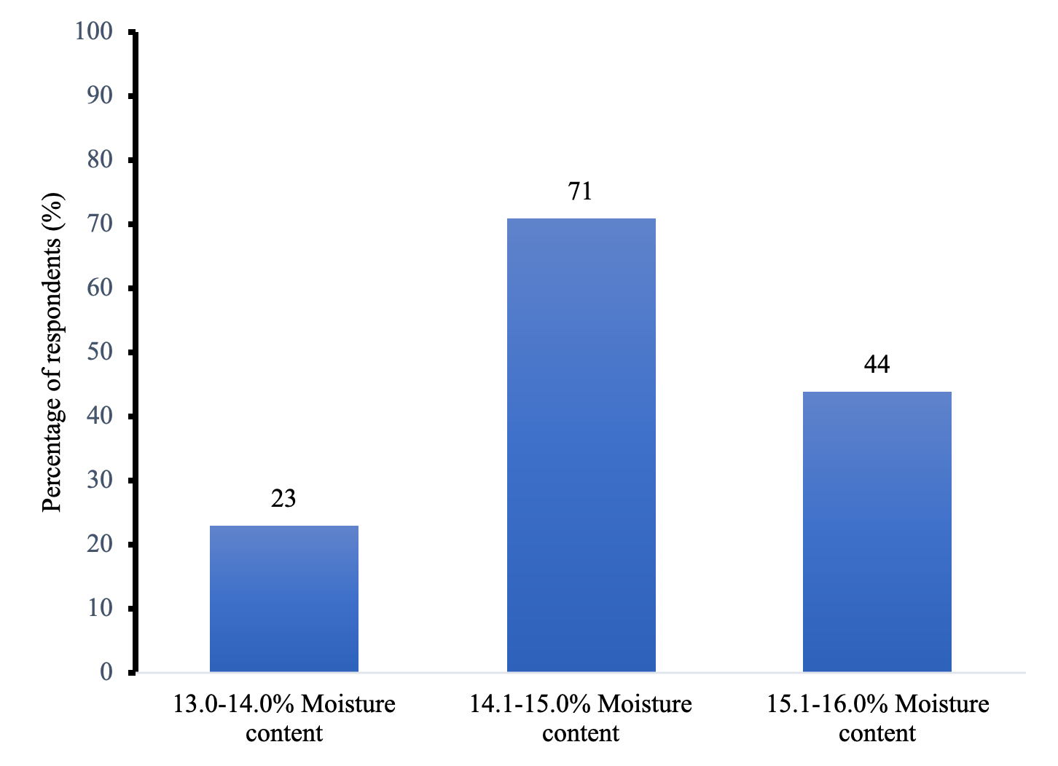

Fig. 5. Moisture Content at Which Traders Stored Maize

4.7 Chemical Treatment of Maize Among Traders
Our survey further attempted to understand if maize traders treated maize with chemicals before storage. We then asked the respondent the question, “Do you treat your maize before storage?” We presented a yes or no response for them to choose from. The results indicated that respondents (63%) did not treat maize with chemicals before storage (Figure 6). It means that traders might experience severe losses in store in case a few weevils find their way into the storage structures. Even a small initial infestation could escalate rapidly during storage, leading to post-harvest losses. This finding aligns with the PHL theory. This result agrees with the findings of Yimer (2022) in Ethiopia, which highlights the need for extension support in training maize traders on good chemical treatment procedures.

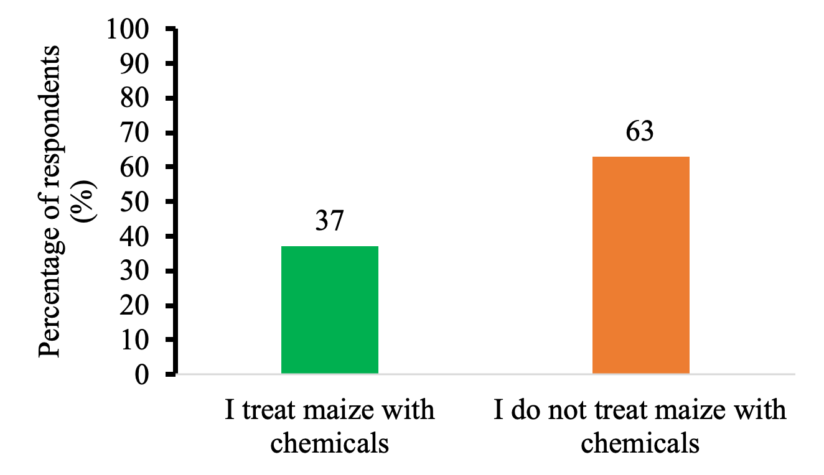

Fig. 6. Traders’ Treatment of Maize Before Storage

For those respondents who treated maize before storage, 21% used phosphine gas from phostoxin (Figure 7). About 9% used Actellic, while 5% treated maize with Aflasafe. Only 2% treated maize with Propikil. None of the respondents used Magtoxin, suggesting a lack of familiarity or preference for this particular fumigant among traders. It means that traders relied more on phosphine gas in protecting maize from pests during the storage phase. This finding implies that phosphine gas (marketed as Phostoxin) is an effective fumigant and is relatively easy for traders to handle and use with minimal complications.

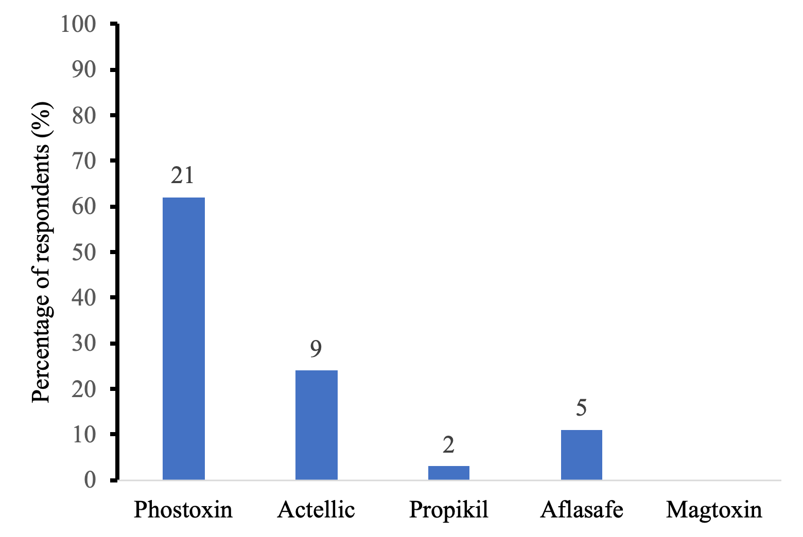

Fig. 7. Types of chemical treatment of maize

4.8 Maize Traders’ Storage and Transportation Losses
Our survey tried to clarify maize traders’ losses incurred in storage. We asked the respondents a multiple-choice question: What causes maize loss in your store? The following options were provided for them to choose from: (1) Insect infestation of grains; (2) Rodents invading grains; (3) Germination of grains; (4) Decolorization of grains; (5) Mold formation in grains; (6) Caking of grains.
All the respondents reported insect infestation (weevils and grain borers) in storage (Figure 8). It means that the storage methods used by traders had some inefficiencies. Despite traders’ efforts to use chemical treatments and fumigation, pest infestations continued to persist. This highlights the need for improved storage methods and pest management strategies to protect maize and ensure food security. Chattha et al. (2016) found that insects penetrated bags and severely damaged grains, resulting in significant post-harvest loss.
Regarding rodents, about 72% experienced rodents’ attacks in storage. It means that storage structures and bagging materials were inadequately secured and sanitation practices were poor to prevent rodents. This implies that rodents might damage equipment and infrastructure. They might destroy stored maize, cause contamination, and create financial losses, highlighting the need for effective pest control. Esther et al. (2022) found that regular inspections and proper sanitation practices prevented and mitigated rodent infestations in storage.
Respondents (47%) reported mold formation and germination losses in storage. This means that traders might have had issues with poor storage conditions and inadequate ventilation. The presence of mold implies a decrease in maize quality and market value. This might pose health risks if contaminated maize is consumed, highlighting the need for ventilation, investment in proper storage facilities, and regular monitoring of storage conditions. This might ensure that maize remains viable and available for sale, aligning with the food security framework. Kortei et al. (2022) found that aflatoxin levels in maize often exceeded safe limits, posing a high health risk.
About 39% reported decolorization of maize grains in storage, while 37% said grains sometimes cake in storage. This finding means that storage conditions might have been compromised by traders. It implies that discoloration and caking might impact the quality and marketability of maize. These issues might not only affect consumer perception but might also cause financial loss for traders. Lakshmi et al. (2020) determined that inadequate drying and poor storage conditions contributed to maize decolorization and caking.

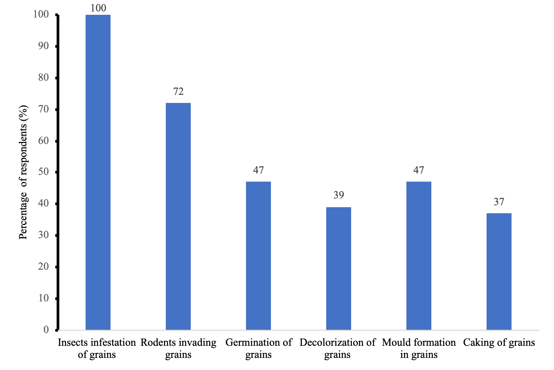
Fig. 8. Losses Encountered During Storage

With regard to transportation losses, we asked the respondents a multiple-choice question of what accounts for their maize loss during transportation. We offered the following options for them to choose from: (1) maize grains sometimes spill on the floor; (2) leakages from bags; (3) damages/breakages from storage materials; (4) rainfall sometimes soaks maize.
Respondents (57%) attributed grain loss to leakages from bags, while 46% blamed damages or breakages from storage materials (Figure 9). This grain loss might impact maize availability and traders’ income, indicating the need for educating traders on proper handling practices. Improved storage structures and handling practices might minimize grain losses and improve food security. Laganda (2023) found that a significant portion of grain loss is attributed to leakages from storage bags and damages to storage materials.
About 53% of traders reported occasional maize spillage, and 28% experienced maize being soaked by rainfall during transportation. This suggests inadequate storage structures and insufficient precautions for protecting produce. Traders might not have used covered trucks or timed transport for dry weather. These findings emphasize the need for education, improved storage, and resource support to help traders enhance post-harvest handling and reduce food loss.
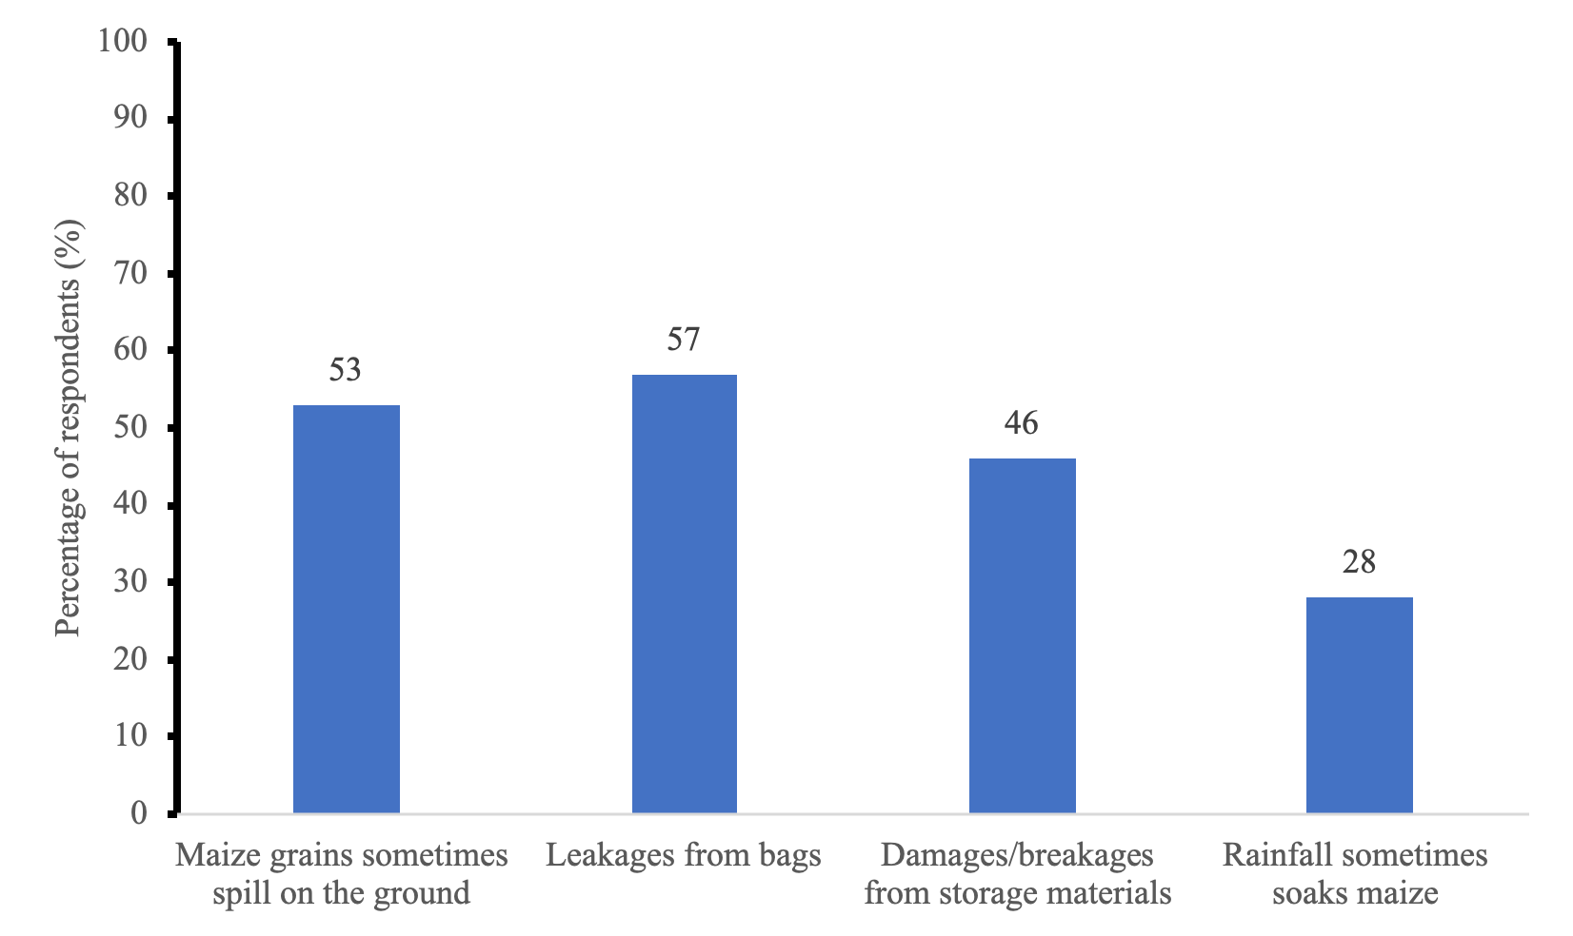

Fig. 9. Losses Encountered During Transportation

4. Conclusion AND RECOMMENDATIONS

This study examined the food security implications of traditional maize storage methods among traders in Ho Municipality of Ghana’s Volta Region. The socio-demographic analysis revealed that respondents had a mean age of 41 years, with 69% falling within the upper range of the productive age group. About 52% had been involved in maize trading for nearly 20 years, gaining extensive experience in storage methods, seasonal market trends, pest control, and PHL challenges. They recognized the risks associated with PHL and were willing to adopt improved storage methods. Approximately 72% of females participated in the management and operation of maize trading enterprises, often without ownership rights, highlighting the need for women’s empowerment. Additionally, 47% of respondents had no formal education, emphasizing the importance of capacity building, training, and extension support.
Respondents primarily stored maize in sacks and bags, with 84% using wooden rooms and 81% using concrete rooms for about 15 weeks. Traders dried maize in the sun and, in the absence of moisture meters, stored it at 14.1% to 15.0% moisture content. About 62% also treated maize with phosphine gas. Storage materials and structures were prone to rodent and insect attacks. All traders reported insect infestations, highlighting the need for hermetic bags. Maize losses in storage were attributed to germination, mold formation, decolorization, and caking. During transportation, losses occurred due to bag leakages, damages, and rain-soaked maize.
Maize traders’ choice of storage methods contributed to maize loss in the post-harvest seasons. To address these challenges, we recommend targeted interventions, such as training programs on improved techniques, provision of affordable moisture meters, credit support, and investment in pest-resistant storage infrastructure. This will reduce post-harvest loss and improve food security. These findings are relevant beyond Ho Municipality and could inform policy strategies across Ghana and Sub-Saharan African countries. For example, based on these findings, governments could formulate and implement policies to enable investment in improved storage technologies and reinforce capacity-building initiatives to mitigate post-harvest losses.

6. STUDY LIMITATIONS
Traditional maize storage methods exhibit technological inefficiencies, leading to higher post-harvest losses compared to conventional alternatives. Economically, they reduce market competitiveness, due to inconsistent quality and higher loss rates. Scalability is limited because traditional methods may not be suitable for large-scale commercial applications. Finally, knowledge systems that are developed within specific geographic contexts may face limitations when applied in different environments.

AcknowledgEments

We express our appreciation to the enumerators of the Directorate of Agriculture in the Ho Municipality of Ghana for their cooperation in collecting the data for this article. We extend our gratitude to the concerned farmers and market traders who participated in the questionnaire interview.

AUTHORS’ CONTRIBUTIONS

M. K. T. designed the study and the theories, performed the theoretical analysis, and wrote the first draft of the manuscript. M. A. and J. K. T. proofread the manuscript and analyzed the study. All authors read and approved the final manuscript.

COMPETING INTERESTS DISCLAIMER:
Authors have declared that they have no known competing financial interests OR non-financial interests OR personal relationships that could have appeared to influence the work reported in this paper.

DISCLAIMER (ARTIFICIAL INTELLIGENCE)
Authors hereby declare that NO generative AI technologies such as Large Language Models (ChatGPT, COPILOT, etc.) and text-to-image generators have been used during the writing or editing of this manuscript.

Consent
As per international standards or university standards, respondents’ written consent has been collected and preserved by the author(s).

References

Abbade, E. B. (2017). Availability, access, and utilization: Identifying the main fragilities for promoting food security in developing countries. World Journal of Science, Technology and Sustainable Development, 14(4), 322-335.
Abdulai, F., & Abdulai, A. F. (2023). Utilisation of maize postharvest strategies and practices among farmers in the Yendi Municipality of the Northern Region of Ghana. International Journal of Postharvest Technology and Innovation, 9(1), 56-71.
Abdulai, S., Nkegbe, P. K., & Donkor, S. A. (2017). Assessing the economic efficiency of maize production in Northern Ghana. Ghana Journal of Development Studies, 14(1), 123-145.
Abebe, D. (2023). Indigenous postharvest protection measures commonly practiced by farmers: A mini-review. Journal of Food Nutrition, 2(2). https://www.mediresonline.org/article/indigenous-postharvest-protection-measures-commonly-practiced-by-farmers-a-mini-review
Abebe, S. G., & Dako, O. D. (2024). First Report of the Larger Grain Borer, Prostephanus truncatus (Horn)(Coleoptera: Bostrichidae) from Stored Maize in Ethiopia. Ethiopian Journal of Science and Sustainable Development, 11(1), 22-29.
Adams, F., Donkor, E., Quaye, J., Jantuah, A. A., & Etuah, S. (2024). Sustainable maize storage technology adoption in Ghana: implications for postharvest losses, farm income, and income inequality. Food and Energy Security, 13(5), e70011. https://doi.org/10.1002/fes3.70011
Adarkwah, C. C., Tuda, M., Adjei, R. R., Obeng-Ofori, D., Ulrichs, C., & Schöller, M. (2022). Evaluation of three German enhanced diatomaceous earth formulations for the management of two major storage pests in Ghana. Journal of Stored Products Research, 96, 101947. https://doi.org/10.1016/j.jspr.2022.101947
Akowuah, J. O., Mensah, L. D., Chan, C., & Roskilly, A. (2015). Effects of practices of maize farmers and traders in Ghana on contamination of maize by aflatoxins: A case study of Ejura-Sekyeredumase Municipality. African Journal of Microbiology Research, 9(25), 1658–1666. https://doi.org/10.5897/AJMR2014.7293
Alawode, A., & Chiamaka, O. T. (2024). Linking structured commodity markets with formal agricultural finance to improve value chain transparency and inclusion. International Journal of Advance Research Publication and Reviews, 1(4), 87-109.
Alessa, L., Kliskey, A., Gamble, J., Fidel, M., Beaujean, G., & Gosz, J. (2016). The role of Indigenous science and local knowledge in integrated observing systems: moving toward adaptive capacity indices and early warning systems. Sustainability Science, 11(1), 91-102. https://doi.org/10.1007/s11625-015-0295-7
Aliaga, M. A., & Chaves-dos-Santos, S. M. (2014). Food and nutrition security public initiatives from a human and socioeconomic development perspective: mapping experiences within the 1996 World Food Summit signatories. Social Science & Medicine, 104, 74–79. https://doi.org/10.1016/J.SOCSCIMED.2013.12.025
Amir, M., & Khan, A. A. (2024). Analyzing Food Security Scales: Evidence and Methods in the FAO Context. Asian Journal of Agricultural Extension, Economics & Sociology, 42(12), 296-308.
Ankrah, D., Okyere, C., Mensah, J., & Okata, E. (2023). Effect of climate variability adaptation strategies on maize yield in the Cape Coast Municipality, Ghana. Cogent Food & Agriculture, 9(1), 2247166. https://doi.org/10.1080/23311932.2023.2247166
Ansah, I. G. K., Gardebroek, C., & Ihle, R. (2019). Resilience and household food security: a review of concepts, methodological approaches and empirical evidence. Food Security, 11(6), 1187-1203. https://doi.org/10.1007/s12571-019-00968-1
Atanda, S. A., Agoda, S., Ihionu, G. C., & Usanga, O. E. (2016). Protection of grains and cereals. The Advanced Science Journal, 1(1), 01–06. https://www.asdpub.com/index.php/asjz/article/view/236
Babu, P. K., & Rampal, A. (2024). Traditional ecological knowledge in sustainable conservation of seeds and food grains in the Himalayas. In Addressing the climate crisis in the Indian Himalayas: Can traditional ecological knowledge help? (pp. 53–93). Cham, Switzerland: Springer Nature. https://doi.org/10.1007/978-3-031-50097-8_3
Baidhe, E., Clementson, C. L., Senyah, J., & Hammed, A. (2024). Appraisal of post-harvest drying and storage operations in Africa: perspectives on enhancing grain quality. AgriEngineering, 6(3), 3030-3057.
Boullouz, M., Bindraban, P. S., Kissiedu, I. N., Kouame, A. K. K., Devkota, K. P., & Atakora, W. K. (2022). An integrative approach based on crop modeling and geospatial and statistical analysis to quantify and explain the maize (Zea mays) yield gap in Ghana. Frontiers in Soil Science, 2. https://doi.org/10.3389/fsoil.2022.1037222
Calloway, E. E., Carpenter, L. R., Gargano, T., Sharp, J. L., & Yaroch, A. L. (2023). New measures to assess the “Other” three pillars of food security–availability, utilization, and stability. International Journal of Behavioral Nutrition and Physical Activity, 20(1), 51.
Chattha, S. H., Hasfalina, C. M., Mirani, B. N., Mahadi, M. R., & Lee, T. S. (2016). Food grain losses associated with indigenous storage methods and development of storage facilities for food security. International Food Research Journal, 23.
Cheruiyot, C., Okoth, M. W., Abong’, G. O., & Kariuki, S. W. (2024). Knowledge, Attitudes, and Food Safety Practices of Informal Market Maize Grain Vendors and Consumers in Meru County, Kenya. International Journal of Food Science, 2024(1), 6592430.
Dijkink, B., Broeze, J., & Vollebregt, M. (2022). Hermetic bags for the storage of maize: perspectives on economics, food security and greenhouse gas emissions in different sub-Saharan African countries. Frontiers in Sustainable Food Systems, 6, 767089.
Esther, A., Hansen, S. C., Klemann, N., & Gabriel, D. (2022). Sanitary measures considerably improve the management of resistant Norway rats on livestock farms. Pest Management Science, 78(4), 1620-1629.
Feliu, N., & Lansberg, I. (2022). Women in family enterprise: Understanding the unique ownership challenges of daughters in business families. In R. N. Trevinyo-Rodríguez & M. Á. Gallo (Eds.), The power of inclusion in family business (pp. 135-150). Emerald Publishing Limited. https://doi.org/10.1108/978-1-80117-578-420221008
Gachara, G., Suleiman, R., Kilima, B., Taoussi, M., El Kadili, S., Fauconnier, M. L., ... & Lahlali, R. (2024). Pre-and post-harvest aflatoxin contamination and management strategies of Aspergillus spoilage in East African Community maize: review of etiology and climatic susceptibility. Mycotoxin Research, 40(4), 495-517.
Galanakis, C. M. (2024). The future of food. Foods, 13(4), 506. https://doi.org/10.3390/foods13040506
Ghana Districts: A repository of all Local Assemblies in Ghana. (n.d.). Ghana Districts. https://www.ghanadistricts.com/Home/District/177
Ghana Statistical Service. (2021b). 2021 Population & Housing Census General Report Volume 3A: Population of Regions and Districts.
Haji, M., & Himpel, F. (2024). Building resilience in food security: sustainable strategies post-COVID-19. Sustainability, 16(3), 995. https://doi.org/10.3390/su16030995
Hendriks, S. L., & Babu, S. C. (2024). What is food security? In Handbook on public policy and food security (pp. 24–30). Edward Elgar Publishing.
Kiriinya, E. (2024). Towards Sustainable Value Chain among Commercial Maize Farmers in Kenya: Leveraging on Technology. African Multidisciplinary Journal of Research, 1(1), 43-54. https://doi.org/10.71064/spu.amjr.1.1.258
Kirui, K. K., Nasirembe, W. W., Wycliffe, K. L., & Indika, J. (2025). Impact of post-harvest technologies on post-harvest losses in crops in Kenya: A review. SSR Journal of Arts, Humanities and Social Sciences, 2(6), 237-243.
Kitaba, A., & Kuma, T. (2024). Investigation of Traditional Crop Storage Pest Control Methods in Western Ethiopia. Proceedings of the National Academy of Sciences, India Section B: Biological Sciences, 1-8. https://doi.org/10.1007/s40011-024-01581-9
Kom, Z., & Nethengwe, N. S. (2024). Indigenous and Local Knowledge: Instruments Towards Achieving SDG2: A Review in an African Context. Sustainability, 16(20), 9137. https://doi.org/10.3390/su16209137
Kom, Z., Nicolau, M. D., & Nenwiini, S. C. (2024). The use of indigenous knowledge systems practices to enhance food security in Vhembe District, South Africa. Agricultural Research, 13(3), 599-612. https://doi.org/10.1007/s40003-024-00716-8
Kortei, N., Amanor, D., Wiafe-Kwagyan, M., Annan, T., Boakye, A., Essuman, E., Deku, J., & Tettey, C. O. (2022). Profile of fungal contaminants of maize (Zea mays) intended for consumption and their potential health implications in the Ho municipality of Ghana. African Journal of Food, Agriculture, Nutrition and Development, 22(115), 21890–21918. https://doi.org/10.18697/ajfand.115.21645
Laganda, G. (2023). Responding to loss and damage in food systems. Nature Food, 4(2), 133–134. https://doi.org/10.1038/s43016-023-00702-3
Lakshmi, V. V., Deepika, J., Kamlaja, T., & Rajeswari, K. (2020). Performance Evaluation of Grain Storage in Hermetic Bag. International Journal of Current Microbiology and Applied Sciences, 9(6), 2021–2028. https://doi.org/10.20546/IJCMAS.2020.906.248
Luo, Y., Huang, D., Miao, H., Wu, L., & Zhu, J. (2022). Impact of advanced storage facilities on households’ maize storage losses and food security in China. Environment, Development and Sustainability, 24(1), 221-237. https://doi.org/10.1007/s10668-021-01406-z

Magocha, M., Soundy, P., Muchie, M., & Magocha, B. (2019). Reviewing the applications of indigenous knowledge systems (IKS) in innovative crop production. Indilinga African Journal of Indigenous Knowledge Systems, 18(2), 229-244.
Makombe, G. (2024). 3 - The food security concept. Africa Development, 48(4). https://doi.org/10.57054/ad.v48i4.5574
Manandhar, A., Milindi, P., & Shah, A. (2018). An overview of the post-harvest grain storage practices of smallholder farmers in developing countries. Agriculture, 8(4), 57. https://doi.org/10.3390/agriculture8040057
Mangnus, E., & Van Westen, A. C. M. (2018). Roaming through the maze of maize in northern Ghana. A systems approach to explore the long-term effects of a food security intervention. Sustainability, 10(10), 3605.
Marson, M. (2022). Direct access to markets by farmers and the role of traders: insights from Kenyan and Tanzanian leafy vegetables markets. Studies in Agricultural Economics, 124(2), 66-73. https://doi.org/10.7896/j.2287
Mehdipour, H., Prokosch, M., Williams, D., Thomas, A. H., Seymour, B., Conley, J., & von Meding, J. (2025). The importance of belonging: reflections on a participatory action research project in Jacksonville, Florida. Disaster Prevention and Management: An International Journal, 34(1), 55-74.
Mekonnen, S. A., Jalata, D. D., & Onyeaka, H. (2024). Building resilience in Sub‐Saharan Africa's food systems: Diversification, traceability, capacity building and technology for overcoming challenges. Food and Energy Security, 13(4), e563. https://doi.org/10.1002/fes3.563
Mlambo, S., Mvumi, B. M., Stathers, T., Mubayiwa, M., & Nyabako, T. (2017). Field efficacy of hermetic and other maize grain storage options under smallholder farmer management. Crop Protection, 98, 198–210. https://doi.org/10.1016/J.CROPRO.2017.04.001
Mutiga, S. K., Mushongi, A. A., & Kangéthe, E. K. (2019). Enhancing food safety through adoption of long-term technical advisory, financial, and storage support services in maize growing areas of East Africa. Sustainability, 11(10), 2827. https://doi.org/10.3390/su11102827
Nath, B., Chen, G., O’Sullivan, C. M., & Zare, D. (2024). Research and technologies to reduce grain postharvest losses: a review. Foods, 13(12), 1875. https://doi.org/10.3390/foods13121875
Ngowi, E. R., & Selejio, O. (2019). Post-harvest loss and adoption of improved post-harvest storage technologies by smallholder maize farmers in Tanzania. African Journal of Economic Review, 7(1), 249-267. https://doi.org/10.22004/AG.ECON.285010
Nwaigwe, K. N. (2019). An overview of cereal grain storage techniques and prospects in Africa. International Journal of Bioengineering and Biotechnology, 4(2), 19-25.
Nwankwo, S. C. (2025). Harnessing indigenous knowledge for climate action: Bridging traditional wisdom. Empowering Resilience: Women, Environment, and Socio-Economic Challenges in Nigeria, 38.
Olorunfemi, B. J., & Kayode, S. E. (2021). Post-harvest loss and grain storage technology-a review. Turkish Journal of Agriculture-Food Science and Technology, 9(1), 75-83. https://doi.org/10.24925/turjaf.v9i1.75-83.3714
Ovharhe, O. J., Emaziye, P. O., Okpara, O., Agoda, S., & Benson, C. O. (2021). Strategies adopted by maize farmers to minimize post-harvest losses in Delta State, Nigeria. International journal of agricultural technology, 17(1), 237-256.
Oyewole, O. S., Raji, M. A., Kazeem, A. A., Ajao, T. O., Ibitoye, O., Abel, O. O., ... & Adewunmi, E. O. (2025). Smart technological innovations for postharvest loss reduction: A review. FUDMA Journal of Sciences, 9(6), 299-307. https://doi.org/10.33003/fjs-2025-0906-3605
Penagos-Tabares, F., Todorov, A., Raj, J., Farkaš, H., Grubješić, G., Jakovčević, Z., ... & Vasiljević, M. (2025). Multi-mycotoxin contamination in Serbian maize during 2021–2023: Climatic influences and implications for food and feed safety. Toxins, 17(5), 227. https://doi.org/10.3390/toxins17050227
Rastegar, A., & Rashidi, M. (2024). Food Safety in International Law: A Step in Preventing the Occurrence of Communicable Diseases. Iranian Journal of International and Comparative Law, 2(1).
Reyes-García, V., García-Del-Amo, D., Porcuna-Ferrer, A., Schlingmann, A., Abazeri, M., Attoh, E. M., ... & Torrents-Ticó, M. (2024). Local studies provide a global perspective of the impacts of climate change on Indigenous Peoples and local communities. Sustainable Earth Reviews, 7(1), 1.
Saars, L., Madsen, M., & Meyer, J. (2024). Optimizing the Operation of an Electrolyzer with Hydrogen Storage Using Two Different Methods: A Trade-Off Between Simplicity and Precision in Minimizing Hydrogen Production Costs Using Day-Ahead Market Prices. Energies, 17(22), 5546. https://doi.org/10.3390/en17225546
Sarkodie, K. (2023). Land cover change analysis of Ho Municipality of Ghana. Journal of Emerging Technologies and Innovative Research, 10, i431-i440.
Stathers, T., Holcroft, D., Kitinoja, L., Mvumi, B. M., English, A., Omotilewa, O., ... & Torero, M. (2020). A scoping review of interventions for crop postharvest loss reduction in sub-Saharan Africa and South Asia. Nature Sustainability, 3(10), 821-835.
Sugh, E. T., Ahule, B., & Nkwain, K. T. (2020). Indigenous strategies of shelf life extension of maize among farmers in Nigeria. https://www.researchgate.net/publication/361746012
Tadesse, M. (2020). Post-harvest loss of stored grain, its causes and reduction strategies. Food Science and Quality Management, 96, 26-35.
Walker, S., Jaime, R., Kagot, V., & Probst, C. (2018). Comparative effects of hermetic and traditional storage devices on maize grain: Mycotoxin development, insect infestation and grain quality. Journal of Stored Products Research, 77, 34-44. https://doi.org/10.1016/j.jspr.2018.02.002
World Bank Group. (2024). What is food security? World Bank. https://www.worldbank.org/en/topic/agriculture/brief/food-security-update/what-is-food-security
Yadav, L., Smith, D., Abdul Aziz, A., Le Thuy, C. T., Thao, H. X., Le, H. H., Nicetic, O., Quyen, L. N., & Vagneron, I. (2021). Can traders help farmers transition towards more sustainable maize based farming systems? Evidence from the Lao-Vietnamese border. International Journal of Agricultural Sustainability, 19, 234–254. https://doi.org/10.1080/14735903.2021.1901466
Yimer, A. H. (2022). Postharvest management practices of maize in Ethiopia: A review. Agricultural Science Digest-A Research Journal, 42(5), 521-527. https://doi.org/10.18805/ag.df-414
Zacharia, H., Feleke, S., Nyaa, M., & Baributsa, D. (2024). Adoption and impacts of hermetic storage on household food insecurity among maize producers’ organizations in Tanzania. Discover Agriculture, 2(1), 98.
Zheng, Y., Wu, W., Sun, C., Liu, H., & Dou, J. (2024). Occurrence and fate analysis of mycotoxins in maize during the post-harvest period. Toxins, 16(11), 459. https://doi.org/10.3390/toxins16110459

