Profitability Assessment of Shilbilati Potato Farmers and Intermediaries Using Traditional Storage Systems in Rangpur, Bangladesh

ABSTRACT
Shilbilati potato, a traditionally significant variety of potato, is grown in norther Rangpur district of Bangladesh, despite its lower yield compared to the high yield varieties of potatoes. This study evaluates the profitability of Shilbilati potato farmers and intermediaries using traditional storage as this varieties of potatoes are stored for a shorter period of time and traditional storage system is also cost effective for the users. Data of 100 Shilbilati potato farmers and 30 intermediaries were collected using simple random sampling technique from Mithapukur and Badarganj upazilas of Rangpur district in Bangladesh. Tabular analysis and statistical method were used to measure the profitability. However, the results revealed that small farmers earned higher net benefit (Tk. 176.39/quintal) compared to the large farmers as small farmers have to handle lower storage and handling costs. Moreover, retailers earned more profit (Tk. 140.48/quintal) followed by the beparies (Tk. 117.94/quintal). The study also find that although storage is advantageous for all the market players of Shilbilati potato but retailers are the most benefitted group as their marketing margin (106.90 Tk./quintal) is higher than others. The findings provide valuable insights to the policymakers to improve the potato value chain in Bangladesh.
Keywords: Shilbilati potato, intermediaries, profitability, traditional storage,

1. INTRODUCTION
Agriculture sector is cornerstone of Bangladesh’s economy, the has employed a large share of the population of the country with ensuring food security as well (Sarma et al., 2024). However, potato (Solanum tuberosum L.) is a major cash crop and also a staple food in Bangladesh, ranking just behind rice and wheat in terms of cultivated area and yield contribution. Major potato-growing areas in the country are Dinajpur, Rangpur, Bogura, Gaibandha, and Sirajganj; which are located in the northern and northwestern divisions (Islam et al., 2018; Khalil et al., 2013). Different varieties of potatoes are cultivated in Bangladesh and local farmers continue to hold cultural importance and grow traditional local varieties despite their yields are lower compared to high-yielding varieties (HYVs) (Singha and Maezawa, 2019). One such local variety is Shilbilati potato, also known as “Sheel Bilatee,” which is usually grown in the Rangpur region. This potato is distinguished by its oblong shape, reddish color, and small size-typically around 30 grams per tuber (Khalil et al., 2013). The demand for Shilbilati potato is significant in the local market for its traditional value and coronary importance in regional diet.
Bangladesh has been witnessing consistent growth in potato production throughout the years. The following table shows the area, production, and yield of potato in Bangladesh during 2015-16 to 20222-23 (Bangladesh Bureau of Statistics, 2023).
Table 1: Area, yield and production of potato in Bangladesh 2015-2016 to 2022-2023.
Year | Area (ha) | Yield(ton/ha) | Production(ton)
2015 - 2016 | 475488 | 19.476 | 9474098
2016 - 2017 | 499725 | 20.443 | 10215957
2017 - 2018 | 477400 | 20.411 | 9744412
2018 - 2019 | 468375 | 20.614 | 9655082
2019 - 2020 | 461317 | 20.822 | 9605624
2020 - 2021 | 468680 | 21.096 | 9887242
2021 - 2022 | 464011 | 21.863 | 10144835
2022 - 2023 | 455523 | 22.901 | 10431736
Source; BBS 2023
Between 2015–16 and 2022–23, potato yields in Bangladesh increased from 19.47 to 22.90 tons per hectare (BBS, 2023), although marketing inefficiencies remain to suppress the earnings of the farmer. Consequently; although the Shilbilati variety is emerging as a promising crop in the Rangpur district; growers face serious marketing constraints such as lack of proper storage, multiple intermediaries, and price volatility (Elias et al., 1980; Hossain et al., 2008). The storage function is responsible for the provision of agricultural products, ensuring a balanced supply throughout the year as well as seasonal imbalances of scarcity and abundance (Patil and Kulkarni, 2023). It increases the value and usage of farm goods, making them suitable for future use or processing (Yadav et al., 2018). Shilbilati potato also has strong production potential for providing increased earnings to the farmers and and seed stock for the next planting season.
Previous studies have highlighted profitability in potato cultivation, including work by Elias et al. (1980), Singh et al. (1985), and Rashid (1994). Most agreed on the profitability of high-yield varieties and identified constraints such as storage costs, price fluctuations, and market inefficiencies (Chowdhury et al., 2015; Sujan et al., 2017). Zubair et al. (2023) emphasized the nutritional superiority of the Shilbilati potato, supporting its market potential. Most of the Shilbilati potato farmers are interested in using traditional storage system for storing potatoes as its storage period is shorter and the traditional storage facility is cost effective and easily accessible to small farmers and traders (Affognon et al., 2015). This study seeks to assess the profitability of Shilbilati potato farmers and intermediaries using traditional storage system in Rangpur district.

2. METHODOLOGY
2.1 Study area, sampling technique and data collection
The study was conducted in Rangpur district of Bangladesh as it is one of the major potatoes growing districts of the country (Nasif et al., 2018) and production and demand of Shilbilati potato is higher in this district. Two Shilbilati producing areas of Rangpur district- Mithapukur and Badarganj upazila were selected for data collection. However, in this study, traditional storage methods were examined as surveys showed that storage periods ranged from 15 to 90 days after harvesting, depending on the farmer's economic status.
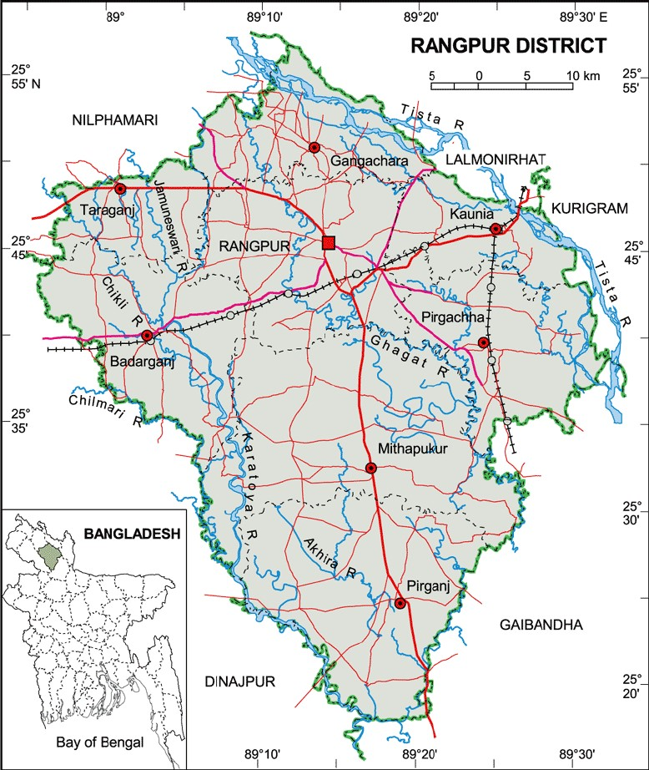
Fig 1: Location of the study area
The target population of this study was Shilbilati potato farmers and market intermediaries of the selected Mithapukur and Badarganj upazilas The sample size of 100 farmers and 30 intermediaries were determined based on considering statistical and practical issues to ensure adequate representation of target population. Primary data of 100 farmers who produce Shilbilati potato in the selected areas were collected using a simple random sampling technique. Among the 100 sampled farmers, 60 were small-scale farmers (who cultivated 0-1.0 hectares of land), while 40 of them were large-scale farmers (who owned over 1.0 hectares of land). In addition, 30 Shilbilati potato traders (intermediaries) actively involved in the potato trade were selected through simple random sampling technique to ensure proper representation without bias.. They comprised 15 Beparies/wholesalers/Arotdhers and 15 retailers. The interviews were conducted with potato growers at their village homes, while market intermediaries were interviewed in their respective markets and business enterprises. Interviews were conducted between December 2024 and January 2025.
2.2 Analytical Tools
The collected data were primarily analyzed using tabular techniques with the assistance of SPSS software. Profitability and marketing margins were calculated using tabular and statistical methods.
The profit earned through the sale of potatoes was found by determining the difference between the average selling price of the potatoes and the current price for non-stored potatoes. The net profit was obtained by deducting wastage/damage charges and other marketing expenses from the revenue. Wastage/damage cost was estimated using the market sale value of the quantity of damaged or lost potatoes per quintal stored to give an accurate indication of losses from storage. As marketing profit is estimated as sales price minus the sum of purchase price and marketing costs (Jahan et al., 2024); the formula for calculating the profit of Shilbilati potato farmers and intermediaries is:
Profit = Sale Price – (Purchase Price + Storage + Loss + Other Marketing Costs)
The marketing margin at any point in the supply chain is thus the purchase price and the sale price of a product, which is different. Kohls and Uhl (1980) define it as the distance between the consumers' and the producers' pay.
In broader terms, the marketing margin indicates the value difference of equal physical quantities of a commodity through various marketing stages. The marketing margin for each market intermediary was calculated as the sale price minus the purchase price of potatoes. The net profit component was then calculated as the difference between the intermediary's share of the marketing margin and marketing expenses.
Marketing margin = Sale Price – Purchase Price
3. RESULT AND DISCUSSION
3.1 Profitability of Farmers Using Traditional Storage
The net benefit of Shilbilati potato farmers (both large and small) using traditional storage system was determined by subtracting the cost of home storage, wastage/damage costs, and other marketing expenses from the gross benefit. The wastage/damage cost was estimated based on the price equivalent of the quantity lost or damaged per quintal during storage. The findings highlight that while traditional storage methods offer financial advantages, they also involve risks of losses due to spoilage and inefficiencies in handling.
The net benefits earned by small and large farmers were Tk. 176.39 and Tk. 138.91 per quintal (Table 2), respectively, from storing potatoes using traditional methods. To assess farm-level profitability, the gross benefit was calculated as the difference between the market price at the time of sales and the prevailing price for immediate post-harvest sales. The result shows that small farmers benefited more, despite risks of spoilage. As small farmers have to maintain lower storage and handling inefficiencies; so, they can be benefitted more from the traditional storage of Shilbilati potato. However, it is also proven from previous studies that small farmers can work more efficiently than large farmers (Aragon et al., 2021; Lutfunnehar and islam, 2021 ) Since both the categories of farmers have been profited from using traditional storage in Shilbilati potato farming; the average net benefit yielded is Tk. 157.65/quintal. The findings of the study is consistent with the prior research findings. Alam et al. (2014) found that storage facility has improved the income level of farmers producing grain crops in Bangladesh. Similar result was found by Wauters et al. (2022) for Uganda.
Table 2: Profitability of storing potatoes in traditional method. (Taka per quintal)
Farmer Type | Sale Price (without Storage) | Sale Price (After Storage) | Storage Cost | Loss | Other Costs | Net Benefit (Tk/Quintal)
Small Farmers | 1280.60 | 1605.55 | 24.26 | 93.67 | 30.64 | 176.39
Large Farmers | 1338.56 | 1683.61 | 32.81 | 128.44 | 44.90 | 138.91

3.2 Profitability of Intermediaries Using Traditional Storage
Similar to farmers, intermediaries stored potatoes to maximize their profits. However, in the traditional storage method, potatoes were stored for only a short period, typically in living spaces or shops. The study revealed that Beparies/wholesalers earned Tk. 117.94 per quintal, while retailers earned Tk. 140.48 per quintal as net profit from traditional storage (Table 3).

Table 3: Profitability of storing potato of intermediaries in traditional method
Intermediary | Purchase Price | Sale Price | Storage Cost | Loss | Other Costs | Net Benefit (Tk/Quintal)
Beparies | 1265.60 | 1559.28 | 31.50 | 92.70 | 51.54 | 117.94
Retailers | 1382.25 | 1728.25 | 35.10 | 131.33 | 39.10 | 140.48

The result (Table. 3) also align with the finding of Minten et al. (2016) where they found that instead of facing higher operating and marketing costs; retailers can capture more profit than other intermediaries because of their ability to control market price and consumer access. The findings also indicate that intermediaries faced higher average sale prices, storage losses, and marketing costs compared to farmers (Table 2 and Table 3). Despite these challenges, short-term storage allowed them to capitalize on price fluctuations, ensuring profitability within the constraints of their storage capacity.
The average profit made by the intermediary from storing one quintal of potatoes was Tk 130. Although traditional systems have reduced storage costs, it increases storage damage. However, it is only suitable for short-term storage.
3.3 Marketing Margin of the Intermediaries
The marketing margin is the difference in value for the same quantity of a commodity at two points in the marketing chain. It is the difference between what is paid for and what is received by a marketing agency. The margin includes profits and payment for distribution, but the greater portion of it allows for marketing costs, such as loading and unloading, market tolls, transportation, and other middlemen expenses. They are typically expressed in monetary terms or as a percentage of the commodity's value. The price spread is typically used interchangeably with marketing margin (Ahamed, 2015).

Table 4: Marketing Margin of the Intermediaries
Intermediary | Purchase Price | Sale Price | Gross Margin | Marketing Cost | Net Margin
Beparies | 1750.74 | 1836.68 | 85.94 | 43.27 | 42.67
Retailers | 1860.09 | 1995.02 | 134.93 | 28.03 | 106.90

The study revealed that the net margin (profit) on average was Tk. 42.67 per quintal for Beparies/wholesalers and Tk. 106.90 per quintal for retailers. Among intermediaries, retailers have the highest net marketing margin, followed by Beparies/wholesalers, having the lowest. This indicates that retailers receive a higher percentage of the final selling price, while wholesalers and Beparies have lower margins due to bulk dealings and higher handling costs. The result complements the prior researches (Sawaran and Masih, 2023; Sorwar et al.,2015) where retailers were found to earn higher marketing margin than beparies and other market intermediaries.
4. CONCLUSION
This study examined the profitability of Shilbilati potato farmers and intermediaries, which is a location-specific local variety grown in Rangpur. The results show that both farmers and intermediaries can be benefitted by using short-term traditional storage, despite the risk of wastage. Since small farmers need to handle small storage which increases their efficiency and achieved more benefit than large farmers. Similarly, retailers are benefitted more than the beparies due to their ability of direct contact with the customers. Both farmers and intermediaries face constraints in Shilbilati potato farming and marketing such as low prices, price fluctuation, lack of capital, lack of proper grading, limited marketing facilities, and inadequate market information. Low prices at harvesting time were the most significant issue for farmers, while high transportation expenses were the most significant issue for intermediaries. Policy interventions and financial support to address these issues can increase the overall profitability and sustainability Shilbilati potato cultivation in northern Bangladesh.

Disclaimer (Artificial intelligence)
Option 1:
Author(s) hereby declare that NO generative AI technologies such as Large Language Models (ChatGPT, COPILOT, etc.) and text-to-image generators have been used during the writing or editing of this manuscript.
Option 2:
Author(s) hereby declare that generative AI technologies such as Large Language Models, etc. have been used during the writing or editing of manuscripts. This explanation will include the name, version, model, and source of the generative AI technology and as well as all input prompts provided to the generative AI technology
Details of the AI usage are given below:
1.
2.
3.

COMPETING INTERESTS
Authors have declared that no competing interests exist among them.

References
Affognon, H., Mutungi, C., Sanginga, P. & Borgemeister, C. (2015). Unpacking Postharvest Losses in Sub-Saharan Africa: A Meta-Analysis. World Development, 66, 49-68.
Ahmed, M. T., Nath, S. C., Sorwar, S. S. R. M. M. A. & Harun-OR- Rashid, M. (2015). Cost-effectiveness and resource use efficiency of sweet potato in Bangladesh. Journal of Agricultural Economics and Rural Development, 2(2): 026-031.
Alam, M.S., Ashraf, M.A., Mia, M.I.A. & Abedin, M.Z. (2014). Study on Grain Storage Facilities as Food Security Measure in Flood Prone Areas of Bangladesh. Progressive Agriculture,18(2).
Aragón, F.M., Restuccia, D. & Rud, J.P. 2021. Are small farms really more productive than large farms? Food Policy, vol. 106(C).
BBS. (2023). Statistical Year Book of Bangladesh. Bangladesh Bureau of Statistics.
Chowdhury, M. D. and Chowdhury A. H. (2015). Problems and Prospects of Potato Cultivation in Bangladesh. Asian Business Review, 5(10): 28-32.
Elias, S. M. A., Jubber and N. I. Mondol (1980). An Economic profile of potato cultivation in Bangladesh. Agricultural Economics Research Report No. 2, Agricultural Economics Division, BARI.
Hossain, M. A., Hasan, M. K. and Naher, Q. (2008). Assessment of Technical Efficiency of Potato Producers in Some Selected Areas of Bangladesh. J. Agric. Rural Dev., 6(1&2): 113-118.
Islam, Q., Matin, M., Siddiquee, M., & Islam, M. (2018). Adoption and profitability of BARI released potato varieties in northern region of Bangladesh. Bangladesh Journal of Agricultural Research, 43(2), 309–322. https://doi.org/10.3329/bjar.v43i2.37334
Jahan, R., Chad, N.A., Hossain, J., Kamal, S.A. & Ferdous, A. (2024). Marketing Margin and Profit Structure of Some Commercially Important Marine Fishes in Bangladesh: A Study from the Southeast Bay of Bengal Fisheries. Journal of Agribusiness and Rural Development, 74(4):389-401
Khalil, M. I., Haque, M. E. & Hoque, M. Z. (2013). Adoption of BARI Recommended Potato (Solanum tuberosum) Varieties by the Potato Farmers of Bangladesh. The Agriculturists, 11(2): 79-86.
Kohls, R.L. & J. N. Uhl. (1980). Marketing of Agricultural Products (Fifth edition). Macmillan Publishing Co., Inc. New York, 5-8.
Lutfunnehar & Islam, M.N. (2021). Farm Size, Tenancy and Productivity: An Overview. Asian J. Soc. Sci. Leg. Stud., ; 3(5), 165-171
Minten, B., Habte, Y., Tamru, S., & Tesfaye, A. (2016). The transformation of food retail in Ethiopia: Evidence from vegetable value chains. ESSP Working Paper 83. International Food Policy Research Institute (IFPRI). https://doi.org/10.2499/9780896292345_04
Nasif, S.O., Sani, M.N.H., Islam, M.S., Anondo, M.T., Punam K.F. & Ali, M.R. (2018). A survey of potato growers in Bangladesh: production and challenges. Res. Agric. Livest. Fish. 5 (2): 165-174
Patil, N. F. & Kulkarni, A. R. (2023). Analysis Of Storage Practices And Economic Benefits Of Agricultural Products In Dharwad District. International Journal of Creative Research Thoughts, 11(11):2320-2882.
Rasid, M. H. (1994). An Economic study of Farmers growing crops with potato in a selected area of Rangpur District. M.SC. Ag. Econ. Thesis Submitted to the department of Agricultural Economics, Bangladesh Agricultural University, Mymensing.
Sarma, P. K., Alam, M. J., Begum, I. A. & Mckenzie, A.M. (2024). The effect of total factor productivity on the food security and livelihood vulnerability of farm households in Bangladesh. Frontiers in Sustainable Food Systems, 8.
Sawaran, S. & Masih, V.A. (2023). A Study on Post-Harvest Losses and Marketing of Potato in Pryagraj District of Uttar Pradesh. International Journal of Innovative Science and Research Technology, 8(6), 1991-1995.
Singh, Chhotan & Vasisht, A. K. (1985). A Study of Changes in Producer's Share in the Consumer's Rupee of Agricultural Commodities in India. Indian Journal of Agricultural Economics, Indian Society of Agricultural Economics, vol. 40(3).
Singha, U. & Maezawa, S. (2019). Production, marketing system, storage and future aspect of potato in Bangladesh. Reviews in Agricultural Science. 7:29-40.
Sorwar, S.S.R.M.A.M., Ahmed, M.T., Nath, S.C., Harun-Or-Rashid, M. & Wheatley, C. (2015). Analysis of value chain of sweet potato in two districts of Bangladesh. International Journal of Agricultural Marketing, 2(3):78-83.
Sujan, H. K., Islam, F., Kazal, M. H. & Mondal, R. K. (2017). Profitability and Resource Use Efficiency of Potato Cultivation in Munshiganj District of Bangladesh. SAARC J. Agri., 15(2): 193-206.
Wauters, P., Naziri, D., Turinawe, A., Akello, R. & parker, M.L. (2022). Economic Analysis of Alternative Ware Potato Storage Technologies in Uganda. American Journal Potato Research. Vol. 99, 217–228. https://doi.org/10.1007/s12230-022-09874-3
Yadav, A. K., Shrotriya, V. & Dhuria, L. (2018). Storage and Processing of Agricultural Commodities. International Journal of Advances in Arts, Sciences and Engineering, 7(15), 1-6.
Zubair, M.A., Esrafil, M., Hosen, F., & Afrin, A. (2023). Assessment of nutritional composition and bioactive compounds of various wild potato cultivars in Bangladesh. International Journal of Food Properties, 26, 1534 - 1545.

