Synthesis, Characterization, and Application of Activated Biomaterials as Potential Adsorbents for the removal of Cr(VI), Pb(II), and Cu(II) Ions from aqueous solution

Article type: Original Research Article

Abstract
Piliostigma thonningii (PSH), Perqutinia negrecrecens (PNS), and Hildegardia barteri (HB) activated carbon bio-sorbents were prepared for removal of Cr(VI), Pb(II) and Cu(II) ions from aqueous solutions. The bio-sorbents were characterized using SEM, EDX, FTIR, and CHN methods. The SEM results showed crystalline material with flake-like structures. Effect of concentrations, contact time, pH, adsorbent dosage and temperature were studied to determine the optimal conditions of adsorption. The adsorption capacities of Pb (II) ions was 14.29, 13.74 and 16.67, while Cu(II) ions 24.88, 17.21 and 25.13 mg/g onto HB, PSH and PNS respectively. Optimum temperature of adsorption was recorded at 40 ºC with pH range between 6 and 7. The thermodynamic study revealed that ∆G◦ values were between -20 and 0 KJmol⁻¹ suggesting spontaneous physical adsorption. The ∆H for Cr(VI) ions adsorption was +0.067, +0.168, and +0.025 kJ/mol, while Pb(II) ions was +0.137, +0.095, and +0.178 kJ/mol, with that of Cu(II) ions as +0.005, +0.002, and +0.0400 kJ/mol onto PSH, PNS and HB respectively. The ∆S for Cr(VI) ions was found to be +0.320, +0317 and +0.378 kJ/mol, with that of Pb(II) ions as +0.261, 0.244 and 0.188 kJ/mol, while Cu(II) ions was +0.236, +0.210 and +0.193 kJ/mol respectively, showing endothermic and randomness of the adsorption process. The Langmuir isotherm model and pseudo-second order kinetics fitted well to all the adsorbents. The results demonstrated that the activated carbon bio-sorbents from the three biomasses have the potential to be employed as low-cost adsorbents.
Keywords: PHS, PNS, HB bio-sorbents, adsorption, metal ions
1.0 Introduction
The advent of industrialization and increase in domestic activities have resulted in release of toxic pollutants inform of organic and inorganic substances into the natural environment [1]. The effects of the discharge of these pollutants on plants and animals is gradually going out of control. It has been proven for many years that attacks on human health is mainly through ingestion of infected water which are polluted in many ways. To solve this global menace, several research works have been reported on methods designed for synthesis of organic and inorganic materials. Amongst many, biomass adsorbents are promising removal agents for wastewater and industrial effluents as revealed in various studies. Bioactive adsorbents have shown to be more advantageous than inorganic adsorbents because of their environmental friendliness, low cost, ease of accessibility and lack of secondary wastes. Studies carried out by Abdus-Salam et al. [2] examined some samples of water including some physicochemical parameters and heavy metals, in order to express the degree of natural and anthropogenic input to water pollution. The drift in the physicochemical parameters showed how unfriendly the water as a result of pollutants produced from domestic, agricultural and industrial activities, as well as oil spill. The studies revealed that some heavy metal ions and anionic radicals were discovered at concentrations that were detrimental to human health. The concentrations of phosphate, sulphate, Pb and As ions were about that of WHO, while Ni and Va were strongly above the WHO standards for portable water. Biney et al. [3], carried out a review of heavy metal ions concentrations in an aquatic environment, and their studies showed that anthropogenic concentrations of Cd, Co, Cu, Cr, Fe, Mn, Pb, Zn and Ni ions were reported to have emanated from land-based urban and industrial wastes sources. Bernard et al. [4] examined the treatment of industrial wastewater containing Pb, Fe, Cu, and Zn ions by activated carbon adsorbent prepared from coconut shell. The batch experiments were performed and showed to be dependent on time, adsorbent dosage, pH and stirring speed of the process. Similarly, Cd²⁺ ions adsorption on activated carbon prepared from sugarcane bagasse-based was investigated by Musa et al. [5]. The result of the report indicated that the bio-adsorbent performed to some extent in removing the metal ions from the aqueous phase but not entirely. In another research work, Sethu et al. [6] investigated the adsorption of Cu² ⁺ ions from wastewater using neem-leaf bio-sorbents. The report of the work showed that heavy metals like Cd, Pb and Cu ions were removed from aqueous solution using cotton stalks activated carbon. It was discovered that the bio-sorbent prepared was a promising potential for adsorption of heavy metal ions in both single and multiple adsorption systems at higher pH values. The studies revealed that there is a high negative charge on the surface of the prepared activated carbon adsorbent. Elaigwu et al. [7] in their studies on Pb(II) ions by activated carbon prepared from cow dung showed that the adsorption was dependent on pH, temperature, contact times, and adsorbate concentration. The studies revealed that the adsorption process was found to be fast, stable, and was completed in a short time. The efficiency of the adsorption process was very high showing how the bio-sorbent derived from cow dung is promising in heavy metal adsorption or treatment of wastewater. The removal of Pb² ⁺ and Cu²⁺ ions from the aqueous solution by Adanonsia digitata biomass from fruit shells was studied by Chigondo et al. [8]. The study demonstrated favourable conditions for the biosorption of Pb²⁺and Cu²⁺ ions from aqueous solution and the conditions were improved acidic pH values. Huseyin and Yakup [9] studies on bio-chars derived from the pyrolysis of oily seeds of Pistacia terebinthus L for removal of Cr(VI) ions from aqueous solutions in batch experiments showed a significant removal of the Cr(VI) ions from aqueous solution. Also, Azadirachta indica leaf powder was employed as an adsorbent for the removal of Cr(IV) ions and compared with some commercially available adsorbents [10] was found to be more promising than Charcoal. Agarwal et al. [11] investigated a low-cost agro-based material, Tamarindus indica seed, coconut shell, almond shell, ground nut shell, and walnut shell for removal of Cr(VI) ions.
All the results of the findings showed that the bio-sorbents have promising adsorption ability and can be used as low-cost adsorbents for removal of metal ions from aqueous solutions under the experimental conditions being tested. Nature reveals that there are still numerous untapped potentially available plant materials that have not been explored in treatment of wastewater including Piliostigma thonningii, Perqutinia negrecrecens, and Hildegardia barteri. Though, several bio-sorbents have been applied, it is important to note that few of these materials have performed satisfactorily or appreciably, and this is what necessitated this research work. Also, it is important that adsorption involving bio-sorbents should undergo various examination in the physiochemical and spectroscopic aspects in other to characterize the materials before they are employed for adsorption processes. This is one of the drawbacks in most research works and forms the basis for this study as the materials were characterized in both aspects before they were applied.
In this studies, Piliostigma thonningii (PSH), Perqutinia negrecrecens (PNS), and Hildegardia barteri (HB) Activated Carbon (AC) bio-sorbents were prepared for removal of Cr(VI), Pb(II) and Cu(II) ions from aqueous solutions, subjected to optimum conditions of concentration, adsorbent dosage, time, pH and temperatures of adsorption. The isotherm, kinetic and thermodynamic studies were carried out to determine the nature of the adsorption process.
2.0 Materials and Methods
Chemicals used in these study, (NaOH), acetone (CH₃COCH₃), hydrochloric acid (HCl), potassium dichromate (KCr₂O₇), lead nitrate (Pb(NO₃)₂), orthophosphoric acid (H₃PO₄), nitric acid (HNO₃), potassium nitrate (KNO₃), potassium hydroxide (KOH), nitrogen gas and deionised water. Analytical grade chemicals from BDH and Sigma Aldrich were considered in sourcing all the materials and reagents selected for the study. Other basic laboratory glass-wares and apparatus were used in the course of this research.
2.1 Sample Collection and Preparation of Adsorbent
The biomass samples used in this study include Piliostigma thonningii (PSH), Perqutinia negrecrecens (PNS), and Hildegardia barteri (HB) fruit shells. The samples were cracked using hammer, and the seeds embedded in white pulp removed leaving the shells which were properly washed using de-ionized water for the preparation of the bio-sorbent samples. Dilute nitric acid (0.01M) was also used to wash the shells to further remove impurities, and rinsed several times with de-ionized water till the pH of the washed water was neutral. The washed shells were air-dried for 5 days under laboratory conditions and was later used to produce AC by carbonization process followed by chemical activation. The carbonization process converts the organic materials to primary carbon, whereas the activation process removes the decomposed products deposited in the pores and makes the activated carbon more porous in nature. (Etong and Abdus-Salam,2022)
2.2 Preparation of AC
2.2.1 Carbonization and Activation
“A 400 g sample of PNS, HB and PSH were carbonized in a pyrolyzer under a continuous flow of nitrogen gas and at temperatures of 400, 500 and 600 ºC for 60 min. The charred products were allowed to cool to room temperature, and crushed with mortar and pestle and stored in air tight containers. A 150 g of the carbonized samples were weighed and transferred into a beaker containing 150 mL 75 % ortho-phosphoric acid (H₃PO₄), in ratio 1:1. The impregnation was carried out at 60 ºC in a hot air oven for 24 h for penetration of chemicals into the interior part of the precursor. The activated sample was then cooled to room temperature, washed with de-ionized water to neutral pH, oven dried and stored for characterization. After cooling, each of the carbonized materials was weighed to determine the percentage yield per mass of the raw sample used” [12].
2.4 Characterization of Adsorbents
2.4.1 Determination of moisture contents of biomass
An oven-dried clean crucible was weighed as W_{o}, 2 g of each bio-sorbent was accurately weighed into the crucible and reweighed as W_{x}. The crucible and its content were dried at 105 ºC in an oven for 8 h, removed and cooled in the desiccator before weighing. This was returned to the oven at 105 ºC for 2 h, removed into a desiccator to cool and re-weighed. This procedure continued until a constant weight was obtained as W_{y}. The moisture content was calculated according to equation 1 [13].
% Moisture content = $\frac{W_{x}-W_{y}}{W_{x}-W_{o}}$ X 100 (1)
where; W_{o} is mass of empty crucible, W_{x} is mass of empty crucible + adsorbent, and W_{y} is mass of empty crucible + adsorbent after drying I grams
2.4.2 Determination of ash content of biomass
A clean, empty and dried crucible was weighed and recorded as W_{o} and a 2 g of each sample was added and reweighed as W_{i}. The crucible was transferred into a preheated furnace set at a temperature of 600 ºC for 1h after which the crucible and its contents were transferred into a desiccator, cooled and reweighed as W_{f}. The percentage ash content on dry basis was given by equation 2 [14].

% Ash = $\frac{W_{f} -W_{o}}{W_{i} -W_{o}}$ x 100 (2)
where: $W_{i }$is initial weight of crucibles + sample, $W_{f }$is final weight of crucibles + sample, W_{o} is weight of empty crucible (g)
2.4.3 Determination of yield of activated carbon
The dried weight of the AC sample was determined from the weight of the raw and final activated samples using analytical balance, and the yield was calculated using equation 3 [15].

Carbon yield (%) = $\frac{Weight of product(AC)}{Weight of starting material}$ x 100 (3)
2.4.4 Determination of bulk density of biomass
A clean dried 10 mL measuring cylinder was weighed and recorded as W_{o}. Each of the sample was poured into the weighed 10 mL measuring cylinder to the 10 mL mark and tapped for 200 counts, without losing any drop of the sample. This is done to compact the sample so that the volume of the sample would dropped to a marked v mL. The new volume (v) was recorded and reweighed and the new weight recorded as W₂. The bulk density (ρ_{AC}) was calculated using equation 4 [16, 17].

Bulk density (ρ_{AC}) = $\frac{W_{2 }{-W}_{0 }}{V}$ (4)
where: W_{o} is weight of empty measuring cylinder, W₂ is weight of empty measuring cylinder + sample, W₂ - W_{o} is weight of sample, and v is Final volume of the sample. Bulk density (ρ_{AC}) is measured in g/ml.
2.4.5 Determination of iodine number
“The iodine value, defined as the amount of iodine adsorbed per gram of AC at an equilibrium concentration of 0.02N was measured according to the procedure established by the American Society for testing Materials (ASTM D4607-94)” [18]. A 10 ml of 0.1 N iodine solution was measured into a conical flask and 2 drops of starch solution added, and the pale yellow colour of iodine solution turned blue. The solution was titrated with 0.05 N sodium thiosulphate solution to a colourless endpoint and the volume of the titrant used was recorded as the blank B. A 0.2 g of each sample was weighed and carefully transferred into a dried conical flask, 40 mL of 0.1 N iodine solution was added and the content of the flask shaken continuously for 5 min and filtered into a dry conical flask. A 10 mL of the filtrate was pipetted into 100 mL conical flask and titrated against standard sodium of thiosulphate solution using starch solution as an indicator until the colour changes from Pale yellow to colourless, and the burette reading recorded as A. the iodine number was estimated as represented in equation 5.

Iodine Number = $\frac{126.9 (B-A)}{WXB}$ (5)

where: B is Volume of blank (mL), A is Volume adsorbed (mL), and W is weight of sample used in grams.
2.4.6 Spectroscopic Characterization
Phase composition of the samples were analyzed using Energy Dispersive X-Ray (EDX), while Scanning Electron Microscope (SEM) were used to determine the surface morphology of the samples. CHN analyzer was used for the AC to determine the carbon, hydrogen and nitrogen contents, while the functional groups present in the structure of the samples were determined by Fourier Transform Infrared (FTIR) spectroscopy.

2.5 Adsorption Batch Experiment
The adsorption experiments were performed by mixing 0.1 g each of the adsorbents and agitated with 25 mL of different concentrations of the adsorbates ranging from 1.0 to 50 mg/L and 5.0 to 250 mg/L of K₂Cr₂O₇ and Pb(NO₃)₂ respectively in a 100 mL conical flask to study the effect of initial concentration. Similarly, the effects of solution pH (2.0 – 8.0), adsorbent dose (0.2 - 1.6 g), contact time (5 - 300 min.), and temperature (range 30 - 70 ºC) were carried out. For each set of the experiments, the conical flasks were tightly covered during the equilibration process and placed on a mechanical shaker (SHZ-82 and SHA-B). At equilibrium, the supernatants were filtered and the filtrates were analyzed by using Atomic Absorption Spectrophotometry (AAS). The quantity of the metal adsorbed by the adsorbent were calculated using equation 6 [19].
2.6 Determination of Adsorption Capacity
The amount of metal ions adsorbed, q_{e} (mg/g), by the biomass adsorbents were calculated using equation 1, while the efficiency of adsorption (% R_{em}), which represents the metal ions removed from aqueous solutions by the adsorbents was estimated by equation 7 [20].
$q_{e}=\frac{C_{0}-C_{e}}{M}×V$ (6)
$\%{ R}_{em =}\frac{C_{0}-C_{e}}{C_{0}} x 100$ (7)
where; C_{o} and C_{e} are the initial and equilibrium concentrations (mg/L) of metal ions in solution at a given time (t), V is the total volume (L) of the metal ions and M is the mass (g) of adsorbent used.
2.7 Isotherm of Adsorption
The Langmuir, Freundlich and intraparticle diffusion adsorption parameters were used to study the nature of adsorption in this study. The Langmuir adsorption isotherm describes homogenous adsorption sorption between the sorbate-sorbent particles. The linear form of the Langmuir is represented in equation 8.
$\frac{1}{q_{e}}$ = $\frac{1}{q_{m}}$ + $\frac{1}{q_{m}K_{L}C_{e}}$ (8)
where: q_{m} (mg/g) is maximum monolayer coverage capacity, and K_{L} is Langmuir isotherm constant (L/mg). The slope and intercept of the Langmuir plot were determined from the values of K_{L} and q_{m}. In terms of the equilibrium parameter, R_{L} is an essential characteristic of the Langmuir isotherm determined using equation 9.
R_{L} = $\frac{1}{{1+}_{K_{L}C_{o}}}$ (9)
where the R_{L} value indicates the nature of adsorption which reveals whether adsorption is unfavourable (R_{L}>1), favourable (0 < R_{L} < 1), linear (R_{L} = 1) or irreversible (R_{L} = 0).
The Freundlich isotherm shown in linear equation 10 describes heterogeneous adsorption on the surface of adsorbents [21, 22].
${Logq}_{e}=LogK_{f}$ + $1/nlogC_{e}$ (10)
where $K_{f}$ is a Freundlich isotherm constant (mg/g), n is adsorption intensity, while 1/n is a function of the strength of adsorption¹⁷. If n = 1, the partition between the two phases are independent of the concentration; where the value of 1/n is < 1, normal adsorption is indicated, while 1/n > 1 indicates cooperative adsorption.
The Temkin isotherm assumes that heat of adsorption for all molecules in the layer decreases linearly rather than logarithmic with coverage. It is defined by a uniform distribution of binding energies which was determined by plotting q_{e} against lnCe in equation 11. The linear equation 6 is used to determine the Temkin parameters.
q_{e} =$\frac{RT}{b_{T}}lnA_{T}{+\frac{RT}{b_{T}}lnC}_{e}$ (11)
B = $\frac{RT}{b_{T}}$ (12)
where; A_{T} is Temkin isotherm equilibrium binding constant (L/g), b_{T} is Temkin isotherm constant, R is universal gas constant (8.314 Jmol⁻¹K⁻¹), T is Temperature at 298K (25 ºC), and B is Constant related to heat of sorption (Jmol⁻¹).
2.8 Adsorption Kinetics
A first-order rate equation represented in equation 13 is based on adsorption capability [23].
$\ln\left(q_{e}-q_{t}\right)=lnq_{e}-k_{1}t$ (13)
where; q_{t} (mg/g) is the adsorption capacities at time, t (min), while k₁ (min⁻¹) is the pseudo-first-order rate constant for the kinetic model. A straight-line curve obtained from the linear plot of $ln\left(q_{e}-q_{t}\right)$ against$t$with regression coefficient, R² determines the fitness of adsorption data for the kinetics model.
The pseudo-second order kinetics model is given in equation 14.
$\frac{t}{q_{t}}=\frac{1}{k_{2}q_{e}^{2}} + \frac{1}{q_{e}}t$ (14)
where; K₂ is the pseudo second order rate constant (g mg⁻¹ min⁻¹). A straight-line graph obtained from a linear plot of t/q_{t} against t.
The intra-particle diffusion model describes mass transfer processes. In several phases, the sorbates movement from aqueous phases unto the surface of the pores of the sorbents take place. The intra-particle diffusion in equation 15 was used to estimate the various constants.
$q_{t}$ = $K_{id}t^{1/2}$+ I (15)
where K_{id} is the rate constant of intra-particle diffusion (mg / g min^{-1/2}) and I is the boundary layer thickness of the adsorbent [24]. The intra-particle diffusion model is indicated by a plot of q_{t} versus t^{1/2} where the values of K_{id} were calculated. A straight-line plot of qt versus t^{1/2} reveals that the sorption mechanism is controlled by intraparticle diffusion process.

2.8 Adsorption Thermodynamic Studies
The adsorption thermodynamic study onto PNS, PSH and HB AC was carried out by evaluating the enthalpy change (∆H), the free energy change (∆G), and the entropy change (∆S). The nature and spontaneity of the adsorption processes of the metal ions were determined by the values of ∆H and ∆S. Endothermic and exothermic adsorption with positive and negative values of ∆H respectively, and negative values of ∆G indicates a feasible adsorption process. The values of ∆H and ∆S were estimated from equation 16, while ∆G was determined from the equations 18 and 14 respectively,
$InK_{ad}= \frac{∆S}{R}- \frac{∆H}{RT}$ (16)

$K_{ad}= \frac{q_{e}}{C_{e}}$ (17)

$∆G=-RTInK_{ad}$ (18)

$Ink_{2}=InA- \frac{E_{a}}{RT}$ (19)

where; K_{ad} is the adsorption coefficient as represented in equation 17, R is gas constant, and k₂ is the rate constant. The ∆H was estimated from the plot of InK_{ad} verses 1/T.
3.0 Results and Discussion
3.1 Carbonization Process
The percentage yield is an important parameter used to estimate the rate of carbonization process [22]. It has been established that AC requires a high yield for feasible economic production [23]. The results for percentage yield of the char during various conditions in this study are shown in Table 1. The Table shows that charring temperature and percentage yield have direct proportional relationship. According to this study, the highest percentage yield was obtained at 400 ºC in 60 min for all the three samples. This suggests that volatile components were lost as time and temperature of carbonization were increased, thereby decreasing percentage yield [24]. The negative effect of carbonization temperature and time was most felt at the highest experimental temperature of 600 ºC [25]. This is because high carbonization temperature would result in a greater number of volatile materials been released from the raw samples and will eventually influence the yield and porosity.
Table 1: Carbonization time and temperature for HB, PSH and PNS
Sample Code | HBa | HBb | HBc | PSHa | PSHb | PSHc | PNSa | PNSb | PNSc
Charring Temperature(ºC) | 400 | 500 | 600 | 400 | 500 | 600 | 400 | 500 | 600
Charring Time (min) | 60 | 60 | 60 | 60 | 60 | 60 | 60 | 60 | 60
%Yield | 40.09 | 18.10 | 17.20 | 41.61 | 31.44 | 29.40 | 29.40 | 30.60 | 28.70

3.2 Physicochemical Characteristics
The physicochemical characteristic of the adsorbents with carbonization time of 60 min and 400 ºC temperature is presented in Table 2. The moisture content was approximately the same for the three biomasses. The moisture content ranges from 0.22 $±$ 0.03 – 0.44 $±$0.01 %. The percentage ash content is higher in PNS than PSH and HB, but were lower than banana empty fruit bunch (15.73 $±$ 1.66 %) reported by Sugumaran et al. [26]. The ash content is a reflection of the amount of inorganic substituent present, and the higher the value, the higher the inorganic constituents. The ash contents were within the range (0.2 – 13.4 %) of most AC from agricultural products [27]. The percentage carbon yield was higher for PSH than HB, while PNS recorded the least value. The bulk density from the precursor’s fiber quality shows that the lower the weight, the better its regeneration after use [2]. The iodine amount of HB was found to be higher than that of PNS and PSH showing that HB is more porous. Studies have shown that activation process increases surface area and porosity as well as lowering the surface acidity of AC [25], which gives rise to low pH values of 4.4 and 5.7 observed for HB and PSH respectively.
Table 2: Physico-Chemical Characteristic of Adsorbents (% Wt.) (Etong and Abdus-Salam,2022)
Parameter | PSH | PNS | HB
Moisture (%) | 0.33+0.01 | 0.44+0.01 | 0.22+0.03
Ash (%) | 3.40+0.02 | 4.20+0.03 | 2.80+0.02
Carbon yield (%) | 41.61+0.04 | 29.40+0.03 | 40.09+0.04
Bulk Density (g/ml) | 0.635+0.01 | 0.636+0.01 | 0.450+0.02
Iodine Number (mg/g) | 850.0+10 | 900.0+20 | 950.0+25
pH | 5.70 | 6.50 | 4.40

3.3 Instrumental Characterization
3.3.1 CHN Analysis
“The results of the CHN analysis presented in Table 3 shows that HB has the highest percentage carbon content, while PNS has the least. The PNS percentage of hydrogen and nitrogen were higher, while HB has the least. The percentages of carbon and nitrogen were within the range reported for most agricultural materials, while hydrogen values were below the range” [27]. “The carbon, hydrogen and nitrogen contents of PNS were higher than those reported for mango seed, while PSH and HB were higher for carbon and nitrogen but lower for hydrogen than mango seed reported” [2].
Table 3: CHN Analysis
Biomass | % C | % H | % N
PNS | 68.42 | 3.71 | 3.42
PSH | 69.42 | 3.34 | 2.06
HB | 72.27 | 2.82 | 1.20

3.3.2 Scanning Electron Microscopy (SEM)
“The SEM spectra result obtained from the analysis at different magnification are presented in Fig. 1a – c. The samples particles showed dense irregular leaf-like shape which tends to agglomerate, while smaller and homogenous particles were found in PSH. The surface of the PNS particles showed larger pores (high porosity). These pores are readily available for composite formation with other adsorbents or in adsorption process, making the samples to have prospect in practical application to adsorption processes. The samples showed agglomeration in a sheet-like structures” [28].

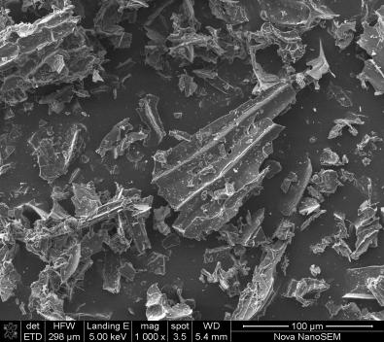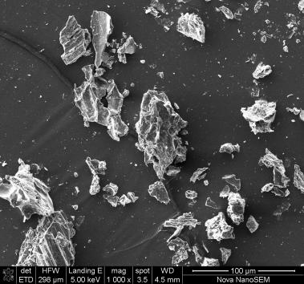
c
b
a
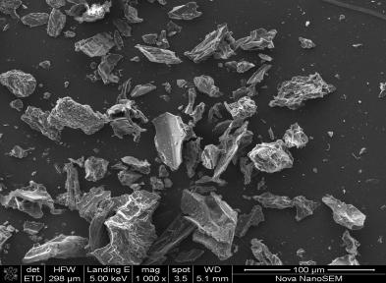
Fig. 1a: SEM micrograpsh of HB (a), PNS (b), and PSH (c) synthesized bio-sorbents

3.3.2 Energy Dispersive X-Ray (EDX) Analysis
“The EDX analysis presented in Table 4 was carried out to determine the elemental composition of the samples. Carbon was the predominant element in all the samples, Nitrogen was absent in PSH and HB, while Oxygen was highest in PSH, followed by HB. The insignificant percentage of phosphorus in HB and PSH appeared as impurities. The carbon contents from EDX analysis were slightly higher than those of CHN but practically in close range. The EDX values recorded in this studies were within the range reported for most agricultural materials” [22]. The higher the carbon content, the more desirable the material is as precursor for AC preparation. The significant value of N detected in CHN analysis but not by EDX is expected and justifiable. It is due to the high sensitivity and bulk nature of CHN verses the limited, surface-based, and Z-element insensitivity of EDX.
Table 4: EDX Analysis for activated carbon
Biomass | % C | % O | % N | % Cl | % S | % P | % Fe | % K
PSH | 79.06 | 20.84 | - | - | - | 0.1
PNS | 76.39 | 17.93 | 5.52 | 0.16 | - | -
HB | 79.20 | 20.23 | - | - | 0.22 | 0.35

3.3.3 Fourier Transform Infrared (FTIR)
“The spectrum of HB in Fig. 2a shows prominent peak at 2347.23 cm⁻¹ that is attributed to C$≡$C stretching vibration, while peaks observed at 1701.32 and 1593,67cm⁻¹ depicted C=O stretching and conjugated C=C” [2]. “The spectrum of PSH AC in Fig. 2b observed at 2920.32cm⁻¹ is attributed to C-H asymmetric stretching vibration of CH₂. Other peaks seen at 2350.40 cm⁻¹,1704.49, 1448.02 and 874.93/811.61/748.28cm⁻¹ show C$≡$C stretching vibration, C=O stretching, methyl C-H asymmetric/symmetric bending and C-H bending (out of plane) vibration respectively. The spectrum of PNS AC in Fig. 2c shows a prominent peak at 2926.65 cm⁻¹ that is attributed to C-H asymmetric stretching vibration of CH₂. A strong absorption was noticed at 2350.40, 1704.49, 1606.33 and 874.93/783.11 cm⁻¹ which indicates C$≡$C stretching vibration, C=O stretching, conjugated C=C and C-H bending (out of plane) vibration respectively. For most carbonaceous materials, C=C stretching absorption frequently occurs at ~1600 cm⁻¹ region” [29]. It is important to note that at high temperature of carbonization, some organic functional groups reappear because of post-carbonization surface oxidation during cooling, incomplete carbonization, or adsorption of atmospheric gases or moisture.

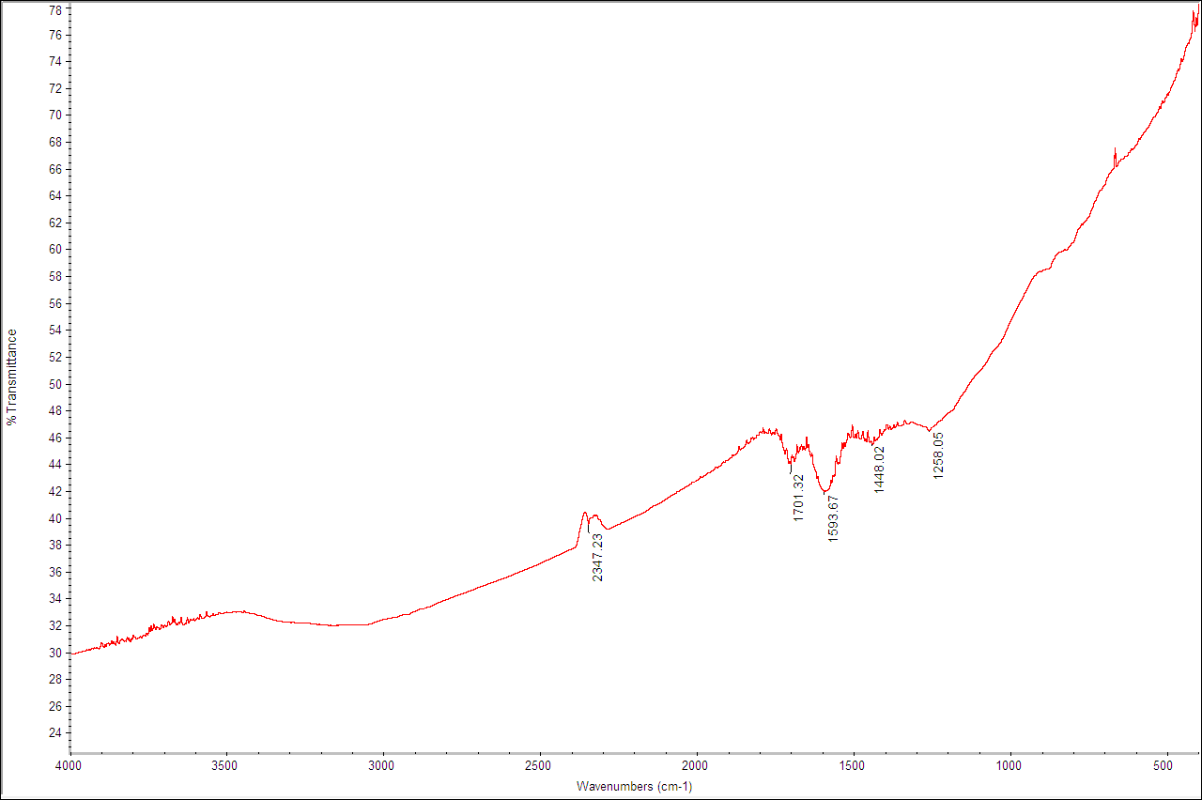
a
b
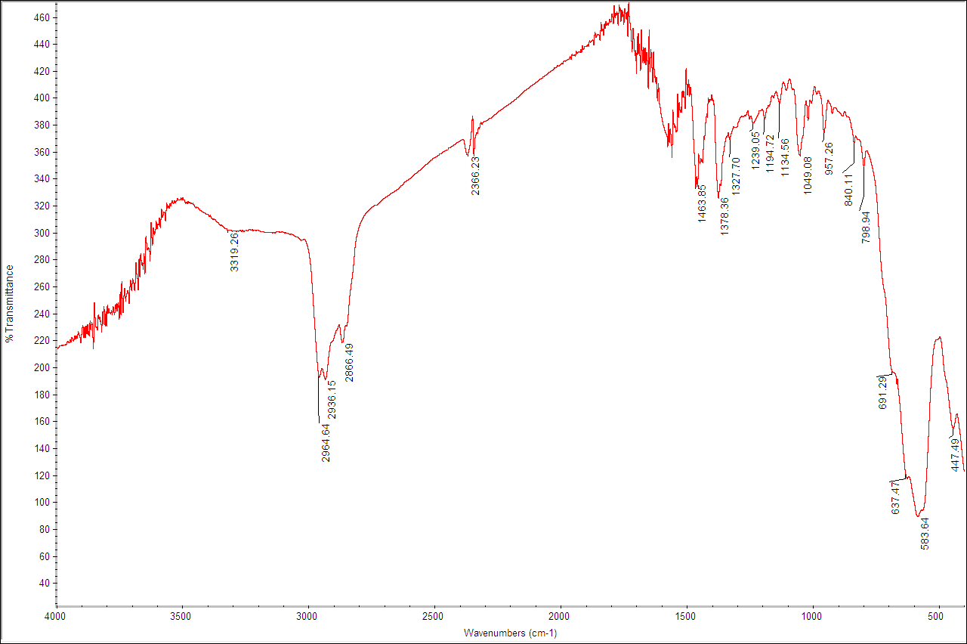
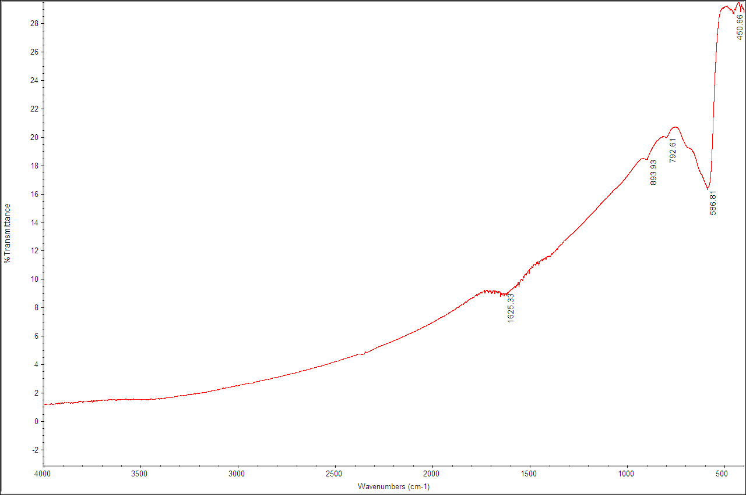
c
Fig. 2: FTIR spectra of HB (a), PNS (b), and PSH (c) synthesized bio-sorbents

Table 5: Summary of the assignments of Peaks of HB, PSH, and PNS (Etong and Abdus-Salam,2022)
HB Frequencies (cm⁻¹) | PSH Frequencies (cm⁻¹) | PNS Frequencies (cm⁻¹) | Assignment
 |  |  | O-H Stretching and bending vibration
- | 2920.32 | 2926.65 | C-H Asymmetric stretching vibration of CH₂
- | - | 2844.33 | C-H Stretching vibration of CH₃, CH₂
2347.23 | 2350.40 | 2350.40 | C$≡$C Stretching vibration
1701.32 | 1704.49 | 1704.49 | C=O Stretching
1593.67 | 1596.83 | 1606.33 | Conjugated C=C
1441.69 and 1365.70 | 1448.02 | 1448.02 and 1372.03 | Methyl C-H Asymmetric/Symmetric bend
- | 874.93/811.61/748.28 | 874.93/783.11 | C-H bending (out of plane) vibration
- | - | - | Fe-O Stretching and bending vibrations

3.4 Determination of point of zero charge (pH_{pzc})
“The pH_{pzc} is the pH at which the net charge on the surface of the adsorbent is zero. The pH_{pzc} of the three adsorbents as shown in Fig 3 were determined by pH drift method which were obtained as 7.5, 4.1, and 4.9 for HB, PSH, and PNS respectively. The adsorbents surface charge is positive at pH values lower than the pHpzc and will favour adsorption of negatively charged species. However, adsorbent surface is negatively charged at pH higher than pHpzc, except where there are other inter-playing factors. When the surface has net negative charge, it favours adsorption of positively charged species. The pHpzc for PSH and PNS are in the acidic region while HB AC sorbent is in the basic region”. (Etong and Abdus-Salam,2022)

4.0 Optimization of Adsorption Parameters
4.1 Effect of Initial Concentration of Cr(VI), Pb(II) and Cu(II) Ions
“Figs. 4a shows the effect of initial concentration of Cr(VI) ions on PSH, HB and PNS. The decrease in percentage removal may be due to the fact that at lower concentration there were more available active sites on the adsorbent that could easily be occupied by the ions. At higher concentration, there is more electrostatic repulsion between charges of Cr(VI) ions in solution, hence the actual amount adsorbed by the adsorbent increase with increasing ions concentrations which enhances the adsorption process” [30]. “The effect of initial concentration on the adsorption of Pb (II) in Fig. 4b shows the adsorption capacity of ions from aqueous phase by PSH, PNS and HB bio-sorbents. The initial q_{e} increase was followed by a fast uptake which became practically constant, and declined after the equilibrium point. Results of adsorption experiments have shown that percentage removal decreases due to an increase in the number of metal ions for a fixed number of active sites on the adsorbent” [22, 31, 65]. “Consequently, the q_{e} of the ions adsorbed per unit mass of the adsorbent decreased as concentration of ions increased due to increase in competitive adsorption on the vacant adsorbent sites” [32]. “The Fig. 4c shows that the initial concentration for Cu(II) ions resulted in increased uptake of the metal ions since at lower concentrations, the ratio of initial amount of the metal ions to the available vacant site was low” [34].

a
b

c
Fig 4: Effect of concentration of Cr(VI) [a], Pb(II) [b] and Cu(II) [c] onto PSH, PNS and PNS adsorbents
4.2 Effect of Contact Time Cr(VI), Pb(II) and Cu(II) Ions
“Fig 5 shows the effect of contact time on the adsorption of Cr (VI) ions onto PSH, PNS, and HB AC adsorbents. The results reveal that the adsorption of Cr ions onto PSH, PNS, and HB increased rapidly when the contact time was increased. The maximum adsorption was achieved in the first 30 min for all the bio-sorbents. The initial rapid increase in the q_{e} may be due to the numerous vacant sites available and equally accessible at the initial period of adsorption” [35]. The slight or insignificant change in the adsorption rate at the last stage of the adsorption time may be due to the less available active sites on the adsorbent, available for diffusion of Cr(VI) ion from the outer to the inner surface of the adsorbent particles [36]. The effect of contact time on Pb(II) and Cu(II) ions adsorption is shown in Fig. 5b and c with increased rate of adsorption in the first 20 min onto all the adsorbents. The initial increase in rate of adsorption capacity have been reported to be due to the presence of large number of diffusion sites at the initial time of adsorption process which helped to increase the adsorption rate as time progresses [35, 37]. Most reports of adsorption work in literature, are in agreement with this studies [38, 39, 40, 60, 61, 62, 65].

a
b
c
Fig 5: Effect of time on adsorption capacity of Cr(II) [a], Pb(II), and Cu(II) onto HB, PSH, and
PNS

4.3 Effect of Adsorbent Dosage Cr(VI), Pb(II) and Cu(II) Ions
The results in Figs. 6a show that the quantity of metal ions adsorbed on the three adsorbent decreased when the adsorbent doses were increased. The optimum adsorbent dose for PSH, PNS and HB was 0.1 g. Further increase in the adsorbent dose yielded no significant change on the actual number of ions removed [39]. Reports have shown that phenomenon like clogging or overlapping at higher doses were responsible for the decrease in q_{e} at higher mass doses [40]. This is because at higher adsorbent mass dose, there are more active un-occupied pore on the surface of the adsorbent during adsorption which are not accessible due to surface overlap [39].

a
b
c
Fig 6: Effect of dose on adsorption capacity of Cr(II) [a], Pb(II), and Cu(II) onto HB, PSH, and PNS
4.4 Effect of pH on Adsorption of Cr(VI), Pb(II) and Cu(II) Ions
“The Cr(VI) ions co-exist in different forms such as Cr₂O₇²⁻, HCrO₄⁻, Cr₃O₁₀²⁻, Cr₄O₁₃²⁻ of which HCrO₄⁻ predominates at pH < 6.5. Cr ions in form of CrO₄²⁻ and Cr₂O₇²⁻ predominate at pH greater than 6.5, and the stability of these ions depends also on pH values” [1]. “Fig. 7a, revealed curves with two stages of fast and slow adsorption rates. The pH between 2 - 4 and 6 - 8 represent slow adsorption while the curve between 4 - 6 represent a sharp rise in the quantity of the ions adsorbed by PSH and PNS. The higher removal at an increasing pH may be attributed to higher affinity of the adsorbent surface for the ions of the metal” [41]. “The result of pH on the adsorption of Pb (II) ion by PSH, PNS and HB are shown in Figs 7b. The result revealed an increase in adsorption capacity of the metal ions for PSH and HB between pH 2 to 7. Adsorption of the Pb(II) ions on PNS increased fast from pH 2 to 5, slows down at pH 6, and increased from pH 7 to 8. The maximum adsorption capacity was 19.402 mg/g at pH 7 for PNS. Adsorption capacity for PSH increased from pH 2 - 8, with adsorption maximum of 19.294 mg/g at pH 7, while that of HB increased from pH 2 - 6, but reduced at pH 8 with a maximum adsorption at pH 6 corresponding to 19.44 mg/g. This shows that the adsorption capacity increases as the acidity of the solution decreases” [36]. “Figs. 7c shows that 2.96 mg/g to 11.503 mg/g, 2.79 mg/g to 10.58 mg/g and 6.62 mg/g to 11.48 mg/g of Cu ions were adsorbed onto PSH, PNS and HB respectively, when the pH was increased from 2 – 8. As the pH increases, the concentration of H⁺ decreases which resulted to lesser competition between the metal and H⁺ ions for the vacant sites resulting in more adsorption of the metal ions” [36]

a
b
c

Fig. 7: Effect of pH on adsorption capacity of Cr(II) [a], Pb(II), and Cu(II) onto HB, PSH, and

4.5 Effect of Temperature on Adsorption Cr(VI), Pb(II) and Cu(II) Ions
“The adsorption capacity of Cr(VI) ions in Figs. 8a shows that at 50 ºC, HB had adsorption maxima of 5.47 mg/g, PSH had its optimum adsorption at 40 ºC with the value of 3.19 mg/g, while at 60 ºC, a value of 3.15 mg/g was recorded for PNS adsorbent. The effect of temperature on the adsorption of Pb (II) ions from aqueous solution is represented in Figs 8b. The results show that q_{e} increased as temperature was increased from 30 ºC to 70 ºC. It was observed that as the temperature increases, there was a proportionate increase in adsorption capacity of the ions, indicating that the adsorption mechanism is endothermic in nature. The increase in thermal supply results in an increase in the rate of diffusion of the metal ions through the adsorbent pores” [42]. Several mechanisms may be responsible for the increase in adsorption capacities Cr, Pb, and Cu ions onto the PHS, PNS and HB bio-sorbents as temperature was increased. A reason may be due the increase in the rates of diffusion of the ions across the external boundary as temperature increases [42]. Several works have been compared with the bio-sorbents in this current work as represented in Table 6. Though, PHS, PNS and HB adsorbents performed comparatively low for Cr(VI) ions for most bio-sorbents found in literature, the adsorbents have performed appreciably well for Pb(II) and Cu(II) ions. It is recommended that compositing these materials can increase their adsorptive capacity.

a
b
c
Fig 8: Effect of temperature on adsorption capacity of Cr(II) [a], Pb(II), and Cu(II) onto HB, PSH, and PNS

Table 6: Comparison of maximum adsorption capacity of different adsorbents
Adsorbents | Analyte | Adsorbent Capacity  q_{m} (mg/g) | Reference
Char of South African Coal (CSAC) | Cr(VI) | 0.3 | [50]
Rice bran | Cr(VI) | 0.069 | [51]
Sawdust | Cr(VI) | 15.823 | [52]
Potato peel waste | Cr(VI) | 8.012 | [53]
Bamboo dust | Pb(II) | 2.151 | [54]
Powder activated carbon | Pb(II) | 20.7 | [55]
Coconut | Pb(II) | 4.38 | [56]
Seed hull of palm tree | Pb(II) | 3.77 | [56]
Powder activated carbon | Cu(II) | 3.56 | [57]
Pomegranate peel | Cu(II) | 1.32 | [58]
Potato Peel | Cu(II) | 0.39 | [59]
Pyenoporus sanguineous | Cu(II) | 2.76 | [60]
Hildegardia barteri (HB) AC | Cr(VI) | 0.0685 | This work
Piliostigma thonningii (PSH) AC | Cr(VI) | 0.0713 | This work
Perqutinia nigrecens (PNS) AC | Cr(VI) | 0.1027 | This work
Hildegardia barteri (HB) AC | Pb(II) | 14.29 | This work
Piliostigma thonningii (PSH) AC | Pb(II) | 13.74 | This work
Perqutinia nigrecens (PNS) AC | Pb(II) | 16.67 | This work
Hildegardia barteri (HB) AC | Cu(II) | 24.88 | This work
Piliostigma thonningii (PSH) AC | Cu(II) | 17.21 | This work
Perqutinia nigrecens (PNS) AC | Cu(II) | 25.13 | This work
AcC = Activated Carbon

4.7 Adsorption Isotherm Study
“The isotherm data for the uptake capacity of the metal ions on PSH, PNS and HB were estimated using Langmuir, Freundlich, and Temkin models as listed in Table 7. The values of the Langmuir correlation co-efficient (R²) for adsorption of Cr ions unto PSH, PNS and HB show good fitness of the experimental data. These reveal that the sorption of Cr(VI) ions occurred by monolayer and homogeneous adsorption process” [43]. “The exceptionally high values of the K_{L} for the three adsorbents especially for HB suggest high energy of sorption and a possibility of chemical adsorption of Cr(VI) ions. The dimensionless separation factor, R_{L} with the values indicate favourable adsorption process for all the metal ions” [44]. “The n value for PNS for adsorption of the Cr ions is greater than one (n > 1) indicating favourable adsorption, while that of PSH and HB is less than one (n < 1) signifying normal adsorption” [45]. “Table 7 shows that the three models for adsorption of Cr ions fitted well to the adsorption data moderately with 0.5 > R² < 0.9. Comparison between R² values of Freundlich and Temkin models for adsorption of Pb ions with the Langmuir data show that the Langmuir values were much lower. Consequently, Freundlich and Temkin models fitted well to the adsorption data. The n values for Fruendlich constant, which is related to the surface heterogeneity of the adsorbent is greater than one (n > 1) for Pb(II) ions sorption indicating favourable adsorption onto PNS, HB and PSH (suggesting chemisorption). The adsorption K_{F} for Pb(II) ions implied that there were high uptake of the metal ions onto the adsorbents surfaces” [1]. The Temkin A_{T} and B with high values as represented in Table 7 indicate a strong sorbate-sorbent interaction and is consistent with ion exchange mechanism or chemical interaction between Pb(II) ions and adsorbent surfaces. The K_{L} and the R _{L} values for Pb(II) ions (0 < R_{L}< 1) indicate favourable adsorption of the ions onto PSH, PNS and HB adsorbents [20]. The adsorption data for adsorption of Cu|(II) ions fitted well into Langmuir isotherm with the R² values close to unity as indicated in Table 7. The separation factor, R_{L}, were greater than zero and less than one (0 < R_{L}< 1), indicating favourable adsorption process over the concentration range used.

Table 7: Isotherm parameters for adsorption on PSH, PNS and HB
 |  | Freundlich |  |  | Temkin |  |  | Langmuir
 |  | K_{F} (mg/g) | n | R² | A_{T}  (L/mg) | R² | R_{L} | R² | q_{m}  (mg/g)
Pb(II) | PSH | 2.3453 | 1.6818 | 0.8432 | 5.31 | 0.6889 | 0.4831 | 0.5122 | 13.74
 | PNS | 1.5977 | 2.4160 | 0.9116 | 12.23 | 0.6889 | 0.2211 | 0.6611 | 1.12
 | HB | 1.5435 | 1.9088 | 0.94571 | 11.61 | 0.6889 | 0.4276 | 0.5295 | 7.66
Cr(VI) | PSH | 20.0586 | 0.9360 | 0.7722 | 21.29 | 0.6889 | 2.43x10⁻⁵ | 0.9334 | 10.90
 | PNS | 8.6896 | 1.1031 | 0.8686 | 13.55 | 0. 253 | 9.26x10⁻⁵ | 0.9381 | 14.41
 | HB | 18.1828 | 0.9433 | 0.7532 | 26.70 | 0.7299 | 7.40x10-⁵ | 0.9977 | 13.11
Cu(II) | PSH | 1.0797 | 1.6412 | 0.9746 | 6.39 | 0.8513 | 0.4024 | 0.9481 | 17.21
 | PNS | 4.1486 | 1.2012 | 0.9809 | 15.21 | 0.8575 | 0.7407 | 0.9723 | 25.13
 | HS | 1.4538 | 1.5518 | 0.8344 | 8.26 | 0.6912 | 0.6369 | 0.9427 | 24.8

4.8 Adsorption Kinetics Study
The kinetic data revealed that the pseudo first order kinetic cannot be used to explain the uptake rate of Cr(VI), Pb(II) and Cu(II) ions onto the three adsorbents due to the low R² values, and the disagreement between q_{e,cal} and q_{e,exp} in all the adsorption cases. The R² values recorded show that the adsorption data for all the ions fitted well into pseudo second order kinetics. This is confirmed the high R² values as indicated in Table 8, which are all very close to unity. These suggest that the adsorption of ions onto the three adsorbents may be chemical processes. The data indicated for the intra-particle diffusion model revealed that the model is not the only step involved in the adsorption of the metal ions [46]. It has been established that the rate-limiting step is intra-particle diffusion if the line passes through the origin of the diffusion plot [47]. Since the plot for the model in this study did not pass through the origin, it shows that the rate-limiting step is not the intra-particle diffusion model.

Table 8: Kinetic Parameters for adsorption on PSH, PNS and HB Adsorbents
 |  | Pseudo-first-order |  |  | Pseudo-second-order |  |  | Intra-particular
 |  | k₁  (min⁻¹) | q_{ecal}  (mg/g) | R² | k₂  (gmg⁻¹min⁻¹) | q_{ecal} (mg/g) | R² | K_{id} (mg/gmin^{-0.5}) | C | R² | q_{e,exp.}
Pb(II) | PSH | -0.0142 | 34.0592 | 0.6173 | 0.0155 | 10.7032 | 0.9161 | 0.0531 | 8.8813 | 0.0064 | 11.203
 | PNS | 0.0027 | 1.9178 | 0.0617 | 0.0006.4 | 30.49 | 0.5761 | 1.4619 | 3.9743 | 0.4973 | 31.348
 | HS | -0.0047 | 2.8205 | 0.1495 | 0.0095 | 11.8343 | 0.9314 | 0.2098 | 8.5713 | 0.225 | 12.526
Cr(II) | PSH | 0.0017 | 2.6928 | 0.0399 | 0.0564 | 9.6923 | 0.9861 | 0.1066 | 6.4944 | 0.0756 | 9.825
 | PNS | 0.0029 | 1.86 | 0.0827 | 0.0045 | 8.5602 | 0.9674 | 0.467 | 2.7069 | 0.8395 | 8.87
 | HS | 0.0098 | 4.3671 | 0.6294 | 0.3172 | 7.3816 | 0.9781 | 0.0274 | 6.14 | 0.0108 | 7.925
Cu(II) | PSH | 0.0106 | 0.3019 | 0.361 | 0.014 | 11.51 | 0.9785 | -0.1189 | 12.015 | 0.2137 | 11.925
 | PNS | 0.0025 | 1.1397 | 0.012 | 0.011 | 12.60 | 0.9426 | -0.0016 | 11.597 | <<< 1 | 13.157
 | HS | 0.0026 | 3.704 | 0.046 | 0.012 | 11.32 | 0.8961 | 0.24 | 9.536 | 0.0931 | 12.83

4.9 Study of Thermodynamic of Adsorption Experiment
“The thermodynamic parameter in Table 9 shows positive values of the ΔH for HB and PNS indicating that the adsorption of Cr(VI) ions were endothermic processes, while the negative value for PSH signifies exothermic process” [47]. The value of ΔH gives an idea about the type of reaction that occurs during the adsorption process. Ackacha and Elsharif [48], reported that “if ΔH is lesser than 40 KJ/mol (ΔH < 40 KJ/mol), the adsorption may be a physical process, but values beyond this indicate a chemisorption process. The positive values of the ΔG indicate non-spontaneous nature of Cr(VI) ions adsorption, and the process becomes more favourabe as temperature increases. The positive values of the ΔS for adsorption of HB, PSH, and PNS suggest favourable adsorption, and there are no significant changes in the internal structure of the adsorbent during the adsorption of metal ions” [48]. “The negative value of the entropy change also indicates that the adsorption of Cr(VI) ions onto the three adsorbent are irreversible” [49, 64]. “The negative value of the entropy change ΔS for adsorption of Pb(II) ions onto the three adsorbents as represented in Table 9 suggest favorable adsorption processes and irreversible” [61, 62, 63]. “The positive value of ΔS shows that there is increase in randomness at the sorbent-sorbate interface during the adsorption of Cu(II) ions onto PSH, HB and PNS bio-sorbents. The magnitude of ΔH value recorded for the adsorption of Cu(II) ions onto PNS, PSH and HB respectively, suggest a physisorption process. The negativity of ΔG which becomes more negative with increase in temperature reflects the feasibility of the adsorption process but more efficient adsorption at higher temperature. Generally, ΔG for physisorption process ranges between -20 and 0 KJmol⁻¹, while chemisorption is between - 80 and - 400 KJmol^{-1”} [2, 65]. Therefore, the adsorption of Cu(II) ions onto PSH, PNS and HB is by physisorption process.

Table 9: Thermodynamic parameters calculated for the adsorption of Cr (VI) onto PSH, HB and PNS Adsorbent
 | T  (K) | ΔG  Cr(II)  (KJ/mol) | ΔS  Cr(II)  (J/mol/K) | ΔH  Cr(II)  (KJ/mol) | ΔG  Pb(II)  (KJ/mol) | ΔS  Pb(II)  (J/mol/K) | ΔH  Pb(II)  (KJ/mol) | ΔG  Cu(II)  (KJ/mol) | ΔS  Cu(II)  (J/mol/K) | ΔH  Cu(II)  (KJ/mol)
HB | 303 | -9.76 | +0.320 | +0.067 | 7.767 | +0.261 | +0.137 | -7.148 | +0.236 | +0.005
HB | 313 | -10.08 |  |  | 8.028 |  |  | -7.390
HB | 323 | -10.40 |  |  | 8.289 |  |  | -7.626
HB | 333 | -10.72 |  |  | 8.550 |  |  | -7.862
 | 343 | -11.04 |  |  | 8.811 |  |  | -8.089
PSH | 303 | -9.43 | +0.317 | +0.168 | 7.286 | +0.244 | +0.095 | -6.364 | +0.210 | +0.002
 | 313 | -9.74 |  |  | 7.530 |  |  | -6.574
 | 323 | -10.06 |  |  | 7.773 |  |  | -6.784
 | 333 | -10.38 |  |  | 8.017 |  |  | -6.994
 | 343 | -10.69 |  |  | 8.261 |  |  | -7.204
PNS | 303 | -11.47 | +0.378 | +0.025 | 5.506 | +0.188 | +0.178 | -5.805 | +0.193 | +0.040
 | 313 | -11.84 |  |  | 5.694 |  |  | -5.998
 | 323 | -12.22 |  |  | 5.881 |  |  | -6.190
 | 333 | -12.60 |  |  | 6.069 |  |  | -6.383
 | 343 | -12.98 |  |  | 6.256 |  |  | -6.576

5.0 Conclusion
The study evaluates adsorptive removal of Pb(II), Cu(II), and Cr(VI) ions from aqueous solution onto Piliostigma thonningii (PSH), Perqutinia negrecrecens (PNS), and Hildegardia barteri (HB) activated carbon bio-sorbents. Activation of the raw materials with orthophosphoric acid (H₃PO₄) led to carbons with high energy adsorption pores. Adsorption of the metal ions were found to rise significantly with increase in temperature and pH values between 6 and 7 especially for Pb and Cu ions. In general, The Langmuir adsorption isotherm and pseudo-second-order kinetics models were found to fit well to adsorption of the metal ions from the aqueous phase. The thermodynamic investigation revealed an increasing randomness, spontaneous, and endothermic in nature of the adsorption process. This is important in terms of design and fabrication of systems for treatment of wastewater in an industrial or a large-scale purpose. The result demonstrated that the activated carbon bio-sorbents from the three biomasses have the potential to be employed as low-cost adsorbents.
Conflict of Interest
The authors declare that there is no conflict of interest amongst the authors.
Declaration of generative Artificial intelligence
Author(s) hereby declare that NO generative AI technologies such as Large Language Models (ChatGPT, COPILOT, etc.) and text-to-image generators have been used during the writing or editing of this manuscript.

References
- John G, Abdus-Salam N, Adegoke IH, Njimou JR, Akor EJ, Etong ID. (2022a) Two Step Fabrication of Nano-ZnO-α-FeOOH Composite for Experimental and Modeling Studies of Removal of Indigo Carmine and Alizarin Red S in Batch Process. Chemistry Africa; Springer; 2022; 1–15.
- Abdus-Salam, N., Adekola, F.A. and Apata, A.O. (2010). A Physicochemical Assessment of Water Quality of Oil Producing Areas of Ilaje, Nigeria. Advances in Natural and Applied Sciences, 4(3): 333-344.
- John G., Abdus-Salam N., Panda P. K., and Tripathy B. C. (2020). Special Crystal Growth and Nucleation process of Zinc Oxide Nanoparticles from Urea Solution for Efficient Removal of Pb(II) and Alizarin Red S. May 22. Preprint available at Research Square. https://doi.org/10.21203/rs.3.rs-1625280/v1.
- Bernard, E., Jimoh, A. and Odigure, J.O. (2013) Heavy Metals Removal from Industrial Wastewater by Activated Carbon Prepared from Coconut Shells, Research Journal of Chemical Science, 3(8):3-9.
- Musa, M., Kikuchi, A., Abdul Majid, Z., Jaafar, J., Salim M. R., and Ismail, N. E. (2013). Production of sugarcane bagasse based activated carbon for Cd²⁺ removal using factorial design. International Journal of Innovative Technology and Exploring Engineering. (IJITEE), 2(4): 121-125.
- Sethu, V.S., Kua, Y. L., Quek, W. S., Lim, K. V. and Andresen, J. M. (2011). Adsorption Thermodynamics of Cu²⁺ ions from Waste water using Neem-Leaf Base Biosorbents. Journal of Environmental. Research and Development. 6(1), 26-33.
- Elaigwu, S.E., Usman, L.A., Awolola, G.V., Adebayo, G.B. and Ajayi, R. M. K. (2009). Adsorption of Pb(II) from Aqueous Solution by Activated Carbon Prepared from Cow Dung. Advances in Natural and Applied Sciences, 3(3): 442-446.
- Aningo, Gloria N., Abdulrazaq Yahaya, Rotimi A. Larayetan, Gideon Ayeni, Abdulraham O. C. Aliyu, John Godwin, and Clifford B. Okpanachi. 2025. “Isotherms, Kinetics and Thermodynamics of Removal of Pb (II), Cd (II) and Cr (III) Ions in Wastewater onto Green Silver Nanoparticle Adsorbent”. Journal of Applied Chemical Science International; 16 (1):11-25. https://doi.org/10.56557/jacsi/2025/v16i19086.
- Alkali, M.I., Abdus-Salam, N., Dikwa, M.K., Oyewumi-Musa, R.T., Jimoh, A.A., Ojo, I. and John G. (2022). Adsorption of Pb (II) ion onto Modified Doum Palm (Hyphaenethebaica) Shells: Isotherm, Kinetic and Thermodynamic Studies. Arid Zone Journal of Basic and Applied Research; 1(5), 2022: 80-102. doi.org/10.55639/607gfedc.
- John G. (2025). Hydrothermal Synthesis of Mixed Nanocomposite of α-[Fe₂O₃-FeOOH] from Iron Nitrate Salt in Teflon Autoclave. Journal of Materials Science and Engineering and Technology. 3(1): 1-4. DOI: doi.org/10.61440/JMSET.2025.v3.32.
- John G., Jacques R. N., Abdus‑Salam N., Adegoke H. I., Prasanna K. P., Bankim C. T., Sanda A. M. (2023)..Nanosorbent Based on Coprecipitation of ZnO in Goethite for Competitive Sorption of Cd(II)‑Pb(II) And Cd(II)‑Pb(II)‑Ni(II) Systems. Journal of Environmental Health Science and Engineering. https://doi.org/10.1007/S40201-023-00882-x.
- John G., Abdus-Salam N., Adegoke I. H., Mojeed O. B., Etong D. I,, Mamman I. A., Bankim C. T. (2022). High performance nanohybrid ZnO-α-FeOOH nanocomposite prepared for toxic metal ions removal from wastewater: Combined sorption and desorptionstudies. Inorganic Chemistry Communication. https://doi.org/10.1016/j.inoche.2022.109900.
- Hesse, P.R., (1997). A textbook of soil analysis, illustrated. Chem. pub. Co. John Murray, London, 520.
- Dara S.S. (2006). Experiments and Calculations in Engineering Chemistry, 11th revised edition S. Chand and Co. Ltd, New-Delhi, 189-191.
- Fapetu, O. (2000). Production of carbon from biomass for industrial and metallurgical Process. Nigerian Journal of Engineering Management, 1(2): 34-37
- Yoshiguki, S. and Yukata, K. (2003). Pyrolysis of plant, Animal and human waste: Physical and Chemical Characterization of the Pyrolytic Product. Bioresource Technology, 90 (3): 241-247.
- Subhashree, P. (2011). Production and Characterization of activated Carbon Produced from a Suitable Industrial Sludge. B.Sc Project report submitted to Department of chemical Engineering National Institute of Technology, Rourkela, 1-50.
- ASTM D4607-94 (2006). Standard test method for determination of iodine number of activated carbon.
- John G, Abdus-Salam N, Adegoke HI, Panda PK, Panda J, Tripathy BC (2022). Facile synthesis of rod-like α-FeOOH nanoparticles adsorbent and its mechanism of sorption of Pb(II) and indigo carmine in batch operation. Inorganic Chemistry Communication. https://doi.org/ 10.1016/j.inoche.2022.109346.
- Abia, A.A. and Asuquo, E.D. (2006). Lead (II) and Nickel (II) adsorption kinetics from aqueous metal solutions using chemically modified and unmodified agricultural adsorbents. Africa Journal of Biotechnology, 5(16): 1475-1482.
- John G., Njimou JR, Nasalam A-S, Kumar Panda P, Tripathy BC, Kumar Ghosh M. (2022b). Nanoscale ZnO-adsorbents carefully designed for the kinetic and thermodynamic studies of Rhodamine B. Inorg Chem Commun. 2022; 109287.
- Eldin Mohy M.S, Aly K. M., Khan Z. A., Mekky A. E. M., Saleh T.S.and Al-Bogami A. S. (2016). Removal of methylene blue from synthetic aqueous solutions with novel phosphoric acid-doped pyrazole-g-poly (glycidyl methacrylate) particles: kinetic and equilibrium studies, Desalination and Water Treatment, 2016: 1-16
- Losso N.J., Ng, C. Marshall, E. M. and Rao, M. R. (2002). Physical and chemical properties of agricultural by-product based activated carbons and their ability to adsorb geosmin. Bioresources and Technology, 84:177 – 185.
- Seo W.C., Kermit, W., Yang, H., and Marshall E. W. (2006). Selected metal adsorption by activated carbon made from peanut shells, Bioresources and Technology, 97:2266-2270
- Abechi S.E., Gimba, C. E. Uzairu A. and Dallatu Y. A.(2013a). Preparation and characterization of activated carbon from palm kernel shell by chemical activation, Research Journal of Chemical Sciences, 3 (7):54 – 61.
- Dina, D.J.D., Ntieche, A.R., Ndi, J. N. and Ketcha, M. J. (2012). Adsorption of acetic acid onto activated carbons obtained from maize cobs by chemical activation with zinc chloride (ZnCl₂). Research Journal of Chemical Sciences, 2 (9):42-49.
- Sugumaran, P. ,Priya, S. V., Ravichandran, P., and Seshadri, S.(2012).Production and Characterization of Activated Carbon from Banana Empty Fruit Bunch and Delonix regia Fruit Pod. Journal of Sustainable Energy and Environment 3(2012):125 – 132.
- Ioannidou, O. and Zabaniotou, A. (2007).”Agricultural residues as precursor for Activated Carbon Production: A Review” Renewable and Sustainable Energy Reviews. 11:1966-2005.
- Harikumar, P. S. and Joseph, L. (2012).Kinetic and Thermodynamics Studies of As(III) Adsorption onto Iron Nanoparticles Entrapped Ca- Alginate Beads. International Journal of Plant, Animal and Environmental Sciences 2(1): 159 – 166.
- Florido, A.C., Valderrama, J. A., Arevalo, I.,Casas, M. Martinez and N. Miralles (2009). “Application of Two Sites Non-Equilibrium Sorption Model for the Removal of Cu (II) onto Grape Stalk Wastes in a Fixed-Bed Column” Chemical Engineering Journal 156:298-304.
- Ghorbani, F., Younesi, H., Ghasempouri, S.M., Zinatizadeh, A.A., Amini, M. and Daneshi, A. (2008). Application of response surface methodology for optimization of cadmium biosorption in an aqueous solution by Saccharomyces cerevisiae. Chemical Engineering Journal, 145(2): 267-275.
- Senthilkumar, R., Vijayaraghavan, K., Thilakavathi, M., Iyer P.V.R. and Velan, M. (2007) .Application of seaweeds for the removal of lead from aqueous solution, Biochemistry Engineering Journal, 33:211-216.
- Agbozu, I. E. and Emoruwa F. O. (2014).Batch adsorption of heavy metals (Cu, Pb, Cr, Fe, and Cd) from aqueous solution using coconut husks. African Journal of Environmental Science and Technology, 8(4): 239-246.
- Gongden, J. J., Lohdip, Y.N. and Nnebedun, J. (2014). Kinetic Equilibrium and thermodynamic assessment of the adsorption of cadmium using waer lilly (Nymphaea ampla) root biomass. Journal of Physical Science and Environmental Safty, 4(1): 33-50.
- Shirsath, D.S. and Shrivastava, V. S.(2012).Removal of hazardous dye panceous by using chitin: an organic bioadsorbent, African Journal of Environmental Science and Technology, 6(2): 115-124.
- Wong, C. H., Sharma, Y.C., and Chu, S. H. (2009).Adsorption of Cr (VI) from aqueous solution by spent activated clay. Journal of hazardous materials, 155(1):65-75.
- Dubey, A. and Shiwani, S. (2012). Adsorption of lead using a new green material obtained from portulaca plant. International Journal of Environmental Science and Technology, 9(1): 15-20.
- Lingamdinne, L. P., Roh, H., Choi, Y. L., Koduru, J. R., Yang, J.K., and Chang, Y. Y., (2015).Influencing factors on sorption of TNT and RDX using rice husk biochar. Journal of Industrial and Engineering Chemistry, 32:178-186.
- Kanchana, V., Gomathi, T., Geetha, V., and Sudha, P. N. (2012). Adsorption analysis of Pb (II) by nanocomposites of chitosan with methyl cellulose and clay. Pharmacia Lettre, 4(4): 1071-1079.
- Fatemeh, G. F and Bahri, R. A. M. (2017). Adsorption of Cr (VI) from aqueous solution by adsorbent prepared from paper mill sludge: Kinetics and thermodynamics studies. Adsorption Science and Technology, 0(0):1-21.
- Radina, O., Obiageli, N. and Ajemba, U. (2012). Kinetic and equilibrium modeling of lead II and Cr (VI) ions adsorption onto clay, Turkish Journal of Engineering and Environmental Science, 38:455-479.
- Sumanjit, T. P. S. W. and Ishu, K. (2007).”Removal of Rhodamine –B by Adsorption on Walnut Shell Charcoal”. Journal of Surface Science and Technology, 24(3-4):179 – 193.
- Hasan, S.H., Singh, K. K., Prakash, O., Talat, M. and Ho, Y. S. (2008). Removal of Cr (VI) from aqueous solution using agricultural waste “maize bran”. Journal of Hazardous Material, 152(1): 356 – 365.
- Lekene, N. R. B., Kouoh, S. P. M. A., Ndi, N. J., Kouotou, D., Belibi, P. D. and Ketcha, M. J.(2015). Kinetics and equilibrium studies of the adsorption of phenol and methylene blue onto cola nut shell based activated carbon, International Journal of Current Research and Review, 7(9):1- 9.
- Krishna, D. and Padma, S. R (2013). Removal of chromium from aqueous solution by custard apple (Annona squamosa) peels powder as adsorbent.International Journal of Applied Science and Engineering, 11(2):171 – 194.
- Goldberg, S. (2005).Equations and models describing adsorption processes in soils, “Soil sciences society of America”677 S. Segoe road, Madison, USA. Chemical Processes in Soils. SSSA Books Series, no. 8.
- Saha, S., Chowdhury, S. and Gupta, K. I. (2010). Insight into adsorption equilibrium, kinetics and thermodynamics of Malachite Green onto clayey soil of Indian origin, Chemical Engineering Journal, 165(3):874-882.
- Dogan, M. Alkan, M.,Turkyilmaz, A. and Ozdemir, Y. (2004). Kinetic and mechanism of removal of methylene blue by adsorption onto Perlite, Journal of Hazardous Materials, B109: 141 – 148.
- Ackacha, M. A. and Elsharif, L. A. (2012).Adsorption removal of lead ions by Acacia tortilis leaves: Equilibrium, kinetics and thermodynamics. International Journal of Environmental Science and Development, 3(6): 584 s– 600.
- Elsay, M., Menberu, Y. and Tesfaye, R. S. (2015). Kinetics and thermodynamic studies of the adsorption of Cr (VI) onto some selected local adsorbents, South African Journal of Chemistry, 68:45 – 52.
- Di Natale, F., Lancia, A., Molino, A. and Musmarra, D. (2007). Removal of chromium ions from aqueous solutions by adsorption on activated carbon and char, Journal of Hazardous Materials, 145: 381-390.
- Hsu, N.H., Wang, S. L., Liao, Y.H., Huang, S.T., Tzou, Y.M. and Huang, Y.M. (2009). Removal of hexavalent chromium from acidic aqueous solution using rice straw-derived carbon, Journal of Hazardous Materials, 171: 1066-1070
- Dakiky, M., Khamis, M., Manassra, A. and Mer’eb, M. (2002). Selective adsorption of chromium (VI) in industrial wastewater using low cost abundantly available adsorbents, Advances in Environmental Research, 6: 533-540.
- Abdullah, M. A. and Devi, P.A.G. (2009). Kinetic and equilibrium studies for the biosorption of (VI) from aqueous solutions by potato peel waste, International Journal of Chemical Engineering Resource, 1: 51-62.
- Kannan, N. and Veemaraj, T. (2009). Removal of Pb (II) ions by adsorption onto bamboo dust and commercial activated carbons – a comparative study, Electronic Journal of Chemistry, 6(2): 247-256.
- Goel, J., Kadirvelu, K., Rajagopal, C.and Garg, V. K. (2005). Removal of lead (II) by adsorption using treated granular activated carbon: batch and column studies, Journal of Hazardous Materials, 125 (1): 211-220.
- Gueu, S., Yao, B. and Adouby, K. (2007). Kinetics and thermodynamics study of lead adsorption onto activated carbons from coconut and seed hull of palm tree, International Journal of Environmental Sciences and Technology, 4(1): 11-17.
- Machida, M., Aikawa, M. and Tatsumoto, H. (2005). Prediction of simultaneous adsorption of Cu (II) and Pb (II) onto activated carbon by conventional Langmuir type equations, Journal of Hazardous Materials, 120: 271-275.
- El-Ashtoukhy, E. S. Z., Amin, N. K. and Abdelwahab, O. (2008). Removal of lead (II) and copper (II) from aqueous solution using pomegranate peel as a new adsorbent, Desalination, 223: 162-173.
- Aman, T., Kazi, A.A., Sabri, M.U. and Bano, Q. (2008) “Potato peels as solid waste for the removal of heavy metal copper (II) from waste water/industrial effluent,” Colloids and surface B, 63 (I):116-121.
- Yahaya, Y.A., Don, M.M. and Bhatia, S. (2009). Biosorption of copper (II) onto immobilized cells of Pycnoporus sanguineus from aqueous solution: equilibrium and kinetic studies, Journal of Hazardous Materials, 161: 189-195.
- Sravanthi, K., Ayodhya, D., & Yadgiri Swamy, P. (2018). Green synthesis, characterization of biomaterial-supported zero-valent iron nanoparticles for contaminated water treatment. Journal of Analytical Science and Technology, 9(1), 1-11. https://link.springer.com/article/10.1186/s40543-017-0134-9.
- Saleh, T. A. (2021). Protocols for synthesis of nanomaterials, polymers, and green materials as adsorbents for water treatment technologies. Environmental Technology & Innovation, 24, 101821. https://www.sciencedirect.com/science/article/pii/S2352186421004697.
- J. R. Njimou, J. Godwin, H. Pahimi., A. Maicaneanu, F. Kouatchie-Njeutcha, B. C. Tripathy, A. Talla, T. Watanabe, and N. G. Elambo (2021). Biocomposite spheres based on aluminum oxide dispersed with orange-peel powder for adsorption of phenol from batch membrane fraction of olive mill wastewater. Colloid and Interface Science Communications; 42 (2021); 100402. tps://doi.org/10.1016/j.colcom.2021.100402.
- John Godwin, Nasir Abdus-Salam, Adegoke Iyabode Haleemat, Mojeed Olalekan Bello, Etong Daniel Inyang, Mamman Ibrahim Alkali, Bankim Chandra Tripathy (2022). High performance nanohybrid ZnO-α-FeOOH nanocomposite prepared for toxic metal ions removal from wastewater: Combined sorption and desorptionstudies. Inorganic Chemistry Communication. https://doi.org/10.1016/j.inoche.2022.109900.
- Etong, D. I., & Abdus-Salam, N. (2022)EQUILIBRIUM SORPTION OF METHYLENE BLUE FROM AQUEOUS SOLUTION USING PSH, PNS AND HB ACTIVATED CARBON. FUW Trends in Science & Technology Journal.7(3) 24085162

