Climate Change and Livestock Production in Semi-Arid Regions: The Untapped Potential of Climate-Resilient Forages

ABSTRACT
Climate change poses significant challenges to livestock production in the world's semi-arid regions. Rising temperatures, unpredictable precipitation, and frequent drought events contribute to reduced forage availability, thereby intensifying the socio-economic vulnerability of livestock-dependent households in semi-arid regions. The aim of this opinion article is to assess the potentials of the climate-resilient forages; like Chloris gayana, Cenchrus ciliaris, and Cenchrus sitigerus; arguing that their underutilization is a critical oversight in the quest to fortify livestock systems. These hardy forages stand as sentinels of year-round feed security, breathing life back into depleted soils and playing a vital role in curbing greenhouse gas emissions. Beyond mere sustenance, these grasses bestow a wealth of ecological blessings, nurturing pastoral livelihoods and offering a lifeline to communities in distress. By staving off livestock mortality, diminishing the reliance on costly imported feeds, and injecting stability into precarious production systems, these forages emerge as indispensable allies. Moreover, cultivating these forages locally can quell conflicts sparked by resource scarcity and cultivate a climate of resilience in at-risk societies. While acknowledging the hurdles of adoption—rooted in cultural norms and resource constraints—this piece underscores that community engagement, governmental backing, and precisely targeted assistance can pave the way for widespread utilization. In essence, drought-tolerant forages serve as a linchpin, forging an unbreakable bond between sustainable livestock production and climate change adaptation, transforming vulnerability into a wellspring of resilience for the vast majority of pastoralists dwelling in semi-arid landscapes.

Keywords: Climate change, Climate-resilient forages, Livestock production, Sustainable farming, Semi-arid regions.

- INTRODUCTION
Livestock producers in semi-arid regions increasingly face challenges associated with climate change, including prolonged dry seasons, reduced water availability, and declining pasture quality. These conditions threaten the sustainability of traditional livestock production systems and have profound implications for food security, livelihoods, and resilience in affected communities.
Climate change is a current and urgent crisis driven by various anthropogenic activities. Deforestation, primarily for agriculture and development, releases substantial amounts of stored carbon into the atmosphere. Land use changes, including urban expansion and unsustainable agricultural practices, further disrupt ecosystem stability. The combustion of fossil fuels, which underpins modern industry, contributes significantly to the increase of greenhouse gases (GHGs). Additionally, intensive agriculture; with its dependence on fertilizers and mechanization, adds to GHG emissions (Kabir et al., 2023). Collectively, these activities have elevated atmospheric concentrations of methane, carbon dioxide, and nitrous oxide, enhancing the greenhouse effect and accelerating global warming.
The consequences of this warming trend are far-reaching and devastating, particularly for the agricultural sector, with livestock production bearing the brunt of the impact (Cheng et al., 2022). Climbing temperatures, erratic rainfall patterns, and prolonged dry spells are transforming landscapes, shrinking rangelands, and jeopardizing the delicate balance of forage availability. This manifests in reduced forage quality, diminished biomass, and widespread forage degradation, leaving livestock vulnerable to malnutrition and suffers from deficiency diseases. If we fail to prioritize resilient forage systems, semi-arid pastoral communities will continue to face a recurring cycle of forage shortages, livestock deaths, and dwindling household incomes (Habte et al., 2022). The ripple effects of this crisis extend far beyond the farm, impacting food security, economic stability, and social cohesion.
In our opinion, to effectively tackle the issue of climate change in livestock rearing, climate-resilient forage emerges as a vital, yet often overlooked, solution for sustaining livestock production in semi-arid regions. While significant attention is directed towards veterinary care, livestock breeds, and breeding programs, the fundamental element of animal survival; their sustenance, is frequently neglected. This opinion article posits that climate-resilient livestock grass can ensure year-round feed security, bolster household economies, rehabilitate degraded ecosystems, and serve as the crucial link for sustainable livestock production in semi-arid locations (Mganga et al., 2024). These forages are not merely a source of nutrition; they are a cornerstone of resilience, offering a pathway towards a more sustainable and secure future for pastoral communities.
Semi-arid regions, spanning across parts of Sub-Saharan Africa, Latin America, and Asia, provide homes for millions of livestock keepers and smallholder farmers. These regions, characterized by their limited rainfall and harsh environmental conditions, are particularly vulnerable to the impacts of climate change. Among the pastoralist communities that inhabit these areas are the Somali, Samburu, and Masai, each with their unique cultural heritage and deep-rooted connection to the land. These communities rely almost entirely on livestock for their livelihoods, deriving essential resources such as meat, hides and skins, milk, and income from their herds. As a natural pattern, natural forages typically provide adequate pastures during the rainy seasons, with some reserves carrying over into the dry spells, sustaining livestock through periods of scarcity. However, climate change is disrupting this delicate balance, throwing traditional grazing patterns into disarray and threatening the very survival of these communities (Tulu et al., 2023).
The Inter-governmental Panel on Climate Change (IPCC) has issued stark warnings about the accelerating impacts of climate change in semi-arid regions (IPCC, 2022). According to their findings, these regions are experiencing temperature increases at a rate faster than the global average, with rainfall patterns becoming increasingly unpredictable and erratic. In Sub-Saharan Africa alone, the frequency of droughts has tripled in the past three decades, while rangeland productivity has declined sharply (Thornton et al., 2024). This alarming trend poses a direct threat to livestock production, as forage resources dwindle and grazing lands become increasingly barren. As forage resources decline, livestock production suffers, creating a cascade of negative consequences. Milk production diminishes, hindering the nutritional well-being of families and reducing income from sales. The growth rates of animals decelerate, delaying maturity and reducing their market value. Mortality rates increase, decimating herds and plunging families into deeper poverty. Food insecurity worsens, as communities struggle to access adequate sources of nutrition. Simultaneously, demand for animal-sourced foods is on the rise, driven by urbanization and population growth. Meeting this growing demand in the face of dwindling forage supplies requires innovative solutions, and drought-resilient forages offer a promising pathway forward. By investing in these resilient resources, we can help pastoral communities adapt to the challenges of climate change, secure their livelihoods, and ensure a more sustainable future for all.
MAIN ARGUMENTS
  - Climate-resilient forages guarantee year-round feed security.
Conventional grasses and natural grasslands, including Napier grass and alfalfa, often struggle to thrive during prolonged droughts. This is primarily because they require substantial rainfall to achieve optimal yields. In contrast, enhanced drought-tolerant forages like Chloris gayana (Rhodes grass), Cenchrus setigerus, and Cenchrus ciliaris (buffel grass) exhibit superior adaptation to arid climatic conditions and regions with limited rainfall (Jimoh et al., 2021). Research conducted in East Africa demonstrates that these resilient grasses not only endure drought conditions but also exhibit rapid regeneration following brief periods of rainfall (Figure 1). To maintain year-round stability, it is crucial to establish fodder banks, silage, haylage, and hay reserves, alongside implementing rotational grazing practices for sustaining livelihood securities and animal welfare issues. By adopting these strategies, livestock keepers can effectively bridge the critical dry-season to fill the gap. Such measures also diminish reliance on expensive purchased feeds, promote improved animal nutrition, and stabilize overall animal production.
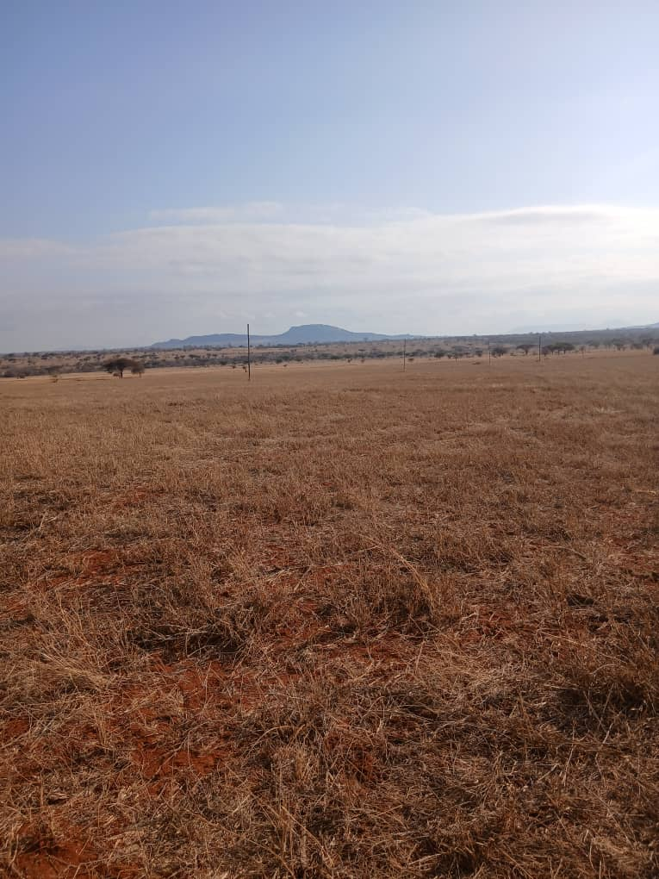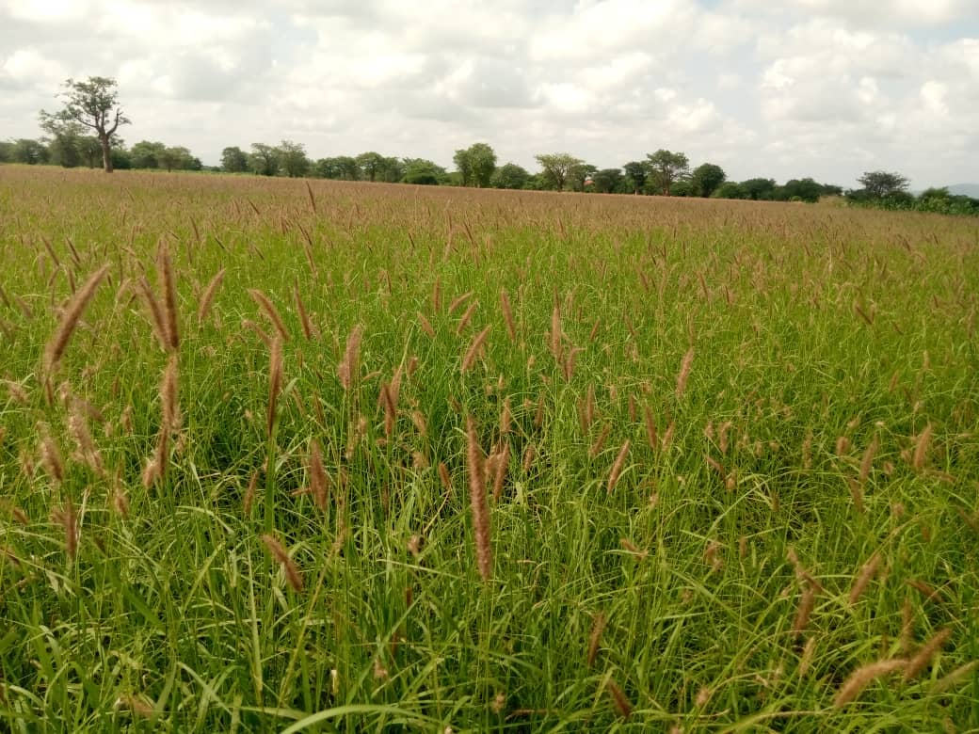
Figure 1: Cenchrus ciliaris pasture, TALIRI Kongwa, Dodoma, Tanzania. Demonstrates post-cut and post-rainfall regeneration in a semi-arid climate.
  - Forages assist both food security and reduce the effect of climate change
Beyond their primary use as animal feed, these climate-resilient forages offer valuable ecosystem services. As predominantly perennial grasses, they significantly enhance soil cover and contribute to mitigating greenhouse gas emissions. A report by the FAO (2020) indicates that improved forage systems can increase soil carbon stocks by up to 2,000 kilograms (2 tons) per hectare annually. For livestock keepers, this translates to healthier rangelands, enhanced animal productivity, and a contribution to the global climate change mitigation goal by reducing greenhouse gas emissions. Furthermore, integrating these forages with food crops allows farmers to improve soil fertility and diversify their food resources (Bernard et al., 2015).
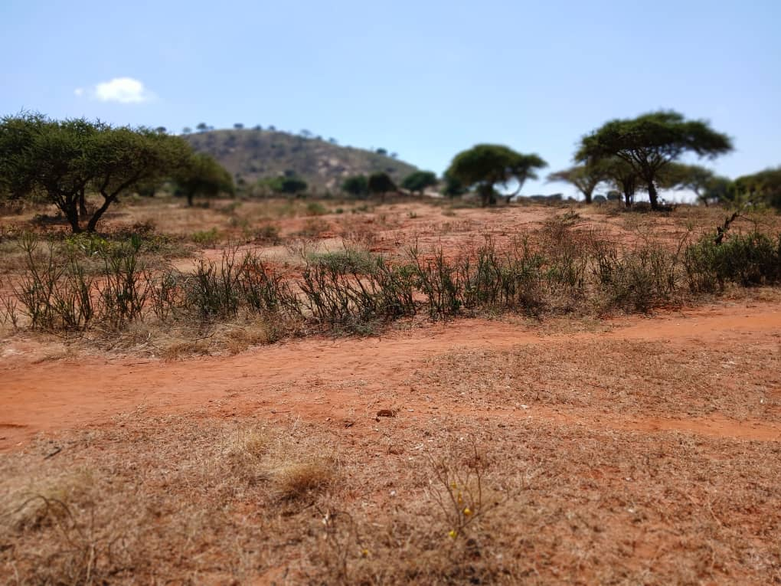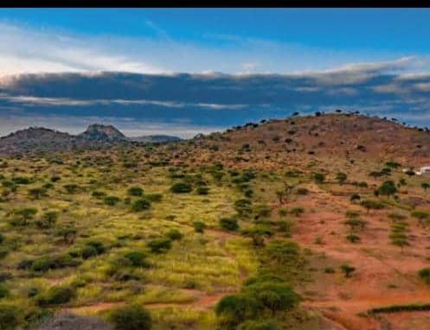
Figure 2: The degraded rangeland, pre and post restoration by Cenchrus ciliaris in Simi-arid region Kongwa district, Dodoma- Tanzania
  - Economic prosperity for pastoralists
The economic rationale for utilizing resilient forage grasses is compelling. During dry spells, livestock keepers often face the difficult choice of selling their animals at reduced prices or purchasing costly feeds to sustain them (Trail & Ward, 2024), both of which negatively impact household finances. For example, in Ethiopia, households can lose up to 50% of their cattle during severe droughts (Dika et al., 2023). Resilient grasses mitigate this vulnerability by providing a consistent and renewable feed source. In Kenya, pastoral communities that have adopted improved grasses have reported reduced livestock mortality and increased milk and meat yields, resulting in improved household incomes (Oscar Kipchirchir, 2015). Thus, by lowering production costs and stabilizing outputs, resilient forages serve as a buffer against both market and climate-related shocks (Kisambo et al., 2023). This not only enhances family income but also contributes to reducing greenhouse gas emissions.
  - Resilient forages minimize conflict over scarce resources
In many pastoralist societies, conflicts between livestock keepers and crop cultivators are common. Adopting these drought-tolerant forages can help minimize disputes over scarce resources such as water, grazing lands, and feed (Bernard et al., 2015). In numerous semi-arid regions, feed shortages are not only an economic issue but also a significant security concern. Competition for dwindling rangelands often exacerbates conflicts among pastoral communities (Peerzada et al., 2017; Sharma et al., 2025). By establishing localized pasture production through community-managed forage banks or agro-pastoral integration, mobility pressures can be reduced, thereby lowering the risk of conflict.
- COUNTERARGUMENT AND REBUTTAL
Criticism 1: Resource Needs of Drought-Tolerant Forages
While it is reasonable to suggest that drought-tolerant forages require scarce resources such as water, land, and capital, this perspective appears short-sighted. Most resilient forages can thrive on marginal or degraded lands that are unsuitable for food crops (Basharat et al., 2024). Furthermore, establishing pasture plots requires a one-time initial investment, with yields that can be sustained for many years (Thivierge et al., 2023). Although initial efforts may require more energy and focus, subsequent years involve only simple maintenance, such as weeding. With appropriate support from governments and NGOs, the adoption of these forages can be scaled affordably.

Criticism 2: Cultural Reluctance to Adopt New Forage Technologies
In many pastoral societies, residents are often reluctant to adopt new technologies and innovations. Some communities believe that ruminant animals should graze exclusively on natural grasslands, without the need for planted forages. Consequently, many pastoralists do not see a role for new forage species in their livestock rearing practices (Ndiritu, 2021). This cultural attachment to traditional practices is significant, although participatory approaches may offer a promising solution. By engaging communities in the selection, scaling, testing, and adoption of forages, agricultural extension services and farmer-to-farmer knowledge sharing can bridge this gap (Njarui et al., 2021).
Criticism 3: The Impact of Extreme Climate Change on Forage Effectiveness
It’s clear known that climate change effects are extreme especially in semi-arid regions, in the context of increase temperature and erratic rainfall, figure 2 While it is true that no single solution can completely neutralize the impact of climate change (Giridhar & Samireddypalle, 2015). Drought-tolerant forages represent one of the most scalable, practical, and immediate tools available. When combined with water harvesting, rotational grazing, and the use of livestock breeds resilient to climate change effects, these strategies can significantly reduce vulnerability (Yator, 2024).
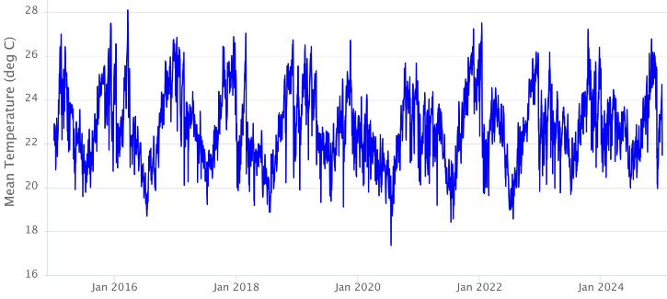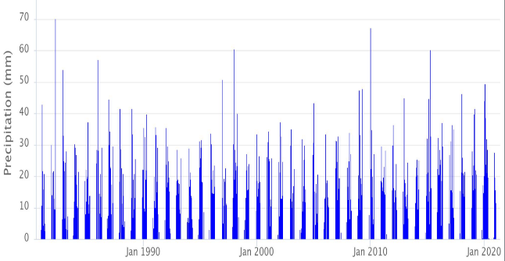

Figure 3: The trend of temperature (⁰C) and rainfall (mm) in the semi-arid region of East Africa (Dodoma, Tanzania) Source, Climate engine

- CONCLUSION
Livestock production in semi-arid regions is challenged by the intertwined effects of climate change, soil degradation, and population growth, which collectively threaten the resilience and sustainability of pastoral systems. According to resilience theory, adaptive capacity depends on the ability of systems to absorb disturbances while maintaining function. Our findings underscore that investing in climate-resilient forage species enhances this adaptive capacity by stabilizing feed availability and restoring degraded ecosystems.
However, a critical gap remains in integrating forage-based adaptation strategies with broader mitigation efforts and sustainable production practices, as highlighted in socio-ecological frameworks. To bridge this gap, we recommend: effectively support the sustainability of livestock production in semi-arid regions, it is crucial to prioritize interdisciplinary research focused on optimizing the selection and management of forage species under variable climatic conditions. Alongside this, policy incentives should be developed to encourage the widespread adoption of climate-resilient forages, integrated with improved livestock breeds and enhanced veterinary services, ensuring a comprehensive approach to resilience. Equally important is the engagement of local communities through participatory methods, enabling the co-design of forage systems that are adapted to their specific ecological and socio-economic contexts, thereby increasing the likelihood of successful and sustainable implementation

Disclaimer (Artificial intelligence)
Author(s) hereby declare that NO generative AI technologies such as Large Language Models (ChatGPT, COPILOT, etc.) and text-to-image generators have been used during the writing or editing of this manuscript.

REFERENCES
Basharat, S., Ahmad, F., Hameed, M., Naeem, M. S., Asghar, A., Ahmad, M. S. A., & Fatima, S. (2024). Defense strategies in Cenchrus biflorus, C. ciliaris, and C. orientalis to cope with aridity, salinity, and cold stress. Arid Land Research and Management, 38(3), 409–446. https://doi.org/10.1080/15324982.2023.2285886
Bernard, E. C., Gwinn, K. D., & Griffin, G. D. (2015). Forage grasses. Plant and Nematode Interactions, 427–454. https://doi.org/10.2134/agronmonogr36.c20
Cheng, M., McCarl, B., & Fei, C. (2022). Climate Change and Livestock Production: A Literature Review. Atmosphere, 13(1). https://doi.org/10.3390/atmos13010140
Dika, G., Tolossa, D., & Eyana, S. M. (2023). Understanding Poverty and Survival Strategy among Ethiopian Pastoralists: The Boorana Pastoralists Perspectives. International Journal of Rural Management, 19(2), 171–188. https://doi.org/10.1177/09730052211073197
FAO. (2020). FAO. In The State of Food and Agriculture 2020. https://doi.org/10.4060/cb1447en
Giridhar, K., & Samireddypalle, A. (2015). Impact of climate change on forage availability for livestock. In Climate change impact on livestock: adaptation and mitigation (pp. 97-112). New Delhi: Springer India.
Habte, M., Eshetu, M., Maryo, M., Andualem, D., & Legesse, A. (2022). Effects of climate variability on livestock productivity and pastoralists perception: The case of drought resilience in Southeastern Ethiopia. Veterinary and Animal Science, 16(March), 100240. https://doi.org/10.1016/j.vas.2022.100240
IPCC. (2022). Fact Sheets | Climate Change 2022: Impacts, Adaptation and Vulnerability. In Fact Sheets | Climate Change 2022: Impacts, Adaptation and Vulnerability. https://www.ipcc.ch/report/ar6/wg2/about/factsheets/%0Ahttps://www.ipcc.ch/report/ar6/wg2/about/factsheets
Jimoh, S. O., Ishiaku, Y. M., Burnett, T., Amisu, A. A., & Adebayo, R. A. (2021). Potentials of leys or pasture-based forage production in Nigeria. African Journal of Range and Forage Science, 38(3), 191–205. https://doi.org/10.2989/10220119.2020.1799073
Kabir, M., Habiba, U. E., Khan, W., Shah, A., Rahim, S., Rios-Escalante, P. R. D. los, Farooqi, Z. U. R., & Ali, L. (2023). Climate change due to increasing concentration of carbon dioxide and its impacts on environment in 21st century; a mini review. Journal of King Saud University - Science, 35(5), 102693. https://doi.org/10.1016/j.jksus.2023.102693
Kisambo, B. K., Wasonga, O. V., Kipchirchir, O. K., Karuku, G. N., & Kirwa, E. C. (2023). Forage yields and quality of Cenchrus ciliaris and Panicum maximum ecotypes under varied harvest intervals in a semi-arid environment in Kenya. International Journal of Tropical Drylands, 7(2), 102–111. https://doi.org/10.13057/tropdrylands/t070205
Mganga, K. Z., Munyoki, B., Bosma, L., Kadenyi, N., Kaindi, E., Amolo, K. O., Kioko, T., Musyoki, G. K., & van Steenbergen, F. (2024). Pasture farming for climate change adaptation in a semi-arid dryland in Kenya: status, challenges and opportunities. Discover Sustainability, 5(1). https://doi.org/10.1007/s43621-024-00760-y
Ndiritu, S. W. (2021). Drought responses and adaptation strategies to climate change by pastoralists in the semi-arid area, Laikipia County, Kenya. Mitigation and Adaptation Strategies for Global Change, 26(3), 1–18. https://doi.org/10.1007/s11027-021-09949-2
Njarui, D. M. G., Gatheru, M., Ndubi, J. M., Gichangi, A. W., & Murage, A. W. (2021). Forage diversity and fertiliser adoption in napier grass production among smallholder dairy farmers in Kenya. Journal of Agriculture and Rural Development in the Tropics and Subtropics, 122(2), 245–256. https://doi.org/10.17170/kobra-202110274962
Oscar Kipchirchir, K. (2015). Water Stress Tolerance of Six Rangeland Grasses in the Kenyan Semi-arid Rangelands. American Journal of Agriculture and Forestry, 3(5), 222. https://doi.org/10.11648/j.ajaf.20150305.18
Peerzada, A. M., Naeem, M., Ali, H. H., Tanveer, A., Javaid, M. M., & Chauhan, B. S. (2017). Cenchrus biflorus Roxb. (Indian sandbur), a blessing or curse in arid ecosystems: a review. Grass and Forage Science, 72(1), 179–192. https://doi.org/10.1111/gfs.12215
Sharma, N., Farooq, F., Srivastava, H., Saini, H., Nanda, D., Mehta, S., MeCarty, J. S., Attri, M., & Kumar, N. (2025). Perennial Grass-Legume Integration: A Sustainable Approach to Fodder Production. Grass and Forage Science, 80(3). https://doi.org/10.1111/gfs.12727
Thivierge, M. N., Bélanger, G., Jégo, G., Delmotte, S., Rotz, C. A., & Charbonneau, É. (2023). Perennial forages in cold-humid areas: Adaptation and resilience-building strategies toward climate change. Agronomy Journal, 115(4), 1519–1542. https://doi.org/10.1002/agj2.21354
Thornton, P. K., Wollenberg, E. K., & Cramer, L. K. (2024). Livestock and Climate Change: Outlook for a more sustainable and equitable future. International Livestock Research Institute. https://hdl.handle.net/10568/172688
Trail, S., & Ward, F. A. (2024). Economically optimized forage utilization choices in drylands for adapting to economic, ecological, and climate stress. Heliyon, 10(15), e35254. https://doi.org/10.1016/j.heliyon.2024.e35254
Tulu, D., Gadissa, S., Hundessa, F., & Kebede, E. (2023). Contribution of Climate-Smart Forage and Fodder Production for Sustainable Livestock Production and Environment: Lessons and Challenges from Ethiopia. Advances in Agriculture, 2023. https://doi.org/10.1155/2023/8067776
Yator, M. (2024). Adaptation Measures Adopted by Pastoralist Livestock Farmers in Kenya in Response to Climate Change. Journal of Aquatic and Terrestrial Ecosystems, 2(2), 22–36. https://blueprintacademicpublishers.com/index.php/JATEMS/article/view/110%0Ahttps://blueprintacademicpublishers.com

