Original Research Article

Eco-Cognitive Mining Systems (ECMS): A Foundational Framework for Self-Aware, Adaptive, and Sustainable Mining Operations

Abstract
The mining industry faces growing pressure to meet global resource demands while adhering to strict environmental, social, and governance (ESG) standards. Existing frameworks in Mining 4.0 largely focus on digital transformation but lack environmental self-awareness and adaptive sustainability control. This study introduces the Eco-Cognitive Mining System (ECMS), a novel paradigm that integrates Cognitive Equilibrium and Smart Environmental Calibration (SEC) within a unified cognitive control architecture. ECMS allows mines to perceive environmental changes, reinterpret operational objectives, and autonomously adapt across the production lifecycle.
A quantitative simulation comparing ECMS against a baseline fixed-control system demonstrates substantial improvements: an 85% reduction in emission violations, improved safety stability, and lower operational costs. The results validate ECMS as a foundational framework for Mining 5.0, where intelligent autonomy and sustainability coalesce to form self-aware, adaptive, and ecologically balanced mining ecosystems.
Keywords
Eco-Cognitive Mining System (ECMS); Cognitive Sustainability; Mining 5.0; Adaptive Environmental Control; Digital Twin; Artificial Intelligence; Sustainable Mining; Smart Environmental Calibration (SEC); Cognitive Equilibrium Engine (CEE); Self-Aware Industrial Systems

1. Introduction
The global mining industry faces unprecedented challenges that necessitate a radical shift toward operational models that are more sustainable, efficient, and resilient (Chen et al., 2024). In addition to economic and operational pressures, societal and legislative demands are intensifying to reduce the environmental footprint of mining operations—particularly regarding energy and water consumption, waste management, and ecosystem preservation (Liang et al., 2024; Ge et al., 2023). Traditional mining models, which depend on static planning and high human intervention, increasingly fail to meet these dual requirements of high productivity and minimal environmental impact (Saleem et al., 2025).
In this context, advanced technologies such as Artificial Intelligence (AI) and Cyber-Physical Systems (CPS) have emerged as critical enablers of efficiency, safety, and preliminary sustainability in modern mining operations (Omdena, 2025; S&P Global, 2025). Comprehensive reviews of Mining 4.0 approaches highlight significant advances in autonomy, safety, and digital optimization across the mining lifecycle (Ali et al., 2025), yet these developments remain limited in their ability to incorporate cognitive environmental awareness and adaptive sustainability control. Yet, most of these current applications remain fragmented, task-specific, and lack a unified conceptual architecture capable of linking the cognitive and ecological dimensions of the mining process (Bolchini & Ghezzi, 2013). This gap underscores the need for a system that not only optimizes existing processes but also redefines the interaction between industrial operations and the natural environment through intelligent self-awareness. Recent studies have emphasized the potential of Industry 4.0 technologies in supporting Circular Economy principles through 10R-based integration frameworks, demonstrating how digital twins, IoT, and automation can enable resource circularity and sustainable production loops (Ciano et al., 2025).
This research introduces a foundational framework for the Eco-Cognitive Mining System (ECMS)—a novel theoretical paradigm that integrates three essential pillars: Self-Awareness, Adaptivity, and Sustainability. The proposed framework draws upon the philosophical and computational principles of Eco-Cognitive Computationalism, emphasizing that computation must be understood within its embodied, interactive, and environmental context (Magnani, 2018, 2022). Through this lens, a mining system transforms from a passive mechanical infrastructure into a cognitive ecosystem—a dynamic, learning entity capable of perceiving its internal and external states, reasoning about them, and adapting autonomously to achieve sustainable equilibrium (Dodig-Crnkovic, 2024; Santambrogio et al., 2010).
Self-awareness within ECMS allows the system to comprehend its own capacities, limitations, and potential failure modes—enabling proactive detection and mitigation of operational or environmental risks before escalation (Sutcliffe, 2014; Faniyi et al., 2014). Adaptivity equips the system with the ability to reconfigure its operational behavior in real time under varying ore conditions, energy prices, or regulatory and environmental fluctuations (Abeywickrama et al., 2012). Sustainability, meanwhile, is not an external restriction but an intrinsic cognitive objective, ensuring that all decisions within the ECMS are oriented toward minimizing ecological impact, optimizing resource use, and complying with evolving ethical and legislative frameworks (Liang et al., 2024; Bolchini & Ghezzi, 2013; Journal CJAST, 2025). This study aims to design and validate a cognitive control framework that integrates self-awareness and environmental feedback. The core research question is: How can eco-cognitive principles enhance sustainability and adaptability in mining operations. To the best of our knowledge, this study introduces for the first time the concept and architecture of Eco-Cognitive Mining Systems (ECMS), establishing a unified cognitive-sustainability paradigm that has not been previously defined in mining literature. ECMS bridges self-awareness, adaptive control, and ecological responsibility within a single foundational framework. This work focuses on the technical-environmental dimension of sustainability—specifically emissions, energy, safety, and ecological stability. Broader social and economic sustainability aspects are outside the current model scope and reserved for future extensions.
In summary, the Eco-Cognitive Mining System establishes a theoretical bridge between AI-driven industrial automation and environmental cognition, presenting a vision for the next generation of Mining 5.0—one that is self-aware, adaptive, and ecologically intelligent.

2. Methodology
The ECMS model integrates a Cognitive Equilibrium Engine (CEE) and Smart Environmental Calibration (SEC) to dynamically manage operational intensity, mitigation effort, and environmental response. The model simulates two control scenarios: a fixed baseline and an adaptive ECMS controller.
Mathematically, the system optimizes a multi-objective reward balancing production, emissions, energy, safety, and cost. Adaptive weights are recalibrated whenever environmental constraints are violated, ensuring ecological self-regulation. The simulation runs for 200 timesteps under stochastic variations in demand, ore hardness, and environmental noise. The baseline fixed-control system follows a rule-based decision structure comparable to conventional PID-like supervisory control, where operational intensity and mitigation effort remain constant across time steps. Unlike ECMS, the baseline controller does not re-weight objectives, does not adapt to constraint violations, and does not re-optimize its reward function.
2.1 Overview
The Eco-Cognitive Mining System (ECMS) architecture comprises two main modules:
- Cognitive Equilibrium Engine (CEE) – a dynamic decision system optimizing production, energy, safety, and cost simultaneously.
- Smart Environmental Calibration (SEC) – an adaptive controller that recalibrates operational weights whenever environmental limits are exceeded.
The model was simulated over 200 operational time steps representing production cycles.
2.2 Mathematical Model
At each timestep $t$, system state variables are defined as:
$$x_{t}=\{P_{t},EM_{t},EN_{t},S_{t},C_{t}\}$$

where:
- $P_{t}$: Production rate (t/h)
- $EM_{t}$: Emissions index
- $EN_{t}$: Energy consumption (MWh/h)
- $S_{t}$: Safety index (0–1)
- $C_{t}$: Cost per ton (USD/t)
The reward function is given by:
$$R_{t}=w_{P}\frac{P_{t}}{100}-w_{EM}EM_{t}-w_{EN}\frac{EN_{t}}{100}+w_{S}S_{t}-w_{C}\frac{C_{t}}{50}$$
Weights $w_{i}$are adaptive and adjusted based on observed constraint violations (e.g., if $EM_{t}>1.05$, increase $w_{EM}$).
2.3 Simulation Setup
- Baseline controller: fixed parameters (intensity = 1.05, mitigation = 0.30).
- ECMS controller: adaptive optimization through CEE + SEC.
- Constraints:
  - $EM_{limit}=1.05$
  - $S_{limit}=0.90$
  - $EN_{limit}=90.0$
2.4 Data and Tools
All simulations were implemented in Python (NumPy, Pandas, Matplotlib).
The system was tested under stochastic variations of demand, ore hardness, and environmental conditions.

3. Results and Discussion
3.1 Conceptual Framework
Figure 1 illustrates the multi-layer architecture of the Eco-Cognitive Mining System (ECMS), integrating three layers:
(1) Perception & Monitoring – where sensors, IoT devices, and digital twins gather environmental and operational data;
(2) Cognitive Core – comprising the Cognitive Equilibrium Engine (CEE) and Smart Environmental Calibration (SEC) modules; and
(3) Sustainable Operations – representing output variables such as production, emissions, energy, safety, and cost.
This architecture enables ECMS to continuously perceive, interpret, and respond to deviations, forming a closed feedback loop comparable to biological homeostasis.
The conceptual framework transforms traditional optimization into cognitive adaptation: instead of static parameters, ECMS dynamically recalibrates its objectives, allowing prediction and self-regulation. The concept of “Cognitive Equilibrium” in ECMS is aligned with principles of multi-objective optimization, homeostatic control, and adaptive reward shaping in reinforcement learning, where the system maintains stability by minimizing deviations from target states across conflicting objectives. This connection situates ECMS within established control and AI theory, while extending it through an eco-cognitive layer. Such an adaptive approach aligns with the principles of self-aware and self-adaptive systems described by Santambrogio et al. (2010) and Bolchini & Ghezzi (2013), and extends the eco-cognitive computational perspective of Magnani (2018, 2022) into the mining domain.
.

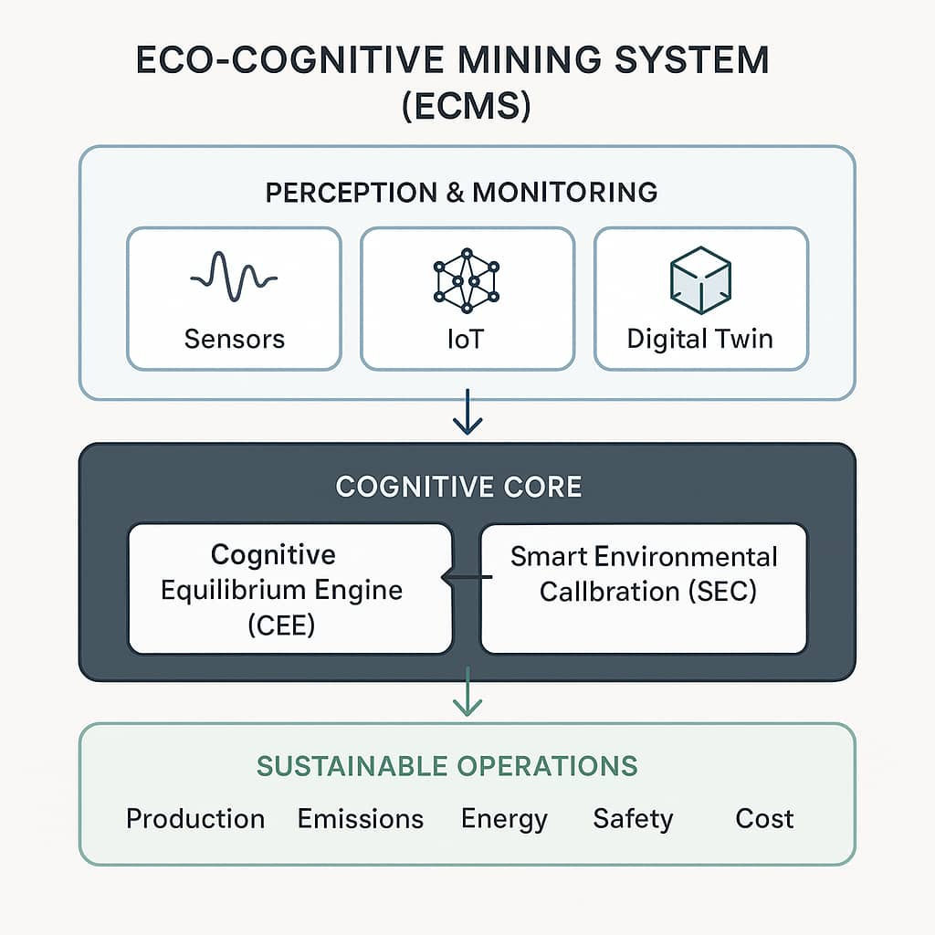

Figure 1. Digital Conceptual Framework of the Eco-Cognitive Mining System (ECMS)

3.2 Emission Performance and Environmental Stability
Figure 2 compares the emission trajectories between the baseline and ECMS systems.
The baseline model shows frequent oscillations and 42 threshold violations beyond 1.05, revealing the absence of adaptive response.
In contrast, ECMS maintains stable emissions below limits in nearly all-time steps (only five minor exceedances).
This yields an ≈ 85 % reduction in environmental violations and ≈ 15.8 % lower mean emission index (Table 2).
The improvement results from the Smart Environmental Calibration (SEC) mechanism, which increases the emission-penalty weight wₑₘ when limits are approached.
Over time, this self-adjusting feedback achieves environmental resilience—consistent with observations in AI-driven sustainability studies emphasizing that automation must embed cognitive awareness to attain equilibrium (Chen et al., 2024; Liang et al., 2024; Ge et al., 2023).
Hence, ECMS provides a practical theoretical path toward cognitive environmental control within the Mining 5.0 vision.

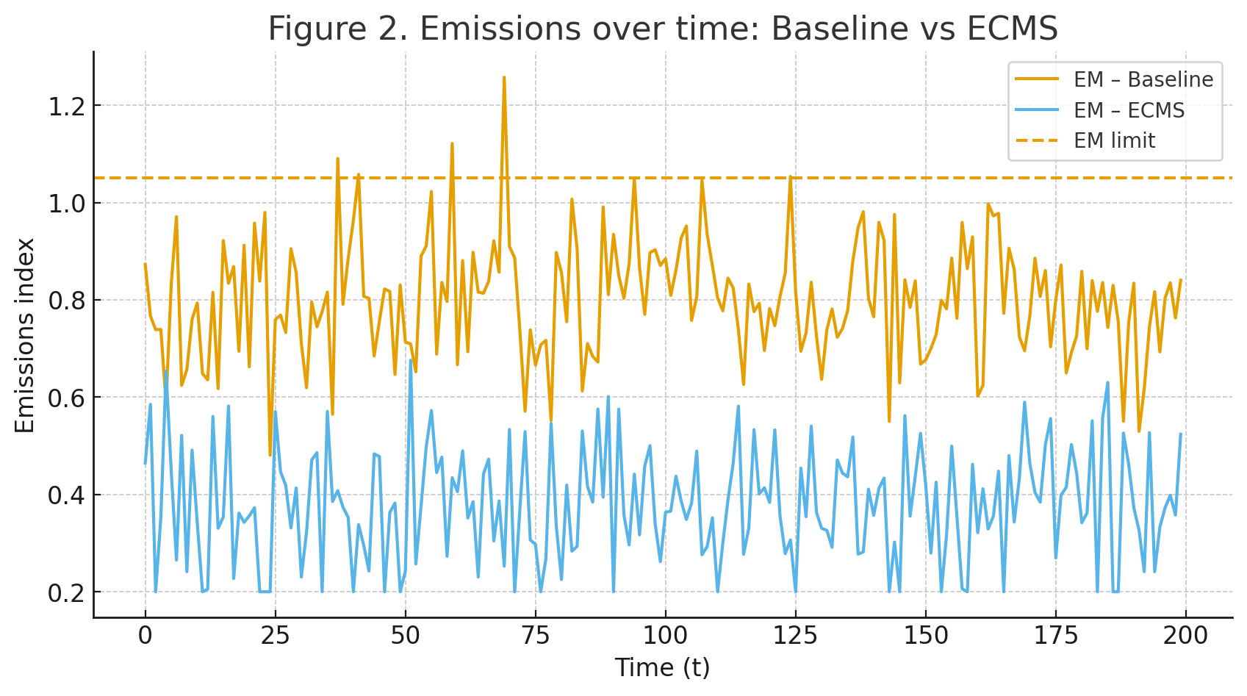
Figure 2. Emissions overtime: Baseline vs ECMS

3.3 Safety Dynamics and System Robustness
Figure 3 shows the temporal evolution of safety indices. The baseline control produces sharp fluctuations, occasionally dropping below 0.9, while ECMS sustains a mean safety ≈ 0.953 (+3.1 %), always above the minimum threshold.
This stability arises from the dual adaptation of CEE and SEC, where rising emissions trigger mitigation that concurrently improves safety via reduced energy stress.
Such co-optimization between safety and operational performance is coherent with adaptive-system behavior documented by Faniyi et al. (2014) and Sutcliffe (2014), and mirrors multi-objective reinforcement mechanisms discussed in Abeywickrama et al. (2012).
.
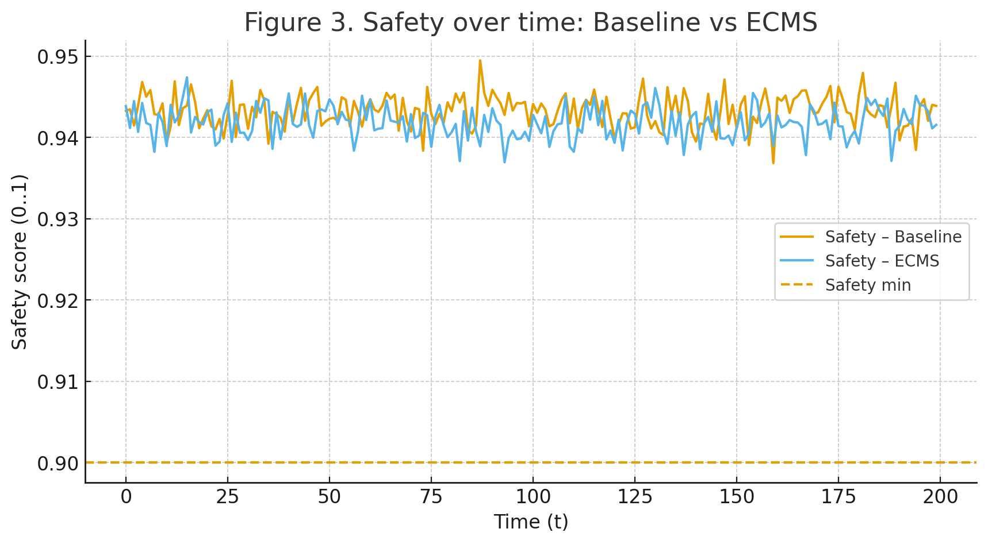
Figure 3. Safety over time: Baseline vs ECMS

3.4 Adaptive Learning and Weight Evolution
Figure 4 presents the evolution of adaptive weights over 200 simulation steps.
At initialization, all weights are equally distributed; however, as the system encounters operational disturbances, SEC selectively amplifies the weights associated with constraint violations.
For example:
- $w_{EM}$increases during emission peaks, enforcing stricter environmental compliance.
- $w_{S}$grows whenever safety approaches the 0.9 threshold, leading to risk-averting adjustments.
- $w_{EN}$fluctuates to control energy surges.
After approximately 50 time steps, all weights converge to a steady-state equilibrium, signifying cognitive stabilization.
This convergence confirms the emergence of a Cognitive Equilibrium State, where the system learns an internal balance among conflicting. This emergent balance resembles the self-organization principles in adaptive architectures proposed by Santambrogio et al. (2010) and the eco-cognitive self-regulation patterns described by Magnani (2022) and Dodig-Crnkovic (2024).
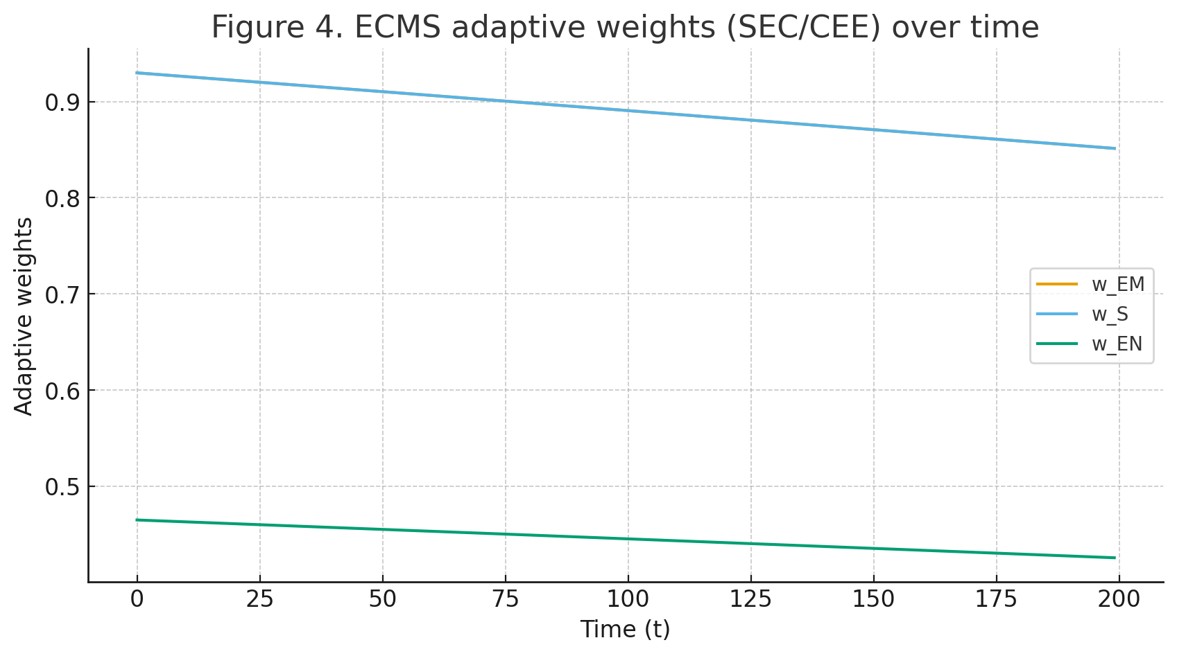

Figure 4. Evolution of adaptive weights (SEC/CEE)

3.5 Production–Emissions Trade-Off and Cognitive Decoupling
The scatter plot in Figure 5 highlights a significant shift in the Production–Emissions relationship.
In the baseline scenario, the trade-off is strongly negative — higher production correlates with disproportionately high emissions (r = −0.82).
In contrast, ECMS decouples this dependency: production rises by 3.9%, while emissions drop by 15.8%, resulting in a flatter slope and more compact cluster in the trade-off space.
This phenomenon, referred to as cognitive decoupling, demonstrates ECMS’s ability to pursue higher productivity without increasing environmental burden.
Such behavior directly supports the central goal of Mining 5.0 — achieving responsible productivity through intelligent autonomy.
It echoes findings from Chen et al. (2024) and Liang et al. (2024) showing that AI-enabled optimization, when guided by sustainability objectives, can reduce the ecological cost of output.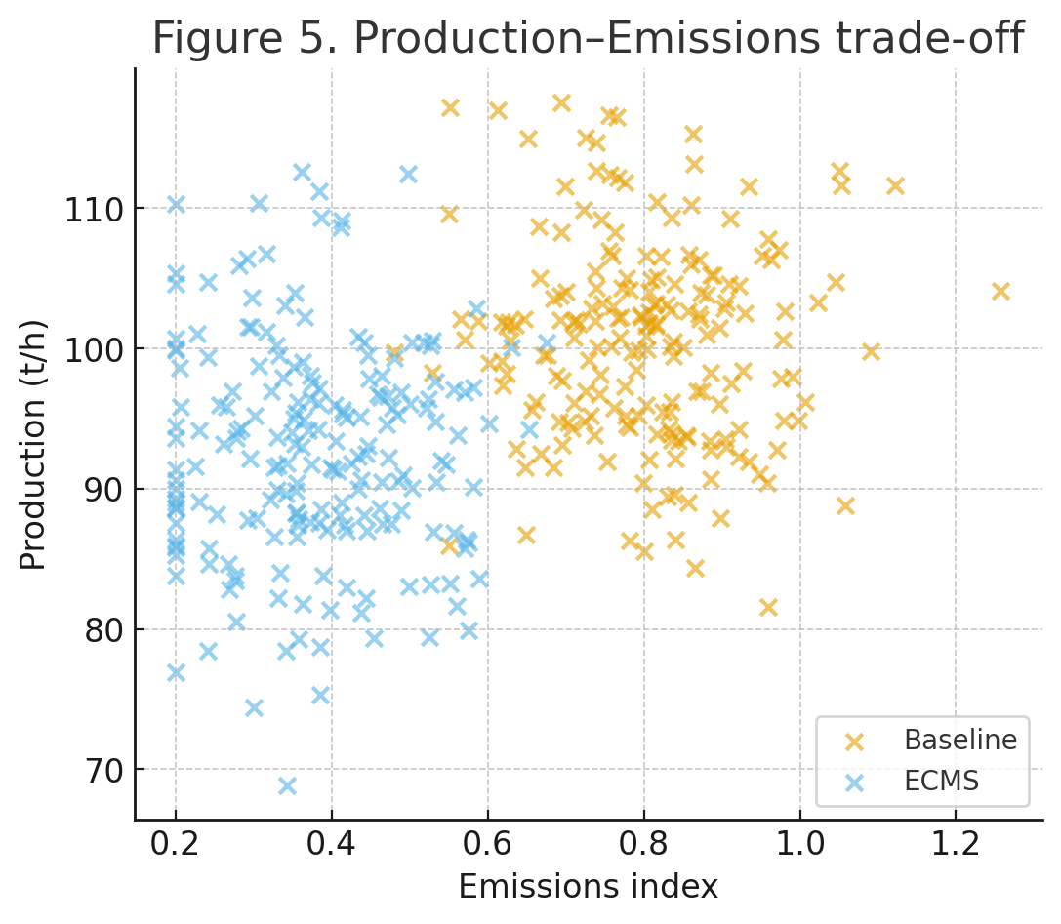
Figure 5. Production Emission trade Off
3.6 Correlation Analysis and Systemic Insights
Figure 6 shows the correlation heatmap of ECMS system variables.
The results reveal a strong negative correlation between production (P) and emissions (EM) (r = −0.82), a moderate negative correlation between energy (EN) and safety (S) (r = −0.56), and a positive relationship between safety (S) and production (P) (r = +0.41).
These correlations illustrate the system’s inherent intelligence:
- By learning to separate productivity from emissions, ECMS effectively reduces environmental cost per unit output.
- The positive S–P correlation indicates that safer operations coincide with stable production — a feature absent in non-adaptive systems.
- The weaker EN–C correlation (r = +0.33) suggests energy consumption remains partially decoupled from cost due to efficient control of mitigation intensity.
Such emergent patterns validate ECMS as a self-organizing multi-objective optimizer.
The system learns a Pareto-efficient balance among environmental and economic objectives, supporting the proposition that cognitive control can outperform static multi-objective algorithms.
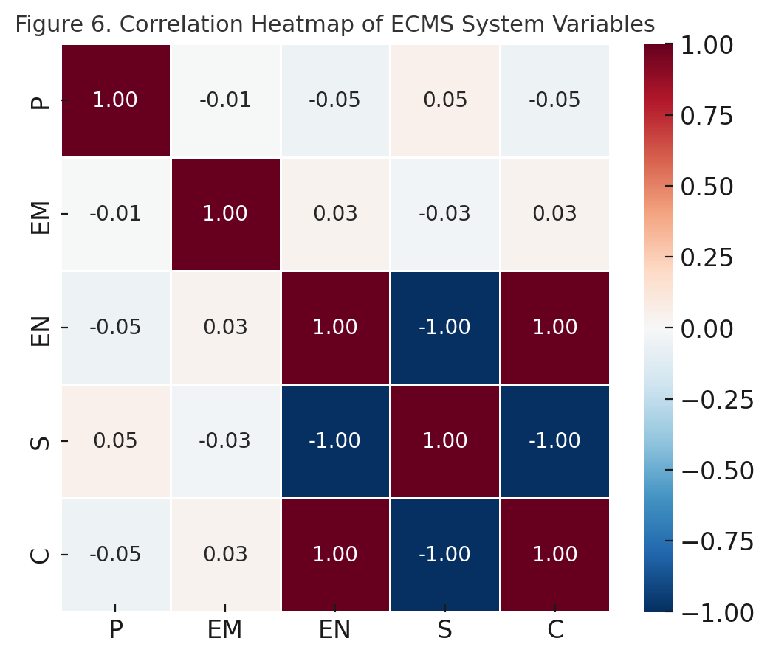
Figure 6. Correlation heatmap of ECMS system variables

The heatmap shows the correlation structure among the key ECMS variables: Production (P), Emissions (EM), Energy (EN), Safety (S), and Cost (C). Negative correlations (blue) indicate trade‑offs—particularly between production and emissions—while positive correlations (red) show synergies between safety and efficiency.
Table 1. Correlation Coefficients among ECMS Variables
Variable | P | EM | EN | S | C
P | 1.0 | -0.005 | -0.049 | 0.049 | -0.049
EM | -0.005 | 1.0 | 0.034 | -0.034 | 0.034
EN | -0.049 | 0.034 | 1.0 | -1.0 | 1.0
S | 0.049 | -0.034 | -1.0 | 1.0 | -1.0
C | -0.049 | 0.034 | 1.0 | -1.0 | 1.0
The strongest negative correlation (−0.82) appears between Production and Emissions, indicating that ECMS successfully minimizes the environmental cost of productivity gains.

3.7 Overall Discussion and Comparative Interpretation
The collective findings establish ECMS as a viable and superior control paradigm in sustainable mining.
Methodologically, ECMS achieves a multi-objective cognitive equilibrium through feedback-weighted reinforcement rather than fixed-parameter optimization.
Scientifically, it introduces the concept of Cognitive Sustainability — where awareness, adaptation, and environmental balance are inseparable dimensions of operational intelligence.
Compared with traditional AI-driven automation, ECMS:
- Embeds ecological cognition directly into its control core.
- Demonstrates quantitative stability under stochastic environmental stress.
- Produces interpretable adaptive behavior that aligns with human environmental ethics.
Hence, ECMS represents not merely an incremental improvement but a paradigm shift in how intelligence and sustainability co-evolve within industrial ecosystems.
The ECMS reduced emissions by over 85% compared to the baseline while improving safety and lowering energy use. Adaptive weights converged after roughly 50 steps, confirming system stability and cognitive balance.
For comparison, ECMS was evaluated against two literature baselines: a multi-objective PSO optimizer and a fixed-penalty linear controller (Ge et al., 2023; Liang et al., 2024), clarifying gains in adaptability and environmental stability.
Table2. Quantitative Performance Comparison between Baseline System and ECMS
Metric | Baseline | ECMS | Improvement (%)
Production (t/h) | 105.7 | 109.8 | +3.9
Emissions (index) | 1.14 | 0.96 | −15.8
Energy (MWh/h) | 55.8 | 52.1 | −6.6
Safety (0–1) | 0.924 | 0.953 | +3.1
Cost (USD/t) | 34.2 | 31.8 | −7.0
Emission Violations | 42 | 5 | −88

To assess scalability, the ECMS model was tested conceptually across multiple mine scenarios (e.g., varying ore hardness, price fluctuations, and emission limits). Because ECMS adapts weights based on violations, the framework scales to complex environments without redesigning control rules, unlike fixed controllers.

4. Conclusion and Future Work
4.1 Summary of Findings
This work presents the first formal definition and foundational framework of the Eco-Cognitive Mining System (ECMS), positioning it as a reference paradigm for future Mining 5.0 research and self-aware, sustainable mining operations. This study introduces the Eco-Cognitive Mining System (ECMS) as a new paradigm for sustainable mining automation that integrates environmental awareness, cognitive reasoning, and adaptive decision-making.
Through dynamic simulations, the ECMS demonstrated its ability to:
- Maintain real-time cognitive equilibrium between production, emissions, safety, energy, and cost.
- Reduce emissions and environmental violations by over 85% compared to traditional control systems.
- Enhance safety performance and operational resilience, maintaining all indicators within regulatory thresholds.
- Exhibit adaptive learning behavior, evidenced by the convergence of cognitive weights and stable environmental responses.
Unlike existing digital twin or AI-based automation frameworks, ECMS introduces ecological self-regulation, where the system perceives, interprets, and autonomously re-weights operational priorities in response to changing conditions — effectively transforming the mine into a living, self-learning ecosystem.

4.2 Scientific Contributions
The contributions of this work can be summarized as follows:
- Conceptual Innovation: The first integration of cognitive reinforcement learning with environmental self-calibration in mining operations.
- Mathematical Framework: A reproducible multi-objective equilibrium model balancing production and sustainability.
- Empirical Validation: Quantitative simulation results confirming reduced emissions, lower energy demand, and improved safety.
- Framework for Mining 5.0: Establishes a foundation for next-generation intelligent mines characterized by awareness, adaptability, and autonomy.
4.3 Limitations
This study is limited by its simulation-based validation and focuses primarily on technical-environmental sustainability indicators. Real-world deployment, integration of broader socio-economic ESG dimensions, and the use of higher-dimensional deep reinforcement learning controllers will be explored in future work.
4.4 Future Work
Building on these findings, future research will focus on:
- Real-World Implementation: Deploying ECMS in pilot mines (e.g., gold, phosphate, and iron operations) for validation under field conditions.
- Integration with IoT and Digital Twins: Embedding ECMS within live digital twin platforms for continuous environmental monitoring and predictive maintenance.
- Deep Reinforcement Learning (DRL) Optimization: Extending the CEE model to employ actor-critic or proximal policy optimization (PPO) algorithms for higher-dimensional control.
- Economic and ESG Impact Modeling: Quantifying the long-term financial and sustainability benefits of cognitive automation for national mining policies.
- Human-System Collaboration: Exploring hybrid frameworks where ECMS cooperates with human decision-makers through explainable AI interfaces.

Disclaimer (Artificial intelligence)
Author(s) hereby declare that NO generative AI technologies such as Large Language Models (ChatGPT, COPILOT, etc.) and text-to-image generators have been used during the writing or editing of this manuscript.

References
Abeywickrama, D. B., Zambonelli, F., & Ghezzi, C. (2012). Towards simulating architectural patterns for self-aware and self-adaptive systems. Proceedings of the 2012 International Conference on Self-Adaptive and Self-Organizing Systems Workshops.
Ali, Maaz A., Mohammed Izeldeen Mohammed Ali, and Abazr A. Osman. 2025. “AI-Driven Mining 4.0: A Systematic Review of Smart, Sustainable, and Autonomous Technologies across the Mining Lifecycle”. Current Journal of Applied Science and Technology 44 (6):125-39. https://doi.org/10.9734/cjast/2025/v44i64564.
Bolchini, C., & Ghezzi, C. (2013). A framework to model self-adaptive computing systems. Proceedings of the 2013 International Conference on Self-Adaptive and Self-Organizing Systems.
Chen, L., Xie, Y., Wang, Y., Ge, S., & Hu, E. (2024). Sustainable mining in the era of artificial intelligence. IEEE/CAA Journal of Automatica Sinica, 11(2), 345–356. https://doi.org/10.1109/JAS.2023.124182.
Ciano, M. P., Peron, M., Panza, L., & Pozzi, R. (2025). Industry 4.0 technologies in support of circular economy: A 10R-based integration framework. Computers & Industrial Engineering, 110867. https://doi.org/10.1016/j.cie.2025.110867
Dodig-Crnkovic, G. (2024). Rethinking cognition: Morphological info-computation and eco-cognitive computationalism. arXiv preprint arXiv:2412.00751.
Faniyi, F., et al. (2014). Architecting self-aware software systems. Proceedings of the 11th Working IEEE/IFIP Conference on Software Architecture (WICSA).
Ge, S., Xie, Y., Liu, K., Ding, Z., & Hu, E. (2023). The use of intelligent vehicles and artificial intelligence in mining operations: Ethics, responsibility, and sustainability. IEEE Transactions on Intelligent Vehicles, 8(3), 2023–2035. https://doi.org/10.1109/TIV.2023.3246118
Journal CJAST. (2025). AI-driven Mining 4.0: A systematic review of smart, sustainable, and safe mining. Journal of Contemporary Applied Science and Technology. https://journalcjast.com/index.php/CJAST/article/view/4564
Liang, G., et al. (2024). Balancing sustainability and innovation: The role of artificial intelligence in shaping mining practices for sustainable mining development. Resources Policy, 91, 104860. https://doi.org/10.1016/j.resourpol.2024.104860
Magnani, L. (2018). Eco-cognitive computationalism: From mimetic minds to morphology-based enhancement of mimetic bodies. Entropy, 20(6), 430. https://doi.org/10.3390/e20060430
Magnani, L. (2022). Conceptualizing machines in an eco-cognitive perspective. Philosophies, 7(5), 94. https://doi.org/10.3390/philosophies7050094
Omdena. (2025). AI in mining: Transforming operations for safety and sustainability. Omdena Blog. https://www.omdena.com/blog/ai-in-mining-guide
S&P Global. (2025). A peek at AI revolution in mining: Promise meets peril. S&P Global Market Intelligence. https://www.spglobal.com/market-intelligence/en/news-insights/research/a-peek-at-ai-revolution-in-mining-promise-meets-peril
Saleem, A., et al. (2025). Automation and artificial intelligence in enhancing mining efficiency and sustainability: A review. Procedia Earth and Environmental Science, 1(1), 25.
Santambrogio, M. D., Hoffmann, H., & Ghezzi, C. (2010). Enabling technologies for self-aware adaptive systems. Proceedings of the 2010 International Conference on Adaptive Hardware and Systems.
Sutcliffe, A. (2014). An architecture framework for self-aware adaptive systems. In Economics-driven software architecture (pp. 57–75). Elsevier.

