Original Research Article

Research on the Characteristics of Similar Materials with Different Properties Based on Geomechanical Model Experiments

Abstract:
This paper introduces the basic principle of geomechanical model test, and analyzes its research status. Some new test technologies have been applied in geomechanical model tests, using infrared thermal imaging technology as the measurement method of geomechanical model tests, and using 3D printing technology to design and manufacture model similar materials. The advantages and disadvantages of the geomechanical model are studied and analyzed. Its advantages are that it can better simulate the construction process of the project, as well as the action mode and time effect of the load, and can study the whole process of the stress of the project, from elasticity to plasticity, to failure. The disadvantage is that relatively complex test technology and special test equipment are required, and similar conditions are generally difficult to meet. In order to explore the similarity of materials and the influence of rock mass with different properties, materials with low elastic modulus, medium elastic modulus and high elastic modulus were prepared and simulated Through the experimental results, the composition and preparation method of rock mass model material are determined, and it is concluded that cement, paraffin and oil are the controlling factors affecting the deformation characteristics of high, medium and low performance rock mass model material. This provides a theoretical basis for the problem that the similarity conditions of model materials are generally difficult to meet.

Keywords:Geology;model experiment ;similar materials;rock mass;simulation.

Introduction
Geomechanical model testing is a commonly used method in geotechnical engineering research, as well as in theoretical analysis and numerical simulation. Since its introduction in the early 20th century, model testing has been applied in many fields, including hydropower engineering, transportation tunnel engineering, mining engineering, and national defense engineering, among others. With the continuous increase in the rate of underground space exploration and hydraulic forces in China, model tests on the excavation of rock mass or rock foundation structures have been extensively studied（Jacques Garnier et al.,2007;Li et al.2009,2014）. Zhao et al(2012) conducted a comprehensive three-dimensional geomechanical model test to study the excavation and support of super large cross-section railway tunnels. The study combines the actual working conditions, and uses various excavation and support methods to simulate different road sections. Researchers studied the evolution of surrounding rock load and supporting structure during tunnel construction. Li et al. (2012) used the large-scale combined 3D uniform gradient load test system independently developed by them. A model test was carried out to study the progressive damage process of soft fractured surrounding rock in large - cross - section railway tunnels. This study provides a comprehensive analysis of the damage zones, displacement, stress, and load responses of surrounding rock under different excavation and support conditions, taking into account the effects of various burial depths. Recent years have witnessed a notable increase in geotechnical engineering projects, paralleling the accelerated advancement of China's Western Development initiatives. These encompass transportation infrastructure projects, such as railways, subways, and highways that bridge the western regions with more developed areas, as well as mining ventures, slope - related projects, and hydropower stations.Simultaneously, even more arduous and intricate geotechnical engineering problems have cropped up in the course of construction(Fan et al.2017;Li et al.2020;Meng et al.2020). The main characteristics are as follows: the model should simulate faults, fracture zones, weak zones, and sometimes major joint fissure groups in rock masses, and should reflect such rock mechanics characteristics as non-homogeneous, non-elastic, and discontinuous properties of the rock mass. Meanwhile, the geometric dimensions, boundary conditions, applied loads, and the unit weight, strength, and deformation properties of the model materials used to simulate the rock mass must all satisfy similarity theory.
In modern times, due to the development of production, construction and science and technology, more buildings need to be built on the rock foundation or rock mass with complex geological structure, such as dams, power plants, tunnels, underground power stations, underground oil depots and mines. The anti sliding stability of such buildings, the influence of foundation deformation on building structures, the surrounding rock stability and lining pressure of underground structures, and the stability of high rock slopes are all the research contents of geomechanical model tests. Moreover, a large number of engineering practice has proven that geomechanical model test method is an effective method to study large-scale geotechnical engineering problems, especially underground engineering problems. Under the condition of basically meeting the similarity principle, it can more truly reflect the spatial relationship between geological structure and engineering structure, and more accurately simulate the construction process and influence. The test outcomes offer an intuitive representation, enabling a comprehensive grasp of the global mechanical properties, deformation tendencies, and stability characteristics of the rock mass for sound engineering judgment. However, at present, there is still great room for the development of geomechanical model test technology. In this paper, the research status, characteristics and model similar materials of geomechanical model test technology are described.

Research status of geomechanical model test technology
In recent years, researchers including Li Zhongkui from Tsinghua University, Gu Jincai and Chen Anmin from the Third Research Institute of Engineering Corps under the General Staff Department, Shen Tai from the Yangtze River Water Resources Commission, and Du Yingji from the Western Hydraulic Research Institute of the Ministry of Water Resources have pioneered new technologies in geomechanical model testing. Their work encompasses advancements in similarity materials, experimental apparatus design, excavation simulation techniques, and testing methodologies, yielding significant achievements with practical implications.
However, there are still many key technical problems that have not been satisfactorily solved so far. For example, in terms of model material similarity simulation, the abutment rock mass of high arch dam projects often has the characteristics of many types, large variation range of deformation modulus, and serious nonuniformity.For example, the deformation modulus of class I to class IV rock mass in the two abutments of an arch dam changes from 25 GPa to 5 GPa; for another example, the deformation modulus of class Ⅱ, Ⅲ 1, Ⅲ 2, Ⅳ 1 and Ⅳ 2 rock masses in the abutment of an arch dam varies from 30 GPa to 2 GPa, which leads to inconsistent deformation distribution under stress conditions, and has a certain impact on the stability of the abutment and dam foundation.In model experiments, the heterogeneity of these rock masses poses significant challenges to the analogous simulation of rock mass materials. To address the issue of analogous simulation of rock mass materials, numerous research institutions have conducted extensive studies and achieved certain research results. For example, a mixture of barite powder and limestone with epoxy resin as the binding agent can attain relatively high strength and deformation modulus. However, the preparation process of such materials requires high-temperature curing, during which toxic gases are emitted, posing health hazards to humans. Additionally, epoxy resin is relatively expensive (OBERTY et al.1979)
In addition, some experimental techniques have been applied in geomechanical model tests. Infrared thermal imaging technology has emerged as a versatile and transformative tool in geotechnical engineering due to its non-contact nature, high sensitivity, and real-time monitoring capabilities.Yang et al. (2025) explored the principles, applications, and future potential of infrared thermal imaging technology in this field. Its main applications include measuring soil and rock properties, conducting geotechnical investigations, and monitoring geological hazards. It has been proven that infrared thermal imaging technology is effective in detecting thermal anomalies, evaluating geotechnical material properties, and monitoring hazards such as landslides and rockfalls. Zhu et al.(2023) employed 3D printing technology using photosensitive resin materials to design and fabricate rock-like specimens. They conducted laboratory direct shear tests on two types of rocks with parallel coplanar discontinuous joints to investigate the effects of joint roughness and loading conditions on the shear behavior and acoustic emission characteristics of the rocks.

Characteristics of geomechanical model test technology
Geomechanical model test considers the engineering structure and surrounding rock and soil as a unity, which is the biggest difference from the traditional structural model test. In the traditional structural model test, the effect of rock and soil around the structure is treated as a load, while in the geomechanical model test, the effect of geological structure on the building is concerned. This effect (i.e. interaction) is generally complex, and it is difficult to carry out accurate theoretical analysis and calculation. However, it can be naturally considered in the geomechanical model test without manual intervention. This advantage is particularly prominent when the geological conditions are complex.
Another advantage of geomechanical model testing technology lies in its ability to effectively simulate construction techniques, load application methods, and time-dependent effects. It enables the study of the entire stress evolution process of a project, from elastic to plastic deformation, and ultimately to failure. Therefore, this type of testing not only facilitates the investigation of normal stress conditions in engineering but also allows for the examination of ultimate load capacities and failure modes. Moreover, compared to numerical simulation results, the outcomes provided by geomechanical model tests are more vivid and intuitive, offering deeper insights. It is precisely due to these unique advantages that geomechanical model testing technology has garnered widespread attention and application within the geotechnical engineering community both domestically and internationally.
Of course, the geomechanical model test technology also has its weakness, that is, it requires relatively complex test technology and special test equipment, and similar conditions are generally difficult to meet, so the results given by it can only be an approximation to the engineering practice. In addition, the physical model change scheme is not flexible, and the measurement data is greatly affected by the accuracy of the instrument; the existence of size effect makes it difficult to ensure that all physical parameters meet the similarity theory; the test workload is large, the cost is high, and the test technology is complex.

Study on model similar materials

4.1 New similar materials
In the geomechanical model test, the preparation of simulation materials is the basis of its reliability; however, due to the unknown influence of the weighting agent, trial and error method is still the most widely used method, which is time-consuming and laborious. The adjustment of mechanical properties has not yet been clearly resolved. When the nature of prototype rock changes, the tedious and tired trial and error process must be repeated to find out the proportion that meets the proportion standard. A new simulation material with adjustable, predictable and stable performance will be conducive to the application of geomechanical model test(Fan et al.2017). Generally speaking, similar materials are a mixture of natural materials (such as barite powder, lime powder or gypsum powder) and artificial materials (such as cement, bentonite, glue or resin) in a certain proportion. Since the similarity coefficient per unit weight is 1.0 and the geometric similarity coefficient is large, the model material should have high density, low strength and low deformation modulus(Zhou et al.2005). According to the similarity theory, the geometric dimensions, boundary conditions, loads, bulk density, strength and deformation characteristics of similar materials of the model must be similar to the prototype.
On the basis of summarizing previous studies, wanghanpeng et al. Developed a new similar material iron crystal sand binder (IBSCM) through a large number of proportioning tests, which has the following advantages(Wang et al.2009):(1) high bulk density, low compressive strength and elastic modulus; (2) stable performance, non rusting, high insulation; (3) easy to obtain and cheap; (4) the mechanical parameters are easy to adjust. For example, the elastic modulus and compressive strength of the material can be easily adjusted by adjusting the concentration of rosin alcohol cement; (5) alcohol is easy to volatilize and the drying time is short, which can shorten the test cycle; (6) no toxic and side effects, no harm to human body; (7) the pressed block is easy to cut and can meet the process requirements of model assembly and masonry; (8) because the rosin alcohol solution is used as the cementing agent, the block surface has self-adhesive ability after being wetted with alcohol, so the block joints can be bonded with their own materials, so the existence of the joint does not affect the overall performance of the model; (9) since there is no chemical reaction after mixing of various materials, the tested materials can be reused, which improves the utilization rate and service life of materials.

4.2 Study on similarity simulation of rock mass materials
The similarity principle between sample and model is the key of geomechanical model test. On the geometric scale, the material modulus and load strength need to meet the similarity principle（Tao et al.2019）. The performance of similar materials determines whether the model test can accurately reflect the main physical and mechanical properties of the research object, while the test system determines the loading mode and measurement accuracy(Xu et al.2021). Lu et al(2025) analyzed the sensitivity of elastic modulus of similar materials, and found that there was a strong coupling relationship between elastic modulus and compressive strength; therefore, the influence of each factor on the elastic modulus of the material is basically the same as the compressive strength of the law. In order to facilitate the similar simulation study of rock mass materials, according to the size of rock mass deformation modulus E, the rock mass is divided into three categories: high, medium and low. High performance rock mass is suitable for class I and II rock mass with modulus of deformation above 15 GPa; Medium performance rock mass is suitable for class III rock mass with variable modulus of 6~15 GPa; low performance rock mass is applicable to class IV and V rock mass with modulus of deformation below 6gpa, unloading rock mass, columnar joints, etc. The three types of rock masses are simulated.

4.2.1 High performance rock mass similarity simulation
To obtain high-performance rock mass simulant materials, mechanical property experimental research was conducted by varying the cement content while keeping the proportions of other ingredients unchanged. The research findings are illustrated in Figure 1. The results indicate that both the deformation modulus and compressive strength gradually increase with the rising cement content, showing a roughly proportional relationship. When the cement content increases from 0.5% to 7%, the deformation modulus ranges from 35.2 MPa to 85.8 MPa. The experimental results demonstrate that cement has a significant impact on improving the mechanical properties of the model materials. Therefore, when it is necessary to prepare rock mass simulant materials with high strength and large deformation modulus, increasing the cement content can be employed as a viable approach.
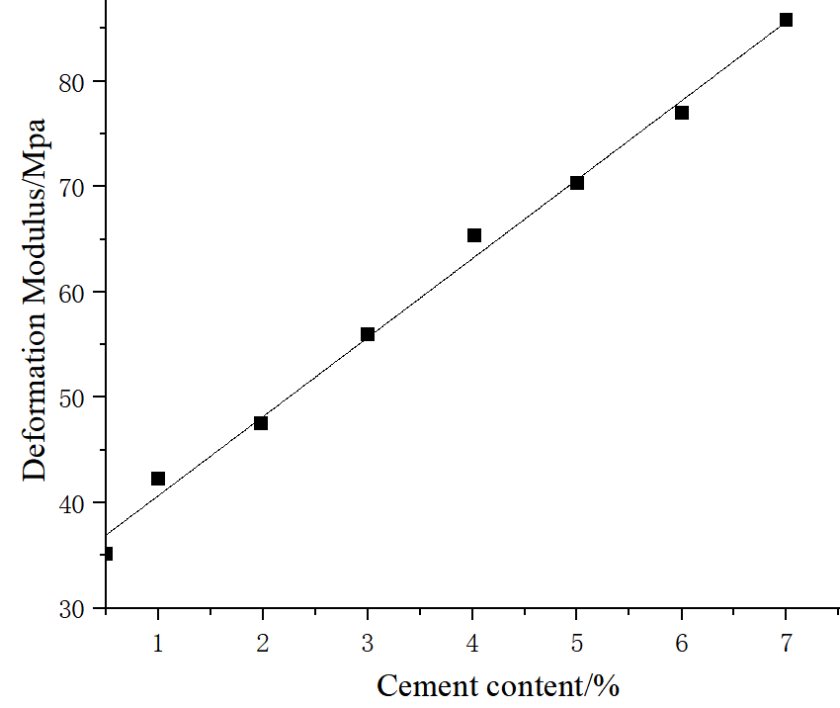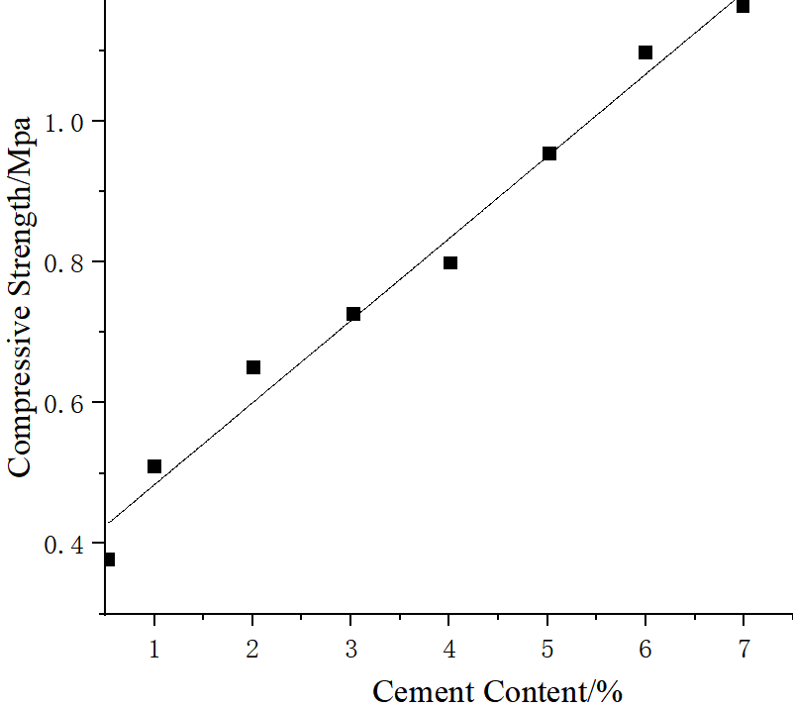
Fig 1 Relationship between model material properties and cement content

4.2.2 Similarity simulation of neutral energy rock mass
For the similarity simulation of medium-performance rock mass materials, the research findings indicate that no cement and water will be incorporated into the raw material proportioning. Instead, the materials will only consist of barite powder, paraffin, and machine oil, with adjustments made by varying the paraffin content. The semi refined solid paraffin used in this test has strong adhesion and flexibility, and the material performance is relatively stable. It is ideal as a binder for medium performance rock mass materials. However, due to the solid state of paraffin at room temperature, it can not be fully integrated with the model material, so in order to increase the uniformity of paraffin in the model material ratio, before adding other components, it is necessary to mix the solid paraffin with barite powder and dissolve it at a certain temperature. The test results are shown in Figure 2. The results show that the deformation modulus increases with the increase of paraffin content, which is basically in direct proportion. When the mass ratio increases from 0.5% to 7%, the deformation modulus of the corresponding model material increases from 22.5 MPa to 35.6 MPa.
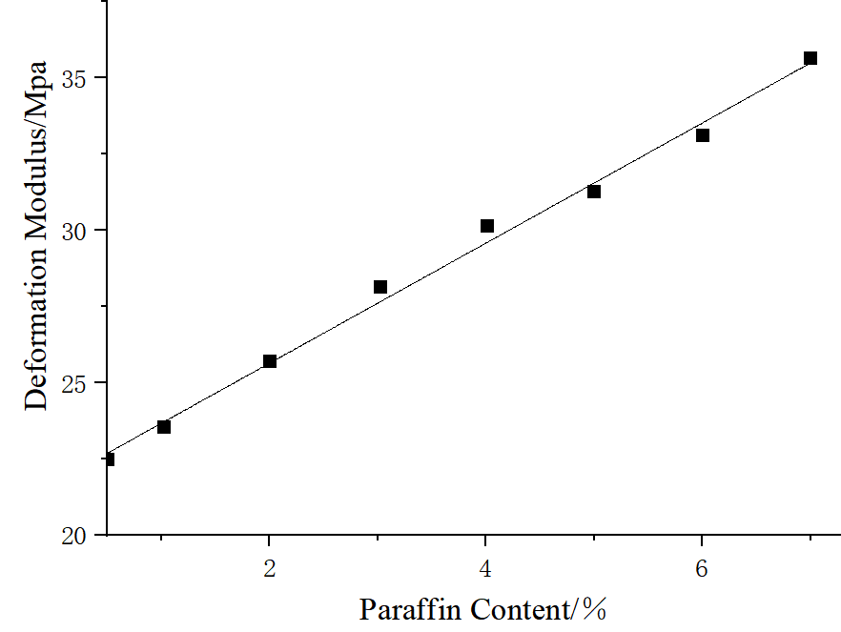
Fig 2 Relationship between deformation modulus and paraffin content of model material

4.2.3 Similarity simulation of low performance rock mass
For the similar simulation of low performance rock mass, such as class IV and V rock mass, the requirements of low modulus can not be met by adjusting the content of cement and paraffin. The test results show that increasing the oil content has obvious effect on reducing the deformation modulus, and the test results are shown in Figure 3. It can be seen from the figure that the deformation modulus decreases with the increase of oil content, which is basically inversely proportional. When the oil content increases from 3.5% to 6.5%, the corresponding deformation modulus ranges from 22.5 MPa to 14.3 MPa, which can meet the similar simulation requirements of low performance rock mass.
Therefore, based on the experimental results, it is relatively easy to identify a material proportion that meets the experimental requirements, thereby reducing the workload of conducting proportioning experiments anew and accelerating the experimental progress. This model material, characterized by a wide range of deformation moduli, stable performance, low cost, easily adjustable physico-mechanical parameters, and the absence of toxic side effects, is a relatively ideal simulant material for simulating rock masses.
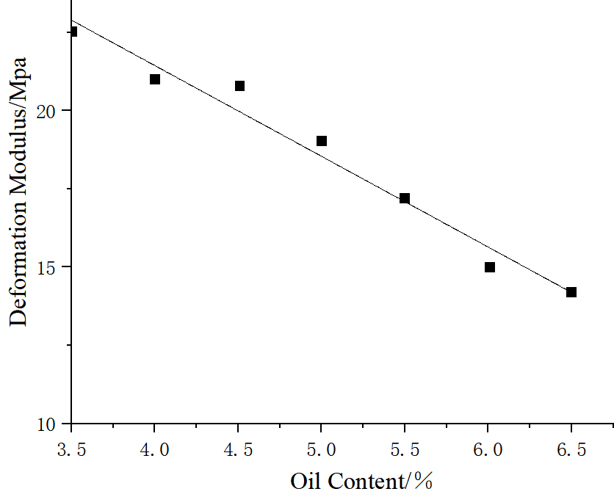
Fig 3 Relationship between deformation modulus of model material and oil content
For example, the high-performance rock mass with high strength and good integrity can be simulated by using model blocks with an area of 10 cm × 10 cm and a thickness of 7~10 cm; the model block with an area of 10 cm × 10 cm and a thickness of 5~7 cm is usually used for the simulation of medium performance rock mass materials; small blocks with an area of 5 cm × 5 cm and a thickness of 1~5 cm are often used for fine simulation of class IV and class V rock masses, deep fractures, unloading rock masses, columnar joints and other low-performance rock masses.

Conclusion
This paper introduces the research progress and characteristics of the new technology of geomechanical model test, focuses on the new similar materials, and studies and analyzes the similar simulation of rock mass materials existing in geomechanical model test. The results show that:(1) for high-performance simulants, increasing cement content proportionally enhances the deformation modulus and compressive strength.; (2) medium-performance materials, composed of barite powder, paraffin, and machine oil (without cement/water), see their deformation modulus rise proportionally with paraffin content after a heated mixing process for homogeneity;(3) for low-performance simulants, increasing machine oil content effectively and inversely proportionally reduces the deformation modulus, achieving low moduli unattainable by adjusting cement or paraffin. These established relationships from the tests facilitate the quick selection of suitable mixes, minimizing further trial efforts and accelerating experimental timelines.
Disclaimer (Artificial intelligence)

Option 1:

Author(s) hereby declare that NO generative AI technologies such as Large Language Models (ChatGPT, COPILOT, etc.) and text-to-image generators have been used during the writing or editing of this manuscript.

Option 2:

Author(s) hereby declare that generative AI technologies such as Large Language Models, etc. have been used during the writing or editing of manuscripts. This explanation will include the name, version, model, and source of the generative AI technology and as well as all input prompts provided to the generative AI technology

Details of the AI usage are given below:
1.
2.
3.

References
Fan, P., Yan, Z., Wang, M. et al.(2017) Recyclable resin-based analogue material for brittle rocks and its application in geomechanical model test. Arab J Geosci 10, 29 .

Jacques Garnier, C. Gaudin, Sm Springman, Pj Culligan, D. Goodings, et al.(2007). Catalogue of scaling laws and similitude questions in geotechnical centrifuge modelling. International Journal of Physical Modelling in Geotechnics.

Li, L., S. Li, Y. Zhao, S. Li, H. Wang, Q. Liu, Y. Zhao, and X. Yuan.（2012）. “3D geomechanical model for progressive failure progress of weak broken surrounding rock in super large section tunnel.” Chin. J. Rock Mech. Eng. 31: 550–560.

Li, S., Wang, Q., Li, W., Li, Z., Wang, H., Jiang, B., & Zhang, H. (2014). Research on application of flexible uniform pressure loading device to model test. Rock Soil Mech, 1, 61-66.

Li, Z., Liu, S., Ren, W., Fang, J., Zhu, Q., & Dun, Z. (2020). Multiscale Laboratory Study and Numerical Analysis of Water‐Weakening Effect on Shale. Advances in Materials Science and Engineering, 2020(1), 5263431.

Li, Z. K., Wang, A. M., Wang, K. Z., Liao, Y., & Fu, S. Y. (2009). Study and application of inverse controlling technology for 3d geomechanical model construction of underground engineering. Chinese Journal of Rock Mechanics and Engineering, 28(9), 1729-1734.

Lu, J., Shao, Y., Wang, L., & Ma, G. (2025). Experimental study on similar materials for a large-scale geomechanical model constructed by extrusion deposition 3D printing. Rock Mechanics and Rock Engineering, 58(1), 981-1001.

Meng, Q., Wang, H., Cai, M., Xu, W., Zhuang, X., & Rabczuk, T. (2020). Three-dimensional mesoscale computational modeling of soil-rock mixtures with concave particles. Engineering Geology, 277, 105802.

Oberti, G., & Fumagalli, E. (1979, September). Static geomechanical model of the Ridracoli arch gravity dam. In ISRM Congress (pp. ISRM-4CONGRESS). ISRM.

Tao, Z., Liu, Y., Cheng, L., & Yang, Q. (2019). Failure and stability analysis of jinping-I arch dam based on geomechanical model test and nonlinear numerical analysis. Rock Mechanics and Rock Engineering, 52(7), 2245-2260.

Wang, H. P., Li, S. C., Zheng, X. F., & Zhu, W. S. (2009). Research progress of geomechanical model test with new technology and its engineering application. Chin. J. Rock Mech. Eng, 28(S1), 2765-2771.

Xu, Z., Luo, Y., Chen, J., Su, Z., Zhu, T., & Yuan, J. (2021). Mechanical properties and reasonable proportioning of similar materials in physical model test of tunnel lining cracking. Construction and Building Materials, 300, 123960.

Yang, S. Q., Cheng, Q., Tang, C. S., & Shi, B. (2025). Applications and advancements of infrared thermal imaging technology in geotechnical engineering: A review. Journal of Rock Mechanics and Geotechnical Engineering.

Yin, Q., Jing, H., Ma, G., Su, H., & Liu, R. (2018). Investigating the roles of included angle and loading condition on the critical hydraulic gradient of real rock fracture networks. Rock Mechanics and Rock Engineering, 51(10), 3167-3177.

Zhao, Y., Li, S., Zhao, Y., & Li, L. (2012). Model test study of surrounding rock load releasing during super-large section tunnel excavation. Chin. J. Rock Mech. Eng., 31(Suppl. 2), 3821-3830.

Zhou, W., Yang, R., Liu, Y., & Lin, P. (2005). Research on geomechanical model of rupture tests of arch dams for their stability. Shuili Fadian Xuebao(J. Hydroelectr. Eng.), 24(1), 53-58.

Zhu, Y., Wang, G., Li, A., Chen, H., Liu, T., & Guan, H. (2023). Effects of joint roughness, shear rate, and normal stress on shear behavior and acoustic emission characteristics in two parallel coplanar intermittently jointed rock: An experimental study. Rock Mechanics and Rock Engineering, 56(2), 1289-1303.

