Research progress on the application of rheometer to self-compacting concrete

Abstract：The study of rheological properties is of great significance to the fields of materials science and civil engineering. In this paper, combined with relevant research, the rheological model of self-compacting concrete is expounded, the influence of mineral admixtures, fibers, admixtures, recycled aggregates and other aspects on the rheological properties of self-compacting concrete is explained, the existing problems of the rheological properties of self-compacting concrete are analyzed, and the future rheological properties of concrete are prospected.
Keywords: self-compacting concrete, rheological properties, rheological model
0 Introduction
In the past 40 years, self-compacting concrete (SCC) is a new type of concrete material that is characterized by high fluidity without segregation or bleeding at a low water-cement ratio, and can be leveled without vibration and filled with formwork and wrapped steel bars. Due to its unique properties, self-compacting concrete performs well in solving the problems of vibration leakage, overvibration and difficult vibration of dense steel bars in traditional concrete construction, and can make a large number of industrial waste materials as admixtures to improve durability. The rheological properties of freshly mixed self-compacting concrete directly determine its self-filling and compaction properties, so the rheological characteristics of self-compacting concrete are of great significance to the development of self-compacting concrete^{[1-4]}。
Due to the addition of mineral admixtures and admixtures, it is far from being able to characterize its workability only through traditional slump cylinder tests. After a large number of experimental studies, it has been found that in order to fully and accurately grasp the complex workability of freshly mixed self-compacting concrete, it is necessary to start with the rheological mechanism and model of self-compacting concrete ^{[5]}. Only in this way can the interaction of various components in concrete and the mechanism of the working performance of freshly mixed self-compacting concrete can be better revealed, so as to establish the relationship curve or relationship between the rheological properties of the concrete mixture and the working parameters in practical engineering applications, realize the on-site construction control and application, and even carry out numerical simulation of self-compacting concrete and establish a virtual laboratory.
In recent years, a large number of experiments and theoretical studies have been carried out on the rheological properties of self-compacting concrete at home and abroad. At present, the rheological properties of concrete are mainly improved by adding mineral powder materials, superplasticizers and viscosity modifiers. In this paper, the rheological studies of newly mixed self-compacting concrete are introduced from four aspects: mineral admixtures, admixtures, fibers, and recycled aggregates ^{[6-13]}.
1 Application of rheological model of self-compacting concrete
1.1 Test and inversion with L-box based on the Herschel-Bulyley rheological model
Zeng Shuai ^{[14]} used FLUENT software to simulate the flow time of freshly mixed self-compacting concrete in the L-box, and compared it with the flow time in the actual L-box test, established the objective function by the least squares method, and used the pattern search method to optimize the three rheological parameters, τ0, k, and n, and carried out the simulation of V-shaped funnel and slump expansion test by taking the inversion of the six sets of rheological parameters τ0, k, and n as known inputs. The results show that the rheological parameters of the H-B model are feasible to invert them.
1.2 Research on the inversion of rheological parameters of newly mixed self-compacting concrete based on Bingham model
Zhou et al. ^{[15]} assumed that the rheological model was the Bingham model, took the improved L-box test as the known input, and the flow pattern of the newly mixed self-compacting concrete at different time points as the known output, used the computational fluid dynamics method to calculate the flow pattern, and established the objective function by the weighted least squares method. The feasibility of the method is verified. This method is simpler and lighter than rheometer testing, and is suitable for engineering practice.
1.3 CFD simulation of self-compacting concrete flow based on the Herschel-Bulyley rheological model
Li et al. ^{[16]} used a CFD (Computational, Fluid Dynamics) simulation method based on the Herschel-Bulkley rheological model to simulate the pouring process of self-compacting concrete under the action of self-weight in 2D and 3D, and compared it with the flow time and flow pattern of the L-box flow to a specific position in the laboratory. Compared with the 2D simulation results based on the Bingham model, the Herschel-Bulkley rheological model has higher accuracy.
1.3 Numerical simulation of self-compacting concrete flow based on MPS method
Li et al. ^{[17]} used the three-dimensional moving particle semi-implicit (MPS) method to analyze and predict the fluidity of self-compacting concrete (SCC), and performed numerical simulations on the L-box test, and compared and analyzed the flow pattern and flow time of SCC in numerical simulation and experiment. On this basis, the influence of plastic viscosity on SCC fluidity in the L-shaped box test and the V-shaped funnel test was studied, and the relationship between SCC density and plastic viscosity and the fall time of the V-shaped funnel test was established. The results show that the MPS method based on Bingham rheological model can simulate the flow characteristics of SCC well and with high accuracy.
2 Effect of raw materials on the rheological properties of self-compacting concrete
2.1 Mineral admixtures
Xu et al. ^{[18]} studied the operational and rheological parameters of self-compacting concrete with cement, fly ash, and powdered blast furnace slag as cementitious materials, and analyzed their relationship. In this paper, the rheological performance of self-compacting concrete was tested by Viscometer 5 concrete rheometer, and the torque-speed curve of self-compacting concrete and the yield stress and plastic viscosity calculated based on the Reiner-Riwlin formula were obtained.

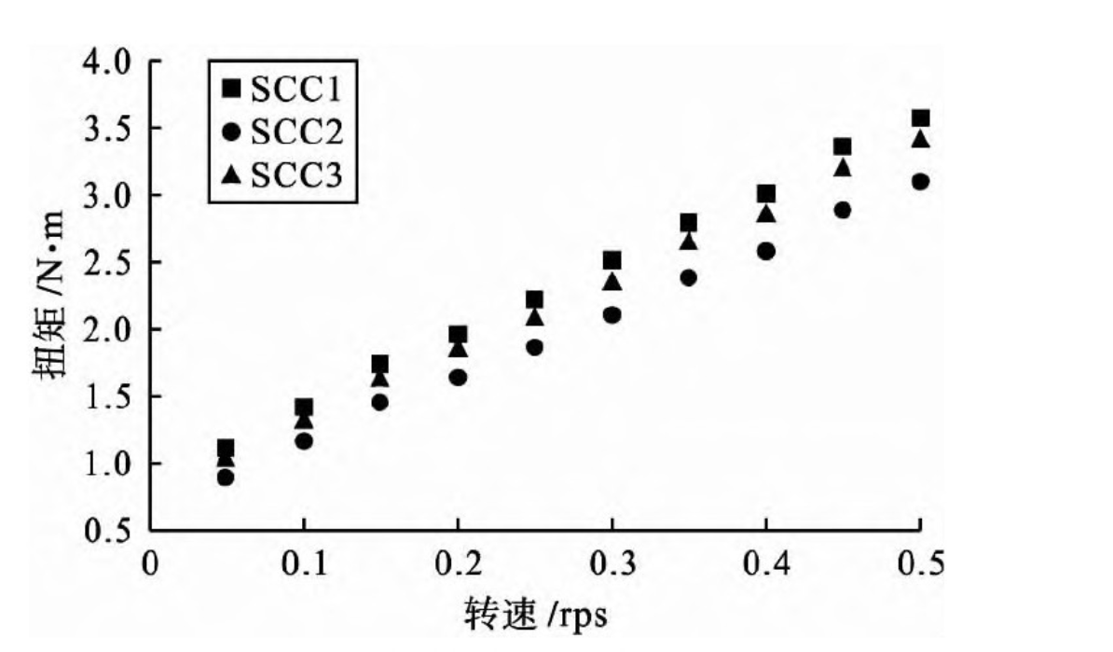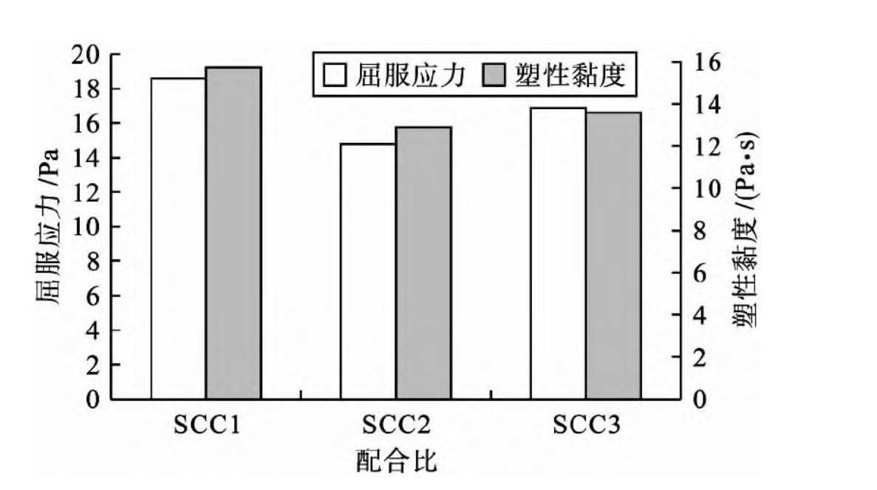
Comparing the torque speed test points of concrete with different mix ratios, it can be seen that SCC1 has the largest torque value corresponding to the same rotational speed, followed by SCC3. SCC2, which has the largest amount of fly ash, has the smallest torque value. The yield stress and plastic viscosity of concrete with the mix ratio SCC1 were the largest, while the yield stress and plastic viscosity of SCC2 were 14.75 Pa and 12.82 Pa·s, respectively, which were the smallest values among the three mix ratios. Generally speaking, yield stress reflects the minimum stress required for concrete to flow after being subjected to shear external forces, while viscosity characterizes the viscosity resistance of concrete after flow. Due to its small specific surface area and smooth surface, fly ash can play a certain lubricating role in the cementitious system, thus significantly increasing the fluidity of the self-compacting concrete system.
Lu et al. ^{[19]} used three hydrophobic minerals, graphite, talc, and hollow glass beads, to prepare C60 self-compacting concrete, and studied the effects of hydrophobic minerals on the flow and mechanical properties of high-strength self-compacting concrete by testing the working properties, rheological parameters, and compressive strength of concrete. Within a certain dosage and fineness range, hollow glass beads and appropriate amount of talcum powder can significantly improve the working performance of freshly mixed concrete and reduce the yield stress and viscosity of the mixture. However, when the mass fraction of talcum powder reaches 15%, it will cause a sharp decrease in the fluidity of the mixture. When the mass fraction of graphite is 3%, the fluidity of the mixture will increase slightly, but the fluidity will continue to decrease as the graphite content continues to increase. The addition of graphite and talcum powder will significantly reduce the compressive strength of concrete. However, the addition of hollow glass beads has little effect on the compressive strength, and even improves the early strength of concrete. Hollow glass beads have good effects in improving the properties of high-strength self-compacting concrete.
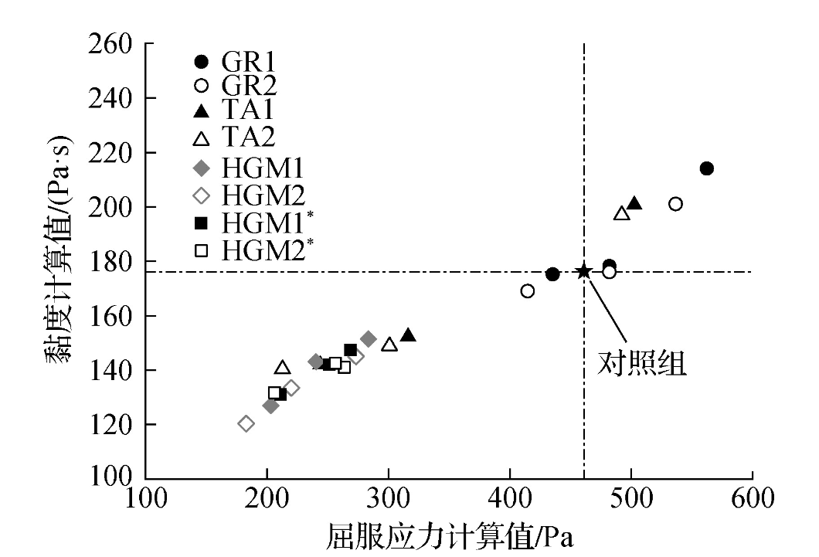
Feng Feihong et al. ^{[20]} used molybdenum tailings to replace fine aggregates to prepare self-compacting concrete, and the rheological properties of eBT-V self-compacting concrete rheometer were analyzed. According to the rheological performance test of self-compacting concrete mixtures, it can be seen that the self-compacting concrete mixtures with different mix ratios show good fluidity, and the yield stress of concrete decreases to varying degrees after the use of molybdenum tailings replacement, indicating that the finer particles of molybdenum tailings can make the concrete system more prone to flow under the action of external forces.
2.2 Fibre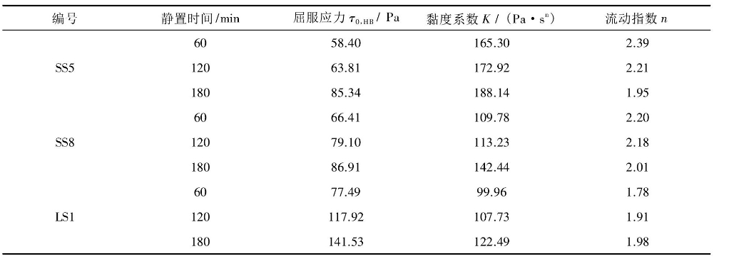
Su Wende ^{[21]} used a Con Tec Viscometer concrete rheometer to determine the rotational rate and corresponding shear stress of the mixture, and the rheological parameters of the mixture were calculated by calculation. The self-compacting concrete mixture of steel fiber in the study exhibits shear thickening characteristics. The shear stress of steel fiber self-compacting concrete mixture shows a power-law increase relationship with the shear rate, so the viscosity of the mixture is not a fixed constant, but increases with the increase of shear rate. With the increase of time, the yield stress and viscosity coefficient of each group of mixtures increased. The flow index of slag steel fiber self-compacting concrete decreases with the increase of resting time, while the flow index of stone powder fiber self-compacting concrete increases with the increase of resting time. When the water-cement ratio remains unchanged, the incorporation of steel fibers can increase the yield stress of the mixture, while the increase of water consumption will reduce the viscosity coefficient of the mixture.
Lu Rui et al. ^{[22]} studied the effects of different volume content and different length-diameter ratios on the rheological properties of C45 self-compacting concrete using the relationship between the Bingham model and the slump expansion degree of self-compacting concrete, and calculated the yield stress and plastic viscosity of fiber self-compacting concrete under different conditions. When the length of basalt fiber is 5mm and the fiber volume content is 0.2%, the yield stress and plastic viscosity of the rheological parameters of the concrete meet the requirements of self-compacting concrete, and the rheological performance reaches the best. The Bingham model can be used as an important basis for determining the rheological properties of basalt fiber self-compacting concrete.
Dongdong J et al. ^{[23]} investigated the effects of steel-polypropylene fibers (milled steel fibers and polypropylene fibers), silica ash, and fly ash on the rheological properties and working properties of SPFRA-SCC with different composite volume scores. Based on the experimental results, the rheological parameters of SPFRA-SCC were predicted by the multiple output least squares support vector regression machine (MLS-SVR) method. The test results showed that RCA, RFA, and steel-polypropylene mixed fibers had a negative effect on the workability and rheological properties of SPFRA-SCC, while an appropriate amount of silica ash and fly ash could improve the rheological and rheological parameters of SPFRA-SCC ^{[24]}.
2.3 Admixtures
Yang et al. ^{[25]} used an ICAR rheometer produced by GERMANN Instrument Factory in Denmark to test the rheological properties of fresh concrete. Test method: The fresh mixed concrete sample is quickly loaded into the rheometer cylinder, and the equipment parameters are set according to the concrete slump expansion degree, and the yield stress and plastic viscosity of the fresh mixed concrete are automatically measured. The results show that under the conditions of similar slump expansion and gas content of self-compacting concrete, the plastic viscosity, yield stress and flow time of self-compacting concrete can be significantly reduced by appropriately reducing the tackifier content.
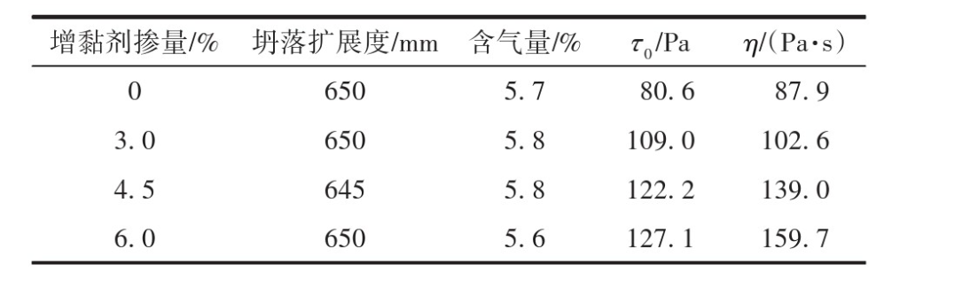
Swartz M et al.^{[26]} investigated the effect of a blended polycarboxylic acid (PCE) superplasticizer on the rheological properties of three different cements. It was found that two SP agents with the same molecular structure but different masses and side chain lengths provided an SP product with a greater impact on the rheological properties of cement slurry. The yield stress value was not affected in the presence of blended SP with SP content above 50% and long side chains, while its adsorption capacity increased with the decrease of SP content with short side chains and lower molecular weight ^{[27]}.
2.3 Regenerated aggregate
yang et al. ^{[28]} used CAR rheometer to determine the static yield stress, plastic viscosity, and yield stress of SCC through static yield stress test and flow curve test. When measuring plastic viscosity and yield stress, it is assumed that the SCC conforms to the Bingham model. With the increase of the substitution rate of recycled fine aggregates, the plastic viscosity and yield stress of recycled SCC increased linearly. The rough surface texture and angularity of recycled fine aggregates lead to a decrease in the fluidity of the mortar, which affects the working performance of SCC. Due to the higher CAAT index and roughness of recycled fine aggregate than natural sand, the increase of substitution rate can effectively improve the yield stress and plastic viscosity of SCC, improve the rheological properties, but reduce the working performance of SCC. The increase of the pre-wetting time of recycled fine aggregates will reduce the working performance of recycled SCC and improve the rheological characteristics ^{[29]}.
Bir R S et al. ^{[6]} studied the rheological properties of self-compacting concrete (SCC) with different dosages of silica ash ((0% (control mix)), 5%, 10%, 15%) in binary binders using a flow curve test protocol implemented on a coaxial cylindrical rheometer. The volume substitution levels of recycled concrete coarse aggregate were 0%, 50% and 100% respectively under each silica ash content. The selected flow model was corrected by the measured flow data, and it was found that with the increase of silica ash content from 0 to 15%, the rheology changed from shear thickening to shear thinning, and the other mix ratios remained unchanged.
SCCs made with recycled concrete aggregates (SCRACs) have similar flow behavior at all substitution levels, although for a given amount of silica ash, the degree of shear thinning decreases with increasing crude recycled aggregate content ^{[30]}.
3 Conclusion and outlook
There are several major problems and challenges in the study of rheological properties of self-compacting concrete, and the following is a summary of these issues:
In terms of rheological models: (1) Bingham model, although it can describe the rheological behavior of concrete, may not be able to describe the rheological characteristics of self-compacting concrete completely accurately. Because self-compacting concrete may exhibit more complex nonlinear behavior during flow, more advanced models need to be developed to better describe its rheological properties. (2) The Herschel-Bulkley model, although it can describe the rheological behavior of many non-Newtonian fluids, not all fluids fully meet the assumptions of the H-B model. The accuracy and reliability of the H-B model depend heavily on the accuracy and completeness of the experimental data. If the experimental data is incorrect or insufficient, the results predicted by the model may be biased. In addition, obtaining experimental data often requires a lot of time and resources, which may limit the application of the H-B model.
In terms of raw materials: (1) Adding a certain amount of mineral admixtures will increase the rheological properties of self-compacting concrete to a certain extent. The addition of a certain amount of slag and fly ash will reduce the yield stress and plastic viscosity of self-compacting concrete, and molybdenum tailings instead of aggregate will increase the fluidity of self-compacting concrete. (2) The addition of different fibers will also increase the fluidity of self-compacting concrete. The addition of steel fiber and basalt fiber reduces the yield stress and plastic viscosity of the mixture to a certain extent. (3) Under the condition that the slump expansion and gas content of self-compacting concrete are similar, the plastic viscosity, yield stress and flow time of self-compacting concrete can be significantly reduced by appropriately reducing the amount of viscosity. (4) With the increase of the substitution rate of recycled fine aggregates, the plastic viscosity and yield stress of recycled SCC increased linearly.
Future research on the rheological properties of self-compacting concrete will focus on model optimization, material ratio innovation, construction technology innovation, durability and long-term performance improvement, and environmental protection and sustainable development. Through in-depth research, it is expected to more accurately describe its rheological behavior, optimize material properties and ratios, improve construction efficiency and quality, ensure its stability and durability in long-term use, and promote its development in a more environmentally friendly and sustainable direction.
Disclaimer (Artificial intelligence)
Option 1:
Author(s) hereby declare that NO generative AI technologies such as Large Language Models (ChatGPT, COPILOT, etc.) and text-to-image generators have been used during the writing or editing of this manuscript.
Option 2:
Author(s) hereby declare that generative AI technologies such as Large Language Models, etc. have been used during the writing or editing of manuscripts. This explanation will include the name, version, model, and source of the generative AI technology and as well as all input prompts provided to the generative AI technology
Details of the AI usage are given below:
1.
2.
3.

References
- Domone, P. L. (2006). Self-compacting concrete: An analysis of 11 years of case studies. Cement and concrete composites, 28(2), 197-208.
- C. K O ,N. P D K .A critical review of rheological models in self-compacting concrete for sustainable structures[J].Scientific Reports,2023,13(1):21296-21296.
- Prasad S J ,Veljarla R ,Sai A M S .Enhancing frost resistance and durability of self-compacting concrete through basalt fiber reinforcement[J].Journal of Building Pathology and Rehabilitation,2023,9(1):
- J. Y Z ,H. K Y ,H. F A S .Properties of sustainable self-compacted concrete with recycled concrete and waste tire crumb rubber aggregates[J].Construction and Building Materials,2023,407
- Sudheer K ,Kanish K ,Bir R S , et al.Application of silica fume in high-volume fly ash self-compacting recycled aggregate concrete[J].Australian Journal of Civil Engineering,2023,21(2):207-223.
- Bir R S ,Kanish K ,Arshdeep S , et al.Rheology of self-compacting concrete containing silica fume and recycled aggregates[J].European Journal of Environmental and Civil Engineering,2024,28(7):1483-1500.
- Mandal R ,Panda K S ,Nayak S .Evaluation of rheological properties of sustainable self-compacting recycled aggregate concrete produced by two-stage mixing approach[J].Journal of Building Engineering,2024,87109126-.
- Şenol F A ,Karakurt C .High-strength self-compacting concrete produced with recycled clay brick powders: Rheological, mechanical and microstructural properties[J].Journal of Building Engineering,2024,88109175-.
- Patil S ,Ramesh B ,Sathish T , et al.RSM-based modelling for predicting and optimizing the rheological and mechanical properties of fibre-reinforced laterized self-compacting concrete[J].Heliyon,2024,10(4):e25973-.
- Patil S ,Bhaskar R ,Xavier R J .Optimization of rheological and mechanical properties of sustainable lateritic self-compacting concrete containing sisal fiber using response surface methodology[J].Journal of Building Engineering,2024,84108574-.
- Qadir A M I ,Noaman T A .Effect of combination between hybrid fibers and rubber aggregate on rheological and mechanical properties of self-compactin concrete[J].Construction and Building Materials,2024,414135038-.
- Ahmad S ,Umar A .Rheological and mechanical properties of self-compacting concrete with glass and polyvinyl alcohol fibres[J].Journal of Building Engineering,2018,1765-74.
- Geiker, M. R., Brandl, M., Thrane, L. N., & Nielsen, L. F. (2002). On the effect of coarse aggregate fraction and shape on the rheological properties of self-compacting concrete. Cement, concrete and aggregates, 24(1), 3-6.
- González-Taboada, I., González-Fonteboa, B., Martínez-Abella, F., & Carro-López, D. (2017). Self-compacting recycled concrete: Relationships between empirical and rheological parameters and proposal of a workability box. Construction and Building Materials, 143, 537-546.
- Li, H., Huang, F., Yi, Z., Wang, Z., Zhang, Y., & Yang, Z. (2020). Investigations of mixing technique on the rheological properties of self-compacting concrete. Applied Sciences, 10(15), 5189.
- Li Jingqi, Xu Wei. CFD simulation of self-compacting concrete flow based on Herschel-Bulkley rheological model[J].Engineering Mechanics,2013,30(01):373-377.
- Li Jingjun, Tian Lei, Qiu Liuchao, et al. Numerical simulation of self-compacting concrete flow based on MPS method[J].Journal of Chinese Building Materials,2020,23(02):309-316.
- Mohammed, A. M., Asaad, D. S., & Al-Hadithi, A. I. (2022). Experimental and statistical evaluation of rheological properties of self-compacting concrete containing fly ash and ground granulated blast furnace slag. Journal of King Saud University-Engineering Sciences, 34(6), 388-397.
- Chen, L., Jiaping, L., Yi, T., & Changhui, Y. (2022). Influence of hydrophobic minerals on fluidity and strength of high-strength self-compacting concrete. Journal of Southeast University/Dongnan Daxue Xuebao, 52(2).
- Hua, C., Tang, R., & Lu, X. (2024). Radon emission characteristics and pore structure evolution of self-compacting concrete with silica fume-molybdenum tailings under different curing environments. Journal of Building Engineering, 97, 110769.
- Gueciouer, D., Youcef, G., & Tarek, N. (2022). Rheological and mechanical optimization of a steel fiber reinforced self-compacting concrete using the design of experiments method. European Journal of Environmental and Civil Engineering, 26(3), 1097-1117..
- Ashteyat, A., Obaidat, A. T., Qerba’a, R., & Abdel-Jaber, M. T. (2024). Influence of basalt fiber on the rheological and mechanical properties and durability behavior of self-compacting concrete (SCC). Fibers, 12(7), 52.
- Dongdong J ,Zongran W ,Danying G , et al.Analysis on rheological and workability properties of steel-polypropylene ﬁbers reinforced self-compacting concrete with recycled coarse and fine aggregates[J].Journal of Building Engineering,2023,79
- M.G. A ,A. E ,J.C. G .The effect of fibres in the rheology of self-compacting concrete[J].Construction and Building Materials,2019,219144-153.
- Zeng, Z. P., Huang, X. D., Yan, B., Wang, W. D., Shuaibu, A. A., & He, X. F. (2021). Research on the fatigue performance of self-compacting concrete structure in CRTSIII slab ballastless track under the action of heavy haul train. Construction and Building Materials, 303, 124465.
- Swartz M ,Mbasha W ,Haldenwang R .The Effect of a Blended Polycarboxylate Superplasticizer on the Rheology of Self-Compacting Concrete Paste[J].Applied Sciences,2023,13(7):
- Huang F ,Li H ,Yi Z , et al.The rheological properties of self-compacting concrete containing superplasticizer and air-entraining agent[J].Construction and Building Materials,2018,166833-838.
- Yang Lijun,Li Ye,Liu Caihong,et al. Effects of recycled aggregates on the working performance and rheological properties of self-compacting concrete[J].Municipal Technology,2024,42(01):175-181.DOI:10.19922/j.1009-7767.2024.01.175.
- Behera, M., Minocha, A. K., & Bhattacharyya, S. K. (2019). Flow behavior, microstructure, strength and shrinkage properties of self-compacting concrete incorporating recycled fine aggregate. Construction and Building Materials, 228, 116819.
- Xuyong C ,Long L ,Qiaoyun W , et al.Optimization on the mix design method of self-compacting concrete with recycled coarse aggregate based on paste rheological threshold theory and material packing characteristics[J].Construction and Building Materials,2023,407

