POSTURE-RELATED MUSCULOSKELETAL DISCOMFORT EXPERIENCED BY HOTEL STAFF IN VADODARA

.
ABSTRACT

The hospitality industry is physically demanding, with hotel employees frequently performing tasks that place significant strain on their musculoskeletal systems. This study investigates the occurrence of posture-related musculoskeletal discomfort (MSD) among hotel staff in Vadodara, specifically focusing on employees in the Front Office, Housekeeping, and Food and Beverage departments. A purposive and snowball sampling technique was used to select 120 participants from a variety of hotels within the city. A structured questionnaire was employed to collect data regarding posture-related discomfort, considering factors such as demographic details and work-related conditions. The results revealed that housekeeping staff experienced the highest levels of discomfort, particularly in the lower back, neck, shoulders, and legs. The discomforts were primarily linked to prolonged periods of standing, awkward postures, repetitive tasks, and limited rest breaks. Front Office and Food and Beverage department staff also reported discomfort, but to a lesser degree. For Gender t-value was 3.69 and for Family type, the t-value was 2.63 which were found significant (α=0.05). For Age, F value was 3.73 and for and Work Experience, F value was 6.71 which was found to be significant (α= 0.05). The study emphasizes the need for ergonomic improvements such as adjusting workstations, providing anti-fatigue mats, and offering posture correction training to alleviate physical strain. These findings offer valuable insights that can assist hotel management in enhancing workplace conditions and promoting employee well-being.

Keywords: Musculoskeletal discomfort, ergonomic interventions, hotel staff, posture-related discomfort

1. INTRODUCTION

The hospitality sector, especially hotels, has rapidly become one of the fastest-growing parts of the global service industry, hosting an increasing number of travelers. As the industry expanded, hotel staff faced rising physical and mental demands—such as repeated movements, long hours of standing, and awkward postures—which raised concerns about musculoskeletal discomfort caused by poor ergonomics. This study examines how these physical strains affect hotel workers in Vadodara and explores practical ergonomic solutions to improve their daily working conditions.
Recent studies have consistently shown that repetitive tasks, prolonged standing, and awkward postures significantly contribute to musculoskeletal disorders (MSDs) among hotel employees (Hoy et al., 2012; Rahman et al., 2017). For example, Parmar and Dalal (2017) found that 25% of housekeeping staff in Gujarat hotels experienced work-related MSDs, with low back pain most prevalent due to heavy lifting and sustained postures. Similarly, Chauhan and Sondhi (2020) identified strong links between prolonged standing and discomfort in receptionists’ lower back, calves, neck, and ankles, aggravated by irregular shifts.
Recent research underscores the high risk faced by housekeeping staff while performing repetitive, physically demanding tasks in awkward postures (Gangurde & Pinto, 2023). Furthermore, Patel, Smita, and Veerkumar (2024) highlight that poor ergonomics and posture also contribute to musculoskeletal discomfort in office environments, especially among female employees.
Systematic reviews and studies from related sectors have reinforced the connection between physical work demands and MSDs. Hoogendoorn et al. (2014) confirmed strong evidence linking low back pain to manual handling, bending, twisting, and whole-body vibration. Studies in agriculture reveal similar patterns: Keawduangdee et al. (2015) reported high rates of low back pain among Thai rice farmers due to poor working postures; Kearney et al. (2016) found 79% of Latino farmworkers reported pain, mainly in the back and shoulders; and Munala et al. (2021) reported that 68.1% of Kenyan flower farm workers suffered musculoskeletal disorders, largely attributed to repetitive manual tasks and prolonged labour. Additionally, Mahto et al. (2018) documented that over 70% of Nepalese farmers experienced MSDs in key body areas due to inadequate ergonomic practices, while Kim et al. (2019) reported high prevalence of upper extremity MSDs among Korean fruit farmers. In the hotel sector, Lee et al. (2013) linked musculoskeletal symptoms significantly to gender, job role, and labor intensity.
Despite this body of research on MSDs in various industries, limited data is available on ergonomic risks and musculoskeletal health specifically among hotel workers in Vadodara. This study addresses this gap by assessing the prevalence of MSDs among hotel employees in this region and identifying targeted ergonomic interventions to improve their health and productivity.
Our findings reveal frequent posture-related discomfort in the lower back, neck, shoulders, and knees, varying by job role. Housekeeping staff reported back pain, food and beverage workers experienced leg and shoulder strain, and front desk employees suffered from neck and shoulder issues. Additional factors such as age, past injuries, and poorly designed workspaces exacerbated these conditions. By examining pain frequency, intensity, and impact on work performance, the study identifies critical areas where ergonomic improvements are most needed. Promoting posture awareness and improving workspace design positively influenced employee comfort and productivity.
In conclusion, poor workplace ergonomics remains a primary factor in musculoskeletal discomfort and disorders within the hospitality sector, highlighting the urgent need for ergonomic interventions, employee education, and workplace redesign to enhance employee health and efficiency (Veerkumar, 2020).
OBJECTIVES
- To find out the background information of the respondents.
- To assess the Posture related Musculoskeletal Discomfort experienced by the Hotel staff working in different departments viz; Front Office Department, Housekeeping Department and Food and Beverage Department.

2. methodology

The present study employed a descriptive research design and was conducted in Vadodara City, Gujarat, India. A total of 120 hotel staff members were purposively selected, all of whom provided informed consent to participate in the study.​ The study collected data using a structured questionnaire, which comprised two sections. Section I included the Background Information of the Respondents which gathered demographic details of the respondents, including age, personal monthly income (in rupees), marital status, gender, education, type of family, number of family members, and educational qualification.​ Section II comprised of Posture-Related Musculoskeletal Discomfort Experienced by the Hotel Staff
This section assessed the extent of musculoskeletal discomfort experienced by hotel staff working in various departments of the hospitality industry (viz., Front Desk, Housekeeping Management, and Food and Beverage) while performing different job tasks. Respondents were asked to indicate the frequency of discomfort using a 3-point continuum scale: “Always,” “Sometime,” and “Never,” with corresponding scores of 3, 2, and 1, respectively. To categorize the extent of discomfort, the total scores were divided into equal intervals.​ Data collection was carried out from October to December 2024. Respondents were identified using the snowball sampling technique within Vadodara city. Prior to data collection, the purpose of the research was explained to the participants, and rapport was established to ensure full cooperation and obtain genuine responses. The investigator personally distributed and collected the completed questionnaires to ensure that respondents clearly understood the terms used, thereby minimizing misinterpretations and enhancing the reliability of the data.​ The collected data underwent the processes of categorization, coding, and tabulation. Subsequently, appropriate statistical analyses were conducted to interpret the findings.​

3. results and FINDINGS

Section I: Background Information of the Respondents
This section gathered demographic details of the respondents, including age, personal monthly income (in rupees), marital status, gender, education, type of family, number of family members, and educational qualification.​
PART A: Demographic Profile
Among the respondents (n = 120), 81.67 per cent were aged between 20 and 29 years, with a mean age of 27 years. Male respondents accounted for 75.83 per cent. Unmarried individuals comprised 50.83 per cent of the sample. In terms of family structure, 54.17 per cent belonged to joint families, and 55.83 per cent reported having 5 to 7 family members. Personal monthly income between ₹50,001 and ₹1,00,000 was reported by 55.83 per cent. Educational qualifications showed that 43.33 per cent were graduates. Additionally, 41.67 per cent of respondents worked in 4-star hotels.

PART B: Work Related Information of the Respondents
Table 1: Percentage distribution of Respondents according to their Work-Related Information.

Sr. No. | Work Related Information | Departments
Sr. No. | Work Related Information | Front office  (n = 40) |  | Housekeeping  (n=40) |  | Food and Beverages  (n=40)
Sr. No. | Work Related Information | f | % | f | % | f | %
1. | Working Hours (per day)
1. | 5-7 hours | 06 | 15.00 | 01 | 02.50 | 02 | 05.00
1. | 8-10 hours | 32 | 80.00 | 33 | 82.50 | 35 | 87.50
1. | 11 - 13 hours | 02 | 05.00 | 06 | 15.00 | 03 | 07.50
2. | Working experiences (per day)
2. | 2-4 years | 11 | 27.50 | 09 | 22.50 | 13 | 32.50
2. | 4-6 years | 28 | 70.00 | 26 | 65.50 | 25 | 62.50
2. | 6 - 8 years | 01 | 02.50 | 05 | 12.50 | 02 | 05.00
3. | Types of Tasks
3. | Heavy lifting | 06 | 15.00 | 31 | 77.50 | 28 | 70
3. | Repetitive motions | 23 | 57.50 | 25 | 62.50 | 26 | 65
3. | Prolonged standing | 25 | 62.50 | 18 | 45.00 | 18 | 45
3. | Carrying loads over distances | 07 | 17.50 | 20 | 50.00 | 07 | 17.50
3. | Frequent walking | 27 | 67.50 | 31 | 77.50 | 36 | 90.00
3. | Pushing and Pulling objects | 05 | 12.50 | 18 | 45.00 | 09 | 22.50
3. | Manual handling of materials | 04 | 10.00 | 19 | 47.50 | 19 | 47.50
3. | Use of hand tools (e.g., vacuum cleaners, mope, or kitchen utensils | 02 | 05.00 | 26 | 65.00 | 11 | 27.50
3. | Prolonged sitting (e.g., at the front desk) | 14 | 35.00 | 10 | 25.00 | 11 | 27.50
3. | Maintaining awkward postures (e.g., reaching for high shelves) | 05 | 12.50 | 08 | 20.00 | 07 | 17.50
3. | Frequent crouching | 07 | 17.50 | 10 | 25.00 | 17 | 42.50
3. | Frequent kneeling | 08 | 20.00 | 10 | 25.00 | 16 | 40.00
4. | Personal Protective equipment (PPE)
4. | Always use PPE | 12 | 30.00 | 08 | 20.00 | 21 | 52.50
4. | Occasionally use PPE | 26 | 65.00 | 32 | 80.00 | 19 | 47.50
4. | Never use PPE | 02 | 05.00 | - | - | - | -
5. | Personal Protective Equipment (PPE)
5. | Gloves | 10 | 25.00 | 32 | 80.00 | 31 | 77.50
5. | Masks/ Respirators | 30 | 75.00 | 29 | 72.50 | 26 | 65.00
5. | Safety Goggles/Glasses | 05 | 12.50 | 26 | 65.00 | 06 | 15.00
5. | Protective Clothing (e.g., uniforms, aprons) | 34 | 85.00 | 30 | 75.00 | 38 | 95.00
5. | Face Shields | 01 | 02.50 | 14 | 35.00 | 09 | 22.50
5. | Safety Footwear | 10 | 25.00 | 21 | 52.50 | 23 | 57.50
5. | Sleeve protectors | - | - | - | - | 03 | 07.50
Total |  | 40 | 100 | 40 | 100 | 40 | 100

Among the respondents, 87.50 per cent of Food and Beverages staff reported working 8 to 10 hours per day. In terms of work experience, 70.00 per cent of Front Office employees had 4 to 6 years of experience. Regarding task types, 90.00 per cent of Food and Beverages staff reported frequent walking.
Use of personal protective equipment (PPE) was highest among Food and Beverages employees, with 52.50 per cent reporting consistent use. Additionally, 80.00 per cent of housekeeping staff used PPE occasionally. Protective clothing was worn by 95.00 per cent of Food and Beverages staff—the highest usage rate for any PPE item across all departments (table 1).

Section II
2. Posture-Related Musculoskeletal Discomfort Experienced by Hotel Staff
2.1 Posture-Related Musculoskeletal Discomfort Experienced by Respondents working in Front Office Department
Analysis of the survey responses indicated that all front office staff consistently reported wrist strain from regularly handling guest requests and documents. Participants also experienced discomfort in the shoulder or neck due to carrying guest bags. Leg discomfort linked to musculoskeletal issues was commonly noted during long periods of standing, particularly at peak check-in and check-out times. Additionally, staff described physical strain resulting from managing several tasks simultaneously. Each of these symptoms was reflected in a weighted mean score of 3 on the discomfort scale. The data also reported that, 82.50 per cent of respondents sometimes experienced shoulder discomfort while supervising the front desk, pain in the lower back due to prolonged standing during peak check-in times, pain in the wrist due to extensive use of the computer, and upper back pain from frequently moving between workstations with a weighted mean of 2.18. Furthermore 67.50 per cent respondents sometimes experienced numbness in fingers due to excessive computer use, and musculoskeletal discomfort due to handling luggage and deliveries with a weighted mean of 2.68.

2.1.1 Extent of Posture related Musculoskeletal Discomfort Problems experienced by the Respondents while working in Front Office Department
This section dealt with the extent of posture related musculoskeletal discomfort (MSD) problems experienced by the respondents related to posture while working in the front office. The respondents were asked to respond to a 3-point continuum in terms of “Always,” “Sometime,” and “Never,” with scores from 3 through 1 assigned to the respondents, respectively. The possible score ranged from 39 to 120, with three categories having almost equal intervals based on a total of 39 statements in the scale. Lower scores indicated a lower extent of musculoskeletal discomfort problems experienced by the respondents, while higher scores indicated a higher extent of musculoskeletal discomfort problems.
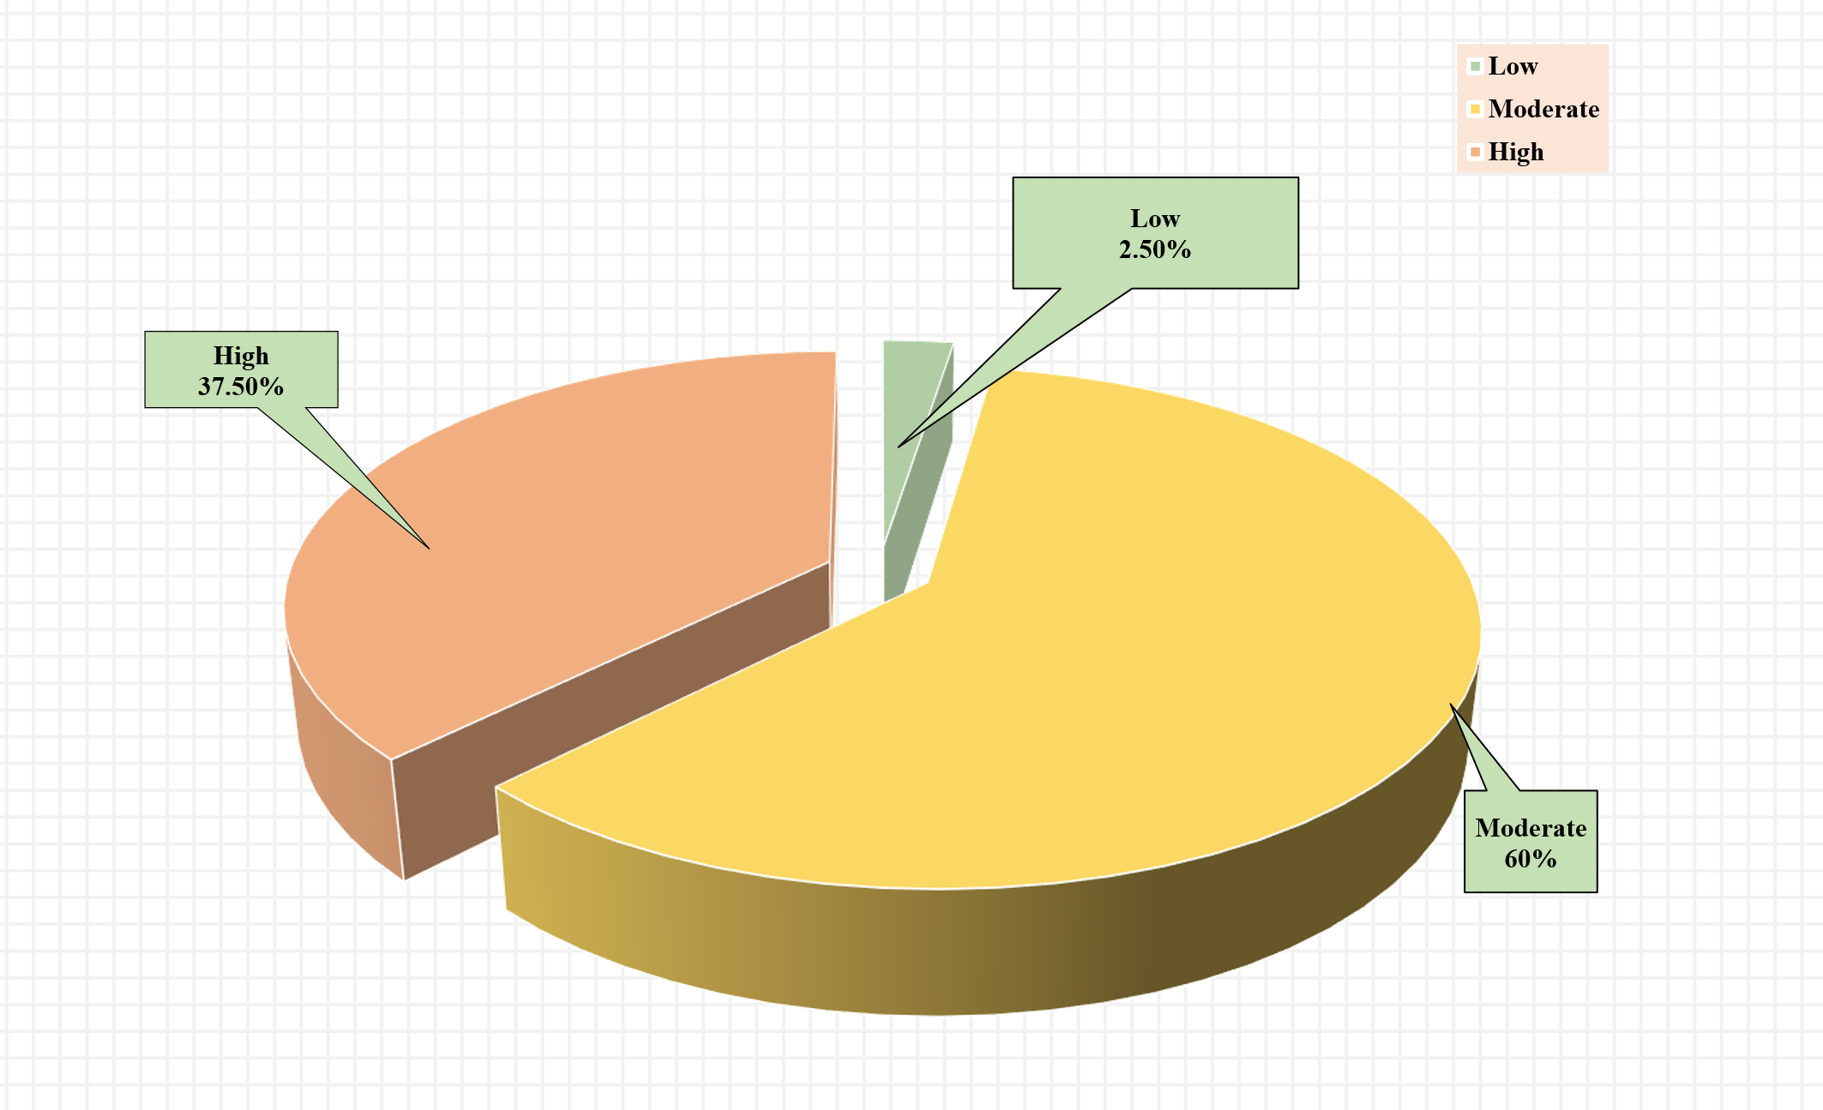

Figure 1: Extent of Posture Related Musculoskeletal Discomfort Experienced by the respondents Working in Front desk Operations
The data showed that 2.50 per cent of the respondents had experienced a low extent of musculoskeletal discomfort, 60.00 per cent had experienced a moderate extent, and 37.50 per cent had experienced a high extent of musculoskeletal discomfort problems related to posture in the front office department (fig. 1).

  - Posture Related Musculoskeletal Discomfort Experienced by the respondents Working in Housekeeping Department
The data revered that 100 per cent of the respondents always experienced pain in low back pain while performing cleaning tasks with a weighted mean of 2.18 and wrist pain from repetitive cleaning motions having weighted mean 2.45, felt upper back pain due to maintaining posture while working, Experienced neck or shoulder discomfort because of answering phones and coordinating tasks, and felt shoulder or neck discomfort because of loading and unloading machines with a weighted mean of 2.63. Additionally, 75 per cent of the respondent experience in feet always pain from extended walking and standing with weighted mean 2.50), and 62.5 per cent of the respondent always had shoulder or neck discomfort while loading and unloading machines of weighted mean 2.50.
Moreover, 65 per cent of the respondents sometimes experienced lower back pain from bending and lifting heavy items having weighted mean 2.45, while 60 per cent of the respondent experience body pain from cleaning tasks and arm strain from pushing heavy carts with weighted mean 2.45. One-half of the respondents sometimes felt fatigue while inspecting rooms and leg fatigue from walking long distances with a weighted mean of 3.00.
Further, 50 per cent of the respondents sometimes experienced discomfort from irregular work hours or poor ventilation with weighted mean 2.18, and 37.5 per cent of the respondents had knee discomfort from prolonged standing having weighted mean 2.0. Around 12.5 per cent of the respondents never felt discomfort from poor ventilation, and 20 per cent of the respondents never experienced discomfort from cleaning high surfaces with weighted mean 2.10.
The overall weighted mean for musculoskeletal discomfort was 2.37, indicating moderate discomfort among the respondents.

2.2.1 Posture Related Musculoskeletal Discomfort experienced by The Respondents while Working in Housekeeping Department
This section provides an analysis of the extent of Posture related musculoskeletal discomfort experienced by the respondents while working housekeeping department. The data is based on a summated rating scale where the respondents were asked to respond to a 3-point continuum: “Always,” “Sometimes,” and “Never,” with the scores of 3, 2, and 1, respectively. The total score for each respondent ranged from 34 to 102, based on their responses to 34 statements related to musculoskeletal discomfort. A higher score indicated a greater extent of discomfort experienced by the staff, while a lower score indicated less discomfort.

The distribution of the respondents according to the extent of musculoskeletal discomfort is as follows:
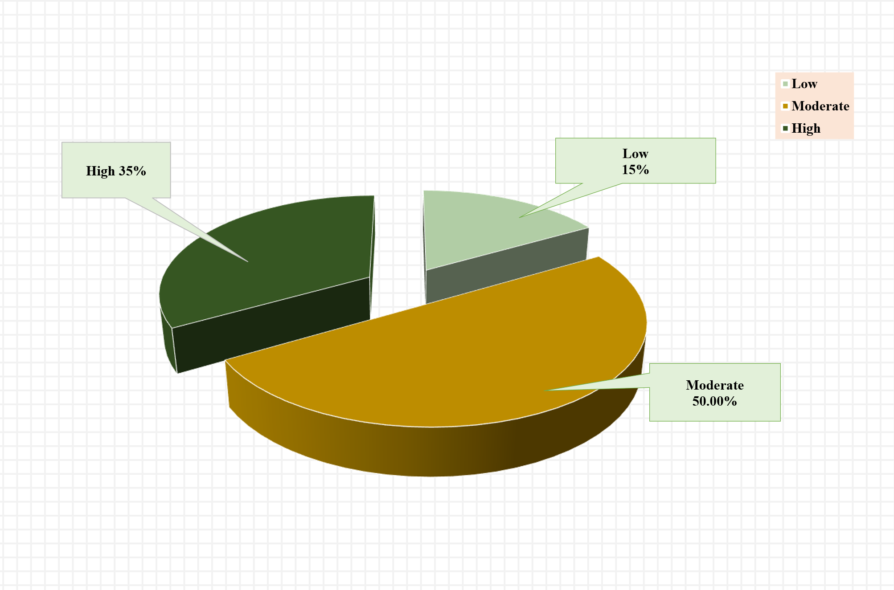

Figure 2: Extent of Posture Related experience by the respondents working in the Housekeeping Department

The data showed that 15.00 per cent of the respondents had experienced a low extent of musculoskeletal discomfort, 50 per cent had experienced a moderate extent, and 35.00 per cent had experienced a high extent of musculoskeletal discomfort problems in the housekeeping department (fig. 2).

2.3 Posture Related Musculoskeletal Discomfort Experienced by the respondents working in the Food and Beverage Department
The data showed that all respondents consistently reported experiencing lower back pain from carrying heavy trays to guest rooms, along with wrist pain caused by repetitive movements while operating espresso machines, with a weighted mean score of 3.0. Furthermore, 75% of respondents frequently experienced discomfort in the neck or shoulders due to supervising restaurant operations, as well as lower back pain from extended periods of standing and walking, reflected by a weighted mean score of 2.75. Additionally, 70% of respondents experienced upper back pain from regularly moving between work areas and discomfort in the shoulder or neck region while preparing food, with a weighted mean score of 2.68.
Moreover, 65 per cent always experienced wrist pain from repetitive tasks like stirring, mixing, and handling banquet materials (weighted mean 2.65). The data also highlighted that 62.5 per cent always felt wrist pain while holding and serving items (weighted mean 2.45), and 55 per cent always felt physical strain from the fast-paced work environment (2.38).
Further, 50 per cent of the respondents always experienced discomfort from repetitive cooking activities and foot pain from prolonged standing and walking (weighted mean 2.50). 65 per cent of the respondents sometimes experienced lower back pain from standing during service hours had weighted mean 2.88, and 32.5 per cent of the respondents experienced discomfort due to improper shoes had weighted mean 2.68.

    - Posture Related Musculoskeletal Discomfort experienced by the respondents working in the Food and Beverage Department.
This section analyzed the overall extent of Posture related musculoskeletal discomfort experienced by the staff working in food and beverage department. The data was collected using a summated rating scale, where respondents answered on a 3-point continuum: “Always,” “Sometimes,” and “Never,” with scores of 3, 2, and 1, respectively. The total score for each respondent ranged from 35 to 105, based on their responses to 35 statements related to musculoskeletal discomfort. A higher score indicated a greater extent of discomfort, while a lower score suggested less discomfort.

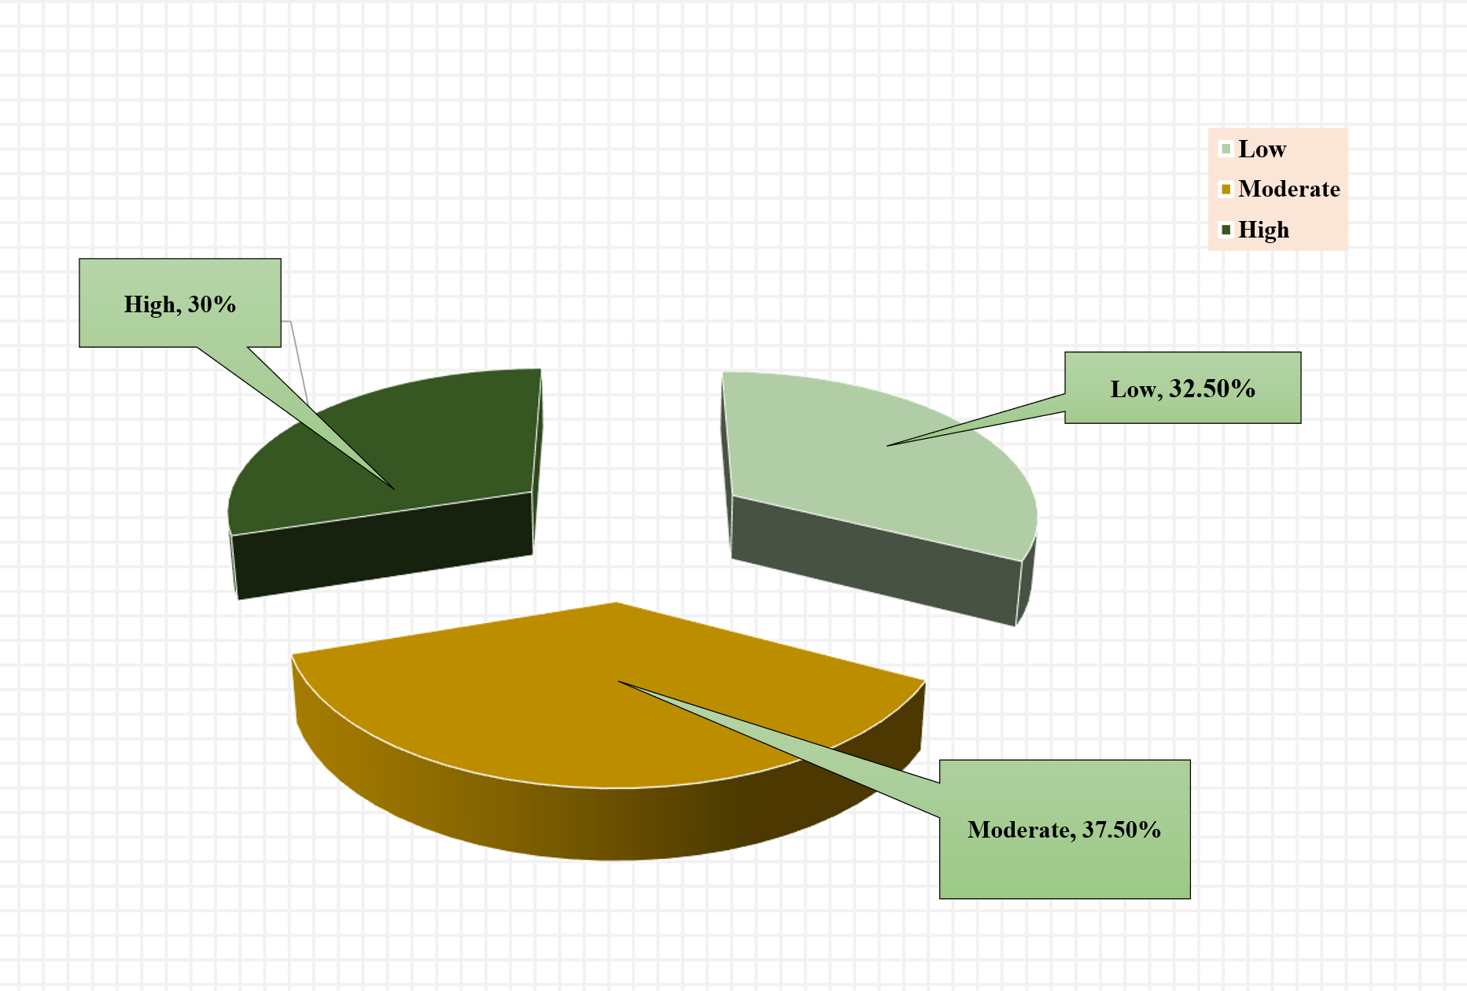
To categorize the extent of discomfort, three intervals were established based on the possible score range, with nearly equal intervals for all respondents. The classification was as follows:
Figure 3: Extent of Posture Related Musculoskeletal Discomfort Experienced while Working in the Food and Beverages Department

The data showed that 32.50 per cent of the respondents experienced low extent of Posture related musculoskeletal discomfort while working in food and beverages department. Followed by 37.50 per cent of the respondent experienced moderate extent of posture related musculoskeletal discomfort while working in food and beverages department. the data also revealed that 30 per cent of respondents experienced high extent of Posture related musculoskeletal discomfort while working in food and beverages department (fig. 3).

TESTING OF HYPOTHESES

Based on the objectives of the study a number of hypotheses were formulated. For the present investigation, as per the nature of the variables, Coefficient of Correlation, t Test and F Test were computed. For the purpose of statistical analysis, the hypotheses were formulated in null forms. The results are discussed as under.
HO1: There exists no variation in the Musculoskeletal Discomfort experienced by the respondents with their age, gender, education level, family type, number of family members, work experience and work type.
To find out the difference between Musculoskeletal Discomfort experienced by the respondents with their Age, Gender, Marital Status, Education Level, Family type, Number of Members in the Family, Work Experience and Work type t-test was computed. Variables.

Table 2: t-test showing the variation in the Musculoskeletal Discomfort experienced by the respondents with their gender and family type
Variables | Mean score of Musculoskeletal Discomfort | t-value | df | Level of significance
Gender
Male | 158.50 | 3.69 | 66 | 0.05
Female | 146.28 | 3.69 | 66 | 0.05
Family type
Nuclear | 144.00 | 2.63 | 105 | 0.05
Joint | 150.86 | 2.63 | 105 | 0.05

For Gender and Family type, the t-value were found to be significant at 0.05 level of significance (table 2). Hence, the null hypothesis was rejected. Hence, it can be concluded that the Musculoskeletal Discomfort among the respondents differed with the gender and type of family. Male respondents experienced high Musculoskeletal Discomfort as compared to the female.
To find out the difference between Musculoskeletal Discomfort experienced by the respondents with their Age, Education Level, Number of Members in the Family and Work experience ANOVA was computed.
Table 3: F-test showing the variation in the Musculoskeletal Discomfort experienced by the respondents with their Age, Education Level, Number of Members in the Family and Work Experience.
Variables | Mean score of Musculoskeletal Discomfort |  | df |  | F-value |  | Level of significance
Age
Between groups | 110.98 |  | 2 |  | 3.73 |  | 0.05
Within groups | 41.94 |  | 117
Education Level
Between groups | 23.12 |  | 2 |  | 2.09 |  | N.S.
Within groups | 11.04 |  | 117
Number of Members in the Family
Between groups |  | 20.33 |  | 2 |  | 2.02 |  | N.S.
Within groups |  | 10.04 |  | 117
Work Experience
Between groups |  | 125.26 |  | 2 |  | 6.81 |  | 0.05
Within groups |  | 18.40 |  | 117

For Age, and Work Experience, ANOVA was found to be significant at 0.05 level of significance (table 3). Hence, the null hypothesis was rejected. Hence, it can be concluded that the Musculoskeletal Discomfort differed with the Age, and Work Experience of the respondents whereas for Education Level and Number of family members, F test was found to be non-significant hence it was concluded that the Musculoskeletal Discomfort did not differ with the Education Level and Number of Members in the Family.
Further Scheffe’s test was applied for age and work experience.

Table 4: Scheffe’s test showing the mean significant in the Musculoskeletal Discomfort of the respondents with their age (in years).
Sr.  No. | Selected Variable | Mean | df | Level of significance
 | Age (in years)
1 | 20 Years - 29 Years | 49.94 | 137 | 0.01
2 | 30 Years - 39 Years | 52.00 | 137 | 0.01
3 | 40 Years - 49 Years | 42.62 | 137 | 0.01
The statistical analysis in Scheffe’s test on various categories of age of the respondents stated that respondents between age group of 20 to 29 years significantly differed in the Musculoskeletal Discomfort of the respondents with their age. Hence, it can be concluded that the extent of Musculoskeletal Discomfort experienced by the respondents was more among respondents who were 30 to 39 years of age (table 4).

Table 5: Scheffe’s test showing the mean significant in the extent of Musculoskeletal Discomfort of the respondents with their work experience

Sr.  No. | Selected Variable | Mean | df | Level of significance
 | Experience (in years)
1 | 2 Years - 4 Years | 96.40 | 137 | 0.05
2 | 4 Years - 6 Years | 88.20 | 137 | 0.05
3 | 6 Years - 8 Years | 76.46 | 137 | 0.05

The statistical analysis in Scheffe’s test on various categories of experience of the respondents showed that the respondents between work experience of 2 to 4 years significantly differed with the extent of musculoskeletal discomfort experienced by the respondents with experience of 2 to 4 years, 4 to 6 years and of 6 to 8 years. Hence, it can be concluded that the extent of musculoskeletal discomfort experienced by the respondents was more among respondents who were above 6 to 8 years of experience (table 5).

4. Conclusion

The research clearly shows that posture-related musculoskeletal discomfort is a major concern for hotel staff in Vadodara, especially those working in Housekeeping, Front Office, and Food and Beverage departments. Prolonged standing, repetitive movements, awkward body positions, and heavy lifting contribute to pain and discomfort in areas such as the lower back, neck, shoulders, and legs. Housekeeping staff face the most discomfort due to frequent bending, lifting, and repetitive tasks. Front Office workers experience issues mainly from standing for long periods and desk work, while Food and Beverage employees endure physical strain from serving, walking, and carrying heavy items.
These results highlight the critical need for ergonomic improvements in the workplace. Introducing solutions like adjusted workstations, anti-fatigue mats, posture training, and more frequent rest breaks can significantly reduce discomfort. By adopting these measures, hotel management can promote better employee health, increase work efficiency, and lower the chances of chronic injuries.
In summary, this study provides valuable insight into the physical challenges faced by hotel employees and offers practical recommendations to create safer, healthier work environments. Proactively addressing these concerns can improve employee satisfaction, reduce health problems, and boost overall productivity in the hospitality sector.

AcknowledgEment

We would like to extend our sincere thanks to all the hotel staff workers who participated as respondents in the study; their willingness to contribute their time and insights was invaluable. We also appreciate the support provided by the faculty and staff of the Department of Family and Community Resource Management for creating a conducive research environment.

Ethical approval

The study was approved by the Institutional Ethics Committee for Human Research (IECHR), Faculty of Family and Community Sciences, The Maharaja Sayajirao University of Baroda (Approval No. IECHR/FCSc/M.Sc./10/2024/18).

Disclaimer (Artificial intelligence)
Option 1:
Author(s) hereby declare that NO generative AI technologies such as Large Language Models (ChatGPT, COPILOT, etc.) and text-to-image generators have been used during the writing or editing of this manuscript.
Option 2:
Author(s) hereby declare that generative AI technologies such as Large Language Models, etc. have been used during the writing or editing of manuscripts. This explanation will include the name, version, model, and source of the generative AI technology and as well as all input prompts provided to the generative AI technology
Details of the AI usage are given below:
1.
2.
3.
References

Chauhan, M. K., & Sondhi, A. (2020). Posture-related musculoskeletal problems among hotel receptionists in Mumbai: A cross-sectional study. Indian Journal of Occupational and Environmental Medicine, 24(3), 157–162. https://doi.org/10.4103/ijoem.IJOEM_275_18
Gangurde, D., & Pinto, R. (2023). A study on musculoskeletal disorders among housekeeping staff in the hotel industry. International Journal of Advanced Research in Science, Communication and Technology, 6(1), 87–94. https://www.ijarsct.co.in/Paper13767.pdf
Gawde, N. C. (2018). A study of musculoskeletal pain among hotel employees, India. Journal of Ecophysiology and Occupational Health, 18(1 & 2), 44–51. https://doi.org/10.18311/jeoh/2018/20012
Hoogendoorn, W. E., van Poppel, M. N., Bongers, P. M., Koes, B. W., & Bouter, L. M. (1999). Physical load during work and leisure time as risk factors for back pain. Scandinavian Journal of Work, Environment & Health, 25(5), 387–403. https://doi.org/10.5271/sjweh.451

Hoy, D., Bain, C., Williams, G., et al. (2012). A systematic review of the global prevalence of low back pain. Arthritis and Rheumatism, 64(6), 2028–2037. https://doi.org/10.1002/art.34347
Kearney, G. D., Allen, D. L., Balanay, J. A. G., & Barry, P. (2016). A descriptive study of body pain and work-related musculoskeletal disorders among Latino farmworkers working on sweet potato farms in eastern North Carolina. Journal of Agromedicine, 21(3). https://doi.org/10.1080/1059924X.2016.1178613
Keawduangdee, P., Puntumetakul, R., Swangnetr, M., Laohasiriwong, W., Settheetham, D., Yamauchi, J., & Boucaut, R. (2015). Prevalence of low back pain and associated factors among farmers during the rice transplanting process. Journal of Physical Therapy Science, 27(7), 2239–2245. https://doi.org/10.1589/jpts.27.2239
Kim, S. Y., Park, S. B., Lee, J. H., & Kim, H. J. (2019). Prevalence of upper extremity musculoskeletal diseases and disability among fruit tree farmers in Korea. Annals of Occupational and Environmental Medicine, 31, Article 21. https://doi.org/10.1186/s40557-019-0285-8
Lee, J., Lee, J. J., Mun, H. J., Lee, K.-J., & Kim, J. J. (2013). The relationship between musculoskeletal symptoms and work-related risk factors in hotel workers. Annals of Occupational and Environmental Medicine, 25, Article 20. https://doi.org/10.1186/2052-4374-25-20

Mahto, S., Tamang, D., & Parajuli, D. R. (2018). Prevalence of work-related musculoskeletal disorders in agricultural farmers of Bhaktapur District, Nepal. International Journal of Occupational Safety and Ergonomics, 24(4), 543–550. https://doi.org/10.1080/10803548.2017.1339921
Munala, J. M., Olivier, B., Karuguti, W. M., & Karanja, S. M. (2021). Prevalence of musculoskeletal disorders amongst flower farm workers in Kenya. South African Journal of Physiotherapy, 77(1), Article 1515. https://doi.org/10.4102/sajp.v77i1.1515
Parmar, S., & Dalal, P. (2017). A study of musculoskeletal disorder among housekeeping staff in hotel industry. International Journal of Home Science, 3(3), 83–85. https://www.homesciencejournal.com/archives/?year=2017&vol=3&issue=3&part=B&ArticleId=449
Patel, S., Smita, & Veerkumar, K. (2024). Musculoskeletal discomfort experienced by the office staff: A hindrance in efficient work performance. Annals of Occupational and Environmental Medicine. https://www.researchgate.net/publication/378969013_MUSCULOSKELETAL_DISCOMFORT_EXPERIENCED_BY_THE_OFFICE_STAFF_A_HINDRANCE_IN_EFFICIENT_WORK_PERFORMANCE
Rahman, M. N. A., & Jaffar, M. S. M. (2017). Musculoskeletal symptoms and ergonomic hazards among room attendants in hotel industries. Human Factors and Ergonomics Journal, 1(2), 25–34. https://doi.org/10.33736/hfej.25903705.2017
Samani, A. (2012). Musculoskeletal disorders among housekeeping staff in hotel industries. Musculoskeletal Symptoms and Ergonomic Hazards Among Room Attendants in Hotel Industries.
Vashima, V. (2020). Musculoskeletal pain and postural discomfort experienced by the marble cutting workers in the marble industry [Unpublished doctoral dissertation]. Maharaja Sayajirao University of Baroda. https://shodhganga.inflibnet.ac.in/handle/10603/329608

