Review Article

Stimuli-Responsive Chromic Textiles: Mechanisms, Fabrication Strategies, and Emerging Applications

Abstract
Chromic textiles, fabrics that change colour in response to external stimuli, have attracted considerable interest for their potential in smart clothing, sensors, protective gear, and aesthetic design. These stimuli include light (photochromism), temperature (thermochromism), electric field (electrochromism), pH (halochromism), solvents (solvatochromism), mechanical stress (mechanochromism), among others. This review synthesizes recent developments in chromic textiles: the molecular and material mechanisms of chromism, methods for incorporating chromic functionality into textile substrates, evaluation of performance metrics, applications across sectors, current limitations, and future research directions. Recent advances in multifunctional and dual-/multi‐stimuli responsive systems are emphasized. Notably, recent studies have achieved wash durability up to 100 cycles and response times below 1 second, demonstrating significant improvements in performance reliability. Attention is also given to the environmental sustainability and scalability of chromic textile production, critical factors for their commercial and ecological viability. The objective is to provide a thorough resource and to highlight both the promise and the gaps that need addressing for real‐world deployment, particularly the need for standardized testing protocols, long-term durability assessments, and the development of sustainable, scalable chromic systems for next-generation smart textiles.
1. Introduction
The textile industry has long been one of the most dynamic sectors of human civilization, evolving from rudimentary woven fabrics to highly engineered materials that respond intelligently to their environment. Traditional textiles have primarily served purposes of protection, comfort, and aesthetics, yet the increasing demands of modern society ranging from wearable electronics to personalized healthcare have accelerated the integration of advanced materials into textiles, giving rise to what are broadly referred to as smart textiles or functional textiles. Within this rapidly expanding domain, chromic textiles have emerged as a particularly promising class of materials, defined by their ability to undergo reversible or irreversible color changes when exposed to specific external stimuli such as light, heat, electric fields, solvents, pH, pressure, or mechanical stress (Dominique and Crégo, 2018; Ramlow et al., 2021).
The study of chromic materials has deep scientific roots in organic and inorganic chemistry, where photochromism, thermochromism, and electrochromism have been explored for decades. However, their translation into flexible, durable, and wearable textile substrates represents a significant interdisciplinary challenge involving chemistry, materials science, nanotechnology, and textile engineering. The attraction of chromic textiles lies not only in their aesthetic appeal, which enables garments that can shift hues dynamically, but also in their vast potential for functional applications. For instance, chromic fabrics can serve as UV sensors, thermoregulatory garments, camouflage materials for defense, or pH-indicating wound dressings in healthcare. These dual aesthetic-functional characteristics situate chromic textiles at the intersection of fashion, performance, and technology (Mohamed et al., 2024).

Recent years have witnessed considerable progress in the synthesis of novel chromic dyes and pigments, the development of durable encapsulation strategies, and the design of hybrid materials that integrate chromic agents into polymer matrices and fibers. Equally significant are the fabrication advancements in textile processing, where coating, printing, electrospinning, and fiber-spinning techniques are increasingly tailored to achieve wash-durability, rapid response times, and reversibility of chromic effects. Such progress has expanded the scope of chromic textiles from niche laboratory demonstrations to potential large-scale applications in consumer wearables, sports and fitness monitoring, protective clothing, and medical textiles (Chen et al., 2025).

Despite these advancements, numerous challenges remain. Chromic textiles often suffer from poor long-term stability, limited wash and abrasion resistance, relatively slow response times, and issues related to toxicity and environmental sustainability of certain chromic compounds. Furthermore, the cost and scalability of manufacturing processes continue to hinder widespread commercialization. Addressing these limitations requires not only the discovery of new chromic systems but also multifunctional integration combining chromism with conductivity, antimicrobial activity, self-healing, and biodegradability (Zhai et al., 2022 and Zheng et al., 2023).

In light of these developments and challenges, this review aims to provide a comprehensive and critical assessment of chromic textiles. The paper begins by categorizing the different types of chromic textiles based on their underlying stimuli-response mechanisms, followed by fabrication techniques. It then explores the expanding landscape of applications, ranging from fashion and lifestyle to defense and healthcare, and concludes with an examination of persistent challenges and emerging research directions.

2. Classification of Chromic Mechanisms

Table 1- Stimuli-Responsive Chromic Materials: Types, Chemistries, and Key Features
Stimulus | Term | Typical Chromic Agents / Chemistries | Key Features
Light (usually UV/visible) | Photochromism | Spiropyrans, spirooxazines, azobenzenes, transition metal oxides (e.g. WO₃), organic photochromic dyes | Fast switching, reversible; sometimes issues of fatigue (loss of effect over cycles), UV stability.
Temperature | Thermochromism | Leuco dyes, liquid crystals, VO₂ (vanadium dioxide) coatings or doped variants, other inorganic/organic composites | Defined transition temperature (on/off), reversible colour change; often requires thermal insulation or fast heat transfer; hysteresis and gradual vs sharp transitions are design parameters.
Electric field / Potential | Electrochromism | Conducting polymers (polyaniline, polythiophene, PEDOT etc.), transition metal oxides; hybrid inorganic‐organic composites | Controlled by applied voltage; good control over switch speed; may require electrodes, power source; durability under repeated cycling important.
pH / Chemical composition | Halochromism / Ionochromism | pH‐sensitive dyes/indicators, acid‐base indicators, dye molecules whose structure/ conjugation changes with protonation or ion binding | Useful for sensing; colour changes often vivid; constraints include chemical stability, washfastness, leaching, response in realistic environments.
Solvent / Humidity | Solvatochromism, Hydrochromism | Dyes sensitive to polarity of surrounding medium; hydrogels that swell/shrink; humidity‐sensitive polymers | Useful for humidity sensors, moisture indicators; often slower response, may require exposure to solvents etc.; durability issues.
Mechanical stimuli | Mechano‐/Piezo-/Tribochromism | Materials where strain or pressure alters molecular or supramolecular structure, altering optical absorption or scattering | Often visual cues of stress; advantage in wearables where deformation occurs; challenge is reversibility and maintaining mechanical integrity.

Source: Ramlow et al., 2021 and Toan et al., 2024
Chromic Mechanism | Response Time | Reversibility | Cost | Durability
Thermochromic | Fast (seconds–minutes) | Usually reversible with temperature | Low–moderate | Moderate; can degrade under UV/light
Photochromic | Moderate (seconds–minutes) | Reversible with light exposure | Moderate | Moderate; efficiency may decline over cycles
Electrochromic | Moderate (seconds–minutes) | Highly reversible with applied voltage | High | High; can sustain many switching cycles
Mechanochromic | Instant–fast | Often reversible; depends on material | Low–moderate | Moderate; repeated stress can reduce effect
Solvatochromic | Fast | Usually reversible with solvent environment | Low–moderate | Moderate; depends on solvent and medium
Electrofluorochromic | Fast–moderate | Reversible with voltage | High | Moderate–high; depends on fluorophore stability
Ionochromic | Fast | Reversible with ion exchange | Moderate | Moderate; limited by ion leaching
Chemichromic | Slow–fast (minutes–hours) | Often irreversible or partially reversible | Low–moderate | Low–moderate; depends on chemical stability

Source: Hu and Tao, 2023 and Santos, 2024

3. Mechanisms at Molecular / Material Level
Understanding the mechanisms is essential both for selecting agents and for designing textile composites.
- Photochromism typically involves reversible isomerization (e.g. open/closed rings in spiropyrans, cis/trans in azobenzenes) or redox changes (e.g. reduction of W⁶⁺ to W⁵⁺ in tungsten oxide composites) under light exposure. UV (or high‐energy visible) light triggers the transition; reverse occurs either thermally or with visible light.
- Thermochromism mechanisms include leuco dye / developer / sensitizer systems, liquid crystal alignment changes, or phase transitions in inorganic materials such as VO₂. For VO₂, above a critical temperature, there is a metal‐insulator transition that changes optical properties (reflectivity, transmittance) significantly (Sankauskaite et al., 2023).
- Electrochromism involves insertion / extraction of ions (and associated electrons) into/from host materials, changing oxidation states and thereby optical absorption. For example, conducting polymers change from neutral to doped state, or metal oxides change between different oxidation states.
- Halochromism / Ionochromism: Protonation/deprotonation, or binding of ions, causes change in conjugation or molecular structure, shifting absorption spectra.
- Solvatochromism / Humidity response: Changes in medium dielectric constant or swelling of polymer matrices alter molecular environment, which shifts absorption / emission features (Trovato et al., 2022 and Mo et al., 2025).
- Piezochromic materials are already used to measure pressure; however at the moment the colour change associated with this is not reversible so the materials can only be used once.
- Other material have applied paints which can store light and these are used in working clothes for road works/repairs in bad light situations or for making arrows on carpets to guide people during a power failure. Apart from this, the most important application for chromic materials fashion, to create fantasy designs changing its colour depending on the volume of incident light.

4. Fabrication Methods for Chromic Textiles
Embedding chromic behavior into textiles demands techniques that maintain the underlying textile properties (flexibility, durability, comfort) while enabling stimulus response. Key methods include (Gupta, 2021 and Xiang et al., 2024):
- Coating / Printing Techniques
  - Dip‐coating, pad‐dry‐cure processes where chromic agents (or dispersions) are applied to finished fabric.
  - Screen printing, inkjet printing: allow patterning; relevant for photochromic / halochromic sensors.
  - Pigment or dye inks encapsulating chromic molecules or nanoparticles.
- Microencapsulation
  - Encapsulating chromic agents (e.g., thermochromic leuco dyes) within microcapsules allows their protection and more controlled release / response.
- Fiber Spinning or Composite Yarns
  - Co‐spinning or blending chromic agent (or its precursor) with polymer matrix during fiber formation (melt, solution, or electrospinning methods).
  - For example, photochromic or thermochromic nanofibers via electrospinning for sensors or patches.
- Hybrid / Composite Materials
  - Composites of inorganic and organic chromic materials (e.g., integrating metal oxides, nanoclays, or quantum dots) within polymer matrices or fabrics.
  - Embedding conductive layers or electrodes for electrochromic textiles.
- Dual / Multi‐Stimuli Systems
  - Systems designed to respond to more than one stimulus (e.g., light + temperature, or pH + humidity) require integrating several chromic components or multifunctional chromic agents.
- Post‐Treatment for Durability
  - Crosslinking, covalent bonding (vs physical adsorption) to minimize leaching.
  - UV and wash fastness treatments.
  - Encapsulation layers or barriers to protect from environmental degradation.
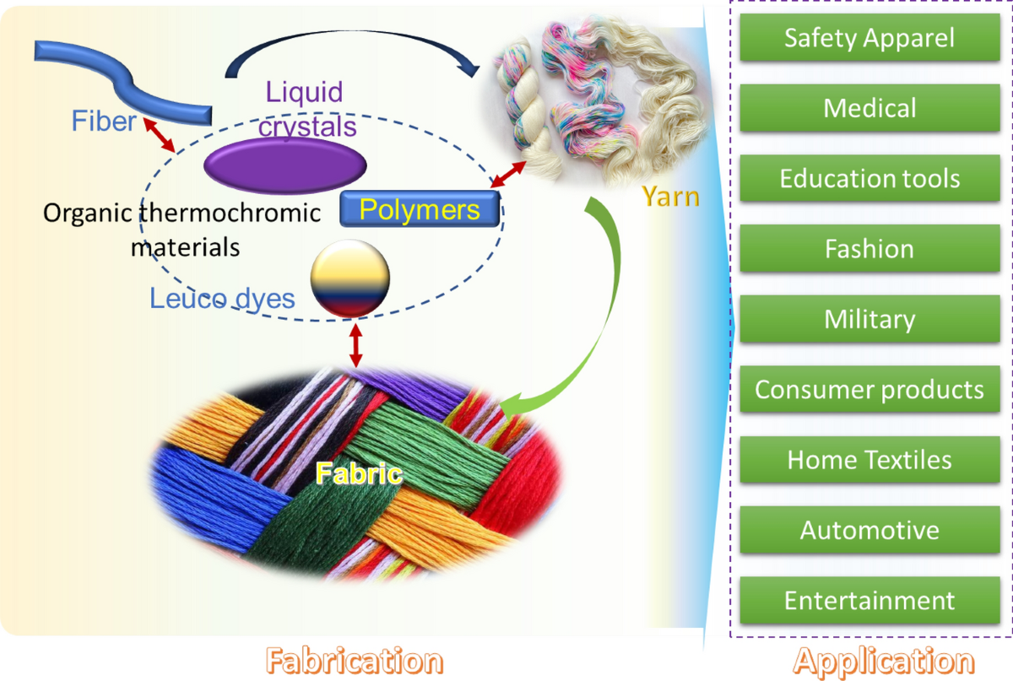

Fig 1: Fabrication of chromic textiles
5. Performance Evaluation Metrics
To assess chromic textiles, the following metrics are commonly used:
- Switching On/Off Threshold (Stimulus Level): e.g., temperature of transition for thermochromic, voltage for electrochromic, intensity or wavelength of light for photochromic.
- Response Time: Time taken to change colour (on‐set) and to revert to original state (recovery). Quick response is often critical in wearable or safety applications.
- Colour Contrast / Colour Change Magnitude: Quantified via ΔE in colorimetric space, or spectral absorbance/transmittance changes; how noticeable the change is.
- Durability / Cycle Stability: Number of switching cycles before performance degrades significantly. Also resistance to washing, rubbing, light exposure, chemicals.
- Fastness Properties: Wash fastness, light fastness, rubbing fastness, perspiration fastness etc., especially for clothing use.
- Mechanical Properties and Comfort: Does the chromic treatment affect flexibility, breathability, tensile strength, drape, etc.
- Safety & Toxicity: Are the dyes or agents safe for skin contact? Do they leach toxic substances? Environmental impact of production and disposal.
- Cost and Scalability: Material costs, process scalability, and whether manufacturing can be done with existing textile machinery (Civan and Kurama, 2021; Liang et al., 2023).

6. Applications
Chromic textiles have been explored in many domains (Karpagam et al., 2017 and Zhang et al., 2023). Some representative applications include:

Fashion and Aesthetic Applications
- Color-changing clothing: Garments that change color with temperature (thermochromic) or sunlight (photochromic).
Example: T-shirts that change design when exposed to sunlight.
- Dynamic patterns: Designers use chromic textiles to create interactive clothing or accessories that change appearance based on environment or mood.
- Customizable footwear and accessories: Shoes, bags, or scarves that respond to heat, light, or sweat.

Sports and Performance Wear
- Thermal monitoring: Thermochromic textiles can show color change to indicate overheating or exertion in athletes.
Example: Cycling or running shirts that indicate body temperature zones.
- UV exposure indication: Photochromic fabrics can alert wearers of dangerous UV levels.
- Sweat detection: pH-sensitive textiles detect sweat acidity to monitor hydration or exertion levels.

Medical and Healthcare Applications
- Wound monitoring: Chromic textiles that change color with pH or temperature can indicate infection or inflammation.
- Patient monitoring: Smart bedsheets or hospital gowns that signal fever or sweat anomalies.
- Drug delivery systems: Textiles coated with responsive dyes can release medication in response to body heat or pH changes.

Safety and Protective Clothing
- Firefighting and industrial safety gear: Thermochromic fabrics can indicate dangerous heat levels.
- Chemical hazard detection: pH-sensitive or chemosensitive textiles alert workers to chemical spills.
- UV protective wear: Sun-exposure warning garments for outdoor workers.

Military and Defense
- Camouflage: Textiles that adapt color or pattern to the environment (thermochromic or photochromic) for concealment.
- Signaling: Uniforms or flags that change color under certain conditions for communication.
- Chemical exposure detection: Fabrics that react to chemical agents for early warning.

Interior Design and Smart Textiles
- Adaptive upholstery: Curtains or furniture that respond to light or temperature to change ambiance.
- Interactive home textiles: Bedspreads, carpets, or wall hangings that react to sunlight or body heat.
- Temperature-sensitive sheets: Indicate heat zones for comfort or energy savings.

Environmental and Sustainability Applications
- Pollution indicators: Fabrics that detect airborne pollutants or acidity in rain.
- Water contamination detection: Textiles for environmental monitoring that change color in response to chemicals in water.
- Smart packaging: Wrapping materials that visually indicate spoilage or exposure to harmful conditions.

Marketing and Entertainment
- Promotional merchandise: Color-changing fabrics for interactive branding.
- Theatrical costumes: Costumes that adapt color or pattern under stage lights for dramatic effect.
- Toys and novelty items: Mood-detecting or heat-sensitive products.

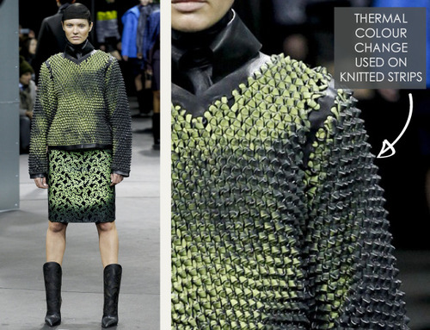
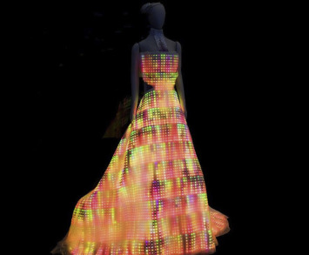
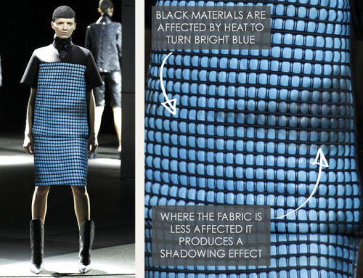
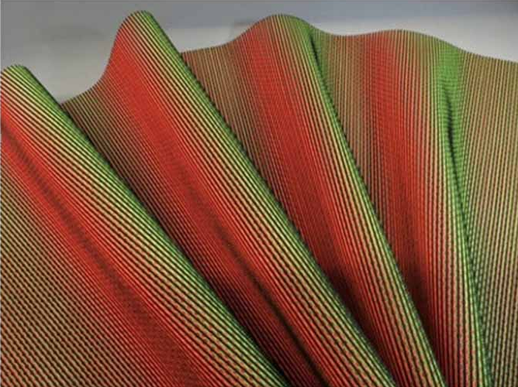
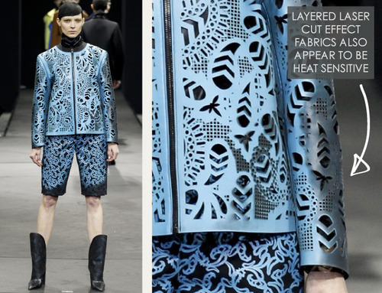
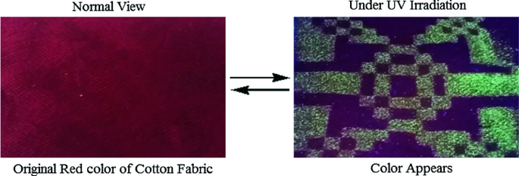
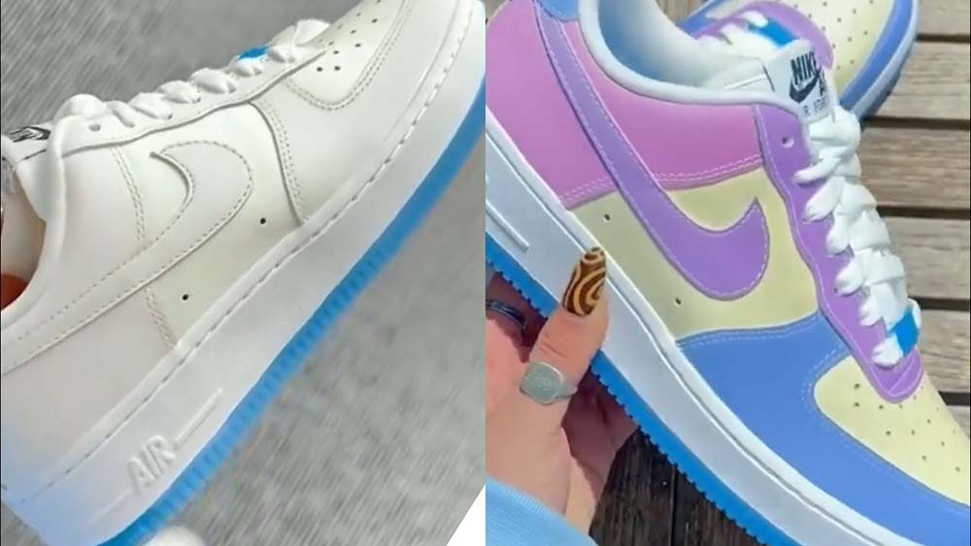
Fig 2: Applications of chromic textiles

7. Recent Advances
Some of the newer and promising developments include:
- VO₂‐based thermochromic composites: Work on lowering transition temperature, improving luminous transmittance, improving solar modulation for energy-saving applications. For example, W and Sr co-doped VO₂ films with low transition temperature and higher visible‐range transmittance have been developed.
- Wearables with dual/multi stimuli: Integrating photo-, thermo-, electro-, halochromic responses in single fabrics to increase functionality.
- Improved durability & wash/vibration/light fastness: Advances in encapsulation, covalent bonding, improved fibers/coatings that maintain chromic performance over many cycles.
- Patterned and high-resolution printing of chromic agents for complex design, sensors. Use of screen, inkjet, and pigment printing in photochromism and halochromism.
- Safety and environmental concerns being addressed more explicitly: selection of non-toxic chromic agents, biodegradable or bio-derived materials, reducing leaching (Degenstein et al., 2021 and Atav et al., 2022).

8. Challenges & Limitations
Despite promising advances, several hurdles remain:
- Durability: Wash fastness and mechanical wear (rubbing, stretching) often degrade performance, particularly for coatings or printed chromic agents.
- Fatigue / Photodegradation: For photochromic agents, repeated exposure to UV or light can reduce the magnitude of colour change over time.
- Toxicity & Environmental Impact: Some chromic dyes or compounds (organic or inorganic) may release harmful chemicals; disposal and degradation are concerns.
- Limited Range of Stimulus Conditions: For example, transition temperatures of many thermochromic systems are either too high or too low for comfortable wearable use. Similarly, required voltage levels for electrochromic systems may be impractical.
- Cost and Manufacturing Scalability: Many lab methods are not suitable for mass production; costs of specialized materials and processes, energy for curing, etc., remain high.
- Comfort and Textile Properties: Maintaining breathability, flexibility, weight, drape; ensuring that chromic treatment doesn’t compromise wearer comfort.
- Response Speed and Reversibility: For some stimuli (especially combination or dual/multi stimuli), response times can be slow, or recovery can lag.
- Standardization in Characterization: Lack of uniform metrics and protocols for measuring switching cycles, response time, colour contrast, etc., makes comparison between studies difficult (Shi et al., 2020).

9. Future Directions and Opportunities
To push chromic textiles toward widespread application, the following areas deserve attention:
- Development of Non‐Toxic, Sustainable Chromic Materials
  - Bio‐derived or biodegradable chromic agents.
  - Green synthesis routes, low energy processes, use of renewable substrates.
- Multi-Stimuli / Modular Systems
  - Further combinations (e.g. light + temperature + pH) for richer functionality.
  - Modular textile systems: detachable/replaceable chromic modules.
- Integration with Electronics and Smart Systems
  - Embedding sensors, energy harvesting, displays; connecting chromic textiles with IoT.
  - Low-power electrochromic systems.
- Lowering Thresholds and Improving Comfort
  - Tune transition temperatures and stimulus levels to match human comfort ranges.
  - Design for wearability: lightweight, flexible, breathable.
- Improved Durability and Life‐Cycle Performance
  - Better bonding / encapsulation; robust to wash, light, chemicals.
  - Long cycle life, minimal fading or loss of contrast.
- Standardization in Testing and Metrics
  - Agreement on metrics: e.g. how many cycles until e.g. 80% of initial performance, standard wash/rub tests, standard spectral measurement conditions.
- Customisable and Consumer-Friendly Applications
  - Designs for fashion, personalized wearables, interactive garments.
  - Affordable products: cost reduction via materials and manufacturing scale (Basak and Laha, 2023 and Al-Minyawi et al., 2025).

10. Conclusion
Chromic textiles embody a compelling convergence of chemistry, materials science, textile engineering, and design, offering fabrics that can visibly and reversibly respond to environmental stimuli such as temperature, light, chemical exposure, and electric fields. This responsiveness positions chromic textiles as highly versatile materials with transformative potential across diverse sectors—including fashion and aesthetics, healthcare and wearable diagnostics, safety and protective clothing, and adaptive interior or architectural applications. Recent research has significantly advanced our understanding of the underlying molecular and material mechanisms, led to the development of improved chromic systems such as VO₂-based thermochromic composites and durable photochromic fibers, and begun to address persistent limitations related to stability, wash durability, and response speed. However, the translation of chromic textiles from laboratory prototypes to commercially viable products still faces critical challenges, including enhancing long-term durability, reducing production costs, maintaining wearer comfort, ensuring safety and environmental compatibility, and establishing standardized testing and characterization protocols. Looking forward, innovations in sustainable and non-toxic chromic materials, multifunctional and dual- or multi-stimuli systems, and seamless integration with electronic devices are poised to drive the next generation of smart textiles, enabling fabrics that are not only visually dynamic but also functionally intelligent, interactive, and environmentally responsible.
Disclaimer (Artificial intelligence)
Author(s) hereby declare that NO generative AI technologies such as Large Language Models (ChatGPT, COPILOT, etc.) and text-to-image generators have been used during the writing or editing of this manuscript.
References
- Al-Minyawi, O. M. A., Mahmoud, M. N. I., Ragab, A. G., Al-Gizawy, A. S. H., & Hassabo, A. G. (2025). Smart technology and materials in the clothing industry. Journal of Textiles, Coloration and Polymer Science, 22(1), 171-178.
- Atav, R., Ergünay, U., & Akkuş, E. (2022). Producing garment based multichromic smart sensors through dyeing cotton fabrics with chromic dyes. Cellulose, 29(1), 571-604.
- Basak, S., & Laha, A. (2023). Stimuli-responsive smart and functional textiles. Smart and Functional Textiles, 355.
- Chen, T., Yang, Q., Fang, C., Deng, S., & Xu, B. (2025). Advanced Design for Stimuli‐Reversible Chromic Wearables With Customizable Functionalities. Advanced Materials, 37(6), 2413665.
- Civan, L., & Kurama, S. (2021). A review: preparation of functionalised materials/smart fabrics that exhibit thermochromic behaviour. Materials Science and Technology, 37(18), 1405-1420.
- Degenstein, L. M., Sameoto, D., Hogan, J. D., Asad, A., & Dolez, P. I. (2021). Smart textiles for visible and IR camouflage application: state-of-the-art and microfabrication path forward. Micromachines, 12(7), 773.
- Dominique, P., & Crégo, P. (2018). Wearables, Smart Textiles & Smart Apparel. Elsevier.
- Gupta, V. K. (2021). Photochromic dyes for smart textiles. In Dyes and pigments-novel applications and waste treatment. IntechOpen.
- Hu, J., & Tao, X. (2023). Advances in wearable chromic materials for adaptive fashion and health monitoring. Journal of Smart Materials and Structures, 12(06), 56-68.
- Karpagam, K. R., Saranya, K. S., Gopinathan, J., & Bhattacharyya, A. (2017). Development of smart clothing for military applications using thermochromic colorants. The Journal of The Textile Institute, 108(7), 1122-1127.
- Liang, F., Wu, M., Meng, J., Yu, L., & Zhi, C. (2023). Research progress in conductive polymer-based electrochromic fabrics. Textile Research Journal, 93(21-22), 5092-5111.
- Mo, H., Lai, C., & Huang, J. (2025). Research progress on the combination of structural color and phase change materials in responsive color change. ES Chemistry and Sustainability, 4, 1609.
- Mohamed, A. L., Okda, H., & Salama, M. (2024). Utilizing Smart Chromic Dyes in the Textile Sector. Journal of Textiles, Coloration and Polymer Science, 21(3), 213-226.
- Ramlow, H., Andrade, K. L., & Immich, A. P. S. (2021). Smart textiles: an overview of recent progress on chromic textiles. The Journal of The Textile Institute, 112(1), 152-171.
- Sankauskaite, A., Pauliukaite, R., Baltusnikaite-Guzaitiene, J., & Abraitiene, A. (2023). Smart textile with integrated wearable electrochemical sensors. Current Opinion in Electrochemistry, 42, 101410.
- Santos, R. (2024). Eco-friendly chromic dyes: Toward sustainable smart textile applications. Sustainable Materials and Technologies, 09(03):89-100.
- Shi, J., Liu, S., Zhang, L., Yang, B., Shu, L., Yang, Y. & Tao, X. (2020). Smart textile‐integrated microelectronic systems for wearable applications. Advanced Materials, 32(5), 1901958.
- Toan, V. N., Tri, N. M., Nguyen, X. H., Nguyen, D. D., Chung, W., Chang, S. W., & La, D. D. (2024). Exploring the potential of organic thermochromic materials in textile applications. Journal of Materials Science, 59(32), 14924-14947.
- Trovato, V., Sfameni, S., Rando, G., Rosace, G., Libertino, S., Ferri, A., & Plutino, M. R. (2022). A review of stimuli-responsive smart materials for wearable Technology in Healthcare: Retrospective, perspective, and prospective. Molecules, 27(17), 5709.
- Xiang, H., Li, Y., Liao, Q., Xia, L., Wu, X., Zhou, H. & Fan, X. (2024). Recent advances in smart fabric-type wearable electronics toward comfortable wearing. Energies, 17(11), 2627.
- Zhai, X., Wu, Z., & Peng, H. (2022). Minireview on application of microencapsulated phase change materials with reversible chromic function: advances and perspectives. Energy & Fuels, 36(15), 8054-8065.
- Zhang, L., Meng, J. G., Liu, Y. M., Wang, Y. Z., Sun, Z. L., Yu, L. J. & Zhi, C. (2023). Preparation of multicolor microcapsules and their application in smart color-switching textiles. Textile Research Journal, 93(5-6), 1334-1346.
- Zheng, C., Han, H., Gao, A., Ju, M., Hou, A., & Xie, K. (2023). Photosensitivity enhancement of spiropyran-containing functional molecules by introducing flexible spacers and their application in smart color-changing textiles. Fibers and Polymers, 24(2), 445-457.

