Sleep patterns across different age groups: A survey study in Ballari city, Karnataka

The type of article: Original research article.
ABSTRACT
The study was carried out on the individual sleep quality of 400 individuals of different age groups of the Ballari city by considering various parameters. Sample size of 400 people. 25 male and 25 female of each group of 1-18, 95 people male and female for 19-45, 46-60 and above 60 age group were subjected to asking questions using survey method. Data collected for 1-18 years revealed that male have more response to sleep than females, mobile utilization is extremely high in females than males in the same group. Between 19-45 reveled that both male and female have shown similar response. Between 46-60 group male have less response than female due to stress and occupational stress. Above 60 age male sleep good than females as female watch more TV serials however they us less mobiles. In males no significant correlations were noticed between health status and sex or subjective quality. Further study helps to overcome from the psychosomatic diseases, physcological disorders like sleep apnea, parasomnias, sleep –wake disorders and some other physiological conditions.

Key words: Sleep pattern, Ballari, Male, Female, Age groups, Mobile use, Insomnia.

INTRODUCTION
Although humans spend one-third of their lives sleeping, they know very little about sleep.However, its function remains to be fully elucidated; sleep is a universal need, and it is reduced, and also, in general, many of our physiological functions are quite variable when we are awake [B]. Of all higher life forms, including humans, the absence of which has serious physiological consequences.
No behavior so regular and pervasive characterizes our daily life and is yet so little understood as sleep. Sleep duration for older adults (46–60 years) is 7 hrs or more per night; for adults (18–45 years), an even longer duration (>9) is considered appropriate. Mental performance and functions are greatly influenced by sleep. Sleep greatly influences mental function and thus affects performance. Lack of sleep reduces the general alertness and lack of attention (Abdullah et al., 2019).
Sleep has an important role in human lives. Studies were carried out on the sleep circadian rhythms throughout the world. The following papers emphasize the sleep quality, durations, patterns, strategies, food habits, health, effects, disorders, and also problems associated with sleep disturbance. Some of the reports that are related to the present study are reviewed in this project.
Sleep is an actively regulated process significantly modulated by homeostatic influences that accumulate during ongoing wakefulness and dissipate during sleep and by circadian effects entrained to the 24-hour day (David et al., 2016).Metabolism and glucose homeostasis are being influenced by the sleep and wake cycle, which in turn is characterized by distinct hormonal patterns. Stress, depression, and anxiety were associated with poor sleep habits. Abdullah et al. (2019). Intricate interactions between physiological, behavioral, and environmental factors that contribute to sleep and circadian rhythm disturbances in intensive care unit (ICU) patients (Telias et al., 2019). Low-quality, distressing relationships with poorer sleep Amie et al. (2020). Designing for daylight is not only beneficial for buildings that house the sick but also imparts substantial health benefits for the general population. These benefits of daylight should be considered by developers and architects when designing buildings intended to be human-centered. Rohan Nagare et al. (2021).
Study Area and Methods
The study area comprised Ballari. This district belongs to the Hyderabad-Karnataka region. Ballari district was one of the biggest districts in Karnataka until the Vijayanagara district was carved out of Ballari district in 2020. In Ballari the area includes outpatient door Vidyanagar, Dara Mill, Gautamnagar, Cantonment, Patel Nagar, Belgal Cross, Cowl Bazaar, Siddharth Colony, Kappagal Road, and Best School, where the latitude is 15.1394°N and the longitude is 76.9214°E and the mean maximum temperature is 31℃.Humidity is 23%. We randomly selected these areas to collect the data related to sleep quality. We randomly selected the above areas to study a preliminary survey of sleep quality in Ballari district.
Plate.1 Map of Ballari District Showing Study Area
Results and Discussion
The sleep survey was conducted in Ballari city, VSK University and surrounding areas, including Allipur, Daramill, Vidyanagar, Cowl Bazaar, Belagal Cross, Cantonment, and Ashok Nagar, in the year 2022. Both the structured and unstructured questionnaire methods were used to collect the data related to the sleep quality survey. There were 50 questions, and 400 individuals were surveyed to know about the present status related to an individual’s sleep quality based on different parameters. The total survey data is presented in graphs 1, 2, 3 & 4, respectively.
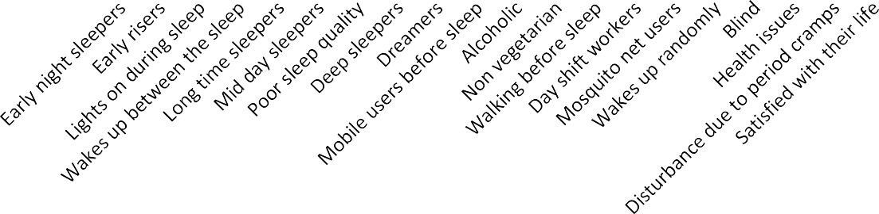
Agegroup1-18years
30
2255
25
2523
24
20
212121
18191198
19
17
1717
15
15
1615
10
10
9 9
8
7
10
6
11
88
11
67
7
78
9
7
8
17
14
10
8
5
4
5
2
2
5
3
3
0
Male Female
Graph.1: Depicting comparative analysis of various parameters from participant’s survey of sleep quality in male and females.
Consider the different parameters of sleep quality by taking different categories on the X-axis and the number of individuals in male and female sleep status on the Y-axis, respectively. The survey was estimated out of 50 individuals; the number of individuals (i.e., 25 males and 25 females) who participated in the consideration was 50. Among 50 individuals the number of variations found according to the different parameters that were depicted in graph-1. In the age group between 1 and 18 years, the early-night sleepers were greatly peaked in males, whereas in the case of females, it shows the least character in their sleep due to stress, medications, etc. Females show more response to sleep on late nights. And males have more response to good sleep quality, whereas females have the least response because of their householdactivities and period cramps, which may disturb their sleep. Although the condition of utilization of mobiles in females was extremely high compared to males, in a similar case, the manipulation of using social media and the internet was the least in estimation. Except for these, all other parameters show the similar responses. Evan et al. (2012) suggest that sleep hygiene education programs might be effective in improving sleep in children and adolescents.

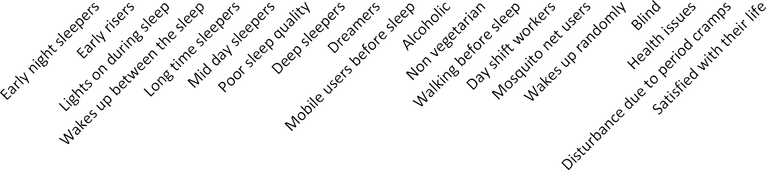
90
80
70
60
50
40
30
20
10
0
Agegroup19-45years
82
75
69
585653
4748
6620 59
59
6674
393742
50
4445
57
4458
6601
58
6635
57
63
57
65
60
51
43
54
56
335
40
41
3354
38
33
3632
3838
22
26
23
112314
18
1153
29
2021
11
3311
23
15
10
16
0
0
male female
Graph.2: Depicting comparative analysis of various parameters from participant’s survey of sleep quality in male and females.
Under the age group of 19-45 years the number of individuals were 95 males and 95 females had participated into the consideration. Among 190 individuals under this age group, a greater number of variations are frequently seen according to different parameters that were depicted in graph-2. In the age group between 19 and 45 years, the mobile users are recorded more in both males and females. And the males are high in response to non-vegetarian food habits because nowadaysyoungsters are more conscious of fitness, strengthening muscles, and fast growth. It is observed that the males have a higher number of cases of alcohol consumption due to stress, love failures, depression, etc. The rest of the parameters have shown similar responses. Abdul Rahman (2022) found there is a weak relationship between social media, depression, anxiety, and poor sleep quality.

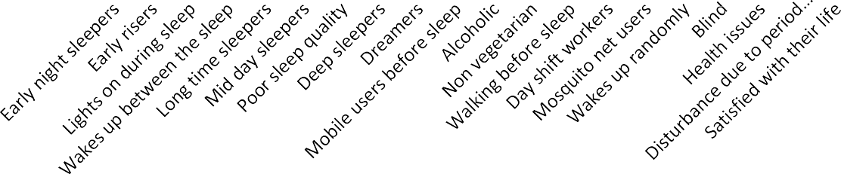
Agegroup46-60years
60
50
40
30
20
10
0
447849
40
48
42
30
20
16
10
1
3436
33
2299
2211
4464
39
29
32
33
28 28
22
29
26
14
17
2121
16
20
12
23
18
20
16
39
31 34
28
23
18
57
15
11
9
13
45 5
21
15 15
8
1
111131
1
0
1
male female
Graph.3: Depicting comparative analysis of various parameters from participant’s survey of sleep quality in male and females
Under the age group between 46-60 (Graph -3) the number of individuals are 50 males and 50 females has participated in into the consideration. Among 100 individuals the variations are depicted in graph 3. In the age group between 46 and 60, it has been observed that males are highly responsive to difficulty in falling asleep due to their work tensions, finances, and family keeping their minds active at night. Night shift workers are seen more in the case of males because of the financial problems that drive men to work even at nighttime. Females' response is more towards the satisfaction with their life, as the females under this age group stay home mostly, and they don’t have any pressures, tensions, or financial pressures. Soon-Yeob et al. (2015) found that the men with more alcohol consumption suffer from overall poor sleep quality and experience difficulty in maintaining sleep, rather than falling asleep. In the case of females, they show average results in waking up randomly owing to menstrual problems or night sweats and night flashes.

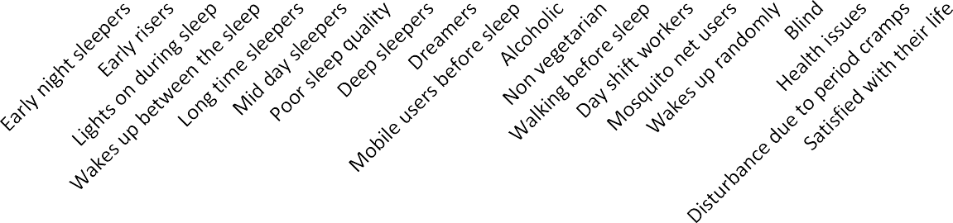
Agegroupabove60years
35
30
2299
25
25
23
26
24
24
25
20
21
21
20
2211
20
19
19
16
14
17
17
15
15
15
12
1313
12
13
12
13

10
10
8
11
11
12
9 999
10
9
5
6
6 6
7
6
6 6
6
7
5
4 4
5
5
3
4
2
2
0
1
0
Male Female
Graph.4:Depicting comparative analysis of various parameters from participant’s survey of sleep quality in male and females.
Graph-4 shows the equal proportions and variations in all cases of different parameters in both males and females considering the duration of sleep, health issues, and diseases due to sleeplessness. All males and females under this age group do not tend to work outside, as they have lost their strength. Hence, they stay home and have zero pressures and problems. All males and females are facing a number of health issues. The males show the highest number in good sleep quality, whereasin females they tend to watch serials and all the television shows; hence, they sleep less. The old-age people in our survey have shown no usage of mobile phones, as they have less knowledge of the internet and are illiterate. Julie et al. (2001) found that increasing age may be due to attenuation of homeostatic sleep pressure and an increase in cortical activation during sleep.

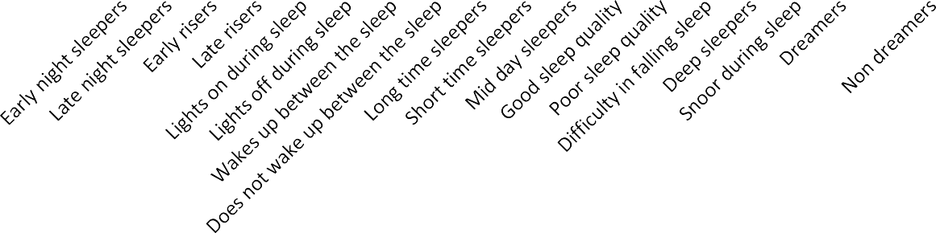
0-18years (Totalmale-25Totalfemale-25) Male
0-18years (Totalmale-25Total female-25)Female
19-45 Years (Total male-95 Total female-95)Male
19-45Years (Totalmale-95Total female-95)Female
46-60 Years (Total male-50Total female-50Male
46-60Years (Totalmale-50 Total female-50 Female
Above 60 Years (Total male-30Total female-30Male
80
70
60
50
40
30
20
10
0
Above 60Years (Totalmale-30 Total female-30Female
  - Graph 5: Depicting overall analysis of various parameters from participants survey of sleep quality in male and females.
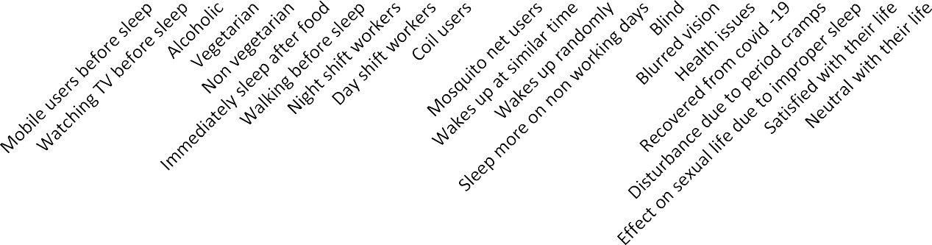
0-18years(Totalmale-25Totalfemale-25)Male
0-18years(Totalmale-25Totalfemale-25)Female
19-45Years(Totalmale-95Totalfemale-95)Male
46-60Years(Total male-50 Total female-50 MaleAbove60Years(Totalmale-30Totalfemale-30Male
90
19-45Years(Totalmale-95Totalfemale-95)Female
46-60Years(Total male-50 Total female-50 FemaleAbove60Years(Totalmale-30Totalfemale-30Female
80
70
60
50
40
30
20
10
0
Graph.6: Depicting Overall comparative analysis of various parameters from participant’s survey of sleep quality in male and females
In graphs 5 and 6, considering that overall 400 individuals were surveyed, the percentage of early-night sleepers was increased in proportion under the age group of 1-18 years. The maximum participants in the survey have shown increased usage of cell phones, watching TV, early sleepers, waking up randomly, and alcoholic consumption in both males and females. Lim (2022) studied that the usage of social media would not lead to mental health among youngsters. Except for old-age people, the females are more numerous in response to health issues in the age group between 19 and 60. Jay et al. (2015) reported that early sexual maturation is a core component linking early adversity and stress physiology with poor health later in life in females. From children to adults, there is a high response in the usage of mobile phones. Shabnoor et al. (2016) studied that youngsters are seen in contact with social media regularly, which affects people negatively.
And the non-vegetarians are high in males among all the age groups due to the several health benefits, fast growth, and strengthening muscles. Sanjay Borude (2019) has studied that all vegetarian diets are healthy diets, findings utilized to discourage refined and processed food consumption and promote healthy vegetarian food choices. Overall, old-age people reported significantly poor quality of sleep, more nighttime awakenings, and less frequent napping. The number of nighttimeawakenings increased significantly with age only in males. In males no significant correlations were found between health status and sex or subjective quality. The most frequently reported causes of disturbed sleep onset and sleep maintenance were worries and nocturia, respectively. Subjective quality of sleep was mostly associated with self-estimated sleep latency. Middelkoop et al. (1996) found that sleep disorders are common generally in the elderly population. In other cases the survey has estimated that there was no relation between the sleep quality and the age, sex, alcohol consumption, medications, or usage of mobile phones. Yilmaz et al. (2017) found that students who do not smoke, sleep 6-7 hrs/day, and consume beverages with less caffeine have better sleep quality.

Conclusion
The survey serves to understand the sleep quality among different individuals in Ballari city. A good respondent was found under the respective survey. The estimated survey reveals that males reported the most frequent alcoholic habits under all the age groups except 1-18 years due to tensions, family pressures, love failures, etc. Whereas in the case of females, various medications, stress, menstrual cramps, household activities, etc., were the reasons for waking up randomly during nighttime.
Regarding the usage of mobile phones, in all the age groups except above 60 years, a high number of responses were reported, as they are more technologically advanced and can find solutions to situations that would have otherwise been difficult. The old-age people lack to lay behind because their interest has been reduced in such aspects as the usage of the internet and its gadgets, etc.
Thus the survey concluded that sleep plays an important vital role in all living creatures on the earth. In the light of this research, we could infer that more than half of the individuals have low sleep quality. It is reported that sleep is important in terms of the health of young adults, and it was said that young people need sleep for an average of 9-10 hours. In the present study, those who wake up early and sleep 6-7 hrs/day have good sleep quality, and it is known that alcohol has a negative effect, and it is known that alcohol intake before sleep especially makes it difficult to fall asleep and affects the sleep quality negatively. Hence, by this survey, we came to know how sleep is important in human life, and also our survey helped us to know the sleep status of people in Ballari city. As it is a preliminary survey, it helps to know the effects of sleep deprivation.
Limitations/Suggestions/Recommendations
Study helps to overcome from the psychosomatic diseases, psychological disorders like sleep apnea, parasomnia, sleep–wake disorders and some other physiological conditions. And also helps to illiterates, farmers, some other occupational workers to know the sleep related disorders they are facing due to, their day and night continues work pressures.

Declarations
- Ethics approval and patient consent to participate.
There are no animal studies nevertheless respondents have given consent to participate
- Patient Consent for publication: Respondents have consented for publication
- Animal Studies: Not Applicable
- Conflict of interest: There are no conflicts of interest among the authors
- Availability of data and materials: No additional data available
- Clinical trial registry number: Not applicable
- PROSPERO registry number: Not applicable

References
- Abdullah Murhaf A-khani, Muhammad Ishaque Sarhandi, Mohamed Saddik Zaghloul, Mohammed Ewid, And Nazmus Saquib, (2019). A cross- sectional Survey on sleep quality, mental health, and academic performance among medical students in Saudi Arabia. https;//Doi.org/10.1186/s13104-019-4713.
- Amie M. Gordon, Belinda Carrillo, Christopher M. Barnes. (2021). Sleep and social relationships in healthy populations. Sleep Medicine Reviews. 57,101428.
- David W. Carley and SarahS.Farabi. (2016). Physiology of sleep. DoI:10.2337/diaspect.29.1.5
- Evan T, Dione Healey, Andrew R Gray and Barbara C Galland. (2012). Sleep hygiene intervention for youth aged 10 to 18 years with problematic sleep: a before–after pilot study. http://www.biomedicentral.com/1471-2431/12/189.
- Jay Belsky, Paula L. Ruttle, W. Thomas Boyce, Jeffrey M. Armstrong, Marilyn J. Essex (2015). Early adversity, elevated Stress physiology, accelerated sexual maturation, and poor health in females.
- Lim S I. (2022). Social media and its association with poor sleep quality, depression and anxiety among youngsters.
- Middelkoop H. A. M, Dini A. Smilde-Van den Doel, (1996). Sleep disorders are common in the generally elderly population. Journal of Geroniology: Medical Sciences. Vol.51A. N0.3,M108-M115.
- Nagare R, May Woo, Piers MacNaughton, Barbara pitnick, Brandon Tinianov andMariana Figueiro.(2021) Access to daylight at home improves circadian alignment, sleep and mental health in healthy adults : A crossover study. International Journal of Environmental Research and Public Health.https://doi.org/10.3390/ijerph18199980.
- Sanjay Borude (2019). Which is a good diet–veg or non-veg faith-based Vegetarianism for protection from obesity—a my athor actuality.
- Shabnoor Siddiqui and Tajinder Singh. (2016). Social media its impact with positive and negative aspects. International Journal of Computer Applications Technology and Research Vol. 5-Issue 2, 71-75,ISSN:2419-8656.
- Soon –Yeob Park, Oh MK, Lee BS, Kim HG, Lee WJ, Lee J.H, Lim J.T, Kim JY. (2015).The effects of alcohol on quality of sleep. Korean J. Fam. Med. 36(6):294-9. doi: 10.4082/kjfm.2015.36.6.294.
- Telias I, Wilcox ME (2019). Sleep and circadian rhythm in critical illness. Crit. Care. Mar 9;23(1):82. doi: 10.1186/s13054-019-2366-0.
- Yilmaz C. K, Sevgisun Kapucu (2017). The effects of progressive relaxation exercises on fatigue and sleep quality individuals with COPD. DOI:10.1097/HNP.000000000000234.
- C] https://www.ncbi.nim.nih.gov

