Reproductive Potentials of Brycinus nurse (RUPPELL, 1832) in Goronyo Reservoir, Sokoto State, Nigeria

Abstract
Reproductive study is an important aspect of stock assessment, it describes the reproductive strategies and potential of fishes in the aquatic ecosystem. Nearly all fishes fish reproduce sexually, and most species have separate sexes (male and female). Those without separate sexes avoid self-fertilisation by producing sperm and eggs at different times. Fecundity is described as batch fecundity, breeding season fecundity, life time fecundity, relative fecundity or absolute fecundity in stock assessment studies.
The objective of this study is to describe the reproductive potential of B. nurse in Goronyo reservoir, Sokoto state, Nigeria. The ovarian maturation stages of Brycinus nurse specimens were determined by usinga single standard protocol. The gonads were removed and weighed, and the fecundity and GSI estimations were carried out. Data was analysed in descriptive statistics, t-test and compared using ANOVA at (p<0.05) level using Excel sheets and SPSS version 25. The study revealed a sex ratio dominated by bigger males sampled between June and August, with more male specimens at Stage III and female specimens at Stage IV and VI of gonad maturation. Similarly, the highest mean gsi values were recorded in June to September in male Brycinus nurse specimens and lower mean gsi values were recorded in August, indicating this was the period the species spawns. The mean fecundity was highest from August to October in gravid Brycinus nurse specimens. Conclusively, this species spawns in August and has high reproductive potentials potential in Goronyo reservoir. The study revealed a strong fecundity and total somatic weight relationship in Brycinus nurse specimens, therefore confirming somatic weight as the best indicator of fecundity. The study recommends the adoption of a closed season management strategy between June and October to allow an uninterrupted breeding activity of this species in Goronyo reservoir.

Keywords: fecundity, breeding season, gonads, stock assessment, Reproductive study

Introduction
Currently, the demand for fish in Nigeria stands at 3.6 million tonnes. The current situation necessitates urgent and decisive action to ensure the adequate and sustainable production of fish. Fish is crucial for national development as it provides a cost-effective source of highly nutritious protein and contains other essential nutrients vital for the body (Adeniyi & Agbugui, 2024; Quarshie et al., 2024). Reproductive study is an important aspect of stock assessment, it describes the reproductive strategies and potential of fishes in aquatic ecosystems, (Floyd and Petty, 2020). Nearly all fish reproduce sexually, and most species have separate sexes (male and female) and those without separate sexes avoid self-fertilisation by producing sperm and eggs at different times (CK-12, 2024). Fish reproduce by bearing live young ones called fry or by laying eggs (Weitzman and Vari, 1998; Floyd and Petty, 2020; Weitzmann and Parenti, 2024). Understanding the reproductive potential of fish species for management purposes requires fecundity Studies (Bagenal and Tesch, 1978; Shinkafi et al., 2013; Esa et al., 2023). Fecundity is the number of eggs a female fish produces in each reproductive cycle (Bagenal and Tesch, 1978; Eyo et al., 2016; Opiyo et al., 2017; Mimoune et al., 2023). It is the potential reproductive capacity of a gravid fish and usually increases with size and age and changes with prevailing aquatic conditions (Berek and Novak, 2007; FishBase, 2017; Esa et al., 2023). Fecundity is described as batch fecundity, breeding season fecundity, life time fecundity, relative fecundity or absolute fecundity in stock assessment studies (Bagenal and Tesch, 1978; FishBase, 2017; Patrick et al., 2020).
Several studies have been conducted for assessing fecundity in fishes, for instance, Jan and Ahmad (2016) studied fecundity of Snow trout (Schizothorax plagiostomus) in the river Lidda. Fish enhance offspring survival through deploying a variety of reproductive strategies. Most fish are highly fecund, with spawning activity occurring over different temporal scales, spanning from semelparity, i.e. one spawning event in a lifetime like some salmons and eels, to species that spawn continuously through their entire adult life like some short-living tropical clupeids (Ganias, 2013). The authors observed mean fecundity, which was related to the size of 12,964 eggs. Similarly, Olusegun et al. (2019) reported fecundity ranging from 5,838 eggs to 29,208 eggs and relative fecundity ranging from 441 eggs to 3,597 eggs on Brycinus macrolepidotus in Akomoje reservoir. Paugy and Shaefer (2007) reported a mean fecundity of 300 eggs in Alestes dentex in the Nile basin. Furthermore, Saliu and Fagade (2003) observed fecundity ranging from 1,720 eggs to 68,700 eggs and relative fecundity ranging from 19,933 eggs to 49,453 eggs in Brycinus nurse in Asa reservoir. Offem et al. (2008) studied an African silver catfish and observed that the breeding period of the species in the Cross River was between April and August. According to the authors, the female species had a mean fecundity ranging between 4,522±1,924 eggs and 20,321±5,543 eggs. Kingdom and Allison (2011), Obah et al. (2013) and Nandikeswari et al. (2014), and Patrick et al. (2020) reported that fecundity is influenced by the weight of the fish, gonads and season. However, Kingdom and Allison (2011) did not observe significant seasonal differences between fecundity and season, and Obah et al. (2013) did not observe a positive relationship between fecundity and length of the fish.
Reproduction is one of the most significant biological aspects of a fish community and the survival of populations depends on its success. Each fish species lives in a special ecological environment; therefore, it has a unique reproductive strategy, with special anatomical, behavioural and physiological adaptations (Rayal et al., 2021). Studies on reproduction also involve investigating Gonado-somatic index (GSI), which reveals the ratio of gonad weight to somatic weight in fishes (Bagenal and Tesch, 1978; Shinkafi et al., 2013; Esa et al., 2023). The GSI is particularly helpful in estimating the maturity ogive, identifying days and season of spawning, this is because the ovaries of spawning gravid females swiftly increase in size just prior to spawning (Flores et al., 2015). In Lake Albert, Kasozi et al. (2013) investigated the ovarian development in Alestes baremose specimens. The authors observed that the female GSI varied across the 12 months of the study. Minimum (2.1±2.0%) observed GSI occurred in December, and the maximum GSI value of 5.4±1.8% was reached in January, followed closely by 5.3±1.8% in October. In another study, Yusuf et al. (2013) investigated gonad development in Clarias gariepinus in Doma Dam and observed GSI mean values of 0.38% and 7.16% for both male and female specimens. Similarly, Kaur et al. (2018) investigated GSI in some fish species in the river Sutlej to determine the spawning season. The authors observed the fishes had higher mean GSI in pre-monsoon and lower in monsoon and post-monsoon, indicating their spawning period was in the Jun/Jul season.
There is a paucity of information on Brycinus nurse reproductive potentials. Therefore, it’s the objective of this study to describe the reproductive potentials of B. nurse in Goronyo reservoir, Sokoto state, Nigeria.

Materials and Methods
Description of Study Area/Location
Goronyo Reservoir (Figure 1) is located between latitudes 13°30' N to 14° N and longitudes 5° 30' E to 6° E in Goronyo Local Government Area, Sokoto State, Northwest Nigeria (Ita, 1993a; Elisha et al., 2016). The reservoir was impounded on the river Rima, completed in 1984 and commissioned in 1992 (Sambenelli and Consulting, 2011). It has a length of about 20 km with a width of about 10 km, and an area of about 200 km² with a storage capacity of 976,000,000 m³ (Sambenelli and Consulting, 2011). The study area is part of the Sokoto-Rima basin, which has a total catchment area of about 193,000 km² distributed in Nigeria and the Niger Republic (Gill, 1974). The Sokoto-Rima basin has a semi-arid tropical climate with a prolonged dry season from October to May and a short wet season from the end of May to early October (Weather & Climate, 2020). The three landing sites were selected because of their high fishing activities and include Rimawa fish landing village on coordinates 13° 29’ 51.6’’ N, 5° 52’ 50.676’’ E, Katsira fish landing village (figure 2) on coordinates 13° 31’48.57’’ N, 5° 52’ 51.024’’ E and Kaita fish landing village on coordinates 13° 31; 44.79’’ N, 5° 52’ 50.862’’ E (Sambenelli and Consulting, 2011; Abubakar and Aliyu, 2017; Field work, 2023). Temperatures depict both seasonal and diurnal variations in the area and averaged at 32.19 °C, 2.73 % higher than Nigeria’s averages (Davis, 1982, Wheather and Climate, 2020). During the rainy season, the diurnal range of temperature in the area is low, but during the dry season it is high (Davis, 1982, Weather & Climate, 2020). The mean annual rainfall varies from about 700 mm in the northern part of the Rima basin to about 1,100 mm in the south (Gill, 1974; Davis, 1982; Muhammad et al., 2020).
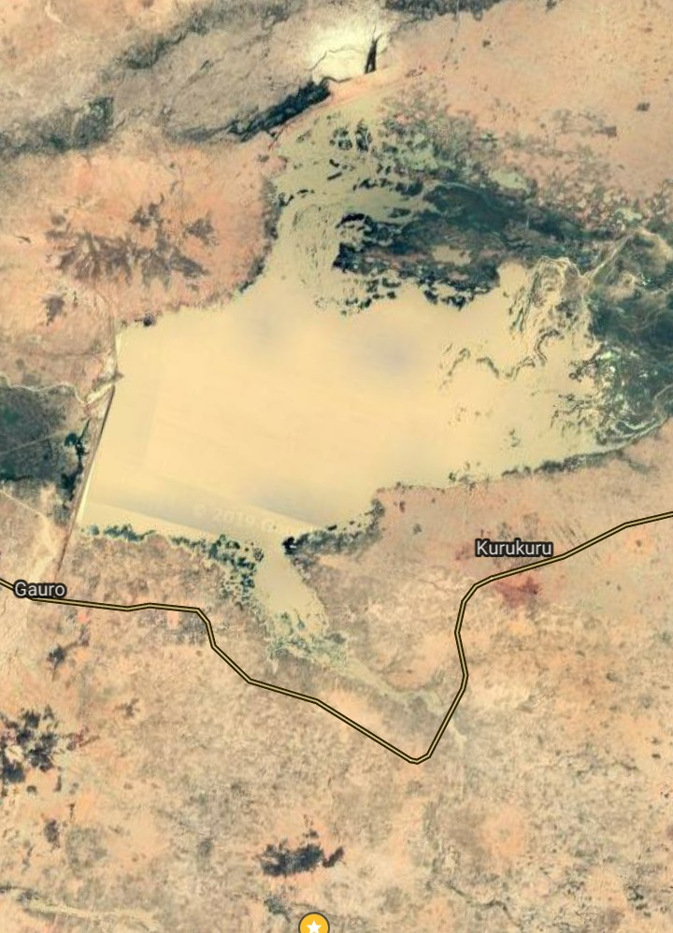Figure 1: Satellite image of Goronyo Reservoir, Sokoto State, Nigeria, (Weather & Climate,2020)

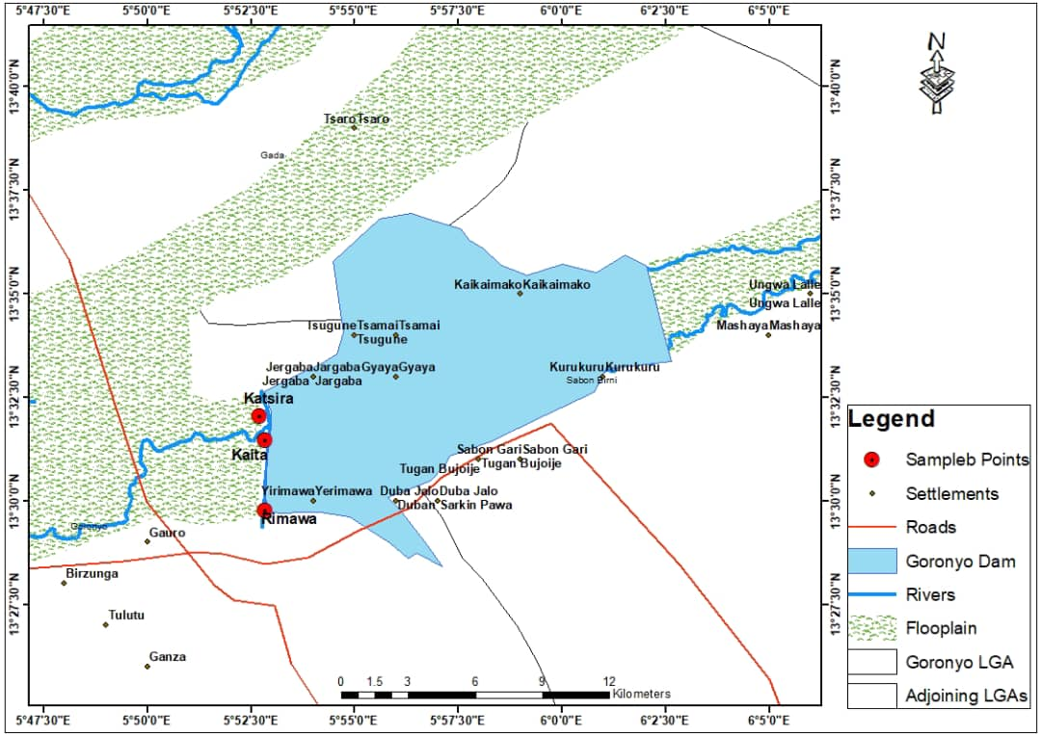
Figure 2: Map of Goronyo Reservoir Showing Rimawa, Kaita and Katsira Fish Landing Sites of Goronyo Reservoir, Sokot
Studies on Reproduction
The ovarian maturation stages of B. nurse specimens were determined as described by Kasozi et al. (2013) as follows: Immature, developing, imminent spawning, spawning, partial post-spawning and spent ovary.
Gonad Weights: The gonads were removed and weighed as described by Hunter and Beverly (1980), Cao et al. (2009) and Suresh (2014) at the fisheries and aquaculture laboratory of Usmanu Danfodiyo University, Sokoto. The fecundity and GSI estimations were carried out as described by Hunter and Beverly (1980), Pepin et al. (2007), Waidi (2015) and Esa et al. (2023), using below equations:
Fecundity = Wa – Wb x N, where
Wa = weight of specimen before ovary removal,
Wb = weight of specimen after ovary removal,
g = gram and
N = number of eggs per 1 gram,
or
Fecundity = N * W/V where;
N = no. of the eggs
W = weight of the eggs
V = volume of displaced water

Data Analysis
Data was analyzed in descriptive statistics, t-test and compared ANOVA at (p<0.05) level using Excel sheets and SPSS version 25.

Results
Results obtained on Figure 3 showed a sex ratio (M: F) of 1:1.4 in the Brycinus nurse specimens sampled in Goronyo reservoir. Male specimens dominated (n=441) and accounted for about 57.80% compared to female (n=322) specimens, which accounted for about 42.20%.
Similarly, results in Figure 4 showed seasonal variation in the abundance of male and female Brycinus nurse specimens sampled in Goronyo reservoir. More males were sampled in July, while mainly females were sampled in August.

Fig. 3: Sex Ratio (M:F) of Brycinus nurse Specimens in Goronyo Reservoir, Sokoto State Nigeria.

Fig.4: Seasonal Variation in Abundance of Male and Female Brycinus nurse Specimens in Goronyo Reservoir, Sokoto State Nigeria

Results obtained in Table 1 revealed the ANOVA results of the variation in abundance of male and female specimens of B. nurse specimens sampled in Goronyo reservoir. The results showed a significant difference (0.001) at a 95% confidence interval of the mean of the two sexes.

Table 1: ANOVA on Abundance of Male and Female Brycinus nurse Specimens in Goronyo Reservoir, Sokoto State, Nigeria
Sex | Frequency | Percent | Mean | Std. | Sex Ratio
Males | 446 | 58.50 | 1.42 | 0.49 | 1:1.4
Females | 317 | 41.50
Total | 763 | 100
t-test
 | t | df | Sig.(2-tailed) | Mean | 95% Confidence interval of the difference
 |  |  |  |  | Lower | Upper
 | 79.287 | 762 | 0.001 | 1.42 | 1.38 | 1.45

Results obtained on Figure 5 revealed testis maturation stages in male Brycinus nurse specimens sampled in Goronyo reservoir. Stage III was more encountered than any other stage, with Stage V being the least recorded.
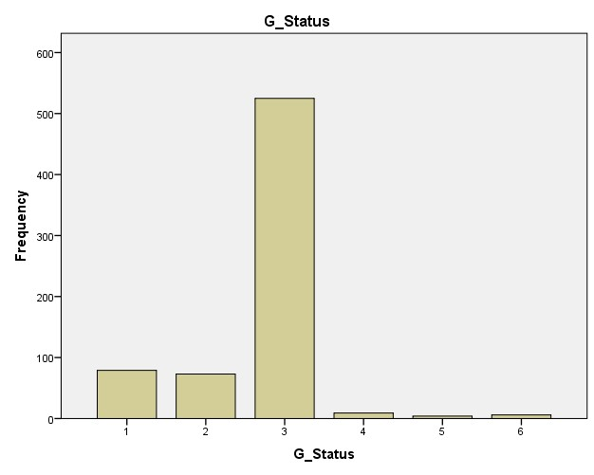
Fig. 5: Testes Maturation stages in Male Brycinus nurse specimens in Goronyo reservoir, Sokoto State, Nigeria

Results shown in Figure 6 revealed ovary maturation stages in female Brycinus nurse specimens sampled in Goronyo reservoir. Stage IV of ovary maturation was the most common in this species, while the least recorded was stage II.

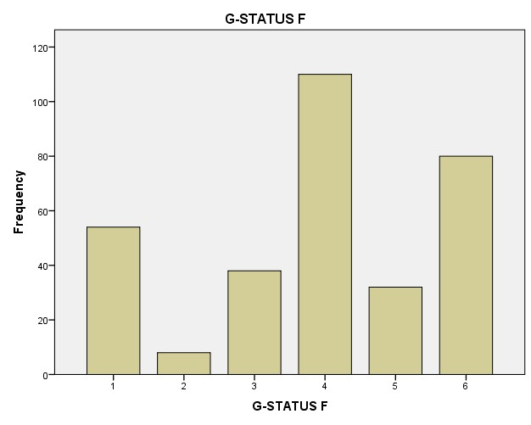
Fig. 6: Ovary Maturation Stages in Female Brycinus nurse Specimens in Goronyo Reservoir Sokoto State Nigeria

Results obtained in Table 2 revealed ovary maturation stages in male and female specimens of Brycinus nurse sampled in Goronyo Reservoir. Stage IV was the most common in the female specimens, while stage III was the most abundant in males.
Table 2: Ovary Maturation Stages of Male and Female Specimens of Brycinus nurse in Goronyo Reservoir, Sokoto State, Nigeria.
No. | Maturity Stage | Number | Percent | Mean | Mode | Percentile
 |  |  |  |  |  | 25 | 50 | 75
 | Males
1 | Stage I | 81 | 18.40 | 2.53 | 3 | 2 | 3 | 3
2 | Stage II | 65 | 14.70
3 | Stage III | 383 | 64.20
4 | Stage IV | 8 | 1.80
5 | Stage V | 4 | 0.90
6 | Stage VI | 0 | 0.00
 | Females
1 | Stage I | 54 | 16.80 | 3.93 | IV | 3 | 4 | 5
2 | Stage II | 8 | 2.50
3 | Stage III | 38 | 11.80
4 | Stage IV | 110 | 34.20
5 | Stage V | 32 | 9.90
6 | Stage VI | 80 | 24.80

Results obtained on Tables 3 and 4 and Figure 8 revealed seasonal variations in mean testes and ovary weights (g) of Brycinus nurse specimens sampled in Goronyo reservoir. The mean testes weight ranged from a minimum of 0.53g±0.33 in August to a maximum of 4.01g±0.79 in July. Similarly, the mean ovary weights ranged from 1.64g±0.68 in August to 7.59g±1.36 in July.
Table 3 Seasonal Variation in Mean Testes Weights (g) of Brycinus nurse Specimens in Goronyo Reservoir, Sokoto State Nigeria
Season | Minimum | Maximum | Mean | Std.
January | 0.20 | 3.40 | 0.84 | 0.89
February | 1.30 | 2.90 | 2.00 | 0.60
March | 0.30 | 3.30 | 2.20 | 0.73
April | 1.10 | 3.20 | 2.23 | 0.64
May | 0.20 | 6.30 | 1.72 | 1.37
June | 0.20 | 3.50 | 2.89 | 0.89
July | 2.90 | 5.30 | 4.01 | 0.79
August | 0.20 | 1.10 | 0.53 | 0.33
September | 0.13 | 3.20 | 1.09 | 1.03
October | 0.20 | 5.30 | 2.09 | 1.73
November | 0.20 | 3.50 | 1.71 | 1.37
December | 0.20 | 3.50 | 0.78 | 0.96

Table 4: Seasonal Variation in Mean Ovarian Weights (g) of Brycinus nurse Specimens in Goronyo Reservoir, Sokoto State, Nigeria
Season | Min. | Max. | Mean | Std.
January | 3.00 | 3.70 | 3.30 | 0.32
February | 0.10 | 4.60 | 2.64 | 1.90
March | 0.80 | 3.50 | 3.11 | 0.65
April | 2.50 | 4.90 | 3.25 | 0.50
May | 2.90 | 5.70 | 4.17 | 0.84
June | 3.40 | 7.20 | 6.05 | 1.40
July | 5.30 | 9.30 | 7.59 | 1.36
August | 0.98 | 3.00 | 1.64 | 0.68
September | 1.10 | 3.00 | 1.80 | 0.66
October | 0.20 | 4.50 | 1.99 | 1.81
November | 0.20 | 5.30 | 2.80 | 1.51
December | 0.20 | 3.80 | 2.17 | 1.64

Results obtained on Table 5 and Figure 8 revealed seasonal variation in mean values of the Gonado-somatic index of male and female B. nurse specimens sampled in Goronyo reservoir. The GSI mean value ranged from 0.95%±0.57 in December to 3.99%±0.31 in July in males, while the highest mean value (7.12%±0.58) was obtained in July in female specimens.
Figure 7: Seasonal Variation on Mean Gonads Weights (g) of Male and Female Brycinus nurse Specimens in Goronyo Reservoir, Sokoto State, Nigeria

Table 5: Seasonal Variation in Mean Values of Gonado-somatic Index in Male and Female Brycinus nurse Specimens in Goronyo Reservoir, Sokoto State, Nigeria
Males |  |  |  |  | Females
Season | Min. | Max. | Mean | Std. | Min. | Max. | Mean | Std.
January | 0.45 | 2.45 | 1.87 | 0.60 | 1.20 | 2.8 | 1.99 | 0.41
February | 1.50 | 2.25 | 1.75 | 0.27 | 1.15 | 2.26 | 1.16 | 0.87
March | 0.83 | 3.21 | 1.85 | 0.64 | 0.99 | 2.83 | 1.73 | 0.56
April | 1.16 | 1.41 | 1.25 | 0.08 | 0.82 | 1.6 | 1.29 | 0.14
May | 0.29 | 3.45 | 1.62 | 1.00 | 0.80 | 3.52 | 2.97 | 0.62
June | 0.22 | 2.46 | 2.09 | 0.71 | 0.42 | 5.35 | 4.74 | 0.78
July | 0.44 | 4.56 | 3.99 | 0.31 | 0.41 | 10.23 | 7.12 | 0.58
August | 0.76 | 2.15 | 1.11 | 0.40 | 1.14 | 1.71 | 1.48 | 0.22
September | 0.75 | 2.08 | 1.58 | 0.45 | 1.11 | 1.95 | 1.37 | 0.26
October | 1.03 | 2.76 | 1.56 | 0.50 | 0.56 | 2.40 | 1.37 | 0.59
November | 0.51 | 2.32 | 1.48 | 0.67 | 0.92 | 2.84 | 1.78 | 0.60
December | 0.43 | 2.09 | 0.95 | 0.57 | 0.36 | 2.75 | 1.66 | 0.71

Fig. 8: Seasonal Variation in Mean Values of Gonado-somatic Index in Male and Female Brycinus nurse Specimens in Goronyo Reservoir, Sokoto State, Nigeria

Results obtained on Figure 9 showed seasonal variation in mean GSI (%) of male Brycinus nurse specimens sampled at Rimawa, Katsira and Kaita landing sites of Goronyo Reservoir. The mean gsi values were higher (2.32%) in September 2023 at Rimawa landing site, while the least (0.26%) was in July at Kaita landing site, but did not significantly (p>0.05) vary at the landing sites.

Fig. 9: Seasonal Variation in Mean Gonado-somatic Index (%) of Male Brycinus nurse Specimens at Rimawa, Katsira and Kaita Landing Sites of Goronyo reservoir, Sokoto State Nigeria

Results obtained on Figure 10 revealed seasonal variation in mean Gonadosomatic Index (%) of female Brycinus nurse Specimens sampled at Rimawa, Katsira and Kaita landing sites of Goronyo reservoir. The highest (9.1%) mean value was recorded in July, 2022, while the least (0.71%) was in September, 2022, at Kaita landing site, but did not differ significantly (p>05) at the landing sites.

Fig. 10: Seasonal Variation in Mean Gonado-somatic Index (%) of Female Brycinus nurse Specimens at Rimawa, Katsira and Kaita Landing Sites of Goronyo reservoir, Sokoto State Nigeria

Results obtained in Table 6 revealed seasonal variation in the mean fecundity of gravid Brycinus nurse specimens sampled in Goronyo reservoir. The mean fecundity ranged from 544±77 eggs in December to 10,447±1,648 eggs in June.
Table 6: Seasonal Variation in Mean Fecundity in Gravid Brycinus nurse Specimens in Goronyo Reservoir, Sokoto State, Nigeria
Season | Minimum | Maximum | Mean | Std.
2022
February | 13,000 | 41,000 | 6,133 | 296
April | 3.500 | 45,000 | 8,765 | 935
June | 1,120 | 16,000 | 8,613 | 824
August | 1.550 | 33,200 | 6,424 | 930
October | 13,000 | 40,000 | 2,667 | 1,208
December | 13,000 | 33,400 | 1,625 | 604
2023
February | 1,300 | 37,000 | 9,254 | 1,232
April | 1,400 | 45,300 | 8678 | 1,329
June | 6,000 | 8,330 | 10,447 | 1648
August | 10,000 | 28,000 | 7,465 | 685
October | 2,000 | 23,000 | 1,200 | 556
December | 300 | 20,000 | 544 | 77

Results obtained on Figure 11 revealed seasonal variation in mean fecundity in gravid Brycinus nurse specimens sampled in Goronyo reservoir. The fecundity was highest in July.

Fig.11: Seasonal Variation in Mean Fecundity of Gravid Brycinus nurse Specimens in Goronyo Reservoir, Sokoto State Nigeria
Results obtained in Table 7 revealed the total weight of the female Brycinus nurse ranged from a minimum of 31.80g to >116.30g. The relative fecundity in Brycinus nurse ranged from 5,431-19,150 eggs.
Table 7: Relative Fecundity in Gravid Alestes dentex and Brycinus nurse Specimens in Goronyo Reservoir, Sokoto State, Nigeria
No. | Body Weight (g) | No. of Gravid | Relative Fecundity
1 | <100 | 8 | 5,431
2 | 100-130 | 216 | 19,150
3 | 131-160
4 | >160

Results obtained on Figure 12 showed a relationship between ovary weight and fecundity in gravid Brycinus nurse specimens sampled in Goronyo reservoir. There was a moderate (R²=0.56) relationship between ovary weight and fecundity of the regressions.
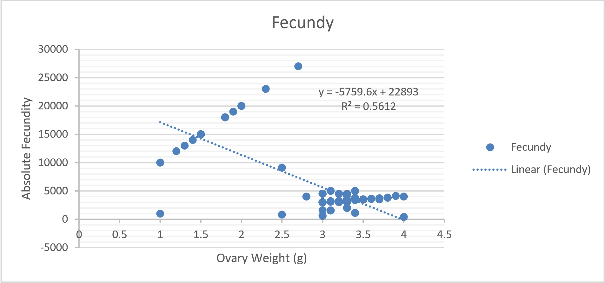Fig. 12: Ovaryweight-Fecundity-Relationship of Brycinus nurse Specimens in Goronyo Reservoir, Sokoto State Nigeria.

Results obtained on Figure 13 showed a relationship between testis weight and somatic weight in male Brycinus nurse specimens sampled in Goronyo reservoir. There was a strong goodness of fit (R²=0.92) of the regression in male Alestes dentex specimens.
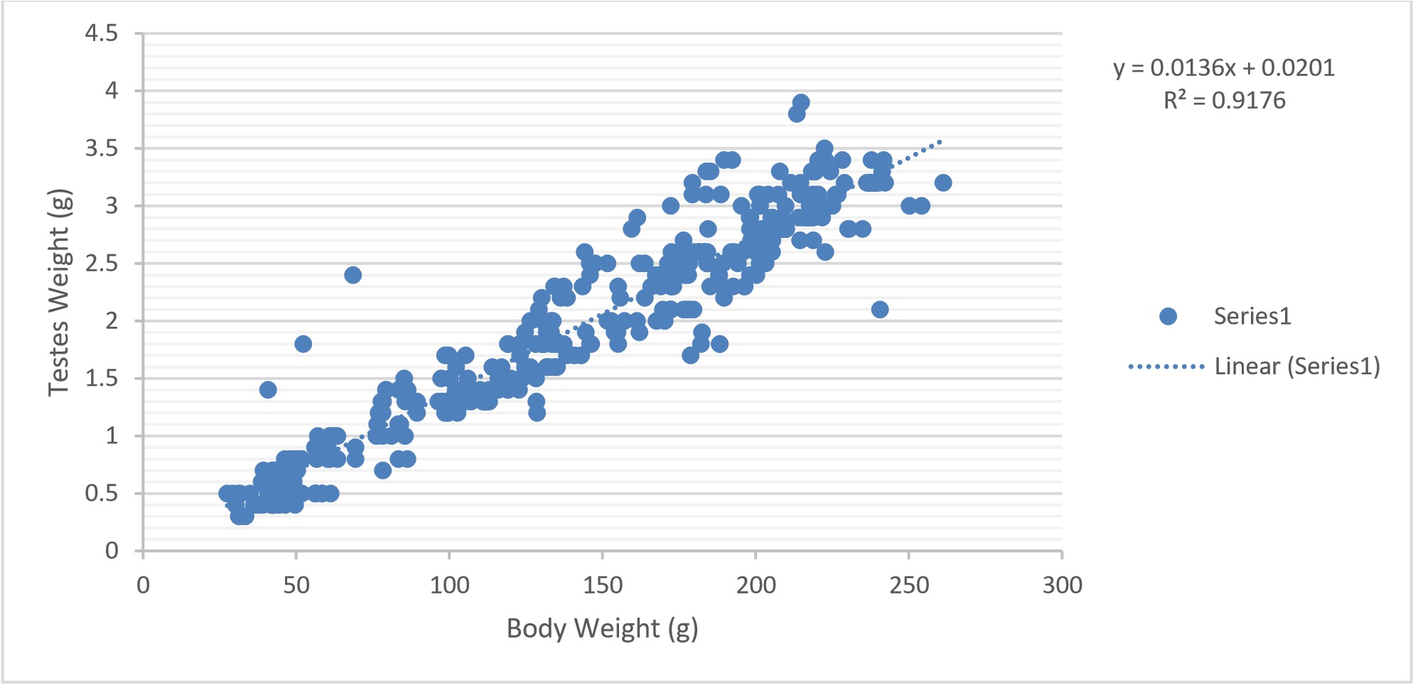Fig..13: Testes weight-Body Weight-Relationship in Male Brycinus nurse Specimens in Goronyo Reservoir, Sokoto State Nigeria
Results obtained from Figure 14 showed a body weight and fecundity relationship in gravid Brycinus nurse specimens sampled in Goronyo reservoir. A very strong goodness of fit (R²=94) indicated that there was a strong relationship between fecundity and gravid somatic weight in the specimens.
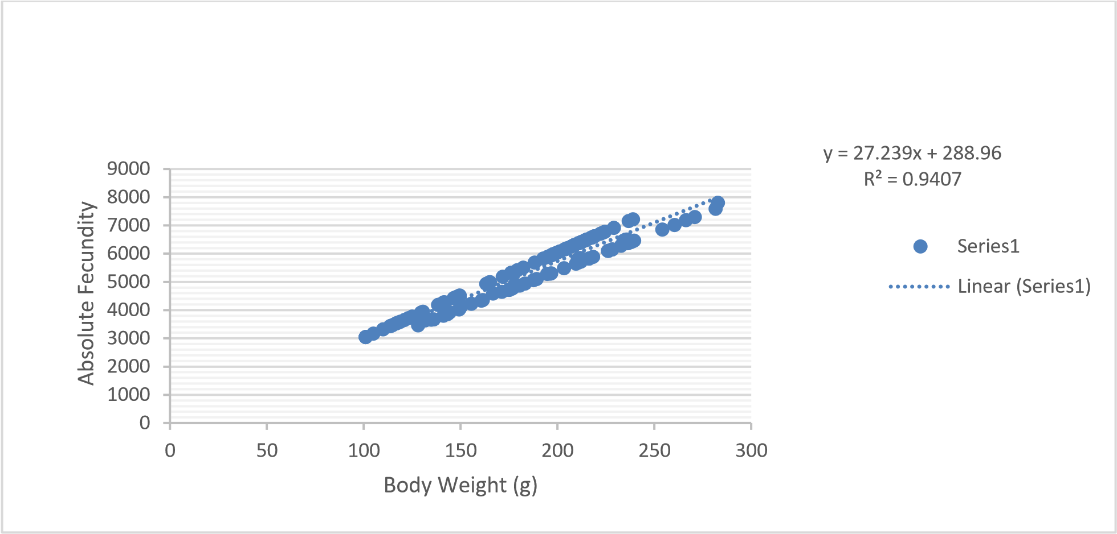Fig. 14: Bodyweight–Fecundity-Relationship in Brycinus nurse Gravids in Goronyo Reservoir, Sokoto State, Nigeria.
Results obtained on Figure 15 revealed a weak (R² = 0.19) goodness of fit of the relationship between total length and fecundity of Brycinus nurse specimens in Goronyo Reservoir.

y = 453.96x + 6839.2
R² = 0.1945
0
5000
10000
15000
20000
25000
30000
0
5
10
15
20
25
30
Mean
Fecundity
Total Length (cm)

Absolute Fecundity
Linear (Absolute Fecundity)
Fig. 15: Total Length-Fecundity-Relationships in Brycinus nurse Specimens in Goronyo Reservoir, Sokoto State, Nigeria
Discussion
Spawning and breeding activities take place when there is are adequate number of spawners and mostly in the tropical water bodies, this starts in April to August (Dadebo, 2000&2011; Grau et al., 2016). The correct ratio of Male: female (M: F) is very important in breeding processes in waterbody and most studies reported various numbers of M:F ratios of spawning stocks in the tropical water bodies (Paugy, 2001; Kamugisa et al., 2010; Grau et al., 2016). Dadebo (2000) reported a M: F ratio almost equivalent to a unitary number of spawners in both sexes. Boot and McKinlay (2001) reported F: M of 4.8:1 (floodplain) and 2.2:1 (riverine) for Brycinus lateralis, which contrasted with the findings in this study. Furthermore, Dadebo et al. (2011) reported more males caught in January to October. As was similarly reported in this study.
Gonads Maturation Stages
Gonads are the sexual organs of the fish specimen, testis for the male and ovary for the female (Bagenal and Tech, 1978; Gabr et al., 1998). The authors observed that fish species gonads undergo different stages of gonad development as the fish mature. For instance, Shinkafi et al. (2013) had categorised the gonad development of female Nile perch (Lates niloticus) specimens in River Rima into five stages namely: unripe, maturing, matured, spent and resting. Similarly, Oboh et al. (2013) also studied and reviewed reproduction strategies in Synodontis schall in Jamieson River and divided the ovary maturation stages in the female specimens into five stages namely, immature, recovery, maturing, ripe and spawning. Furthermore, Kasogi et al. (2013) classified ovary development in female Alestes baremose in Albert Lake based on six stages which is adopted by this study namely; immature, developing, imminent spawning, spawning, post spawning and spent stage with stage IV been more popular thereby indicating a short spawning period for the species. This study also revealed that stage IV is the most popular.
Gonadosomatic Index (GSI)
Gonado-somatic-index (gsi) is the weight of the ovary or the testis relative to that of the somatic weight of the fish specimen (Meio et al. 2011). In a related study on Lates niloticus in River Rima, Shinkafi et al. (2013), citing Rhodes and Sadovy (2002) reported that, Gonado-somatic index (gsi) was a tool used for measuring the sexual maturity of animals in correlation to ovary and testis development. Rhodes and Sadovy (2002) reported that gsi was a good indicator of reproductive activity used in determining the fish reproductive cycle. Saliu and Fagade (2003) reported gsi values ranging from 0.02-29.25% with a mean value of 6.43% varying with season, size, sex and stage of gonad maturity, as was similarly reported in this study. Similarly, Offem et al. (2008), Shinkafi et al. (2013), Yusuf et al. (2013) and Kasogi et al (2013) reported mean GSI values as reported by this study.
Fecundity
Fecundity is the total number of eggs a gravid fish contains in its productive cycle in the ovaries prior to spawning (Bagenal and Tesch, 1978; Eyo et al., 2016; Opiyo et al, 2017; Saleh et al., 2020; Mimoune et al., 2023). In demographic studies, fecundity is the actual reproductive rate of an organism or population measured by the number of gametes, eggs, seed set, or asexual propagules (Berek and Novak, 2007). Fecundity is important and well-studied in the field of population studies. Fecundity can increase or decrease in a population according to the current conditions, aquatic environment and certain regulating factors (Berek and Novak, 2007). For instance, in times of hardship for a population, such as a lack of food, juveniles and eventually adults’ fecundity has been shown to decrease (i.e. due to lack of resources, the juvenile individuals are unable to reproduce, eventually the adults will run out of resources and reproduction will cease). This study revealed that mean fecundity ranged from 544±77 eggs to 10,447±1,648 eggs in Brycinus nurse gravids in Goronyo reservoir. Similarly, Saliu and Fagade (2003), Offem et al. (2008), Kingdom and Allison (2011), Yusuf et al. (2013), Nandikeswari et al. (2014), Abdulkarim et al. (2017), and Nguvan et al. (2024) reported fecundity ranges from 348 eggs to 155 920 eggs in various water bodies. The fecundity was also shown to be dependent on total length (Kabir and Quddus, 2013; Nandikeswari et al., 2014), body size and season (Kingdom and Allison, 2011; Abdulkarim et al., 2017; Nguvan et al., 2024).
Fecundity-Ovary Weight-Relationship
This study revealed a moderate relationship between fecundity and ovary weight in Brycinus nurse specimens. Obah et al. (2013) and Nandikeswari et al. (2014) reported a high relationship between fecundity and ovary weight in Terapon jarbua species in an Indian water, therefore confirming the findings in this study.

Fecundity-Total Bodyweight-Relationship
The study revealed a strong fecundity and total somatic weight relationship in Brycinus nurse specimens, therefore confirming somatic weight as the best indicator of fecundity as reported by Kingdom and Allison (2011).
Fecundity-Total Length-Relationship
One of the main goals of estimating fecundity is to establish a fecundity-size (length/weight/age) relationship which can be used to estimate spawning stock biomass or spawner abundance (Morua et al., 2003). This study revealed a weak relationship between fecundity and total length in Brycinus nurse specimens in Goronyo reservoir. This finding was further corroborated by the report of Kingdom and Allison (2011) who observed that total length was not the best predictor of fecundity in Pellonula leonensis in Run River. Obah et al. (2013) reported positive correlation between fecundity-weight and fecundity-ovary weight but an insignificant relationship in fecundity-length relationship in Synodontis schall in Jamieson River, as was similarly reported in this study. However, Kabir and Quddus (2013) reported significant relationships (p<0.01) between fecundity and total length and standard length in a study on a small cyprinid in a small pond in Paridpur district.

Conclusion
The study investigated the reproductive potential of Brycinus nurse species in Goronyo reservoir. The study revealed a sex ratio dominated by bigger males sampled between June and August, with more male specimens at Stage III and female specimens at Stage IV and VI of gonad maturation. Similarly, the highest mean gsi values were recorded in June to September in male Brycinus nurse specimens and lower mean gsi values were recorded in August, indicating this was the period the species spawns. The mean fecundity was highest in August to October in gravid Brycinus nurse specimens. All other reproductive indices had shown high relationships with specimens’ somatic weight, gonad weight, and season, except total length. Conclusively, this species spawns in August and has high reproductive potential in Goronyo reservoir.
Recommendation
The study recommends the adoption of a closed season management strategy between June and October to allow an uninterrupted breeding activity of this species in Goronyo reservoir.

Disclaimer (Artificial intelligence)

Option 1:

Author(s) hereby declare that NO generative AI technologies such as Large Language Models (ChatGPT, COPILOT, etc.) and text-to-image generators have been used during the writing or editing of this manuscript.

Option 2:

Author(s) hereby declare that generative AI technologies such as Large Language Models, etc. have been used during the writing or editing of manuscripts. This explanation will include the name, version, model, and source of the generative AI technology and as well as all input prompts provided to the generative AI technology

Details of the AI usage are given below:
1.
2.
3.

References
Abdulkarim M., Yusuf, Z.A., and Suleiman, S.B (2017). Preliminary studies on the Potential of Brycinus nurse (RUPELL, 1832) for Aquaculture in Nigeria, Nigerian Journal of Fisheries and Aquaculture, 5(1), pp30-36, ISSN:2350-1537
Abubakar, S.D. and Aliyu M. (2017). Examining Sediment Accumulation in Goronyo
Reservoir, Sokoto State, Nigeria, IOSR Journal of Humanities and Social Science (IOSR-JHSS) Volume 22, Issue 8, PP 60-65 e-ISSN: 2279-0837, p-ISSN: 2279-0845. www.iosrjournals.org
Bagenal, T., and Tesch, F. (1978). Age and Growth in: T.B. Bagenal (Ed.) Methods for Assessment of Fish Production in Fresh water (3 ed.). Oxford: Blackwell Scientific Publication.
Berek, J. S. and Novak, E. (2007). Berek and Novak’s Gynaecology (14 ed.). Philadelphia: Lippincott Williams and Wilkins.
Booth, A.J. and Mckinlay, B.W (2001). Spatial Aspect of the Reproductive and Feeding Biology of the Striped Robber, Brycinus letaralis (Pisces: Characidae) in the Okavango Delta Botswana, African Zoology, 36:1, 31-40, DOI:10.1080/15627020.2001.11657111
Cao, L., Song, B., Zha, J., Yang, C., Gong, X., Li, J., and Wang, W. (2009). Age Composition, Growth, and Reproductive Biology of Yellow Catfish (Petobagrus fulvidraco, Bagridae) in Ce Lake of Hubei Province, Central China. Eniron.Biol. Fish, 86(75).
CK-12(2024). Fish Reproduction and Development, LibreTexts Biology, https://bio.libretexts.org
Dadebo, E. (2000). Reproductive Biology and Feeding Habits of The Catfish Clarias Grapienus (Burchell) (Pisces: Claridae) In Lake Awassa, Ethiopia, Ethiopian Journal of Science 23(2):231-246
Dadebo, E., Mariam, Z.G. and Mengistou, S. (2011). Breeding Season, Maturation, Fecundity and Condition Factor of African Catfish Clarias Grapienus (Burchell 1922) (Pieces: Claridae) In Lake Chamo Ethiopia, Ethiopian Journal of Science, 10(1):1-17
Davis, G. (1982). Rainfall and Temperature. In: Abdu, P.S. and Swindell, K. (eds.) Sokoto State in Maps: An Atlas of Physical and Human Resources, Ibadan, Ibadan University Press.

Elisha, I., Sawa, B.A., Lawrence, E. and Adekunle, M.O. (2016). Adaptation Strategies to
Climate Change among Grain Farmers in Goronyo Local Government Area of Sokoto State, International Journal of Science for Global Sustainability, Vol. 201): Pp 55-65, ISSN: 2488-9229
Esa, B.Y., Dadile, A.M., Syukri, F., Christianus, A. Diyaware, A.Y. (2023). Evaluation of Fecundity, Fertilization, Hatching, and Gonadosomatic Index of Exotic Clarias gariepinus (Burchell, 1822) and Native Claris macromystax (Gunther, 1864) under Semi-Arid Conditions of Nigeria, MDPI Journals/Animals/Vol 13/Issue 11,
DOI:103390/ani13111723
Eyo, V.O., Ekanem, A.P. and Ajom, V.A. (2016). Fecundity studies of African catfish Clarias gariepinus (Burchell, 1822) fed Coppens feed and Unical aqua feed in circular concrete tanks, Journal of Coastal Life Medicine, 4(7): 531-535, doi;10.12980/jcm.4.2016J6-45

FishBase (2017). LIFE HISTORY AND REPRODUCTION OF FISH, FishBase and Fish Taxonomy Training Session, Royal Museum for Central Africa, (RMCA Tervuren), https://www.afriacmuseum.be
Flores, A., Wiff, R. And Diaz E. (2015). Using the gonadosomatic index to estimate the maturity ogive: application to Chilean hake (Merluccius gayi gayi), ICES, Journal of Marine Science, Vol. 72, issue 2.p 508-514, https://doi.org/10.1093/icesjms/fsu155
Floyd, R.F. and Petty, B.D. (2020). Breeding and Reproduction of Fish, PET OWNER VERSION, MSD MANUAL, Veterinary Manual, https://www.msdvetmanual.com
Gabr, H. R., Hanlon, T. H., Mahmoud, H. H. and El-etreby, S. (1998). Maturation, Fecundity of Two Commercially Valuable Cuttlefish, Sephia pharaonis and S. dollfusi in Suez Canal, Journal of Fisheries Research, 36(23), 99-115.
Gill, M.A. (1974). Hydrological characteristics of the Sokoto – Rima basin, Savana 39(1):61-
76
Grau, A., Saborido-Rey, F, Pastor, E., Palmer, M., Quetglas, A, Riera, I., Morales-Nin B. (2016). Reproductive Strategy of common Dentex dentex: management implications, Mediterranean Marine Science, Vo. 17 no. 2, 552-566, https//doi.org/10.12861/mms/1156
Hunter, J. R., and Beverly, J. M. (1980). Sexual Maturity, Batch Fecundity, Spawning Frequency and Temporal Pattern of Spawning for the North Anchovy, Engrauliulis modax, During the 1979 Season. CalCOFI rEP., XXI, 139-149.
Ita, E. O. (1993a). Inland Fisheries Resources of Nigeria. F.A.O. of the United Nation. Rome: F.A.O. of the United Nation.
Jan, M. and Ahmed, I. (2016). Assessment of fecundity, gonadosomatic index and hepatosomatic index of snow trout, Schizothorax plagiostomus in river Lidder, From Kashmir Himalaya, India, International Journal of Fisheries and Aquatic Studies, 4(2):370-375,
Kabir, M.A. and Quddus, M.M.A. (2013). Fecundity and gonadosomatic index of Labeo calbasu (Hamilton)from a stocking pond of a hatchery at Faridpur, Bangladesh, Bangladesh J. Zool. 41(1):43-48
Kamugisa, G.M., Kasam, D. Owiny, D.O., Balirwa J.S. and Agba, M. (2010). Reproductive Biology and Cryopreservation of Milt Alestes baremose (Joannis, 1835) of Lake Albert, Uganda, Second REFORUM Biennial Meeting 20-24, Entebbe, Uganda. Research Application Summary
Kasozi, N., Atibuni, K., Degu, I.G. and Mugerwa, S. (2013). Classification of Ovarian Stages of Alestes baremoze (Joannis, 1835): A Step Towards Understanding Its Reproductive Biology, Frontiers in Science, Vol 3 (4): 107-113, DOI: 10.5923/j.ffs.20130304.01
Kaur, S., Singh, P. and Hassan, S.S. (2018). Studies on Gonadosomatic index (GSI) of selected fishes of River Sutlej, Punjab, Journal of Entomology and Zoology Study, 6(2):1274-1279
Kingdom, T., and Allison, M. E. (2011). The Fecundity, Gonadosomatic and Hepatosomatic Indices of Pellonula leonensis in the lower Run River, Niger Delter, Nigeria. Current Research Journal of Biological Sciences, 3(2), 175-179.
Meio, R. M., Arantes, F. P., Sato, Y., dos Santos, J. E., Rizo, E., and Bazzoli, N. (2011). Comparative Morphology of the Gonad Structure Related to Reproductive Strategies of Six Species of Neotropical Catfishes (Teleostei: Siluriformes). Journal of Morphology, 272(5), 525-535.
Mimoune, N., Rouabah, A., Khelef, D. Kaidi, R. (2023). Assisted reproduction of Clarias gariepinus (Burchell, 1822), VETERINARSKA STANICA, 54(1), 95-104
Muhammad, L.A., Ismail, A., Adeogun, B.K., Abdullahi, S.A., and Sani, I.M. (2020). Assessment of Water Availability and Demand in Goronyo Reservoir, Sokoto, Nigeria,
FUOYE, Journal of Engineering and Technology, Vo. 5 No. 2,
DOI: https: doi.org. /10.46792/fuoyejet. v5i2.486
Murua, H., Kraus, G., Saborido-Rey, F., Witthames, P.R. Thorsen, A. and Junquera, S. (2003). Procedures to Estimate Fecundity of Marine Species in Relations to their Reproductive Strategy, Journal of Northwest Atlantic Fisheries Sciences, Vol. 33: 33-54, http://journal.nafo.int
Nandikeswari, R., Sambasivan, M. and Anadan, V. (2014). Estimation of fecundity and Gonadosomatic Index of Terapon jarbua from Pondicherry Coast, India, World Academy of Science, Engineering and Technology, International Journal of Biological, Biological, Biomolecular, Agricultural, Food and Biotechnological Engineering, 8(1): 61-65
Nguvan, S.J., Samuel, O.O., Kulamter, A.P., Inya, O.J. and Pauline, A. (2024). Some Aspects of Biology of Brycinus nurse (Alestidae, Ruppell, 1832) from the Lower River Benue River, Nigeria, Global Scientific and Academic Research Journal of Multidisciplinary Studies, p1-10, ISSN:2583-4088 (Online), https://gsarpublishers.com/journals-gsarjms-home/
Oboh, I.P., Ogbeibu, A.E., Ogoanah, S.O., (2013). Gonadal development, fecundity and spawning pattern of Synodontis schall (Pisces: Morkhokidae) from Jamieson River, Nigeria, Res. Rev. J Zool Sci. 2013 (1): 13-23
Offem, B.O., Akegbejo S.Y.Y. and Omoniyi I.T. (2008). Diet, Sizes and reproductive biology of the silver catfish Chrysichthys nigrodigitatus (Siluriformes Bagridae) in Cross River, Nigeria, Rev.Biol.Trop. 56:(4)1785-99
Olusegun, A.E., Idowu, A.F., Oghenebroorhie, M.O.T. (2019). Assessment of fecundity of Brycinus macrolepidotus in Akomoje water reservoir, Abeokuta, South West, Nigeria, Egyptian Journal of Aquatic Biology and Fisheries, Vol. 231(1);245-252, ISSN:1110- 6131, www.ejabf.journals.ekb.eg
Opiyo, M.A., Orina, S. and Karisa, H.C (2017). Fecundity, Growth Parameter and Survival Rate of Three African Catfish (Clarias Gariepinus) Under Hatchery Conditions, Journal of Aquaculture and Fishery Research, 3(2): 75-81, doi.103153/JAEFR17010, E-ISSN 2149-0236
Patrick, K.O.D., Abdulhakim, A. and Samuel, K.K.A. (2020). Fecundity of Some Commercially Important Demersal Fish Species in Ghanian Coastal Waters, West Africa, Journal of Fisheries International, Volume 10, Issue 4: p33-38
Paugy, D. (2001). Reproductive Strategies of Fishes in Tropical Temporary Stream of The Upper Senegal Basin: Baoule River in Mali, Aquatic Living Resources, 15(2002), 25- 35
Paugy, D. and S.A. Schaefer, (2007). Alestidae. P.347-411.In M.L.J. Stiassny, G.G. Teugels and C.D. Hopkin (eds.). Poissons d’eaux douces et saumatres de basse Guine’e, ouest de l’Africa centrale/The Fresh and brackish water fishes of Lower Guinea, west-central Africa. Vol. 1Coll. Faune et Flore tropicales 42. Istitut de rechaerge pour le development, Paris, France, Museum nationale d’histoire naturelle, Paris, France and Musee’ royale de l’Afrique centrale, Tervuven, Belgique, 800p.
Pepin, P., Curtis, K.A., Snelgrove, P.V.R., de-Young, B. and Helbig, A. (2007). Optimal estimation of catch by the continuous underway fish egg sampler based on a model of American plaice (Hippoglossoides platessoides) egg, ICES Journal of Marine Science, Volume 64, Issue 1, p 18-30, https://doi.org/10.1093/icesjms/fsl016
Rhodes, K.L. and Sadovy, Y. (2002). REPRODUCTION IN THE CAMOUFLAGE GROUPER (PISCES: SERRANIDAE) IN POHNPEI, FEDERATED STATES OF MICRONESIA, BULLETIN OF MARINE SCIENCE, VOL. 70, NO. 3: 851-869, https://www.researchgate.net/publication/233697836
Saley, H.H.E., Semaida, A.I., Zidan S.R.S., Abou-Zied, R.M. and Allam, S.M. (2020). Sex Hormones Changes in Blood and Their Effects on Fecundity of African Catfish (Clarias gariepinus) Burchell, 1822) After Being Injected with Different Doses of Human Chronic Gonadotropin (HCH) Hormone, Journal of Zoological Research, Volume 2, Issue 4, 19-30
Saliu, J.K and Fagade, S.O. (2003). The Reproductive Biology of Brycinus nurse (Paugy, 1986), Pisces: Characidae in Asa Reservoir, Ilorin, Nigeria, Turkish Journal of Fisheries and Aquatic Sciences 3: 5-9
Sambenelli Consulting. (2011). www.wikipedia.org. Retrieved from Wikipedia: https//enim.wikipedia.org>wiki>Goronyo Dam.
Shinkafi, B. A., Ukola, L. N. and Tukur, N. A. (2013). Some Aspects of Growth and Reproduction in the Nile Perch (Lates Niloticus, Linne 1760) from River Rima, North western Nigeria. Nigerian Journal of Fisheries and Aquaculture, 1(1), 31-41.
Suresh, K.W. (2014). Studies on Gonadosomatic Index, Fecundity and Hatchability of Domesticated Stock of Asala Schizothorax richardsonii (Gray) from Nallu River of Lalitpur Distric , Our Nature, 12(1): 19-27, DOI: http://dx.doi.org/10.3126/0n.v12i1.12253
Waidi, O. A. (2015). Life history change in silver catfish Chrysichthys nigrodigitatus, family Bagridae in Ogun Coastal estuary, Nigeria, Ife Journal for Science, 17(3), 691-700.
Weather and Climate (2020). Goronyo, Sokoto, Nigeria Climate,www.weatherandclimate.com
Weitzman, S.H. and Vari R.P. (1998). Miniaturization in South American fresh water fishes: an overview and discussion, proceedings of the Biological Society of Washington, 101(2):444-465
Weizmann, S.H. and Parenti, L.R. (2024). Reproduction, Encyclopedia Britannica, https://www.britannica.com
Yusuf, K., Dada, S. A., and Abari, M. A. (2013). Length-Weight-Relationship, Fecundity and Gonadal Development of an African Catfish (Clarias gariepinus) From Doma Dam, Nasarawa State, Nigeria. FAT, 9(1), 47-58.
Ganias, K. (2013). Determining the indeterminate: Evolving concepts and methods on the assessment of the fecundity pattern of fishes. Fisheries Research, 138, 23-30.
Adeniyi, O. A., & Agbugui, M. O. (2024). Length-weight relationship and condition factor of the dominant fish species in lower river Niger, Agenebode, Nigeria.
Quarshie, E. N., Alhassan, E. H., & Abobi, S. M. (2024). Growth and population structure of Odaxothrissa mento and Brycinus leuciscus from the lower reaches of the White Volta in Ghana. Lakes & Reservoirs: Research & Management, 29(1), e12457.
Rayal, R., Selakoti, A. N. K. I. T. A., & Bahuguna, P. (2021). A comparison between Gonado-Somatic Index (GSI) and Dobriyal Index (DI) for determination of sexual maturity in Puntius ticto from Aasan River, India. Uttar Pradesh J. Zool, 42(15), 60-66.

