A DIAGNOSTIC STUDY TO CONTROL PACKAGING WEIGHT VARIABILITY IN CHILLI POWDER MANUFACTURING USING STATISTICAL PROCESS CONTROL

ABSTRACT
In the food processing industries, weight variation in the net product content is frequently noticed, particularly in the case of spices (Chilli Powder). Since it directly affects customer satisfaction and brand image, the variation of excessive weight in the spice packing, either more or less than the legal minimum weight, is a serious problem. This weight fluctuation is a possible waste that could result in different product quality, higher production costs, and worse profitability. Product weight variations during packaging are still a major issue due to human error, machine calibration, raw material variability, environmental variables, and standard operating procedures. Chilli powder is fine and sticky, thus the auger filler nozzle can affect weight variations in packaging. A poorly sized or residue-clogged nozzle might inhibit chili powder flow, resulting in irregular fills. Proper nozzle design and regular cleaning reduce these difficulties and will help the chilli industry standardize products, cut waste, and compete globally.
Quality is essential in any productive industry, including manufacturing and services. Several techniques have been consolidated to analyze the standardization of production process quality. The research method included data collection, statistical analysis and process control to evaluate packing machine component changes. A large sample size was employed to measure spice packet weight before and after change to ensure statistical significance. Descriptive statistics, a two-sample t-test, and variance tests (F-test and Levene's test) assessed mean weight and variability. SPC used X-bar and R charts to monitor how stable the process was, set control limits, and calculate process capability (Cp and Cpk) based on the set specifications. These tools helped check how effective the component change was. Before changing the component, there were 38 outliers on the X-bar chart and 5 on the R chart. After making the change, outliers on both charts were very few and insignificant. This study recommends modifying the auger filler nozzle to help lower packing weight variation.
Keywords:Weight Variation, Spice packaging, Component change, t-test, Process capacity

- Introduction
A significant category of agricultural products, spices are thought to be essential for cooking and flavoring meals. Additionally, various spices and spice-related items are utilized for cosmetic, fragrance, and medical purposes. Referred to as the "Land of Spices," India cultivates a wide range of spices in vast quantities. The nation grows over sixty-three different types of spices, including pepper (the King of Spices), cardamom (the Queen of Spices), ginger, turmeric, coriander, cumin, and many more.
Humanitarians have long used spices as a herbal cure to stave against illness and maintain their physical and emotional well-being. In addition to using herbal medicines, Ayurveda is utilized to preserve, flavor, and color food (Gidwani et al., 2022). Spices that have particular qualities because of a special volatile oil or molecule they contain include whole or ground spices, spice blends, purees, air-dried products, and essential oils (Siruguri& Bhat 2015; Kumar et al., 2024). Their fundamental processing and packaging features have received little attention despite this massive production. The importing nations have strict safety and hygienic requirements, which can vary from one nation to another. However, the presence of poisons, pesticide residues, and biological infestations always worry the regulatory bodies more. Due to inadequate packaging, a number of shipments failed to arrive. Therefore, it is reasonable to assume that appropriate functional packaging will be crucial to preserving the quality of spices throughout storage and transit (Indriramma, 2004). Recent advancements show a shift toward smart and bio-based food packaging systems (Portal D’Almeida & de Albuquerque, 2024).

  - Role of Packaging in Spice Manufacturing
Enclosing food to prevent physical, chemical, or biological contamination or tampering is known as packaging. Even after the production process is complete, packaging is essential to maintaining the benefits of food processing. It guarantees that food items can be securely transported over long distances from their place of production and will still be safe and nutritious when eaten. Food packaging's main goal is to protect food against external elements such as air, moisture, ultraviolet radiation, and microbial and chemical hazards (Pruthi et al., 1962). Because different spices have different and particular packaging needs, packing spices is a more complex undertaking than packaging other products. To prolong the storage life of multiple spice categories, like whole seeds (celery, fennel, cumin, and fenugreek), ground or powdered spices, blended seasonings (curry powders and masalas), essential oils and oleoresins, and through diverse distribution networks, appropriate packaging materials must be designed and developed. To eliminate inferior materials, impurities, and foreign objects during the production and final packaging processes, continuous quality control should be put in place. Following defined operational standards and national or regional regulations established by the producing and consuming countries, processed plant materials must be packed in clean, dry containers such as boxes, sacks, bags, or other suitable packaging (Ammaan et al., 2024).

Packaging is critical to the manufacture of spices since it guarantees efficiency and uniformity in the entire production process, storage and distribution. It preserves the quality of the product by keeping it fresh, preventing contamination and keeping out air, light and moisture which destroy flavor, aroma and color. The design of packaging can bring about fill efficiency and consistency of the product (Klein et al., 2024). Modern methods of packaging make it possible to become very precise with the portion of each unit since the weight and volume are guaranteed to be constant. Automation through sensors enhances the accuracy of fills and variability (Palanisamy et al., 2025). This is necessary to regulatory compliance as well as consumer trust. Although automated filling and sealing systems enhance the efficiency of operations, reducing manual error and waste of material, the advanced technologies such as vacuum sealing and multilayer films raise the shelf life. Packaging simplifies logistics by ensuring that it is strong enough to be transported and stores as much information as possible because of uniform designs. It also enhances branding through conveniently available features such as resealable pouches, portion control, and the clear labeling. Due to the evolution of the spice industry, the manufacturers can meet the environmental goals as well as maintain high-quality, consistency, and cost-effectiveness standards because of the modern achievements of sustainable materials and smart packaging.

  - Importance of Consistent Product Weight
    - Accuracy and Consistency- Crucial in Quality Assurance
Quality assurance should be the priority of any company that tries to maintain the satisfaction of clients and ensure the utmost quality of merchandise. Accuracy and consistency are two vital elements of quality assurance, which has a direct impact on consumer satisfaction and brand recognition. Check weighing is necessary in terms of accuracy to ensure that the consumer has been provided with the correct amount of product. Any variation such as that of recommended weight may cause dissatisfied customers and potential legal issues, regardless of whether the product is a handcrafted part, a prescription drug, or a packaged food stuff. To ensure that all products being shipped out of the business meet the required weight specifications, the businesses can also include check weighing in the quality assurance process. Consistency also plays an important role in quality assurance. Customers expect uniformity in the products they purchase and when the uniformity is violated they will develop distrust and loyalty. Check weighing helps businesses to identify any differences in the weight of products, and remedy the situation before it impacts the customer. This can be used to maintain brand reputation and competitiveness within the market besides ensuring the satisfaction of clients. To summarize, since accuracy and consistency have direct relationship with consumer happiness, brand reputation, and with the law, they are crucial elements of quality assurance. Check weighing is an important process in quality control processes because it is a reliable method of ensuring that weight of products is correct and the same.
1.2.2. Advantages of Using Check Taking Quality Assurance into Account
Businesses in a variety of industries can benefit greatly from the use of check weighing in quality assurance procedures. Among the main benefits are:
- Higher customer satisfaction: When businesses ensure that products weigh right and always, this will satisfy the expectations of customers and result in high customer satisfaction. It makes consumers happy to receive the appropriate amount of goods and check weighing adds to their loyalty and trust.
- Better brand image: Consistency in the weight of products leads to improved brand image. Whenever the customers receive goods that do not weigh the expected weight, they tend to associate the brand with reliability and quality. This makes the business distinct among the competitors and increases its recognition in the market.
- Cost savings: Check weighing minimizes waste and production streamlines and minimizes the cost. The early identification of underweight or overweight products assists companies to save unnecessary expenses related to rework, product recall or lawsuits.
- Compliance with regulation: Many industries have strict regulation regarding the weight of the product especially the food and beverage and pharmaceutical sectors. Check weighing will reduce the risk of fines or recalls by making sure that these rules are adhered to.
- Process enhancement: Check weighing can be introduced into the quality control processes that help businesses to discover any inconsistencies or deviations and take corrective actions. This continuous development cuts down the errors, optimizes production and enhances efficiency.

In conclusion, the benefits of integrating check weighing with quality assurance procedures include improved customer satisfaction, improved brand recognition, reduction in costs, compliance with different regulations, and enhancement of processes. These advantages make check weighing an important process to any business operating in any industry that aims at succeeding in quality control and delivering quality products to their customers.
  - Factors Causing packaging variations in spice manufacturing
There are a great number of factors, such as human abilities, equipment, material, process, control systems, and environmental conditions, which influence the accurate and effective production of products. All of these factors play a vital role in ensuring that the quality remains the same and that the number of errors in the production processes is minimized.
1.3.1. Human Factors (Man):
- Inadequate Training and Lack of Care: The right training programs have to be made to minimize errors and enhance operator expertise. Smith and Jones in Manufacturing Practices, 2020, state that a well-trained worker significantly enhances the lack of output. Lack of training will lead to mistakes in operations, reduced productivity and potential safety risks. Regular reviews and study courses can be used to fill the gaps in knowledge and reinforce best practices.
- -Stress at work: When the workers are overburdened, the stress levels can lead to a higher number of errors. Stress levels influence concentration, efficiency, and decision making. According to the Industrial Management Journal, 2019, stress and low productivity are interconnected, and balanced workloads, ergonomic improvements, and mental health care are needed in the industrial environment.
1.3.2. Machine Equipment Factors:
Calibration Problems & Malfunctions: Quality control, as stipulated by ISO 9001 requirements, involves calibration of equipment used to weigh and fill. This will help to ensure that the equipment is accurate. Regulatory non-compliance and unhappiness by customers may result in inconsistent weights because of improper calibration. Periodic checks ensure that machines work within the reasonable ranges of tolerance.
Upkeep Timetables: The Maintenance Engineering Handbook has claimed that preventive maintenance reduces machine-related errors and downtimes (Higgins & Mobley, 2015). A systematic maintenance plan can enhance the reliability of the operations and can prolong equipment life by preventing potential problems before they occur. Predictive maintenance is able to identify faults prior to the occurrence of weight variability (Mateo et al., 2024).
1.3.3. Raw Material Factors (Material):
Moisture Content: Changes in the moisture content affect the accuracy and consistency of the weights of the products. To ensure that the conditions of raw materials are uniform, environmental control is very important, according to the Bovi et al., 2018. Compliance with standards and quality of the product is maintained by maintaining a watchful eye and controlling the amount of moisture content in raw materials.
The distribution of particle sizes: The products whose weight distribution is not equal can be due to non-uniform grinding. The measurement of the particle size distribution in the preparation of the raw material ensures a higher corresponding consistency in the outcome of the production process, as studies in Powder Technology by Kim et al., 2019.
1.3.4. Process Factors (Method):
Inconsistent Filling Techniques: Sometimes, weight differences are as a result of inconsistency in manual filling processes. In reference to (Partida, 2021), automated filling methods improve the productivity of manufacturing, and reduce the error of humans. Also, automation ensures uniformity and compliance with the industry standards.
SOP Compliance: The uniformity in manufacturing is assured when Standard Operating Procedures (SOPs) are adhered to. The FDA defines Good Manufacturing Practices of Food Processing, 2020 as clear SOPs that enhance quality control and reduces variability of the processes, which creates consumer confidence.
1.3.5. Control Factors (Measurement):
Inaccurate Scales: The weighing scales need to be calibrated frequently to avoid inaccurate data. According to Espy&Tomalino (2024), the value of maintaining accuracy by regular checks and re-calibration of measuring tools is stressed.
Keeping an eye on frequency: Frequent weight checks during production helps identify the differences in a timely manner preventing more severe issues. To ensure the uniformity of quality and safety regulations, standards in ISO 22000 encourage the systematic observance.
1.3.6. External Factors (Environmental):
Humidity and Temperature: Variations in temperature and humidity, for example, may alter the moisture content of materials and this may affect the weight and the uniformity of the final product. According to Zhang et al. 2020, it is important to control these aspects to achieve stable production outcomes.
Contamination and Dust: It minimizes operational errors that are occasioned by contamination in a well and clean environment. The relevance of cleanliness in the reduction of errors and improvement of overall productivity is highlighted in the Lean operations Guidelines, 2020.

  - Precautions and Solutions to Minimize Weight Variation
An intensive strategy that deals with the operation components as well as the environmental provisions is necessary in minimizing the weight change in packaging operations. Due to wear and tear that may instigate change overtime, there is a necessity that the weighing system be calibrated regularly so as to be able to correctly dosage. This can be done by ensuring that the routine calibration schedules are done with certified weights, which will ensure that it remains accurate and that they do not compromise on quality. It is also necessary to improve flow properties of spices. Powder flow can be controlled and such issues as clumping or bridging that often create uneven filling can be prevented with the help of vibratory feeders or auger systems.
Environmental control is another main part. Densities and absorption of spices may also be prevented through maintaining the temperature and humidity of the area of production. This can be achieved using air conditioners, dehumidifiers as well as environmental sensors. Also, it is possible to change the machine settings, which suit the specific characteristics of the spice being packed, e.g. the same particle size, moisture content, etc. Test runs and recording of the recommended parameters of different items make fast and efficient adjustments of the machines.
Maintaining equipment and normal monitoring is also necessary. The inspection of the various components such as machine mechanism, bag positioning and sealing system can help in identifying potential issues before they affect production. Preventive maintenance based on industry best practices schedules can support the maintenance of operational effectiveness and reduce downtime. The quality can be enhanced by deploying automated check weighers to check the weights of the packages during production. This minimizes wastage and improves uniformity of products since anomalies in the weight of the products can be detected and corrected in real-time.
Lastly, there must be proper training of the operators. Operators are expected to have information and skills that will help them effectively manage and monitor machine settings. Regular training in issues to do with quality standards, troubleshooting and machine operation will ensure that the equipment is utilized within optimal limits. By implementing these safety measures and solutions manufacturers can work towards producing goods that are more consistent in weight, reduced in material wastages as well as ensure a high standard of quality.

- Research Methodology
  - Data Collection
In order to determine the effect of the component change in the packaging machine, the weight of spice packages was also measured and recorded before and after the modification. To have a measure of comparison, the pre-modification measurements (baseline data) were collected. After the component change, the component change measurements (post-modification data), were recorded at the same operating conditions after the implementation.
In both studies, the sample size that was used was sufficiently large to allow the achievement of statistical significance, hence ensuring meaningful and sound comparisons. Factors that were taken into consideration when determining the sample size included the level of variation expected to be experienced on package weights, and the level of confidence that was intended to be used to perform statistical analysis. This method will make sure that any differences noticed between the pre-change and post-change datasets can be stated to be a result of the component change with a lot of assurance.

  - Statistical Analysis of Package Weights
    - In order to determine how the change in component affected the weight of spice packages, a standardized statistical analysis of the pre-change (baseline) and post-change datasets was carried out. The steps that were applied included:
    - Comparison of Means and variance
The average (𝑥̅) and standard deviation (σ) of the weights of the packages were determined in the baseline group (before change) and post-change analysis. Such descriptive statistics allow seeing the central values and how the data is spread within each of the datasets.
To assess whether the component change had a significant impact on the mean package weight, a two-sample t-test was performed.
A p-value was computed to evaluate whether the difference in means was statistically significant, with a threshold significance level (α) set at 0.05. This methodology follows best practices described in statistical texts such as Howell, 2013.
As a way of testing whether the change in the components reduced the variability in the package weights, the variances of the base and post-change data were tested by both the F-test and the Levene’s test. The test of equality of variances was checked by the use of Levene’s test. The test makes use of the absolute deviations of group means to test the null hypothesis of equal variances (Levene, 1960).
The two tests can be used to complement each other of whether the component change decreased weight variability. Statistical significance for these tests was also evaluated at the α=0.05 level.
2.2.2. Statistical Process Control (SPC)
According to Montgomery (2009), Statistical Process Control (SPC) aims at detection of nonconformities which could disrupt a process, and the end result is prevention of defective units of a particular product. To accomplish this, he clarifies that control charts can be used in the definition of process capability through estimation of critical parameters that have a direct bearing on the process under scrutiny as well as facilitating process improvement by reducing the intrinsic variability.
In addition to that, Lins (1993) explains that a control chart can be used to apply SPC by doing the following:
- select the characteristic to be measured;
b) measure this characteristic at regular intervals during sequential steps;
c) calculate the mean and range of the collected samples;
d) plot these values on the control chart;
e) check whether the process remains under control.
These steps can trace the performance of the processes and monitor their variation, which is emphasized by Martini and Drei (2019).
The process capability analysis of using X-bar and R charts makes it possible to evaluate a process over time by gathering sample data. These samples are used in determining the mean and the range of the process and control limits are put in place to identify the possible variations. The presence of data points that are out of these control limits is an indication that the data process is not in control.
The steps to be followed to build X-bar and R charts are given by Montgomery (2009):
a) Determine the mean (𝑥̅) and range (R) of every sample observation;
b) Calculate the average of the entire sample means and ranges in consideration of the sample size;
c) establish control limits for both the 𝑥̅ and R charts.
Additionally, process capability can be evaluated in two ways based on the control limits to understand how well the process performs and to assess the quality of produced items. The first metric, Cp, measures the width of the process variation relative to the specification limits and considers only process variability. The second, Cpk, assesses how centered the process mean is within the specification limits, reflecting both variability and process centering, as noted by Silveira (2014).
    - Calculation of control limits
Having arranged the samples, it was necessary to calculate the limits of control of them, using the norms of the quality chart X-bar and R. For this, it was necessary to obtain some variables related to this quality charts. Thus:
- The variable m indicates the total number of samples selected, which in this case is m = 50;
- The variable n denotes the number of observations within each sample;
- The mean of the X-bar chart was determined by calculating the simple arithmetic average,
which involves summing all X-bar values and dividing by the total number of samples m. Thus,
Mean ( ̅)= $\frac{Σ x̅}{m}$
• The R-bar is calculated as the simple arithmetic average of all range values by summing the individual R values and dividing by the total number of samples m. Thus,
R̅ = $\frac{ΣR}{m}$
To determine the upper (UCL) and lower (LCL) control limits for both the X-bar and R charts, it was also necessary to define specific constants. These constants are associated with the number of observations per sample n used in this study and are provided in Table 3. Accordingly, for a sample size of 5, we have:
• The constant A2 is required to calculate the upper and lower limits for X-bar. With A2 = 0.577, the limits are given by the formulas:
UCL= Mean (𝑥̅) + A₂ * R̅
LCL= Mean (𝑥̅) – A₂ * R̅
• And, finally, the constants D3 and D4 are used to set the control lines of the R chart. With D3 = 0 and D4 = 2.114, we have:
𝑈𝐶𝐿 = 𝐷4 ∗ R̅
𝐿𝐶𝐿 = 𝐷3 ∗ R̅
It is necessary to mention that these values are automatically calculated by the SPSS software to understand whether the process does not exceed the limits of the control.
    - Process Capability Analysis (Cp)
Using the calculated control limits, it became necessary to determine the process capability of the RU based on the recorded grades. To do this, two key control parameters were first computed:
• The Standard Deviation (𝜎), obtained by dividing the R-bar by d2, where d2 is a constant dependent on the sample size n. In this case, with d2 = 2.326, we have:
𝜎= $\frac{ R̅}{d2}$
• Additionally, the Specification Limits were required, which were defined by the person responsible for managing the RU. This person established the control range of grades between 6 (Lower Specification Limit – LSL) and 8 (Upper Specification Limit – USL), with a target value of 7. Using this data, the Cp of the RU was then calculated as follows:
c_{p}= $\frac{USL-LSL}{6σ }$
Since the resulting Cp value falls between 0 and 1, it indicates that the process variation exceeds the specified specification limits, meaning the process, by definition, is not capable.
    - Process Capacity Index (Cpk)
Since Cp only reflects the potential process capability and does not capture the actual alignment of the process results with the specification limits, it becomes necessary to calculate Cpk to address this limitation. To compute Cpk, two intermediate values must first be determined: the Upper Production Capacity (UPC) and the Lower Production Capacity (LPC). These are calculated using the following formulas:
UPC = $\frac{USL-(x̅̅̅)}{3σ }$

LPC= $\frac{(X̅̅)-LSL}{3σ }$

With UPC and LPC duly calculated, it is possible to find the value of Cpk, which is given by the formula:
𝐶𝑝𝑘 = 𝑚𝑖𝑛 (𝑈𝑃𝐶, 𝐿𝑃𝐶) (Martino &Drei, 2019).

- Data Analysis
There was no significant difference in the mean value of weight of the chili powder prior to the replacement (199.29) and after replacement (200.02). The standard deviations however exhibited a significant difference with 5.06 for pre replacement and 1.67 after replacement.
To ensure that significant difference between variances, a test by Levene’s test was done, with the F-value being 130.605 and the p-value of 0.000 (p < 0.05). This implies that, the equal variances assumption is not met i.e. the standard deviations are very different.
Also, a t-test of Equality of Means was performed to test whether there would be a significant difference in the mean weights. For both cases—equal variances assumed and equal variances not assumed—the p-values were 0.093, suggesting that there is no statistically significant difference in the mean weight of chili powder before and after replacement.
To investigate weight variation in chili powder before and after replacement, control charts (specifically X̅ and R charts) were developed to identify outliers contributing to the significant difference in standard deviations.
The data comprising of 50 observations was taken in the form of triplet and for the first time, the average $({\overline{X}}_{1}, {\overline{X}}_{2}, …)$ and range $(R_{1}, R_{2}, …)$ was computed for each of the triplet and then, the overall average $\left(\overline{\overline{X}}\right)$ and range $(\overline{R})$ were calculated.
Limits can be established around the sample means using the following relationships for $\overline{X}$ and R charts, which illustrate the amount of variance that can be anticipated for a specific sample size. These expected limits are referred as upper control limit (UCL) and lower control limit (LCL).
3.1. $\overline{X}$ Chart: This chart is used to monitor process mean by plotting sample means to control the mean value of a variable.
The X - bar chart for 50 observations taken in the triplet form (for before replacement) is given below:
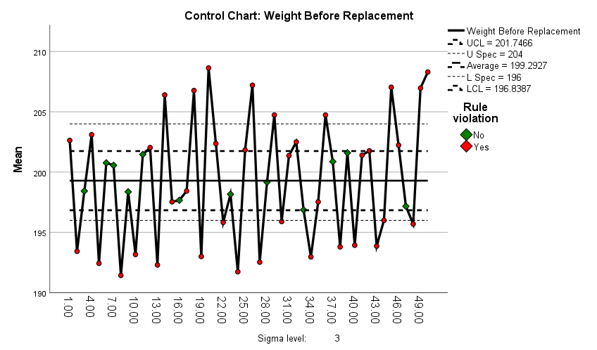
Figure 1. $\overline{\text{X}}$Chart for Weight Before Replacement
The outliers observed from the above control chart are given in the following table –
Table 1. Rule Violations for X-bar
Unit | Violations for Points | Frequency
1, 4, 12, 14, 18, 20, 21, 25, 26, 29, 32, 36, 42, 45, 46, 49, 50 | Greater than +3 sigma | 17
2, 5, 8, 10, 13, 19, 22, 24, 27, 30, 34, 38, 40, 43, 44, 48 | Less than -3 sigma | 16
12, 14, 20, 21, 26, 31, 32, 41, 42, 46, 50 | 2 points out of the last 3 above +2 sigma | 11
10, 15, 24, 34, 35, 40, 44, 48 | 2 points out of the last 3 below -2 sigma | 8
17, 19 | 4 points out of the last 5 below -1 sigma | 2

The X-bar control chart 50 observations (taken in triplet form) records that there are rule violations, which are significant and illustrates that the process is not under control in terms of statistics. There are 38 points of violating control rules, and that is a significant instability in the processes. Specifically:

17 points exceed the +3-sigma limit, and 16 points fall below the -3-sigma limit, indicating extreme deviations from the process mean. Further violations include 11 points where 2 out of the last 3 observations are above +2 sigma and 8 points where 2 out of the last 3 observations are below -2 sigma, suggesting a persistent pattern of variation.Additionally, 2 instances of 4 out of the last 5 points falling below -1 sigma further confirm systematic instability.

The average of a process is 199.27, lower than the anticipated average, which indicates a negative movement of performance. The fact that there are 38 outliers suggests that there is a lot of variation between the sets of the triplets, and this process is not affected by chance variance but assignable causes. This proves that the statistical process is not within control and needs urgent research and intervention measures to be taken to define and eradicate the sources of variation.

  - Range (R) Chart: The chart shows the changes in the process variability by plotting the sample ranges to regulate the variability of a variable.

The R chart of 50 observations of triplet taken (before replacement) is presented below: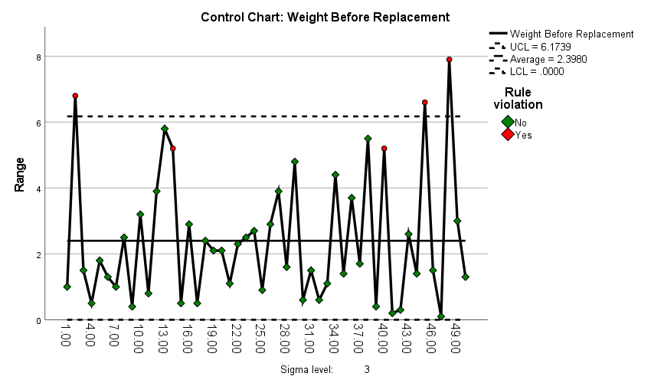
Figure 2. Range Chart for Weight Before Replacement

The outliers detected from the above R control chart are given in the following table –

Table 2. Rule Violations for Range
Unit | Violations for Points | Frequency
2, 45, 48 | Greater than +3 sigma | 3
14, 40 | 2 points out of the last 3 above +2 sigma | 2

The R (Range) chart of 50 observations measured in triplets shows that the process is not statistically controlled. Whereas the actual range is 8 (USL = 204, LSL = 196), the seen or observed range of the control chart is much less at 2.398, much lower than the anticipated range. This difference implies that there is limited variability which is inconsistent with the process limits.
Moreover, 5 points are breaching of the control rules which proves the existence of assignable causes that drive the process out of control. The assignable causes are the reason behind the observed variability in the ranges and denote that the process is not stable and predictable. There is need to undertake immediate corrective measures to establish and rectify the causes of this variation to put the process back on track.

  - Process Capability Index (Cp): Cp is the potential capability of the process that is used to measure the performance of the process in the event of the non-existence of assignable causes. The implication of the process capability index (Cp) are as following. When tolerance spread increases, the Cp also increases and this represents a more capable process. When Cp > 1, the process is capable, that is, variation is small, and defects are not theoretically possible. The process is just in specifications at Cp = 1, and defects are probable, particularly when the process is not centered. In cases where Cp < 1, the process becomes incapable because the variation is greater than a specification hence leading to defective units. Practically, the perfect centering is impossible and assignable causes cannot be absolutely neglected. The coefficients above 1 are desirable to maintain quality, where the coefficient of 1.33 is normally regarded to represent an appropriate coefficient to maintain an effective and consistent process in the production of the chili powder.
3.4. Process Capability Index (Cpk): It measures the process real capability. Cpk can be defined as a one sided process capability index (PCI) which is associated with the nearest process specification limit to the process mean. This index accounts for the centering or offset of the process, so Cpk measures both the process variation relative to the allowable specifications and the position of the process average.
An increased CPK value means less defects. With two sided specifications, Cp and Cpk are both applied in testing process capability. CPK specifically measures the distance of the process mean to the nearest specification limit against half the process spread. The Cpk and Cp will be equal when the process mean are centered. The meaning of Cpk is as follows: When Cpk is more than 1, then it indicates that the process is within the required specifications; when Cpk is less than 1, then it indicates that the process mean is not within the limits. A Cpk of 1 to 1.33 means that the process is slightly capable whereas a Cpk of 2 means that a process is highly capable. Practically, the industries usually aim at attaining a Cpk of 1.33 with an optimal value being 2.

Process capability (weight after replacement) has given the statistical measures (indices) as shown in the following table:
List 1 Process Statistics
Capability Indices | CP | 0.941
Capability Indices | CpL | 0.775
Capability Indices | CpU | 1.108
Capability Indices | CpK | 0.775

The Cp value measures the overall process capability, indicating how well the process can fit within the specified limits (LSL = 196, USL = 204). The Cp of 0.941 is implying that the actual process cannot always deliver results within the specification limits (the desired value is 1.33 and above). This implies that the process spread (variation) is too big in comparison to the specification range.

The process capability to the lower specification (LSL = 196) is measured as CpL (0.775). A CpL of less than 1.0 implies that there is greater chance of the process to generate values less than the lower limit therefore poor performance in this direction. CpU (1.108) evaluates the ability of the process to the upper specifications limit (USL = 204). The CpU of greater than 1.0 means that the process has better performance toward the upper limit, and the below performance will be less probable to generate values that surpass the upper limit. Combining these indices, the asymmetry in the process performance can be observed: the lower limit is worse than the upper limit.

The Cpk index takes into account the process mean and the variability which is the ability of the process to attain the lower and upper specification limits. A Cpk of 0.775 indicates that the process is not centered and is closer to violating the lower limit. Since Cpk is lower than 1.0, this confirms that the process is incapable of consistently meeting specifications.
Overall, the process capability indices suggest that the process is not capable of producing consistent results within the specified limits (196 to 204). The spread of the process variation exceeds the specification range, and there is a tendency for the process to drift towards the lower specification limit (LSL = 196), which is a concern. Improving the process performance will require reducing variability and re-centering the process mean closer to the midpoint of the specification range.

In the further process, we will construct the variable control charts for the wight of chilli powder after replacement.
The X - bar chart for 50 observations taken in the triplet form (for after replacement) is given below:

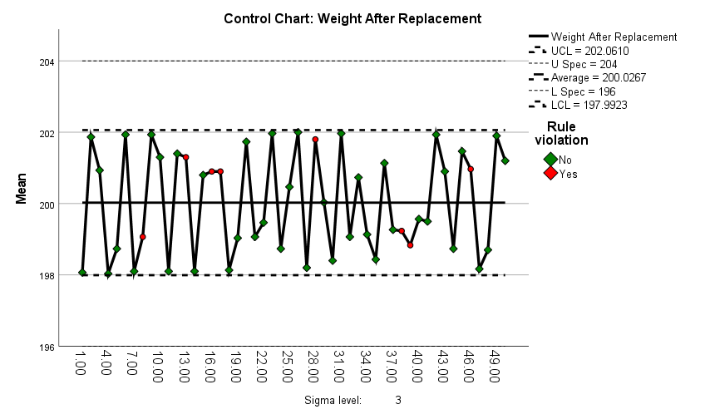
Figure 3. $\overline{\text{X}}$Chart for Weight After Replacement
The outliers observed from the above control chart are given in the following table –

Table 3. Rule Violations for X-bar
Unit | Violations for Points | Frequency
13, 16, 17, 46 | 4 points out of the last 5 above +1 sigma | 4
8,38, 39 | 4 points out of the last 5 below -1 sigma | 3
28 | 2 points out of the last 3 above +2 sigma | 1

The X-bar chart for 50 observations taken in triplet form after replacing the machine component shows significant improvement in process stability. Process average has increased up to 200.026 (it was 199.27 prior to replacement) and it has got nearer to the target mean.

Among the 50 observations, only 8 outliers are found, which is a significant decrease in the number of violations (38 before replacement). Notably, there are no violations on both sides of +3 sigma and -3 sigma, which means that the extreme deviations have been removed. The violations of the rules observed are:

4 instances where 4 out of the last 5 points are above +1 sigma.
3 instances where 4 out of the last 5 points are below -1 sigma.
1 instance where 2 out of the last 3 points are above +2 sigma.

The lack of extreme outliers and the decrease in the total violations proves that the variability of the processes is considerably decreased. It is now far more stable and is now even more like to be under statistical control. The fact that there is an improvement in the process average and consistency indicates the beneficial effect of changing the machine component. This better performance should be continued with further observation.

The R chart of 50 observations made in the triplet form (after replacement) is as shown below:
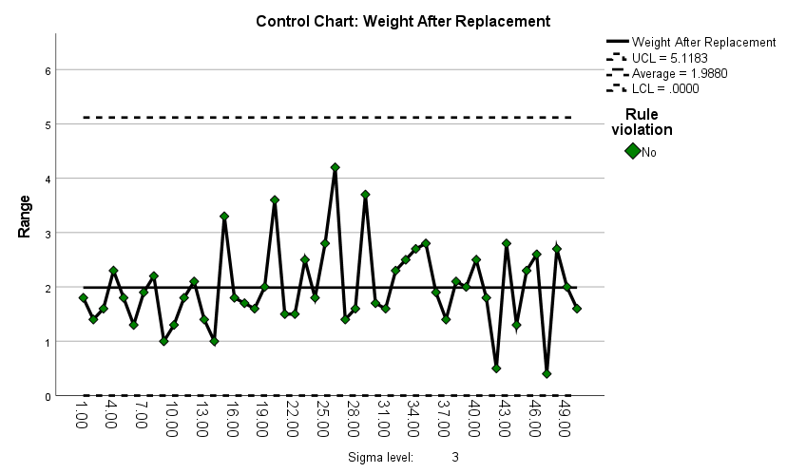
Figure 4. Range Chart for Weight After Replacement

The R (Range) chart of 50 observations made in triplet after changing the machine component indicates an evident enhancement of the process control. The observed range has decreased to 1.98 (previously this was 2.398, but it has been replaced), which is very low, compared to the actual range of 8 (USL = 204, LSL = 196).

It is important to mention that all points are not out of control, and there is no outlier in the range diagram. This implies that the variability in the process is also reduced further, and the process is now stable and under control. The lack of outliers and break of rules will demonstrate that the assignable causes of process instability are successfully removed. The increase in the range variability illustrates the beneficial effect of substituting the machine component, which results in a more predictable process that is also more uniform.

The table below presents the statistical values (process capability) of the process (weight after replacement):
List 2 Process Statistics
Capability Indices | CP | 1.135
Capability Indices | CpL | 1.143
Capability Indices | CpU | 1.128
Capability Indices | CpK | 1.128

The Cp value measures the overall process capability, indicating how well the process variation fits within the specification limits (LSL = 196, USL = 204). A Cp of 1.135 is greater than 1.0, suggesting that the process variability has improved and now fits more comfortably within the specification limits. However, it is still slightly below the industry benchmark of 1.33, which is often considered desirable for a capable process.

CpL (1.143) measures the process capability towards the lower specification limit (LSL = 196). A CpL greater than 1.0 indicates that the process performs well in avoiding values below the lower limit. CpU (1.128) measures the process capability towards the upper specification limit (USL = 204). A CpU greater than 1.0 shows that the process also performs well in avoiding values exceeding the upper limit. The closeness of CpL and CpU values indicates that the process is well-balanced, with no significant skewness or asymmetry towards either specification limit.

The Cpk index reflects the actual process capability, considering both the process mean and variability relative to the specification limits. A Cpk of 1.128 suggests that the process is capable and well-centered, with sufficient room to meet both lower and upper specification limits. While still slightly below the ideal value of 1.33, it demonstrates significant improvement compared to the previous state.

After replacing the machine component, the process capability has significantly improved. The indices (Cp, CpL, CpU, and Cpk) are all above 1.0, indicating that the process is capable of producing outputs consistently within the specification limits (LSL = 196, USL = 204). The process is now more balanced and stable, with reduced variability. To achieve the ideal benchmark of 1.33 or higher, further refinements may be needed, but overall, the replacement has resulted in a much more reliable and capable process.

- Conclusion
The overall conclusion for weight variation in chilli powder before and after replacement is as follows:

4.1. Comparison of mean and standard deviation for Before and After Replacement
While the mean weights of chili powder before (199.29) and after replacement (200.02) did not differ significantly (p = 0.093), the standard deviations showed a robust and statistically significant reduction (5.06 to 1.67), as confirmed by Levene's Test (p = 0.000). This indicates that the replacement improved process consistency by reducing variability, even though the mean weight remained stable.

  - Comparison of Control Charts Before and After Replacement
The comparison of the X-bar chart and Range chart before and after replacing the machine component highlights significant improvements in process stability and control.
X-bar Chart: Before replacement, the process average was 199.27, with 38 outliers, including extreme deviations beyond +3 sigma and -3 sigma, indicating substantial variation and the presence of assignable causes. After replacement, the process average improved to 200.026, with only 8 outliers and no violations for points beyond +3 sigma or -3 sigma, reflecting reduced variation and better process stability.
Range Chart: Before replacement, the observed range was 2.398, and 5 points violated control rules, confirming the presence of assignable causes and an unstable process. After replacement, the range further reduced to 1.98, with no violations of control rules and no outliers, demonstrating that the assignable causes were eliminated, and the process variability was minimized.

  - Comparison of Process Capability Before and After Replacement
The comparison of process capability indices before and after the replacement of the machine component shows a significant improvement in process performance. Before replacement, the process capability (Cp = 0.941, Cpk = 0.775) indicated excessive variability and poor control, with a higher risk of outputs falling below the lower specification limit (CpL = 0.775). After replacement, the overall process capability improved (Cp = 1.135, Cpk = 1.128), demonstrating reduced variability and better alignment with the specification limits (LSL = 196, USL = 204). Both CpL (1.143) and CpU (1.128) show the process is now balanced and well-controlled. While further refinements can be made to achieve the ideal benchmark of 1.33, the replacement has successfully made the process capable of consistently meeting specifications.
Finally, the replacement improved process control and reduced variance but introduced a situation of underfilling due to insufficient process capability and centering.

COMPETING INTERESTS DISCLAIMER:
Authors have declared that they have no known competing financial interests OR non-financial interests OR personal relationships that could have appeared to influence the work reported in this paper.
Disclaimer (Artificial intelligence)
Option 1:
Author(s) hereby declare that NO generative AI technologies such as Large Language Models (ChatGPT, COPILOT, etc.) and text-to-image generators have been used during the writing or editing of this manuscript.

- References
Ammaan, M., Panjavarnam, G., Sudha, R., Anuradha, P. (2024). An overview of packaging technologies for seed spices: a review. Plant Archives, 24 (2), 725-730.
FDA (2020). Good Manufacturing Practices for Food Processing. U.S. Food & Drug Administration.
Gidwani, B., Bhattacharya, R., Shukla, S.S., Pandey, R.K. (2022). Indian spices: past, present and future challenges as the engine for bio‐enhancement of drugs: impact of COVID‐19. Journal of the Science of Food and Agriculture, 102(8), pp.3065-3077.
Higgins, L. R., Mobley, R. K. (2015). Maintenance Engineering Handbook. McGraw-Hill Education.
Howell, D. C. (2013). Statistical Methods for Psychology (8th ed.). Cengage Learning.
Indiramma, A. R. (2004). Packaging aspects of spices and spice products. Plastics in food packaging. Mysore, India: Food Packaging Technology Department, Central Food Technological Research Institute.
ISO (2005). ISO 9001 Standards for Quality Control. International Organization for Standardization.
ISO(2018). ISO 22000 Standards for Food Safety Management Systems. International Organization for Standardization.
Kim, B., Song, J., Kim, J. Y., Hwang, J., & Park, D. (2019). The control of particle size distribution for fabricated alumina nanoparticles using a thermophoretic separator. Advanced Powder Technology, 30(10), 2094-2100.
Kumar, V., Raj, R., Verma, P., Garza-Reyes, J.A., Shah, B. (2024). Assessing risk and sustainability factors in spice supply chain management. Operations Management Research, 17(1),233-252.
Development Commissioner (MSME). (2020). Guidelines for the implementation of Lean Manufacturing Competitiveness Scheme under Credit Linked Capital Subsidy and Technology Up-gradation Scheme (CLCS-TUS):Operational guidelines [Version 3, 03 January 2020]. Ministry of Micro, Small and Medium Enterprises, Government of India. https://www.dcmsme.gov.in/schemes/clcs-tus/LEAN-Operational-Guidlelines.pdf
Levene, H. (1960). "Robust Tests for Equality of Variances." In Contributions to Probability and Statistics, edited by I. Olkinet al., 278–292. Stanford University Press.
Lins, B. F. (1993). Ferramentasbásicas da qualidade. Ciência da Informação, 22(2).
Martino, D. P., Drei, S. M. (2019). Using Control Charts X-Bar And R To Analyze The Quality Of A Restaurant At A Federal University. XXXIX Encontro Nacional De Engenharia De Producao.
Montgomery, D. C. (2007). Introduction to statistical quality control. John Wiley & Sons.
Partida, D. (2021, September 20). 6 trends in liquid filling.Packaging Technology Today.https://www.packagingtechtoday.com/machinery/6-trends-in-liquid-filling/
Pruthi, Y. S., Ramu, S. D., Jayaramen, A. (1962). Studies on the chemical composition and sortion isotherms of spices. Spice Rok, Nat’lecon, 10.
Espy, N., &Tomalino, R. (2024). Calibration of Weighing Instruments. Chemical Engineering, 131(3).
SILVEIRA, Cristiano Bertulucci. Cp e Cpk – Índices de capacidade de um processo. Citisystems, 2014. Disponívelem: Acessadoem 6 de fevereiro de 2019.
Siruguri, V., Bhat, R.V. (2015). Assessing intake of spices by pattern of spice use, frequency of consumption and portion size of spices consumed from routinely prepared dishes in southern India. Nutrition journal, 14, pp.1-9.
Smith, J., Jones, L. (2020). Manufacturing Practices.
Zhang, Y. Q., Hui, Y., Wang, Y., Zhang, B., Guo, B. L., Zhang, G. Q., & Wei, Y. M. (2020). Effects of drying temperature and relative humidity on quality properties of Chinese dried noodles. Journal of Food Quality, 2020(1), 8843974.
Bovi, G. G., Caleb, O. J., Klaus, E., Tintchev, F., Rauh, C., & Mahajan, P. V. (2018). Moisture absorption kinetics of FruitPad for packaging of fresh strawberry. Journal of Food Engineering, 223, 248-254.
D’Almeida, A. P., & de Albuquerque, T. L. (2024). Innovations in food packaging: from bio-based materials to smart packaging systems. Processes, 12(10), 2085.
Palanisamy, Y., Kadirvel, V., & Ganesan, N. D. (2025). Recent technological advances in food packaging: sensors, automation, and application. Sustainable Food Technology.
Klein, M., Werner, C., Tacker, M., & Apprich, S. (2024). Influence of packaging design on technical emptiability of dairy products and implications on sustainability through food waste reduction. Sustainability, 16(15), 6335.
Mateo, F., Vila-Francés, J., Soria-Olivas, E., Martínez-Sober, M., Gómez-Sanchis, J., & Serrano-López, A. J. (2025). Dynamic classifier auditing by unsupervised anomaly detection methods: an application in packaging industry predictive maintenance. Applied Sciences, 15(2), 882.

