Original Research Article

Effect of salt and glycol on ice crystal nucleation and growth during freezing

.
ABSTRACT

Water’s high specific and latent heat make it an effective coolant, though its high freezing point limits use in subzero applications. To solve this problem and change the properties of water; different antifreeze chemicals are added and their cooling performance was evaluated through experiments. The cooling characteristics of PG and NaCl aqueous ternary solution at different concentrations were analyzed. The result indicates that as salt concentration rose from 0 to 5% NaCl, the freezing point reduced to 2.5 ± 0.5°C. Addition of different solutes in RO water act as a nucleating agents and initiate the early freezing process resulting in lower degree of subcooling of solutions as compared to pure solvent. The lowest degree of subcooling (0.1°C) was observed in a solution containing 6% PG and 1% NaCl multi component blend (MCB). The results showed that salt reduced the degree of subcooling, while propylene glycol lowered ice adhesion and prevented ice crystal agglomeration. The results give critical understanding for developing effective coolants in industrial refrigeration, food preservation, and thermal energy storage systems.

Keywords: Cooling curve, Propylene glycol, degree of subcooling, Freezing point, Sodium chloride (NaCl)

1. INTRODUCTION

Water is an excellent cooling medium, but it is unsuitable for cooling application below 0°C due to its high freezing point [1]. It was experimented on water subcooling and observed that water remained subcooled for over 5 hours without initiating phase change [2]. Therefore, water is not suitable for use as a phase change material (PCM). For water to freeze, its molecular structure must shift from a liquid to a solid state, forming ice. A nucleation material is necessary to initiate phase change. Otherwise, water can remain supercooled [3]. Adding antifreeze to water lowers the freezing point, reduces supercooling, and acts as a nucleating agent [4]. A eutectic solution is formed when one or more solutes are combined with one or more solvents in specific proportions to achieve the lowest possible freezing point for the mixture. The eutectic point is the lowest freezing temperature of solution [5]. Several anti-freeze chemicals perform very well when used along with water as a solution. Each anti-freeze chemical has its benefits and disadvantages.
In accordance with the heterogeneous nucleation theory, the formation of a crystal nucleus initially occurs on the solid particle surface present in the parent phase [6]. This process effectively reduces the nucleation work required. Heterogeneous nucleation is widely accepted as the predominant form of nucleation. The salt particles act as nucleating agent and provide the way of heterogeneous nucleation, thereby reducing the time taken for freezing [7].
Cooling systems in industries typically use brines made of potassium carbonate (K₂CO₃) or calcium chloride (CaCl₂). These brines are good because they have useful thermal properties and are affordable. However, they can be unpredictable because they can corrode at temperatures below 0°C. Aqueous salt-water solutions like NaCl and KCl are also used as phase change materials (PCM) [8]. They have a low cost and a melting-freezing point below 0ºC. NaCl solutions are better because they have better thermal transport properties, stable with metals, and are cheaper and more readily available than KCl solutions for cooling. NaCl solutions have a lower degree of sub-cooling and a higher freezing point depression than other aqueous salt solutions, a 23.3% NaCl aqueous solution has a comparatively low freezing point of -21.1°C. This makes salt solution a reasonable choice for cooling systems [9].
It was investigated experimentally to improve coolant performance by examining the thermophysical specific heat capacity and freezing point of ethylene glycol (EG) and RO water mixtures at various concentrations [10].The experimental result shows that the specific heat of the mixture and freezing point decreases as the EG of the solution increases.It was determined that the ideal coolant concentration was 40% EG and 60% ultrapure water because the freezing point measured in this experiment was -45.97 ˚C.It was found that addition of water to the phase change material (PCM) improves the ability to retain cooling of cold storage unit [11].In cold storage units with 100% ethylene glycol (EG) PCM and without PCM, the cooling retention is extremely low. However, 50% water and 50% EG provide good cooling retention. According to previous study [12], the best cooling effect is achieved by a 20% concentration of propylene glycol (PG) solution; low concentration solutions (<20%) have an efficiency that is comparable to water, and high concentration solutions (>80%) have a worse efficiency because of their unfavorable latent heat and physical characteristics.
In the present study, different multi component blends (MCBs) were formulated by using the PG and sodium chloride (NaCl) at different concentrations in RO water. The effect of different concentration of PG and NaCl on freezing point, cooling rate, degree of subcooling, ice crystal nucleation and growth during freezing process were evaluated experimentally.

2. material and methods

Multi component blends (MCBs) was formulated using different concentration of PG (2, 4 and 6%) and NaCl (0, 1, 2, 3, 4 and 5%) in RO water (Table 1). The primary objective of MCB is to act as a PCM because it has a suitable phase change properties and can be used as a cold thermal energy storage material. PG was mixed with RO water at different concentration by volume and NaCl by weight to formulate MCBs. All the MCBs were kept in a temperature analyzing modules (TAMs) (Fig. 1) consisted of PT-100 temperature measuring sensors to analyze the temperature of MCBs during freezing process. All the temperature sensors were inserted to the data logging system (data logger) (Fig. 4) for continuously recording the temperature with 1 min time interval during freezing period. An experimental setup (Fig. 1) was developed to analyze the effect of glycol and salt on nucleation and growth of ice crystals during freezing process. Three replicates of each dataset were used to calculate the average values, and all parameters were statistically analyzed using the SPSS software. A two-way analysis of variance (ANOVA) was performed on the experimental data at a 95% confidence level (p < 0.05).

Table 1: Composition of multi component blends (MCBs)
Antifreeze chemicals | Concentration
Propylene glycol (PG) (vol. /vol.) | 2%, 4% and 6%
Sodium chloride (NaCl) (wt. /vol.) | 0, 1, 2, 3, 4, 5%

PT-100 Temperature sensor

Data
Logger

Temperatureanalyzing module

Deep fridge

Fig. 1: Schematic of experimental setup for analyzing freezing characteristics of MCBs

2.1 Freezing point determination

Freezing point of pure solvent is decreased when a solute is added to the solvent which is called freezing point depression; hence the solution has a lower freezing point as compared to solvent [13].

Freezing point of different MCBs was measured with the help of temperature profile of MCB during freezing. From the temperature profile during freezing (Fig. 2), different zones were identified viz., zone 1: sensible cooling up to a freezing point zone, 2: phase change zone, and 3: solid cooling. Freezing point of solution is the temperature at which segment 1 and 2 intersect [14]. Time intervals for each zone and freezing point were determined for different MCBs based on temperature profile during freezing or cooling curve.

Temperature
Time
Freezing Point

1
2
3
Fig. 2: temperature profile during freezing

2.2 Degree of subcooling of MCBs

Degree of subcooling of different MCBs was also determined based on the cooling curve. As mentioned in Fig. 3,cooling curves lowest temperature suggest the beginning of ice crystal development. After that due to release of latent heat of ice crystal formation the temperatures rise and the maximum temperature of cooling curve is called the freezing point, which is linked with the development of ice crystals [15]. The difference between the minimum temperature of cooling cure and freezing point is known as degree of subcooling [16].

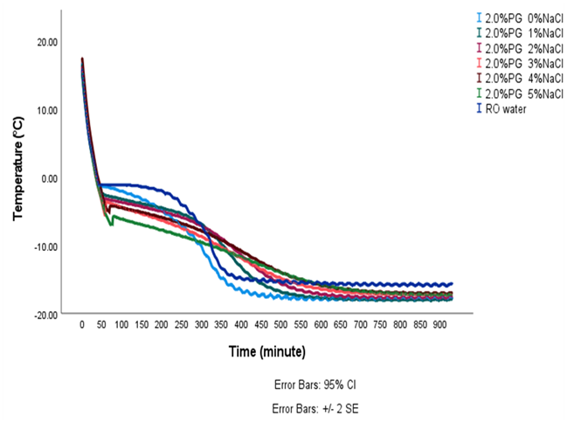
Fig. 3: Determination of degree of subcooling

2.3 Cooling rate of MCBs

Cooling rate is the ratio of temperature change to time [17]. It is calculated from the initial temperature (T₁) and final temperature (T₂) of MCB at every 1 minute time interval (t₂-t₁) from Data logger readings.
$$Cooling rate=\frac{T_{2}-T_{1}}{t_{2}-t_{1}}$$

2.4 Instrument used for the experiment

2.4.1 Temperature data logger
A temperature data logger is a device that is designed to record temperature over a specific period of time. It usually comprises a thermistor or other temperature sensor, a microprocessor, and memory to store the collected data. The data can then be uploaded to a computer for further scrutiny or utilized in real-time monitoring applications. The data logger Model CT708U, manufactured by Countron in UP, India was employed to record the temperature during the experiment. The temperature was detected using RTD (Resistance Temperature Detector) PT-100 sensors.

2.4.2 Temperature controller
A temperature controller is an instrument used to control the temperature of a system or process. It comprises a sensor that measures the temperature, a controller that compares the temperature with a set point, and an actuator that adjusts the temperature by regulating the flow of heat or coolant to the system. In the experiment, deep freezer was set at -15 °C, a temperature controller (Model: TC-513-BX, Selec, New Delhi, India) was used to maintain the desired temperature.

2.4.3Ultrasonic stirrer
In the present study, ultrasonic stirrer was used for effectively and efficiently mixing of PG and NaCl in RO water. High-frequency sound waves are used by ultrasonic stirrers to produce cavitations bubbles in the liquid. When these bubbles collapse, they cause intense molecular micro-mixing, leading to more consistent and effective mixing compared to traditional mechanical stirring.

3. results and discussion

3.1 Freezing point of MCBs
Freezing point of the formulated MCBs by using different concentration of propylene glycol (2, 4 and 6%) with NaCl (0, 1, 2, 3, 4 and 5%) is depicted in Fig. 4. The determination of the freezing point of MCBs was found to be useful based on the cooling curve using a four-step method [18]. The freezing point depression of MCBs was demonstrated to have a synergistic effect from PG and NaCl in the present study. Higher concentrations of propylene glycol (PG) and NaCl in MCBs resulted in a significant (P = .05) depression in the freezing point, consistent with the findings of [19]. The freezing point depression is determined by the colligative principles of thermodynamics when a small quantity is introduced to water. The freezing point depression in diluted ideal solutions of non-electrolytes is independent of the solute's characteristics and is directly correlated with the solute's molar concentration.

Freezing point depression (FPD) was highest (-6.593°C) for 6% PG with 5% NaCl MCB and lowest (-1.0°C) in 2% PG with 0% NaCl MCB. As salt concentration increased from 0% to 5% NaCl, the freezing point reduced to 2.5 ± 0.5°C and it was similar to the previous study [20].Raoult's law can be used to explain how the freezing point decreases as the concentration of salt particles increases [21]. Reportedly, cooling curve technique is known for its high accuracy and simplicity in determining the freezing point ([22], [23]). The cooling curve method was utilized to establish the freezing point and endpoint of freezing for tuna meat [24], abalone, and garlic [25].
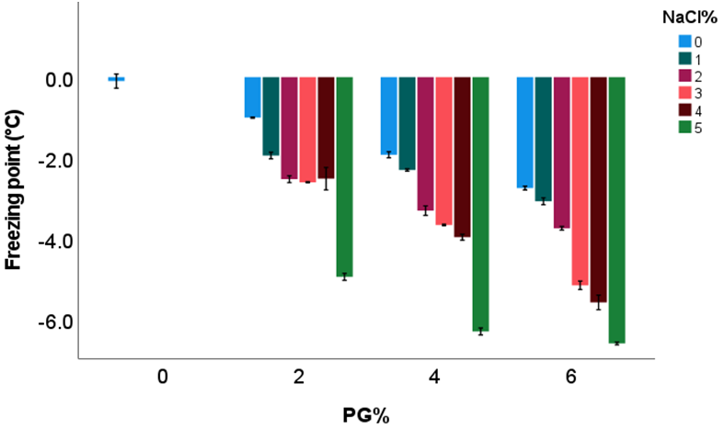
Fig. 4: Freezing point of MCBs at different concentration of PG (2, 4, and 6%) with NaCl (0, 1, 2, 3, 4, 5 %)

The molecular weight of PG and NaCl is 76.09 and 58.44 g/mol, respectively. NaCl can dissociate into two species, Na⁺ and Cl⁻ whereas PG cannot which makes NaCl almost twice as effective as PG for reducing the freezing point on a weight basis. By adding 20% of NaCl to water on wt basis, this behavior may be better understood and compared. This will decrease the freezing point of salt aqueous solution by 16.5°C, whereas a 20% (wt basis) ethylene glycol (EG) aqueous solution will decrease the freezing point by 8°C only [26]. According to previous study [27], to preserve refrigerated food at temperatures between 2 and 5°C, a cooling medium temperature around -5°C would be necessary.

The freezing point decreased from -5°C to -12.5°C as the PG concentration increased from 1:8 to 1:1 (PG: RO water) in the solution [5]. Compared to NaCl, 5% KCl has a lower freezing point depression of 2.32°C [28]. The freezing point decreases as the concentration of PG increases from 0 to 55%, and a concentration of PG above 60% causes the freezing temperature to rise. When 10%, 20%, and 30% propylene glycol and 10%, 20% glycerol are added to tap water, the phase change temperature can lower the water's freezing point from 0 °C to 4.5 °C, -12 °C, -17 °C, and -5 °C, -10 °C, respectively according to the T-history thermal study [29].

3.2 Degree of sub cooling of MCBs
To investigate the effect of NaCl and PG concentration on degree of subcooling, samples with different PG concentration (by volume) viz., 2, 4 and 6% with NaCl concentrations (by weight) viz., 0%, 1%, 2%, 3%, 4% and 5% were evaluated. The amount and properties of the solute determine the freezing point depression, subcooling temperature, and degree of subcooling. In each experiment used a 100 ml sample and the experimental conditions were kept same throughout.
The degree of subcooling significantly affects the freezing behavior of MCBs and can be monitored using a cooling curve occurring before the freezing point [30]. Efforts have been undertaken to achieve a higher temperature of nucleation to prevent degree of subcooling of water. It has been noted that samples containing NaCl concentrations of up to 2% facilitate early ice nucleation because salt particles serve as volumetric nucleation sites [21].
The addition of a low salt concentration not only leads to earlier nucleation but also decreases the latent heat of phase change. It was reported previously that salinity enhances the formation of ice crystal nuclei and growth, hence decreasing the degree of subcooling [31]. Addition of different solutes in RO water act as a nucleating agents and initiate the early freezing process resulting in lower degree of subcooling of solutions as compared to pure solvent. The lowest degree of subcooling (0.1°C) was observed in a solution containing 6% PG and 1% NaCl MCB (Fig. 5). PG easily forms hydrogen bond with water molecules, which disturbs the structured hydrogen-bond network of water. This disturbance reduces the energy barrier for ice nucleation, enabling ice formation to occur more readily at temperatures nearer to freezing point. Addition of 1% NaCl to MCB act as a volumetric nucleating agent. On the surface of small sized salt particles, ice crystals easily forms and start phase change.

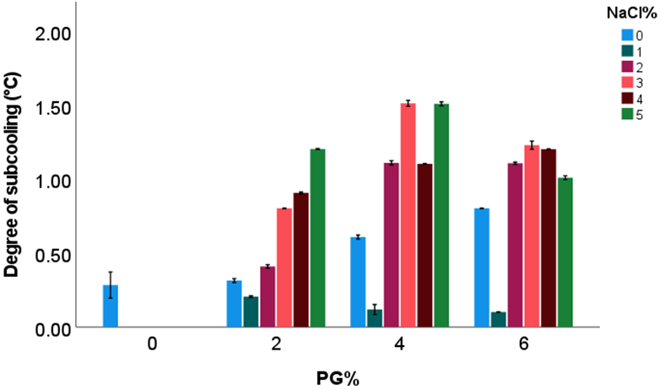
Fig. 5: Degree of subcooling of MCBs at different concentration of PG (2, 4, and 6%) with NaCl (0, 1, 2, 3, 4, and 5 %)

According to previous study, when the concentration of carbon nanotubes (CNTs) in aqueous solutions raised from 50 to 2000 ppm, the degree of subcooling and the amount of time that energy is stored decrease. For the CNTs nanofluid of less than 8 nm diameter and 10-30 μm length at 500 ppm, a maximum reduction of 47.3% in degree of subcooling and 17.8% in charging speed advance was attained in comparison to the deionized water [32]. The findings indicate that a minimum nucleation free energy corresponds to a minimum degree of subcooling. In the present study, salt particles acted as a nano particles and reduce the degree of subcooling. Nucleating agents are required to decrease the causes of subcooling of water. Mulawarman et al. [29]Investigated the solution or mixture's ability to remove the degree of subcooling and decrease the freezing point of water compared to pure solvent. They also reported that a mixture of specific antifreeze chemicals has great potential for low-temperature latent heat thermal energy storage (LHTES) to be used in refrigeration systems.

3.3 Cooling rate of MCBs during freezing
The cooling rate of formulated MCBs by using different concentrations of PG (2, 4, and 6%) and NaCl (0, 1, 2, 3, 4, and 5%) during freezing was graphically depicted in fig. 6. Cooling rate of MCBs was changed significantly concerning different concentration of PG and NaCl and time at 95% confidence level (P = .05). The cooling rate of MCBs was high during the first 150 minutes of freezing because sensible cooling was taking place. After that, during the phase transition zone, the rate of cooling decreased because temperature remained almost constant or decreased at a very low rate during ice formation, and only latent heat was released. According to previous experiment [33], adding PG to an aqueous solution may be a useful strategy to mitigate the negative effects of subzero cooling with liquid water, including decreasing the freezing point, increasing the boiling point, reducing temperature fluctuation, and enhancing cooling uniformity. At the beginning of the freezing process, because of the low specific heat of PG and the higher thermal conductivity of NaCl, the cooling rate of MCBs is higher than that of RO water.
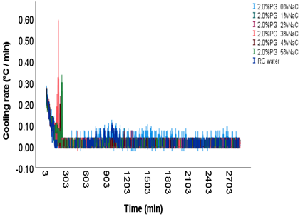 | 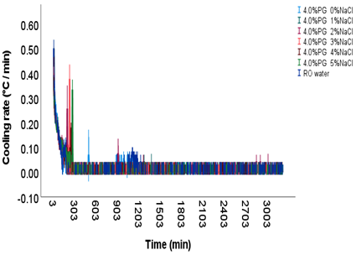
(a) | (b)
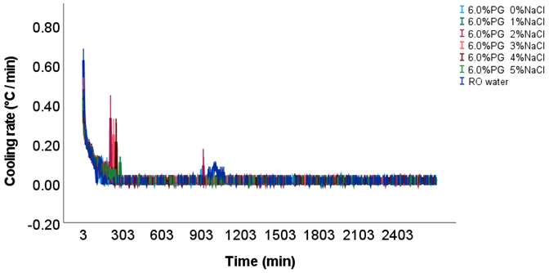
(c)
Fig. 6: Cooling rate of MCBs at different concentration of PG (a) 2% PG (b) 4% PG and (c) 6% PG with NaCl concentration of 0, 1, 2, 3, 4, and 5 %

3.4 Effect of PG and NaCl on ice crystals nucleation and growth
Effect of PG and NaCl on ice crystal nucleation and growth is shown in fig. 7. It was observed that by using PG and NaCl in MCBs caused a reduction in the size of ice crystals. It was very small, uniform in nature, globular in shape and surface is also very smooth. During the freezing process, as ice crystals formed, a high concentration of PG layer formed surrounding the ice crystals and decreased the local freezing point. PG also reduced the ice adhesion force and decreased the agglomeration of ice crystals and cluster formation. Without using PG and NaCl, in pure RO water, it was observed that sizes of ice crystals was very large and were not uniform in shape (Fig. 8). Agglomeration of ice crystals was very high owing to the strong ice adhesion force and formed large ice cubes. It was experimented by Muthukumar and Lakshmi [21] that a 1% increase in salt concentration raised the distilled water's nucleation temperature from -8.2 °C to roughly -1.8 °C. However, higher salt concentration of above 2 % (investigated up to 5%) decreased the nucleation tendency. It was also reported that by providing the indents (roughness) on the surface of experimental setup will significantly enhance the nucleation temperature. Mulawarman et al. [29] found that water possesses excellent thermal properties but exhibits significant degree of subcooling. Phase change materials (PCMs) with high degree of subcooling can lower system performance. To address this, water should be cooled below 0°C and nucleation agents should be introduced to eliminate supercooling and promote faster freezing. Their results indicated that water solutions containing glycerol and PG are suitable as PCMs for cold thermal energy storage applications.
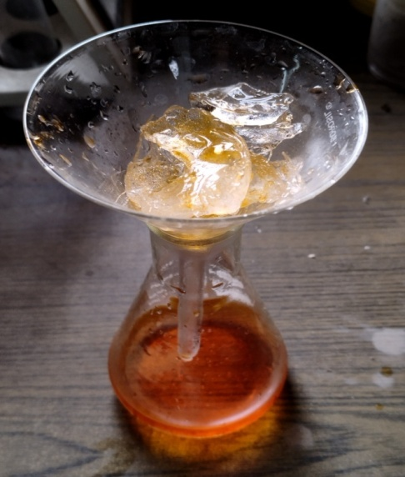 | 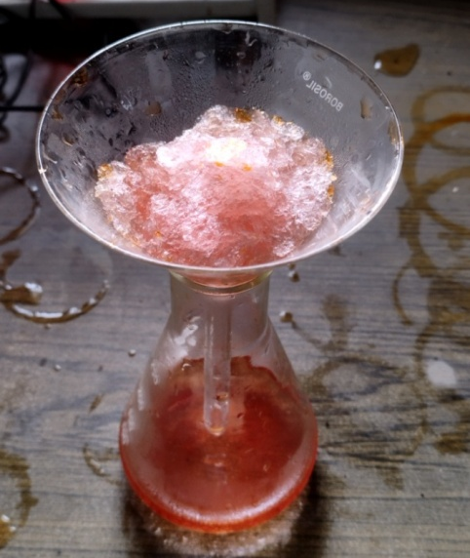
(a) | (b)
Fig. 7: (a) Size of ice crystals in pure RO water, (b) Size of ice crystals in MCBs
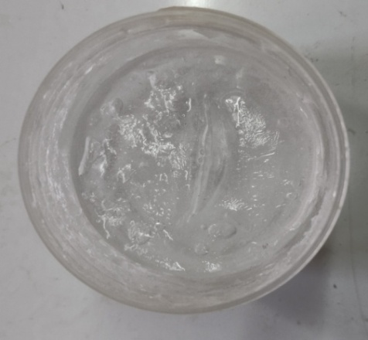 | 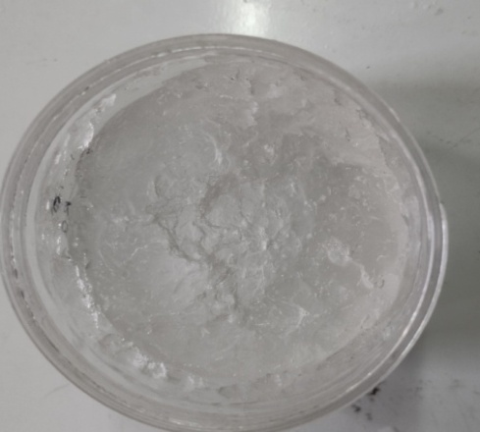
(a) | (b)
Fig. 8: (a) Freezing of pure RO water, (b) Freezing of MCBs

4. Conclusion

In the present study, freezing point, degree of subcooling, cooling rate and effect of PG and salt on ice crystal nucleation and growth were investigated experimentally. The salient findings that can be drawn from this experiment are as follows:As salt concentration increased from 0 to 5% NaCl, the freezing point decreased to 2.5 ± 0.5°C.Addition of different solutes in RO water act as a nucleating agents and initiate the early freezing process resulting in lower degree of subcooling of solutions as compared to pure solvent. The lowest degree of subcooling (0.1°C) was observed in a solution containing 6% PG and 1% NaCl MCB.In the present study, salt particles acted as nanoparticles and reduce the degree of subcooling.PG also reduced the ice adhesion force and decreased the agglomeration of ice crystals and cluster formation. The developed MCBs can be used as cooling medium in sustainable refrigeration systems, cryogenic preservation, antifreeze formulation, subzero cooling systems and energy-efficient cold storage applications.

References

- Rohit H K, Chitrnayak, Minz P S, Dabas J K and Ray A. 2023. Characterization of multi-component antifreeze liquids for sub-zero cooling applications. Journal of AgriSearch 10(4):259-265
- Shamseddine, I., Pennec, F., Biwole, P., &Fardoun, F. (2022). Supercooling of phase change materials: A review. Renewable and Sustainable Energy Reviews, 158, 112172.
- Safari, A., Saidur, R., Sulaiman, F. A., Xu, Y., & Dong, J. (2017). A review on supercooling of Phase Change Materials in thermal energy storage systems. Renewable and Sustainable Energy Reviews, 70, 905-919.
- Maeda, N. (2021). Brief overview of ice nucleation. Molecules, 26(2), 392.
- Rohit, H., Chitranayak, P. M., Dabas, J., &Kumari, K. (2022). Estimation of Freezing Point of Ternary Coolant Mixture. Material Science Research India, 19(3).
- Knopf, D. A., & Koop, T. (2006). Heterogeneous nucleation of ice on surrogates of mineral dust. Journal of Geophysical Research: Atmospheres, 111(D12).
- Liu, S., Li, H., Song, M., Dai, B., & Sun, Z. (2018). Impacts on the solidification of water on plate surface for cold energy storage using ice slurry. Applied energy, 227, 284-293.
- Lu, W., Liu, G., Xing, X., & Wang, H. (2019). Investigation on ternary salt-water solutions as phase change materials for cold storage. Energy Procedia, 158, 5020-5025.
- Xiao, Z., Lai, Y., & Zhang, J. (2021). Method for calculating the liquid water fraction of saline soil during the freezing process. Permafrost and Periglacial Processes, 32(1), 92-101.
- AzmiRoslan, A. M., Tukiman, N., Ibrahim, N. N., &Juanil, A. R. (2017). The effects of ethylene glycol to ultrapure water on its specific heat capacity and freezing point. J. Appl. Environ. Biol. Sci, 7(7S), 54-60.
- Gupta, K. K., &Ramachandran, M. (2018, June). Effect of Ethylene glycol as Phase Change Material in a Cold Storage Unit on retention of cooling. In IOP Conference Series: Materials Science and Engineering (Vol. 377, No. 1, p. 012190). IOP Publishing.
- He, F., Xie, S., He, C., & Zhao, Y. (2025). Phase change transpiration cooling of propylene glycol solution considering pyrolysis. Physics of Fluids, 37(9).
- Yilmaz, S., Sheth, F., Martorell, I., Paksoy, H. O., &Cabeza, L. F. (2010). Salt-water solutions as PCM for cooling applications. In Proceedings of EuroSun.
- Ribero, G. G., Rubiolo, A. C., &Zorrilla, S. E. (2007). Influence of immersion freezing in NaCl solutions and of frozen storage on the viscoelastic behavior of Mozzarella cheese. Journal of food science, 72(5), E301-C307.
- Bainy, E. M., Corazza, M. L., &Lenzi, M. K. (2015). Measurement of freezing point of tilapia fish burger using differential scanning calorimetry (DSC) and cooling curve method. Journal of Food Engineering, 161, 82-86.
- Wang, H., Feng, R., Duan, H., & Chen, A. (2016). Study on sub-cooler based on the characteristics of the super-hydrophobic surface. Experimental Thermal and Fluid Science, 76, 205-210.
- Hosseini, V. A., Shabestari, S. G., &Gholizadeh, R. (2013). Study on the effect of cooling rate on the solidification parameters, microstructure, and mechanical properties of LM13 alloy using cooling curve thermal analysis technique. Materials & Design, 50, 7-14.
- Rohit, H. K., Minz, P. S., Dabas, J. K., Sain, M., &Kumari, K. (2023). Determination of cooling characteristics of multicomponent phase change coolant. Current Advances in Agricultural Sciences, 15(2), 180-185.
- Prakash, R., Manjunatha, M., Kumar, M., &Ravindra, M. R. (2018). Sub-zero temperature profile and chilling energy storage behaviour of aqua-glycol eutectics for milk cold chain. Journal of Pharmacognosy and Phytochemistry, 7(2), 3358-3362.
- Stefl, B. A., & George, K. F. (2000). Antifreezes and deicing fluids. Kirk‐OthmerEncyclopedia of Chemical Technology.
- Muthukumar, P., & Lakshmi, D. V. N. (2017). Nucleation enhancement studies on aqueous salt solutions. Energy Procedia, 109, 174-180.
- Marini, G. A., Bainy, E. M., Lenzi, M. K., &Corazza, M. L. (2014). Freezing and thawing of processed meat in an industrial freezing tunnel. ActaScientiarum. Technology, 36(2), 361-368.
- Seetapan, N., Limparyoon, N., Gamonpilas, C., Methacanon, P., &Fuongfuchat, A. (2015). Effect of cryogenic freezing on textural properties and microstructure of rice flour/tapioca starch blend gel. Journal of Food Engineering, 151, 51-59.
- Rahman, M. S., Kasapis, S., Guizani, N., & Al-Amri, O. S. (2003). State diagram of tuna meat: freezing curve and glass transition. Journal of Food Engineering, 57(4), 321-326.
- Rahman, M. S., Sablani, S. S., Al‐Habsi, N., Al‐Maskri, S., & Al‐Belushi, R. (2005). State diagram of freeze‐dried garlic powder by differential scanning calorimetry and cooling curve methods. Journal of Food Science, 70(2), E135-E141.
- Woods, E. J., Zieger, M. A., Gao, D. Y., &Critser, J. K. (1999). Equations for obtaining melting points for the ternary system ethylene glycol/sodium chloride/water and their application to cryopreservation. Cryobiology, 38(4), 403-407.
- Guilpart, J., Stamatiou, E., Delahaye, A., &Fournaison, L. (2006). Comparison of the performance of different ice slurry types depending on the application temperature. International Journal of Refrigeration, 29(5), 781-788.
- Lide, D. R. (Ed.). (2004). CRC Handbook of Chemistry and Physics (Vol. 85). CRC press.
- Mulawarman, A. A. N. B., Rasta, I. M., &Sunu, P. W. (2018, October). Characterization and Experimental Investigation of Glycerol and Propylene glycol in Water Solutions for cool Thermal Energy Storage. In 2018 International Conference on Applied Science and Technology (iCAST) (pp. 732-734). IEEE.
- Rahman, M. S., Guizani, N., Al-Khaseibi, M., Al-Hinai, S. A., Al-Maskri, S. S., & Al-Hamhami, K. (2002). Analysis of cooling curve to determine the end point of freezing. Food Hydrocolloids, 16(6), 653-659.
- Li, K., Wang, C., Wu, Y., Lin, Z., Ren, J., Gao, J., & Li, S. (2024). Study on the supercooling and crystallization mechanism of saline soil based on thermodynamic framework. Journal of Hydrology, 628, 130451.
- Xing, M., Zhang, H., Chen, H., & Wang, R. (2022). Solidification characteristic enhancement of aqueous nanofluid with different carbon nanotube sizes. International Communications in Heat and Mass Transfer, 131, 105880.
- He, F., Wu, N., Zhou, Z., & Wang, J. (2021). Experimental investigation on transpiration cooling using propylene glycol aqueous solution. International Journal of Thermal Sciences, 164, 106890.

