Original Research Article

Barriers for Smallholder Dairy Farmers of North Kerala: A Constraint Analysis

ABSTRACT
In India, where approximately 89.4 per cent of farmers own less than two hectares of land, understanding their livelihood security is vital for formulating strategies to enhance their quality of life. This study focused on constraints affecting dairy farming livelihoods among smallholder mixed farmers in North Kerala, who primarily cultivate coconut along with banana, fodder, vegetables, and arecanut as subsidiary crops. A total of 200 farmers, each owning up to two hectares of land and rearing one to three milch cattle, were purposively selected for the study. The selection focused on regions with the highest concentration of milch cattle in North Kerala. Based on the National Livestock Census (2019), two blocks each were selected from Kozhikode (Perambra and Kunnummal) and Kannur (Thaliparamba and Peravoor) districts.
The study employed the Garrett ranking technique to identify and prioritize the major factors influencing farmers’ livelihoods. The Garrett ranking technique was applied to the primary data collected through structured interviews, where farmers openly shared the main challenges affecting their livelihoods.The results revealed that high feed and labour costs, low milk prices, and inadequate institutional support were the most critical challenges faced by farmers. Addressing these issues through effective policies and targeted support programmes could enhance the profitability and sustainability of farming systems. The study’s findings can help policymakers and development agencies craft practical, evidence-based solutions to strengthen smallholder dairy farming and build more resilient rural livelihoods.

Keywords: Small holder farmers; constraints; livelihood security; marginal farmers; Garrett ranking
1. INRODUCTION
Crop–livestock farming systems constitute the backbone of smallholder agriculture across developing nations, providing an integrated approach to food production, income generation, and resource utilization (Innazent et al., 2022). Livestock occupies a pivotal position in India’s farming systems and rural livelihoods. Farmers across the country rear a wide variety of animals such as cattle, buffalo, sheep, goats, and poultry, which supply essential products including milk, meat, and wool. These products not only meet household consumption needs but also enhance India’s growing export potential (Sabareeswaran et al., 2025). The dairy sector serves as a vital and promising component of Indian agriculture. India continues to lead the world in milk production, with an output of 230.58 million tonnes in 2022–23, representing nearly one-fourth of global milk production (NDDB, 2023).
Agricultural development remains central to India’s economic progress, with the dairy sector playing a particularly significant role. It ensures a steady supply of affordable and nutritious food to a large section of the population, while simultaneously generating substantial employment opportunities in rural areas (Veerakumaran, 2022). According to the Agricultural Census (2021–22), nearly 86 per cent of operational landholdings in India belong to small and marginal farmers. Given their numerical dominance, understanding the livelihood challenges faced by these farmers is critical to designing effective interventions that enhance productivity and income stability.
Small and marginal farmers encounter numerous constraints that limit their economic resilience. These include restricted access to credit and insurance, vulnerability to climate variability, and weak bargaining power in agricultural markets. Additionally, inadequate transport facilities, low and fluctuating farmgate prices, and dependence on unorganized traditional markets further undermine their profitability and livelihood security (Induja et al., 2024). Many developing countries are simultaneously striving to meet the rising food demand from increasingly affluent consumers and to alleviate rural poverty. To achieve this, several initiatives aim to strengthen smallholder participation in market-oriented activities, thereby enhancing household income and overall livelihood security (Bosire et al., 2019).
In India, mixed farming—integrating crop cultivation with animal husbandry—has long been practiced as a strategy to optimize the use of available resources and to stabilize farm incomes. Livestock contribute significantly to such systems by converting crop residues into valuable animal products, enriching soil fertility through organic manure, and facilitating more efficient utilization of household labour throughout the agricultural cycle (Shrey et al., 2015). In North Kerala, dairy farming is mostly carried out by small and marginal farmers who see it as a steady side income alongside their crop cultivation. It not only brings regular cash flow but also ensures better nutrition for their families, especially when farming is hit by seasonal or market ups and downs. Cooperatives like MILMA have become a lifeline by helping farmers collect and market their milk efficiently. Yet, many still struggle with rising feed costs, limited access to veterinary care, and low profits that make it hard to sustain their livelihoods.
Against this background, it becomes imperative to assess the constraints faced by smallholder mixed farmers in sustaining their crop–livestock systems. A comprehensive understanding of these challenges is essential for formulating evidence-based strategies that enhance productivity, ensure livelihood security, and promote sustainable agricultural growth. Accordingly, the present study was undertaken to analyze the major constraints associated with crop–livestock mixed farming in North Kerala, with the objective of understanding their implications for smallholder livelihoods and identifying pathways to strengthen their sustainability and well-being.
2. METHODOLOGY
2.1 STUDY AREA
This study was conducted in North Kerala, focusing on the districts of Kannur and Kozhikode, which host the region’s highest concentrations of smallholder dairy cattle, as reported by the National Livestock Census (2019) (DAHD, 2019). Within these districts, the blocks of Thaliparamba and Peravoor in Kannur, and Perambra and Kunnummal in Kozhikode were selected for the study.
Figure 1. Kannur district block map
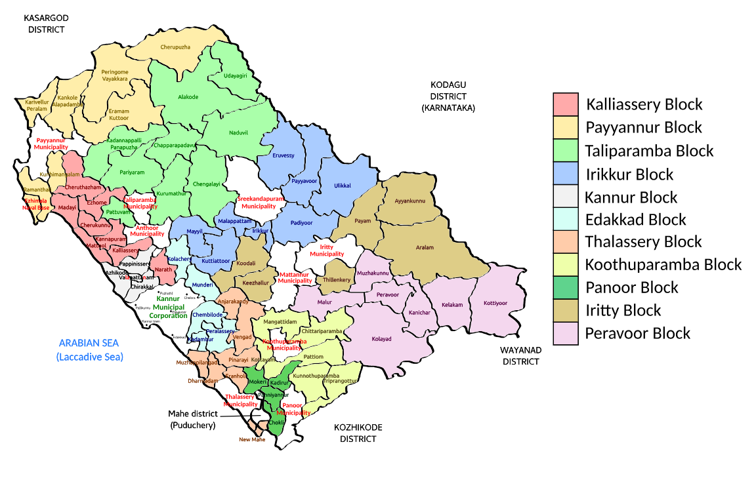
Table 1. Cattle population in Kannur district as per the National Livestock Census (2019)
Sl.no | Block panchayath | Number of cattle
1 | Edakkad | 295
2 | Irikkur | 1002
3 | Iritty | 1142
4 | Kallissery | 438
5 | Kannur | 147
6 | Koothuparambhu | 620
7 | Panoor | 174
8 | Payyannur | 1172
9 | Peravur | 1236
10 | Thaliparambhu | 1598
11 | Thalassery | 334

Figure 2. Kozhikode district block map

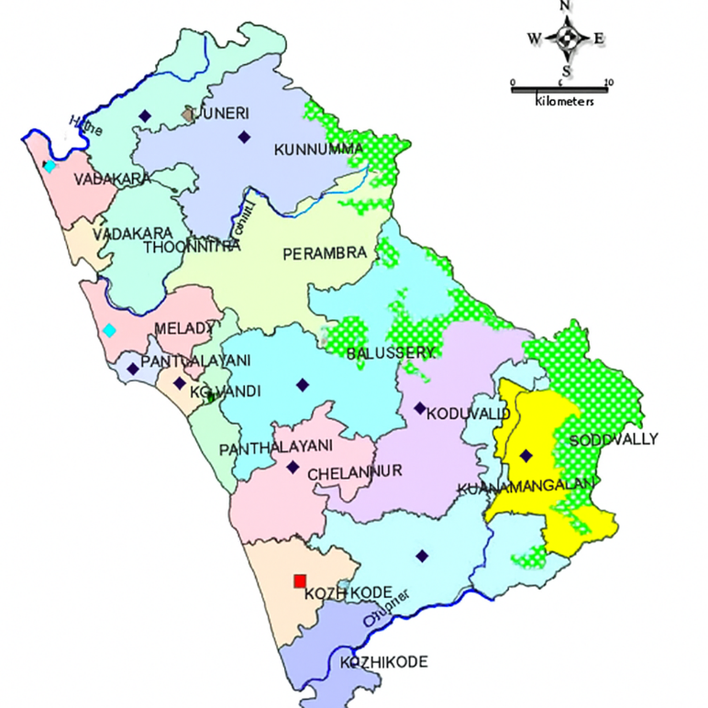
KUNNUMMAL BLOCK
PERAMBRA BLOCK
Table 2. Cattle population in Kozhikode district as per the National Livestock Census (2019)
Sl.no | Block panchayath | Number of cattle
1 | Balussery | 1021
2 | Chelannur | 522
3 | Koduvally | 981
4 | Kozhikode | 190
5 | Kunnamangalam | 899
6 | Kunnummal | 1467
7 | Meladi | 286
8 | Panthalayani | 471
9 | Perambra | 1137
10 | Thodannur | 638
11 | Tuneri | 801
12 | Vadakara | 149

These areas showcase the region’s typical mixed farming systems, where small-scale dairy activities are seamlessly combined with diverse crop cultivation, reflecting the resilient and resourceful nature of local farmers. In this region, smallholder farmers primarily rear crossbred cattle, which are a mix of indigenous and exotic breeds such as Jersey, Brown Swiss, and Holstein Friesian, chosen for their higher milk production. These crossbred cows usually provide 7 to 15 liters of milk per day, offering a steady source of income and nutrition for farming families. Alongside them, a few indigenous breeds, including the native Vechur cow, are also kept, producing around 3 liters of milk daily, depending on the quality of feed and care they receive. Together, these animals form the backbone of local dairy farming, supporting both livelihoods and household food security in a sustainable, mixed-farming system.
2.2 STUDY POPULATION
From each selected block, fifty smallholder farmers were carefully chosen, bringing the total number of participants to two hundred. Each farmer managed one to three milch cattle and cultivated up to two hectares of land, with coconut as the primary crop, complemented by banana, green fodder, homestead vegetables, and arecanut, showcasing the rich diversity of local farming systems. Primary data were gathered through a well-structured and pretested interview schedule to ensure reliable and consistent responses. Before conducting the main survey in April–May 2025, a pilot study was carried out to refine the questionnaire, confirm its clarity, and gain early insights into the challenges these farmers face in their daily livelihoods.
2.3 GARRETT’S RANKING TECHNIQUE
In this study, Garrett’s ranking technique was employed to identify and prioritize the major constraints experienced by smallholder mixed farmers in North Kerala, providing a systematic understanding of the challenges affecting their farming practices. Using a well-structured questionnaire, data were collected from all 200 farmers to identify the major issues they faced. The questionnaire primarily focused on assessing the livelihood security of smallholder mixed farmers through multiple dimensions, including food, economic, social, and ecological security, by evaluating specific indicators under each category. It covered aspects such as family food sufficiency, income stability, access to healthcare and institutional support, market connectivity, education, soil and water conservation, and climate resilience. Data were recorded digitally and organized using Microsoft Excel, which facilitated accurate processing, management, and analysis of the information collected.
The selected farmers were asked to rank the identified constraints based on their level of severity. The percentage position for each constraint, derived from these rankings, was then calculated and subsequently converted into scores using the formula and conversion tables developed by Garrett and Woodworth (Logeshwari et al., 2024). Following Garrett’s Ranking Technique, these rankings were systematically transformed into numerical scores to quantify and prioritize the constraints, allowing the relative importance of each issue to be compared across respondents (Raj and Ramachandra, 2022; Shanjeevika et al., 2022). This approach enabled the identification of the most critical issues in the study area. A similar study was carried out by Prabha et al. (2024), which also highlighted the challenges faced by farmers and emphasized the need for better support systems. To systematically quantify the participants’ rankings, they were first converted into percentage positions using the following formula
Percentage position = 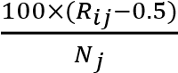
Rij = Rank assigned to the ith factor by the jth respondent.
N_{j} = Number of factors ranked by j^{th} individual
The calculated percentage positions were subsequently converted into scores based on the table proposed by Garrett and Woodworth, (1979). The mean score for each constraint was calculated by summing the individual scores provided by all respondents and dividing the total by the number of participants.
Mean Score for Factor i = Sum of Garrett Scores for Factor i​
Number of respondents
Subsequently, the constraints were ranked in descending order of their mean scores to identify the most critical issues.
Table 3. Ranking of farmers’ constraints based on the Garrett ranking technique.
Sl.  No. | Constraint | Garrett’s score | Garrett’s Ranking
1 | High cost of feed | 78.59 | I
2 | Low milk price | 69.99 | II
3 | High labour costs | 67.16 | III
4  5  6  7  8  9  10  11 | Labour scarcity  Price Fluctuation in crops  High cost of veterinary services/medicine  Lack of institutional support  Insurance  Wild animal intrusion  Disease and pest attack (crops)  Problem due to wind and irregular monsoon | 59.54  57  53.83  44.67  38.63  32.48  28.23  24.16 | IV  V  VI  VII  VIII  XI  X  XI
3. RESULT AND DISCUSSION
The constraints affecting farmers’ livelihoods were analyzed using the Garrett ranking technique to identify and prioritize the main challenges they faced. The results showed that the high cost of feed (Garrett’s score = 78.59, Rank I) was considered the most serious problem by the farmers. The continuous increase in feed prices substantially elevates production costs, leading to reduced profit margins and limiting farmers’ capacity and motivation to expand their livestock enterprises. According to the study conducted by Rajadurai et al. (2022) in Tamilnadu, Farmers faced several challenges in feed management, including the high and fluctuating cost of concentrate feeds, the lack of accessible grazing land, and the shortage of green fodder throughout the year. Similar results were reported in the study by Shrey et al. (2015), which found that the major constraints faced by dairy farmers rearing crossbred cows included the low price of milk, high cost of feed and fodder, and the lack of organized markets for selling their produce.
The low price of milk (69.99, Rank II) was identified as the second major challenge. Although the costs of inputs continue to rise, the income farmers receive from milk sales remains relatively low, creating a clear imbalance between production costs and earnings. This imbalance undermines the financial stability and long term sustainability of dairy farming operations. The high cost of labour (67.16, Rank III) and labour scarcity (59.54, Rank IV) were also identified as major challenges by the farmers. Many agricultural activities require intensive manual work, which has become increasingly costly in recent years. This rise in labour expenses is largely linked to rural outmigration, as many workers move to urban areas in search of better opportunities. Consequently, the shortage of skilled farmworkers has added further strain to farming operations, affecting both productivity and efficiency.
Another important constraint identified was the price fluctuation in crops (57.00, Rank V), particularly in coconut, which served as the main crop in this study. Frequent and unpredictable changes in market prices make it challenging for farmers to plan production and maintain stable income levels. This issue is also reflected in the challenges faced by farmers in the southern coastal plains of Kerala, as noted by Innazent et al. (2022). Similar findings were reported by Induja et al. (2024), who noted that farmers often struggle with a lack of proper market information. They also identified low prices for their produce, high transportation costs, and insufficient marketing or advertisement as major challenges limiting their ability to earn fair returns from their products. The farmers of Kallakurichi district in Tamil Nadu identified several health related challenges, including the high cost of veterinary services, reproductive disorders, and the lack of timely and accessible veterinary care. These issues make it difficult for farmers to maintain the health and productivity of their animals (Rajadurai et al., 2022).
The high cost of veterinary medicines (53.83, Rank VI) was also a serious concern, as many farmers found it difficult to afford these treatments during disease outbreaks. The lack of institutional support (44.67, Rank VII) was a major concern, as many farmers reported limited help from government and cooperative agencies. This made it difficult for them to access credit, technical advice, and marketing support. According to the study conducted by Rajadurai et al. (2022) in Tamilnadu, Farmers also reported financial constraints such as limited access to loans, low milk prices, and the unavailability of credit facilities from government institutions, which hindered their ability to invest in and sustain their farming activities. Such financial challenges hinder timely animal care, increasing the risk of livestock losses and reduced farm productivity. Limited access to insurance (38.63, Rank VIII) leaves farmers vulnerable to losses from crop failures and livestock diseases, as many are either unaware of existing schemes or find them difficult to access. Similar observations were reported by Induja et al. (2024), who noted that inadequate animal insurance facilities and limited awareness of credit options were perceived by farmers as less severe challenges, highlighting the need for more practical and accessible support systems. According to Rajashekhar et al. (2023), farmers identified the absence of a subsidized livestock insurance policy from the government as a major constraint. In the northern districts of Kerala the government helps protect cattle from major illnesses such as Foot and Mouth Disease and Brucellosis through regular vaccinations carried out by the Directorate of Animal Husbandry. Since cattle rearing involves significant risks such as death or incurable diseases, farmers emphasized the need for affordable insurance support to help them recover from potential financial losses.
Many regions across the country experience recurring natural calamities such as floods, heavy rainfall, or droughts almost every year, which continue to disrupt agricultural activities and rural livelihoods (Shrey et al., 2015). One of the major challenges faced by dairy farmers was their limited knowledge about how to prepare for natural disasters to protect their livestock. This was mainly because, even though the area is frequently affected by floods, very little effort has been made to train or build the farmers’ capacity for disaster preparedness (Gautam and Jha, 2022). Environmental challenges such as wild animal intrusion (32.48, Rank IX), disease and pest attacks on crops (28.23, Rank X), and problem due to wind and irregular monsoons (24.16, Rank XI) were found to be less frequent but still posed notable difficulties for farmers. Although these problems occurred less often than economic constraints, they continued to disrupt farming activities and reduce yields. These findings highlight that environmental factors, while secondary, still play a significant role in affecting farm productivity and livelihood stability in North Kerala.
4. CONCLUSION
The analysis of constraints using the Garrett ranking technique shows that smallholder farmers in North Kerala face economic, institutional, and environmental challenges that collectively influence their livelihood security. Among these, the high cost of feed emerged as the most critical problem, reducing production efficiency and profitability. Smallholder farmers are unable to meet the high cost of feed, even though subsidies are available from cooperatives, which are not enough to meet the farmers’ requirements. The low price of milk further deepens financial stress, while the scarcity of skilled labour and fluctuations in crop prices increase farmers’ vulnerability. Migration of labour to urban areas also contributes to the labour shortage.
In addition, limited veterinary services, the high cost of medicines, and a lack of institutional support make farmers more reluctant to engage in livestock based mixed farming. They also find it increasingly difficult to manage disease outbreaks, especially viral infections that arise with changing climatic conditions, which can drain much of the profit earned from mixed farming. Knowledge about vaccination and disease prevention can be provided to farmers through institutions and farmer groups.
Even though environmental issues such as wild animal intrusion, pest attacks, and irregular monsoons were ranked lower, they remain notable constraints for farmers and continue to contribute to reduced productivity and unstable income. The findings highlight the need for an integrated policy framework that addresses the economic and institutional constraints faced by smallholder farmers. Building a strong input support system, stabilizing market prices, improving access to credit and insurance, and promoting capacity-building initiatives for disaster preparedness are essential steps toward enhancing the resilience and stability of crop livestock mixed farming systems in North Kerala.
DISCLAIMER (ARTIFICIAL INTELLIGENCE)
Author(s) hereby declare that generativ AI technologies such as Large Language Models, etc. have been used during the writing or editing of manuscripts. This explanation will include the name, version, model, and source of the generative AI technology and as well as all input prompts provided to the generative AI technology
Details of the AI usage are given below:
1. ChatGPT (GPT-5, OpenAI, 2025) — ChatGPT was used to assist in Grammar check and paraphrasing of the manuscript.
COMPETING INTERESTS

The authors confirm that there are no conflicts of interest related to this study.

References

Bosire, C. K., Rao, E. J. O., Muchenje, V., Van Wijk, M., Ogutu, J. O., Mekonnen, M. M., Auma, J. O., Lukuyu, B., & Hammond, J. (2019). Adaptation opportunities for smallholder dairy farmers facing resource scarcity: Integrated livestock, water and land management. Agric. Ecosyst. Environ., 284, 106592.
Department of Animal Husbandry and Dairying (DAHD). (2019). 20th Livestock Census – 2019: All India Report. Ministry of Fisheries, Animal Husbandry and Dairying, Government of India. Available at: https://dahd.gov.in/schemes/programmes/animal-husbandry-statistics
Gautam, P. K., & Jha, S. K. (2022). Constraints faced by dairy households in Bundelkhand India: A Garrett ranking approach. [Journal name missing—please add full journal title to complete reference.]
Garrett, H. E. (1979). Statistics in Psychology and Education (pp. 328–332). Hyderabad: International Book Bureau.
Induja, T. R., Senthilkumar, R., Bashir, B. P., George, P. R., & Gleeja, V. L. (2024). Constraints perceived by the shareholders of livestock based farmer producer organizations in Kerala. J. Krishi Vigyan, 12(2), 214–219.
Innazent, A., Jacob, D., Bindhu, J. S., Joseph, B., Anith, K. N., Ravisankar, N., Prusty, A. K., Paramesh, V., & Panwar, A. S. (2022). Farm typology of smallholders integrated farming systems in Southern Coastal Plains of Kerala, India. Sci. Rep., 12(1), 333.
Logeshwari, N., Hema, M., Prema, A., Neetha Rose, C. D., & Sumiya, K. V. (2022). Constraints in production and marketing of organic millets in rainfed tribal tract of Attapady Hills, Kerala. Journal of Extension Education, 34(4), 123–130.
National Dairy Development Board (NDDB). (2023). Milk production in India. Available at: http://www.nddb.coop/information/stats/milkprodindia
Prabha, P. P., Durga, A. R., Kuruvila, A., Vijayan, A., & Gopinath, P. P. (2024). Constraints faced by members of rice group farming: An analysis using Garrett ranking technique in Palakkad, Kerala, India. Asian J. Agric. Ext. Econ. Sociol., 42(12), 167–171.
Raj, K., and Ramachandra. (2022). Garrett scoring technique for assessing the constraints faced by dairy farmers of Madhepura district, Bihar. Environment Conservation Journal, 23(1 & 2), 335–341. https://doi.org/10.36953/ECJ.021967-2193
Rajadurai, A., Alimudeen, S., & Kumaravelu, N. (2022). Constraints of buffalo farming in Kallakurichi district of Tamil Nadu, India. Buffalo Bull., 41(3), 481–485.
Rajashekhar, K., Jagadeeswary, V., Satyanarayan, K., Kumar, S. N., Patil, V. M., & Shree, J. S. (2023). Constraints perceived by the livestock farmers in management of Khillar cattle of Karnataka. Indian J. Anim. Health, 62(2), 371–374.
Sabareeswaran, A. (2025). Constraints faced by the private veterinary practitioners (PVPs) of Kerala. J. Vet. Anim. Sci., 56(2), 363–368.
Shanjeevika, V., Balasubramaniam, P., Palanichamy, N. V., Pirabu, J. V., & Duraisamy, M. R. (2022). Evaluation of constraints encountered by banana growers in adopting water management practices using Henry Garrett Ranking Technique. International Journal of Environment and Climate Change, 12(11), 1965–1971. https://doi.org/10.9734/ijecc/2022/v12i113019
Shrey, R., Bante, R., Pallewar, S., Acharya, G. K., & Dhurwey, C. (2015). Constraints perceived by farmers in crop-dairy mixed farming system on small farms in Parbhani district of Marathwada region (Maharashtra), India. Plant Arch., 15(1), 41–46.
Veerakumaran, G. (2022). Problems faced by the dairy farmers in Palakkad District of Kerala, India. Asian J. Agric. Ext. Econ. Sociol., 40(5), 98–102.

