Geospatial Assessment and Mapping of Soil Fertility Status in the Ballakere Micro-Watershed of Vitalapura Sub-Watershed

Abstract
This study aims to assess the fertility status of the Ballakere micro-watershed, located in the Lower Tungabhadra catchment—a region of vital importance for agricultural output and environmental conservation. Soil samples were systematically collected from a depth of 0–20 cm and analyzed using standardized procedures to determine key soil properties. Advanced geospatial tools, including ArcGIS and kriging interpolation techniques, were employed to develop detailed maps illustrating the spatial distribution of soil nutrients and overall fertility. The results revealed soil pH values ranging from neutral to slightly alkaline (6.70 to 7.58), with all soils being non-saline, reflecting the area's diverse soil characteristics. However, the organic carbon content was found to be low (0.30 to 0.49 g kg⁻¹), which may negatively affect soil health and agricultural productivity. Available nitrogen levels varied widely, from low to high (194.72 to 243.20 kg ha⁻¹), indicating potential limitations for crop performance. Phosphorus (24.28 to 58.04 kg ha⁻¹), potassium (168.80 to 395.19 kg ha⁻¹), and sulphur (14.72 to 19.98 mg kg⁻¹) levels were also found to vary, all of which are critical for effective nutrient uptake and plant growth. Exchangeable calcium and magnesium levels were found to be adequate. Among micronutrients, boron was consistently low (0.38 to 0.44 mg kg⁻¹), while iron, copper, and manganese levels were generally sufficient. Zinc availability ranged from deficient to sufficient across the area. These findings highlight the importance of evaluating soil nutrient status to support data-driven land management practices, enhance sustainable agriculture, improve crop yields, and maintain ecological balance within micro-watershed ecosystems.
Key Words: Watershed, Soil fertility, Mapping, GIS and Remote sensing, Nutrient Index
I Introduction
Assessing and mapping soil fertility are essential components of sustainable land and watershed management. As a vital natural resource, soil forms the foundation of agricultural productivity, supports essential ecosystem services, and plays a key role in regulating water and nutrient cycles. With the global population steadily increasing and the demand for food security rising, adopting sustainable agricultural practices has become increasingly urgent. Gaining a comprehensive understanding of soil fertility and its spatial distribution is critical for optimizing land use and ensuring long-term environmental sustainability.
Soil fertility refers to the soil’s capacity to provide plants with the necessary nutrients in appropriate amounts and proportions to support healthy growth. This capability is influenced by a complex interplay of physical, chemical, and biological factors, including soil texture, organic matter content, nutrient levels, pH balance, microbial activity, and moisture retention. Fertile soils are crucial for robust agricultural systems, enabling the growth of crops, pastures, and forests that are vital for economic development and human well-being. However, widespread threats such as deforestation, overgrazing, unsustainable farming techniques, and urbanization are contributing to the global decline in soil fertility, jeopardizing both food security and environmental health.
Sustainable land management seeks to harmonize environmental health, societal needs, and economic development by utilizing land resources efficiently while preventing degradation and maintaining ecological functions. This approach promotes practices that enhance soil fertility, conserve biodiversity, and protect water resources. Within this framework, watershed management plays a key role by integrating the management of land, water, and related resources within a defined drainage area. Watersheds are instrumental in managing water flow, sediment transport, and nutrient cycles, making them vital for productive agriculture and ecosystem conservation.
Soil fertility mapping is a critical tool for achieving sustainable land and watershed management. It allows for the spatial and temporal analysis of soil attributes, facilitating targeted strategies that improve productivity, conserve resources, and mitigate environmental impacts. Because soil properties vary due to differences in terrain, climate, vegetation, and human influence, generalized management strategies often prove ineffective. Utilizing advanced geospatial technologies like Geographic Information Systems (GIS), remote sensing, and digital soil mapping enables the creation of detailed maps that illustrate the spatial distribution of key soil fertility indicators. These maps support more accurate, site-specific interventions that increase resource use efficiency and reduce ecological damage.
In the context of watershed management, understanding soil fertility is especially important for maintaining the health and functionality of entire catchment areas. Soil characteristics have a direct impact on water quality, hydrology, and sediment dynamics. Fertile soils with good structure and high organic matter content improve water infiltration and retention, helping to minimize surface runoff and erosion. Conversely, infertile or degraded soils are more susceptible to nutrient leaching, sediment buildup, and contamination, which can impair downstream ecosystems and water resources. Therefore, integrating soil fertility assessments into watershed planning is key to achieving long-term environmental resilience and sustainability.
Incorporating soil fertility evaluation and mapping into broader strategies for sustainable land and watershed management contributes significantly to advancing global development goals. This approach aligns with several United Nations Sustainable Development Goals (SDGs), particularly Goal 2 (Zero Hunger), Goal 13 (Climate Action), and Goal 15 (Life on Land). These goals emphasize the need for responsible land and soil stewardship to ensure food security, strengthen climate resilience, and preserve biodiversity. By safeguarding soil productivity and ecosystem functionality, soil fertility mapping emerges as a vital tool in realizing these global targets and building a more sustainable, resilient future.
II Methodology
Hydrologically, the Ballakere micro-watershed forms part of the Vitalapura Sub-watershed, which lies within the Vedavathy watershed of the Lower Tungabhadra catchment in the Krishna basin. Administratively, this Sub-watershed is situated in Kadur taluk of Chikkamagaluru district, Karnataka. Geographically, the micro-watershed extends between 13°35′0″ N to 13°37′0″ N latitudes and 76°12′0″ E to 76°15′0″ E longitudes (Fig. 1). The geological formation of the micro-watershed comprises a single unit—the Peninsular Gneiss—which is distributed throughout the study area. Stratigraphic evaluation reveals that the lithological formations belong to both the Archean and Proterozoic eras, representing different stages of geological evolution. The micro-watershed mainly consists of granite (76.36%) and migmatites with granodiorite–tonalitic gneiss (23.63%).
Geomorphologically, the area is dominated by shallow weathered or shallow buried pediplain (50.42%), followed by moderately weathered or moderately buried pediplain (31.63%), pediment/valley floor (7.42%), valley fill/filled-in valley (6.02%), and inselberg complex (4.54%). The micro-watershed falls under the Central Dry Zone (Zone IV). March to May constitute the summer months, with temperatures ranging from 15°C to 32°C. The lowest temperature of 15°C is usually recorded in December. The average annual rainfall over the past ten years is 777.81 mm, received mainly from the southwest monsoon and partly from the northeast monsoon, typically spread over four to five months.
To assess the fertility status of surface soils (0–20 cm depth), a grid sampling technique was employed with grids placed at 320 m intervals across the micro-watershed. In total, 69 surface soil samples were collected from predetermined grid points using a handheld GPS (Fig. 2). The collected samples were air-dried in shade, ground, and sieved through a 2 mm Indian Standard Sieve to obtain the fine earth fraction, separating out coarse fragments (>2 mm).
2.1. Method of analysis
2.1.1 Soil reaction
Soil pH was determined by taking 10 g soil in 1:2.5, soil: water suspension by dipping the combined electrode (glass electrode plus calomel electrode) using a digital pH meter (Jackson, 1973). The soil pH values were interpreted based on the interpretation criteria given by Natrajan et al., 2016.
2.1.2 Electrical conductivity
The electrical conductivity of soils was measured in 1: 2, soil: water extract using an electrical conductivity bridge (Jackson, 1973). The results were expressed as dS m⁻¹ at 25 ˚C.
2.1.3 Soil organic carbon
The organic carbon content in the soil sample was determined by treating a known weight of finely powdered soil (0.5 g) with the known excess quantity of chromic acid (sulfuric acid and potassium dichromate) to oxidize the organic carbon present in the soil to carbon dioxide. After oxidation, the untreated potassium dichromate left in the contents was back titrated against standard ferrous ammonium sulphate using the diphenylamine indicator (Walkely and Black, 1934). The soil organic carbon content was expressed in g kg⁻¹.
2.1.4 Available nitrogen
The available nitrogen content of the soil was determined by the modified alkaline KMnO₄ method, where the organic matter in soil was oxidized with alkaline KMnO4 solution. The ammonia (NH₃) evolved during oxidation was distilled and trapped in boric acid mixed indicator solution. The total amount of NH₃ was estimated by titrating with standard acid (Subbiah and Asija, 1956).

2.1.5 Available phosphorus
Available phosphorus in soil samples was extracted by Olsen's method (0.5 NaHCO₃) for soils with pH ≥ 6.5 and Brays and Kurtz method (0.03 N NH₄F + 0.025 N HCl) for soils with pH < 6.5 as described by Jackson (1973). Phosphorus in the extractant was complexed by molybdenum and reduced by ascorbic acid in the presence of H₂SO₄ and estimated by using spectrophotometry at 660 nm.
2.1.6 Available potassium
Available potassium was extracted with neutral normal ammonium acetate (pH 7.0) and the content of potassium in the soil solution was estimated by a flame photometer (Jackson, 1973).
2.1.7 Exchangeable calcium and magnesium
The Exchangeable calcium and magnesium were determined by Versnate titration method (Black, 1965).
2.1.8 Available sulphur
Available sulphur was extracted with 0.15 per cent calcium chloride solution and sulphur in the extract was estimated by the turbidometric method using BaCl₂ as a stabilizing agent. The turbidity was measured by using a spectrophotometer at 420 nm (Black, 1965).
2.1.9 DTPA extractable zinc, iron, manganese and copper
Available zinc, iron, manganese and copper were extracted by using DTPA extractant (0.005 M Diethylene Triamine Penta Acetic acid and 0.01 M CaCl₂ + 0.1 N Triethanol Amine at pH 7.3) and concentrations of Zn, Fe, Mn and Cu were measured by using Atomic Absorption Spectrophotometer (Perkin Elmer Model: PinAAcle 900F) (Lindsay and Norvell, 1978).
2.1.10 Available Boron
The available boron was extracted with hot water and estimated with azomethine-H reagent with absorbance of spectrophotometer at a wavelength of 420 nm as per the procedure outlined by John et al. (1975).
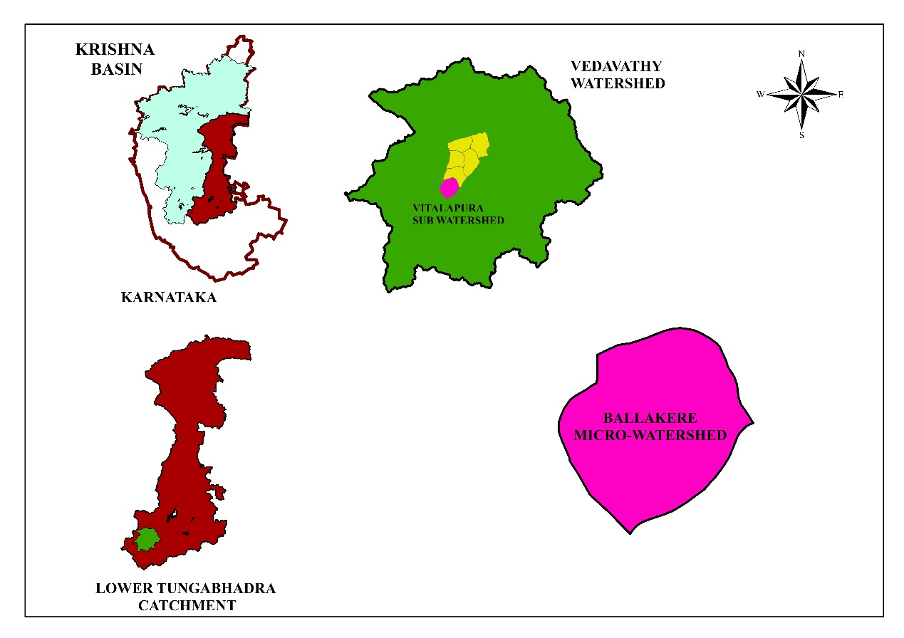
The data regarding the various chemical properties of the surface soil samples are presented in the below section.
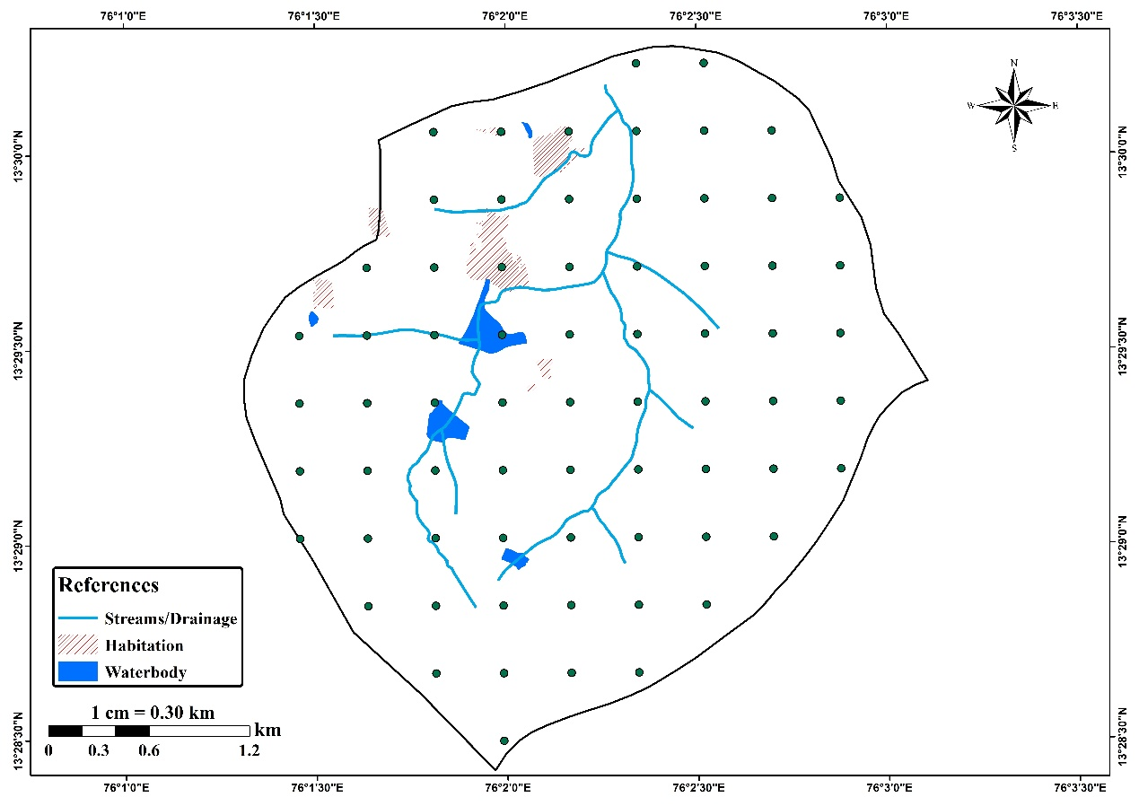
Fig.1. Location map of the study area
Fig.2. Location of the grid points for surface soil sampling in Ballakere micro watershed
III Result and Discussion
3.1 Soil reaction (pH)
The surface soils of the Ballakere micro-watershed exhibited pH values ranging from neutral to slightly alkaline, varying between 6.70 and 7.58, with an average of 6.96 and a standard deviation of 0.66 (Table 1). Geospatial analysis revealed that 93.80% of the area (668 ha) had neutral pH, while slightly alkaline conditions were observed in 8.00% (1.10 ha) of the area (Table 2; Fig. 3).
The relatively higher mean pH of the micro-watershed may be attributed to its topographical location within the sub-watershed. Basic cations leached from the upper sub-watersheds tend to accumulate in the lower sub-watersheds, resulting in an increase in soil pH. Furthermore, the higher soil pH could be influenced by the nature of the parent material, primarily Peninsular gneiss and other acidic lithological formations. The slightly lower pH observed in red soils may be associated with the presence of iron hydroxide species (Dasog and Patil, 2011). The elevated pH levels may also result from a high degree of base saturation, as reported by Meena et al. (2006). Similar findings were reported by Seema (2022) in the soils of the Duglapura mini-watershed.
3.2 Electrical conductivity (EC)
The soil samples from the Ballakere micro-watershed showed electrical conductivity (EC) values ranging from 0.03 to 0.50 dS m⁻¹, with an average of 0.13 dS m⁻¹ and a standard deviation of 0.08 dS m⁻¹ (Table 1). Geospatial analysis revealed that the entire micro-watershed exhibited very low EC values, indicating that the soils were non-saline (Table 2; Fig. 4).
The variation in total soluble salt content can be attributed to the area’s slope and efficient drainage conditions, which facilitated the leaching of salts from the soil profile. These findings are consistent with the observations of Swarnam et al. (2004) and Jhanvi (2020).
3.3 Organic carbon (OC)
The soil samples from the Ballakere micro-watershed recorded an average organic carbon content of 0.47 g kg⁻¹, ranging from 0.30 to 0.49 g kg⁻¹, with a standard deviation of 0.10 g kg⁻¹ (Table 1). A major portion of the micro-watershed, about 94.90% (676 ha), exhibited low levels of organic carbon (Table 2; Fig. 5).
The findings suggest that topography and the relative location of the micro-watershed within the sub-watershed significantly influenced the organic carbon concentration in the soils. The low organic carbon content may be due to the rapid oxidation of organic matter under high temperature conditions, as also noted by Balpande et al. (2007). Medium levels of organic carbon can be attributed to the deposition of organic materials transported from the hilly regions to the lower valley areas during sediment movement (Zhang et al., 2013). Additionally, the incorporation of crop residues and other organic materials contributes to the buildup of organic carbon in the soil, as reported by Nayak et al. (2002). Similar observations were made by Seema (2022) for comparable micro-watershed soils.
3.4 Available nitrogen
Laboratory analysis revealed that the surface soils of the Ballakere micro-watershed had an average available nitrogen content of 244.60 kg ha⁻¹, ranging from 194.72 to 243.20 kg ha⁻¹, with a standard deviation of 28.59 kg ha⁻¹ (Table 1). Geospatial analysis indicated that the soils of the micro-watershed were generally low in available nitrogen, with about 94.90% of the total area (676 ha) classified under the low nitrogen category (Table 2; Fig. 6).
The low nitrogen content may be attributed to intensive and continuous cultivation practices without adequate replenishment of nitrogen through organic or inorganic sources. Limited application of nitrogenous fertilizers is also a contributing factor to the observed nitrogen deficiency (Pramod and Patil, 2015). These findings are consistent with the results reported by Jhanvi (2020).
3.5 Available phosphorus
Soil analysis results revealed that the available phosphorus content in the surface soils of the Ballakere micro-watershed ranged from 24.28 to 58.04 kg ha⁻¹, with an average value of 31.21 kg ha⁻¹ and a standard deviation of 5.16 kg ha⁻¹ (Table 1). Geospatial analysis indicated that about 94.90% of the total area (676 ha) of the micro-watershed had medium levels of available phosphorus (Table 2; Fig. 7).
The medium phosphorus availability can be attributed to the predominance of clayey soils in the region, which possess high cation exchange capacity (CEC) and a strong phosphorus-fixing ability. This characteristic of clay-rich soils influences phosphorus retention and availability, as also noted by Rajashekar (2018).
3.6 Available potassium
The analytical results showed that the available potassium content in the surface soils of the Ballakere sub-watershed ranged from 168.80 to 395.19 kg ha⁻¹, with an average value of 275.10 kg ha⁻¹ and a standard deviation of 48.82 kg ha⁻¹ (Table 1). Geospatial analysis revealed that 94.90% of the total area (676 ha) exhibited medium levels of available potassium (Table 2; Fig. 8).
The medium potassium status of the soils can be attributed to the presence of potassium-rich parent materials from which the soils have developed, as well as the periodic application of potassic fertilizers. These findings are in agreement with the observations made by Pulakeshi et al. (2014) and Seema (2022).
3.7 Exchangeable calcium and magnesium
Soil analysis results indicated that the surface soils of the Ballakere micro-watershed contained adequate levels of exchangeable calcium and magnesium. Geospatial analysis further revealed that about 94.90% of the total area (676 ha) was classified as sufficient in both exchangeable calcium and magnesium (Table 2). The spatial distribution of exchangeable calcium and magnesium across the micro-watershed is illustrated in Fig. 9 and Fig. 10, respectively.
3.8 Available sulphur
Laboratory analysis revealed that the available sulphur content in the soils of the Ballakere micro-watershed ranged from 14.72 to 19.98 mg kg⁻¹, with an average of 13.32 mg kg⁻¹ and a standard deviation of 3.97 mg kg⁻¹ (Table 1). Geospatial analysis indicated that the entire micro-watershed exhibited medium levels of available sulphur (Table 2; Fig. 11).
The sulphur content in the soils may be largely influenced by the presence of organic carbon, which contributes to sulphur availability. Additionally, the fine-textured soils prevalent in the area could have enhanced sulphur retention. Similar observations were reported by Vikas (2016) for the Gollarahatti-2 micro-watershed, and consistent results were also noted by Manoj (2022).
3.8 Available zinc
Analysis of the surface soils of the Ballakere micro-watershed revealed available zinc concentrations ranging from 0.12 to 1.99 mg kg⁻¹, with an average of 0.53 mg kg⁻¹ and a standard deviation of 0.37 mg kg⁻¹ (Table 1). Geospatial analysis showed that 27.55% of the area (196 ha) had sufficient zinc levels, while 67.35% of the area (480 ha) was deficient in available zinc (Table 2; Fig. 12).
The zinc deficiency observed in certain pockets may be attributed to the alkaline soil conditions (Thangasamy et al., 2005), limited zinc supplementation, and intensive cultivation practices. In contrast, areas with sufficient zinc could be associated with relatively acidic soil pH, along with the addition of organic matter and fertilizers, which enhance zinc availability (Swathi, 2023).
3.11 Available iron
Laboratory analysis showed that the available iron content in the soils of the Ballakere micro-watershed ranged from 1.70 to 25.62 mg kg⁻¹, with an average of 11.83 mg kg⁻¹ and a standard deviation of 5.47 mg kg⁻¹ (Table 1). Geospatial analysis indicated that the soils across the micro-watershed generally had sufficient levels of available iron (Table 2; Fig. 13).
The adequate iron content may be attributed to the ferruginous nature of the parent material, which is inherently rich in iron, as well as the acidic soil conditions observed in certain parts of the micro-watershed. These findings are consistent with the results reported by Ravikumar et al. (2009), Jhanvi (2020), and Shwetha (2021).
3.12 Available manganese
Laboratory analysis revealed that the available manganese content in the surface soils of the Ballakere micro-watershed ranged from 1.27 to 28.72 mg kg⁻¹, with an average of 13.37 mg kg⁻¹ and a standard deviation of 6.20 mg kg⁻¹ (Table 1). Geospatial analysis indicated that the soils of the micro-watershed generally contained sufficient levels of available manganese (Table 2; Fig. 14).
The adequate manganese content can be attributed to the high organic matter present in the soils, which enhances manganese availability. Additionally, the DTPA-extractable manganese levels are influenced by the parent material of the soils. Similar observations linking sufficient manganese content to high organic matter were reported by Yeresheemi (1996) for the Upper Krishna command area, and comparable findings were also noted by Vikas (2016) and Krishna et al. (2017).
3.13 Available Copper
Laboratory analysis showed that the available copper content in the surface soils of the Ballakere micro-watershed ranged from 0.36 to 2.62 mg kg⁻¹, with an average of 1.08 mg kg⁻¹ and a standard deviation of 0.45 mg kg⁻¹ (Table 1). Geospatial analysis indicated that the soils across the micro-watershed generally had sufficient levels of available copper (Table 2; Fig. 15).
The adequate copper content in the area is likely linked to the parent material, specifically granite gneiss, which is naturally rich in copper (Rajkumar, 1994). Similar observations were reported by Ravikumar (2006) and Seema (2022).
3.14 Available Boron
Laboratory analysis revealed that the available boron content in the surface soils of the Ballakere micro-watershed ranged from 0.38 to 0.44 mg kg⁻¹, with an average of 0.36 mg kg⁻¹ and a standard deviation of 0.05 mg kg⁻¹ (Table 1). Geospatial analysis indicated that the soils were generally low in available boron, with approximately 94.90% of the watershed area (676 ha) classified under low boron levels (Table 2; Fig. 16).
The low boron content in a major portion of the micro-watershed may be due to the scarcity of boron-bearing minerals. Additionally, low organic carbon content and acidic soil pH in significant areas likely contributed to reduced boron availability. Organic carbon also plays a role in enhancing boron content, while the fine-textured soils and relatively higher pH in certain pockets may have resulted in medium boron levels. Similar observations were reported by Seema (2022) for the Duglapura mini-watershed and by Manoj (2022).
Table 1: Fertility status of surface soils of Ballakere micro-watershed.

Soil properties | Range | Mean | SD
Soil reaction (pH) | 6.70 – 7.58 | 6.96 | 0.66
Electrical Conductivity (EC) (dS m⁻¹) | 0.03 - 0.50 | 0.13 | 0.08
Organic Carbon (g kg⁻¹) | 0.30 - 0.49 | 0.47 | 0.10
Available nitrogen (kg ha⁻¹) | 194.72 – 243.20 | 244.60 | 28.59
Available P₂O₅ (kg ha⁻¹) | 24.28 – 58.04 | 31.21 | 5.16
Available K₂O (kg ha⁻¹) | 168.80 – 395.19 | 275.10 | 48.82
Exchangeable Ca [cmol (p⁺) kg⁻¹] | 2.60 – 11.30 | 7.29 | 1.92
Exchangeable Mg [cmol (p⁺) kg⁻¹] | 0.80 – 8.60 | 4.50 | 1.78
Available S (mg kg⁻¹) | 14.72 – 19.98 | 13.32 | 3.97
Available Zn (mg kg⁻¹) | 0.12 – 1.99 | 0.53 | 0.37
Available Fe (mg kg⁻¹) | 1.70 – 25.62 | 11.83 | 5.47
Available Mn (mg kg⁻¹) | 1.27 – 28.72 | 13.37 | 6.20
Available Cu (mg kg⁻¹) | 0.36 – 2.62 | 1.08 | 0.45
Available B (mg kg⁻¹) | 0.38 – 0.44 | 0.36 | 0.05

Table 2: Area under different chemical and fertility classes of Ballakere micro-watershed
Parameters | Classes |  |  |  |  |  |  |  |  | Others
Soil Reaction (pH) | Moderately Acid | Slightly Acid |  | Neutral | Slightly Alkaline |  | Moderately Alkaline |  | Strongly Alkaline | Others
Soil Reaction (pH) | - | - |  | 668 (93.80) | 8 (1.10) |  | - |  | - | 36 (5.10)
Electrical Conductivity | Non- Saline |  |  |  |  |  |  |  |  | 36 (5.10)
Electrical Conductivity | 676 (94.90) |  |  |  |  |  |  |  |  | 36 (5.10)
 | Low |  | Medium |  |  |  |  | High |  | 36 (5.10)
Organic Carbon (OC) | 676 (94.90) |  | - |  |  |  |  | - |  | 36 (5.10)
Available Nitrogen | 676 (94.90) |  | - |  |  |  |  | - |  | 36 (5.10)
Available Phosphorus | - |  | 676 (94.90) |  |  |  |  | - |  | 36 (5.10)
Available Potassium | - |  | 676 (94.90) |  |  |  |  | - |  | 36 (5.10)
Available Sulphur | - |  | 676 (94.90) |  |  |  |  | - |  | 36 (5.10)
Available Boron | 676 (94.90) |  | - |  |  |  |  | - |  | 36 (5.10)
 | Sufficient |  |  |  |  | Deficient |  |  |  | 36 (5.10)
Exchangeable Calcium | 676 (94.90) |  |  |  |  | - |  |  |  | 36 (5.10)
Exchangeable Magnesium | 676 (94.90) |  |  |  |  | - |  |  |  | 36 (5.10)
Available Zinc | 196 (27.55) |  |  |  |  | 480 (67.35) |  |  |  | 36 (5.10)
Available Iron | 676 (94.90) |  |  |  |  | - |  |  |  | 36 (5.10)
Available Manganese | 676 (94.90) |  |  |  |  | - |  |  |  | 36 (5.10)
Available Copper | 676 (94.90) |  |  |  |  | - |  |  |  | 36 (5.10)
*Note: Others include streams/drainage, railway track, road, habitation and waterbodies
Figures in parenthesis indicate the percentage of total micro-watershed area

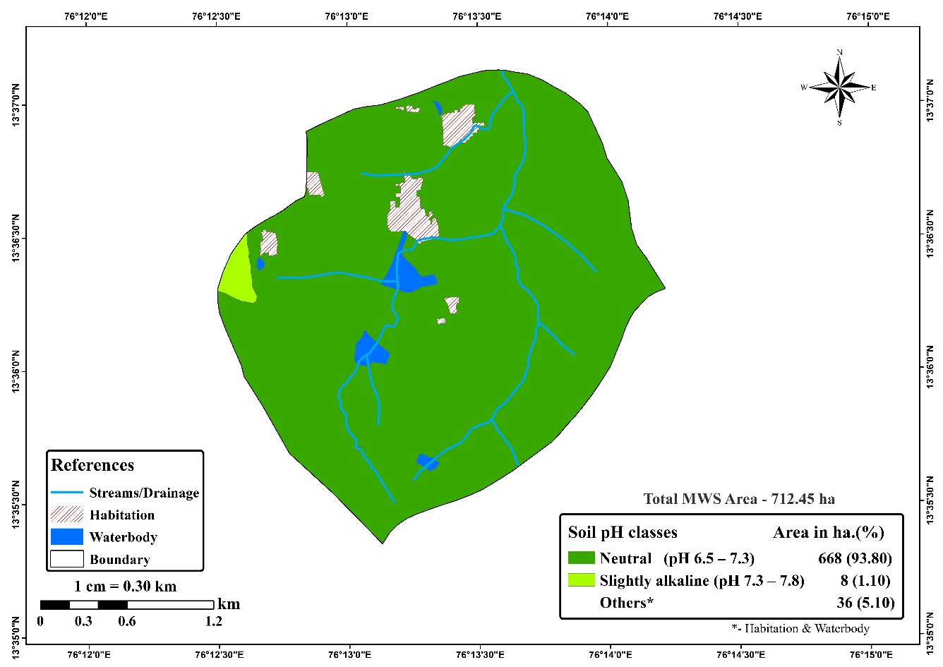

Fig. 3: Soil reaction (pH) map of Ballakere micro-watershed
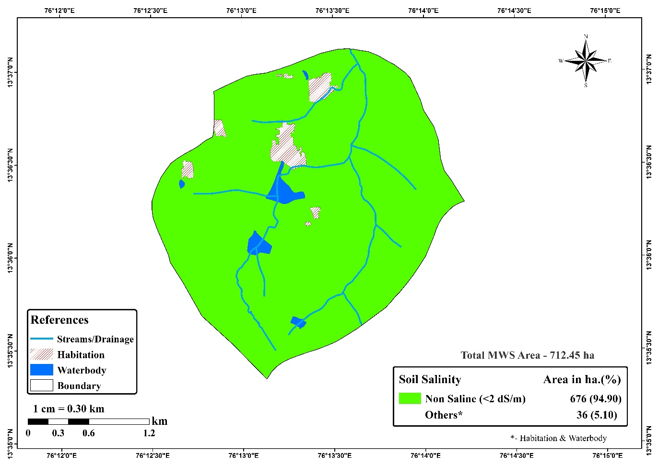
Fig. 4: Soil salinity (EC) map of Ballakere micro-watershed
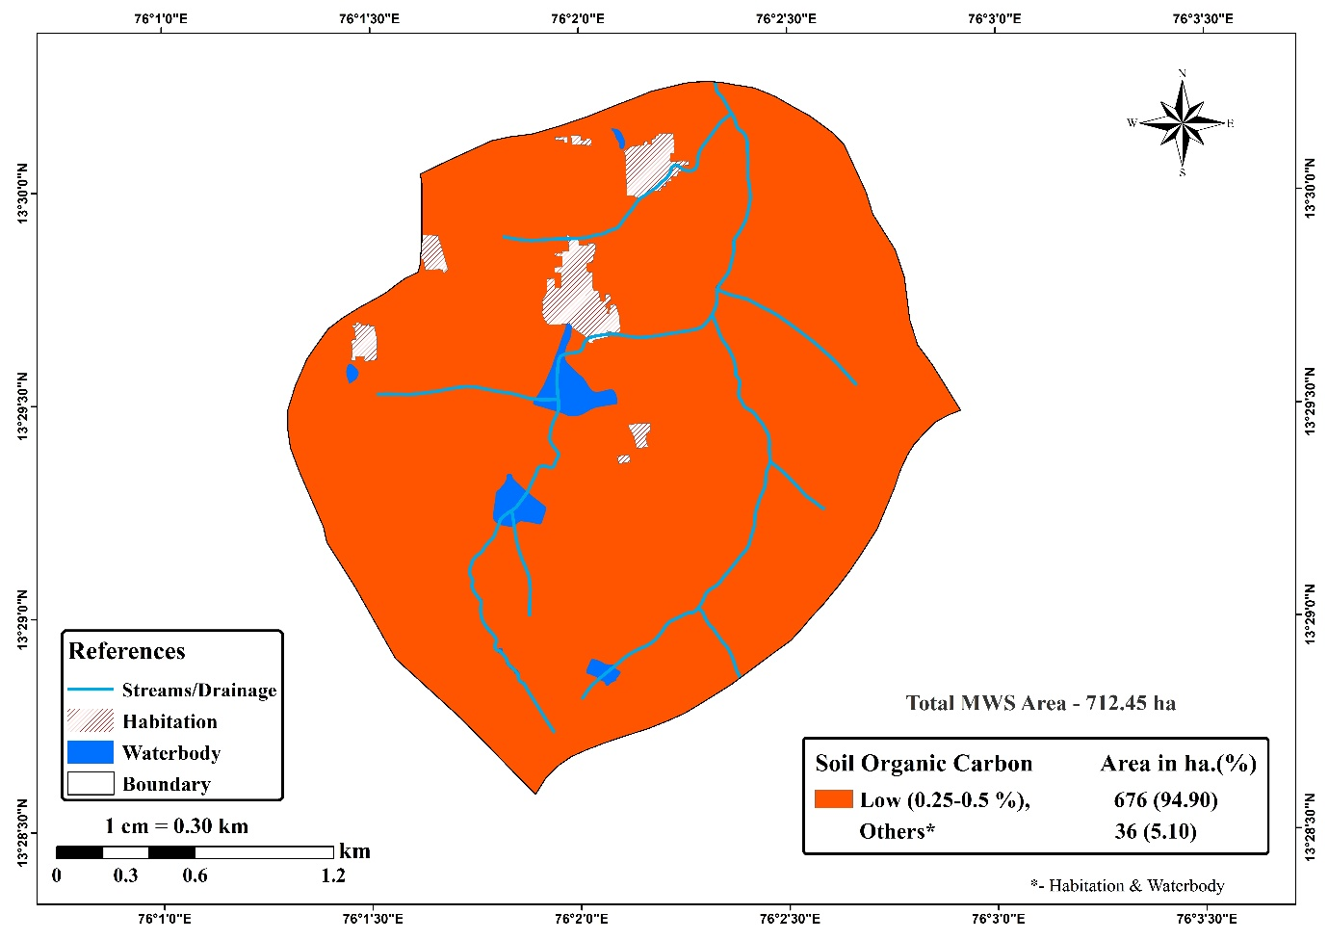
Fig. 5: Spatial distribution of Soil organic carbon of Ballakere micro-watershed
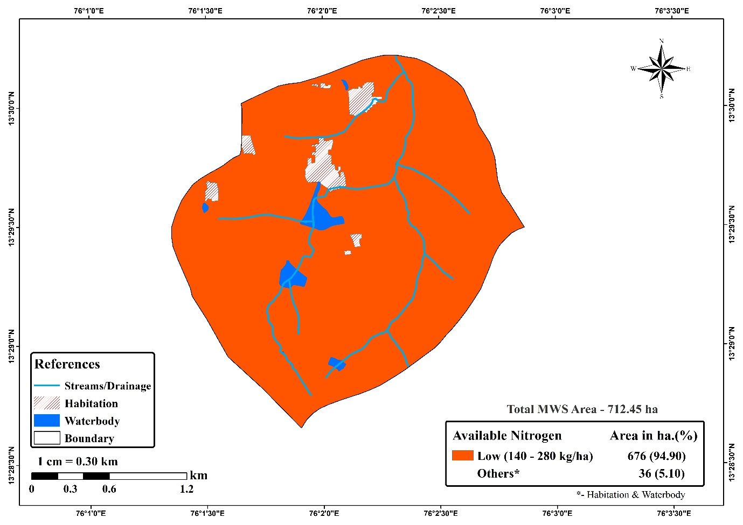
Fig. 6: Spatial distribution of available nitrogen of Ballakere micro-watershed

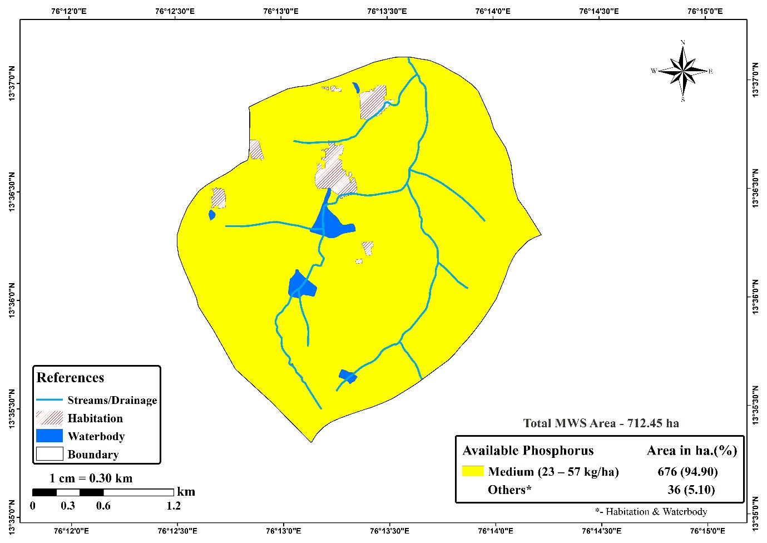
Fig. 7: Spatial distribution of available phosphorus of Ballakere micro-watershed
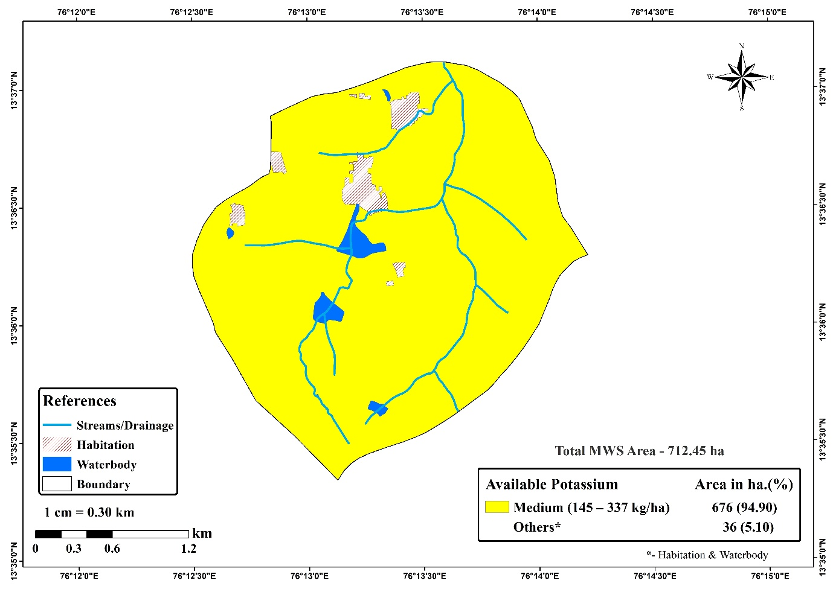

Fig. 8: Spatial distribution of available potassium of Ballakere micro-watershed
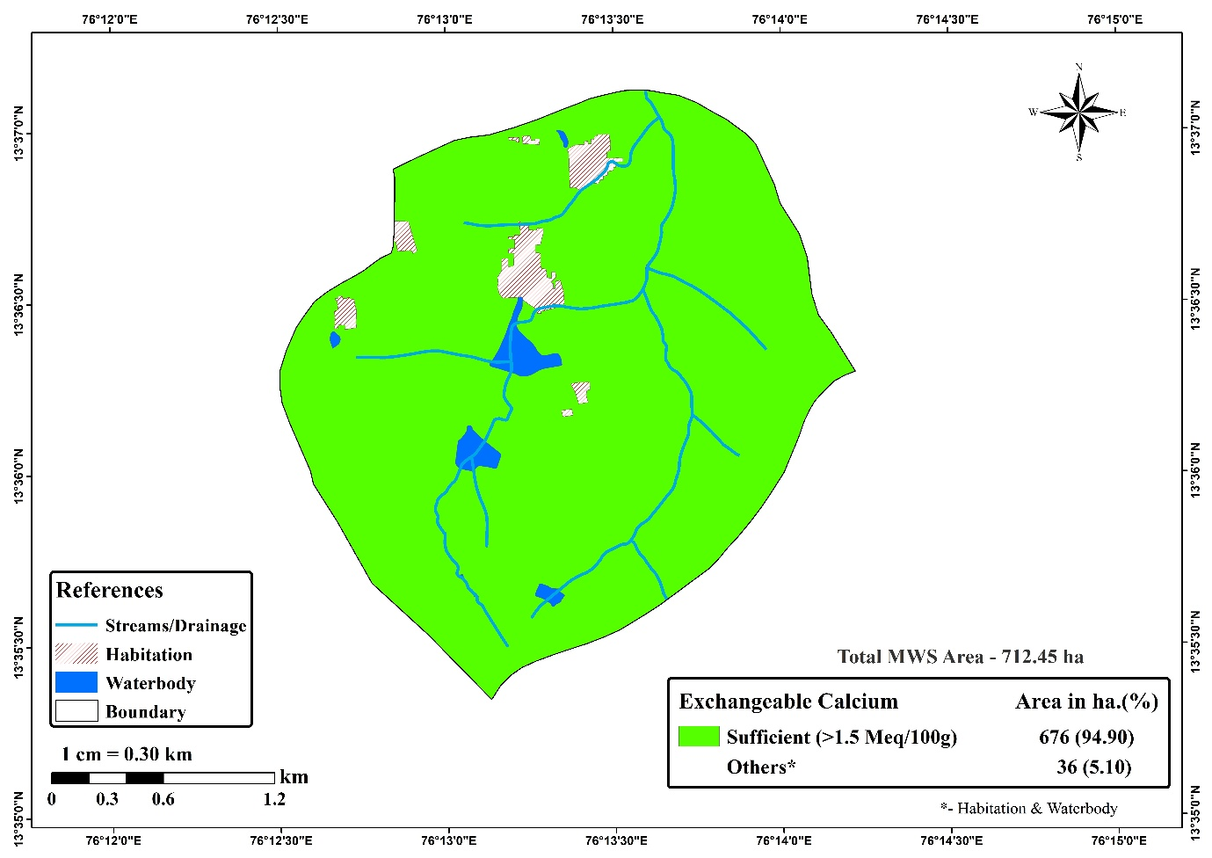
Fig. 9: Spatial distribution of exchangeable calcium of Ballakere micro-watershed
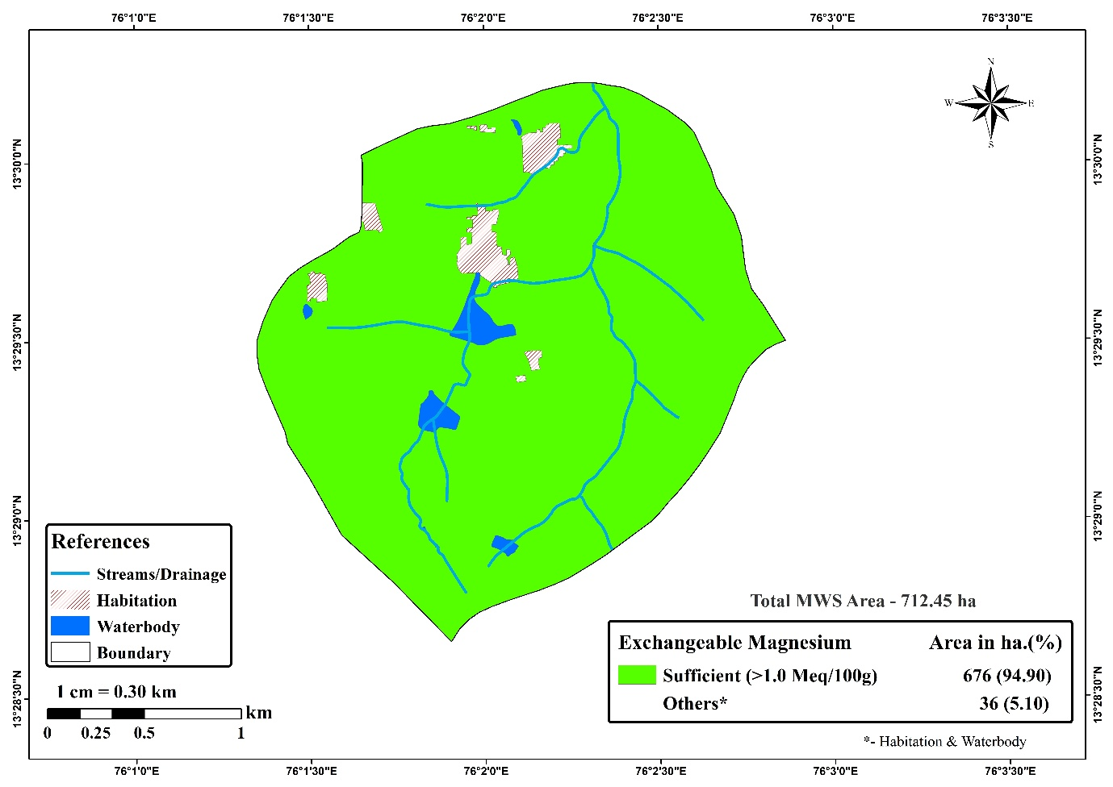
Fig. 10: Spatial distribution of exchangeable magnesium of Ballakere micro-watershed

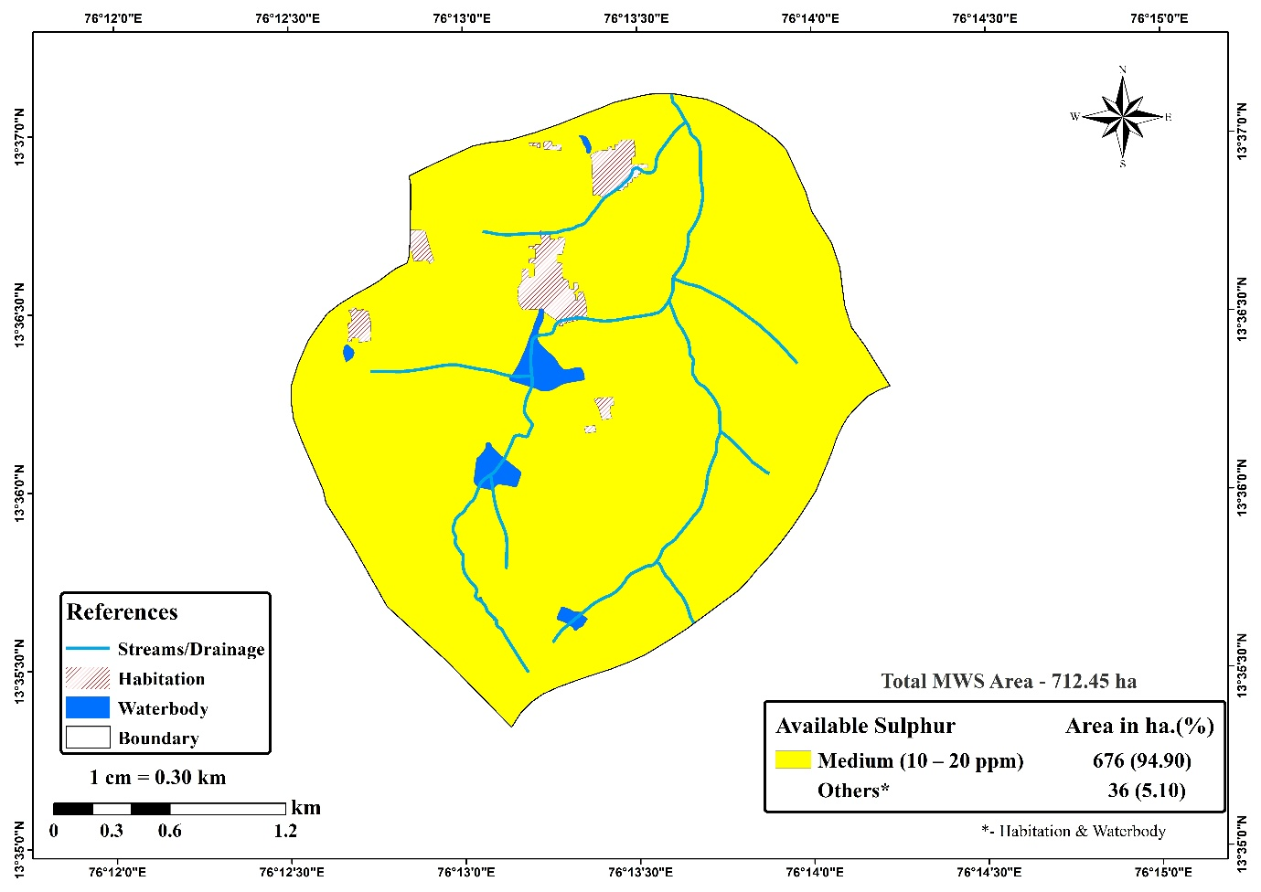
Fig. 11: Spatial distribution of available sulphur of Ballakere micro-watershed

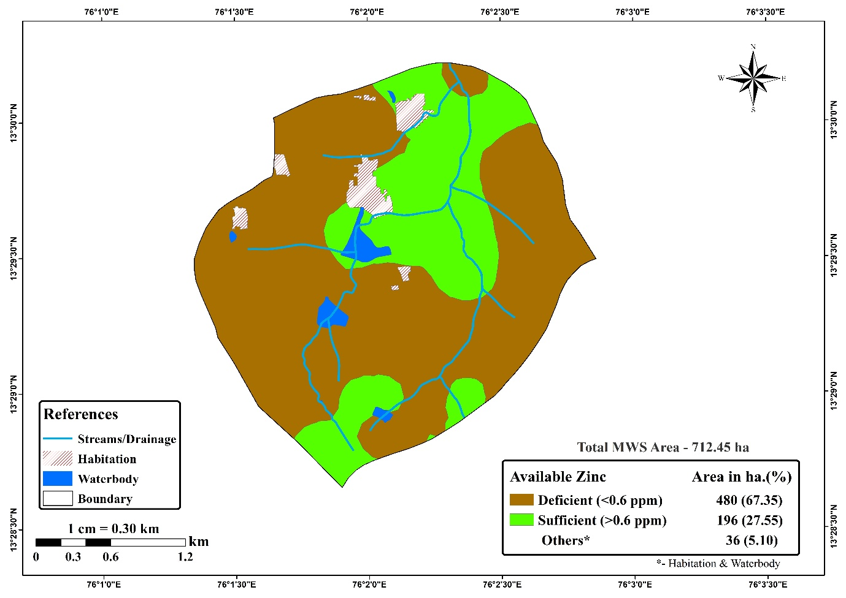
Fig. 12: Spatial distribution of available zinc of Ballakere micro-watershed
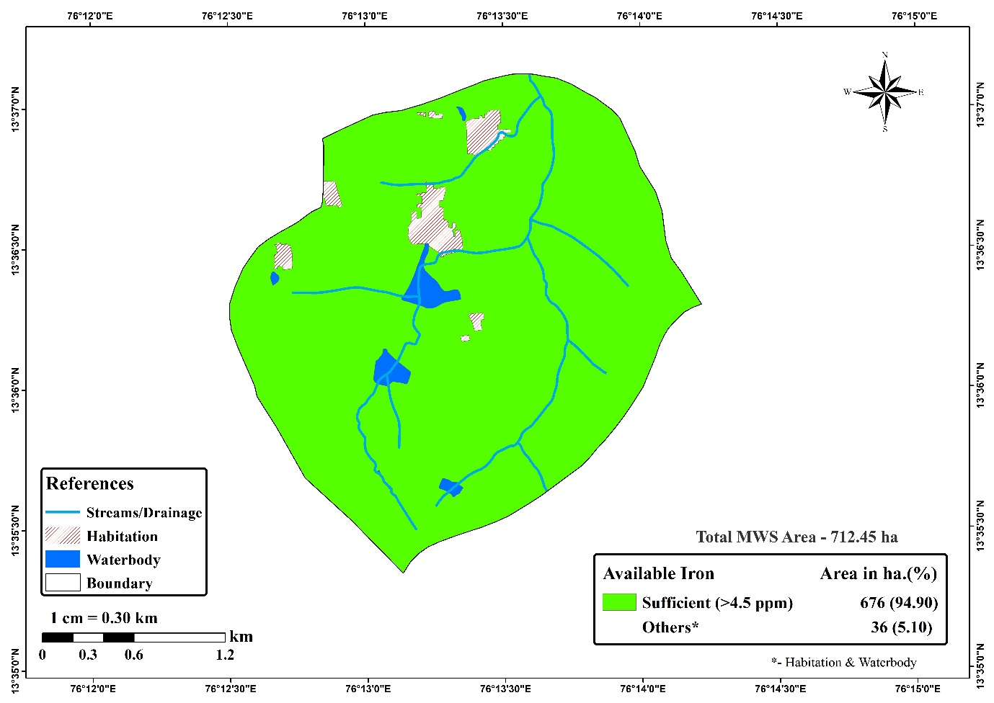
Fig. 13: Spatial distribution of available iron of Ballakere micro-watershed

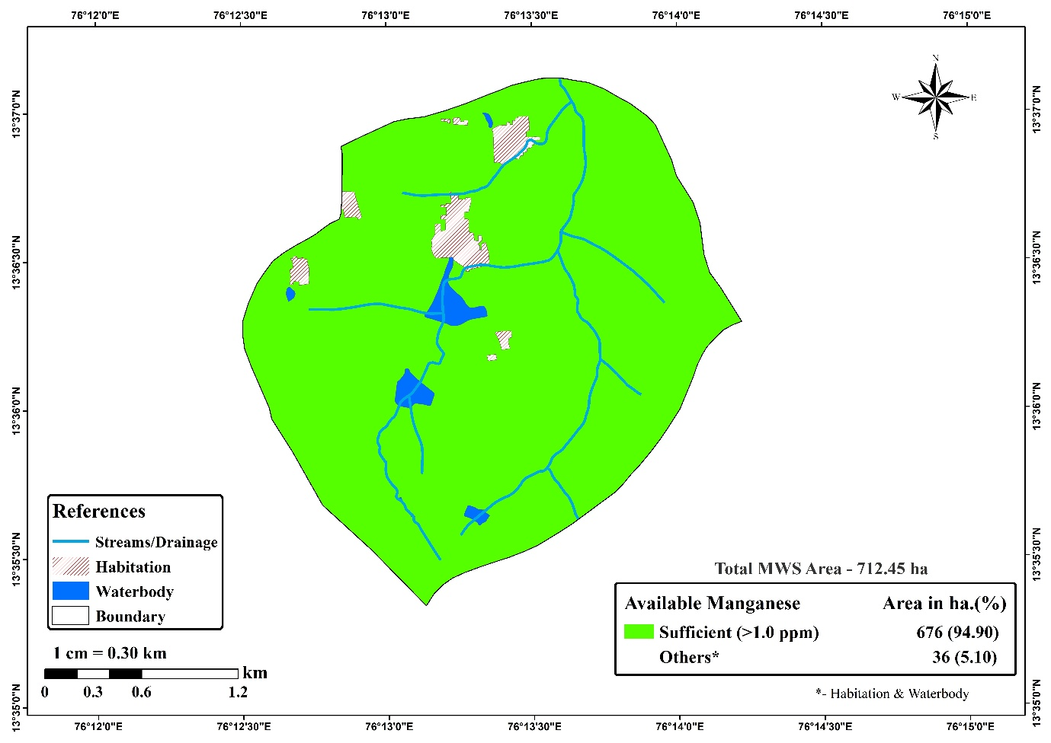
Fig. 14: Spatial distribution of available manganese of Ballakere micro-watershed
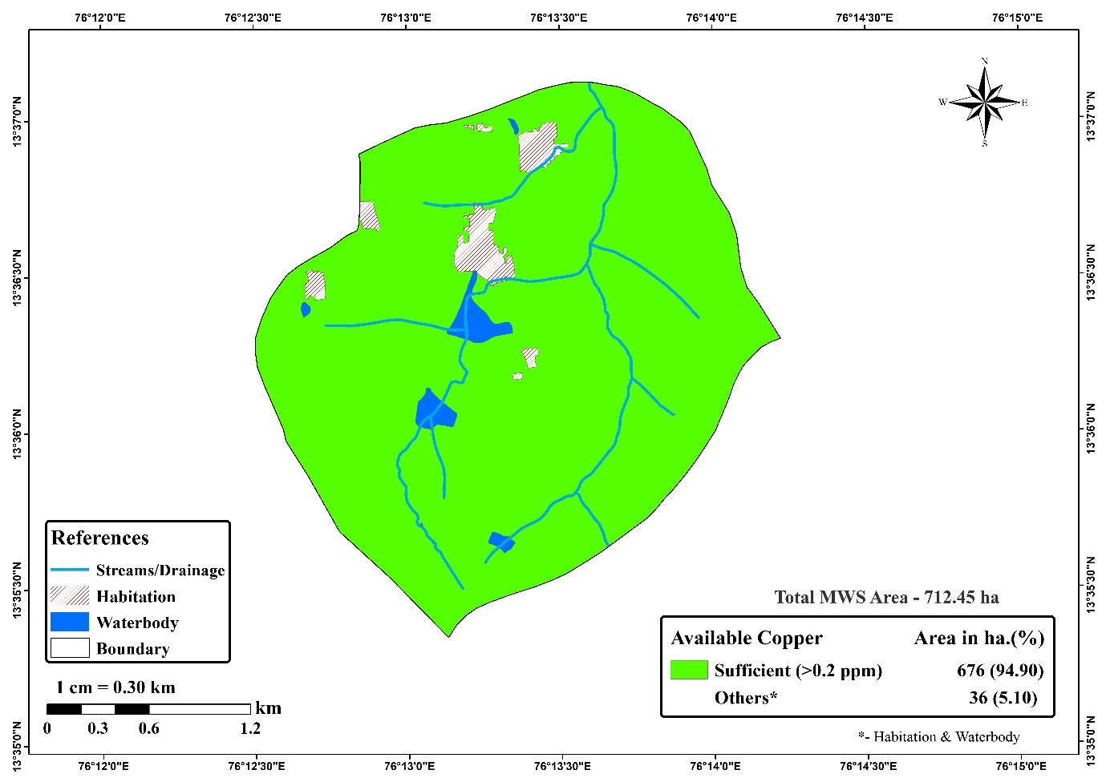
Fig. 15: Spatial distribution of available copper of Ballakere micro-watershed
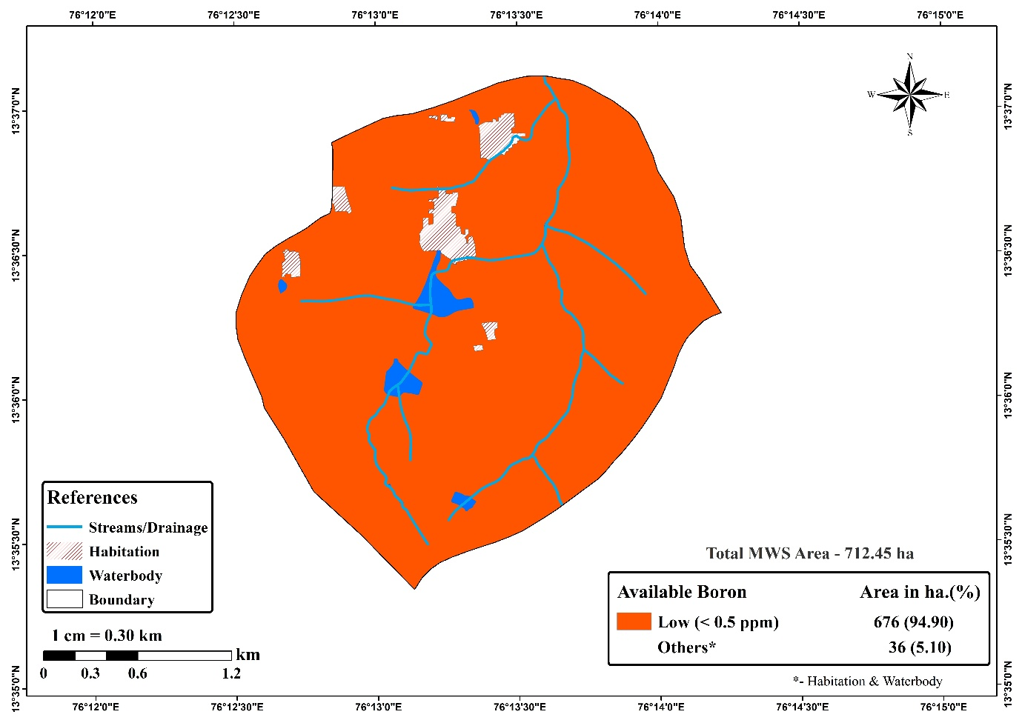
Fig. 16: Spatial distribution of available boron of Ballakere micro-watershed

IV Conclusion
This study presents a detailed evaluation of soil nutrient dynamics in the Ballakere micro-watershed, located within the Lower Tungabhadra catchment of Karnataka. By combining systematic soil sampling with advanced geospatial analysis, we obtained a comprehensive understanding of the soil’s fertility status and its implications for agricultural productivity and environmental sustainability.
The use of geospatial techniques enabled the development of detailed maps of soil nutrient distribution and fertility, providing critical spatial information to support informed land management decisions. This approach highlights the importance of assessing soil nutrient status with high spatial precision, offering practical guidance for implementing sustainable land management practices and optimizing crop production.
Overall, the study underscores the value of soil nutrient assessment and mapping in enhancing agricultural productivity, conserving natural resources, and protecting environmental health within micro-watershed ecosystems. By understanding the complex interactions and distribution of soil nutrients, policymakers and stakeholders can formulate targeted strategies to address fertility limitations, promote sustainable agriculture, and strengthen ecosystem resilience in the context of global challenges such as food security and climate change.
Disclaimer (Artificial intelligence)
Option 1:
Author(s) hereby declare that NO generative AI technologies such as Large Language Models (ChatGPT, COPILOT, etc.) and text-to-image generators have been used during the writing or editing of this manuscript.
Option 2:
Author(s) hereby declare that generative AI technologies such as Large Language Models, etc. have been used during the writing or editing of manuscripts. This explanation will include the name, version, model, and source of the generative AI technology and as well as all input prompts provided to the generative AI technology
Details of the AI usage are given below:
1.
2.
3.

References
Abate, K., Mohammed, M. and Kibret, K., 2016. Soil fertility assessment and mapping of spatial variability at Amareganda-Abajarso sub-watershed, north-eastern Ethiopia. East African Journal of Sciences, 10(1), pp.1-14.
Akanbi, O.D., Bhuvanagiri, D.C., Barcelos, E.I., Nihar, A., Gonzalez Hernandez, B., Yarus, J.M. and French, R.H., 2024. Integrating multiscale geospatial analysis for monitoring crop growth, nutrient distribution, and hydrological dynamics in large-scale agricultural systems. Journal of Geovisualization and Spatial Analysis, 8(1), p.9.
BLACK, C. A., 1965, Method of Soil Analysis Part-II, Chemical and microbiological properties, No. 9 in Agronomy series. J. Agron., Madison Wisconsin, USA, 2: 82-86.
Chartres, C.J. and Noble, A., 2015. Sustainable intensification: overcoming land and water constraints on food production. Food security, 7, pp.235-245.
DAS D K, BANDYOPADHYAY S, CHAKRABORTY D., 2009, Application of Modern Techniques in Characterization and Management of Soil and Water Resources. Indian Society of Soil Sci.;57(4):445–460.
HARSHITHA. S., GANAPATHI, GURUMURTHY, K. T., MAVARKAR, N. S. AND SOUMYA, T. M., 2018, Assessment of secondary and micro nutrient status in Hebbalagere micro watershed of Channagiri taluk, Davanagere district of Karnataka. Int. J. Chem. Studies, 6(6): 541-549.
Hillel, D., 2009. The mission of soil science in a changing world. Journal of Plant Nutrition and Soil Science, 172(1), pp.5-9.
JACKSON, M. L., 1973, Soil chemical analysis. Prentice Hall of India Private Limited, New Delhi.
JHANAVI, K., 2020, Assessment of soil carbon fractions under different land-use systems and micro level land resource inventory of nandipura mini-watershed of tarikere taluk of Chikkamagaluru district. Ph.D., Thesis, Univ. Agric. Horti. Sci., Shivamogga, Karnataka, India.
JHANAVI, K., GURUMURTHY, K. T., RAVIKUMAR, D., GIRIJESH, G. AND SRIDHAR, C. J., 2020, Fertility assessment of soils of Nandipura micro- watershed under Chikkamagaluru district, Karnataka. Int. J. Chemical Studies., 8(5): 977-984.
JOHN, M. K., CHUAH, H. H. AND NEUFED, J. H., 1975, Analysis of macro-micronutrients in soils and plants. Anal. Lett., 8: 59.
KANWAR J S, 2000, Soil and Water resources management for sustainable agriculture imperatives from India. In: Development and Conservation. New Delhi: International Conference of Agricultural Production in 21st Century; 17–37.
KARAJANAGI, M. S., PATIL, P. L. AND GUNDLUR, S. S., 2016, GIS mapping of available nutrients status of Dundur village under Malaprabha command area in Karnataka. J. Farm Sci., 29(1): 37-40.
Khadka, D., Lamichhane, S., Bhurer, K.P., Chaudhary, J.N., Ali, M.F. and Lakhe, L., 2018. Soil fertility assessment and mapping of regional agricultural research station, Parwanipur, Bara, Nepal. Journal of Nepal Agricultural Research Council, 4, pp.33-47.
KIRANKUMAR, H. A. AND HUNDEKAR, S. T., 2018, Soil fertility status of Hittnalli micro-watershed of Vijayapur district of Karnataka for site specific recommendations. J. Farm Sci., 31(4): 15-418.
KRISHNA, N. R., CHANDRAVAMSHI, P. AND ASHOK, L. B., 2017, Soil fertility status of major nutrients, micronutrients and mapping in Nicchapura-2 micro watershed of Davanagere district, Karnataka, India. Int. J. Curr. Microbiol. App. Sci., 6(9): 1178-1186.
LINDSAY, W. L. AND NORVELL, W. A., 1978, Development of a DTPA soil test for zinc, iron, manganese and copper. Soil Sci. Soc. America. J., 42: 421-428.
MEENA, H. B., SHARMA, R. P. AND RAWAT, U. S., 2006, Status of macro and micronutrients in some soils of Tonk district of Rajasthan. J. Indian Soc. Soil Sci., 54(4): 508-512.
NATRAJAN, A. R. S., REDDY, R. S., NIRANJANA, K. V., HEGDE, R., SRINIVASAN, R., DHARMARAJAN, S., SRINIVAS, S., DHANORKAR, D. A. AND VASUNDHARA, R., 2016, Field guide for land resource inventory, SUJALA-III project, Karnataka, NBSS AND LUP, pp. 1-154.
NAYAK, R. K., SAHU, G. C. AND NANDA, S. S. K., 2002, Characterization and classification of the soils of Central Research Station, Bhubaneswar. Agropedology, 12: 1-8.
PANDA S. C., 2010, Soil Management and Organic Farming. India: Agrobios, Bharat Printing Press;. 462 p.
PARKER, F. W., NELSON, W. L., WINTERS, E. AND MILES, I. E., 1951, The broad interpretation and application of soil test information. Agron. J., 43(3): 105-112.
POOJA, S., 2020, Studies on carbon and nitrogen dynamics as influenced by different land use systems of Rangapura micro watershed, Chikkamagaluru district, Karnataka, M.Sc. Thesis, Univ. Agric. Horti. Sci., Shivamogga, Karnataka, India.
PRAMOD, T. AND PATIL P. L., 2015, Characterization and classification of soil resources of Balapur micro-watershed. Karnataka J. Agric. Sci., 28(4): 510-517.
PULAKESHI, H. B. P., PATIL, P. L. AND DASOG, G. S., 2014, Characterization and classification of soil resources derived from chlorite schist in northern transition zone of Karnataka. Karnataka J. Agric. Sci., 27(1): 14-21.
RAJASHEKAR, L., 2018, Soil resource characterization, classification and productivity assessment of Sigehadlu microwatershed Kadur taluk of Chikkamagaluru district. Ph.D., Thesis, Univ. Agric. Horti. Sci., Shivamogga, Karnataka, India.
RAJKUMAR, G. R., 1994, Studies on forms and distribution of micronutrients in paddy soils of Tungabhadra project area, Karnataka. M. Sc. (Agri.) Thesis, Univ. Agric. Sci., Dharwad, India.
RAVIKUMAR, D. AND GOVINDARAJU, 2019, Assessment of soil fertility status of Koranahalli sub watershed in Tarikere taluk using nutrient index approach. Earth Resour. Conserv. Manage., 47-52.
RAVIKUMAR, M. A., 2006, Soil resource characterization of 48A distributary of Malaprabha right bank command for sustainable land use planning. M. Sc. (Agri.) Thesis, Univ. Agric. Sci., Dharwad, Karnataka, India.
RAVIKUMAR, M. A., PATIL. P. L. AND DASOG, G. S., 2009, Soil resource characterization classification and mapping of 48A distributary of Malaprabha right bank command, Karnataka for land use planning. Karnataka J. Agric. Sci., 22(1): 81-88.
Rout, P.K., Paul, J.C. and Panigrahi, B., 2016. Remote sensing and GIS applications for water resources planning in micro-watershed. Modeling Methods and Practices in Soil and Water Engineering, pp.215-278.
SHETTY, Y. V., NAGAMMA, M. S., KUMAR, M. D. AND JAYAPRAKASH, S. M., 2008, Fertility status in arecanut garden soils of Karnataka. Karnataka. J. Agril. Sci., 21(4): 503-506.
SINGH, G., SHARMA, M., MANAN, J. AND SINGH, G., 2016, Assessment of soil fertility status under different cropping sequences in district Kapurthala. J. Krishi Vigyan. 5(1): 1-9.
Singh, S., Rai, V., Upadhyay, S. and Singh, S., 2023. Geo-spatial Tools for Assessing Soil Fertilty: A Review. International Journal of Plant & Soil Science, 35(18), pp.1386-1394.
SUBBIAH, B. V. AND ASIJA, G. L., 1956, A rapid procedure for the estimation of available nitrogen in soils. Current Sci., 25: 259-260.
SWARNAM, T. P., VELMURUGAN, A. AND RAO, Y. S., 2004, Characterization and classification of some soils from Shahibi basin in parts of Haryana and Delhi. Agropedology, 14: 114-122.
THANGASAMY, A., NAIDU, M. V. S., RAMAVATHARAM, N. AND RAGHAVA REDDY, C., 2005, Characterization, classification and evaluation of soil resources in Sivagiri micro-watershed of Chittoor district in Andhra Pradesh for sustainable land use planning. J. Indian Soc. Soil Sci., 53(1): 11-21.
VIKAS, N. K., ANILKUMAR, K. S. AND KALAISELVI, B., 2018, Soil characterization and classification of Gollarahatti-2 watershed, Karnataka, India. Advances Res., 16(5): 1-12.
WALKLEY, A. J., AND BLACK, C. A., 1934, Estimation of soil organic carbon by the chromic acid titration method. Soil Sci., 37: 29-38.
YERESHEEMI, A. M., 1996, Studies on salt affected soils of upper Krishna project command area. M. Sc. (Agri.) Thesis, Univ. Agric. Sci., Dharwad, Karnataka, India.

