Compatibility of Beauveria bassiana with agrochemicals (in vitro)

ABSTRACT
Beauveria bassiana (Bals.) Vuill., a facultative entomopathogenic fungus with a broad host range and notable host specificity, is one of the insect pathogens studied. Environmental variables, biopesticides, and chemical products used to protect crop plants affected the survival of its conidia. This study evaluated the fungus's compatibility with five fungicides, five herbicides and five insecticides with four replications of each treatment. Two concentrations of each pesticide formulation were tested (Recommended and higher dose). The results showed that selected all fungicides, all herbicides and some of the insecticides were completely or significantly inhibited the development of B. bassiana and were incompatible with the fungus. The insecticide flonicamid, on the other hand, was found to be highly compatible with B. bassiana at recommended dose only which showed 21.06 per cent mycelial growth inhibition as compared to control. This combination could have been effectively employed only at recommended dose only in integrated pest management strategies.
Key words: Compatibility, Beauveria bassiana, Agrochemicals

INTRODUCTION
Management of insect pest using beneficial microbes is an important aspect to reduce reliance on chemical pesticides and sustainability of agriculture. Now a days, Beauveria bassiana is a commercially available biopesticides for management of wide range of insect pest. B. bassiana infect the host insect via attachment to and penetration of the outer integument. The hyphomycetous fungus Beauveria bassiana (Balsamo) Vuillemin (Hypocreales: Clavicipitaceae) is found in soil and has entomopathogenic qualities. It’s isolates found all over the world and infect a vast variety of insects at different stages of development. (Gupta et al. 1995).
Various potent toxic metabolites with cytotoxic, insecticidal, antibacterial, and antifungal properties are produced by B. bassiana (Ownley et al. 2004). With a wide host range of about 700 insect species, B. bassiana is a permitted biopesticide used to control a variety of crop insect pests, including aphids, white flies and thrips, both in the lab and in the field (Legaspi et al. 2000). Furthermore, the majority of non-target organisms seem to be unaffected by this fungus (Goettel et al. 1990). According to research, B. bassiana may be able to manage plant diseases that are transmitted through the soil (Ownley et al. 2000).
This fungus known to be affected by chemical pesticides. Hence, it is essential to know its compatibility with newly developed pesticides for effective combination in IPM system. Hence, in the present study of compatibility of Beauveria bassiana was tested with five fungicides, five herbicides and five insecticides.
MATERIALAND METHODS
The present study was conducted at the Plant Pathology Section of Rajarshee Chhatrapati Shahu Maharaj College of Agriculture, Kolhapur, Maharashtra during the year 2024-25.
The conical flasks containing PDA were sterilized, then allowed to cool at 40°C before carefully measured amounts of chemical pesticides, herbicides, and fungicides were applied, as explained below.

Table 1: Fungicidal Treatments
Sr. No. | Treatment | Name of fungicide | Trade name | Rate of application/100 ml PDA
 |  |  |  | X dose | 2X dose
1 | T₁ | Fluxapyroxad 167 g/L + Pyraclostrobin 333 g/L SC | Priaxor (BASF) | 0.06 ml | 0.12 ml
2 | T₂ | Tebuconazole 50 % + Trifloxystrobin 25 % WG | Nativo (Byer) | 0.07 gm | 0.14 gm
3 | T₃ | Dimethomorph 50 % WP | Acrobat (BASF) | 0.13 gm | 0.26 gm
4 | T₄ | Azoxystrobin 18.2 % + Difenoconazole 11.4 % SC | Amistar Top (Syngenta) | 0.1 ml | 0.2 ml
5 | T₅ | Propiconazole 13.9 % + Difenoconazole 13.9% EC | Glo It (Syngenta) | 0.1 ml | 0.2 ml
Table 2: Herbicidal Treatments
Sr. No. | Treatment | Name of herbicide | Trade name | Rate of application/100 ml PDA
 |  |  |  | X dose | 2X dose
1 | T₁ | Paraquat dichloride 21 % SL | Gramoxone (Syngenta) | 0.5 ml | 1 ml
2 | T₂ | Ametryne 80 % WG | Tamar (Adama) | 0.5 gm | 1 gm
3 | T₃ | Sodium aciflourfen 16.5 % + Clodinafop- propargyl 8 % EC | Enzip (TATA Rallis) | 0.2 ml | 0.4 ml
4 | T₄ | Glyphosate 71 % SG | Excel Mera (Sumitomo) | 0.6 gm | 1.2 gm
5 | T₅ | Mesotrione 2.27 % + Atrazin 22.7 % SC | Calaris Xtra (Syngenta) | 0.7 ml | 1.4 ml

Table 3: Insecticidal Treatments
Sr. No. | Treatment | Name of insecticide | Trade name | Rate of application/100 ml PDA
 |  |  |  | X dose | 2X dose
1 | T₁ | Fipronil 40 % + Imidacloprid 40 % WG | Lesenta (Bayer) | 0.05 gm | 0.1 gm
2 | T₂ | Flubendiamide 20 % WG | Takumi  (TATA Rallis) | 0.05 gm | 0.1 gm
3 | T₃ | Novaluron 5.25 % + Emamectin benzoate 0.9 % SC | Barazide (Adama) | 0.15 ml | 0.3 ml
4 | T₄ | Fipronil 5 % SC | Tag Agent (Tropical Agro) | 0.3 ml | 0.6 ml
5 | T₅ | Flonicamid 50 % WG | Ulala (UPL) | 0.04 gm | 0.08 gm

- Preparation of Culture Medium:
  - About 20 ml of PDA (Potato Dextrose Agar), amended with various chemical insecticides, was poured into each pre-sterilized Petri plate (9 cm diameter).
  - An insecticide-free PDA medium served as the untreated control.
- Solidification:
  - All Petri plates were allowed to solidify.
- Selection of Insecticides:
  - Five commonly used insecticides, applied in various crops for pest management, were selected for this study.
- Fungal Inoculation and Incubation:
  - After medium solidification, the entomopathogenic fungus Beauveria bassiana was inoculated aseptically.
  - A 5 mm diameter mycelial disc was taken from an actively growing 7-day-old culture using a sterilized cork-borer.
  - The disc was placed at the center of each Petri plate (both treated and control).
  - Plates were then incubated at 28 ± 2°C for 144 hours.

- Observation of Fungal Growth:
  - Radial mycelial growth of B. bassiana was measured in millimeters using a measuring scale.
  - Four replications were maintained for each treatment.
  - Observations were recorded at 24-hour intervals up to 144 hours.
- Estimation of Growth Inhibition:
  - Percent inhibition of mycelial growth was calculated using the formula proposed by Vincent (1947):
$$\text{Percent Inhibition}=\frac{C-T}{C}×100$$

Where,
I = Per cent growth inhibition
C = Colony diameter in control (mm)
T = Colony diameter in treatment (mm)

All the tested chemical pesticides were classified in four categories based on per cent inhibition of mycelial growth of fungal B. bassiana at 144 hrs as 1 = toxic (> 50%), 2 = moderately toxic (35-50%), 3 = slightly toxic (25-35%) and 4 = compatible (< 25% inhibition) as described by Ambethgar, 2009.
Statistical analysis
All laboratory work was carried out in Completely Randomized Design with four replications and six treatments. Five treatments of chemical insecticides and sixth was untreated control. Data obtained which in per cent format were transformed in arcsine format. Transformed data was subjected to analysis of variance.
RESULTS
Laboratory studies were conducted to study the compatibility of B. bassiana with insecticides at recommended (X) and higher (2X) doses.
Effect of fungicides on B. bassiana
At X dose (Table 4, Fig.1, Plate 1), all fungicidal treatments restrict colony growth of B. bassiana. The fungicide dimethomorph (17.56 mm) proved toxic, which showed 63.24 per cent inhibition of mycelial growth followed by propiconazole + difenoconazole (8.11 mm) and tebuconazole + trifloxystrobin (0.89 mm) which shows inhibition of mycelial growth 82.69 and 98.11per cent, respectively. Maximum colony diameter at 144 hrs was observed in the control treatment (47.56 mm). The fungicide fluxapyroxad + pyraclostrobin and azoxystrobin + difenoconazole inhibit the mycelial growth 100 per cent from 24 to 144 hrs of incubation and were found completely toxic with B. bassiana.
At 2X dose (Table 5, Fig. 2, Plate 2), There was considerable inhibition of B. bassiana growth across all fungicidal treatments. The fungicide fluxapyroxad + pyraclostrobin, tebuconazole + trifloxystrobin, azoxystrobin + difenoconazole and propiconazole + difenoconazole inhibit the mycelial growth 100 per cent from 24hrs to 144 hrs and were found toxic with B. bassiana. Maximum colony growth at 144 hrs was observed in the control treatment (46.11 mm). Also, fungicide diamethomorph (15.22 mm) found incompatible, which showed 67.00 per cent inhibition of mycelial growth. In all fungicides except dimethomorph (15.22 mm) at 24 to 144 hrs, inhibition of mycelial growth was found constant and above 80 per cent.
It is clearly evident from the earlier reports that fungicides have the potential to inhibit either mycelial growth or sporulation of B. bassiana under in vitro condition. Many of the past workers reported incompatibility of fungicides with B. bassiana were Pandey and Kanaujia (2009) (Propiconazole); Kos and Celar (2016) (Copper hydroxide, Chlorothalonil); Fiedler and Sosnowska (2017) (Chlorothalonil, azoxystrobin and thiophenate methyl); Joshi et al. (2018) (Propiconazole, Hexaconazole and Carbendazim); Reddy et al. (2018) (Propiconazole).
The fungicidal molecules viz., pyraclostrobin, fluxapyroxad, tebuconazole, azoxystrobin and dimethomorph were included in the present study. These fungicidal molecules had been studied by Khun et al. (2020), Bisandre et al. (2023), Erdogan and Saglan (2023) and Shinde et al. (2021) and had reported its toxicity to B. bassiana all these reports are in conformity with the present investigations.
Above results suggested that, all the fungicides were found to be fully toxic with B. bassiana, which completely inhibits the mycelial growth. Hence, B. bassiana shall not be applied in combination with these fungicides or these fungicides shall not be applied post- application of B. bassiana considering its persistence period.
Effect of herbicides on B. bassiana
At X dose (Table 6, Fig. 3, Plate 3), all the herbicidal treatments had reduced growth of B. bassiana to a major extent. The herbicidal treatments mesotrione + atrazin (21.00 mm), paraquat dichloride (7.33 mm) and ametryne (7.00 mm) showed toxicity, which showed 55.62, 84.48 and 85.17 per cent inhibition of mycelial growth respectively. The herbicide sodium aciflourfen + clodinafop-propargyl, glyphosate inhibit the mycelial growth 100 per cent from 24 to 144 hrs and were found toxic with B. bassiana. Also, in all herbicides at 24 to 144 hrs, inhibition of mycelial growth was found constant and above 80 per cent except mesotrione + atrazin (21.00 mm) which showed 55.62 per cent inhibition of mycelial growth. maximum colony growth at 144 hrs was observed in the control treatment (47.56 mm).
At 2X dose (Table 7, Fig. 4, Plate 4), all the herbicidal treatments with B. bassiana indicated toxicity. The herbicide mesotrione + atrazin (16.78 mm) and paraquat dichloride (2.67 mm) which were proved toxic, which showed 63.57 and 94.21 per cent inhibition of mycelial growth respectively. Secondly, the herbicide ametryne, sodium aciflourfen + clodinafop-propargyl, glyphosate inhibit the mycelial growth 100 per cent from 24 to 144 hrs of incubation and were found toxic with B. bassiana. All herbicides at 24 to 144 hrs, inhibition of mycelial growth was found constant and above 80 per cent except mesotrione + atrazine. Maximum colony growth at 144 hrs was observed in the control treatment (46.11 mm).
Compatibility studies between herbicides and B. bassiana in the earlier reports showed less toxicity of pendimethalin, butachlor and fluchloralin (Ambethgar et al. 2009); inhibition of spore formation due to flurochoridone, foramsulfuron and prosulfocarb (Kos and Celar, 2016); inhibition of mycelial growth due to pendimethalin and pendimethalin + imazamox (Ondrackova et al. 2019); inhibition of colony growth due to glyphosate (Shinde et al. 2021) and atrazine + simazine, atrazine and glyphosate are incompatible with B. bassiana (Rakes et al. 2024).These results are supportive to the present work.
With the above study it is found that the herbicides under study were completely toxic to B. bassiana. Hence, these herbicides shall be harmful in the field if applied with B. bassiana.
Effect of insecticides on B. bassiana
At X dose (Table 8, Fig.5, Plate 5), the insecticidal treatments showed larger variation in reducing colony growth of B. bassiana. The insecticides flubendiamide (21.22 mm) and fipronil (13.67 mm) and novaluron + emamectin benzoate (8.44 mm) reduced the growth by 55.23, 71.20, 82.26 per cent growth of B. bassiana and found to be toxic. Secondly, Fipronil + imidacloprid (33.44mm) shows slightly toxicity with 29.26 per cent inhibition of mycelium while only flonicamid (37.33mm) was found compatible which showed 21.06 per cent mycelial growth inhibition as compared to control (47.56 mm).
At 2X dose (Table 9, Fig. 6, Plate 6), all the insecticidal treatments were found to be toxic. The insecticide fipronil + imidacloprid (14.78), fipronil (12.67), flubendiamide (11.56) and novaluron + emamectin benzoate (5.11 mm) reduced the growth by 68.08, 72.52,74.92 and 88.90 per cent, which were reduced the growth of B. bassiana and found toxic. However, only flonicamid was found toxic which showed 100 per cent mycelial growth inhibition at 24 to 144 hrs. maximum colony growth at 144 hrs was observed in the control treatment (46.11 mm).
Flonicamid was found compatible with B. bassiana at X dose while at 2X dose it was proved toxic and could not allowed growth during incubation. hence, increment in the X dose of flonicamid shall be detrimental to B. bassiana during its application in the field.
Insecticides were found to be safer as compared to fungicides and herbicides with B. bassiana as reported by the earlier scientist. Compatibility/ less toxicity of imidacloprid (Ali et al., (2007); Amutha et al. (2010); Vats et al. (2014); Abidin et al. (2017); Kakati et al. (2018); and Shinde et al. (2021); Spinosad (Fiedler and Sosnowska, 2017 and Shinde et al. 2021) Acetamiprid (Khan et al. 2012; Vats et al. 2014 and Ondrackova et al. 2019) and many other insecticides had been reported by many other scientists.
On the other hand, some of the scientist had reported toxicity/incompatibility of few newly available insecticides in the market. Among those, flufenoxuron and indoxacarb inhibit colony growth completely (Khezri et al. 2007 and Amutha et al. 2010, respectively); fluvalinate and primicarb (Ondrackova et al. 2019) found to inhibit mycelial growth of B. bassiana. Shinde et al. (2021) also studied recently developed insecticides namely chlorantraniliprole, imidacloprid, emamectin benzoate, spinosad, thimethoxam + lambda cyhalothrin and acetamiprid and found to had more or less toxicity to B. bassiana due to all the insecticides under in vitro conditions.
Similarly, in the present study recently developed and largely accepted insecticides had been studied which showed toxicity to B. bassiana except flonicamid which was found compatible at X dose and all these insecticides showed complete toxicity at higher dose. Therefore, scrupulous application of insecticides along with B. bassiana is necessary to have desired results.

CONCLUSIONS
- All fungicides like fluxapyroxad + pyraclostrobin, tebuconazole + trifloxystrobin, dimethomorph, azoxystrobin + difenoconazole, propiconazole + difenoconazole were incompatible with B. bassiana at X as well as 2X dose, so it is found to be harmful in IPM.
- All the herbicides selected for study were toxic to Beauveria bassiana at recommended dose and higher dose
- Among the insecticides all found toxic except flonicamide which was found compatible with Beauveria bassiana at recommended dose while at higher dose it was proved toxic and could not allowed growth during incubation. hence, increment in the recommended dose of flonicamid shall be detrimental to Beauveria bassiana during its application in the field.

Conflicts of Interest: On behalf of all authors, the corresponding author states that there is no conflict of interest.

Disclaimer (Artificial intelligence)
Option 1:
Author(s) hereby declare that NO generative AI technologies such as Large Language Models (ChatGPT, COPILOT, etc.) and text-to-image generators have been used during the writing or editing of this manuscript.
Option 2:
Author(s) hereby declare that generative AI technologies such as Large Language Models, etc. have been used during the writing or editing of manuscripts. This explanation will include the name, version, model, and source of the generative AI technology and as well as all input prompts provided to the generative AI technology
Details of the AI usage are given below:
1.
2.
3.

REFERENCES
- Abidin, A. F., Ekowati, N. and Ratnaningtyas, N. I. (2017). Insecticide compatibility to the entomopathogenic fungi Beauveria bassiana and Metarhizium anisopliae. Scripta Biologica, 4(4), 273-279.
- Ali A., Mohammad, A. S., Masood, K. and Rohallah, S. R. (2007). Compatibility of Beauveria bassiana (Bals.) Vuill. with several pesticides. International journal of agricultural biology, 9(1), 31-34.
- Ambethgar, V. (2009). Potential of entomopathogenic fungi in insecticide resistance management (IRM): A review. Journal of Biopesticides, 2(2), 177-193.
- Amutha, M., Banu, J. G., Surulivelu, T. and Gopalakrishnan, N. (2010). Effect of commonly used insecticides on the growth of white muscardine fungus, Beauveria bassiana under laboratory conditions. Journal of Biopesticides, 3(1), 143-146.
- Bisandre, S. M., Ingle, Y. V., Lande, G. K. and Giri, M. D. (2023). Pathogenicity of Beauveria bassiana and laboratory assessment with selective pesticides. Science Asia, 49(1).
- Erdogan, O. and Saglan, Z. (2023). In Vitro Compatibility of entomopathogenic fungi Beauveria Bassiana (Bals.) Vuill. with different fungicides. Black Sea Journal of Agriculture, 6(4), 416-421.
- Fiedler, Z. and Sosnowska, D. (2017). Side effects of fungicides and insecticides on entomopathogenic fungi in vitro. Journal of Plant Protection Research, 57(4), 1427-4345.
- Goettel, M. S., Poprawski, T. J., Vandenberg, J. D., Li, Z. M. and Roberts, D.W. (1990). Safety to nontarget invertebrates of fungal biocontrol agents. Safety of Microbial Insecticides, 10 (7), 209– 231.
- Gupta, S., Montllor, C. and Hwang, Y. S. (1995). Isolation of novel beauvericin analogues from the fungus Beauveria bassiana. Journal of Natural Products, 58(5), 733-738.
- Joshi, M., Gaur, N. and Pandey, R. (2018). Compatibility of entomopathogenic fungi Beauveria bassiana and Metarhizium anisopliae with selective pesticides. Journal of Entomology and Zoology Studies, 6(4), 867-872.
- Kakati, N., Dutta, P., Das, P. and Nath, P. D. (2018). Compatibility of Entomopathogenous fungi with commonly used insecticides for management of banana aphid transmitting Banana bunchy top virus (BBTV) in Assam banana production system. International Journal of Current Microbiology and Applied Sciences, 7(11), 2507-2513.
- Khan, S., Bagwan, N. B., Fatima, S. and Iqbal, M. A. (2012). In vitro compatibility of two entomopathogenic fungi with selected insecticides, fungicides and plant growth regulators. Libyan Agriculture Research Centre Journal International, 3(1), 36-41.
- Khezri, M., Riseh, R. S., Alizadeh, A. and Samih, M. A. (2007). Compatibility of Beauveria bassiana (Bals.) Vuill. With several pesticides. International Journal of Agricultural Biology, 9(1), 31-34.
- Khun, K. K., Ash, G. J., Stevens, M. M., Huwer, R. K. and Wilson, B. A. (2020). Compatibility of Metarhizium anisopliae and Beauveria bassiana with insecticides and fungicides used in macadamia production in Australia. Pest Management Science, 20(77), 709-718.
- Kos, K. and Celar, F. A. (2016). Effect of selected herbicides and fungicides on growth, sporulation and conidial germination of entomopathogenic fungus Beveria bassiana. Pest management science, 72(11), 2110-2117.
- Legaspi, J. C., Poprawski, T. J. and Legaspi, B. C. (2000). Laboratory and field evaluation of Beauveria bassiana against sugarcane stalkborers (Lepidoptera: Pyralidae) in the Lower Rio Grande Valley of Texas. Journal of Economic Entomology, 93(2), 54-59.
- Nene, Y. L. and Thapliyal, P. N. (1993). Fungicides in plant disease control. Oxford and IBH, New Delhi, pp 691
- Ondrackova, E., Seidenglanz, M. and Safar, J. (2019). Effect of seventeen pesticides on mycelial growth of Akanthomyces, Beauveria, Cordyceps and Purpureocillium strains. Czech Mycology, 71(2), 123-135.
- Ownley, B. H., Bishop, D. G. and Pereira, R. M. (2000). Biocontrol of Rhizoctonia damping-off of tomato with Beauveria bassiana. Phytopathology, 90, S58.
- Ownley, B. H., Pereira, R. M., Klingeman, W. E., Quigley, N. B. and Leckie, B. M. (2004). Beauveria bassiana, a dual-purpose biocontrol organism, with activity against insect pests and plant pathogens. Emerging concepts in plant health management, 51,255-269
- Pandey, A. K. and Kanaujia, K. R. (2009). Effect of different fungicides on growth, sporulation and germination of Beauveria bassiana (Balsamo) Vuilemin. International journal of plant protection, 2(1), 4-7.
- Rakes, M., Morais, M. C., Sperotto, M. E., Zanardi, O. Z., Bernardi, D., Anderson, D. G. and do Prado Ribeiro, L. (2024). Toxicity of post-emergent herbicides on entomopathogenic fungi used in the management of corn leafhopper: In vitro and in vivo assessments. Agriculture, 14(12), 2189-2201.
- Reddy, D. S., Reddy, M. and Pushpalatha, M. (2018). Interaction of fungicides with bio-control agents. Journal of Entomology and Zoology Studies, 3(15), 2098-2104.
- Shinde, T. B., Mahajan, S. B., Patil, V. S., Deshmukh, D. P., Karade, V. M. and Waghmare, S. J. (2021). Compatibility studies among biocontrol agents and chemical pesticides (in vitro). M.Sc. (Ag.) thesis submitted to M.P.K.V., Rahuri, Maharashtra, India.
- Vats, S., Sing, R. K. and Sing, B. (2014). Compatibility analysis of entomopathogenic fungi Beauveria bassiana (NCIM No1300) with several pesticides. Research Journal of Pharmaceutical, Biological and Chemical Sciences, 5(1), 837-844.

Table 4. Compatibility of Beauveria bassiana with fungicides at X dose.
Treatments | Average colony diameter of Beauveria bassiana (mm)* |  |  |  |  |  |  |  |  |  |  |  | Toxicity  Level
Treatments | 24 hrs | %  Inhibition | 48 hrs | %  Inhibition | 72 hrs | %  Inhibition | 96 hrs | %  Inhibition | 120 hrs | %  Inhibition | 144 hrs | %  Inhibition | Toxicity  Level
T₁  Fluxapyroxad + Pyraclostrobin | 0.00 | 100.00  (90.00) ** | 0.00 | 100.00  (90.00) | 0.00 | 100.00  (90.00) | 0.00 | 100.00  (90.00) | 0.00 | 100.00  (90.00) | 0.00 | 100.00  (90.00) | Toxic
T₂  Tebuconazole + Trifloxystrobin | 0.00 | 100.00  (90.00) | 0.00 | 100.00  (90.00) | 0.00 | 100.00  (90.00) | 0.67 | 97.65  (81.32) | 0.78 | 98.01  (81.92) | 0.89 | 98.11  (82.14) | Toxic
T₃  Dimethomorph | 0.00 | 100.00  (90.00) | 4.78 | 39.41  (38.84) | 8.11 | 53.31  (46.90) | 11.67 | 58.66  (50.02) | 14.78 | 62.22  (52.09) | 17.56 | 63.24  (52.70) | Toxic
T₄  Azoxystrobin + Difenoconazole | 0.00 | 100.00  (90.00) | 0.00 | 100.00  (90.00) | 0.00 | 100.00  (90.00) | 0.00 | 100.00  (90.00) | 0.00 | 100.00  (90.00) | 0.00 | 100.00  (90.00) | Toxic
T₅  Propiconazole + Difenoconazole | 0.00 | 100.00  (90.00) | 0.67 | 91.02  (73.08) | 1.11 | 93.58  (75.75) | 2.89 | 89.77  (71.65) | 4.33 | 88.78  (70.65) | 8.11 | 82.69  (65.69) | Toxic
T₆  Control | 0.67 | 0.00  (0.00) | 8.00 | 0.00  (0.00) | 17.67 | 0.00  (0.00) | 28.33 | 0.00  (0.00) | 39.00 | 0.00  (0.00) | 47.56 | 0.00  (0.00) | _
SEm± | 0.06 | 0.00 | 0.29 | 1.35 | 0.55 | 1.39 | 0.61 | 1.17 | 0.81 | 0.90 | 1.04 | 1.09
CD at 1% | 0.17 | NS | 0.86 | 4.00 | 1.64 | 4.14 | 1.82 | 3.47 | 2.41 | 2.67 | 3.10 | 3.24
* Data is average of four replications.
** Figures in parenthesis are arcsine transformed value.

Table 5. Compatibility of Beauveria bassiana with fungicides at 2x dose.
Treatments | Average colony diameter of Beauveria bassiana (mm)* |  |  |  |  |  |  |  |  |  |  |  | Toxicity  Level
Treatments | 24 hrs | %  Inhibition | 48 hrs | %  Inhibition | 72 hrs | %  Inhibition | 96 hrs | %  Inhibition | 120 hrs | %  Inhibition | 144 hrs | %  Inhibition | Toxicity  Level
T₁  Fluxapyroxad + Pyraclostrobin | 0.00 | 100  (90.00)** | 0.00 | 100  (90.00) | 0.00 | 100  (90.00) | 0.00 | 100  (90.00) | 0.00 | 100  (90.00) | 0.00 | 100  (90.00) | Toxic
T₂  Tebuconazole + Trifloxystrobin | 0.00 | 100  (90.00) | 0.00 | 100  (90.00) | 0.00 | 100  (90.00) | 0.00 | 100  (90.00) | 0.00 | 100  (90.00) | 0.00 | 100  (90.00) | Toxic
T₃  Dimethomorph | 0.00 | 100  (90.00) | 2.00 | 72.06  (58.44) | 6.11 | 56.18  (49.27) | 10.67 | 57.62  (49.45) | 13.00 | 65.08  (53.81) | 15.22 | 67.00  (54.95) | Toxic
T₄  Azoxystrobin + Difenoconazole | 0.00 | 100  (90.00) | 0.00 | 100  (90.00) | 0.00 | 100  (90.00) | 0.00 | 100  (90.00) | 0.00 | 100  (90.00) | 0.00 | 100  (90.00) | Toxic
T₅  Propiconazole + Difenoconazole | 0.00 | 100  (90.00) | 0.00 | 100  (90.00) | 0.00 | 100  (90.00) | 0.00 | 100  (90.00) | 0.00 | 100  (90.00) | 0.00 | 100  (90.00) | Toxic
T₆  Control | 0.67 | 0.00 | 7.11 | 0.00 | 15.56 | 0.00 | 26.11 | 0.00 | 37.33 | 0.00 | 46.11 | 0.00 | -
SEm± | 0.06 | 0.00 | 0.20 | 1.59 | 0.21 | 0.90 | 0.34 | 1.27 | 0.39 | 0.66 | 0.53 | 0.38
CD at 1% | 0.17 | NS | 0.60 | 4.73 | 0.63 | 2.67 | 1.01 | 3.77 | 1.16 | 1.95 | 1.58 | 1.13
* Data is average of four replications.
**Figures in parenthesis are arcsine transformed value.

Table 6. Compatibility of Beauveria bassiana with herbicides at X dose.
Treatments | Average colony diameter of Beauveria bassiana (mm)* |  |  |  |  |  |  |  |  |  |  |  | Toxicity  Level
Treatments | 24 hrs | %  Inhibition | 48 hrs | %  Inhibition | 72 hrs | %  Inhibition | 96 hrs | %  Inhibition | 120 hrs | %  Inhibition | 144 hrs | %  Inhibition | Toxicity  Level
T₁  Paraquat dichloride | 0.00 | 100.00  (90.00)** | 1.33 | 82.96  (65.67) | 3.67 | 78.69  (62.65) | 5.33 | 81.00  (64.23) | 6.56 | 82.68  (65.47) | 7.33 | 84.48  (66.84) | Toxic
T₂  Ametryne | 0.00 | 100.00  (90.00) | 0.89 | 87.97  (70.45) | 2.11 | 88.03  (69.77) | 4.22 | 85.20  (67.42) | 5.78 | 84.75  (67.11) | 7.00 | 85.17  (67.43) | Toxic
T₃  Sodium aciflourfen + Clodinafop-propargyl | 0.00 | 100.00  (90.00) | 0.00 | 100.00  (90.00) | 0.00 | 100.00  (90.00) | 0.00 | 100.00  (90.00) | 0.00 | 100.00  (90.00) | 0.00 | 100.00  (90.00) | Toxic
T₄  Glyphosate | 0.00 | 100.00  (90.00) | 0.00 | 100.00  (90.00) | 0.00 | 100.00  (90.00) | 0.00 | 100.00  (90.00) | 0.00 | 100.00  (90.00) | 0.00 | 100.00  (90.00) | Toxic
T₅  Mesotrione + Atrazin | 0.00 | 100.00  (90.00) | 1.00 | 87.67  (69.46) | 3.67 | 79.18  (63.18) | 10.89 | 61.49  (51.71) | 17.89 | 52.65  (46.52) | 21.00 | 55.62  (48.24) | Toxic
T₆  Control | 0.67 | 0.00  (0.00) | 8.00 | 0.00  (0.00) | 17.67 | 0.00  (0.00) | 28.33 | 0.00  (0.00) | 38.22 | 0.00  (0.00) | 47.56 | 0.00  (0.00)
SEm± | 0.06 | 0.00 | 0.30 | 1.49 | 0.61 | 1.48 | 0.71 | 1.20 | 0.81 | 1.22 | 1.07 | 0.80
CD at 1% | 0.17 | NS | 0.88 | 4.42 | 1.80 | 4.41 | 2.12 | 3.55 | 2.39 | 3.62 | 3.17 | 2.39
* Data is average of four replications.
**Figures in parenthesis are arcsine transformed value.

Table 7. Compatibility of Beauveria bassiana with herbicides at 2x dose.
Treatments | Average colony diameter of Beauveria bassiana (mm)* |  |  |  |  |  |  |  |  |  |  |  | Toxicity  Level
Treatments | 24 hrs | %  Inhibition | 48 hrs | %  Inhibition | 72 hrs | %  Inhibition | 96 hrs | %  Inhibition | 120 hrs | %  Inhibition | 144 hrs | %  Inhibition | Toxicity  Level
T₁  Paraquat dichloride | 0.00 | 100  (90.00)** | 0.67 | 90.50  (74.43) | 1.22 | 91.89  (73.52) | 1.33 | 94.73  (76.78) | 2.00 | 94.65  (76.65) | 2.67 | 94.21  (76.08) | Toxic
T₂  Ametryne | 0.00 | 100  (90.00) | 0.00 | 100  (90.00) | 0.00 | 100  (90.00) | 0.00 | 100  (90.00) | 0.00 | 100  (90.00) | 0.00 | 100  (90.00) | Toxic
T₃  Sodium aciflourfen + Clodinafop-propargyl | 0.00 | 100  (90.00) | 0.00 | 100  (90.00) | 0.00 | 100  (90.00) | 0.00 | 100  (90.00) | 0.00 | 100  (90.00) | 0.00 | 100  (90.00) | Toxic
T₄  Glyphosate | 0.00 | 100  (90.00) | 0.00 | 100  (90.00) | 0.00 | 100  (90.00) | 0.00 | 100  (90.00) | 0.00 | 100  (90.00) | 0.00 | 100  (90.00) | Toxic
T₅  Mesotrione + Atrazin | 0.00 | 100  (90.00) | 0.67 | 90.61  (72.44) | 2.00 | 86.12  (68.51) | 5.78 | 77.40  (61.65) | 9.00 | 75.92  (60.62) | 16.78 | 63.57  (52.88) | Toxic
T₆  Control | 0.67 | 0.00  (0.00) | 7.11 | 0.00  (0.00) | 15.56 | 0.00  (0.00) | 26.11 | 0.00  (0.00) | 37.33 | 0.00  (0.00) | 46.11 | 0.00  (0.00) | _
SEm± | 0.06 | 0.00 | 0.13 | 1.68 | 0.24 | 1.12 | 0.29 | 0.50 | 0.54 | 0.28 | 0.81 | 0.17
CD at 1% | 0.17 | NS | 0.38 | 5.00 | 0.71 | 3.34 | 0.85 | 1.48 | 1.60 | 0.84 | 2.41 | 0.49
* Data is average of four replications.
**Figures in parenthesis are arcsine transformed value.

Table 8. Compatibility of Beauveria bassiana with insecticides at X dose.
Treatments | Average colony diameter of Beauveria bassiana (mm)* |  |  |  |  |  |  |  |  |  |  |  | Toxicity  Level
Treatments | 24 hrs | %  Inhibition | 48 hrs | %  Inhibition | 72 hrs | %  Inhibition | 96 hrs | %  Inhibition | 120 hrs | %  Inhibition | 144 hrs | %  Inhibition | Toxicity  Level
T₁  Fipronil + Imidacloprid | 0.00 | 100.00  (90.00)** | 3.44 | 42.76  (40.14) | 11.11 | 36.82  (37.34) | 21.44 | 24.47  (29.62) | 26.89 | 31.62  (34.05) | 33.44 | 29.26  (32.53) | Slightly  toxic
T₂  Flubendiamide | 0.00 | 100.00  (90.00) | 4.11 | 22.29  (48.30) | 9.33 | 46.79  (43.12) | 12.67 | 55.19  (47.98) | 17.33 | 56.01  (48.46) | 21.22 | 55.23  (48.01) | Toxic
T₃  Novaluron + Emamectin benzoate | 0.00 | 100.00  (90.00) | 1.89 | 67.47  (55.79) | 3.11 | 81.77  (65.01) | 4.56 | 83.60  (66.34) | 6.44 | 83.73  (66.24) | 8.44 | 82.26  (65.09) | Toxic
T₄  Fipronil | 0.00 | 100.00  (90.00) | 3.78 | 33.57  (41.75) | 6.67 | 61.97  (51.93) | 10.33 | 63.64  (52.95) | 12.00 | 69.59  (56.55) | 13.67 | 71.20  (57.56) | Toxic
T₅  Flonicamid | 0.00 | 100.00  (90.00) | 3.44 | 39.10  (41.31) | 12.22 | 29.03  (31.95) | 19.78 | 30.13  (33.17) | 29.22 | 25.80  (30.46) | 37.33 | 21.06  (26.90) | Compatible
T₆  Control | 0.67 | 0.00  (0.00) | 6.89 | 0.00  (0.00) | 17.67 | 0.00  (0.00) | 28.33 | 0.00  (0.00) | 39.45 | 0.00  (0.00) | 47.56 | 0.00  (0.00) | -
SEm± | 0.06 | 0.00 | 0.68 | 1.36 | 0.75 | 1.36 | 0.97 | 1.54 | 1.01 | 1.48 | 1.02 | 1.43
CD at 1% | 0.17 | NS | 2.02 | 4.05 | 2.24 | 4.03 | 2.90 | 4.56 | 3.01 | 4.38 | 3.05 | 4.26
* Data is average of four replications.
** Figures in parenthesis are arcsine transformed value.

Table 9. Compatibility of Beauveria bassiana with insecticides at 2x dose.
Treatments | Average colony diameter of Beauveria bassiana (mm)* |  |  |  |  |  |  |  |  |  |  |  | Toxicity  Level
Treatments | 24 hrs | %  Inhibition | 48 hrs | %  Inhibition | 72 hrs | %  Inhibition | 96 hrs | %  Inhibition | 120 hrs | %  Inhibition | 144 hrs | %  Inhibition | Toxicity  Level
T₁  Fipronil + Imidacloprid | 0.00 | 100  (90.00)** | 1.33 | 81.22  (64.41) | 5.56 | 61.71  (52.10) | 9.22 | 63.32  (52.86) | 12.22 | 67.29  (55.18) | 14.78 | 68.08  (55.63) | Toxic
T₂  Flubendiamide | 0.00 | 100  (90.00) | 1.00 | 86.03  (68.16) | 3.67 | 75.26  (60.46) | 6.78 | 73.68  (59.20) | 9.33 | 75.06  (60.08) | 11.56 | 74.92  (59.96) | Toxic
T₃  Novaluron + Emamectin benzoate | 0.00 | 100  (90.00) | 1.44 | 79.81  (63.43) | 1.89 | 87.71  (69.53) | 2.56 | 90.04  (71.87) | 4.00 | 89.30  (70.93) | 5.11 | 88.90  (70.57) | Toxic
T₄  Fipronil | 0.00 | 100  (90.00) | 0.89 | 87.56  (70.02) | 2.33 | 83.37  (66.70) | 4.56 | 81.09  (64.83) | 7.11 | 80.90  (64.20) | 12.67 | 72.52  (58.45) | Toxic
T₅  Flonicamid | 0.00 | 100  (90.00) | 0.00 | 100  (90.00) | 0.00 | 100  (90.00) | 0.00 | 100  (90.00) | 0.00 | 100  (90.00) | 0.00 | 100  (90.00) | Toxic
T₆  Control | 0.67 | 0.00  (0.00) | 7.11 | 0.00  (0.00) | 15.56 | 0.00  (0.00) | 26.11 | 0.00  (0.00) | 37.33 | 0.00  (0.00) | 46.11 | 0.00  (0.00) | -
SEm± | 0.06 | 0.00 | 0.18 | 1.24 | 0.51 | 1.58 | 0.54 | 1.67 | 0.70 | 1.14 | 0.83 | 0.88
CD at 1% | 0.17 | NS | 0.52 | 3.68 | 1.50 | 4.68 | 1.61 | 4.96 | 2.07 | 3.39 | 2.47 | 2.63
* Data is average of four replications.
**Figures in parenthesis are arcsine transformed value.

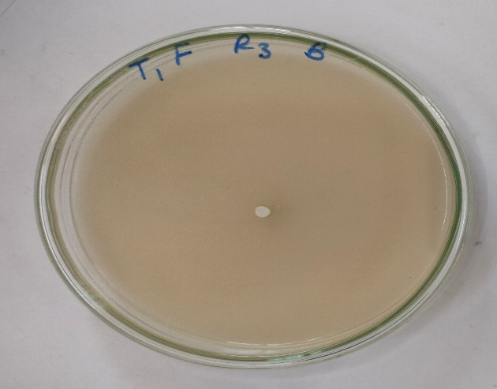  T1. Fluxapyraxad + Pyraclostrobin | 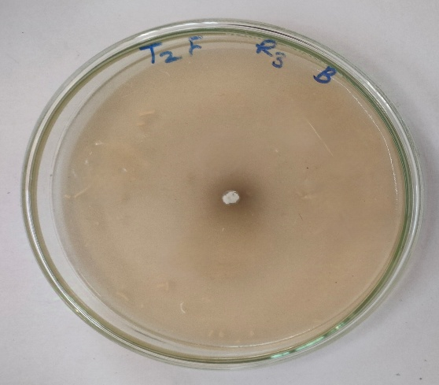  T2. Tebuconazole + Trifloxystrobin
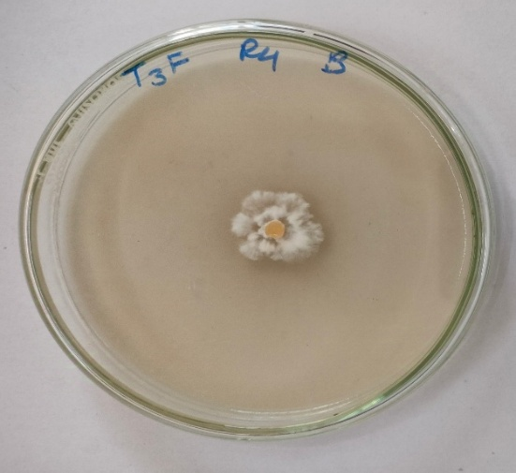  T3. Dimethomorph  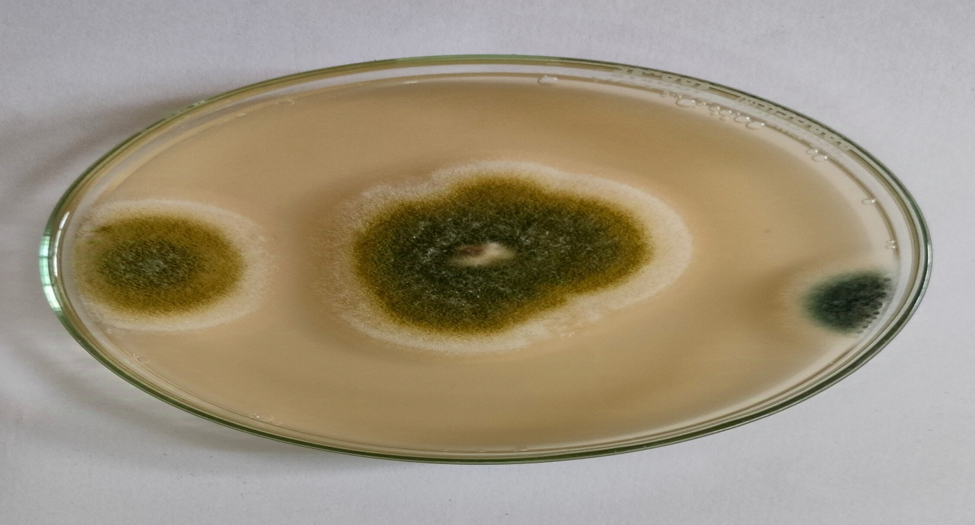 | 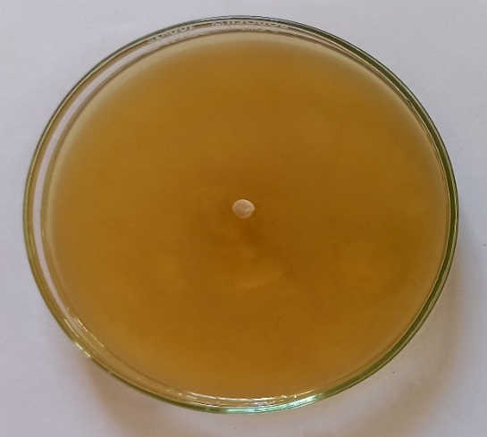  T4. Azoxystrobin + Difenoconazole
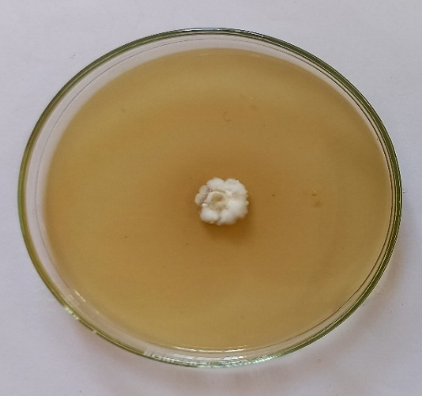  T5. Propiconazole + Difenoconzole | 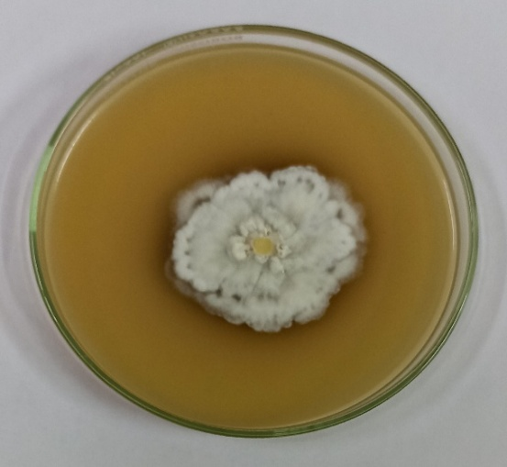  T6. Control

Plate 1. Compatibility of Beauveria bassiana with fungicides at X dose
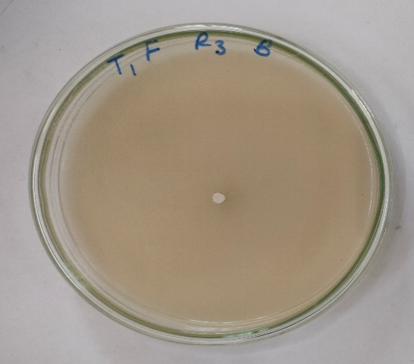  T1. Fluxapyraxad + Pyraclostrobin | 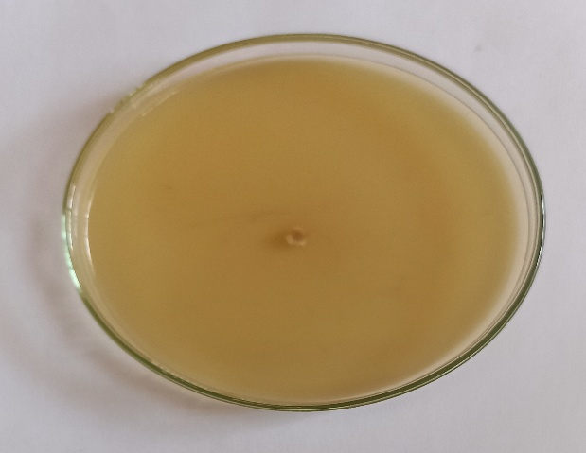  T2. Tebuconazole + Trifloxystrobin
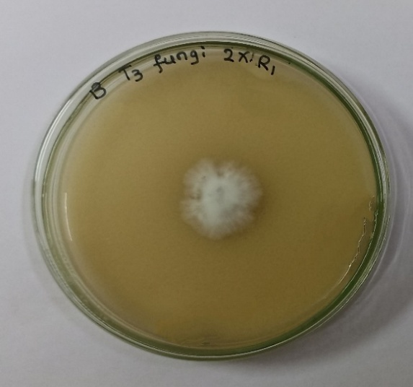  T3. Dimethomorph | 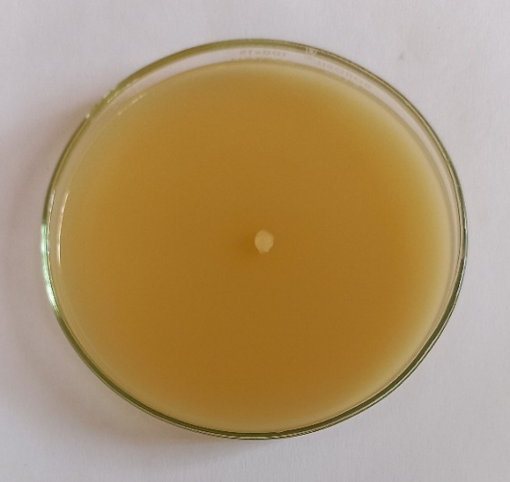  T4. Azoxystrobin + Difenoconazole
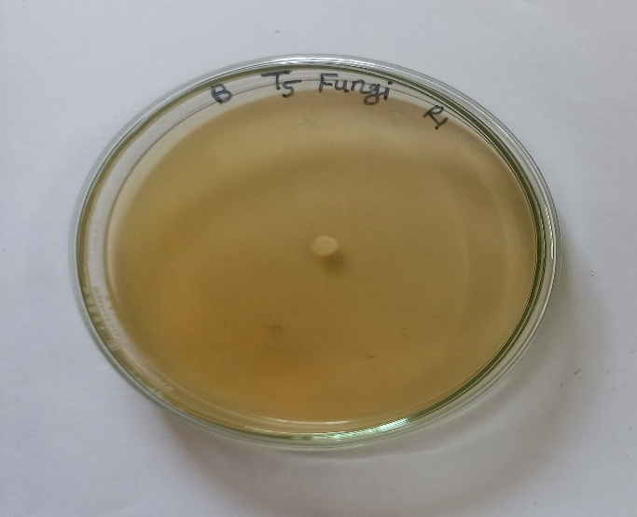  T5. Propiconazole + Difenoconazole | 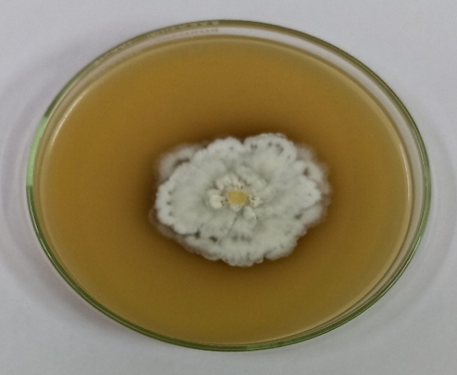  T6. Control
Plate 2. Compatibility of Beauveria bassiana with fungicides at 2X dose
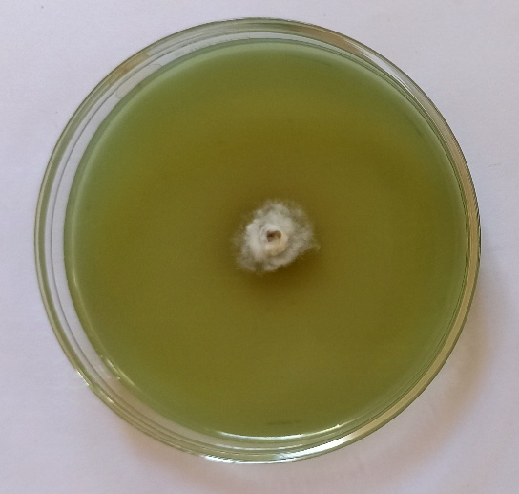  T1. Paraquat dichloride | 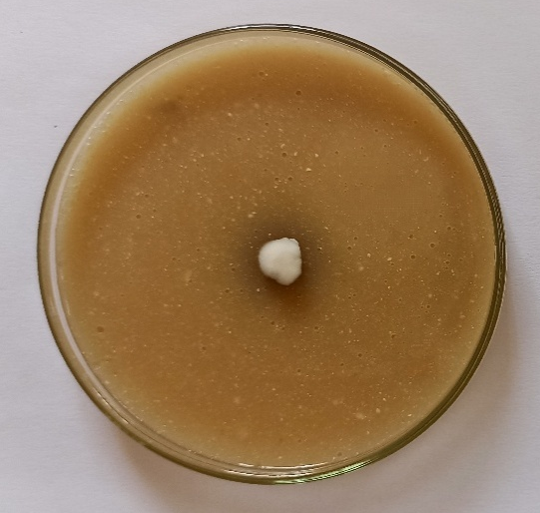  T2. Ametryne
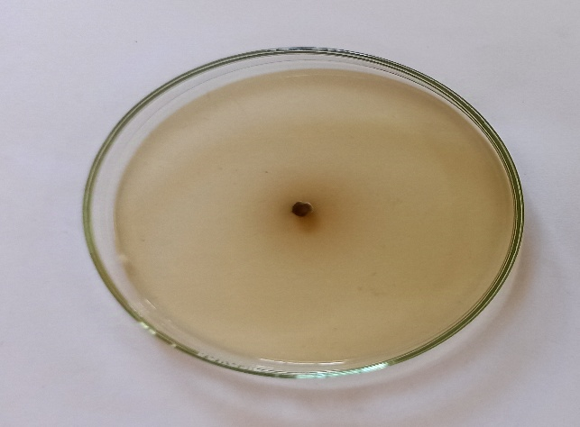  T3. Sodium acifluorfen + Clodinafop propargyl | 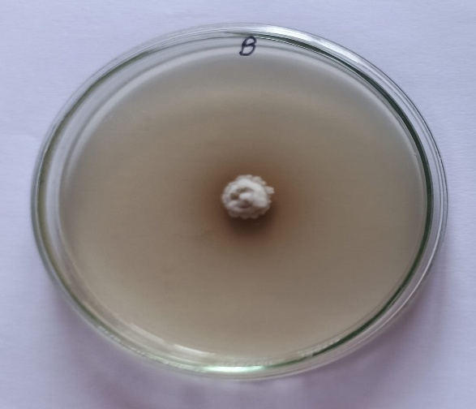  T4. Glyphosate
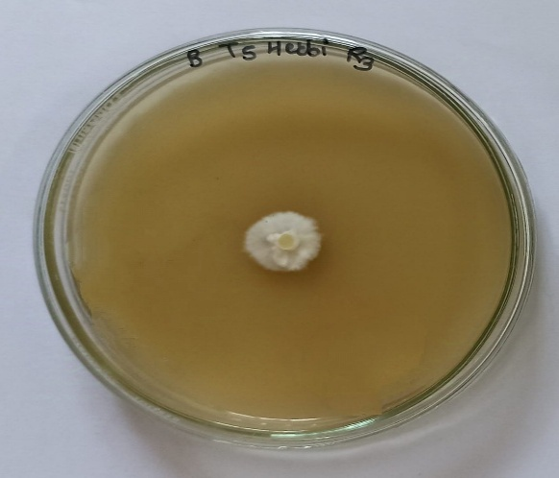  T5. Mesotrione + Atrazine | 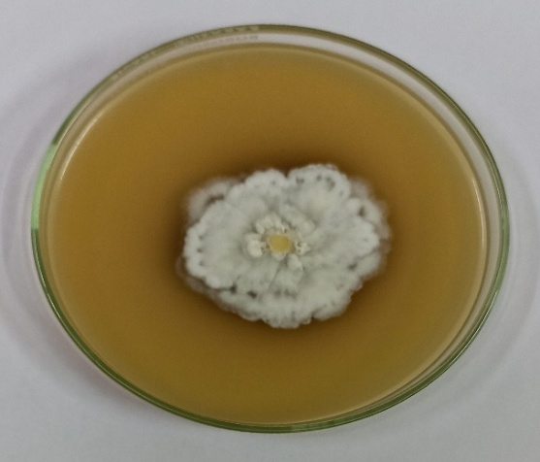  T6. Control
Plate 3. Compatibility of Beauveria bassiana with herbicides at X dose
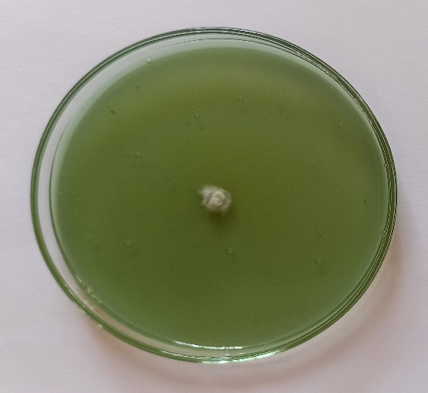  T1. Paraquat dichloride | 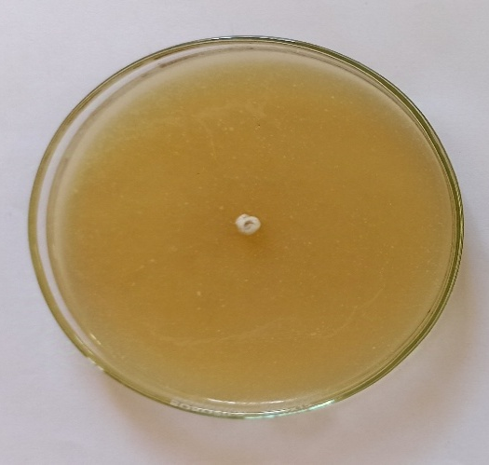  T2. Ametryne
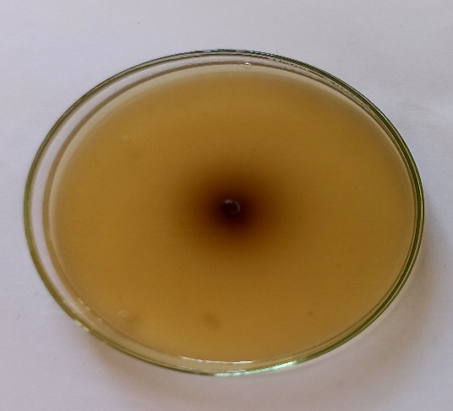  T3. Sodium acifluorfen + Clodinafop- propargyl | 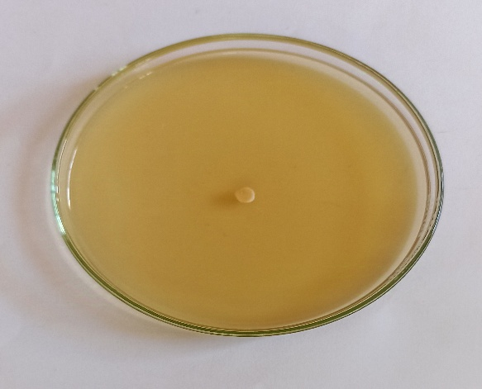  T4. Glyphosate
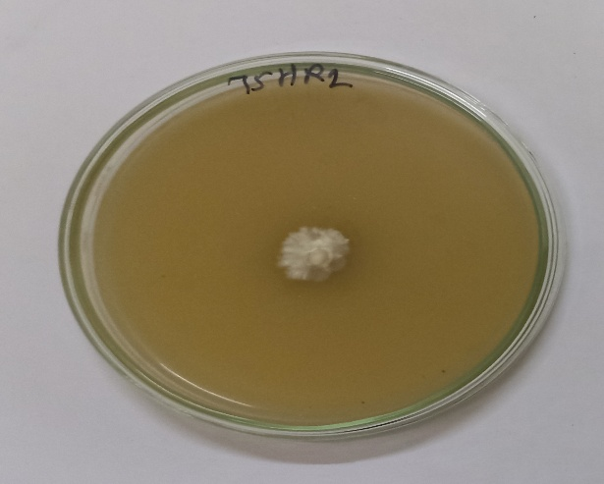  T5. Mesotrione + Atrazine | 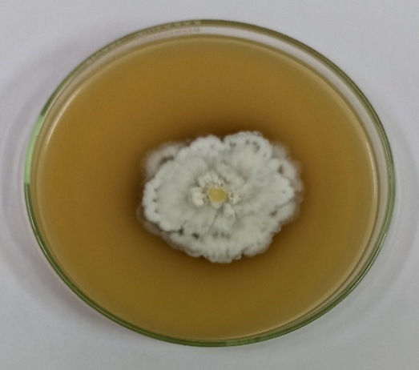  T6. Control

Plate 4. Compatibility of Beauveria bassiana with herbicides at 2X dose
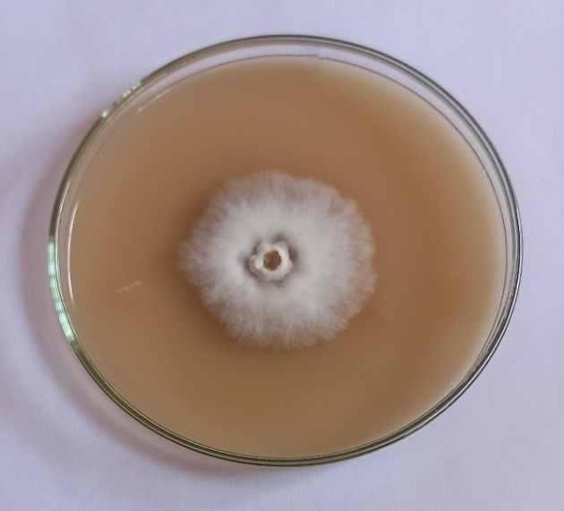  T1. Fipronil + Imidacloprid | 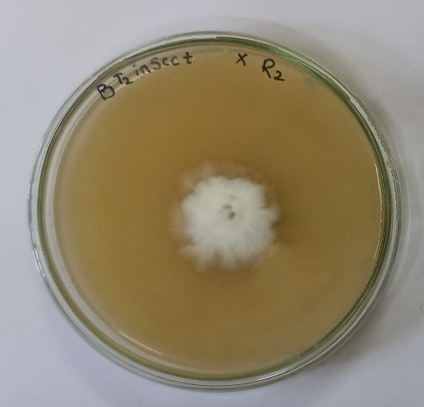  T2. Flubendiamide
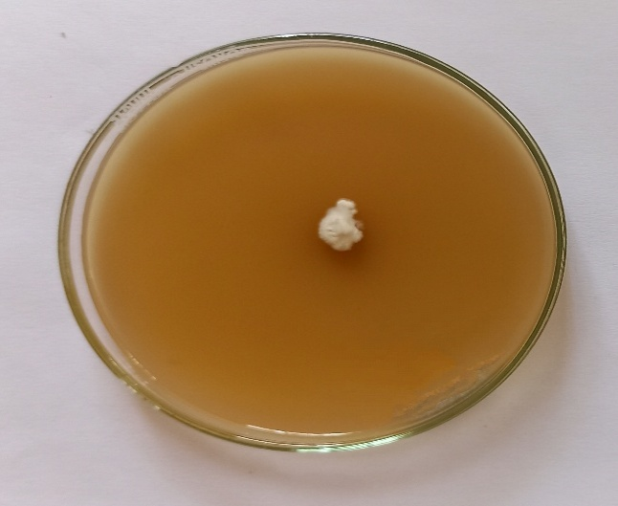  T3. Novaluron + Emamectin benzoate | 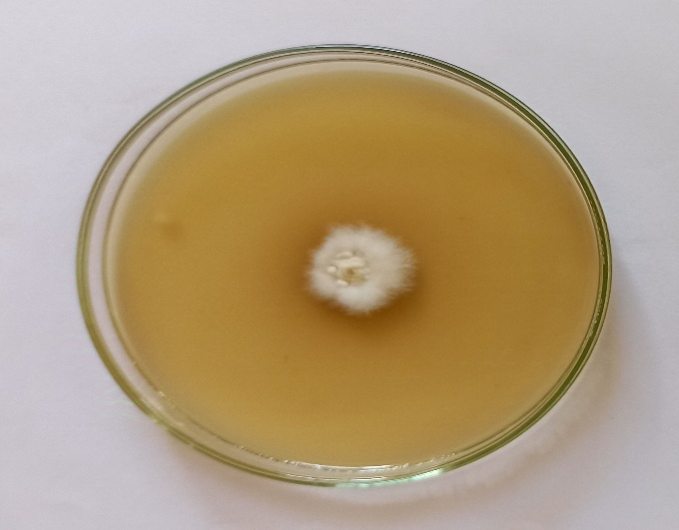  T4. Fipronil
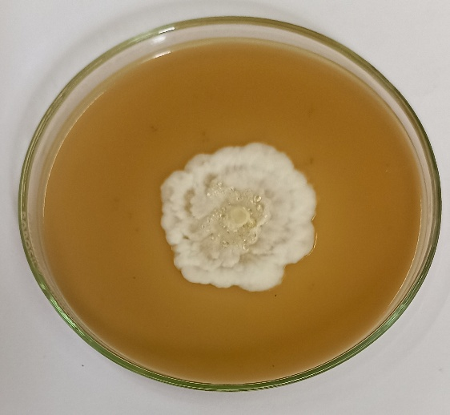  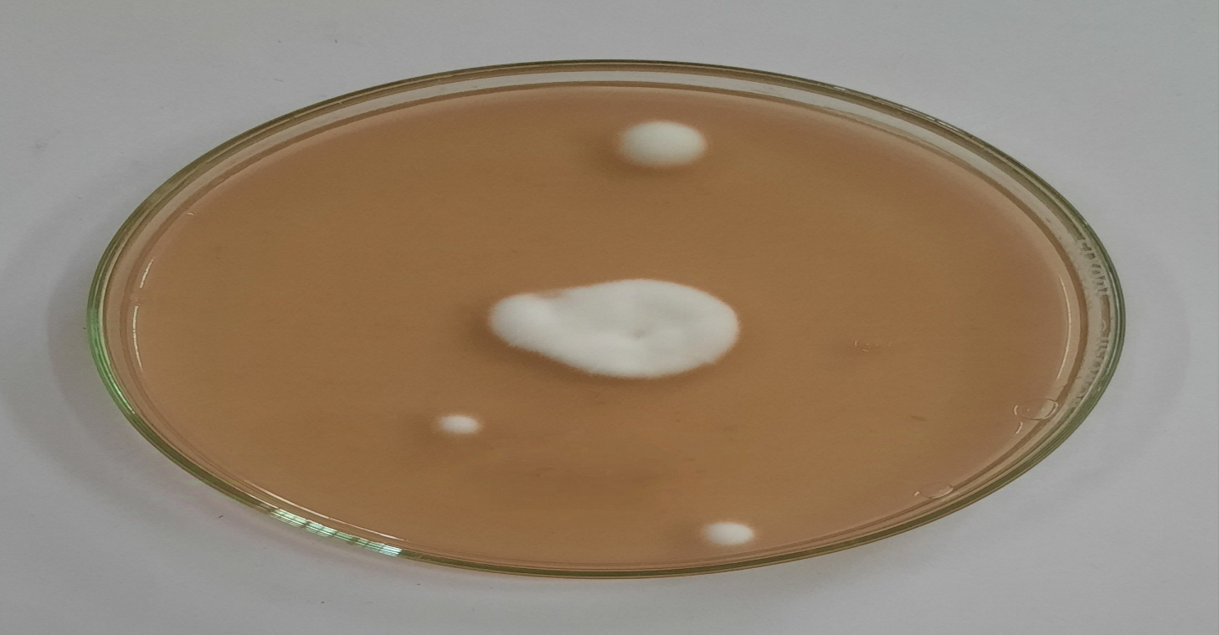  T5. Flonicamid | 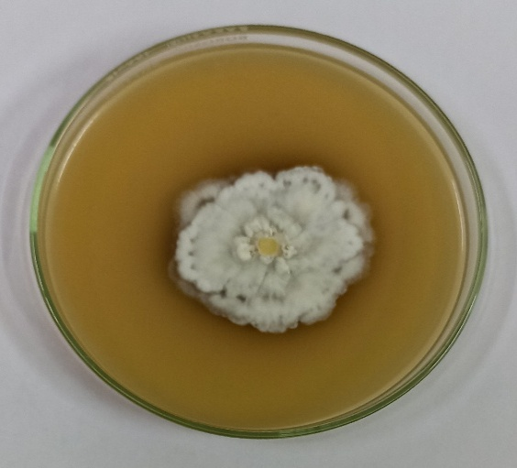  T6. Control
Plate 5. Compatibility of Beauveria bassiana with insecticides at X dose
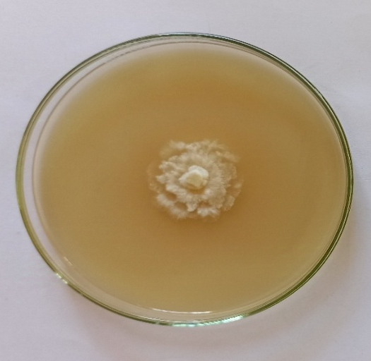  T1. Fipronil + Imidacloprid | 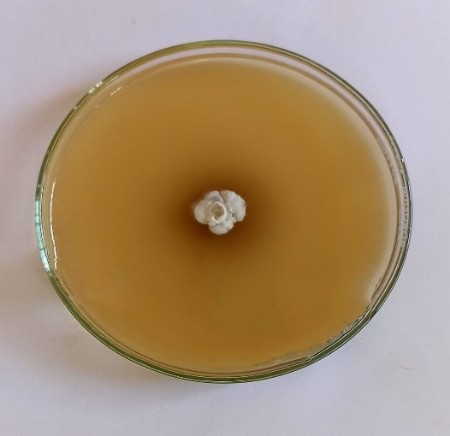  T2. Flubendiamide
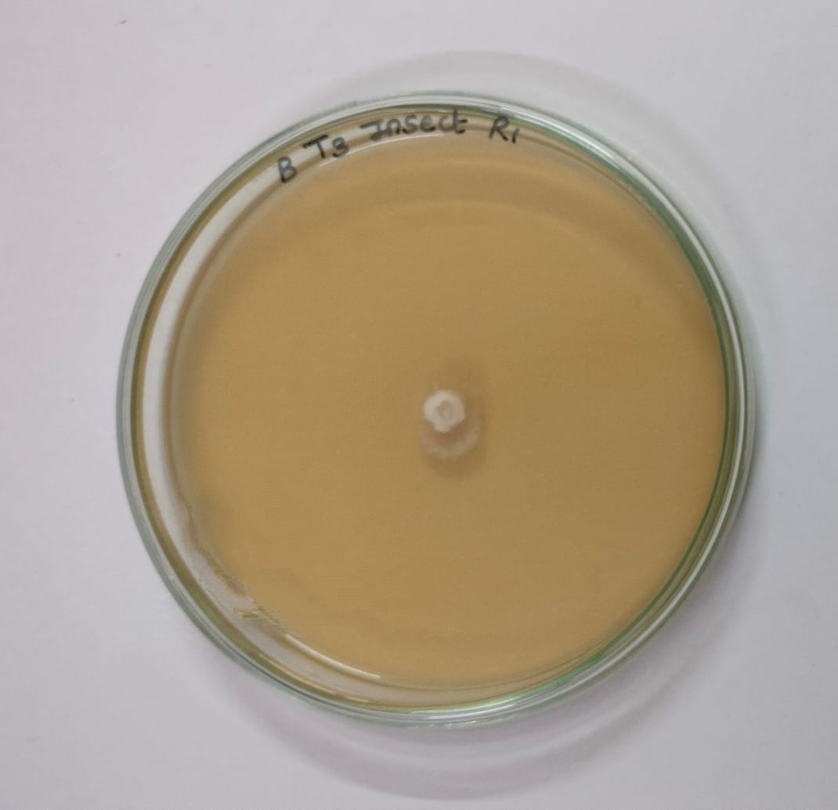  T3. Novaluron + Emamectin benzoate | 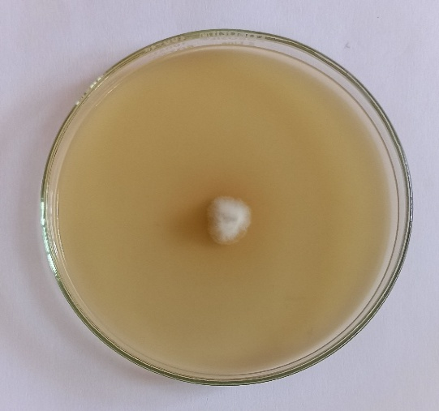  T4. Fipronil
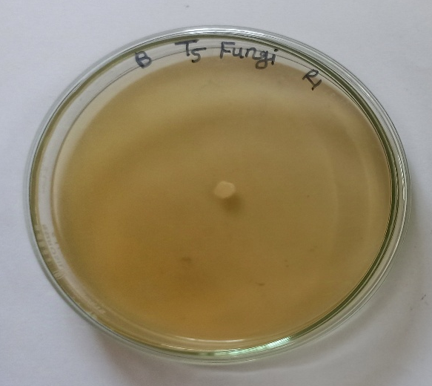  T5. Flonicamid | 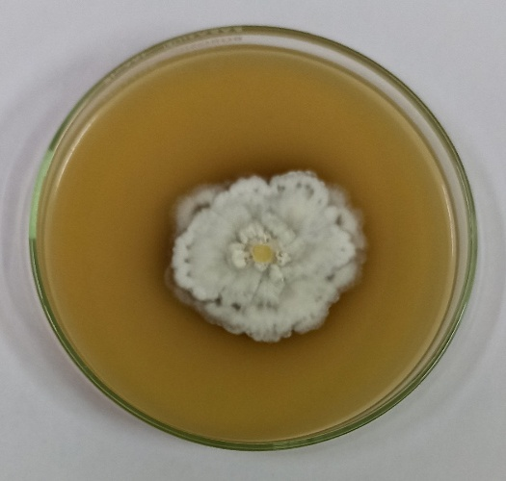  T6. Control
Plate 6. Compatibility of Beauveria bassiana with insecticides at 2X dose

