Original Research Article
Self-Help Groups as Catalysts for Financial Inclusion: A Multidimensional Study from Rural Andhra Pradesh, India

ABSTRACT
The primary objective of Deendayal Antyodaya Yojana–National Rural Livelihood Mission’s (DAY–NRLM) is to mobilize rural poor households into Self-Help Groups (SHGs). This study was conducted to find the role of SHGs in financial inclusion of members. The present study was purposively conducted in Andhra Pradesh, covering four districts through proportionate random sampling. A total of 120 respondents were randomly chosen, with 15 SHG members and 15 non-SHG members from each district. Both exploratory and descriptive research designs were employed. A financial inclusion index (FII) was developed for the study using eight dimensions and fourteen indicators. Weights were assigned based on expert judgments inputs. The results revealed that the mean FII was higher for SHG members (0.742) compared to non-members (0.375). A significant difference was observed between the two groups, with a magnitude of 17.921. While SHG members generally exhibited medium to high levels of financial inclusion, non-members were largely concentrated in the low to medium range. This study finds that variables like proximity to financial services affects the financial inclusion along with credit facilities, annual income, risk orientation are associated with financial inclusion. It recommends to link left out SHGs to financial institutions to improve their effectiveness.
KEYWORDS
Financial Inclusion Index, Self-help Groups, Normalization, National Rural Livelihood Mission, Microfinancing, Andhra Pradesh.
INTRODUCTION
Self-Help Groups (SHGs) are voluntary associations of 8–20 members who pool their resources and savings to meet financial needs as they arise (Jakimow & Kilby, 2006). They are closely linked to solidarity lending, a model widely adopted by government agencies and financial institutions to support rural development (Ministry of Rural Development, n.d.). There is a strong correlation between financial inclusion and human development, underscoring its rising prominence in development policy (Nanda & Kaur, 2016).
The National Rural Livelihood Mission (NRLM), launched in 2011 and later renamed the Deendayal Antyodaya Yojana–National Rural Livelihood Mission (DAY-NRLM) in 2016, represents one of the Government of India’s most significant initiatives to organize rural households into SHGs. NRLM was introduced through the restructuring of the Swarnajayanti Gram Swarojgar Yojana (SGSY). To achieve its objectives, the Mission invests in four core components: (a) social mobilization and the strengthening of self-managed, financially sustainable community institutions of rural women; (b) financial inclusion; (c) sustainable livelihoods; and (d) social development, social inclusion, and improved access to entitlements through convergence (Ministry of Rural Development, n.d.).
In alignment with Reserve Bank of India (RBI) regulations, banks are mandated to provide SHG members with financial services, including collateral-free loans at low interest rates, thereby addressing the challenges of exclusion from institutional finance. There are certain drawbacks in SHG maintenance, as banks contribute to financial inclusion, ground-level access to services and products remains limited (Sangwan, 2019). Thus, financial inclusion is crucial for creating awareness of financial services among economically disadvantaged groups (Babu & Thangavel, 2023). SHGs have been highly effective in strengthening both financial and social inclusion (Maity, 2023).
According to Oxfam India’s report (2023), on inequality in India, just 5 percent of Indians own more than 60 per cent of the country’s wealth in 2021, and the top 1 percent in India owns more than 40.5 percent of total wealth, while the bottom 50 per cent of the population possess only 3 per cent of the wealth. The significance lies in exposing the stark wealth inequality which highlights the urgent need for inclusive policies that address economic disparities. In this context, the Sangathan Se Samriddhi campaign comes into the limelight. It was launched by Ministry of Rural Development and Panchayati Raj. This stresses importance of SHGs rural women members, as they can contribute significantly into making our country a 5 trillion economy. Based on these data and figures, the study underlined the specific objectives as follows:
- To construct financial inclusion index with reference to SHGs
- To measure the financial inclusion of rural household members and non-members of SHGs
- To know the association of independent variables with the financial inclusion
Review of literature
Sangwan (2008) reported that the proportion of adults participating in SHGs showed a positive association with financial inclusion, particularly in access to credit accounts.
SHGs have effectively reached poorer rural populations and highlighted their strong potential for promoting financial inclusion in North East India as observed by Pati (2009).
Both SHG membership and the duration of membership significantly contribute to reducing financial exclusion and improving financial inclusion (Adhikary & Bagli 2010).
Chithra & Selvam (2013) identified socio-economic factors such as income and literacy as critical drivers of financial inclusion, alongside infrastructure elements like connectivity and information access also among banking-related variables, deposit and credit penetration were key contributors.
Banerjee et al. (2013) further showed that expanded access to financial services including credit, savings, insurance, and ATM facilities enhances household consumption, fosters self-employment, reduces poverty, and improves overall well-being.
Sarania & Maity (2014), using chi-square analysis, found that the SHG–Bank Linkage Programme significantly improved financial inclusion among SHG households compared to non-participants.
Individuals often prefer SHGs for meeting financial needs, as SHG loans are more accessible and less burdensome than formal banking procedures as stated by Dar (2017).
Sharma (2020) found that government-supported SHGs, through financial inclusion programmes, positively influenced social mobilization, poverty alleviation, and economic sustainability.
Raghunathan et al. (2019) highlighted that SHG membership improved access to bank accounts, borrowing behaviour, and consumer durable expenditure, though it had little effect on food spending.
Theoretical underpinnings and study hypotheses
The present study is grounded in an interdisciplinary theoretical framework that integrates several social and behavioural science theories to explain how SHGs facilitate financial inclusion across multiple dimensions. Social capital theory (Putnam, 1993; Bourdieu, 1986) explains how SHGs build networks of trust, reciprocity, and shared norms, enabling members to access financial services that are often inaccessible individually. Empowerment theory (Kabeer, 2010) supports the idea that SHGs enhance members' self-efficacy and decision-making, leading to improved financial behaviours such as saving and investing. The capability approach (Internet Encyclopedia of Philosophy, 1995) complements with SHG participation in expanding individuals’ real freedoms to generate income and secure livelihoods.
Further, Ostrom’s collective action theory (via, Liberto, 2024) is particularly relevant for understanding how group-based structures like SHGs effectively manage internal credit and risk-sharing mechanisms, enhancing credit inclusion and insurance coverage. Diffusion of innovation theory (Rogers, 1995) offers insight into how financial literacy and digital financial tools are adopted and internalized through SHG networks. Additionally, institutional theory (Scott, 2005) highlights the role of government and organizational support systems in shaping and sustaining SHG-based financial inclusion initiatives, particularly through public policy and formal institutional linkages.
Together, these theories provide a robust approach to analyse the mechanisms through which SHGs impact financial inclusion of members. Thus, based on these theories, eight dimensions were selected i.e., financial literacy, service access, savings, income generation, credit and insurance inclusion, digital participation, and institutional support. This integrative approach helps contextualize the multidimensional nature of financial inclusion as both a process and an outcome within SHG ecosystems.
Following the past reviews and various theories this study framed the following hypotheses (figure 1):
H₁ to H₁₇: There is linear association between the respective independent variables and financial inclusion
H₁₈: There is significant difference between members and non-members of SHGs with respect to financial inclusion.
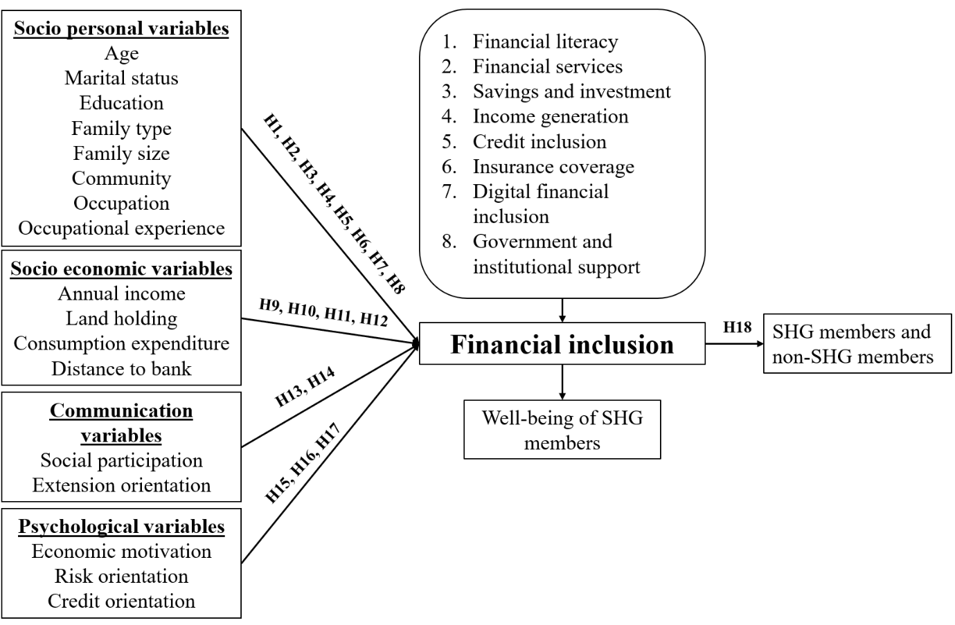
Figure 1: Framework of the study
METHODOLOGY
Sampling area and data
The study was purposively conducted in Andhra Pradesh, where four districts representing three distinct geographical regions were chosen through proportionate random sampling: Kurnool (Rayalaseema), East Godavari and NTR (Coastal Andhra), and Visakhapatnam (Uttarandhra). Data was collected in two phases, in phase 1, semi structured interviews were carried out to frame the statements and to fill out the gaps in questionnaires. This was done to assist the next phase i.e., final interview which was carried out by prepared structured interview schedule. For phase 1 (semi-structured interview), ten members and non-members of SHG were randomly sampled from area other than sampled location. For phase 2 (structured interview), fifteen members and non-members of SHG from each district, thus, sixty SHG members and sixty non-SHG members from four districts from sampled area were pooled for final interview. Total of 120 respondents were comprised in the study. For pilot study, ten members of SHG and non-SHG were sampled randomly. For relevancy testing of dimensions and indicators, the google form containing 5-point scale statements were mailed to 200 experts and out of them 30 experts’ responses were selected for assigning weights and testing relevancy of dimensions and indicators.
Sample size adequacy: Sensitivity analysis
Based on the study results, sensitivity analyses for both correlation and regression were conducted using G*Power (Faul et al., 2007) software. These analyses were performed to determine the extent to which the given sample size could detect a true effect at a power level of 0.80. The findings indicated that medium to large effect sizes could be reliably detected at the 80% power threshold (see more in results and discussion section).
Financial Inclusion Index (FII)
This section deals with construction of index in relevance of SHG members and it follows in the following specific sub-headings.
Independent and dependent variables
Selected independent and dependent variables are given in the table 1, along with its operational definition considered under the study.
Table 1: Eight dimensions’ operational definition
Dimensions | Operational definition
Habitat security | Degree of possession and utilization of different facilities required for better home environment (housing with basic amenities).
Food security | Availability and access to balanced food to meet nutritional levels of the family of respondents.
Health security | Health status and access to health care facilities of the family members.
Educational security | Educational level of the respondent and access to educational facilities including higher education.
Economic security | Respondents’ income levels, employment status and access to financial services.
Social security | Social participation, social status of the respondent and social support received as well as provided by the respondent.
Environmental security | Access to clean water, pollution free environment, implementation of climate mitigation initiatives and protection from natural calamities like flood and drought.
Institutional security | Access to government programmes, training and capacity building to the SHG members.

Construction of index
FII was constructed with 8 dimensions and 14 indicators. These were analyzed with mean relevancy score (MRS), and relevancy percentage (RP) consulting the experts (table 2) for relevancy testing. All those dimensions and indicators selected were having relevance percentage above 80 and thus all these were finalized for further processing.
MRS=(HR×5+R×4+N×3+IR×2+HIR×1)/n
RP=[(HR×5+R×4+N×3+IR×2+HIR×1)/ N] ×100
Whereas HR=Highly relevant, R=Relevant, N=Neutral, IR=Irrelevant and HIR=Highly Irrelevant, n=Total number of judges responded, and N= Maximum possible score.
Table 2: Relevancy score of dimensions and indicators
S.No. | Dimensions | MRS | RP | Indicators | RP
 | Financial literacy | 4.733 | 94.66 | Access to Financial services | 92.66
 |  |  |  | Awareness on Financial terms and concepts | 86.66
 |  |  |  | Financial decision making | 90
 | Financial services | 4.7 | 94 | Financial sources | 94.66
 |  |  |  | Bank account for financial needs | 89.33
 | Savings and investment | 4.46 | 89 | Savings propensity | 92
 |  |  |  | Investments | 85.33
 | Income generation | 4.57 | 91 | Income level from SHG operations | 94.66
 |  |  |  | Percentage increase in income level | 86.66
 | Credit inclusion | 4.26 | 85 | Loan size and Timely loan repayment | 89.33
 | Insurance coverage | 4.26 | 85 | Access to Insurance schemes | 92.66
 | Digital financial inclusion | 4.33 | 86 | Digital financial platforms (Awareness and it's usage) | 94.7
 | Government and institutional support | 4.33 | 86 | Capacity building on finance | 94
 |  |  |  | Institutional support by DAY – NRLM | 87.33

The formula to measure the financial inclusion is by following the min-max standardization method (Anand & Sen, 1995),
FII_{j} = ∑(U_{i}×W_{i})/ ∑W
Whereas,
W_{i} represents MRS of i^{th} dimension
U_{i} represents normalized value of i^{th} dimension
∑W represents the summation of the score of all dimensions i.e., ∑W=35.643.
i stands for dimension and j stands for respondent
Standardization method normalises the values between 0 and 1 to reduce bias in different scale items (Formal et al., 2009). Thus, the index constructed lies between 0 (complete financial exclusion) to 1 (complete financial inclusion).
RESULTS AND DISCUSSION
The results and discussion of primary data from respondents are given as follows.
Figure 2: Mean financial inclusion index
The findings in figure 2 depicts that financial inclusion is more for members of SHG (0.742) and it is two times more than their counter part (0.375).
Cronbach’s reliability (Cronbach, 1951) was adopted to check the internal consistency of the measuring instrument (table 3).
Table 3: Reliability statistics
Reliability Statistics |  | Scale Statistics
Cronbach's Alpha | N of Items | Mean | Variance | Standard deviation
0.724 | 8 | 19.9227 | 41.731 | 6.45999

The results (table 3) concludes that there is internal reliability in the measuring instrument with acceptable reliability, i.e., 0.724. This is statistically acceptable and reliable for the given sample size (Pallant, 2020).
The Independent sample t-test was conducted to test hypothesis on whether two group means differ significantly or not (table 4).
Table 4: Independent sample t-test under financial inclusion
t-test for Equality of Means
t | df | p (1-Sided) | p (2-Sided) | M. D | S. E. D | 95% C. I
17.921 | 118 | <.001 | <.001 | .36783 | .02053 | .32719 | .40848
M.D-Mean Difference; S.E.D-Standard Error Difference; C.I-Confidence Interval of the difference
Based on findings (table 4) it is concluded that there is significant difference between SHG and non-SHG members in the financial inclusion thus, null hypothesis is rejected while alternate hypothesis (H₁₈) is accepted. This study finding has showed, significant impact by SHGs in financial inclusion of members.
The following table 5, shows distribution of respondents based on the FII scores.
Table 5: Distribution of respondents based on index scores
Frequency distribution
Categories | Frequency | Percentage | Frequency | Percentage
Low (<0.343) | 0 | 0.0 | 28 | 46.7
Medium (0.343-0.773) | 40 | 66.7 | 32 | 53.3
High (>0.773) | 20 | 33.3 | 0 | 0.0
Total | 60 | 100.0 | 60 | 100.0
**Significant at 0.001 level
The results (table 5) shows that 66.7 percent and 33.3 percent of SHG members have medium to high level of financial inclusion while 46.7 percent and 53.3 percent of non-SHG members have low to medium level of financial inclusion.
The distribution is quite recognisable from two groups, that members of SHGs are having medium to high level, in contrast, members of non-SHGs are having low to medium level of financial inclusion.
Association of determinants with financial inclusion
The 17 determinants/independent variables selected for the study were analysed for correlation with financial inclusion, by using Pearson correlation analysis. The results are presented in the following table 6.
Table 6: Pearson correlation analysis
Particulars | Pearson correlations
Age | 0.696**
Marital status | -0.005
Educational qualification | 0.816**
Family type | 0.551**
Family size | 0.453**
Community | 0.225
Occupation | 0.493**
Occupational experience | 0.478**
Annual income | 0.536**
Land holding | 0.336**
Consumption expenditure | 0.395**
Distance to bank | -0.821**
Social participation | 0.743**
Economic motivation | 0.596**
Risk orientation | 0.592**
Credit orientation | 0.605**
Extension orientation | 0.398**
**Correlation is significant at the 0.01 level (2-tailed).
From table 6, two null hypotheses (H₂ and H₆) are accepted and remaining are rejected. Similarly, thirteen alternate hypotheses (H₁, H₃, H₄, H₅, H₇H₈, H₉, H₁₀, H₁₁, H₁₂, H₁₃, H₁₄, H₁₅, H₁₆, and H₁₇) are accepted and remaining are rejected.
The study reflected that among these variables, the 15 determinants were positively associated significantly with financial inclusion while a variable distance to bank is negatively associated. There is a significant association between all independent variables with financial inclusion except for marital status and community.
Sensitivity analysis
This analysis (figure 3) shows that with a sample size of 120, a significance level of 0.05, and a desired power of 0.80 (see Cohen, 1992), it can detect a moderate effect size of 0.319 in a point biserial correlation. The critical t-value is 1.98027, thus results beyond this threshold are statistically significant. Overall, the study is well-powered to identify meaningful relationships.

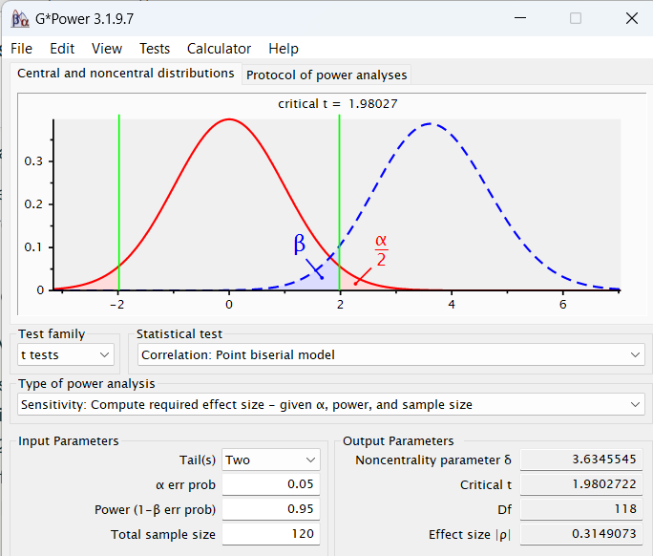 Figure 3: Sensitivity analysis under Correlation
Linear regression analysis
To know about the model fitness of this study, regression analysis was done. The results of the same are presented in the following.
Table 7: Model summary under financial inclusion
Model Summary^{b}
Model | R | R² | Adjusted R² | Standard error of the estimate | Durbin-Watson
FII | 0.943ª | 0.889 | 0.855 | 0.03100 | 2.088

From the table 7, the value of Adjusted R² is 0.855 with standard error of the estimate is 0.031. It is implied that the 85.5 percent of variance in the outcome variable is explained by the predictors. Durbin-Watson value lies around 2.088, which is desirable for model fitness.
Table 8: Analysis of variance under financial inclusion
ANOVA^{b}
Model | Sum of squares | df | Mean square | F | Sig.
Regression | 0.348 | 14 | 0.025 | 25.830** | <0.001ª
Residual | 0.043 | 45 | 0.001
Total | 0.391 | 59

The result from table 8, shows that value of regression analysis is significant at 0.001 level at magnitude being 25.830.

The following table 9, shows the results of correlational coefficients and collinearity statistics.
Table 9: Correlational coefficients and collinearity statistics under financial inclusion
Coefficients^{b} |  |  |  |  |  | Collinearity statistics
Model | Unstandardized B | Coefficients standard error | Standard coefficients beta | t | Sig. | Tolerance | VIF
(Constant) | 0.463 | 0.227 | - | 2.036* | 0.048 | - | -
Educational qualification | 0.008 | 0.003 | 0.257 | 2.374* | 0.022 | 0.209 | 4.782
Marital status | .030 | .016 | .109 | 1.952 | .057 | .794 | 1.259
Family type | .038 | .012 | .232 | 3.182 | .003 | .464 | 2.156
Family size | -0.002 | 0.002 | -0.057 | -0.796 | 0.430 | 0.473 | 2.113
Community | .013 | .017 | .040 | .759 | .452 | .867 | 1.154
Occupation | -.011 | .011 | -.064 | -.977 | .334 | .566 | 1.766
Occupational experience | -0.001 | 0.001 | -0.083 | -1.197 | 0.238 | 0.512 | 1.955
Annual income | 5.074E-7 | 0.000 | 0.175 | 2.769** | 0.008 | 0.617 | 1.622
Land holding | 0.001 | 0.002 | 0.032 | 0.549 | 0.586 | 0.747 | 1.338
Consumption expenditure | 1.096E-5 | 0.000 | 0.125 | 2.223* | 0.031 | 0.777 | 1.287
Distance to bank | -0.022 | 0.004 | -0.425 | -5.015** | <0.001 | 0.342 | 2.922
Social participation | 0.019 | 0.007 | 0.225 | 2.654* | 0.011 | 0.342 | 2.921
Economic orientation | -0.007 | 0.012 | -0.046 | -0.606 | 0.548 | 0.432 | 2.312
Extension orientation | 0.000 | 0.002 | -0.006 | -0.103 | 0.919 | 0.754 | 1.326
- Predictors: (Constant), extension orientation, marital status, community, consumption expenditure, family type, land holding, occupational experience, occupation, annual income, economic orientation, family size, social participation, distance to bank, educational qualification.
- Dependent variable: FII
**Correlation is significant at the 0.01 level (2-tailed)
*Correlation is significant at the 0.05 level (2-tailed)
The results (table 9) indicate that annual income and distance to the bank were significant predictors at the 1% level, while educational qualification, social participation, and consumption expenditure were significant at the 5% level. The overall model constant was also significant at the 5% level.
The Variance Inflation Factor (VIF) values were all below 5, confirming the absence of severe multicollinearity among the 14 predictor variables and suggesting that the model is robust. However, three variables i.e., age, risk orientation, and credit orientation, were excluded from the regression analysis due to their high multicollinearity (VIF>5 i.e., 6.198, 7.981, 9.140 respectively) with other predictors. The removal of these variables enhanced the model’s stability, thereby improving the reliability of the regression results.
Sensitivity analysis
Given study parameters (120 cases, 14 predictors, α = 0.05, power = 0.95), this design can reliably detect a minimum effect size of f² = 0.25 (medium effect) in regression model (Cohen, 1992). If the true effect is smaller than this, the study would be underpowered to detect it (at the specified error rates) (figure 4).
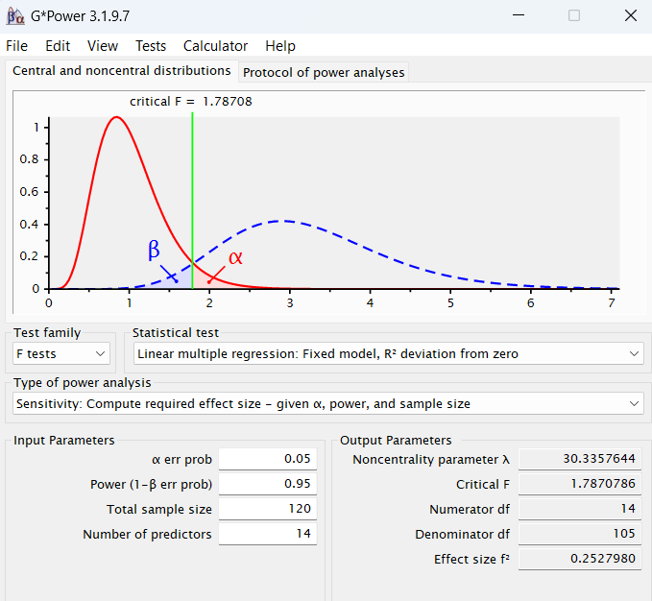
Figure 4: Sensitivity analysis under Multiple Linear Regression
CONCLUSION
The flagship programme DAY–NRLM plays a vital role in rural development, with SHGs serving as voluntary organizations that support their members in multiple ways. Through SHGs, members gain improved access to financial services and facilities. The study concludes that SHGs function as an effective platform for enhancing members’ financial conditions while simultaneously promoting social inclusion by enabling disadvantaged groups to benefit from institutional financial services.
The findings further highlight that determinants such as educational qualification, annual income, consumption expenditure, distance to the bank, and social participation significantly contribute to the financial inclusion of respondents in the study area. To strengthen this process, SHGs that remain excluded should be linked with banks to enhance their credit access, and financial institutions should consider tailoring repayment schedules to suit individual needs.
It is further recommended that for policy makers and stakeholders to focus on linking left out SHGs to financial institutions; implementing programmes on digital literacy and customise individual credit plans especially to the needy SHG members planning for livelihood diversification.
The FII developed in this study offers a replicable tool for future research, with scope for modification depending on the sampling framework and study area. Since each SHG operates within unique socio-economic contexts, focused group discussions can serve as a valuable means to identify region-specific factors influencing financial inclusion and to design localized SHG models tailored to the needs of rural communities.
Study limitations such as potential bias in selecting SHGs and their members was minimised by selecting SHG members from all possible age groups, also sampling area includes diverse geographical regions from the study area, which embraces the possible differences from diverse locations. This limitation is negligible as participants were selected randomly that represents the sampled study area.
ETHICAL APPROVAL
The research involving human participants received approval from the Social Sciences Research Ethics Committee of the ICAR–Indian Agricultural Research Institute, New Delhi. All procedures were carried out in accordance with relevant institutional guidelines and local regulations. The ethics committee/institutional review board granted a waiver for written informed consent, as the study strictly maintained participants’ anonymity. Participants were clearly informed about the objectives of the study, and their voluntary consent was obtained verbally.

COMPETING INTERESTS DISCLAIMER:
Authors have declared that they have no known competing financial interests OR non-financial interests OR personal relationships that could have appeared to influence the work reported in this paper.

Disclaimer (Artificial intelligence)
Option 1:
Author(s) hereby declare that NO generative AI technologies such as Large Language Models (ChatGPT, COPILOT, etc.) and text-to-image generators have been used during the writing or editing of this manuscript.
REFERENCES
Adhikary, M. L., & Bagli, S. (2010). Impact of SHGs on Financial Inclusion-A case study in the District of Bankura. Journal of Management and Information Technology, 2(1), 16-32.
Anand, S., & Sen, A. (1994). Human Development Index: Methodology and Measurement. 1994.
Babu, D. P. R. & Thangavel. V. (2023). Gaining Trust for Financial Inclusion Through the Emerging Tool of Micro-Finance Institutions (MFI). Available at: https://ssrn.com/abstract=4538890.
Banerjee, A.V., Duflo, E., Glennerster, R., & Kinnan, C. (2013). The miracle of microfinance? Evidence from a randomised evaluation. Working Paper 18950. NBER.
Bourdieu, P. 1986. “The Forms of Capital.” Pp. 241–58 in Handbook of theory and research for the sociology of education, edited by J. G. Richardson. New York: Greenwood Press.
Chithra, N., & Selvam, M. (2013). Determinants of financial inclusion: An empirical study on the inter-state variations in India. Available at: SSRN 2296096.
Cohen, J. (1992). A Power Primer. Psychological Bulletin, 112 (1), 155–159. https://doi.org/10.1037/0033-2909.112.1.155.
Cronbach, L. J. (1951). Coefficient alpha and the internal structure of tests. Psychometrika, 16(3), 297-334.
Dar, T. A. (2017). Role of self-help groups (SHGs) in financial inclusion-A study of Anantnag district, Jammu and Kashmir. International Journal of Management, IT and Engineering, 7(4), 424-439.
Faul, F., Erdfelder, E., Lang, A. G., & Buchner, A. (2007). G* Power 3: A flexible statistical power analysis program for the social, behavioral, and biomedical sciences. Behavior research methods, 39(2), 175-191.
Forman, G., Scholz, M., & Rajaram, S. (2009). Feature Shaping for Linear SVM Classifiers. Proceedings of the 15th ACM SIGKDD International Conference on Knowledge Discovery and Data Mining, June 28, 2009, 299–308. https://doi.org/10.1145/1557019.1557057.
India, O. (2023). Survival of the richest: the India story. The India Supplement. 7-13.
Internet Encyclopedia of Philosophy. (1995). Sen’s Capability Approach. Available online at Sen’s Capability Approach | Internet Encyclopedia of Philosophy accessed on 01 April 2024.
Jakimow, T., & Kilby, P. (2006). Empowering Women: A Critique of the Blueprint for Self-help Groups in India. Indian Journal of Gender Studies, 13(3), 375-400.
Kabeer, N. (2010). Women’s empowerment on development information. News Reach. 3-13. Available online at pr_july_august_print19_2010_Layout 1.qxd accessed on 04 April 2024.
Liberto, D. (2024). Elinor Ostrum: Early Life, Accomplishments, Theory. Investopedia. Available online at Elinor Ostrom: Early Life, Accomplishments, Theory
Maity, S. (2023). Self-help groups, microfinance, financial inclusion and social exclusion: Insight from Assam. Heliyon. 9(6): E16477.
Ministry of Rural Development. (n.d.). Deendayal Antyodaya Yojana – NRLM: Genesis. Retrieved from DAY-NRLM Aajeevika Accessed February, 05, 2024.
Nanda, K., & Kaur, M. (2016). Financial inclusion and human development: Cross-country evidence. Management and Labour Studies, 41(2), 127-153. Retrieved from https://doi.org/10.1177/0258042X16658734DIMENSIONSOFFINANCIALINCLUSION
Pallant, J. (2020). SPSS Survival Manual: A Step by Step Guide to Data Analysis Using IBM SPSS. Routledge.
Pati, A. P. (2009). Financial Exclusion to Inclusion–Do SHGs Help? Evidences from North East India. The Indian Journal of Commerce, 62(3).
Putnam, R.D. "The prosperous community: Social capital and economic growth," Current:356) 1993, p 4.
Raghunathan, K., Kannan, S., & Quisumbing, A. R. (2019). Can women’s self‐help groups improve access to information, decision‐making, and agricultural practices? The Indian case. Agricultural Economics, 50(5), 567-580. https://doi.org/10.1111/agec.12510
Rogers, Everett M. (1995). Diffusion of Innovations. 4thed. New York: Free Press. http://en.wikipedia.org/wiki/Diffusion_of_innovation
Sangwan, A. (2019). Financial Inclusion in India: An Analysis. Think India Journal. 22(4): 8051-8066.
Sangwan, S. S. (2008), “Financial Inclusion and Self Help Groups”, Available at: http://www.nabard.org/databank/IARD%20Web/csidfiles/Financial%20lnclusion%20and%20SHGs.
Sarania, R., & Maity, S. (2014). Self Help Groups (SHGS) and financial inclusion-A case study in Baksa district of Assam. International Journal of Humanities and Social Science Studies, 1(3), 137-146.
Scott, W. R. (2005). Institutional theory: Contributing to a theoretical research program. Great minds in management: The process of theory development, 37(2), 460-484.
Sharma, N. (2020). An analysis of financial inclusion in India: Trends, progress and performance of self-help groups in Punjab. Dynamics of Public Administration, 37(2), 79-94.

