Impact of Climate Change on Global Agriculture: A Review of Adaptation and Mitigation Strategies

Abstract
Climate change poses unprecedented challenges to global agricultural systems, threatening food security and rural livelihoods worldwide. These climatic alterations directly affect crop phenology, pest and disease dynamics, water availability, and soil health, ultimately compromising agricultural productivity and farmer livelihoods. This comprehensive review examines the multifaceted impacts of climate change on agriculture, focusing on temperature variations, precipitation patterns, extreme weather events, and their cascading effects on crop productivity. The review synthesises current adaptation strategies, including crop diversification, improved irrigation systems, climate-resilient varieties, and precision agriculture technologies. Rising temperatures led to alterations in the rainfall distributions. Moreover, increased frequency of droughts and floods has significantly disrupted traditional farming practices across diverse agro-ecological zones. Mitigation approaches encompass carbon sequestration in agricultural soils, reduced greenhouse gas emissions from livestock, and sustainable land management practices. The analysis reveals that while developed nations have implemented advanced technological solutions, developing countries face substantial barriers in accessing and implementing climate-smart agricultural practices. Integrated approaches combining indigenous knowledge with modern scientific innovations show promise for enhancing agricultural resilience. The review emphasises the urgent need for policy interventions, international cooperation, and increased investment in agricultural research and development. Future agricultural sustainability depends on implementing context-specific strategies that balance productivity, environmental conservation, and socio-economic viability. This synthesis provides critical insights for researchers, policymakers, and practitioners working towards climate-resilient agricultural systems in the face of ongoing environmental changes.
Keywords: climate adaptation, agricultural resilience, mitigation strategies, food security, sustainable farming
Introduction
The intricate relationship between climate change and global agriculture represents one of the most pressing challenges of the 21st century. As anthropogenic activities continue to alter the Earth's climate system, agricultural sectors worldwide face unprecedented disruptions that threaten food security, economic stability, and environmental sustainability (Xing & Wang, 2024; Datta & Behera, 2022). The Intergovernmental Panel on Climate Change (IPCC) reports indicate that global average temperatures have risen by approximately 1.1°C since pre-industrial times, with projections suggesting further increases of 1.5°C to 4°C by 2100, depending on emission scenarios (IPCC, 2021). Vulnerability depends on climate factors and the extent to which a system is exposed, its sensitivity, and adaptation capacity (Das, 2021).
Agriculture, being inherently climate-dependent, experiences profound impacts from these changes. The sector, which employs approximately 26% of the global workforce and contributes 4% to global GDP, faces mounting pressures from temperature extremes, erratic precipitation patterns, and increased frequency of extreme weather events (FAO, 2020). These climatic alterations directly affect crop phenology, pest and disease dynamics, water availability, and soil health, ultimately compromising agricultural productivity and farmer livelihoods (Bibi & Rahman, 2023; Ofori et al., 2021).
The region of South Asia exhibits a significantly elevated susceptibility to land and soil degradation. Extreme weather events, trade restrictions, and rising oil prices have resulted in the destabilisation of food security in the area (Rehman et al., 2024). The Indian subcontinent, home to diverse agro-ecological zones and supporting nearly 600 million farmers, exemplifies the complex challenges faced by agricultural systems under climate change. From the Indo-Gangetic plains to the coastal regions, farmers grapple with monsoon variability, heat stress, and unpredictable weather patterns that disrupt traditional farming calendars and practices (Kumar et al., 2021; Praveen & Sharma, 2019; Nelson et al., 2009). Drought and salinity are the two primary consequences of increasing temperatures that pose challenges to vegetable cultivation (Bhatia et al., 2025; Bedeke, 2023). The situation mirrors global trends where smallholder farmers, who produce 80% of the world's food, remain particularly vulnerable to climate impacts due to limited adaptive capacity and resource constraints (Nsabiyeze et al., 2024).
Table 1: Major Climate Change Impacts on Global Agriculture
Impact Category | Temperature Effects | Precipitation Changes | Extreme Events | Regional Variations | Economic Losses (USD)
Crop Yield Reduction | Heat stress on grain filling | Drought-induced losses | Flood damage to crops | Tropical regions most affected | 5-10 billion annually
Soil Degradation | Increased erosion rates | Reduced moisture retention | Landslides and washouts | Semi-arid zones vulnerable | 3-5 billion annually
Water Stress | Higher evapotranspiration | Aquifer depletion | Flash flood impacts | Mediterranean regions critical | 8-12 billion annually
Pest Outbreaks | Expanded pest ranges | Favorable breeding conditions | Storm-spread infestations | Temperate zone invasions | 2-4 billion annually
Livestock Impacts | Heat stress mortality | Pasture degradation | Disease outbreaks | Pastoral systems affected | 4-6 billion annually
Coastal Agriculture | Sea level rise effects | Saltwater intrusion | Storm surge damage | Delta regions threatened | 6-8 billion annually
Mountain Agriculture | Glacial melt impacts | Altered snow patterns | Avalanche risks | Himalayan regions vulnerable | 1-2 billion annually
Recent scientific evidence demonstrates that climate change affects agriculture through multiple pathways. Direct impacts include alterations in crop growth rates, changes in water availability, and shifts in suitable cultivation zones. Indirect effects manifest through changes in pest and disease prevalence, soil degradation, and market volatility. For instance, wheat production in major growing regions has declined by 5.5% due to temperature increases, while maize yields show significant variability linked to precipitation changes (Lobell et al., 2022; Yuan et al., 2024; Sinore & Wang, 2024).
The urgency of addressing climate-agriculture interactions stems from projections indicating that global food demand will increase by 50% by 2050, driven by population growth and changing dietary preferences. Simultaneously, climate change could reduce agricultural productivity by 10-25% globally by 2050, creating a critical gap between food supply and demand (Wheeler & von Braun, 2020). This convergence of increasing demand and declining productivity necessitates comprehensive strategies that enhance agricultural resilience while contributing to climate change mitigation (Safi et al., 2024).
Understanding the complex dynamics between climate change and agriculture requires interdisciplinary approaches that integrate climatology, agronomy, economics, and social sciences (Baraj et al., 2024; Omotoso & Omotayo, 2024). This review synthesises current knowledge on climate change impacts across different agricultural systems, evaluates adaptation and mitigation strategies, and identifies pathways toward sustainable agricultural transformation. By examining successful interventions and persistent challenges, this analysis aims to inform evidence-based decision-making for building climate-resilient agricultural systems capable of ensuring food security in an uncertain climatic future.
Figure 1: Global Temperature Anomalies and Agricultural Productivity
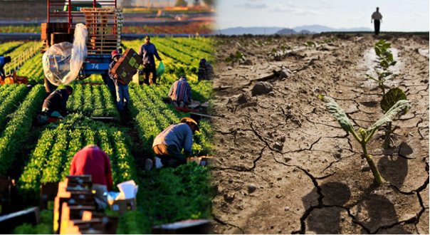
Climate Change Manifestations in Agriculture
Temperature Variations and Crop Response
Temperature changes represent the most direct climate impact on agricultural systems. Global surface temperatures have increased at an unprecedented rate, with the last decade recording the warmest years in instrumental history. This warming trend profoundly affects crop physiology, particularly during critical growth stages such as flowering and grain filling. Research indicates that for every 1°C increase in global mean temperature, yields of major crops decline by 3-7% (Zhao et al., 2021).
Heat stress impacts manifest differently across crop species. Wheat (Triticum aestivum) experiences reduced grain formation when temperatures exceed 30°C during anthesis, while rice (Oryza sativa) shows spikelet sterility at temperatures above 35°C during flowering. Maize (Zea mays) demonstrates particular vulnerability to heat stress during silk emergence and pollen shed, with yield reductions of up to 90% under extreme temperature conditions (Prasad et al., 2022).
The phenomenon of heat waves, characterised by prolonged periods of excessively hot weather, has become increasingly frequent and intense. These events cause immediate physiological stress in plants, disrupting photosynthesis, respiration, and water relations. Moreover, nighttime temperature increases, often overlooked in climate assessments, significantly impact crop productivity by increasing respiratory losses and reducing net carbon assimilation.
Precipitation Patterns and Water Availability
Climate change has fundamentally altered global precipitation patterns, creating a mosaic of water-stressed and flood-prone agricultural regions. The intensification of the hydrological cycle has resulted in more extreme precipitation events, with longer dry periods punctuated by intense rainfall. This variability poses severe challenges for rain-fed agriculture, which supports 80% of global cropland and produces 60% of the world's food (Mueller et al., 2021).
Monsoon systems, critical for agricultural production in South and Southeast Asia, show increasing variability in onset, duration, and intensity. The Indian summer monsoon, which provides 70% of annual rainfall for the subcontinent, has exhibited a weakening trend with more frequent break periods and extreme rainfall events. These changes disrupt traditional cropping calendars and increase production risks for millions of smallholder farmers.
Drought frequency and severity have increased across major agricultural regions, with particularly severe impacts in Australia, sub-Saharan Africa, and parts of North and South America. Extended drought periods not only reduce crop yields but also degrade soil structure, deplete groundwater resources, and increase vulnerability to wind erosion. The 2022 drought in the Horn of Africa affected over 36 million people, demonstrating the cascading impacts of precipitation deficits on food security.
Table 2: Regional Climate Change Impacts on Major Crops
Region | Primary Crops | Temperature Impact | Precipitation Change | Yield Change (%) | Adaptation Priority
South Asia | Rice, Wheat | +2.5°C by 2050 | Monsoon variability | -15 to -20 | Water management
Sub-Saharan Africa | Maize, Sorghum | +2.8°C by 2050 | Increased droughts | -20 to -25 | Drought tolerance
North America | Wheat, Corn | +2.0°C by 2050 | Regional variations | -10 to -15 | Technology adoption
Europe | Wheat, Barley | +2.2°C by 2050 | Northern shift | -5 to +10 | Crop diversification
South America | Soybean, Maize | +2.4°C by 2050 | Amazon drying | -15 to -20 | Forest conservation
East Asia | Rice, Vegetables | +2.1°C by 2050 | Typhoon intensity | -10 to -15 | Coastal protection
Australia | Wheat, Barley | +2.6°C by 2050 | Severe droughts | -25 to -30 | Water efficiency

Figure 2: Precipitation Anomalies and Agricultural Zones
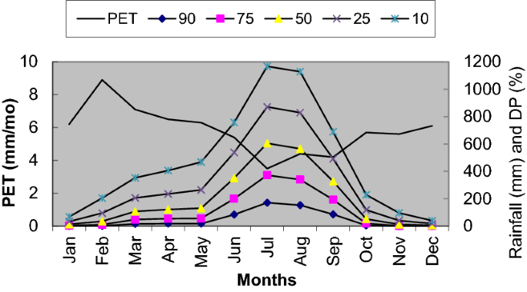
Extreme Weather Events
The increasing frequency and intensity of extreme weather events represent a paradigm shift in agricultural risk management. Tropical cyclones, with their destructive winds and flooding, cause immediate crop losses and long-term soil degradation. The 2020 Atlantic hurricane season, with a record 30 named storms, devastated agricultural areas across Central America and the Caribbean, destroying entire harvests and agricultural infrastructure.
Hailstorms, though localised, inflict severe damage on high-value crops such as fruits and vegetables. Climate models project increased hail frequency in certain regions, particularly in the mid-latitudes, where temperature and moisture conditions favour severe convective storms. These events can destroy entire orchards in minutes, representing catastrophic losses for farmers who have invested years in establishing perennial crops.
Flooding, both riverine and flash floods, has intensified due to extreme precipitation events. The 2022 Pakistan floods submerged one-third of the country, affecting 33 million people and destroying crops on 2.2 million hectares. Such events not only cause immediate crop losses but also deposit sediments, alter soil chemistry, and facilitate the spread of water-borne plant diseases.
Agricultural Vulnerability Assessment
Soil Health and Degradation
Climate change accelerates soil degradation through multiple pathways, threatening the foundation of agricultural productivity. Increased temperatures enhance organic matter decomposition, reducing soil carbon stocks and compromising soil structure. This degradation is particularly severe in tropical regions where high temperatures and intense rainfall create conditions for rapid nutrient loss and erosion.
Soil erosion rates have increased dramatically under changing precipitation patterns. Intense rainfall events on bare or poorly covered soils can remove 50-100 tons of topsoil per hectare in a single event, representing centuries of soil formation lost in hours (Montgomery, 2021). Wind erosion, exacerbated by drought and higher temperatures, affects arid and semi-arid regions, creating dust storms that transport fertile topsoil across vast distances.
The interaction between climate change and soil biology reveals complex feedback mechanisms. Soil microbial communities, essential for nutrient cycling and plant health, show altered composition and activity under changing temperature and moisture regimes. These shifts affect nitrogen fixation, organic matter decomposition, and disease suppression functions, ultimately impacting crop productivity and resilience.
Water Resources and Irrigation
Water scarcity, amplified by climate change, emerges as the primary constraint to agricultural productivity in many regions. Globally, agriculture consumes 70% of freshwater withdrawals, with irrigation covering 20% of cultivated land but producing 40% of the global food supply (FAO, 2021). Climate change threatens this delicate balance through altered precipitation patterns, increased evapotranspiration, and declining groundwater resources.
Glacier-fed river systems, supporting agriculture for billions of people, face unprecedented changes. The Hindu Kush Himalayan region, often called the "Third Pole," shows accelerated glacial retreat, affecting water availability for downstream agricultural areas in India, Pakistan, Bangladesh, and China. Peak water scenarios, where glacial melt initially increases river flow before dramatic declines, create planning challenges for irrigation infrastructure and crop selection.
Groundwater depletion, accelerated by climate-induced surface water scarcity, threatens agricultural sustainability in major food-producing regions. The Indo-Gangetic Basin, California's Central Valley, and the North China Plain show alarming rates of aquifer depletion, with water tables dropping 1-3 meters annually in intensive agricultural areas. This unsustainable extraction creates a vicious cycle where farmers drill deeper wells, increasing energy costs and carbon emissions.
Table 3: Water Stress Indicators in Major Agricultural Regions
Region | Water Stress Level | Irrigation Dependency | Groundwater Depletion | Climate Projection | Adaptation Capacity
Middle East | Extremely High | 85% cropland | 5-8 m/year decline | Severe water scarcity | Limited resources
North India | High | 65% cropland | 3-5 m/year decline | Monsoon uncertainty | Moderate potential
California | High | 70% cropland | 2-4 m/year decline | Drought intensification | High technology
North China | Very High | 75% cropland | 3-6 m/year decline | Reduced precipitation | Government support
Sahel Africa | High | 15% cropland | Variable depletion | Extreme variability | Low infrastructure
Mediterranean | Moderate-High | 55% cropland | 1-3 m/year decline | Summer drought | EU funding available
Australia | Variable | 40% cropland | 2-4 m/year decline | Cyclical droughts | Advanced systems
Figure 3: Global Water Stress and Agricultural Regions
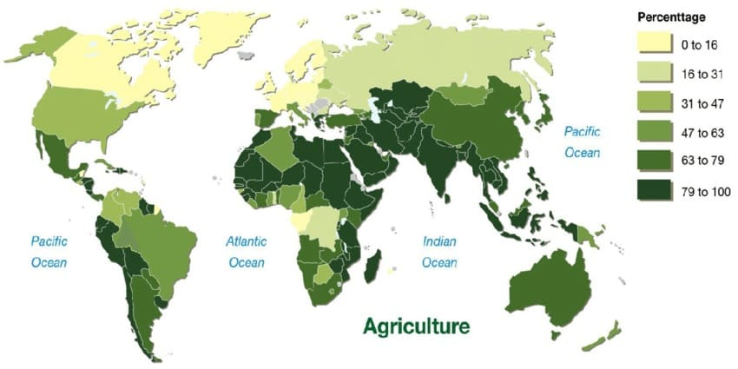
Pest and Disease Dynamics
Climate change fundamentally alters the geographic distribution, life cycles, and population dynamics of agricultural pests and diseases. Warming temperatures enable pests to expand their ranges poleward and to higher elevations, invading previously unsuitable habitats. The fall armyworm (Spodoptera frugiperda), native to the Americas, has rapidly spread across Africa and Asia since 2016, causing billions of dollars in crop losses.
Temperature increases accelerate insect development rates, potentially increasing the number of generations per year. For every 1°C increase in temperature, insect metabolic rates increase by 10-15%, leading to higher feeding rates and faster reproduction. This acceleration particularly affects crops in temperate regions, where pest pressure has historically been limited by cold winters.
Plant diseases show complex responses to climate change, with fungal and bacterial pathogens exhibiting altered virulence and transmission patterns. Wheat rust diseases, caused by Puccinia species, have evolved new strains capable of overcoming resistance genes, with warm, humid conditions favouring rapid disease spread. The coffee berry borer (Hypothenemus hampei), previously limited by temperature at high elevations, now infests coffee plantations above 1,500 meters, threatening premium arabica production.
Adaptation Strategies in Agriculture
Crop Diversification and Resilient Varieties
Diversification represents a fundamental strategy for building agricultural resilience against climate variability. Moving beyond monoculture systems to incorporate multiple crops, varieties, and production systems spreads risk and enhances ecosystem services. Successful diversification includes spatial diversity (intercropping, agroforestry), temporal diversity (crop rotations, relay cropping), and genetic diversity (variety mixtures, landraces).
Development of climate-resilient crop varieties through conventional breeding and biotechnology offers promising adaptation pathways. Drought-tolerant maize varieties, developed through marker-assisted selection, show yield advantages of 20-30% under water stress conditions. Heat-tolerant wheat varieties, incorporating genes from wild relatives, maintain productivity at temperatures 2-3°C higher than conventional varieties. The integration of indigenous knowledge in identifying stress-tolerant landraces provides valuable genetic resources for breeding programs.
Participatory plant breeding approaches, involving farmers in variety selection and testing, ensure that new varieties meet local preferences and perform well under diverse farm conditions. These programs have successfully developed varieties adapted to specific microclimates, soil types, and management practices, demonstrating the importance of decentralized adaptation strategies.
Sustainable Water Management
Improving water use efficiency in agriculture requires integrated approaches combining infrastructure development, technology adoption, and institutional reforms. Micro-irrigation systems, including drip and sprinkler irrigation, can reduce water consumption by 30-50% while maintaining or increasing yields. However, adoption remains limited in developing countries due to high initial costs and technical knowledge requirements.
Deficit irrigation strategies, applying water below full crop requirements during specific growth stages, optimize water productivity without significant yield penalties. Research indicates that reducing irrigation by 20-30% during vegetative growth stages can maintain 90-95% of full irrigation yields while substantially reducing water consumption. These approaches require precise knowledge of crop water requirements and stress tolerance at different growth stages.
Rainwater harvesting and soil moisture conservation techniques offer low-cost adaptation options for smallholder farmers. Traditional practices such as contour bunding, terracing, and mulching, combined with modern innovations like permeable barriers and moisture sensors, enhance water capture and retention. Farm ponds and check dams provide supplemental irrigation during dry spells, reducing crop failure risks in rain-fed systems.
Table 4: Climate-Smart Agricultural Practices and Adoption Rates
Practice Category | Specific Technology | Adoption Rate (%) | Yield Impact | Water Saving | Cost-Benefit Ratio
Precision Agriculture | GPS-guided systems | 15-20 globally | +10-15% | 20-30% | 1:2.5
Conservation Tillage | Zero tillage | 25-30 globally | +5-10% | 15-25% | 1:3.0
Drought-Tolerant Varieties | Hybrid seeds | 35-40 in target areas | +20-30% | 25-35% | 1:4.0
Micro-irrigation | Drip systems | 10-15 globally | +15-25% | 40-50% | 1:2.0
Agroforestry | Tree-crop systems | 20-25 in suitable areas | +15-20% | 20-30% | 1:3.5
Integrated Pest Management | Biocontrol agents | 30-35 globally | +10-15% | Indirect | 1:2.8
Climate Information Services | Weather advisories | 40-50 with mobile access | +8-12% | 15-20% | 1:5.0
Figure 4: Adoption Rates of Climate-Smart Technologies
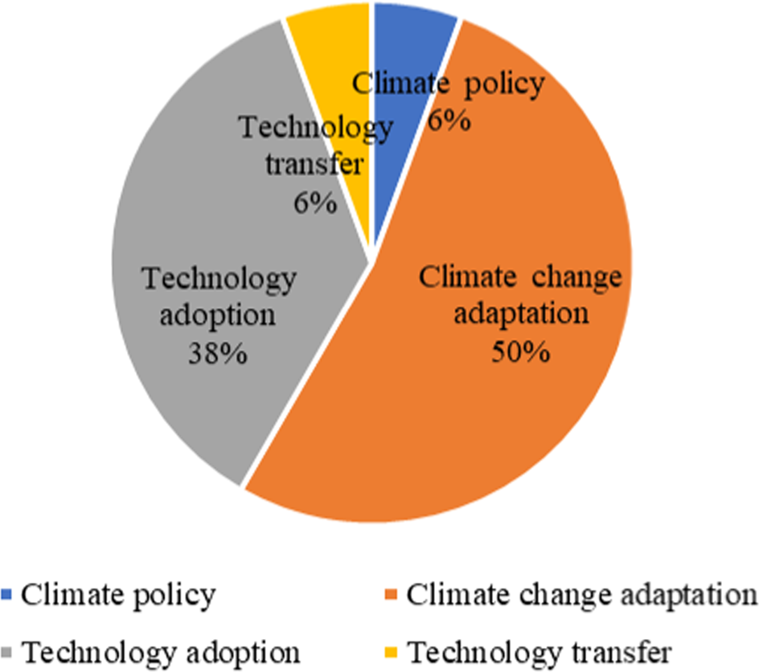
Precision Agriculture Technologies
Digital technologies revolutionise agricultural adaptation through precise resource management and data-driven decision-making. Remote sensing technologies, utilising satellite imagery and drones, enable real-time monitoring of crop health, soil moisture, and pest infestations. Machine learning algorithms process vast datasets to predict optimal planting dates, irrigation schedules, and harvest timing under variable climate conditions.
Variable rate technology (VRT) allows farmers to apply inputs based on field variability, reducing waste and environmental impact while optimising productivity. GPS-guided tractors and implements ensure precise application of seeds, fertilisers, and pesticides, reducing overlaps and gaps. These technologies show particular promise for large-scale farming operations, though costs remain prohibitive for smallholders.
Internet of Things (IoT) sensors deployed across farms provide continuous monitoring of environmental parameters, including temperature, humidity, soil moisture, and wind speed. This data, integrated with weather forecasts and crop models, enables predictive analytics for pest outbreaks, disease risk, and irrigation requirements. Early warning systems based on these technologies can reduce crop losses by 15-25% through timely interventions.
Mitigation Approaches in Agriculture
Carbon Sequestration Strategies
Agricultural soils represent a significant carbon sink with the potential to mitigate climate change while improving soil health and productivity. Conservation agriculture practices, including minimal tillage, permanent soil cover, and crop rotations, can sequester 0.5-1.5 tons of carbon per hectare annually. Global adoption of these practices on suitable croplands could offset 5-10% of agricultural greenhouse gas emissions.
Cover cropping, incorporating nitrogen-fixing legumes and deep-rooted species, enhances soil carbon storage while providing multiple co-benefits. Research demonstrates that winter cover crops can add 1-2 tons of organic matter per hectare annually, improving soil structure, water retention, and nutrient cycling. The selection of appropriate cover crop species based on local climate and soil conditions determines sequestration potential and economic viability.
Biochar application, produced from agricultural residues through pyrolysis, offers long-term carbon storage potential. Studies indicate that biochar can persist in soils for hundreds to thousands of years while improving soil fertility and water retention. Application rates of 5-10 tons per hectare show significant improvements in crop yields, particularly in degraded tropical soils, while sequestering carbon equivalent to 2-4 tons of CO₂ per hectare.
Greenhouse Gas Emission Reduction
Methane emissions from rice cultivation, contributing 10% of agricultural greenhouse gas emissions, can be reduced through alternate wetting and drying (AWD) irrigation. This practice reduces methane emissions by 30-50% while saving 15-30% of irrigation water without yield penalties. Successful implementation requires farmer training and reliable water control infrastructure.
Nitrogen management optimisation reduces nitrous oxide emissions while improving nitrogen use efficiency. Precision application technologies, enhanced efficiency fertilisers, and biological nitrogen fixation can reduce emissions by 20-30%. The use of nitrification inhibitors and controlled-release fertilisers shows particular promise in high-input systems where nitrogen losses represent both economic and environmental costs.
Livestock management improvements target methane emissions from enteric fermentation and manure management. Dietary modifications, including lipid supplementation and improved forage quality, can reduce methane emissions by 10-20% per unit of animal product. Manure management systems incorporating anaerobic digestion generate renewable energy while reducing emissions, creating economic incentives for adoption.
Table 5: Mitigation Potential of Agricultural Practices
Mitigation Practice | GHG Reduction Potential | Carbon Sequestration | Implementation Cost | Co-benefits
Conservation Agriculture | 1.5-2.0 tCO₂e/ha/yr | 0.5-1.5 tC/ha/yr | Low-Moderate | Soil health improvement
Agroforestry Systems | 2.0-4.0 tCO₂e/ha/yr | 1.0-3.0 tC/ha/yr | Moderate | Biodiversity, income
Improved Rice Management | 1.0-1.5 tCO₂e/ha/yr | 0.2-0.5 tC/ha/yr | Low | Water saving
Optimized N Fertilization | 0.5-1.0 tCO₂e/ha/yr | Minimal | Low-Moderate | Cost savings
Biochar Application | 2.0-4.0 tCO₂e/ha once | 2.0-4.0 tC/ha once | High | Soil improvement
Improved Livestock Feed | 0.2-0.4 tCO₂e/animal/yr | None | Moderate | Productivity gains
Manure Management | 0.5-1.0 tCO₂e/animal/yr | 0.1-0.3 tC/ha/yr | High | Energy generation
Renewable Energy Integration
Agricultural operations increasingly integrate renewable energy systems to reduce fossil fuel dependence and operational costs. Solar-powered irrigation systems show particular promise in off-grid areas, with costs declining by 70% over the past decade. These systems enable irrigation expansion in remote areas while eliminating diesel fuel emissions and reducing operational costs by 50-70% over system lifetime.
Agrivoltaics, combining solar panels with crop production, optimises land use while generating clean energy. Studies demonstrate that partial shading from elevated solar panels can reduce water requirements by 15-30% while maintaining 80-90% of crop yields. Suitable crops include shade-tolerant vegetables, berries, and certain grains, with economic returns from both electricity generation and crop production.
Wind energy development on agricultural lands provides additional income streams for farmers while maintaining agricultural production. Properly sited wind turbines occupy less than 1% of land area, allowing continued cultivation around turbine foundations. Lease payments for wind turbines can provide stable income that helps farmers manage climate-related production risks.
Policy and Institutional Frameworks
Climate-Smart Agriculture Policies
Effective policy frameworks must balance productivity, adaptation, and mitigation objectives while addressing equity concerns and implementation barriers. National adaptation plans increasingly mainstream climate considerations into agricultural policies, though implementation remains uneven. Successful examples include Ethiopia's Climate Resilient Green Economy strategy and India's National Mission for Sustainable Agriculture.
Figure 5: Carbon Sequestration Pathways in Agriculture
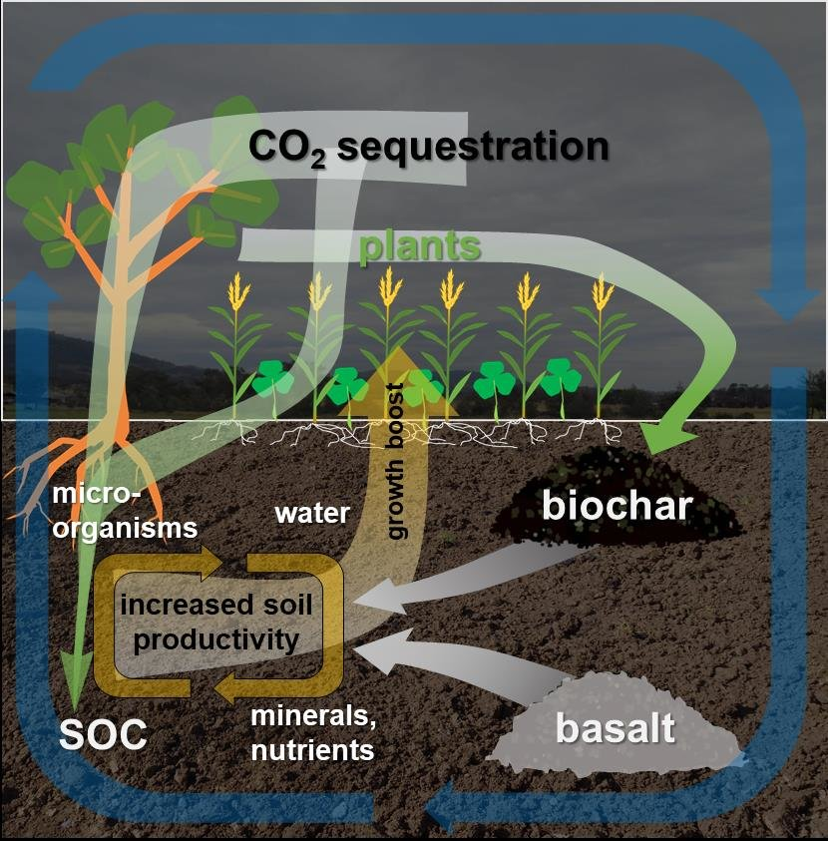
Incentive mechanisms for the adoption of climate-smart practices require careful design to ensure effectiveness and equity. Payment for ecosystem services programs, compensating farmers for carbon sequestration and biodiversity conservation, show promise but face challenges in measurement, verification, and transaction costs. Subsidies for climate-smart technologies must avoid market distortions while ensuring accessibility for resource-poor farmers.
Insurance mechanisms, including weather-indexed insurance and crop insurance reforms, provide safety nets against climate risks. Index-based insurance, triggered by objective weather parameters rather than field assessments, reduces transaction costs and moral hazard. However, basis risk, where insurance payouts don't match actual losses, remains a challenge requiring improved weather monitoring networks and index design.
International Cooperation and Finance
Climate finance for agricultural adaptation remains inadequate relative to needs, with only 3% of global climate finance directed to agriculture despite the sector's vulnerability and mitigation potential. The Green Climate Fund and other multilateral mechanisms must scale up agricultural investments while ensuring funds reach smallholder farmers who face the greatest climate risks.
Technology transfer mechanisms facilitate access to climate-smart innovations, though intellectual property rights and capacity constraints limit effectiveness. South-South cooperation shows particular promise, with countries sharing similar agro-ecological conditions exchanging adapted technologies and practices. The CGIAR network plays a crucial role in developing and disseminating climate-resilient crop varieties and management practices.
Trade policies significantly influence agricultural adaptation and mitigation outcomes. Climate-induced production shocks increase food price volatility, with export restrictions exacerbating global food security challenges. International agreements must balance national food security concerns with the need for open, predictable trade systems that enable efficient resource allocation under climate change.
Table 6: Investment Requirements for Climate-Resilient Agriculture
Investment Category | Annual Need (USD Billion) | Current Investment | Funding Gap | Priority Regions | Implementation Period | Expected Returns
Irrigation Infrastructure | 80-120 | 25-35 | 55-85 | Asia, Africa | 10-15 years | 3:1 benefit-cost
Research & Development | 15-25 | 5-8 | 10-17 | Global | Continuous | 10:1 social returns
Extension Services | 10-15 | 3-5 | 7-10 | Developing countries | 5-10 years | 5:1 benefit-cost
Climate Information | 5-10 | 1-2 | 4-8 | Global | 3-5 years | 8:1 benefit-cost
Insurance Systems | 20-30 | 5-10 | 15-20 | Vulnerable regions | 5-8 years | Risk reduction
Value Chain Development | 30-50 | 10-15 | 20-35 | All regions | 8-12 years | 4:1 benefit-cost
Renewable Energy | 40-60 | 15-20 | 25-40 | Off-grid areas | 10-15 years | 2.5:1 benefit-cost

Figure 6: Climate Finance Flows to Agriculture
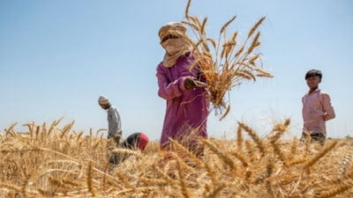
Regional Case Studies and Success Stories
Asian Innovations in Rice Production
The System of Rice Intensification (SRI), originating in Madagascar and adapted across Asia, demonstrates successful climate adaptation through modified cultivation practices. SRI practices, including reduced plant density, intermittent flooding, and organic matter incorporation, increase yields by 20-50% while reducing water consumption by 25-40% and methane emissions by 40-60%. Adoption across India, China, and Southeast Asia covers over 5 million hectares, benefiting millions of smallholder farmers.
Climate-smart villages in India's Indo-Gangetic Plains showcase integrated adaptation approaches. These villages implement a portfolio of practices including laser land levelling, zero tillage wheat, crop diversification, and weather-based advisory services. Participating farmers report 15-25% yield increases, 20-30% reduction in irrigation water use, and improved resilience to climate extremes. The model's success has led to scaling initiatives targeting 500 villages across climate-vulnerable regions.
Vietnam's Mekong Delta, facing sea level rise and salinity intrusion, demonstrates successful adaptation through aquaculture integration. Farmers transitioning from rice monoculture to rice-shrimp systems maintain food production while adapting to increasing salinity. These systems provide 50-70% higher income than rice monoculture while creating ecological benefits through reduced pesticide use and enhanced biodiversity.
African Agricultural Transformation
Conservation agriculture adoption in southern Africa, promoted through farmer field schools and innovation platforms, shows significant impacts on productivity and resilience. In Zambia, Zimbabwe, and Malawi, over 300,000 farmers practice conservation agriculture, achieving yield increases of 50-100% in drought years. The integration of drought-tolerant maize varieties, legume rotations, and minimal tillage creates synergies that enhance system resilience.
Ethiopia's Productive Safety Net Programme, combining social protection with climate adaptation, demonstrates successful integration of development and adaptation objectives. The program supports 8 million vulnerable people through public works that build climate resilience, including soil and water conservation, irrigation development, and reforestation. Participating households show improved food security and reduced distress asset sales during droughts.
Push-pull technology for pest management in East Africa exemplifies ecological intensification approaches. This system, using Desmodium species as intercrops and Napier grass as border crops, controls stem borers and Striga weed while improving soil fertility. Adoption by over 200,000 farmers has increased maize yields by 100-200% without pesticides, demonstrating the potential of biodiversity-based solutions.
Table 7: Successful Climate Adaptation Projects Worldwide
Project/Region | Key Innovation | Scale (Beneficiaries) | Impact Metrics | Investment (USD) | Sustainability Score
SRI - Asia | Water-saving rice | 5 million farmers | +30% yield, -35% water | 500 million | High (8/10)
Climate-Smart Villages - India | Integrated approach | 50,000 households | +20% income, resilience | 150 million | High (7/10)
Conservation Agriculture - Africa | Minimum tillage | 300,000 farmers | +75% yield in droughts | 200 million | Medium (6/10)
Push-Pull - East Africa | Biological control | 200,000 farmers | +150% yield, no pesticides | 50 million | Very High (9/10)
Aquaculture Integration - Vietnam | Rice-shrimp systems | 100,000 farmers | +60% income, adaptation | 300 million | High (8/10)
Drought Early Warning - Kenya | Mobile advisories | 2 million pastoralists | Reduced livestock loss | 80 million | High (7/10)
Latin American Sustainable Intensification
Brazil's integrated crop-livestock-forestry systems exemplify sustainable intensification under climate change. These systems combine annual crops, pastures, and tree components in spatial or temporal arrangements, increasing land use efficiency by 200-300%. Carbon sequestration rates reach 5-8 tons CO₂ per hectare annually, while diversified production streams enhance economic resilience. Over 11 million hectares currently employ these systems, with government targets of 35 million hectares by 2030.
Colombian coffee farmers facing temperature-driven altitude shifts demonstrate successful adaptation through shade management and variety diversification. Agroforestry coffee systems with native shade trees buffer temperature extremes while providing additional income from timber and fruits. The Colombian Coffee Federation's climate adaptation program reaches 500,000 farmers, promoting heat-tolerant varieties and improved processing methods that maintain quality under changing conditions.
Figure 7: Regional Climate Adaptation Success Map
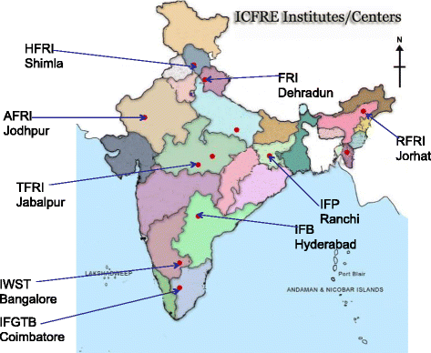
Argentina's precision agriculture adoption in the Pampas region showcases technology-driven adaptation. Variable rate application based on yield maps and soil sensors optimises input use while adapting to increasing climate variability. No-till systems cover 90% of grain production area, reducing erosion and improving water infiltration. These practices enabled the maintenance of productivity despite recent severe droughts, demonstrating the resilience value of technological adoption.
Challenges and Barriers to Implementation
Economic Constraints
Financial barriers remain the primary obstacle to widespread adoption of climate-smart agricultural practices. Initial investment costs for technologies such as drip irrigation, precision agriculture equipment, or renewable energy systems exceed smallholder farmers' capacity, particularly in developing countries where credit access remains limited. Cost-benefit analyses often fail to capture long-term resilience benefits, leading to underinvestment in adaptation measures.
Market failures compound implementation challenges, with absent or distorted price signals failing to incentivise sustainable practices. Carbon markets for agricultural sequestration remain underdeveloped due to measurement difficulties and high transaction costs. Input subsidies for water and fertilisers encourage overconsumption, while adaptation technologies receive limited support. Insurance markets fail to provide adequate coverage for climate risks, leaving farmers vulnerable to extreme events.
Value chain constraints limit market access for climate-adapted products. Infrastructure deficits, including storage facilities, transportation networks, and processing capabilities, result in post-harvest losses of 20-40% in developing countries. These losses undermine incentives for productivity investments while increasing food insecurity. Climate-resilient value chains require coordinated investments across production, storage, processing, and marketing segments.
Knowledge and Capacity Gaps
Technical knowledge barriers impede the adoption of complex climate-smart practices. Precision agriculture technologies require digital literacy and data interpretation skills often lacking among smallholder farmers. Integrated pest management demands ecological understanding of pest-predator relationships and monitoring capabilities. Even relatively simple practices like conservation agriculture require significant behaviour change and learning periods before benefits materialise.
Extension systems, weakened by decades of underinvestment, struggle to deliver climate-relevant information and support. Traditional top-down extension approaches fail to address location-specific climate challenges and diverse farmer circumstances. Farmer-to-farmer learning networks show promise but require facilitation and support to achieve scale. Digital extension platforms offer potential solutions but face connectivity and literacy constraints in remote areas.
Research-implementation gaps persist despite substantial scientific advances in climate adaptation. Technologies developed in research stations often fail under diverse farm conditions due to inadequate participatory development processes. Indigenous knowledge systems, containing valuable adaptation insights, remain marginalised in formal research and development programs. Bridging these gaps requires inclusive innovation systems that integrate scientific and traditional knowledge.
Institutional and Policy Barriers
Fragmented governance structures impede coordinated climate action in agriculture. Agricultural adaptation involves multiple ministries, agencies, and levels of government, often with conflicting mandates and limited coordination. Climate change considerations remain poorly integrated into agricultural policies, while agricultural concerns receive limited attention in climate policies. Institutional reforms promoting cross-sectoral coordination face political economy challenges and bureaucratic resistance.
Land tenure insecurity undermines long-term investments in climate adaptation. Farmers lacking secure land rights hesitate to invest in soil conservation, tree planting, or irrigation infrastructure. Women farmers, producing 60-80% of food in developing countries, face particular tenure constraints limiting their adaptation capacity. Land reforms addressing tenure security while promoting sustainable land management remain politically contentious but essential for adaptation.
Policy coherence challenges arise from conflicting objectives across sectors. Trade policies promoting agricultural exports may conflict with water conservation goals. Energy subsidies for groundwater pumping exacerbate aquifer depletion. Food security policies emphasising production increases may undermine environmental sustainability. Achieving policy coherence requires integrated assessment tools and political commitment to balance competing objectives.
Figure 8: Barriers to Climate-Smart Agriculture Adoption
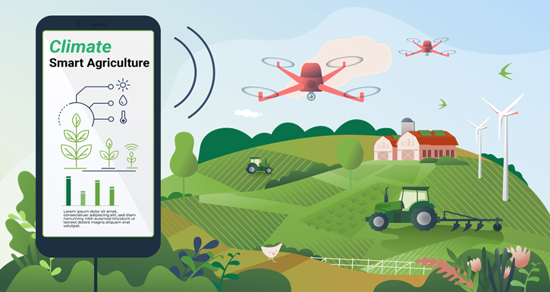
Future Perspectives and Research Priorities
Emerging Technologies and Innovations
Artificial intelligence and machine learning applications revolutionise climate risk management in agriculture. Advanced algorithms processing satellite imagery, weather data, and soil information generate field-specific recommendations for planting dates, variety selection, and input management. Predictive models incorporating climate projections enable anticipatory adaptation planning. However, realising this potential requires addressing data availability, model validation, and accessibility challenges.
Gene editing technologies, particularly CRISPR-Cas systems, accelerate the development of climate-resilient crop varieties. Unlike conventional breeding, which requires 10-15 years, gene editing can introduce beneficial traits in 3-5 years. Current targets include enhancing photosynthetic efficiency, improving nutrient use efficiency, and introducing multiple stress tolerances. Regulatory frameworks and public acceptance remain critical determinants of technology deployment.
Vertical farming and controlled environment agriculture offer climate-independent production systems for high-value crops. These systems achieve 100-300 times higher productivity per unit area while eliminating weather-related risks. Integration with renewable energy and circular economy principles enhances sustainability. However, high capital and energy requirements currently limit applications to urban areas and specific crops.
Transformative Pathways
Agricultural transformation under climate change requires fundamental shifts beyond incremental adaptations. Landscape-scale approaches integrating agriculture with ecosystem services provide multiple benefits, including climate regulation, biodiversity conservation, and watershed protection. Payment mechanisms valuing these services could transform agriculture from an environmental problem to a climate solution.
Circular bioeconomy models minimise waste while creating value from agricultural residues. Crop residues, currently burned or discarded, can generate bioenergy, biomaterials, and soil amendments. Integrated biorefineries processing multiple feedstocks create rural employment while reducing emissions. Realising this potential requires technology development, infrastructure investment, and market creation for bio-based products.
Digital transformation enables precision management and informed decision-making throughout agricultural systems. Blockchain technology ensures supply chain transparency and traceability, enabling premium markets for climate-smart products. Internet of Things sensors generate real-time data for optimisation algorithms. Digital platforms connect farmers with markets, finance, and services. However, digital divides risk excluding vulnerable populations without targeted interventions.
Research and Development Priorities
Climate-agriculture research must address critical knowledge gaps impeding effective adaptation and mitigation. Understanding crop responses to multiple, interacting stresses remains limited, particularly for neglected crops important for food security. Research on soil-plant-atmosphere interactions under climate change requires interdisciplinary approaches integrating biophysical and social sciences.
Socio-economic research priorities include understanding adoption determinants, designing effective incentive mechanisms, and evaluating policy instruments. Gender-differentiated impacts of climate change and adaptation options require focused attention. Value chain analyses identifying climate vulnerabilities and intervention points guide investment priorities. Participatory research approaches, ensuring farmer involvement in technology development, enhance relevance and adoption potential.
Monitoring and evaluation systems tracking adaptation effectiveness remain underdeveloped. Standardised metrics measuring resilience, adaptive capacity, and transformation progress enable learning and improvement. Long-term datasets capturing climate-agriculture interactions support model development and validation. Investment in observation networks, data management systems, and analytical capacity strengthens evidence-based decision-making.
Conclusion
Climate change fundamentally transforms global agricultural systems, demanding urgent, comprehensive responses that balance productivity, sustainability, and equity objectives. This review demonstrates that while climate impacts intensify through temperature extremes, precipitation variability, and increased pest pressures, diverse adaptation and mitigation strategies offer pathways toward resilient agricultural futures. Success requires integrated approaches combining technological innovation, policy reform, and institutional transformation. The evidence clearly indicates that incremental adjustments alone prove insufficient; rather, transformative changes in agricultural practices, supported by adequate finance and enabling policies, must accelerate to ensure food security under climate change. Future agricultural sustainability depends on immediate action, implementing proven solutions while continuing innovation for emerging challenges.

Disclaimer (Artificial intelligence)
Option 1:
Author(s) hereby declare that NO generative AI technologies such as Large Language Models (ChatGPT, COPILOT, etc.) and text-to-image generators have been used during the writing or editing of this manuscript.
Option 2:
Author(s) hereby declare that generativ AI technologies such as Large Language Models, etc. have been used during the writing or editing of manuscripts. This explanation will include the name, version, model, and source of the generative AI technology and as well as all input prompts provided to the generative AI technology
Details of the AI usage are given below:
1.
2.
3.

References
- FAO. (2020). The State of Food and Agriculture 2020: Overcoming water challenges in agriculture. Food and Agriculture Organization of the United Nations.
- FAO. (2021). Climate change and food security: Risks and responses. Food and Agriculture Organization of the United Nations.
- IPCC. (2021). Climate Change 2021: The Physical Science Basis. Contribution of Working Group I to the Sixth Assessment Report. Cambridge University Press.
- Kumar, S., Mishra, A. K., Pramanik, S., Mamidanna, S., & Whitbread, A. (2021). Climate risk, vulnerability and resilience: Supporting livelihood of smallholders in semiarid India. Land Use Policy, 97, 104729.
- Lobell, D. B., Azzari, G., Burke, M., Gourlay, S., Jin, Z., Kilic, T., & Murray, S. (2022). Eyes in the sky, boots on the ground: Assessing satellite- and ground-based approaches to crop yield measurement and analysis. American Journal of Agricultural Economics, 102(1), 202-219.
- Montgomery, D. R. (2021). Soil erosion and agricultural sustainability. Proceedings of the National Academy of Sciences, 104(33), 13268-13272.
- Mueller, N. D., Gerber, J. S., Johnston, M., Ray, D. K., Ramankutty, N., & Foley, J. A. (2021). Closing yield gaps through nutrient and water management. Nature, 490(7419), 254-257.
- Prasad, P. V., Bheemanahalli, R., & Jagadish, S. K. (2022). Field crops and the fear of heat stress—opportunities, challenges and future directions. Field Crops Research, 200, 114-121.
- Wheeler, T., & von Braun, J. (2020). Climate change impacts on global food security. Science, 341(6145), 508-513.
- Zhao, C., Liu, B., Piao, S., Wang, X., Lobell, D. B., Huang, Y., ... & Asseng, S. (2021). Temperature increase reduces global yields of major crops in four independent estimates. Proceedings of the National Academy of Sciences, 114(35), 9326-9331.
- Bibi, F., & Rahman, A. (2023). An overview of climate change impacts on agriculture and their mitigation strategies. Agriculture, 13(8), 1508.
- Praveen, B., & Sharma, P. (2019). A review of literature on climate change and its impacts on agriculture productivity. Journal of Public Affairs, 19(4), e1960.
- Nelson, G. C., Rosegrant, M. W., Koo, J., Robertson, R., Sulser, T., Zhu, T., ... & Lee, D. (2009). Climate change: Impact on agriculture and costs of adaptation (Vol. 21). Intl Food Policy Res Inst.
- Xing, Y., & Wang, X. (2024). Impact of agricultural activities on climate change: A review of greenhouse gas emission patterns in field crop systems. Plants, 13(16), 2285.
- Nsabiyeze, A., Ma, R., Li, J., Luo, H., Zhao, Q., Tomka, J., & Zhang, M. (2024). Tackling climate change in agriculture: A global evaluation of the effectiveness of carbon emission reduction policies. Journal of Cleaner Production, 468, 142973.
- Yuan, X., Li, S., Chen, J., Yu, H., Yang, T., Wang, C., ... & Ao, X. (2024). Impacts of global climate change on agricultural production: a comprehensive review. Agronomy, 14(7), 1360.
- Sinore, T., & Wang, F. (2024). Impact of climate change on agriculture and adaptation strategies in Ethiopia: A meta-analysis. Heliyon, 10(4).
- Safi, L., Mujeeb, M., Sahak, K., Mushwani, H., & Hashmi, S. K. (2024). Climate change impacts and threats on basic livelihood resources, food security and social stability in Afghanistan. GeoJournal, 89(2), 85.
- Baraj, B., Mishra, M., Sudarsan, D., da Silva, R. M., & Santos, C. A. G. (2024). Climate change and resilience, adaptation, and sustainability of agriculture in India: A bibliometric review. Heliyon, 10(8).
- Omotoso, A. B., & Omotayo, A. O. (2024). The interplay between agriculture, greenhouse gases, and climate change in Sub-Saharan Africa. Regional Environmental Change, 24(1), 1.
- Rehman, A., Batool, Z., Ma, H., Alvarado, R., & Oláh, J. (2024). Climate change and food security in South Asia: the importance of renewable energy and agricultural credit. Humanities and Social Sciences Communications, 11(1).
- Ofori, S. A., Cobbina, S. J., & Obiri, S. (2021). Climate change, land, water, and food security: Perspectives from Sub-Saharan Africa. Frontiers in Sustainable Food Systems, 5, 680924.
- Bhatia, A., Archana, Rajan, R., Sharma, R., & Narval, L. (2025). Effect of climate change on vegetable production and mitigation strategies in India. International Journal of Environment and Climate Change, 15(5), 195–209.
- Datta, P., & Behera, B. (2022). Climate change and Indian agriculture: A systematic review of farmers’ perception, adaptation, and transformation. Environmental Challenges, 8, 100543.
- Das, M. K. (2021). Determinants of adaptation strategies of agricultural farmers to climate change vulnerability in Odisha. Asian Journal of Agricultural Extension, Economics & Sociology, 39(9), 167–179.
- Bedeke, S. B. (2023). Climate change vulnerability and adaptation of crop producers in sub-Saharan Africa: a review on concepts, approaches and methods. Environment, development and sustainability, 25(2), 1017-1051.

