Original research article

Evaluating Non-Contact Infrared Thermometry as an Alternative to Rectal Temperature Measurement in Cattle and Goats

Abstract
This study investigates the correlation between rectal and eye temperatures in cattle and goats, aiming to validate non-contact infrared thermometry as a practical alternative for assessing core body temperature. Experiment 1. Conducted on eleven (n=11) healthy lactating cows; Experiment 2. Conducted on eleven (n=11) healthy goats post-grazing; Experiment 3. Conducted on ten (n=10) healthy goats before and after grazing. Results indicated that eye temperatures were consistently lower than rectal temperatures, with significant positive correlations observed in certain conditions, such as post-grazing in goats. While eye temperature measurements did not consistently match rectal temperatures under normal conditions, they showed potential for detecting thermal responses following heat stress. This suggests that non-contact eye temperature measurement could serve as a supplementary tool for monitoring animal health in specific contexts.
Key words: Non-contact infrared thermometry, rectal temperature, eye temperature, cattle and goat.

Introduction
Rectal temperature measurement using a thermometer remains the gold standard for assessing core body temperature in animals. It provides critical insights into physiological states such as fever, infection, and metabolic disturbances. However, the invasive nature of rectal thermometry can induce stress, particularly in farm animals, and sometimes may not be practically suitable for frequent monitoring in field conditions. In recent years, non-contact infrared thermography (IRT) has emerged as a promising alternative, offering rapid, non-invasive assessment of surface temperatures, including ocular regions, which are highly vascularized and sensitive to thermoregulatory changes. Bora et al. (2022) reviewed the application of IRT in veterinary filed in health assessment and stress detection in animals, Widely applied in veterinary diagnostics and livestock research, IRT enhances welfare monitoring and improves reproducibility in pre-clinical studies.
Several studies have explored the potential of ocular temperature as a proxy for core body temperature. Zanghi (2016) reported a significant correlation (r = 0.674) between eye and rectal temperatures in dogs during hyperthermia. Tucker et al. (2023) found that while ear tip temperature had a weak correlation with rectal temperature (r < 0.039, p = 0.20), the ear base and eye temperatures showed moderate correlations (r = 0.53 and 0.55, respectively, p < 0.001). Kapcak and Dogan (2023) observed that ocular and auricular IRT readings were significantly lower (p < 0.05) than rectal temperatures in anesthetized dogs, with no strong correlation, highlighting the influence of physiological state and measurement conditions. Giannetto et al. (2021) demonstrated that mean ocular temperatures of the left (37.5±0.71°C) and right eyes (37.4±0.72°C) were significantly lower than rectal temperature (38.6±0.73°C), yet showed a strong positive correlation, suggesting consistent thermal gradients. In equine studies, Aragona et al. (2022) reported that both ocular and rectal temperatures increased significantly post-exercise, with a strong correlation, supporting the utility of IRT in monitoring thermoregulatory responses during physical activity. Rectal temperature measurements and thermal imaging of the lacrimal region have demonstrated a positive correlation in cattle following intravenous administration of lipopolysaccharide (LPS) to induce fever. This finding suggests that infrared thermography holds promise as a rapid, non-invasive method for detecting febrile responses in cattle (Hoffman et al., 2023). Hoffmann et al. (2013) found that temperature readings at the eye and behind the ear were practical and correlated well with rectal temperature, supporting non-contact infrared thermometry as a reliable, non-invasive method for monitoring core body temperature in livestock.
In poultry, Yehia et al. (2025) documented strong correlations between skin and rectal temperatures under heat stress and thermoneutral conditions in broiler chickens, reinforcing the feasibility of IRT for non-invasive thermal monitoring. In buffaloes, Balhara et al. (2024) recorded rectal temperature (38.26±0.38°C) and eye temperature (36.99±0.47°C) with a significant positive correlation (r = 0.674). They also noted moderate correlations between rectal temperature and ambient temperature (r = 0.488) and developed a predictive equation: RT = 20.377 + 0.465 (AET) + 0.024 (AT), where RT is rectal temperature, AET is average eye temperature, and AT is ambient temperature. This model yielded R² = 51.6%, RMSE = 0.272, and AIC = 71.601, indicating satisfactory predictive accuracy.
Building on these findings, the present study investigates whether eye temperature measured using a commercially available non-contact infrared thermometer can reliably approximate rectal temperature obtained via a digital thermometer. By establishing this correlation, the study aims to validate non-contact infrared thermometry as a practical, rapid, and stress-free tool for routine health monitoring in animals; particularly beneficial for farmers seeking efficient, non-invasive diagnostic methods in field settings.
Material and method
During the study period, the mean maximum ambient temperature recorded was 31.8°C, while the mean minimum temperature was 24.8°C. Accumulated rainfall ranged from 6 cm to 70 cm across the Dhemaji and North Lakhimpur districts of Assam, as reported by the India Meteorological Department. Experiment 1: - Eleven (n=11) healthy lactating cows were selected from Livestock farm complex (LFC) of Lakhimpur College of Veterinary Science (LCVSc), AAU, Johying, North Lakhimpur for the study to measure the eye temperature using non-contact infrared thermometer (figure 1) and rectal temperature using clinical digital thermometers (figure 2). The floor, wall and roof temperature were recorded using non-contact infrared thermometer. The experiment was carried out at 10:00 am. The rectal temperature was measured by gently inserting a clinical digital thermometer into the animal’s rectum and maintain it in a slightly bent position for one minute, ensuring that the thermometer’s sensor bulb remained in contact with the rectal mucosa (figure 3). The eye temperature was recorded just placing the non-contact infrared thermometer keeping at 5 cm distance from the eye.
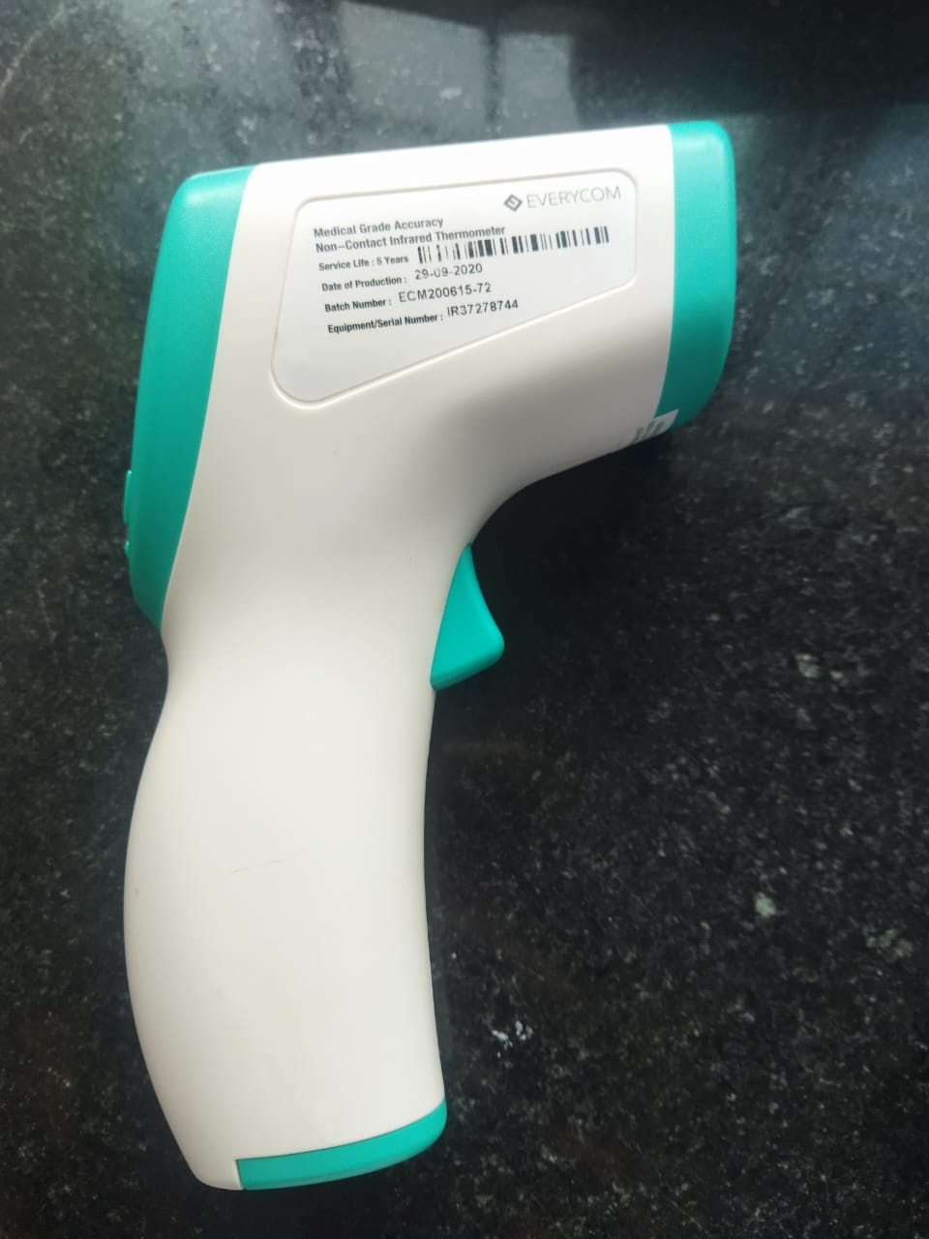
Fig. 1. Non-contact infrared thermometer
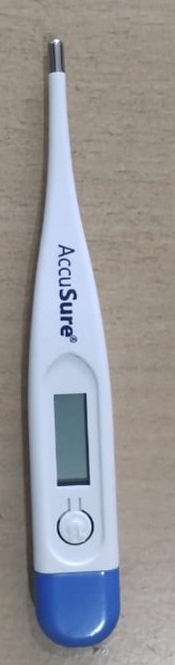
Fig. 2. Clinical digital thermometer (Accu Sure)
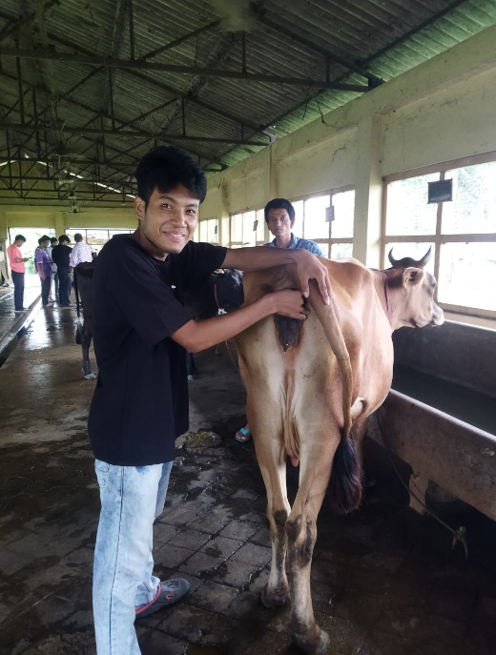
Fig. 3. Measuring the rectal temperature
Experiment 2: - To investigate the relationship between rectal and eye temperatures in goats eleven (n=11) healthy adult goats (n=6 female and n=5 male) were selected after grazing (heat exposure) in the month of August 2025 for this study. After 6 hours of outdoor/grazing under direct sunlight, the goats were brought back to the farm for temperature measurement. The floor, wall, and roof temperature were recorded using a non-contact infrared thermometer at around 3:00pm. The rectal temperatures were measured using a clinical digital thermometer; the device gently inserted into the rectum and held in place for one minute while the animal was calmly restrained (figure 4). Eye temperatures were obtained by holding a non-contact infrared thermometer approximately 5 cm from the eye, allowing for rapid and non-invasive readings (figure 5). All measurements were conducted at around 3:00 pm.
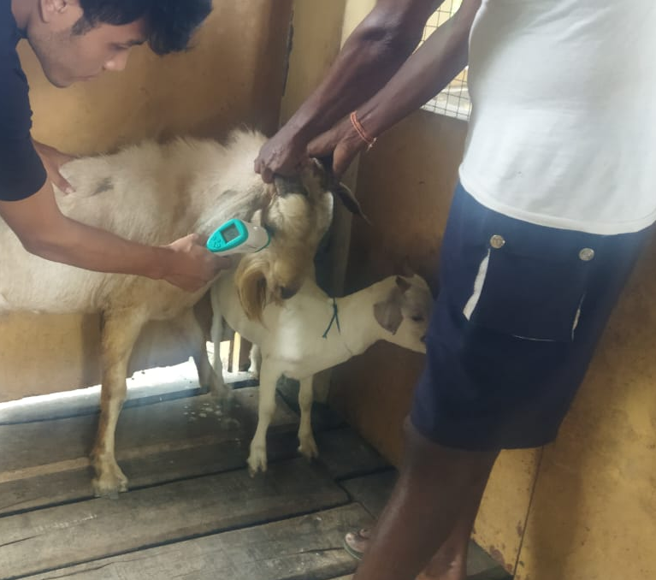
Fig.4. Measuring the eye temperature approximately 5 cm from the eye using non-contact infrared thermometer
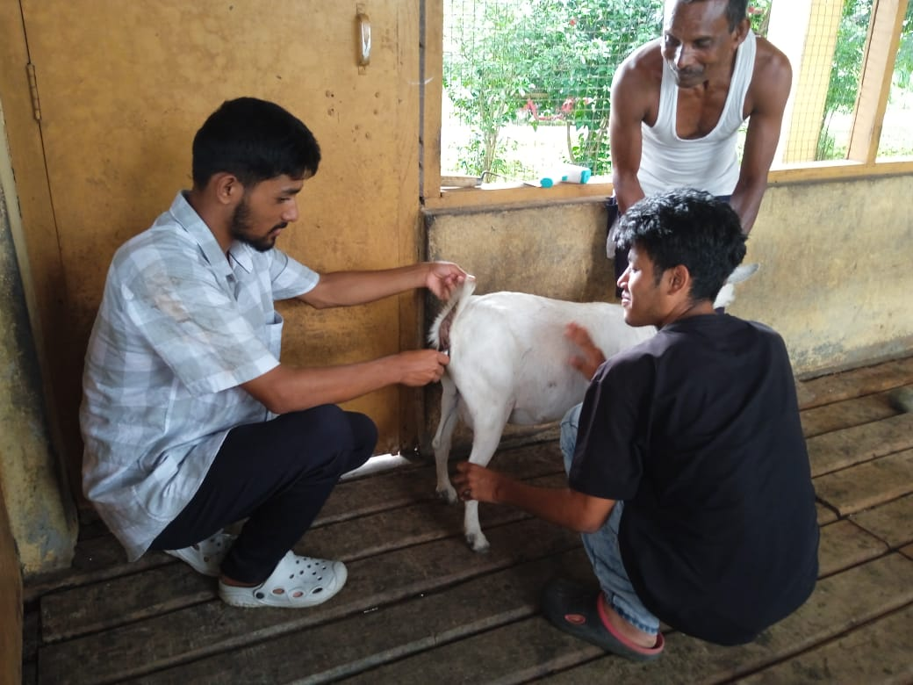
Fig. 5. Measuring rectal temperature in goat.

Experiment 3: - To examine the relationship between rectal and eye temperatures in goats before and after grazing, ten (n=10) healthy adult goats were selected from the Livestock Farm Complex—Goat Farm at Lakhimpur College of Veterinary Science, Joyhing. Rectal temperatures were measured with a clinical digital thermometer, while eye temperatures were recorded using a non-contact infrared thermometer. Measurements were taken both before grazing, at approximately 9:00 am, and after grazing, at 3:00 pm. Correlation analyses were performed to assess the association between rectal and eye temperature readings.
Statistical analysis
The rectal and eye temperature measurements were statistically compared using Student’s t-test, and the differences between them were calculated in both Experiment 1 and 2. For Experiment 3, in addition to the student’s t-test, Pearson correlation coefficients were applied to assess the relationship between rectal and eye temperatures.
Results and Discussion
Experiment 1. The roof temperatures were consistently higher than those recorded for the floor and wall. Eye temperature readings in the animals were lower than rectal temperatures, with an average difference of 4.60 ± 0.81 °F (table 1). The correlation study did not show significant difference between rectal and eye temperature.
Table 1. The mean value of the floor, wall, and roof temperature (°F) as indicators of the animals' microenvironment with the rectal and eye temperatures (°F) in cattle.
Microenvironment of the animal  (Non-contact infrared thermometer) |  |  | Digital thermometer | Non-contact infrared thermometer | Differences
Floor | Wall | Roof | Rectal temperature | Eye temperature | Differences
91.82  ±  0.04 | 90.54  ±  0.14 | 96.89  ±  0.14 | 100.3ª  ±  0.09 | 96.69^{b}  ±  0.811 | 4.60  ±  0.81

Experiment 2. Following exposure to heat stress during grazing, the environmental temperatures measured within the goats' microenvironment indicated marked variations. Roof temperatures were consistently higher than those observed for the floor and wall (table 2). The mean rectal temperature of the goats, assessed with a digital thermometer, was higher than the mean eye temperature measured by a non-contact infrared thermometer. The average difference between rectal and eye temperatures was 5.47±0.10°F and 5.36±0.15°F in male and female goat, respectively, with rectal readings consistently surpassing those recorded at the eye.
Temperatures (°F) of the floor, wall, and roof measured with a non-contact infrared thermometer. The rectal temperatures were obtained using a digital thermometer, while eye temperatures were measured with a non-contact infrared thermometer in goat.
Table 2. Microenvironment of the animal
Microenvironment of the animal  (Non-contact infrared thermometer) |  |  | Digital thermometer | Non-contact infrared thermometer | Differences
Floor | Wall | Roof | Rectal temperature | Eye temperature | Differences
95.98±0.10 | 96.19±0.06 | 98.46±0.21 | 103.1ª±0.16 | 97.72^{b}±0.17 | 5.41±0.10

Experiment 3. The rectal temperature recorded after grazing was increased (p<0.05) as compared to the recoding before grazing; the eye temperature was also showed similar pattern before and after grazing (table 3). The eye temperature recorded lower compared to rectal temperature. The correlation analysis of rectal temperature and eye temperature showed significant (p<0.05) positive correlation (r= 0.739) (figure 6)
Table 3. The rectal temperature and eye temperature of adult goat before and after grazing
Before grazing  (9:00 am) |  | Difference (°F) | After grazing  (3:00pm) |  | Difference (°F)
Rectal temperature (°F) | Eye temperature (°F) | 3.24±0.07 | Rectal temperature (F°) | Eye temperature (°F) | 4.21±0.01
101.19ª±0.22 | 97.95^{b}±0.14 | 3.24±0.07 | 103.6ª±0.20 | 99.39^{b}±4.21 | 4.21±0.01

Fig. 6. Pearson correlation coefficient of rectal temperature and eye temperature of goat.
The elevated roof temperature observed in the cattle farm is primarily attributed to direct solar radiation, whereas the comparatively lower temperatures recorded on the floor and walls can be explained by effective ventilation and routine floor watering during cleaning. These management practices contribute to maintaining a thermally comfortable microenvironment for the housed animals. Notably, the temperature measurements were taken at 10:00 AM, a time when ambient conditions are typically more favorable, further supporting the presence of a relatively stable thermal environment. Fang et al. (2025) reported that under hot and humid climatic conditions, conventional ventilation and cooling strategies had limited efficacy in improving shed microclimates. However, increasing wind speed was shown to significantly reduce cattle respiratory rates, rectal temperatures, and skin temperatures, highlighting the importance of airflow dynamics in thermal regulation (Fang et al. 2025). In the present study, eye temperature readings obtained via non-contact infrared thermometry were consistently lower than rectal temperatures. This finding aligns with previous reports by Giannetto et al. (2021), Balhara et al. (2024), and Barnabe et al. (2012), who also observed similar discrepancies between ocular and core body temperatures. The mean difference recorded in this study was 4.60 ± 0.81°F. In contrast, Gálik et al. (2024) reported a narrower difference of approximately 1.5°C in dairy cows. Hoffmann et al. (2013) observed temperature variations across different body regions, reporting values of 37.2°C at the vulva, 37.0°C at the eye, 35.6°C behind the ear, and 34.9°C at the shoulder. Among these, the eye and the area behind the ear were identified as particularly practical sites for temperature monitoring. It is important to note that the current study was conducted on stall-fed dairy cows, whereas Gálik et al. (2024) examined cows is in a loose housing system. Environmental factors such as ambient temperature, humidity, and airflow may influence ocular surface temperature, potentially accounting for the observed variation. The absence of a significant correlation between rectal and eye temperatures in this study further underscores the limitations of using ocular temperature as a proxy for core temperature under controlled housing conditions. Future investigations with larger sample sizes, multiple time points, and diverse environmental settings are warranted to better evaluate the diagnostic utility of eye temperature in cattle. In contrast, the goat farm exhibited higher floor, wall, and roof temperatures, with measurements taken at 3:00 PM, coinciding with peak ambient heat. This temporal difference likely contributed to the elevated thermal readings compared to the cattle farm. Rectal temperature in goats post-grazing was recorded at 103.1 ± 0.16°F, higher than pre-grazing, indicative of heat stress following outdoor exposure. Eye temperature measured concurrently was 97.72 ± 0.17°F, yielding a mean difference of 5.41 ± 0.10°F between rectal and ocular readings. Importantly, both rectal and eye temperatures increased significantly after grazing, and a strong positive correlation was observed between them in Experiment 3. These findings suggest that non-contact infrared thermometry may be useful for detecting hyperthermic responses in goats following physical exertion or environmental heat exposure. Comparable results have been reported in other species. Aragona et al. (2022) demonstrated significant post-exercise increases in both ocular and rectal temperatures in equines, with strong correlations supporting the use of infrared thermography (IRT) for monitoring thermoregulatory responses. Similarly, Zanghi (2016) observed parallel trends in dogs, reinforcing the potential of ocular temperature as a non-invasive indicator of thermal stress.
Hoffman et al. (2023) reported that both rectal temperature and infrared thermal imaging of the ocular region exhibited an increase following intravenous administration of lipopolysaccharide (LPS) to induce fever in cattle. Furthermore, their analysis revealed a positive Pearson correlation coefficient between these two temperature measurements, indicating a significant association. Larsson et al. (2024) found that skin temperature closely correlated with indoor ambient temperature, while neck temperature measured via infrared radiation best reflected indoor thermal conditions. The elevation of temperature humidity index (THI) impact growth related biomarkers (Borah et al., 2023). Tombolani et al. (2025) reported a strong correlation between perineal infrared temperature and rectal temperature in cats, suggesting that non-contact infrared thermometry may offer practical advantages for feline temperature monitoring. Barnabe et al. (2012) recorded rectal and bilateral eye temperatures in animals, reporting values of 39.8 ± 0.4°C (rectal), 35.9 ± 0.8°C (right eye), and 36.1 ± 0.8°C (left eye), with a modest positive correlation (r = 0.2012) between rectal and ocular temperatures. In dairy cows, Gálik et al. (2024) reported an average rectal and eye temperature difference of 1.5°C, with weak correlations to air temperature (r = 0.22) and temperature-humidity index (THI; r = 0.23), and a negative correlation with relative humidity (r = –0.32), indicating environmental modulation of ocular temperature. Alberghina et al. (2025) demonstrated significant positive correlations (p < 0.01) between ocular and perineal infrared temperatures and rectal temperature in horses. While ocular readings showed minimal bias (–0.2°C), perineal readings exhibited a larger bias (+2°C), yet remained unaffected by ambient conditions, making perineal infrared thermometry a reliable alternative for equine core temperature assessment. Polat and Yanmaz (2024) further highlighted that axillary temperature exhibited the highest agreement with rectal temperature in cats among various anatomical sites, suggesting its potential as a non-invasive alternative for monitoring body temperature in clinically healthy cats in home environments. Collectively, these findings underscore the anatomical and environmental variability influencing infrared temperature measurements. While ocular temperature may not reliably substitute rectal temperature under all conditions, its utility in detecting acute thermal responses particularly post-exercise or heat exposure warrants further exploration across species and housing systems. Although infrared thermography cameras and image-based temperature analysis software have been widely employed in previous studies to assess surface temperature variations across different anatomical sites, their high cost and technical complexity limit routine application in field settings. These studies often explore correlations between surface temperatures and core body temperature, typically measured rectally. However, the use of handheld non-contact infrared thermometers particularly for measuring eye temperature or other accessible anatomical locations as a practical alternative or proxy for rectal temperature remains constrained by inconsistent reliability and limited validation.

Conclusion
In the present study, eye temperature measured via non-contact infrared thermometer did not demonstrate sufficient accuracy or consistency to serve as a substitute for rectal temperature under normal physiological conditions. Nonetheless, eye temperature readings showed potential utility in detecting thermal responses following heat stress exposure, such as post-grazing during the summer season. This suggests that while non-contact eye temperature measurement may not replace rectal thermometry for core temperature estimation, it could serve as a supplementary indicator in specific contexts involving acute thermal stress.
Conflict of interest
All the authors declared no conflicts of interest.

Disclaimer (Artificial Intelligence)
Author(s) hereby declare that generative AI technologies such as Large Language Models have been used during the writing and editing of this manuscript. The following details outline the name, version, model, and source of the generative AI technology, as well as the input prompts provided.
Details of the AI usage are given below:

Name and Source: Microsoft Copilot, developed by Microsoft Corporation.
Model and Version: Based on advanced large language models integrated into Microsoft Copilot as of 2025.

Nature of Use: Drafting and refining scientific text for clarity, precision, and flow. Editing manuscript sections to improve readability. Assisting with formal application writing and logistical phrasing.

References
Alberghina, D., Tombolani, C., Quintavalla, F. 2025. Performance of a non-contact veterinary infrared thermometer and reference intervals of equine temperature at different body sites. Frontiers in Veterinary Science,12. https://doi.org/10.3389/fvets.2025.1583839
Aragona, F., Di Pietro, S., Arfuso, F., Giudice, E., Giannetto, C., Fazio, F., Piccione, G. 2022. Correlation between ocular and rectal temperature with intraocular pressure in horses during exercise. Animals, 12(14), 1850. https://doi.org/10.3390/ani12141850.
Balhara, A. K., Jan, M. H., Hooda, E., Kumar, K., Ghanghas, A., Sangwan, S., Balhara, S., Phulia, S., Yadav, S., Boora, A., Kumar, S., Singh, S., Datta, T. 2024. Prediction of core body temperature using infra-red thermography in buffaloes. Italian Journal of Animal Science, 23(1), 834–841. https://doi.org/10.1080/1828051x.2024.2358872
Barnabe, P. A., Cadioli, F. A., Ferracini, D., Bogaz, G. M. V., Beccaria, R. F., Camargo, V. L. V., Gonçalves, L. R., Mello, A. S., Britto, J. A., Perri, S. H. V. 2010. Comparison between rectal and eyes temperatures obtained by digital and non-contact infrared thermometers in Zebu cattle. In Proceedings of the 26th Congress of the World Association for Buiatrics (pp. 368). Santiago de Chile, Chile. Reprinted in IVIS with permission of the Congress Organizers.
Borah, S., Soren, S., Pame, K., Paul, D., Kalita, L. 2022. Application of infrared thermography for animal health study. Emergent Life Sciences Research, 8(1), 152–157.
Borah, S., Soren, S., Talukdar, R., Kalita, L., Pame, K., Nath, A. J., Borah, B., Pathak, P. K., Bhattacharyya, B. N. 2023. Thermal stress impaired expression of insulin-like growth factor binding proteins in pigs. Indian Journal of Animal Sciences, 93(3), 303–308.
Fang, H., Yan, P., Wei, S., Chen, D. 2025. Evaluation of ventilation and cooling strategies in cattle sheds in the middle and lower Yangtze river regions based on model prediction. Journal of Applied Animal Research, 53(1). https://doi.org/10.1080/09712119.2025.2458279
Gálik, R., Bod’o, Š., Lüttmerding, G., Knížková, I., Kunc, P. 2024. Tracking Differences in Cow Temperature Related to Environmental Factors. Applied Sciences, 14(16), 7205. https://doi.org/10.3390/app14167205
Giannetto, C., Di Pietro, S., Falcone, A., Pennisi, M., Giudice, E., Piccione, G., Acri, G. 2021. Thermographic ocular temperature correlated with rectal temperature in cats. Journal of Thermal Biology, 102, 103104. https://doi.org/10.1016/j.jtherbio.2021.103104
Hoffman, A. A., Long, N. S., Carroll, J. A., Burdick Sanchez, N. C., Broadway, P. R., Richeson, J. T., Jackson, T. C., Hales, K. E. 2023. Infrared thermography as an alternative technique for measuring body temperature in cattle. Applied Animal Science, 39(1), 94–98. https://doi.org/10.15232/aas.2022-02360
Hoffmann, G., Schmidt, M., Ammon, C., Rose-Meierhöfer, S., Berg, W., Burfeind, O., Heuwieser, W. 2013. Monitoring the body temperature of cows and calves using video recordings from an infrared thermography camera. Veterinary Research Communications, 37(2), 91–99. https://doi.org/10.1007/s11259-012-9549-3
India Meteorological Department. 2025. Monthly weather report of Assam: August 2025. Regional Meteorological Centre, Guwahati. https://mausam.imd.gov.in/guwahati/mcdata/wmr_en.pdf
Kapcak, A. B., Dogan, E. 2023. Short Communication: Correlation of Thermographic Ocular and Auricular Temperatures with Rectal Temperature in Anesthetized Dogs. Veterinary medicine international, 9939580. https://doi.org/10.1155/2023/9939580
Larsson, B. Staaf, K. Dahlborn, A. Jansson. 2024. “Methods for Assessing Skin Temperature in Two Breeds of Dairy Cows and Their Correlation to Indoor and Rectal Temperature.” Acta Agriculturae Scandinavica Section a – Animal Science, 1–8. doi: 10.1080/09064702.2024.2435339.
Tombolani, C., Alberghina, D., Gioè, M., Quintavalla, F. 2025. Comparison of Digital Rectal Thermometry and a Non-Contact Veterinary Infrared Thermometer in Cats: Identifying Alternative Sites to Rectal Measurement. Veterinary Sciences, 12(7), 618. https://doi.org/10.3390/vetsci12070618
Tucker, B. S., Jorquera-Chavez, M., Petrovski, K. R., Craig, J. R., Morrison, R. S., Smits, R. J., Kirkwood, R. N. 2023. Comparing surface temperature locations with rectal temperature in neonatal piglets under production conditions. Journal of Applied Animal Research, 51(1), 212–219. https://doi.org/10.1080/09712119.2023.2176310
Yehia, M., Askri, A., Achour, A., Allard Prus, J.-M., Ouellet, V., Alnahhas, N. 2025. Rectal temperature and heat transfer dynamics in the eye, face, and breast of broiler chickens exposed to moderate heat stress. Poultry Science, 104(2), 104748. https://doi.org/10.1016/j.psj.2024.104748
Zanghi, B. M. 2016. Eye and ear temperature using infrared thermography are related to rectal temperature in dogs at rest or with exercise. Frontiers in Veterinary Science, 3 (111), 1-9.

