Molecular Insights into the Genetic Regulation of Calving Interval in Tropical Cattle Breeds
Abstract
Calving interval (CI) is a multifactorial reproductive trait regulated by both genetic and environmental influences. Although its heritability is relatively low, the genetic basis of CI is highly relevant as it reflects the inherent reproductive efficiency of cattle. The underlying genetic mechanisms affecting CI, however, remain to be clarified. In this study, a whole-genome comparative analysis of five Bos indicus breeds from the Indian subcontinent—Kangayam, Tharparkar, Sahiwal, Red Sindhi, and Hariana, was performed. The NCBI public database was used in this study. The MarkDuplicates tool of Picard tools was used to remove potential PCR duplicates from the aligned reads, and then the uniquely mapped reads were used for the variant calling step. The freebayes output was filtered to include high-quality variants in the candidate genes, that is, quality (QUAL > 1). Furthermore, the identified SNP/InDels were classified as high, moderate, low, and modifier using the SnpEff tool. Across these breeds, 17,252 genes carrying single-nucleotide polymorphisms (SNPs) or InDels predicted to have high or moderate impact on protein function were identified. From these, 57 potential candidate genes associated with CI were detected, including LTF, SELP, GC, LENG8, LEPR, GHR, GH1, RPS9, TLR4, GNRHR, ARHGAP29, SEC24D, METTL14, SLC36A2, SLC36A3, APBA3, TCF12, and ZFR2. Functional annotation revealed enrichment of biological processes such as cellular response to hormonal stimuli, regulation of insulin-like growth factor receptor signalling, glucose metabolism, peptide and lipid responses, and ovulation cycle processes. Pathway enrichment highlighted neuroactive ligand-receptor interactions along with growth hormone and prolactin receptor signalling pathways. Network analysis further identified ESR1, IGF1, LEP, MSTN, TNF, FGF2, TLR4, and LTF as central hub genes with potential regulatory influence on CI in indicine cattle. Overall, this study uncovers genomic variants and key molecular pathways that provide novel insights into the genetic regulation of CI in indigenous Bos indicus breeds adapted to tropical conditions. The discovered genetic variants hold potential applications in the development of customised SNP genotyping chips, as well as in marker-assisted and genomic selection programs for cattle breeding in the future.
Keywords: Bos indicus cattle, calving interval, whole genome, genetic variants, genetic mechanisms
Introduction
The calving interval (CI), defined as the period between two consecutive calvings in cattle, is a pivotal reproductive trait directly influencing milk production efficiency, herd replacement, and economic sustainability of dairy production systems in India and globally (Schmidt et al., 2019). Some dairy farmers deliberately extend the interval from calving to first insemination to reduce the number and frequency of critical calving events (Wang et al., 2024). In the Indian context, the optimal calving interval is generally targeted around 365 days, aligning with a one-calf-per-year objective to maximise lifetime productivity and profitability of dairy herds (Vijayakumar et al., 2019; Vijayakumar et al., 2021). However, variations are common across indigenous and crossbred cattle, with reported average calving intervals ranging from approximately 410 to 480 days in several Indian studies, depending on breed, management, and environmental conditions (Vijayakumar et al., 2021; Waghmare et al, 2023). Prolonged calving intervals are indicative of reproductive inefficiency, leading to increased calving-to-conception intervals, higher culling rates, and subsequent economic losses for producers (El-Qaliouby et al., 2025). As a composite trait, calving interval reflects the combined effects of postpartum recovery, resumption of ovarian activity, conception ability, and early embryonic survival, making it a key indicator of overall reproductive performance in cattle.
Calving interval (CI) is a complex reproductive trait influenced by both genetic and environmental factors. Its heritability is generally low to moderate in cattle, typically ranging from 0.05 to 0.20 depending on breed, population, and study design (Pryce et al., 2010). Despite the relatively low heritability, genetic factors underlying CI are important because they reflect the animal’s intrinsic reproductive efficiency, including genes regulating ovarian function, hormone secretion, and metabolic adaptation essential for timely conception and uterine recovery between calvings (Atashi et al., 2020; Waghmare et al., 2023). For improving calving interval in Indian cattle, the identification of trait-associated genes and pathways through genomic technologies offers promising avenues for accelerating reproductive efficiency and productivity. Advances in genomics have led to the identification of candidate genes (e.g., ARHGAP29, IGFBP2, PLAG1) and genomic regions significantly associated with CI, highlighting the polygenic nature of this trait and the complex genetic networks involved (Dias et al. 2024; Haque et al., 2024). The potential for genetic improvement in a trait largely depends upon additive genetic variation existing in a population of interest. The variability for a particular trait in a population is measured by heritability estimates of traits under given environmental conditions (Shashikant et al., 2024). Given its economic and biological complexity, continued research into the genetic architecture and physiological underpinnings of calving interval remains a priority in the pursuit of improved cattle fertility and productivity. Improving CI genetically reduces intervals between calvings, enhancing lifetime productivity and profitability in cattle herds (Aponte et al. 2024; Bene et al. 2024). Therefore, genetics provides both a foundation to understand biological mechanisms controlling reproductive efficiency and a tool for sustainable improvement of CI through marker-assisted and genomic selection. This advances both economic gains and sustainability goals relevant to Indian dairy farming systems characterised by diverse breeds and production environments. In this study, a whole-genome comparative analysis of five Bos indicus breeds from the Indian subcontinent—Kangayam, Tharparkar, Sahiwal, Red Sindhi, and Hariana- was performed.
Materials and methods
Whole-genome datasets and read mapping
We used whole-genome data of five zebu cattle breeds that originated in the Indian subcontinent, including Kangayam (n = 1), Tharparkar (n = 3), Sahiwal (n = 2), Red Sindhi (n = 1), and Hariana (n = 1) breeds available in the NCBI public database (Accession No. PRJNA496267 and PRJNA493191). Quality control of the raw sequencing reads was performed using the FastQC program (Andrews, 2010). Trimmomatic software was used for quality filtering of the short reads (Bolger et al. 2014). The quality reads were mapped into the Bos taurus reference genome assembly ARS-UCD1.2, using Bowtie2 with default parameters (Langmead and Salzberg 2012). The MarkDuplicates tool of Picard tools was used to remove potential PCR duplicates from the aligned reads, and then the uniquely mapped reads were used for the variant calling step.
Variant calling
Freebayes is a Bayesian genetic variant detector used with default parameters to identify single-nucleotide polymorphisms (SNPs), insertions and deletions (InDels), multi-nucleotide polymorphisms (MNPs), and complex events (composite insertion and substitution events) in our mapped datasets (Garrison and Marth, 2012). After the variant calling step, the SnpSift filter tool was used to remove sequencing and alignment artefacts from the SNPs and InDels with the following parameters: DP ≥ 2 and QUAL ≥ 20 (Cingolani et al. 2012a). Furthermore, the freebayes output was filtered to include high-quality variants in the candidate genes, that is, quality (QUAL > 1), presence of supporting reads on both strands (SAF > 0 and SAR > 0), both sides of the variant (RPL > 1 and RPR > 1), and high-quality per alternate observation (QUAL/AO > 4).
Variation annotation
SnpEff is a variant annotation and effect prediction tool used for the functional annotation of identified variants. The identified SNP/InDels were classified as high, moderate, low, and modifier using the SnpEff tool (Cingolani et al. 2012b). All analyses were performed using the Galaxy server (https://usegalaxy.org/) (Afgan et al. 2016). The Cattle Quantitative Trait Locus database (Cattle QTLdb) (https://www. animalgenome.org/cgi-bin/QTLdb/BT/index) contains cattle QTL, candidate genes responsible for various traits. The candidate genes related to calving interval were retrieved using Search and Analysis Tools of Cattle QTLdb and a literature review. Protein–protein interaction (PPI) networks and gene ontology and pathways were analysed using the STRING database server to determine the functional roles of retrieved candidate genes from the Cattle QTLdb databases and from literature in structuring and mediating the biological processes of calving interval of zebu cattle breeds.
Results and Discussion
Over the past decade, extensive research has identified a wide range of candidate genes and biological pathways contributing to variation in calving interval (CI) in cattle. Evidence from genome-wide association studies (GWAS), linkage mapping, and functional annotation has established CI as a polygenic trait influenced by genes related to hormonal regulation, metabolic processes, and ovarian function. Despite these advances, the genetic basis of CI in Bos indicus cattle remains insufficiently understood. Comparative genomic analyses between tropical Bos indicus breeds and temperate Bos taurus populations can provide critical insights into the genetic variants, biological processes, and signalling pathways that enable indicine breeds to adapt their reproductive performance to tropical environments. To address this, the present study utilised whole-genome sequence data previously generated for five Indian indigenous breeds—Kangayam, Tharparkar, Sahiwal, Red Sindhi, and Hariana. In total, 17,252 genes carrying SNPs or InDels predicted to cause high or moderate impacts on protein function were identified. Among these, 57 genes, including LTF, SELP, GC, LENG8, LEPR, GHR, GH1, RPS9, TLR4, GNRHR, ARHGAP29, SEC24D, METTL14, SLC36A2, SLC36A3, APBA3, TCF12, and ZFR2, were recognised as potential candidates associated with CI. Functional annotation of these genes provides a valuable genomic resource for unravelling the molecular mechanisms regulating calving interval in Bos indicus cattle.
Lactoferrin (LTF) plays a crucial role in maintaining uterine health postpartum through its antimicrobial and immunomodulatory properties. By controlling bacterial growth and supporting iron homeostasis, LTF facilitates rapid uterine involution and the early resumption of ovarian cycles, which are essential for reducing the calving interval in cattle (Farnaud and Evans, 2003; Bahar et al., 2011). The SELP gene encodes P-selectin, an adhesion molecule critical for leukocyte trafficking and proper placental attachment. Variations in SELP influence embryo implantation success and early pregnancy maintenance, impacting fertility and thus the length of the calving interval (Chen et al., 2017). The vitamin D binding protein encoded by GC regulates vitamin D transport and is associated with calcium metabolism and steroid hormone synthesis, both vital for ovarian follicle development and estrogen production. Polymorphisms in GC correlate with reproductive efficiency and calving interval variations by modulating these physiological pathways (Lee et al., 2021).
Energy and metabolic signalling genes, including LEPR and LEP, regulate appetite and body energy status, transmitting nutritional information to the hypothalamic-pituitary axis to modulate gonadotropin release. Functional variations in these genes alter oestrous cyclicity, puberty onset, and ovulation rates, which directly affect calving intervals (De Matteis et al., 2012). LENG8, involved in mRNA processing and mitochondrial function, supports energy metabolism in reproductively active tissues such as the ovary and uterus. Adequate energy supply mediated by LENG8 activity is essential for folliculogenesis and gestation maintenance, influencing reproductive timing and calving interval (Zhoa et al., 2021). The GHR and GH1 genes govern growth hormone signalling, which indirectly affects reproduction by regulating insulin-like growth factor-1 (IGF-1) levels pivotal for follicular growth, oocyte maturation, and uterine receptivity; polymorphisms in these genes have been linked to altered fertility and calving intervals in cattle (Garrett et al., 2008). The ribosomal protein gene RPS9 is essential for sustained protein synthesis, facilitating cellular proliferation and tissue remodelling in reproductive organs during the oestrus cycle and postpartum recovery (Janovick-Guretzky et al., 2007). Innate immunity mediated by TLR4 recognises microbial pathogens, triggering immune responses critical to preventing and resolving uterine infections post-calving. GNRHR, encoding the gonadotropin-releasing hormone receptor, is fundamentally involved in the hypothalamic-pituitary-gonadal axis by regulating luteinizing hormone (LH) and follicle-stimulating hormone (FSH) secretion. Polymorphisms in GNRHR alter ovulatory cycles and fertility, directly influencing calving interval length.
Genome-wide association studies (GWAS) in Holstein dairy cows have identified several genes, including ARHGAP29, SEC24D, METTL14, SLC36A2, and SLC36A3, which are implicated in processes such as cellular transport and methylation that can influence reproductive cycle efficiency (Atashi et al., 2020). Similarly, studies in Hanwoo cattle revealed APBA3, TCF12, and ZFR2 as candidates that affect reproductive traits by modulating neuroendocrine and transcriptional regulation pathways (Haque et al., 2024). Furthermore, MTHFR have been reported by multiple investigations as fundamental to the insulin-like growth factor (IGF) system and methylation pathways critical for ovarian function and calving interval (Mota et al., 2020; Peripolli et al., 2024). Genes such as CACNA1A and CACNA1D have also been linked to calcium signalling integral to ovarian function and embryonic development (Fernandez et al., 2019). Collectively, these genes orchestrate interdependent pathways encompassing ovarian follicle development, embryo implantation, metabolic adaptation, and postpartum recovery, which converge to determine reproductive efficiency and calving interval in cattle.
Functional annotation of the identified candidate genes revealed enrichment for several Gene Ontology (GO) terms, including cellular response to hormonal stimuli, growth factor activity, positive regulation of insulin-like growth factor receptor signalling, regulation of glucose metabolism, peptide and lipid response, protein kinase activity regulation, ovulation cycle processes, and female gonad development (Table 1). Many of these GO terms have been previously documented in earlier studies, supporting their relevance to reproductive traits. Gene ontology (GO) analyses have consistently shown enrichment in biological processes related to hormone regulation, including the regulation of gonadotropin secretion, growth hormone receptor signalling, and endocrine hormone secretion (Atashi et al., 2020). These processes explain how hormonal cycles modulated by genetic factors affect ovulation and conception timing. Energy metabolism-related GO terms such as glucose homeostasis, insulin stimulus response, and lipid metabolism further illustrate the critical link between metabolic status and reproductive performance (Abdalla et al., 2023). This metabolic-reproductive nexus is particularly important in cattle, balancing energy demands during lactation and reproduction.

Table 1. Gene ontology term analysis based on candidate genes involved in the calving interval.
Sl.No | GO terms | P Value
1 | Ovulation cycle process | 4.64E-07
2 | Regulation of protein phosphorylation | 1.41E-05
3 | Female gonad development | 2.03E-05
4 | Cellular response to hormone stimulus | 2.03E-05
5 | Positive regulation of signal transduction | 0.00011
6 | Positive regulation of the receptor signalling pathway via JAK-STAT | 0.00016
7 | Positive regulation of protein kinase activity | 0.00017
8 | Positive regulation of protein serine/threonine kinase activity | 0.00017
9 | Response to peptide | 0.00022
10 | Response to lipid | 0.00024
11 | Ovulation from the ovarian follicle | 0.0016
12 | Positive regulation of the insulin-like growth factor receptor signalling pathway | 0.0027
13 | Regulation of the glucose metabolic process | 0.0032
14 | Reproductive process | 0.0036
15 | Receptor ligand activity | 0.0085
16 | Growth factor activity | 0.0108
17 | Prolactin receptor binding | 0.0301
18 | Nuclear steroid receptor activity | 0.0347

Furthermore, calving interval-associated genes participate in ovarian development and folliculogenesis pathways, with enriched GO terms including regulation of ovarian follicle development and ovulation cycle process. Genes involved in neuroendocrine signalling, such as OPRK1 and TMEM68, are essential in regulating luteinizing hormone secretion and estrogen response, crucial for maintaining reproductive cyclicity and fertility (Fortes et al., 2012).
Functional annotation of the candidate genes demonstrated enrichment in several key molecular pathways, including neuroactive ligand–receptor interactions, growth hormone receptor signalling, prolactin receptor signalling, AMPK signalling, MAPK signalling, and the JAK–STAT signalling pathway (Figure 1). Multiple studies reiterate that calving interval is influenced by a complex interaction of genetic components within pathways governing endocrine function, cellular metabolism, follicular development, and neuroendocrine control (Atashi et al., 2020; Haque et al., 2024; Fortes et al., 2012; Peripolli et al., 2024; Abdalla et al., 2023; Fernandez et al., 2024; Aponte et al., 2024; Hyeong et al., 2014).

Figure 1. Molecular pathway analysis of the candidate genes involved in the calving interval.
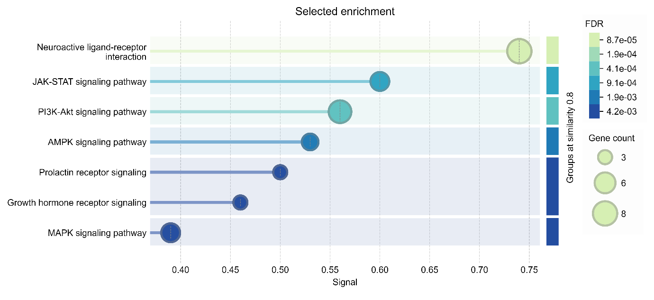
NETWORK ANALYSIS
Protein–protein interaction (PPI) networks are a valuable tool for interpreting complex high-throughput genomic data. In the present study, PPI networks were constructed for the 57 candidate genes associated with calving interval (Figure 2). Through network analysis, key hub genes including ESR1, IGF1, LEP, MSTN, TNF, FGF2, TLR4, and LTF were identified based on degree centrality (Table 2 and Figure 3). Degree centrality, which refers to the number of direct connections a node has with other nodes, was used as the primary topological parameter. Genes with higher degree centrality values were considered potential hub genes, indicating their significant role in regulating cellular signalling pathways.
Figure 2. Protein–protein interaction network based on candidate genes involved in the calving interval.
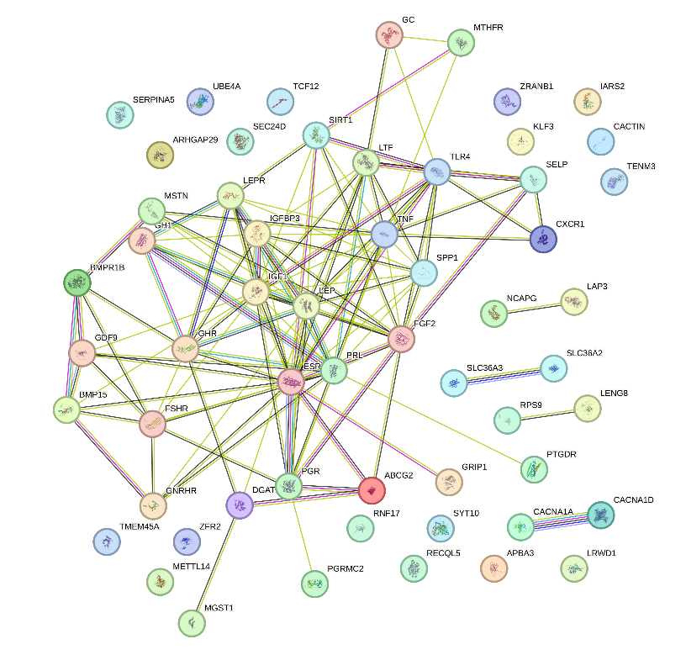

Table 2. Candidate genes identified from protein–protein interaction (PPI) networks based on the degree of centrality measure.
Sl. No | Gene Symbol | Degree centrality | Rank
1 | ESR1 | 19 | 1
2 | IGF1 | 18 | 2
3 | LEP | 17 | 3
4 | MSTN | 16 | 4
5 | TNF | 16 | 4
6 | FGF2 | 13 | 6
7 | TLR4 | 11 | 7
8 | LTF | 10 | 8
9 | IGFBP3 | 10 | 8
10 | SPP1 | 10 | 8
ESR1 is critical in regulating the oestrous cycle, follicular development, and uterine receptivity. Its expression modulates transcription of genes controlling ovulation and implantation, influencing fertility and thus calving interval in cattle. IGF1 (Insulin-like growth factor 1) functions as a key growth factor mediating the effects of growth hormone on cellular proliferation and differentiation within ovarian follicles. IGF1 promotes folliculogenesis, steroidogenesis, and oocyte maturation, facilitating timely ovulation and conception. Elevated IGF1 levels correlate with improved reproductive efficiency and shorter calving intervals, highlighting its regulatory importance (Fortes et al., 2012). The LEP gene encodes leptin, an adipocyte-derived hormone that signals nutritional status to the hypothalamus, thus modulating the reproductive axis. Adequate leptin levels are essential for initiating puberty and maintaining oestrous cyclicity by regulating gonadotropin-releasing hormone (GnRH) secretion. Polymorphisms in LEP affect energy balance and fertility traits, positioning it as a hub gene linking metabolism with reproductive function

Figure 3. The identification of hub genes involved in the molecular mechanism of calving interval is highlighted in red to yellow colour in the PPI network.
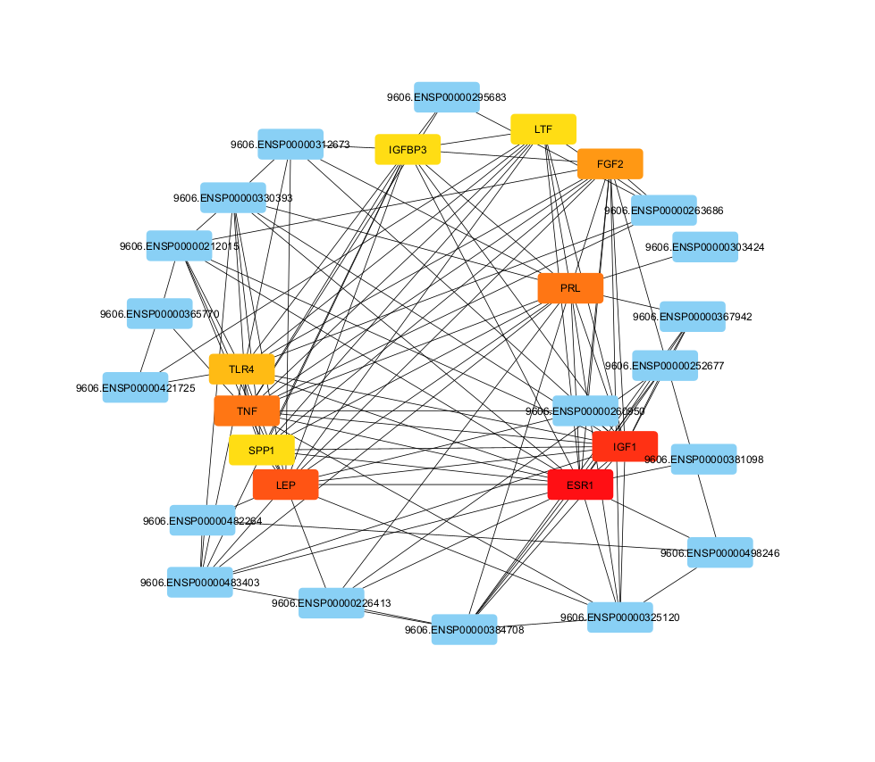

MSTN (Myostatin) is primarily known as a negative regulator of muscle growth but has indirect effects on reproduction by influencing energy allocation and body condition. Better body condition supports metabolic demands of reproduction; thus, MSTN gene variants affect calving interval through impacts on growth and fat reserves (Grobet et al., 1997). TNF regulates corpus luteum function and uterine receptivity, playing a role in early embryonic development and implantation success. Dysregulation of TNF signalling can impair fertility and prolong calving intervals by increasing embryonic loss or uterine inflammation (Green et al., 2010). FGF2 (Fibroblast growth factor 2) promotes angiogenesis and cellular proliferation within ovarian follicles and uterine tissues, supporting follicular growth and endometrial remodelling necessary for implantation. FGF2 expression correlates with successful conception and reproductive cyclicity, marking its importance in reproductive gene networks (Bridges et al., 1991).
TLR4 (Toll-like receptor 4) is vital for innate immune system activation, recognising bacterial lipopolysaccharides and initiating immune responses critical for uterine health postpartum. TLR4-mediated pathogen recognition reduces uterine infections that could delay return to oestrus, thereby shortening calving intervals. Finally, LTF (Lactoferrin) contributes antimicrobial and anti-inflammatory effects in the female reproductive tract, aiding in uterine involution and protection against postpartum infections. By maintaining reproductive tract health, LTF supports timely ovarian activity and facilitates shorter calving intervals (Sharma et al., 2019).
Together, these hub genes form interconnected functional networks integrating hormonal regulation, immune defence, growth, and metabolic status, ultimately coordinating reproductive success and calving interval regulation in cattle. However, the limitation of the present study is the possibility of obtaining false-positive results, as is common in this kind of study. Hence, validation with GWAS, candidate gene approaches, and gene expression analysis is suggested.
Conclusion
The present study was undertaken to explore the molecular mechanisms and key genetic variants within candidate genes influencing calving interval (CI) in Bos indicus cattle, with comparisons to temperate Bos taurus breeds. Targeting the identified hub genes or their associated regulatory pathways may offer novel strategies for enhancing reproductive efficiency through improved calving interval management. Moreover, the discovered genetic variants hold potential applications in the development of customised SNP genotyping chips, as well as in marker-assisted and genomic selection programs for cattle breeding in the future.
Data availability
No datasets were generated during current study. The datasets used for this analysis were obtained from previously submitted datasets in the NCBI database, which have been cited.

Disclaimer (Artificial intelligence)
Option 1:
Author(s) hereby declare that NO generative AI technologies such as Large Language Models (ChatGPT, COPILOT, etc.) and text-to-image generators have been used during the writing or editing of this manuscript.
Option 2:
Author(s) hereby declare that generativ AI technologies such as Large Language Models, etc. have been used during the writing or editing of manuscripts. This explanation will include the name, version, model, and source of the generative AI technology and as well as all input prompts provided to the generative AI technology
Details of the AI usage are given below:
1.
2.
3.

References:
Abdalla, I. M., Hui, J., Nazar, M., Arbab, A. A.I., Xu, T., Abdu, S. M. N., Mao, Y., Yang, Z., & Lu, X. (2023). Identification of Candidate Genes and Functional Pathways Associated with Body Size Traits in Chinese Holstein Cattle Based on GWAS Analysis. Animals, 13(6), 992.
Afgan, E., Baker, D., Van den Beek, M., Blankenberg, D., Bouvier, D., Cech, M., Chilton, J., Clements, D., Coraor, N., Eberhard, C., & Grüning, B. (2016). The Galaxy platform for accessible, reproducible and collaborative biomedical analyses: 2016 update. Nucleic acids research, 44(W1), W3-W10.
Andrews, S. (2010). FastQC: a quality control tool for high throughput sequence data. Available online at: http://www.bioinformatics.babraham.ac.uk/projects/ fastqc.
Aponte, P. F., Carneiro, P. L., Araujo, A. C., Pedrosa, V. B., Fotso-Kenmogne, P. R., Silva, D. A., Miglior, F., Schenkel, F. S., & Brito, L.F. (2024). Investigating the genomic background of calving-related traits in Canadian Jersey cattle. Journal of Dairy Science, 107(12), 11195-11213.
Atashi, H., Salavati, M., De Koster, J., Crowe, M. A., Opsomer, G., Hostens, M., & GplusE Consortium. (2020). A genome-wide association study for calving interval in Holstein dairy cows using weighted single-step genomic BLUP approach. Animals, 10(3), 500.
Bahar, B., Halloran, F., Callanan, M. J., McParland, S., Giblin, L., & Sweeny,T. (2011). Bovine Lactoferrin gene haplotypes have different basal transcriptional activities. Animal Genetics, 42 (3), 270-279.
Bene, S., Korosi, Z. J., Bognar, L., Polgar, J. P., & Szabo, F. (2024). Population genetic features of calving interval of Holstein-Friesian cows bred in Hungary. Animals, 14(17), 2513.
Bolger, A. M., Lohse, M., & Usadel, B. (2014). Trimmomatic: a flexible trimmer for Illumina sequence data. Bioinformatics, 30(15), 2114-2120.
Bridges, P. J., Gadsby, J. E., & Flint, A. P. (1991). The role of fibroblast growth factors in the bovine ovary: stimulation of thecal cell proliferation by fibroblast growth factor-2. Endocrinology, 129(3), 1529–1536.
Chen, X., Zhang, S., Cheng, Z., Cooke, J. S., Werling, D., Wathes, D. C., & Pollott, G. E. (2017). Polymorphisms in the selectin gene cluster are associated with fertility and survival time in a population of Holstein Friesian cows. PLoS ONE, 12(4), e0175555.
Cingolani, P., Patel, V. M., Coon, M., Nguyen, T., Land, S. J., Ruden, D. M., & Lu, X. (2012a). Using Drosophila melanogaster as a Model for Genotoxic Chemical Mutational Studies with a New Program, SnpSift. Frontiers in Genetics, 3, 35.
Cingolani, P., Platts, A., Wang le, L., Coon, M., Nguyen, T., Wang, L., Land, S.J., Lu, X., & Ruden, D.M. (2012b). A program for annotating and predicting the effects of single nucleotide polymorphisms, SnpEff: SNPs in the genome of Drosophila melanogaster strain w1118; iso-2; iso-3. Fly, 6(2), 80-92.
De Matteis, G., Scata, M., Grandoni, F., Petrera, F., Abeni, F., Catillo, G., Napolitano, F., & Moioli, B. (2012). Association analyses of single nucleotide polymorphisms in the leptin and leptin receptor genes on milk and morphological traits in Holstein cows. Open Journal of Animal Sciences, 2, 174-182.
Dias, M. S., Pedrosa, V. B., da Cruz, V. A. R., Silva, M. R., & Pinto, L. F. B. (2024). Genome-wide association and functional annotation analysis for the calving interval in Nellore cattle. Theriogenology, 218, 214-222.
Farnaud, S., & Evans, R. W. (2003). Lactoferrin – a multifunctional protein with antimicrobial properties. Molecular Immunology, 40, 395–405.
Fernandez, J. C., Perez, J. E., Herrera, N., Martinez, R., Bejarano, D., & Rocha, J. F. (2019). Genomic association study for age at first calving and calving interval in Romosinuano and Costeño con Cuernos cattle. Genetics and Molecular Research, 18, 1-13.
Fortes, M. R. S., Lehnert, S. A., Bolormaa, S., Reich, C., Fordyce, G., Corbet, N. J., Whan, V., Hawken, R. J., & Reverter, A. (2012). Finding genes for economically important traits: Brahman cattle puberty. Animal Production Science, 52(3), 143-150.
Garrett, A. J., Rincon, G., Medrano, J. F., Elzo, M. A., Silver, G. A., & Thomas, M. G. (2008). Promoter region of the bovine growth hormone receptor gene: Single nucleotide polymorphism discovery in cattle and association with performance in Brangus bulls. Journal of Animal Science, 86(12), 3315-3323.
Garrison, E., & Marth, G. (2012). Haplotype-based variant detection from short-read sequencing. arXiv preprint arXiv:1207.3907.
Green, M. P., Thompson, J. G., & Kind, A. J. (2010). Tumor necrosis factor-α regulates prostaglandin F2α production and apoptosis in luteal cells from cattle. Reproduction, Fertility and Development, 22(2), 267–273.
Grobet, L., Martin, L. J., Poncelet, D., Pirottin, D., Brouwers, B., Riquet, J., Schoeberlein, A., Dunner, S., Menissier, F., Massabanda, J., Fries, R., & Georges, M. (1997). A deletion in the bovine myostatin gene causes the double-muscled phenotype in cattle. Nature Genetics, 17(1), 71–74.
Haque, M. A., Lee, Y. M., Ha, J. J., Jin, S., Park, B., Kim, N. Y., Won, J. I., & Kim, J. J. (2024). Genome-wide association study identifies genomic regions associated with key reproductive traits in Korean Hanwoo cows. BMC Genomics, 25(1), 496.
Hyeong, K. E., Iqbal, A., and Kim, J. J., (2014). A genome wide association study on age at first calving using high density single nucleotide polymorphism chips in Hanwoo (Bos taurus coreanae). Asian-Australasian Journal of Animal Sciences, 27(10), 1406.
Janovick-Guretzky, N. A., Dann, H. M., Carlson, D. B., Murphy, M. R., Loor, J. J., & Drackley, J. K. (2007). Housekeeping gene expression in bovine liver is affected by physiological state, feed intake, and dietary treatment. Journal of Dairy Science, 90(5), 2246-2252.
Langmead, B., & Salzberg, S. L. (2012). Fast gapped-read alignment with Bowtie 2. Nature methods, 9(4), 357-359.
Lee, Y. L., Takeda, H., Costa Monteiro Moreira, G., Karim, L., Mullaart, E., Coppieters, W., GplusE consortium., Appeltant, R., Veerkamp, R. F., Groenen, M. A. M., Georges, M., Bosse, M., Druet, T., Bouwman, A. C., & Charlier, C. (2021). A 12 kb multi-allelic copy number variation encompassing a GC gene enhancer is associated with mastitis resistance in dairy cattle. PLoS Genetics, 17(7), e1009331.
Mota, L. F., Lopes, F. B., Fernandes Junior, G. A., Rosa, G. J., Magalhaes, A. F., Carvalheiro, R., & Albuquerque, L. G. (2020). Genome-wide scan highlights the role of candidate genes on phenotypic plasticity for age at first calving in Nellore heifers. Scientific reports, 10(1), 6481.
Peripolli, E., Temp, L. B., Fukumasu, H., Pereira, A. S. C., Fabricio, E. C., Ferraz, J. B. S., & Baldi, F. (2024). Identification of candidate genes and genomic prediction for early heifer pregnancy in Nelore beef cattle. Livestock Science, 289, 105582.
Pryce, J. E., Bolormaa, S., Chamberlain, A. J., Bowman, P. J., Savin, K., & Goddard, M. E. (2010). A validated genome-wide association study in 2 dairy cattle breeds for milk production and fertility traits using variable length haplotypes. Journal of Dairy Science, 93(7), 3331-3345.
Schmidt, P.I., Campos, G.S., Roso, V.M., Souza, F.R.P., & Boligon A.A. (2019). Genetic analysis of female reproductive efficiency, scrotal circumference and growth traits in Nelore cattle. Theriogenology, 128, 47-53.
Sharma, A., Singh, M., Kumar, P., & Dogra, P.K. (2019). Investigating post-partum ovarian cyclicity following various treatments in dairy cows. Rural Sustainability Research, 41(336), 22-25.
Vijayakumar, P., Paramasivam, A., Singaravadivelan, A., Sivakumar, T., Vasanthakumar, T., Nithiaselvi, R., & Churchil, R. (2021). Genetic Studies on Productive and Reproductive Traits of Crossbred Jersey (Jersey × nondescript) cattle. Journal of Animal Research, 11(04), 653-659.
Vijayakumar, P., Singaravadivelan, A., Silambarasan, P., Ramachandran, M., & Churchil, R. (2019). Production and reproduction performances of crossbred Jersey cows. Veterinary Research International, 7(2), 56-59.
Waghmare, S.S., Singh, R.P., Ahlawat, N., Panday, R., & Shukla, A.K. (2023). Genetic studies on calving interval and its influence on complete lactation milk and 305 days lactation milk crossbred cattle. The Pharma Innovation Journal, 12(2), 560-566.
Zhao, Y., Wang, X., Liu, Y., Li, N., Wang, S., Sun, Z., Gao, Z., Zhang, X., Mao, L., Tang, R. & Xue, W. (2021). LENG8 regulation of mRNA processing, is responsible for the control of mitochondrial activity. BioRxiv, 2021-07.
Wang, Y., Ipema, A., Goselink, R., Burgers, E., Gross, J., Bruckmaier, R., ... & van Knegsel, A. (2024). Effects of calving interval of dairy cows on development, metabolism, and milk performance of their offspring. Journal of Dairy Science, 107(11), 9934-9947.
Shashikant., Singh, C. V., Barwal, R. S., Singh, C. B., Shahi, B. N., & Sarma, O. (2024). Genetic studies on first lactation traits and lifetime milk yield in crossbred cattle. Journal of Advances in Biology & Biotechnology, 27(10), 741–748.
El-Qaliouby, H. S., El-Kasrawy, N. I., Abouelghait, H. A., Hegazy, M. M., & Abd El-Aziz, A. H. (2024). Influence of calving age, parity, and calf gender on lactation metrics, reproductive and economic efficiency parameters in Egyptian buffaloes. Journal of Advanced Veterinary Research, 14(3), 445-449.

