Original Research Article

Arthrospores Production in Colletotrichum gloeosporioides from Onion under Nutrient-Depleted Conditions

.
ABSTRACT
Colletotrichum gloeosporioides, a well-known anthracnose-causing pathogen, primarily reproduces asexually through conidia. However, the formation of Arthrospores, a less-characterized survival structures, were observed under nutrient-depleted conditions in C. gloeosporioides isolated from onion. The fungus was isolated on PDA, and Arthospores production was notably associated with distinct morphological changes in the colony, particularly in cultures aged 18 days under nutrient-depleted conditions. Light microscopy revealed hyphal fragmentation into thick-walled, rectangular Arthospores distinct from the typical fusiform conidia. This study presents morphological evidence of arthrospore formation in C. gloeosporioides, potentially contributing to its survival and persistence in field environments. These findings highlight a novel adaptation mechanism in this pathogen which may implicate on disease epidemiology and management.

Keywords: Colletotrichum gloeosporioides, onion anthracnose, arthrospores, hyphal fragmentation, nutrient stress, fungal survival

1. INTRODUCTION

Onion (Allium cepa) is a profitable, high value vegetable and spice crop of India, but its cultivation is challenged by various biotic and abiotic stresses. Among biotic stresses, the fungal disease anthracnose is major issue caused by Colletotrichum spp. poses a significant threat, severely impacting bulb production and drawing considerable attention from both growers and researchers. The anthracnose is identified as a kharif season disease, as this with projected yield losses upto 100% (Dutta et al. 2024). Colletotrichum gloeosporioides is a causing anthracnose disease in a broad range of crops, including onion. Its typical life cycle includes the production of conidia in acervulli, which serve as primary inoculum for disease dissemination. However, the fungi can develop alternative survival structures, such as arthrospores, in response to adverse environmental conditions or nutrient stress. Arthrospores are asexual spores formed by the fragmentation of hyphae at septa and are often associated with persistence in adverse conditions. However, Though arthrospore formation is well-documented in genera like Geotrichum and Coccidioides, while limited evidence exists for such structures in Colletotrichum spp. In this study, we report the production of arthrospores in C. gloeosporioides isolated from onion under nutrient-depleted conditions. This research aims to characterize these structures morphologically and evaluate their possible role in fungal survival.

2. material and methods

Fungal isolation and identification
Colletotrichum gloeosporioides (isolate OGRDCGI) was isolated from naturally infected onion (Allium cepa L.) leaves exhibiting typical anthracnose symptoms collected from the experimental fields of ICAR Directorate of Onion and Garlic Research (ICAR-DOGR), Pune, Maharashtra, India (18.5035 N. 73.5305 E; elevation: 611 m above mean sea level; temperature range: 5.5-42.0 °C annual mean rainfall: 669 mm). Infected tissues were surface sterilized and plated on potato dextrose agar (PDA) following standard isolation protocols. Plates were incubated at 252°C for 7 days. Single hyphal tips from emerging colonies were sub-cultured onto fresh PDA plates to obtain pure single-spore isolates. Mycelial plugs (5 mm diameter) from three-day-old actively growing cultures were transferred to PDA plates and slants, and stored at 4 °C for further studies. Cultural and morphological characteristics were examined from 7-day-old cultures using a Carl Zeiss compound light microscope.
Molecular identification of the isolated pathogen was carried out through genomic DNA extraction followed by PCR amplification of the internal transcribed spacer (ITS1/ITS4) and translation elongation factor 1-alpha (tef1-α) genes regions. The resulting amplicons were sequenced, and the obtained ITS and tef1-α sequences were subjected to BLAST analysis against the NCBI GenBank database to confirm the identity of the strain. The validated sequences were subsequently deposited in the GenBank database.
In-vitro arthrospore formation from Colletotrichum gloeosporioides hyphae and observations of colony morphology
Pure cultures of Colletotrichumgloeosporioides were kept incubated under nutrient-depleted conditions on aged potato dextrose agar (PDA) plates without subculturing. Morphological changes were monitored at 10, 15, and 20 days post-incubation. Fungal structures were examined under light microscopy following staining with 1% cotton blue in lactophenol. Two drops (20 µl) of conidial suspension were placed on microscope slides, and 1% cotton blue in lactophenol was added, and slides were examined under a Carl Zeiss light microscope. For quantitative analysis, images were captured from 50 randomly selected microscopic fields. Spore dimensions (length and width) were measured for more than 400 spores using ImageJ software version 1.53a (Schneider et al., 2012; Gunasinghe et al., 2021).

3. results and discussion

To identify the fungal pathogen/s associated with onion samples showing typical anthracnose disease, standard isolation procedures were employed as described in the methods. Infected leaf samples were used for isolation of the pathogens, and incubated at 25 ± 2 °C. The results of isolation after 7 days of incubation at 25 ± 2 °C showed pathogenic fungus associated with this disease in the onion plant, which were later identified as Colletotrichumgloeosporioides (OGRDCG1) based on their morphological characters. The color of the Colletotrichum colony was white to grey with yellowish orange pigments (Fig. 1). The mycelium was hyaline, septate, conidia were single-celled, hyaline, and cylindrical/dumbel with rounded ends having oil globules.
Anthracnose symptoms suspected to be caused by Colletotrichum gloeosporioides were observed on onion leaves and subsequently confirmed through isolation and Morpho-molecular characterization. Initial symptoms included small, white, depressed lesions on the leaves. As the infection progressed, these lesions turned brown and developed distinct orange acervuli. With increasing severity, the disease led to tip drying, wilting, and dieback symptoms, eventually resulting in bulb rot and complete plant death-consistent with the descriptions reported by Alberto and Perez (2020) and Dutta et al. (2022). In the present study, cultures of C. gloeosporioides initially exhibited white to grey mycelia, which darkened with age. These observations are in agreement with Reecha et al. (2022), who isolated C. gloeosporioides from shallot plants and reported colonies that changed from grey to dark brown over time. Microscopically, the fungus produced abundant conidia with cylindrical to dumbbell-shaped morphology, consistent with earlier observations by Subramanyam (1971).

The pathogens' confirmation was done using molecular characterization through universal ITS and tef1-αgene sequencing. The PCR analysis for C. gloeosporioides ITS 1/4 resulted in amplicons of 487 bp and 456 bp in the tef1-α gene, respectively. Upon analysis using NCBI (National Centre for Bioinformatics) BLAST tool, both the isolates of OGRDCG1 had > 98% similarity with C. gloeosporioides. The accession numbers of the ITS and tef1-α gene of C. gloeosporioides (OR141498 and PP263370), respectively. ). After identification, the pure culture of C. gloeosporioides was deposited in the International repository of National Agriculturally Important Microbial Culture Collection (NAIMCC), Mau, Uttar Pradesh (India) (NAIMCC-F-04610).
For confirmatory identification, the isolates were subjected to molecular characterization using the ITSI/ITS4 and translation elongation factor 1-alpha (tef1-α) gene sequencing, following the approach described by Mahmoud and Zaher (2015). BLAST analysis of the obtained sequences against the NCBI GenBank database confirmed the identity of the pathogen as C.gloeosporioides. The sequences were submitted to GenBank and are available under accession numbers OR141498 (ITS) and PP263370 (tefl-α). The ITS and tefl-a regions are widely recognized as informative molecular markers for distinguishing C. gloeosporioides from other Colletotrichum species, consistent with the findings of Patil et al. (2018) and Dutta et al. (2024).

In-vitro arthrospore formation

Observations confirmed the morphogenic plasticity of C. gloeosporioides. Under nutrient-depleted conditions, hyphae began fragmenting into shorter, rectangular cells after 18 days of incubation. The species changed its morphology from septate hyphal growth to rectangular to barrel-shaped (average dimensions of 5-7 µm)arthrospores (Fig. 1). These arthrospores were thick-walled. Non-septate or minimally septate, formed directly by hyphal fragmentation. These spores were distinct from conidia both in shape and formation mode. No such structures were observed in fresh, nutrient-rich PDA cultures. Arthrospores placed on fresh PDA germinated within 48hours, indicating viability and potential for reactivation under favourable conditions
The formation of single-celled arthrospores by Colletotrichum gloeosporioides was associated with prominent changes in colony morphology, particularly in cultures aged 18 days under nutrient-depleted conditions. The emergence of multicelledarthrospores during this period indicates a clear morphological transition, reflecting the fungus's ability to adapt to environmental stress and nutrient stress. Arthrospores are asexually produced, single-celled propagules formed through the segmentation and subsequent fragmentation of hyphae (Barrera and Szaniszło, 1985; Gunasinghe et al., 2021), and their development is a key feature of fungal morphogenesis, especially in dimorphic or polymorphic fungal species, including members of the Ascomycota.
Similar arthrosporic structures have been reported in other fungal taxa. For instance, Geotrichumcandidum is well-documented for producing arthrospores under specific conditions (Allermann et al., 1978; Kier et al., 1980; Olesen and Kier, 1984; Slade et al., 1987).
Carmichael (1957) and Butler (1960) observed that the initially cylindrical arthrospores of G. candidum gradually became more spherical with time, eventually developing into what Carmichael termed thick-walled cells. Duran et al. (1972) described comparable yeast-like forms in G. candidum when grown under low pH conditions, suggesting that mature arthrospores can undergo additional morphological changes and wall thickening. Furthermore, Trinci and Collinge (1974) reported differences in arthrospore morphology depending on whether the fungus was grown in nitrogen or carbon-free media, emphasizing the role of nutrient availability in morphogenesis. Similarly, Gunasinghe et al 2021 reported the dimorphism of Neopsueudocercosporellacapsellae, switching between septate hyphae and single-celled yeast phase under in-vitro (artificial culture media) or in-planta (on the host surface prior to infection occurs). The hyphae-to-yeast transformation occurs via the formation of morphologically distinguishable blastospore (blastoconidia) types (meso-blastospores and micro-blastospores), and arthrospores (arthroconidia). Dimorphic switching is typically reported in genera such as Mucor, Candida albicans, Talaromycesmarneffei, and Paracoccidioides brasiliensiswhichexhibit morphological shifts primarily regulated by temperature, osmotic and oxidative stress, pH fluctuations, metal ion concentrations. These shifts are also recognized as important determinants of virulence (Singh et al., 2016; Hahn et al., 2022; Honorato et al., 2022; Wang et al., 2023; Li et al., 2024). Similarly, the wheat pathogen Zymoseptoriatriticimodulates its dimorphic transition and pathogenic behavior in response to environmental cues -including light, temperature and host derived signals (Kilaur et al., 2020). In lichens, Umbilicariamuhlenbergii, dimorphism is triggered by nutrient limitation and hyperosmotic stress, where interaction with its photobiont Trebouxiajamesiiproduce pseudo hyphal development (Kolhe et al., 2022; Wang et al., 2020). Arthrospore production has also been documented in clinically important fungi such as Trichosporon spp., where these structures are implicated in survival and infection under host-imposed stresses (Klein and Tebbets, 2007; Kurakado et al., 2021).
Conidiogenesis in C. gloeosporioides is a highly regulated developmental process that results in the formation of conidia, which serves as primary inoculum initiating new infections under favorable environmental conditions (Cannon et al. 2012). Whilearthrosporogensisinvolves direct transformation of vegetative hyphae into arthrospores under stress conditions such as or nutrient-depleted or prolonged incubation on minimal media (Chen et al., 2014). While both conidia and arthrospores are asexual propagules, they differed in function and ecological role. Conidia is more energy intensive due to its need for active growth, development, and dispersal for host invasion and rapid disease spread under favourable environmental conditions (Mendgen et al. 1996). The conidiogenesis requires substantial inputs of ATP, NADPH, and carbon precursors and is governed by complex signalling pathways (MAPK, cAMP-PKA), which themselves are ATP-dependent (Li et al., 2024). Whereas, arthrogenesis is more energy-efficient, serving as a stress response or dormancy mechanism, relying more on modification of existing hyphal cells rather than creation of new structures which are primarily associated with long term survival and persistence in adverse environments (Boyce et al. 2015).
The ability of C. gloeosporioides to form arthrospores under nutrient-depleted conditions further underscores its morphogenic plasticity, enabling the fungus to survive and persist in unfavorable environments. These arthrospores likely function as resting or dormant structures, facilitating survival in crop residues or soil during off-seasons. While conidia are primarily responsible for rapid infection and dissemination, arthrospores may enhance the fungus’s resilience under nutrient-limiting or stress conditions. This study among the first to report arthrospore formation in Colletotrichum spp., particularly from onion, thereby expanding our understanding of its life cycle. In the absence of conidial production, arthrospores serve as survival structures and are capable of initiating infection. Their presence may facilitate latent infections or inoculum persistence in the field, posing additional challenges to effective disease management. Further investigations, including ultrastructural studies using electron microscopy and analysis of gene expression associated with arthrosporogenesis, are essential to elucidate the molecular mechanisms governing arthrospore formation in C. gloeosporioides.

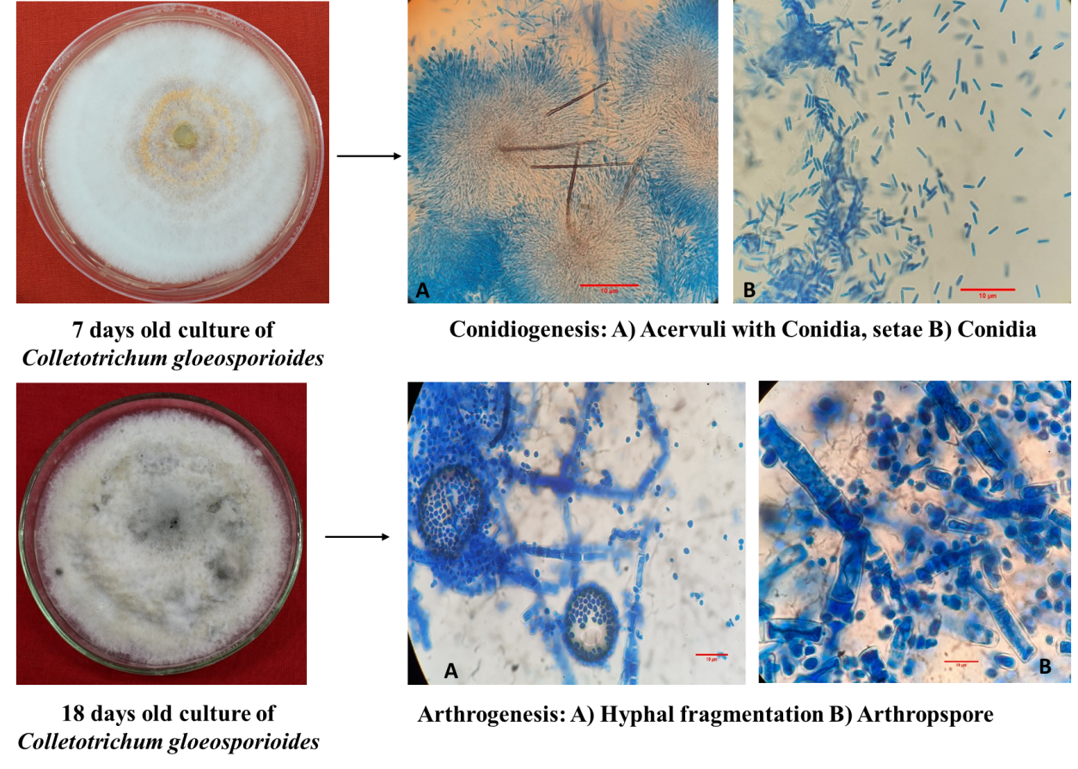

Fig. 1.Conidiogenesis and arthrogenesis of Colletotrichum gloeosporioides

4. Conclusion

This study demonstrates that Colletotrichum gloeosporioides can produce arthrospores under nutrient-depleted conditions, representing a potential survival strategy. The morphological evidence and viability tests support their role as dormant propagules, possibly contributing to disease recurrence after symptom suppression or offseason carryover. Understanding this alternative sporulation pathway could improve understanding of pathogen persistence may aid in improving disease forecasting and sanitation-based management strategies, particularly in high-value crops like onion.

Consent
Not applicable

Ethical approval
Not applicable

References

Alberto, R.T. & Perez PM (2020). Development of an integrated disease management program against Anthracnose-Twister (Colletotrichum gloeosporioides-Gibberella moniliformis) disease of onion (Allium cepa). Plant PathologyAnd Quarantine 10(1), 111–119.
Allermann, K., Floto, F., Olsen, J.,&Sortkjaer O, Kier I (1978) Sporulation and the Macromolecular Composition of the Mycelium and Arthrospores of GeotrichumCandidum. Physiology of Plant 42 (4), 355–358. doi: 10.1111/j.1399 3054.1978.tb04095.x
Barrera C., &Szaniszlo P. (1985) Formation and Germination of Fungal Arthroconidia. Crit ReviewMicrobiology 12 (4), 271–292. doi: 10.3109/10408418509104431
Boyce K.J., &Andrianopoulos A. (2015) Fungal dimorphism: the switch from hyphae to yeast is a specialized morphogenetic adaptation allowing colonization of a host. FEMS Microbiological Review 39(6),797-811. doi: 10.1093/femsre/fuv035.

Butler E.E. (1960) Pathogenicity and taxonomy of Geotrichumcandidum. Phytopathology 50, 665-672.
Cannon P.F., Damm U., Johnston P.R., &Weir B.S. (2012) Colletotrichum – current status and future directions. Studies in Mycology 73,181-213.

Carmichael J.W. (1957). Geotrichum candidum. Mycologia 49: 820-830.
Chen H., Fujita M., Feng Q., Clardy J.,& Fink G.R. (2014).Tyrosol is a quorum-sensing molecule in Candida albicans. Proceedings of the National Academy of Sciences 101(14), 5048-5052.

Duran, A., Uruburu,.F&Villanueva, J.R. (1973). Morphogenetic and nutritional studies of Geotrichum lactis cells. Archiv fur Mikrobiologie 88, 245-256.
Dutta, R., Jayalakshmi, K., Nadig, S.M, Manjunathagowda, D.C., Gurav, V.S., &Singh, M. (2022).Anthracnose of Onion (Allium cepa L.): A Twister Disease. Pathogens, 11, 884.
Dutta, R., Jayalakshmi K., Satish Kumar., Radhakrishna A., Manjunathagowda D.C, Nadig S.M., Gurav., &Mahajan V. (2024). Insights into the cumulative effect of Colletotrichum gloeosporioides and Fusarium acutatumcausing anthracnose‑twister disease complex of onion. ScientificReports,14,9374.
Gunasinghe, N., Barbetti, M.J., Dehigaspitiya,M.P., &Neate, S. (2021). Dimorphism in Neopseudocercosporellacapsellae an emerging pathogen causing white leaf spot disease of brassicas. Frontiers Cell InfectiobMicrobiolgy 11:678231. doi: 10.3389/fcimb.2021.678231. PMID: 34150676; PMCID: PMC8212886.
Hahn R.C., Hagen F., Mendes R.P., Burger E., Nery A.F., Siqueira N.P., Guevara A., Rodrigues AM, &de Camargo ZP (2022).Paracoccidioidomycosis: current status and future trends. Clinical Microbiological Review,35:e0023321. doi: 10.1128/cmr.00233-21
Honorato L., de Araujo J.F.D, Ellis C.C., Piffer A.C., Pereira Y., Frases S., de Sousa Araújo G.R, Pontes B., Mendes M.T., Pereira M.D., Guimarães A.J., da Silva NM, Vargas G., Joffe L., Del Poeta M., Nosanchuk J.D., Zamith-Miranda D., Dos Reis F.C.G., de Oliveira H.C, Rodrigues M.L., de Toledo Martins S., Alves L.R., Almeida, I.C., &Nimrichter L. (2022). Extracellular vesicles regulate biofilm formation and yeast-to-hypha differentiation in Candida albicans. mBio 13:e0030122. doi: 10.1128/mbio.00301-22
Kier, I., Floto, F., Olsen, J., &Allermann, K. (1980). Macromolecular Composition of the Wall and Protoplasm of Mycelia and Arthrospores of GeotrichumCandidum. Trans. British Mycological Society 75 (3), 355–361. doi: 10.1016/ S0007-1536(80)80113-6
Kilaru, S., Fantozzi, E., Cannon, S., Schuster, M., Chaloner, T.M., Guiu-Aragones C, Gurr, S.J.,& Steinberg, G. (2022).Zymoseptoriatritici white-collar complex integrates light, temperature and plant cues to initiate dimorphism and pathogenesis. Nature Communication 13:5625. doi: 10.1038/s41467-022-33183-2
Klein, B.S,&Tebbets, B. (2007). Dimorphism and virulence in fungi. Curent Opinion Microbiology10:,14–319. doi: 10.1016/j.mib.2007.04.002
Kolhe, N., Damle, E., Pradhan, A., &Zinjarde, S.A. (2022). comprehensive assessment of Yarrowialipolytica and its interactions with metals: current updates and future prospective. Biotechnology Advances 59,107967. doi: 10.1016/j.biotechadv.2022.107967
Kurakado, S., Miyashita, T., Chiba, R., Sato, C., Matsumoto, Y., &Sugita, T. (2021). Role of arthroconidia in biofilm formation by Trichosporonasahii. Mycoses 64(1),42-47. doi: 10.1111/myc.13181.
Li, N., Bowling, J., de Hoog, S., Aneke, C.I., Youn, J.H., Shahegh, S., Cuellar-Rodriguez, J., Kanakry, C.G., Rodriguez Pena, M., Ahmed S.A., Al-Hatmi A.M.S., Tolooe, A., Walther, G., Kwon-Chung, K.J, Kang Y., & Lee H.B. (2024).Seyedmousavi A. Mucor germinans, a novel dimorphic species resembling Paracoccidioides in a clinical sample: questions on ecological strategy. mBio. 14, 15(8):e0014424. doi: 10.1128/mbio.00144-24

