Original Research Article
PHENOTYPIC AND GENOTYPIC CHARACTERIZATION OF DRUG RESISTANT SHIGELLA SPECIES ISOLATED FROM NORTH-EAST, NIGERIA

ABSTRACT
Nigeria has the 185th highest age-standardized AMR related mortality rate across 204 countries with higher death than Malaria which could also lead to a 5-7% loss in GDP by 2050. This highlights the urgent need for coordinated efforts to develop effective tools to tackle the growing threat of AMR and address the rapid adaptation of Shigella spp. to changing environments. This study aims to isolate and characterize Shigella species, determine their resistance profile and phylogeny as an essential guide to informing effective treatment measures in northeast Nigeria. Diarrhoeagenic stools samples were collected and cultured on selective media. Colonic phenotypic identification was done using classical microbiology and biochemical testing. Molecular identification combined PCR amplification and detection of the 16S rRNA gene using universal primers. The generated partial sequences aligned using ClustalW and phylogenetic tree constructed using Neighbour-joining method at 1000 bootstraps in MEGA12. Antibiotics susceptibility testing was done using Kirby-bauer diffusion method and interpreted using NCLI guidelines. Out of 324 diarrhoeagenic samples collected, 30 (9%) Shigella species confirmed include Shigella boydii (13), Shigella flexneri (15) and Shigella Sonnei (2). The high resistance was against Cefuroxime (100%), Ampicillin (80%), Amoxicillin-Clavulanic Acid (78%) while high susceptibility observed were against Amikacin (93%), Chloramphenicol (90%) and Azithromycin (85%). All five MDR phenotypes, one of which showed XDR potential and high MAR indices (0.2-0.9) including Shigella boydii and Shigella flexneri showed 16S rRNA amplicon around 720bp with sequences clustered within reference strains from China, Iran and U.S.A. Shigella strains in this study favours Amikacin, Chloramphenicol and Azithromycin as possible empirical treatment option and call for compulsory AST before shigellosis treatment due high MAR indices for the MDR Shigella species and XDR Shigella flexneri high risk. The guidelines recommend molecular diagnostics, genotypic high-risk strains tracking to help clinicians tailor therapy and limit outbreaks of MDR Shigella spp. and need for coordinated national strategy to drive intentional collaboration with research institutions to meet the targets for AMR research in Nigeria. These findings underscore the urgent need for WGS-enhanced surveillance and regional antibiotic stewardship for better genomic information.
Keywords: MDR, XDR, MARI, Shigellosis, Cluster, Genotype, Bauchi, Damaturu

1. INTRODUCTION
Shigella species (Shigella flexneri, Shigella dysenteriae, Shigella Sonnei, and Shigella boydii) are small, non-capsulated, non-motile rods that are the most common cause of severe dysentery across the globe. The fecal-oral route of transmission is activated by direct contact with an infected individual or by coming into touch with contaminated food, drink, or fomites. In the past, travel to low-income areas with unhygienic food and water such as sub-Saharan Africa has been associated with cases in high-income countries. However, cases are now isolated from individuals who never travel, particularly among men who have sexual relations with men in the developed part of the world (Mitchell et al., 2021) and India (Nandi et al., 2023). The illness is characterized by a brief incubation period (8 to 72 hours) and abrupt watery diarrhea, which is sometimes accompanied by muscles cramps, vomiting, and other problems (Matanza & Clements, 2023).
Although there is a lack of thorough community data on shigellosis, the majority of hospital-based research indicate that children under the age of five have the greatest case-fatality rate, especially if they are malnourished. There have been reports of baby death rates as low as 4 months and child mortality rates as high as 3.9% and 19.3%, respectively, in epidemic circumstances. With the exception of a peculiar epidemic in the Central African Republic that killed young adults from sepsis, intestinal perforation, toxic megacolon, dehydration, hyponatraemia, encephalopathy, hemolytic-uraemic syndrome, and pneumonia, the mortality rate generally decreased with age (Sahl et al., 2015). An estimated 1.1 million people die from shigellosis each year, with children being the most common age group to experience this type of mortality in developing countries like Nigeria (Sahl et al., 2015). Nigeria has the 185th highest age-standardized mortality rate per 100,000 population associated with AMR across 204 countries with higher death than in Malaria, tuberculosis, cardiovascular diseases necessitating the fight against AMR being integrated into currently-funded programmes within the health system, such as reproductive, mother, newborn, and child health, HIV, TB, and malaria (NAP, 2024).
There is no coordinated national strategy needed to drive intentional collaboration with research institutions to meet the targets for AMR research in Nigeria. The national research agenda that exist did not clearly state AMR as a priority whereas, mostly academic and operational research in Nigeria are the only active institutions in assessing the state of AMR and AMU across sectors (CDC, 2020).
Shigella related infectious diarrhea is frequently self-limiting, as a result, empiric antibiotic therapy is frequently used in children with assumed Shigella species infection while stool culture and susceptibility testing results are awaited (Ngoshe et al., 2017). Multidrug resistance prevalence have been reported of Shigella species in Damaturu (Saheed et al., 2020). In the three zones of Odeda L.G.A. south west, Nigeria, Shigella spp. isolated from students in every age group and gender were found to be resistant to augmentin, amoxicillin, gentamycin, and other commonly used antibiotics (Ajayi et al., 2019). None of the twelve medications examined in Makurdi, North Central, Nigeria tested 100% sensitivity to S. dysenteriae. The degree of resistance affected the drug's effectiveness (χ2 = 15.68, P<0.05). Tetracycline had an 86.2% drug resistance rate, while ampicillin had a 93.1% rate. There were two documented instances of S. dysenteriae (2% prevalence), and neither case was related to the children's age or gender. Ampicillin, ceftriaxone, and augmentin were the drugs that had 100% resistance (Chukwuma, Esther, Amana, et al., 2022) in a South-eastern study. (Lawal, 2017a). In a Northwestern, Nigeria studies, all Salmonella and Shigella isolates were shown to be responsive to at least one of the ten (10) medicines examined, despite the results showing variable degrees of resistance to the individual treatments tested (Titus et al., 2023). Streptomycin, Amoxicillin, and Augmentin were discovered to be the most that showed no effect on any of the isolates, but chloramphenicol showed the greatest efficacy, showing 25 mm±1.00 against Shigella and 23 mm±1.00 against Salmonella, respectively. Drug resistant Shigella species have been recorded across the geopolitical zones of Nigeria (Olaniyi et al., 2019).
Curiously, recent research indicates that the distribution of Shigella spp. has shifted in a number of contexts, Shigella dysentriae previously confined to developing counties are now frequently isolated in developed world (Mitchell et al., 2021). S. Sonnei is also becoming more common among high income earners in the areas which is also remain a mysteries as no research have really identified the factors responsible (Medeiros et al., 2018) purely interpret changes in the transmission trend.
Shigella strains from Nigeria have been shown to be virulent (Iwalokun et al., 2003) and resistant with regional difference as indicated by disparate data reported in the literature (Ajayi et al., 2019; Chukwuma, Esther, & Amana, 2022; Salleh et al., 2022; R. D. Umar et al., 2025). Treatment failure caused by antimicrobial resistance typically occur in areas where data are not collected making it difficult to efficiently evaluate the impact of resistance (Sack et al., 2001). As a result, the need for regional shigellosis records to guide local antibiotic prescription and provide phylogenetic information is critical to improving treatment effectiveness and tracking the evolution and spread of resistant strains. This study aims to isolate and characterize Shigella species from two secondary hospitals in Yobe and Bauchi states, Northeastern Nigeria, determine their resistance profile and phylogeny.
2. MATERIALS AND METHODS
2.1 The Study Area
Bauchi State Specialist Hospital, Bauchi and Yobe State Specialist Hospital, Damaturu are located in Bauchi and Yobe states, Northeastern Nigeria and bordering many cities and towns. As of 2016 the states had a population of 11,530,465 people with settlers of distinct backgrounds, occupational patterns, and beliefs (Projection, 2022). They share similar climate typified by a single, lengthy dry season that is followed by a shorter wet season. The average yearly rainfall in the Sahel is less than 500 mm, and it might even be as low as 250 mm. Its population is pluralistic and has a wide range of historical and cultural backgrounds (Eze & Onokala, 2022). Yobe State's principal ethnic groups are the Ngamo, Bolewa, Fulani, Manga, Kare-kare, Ngizim, Bade, and Kanuri with 45, 502 km² , it is located at 12000 N, 11030 E (Saheed et al., 2020) while Bauchi Located on the geographical coordinates of latitude 100 30′ North of the Equator, 100 00′ East of Greenwich Meridian, bordering Gombe state, Yobe to the east, Kaduna to the west, Kano and Jigawa to the north, and Taraba and Plateau to the south (Titus et al., 2023), with ethnic groups including Fulani, Gerawa, Jarawa, Warjawa, Sayawa, Kirfawa, Bolewa, Karekare, Zulawa, Fa,awa, and Kanuri, with distinct backgrounds, occupational patterns, and beliefs (Projection, 2022).
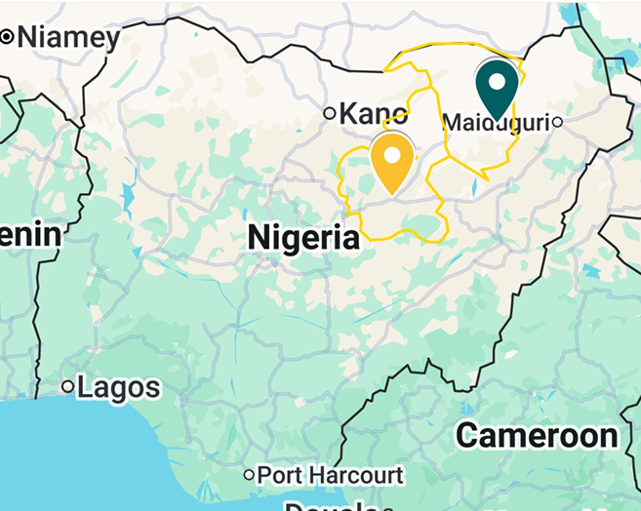
Figure 1: Map of Nigeria Showing Bauchi and Yobe States Boundaries and their State Capitals
Key: Damaturu – Bauchi –

2.2 Collection of Specimens
On the day of collection, fresh stool samples were collected in Cary-Blair transport medium, promptly transmitted to hospital laboratories (Hall, 2013) and tested for bacterial infections (Medeiros et al., 2018). Patients of all ages have their stool samples collected, including both male and female patients (adults, adolescents, and toddlers). Samples were taken from in- and out-patients with diarrhea who are admitted or seek out conventional health care attention concerning bacillary dysentery or diarrheal between February 2024 and July 2024 (Abdulhassan & Naji, 2022a).

2.3 Isolation of Shigella species

2.3.1 Cultural methods
In order to diagnose Shigella sp. The sample were inoculated using a sterile wire loop and incubated at 35±2°C for 18–24 hours on MacConkey agar (Himedia), Hektoen enteric agar, Salmonella Shigella agar, and Selenite Cystine Broth.

2.3.2 Morphological characterization (Gram’s Staining/Microscopy)
Morphology, dimensions, structure, and colony arrangement of bacteria cultured on Salmonella Shigella agar (Himedia), MacConkey agar, and Hektoen enteric agar were observed and recorded. The isolates were identified based on morphological properties (for cells and colonies) by picking a single colony of the isolates used for Gram staining procedure and examined under a 100x oil-emersion light microscope (Varghese & Joy, 2016). The pure isolates were kept at -70°C in Trypticase Soy Broth with 15% glycerol for two weeks before sensitivity testing.

2.3.3 Biochemical identification test for Shigella species
Colonies showing characteristic appearance on selective media were sub-cultured on Kligler iron agar (KIA) and Triple sugar iron agar (TSI). To obtain true reactions in KIA and TSI, a pure culture was used to inoculate the respective media. Using straight platinum wire, one Shigella colony was picked up and inoculated into each of the test media. The KIA and TSI slants were inoculated by stabbing the butt and streaking the surface of the slant and incubated at 37⁰ C for 24 h (Saheed et al., 2020).
Other biochemical tests used on the Gram’s negative rods arranged singly in pairs or in chains include, viz; Oxidase test, Urease test, Mannitol test, MR, VP, Indole, Citrate, and Motility were also conducted by inoculating putative (M100: Performance Standards for Antimicrobial Susceptibility Testing, 2023):
2.4 Identification of Shigella spp. using Enterosystem 18R
Entero-system 18R (Liofilchem) is a biochemical identification system designed to accurately identify Gram-negative, oxidase-negative Enterobacteriaceae, including Shigella flexneri and Shigella boydii, through 18 distinct biochemical reactions. It uses prepared kits for 18 different biochemical tests and used according to manufacturer’s instructions supplied with the kits. A pure bacterial culture isolated and suspected (confirmed Gram-negative and oxidase negative) from clinical specimens were obtained. Bacterial suspension in sterile physiological saline was thoroughly homogenized using vortex mixer to a turbidity equivalent to 0.5 McFarland standard. The Enterosystem 18R panel was brought to room temperature. 0.2 mL of the bacterial suspension was pipetted into each of the 18 wells containing desiccated biochemical substrates. The inoculated panels were incubated at 36 ± 1°C for 12 to 24 hours
After incubation, each well was observed for color changes that indicate positive or negative reactions for specific biochemical tests as shown in the interpretation sheet (supplied). Biochemical profile numerical codes were generate based on the combination of positive and negative reactions. The biochemical codes were matched against the Enterosystem 18R manufacturer’s software to identify the bacterial species.

2.5 Antibiotic Susceptibility Testing
The disk diffusion method was used to test the isolates for susceptibility patterns using Clinical Laboratory Standard Institute (M100: Performance Standards for Antimicrobial Susceptibility Testing, 2023) as recommended (Cusack et al., 2019). The goal is to cultivate the bacteria to the log-phase, which is roughly 1.5 × 108 CFU/mL. The following commonly prescribed seventeen antibiotic disks (Oxoid, UK; liofilm, Turkey;) had their minimum inhibitory concentrations (MICs): Amoxicillin-Clavulanic Acid (AMC, 30 µg), Ampicillin (AMP, 10 µg), Ceftriaxone (CRO, 30 µg), Ciprofloxacin (CIP, 5 µg), Cefuroxime (CFX, 1 µg), Ceftazidime (CAZ, 100 µg), Cefixime (CFM, 5 µg), Amikacin (AMK, 30 µg), Azithromycin (AZM, 15 µg), Clindamycin (CLI, 10 µg), Chloramphenicol (C, 30 µg), Imipenem (IPM, 10 µg), Levofloxacin (LVX, 15 µg), Piperacillin-Tazobactam (TZP, 110 µg), Streptomycin (STR, 5 µg), Tetracycline (TET, 30 µg) and Trimethoprim-Sulfamethoxazole (TMP-SMX, 25 µg) administered during the test were calculated using the ruler on Mueller-Hinton agar (HI Media).
The results were interpreted using breakpoints suggested by the CLSI (M100: Performance Standards for Antimicrobial Susceptibility Testing, 2023). Only when the MICs of the quality control strains, which are tested concurrently, will be within the established acceptable ranges as the antimicrobial susceptibility of the Shigella isolates approved. Resistance to two or more antibiotics from the same group, resistance to two or more antibiotics from different groups, and resistance to a wider range of antibiotics, categorized as Multi drugs, extensively drugs and pan-drugs resistant’s, were monitored.

2.6 Preservation of the Drug-Resistant Isolates
All drug resistant isolates were preserved in Hi media, Mueller Hinton broth containing glycerol, and stored at 4°C (Hall, 2013).

2.7 molecular Analysis
2.7.1 DNA extraction
After culturing isolates in lysogeny broth for the entire night, the isolates' total genomic DNA was extracted following manufacturers (Bioneer) instruction. A 3 ml preparation was achieved by adding 20 μl of Proteinase K to a clean 1.5 ml tube. 200 μl of cultured cells were added to the tube containing proteinase K. The sample was made to the total volume 200 μl by adding 13 μl PBS. 200 μl of binding buffer was added to the sample and mix immediately by vortex mixer. The sample was completely resuspended to achieve maximum lysis efficiency and incubated at 60℃ for 10 min. 100 μl of Isopropanol was added and mixed well by pipetting. Briefly, they were spin down to get the drops clinging under the lid. Carefully, the lysate was transferred into the upper reservoir of the Binding column tube (a 2 ml tube was fited in). The tube was covered and centrifuged at 8,000 rpm for 1 min. Each binding column tube was closed to avoid aerosol formation during centrifugation. The lysate was centrifuged again at a higher speed (>10,000 rpm) until the binding column tube is empty. The tube was opened and transferred to the Binding column tube to a new 2 ml tube for filtration (supplied). 500 μl of washing buffer 1 (W1) was added without wetting the rim, the tube was closed, and centrifuged at 8,000 rpm for 1min.
The tube was opened and poured into the solution from the 2 ml tube into a disposal bottle. Carefully, 500 μl of washing buffer 2 (W2) was added without wetting the rim, the tube was closed, and centrifuged at 8,000 rpm for 1 min. Centrifugation was repeated at ca. 12,000 rpm for 1 min to completely remove ethanol. The binding column tube to a new 1.5 ml tube for elution (supplied) was transferred, 200 μl of Elution buffer was added onto binding column tube for 1 min at RT (15~25℃) until the elution buffer is completely absorbed into the glass fiber of binding column tube. The volume of elution buffer added was adjusted from 50 μl to 100 μl. The elute was centrifuged at 8,000 rpm for 1 min. About 180 μl of eluent obtained when using 200 μl of elution buffer. The sample was eluted twice and used after concentration process. The eluted genomic DNA was used directly, and the remaining was stored at 4℃ for later analysis (Adesoji et al., 2016).
2.7.2 PCR amplification of 16s rRNA genes
By amplification of 16S rRNA, drug-resistant Shigella isolates was detected using the methodology outlined by (Adesoji et al., 2016; Iliyasu et al., 2020a). The PCR amount was 50 µl in total, with 25 µl of 2x easytaq PCR Super Mix /My Taq polymerase, 23 µl of double-distilled water, and 1 µl of each 16S 8F (GGACTACAGGGTATCTAAT) and 16S-517R (AGAGTTTGATCCTGG) primers, one microliter each for forward and reverse.
The G-Storm thermocycler, model number GS 00001 (ThermoFisher Scientific, UK), was used to conduct the PCR. The subsequent PCR reaction conditions were: First, there was five minutes of 94°C denaturation, one minute of 94⁰, followed by denaturation (94°C for 1 minute), annealing (52°C for 1 minute), and extension 25 cycles (72°C for one minute), with the last extension lasting five minutes at 72°C. To measure the size of the PCR product, a molecular marker 1 kb DNA Hyperladder (Bioline, UK) will be utilized. The products underwent 1.5% agarose gel electrophoresis for separation, gel red staining, and digital UV transillumination image capturing utilizing G:Box Chemi-XX6 (Syngene, UK).

2.7.3 Agarose gel electrophoresis
Commercially available agarose (TAE) was used. 3g of agarose was obtained, the solution was heated in a microwave until agarose was completely dissolved. It was allowed to cool in a water bath at 50⁰C – 55⁰C. The gel casting tray was prepared by sealing ends of gel chamber with tape. Appropriate number of combs were placed in gel tray. 5ul of ethidium bromide added, the mixture was allowed to cool and before pouring into the gel tray. It was allowed to cool and solidify for 23 min at room temperature. The comb(s) were removed, placed in electrophoresis chamber and covered with buffer (TAE).
The DNA mixture and standards (Ladder) were loaded onto the gel, electrophoresed at 5Voltage/Centimeter for 1hour and the DNA bands visualized using UV lightbox (gel imaging system, Biorad).
2.7.4 Purification of 16S rDNA fragment and sequencing
Sequencing reaction were prepared in a 2.0ml tube. All reagents were kept on ice while preparing the sequencing reactions and they were added as followed: 9.5ul of dH₂O, 10.0ul of DNA template, 2.0ul of primers and 8.0ul of Bigdye master mix. The set-up were sequenced using the following PCR conditions: Denaturation at 96⁰C for 20sec, 30 cycles of annealing at 50⁰C for 20sec and extension at 60⁰C for 4min.
2.7.5 Ethanol precipitation
Sterile 0.5ml tube for each sample was prepared and labeled accordingly (1-5). Glycogen mixture was prepared per each sequencing reaction; 2ul of 3M Sodium acetate, 2ul of 100mM Na₂-EDTA and 1ul of 20mg/ml of glycogen (provided in the kit). To each of the labeled tubes, 5ul of the stop glycogen mixture was added. The sequencing reaction to each of the appropriately labeled tube were added and mixed thoroughly 60ul cold 95%(v/v) ethanol from -20 freezer added and mixed thoroughly. Immediately, centrifugation at 14,000rpm at 4⁰C for 15min was completed. The supernatant was carefully removed with a micropipette. The pellet was rinsed with 200ul 70%(v/v) ethanol from -20 freezer, centrifuge at 14,000rpm at 4⁰C for 2 minutes. Carefully, all the supernatant were removed with the aid of a micropipette. The resulting pellets were vacuum dried for 10min and resuspended in 40ul of the sample loading solution (provided in the kit).
2.7.6 16S rRNA sequence analysis
The resuspended samples were transferred to the appropriate wells of the sample plate, each of the resuspended samples were overlayed with one drop of mineral oil from the kit, loaded into the instrument (ABI 3100) and started. The resulting ab1 file was viewed using software (FinchTV and SnapGene) to generate the spectrograms and Sequences. The resulting sequence were searched using the National Center for Biotechnology Information (NCBI) BLAST database.
2.7.7 Phylogenetic analysis

For phylogenetic analyses, recombinant regions of the genome were removed using Gubbins v2.0 and MEGA 12 was used to align the sequences using the CLUSTAL W algorithm and construct Neigbour-Joining and maximum-likelihood trees under the General Time Reversible model and Kimoka model respectivly using up to 1000 bootstrap replicates. Tree annotation was performed using Interactive Tree Of Life (iTOL) v4.3(Allen et al., 2021; Sahl et al., 2015).

2.8 Statistical Analysis
Chi-square will be used to determine the association between Shigella species infection and demographic indices. All statistical tests were considered significant at p>0.05 (Pourhoseingholi et al., 2013). ImageJ was used for gel analysis while Omega 12 was used for sequence alignment and phylogeny.

3. RESULTS
3.1 Phenotypic Characteristics of Shigella Species
Out of 324 diarrhoeagenic samples collected, 228 recorded with positive gram’s negative bacterial growth. 12/12 (100%) growth yield was obtained in adult age 51-60, followed by 0-10 years olds (87%) and 61-70 years age categories. The least age group in bacteria growth yield is 21-30 with 38% bacterial recoverable growth rate. About 40 samples in female category did not show bacterial growth while the male category recorded 63%. There is no significant relationship between age and gender in the bacterial group recoverable but the prevalence of the reported infection is higher in children less than ten years of age and female categories. The significance of bacterial infection between male and female is relatively weak. After the preliminary characterization, only 97 (43%) were suspected to be Shigella species, 27% Escherichia coli, 28% Salmonella species and 2% Staphylococcus species. From 97 suspected shigella species, only 30 (29%) Shigella species (Shigella flexneri – 15, Shigella boydii – 13 and Shigella sonnei – 2) confirmed (Table 1).
The prevalence of Shigella Isolated according to demographic distribution showed that children (0-10 years) have the highest percentage (30%) followed by 41-50 age group (16%), the age group 21-30, 31-40 and 51-60 share equal lowest number of isolates (2) each. Females (57%) showed slightly higher prevalence compared to males (43%) but the statistical differences are not significant (Figure 1). In all, three (3) serogroups were confirmed using Entero-system 18R making a total prevalence of 9% in the seroprevalence dominated by Shigella flexneri in the following proportion Shigella flexneri – 15 (50%), Shigella boydii – 15 (43%) and Shigella Sonnei – 2 (7%). No Shigella dysenteriea was detected in this study (Figure 2).
Table 1: Demographic Characteristics of the patients based on growth yield of samples collected
Demographic Variables | No. of Samples Collected (n=324) | No. (%) samples with Positive Growth (n=228) | Number (%)  Shigella Isolates (n=30) | P – value
Age (Years)
0-10 | 126 | 110 (87.30) | 09 (30)
11-20 | 64 | 40 (62.50) | 03 (10)
21-30 | 45 | 17 (37.78) | 02 (7) | 9.6 ${x 10}^{-82}$*
31-40 | 27 | 11 (40.74) | 02 (7)
41-50 | 22 | 16 (72.72 | 05 (16)
51-60 | 12 | 12 (100) | 02 (7)
61-70 | 12 | 10 (83.33) | 03 (10)
>70 | 16 | 12 (62050) | 04 (13)
Gender
Female | 171 | 131 (76.61) | 17(57) | 6.0 ${x 10}^{-4}*$
Male | 153 | 97 (63.40) | 13(43)

Figure 1: Serogroup Distribution of Shigella species (n=30) Isolated in this study

3.2 Antibiotic Susceptibility Profile of Isolated Shigella Species
The antimicrobial susceptibility testing (AST) results (table 2) demonstrated that the isolated Shigella species have highest (100%) resistance to Cefuroxime (1 µg), High resistance (97%) were also observed against both Ceftazidime (10 µg), Clindamycin (10 µg) followed by Ampicillin (10 µg) – 80%, Amoxicillin-Clavulanic Acid (30 µg) – 78%, Trimethoprim-sulfomethazole (25) – 64%, Tetracycline (30) – 63%, Imipenem (10) – 53%. Highest susceptibilities were recorded for Amikacin (30 µg), Chloramphenicol (30 µg), Azithromycin (15 µg) and Piperacillin-Tazobactam (110 µg) at 93%, 90% 85% and 60% respectively while Cefixime (5 µg) and Streptomycin (5) are more of intermediate rather than resistant or sensitive, Ceftriaxone (30 µg) and Levofloxacin (15 µg) both at – 53%, are weakly susceptible.
Table 2: Distribution of Shigella Isolated According to Antibiotics Susceptibility Pattern
 | No. (%) of Shigella sp. Isolates (n=30) and their Susceptibility Pattern
Antibiotics(µg) | Sensitive | Intermediate | Resistant
Cefuroxime (1) | 00(00.00) | 00 (00.00) | 30(100)
Ceftazidime (10) | 00(00.00) | 01(03.00) | 29(97.00)
Cefixime (5) | 15(50.00) | 00(00.00) | 15(50.00)
Ceftriaxone (30) | 16(53.00) | 02(07.00) | 12(40.00)
Amoxicillin-Clavulanic Acid (30) | 03(10.00) | 04(13.00) | 23(76.00)
Ampicillin (10) | 05(17.00) | 01(03.00) | 24(80.00)
Piperacillin-Tazobactam (110) | 18(60.00) | 07(23.00) | 05(17.00)
Imipenem (10) | 09(30.00) | 05(17.00) | 16(53.00)
Ciprofloxacin (5) | 10(33.00) | 06(20.00) | 14(47.00)
Levofloxacin (15) | 16(53.00) | 05(17.00) | 09(30.00)
Amikacin (30) | 28(93.00) | 00(00.00) | 02(07.00)
Streptomycin (5) | 12(40.00) | 04(13.00) | 14(47.00)
Azithromycin (15) | 25(85.00) | 01(03.00) | 04(13.00)
Tetracycline (30) | 11(37.00) | 00(00.00) | 19(63.00)
Clindamycin (10) | 01(03.00) | 00(00.00) | 29(97.00)
Trimethoprim-sulfomethazole (25) | 10(33.00) | 01(03.00) | 19(64.00)
Chloramphenicol (30) | 27(90.00) | 00(00.00) | 03(10.00)

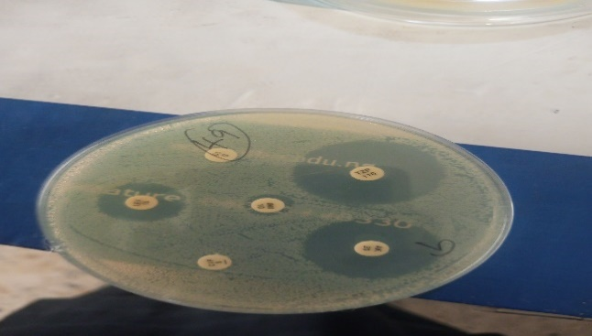
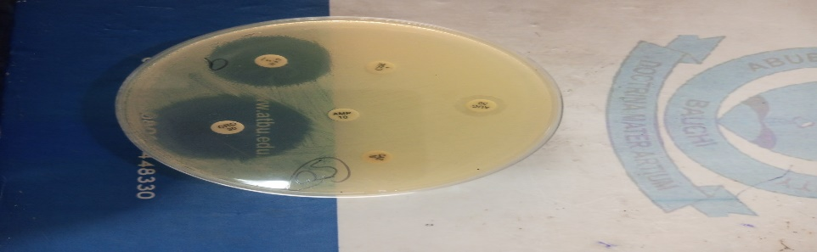
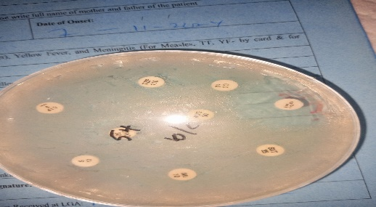
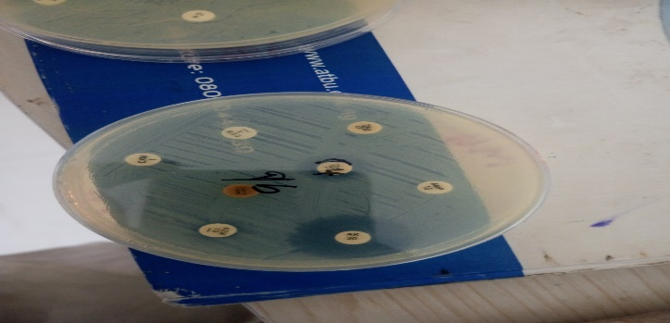
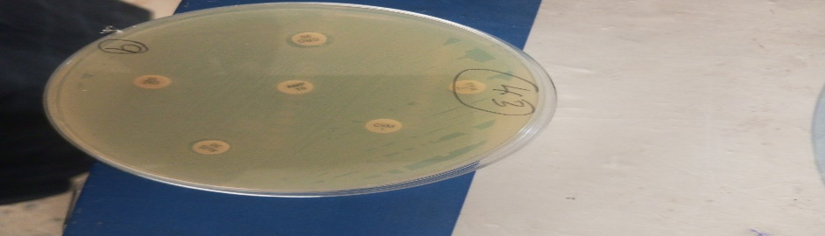
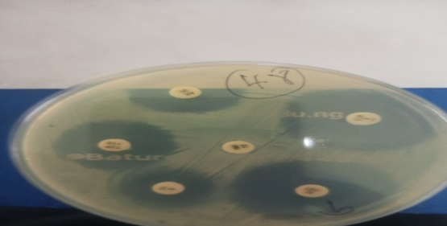

Figure 2: Susceptibility plates

3.3 Multiple Antibiotics Resistance Indices (MARI) of the Shigella species
Only five Shigella species demonstrated MDR phenotypes with a Shigella flexneri (5) showing the highest MAR indices (0.9) followed by Shigella boydii (3) and (4) with the least MARI being exhibited by Shigella boydii (2) close to the threshold of 0.2 at 0.176. The isolates in serial number 1-4 are categorized as MDR, while the last one is categorized as XDR for being resistant to 15 (Cefuroxime (CXM), Ceftazidime (CAZ), Cefixime (CFM), Ceftriaxone (CRO), Amoxicillin (AMX), Ampicillin (AMP), Piperacillin/Tazobactam (TZO), Imipenem (IP), Ciprofloxacin (CIP), Levofloxacin (LVX), Streptomycin (S), Azithromycin (AZM), Tetracycline (TET), Clindamycin (CLN), and Trimethoprim/Sulfamethoxazole (SXT)) of the 17 antibiotics tested and high MAR indices (Table 3).
Table 3: Multiple Antibiotics Resistance Indices (MARI) of the Entero-system 18R (E18R) Shigella sp.
Shigella spp | E18R Id Code | MARI | Antibiotics Resistance Pattern | MDR | XDR | PDR
Shigella flexneri | 40031 | 0.412 | CXM, CAZ, AMX, AMP, S, TET, CLN | + | - | -
Shigella boydii | 510412 | 0.176 | CXM, CAZ, CLN | + | - | -
Shigella boydii | 510510 | 0.529 | CXM, CAZ, CFM, CRO, AMX, AMP, S, CLN, SXT | + | - | -
Shigella boydii | 510412 | 0.529 | CXM, CAZ, CFM, CRO, AMX, AMP, S, CLN, SXT | + | - | -
Shigella flexneri | 41001 | 0.882 | CXM, CAZ, CFM, CRO, AMX, AMP, TZO, IP, CIP, LVX, S, AZM, TET, CLN, SXT | + | + | -
Keys: + = Positive, - = Negative, MARI = Multiple Antibiotics Resistance Index, MDR = Multi-Drugs Resistant, XDR = Extended Drugs Resistant, PDR = Pan Drugs Resistant
3.4 Genetic Confirmation by 16s rRNA Genes
3.4.1 16S rRNA Characteristics in this study
All five samples targeting 16S rRNA are Positive Result, strongly indicating that 16S rRNA was successfully amplified in all five samples via PCR. The ~720 bp size aligns perfectly with the expected amplicon size for many standard 16S rRNA primers targeting the V3-V4 hypervariable regions (e.g., 341F/806R or similar). The observation that all five samples show a band at approximately 720 base pairs (bp) on a gel when detecting 16S rRNA is consistent with successful PCR amplification of the 16S rRNA gene region. The size of ~720 bp corresponds to a common amplified region of the bacterial 16S rRNA gene used for phylogenetic analysis (Figure 3).
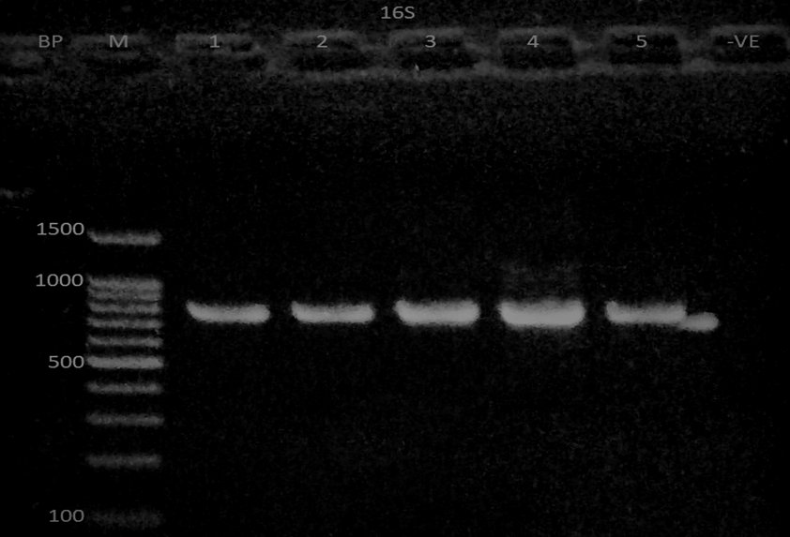
Figure 3: Agarose gel image of PCR amplified 16S rRNA (720bp) region of the Shigella species. Lane M – DNA Ladder, 1 – Shigella flexneri, 2 – Shigella boydii, 3 – Shigella boydii, 4 – Shigella boydii and 5 – Shigella flexneri
3.5 Sequence and Phylogeny
The phylogenetic analysis of the five nucleotide sequences (Sequence1 to Sequence5) revealed were used in constructing maximum likelihood tree with 100 bootstrap replicates. The values above 70% indicates strong clade support. The resulting tree indicates that 2YS and 3YS-4YS falls in two major clusters Shigella flexneri from Iran, China and USA. The first cluster consists of Sequence1 (1YS) and Sequence5 (5YS), which are highly similar, indicating a close evolutionary relationship or common origin. Sequence2 (2YS) is moderately related to this cluster, branching from a more ancestral node. The second cluster comprises Sequence3 (3YS) and Sequence4 (4YS), which form a separate clade with longer branch lengths, suggesting significant genetic divergence. These findings indicate at least two distinct evolutionary lineages among the sequences analyzed, with Sequence3 and Sequence4 being the most divergent (Figure 5).
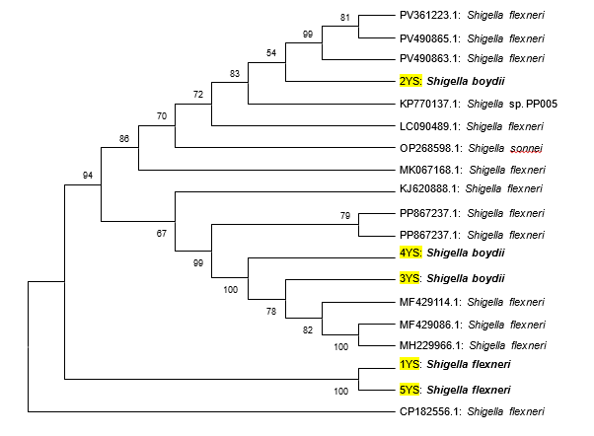
Fig. 4: Dendrogram of the Phylogeny Relationship between the Shigella Sequence (in this study) and Closest Shigella Sequence in the NCBI Database, aligned using ClustalW Alignment algorithm and Constructed using Maximum Likelihood Tree with Mega 12

4.0 DISCUSSION
The Shigella prevalence in this study is relatively higher than 5.9% pooled Shigella spp. prevalence estimates for Africa (Nyarkoh et al., 2024) and 8% reported by (Ngolo, 2023). It is lower than 10%, 13% and 22% Shigella prevalence reported earlier (Abdulhassan & Naji, 2022b; Alhaji et al., 2022; Shoja et al., 2023). However, it is in agreement with previous studies supporting Children population as the risk group (Lawal, 2017a) due to their highest prevalence. Shigella flexneri sero-domination is supported by various studies (Karmoker et al., 2023; Ngoshe et al., 2017; Sangeetha et al., 2014) and the gender matrices were backed by the findings of (Salehi et al., 2025). In a southwestern, no Shigella dysentriae was isolated despite isolating other sero-groups in similar proportion. (Ajayi et al., 2019), unlike (Abdulhassan & Naji, 2022b; Ngoshe et al., 2017) who did report all serotypes of Shigella except S. boydii. Aside that our findings align with previously reported sequence of Shigella sero-groups higher Shigella flexneri followed by Shigella boydii, and Shigella Sonnei (Abdulhassan & Naji, 2022b; Ngoshe et al., 2017; Sangeetha et al., 2014; Shoja et al., 2023) of the cases. This was followed by S. Sonnei at 24.19% and S. boydii at 22.58%. Notably, no instances of S. dysenteriae were found(Shoja et al., 2023). 26 (79%) of the isolates were Shigella flexneri(Sangeetha et al., 2014). 10% Shigella (Abdulhassan & Naji, 2022b) S. flexneri was 3 (15%), S. Sonnei 4(20%), S. dysenteriae 13(65%) and S. boydiii 0(0%). Shigella species isolation rate was 32(8%). It consisted of Shigella flexneri 15(46.9%), Shigella dysenteriae 12(37.5%), Shigella Sonnei 5(15.6%), no Shigella boydii was identified (Ngoshe et al., 2017).
The findings this study aligned with findings of (Enitan et al., 2021) on slightly higher prevalence in women compared to men, (Juraschek et al., 2021; Karmoker et al., 2023; Ud-Din et al., 2013) on Ampicilin, resistance, and Cefuroxime, Ceftazidime (Richard et al., 2023), and Amoxycilin (Ngoshe et al., 2017). Despite all other results aligning, Amikacin which the most sensitive in this study was reported as super resistant in an Iranian study (Shoja et al., 2023). The highly sensitive Chloramphenicol (81.3%) is also supported by various studies from the same and surrounding regions (Abdulhassan & Naji, 2022b; Lawal, 2017b; Titus et al., 2023; L. Umar et al., 2021) with slight disagreement by some Shigella strains against certain antibiotics. The findings in this study contradicts the Susceptibility profiles of Shigella isolates previously reported from one of the study areas (Saheed et al., 2020).
The high diversity in resistance patterns observed in this study mirrors recent findings from both West African and Asian settings, highlighting a rapid evolution of resistance even in historically rare Shigella (Karmoker et al., 2023; Nyarkoh et al., 2024; Okumu et al., 2025). The MDR prevalence in this study stood at 16%, relatively lower compare to studies from different areas Iran 87.1% and above 90% in Vancouver, Canada (Shoja et al., 2023), 25% from non-clinical samples in Port Harcourt, Nigeria (Isaiah et al., 2025), 86.67% isolated Shigella spp. from fecal materials of wild waterfowl and migratory birds in Bangladesh (Karmoker et al., 2023), 100% of Enterobacteriaceae isolated in Nasarawa, Nigeria (Richard et al., 2023), 100% Shigella MDR in Adamawa (Tula et al., 2022).
This isolate demonstrates resistance to a whopping 15 has a multidrug-resistant (MDR) and potentially extensively drug-resistant (XDR) profile antibiotics can be sees as a textbook example of an extensively drug-resistant (XDR) profile (Magiorakos et al., 2012). Such isolates are of grave clinical and epidemiological concern, having little or no effective therapeutic options. Recent literature from Nigeria and neighboring regions increasingly report XDR Shigella flexneri associated with outbreaks and high rates of morbidity in children under five years (Al-Shattrawi, 2025; Karmoker et al., 2023; Nyarkoh et al., 2024). The World Health Organization (WHO) recommends pivmecillinam Azithromycin and Cyprofloxacin for the treatment of XDR Shigella infections (Mason et al., 2023; Vecilla et al., 2025).
MDR in this study might be lower compared to other studies, MAR indices in the 0.4–0.9 is above 0.2 threshold vital for epidemiological tracking (Isaiah et al., 2025). The high MAR isolates in the same environment amplifies risk (Karmoker et al., 2023). High MARI between 0.6-1.0 have also been reported in Odeda, South-West Nigeria and in Kaduna, North-West, Nigeria (Alhaji et al., 2022). These organisms can serve as reservoirs for horizontal gene transfer, fostering further spread of resistance phenotypes emphasizing urgent strengthening of stewardship and infection control in regions with such MAR profiles, with calls to monitor resistance trends and limit empirical use of broad-spectrum antibiotics (Isaiah et al., 2025) in Nigeria. Other studies have reported comparable MARI values in Shigella isolates from pediatric and community settings (Nyarkoh et al., 2024; Satija & Anjankar, 2024).
In many studies, 16S rRNA PCR products around 720 bp have been reported as genus or species-specific amplicons suitable for bacterial identification and community analysis. Seeing a clear band at this size in all samples indicates that the 16S rRNA target region was successfully amplified in all samples, the bacterial RNA was present and intact enough for PCR and the primers and PCR conditions effectively amplified the 16S rRNA gene fragment around 720 bp as reported in a study identifying Shigella flexnery in Kaduna, Nigeria and other studies (Ajuzie & Atuanya, 2014; Kushkevych & Barto, 2014; Salleh et al., 2022).
Recent studies on detection of Shigella species using PCR targeting 16S rRNA reveal that 16S rRNA primers commonly amplify a band roughly between 700 and 760 bp, serving as a conserved bacterial marker (Karakoc Parlayan et al., 2025). A classical multiplex PCR approach uses primers targeting conserved regions of bacterial 16S rRNA, producing a ~755 bp band when Shigella or related bacteria are present. This approach is sensitive and specific for Shigella species among bacteria tested and is often combined with other target genes for confirmation (Somda et al., 2025).
The best matching strains with significant alignment, respectively were Shigella Sonnei (33.3%) and Shigella dysenteriae (40%) (Chen et al., 2014). This underscores that while Sanger sequencing and BLAST provide reliable identification at the genus level, species-level discrimination between Shigella species and E. coli is challenging. (Peker et al., 2019) compared Sanger sequencing of the 16S rRNA gene (using traditional PCR and sequencing protocols) which successfully identified various bacteria, with identification of Shigella versus closely related species was sometimes limited by sequence similarity. (Fong-Flores et al., 2022) emphasized that Sanger sequencing is widely used for clinical identification, especially for organisms difficult to culture, and results are routinely interpreted using BLAST matches. (Locher et al., 2022) sees the BLAST method as standard for bacterial characterization when conventional culture fails to yield results only.
The genetic relatedness established with bootstrap confidence value ≥ 70% for 3YS sequence with three strains of Shigella flexneri where they share same clade as one (MF429114) isolated from, Beijin, China in 2017. This sequence shows the phylogenetic framework for the Shigella sequence, isolated from this study with isolates of Chinese origin which were reported and deposited in the NCBI GenBank from 2017 and 2018.
(Chen et al., 2014) reported similar phylogeny for Shigella species using 16S rRNA sequence but could not completely differentiate from E. coli. Most studies that succeeded in higher percentage identities and close and identical phylogeny for Shigella have used Whole Genome Sequencing (Baker et al., 2018; El-baz et al., 2022). (Halimeh et al., 2021) recommended WGS for more accurate identification of Shigella species. (Peker et al., 2019) thought that an in house developed 16S-23S rRNA sequence would suffice but had challenges resolving some isolates and recommended that the combination of de novo assembly and BLAST could be the optimal approach for data analysis. PCR amplified DNA was separated by Denaturing Gradient Gel Electrophoresis (DGGE) analysis (Ajuzie & Atuanya, 2014).
(Olaniyi et al., 2019) identified M. genitalium with good percentage similarity but it shared no phylogenetic relationship with other examined species from around the world. (Iliyasu et al., 2020b) reported similar cladogram in Cryptosporidium Parvum Strains identified using SSU-rRNA. (Kushkevych & Barto, 2014) uses Sequence analysis of the 16s rRNA gene of sulfate-reducing bacteria isolated from human intestine with 99% homology with sequences Desulfovibrio piger ATCC 29098 deposited in the GenBank.
Although study offers meaningful insights, in interpreting the results the limitations have to be considered: the relatively small sample size and the reliance on 16S rRNA sequencing instead of whole-genome sequencing for phylogenetic analysis. These factors may restrict the ability to distinguish strains at a finer, strain-specific level (Rijah & Al-Galebi, 2025).
5. CONCLUSION
The phenotypic and Genotypic diversity of Shigella strains in Bauchi and Yobe secondary hospitals were emphasized in this study. Although, the prevalence rates are not as high as reported from other regions but it maintains that children are at higher risk of infection. It therefore calls for update of empirical treatment guideline that favour Amikacin, Chloramphenicol and Azithromycin as the best performers in this study or prioritize immediate change of antibiotics after sensitivity studies. The high MAR indices for the MDR Shigella species and XDR Shigella flexneri signify high risk and the guidelines recommend molecular diagnostics and genotype tracking to help clinicians tailor therapy and limit outbreaks. Molecular detection of 16S rRNA genes, sequencing and phylogeny offers meaningful insight into molecular relationship of the isolated strains to their counterparts from other continents. These findings underscore the urgent need for WGS-enhanced surveillance and regional antibiotic stewardship to check MDR Shigella transmission within Northeastern states and other geopolitical zones.
ETHICAL APPROVAL
Ethical approval for collection of clinical specimen/isolate was approved by ‘Bauchi State Heath Research Committee’ and Yobe State Hospital Management Board’s Ethics Review Committee.
COMPETING INTEREST
The authors report no conflicts of interests.

REFERENCES
Abdulhassan, S. S., & Naji, H. F. (2022a). Role of Extended Spectrum B -lactamase Genes in Antibiotics Resistance of Shigella spp . 62(09), 4387–4398.
Abdulhassan, S. S., & Naji, H. F. (2022b). Role of Extended Spectrum B-lactamase Genes in Antibiotics Resistance of Shigella spp. 62(09).
Adesoji, A. T., Ogunjobi, A. A., & Olatoye, I. O. (2016). Characterization of Integrons and Sulfonamide Resistance Genes among Bacteria from Drinking Water Distribution Systems in Southwestern Nigeria. Chemotherapy, 62(1), 34–42. https://doi.org/10.1159/000446150
Ajayi, O. I., Ojo, D. A., Akintokun, A. K., & Akinrotoye, K. P. (2019). Prevalence and Antibiotic Resistance Profiles of Serotypes of Shigella Species isolated from Community Children in Odeda Local Government , Ogun State . Journal of Environmental Treatment Techniques, 7(3), 270–281.
Ajuzie, C. U., & Atuanya, E. I. (2014). IDENTIFICATION OF THE BACTERIAL COMMUNITY RESPONSIBLE FOR DECONTAMINATING ELEME PETROCHEMICAL INDUSTRIAL EFFLUENT USING 16S rDNA PCR DENATURING GRADIENT GEL ELECTROPHORESIS. Nigerian Journal of Technology, 33(4), 459–469.
Alhaji, A. I., Mulade, G. L., Ajibade, G. A., Haroun, A. A., & Benjamin, O. I. (2022). Multiple Antibiotic Resistance Indices of Shigella flexneri and Salmonella enterica Associated with Diarrhoea in Children (0-5 Years) From Selected Hospitals in Kaduna Metropolis, Nigeria. Nigerian Journal of Microbiology, 36((2)), 6300–6309.
Allen, H., Mitchell, H. D., Simms, I., Baker, K. S., Foster, K., Hughes, G., Dallman, T. J., & Jenkins, C. (2021). Evidence for re-infection and persistent carriage of Shigella species in adult males reporting domestically acquired infection in England. Clinical Microbiology and Infection, 27(1), 126.e7-126.e13. https://doi.org/10.1016/j.cmi.2020.03.036
Al-Shattrawi, H. J. G. (2025). Molecular Profiling of Multidrug-Resistant Zoonotic Shigella spp. In Chicken Farms: A Case Study from Diyala. 2(1).
Baker, K. S., Dallman, T. J., Field, N., Childs, T., Mitchell, H., Day, M., Weill, F.-X., Lefèvre, S., Tourdjman, M., Hughes, G., Jenkins, C., & Thomson, N. (2018). Genomic epidemiology of Shigella in the United Kingdom shows transmission of pathogen sublineages and determinants of antimicrobial resistance. Scientific Reports, 8(1), 7389. https://doi.org/10.1038/s41598-018-25764-3
CDC. (2020). Antibiotic Resistance & Patient Safety Portal. National Center for Emerging and Zoonotic Infectious Diseases, May, 1–4.
Chen, L., Cai, Y., Zhou, G., Shi, X., Su, J., Chen, G., & Lin, K. (2014). Rapid Sanger Sequencing of the 16S rRNA Gene for Identification of Some Common Pathogens. PLoS ONE, 9(2), e88886. https://doi.org/10.1371/journal.pone.0088886
Chukwuma, O., Esther, E., & Amana, O. (2022). Among Children (≤5 Years) at the Benue State.
Chukwuma, O., Esther, E., Amana, O., Olalekan, O. J., Chukwuma, O., Esther, E., Amana, O., & Olalekan, O. J. (2022). Analysis of Multi-Drug Resistance of Diarrhoeagenic Escherichia coli and Shigella dysenteriae Infections among Children (≤5 Years) at the Benue State Teaching Hospital, Makurdi, Nigeria. IMCC Journal of Science, 2(1), 42–53.
Cusack, T. P., Ashley, E. A., Ling, C. L., Roberts, T., Turner, P., Wangrangsimakul, T., & Dance, D. A. B. (2019). Time to switch from CLSI to EUCAST? A Southeast Asian perspective. Clinical Microbiology and Infection, 25(7), 782–785. https://doi.org/10.1016/j.cmi.2019.03.016
El-baz, R., Said, H. S., Abdelmegeed, E. S., & Barwa, R. (2022). Characterization of virulence determinants and phylogenetic background of multiple and extensively drug resistant Escherichia coli isolated from different clinical sources in Egypt. Applied Microbiology and Biotechnology, 106(3), 1279–1298. https://doi.org/10.1007/s00253-021-11740-x
Enitan, S. S., Odigie, J., Adekunbi, O. A., Emmanuel, O. O., Ogbonna, N. I., Laura, T. M. C., Ofodile, C. A., Itodo, G. E., Edafetanure-Ibeh, M., & Adetola, A. O. (2021). Prevalence of shigellosis and associated risk factors among undergraduate students of a private university in Ogun State, Nigeria. Trends in Infection and Global Health, 1(1), 25–36. https://doi.org/10.24815/tigh.v1i1.22422
Eze, J. N., & Onokala, P. C. (2022). Pattern of household vulnerability to desertification in Yobe state, Nigeria. GeoJournal, 87(4), 2699–2717. https://doi.org/10.1007/s10708-021-10395-5
Fong-Flores, V., Murillo-Gallo, A., Contreras-Ojeda, L., & Barraza, A. (2022). Sanger Sequencing Implementation in Clinically Ill Patients for Bacterial and Fungal Pathogens Identification. Advances in Infectious Diseases, 12(03), 363–382. https://doi.org/10.4236/aid.2022.123029
Halimeh, F. B., Rafei, R., Osman, M., Kassem, I. I., Diene, S. M., Dabboussi, F., Rolain, J.-M., & Hamze, M. (2021). Historical, current, and emerging tools for identification and serotyping of Shigella. Brazilian Journal of Microbiology, 52(4), 2043–2055. https://doi.org/10.1007/s42770-021-00573-5
Hall, G. S. (2013). Bailey & Scott’s Diagnostic Microbiology, 13 th Edn . Laboratory Medicine, 44(4), e138–e139. https://doi.org/10.1309/lm5jc0ph0oggbszz
Iliyasu, M. Y., Bamanga, R. A., Umar, A. F., Agbo, E. B., & Uba, A. (2020a). 16S rDNA Sequencing analysis in identification of some multidrug resistant (MDR) bacterial isolates from clinical specimens. Nigerian Journal of Biotechnology, 36(2), 158–166. https://doi.org/10.4314/njb.v36i2.16
Iliyasu, M. Y., Bamanga, R. A., Umar, A. F., Agbo, E. B., & Uba, A. (2020b). 16S rDNA Sequencing analysis in identification of some multidrug resistant (MDR) bacterial isolates from clinical specimens. Nigerian Journal of Biotechnology, 36(2), 158–166. https://doi.org/10.4314/njb.v36i2.16
Isaiah, D. O., Otokunefor, K., & Agbagwa, O. E. (2025). Multiple antibiotic resistance indexing and molecular identification of Escherichia coli isolated from clinical and nonclinical sources in Port Harcourt Metropolis, Nigeria. Pan African Medical Journal, 51. https://doi.org/10.11604/pamj.2025.51.11.38524
Iwalokun, B. A., Gbenle, G. O., Adewole, T. A., Smith, S. I., Akinsinde, K. A., & Omonigbehin, E. O. (2003). Effects of Ocimum gratissimum L. essential oil at subinhibitory concentrations on virulent and multidrug-resistant Shigella strains from Lagos, Nigeria. Apmis, 111(4), 477–482. https://doi.org/10.1034/j.1600-0463.2003.1110405.x
Juraschek, K., Deneke, C., Schmoger, S., Grobbel, M., Malorny, B., Käsbohrer, A., Schwarz, S., Meemken, D., & Hammerl, J. A. (2021). Phenotypic and Genotypic Properties of Fluoroquinolone-Resistant, qnr-Carrying Escherichia coli Isolated from the German Food Chain in 2017. Microorganisms, 9(6), 1308. https://doi.org/10.3390/microorganisms9061308
Karakoc Parlayan, H. N., Bulut, D., Haykir Solay, A., Kuzi, S., Arikan, T., & Sencan, I. (2025). An Analysis of Bacterial Infection Distribution in the Elderly, and Their Clinical and Laboratory Profiles: Aging and Bacterial Infection. Infectious Diseases and Clinical Microbiology, 7(1), 47–57. https://doi.org/10.36519/idcm.2025.458
Karmoker, J., Saiful Islam, Md., Liton Rana, Md., Ashek Ullah, Md., Neloy, F. H., Oishy, N. M., Pramanik, P. K., Siddique, M. P., Saha, S., & Tanvir Rahman, Md. (2023). Molecular Detection and Multidrug Resistance of Shigella spp. Isolated from Wild Waterfowl and Migratory Birds in Bangladesh. Veterinary Medicine International, 2023(1), 5374216. https://doi.org/10.1155/2023/5374216
Kushkevych, I., & Barto, M. (2014). Sequence analysis of the 16s rRNA gene of sulfate-reducing bacteria isolated from human intestine.
Lawal, M. S. (2017a). Antimicrobial Resistance Pattern and Plasmid Profile of Diarrheal Salmonallae and Shigallae Bacteria Isolated from Clinical Samples in Kaduna Metropolis, Nigeria. Journal of Bacteriology & Mycology: Open Access, 4(2). https://doi.org/10.15406/jbmoa.2017.04.00084
Lawal, M. S. (2017b). Antimicrobial Resistance Pattern and Plasmid Profile of Diarrheal Salmonallae and Shigallae Bacteria Isolated from Clinical Samples in Kaduna Metropolis, Nigeria. Journal of Bacteriology & Mycology: Open Access, 4(2). https://doi.org/10.15406/jbmoa.2017.04.00084
Locher, K., Belanger, C. R., Eckbo, E., Caza, M., Velapatino, B., & Charles, M. K. (2022). Automated 16S Sequencing Using an R-Based Analysis Module for Bacterial Identification. Microbiology Spectrum, 10(2), e00408-22. https://doi.org/10.1128/spectrum.00408-22
M100: Performance standards for antimicrobial susceptibility testing (33rd editi). (2023). Clinical and Laboratory Standards Institute.
Magiorakos, A.-P., Srinivasan, A., Carey, R. B., Carmeli, Y., Falagas, M. E., Giske, C. G., Harbarth, S., Hindler, J. F., Kahlmeter, G., Olsson-Liljequist, B., Paterson, D. L., Rice, L. B., Stelling, J., Struelens, M. J., Vatopoulos, A., Weber, J. T., & Monnet, D. L. (2012). Multidrug-resistant, extensively drug-resistant and pandrug-resistant bacteria: An international expert proposal for interim standard definitions for acquired resistance. Clinical Microbiology and Infection: The Official Publication of the European Society of Clinical Microbiology and Infectious Diseases, 18(3), 268–281. https://doi.org/10.1111/j.1469-0691.2011.03570.x
Mason, L. C. E., Greig, D. R., Cowley, L. A., Partridge, S. R., Martinez, E., Blackwell, G. A., Chong, C. E., De Silva, P. M., Bengtsson, R. J., Draper, J. L., Ginn, A. N., Sandaradura, I., Sim, E. M., Iredell, J. R., Sintchenko, V., Ingle, D. J., Howden, B. P., Lefèvre, S., Njamkepo, E., … Baker, K. S. (2023). The evolution and international spread of extensively drug resistant Shigella sonnei. Nature Communications, 14(1), 1983. https://doi.org/10.1038/s41467-023-37672-w
Matanza, X. M., & Clements, A. (2023). Pathogenicity and virulence of Shigella sonnei: A highly drug-resistant pathogen of increasing prevalence. Virulence, 14(1), 2280838. https://doi.org/10.1080/21505594.2023.2280838
Medeiros, P. H. Q. S., Lima, A. Â. M., Guedes, M. M., Havt, A., Bona, M. D., Rey, L. C., Soares, A. M., Guerrant, R. L., Weigl, B. H., & Lima, I. F. N. (2018). Molecular characterization of virulence and antimicrobial resistance profile of Shigella species isolated from children with moderate to severe diarrhea in northeastern Brazil. Diagnostic Microbiology and Infectious Disease, 90(3), 198–205. https://doi.org/10.1016/j.diagmicrobio.2017.11.002
Mitchell, H. D., Thomson, N. R., Jenkins, C., Dallman, T. J., Painset, A., Kirwan, P., Delpech, V., Mikhail, A. F. W., Field, N., & Hughes, G. (2021). Linkage of Whole Genome Sequencing, Epidemiological, and Clinical Data to Understand the Genetic Diversity and Clinical Outcomes of Shigella flexneri among Men Who Have Sex with Men in England. Microbiology Spectrum, 9(3), 1–14. https://doi.org/10.1128/spectrum.01213-21
Nandi, D., Kaur, K., & Janardhanan, R. (2023). Shigella storm and men who have sex with men: A perspective on the Indian context. Indian Journal of Public Health, 67(3), 480–481. https://doi.org/10.4103/ijph.ijph_1947_21
NAP. (2024). National Action Plan (NAP) on Antimicrobial Resistance: SITUATIONAL ANALYSIS and Key Recommendations for the Development of NAP 2.0. Federal Ministries of Agriculture and Food Security, Environment and Health and Social Welfare.
Ngolo, J. L. (2023). Epidemiology and Characteristics of Resistant Typhoidal Salmonella Strains Prevalent in. 34(1). https://doi.org/10.12962/j20882033.v34i1.14677
Ngoshe, I., Denue, B., Bello, H., Akawu, C., & Gashau, W. (2017). Prevalence and antimicrobial susceptibility of Shigella species isolates from diarrheal stool of patients in a tertiary health facility in northeastern Nigeria. Sub-Saharan African Journal of Medicine, 4(4), 96. https://doi.org/10.4103/ssajm.ssajm_7_17
Nyarkoh, R., Odoom, A., & Donkor, E. S. (2024). Prevalence of Shigella species and antimicrobial resistance patterns in Africa: Systematic review and meta-analysis. BMC Infectious Diseases, 24(1), 1217. https://doi.org/10.1186/s12879-024-09945-2
Okumu, N. O., Muloi, D. M., Moodley, A., Watson, J., Kiarie, A., Ochieng, L., Wasonga, J. O., Mutisya, C., Alumasa, L., Ngeranwa, J. J. N., Cumming, O., & Cook, E. A. J. (2025). Antimicrobial resistance in community-acquired enteric pathogens among children aged ≤ 10-years in low-and middle-income countries: A systematic review and meta-analysis. Frontiers in Microbiology, 16, 1539160. https://doi.org/10.3389/fmicb.2025.1539160
Olaniyi, F. T., Akaniro, I. R., Oguh, C. E., Fashina, C. D., Ahmed, I., & Ezeh, C. C. (2019). Characterization and Antimicrobial Resistance Profile of Pathogenic Bacteria Isolated from Freshly Sold Amaranthus viridis in Ile-Ife, Southwest Nigeria. Journal of Advances in Microbiology, 18((1)), 1–8.
Peker, N., Garcia-Croes, S., Dijkhuizen, B., Wiersma, H. H., Van Zanten, E., Wisselink, G., Friedrich, A. W., Kooistra-Smid, M., Sinha, B., Rossen, J. W. A., & Couto, N. (2019). A Comparison of Three Different Bioinformatics Analyses of the 16S–23S rRNA Encoding Region for Bacterial Identification. Frontiers in Microbiology, 10, 620. https://doi.org/10.3389/fmicb.2019.00620
Pourhoseingholi, M. A., Vahedi, M., & Rahimzadeh, M. (2013). Sample size calculation in medical studies. Gastroenterology and Hepatology from Bed to Bench, 6(1), 14–17.
Projection, Y. population. (2022). 3218dc9ad03434996c30374e7733eb94f9f08867 @ citypopulation.de (p. 2). Yobe.
Richard, R., Ezejiofor, T. I. N., Nsofor, C. A., & Nkene, I. H. (2023). Antibacterial Resistance and Phenotypic Detection of Extended Spectrum Beta-Lactamase (ESBL) Producing Enterobacteriaceae Isolated from Environmental Sources in Nasarawa State, Nigeria. European Journal of Biology and Biotechnology, 4(5), 6–12. https://doi.org/10.24018/ejbio.2023.4.5.479
Rijah, Z., & Al-Galebi, A. (2025). Molecular Characterisation of Virulence and Antibiotic Resistance Genes in Diarrhoeal Shigella Isolates from Diwaniyah, Iraq. Babcock University Medical Journal, 8(1), 257–270. https://doi.org/10.38029/babcockuniv.med.j..v8i1.822
Sack, D. A., Lyke, C., Mclaughlin, C., & Suwanvanichkij, V. (2001). World Health Organization: Antimicrobial resistance in shigellosis, cholera and campylobacteriosis. World Health, 17, 1–56.
Saheed, Y., Umar, A. F., & Iliyasu, M. (2020). Potential of Silver Nano Particles Synthesized from Ficus sycomorus Linn Against Multidrug Resistant Shigella species Isolated from Clinical Specimens. American Journal of Life Sciences, 8(4), 82. https://doi.org/10.11648/j.ajls.20200804.16
Sahl, J. W., Morris, C. R., Emberger, J., Fraser, C. M., Ochieng, J. B., Juma, J., Fields, B., Breiman, R. F., Gilmour, M., Nataro, J. P., & Rasko, D. A. (2015). Defining the phylogenomics of Shigella species: A pathway to diagnostics. Journal of Clinical Microbiology, 53(3), 951–960. https://doi.org/10.1128/JCM.03527-14
Salehi, M., Laitinen, V., Bhanushali, S., Bengtsson-Palme, J., Collignon, P., Beggs, J. J., Pärnänen, K., & Lahti, L. (2025). Gender differences in global antimicrobial resistance. Npj Biofilms and Microbiomes, 11(1), 79. https://doi.org/10.1038/s41522-025-00715-9
Salleh, M. Z., Nik Zuraina, N. M. N., Hajissa, K., Ilias, M. I., Banga Singh, K. K., & Deris, Z. Z. (2022). Prevalence of Multidrug-Resistant and Extended-Spectrum Beta-Lactamase-Producing Shigella Species in Asia: A Systematic Review and Meta-Analysis. Antibiotics, 11(11), 1653–1653. https://doi.org/10.3390/antibiotics11111653
Sangeetha, A. V., Parija, S. C., Mandal, J., & Krishnamurthy, S. (2014). Clinical and Microbiological Profiles of Shigellosis in Children. JOURNAL OF HEALTH, POPULATION AND NUTRITION.
Satija, K., & Anjankar, V. P. (2024). Molecular Characterization of Multidrug-Resistant Shigella flexneri. Cureus. https://doi.org/10.7759/cureus.53276
Shoja, S., Ghasemi, S., Dastranj, M., Shamseddin, J., Ebrahimi, N., Alizade, H., & Farahani, A. (2023). Characterization of genotypes and antimicrobial resistance profiles of clinical isolates of Shigella from patients in the southern region of Iran. European Journal of Medical Research, 28(1), 611. https://doi.org/10.1186/s40001-023-01570-0
Somda, N. S., Nyarkoh, R., Tankoano, A., Bonkoungou, O. J. I., Tetteh-Quarcoo, P. B., & Donkor, E. S. (2025). Molecular epidemiology of extended-spectrum beta-lactamases and carbapenemases-producing Shigella in Africa: A systematic review and meta-analysis. BMC Infectious Diseases, 25(1), 81. https://doi.org/10.1186/s12879-024-10266-7
Titus, I., Iliyasu, M., Sahal, M., Umar, R., A, V. A., Wali, M., Ismail, S., Umar, A., & Agbo, E. (2023). Molecular Profiling of Class 1 Integron Among Multidrug-Resistant Salmonella Typhi Serovars Isolated from Hospitals in Bauchi. Acta Scientific Microbiology, 36–42. https://doi.org/10.31080/ASMI.2023.06.1256
Tula, M., Enabulele, O., Ophori, A., Aziegbemhin, A., Iyoha, O., & Filgona, J. (2022). Phenotypic and molecular detection of multi-drug resistant Enterobacteriaceae species from water sources in Adamawa-North senatorial zone Nigeria. DYSONA - Life Science, Online First. https://doi.org/10.30493/dls.2022.351097
Ud-Din, A. I. M. S., Wahid, S. U. H., Latif, H. A., Shahnaij, M., Akter, M., Azmi, I. J., Hasan, T. N., Ahmed, D., Hossain, M. A., Faruque, A. S. G., Faruque, S. M., & Talukder, K. A. (2013). Changing Trends in the Prevalence of Shigella Species: Emergence of Multi-Drug Resistant Shigella sonnei Biotype g in Bangladesh. PLoS ONE, 8(12), e82601. https://doi.org/10.1371/journal.pone.0082601
Umar, L., Mansir L., & Sani Mg. (2021). Phytochemical Analysis and Antifungal Activity of Ficus Sycomorus L. (Moraceae) Extracts on some Dermatophytic Fungi. UMYU Journal of Microbiology Research (UJMR), 6(1), 11–17. https://doi.org/10.47430/ujmr.2161.002
Umar, R. D., Titus, I., Joseph, E., & Mamman, U. G. (2025). Molecular characterization of multidrug resistance genes and effect of zinc oxide nanoparticles on Salmonella typhi serovars from clinical specimens. July.
Varghese, N., & Joy, P. P. (2016). Naveena Varghese. In Microbiology Laboratory Manual (Issue January 2014).
Vecilla, D. F., Urrutikoetxea Gutiérrez, M. J., Nieto Toboso, M. C., Inchaurza, K. Z., Zárraga, E. U., Estévez, B. R., & Tuesta Del Arco, J. L. D. D. (2025). First report of Shigella sonnei carrying a blaCTX−M−15 sexually transmitted among men who have sex with men. Infection, 53(1), 443–448. https://doi.org/10.1007/s15010-024-02341-7

