Development of a Predictive Model for Parametric Standardization of Methanol Recovery from Transesterified Oil

ABSTRACT

The present study on Development of a Predictive Model for Parametric Standardization of Methanol Recovery from Transesterified Oil was carried out with major emphasis on maximum recovery of methanol from biodiesel before separation of glycerol. The standardized parametric conditions for highest recovery of methanol as predicted by the model are temperature of distillation as 90 ⁰C, vacuum pressure as 121.5 mm of Hg, time of distillation as 27.8 min. and circulating water temperature through condenser as 10 ⁰C. The model predicted 28.7 g methanol recovery at above condition. The predicted value of methanol recovery was found close to the actual amount of methanol recovered (28.8 g) at the optimized parametric conditions indicating high accuracy of the developed model. The recovery of methanol has been found significantly affected by distillation temperature, vacuum pressure and time of distillation.
Keywords: Biodiesel, Methanol Recovery, RSM, CCRD, Contour Plot

Introduction
Biodiesel is produced through a chemical reaction known as transesterification. In transesterification reaction vegetable oil or animal fats react in presence of a catalyst with a primary alcohol to give the corresponding alkyl esters of the fatty acid mixture that is found in the parent vegetable oil or animal fat. Methanol is widely used as primary alcohol for producing biodiesel as methanol is less expansive. However, the presence of excess methanol in the biodiesel is highly toxic to our environment and therefore it is required to be removed/recovered the excess methanol from biodiesel. The traditional method of removing the excess methanol from biodiesel is through the use of wash water and the resulted wash water containing excess methanol is thrown away causing environment pollution. Therefore, recovery of excess methanol is not only economically beneficial but it will be beneficial from environment point of view also.
The present study on recovery of alcohol from biodiesel was carried out with major emphasis upon optimum recovery of methanol from biodiesel before separation of glycerol.

Materials and Methods
All the experiments were carried out in the Bioenergy Technology Laboratory of the Department of Farm Machinery and Power Engineering of Govind Ballav Pant University of Agriculture and Technology (Pantnagar) during the year 2009-2011.

Preparation of palm methyl ester
The experiments were carried out using food grade refined palm oil procured from local market. The methyl ester of refined palm oil having FFA (free fatty acid) content of 0.815% (1.63 mg KOH/g of oil) was carried out. In the present study anhydrous methanol (99% pure) of H D Scientific, Mumbai make was used with catalyst (KOH), (Merck make) having 1% concentrations. Biodiesel was prepared in the laboratory reacting 400 g of palm oil with 100 g of methanol using 4 g of catalyst. The reaction time and temperature of the process was kept to 60 min and 65 ⁰C respectively.

Recovery of Methanol
In order to remove/recover excess methanol from biodiesel, a Perfit India make, rotary vacuum flash evaporator was used. The methanol was recovered from biodiesel before phase separation of biodiesel and glycerol. This has been adopted due to the reason that for recovery of methanol through distillation, it needs to be heated and recovery of methanol just after transesterification reaction saves lot of energy required for heating as the biodiesel is at around 65⁰C temperature. Also this method helps in better phase separation of ester and glycerol. This is in accordance with the findings of ^{2,} ^{3,} ⁴.

Design of Experiment:
The experiment for recovery of methanol from biodiesel as affected by temperature of distillation, vacuum pressure, time of distillation and circulation water temperature through condenser was designed using response surface methodology (RSM) based on the hypothesis that the responses of the product were functionally related to specific conditions. Attempts were also made to fit the multiple regression equations correlating response to obtain optimized conditions. Since the experiment involves four factors therefore to optimize these factors, their five levels were considered. Hence, four factors, five levels, central composite rotatable design (CCRD) as suggested by ⁵ was considered for the study. Based on above consideration, the factor and their level selected

for the experiment are shown in Table 1. The experiment included 30 experimental runs, which was generated from the statistical method adopted. Experiments were randomized in order to minimize the effects of unexplained variability in the observed responses due to extraneous factors.

In order to establish range of above mentioned parameters affecting methanol recovery, preliminary experiments were carried out selecting a range of values for the above parameters and removal of methanol from biodiesel and its collection as condensate in the flask of distillation plant was observed. The initial experiment indicated that distillation of methanol initiates at 85⁰C distillation temperature and 100 mm of Hg of vacuum pressure. It was further noticed that temperature of water flowing through condenser had an effect on quick condensation of evaporated methanol. Based on above observations a statistical design of experiment using response surface methodology was made.

Statistical Analysis
A mathematical model as shown in Equation 1 (a second order polynomial equation) was developed to describe the relationships between the predicted response variable (recovered methanol) and the independent variables of methanol recovery process like temperature of distillation, vacuum pressure, time of distillation and temperature of circulating water flowing through condenser.

Y = β
4 3
+ β X +
4
β X X
+ 4 β X2

0 Σ i i
i=1
Σ
i=1
Σ ij i j
j=i+1
Σ ii i i=1
… (1)

Where,
β0, βii, βij are constants
Xi, Xj are variables (coded)
A predictive model was developed using the above equation for optimizing parametric conditions of distillation for maximum methanol recovery. Confirmatory experiments on standardized parametric conditions were also carried out to validate the model for the condition of maximizing methanol recovery by comparing the predicted value with actual amount of methanol recovered.

Results and Discussion

The transesterified product containing methyl ester and glycerol was distilled for recovery of methanol using a rotary vacuum evaporator. The product had an initial temperature of 65⁰C. The observations on presence of methanol in the transesterified product before and after distillation at different operating conditions of distillation for 30 experimental runs were also determined and presented in Table 2.
It is evident from the table that transesterified product obtained at different experimental runs prepared initially using 20% methanol contained methanol in the range of 8.1 to 11.6%. This indicates that out of 20% methanol used for preparation of biodiesel about 8.4 to 11.9% methanol remained free in the transesterified product. The above estimation of free methanol was obtained by analyzing the transesterified product using a gas chromatograph. The varied quantity of free methanol in transesterified product before distillation may be due to the reason that some of it might have escaped during the process from reaction vessel due to its high volatility though the transesterification was carried out at similar conditions.
The Table 2 also shows that the transesterified product at different experimental runs after distillation contained methanol in the range of 1.80 to 9.30%. This variation in methanol content may be due to the reason that the operating conditions for distillation for different runs were different.
The results of recovery of excess methanol from biodiesel were statistically analyzed by using Response Surface Methodology (RSM) to asses the effect of selected parameters. Total effect of individual parameter on methanol recovery was calculated using the sequential sum of squares, and it is shown in Table 3. It can be seen from Table 3 that independent variables affected the methanol recovery both at linear level as well as at quadratic level. Temperature level (X1), Vacuum pressure (X2) and Time of distillation (X3) are significant model terms both at linear level and quadratic level at p< 0.1 where as circulation water temperature through condenser had no significant effect. Positive linear coefficients of X1, X2 and X3 indicated that the methanol recovery increased with increase in the level of the temperature, vacuum pressure and time level. However the quadratic effect of temperature, vacuum pressure and time had negative effect upon the methanol recovery indicating that the maximum recovery of methanol was at centre point

and it decreases when the independent variables were increased or decreased from centre point. Circulating water temperature through condenser had no significant effect upon methanol recovery. The model coefficients (Regression Coefficient) based on coded factor level and probability values are shown in Table 4.

Model Development and Validation
A complete second order model (Eq. 2) was developed using response surface methodology for different operational conditions of distillation for methanol recovery. The regression coefficients obtained and significance of response surface quadratic model are shown in Table 4. Based on the coefficients obtained for different parameters and their interactions a model shown in equation 2 was used for prediction on methanol recovery.
Y = 20.90+7.68X1+2.85X2+1.99X3-0.25X4-0.38X1X2-0.31X1X3- 0.87X1X4+0.52X2X3-0.68X2X4-0.47X3X4-2.22X ²-4.04X22-
1
2.11X32-0.074X 2 (2)
4
Where,
Y = Methanol Recovery (g)
X1, X2, X3 and X4 are coded variables of distillation temperature levels, vacuum pressure, time of distillation and circulating water temperature through condenser respectively.
For the above model, probability of significance of predictor’s coefficient is shown in Table 4, which indicates the extent of effect of predictor on the response. The sign and magnitude of the coefficients explain the nature of the effect. Negative sign at linear level means decrease in response when the level of the predictor is increased while positive sign indicates increase in the response. Significant negative interaction suggests that the level of one of the predictors can be increased while that of other decreased for constant value of the response. Positive interaction means the response is minimum at center point and it increases with increase or decrease of both the variables from center point. Positive coefficient of a quadratic term indicates the minimum response at center value of the parameter and it increases with increase or decrease in parameter level. Negative coefficient of the quadratic term shows the maximum response at the centre value and it decreases with increase/decrease in parameter level. The model summary

statistics as presented in Table 5 indicates that the coefficient of determination (R²) for the regression model for methanol recovery was 91.43%, which implies that the model could account for 91.43% data. The F value (11.43) as shown in Table 3 was greater than table F value (9.77) suggesting model was significant at 1% level of significance and also the lack of fit was insignificant (Table 3). Hence, a second order model (Eqn 2) is adequate in describing methanol recovery.

Parametric Standardization for Methanol Recovery
Optimization is a process of making compromises between responses, to achieve a common target which in the present study was higher methanol recovery. A numerical optimization was therefore, carried out using Design Expert 8.0.1 statistical software. The goal was fixed for maximum methanol recovery and variables like distillation temperature, vacuum pressure, distillation time and circulating water temperature through condenser were fixed in the range.
A numerical optimization using the selected software based on above constraints was run. The optimum values of temperature of distillation as 90 ⁰C, vacuum pressure as
121.5 mm of Hg, time of distillation as 27.8 min. and distillation water circulation temperature through condenser as 10 ⁰C was thus obtained.
In order to standardize the parametric conditions, experiments were further conducted at the optimized conditions shown above. The amount of methanol recovered at the optimized values for the three replications are shown in Table 6. The table indicates that at the optimized condition, 28.8 g methanol was recovered. Since, the actual methanol recovery (28.8 g) and methanol recovery predicted by the model (28.7 g) for the optimized condition are similar, therefore, it can be said that developed model is of high relevance for the selection of parameters for recovery of methanol from transesterified product.

Effect of Variables on Methanol Recovery
The experiments involved four variables and the expected variation in methanol recovery was further analyzed by obtaining contour plots generated between two variables. For this, contour equations were developed using predictive model of the response and putting optimum value of third and fourth variables and simplifying the resulting equation. The relationship between independent and dependent variables of the

developed model is shown in Figs. 1- 6 in the form of contour plots. From Figs. 1-6, this can easily be revealed the effect of two variables upon methanol recovery at the optimized value of third and fourth variables.

Conclusions
The standardized parametric conditions for highest recovery of methanol as predicted by the model are temperature of distillation as 90 ⁰C, vacuum pressure as 121.5 mm of Hg, time of distillation as 27.8 min. and circulating water temperature through condenser as 10 ⁰C. The model predicted 28.7 g methanol recovery at above condition. The predicted value of methanol recovery was found close to the actual amount of methanol recovered (28.8 g) at the optimized parametric conditions indicating high accuracy of the developed model. The recovery of methanol has been found significantly affected by distillation temperature, vacuum pressure and time of distillation.

REFERENCES
- Choudhary, S. K., Development of a predictive model for methanol recovery from transesterified oil. Unpublished Ph,d thesis, Department of Farm Machinery and Power Engineering, G.B. Pant University of Agriculture and Technology, Pantnagar, India, 2011.
- V. J. Gerpen and B. Shanks, Biodiesel Production Technology, National Renewable Energy Laboratory, Colorado, 2004.
- W.Y. Zhou and D.G.B. Boocock, Journal of the American Oil Chemists' Society, 2006, 83(12), 1047.
- B. R. Dhar and K. Kirtania, Chemical Engineering Research Bulletin, 2009, 13, 55.
- W. Cochran and G.M. Cox, Experimental Designs. Wiley (New York) Publication, 1992.

Table 1. Coded and Uncoded Values of Various Levels of Independent Variables

Process Variable | Code | Coded Levels
Process Variable | Code | -2.00 | -1.00 | 0.00 | 1.00 | 2.00
Temperature of Distillation, (⁰C) | X1 | 75 | 80 | 85 | 90 | 95
Vacuum Pressure (mm of Hg) | X2 | 0 | 50 | 100 | 150 | 200
Time of Distillation (min.) | X3 | 15 | 20 | 25 | 30 | 35
Water circulation temperature(⁰C) | X4 | 6 | 10 | 14 | 18 | 22


Table 2. Methanol Content and Its Recovery from Trasesterified Product ( Biodiesel + Glycerol )

Experimental Run | Operating Conditions for Distillation |  |  |  |  |  |  |  | Methanol Content in Trasesterified Product Before  Distillation (%) | Methanol Content in Trasesterified Product After Distillation (%) | Amount of Methanol Recovered (g) | Purity of Recovered Methanol (%)
Experimental Run | Coded Value |  |  |  | Actual Value
Experimental Run | X1 | X2 | X3 | X4 | Temperature of Distillation  ( ⁰C) | Vacuum Pressure (mm of Hg) | Time of Distillation  (Min) | Circulating Water Temperature ( ⁰C)
1 | 2 | 0 | 0 | 0 | 95 | 100 | 25 | 14 | 9.9 | 2.4 | 24.1 | 100
2 | 0 | 2 | 0 | 0 | 85 | 200 | 25 | 14 | 10.1 | 9.3 | 9.6 | 100
3 | -1 | -1 | 1 | -1 | 80 | 50 | 30 | 10 | 9.6 | 4.0 | 0.83 | 93.6
4 | 1 | 1 | -1 | 1 | 90 | 150 | 20 | 18 | 9.3 | 2.4 | 22.9 | 100
5 | 1 | 1 | 1 | 1 | 90 | 150 | 30 | 18 | 9.5 | 2.9 | 28.2 | 93.6
6 | 0 | 0 | 0 | 0 | 85 | 100 | 25 | 14 | 8.5 | 2.9 | 14.9 | 94.9
7 | 1 | -1 | 1 | 1 | 90 | 50 | 30 | 18 | 11.6 | 3.4 | 20.9 | 100
8 | -1 | 1 | -1 | -1 | 80 | 150 | 20 | 10 | 9.5 | 2.6 | 3.99 | 100
9 | 0 | 0 | 0 | 0 | 85 | 100 | 25 | 14 | 9.5 | 1.8 | 16.4 | 100
10 | 1 | 1 | -1 | -1 | 90 | 150 | 20 | 10 | 8.6 | 3.4 | 22.9 | 100
11 | -1 | -1 | 1 | 1 | 80 | 50 | 30 | 18 | 8.2 | 2.1 | 0.76 | 100
12 | 1 | -1 | -1 | 1 | 90 | 50 | 20 | 18 | 9.9 | 5.1 | 14.5 | 100
13 | 0 | 0 | 0 | 0 | 85 | 100 | 25 | 14 | 10.7 | 3.2 | 24.3 | 100
14 | 0 | 0 | 2 | 0 | 85 | 100 | 35 | 14 | 10.9 | 2.1 | 18.2 | 94.9
15 | -2 | 0 | 0 | 0 | 75 | 100 | 25 | 14 | 9.3 | 8.9 | 0.0 | NA
16 | -1 | 1 | 1 | 1 | 80 | 150 | 30 | 18 | 9.4 | 3.8 | 10.5 | 94.3
17 | 0 | 0 | 0 | 2 | 85 | 100 | 25 | 22 | 8.7 | 1.9 | 22.9 | 100
18 | 0 | 0 | 0 | 0 | 85 | 100 | 25 | 14 | 10.0 | 3.5 | 24.0 | 100
19 | 1 | -1 | 1 | -1 | 90 | 50 | 30 | 10 | 9.2 | 5.2 | 19.1 | 98.4
20 | 0 | 0 | 0 | -2 | 85 | 100 | 25 | 6 | 8.9 | 2.1 | 18.4 | 100
21 | 1 | -1 | -1 | -1 | 90 | 50 | 20 | 10 | 8.1 | 2.6 | 18.5 | 100
22 | -1 | -1 | -1 | -1 | 80 | 50 | 20 | 10 | 9.2 | 8.6 | 0.0 | NA
23 | 0 | 0 | -2 | 0 | 85 | 100 | 15 | 14 | 9.4 | 3.8 | 6.8 | 93.9
24 | 0 | 0 | 0 | 0 | 85 | 100 | 25 | 14 | 10.3 | 3.1 | 23.9 | 100
25 | -1 | -1 | -1 | 1 | 80 | 50 | 20 | 18 | 11.3 | 8.6 | 0.28 | 100
26 | 1 | 1 | 1 | -1 | 90 | 150 | 30 | 10 | 9.3 | 3.2 | 30.5 | 99.5
27 | -1 | 1 | -1 | 1 | 80 | 150 | 20 | 18 | 10.4 | 3.2 | 3.99 | 100
28 | -1 | 1 | 1 | -1 | 80 | 150 | 30 | 10 | 9.7 | 2.4 | 11.1 | 99.5
29 | 0 | 0 | 0 | 0 | 85 | 100 | 25 | 14 | 9.3 | 3.5 | 21.8 | 100
30 | 0 | -2 | 0 | 0 | 85 | 0 | 25 | 14 | 10.5 | 9.3 | 0.0 | NA
Where, X1= Distillation temperature, X2= Vacuum Pressure, X3= Distillation Time and X4= Circulating water Temperature

10

Table 3. ANOVA for Response Surface Quadratic Model for Methanol Recovery

Source | Sum of  Square | Degree of freedom | Mean Square | F-Value | p-value  Prob>F
Model | 2323.31 | 14 | 166.59 | 11.43 | <0.0001**
X1 | 1414.35 | 1 | 1414.35 | 97.01 | <0.0001**
X2 | 195.40 | 1 | 195.40 | 13.40 | 0.0023**
X3 | 94.80 | 1 | 94.80 | 6.50 | 0.0222**
X4 | 1.53 | 1 | 1.53 | 0.10 | 0.7504
X1X2 | 2.33 | 1 | 2.33 | 0.16 | 0.6952
X1X3 | 1.55 | 1 | 1.55 | 0.11 | 0.7489
X1X4 | 12.25 | 1 | 12.25 | 0.84 | 0.3738
X2X3 | 4.24 | 1 | 4.24 | 0.29 | 0.5975
X2X4 | 7.48 | 1 | 7.48 | 0.51 | 0.4848
X3X4 | 3.59 | 1 | 3.59 | 0.25 | 0.6269
X12 | 135.53 | 1 | 135.53 | 9.30 | 0.0081**
X22 | 447.49 | 1 | 447.49 | 30.69 | <0.0001**
X32 | 122.45 | 1 | 122.45 | 8.40 | 0.0110**
X42 | 0.15 | 1 | 0.15 | 0.010 | 0.9203
Residual | 218.69 | 15 | 14.58
Lack of Fit | 132.00 | 10 | 13.20 | 0.76 | 0.6672 ns
Pure Error | 86.69 | 5 | 17.34
Correlation Total | 2551.01 | 29
** significant at 1% probability levels.

Table 4. Regression Coefficients and Significance of Response Surface Quadratic Model

Factor | Coefficient Estimate | Degree of freedom | Standard Error | 95% CI  Low | 95% CI  High
Intercept | 20.90 | 1 | 1.56 | 17.58 | 24.23
X1 | 7.68 | 1 | 0.78 | 6.02 | 9.34
X2 | 2.85 | 1 | 0.78 | 1.19 | 4.51
X3 | 1.99 | 1 | 0.78 | 0.33 | 3.65
X4 | -0.25 | 1 | 0.78 | -1.91 | 1.41
X1X2 | -0.38 | 1 | 0.95 | -2.42 | 1.65
X1X3 | -0.31 | 1 | 0.95 | -2.35 | 1.72
X1X4 | -0.87 | 1 | 0.95 | -2.91 | 1.16
X2X3 | 0.52 | 1 | 0.95 | -1.52 | 2.55
X2X4 | -0.68 | 1 | 0.95 | -2.72 | 1.35
X3X4 | -0.47 | 1 | 0.95 | -2.51 | 1.56
X12 | -2.22 | 1 | 0.73 | -3.78 | -0.67
X22 | -4.04 | 1 | 0.73 | -5.59 | -2.49
X32 | -2.11 | 1 | 0.73 | -3.67 | -0.56
X42 | -0.074 | 1 | 0.73 | -1.63 | 1.48

Table 5. Model Summary Statistics

Source | Standard  Deviation | R-Square | Adjusted R Square | Predicted R Square | PRESS
Linear | 5.81 | 0.6688 | 0.6158 | 0.5521 | 1142.55
2F1 | 6.54 | 0.6811 | 0.5133 | 0.3616 | 1628.61
Quadratic | 3.82 | 0.9143 | 0.8343 | 0.6530 | 885.16
Cubic | 3.91 | 0.9581 | 0.8264 | -0.1882 | 3031.14
PRESS - Predicted Residual Error Sum of Square

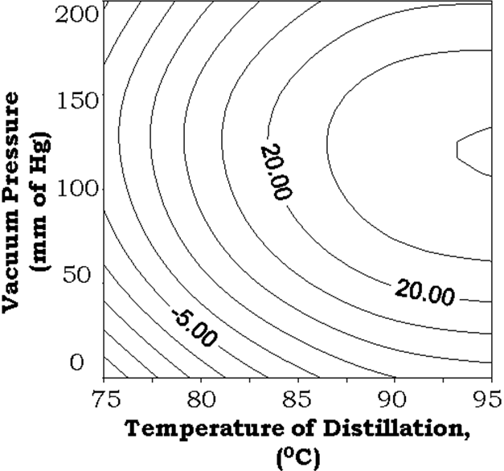Table 6. Methanol Recovered at Optimum Operating Conditions

Optimum Operating Condition for Distillation |  |  |  | Methanol Recovery (g) | Average Amount of Methanol Recovered  (g)
Distillation Temperature ( 0C ) | Vacuum Pressure (mm of  Hg) | Distillation Time (min.) | Circulating Water Temperature  ( 0C ) | Methanol Recovery (g) | Average Amount of Methanol Recovered  (g)
90 | 121.5 | 27.8 | 10 | 28.1 | 28.8
90 | 121.5 | 27.8 | 10 | 29.0 | 28.8
90 | 121.5 | 27.8 | 10 | 29.3 | 28.8

Temperature of Distillation (o C)
Vacuum Pressure (mm of

Fig. 1. Effect of Distillation Temperature and Vacuum Pressure on Methanol Recovery at Distillation Time of 27.8 min and Circulating Water Temperature through condenser as 10⁰C

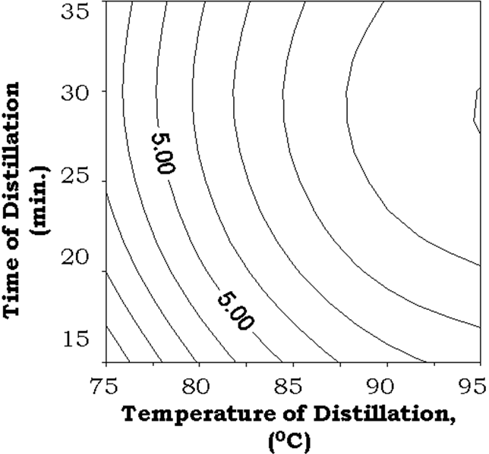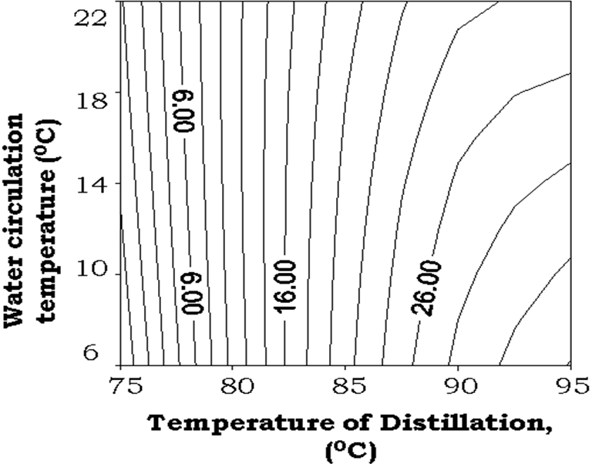Temperature of Distillation (o C)
Time of Distillation (min)
Fig. 2. Effect of Distillation Temperature and Time of Distlltion on Methanol Recovery at Vacuum Pressure of 121.5 mm of Hg and Circulating Water Temperature through Condenser as 10 ⁰C

Temperature of Distillation (o C)
Circulating water temperature (o C)

Fig. 3. Effect of Distillation Temperature and Circulating Water Temperature through Condenser on Methanol Recovery at Distillation Time of 27.8 min and Vacuum Pressure of 121.5 mm of Hg

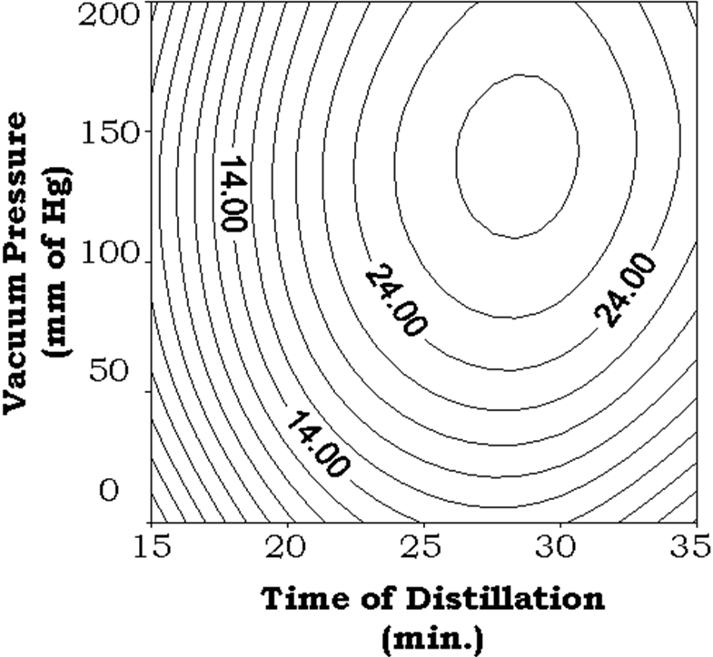Time of Distillation (min)
Vacuum Pressure (mm of

Fig. 4. Effect of Time of Distillation and Vacuum Pressure on Methanol Recovery at Distillation Temperature of 90 ⁰C and Circulating Water Temperature through Condenser as 10 ⁰C

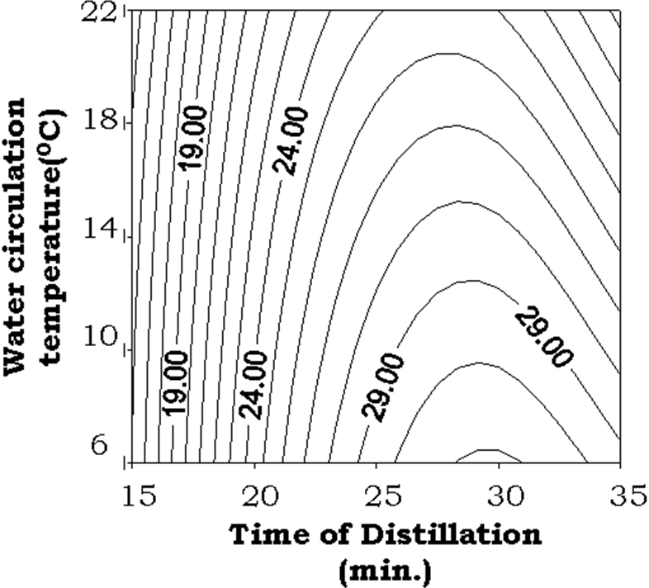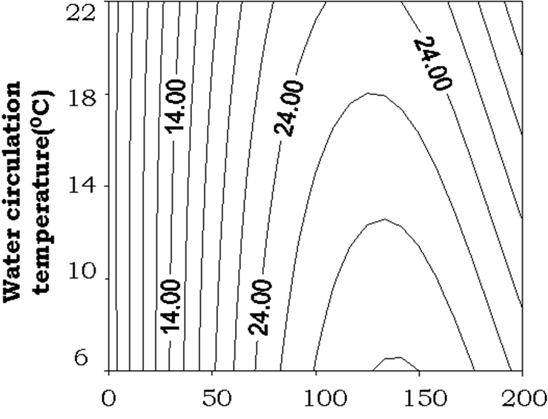

Vacuum Pressure (mm of Hg)
Circulating water temperature (o C)
Fig. 5. Effect of Vacuum Pressure and Circulating Water Temperature through Condenser on Methanol Recovery at Distillation Temperature of 90 ⁰C and Distillation Time of 27.8 min

Time of Distillation (min)
Circulating water temperature (o C)

Fig. 6. Effect of Time of Distillation and Circulating Water Temperature through Condenser on Methanol Recovery at Distillation Temperature of 90 ⁰C and Vacuum Pressure of 121.5 mm Hg

