Systematic Variation, Abundance, and Importance of Shellfish Fauna in Bihar India

Abstract
Freshwater shellfishes are well adapted to equatorial as well as tropical regions and play a crucial role in local ecology and livelihoods. The present study was undertaken in northeastern Bihar, India, documents the taxonomic diversity, abundance, along with economic value of shellfish. Shellfishes were collected from lentic and lotic water bodies using hand-picking and dredging techniques. Systematic identification of taxa was carried out using standard taxonomic keys and reference literature. Species were categorized into three groups-abundant, common, and rare based on their frequency of occurrence. Market surveys were conducted to assess the economic importance of different taxa. A total of 24 taxa belonging to gastropods, bivalves, and crustaceans were recorded from the wetland ecosystems. The most abundant species were Bellamya spp., Achatina fulica, Lymnaea spp., and several small-to medium-sized Macrobrachium species (M. gandaki, M. tiwari, and M. lameraii). Rare species included Alocinma orcula, Indoplanorbis exustus, Novaculina gangetica, Parreysia favidens, and M. gangeticum. Market analyses revealed that M. gangeticum and other small-sized Macrobrachium species had the highest economic value, followed by Paratelphusa and edible gastropods (Pila and Bellamya). The study highlights the rich ecological diversity and notable economic potential of freshwater shellfishes in the Mahananda-Koshi basin. The findings emphasize the need for sustainable exploitation, management, as well as conservation of shellfish resources to maintain ecological balance and support rural livelihoods.
Keywords: Shellfish diversity, abundance, economic value, molluscan, crustacean

Introduction
Shellfishes represent an ancient and highly heterogeneous group, exhibiting remarkable diversity across freshwater ecosystems (Strong et al., 2008). Biodiversity is the number of different species represented in a particular community. Freshwater shellfishes perform diverse functional roles, providing ecosystem services that are vital to rural human settlements (Sajan et al., 2021; Khatoon & Kumari, 2025). They contribute significantly to maintaining ecological equilibrium by facilitating nutrient cycling, sediment turnover, and serving as reliable bioindicators of water quality (Vaughn & Hakenkamp, 2001; Lydeard et al., 2004). In rural Bihar, shellfishes hold notable socio-economic importance. They serve as valuable sources of protein, traditional medicine, and livelihoods for local communities Patel & Kurhe, (2023); Prasad & Sinha, (2024). Additionally, they form a crucial component of the ethnomedicinal, food chain, transferring energy and nutrients from phytoplankton, macrophytes, and zooplankton to fishes, amphibians, reptiles, birds, mammals, and other wildlife species (Subba Rao, 1989; Jamir et al., 2005; Prabhakar & Roy, 2009; Ghosh, et al., 2016; Prasad et al., 2023; Chutia & Pegae, 2017; Jadav et al., 2023; Ghosh, 2022; Hasan et al., 2024).
However, the diversity of freshwater shellfishes is increasingly threatened by anthropogenic pressures such as overharvesting, habitat degradation, and pollution (Dudgeon et al., 2006; Singh et al., 2012; Prasad & Sinha, 2024; Dey, 2017; Prasad et al., 2025; Gupta, et al., 2025). While considerable work has been carried out on the taxonomy, biology, ecology, and behavior of molluscs and crustaceans in the Indian subcontinent (Prasad, 2005; Bhattacharya et al., 2014; Dey, 2017; Chandrawansi et al., 2023; Jha et al., 2014; Navan & Kathv, 2019; Sharma et al., 2012; Athyaman & Rajendran, 2014; Susilo et al., 2020; Jayachandran, 2005; Salathia and Langer 2022). Additional stressors, including climate change, water scarcity, and the unregulated use of pesticides particularly during the cultivation of fox nuts (Euryale ferox) and water chestnuts (Trapa natans) have also contributed to a marked decline in snail populations and production (Prasad, 2023; Prasad & Sinha, 2024). Despite shellfish harvesting being a traditional practice in northeastern Bihar, and certain species enjoying high market demand, systematic documentation of their diversity, relative abundance, and economic significance remains scarce. However, very little information is available on shellfisheries and the diversity potential of northeastern Bihar.
Therefore, present study aims to identify as well as categorize freshwater shellfish species in the region based on their relative abundance as a consequence to assess their economic value in rural and urban markets. This documentation is expected to strengthen the knowledge base required for the sustainable management and conservation of shellfish resources.

Materials and Methods
Study Area
The study was conducted in the region between the Mahananda and Koshi river basins of Bihar, covering five districts: Purnea, Madhepura, Supaul, Katihar, and Khagaria. These northestern districts are characterized as flood-prone areas with extensive wetlands, including ponds, makhana (Euryale ferox), singhara (Trapa natans) as well as paddy fields, along with riverine habitats, all of which support diverse shellfish populations (Prabhakar & Roy, 2008; Jha, 2009). Fieldwork was subsequently carried out over two consecutive years (January 2020 - December 2022), incorporating rural and urban fish market surveys through interviews and on-spot enquiries. Market prices were recorded in Indian Rupees per kilogram. These visualizations were used to highlight the ecological importance and economic contribution of shellfishes in the study region (Figur-1).
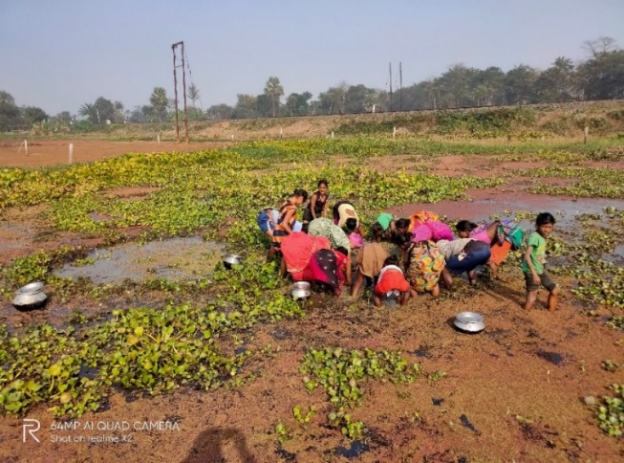
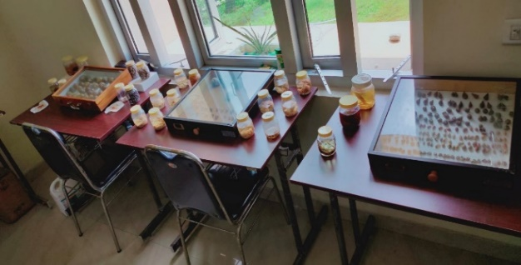
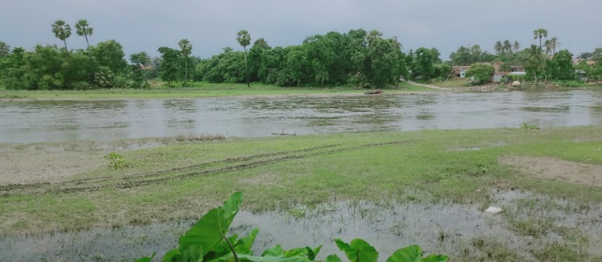
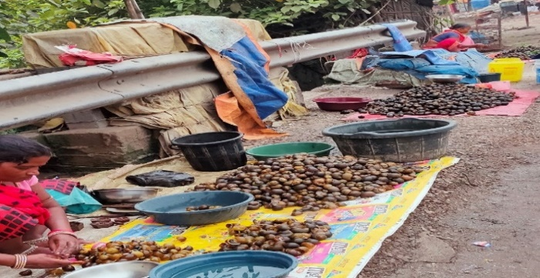
d
a
b
c
Figure:1. (a), Marketing of shellfish, (b). Shellfish museum at BPSAC, Purnea, (c), the Saura river, Purnea, (d) catching of fishermen & women in Purnia wetland

Sampling and Identification
Shellfishes were collected from lentic and lotic habitats using hand-picking, dredging, and netting methods, depending on habitat type. After that instantly representative specimens were preserved in 5% formalin and transported to the Shellfish Biodiversity Laboratory at Bhola Paswan Shastri Agricultural College (BPSAC), Purnea, Bihar (Atsawe et al., 2009). Thereafter, some collected specimens were thoroughly washed with tap water, followed by treatment in a weak acidic medium for slight decalcification, which facilitated the observation of growth rings (Prabhakar & Roy, 2008). Systematic identification was carried out using standard pictorial keys and reference literature (Subba Rao & Dey, 1989; Prasad, 2005; Jayachandran, 2005; Sharma et al., 2012; Prasad et al., 2012; Ramakrishna et al., 2010; Athiyaman and Rajendran, 2014). Relative abundance of species was categorized as Abundant (+++): frequently encountered, forming large populations. Common (++): moderately encountered. Rare (+): infrequently encountered, recorded sporadically during surveys. The collected and identified specimens were deposited in the museum of the Department of Entomology, BPS Agricultural College, Purnea, Bihar (Figure 1b).
Data Analysis
All the respective data were analysed as well as generated for ease of understanding in Microsoft Excel 2010 edition. Relative abundance categories were expressed as simple tabular and market data on price were summarized using descriptive statistics, and mean values were reported in Rs./ Kg. Comparisons of market value across taxa were presented using bar diagrams.

Results
In the present study, a total of 24 shellfish taxa were recorded and identified from the wetlands and riverine habitats of northeastern Bihar detail presented in the Tables (1 & 2). Among these, 7 species were categorized as abundant, 9 as common, and 8 as rare. The dominant taxa included Bellamya bengalensis (race & typica), Pila globosa, Pila virens, Lymnaea acuminata, Lymnaea luteola, Melanoides lineatus, Indoplanorbis exustus, Novaculina gangetica, Lamellidens marginalis, Macrobrachium spp., and the crab Paratelphusa spinigera. The genus Bellamya emerged as the most dominant in terms of abundance, followed by Lymnaea and Pila. Crustaceans were represented by medium and small-sized Macrobrachium species (abundant) and the freshwater crab Paratelphusa spinigera (common). A single large-sized freshwater prawn, Macrobrachium gangeticum (200 mm), was rarely encountered in the lower stretch of the Koshi river system during the rainy season. In contrast, medium-sized prawns such as M. gandaki (75 mm) and M. tiwari (85 mm) were classified as common, while smaller-sized M. lamerri (80 mm) was abundant in the wetland ecosystems.
Market surveys revealed a marked variation in shellfish prices between rural and urban areas (Table 3 and Figure 2). Edible gastropods such as Pila and Bellamya were priced at ₹50-100/kg in rural markets, compared to ₹100-200/kg in urban markets. Crustaceans such as crabs (Paratelphusa) were sold for ₹75-100/kg in rural markets and ₹120-200/kg in urban markets. Medium and small-sized prawns (Macrobrachium spp.) were priced at ₹200-300/kg in rural areas and ₹300-400/kg in urban areas. The large freshwater prawn M. gangeticum, available only occasionally during the rainy season, fetched the highest price, ranging from ₹500-600/kg in rural markets to ₹500-800/kg in urban markets.
Table 1. Systematic variances and abundance of shellfish fauna in Bihar

S. N. | Species / Genera | Taxonomical Features | Relative abundance
1 | Bellamya bengalensis ( Race ) | The shell is thick, globosely turbinate with reddish-brown transverse stripes, bearing 4–5 regularly increasing convex whorls and spaced spiral striae. | +++
2 | Bellamya bengalensis  typica (Lamarck) | These smaller shell is smooth, thin, and banded showing 2 dark green or rusty brown bands on the 4th whorl, 5-7 on the body whorl with 5 convex whorls and an operculum elongated towards the body whorl. | +++
3 | Pila globosa (Swainson, 1822) | These shell is large, thick, and globose, spirally coiled around the columella, with 3–4 well-developed, less-inflated whorls and a slightly depressed spire. |  | ++
4 | Pila Virens  (Lamarck ) | It is smaller than P. globosa, with the spire more strongly depressed to about one-fourth of the shell’s total length. |  | ++
5 | Achatina fulica (Bowdich) | These shell is elongated, thick, and light horny in colour, with six spire whorls and an oval, elongate body whorl; the operculum is absent, and in adults, the columella and whorls are whitish with brown bands. | +++
6 | Lymnaea (Pseudosuccinia) acuminata | The shell is light amber in color with four spire whorls; the first four are large, lightly convex, and pointed towards the apex, while the body whorl is the largest, oval, elongated, and without an operculum. | +++
7 | Lymnaea (Pseudosuccinia)  luteola (Gray) | These shell is small to medium-sized, oval, thin, and imperforate, usually light amber in color, with four spire whorls, the first three being small and convex. | +++
8 | Melanoides lineatus  (Gray) | These shell is less elongated with numerous transverse ridges, having 7–8 slightly convex spire whorls, while the body whorl is large, oval, and with a slightly depressed spire. |  | ++
9 | Melanoides tuberculatus (Muller) | The shell is highly elongated with numerous transverse ridges, having 8–9 convex spire whorls, while the body whorl is small and oval with a strongly depressed spire. |  | ++
10 | Digoniostroma ceraneopoma (Benson) | These shell is small, oval, and conic to elongate, with 4–6 convex spire whorls, and an umbilicus ranging from narrow to wide. |  |  | +
11 | Indoplanorbis exustus (Deshayes) | The shell is brown, stout, and spirally coiled, sinistral and discoidal with a depressed spire, bearing three spire whorls marked with transverse striations. |  |  | +
12 | Gyraulus convexiusculus (Hulton | These shell is small, thin, and transparent, with very fine transverse striations; it is discoidal with whorls rounded to carinate and marked by a spiral ridge. |  |  | +
13 | Segmentina calathus (Benson) | These shell is small and thin-walled, convex on one side and flat on the other, with the last whorl being wide. |  |  | +
14 | Corbiculla bensoni (Deshayes) | The shell is dark brown, strongly striated, and triangular, with an outer surface sculptured by concentric ridges and covered with a greenish, shining periostracum; each valve bears two cardinal teeth and serrated lateral teeth. |  | ++
15 | Novaculina gangetica (Benson) | These shell is kidney-shaped, light yellowish-brown, and elongated, with valve margins slightly concave below and a narrower whitish umbo. |  |  | +
16 | Lamellidens corrianus (Lea) | These shell is strongly inequilateral, large, transverse, and thin, with the left valve bearing one thin cardinal tooth and the right valve two elongated lateral teeth; the umbones are slightly elevated with coarse ridges. |  | ++
17 | Lamallidens marginalis (Lamarck) | These shell is transversely oblong, ovate to oval, with swollen, knoblike umbones positioned near the anterior end of each valve and bearing coarse ridges. It is bottom dweller of freshwater lentic and lotic system and omnivorous in nature. |  | ++
18 | Parreysia favidens (Benson) | These shell is rounded, oval to elliptical, broad, and thick, shorter than Lamellidens, with narrowed cardinal teeth and elevated umbones bearing a strong ridge. |  |  | +
19 | Parreysia corrugata | The shell is small, elliptical to round-oval, slightly inequilateral, and smooth, with strong non-lamellar cardinal teeth and prominent, sometimes eroded umbones. It is bottom dweller of freshwater lentic and lotic system and omnivorous in nature. |  |  | +
Abundant = +++ Common = ++ Rare = +
Table 2. Taxonomic diversity of Crustacean shellfish fauna and their relative abundance in Bihar

S.N. | Species / Genera | Taxonomical Features | Relative abundance
1 | 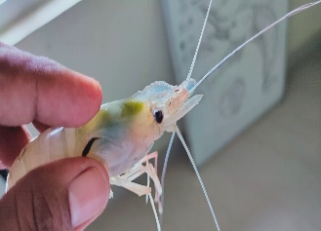  Macrobrachium gangeticum (Bate) | Body larger elongated, bilaterally symmetrical, pale yellow with brown in older specimens. Body divided into cephalothorax, abdomen & telson and 19 segments. A pairs of appendages, present in each segment. Maximum sized 200 mm. Rostral formula 9-11/4-6. |  |  | +
2 | Macrobrachium gandaki  (Prasad et al, 2020)  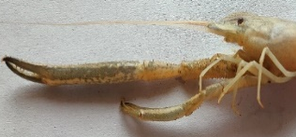  Rostral formula 8-10/2-3, maximum sized 75 mm. | Medium size freshwater prawn, Macrobrachium gandaki Rostrum short and not reaching as far as antennal peduncle, basal crest moderately elevated and distal end directed forwards. The second pair of chelate leg largest, unequal; in which one was very large in size and another small. It is unequal among the all species. |  | ++
3 | Macrobrachium tiwari  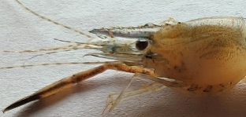  Rostral Formula- 9-10/2-0. | Medium size Rostrum elongated reaching up to or beyond antennal scale. The basal crest moderately elevated, distal end directed forwards. The second periopods was larger and shorter than body length. Sized 85 mm. | +++
4 | 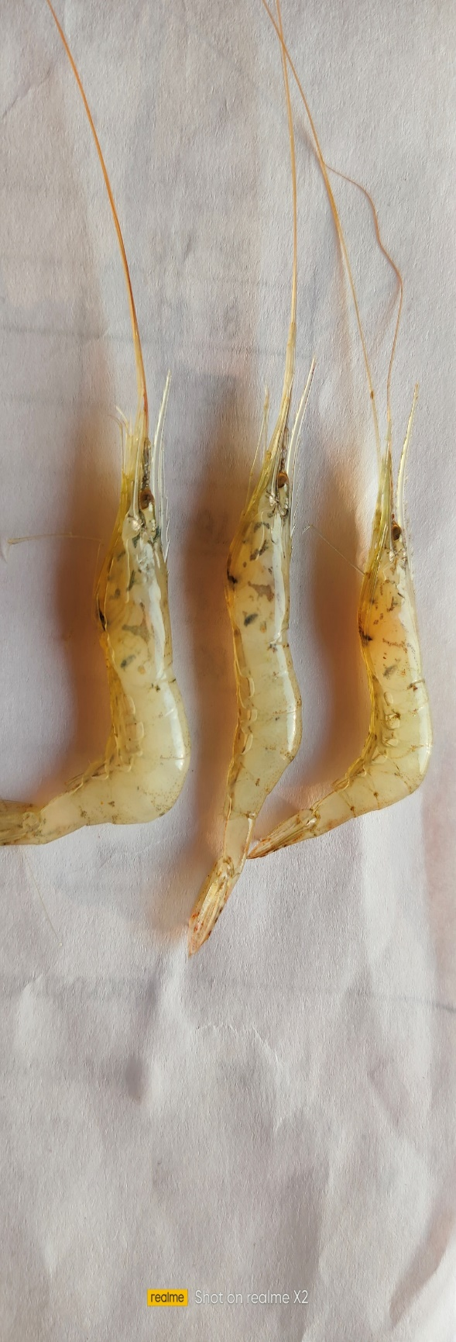  Macrobrachium lammerii | Smaller size, Eco-biology, Food and feeding habit same as M. gangeticum. Rostrum long sword shaped reaching past antennal scale. Basal crest moderately elevated and distal end directed forwards. Rostral formula 8-9/10-12. Maximum sized 80 mm. Second pereopods’ was small, larger than others pereopods. | +++
5 | Paratelphusa  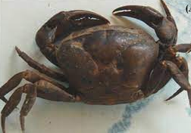  Spinigera | Its body dorso-ventrally compressed and consist of a large, broad cephalothorax and stumpy abdomen. Rostrum absent. antennules and eye stalks are contained in the sockets of carapace. Five pairs of thoracic legs are well developed. Abdomen is reduced and fixed under cephalothorax. Five pairs of thoracic legs are well developed. | +++
Abundant = +++ Common = ++ Rare = +
Table 3. Economic importance of edible shellfish species in Bihar

Genera / Species | Local rural market price  (Rs/Kg | Urban market price  (Rs/kg)
Pila and Bellamya | 50 to 100 | 100 to 200
Paratelphusa Spinigera | 75 to 100 | 120 to 200
Macrobrachium small size | 200 to 300 | 300 to 400
Macrobrachium gangeticum | 500 to 600 | 500 to 800

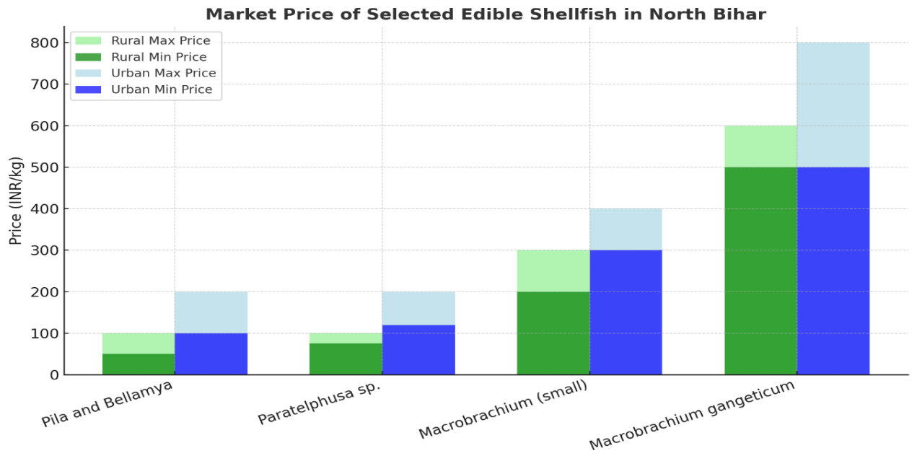
Figure 2. Showing rural & urban market price ranges for edible shellfish species in Bihar

Overall, the findings indicate that shellfishes are closely linked to the socio-economic conditions of local communities, with strong human – shellfish interactions shaping both ecological and economic dynamics. Price differentials between rural and urban sectors highlight the commercial value of certain taxa, particularly Paratelphusa and Macrobrachium, which enjoy high market demand across the region. The higher and middle class people ready to pay higher price of this species.

Discussion
The northeastern Bihar is highly diversified in terms of both aquatic biodiversity and human population. The communities in this region directly depend on animal resources for food, income, medicines, and other purposes, thereby posing increasing pressure on the sustainability of shellfish populations (Prabhakar and Roy, 2007). Shellfishes are also ecologically significant as they form an integral part of the food chain, serving as a natural diet for many birds, reptiles, amphibians, fishes, and other wildlife species Jha, (2009). The survey revealed a high diversity of shellfish fauna in northeastern Bihar, with gastropods forming the dominant group, followed by bivalves and crustaceans. Species of Bellamya, Achatina, and Lymnaea exhibited wide distribution and high abundance, likely due to their adaptability to varied freshwater habitats. The dominance of Bellamya bengalensis and Lymnaea acuminata further indicates their resilience to diverse aquatic conditions and tolerance to moderate levels of pollution (Sharma et al., 2017). The occurrence of rare species such as Parreysia favidens and Novaculina gangetica highlights the presence of specialized microhabitats that may require targeted conservation measures.
The abundance of the invasive species Achatina fulica raises ecological concerns, as it poses potential competitive threats to native molluscs (Lowe et al., 2000). Bivalves such as Lamellidens and Parreysia are ecologically important for biofiltration and nutrient cycling, but their relatively low abundance compared to gastropods may be attributed to overharvesting and sedimentation (Nagabhushanam et al., 2001). Overall, the present study indicates that the Mahananda–Koshi basin harbors appreciable molluscan diversity compared to other freshwater ecosystems. The hydrobiological characteristics of this region appear favorable for sustaining high taxonomic diversity of shellfishes (Begum and Khan, 2002; Prasad, 2005). These findings align with previous reports. Prabhakar and Roy (2008) documented over twenty species of gastropods and ten species of pelecypods and crustaceans from the Kosi river basin, with crabs being dominant. Whereas, Begum and Khan (2002) reported that swamps, chaurs, and wetlands of the region host around thirty-two molluscan species, equally divided between gastropods and bivalves, well adapted to local physico-chemical conditions. Similarly, Prasad et al., 2012; Athiyaman and Rajendra, 2014, reported fresh water prawn diversity in the Ganga and Cauvery ecosystem, while Sajan et al. (2021) recorded 276 malacofaunal specimens from Chintamani Kar Bird Sanctuary, West Bengal. Sharma et al. (2012) reported 21 taxa of gastropods and bivalves from stagnant water bodies in Patna, Bihar. Dey, 2017; Gupta et al., 2025 have been reported 9 & 7 species of freshwater crabs in the aquatic habitat of Kanwar Lake, Begusarai and Burhi Gandak river Monika oxbow Lake in Bihar respectively. The freshwater crab species diversity observed in the present study appears to be lower than the earlier studies from north Bihar (Yadav et al., 2016; Dey, 2017; Priyadarshini et al. 2018: Gupta et al., 2025).
The socio-cultural dimension of shellfish use was also found in this study as evident evident. The present investigation revealed that shellfishes are widely consumed by middle- and lower-income groups, including Hindus, Muslims, and tribal communities, who consider them both affordable and delicacy food items. Whereas, more or less similar Jha (2009) documented 10% of the Muslim population in rural districts consumed Pila and Ballamya species in northeastern Bihar as food. However, in the same region, 22% of rural Muslims favoured Paratelphusa spinigera, whereas only 5% of the urban Muslim population preferred it. However, the biodiversity of shellfishes in the region is under threat (Prasad and Sinha, 2024; Prasad, et al., 2025). Declining trends have been observed due to makhana cultivation practices, where insecticides and pesticides applied on Euryale ferox leaves contaminate aquatic habitats, adversely impacting shellfish populations (Prasad, 2023; Prasad et al., 2025). This decline has also affected air-breathing fishes and avian biodiversity, as noted by Jha (2009; Prasad et al., 2025). Economically, crustaceans, although fewer in species count, play a disproportionately significant role. Macrobrachium species command the highest market prices in both rural and urban areas, underscoring their role as premium aquatic products. In contrast, gastropods such as Pila and Bellamya provide an affordable protein source for rural and indigenous populations. In addition to their nutritional value, these species are also used in aquaculture, food industry as well as traditional medicine for treating various ailments (Jha et al., 2014; Panda et al., 2021; Prasad & Sinha, 2024; Ghose, 2022). Thus, the findings emphasize the dual ecological and socio-economic importance of shellfishes in northeastern Bihar. The region’s biodiversity requires urgent attention for sustainable management, with strategies addressing both conservation of rare species and the regulation of anthropogenic pressures such as overharvesting, habitat degradation, and agrochemical use.

Conclusion and Recommendations
The study reveals rich shellfish diversity in the Mahananda-Koshi basin. While shellfishes support ecosystem functions and rural livelihoods, unsustainable harvesting, habitat degradation, and invasive species threaten their persistence. Conservation and sustainable management are essential to safeguard this biodiversity and its socio-economic benefits. Rare Species Conservation – Protect habitats of vulnerable taxa (Parreysia favidens, Novaculina gangetica) and regulate harvest of high-value crustaceans (M. gangeticum). Agrochemical Management – Use eco-friendly alternatives in makhana and singhara farming to safeguard biodiversity. Community Engagement – Raise awareness, involve locals in conservation, and promote sustainable shellfish-based livelihoods. Policy & Research – Integrate shellfish conservation into policies and strengthen monitoring and ecological studies.

References
Athiyaman, R. and Rajendran, K. 2014. Diversity of freshwater prawns (Crustacea: Decapoda: Palaemonidae and Atyidae) in the river Cauvery, Elixir Appl. Zoology, 74; 975-977.
Atsuwe, T. S., Chikwendu, J. I., & Obisike, V. U. 2019. Survey of freshwater snails in Vandeikya Local Government Area, Benue State, Nigeria. Asian Journal of Research in Zoology, 2(3), 1-8. https://doi.org/10.9734/ajriz/2019/v2i330066
Begum, S. and Khan. R. A., 2002. Assessment of the habitat and diversity of malacofauna of Koshi river system, North Bihar, Rec. Zool. Sur. India, 100 (3-4): 161-175.
Bhattacharya S, Chakraborty M, Bose M, Mukherjee D, Roychoudhury A. 2014. Indian freshwater edible snail Bellamya bengalensis lipid extract prevents T cell mediated hypersensitivity and inhibits LPS induced macrophage activation, J. Ethno. Pharmacol, 157: 320-329.
Chandravanshi, S., Mogalekar, H. S., Sahu, O., Sudhan, C., Ram, R. K., and Kumar, S. 2023. Habitat ecology and shellfish diversity of river Burhi Gandak, North Bihar, India. Pakistan Journal of Zoology, 1-7.
Chutia P., and Pegu L. 2017. Extraction and utilization of freshwater Molluscs by missing and Bodo Tribes and its impact on wetland bio-diversity of Dhemaji District Assam. Int. J. Eng. Sci. Invent. 6: 19–23.
Dey M. 2017. Inventory and population diversity of freshwater crabs of Kanwar Lake, Begusarai, Bihar, India. Biospectra. 12(2):35-38.
Dudgeon D, Arthington A. H, Gessner M. O, Kawabata Z, Knowler D. J, Lévêque C, Naiman R. J, Prieur-Richard A. H, Soto D, Stiassny M. L, Sullivan C. A. 2006. Freshwater biodiversity: importance, threats, status and conservation challenges. Biol Rev Camb Philos Soc. 2006 May; 81(2):163-82. doi: 10.1017/S1464793105006950.
Gautam P, Sharma A, Prakash P, Pathak S. 2021. Macrophyte Diversity and Biomass Productivity of Manikamaun Wetland, Muzaffarpur, North Bihar. International Journal of Current Microbiology and Applied Sciences. 10(2):2827-2837.
Ghosh S 2022. Collection of freshwater molluscs and sale of meat by women in Purba Medinipur, West Bengal, India. Aquaculture. 26(3):15-22.
Ghosh S, Jung C, Meyer-Rochow VB (2016) Snail farming: an Indian perspective of a potential tool for food security, Annals Aqua. Res, 3 (3) 1-6.
Gupta, B.K., Nayak, S. K., Mogalekar, H. S., Bezbaruah, H. K., and Kashyap, D., 2025. Diversity, burrow morphology, and ecological significance of freshwater crabs in the Burhi Gandak River and Manika Oxbow Lake, Bihar, International Journal of Advance Biochemistry Research,, 9(4):273-276.
Hasan, N., Singh, Y. and Khanan, Y. 2024. Diversity and population density of freshwater snails in Darbari and Kodomdesor Village pond in Bikaner districts Rajasthan. Uttar Predesh Journal of Zoology, 45 (18):346-353.
Jadhav A, Das N. K. Sil, M. Arvind N. A. (2023) Snails on the plate: Edible freshwater molluscs of Northeast India. Indian Journal of Traditional Knowledge. 22(2), 409-419.
Jamir N. S, and Lal P, (2005) Ethnozoological practices among Naga tribes, Indian Journal of Traditional Knowledge, 4 (1) 100-104.
Jayachandran, K. V. 2005. Biodiversity of Palaemonid prawns of Kerela and studies on the biology of Macrobrachium latimanus (Von Markens) final Report of ICAR project.
Jha, U. M. 2009. Economics of Fish Farming in flood prone areas of Bihar with special reference to Koshi River System, Chanakya Education Trust, Bhagalpur, Unga Institute of Research Planning and Action. Page No.01-160.
Jha, V., Verma, AP., Jha, P, Jha M., and Kumar, R., 2014. Wetlands in North Bihar provide a basis to its sustainable development. J. of Aquatic Biology and Fisheries 2: 843-856.
Khatoon, F. and Kumari, R. 2023. Malacofaunal diversity, diversity index and its seasonal fluctuation in Daha river of Siwan Bihar, Edited by: Saxena et al., 2023, Footprints of Biodiversity in the Indian Peninsula, Narendra publishing House, Delhi, India 225-234.
Lowe S, Browne, M. Boudjelas, S., De Poorter, M., (2000). 100 of the world’s worst invasive alien species. A. slection for the Global, IUCN Invasive Species Specialist Group.
Lydeard C, 2004. The global decline of nonmarine molluscs. Bio Science. 54(4):321–330.
Nagabhushanam R, et al. 2001. Bivalve molluscs: biology, ecology, and culture. Indian Journal of Fisheries. 48(2):177–193.
Navan, A., and Kathay, G. 2019. Worth chain examination of freshwater apple snail (Pila globosa) utilized for on-homestead feeds in the freshwater prawn cultivation segment in Bangladesh. Journal of Applied Science and Advanced Engineering, 15 (2):39-48.
Panda F., Pati S., Bal A., Mathur S., Nirmaladevi R., and Paital B. 2021. Temporal morphometric analyses of Pila globosa in India for its use in aquaculture and food industry. J. Basic Appl. Zool. 82: 17–19.
Patel, R. J. and Kurhe, A.R. 2023. Freshwater shellfish, Pila globosa: a review on its ecological and economical importance, nutritive and an ethno-medicinal value, Environmental and Experimental Biology, 21: 61-66.
Prabhakar, A. K., and Roy, S. P. (2008). Taxonomic diversity of shellfishes of Kosi region of North Bihar (India). The Ecoscan, 2(2), 149-156.
Prabhakar, A., and Roy, S P. 2009. Ethno-medicine uses of some shellfishes by people of Kosi Basin of North Bihar, India. Stud. Ethno-Med. 3: 1-4.
Prasad S. and Sinha M. K. 2024. Progression of Marketing and Utilization Pattern of Fresh Water Molluscan in Bihar. Uttar Pradesh Journal of Zoology, 45 (18) 402-409.
Prasad S., Kanaujia, D. R., and Patra, A. K. 2012. Diversity, abundance and composition of larger freshwater prawn species in the river Ganga. The Bioscan. 7 (4) ;685-689.
Prasad S., Nath P. and Chaudhary D. N. 2023. Freshwater prawn diversity (Crustacea Decapoda) in the river Koshi, Eastern Bihar, Asian J. of Res. in Zoology 6 (2):11-18.
Prasad, S. 2005. Studies on the freshwater prawn fishery of river Ganga with special reference to the larval biology of larger Macrobrachium species. Ph.D. Thesis. Utkal University, Bhubaneswar.
Prasad, S. 2023. Bio-ecology and management of shell fishes in aqua crop of Bihar, File. No. BAU/SNP/NRM/Rabi/2019-23. Final Report of Non Plan Research Project of BAU Sabour (PCR) 10/07/23. BAU Sabour, 1-37.
Prasad, S., Bhushan, M., Kumari, A., Kumar, U.M., and Nath, P., 2025. Diversity and Habitat Ecology of Freshwater Edible Snails, Essence in Food Security and Ethno-Medicine in Bihar, India. Uttar Pradesh Journal of Zoology, 46 (8): 55-63.
Prasad, S., Nath, P., Kumar, A., Chaudhary, G. L. Kumari, A., Kumar, U. M., and Bhushan, M. 2025. Ecological Association and Diversity of self-recruiting wild fish species in Aqua crop system of Northeastern Bihar India. Journal of Biology and Nature, 17(1): 214-221.
Priyadarshini N, Kumari R, Kumar A, Pandey AK. 2018. Diversity and seasonal variation of spider community in a tropical region: A case study in Saran, Bihar, India. Ecology, Environment and Conservation. 24(1):263-269.
Ramakrishna and Dey, A. 2010. Annotated Checklist of Indian Marine Molluscs (Cephalopoda, Bivalvia and Scaphopoda) : Part-I. Rec. Zool. Surv. India, Occ. Paper No., 320 : 1-357. (Published by the Director, Zool. Surv. India, Kolkata)
Sajan, S. K. Das, S., Tripathi, B., and Biswas, T., 2021. Malacofaunal inventory in Chintamani Kar Bird Sanctuary, West Bengal, India. Journal of Threatened Taxa, 13 (2): 1707-1726.
Salathia S, and Langer S. 2022. Study of freshwater prawn diversity from different rivers of Jammu, India. Indian Journal of Ecology. 49(1):183-186.
Sharma, G., Neeman, H., and Sardana, M., (2012) Molluscan diversity of temporary and permanent Wetlands in and around Patna, Bihar. Biological Forum-An International Journal, Spl. Issue 4(1): 165-170.
Singh I. S., Kumar L., Bhatt B. P., Thakur A. K., Choudhary A. K., Anil K. 2017, Integrated Aquaculture with Fox nut: A case study from North Bihar, India, Int. J. Curr. Microbiol. App. Sci. 6 (10):4906-4912.
Strong, E., Olivier, G., Ponder, W., Bouchet, P., 2008. Global diversity of gastropods (Gastropod; Mollusca) in freshwater. Hydrobiologia., 595:149–166.
Subba Rao, N and Day, A., 1989. Freshwater molluscs in aquaculture, in Handbook of freshwater molluscs of India, Zoological Survey of India, Calcutta, 225-232.
Subba Rao, N.V. (1989). Freshwater Molluscs of India. Zoological Survey of India.
Susilo V.E., Suranto, Fadillan N. Narulia E, Wowor D. 2020. Diversity of freshwater shrimp (Decapoda) from Bande alit river Meru Betri National Park East Java, Indonesia. Journal of Physics. Conference Series. 1465012009.
Vaughn C. C., and Hakenkamp C. C. 2001. The functional role of burrowing bivalves in freshwater ecosystems. Fresh water Biol. 46:1431–1446.
Yadav, M., Goswami T. N, Anil, Ray S. N. 2016. Species composition of spider-fauna in paddy ecosystem throughout the cropping period at Sabour, Bihar, India. Ecology, Environment and Conservation. 22(2):719-722.

