Original Research Article

Seed Development and Maturation Studies and the Impact of Different Threshing Methods in Sirukeerai (Amaranthus polygonoides L.) var. PLR 1

Abstract:
The present investigation (2017–2018) on seed development and maturation in Sirukeerai (Amaranthus polygonoides L.) revealed that seeds attained physiological maturity at 30 days after anthesis. This stage was indicated by the fresh weight of spike (0.063 mg), dry weight of spike (0.019 mg), spike moisture content (36.33%), seed fresh weight (0.051 mg), seed dry weight (0.013 mg) and seed moisture content (18.63%). A visible change in panicle and seed colour from milky white–brown to black also served as a reliable index of maturity. At 30 days after anthesis, maximum seed quality parameters were recorded, including germination (93%), shoot length (6.1 cm), root length (4.3 cm), dry matter production (7.21 mg/10 seedlings) and vigour index (967). After harvest at physiological maturity, freshly harvested spikes were used to evaluate the impact of different threshing methods on seed quality in Sirukeerai. Plants were subjected to three threshing methods: hand rubbing, beating with a pliable stick and tractor treading. Significant variations were observed in seed quality parameters such as germination, dry matter production, vigour indices and mechanical damage. Hand rubbing recorded the highest threshing efficiency (62.4%) and germination (91%), followed by stick beating (85%) and tractor treading (75%). The superior performance of hand rubbing was attributed to reduced mechanical damage compared to stick beating and tractor treading, which caused seed coat injury and higher proportions of abnormal seedlings.
Key words: Sirukeerai, physiological maturity, day after anthesis and threshing methods
- Introduction:
Amaranthus is a widely cultivated leafy vegetable in tropical regions of the world and is an important component of a healthy diet due to its rich supply of vitamins and minerals. It belongs to one of the most ancient groups of plants and has great potential in combating undernutrition and malnutrition in many parts of the world. Being inexpensive, highly nutritious and popular, Amaranthus is mainly propagated through seeds. In developing countries, vegetable amaranth serves as an affordable alternative source of nutrition, particularly for vegetarian populations, as it provides carotenoids, proteins, vitamins, dietary fiber and a wide range of minerals (Prakash & Pal, 1991). Sirukeerai (Amaranthus polygonoides) is an annual or perennial herb well adapted to diverse soil and climatic conditions. The crop attains a height of 85–90 cm within 65–70 days and its leaves are relatively small and narrow. It grows best in soils with a pH range of 5.5–7.5, although certain strains can tolerate alkaline soils with a pH up to 10. The species is highly resistant to seed shattering, responds well to fertilizer application and can be cultivated successfully throughout the year (Pozhilarasi and Geetha., 2021).
Good quality seed acts as a catalyst in realizing the potential of other agricultural inputs. In seed crops, attainment of maximum seed quality at the end of the seed-filling period, i.e., physiological maturity, is critical for successful seedling establishment in the field (Harrington, 1972). Seeds harvested prematurely are immature, poorly developed, and generally less suitable for storage compared to seeds harvested at physiological maturity (Singh & Lachanna, 1995). In grain Amaranthus, seeds were reported to attain physiological maturity at 30 days after 50% anthesis, as indicated by the maximization of physical indices such as spike length and dry weight of spike (Manikandan et al., 2010).
Seed processing is a fundamental component of any planned seed production, as it aims to improve seed quality characteristics. Threshing, the removal of seed from harvested plant parts, can be carried out through hand rubbing, tractor treading, or stick beating. Bartsch et al. (1979) reported that the most common type of visible physical damage during threshing is injury to the seed coat and radicle, along with fractures of the cotyledons beneath the seed coat, which are often difficult to detect and remove. Nave (1979) emphasized that seed producers must maintain threshing and separation efficiency while avoiding unnecessary mechanical damage to the seed. Reddy et al. (1995) found that threshing by hand resulted in higher laboratory germination percentage, lower physical damage, and reduced electrical conductivity in soybean seeds compared to beating on a cement floor. Germination was also highest when threshing was carried out at a seed moisture content of 17–20%, while threshing at ≥30% seed moisture significantly reduced germination and vigour.

- Material and methods:
The study was conducted with Sirukeerai (Amaranthus polygonoides) seeds obtained from the Department of Plant Breeding and Genetics, Agricultural College and Research Institute, Madurai. The field experiment (Kharif season) was carried out at the Department of Seed Science and Technology, Agricultural College and Research Institute, Madurai. A sufficient number of spikes were individually tagged at the time of flowering to evaluate the pattern of seed development and maturation.
  - Seed Development and Maturation Studies in Sirukeerai (Amaranthus polygonoides L.) var. PLR 1
Ten spikes were harvested at five-day intervals from the date of tagging and designated as days after anthesis (DAA). The following observations were recorded: fresh weight of spike (mg), dry weight of spike (mg), spike moisture content (%), seed fresh weight (mg), seed dry weight (mg), and seed moisture content (%). Physiological quality parameters such as germination percentage, shoot length (cm), root length (cm), dry matter production (mg/10 seedlings) and vigour index were also assessed as per ISTA rules (1985).
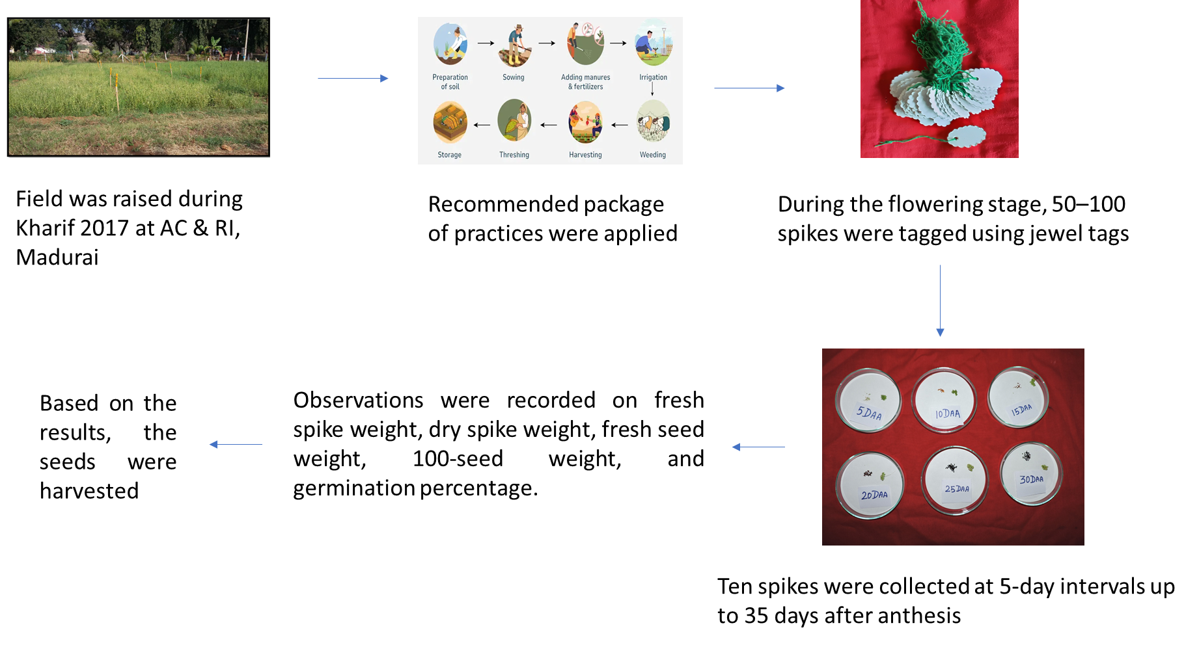
Plate 1. Experimental workflow adopted for the study on seed development and maturation in Sirukeerai (Amaranthus polygonoides L.) var. PLR 1.

  - Impact of Different Threshing Methods in Sirukeerai (Amaranthus polygonoides L.) var. PLR 1
Amaranthus spikes were harvested manually and dried to 17–18% moisture content. The spikes were then threshed using different methods and the seeds obtained were manually cleaned and graded before being analyzed for various seed quality parameters.
T₁: Threshing with hand rubbing
T₂: Threshing with tractor treading
T₃: Beating with pliable stick
- Results and discussion:
  - Seed Development and Maturation Studies in Sirukeerai (Amaranthus polygonoides L.) var. PLR 1
The maturation status of seeds during developmental stages was evaluated using various growth parameters such as fresh and dry weight of spike, spike moisture content, seed moisture content and fresh and dry weight of seeds. Prediction of seed maturation during growth and development is crucial, as it varies from crop to crop and even among seeds within a crop. Accurate determination of maturity is important because delayed harvest can lead to seed shattering or deterioration in quality. Seed development refers to the period between fertilization and the attainment of maximum fresh weight, whereas seed maturation begins after seed development and continues until harvest (Abdul-Baki & Baker, 1973).
In the present study, the change in spike colour to straw, blackening of seeds, and drying of plants served as reliable morphological indicators of both physiological and harvestable maturity. At maturity, the crop exhibited a distinct dry appearance. The fresh and dry weights of spikes showed a progressive increase up to 25 days after anthesis (DAA), reaching their maximum values (0.078 mg and 0.026 mg, respectively). Beyond this stage, both fresh and dry weights declined due to a restricted supply of nutrients from the mother plant, resulting from the disruption of vascular connections and their utilization in various physiological and metabolic processes. Consequently, delayed harvesting may lead to a continuous reduction in seed weight, caused by the cessation of assimilate translocation to the seeds as well as increased seed respiratory activity. The spike moisture content was 67.13% at 5 DAA and gradually decreased to 63.07% at 20 DAA. Beyond 20 DAA, a sharp decline was observed, indicating the onset of the seed maturation phase.
Seed weight is considered a reliable index for determining the physiological maturity of seeds. Seed fresh weight increased from 0.055 mg at 5 DAA and continued to rise until 25 DAA, after which it gradually declined with further advancement in seed development. The increase in seed weight and seed quality parameters during this period could be attributed to the accumulation of large quantities of reserve food materials during seed development (Krishnakumary, et al., 2004). Seed moisture content was 58.13% at 20 DAA and showed a steady decline in the subsequent stages of development. The rate of reduction was most pronounced between 40 and 50 DAA, coinciding with the attainment of maximum seed weight. Physiological maturity is defined as the stage at which seeds attain their maximum dry weight along with associated physical characteristics (Shaw et al., 1950). Beyond this stage, a slight reduction in dry matter production may occur due to internal mechanisms leading to the disorganization of cell organelles (Heydecker et al., 1972). Several researchers have also reported that physiological maturity corresponds to the point of maximum seed dry weight (Andrew et al., 1956; Delouche et al., 1958).
At this stage, seeds attained maximum germinability and vigour along with increased dry matter accumulation. A similar trend of decreasing seed moisture content during seed development has been reported in blackgram (Pozhilarasi et al., 2024) and mung bean (Dharmalingam & Basu, 1993). The decline in seed moisture content is closely associated with seed development within the pod. Following fertilization, moisture content initially increases during the early days, but subsequently decreases as seed development progresses, until equilibrium is reached with the surrounding environmental conditions (Delouche, 1973).
A significant increase in 100-seed weight was observed up to 20 days after anthesis (0.018 mg). Thereafter, seed weight declined, which may be attributed to moisture loss. Similar trends have been reported in other crops such as onion (Ramya, 2006), kolinji, daincha (Arul, 2014) and blackgram and greengram (Pozhilarasi et al., 2024). Germination capacity is a prime indicator of seed quality, as the harvested produce can be considered seed only after it acquires the ability to regenerate. In the present study, seeds exhibited 29% germination at 15 DAA, which gradually increased with maturity and reached a maximum of 93% at 30 DAA. This coincided with the accumulation of maximum fresh and dry weights. Beyond this stage, a slight reduction in viability percentage was observed. Comparable results were reported by Pozhilarasi et al. (2024), where germination improved slightly to 25.00% at 13 DAA. However, no germination was observed at the initial stages of 3 DAA and 8 DAA during seed development and maturation in blackgram (VBN 8).
Root and shoot lengths are important measures of seedling vigour, as they indicate the potential performance of seeds under given environmental conditions. In the present study, root length (4.3 cm) and shoot length (6.1 cm) increased progressively with advancement in maturation and reached their maximum values at 30 DAA. This coincided with the peak stages of dry weight of spike and seed, as well as maximum seed germination. Seedling dry matter, another key parameter for evaluating seed vigour, also showed a steady increase up to 25 DAA (0.078 g), which could be attributed to the accumulation of higher quantities of assimilates in spike and seed during maturation. A slight reduction in dry matter production was observed beyond this stage, which may be due to the development of inbuilt physiological mechanisms that trigger disorganization of cell organelles a few days after physiological maturity. Vigour, defined as the inherent ability of seeds to perform well under a wide range of environmental conditions, was reflected in the vigour index values. In the present study, the vigour index reached its maximum (967) at 30 DAA, in close association with maximum fresh weight, germination percentage, and seedling vigour traits, all of which are considered reliable indices of seed maturation.
Hence, the results of the present study revealed that Sirukeerai seeds attained physiological maturity at 30 days after anthesis, characterized by maximum dry weight accumulation, a marked decrease in seed moisture content, highest 100-seed weight and superior germination and vigour parameters.
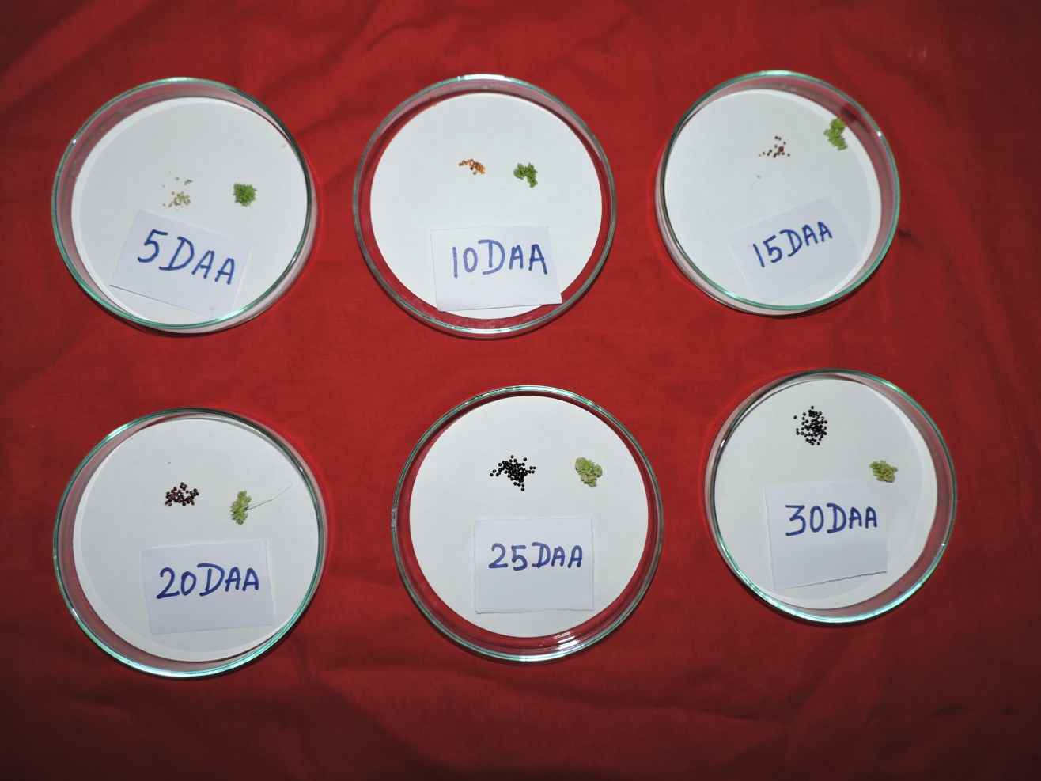
Plate 1. Seed development and maturation studies in Amaranthus polygonoides var PLR1
Table 1. Changes in Germination %, Shoot and Root length, DMP, Vigour Index of seeds during seed development and maturation studies in Amaranthus polygonoides var PLR1
Treatment | Germination (%) | Shoot length (cm) | Root length (cm) | DMP (mg/seedling¹⁰) | Vigour Index I | Vigour Index-II
5 DAA | 0 | 0 | 0 | 0 | 0 | 0
10DAA | 0 | 0 | 0 | 0 | 0 | 0
15 DAA | 29 (32.58) | 5.3 | 3.0 | 3.4 | 241 | 0.98
20 DAA | 58 (49.60) | 5.5 | 4.0 | 4.6 | 551 | 2.66
25 DAA | 75 (60.00) | 5.8 | 4.2 | 6.2 | 750 | 4.65
30 DAA | 93 (74.66) | 6.1 | 4.3 | 7.2 | 967 | 6.69
35 DAA | 90 (71.56) | 5.8 | 4.0 | 7.1 | 882 | 6.39
Mean | 50 | 4.07 | 2.78 | 4.07 | 849 | 3.05
SED | 1.747 | 1.747 | 0.086 | 0.099 | 13.358 | 0.0444
CD(0.05) | 3.747** | 3.747 ** | 0.185** | 0.213 ** | 28.653** | 0.0952**

  - Impact of different threshing methods on seed quality in Amaranthus polygonoides var PLR 1.
In the present study, harvested plants were subjected to three threshing methods, viz., hand rubbing, beating with a pliable stick, and tractor treading. Threshing methods significantly influenced seed quality parameters such as germination, dry matter production, and mechanical damage. The maximum threshing efficiency of 62.4% was obtained with hand rubbing, which was considerably higher than tractor treading (35%). Hand rubbing also recorded significantly higher germination (91%) compared to beating with a pliable stick (85%) and tractor treading (75%) (Plate 2b).
Stick beating resulted in 85% germination, next to hand rubbing. The higher germination percentage and maximum seed recovery in hand rubbing may be attributed to reduced mechanical damage. In contrast, the lower germination in stick beating was likely due to seed coat injury caused by the impact of the stick (Ravi Rathod et al., 2012). Similarly, Prasanna Kumar and Naveen Kumar (2012) evaluated threshing methods in finger millet and reported that the tractor-drawn stone roller method achieved higher threshing efficiency, which increased significantly with a decrease in moisture content. Greater mechanical damage often leads to the production of a higher number of abnormal seedlings. This is mainly due to breaks, cracks, bruises, and abrasions on the seed surface, which cause internal injury to the embryo and ultimately result in abnormal seedling development (Green et al., 1966; Reddy et al., 1995). Dharmaputra et al. (2012) reported that sorghum seeds threshed by panicle beating with a wooden stick showed significantly lower germination (91.04%) compared to seeds threshed by a threshing machine (Plates 2a).
The lowest germination was recorded in seeds obtained by tractor treading. The reduced germination under this method was associated with a higher proportion of abnormal seedlings. Seeds threshed by tractor treading experienced extensive mechanical damage, both visible and invisible, which resulted in lower germination (83.21%), reduced dry weight (0.13 g), and a decline in vigour index (Plate 2c). Mechanical threshing is generally known to cause more damage to seeds compared to manual methods (Saini et al., 1982). Similarly, Shelar (2008) reported that the vigour index of soybean seeds threshed by stick beating and processed manually was significantly higher than that of seeds threshed and processed by machine, irrespective of variety.
El Abady et al. (2012) reported that threshing methods had no significant effect on oil and protein content but did have a marked influence on seed quality. Threshing soybean by hand resulted in higher germination with a greater proportion of normal seedlings, while machine threshing caused more mechanical damage, leading to an increased number of abnormal seedlings. In the present study, mechanical damage was greater in tractor treading compared to hand rubbing, whereas hand rubbing caused the least damage. Although manual threshing produced fewer abnormal seedlings and minimized mechanical injury, it was found to be uneconomical, laborious, and time-consuming despite its higher threshing efficiency compared to other methods.

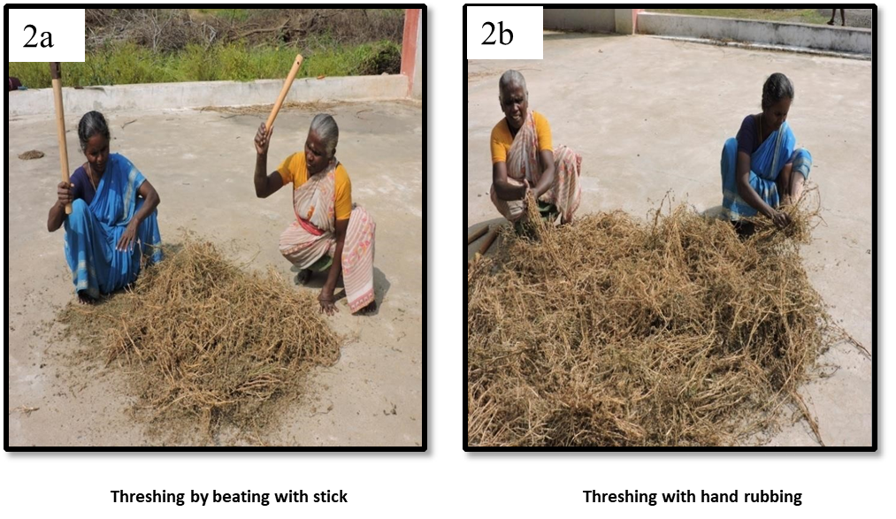
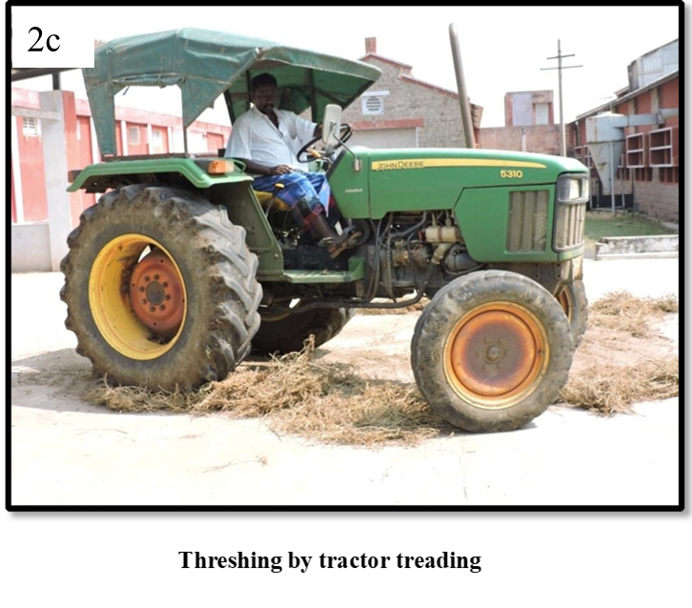
Plate 2. Impact of different threshing methods in Amaranthus polygonoides var
PLR1

Table 2. Impact of different threshing methods on seed quality in Sirukeerai (Amaranthus polygonoides) var. PLR 1.

Threshing methods | Seed recovery (%) | Germination (%) | Shoot length (cm) | Root length (cm) | Dry matter production (g/seedling¹⁰) | Vigour Index I | Vigour Index II
Hand rubbing (T₁) | 62.4  (52.18) | 91  (72.54) | 4.60 | 5.30 | 6.3 | 900 | 5.73
Stick beating (T₂) | 49  (44.43) | 85  (67.21) | 4.20 | 5.10 | 5.59 | 790 | 4.75
Tractor treading (T₃) | 35  (36.27) | 75  (60.00) | 3.70 | 4.68 | 5.44 | 628 | 4.08
Mean | 48.8 | 84 | 4.16 | 5.02 | 5.77 | 773 | 4.85
S.Ed | 1.4245 | 1.2172 | 0.0850 | 0.123 | 0.0831 | 12.5535 | 0.1059
CD (P=0.05) | 3.48** | 2.97** | 0.20** | 0.30** | 0.20** | 30.71** | 0.25**
Reference:
Arul, A. 2014. Effect of topping and foliar nutrition on seed yield and quality of Daincha (Sesbania aculeata (Wild.) Pers.,). M.Sc., (Ag.) Thesis, TNAU, AC & RI, Madurai.
Bartsch, J. A., C. G. Haugh, K. L. Athow, and R. M. Peart. "Impact damage to soybean seed." (1979): 27-pp.
Dharmalingam, C. and Basu R.N. (1993). Determining optimum season for the production of seeds in Mung bean. Madras Agric. J., 80: 684–688.
Dharmaputra, O., Ambarwati, S and Retnowati, I. 2012. Postharvest quality improvement of sorghum (Sorghum bicolor (L.)Moench) grain. BIOTROPIA Vol. 19(2): 115-129.
El. Abady, M. I., A. A. M. El Emam, S. E. Seadh and F. I. Yous of. 2012. Soybean seed quality as affected by cultivars, threshing methods and storage periods. Res. J Seed Sci., 5(4): 115-125.
Green, D.E., L.E. Cavanah and E.L. Pinnell, 1966. Effect of seed moisture content, field weathering and combine cylinder speed on soybean seed quality. Crop Sci., 6: 7-10.
Harrington, J. F. (1972). Seed storage and longevity. Seed biology, 3, 145-245.
ISTA, 1985. International rules for seed testing. Seed Sci. Technol., 13: 421-463.
Krishnakumary, K., Devadas, V.S and M.P. Joseph. 2004. Studies on physiological maturity of oriental pickling melon (Cucumis melo var. Conomon) seeds. Seed Res. 32(1) : 52-54.
Manikandan, S., Srimathi, P., & Kumaran, K. (2010). Studies on Physiological Maturation to Fix the Optimum Time of Harvest in Grain Amaranthus (Amaranthus hypochondriacus L cv. Suvarna. IUP Journal of Life Sciences, 4(3).
Nave, W.R., 1979. Soybean harvesting equipment: Recent innovations and current status. Proceedings of the World Soybean Research Conference 2, March 26-29, 1979, North Carolina State University, USA., pp: 433-449.
Pozhilarasi, S. and Geetha, R. 2021. Effect of Cutting and Foliar Nutrition on Seed Yield of Sirukeerai (Amaranthus polygonoides) var. PLR 1. Int. J. Curr. Microbiol. App. Sci. 10(12): 344352.
Pozhilarasi, S., C. Menaka, A. Yuvaraja, M. Djanaguiraman, K. Raja, and C. Vanitha. "Impact of seed hardness on quality in variety VBN-8 of black gram (Vigna mungo L. Hepper) during maturation." Plant Sci Tod (Early Access). https:/doi. org/10.14719/pst 5104 (2024).
Prakash, D., & Pal, M. (1991). Nutritional and antinutritional composition of vegetable and grain amaranth leaves. Journal of the Science of Food and Agriculture, 57(4), 573-583.
Prasanna kumar and D. B. Naveen kumar. 2012. Performance evaluation of threshing of finger millet by mechanical method. Intl J. Agric. Eng., 5(2): 186-191.
Ravi Rathod, P., P. Balakrishna and A. B. Narayanareddy. 2012. Effect of threshing methods on seed quality of sunflower. Bioinfo., 9(4): 507 – 510.
Reddy, D.M.V., A.B. Gowda and K.M.P. Murthy, 1995. Effect of seasons and threshing methods on seed quality and longevity in soybean. Seed Res., 23: 80-83.
Saini, S. (1975). Effect of cuttings on the seed yield of methi (Trigonella foenum--graecum). Haryana journal of horticultural sciences.
Shaw RH, Loomis WE (1950) Bases for the prediction of corn yields. Plant Physiol 25(2):225
Shelar, V. R. 2008. Role of mechanical damage in deterioration of soybean seed quality during storage - A review. Agric. Rev., 29 (3): 177 – 184.
Singh A. R., and Lachanna A. (1995) Effect of dates of harvesting, drying and storage on seed quality of sorghum parental lines. Seed Res. 13: 180-185.

