Synergistic Effects of Polyphenol-Terpenoid Combinations on NLRP3 Inflammasome-Mediated Neuroinflammation: A Mini Review

ABSTRACT
Neuroinflammation driven by the NLRP3 inflammasome is a key mechanism in many neurological disorders. While plant-derived polyphenols and terpenoids individually show anti-inflammatory potential, their synergistic effects remain underexplored. This review highlights the enhanced efficacy of polyphenol-terpenoid combinations in inhibiting NLRP3-mediated neuroinflammation through complementary pathways. Preclinical studies demonstrate that such pairs like quercetin with limonene or curcumin with ar-turmerone more effectively reduce pro-inflammatory cytokines, microglial activation, and oxidative stress than single compounds. However, clinical translation faces challenges including optimal dosing, formulation, and CNS delivery. Future research should focus on identifying effective combinations, elucidating their mechanisms, and validating their therapeutic potential in clinical trials to develop novel treatments for neuroinflammatory diseases.

Keywords: Polyphenols; Terpenoids; NLRP3 inflammasome; Neuroinflammation; Synergistic effects; Natural compounds; Neurological disorders

Abbreviations
CNS: Central Nervous System
NLRP3: NOD-, LRR- and pyrin domain-containing protein 3
IL-1β: Interleukin-1β
IL-18: Interleukin-18
ROS: Reactive Oxygen Species
NF-κB: Nuclear Factor kappa-light-chain-enhancer of activated B cells
PAMPs: Pathogen-Associated Molecular Patterns
DAMPs: Damage-Associated Molecular Patterns
ATP: Adenosine Triphosphate
COX-2: Cyclooxygenase-2
LOX: Lipoxygenase
LPS: Lipopolysaccharide
TNF-α: Tumor Necrosis Factor alpha

Introduction
Neuroinflammation, a chronic inflammatory response within the central nervous system (CNS), is a critical pathogenic mechanism underlying a spectrum of neurological disorders, including Alzheimer's disease, Parkinson's disease, stroke, and traumatic brain injury (Hua, Zhou, & Shi, 2022; Xu, Huang, & Zhou, 2025; Yu et al., 2021). A key driver of this process is the NLRP3 inflammasome, a multiprotein complex that, upon activation, catalyzes the maturation of potent pro-inflammatory cytokines interleukin-1β (IL-1β) and IL-18, perpetuating a cycle of inflammation and neuronal damage (Tork et al., 2024). Despite its central role, therapeutic strategies that effectively and safely target the NLRP3 pathway remain an unmet clinical need (Bagherniya et al., 2021).

In the search for novel interventions, plant-derived bioactive compounds have garnered significant attention for their potent anti-inflammatory and antioxidant properties (Hua et al., 2022). Among these, polyphenols (e.g., curcumin, quercetin, resveratrol) and terpenoids (e.g., limonene, ginsenosides, boswellic acids) have demonstrated individual efficacy in mitigating neuroinflammation by modulating signaling pathways like NF-κB, scavenging reactive oxygen species (ROS), and suppressing microglial activation (Takata et al., 2021). A critical advantage of many of these compounds is their ability to cross the blood-brain barrier, making them promising candidates for CNS-targeted therapies (La Rosa et al., 2023; Zhan et al., 2019). Despite these advantages, the research community has yet to fully explore how these compounds might work together more effectively than alone. The established efficacy of individual compounds provides a rationale for investigating their combined effects, where synergy could unlock new therapeutic possibilities

However, much of the existing research has focused on the isolated effects of single compounds. “The novelty of this review lies in its specific focus on the emerging concept of synergy: the potential for polyphenols and terpenoids to exert enhanced, multi-mechanistic effects when used in combination”. We posit that by acting on complementary pathways within the neuroinflammatory cascade, these natural compound pairs can achieve a therapeutic effect greater than the sum of their parts, offering a more robust and holistic approach to NLRP3 inflammasome inhibition

1. Overview of Polyphenols, Terpenoids, and the NLRP3 Inflammasome in Neuroinflammation

Given the critical role of neuroinflammation in various neurological disorders, this review begins by introducing polyphenols and terpenoids, two major classes of plant-derived bioactive compounds with potential benefits in this context. While polyphenols and terpenoids each have unique anti-inflammatory properties, as characterized by their structure and subclasses, it's their interaction that this review posits can lead to a novel synergistic approach in combating neuroinflammation. Their neuroprotective effects are largely attributed to potent antioxidant and anti-inflammatory properties, such as inhibiting pro-inflammatory cytokine production and suppressing microglial activation (Moratilla-Rivera, Sánchez, Valdés-González, & Gómez-Serranillos, 2023).

Terpenoids, a diverse group derived from isoprene units, encompass monoterpenes (e.g., limonene, linalool), sesquiterpenes, diterpenes, and triterpenes (e.g., ginsenosides, boswellic acids) (Jang, Hwang, & Cho, 2023). They exhibit a range of anti-inflammatory and neuroprotective effects by modulating inflammatory signaling pathways, inhibiting pro-inflammatory enzymes, and attenuating oxidative stress (Suárez Montenegro et al., 2021). A critical advantage of both compound classes is their ability to cross the blood-brain barrier, making them promising candidates for targeting neuroinflammatory processes in the central nervous system (Xu et al., 2025).

A key mediator of neuroinflammation is the NLRP3 inflammasome, a multiprotein complex whose activation is a hallmark of many neurological disorders (Xu et al., 2025; Yao, Zhang, Wang, & Song, 2023). Its activation is a two-step process: an initial priming signal (e.g., from PAMPs or DAMPs) upregulates NLRP3 and pro-IL-1β via NF-κB, followed by an activation trigger (Dadkhah & Sharifi, 2024). These triggers include extracellular ATP, reactive oxygen species (ROS), mitochondrial dysfunction, lysosomal damage, and critical ion fluxes, particularly potassium efflux (Dominic, Le, & Takahashi, 2022). Upon assembly, the NLRP3 inflammasome activates caspase-1, which cleaves pro-IL-1β and pro-IL-18 into their active, pro-inflammatory forms, perpetuating the inflammatory response and contributing to neuronal damage in conditions like Alzheimer's and Parkinson's disease (Dadkhah & Sharifi, 2024), as illustrated in Figure 1. Building on the individual properties of polyphenols and terpenoids, their combination can yield synergistic effects that enhance their anti-inflammatory and neuroprotective capacities.

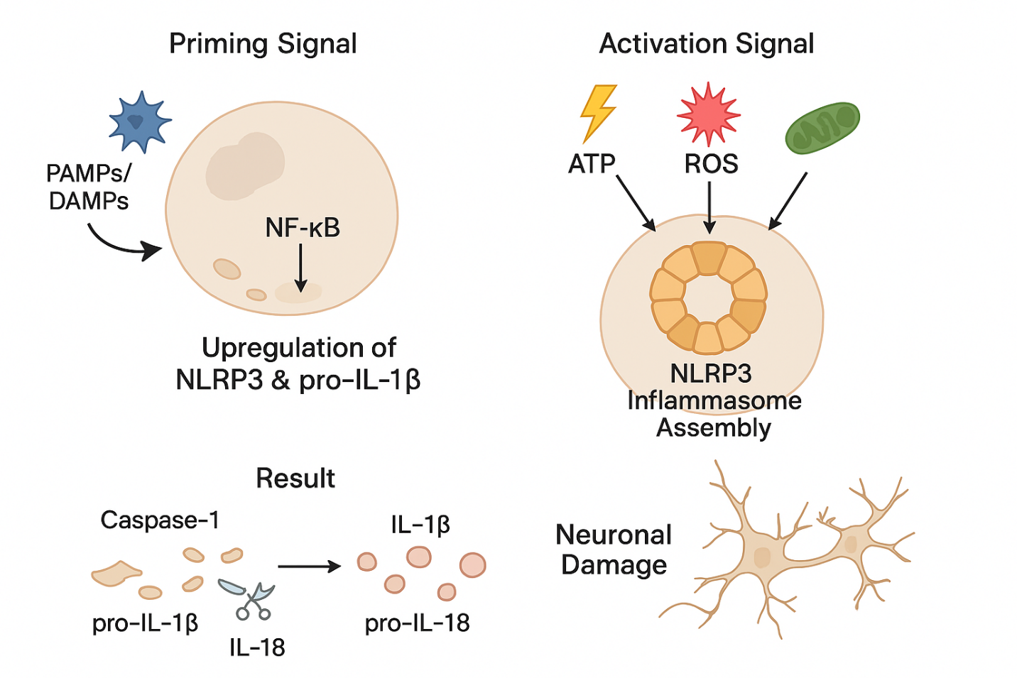

Figure 1: Mechanism of NLRP3 Inflammasome Activation in Neuroinflammation

2. Synergistic Interactions Between Polyphenols and Terpenoids

The combination of polyphenols and terpenoids can yield synergistic effects that enhance their individual anti-inflammatory and neuroprotective capacities. This synergistic effect is achieved by the compounds working together through different, but complementary, pathways in the body. Together, they can more potently inhibit key pro-inflammatory enzymes like COX-2 and LOX, leading to a greater reduction in inflammatory mediators such as prostaglandins and leukotrienes (Rudrapal et al., 2023). They also cooperatively suppress the activation of the master inflammatory transcription factor NF-κB (Liu, Zhang, Yu, Xu, & Dong, 2016).

Furthermore, their combined antioxidant activity more effectively neutralizes ROS, protecting cellular components from oxidative damage and reducing the overall inflammatory burden. These proposed synergistic mechanisms are summarized in Figure 2. This multi-targeted approach also extends to modulating immune cell function and cytokine release, creating a more balanced and controlled inflammatory response. An additional benefit of combining these compounds is the potential for improved bioavailability and cellular uptake, where one compound may enhance the absorption or stability of the other (Shoba et al., 1998).

Specific combinations highlight this potential. For instance, quercetin (a flavonoid) and limonene (a monoterpene) show enhanced antioxidant and anti-inflammatory effects (Eddin et al., 2021). Similarly, the combination of curcumin and ar-turmerone from turmeric exhibits stronger neuroprotective effects, while rosmarinic acid (a polyphenol) and carnosic acid (a terpenoid) in rosemary extracts work together to improve antioxidant capacity (Huerta-Madroñal, Caro-León, Espinosa-Cano, Aguilar, & Vázquez-Lasa, 2021). These synergistic interactions are supported by compelling preclinical evidence from both in vitro and in vivo models of neuroinflammation as detailed below.

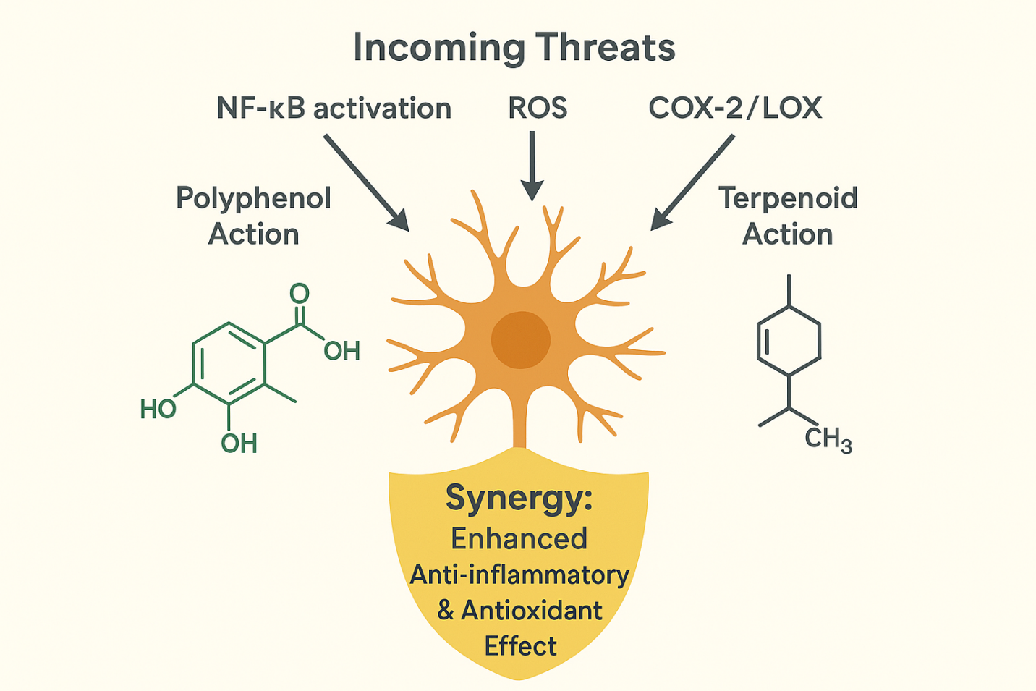

Figure 2: Proposed Synergistic Mechanisms of Polyphenol-Terpenoid Combinations

3. Preclinical Evidence of Synergy in Neuroinflammation Models

To better understand the clinical potential of these findings, the following sections will sequentially discuss preclinical evidence, challenges in translating these findings to clinical settings, and future research directions. In vitro models using microglial cell lines have demonstrated that combinations of natural compounds, such as resveratrol with conventional drugs, can produce a greater inhibition of pro-inflammatory cytokine production than any single agent alone (Lee, Gupta, Park, Yang, & Song, 2021).

This has been substantiated in vivo using rodent models of neuroinflammation induced by LPS or chronic stress (White, Elias, Orozco, Robinson, & Manners, 2024). Combinations targeting multiple inflammatory pathways such as a COX-2 inhibitor with a TNF-α antagonist, or an NF-κB inhibitor paired with an NLRP3 inflammasome blocker have shown enhanced efficacy in reducing microglial activation, attenuating neuroinflammation, and improving cognitive outcomes in models of neurodegenerative disease (Tajdari et al., 2024). More directly relevant to this review, combinations of plant-derived polyphenols and terpenoids have shown similar promise in targeting the NLRP3 inflammasome (De Lima et al., 2025)

The specific focus on NLRP3 inflammasome modulation, with examples provided in Figure 3, has been particularly promising. Combination therapies that pair NLRP3 inhibitors with antioxidants or other neuroprotective compounds have shown synergistic effects in reducing neuroinflammatory markers and improving recovery in models of traumatic brain injury, stroke, and neurodegenerative diseases (Izzy et al., 2025). The underlying mechanisms involve simultaneously targeting multiple points in the inflammatory cascade, reducing oxidative stress, and modulating microglial activation (Zhuang et al., 2021). These promising preclinical findings pave the way for exploring the therapeutic and translational challenges of applying polyphenol-terpenoid synergies in clinical settings.

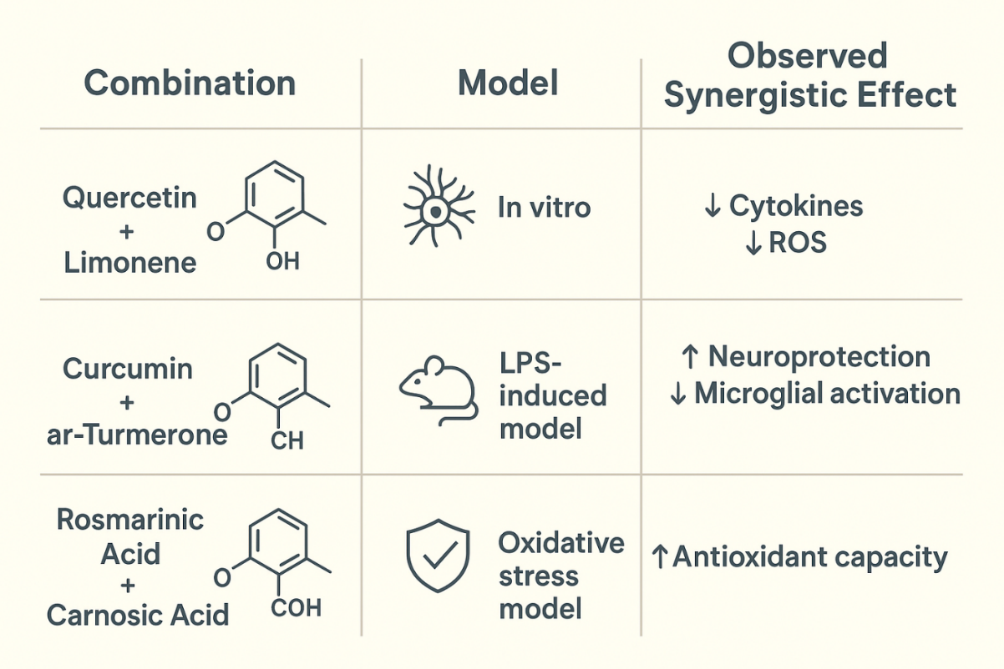

Figure 3: Examples of Synergistic Combinations from Preclinical Studies

4. Potential Therapeutic Applications and Translational Challenges

The therapeutic implications of this synergy are broad, spanning neurodegenerative diseases (Alzheimer's, Parkinson's), neuropsychiatric disorders, stroke, and traumatic brain injury (Nahar et al., 2025). The use of multi-compound combinations is a key strategy in modern pharmacology, as their multi-mechanistic nature can allow for lower effective doses of individual compounds, potentially reducing side effects and improving overall efficacy (Woodcock & Lavange, 2017).

However, a detailed discussion on overcoming the significant challenges of translating these promising preclinical findings into clinical applications will follow, highlighting the need for innovative formulation strategies and targeted delivery mechanisms. A primary hurdle is optimizing dosing and formulation. Determining the most effective ratio of compounds that produces synergy in humans is complex, as factors like bioavailability, metabolism, and drug-drug interactions differ from laboratory models. Formulating stable combinations that ensure consistent bioavailability of multiple active ingredients is technically difficult.

For neuroinflammatory disorders, the challenge is compounded by the need for compounds to penetrate the blood-brain barrier (Jindal et al., 2024). Promising synergistic combinations may have poor oral bioavailability or limited brain exposure in humans. Strategies like nanoformulations may be necessary but can alter the carefully balanced pharmacokinetics and synergistic ratios established preclinically. Furthermore, patient variability in blood-brain barrier permeability and the activity of efflux transporters can lead to inconsistent results. To address these challenges and realize the therapeutic potential, future research must focus on systematically identifying effective compound pairs and validating these findings in clinical trials.

5. Future Research Directions

Future research must focus on systematically identifying the most effective polyphenol-terpenoid pairs. This requires high-throughput screening in various disease models to evaluate their combined effects and elucidate the precise molecular mechanisms behind their synergy.

Ultimately, the critical next step is to validate these preclinical findings in well-designed clinical trials. Rigorous human studies are essential to confirm the safety, efficacy, and optimal dosing regimens of these combinations. Clinical trials will bridge the gap between experimental models and human patients, uncovering any unforeseen side effects or interactions and providing the robust evidence needed to advance the most promising synergistic therapies into clinical practice. This will be paramount for developing novel, effective strategies to combat neuroinflammatory diseases.

Conclusion

Polyphenol-terpenoid combinations represent a promising therapeutic strategy for mitigating NLRP3 inflammasome-mediated neuroinflammation. By leveraging complementary mechanisms, these natural compounds synergistically enhance the suppression of pro-inflammatory cytokines, microglial activation, and oxidative stress beyond what can be achieved individually. Preclinical studies provide compelling evidence for their efficacy across various neurological disorder models. However, clinical translation requires overcoming challenges related to optimal dosing, formulation stability, and targeted CNS delivery. Future efforts should focus on identifying potent compound pairs, clarifying their molecular mechanisms, and advancing them through rigorous clinical trials. Success in these areas may yield multi-targeted therapies with improved efficacy and reduced side effects for neuroinflammatory conditions.

References
Bagherniya, M., Xu, S., Fakheran, O., Johnston, T. P., Sahebkar, A., & Khedmatgozar, H. (2021). Medicinal plants and bioactive natural products as inhibitors of NLRP3 inflammasome. Phytotherapy Research, 35(9), 4804–4833.

Dadkhah, M., & Sharifi, M. (2024). The NLRP3 inflammasome: Mechanisms of activation, regulation, and role in diseases. International Reviews of Immunology, 44(2), 98–111.

De Lima, E. P., Laurindo, L. F., Catharin, V. C. S., Direito, R., Tanaka, M., Jasmin Santos German, I., Lamas, C. B., et al. (2025). Polyphenols, Alkaloids, and Terpenoids Against Neurodegeneration: Evaluating the Neuroprotective Effects of Phytocompounds Through a Comprehensive Review of the Current Evidence. Metabolites, 15(2), 124.

Dominic, A., Le, N.-T., & Takahashi, M. (2022). Loop Between NLRP3 Inflammasome and Reactive Oxygen Species. Antioxidants &amp; Redox Signaling, 36(10–12), 784–796.

Eddin, L. B., Kesari, K. K., Beiram, R., Jha, N. K., Meeran, M. F. N., & Ojha, S. (2021). Neuroprotective Potential of Limonene and Limonene Containing Natural Products. Molecules, 26(15), 4535.

Hua, F., Zhou, P., & Shi, L. (2022). Phenols and terpenoids: natural products as inhibitors of NLRP3 inflammasome in cardiovascular diseases. Inflammopharmacology, 30(1), 137–147.

Huerta-Madroñal, M., Caro-León, J., Espinosa-Cano, E., Aguilar, M. R., & Vázquez-Lasa, B. (2021). Chitosan – Rosmarinic acid conjugates with antioxidant, anti-inflammatory and photoprotective properties. Carbohydrate Polymers, 273, 118619.

Izzy, S., Yahya, T., Albastaki, O., Abou-El-Hassan, H., Aronchik, M., Cao, T., De Oliveira, M. G., et al. (2025). Nasal anti-CD3 monoclonal antibody ameliorates traumatic brain injury, enhances microglial phagocytosis and reduces neuroinflammation via IL-10-dependent Treg–microglia crosstalk. Nature Neuroscience, 28(3), 499–516.

Jang, W. Y., Hwang, J. Y., & Cho, J. Y. (2023). Ginsenosides from Panax ginseng as Key Modulators of NF-κB Signaling Are Powerful Anti-Inflammatory and Anticancer Agents. International journal of molecular sciences, 24(7), 6119.

Jindal, A., Mainuddin, M., Kumar, A., Ratnesh, R. K., & Singh, J. (2024). Nanotechnology Driven Lipid and Metalloid Based Formulations Targeting Blood-Brain Barrier (3B) for Brain Tumor. Indian journal of microbiology, 65(1), 92–119.

La Rosa, G., Sozio, C., Pipicelli, L., Raia, M., Palmiero, A., Santillo, M., & Damiano, S. (2023). Antioxidant, Anti-Inflammatory and Pro-Differentiative Effects of Chlorogenic Acid on M03-13 Human Oligodendrocyte-like Cells. International Journal of Molecular Sciences, 24(23), 16731.

Lee, Y.S., Gupta, D. P., Park, S. H., Yang, H.-J., & Song, G. J. (2021). Anti-Inflammatory Effects of Dimethyl Fumarate in Microglia via an Autophagy Dependent Pathway. Frontiers in Pharmacology, 12(4).

Liu, H., Zhang, X., Yu, C., Xu, T., & Dong, M. (2016). Synergistic protective effect of paeoniflorin and β-ecdysterone against rotenone-induced neurotoxicity in PC12 cells. Apoptosis, 21(12), 1354–1365.

Moratilla-Rivera, I., Sánchez, M., Valdés-González, J. A., & Gómez-Serranillos, M. P. (2023). Natural Products as Modulators of Nrf2 Signaling Pathway in Neuroprotection. International Journal of Molecular Sciences, 24(4), 3748.

Nahar, L., Charoensup, R., Kalieva, K., Habibi, E., Guo, M., Wang, D., Kvasnica, M., et al. (2025). Natural products in neurodegenerative diseases: recent advances and future outlook. Frontiers in pharmacology, 16.

Rudrapal, M., Eltayeb, W. A., Rakshit, G., El-Arabey, A. A., Khan, J., Aldosari, S. M., Alshehri, B., et al. (2023). Dual synergistic inhibition of COX and LOX by potential chemicals from Indian daily spices investigated through detailed computational studies. Scientific Reports, 13(1).

Shoba, G., Majeed, M., Rajendran, R., Joseph, T., Srinivas, P., & Joy, D. (1998). Influence of piperine on the pharmacokinetics of curcumin in animals and human volunteers. Planta Medica, 64(4), 353–356.

Suárez Montenegro, Z. J., Álvarez-Rivera, G., Sánchez-Martínez, J. D., Gallego, R., Valdés, A., Bueno, M., Cifuentes, A., et al. (2021). Neuroprotective Effect of Terpenoids Recovered from Olive Oil By-Products. Foods, 10(7), 1507.

Tajdari, M., Peyrovinasab, A., Bayanati, M., Ismail Mahboubi Rabbani, M., Abdolghaffari, A. H., & Zarghi, A. (2024). Dual COX-2/TNF-α Inhibitors as Promising Anti-inflammatory and Cancer Chemopreventive Agents: A Review. Iranian journal of pharmaceutical research : IJPR, 23(1).

Takata, F., Dohgu, S., Nakagawa, S., & Matsumoto, J. (2021). Blood-Brain Barrier Dysfunction Amplifies the Development of Neuroinflammation: Understanding of Cellular Events in Brain Microvascular Endothelial Cells for Prevention and Treatment of BBB Dysfunction. Frontiers in Cellular Neuroscience, 15(593026).

Tork, M. A. B., Fotouhi, S., Roozi, P., & Negah, S. S. (2024). Targeting NLRP3 Inflammasomes: A Trojan Horse Strategy for Intervention in Neurological Disorders. Molecular neurobiology, 62(2), 1840–1881.

White, A. G., Elias, E., Orozco, A., Robinson, S. A., & Manners, M. T. (2024). Chronic Stress-Induced Neuroinflammation: Relevance of Rodent Models to Human Disease. International Journal of Molecular Sciences, 25(10), 5085.

Woodcock, J., & Lavange, L. M. (2017). Master Protocols to Study Multiple Therapies, Multiple Diseases, or Both. New England Journal of Medicine, 377(1), 62–70.

Xu, W., Huang, Y., & Zhou, R. (2025). NLRP3 inflammasome in neuroinflammation and central nervous system diseases. Cellular & Molecular Immunology, 22(4), 341–355.

Yao, J., Zhang, Y., Wang, Z., & Song, W. (2023). Targeting NLRP3 inflammasome for neurodegenerative disorders. Molecular Psychiatry, 28(11), 4512–4527.

Yu, Q., Li, J., Liu, C., Xia, M., Sun, P., Li, Y., Cao, D., et al. (2021). Targeting NLRP3 Inflammasome in Translational Treatment of Nervous System Diseases: An Update. Frontiers in Pharmacology, 12(7).

Zhan, L., Gan, L., Krabbe, G., Shen, Y., West, B., Jones, I., Wang, C., et al. (2019). Proximal recolonization by self-renewing microglia re-establishes microglial homeostasis in the adult mouse brain. PLOS Biology, 17(2), e3000134.

Zhuang, S., Zhang, C., Wu, L., Liu, B., Liu, S., Ni, X., Xue, Y., et al. (2021). Germacrone alleviates neurological deficits following traumatic brain injury by modulating neuroinflammation and oxidative stress. BMC Complementary Medicine and Therapies, 21(1).

