Original Research Article

Topographic and Radiometric Integration for Enhanced Structural Mapping in Gold Exploration: A Case study of North Central Nigeria

Abstract
Accurate delineation of structurally controlled hydrothermal alteration zones is critical for gold exploration in basement terrains. This study integrates topographic and radiometric data to enhance structural mapping in parts of North-Central Nigeria, a region within the Nigerian Basement Complex known for gold mineralization. This investigation demonstrates how the fusion of SRTM-derived geomorphological parameters and airborne radiometric data improves the delineation of gold favourable zones. Shuttle Radar Topography Mission (SRTM) data and radiometric datasets were processed to delineate lineaments, identify hydrothermal alteration zones, and establish their relationship with known gold occurrences. Topographic derivatives such as slope, curvature, aspect, and terrain ruggedness Index (TRI) were combined with potassium (K), thorium (Th), and uranium (U) concentration maps, as well as K/Th and F-parameter ratios, to highlight regions of structural complexity and potential mineralization. Lineament density and directional analyses revealed dominant NE-SW and NW-SE structural trends, consistent with regional tectonics which coincide with mapped gold mineralized zones suggesting strong tectonic controls on mineral emplacement. Results indicate that potassium anomalies, elevated K/Th ratios, and high F-parameter values are spatially coincident with structurally controlled zones delineated from topographic analysis. Several of these coincident anomalies correspond to known artisanal gold mining sites, while others define previously unrecognized prospective corridors. The findings contribute to exploration strategies by delineating priority zones that warrant detailed geophysical and geochemical follow-up.

Keywords: Topography, Radiometric, Gold Exploration, Structural Mapping, Geomorphology

1. Introduction
Hydrothermal alteration mapping is a crucial component of mineral exploration in Precambrian basement terrains, where mineralization is often structurally controlled and associated with shear zones, brittle–ductile faults, and fracture networks (Andarawus et al., 2023). Such alteration processes typically produce mineralogical and geochemical changes in host rocks, leading to detectable variations in potassium (K), thorium (Th), and uranium (U) concentrations. These variations can be captured effectively using airborne radiometric surveys, which provide spatially continuous measurements of gamma-ray emissions from natural radioelements (Akinlalu, 2023).
In mineralized systems, potassic enrichment is often associated with sericitization, K-feldspar alteration, and illitization, while depletion of thorium and uranium may result from mobilization during hydrothermal fluid flow (Akinlalu, 2023; Eldosouky et al., 2024). Radiometric ratio maps such as Th/K and ternary (K–Th–U) composites, together with derived indices such as the K-deviation (K_{d}) and the F-parameter are effective tools for highlighting hydrothermal-alteration footprints; when integrated with structural datasets, these radiometric signatures have been shown to delineate alteration halos and prospective mineralized zones in basement terrains (Sanusi & Amigun, 2020; Akinlalu, 2023; Salako et al., 2024).
Traditional structural mapping, based solely on geophysical or geological observations, may overlook subtle topographic and geochemical indicators of mineralization (Hronsky & Groves, 2008). The integration of airborne radiometric data with digital elevation model (DEM)‐derived terrain attributes such as slope, curvature, ruggedness index, and topographic position index (TPI) greatly enhances alteration mapping by providing additional structural and geomorphological context. In basement terrains, this combined approach has demonstrated improved delineation of alteration zones and prospective mineralization when applied using methods like band‐ratios, radiometric indices, and terrain derivatives (Onyejiuwaka & Nkiru, 2020; Ohwo & Fadeyi, 2024).
Terrain analysis helps to delineate fault-bounded ridges, valley alignments, and slope breaks that may correspond to zones of enhanced permeability and fluid flow. In structurally complex terranes such as the Nigerian Basement Complex, these topographic signatures are particularly valuable for identifying mineralized structures that may be obscured by regolith or vegetation cover (Ilugbo et al., 2020; Olatubosun et al., 2022).
The study area has a humid tropical climate with seasonal rainfall, which significantly influences surface processes such as weathering and lateritization. This surface alteration further complicates geological mapping but enhances the importance of radiometric integration for subsurface exploration. Thus, the geological and structural framework of North-Central Nigeria provides an ideal setting for testing the integration of SRTM, and radiometric datasets in delineating hydrothermal alteration zones and targeting mineral deposits.
Recent advances in geospatial integration have demonstrated the effectiveness of combining geophysical, remote sensing, and topographic datasets for alteration mapping and mineral prospectivity analysis. Studies in West Africa and other shield terrains have shown that the co-occurrence of radiometric anomalies with slope and curvature discontinuities frequently correlates with productive shear zones (Eldosouky et al., 2024). In Nigeria, integrated geophysical studies have delineated prospective corridors for gold mineralization by combining airborne radiometric indices with structural mapping derived from remote sensing and topographic datasets in Igarra Schist Belt (Ohwo & Fadeyi, 2024).
This study adopts such an integrated approach to map hydrothermal alteration zones in North-Central Nigeria by fusing airborne radiometric datasets (K, Th, U, Th/K, K-deviation, F-parameter, and ternary composites) with DEM-derived terrain attributes. The objective is to identify structurally controlled alteration belts that could serve as exploration targets for gold and other mineral deposits.
The study area has a humid tropical climate with seasonal rainfall, which significantly influences surface processes such as weathering and lateritization. This surface alteration further complicates geological mapping but enhances the importance of radiometric integration for subsurface exploration. Thus, the geological and structural framework of North-Central Nigeria provides an ideal setting for testing the integration of SRTM, and radiometric datasets in delineating hydrothermal alteration zones and targeting mineral deposits.

2. Location, Topography and Geology of the study area
The research area is bounded by latitude 8º30’00”– 10º00’00” North and longitude 5º00’00”– 9º00’00” East. The study area (72,600 square kilometres) lies within the North-Central Nigerian Basement Complex, encompassing parts of Niger state, Federal Capital Territory (FCT) and few other towns in Kaduna, Plateau and Nasarawa adjoining the FCT. The study area constitutes about 7.86 % of Nigeria’s landmass and is part of the North Central geopolitical zone. Major towns observed within the study area are Abuja, Keffi, Minna, Bida, Wushishi, and Abaji as showcased in Figure 1.

The Topography of the study area (Figure 1) is characterized by pen plains with a relatively flat landscape and gentle slopes around Bida and Pategi as the flanks of the River Niger deposits sediments unto these regions. Northeast of the study area unto towns like Minna, Abuja, Kachia, Wamba, Jema’a, the topography is seen to be high ranging from an average elevation of 400 m to about 1500 m. The residents within this region are predominantly Gwari, Nupe, Jabba, Kagoma, and Koro with farming, trading, and cattle rearing as main occupation.
The study area lies within the Nigerian Basement Complex. This region forms part of the Pan-African mobile belt, bounded by the West African Craton to the west and the Congo Craton to the southeast. It represents a tectonically active domain characterized by multiple deformation events, intense metamorphism, and magmatic intrusions (Rahaman, 1988; Ajibade et al., 2008). Geologically, the area is underlain by a wide spectrum of lithologies, including gneisses, granites, and metavolcanic sequences or Pan-African granitoids (Rahaman, 1988; Obaje, 2009; Bolarinwa et al., 2021; Adekeye et al., 2023; Lawrence et al., 2025). Generally, the region is underlain predominantly by Precambrian basement rocks that have been extensively reworked during the Pan-African orogeny (~600–500 Ma) as observed in Figure 2, which played a crucial role in the tectonic and lithological evolution of the area (Akintola et al., 2020; Obaje, 2009).The schist belts, lies within the Nigerian Basement Complex (Precambrain) which are proterozoic in age, and consist of metasedimentary and metavolcanic rocks that have been intruded by syn- to post-tectonic granitoids (Obaje, 2009). These schist belts are known for their high mineral potential, particularly for gold, base metals, and rare minerals, making them strategic targets for exploration.
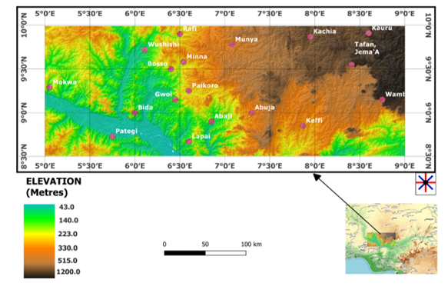
Figure 1: Topography map for the study area [Extracted from NASA Shuttle Radar Topography Mission (SRTM)(2013) on June 5th, 2024 ; Modified using free and open source QGIS software]
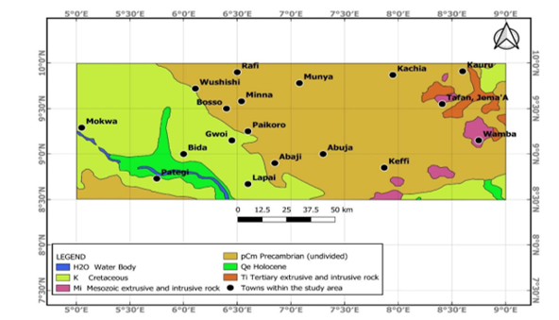
Figure 2: The geological map of the study area (Adapted from Lawrence et al., 2025)

Structurally, the terrain is dominated by NE-SW and NW-SE trending shear zones, fractures, and faults, as documented by researchers such as Ogunmola et al. 2015, Daniel et al., 2019, Mustapha et al., (2020), Ahmed et al., (2020), Ebele et al., (2021), Arogundade et al., (2022), Usman et al., (2023), Egbelehulu and Abu (2024), and Lawrence et al., (2025) which serve as major conduits for hydrothermal fluids responsible for gold mineralization. These structures reflect the Pan-African orogenic processes, which reactivated pre-existing basement fabrics, creating dilation zones favourable for fluid flow and ore deposition (Anakwuba et al., 2014; Akinluyi et al., 2021). In addition to the structural framework, the region exhibits evidence of hydrothermal alteration, associated with artisanal and small-scale mining activities within Minna, Paiko, and Wushishi districts confirming the economic potential of these zones. Hydrothermal zones are commonly marked by potassic alteration, silicification, and ferruginization, which are reflected in both the radiometric datasets (potassium and Th/K anomalies) and in geophysical signatures such as gravity lows and magnetic disruptions (Abdelrady et al., 2023; Saleh et al., 2022).

3. Materials and Method

3.1 Data Acquisition

This study utilized both radiometric and topographic datasets to identify structural controls and hydrothermal alteration zones related to gold mineralization in North-Central Nigeria. Twenty- four (24) high resolution airborne radiometric datasheets were obtained from the Nigerian- Geological Survey Agency (NGSA 2024) as grid multichannel datasheets of potassium (K), Thorium (Th), and Uranium (U).. The sheets are Fashe (161), Akerre(162), Zungeru (163), Minna (164), Bishini (165), Kachia (166), Kafanchan (167), Naragatu 168), Mokwa (182) , Egbako (183), Bida (184), Paiko (185), Abuja (186), Gitata (187), Jema’a (188), Kurra (189), Lafiagi (203), Pategi (204), Baro (205), Gulu (206), Kuje (207), Keffi (208), Akwanga (209), and Wamba (210). These data were acquired and processed into grids by Fugro Airborne surveys between 2002 and 2009 for NGSA using 512-channels gamma-ray spectrometers (NaI “Tl” crystals with size of 2″ × 2″) mounted on fixed-wing aircraft. The radiometric data was obtained along the NW-SE flight line at an average elevation of 100 m, flight spacing of 500 m, and tie lines of 200 m in the NE-SW direction.

Topographic data for the research were derived from the Shuttle Radar Topography Mission (SRTM) digital elevation model (DEM) needed for structural and geomorphological analysis Eight (8) SRTM data (n08_e005_1arc_v3, n08_e006_1arc_v3, n08_e007_1arc_v3, n08_e008_1arc_v3, n09_e005_1arc_v3, n09_e006_1arc_v3, n09_e007_1arc_v3, and n09_e008_1arc_v3) retrieved from NASA (2013) on June 5th, 2024 were used for this research.

3.2 Data Preprocessing
The composite grid of potassium, thorium, and uranium was obtained by merging the individual radiometric grids using the “grid knitting” tool in oasis montaj. Noise filtering was applied to the radiometric grids using low-pass convolution filters to suppress random variations while preserving anomaly patterns (Billings et al., 2003; IAEA, 2003). The eight DEM datasets were first merged using the “build virtual raster” tool in QGIS to produce a composite DEM image. The “clip raster by extent” tool was used to extract the study area from the produced composite DEM map for further analysis. To ensure spatial consistency, all datasets were projected into a common coordinate reference system (CRS) (EPSG: 32632, WGS 84 / UTM Zone 32N). The raster layers were resampled to a uniform spatial resolution of 30 m, following best practices in multi-source geodata harmonization to avoid spatial misalignment (Lorenz et al., 2018; Richter, 2024).

3.3 Hydrothermal Alteration Indicators
Radiometric data processing focused on extracting both elemental concentration maps and analytic indicators of mineral deposits such as gold. In radiometric geophysical data analysis, there are several indicators of hydrothermal alteration that can be used to identify potential mineral deposits. The common indicator is the presence of potassium, thorium, and uranium. These elements are often associated with hydrothermal alteration and can be detected using radiometric techniques such as gamma-ray spectrometry and airborne radiometric surveys (Mamouch et al., 2022). Other indicators include thorium-potassium ratio (Th/K), Potassium derivative (K_{d}), F-Parameter, and ternary.

3.3.1 The ratio maps
The Thorium-to-Potassium (Th/K) ratio map is a crucial radiometric tool for identifying zones of hydrothermal alteration, which are often associated with gold mineralization. This ratio can be used to identify different types of hydrothermal alteration and can be detected using radiometric techniques such as gamma-ray spectrometry and airborne radiometric surveys (Chiozzi et al. 2007; Ahmed et al., 2021; Baratoux et al., 2021; Mamouch et al., 2022). The Th/K ratio is computed to highlight potassic alteration zones associated with gold mineralization.

The Potassium-to-Thorium (K/Th) ratio map which is inverse of Th/K map, showcases the geochemical variation between potassium (K) and thorium (Th) concentrations across the study area. The ratio serves as an indicator of hydrothermal alteration, especially potassic alteration, commonly associated with gold mineralization. Thorium is a relatively immobile element during alteration processes, while potassium is often introduced or enriched by hydrothermal fluids. Thus, an elevated K/Th ratio implies possible enrichment of potassium due to metasomatic activity or weathering processes linked to mineralizing systems.

3.3.2 Potassium deviation (K_{d})
Potassium deviation (Kd) is a hydrothermal indicator often used in radiometric geophysical data analysis to highlight subtle potassium anomalies. It quantifies how much observed potassium values diverge from expected background levels (as captured via ratio or deviation maps). Positive K-deviation suggests enrichment of potassium potentially linked to alteration, while negative values imply relative depletion. Such methods have been successfully applied in Nigerian basement terrains using aeroradiometric datasets (Salako et al., 2024).

Employing the method developed by Saunders et al. (1987) and Pires (1995) as documented by Sanusi and Amigun (2020) and Salako et al., (2024), deviation from the nominal K values (Kd) represent potassium enrichment values due to hydrothermal alteration processes. The nominal K value (K_{n}) in relation to the equivalent thorium (Th) can be obtained from equation 1 (de Quadros et al., 2003; Sanusi and Amigun 2020; Salako et al., 2024).

$K_{n}=\left(\frac{K grid_{average}}{Th grid_{average}}\right)×Th Map$ (1)

The potassium deviation (K_{d}) from the nominal K values is obtained from Equation 2 (de Quadros et al., 2003; Sanusi and Amigun 2020; Salako et al., 2024).

$K_{d}=\left(\frac{K-K_{n}}{K_{n}}\right)$ (2)

where;

K_{d} represents the potassium deviation; K is the measured field potassium concentration and K_{n} the nominal potassium value.

3.3.3 F-Parameter
The F-parameter is another hydrothermal indicator used in radiometric geophysical data analysis; it integrates multi-channel radiometric responses into a single enhancement metric (e.g., observing how observed radiometric variance departs from background expectations). Studies such as those in the Igarra Schist Belt have used F-parameter and K-deviation methods on airborne radiometric data to enhance detection of alteration zones in structurally complex areas (Ohwo & Fadeyi, 2024; Salako et al., 2024).
Recent studies have shown the effectiveness of K_{d} and F-parameter in mineral exploration and mapping. Ohwo and Fadeyi (2024) used K_{d} and F-parameter to identify varying alteration zones associated with mineral deposits in Igarra Schist Belt, Nigeria and Salako et al. (2024) used K-deviation and F-parameter to identify gold mineralization zones in southern parts of Kebbi state Nigeria. The F-parameter as well as K_{d} are important statistical measures in radiometric geophysical data analysis as they help to identify areas with anomalous radiation levels, which can be indicative of valuable mineral deposits or other geological features. The F-parameter reflects two relevant relationships, the richness of K related to Th/U ratio and the richness of U related to the Th/K ratio and is given by equation 3 (de Quadros et al., 2003; Sanusi and Amigun 2020; Salako et al., 2024)

.$F=\frac{K×U}{Th}=\frac{K}{\frac{Th}{U}}=\frac{U}{\frac{Th}{K}}$ (3) where; K, U, and Th are potassium, uranium and thorium grid respectively

3.3.4 Ternary map
The Ternary map integrates three key radiometric parameters, Thorium-to-Potassium ratio (Th/K), F-parameter, and Potassium Deviation (K_{d}), and provides a composite visualization for identifying hydrothermal alteration zones associated with gold mineralization. The map delineates hydrothermal alteration zones through the combination of radiometric signatures, which are often influenced by mineralizing fluids.

3.4 Topographic Parameter Extraction
From the DEM, multiple terrain attributes were derived, including slope, aspect, curvature, and terrain ruggedness index (TRI). These parameters aid in identifying morphological expressions of faulting, folding, and lineament density patterns, which are often spatially associated with hydrothermal fluid pathways (Yakubu et al., 2022). Slope and curvature analyses were performed to highlight fault scarps and ridge alignments, while the ruggedness index quantified terrain complexity and potential zones of structural disruption.

3.5 Data Integration
The F-parameter is another hydrothermal indicator used in radiometric geophysical data analysis; it integrates multi-channel radiometric responses into a single enhancement metric (e.g., observing how observed radiometric variance departs from background expectations). Studies such as those in the Igarra Schist Belt have used F-parameter and K-deviation methods on airborne radiometric data to enhance detection of alteration zones in structurally complex areas (Ohwo & Fadeyi, 2024; Salako et al., 2024).

4. Results and Discussion

4.1 Topographic Structural Analysis
DEM-derived slope and curvature maps highlighted several geomorphological expressions of underlying geological structures. The slope (Figure 3) and profile curvature maps (Figure 4) obtained from (SRTM)-derived Digital Elevation Model (DEM) revealed distinct geomorphic expressions of fault systems and lithological contacts. These patterns observed in the slope map (Figure 2), highlights steep gradients along major fault and fracture zones, indicating areas of intense tectonic activity. The profile curvature map (Figure 4) displayed alternating convex and concave topographic features, reflecting the distribution of ridges and valleys that correspond to lithological boundaries and shear zones. Areas of high curvature often coincided with significant changes in slope, suggesting zones of differential erosion and possible structural weakening. Steep slope gradients and concave–convex curvature patterns were particularly concentrated along NE–SW and NW–SE trending ridges and escarpments. These alignments coincide with known fault traces and inferred shear zones mapped from aeromagnetic derivatives (as documented by Lawrence et al., 2025), confirming their tectonic significance.
The structural trends and orientations as observed in the DEM contour and aspect map (Figures 5 and 6) have been recognized as primary conduits for hydrothermal fluids in the region, facilitating the deposition of gold and other ore minerals. The TRI map (Figure 7) quantifies the topographic heterogeneity of the area, revealing the roughness and complex nature of the study area as terrain influences geological processes and patterns. High TRI (> 150) regions indicate complex regions such as ridges while low TRI value showcases flat or smooth regions within the study area. Lineaments derived from DEM (Figure 8), reveals a dense network of structural features, with dominant orientations trending NE–SW and NW–SE. Areas with steep slopes, is seen to coincide with convex curvature patterns, and it aligns with mapped NE–SW and NW–SE trending shear zones dominating the region.

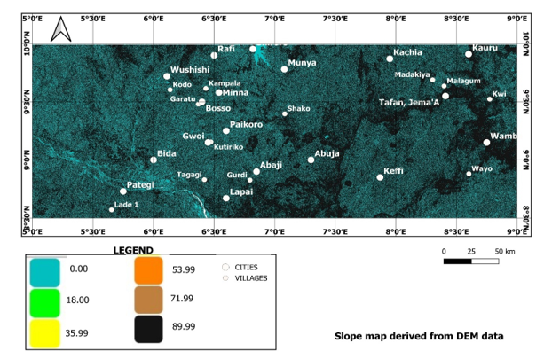
Figure 3: Slope map derived from DEM illustrating steep gradients along major faults and fracture zones (created using the free and open source QGIS software)
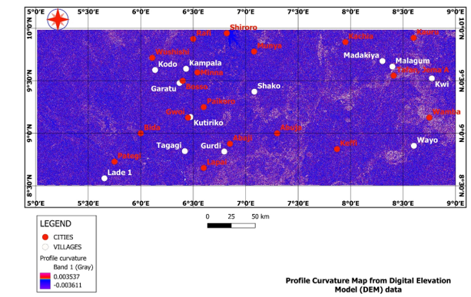
Figure 4: Curvature map highlighting convex and concave topographic features indicative of ridges, valleys, and lithological boundaries (created using the free and open source QGIS software)
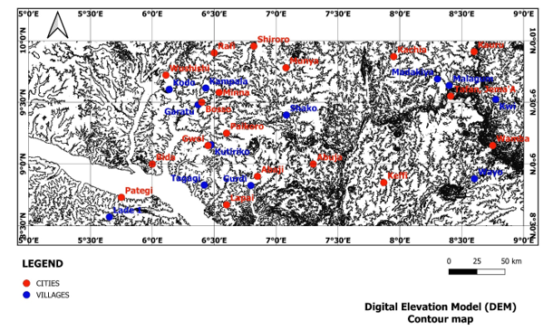
Figure 5: Digital Elevation Model (DEM) of the study area showing major structural trends (created using the free and open source QGIS software)
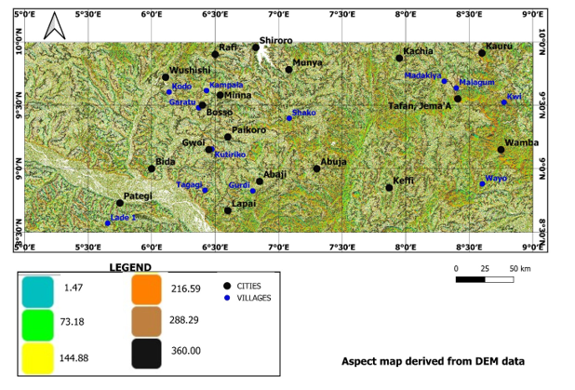
Figure 6: Aspect map derived from DEM highlighting directions of the slope (created using the free and open source QGIS software)
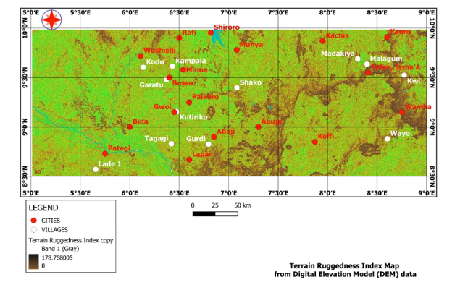
Figure 7: Terrain ruggedness Index (TRI) derived from DEM quantifying terrain complexity and potential zones of structural disruption (created using the QGIS software)
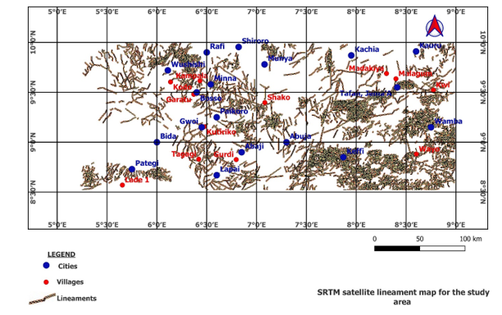
Figure 8: Lineament map derived from DEM showing dominant NE–SW and NW–SE trends. (created using the ArcGIS and QGIS software)

4.2 Radiometric Alteration Mapping
The processed radiometric datasets revealed distinct spatial variations across the study area corroborating the structural observations from the DEM data analysis. The Total count (TC) map (Figure 9) reflects the cumulative gamma emissions from the decay of naturally occurring radioactive elements, primarily potassium (K), Thorium (Th), and Uranium (U) in rocks and soils within the study region, expressed in counts per second (cps), which are sensitive indicators of lithological variation and hydrothermal alteration. The values range from approximately 6.206 to 35.639 cps, with low counts depicted in blue and green shades, and high counts represented by yellow, orange, red, and pink colours. Elevated total gamma count values are associated with felsic lithologies, intrusive bodies, or potentially with hydrothermally altered zones enriched in potassium-bearing minerals such as sericite, biotite, and K-feldspar. These minerals are common products of potassic alteration, which is often spatially and genetically related to gold mineralization in orogenic and intrusion-related systems.
The high gamma anomalies (orange to pink zones: >23 cps) observed in the central and eastern parts of the study area, particularly around Wamba, Kachia, and parts of Paikoro and Wushishi, are interpreted as potential hydrothermal alteration zones. These regions are likely areas of hydrothermal alteration or pegmatitic intrusions that have undergone potassium enrichment through fluid- rock interaction as also visible in the potassium concentration map (Figure 10), making them significant targets for further gold prospectivity investigation. From Figure 10, potassium (K) intensity was notably high in the northeastern and central portions of the map, correlating with zones of felsic intrusives and pegmatitic bodies. These anomalies align with regions where artisanal gold mining activities have been recorded as documented by Ayuba and Abu (2024), suggesting a genetic relationship between potassic alteration and mineralization as stated by Musa et al., (2022).
Conversely, areas with low total count values (blue to green zones: <13 cps), corresponds to mafic, fresh basalts or less altered basement rocks, which are generally less favourable for gold mineralization. However, these zones may still play a structural or lithological role as footwalls or barriers controlling fluid pathways in the region.
In the K/Th map (Figure 11), the values range from –0.039 to 0.346 %/ppm, with low ratios (shown in blue and green shades) reflecting relatively unaltered or thorium-rich zones. Higher ratios (depicted in yellow, red, and pink colours) suggest potassium-enriched alteration zones. The highest K/Th anomalies, represented in pink (values > 0.205 %/ppm), are observed primarily in the southeastern and northeastern parts of the study area, including regions around Wamba, Wayo, Keffi, Kachia, Wushishi, Minna, Abaji and Munya. These zones are interpreted as potential hydrothermal alteration fronts, possibly linked to gold mineralization, given their radiometric signature and alignment with regional structures. Moderate K/Th anomalies are also visible around Paikoro, Madakiya, Malagum, and Gurdi, suggesting transitional alteration halos. In contrast, low-ratio zones in blue and green, indicate areas dominated by resistant thorium-bearing minerals, which are less likely to host gold-bearing alteration zones.
In Figure 12, the Thorium-to-Potassium (Th/K) ratio map (the inverse of K/Th map), different colour ranges represent varying Th/K ratios. High values (depicted in pink, purple, and red hues) around Bida, Tagagi, and western Pategi, suggest thorium enrichment as thorium is immobile, which are typically the result of intense alteration processes such as silicification or argillic alteration. These zones may indicate the presence of mineralizing fluids or past hydrothermal activity. Areas with low Th/K ratios, can be observed around the regions of Shako, Paikoro, Kachia, Kauru, Wamba, and parts of the central and southeastern sectors.

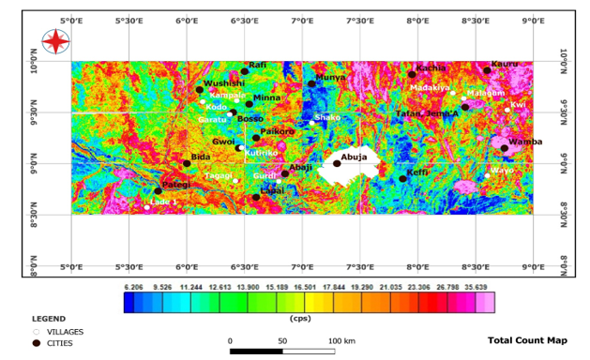
Figure 9: The Total Count map for the study area (created using the Oasis Montaj and the free and open source QGIS softwares)
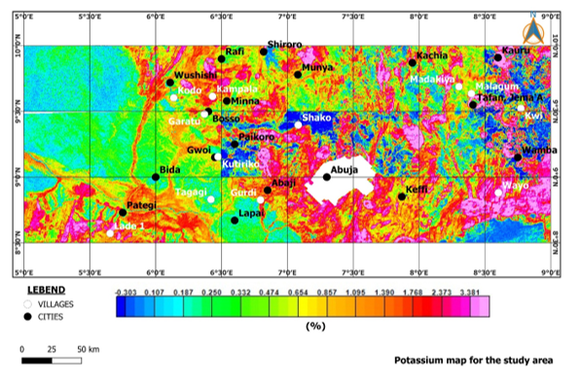
Figure 10: Potassium (K) concentration map showing potassium enrichment around granitic intrusions and altered rock units (created using the free and open source QGIS software)
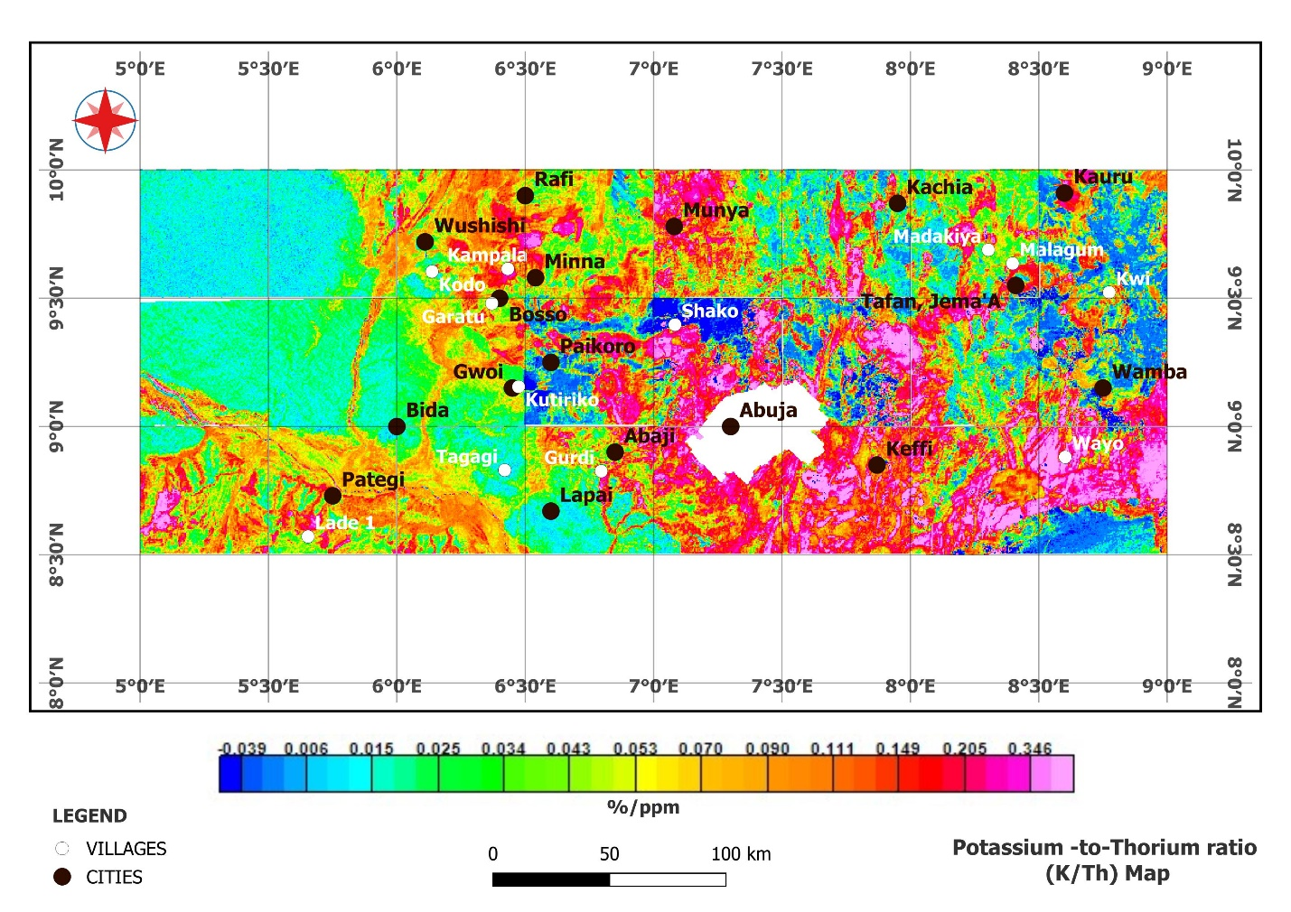
Figure 11: The Potassium-to Thorium ratio (K/Th) map for the study area (created using the Oasis Montaj and the free and open source QGIS softwares)

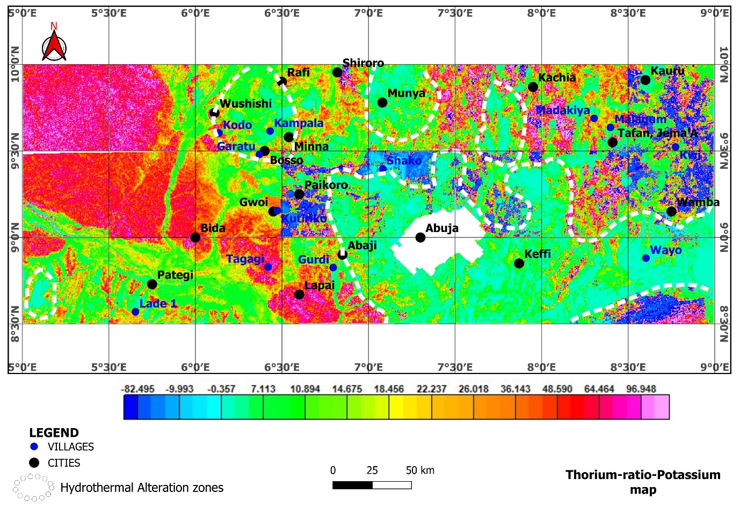Figure 12: Th/K ratio map identifying hydrothermally altered zones along shear and fracture systems (created using the Oasis Montaj and the free and open source QGIS softwares)
These zones are structurally complex areas and aligns well with regions of high K/Th ratio as visible in Figure 11, hence, key targets for further exploration. The delineated hydrothermal alteration zones outlined with dashed white boundaries correlates low Th/K signatures and areas favourable for gold mineralization.
The F-parameter map (Figure 13) further refined the identification of alteration zones by combining potassium and thorium signals, delineating areas with strong geochemical contrasts. The F-parameter map, computed as a function of the concentrations of potassium (K), thorium (Th), and uranium (U), serves as a diagnostic indicator of hydrothermal alteration, particularly in terrains affected by potassic enrichment or metasomatic processes associated with gold mineralization. The mapped values range from –0.098 to 1.160, with the colour spectrum extending from blue (low values) through green and yellow to red and pink (high values). Regions characterized by high F-parameter values (greater than 0.3), indicated by orange to pink hues, are interpreted as zones of enhanced radioelement concentration, especially potassium, which is typically mobilized and concentrated in potassic alteration zones. This alteration is a product of hydrothermal fluid activity, and it plays a critical role in the emplacement of gold-bearing minerals.
Notably, high F-parameter anomalies are concentrated in the eastern and southeastern parts of the study area, particularly around Munya, Wamba, Kachia, Madakiya, Malagum, and Wayo. These zones are therefore considered highly prospective for gold mineralization. In contrast, areas with low F-parameter values (less than 0.1), shown in blue and green colours, dominate the western portion of the study area, including locations such as Pategi, Tagagi, and Bida. These low-intensity zones are indicative of relatively unaltered or weakly altered basement rocks with limited hydrothermal overprint, and are therefore considered less prospective for gold mineralization.
The K-Deviation map (Figure 14) represents the spatial variability of potassium concentration anomalies across the study area. K-deviation specifically highlights how much potassium concentration at each point deviates from the regional background average, and areas of high deviation typically indicate zones of potassic enrichment, often linked to hydrothermal alteration processes that are commonly associated with gold mineralization.
The colour gradient on the map ranges from deep blue (indicating the lowest deviation values around –1.519) through green and yellow (representing moderate deviations), to bright red and pink (showing the highest deviation values up to 3.595). Zones with high K-deviation, particularly those marked in pink, red, and orange, suggest significant potassic alteration and may reflect areas where hydrothermal processes have affected the bedrock. These include notable locations such as Wushishi, Kampala, Minna, Abaji, Gurdi, Wayo, and Keffi, which stand out as areas with potentially favourable conditions for gold mineralization. Conversely, low-deviation zones shown in blue to green, like those around Kutiriko, Bida, Lapai, and Gwoi, may indicate limited alteration or background geochemical conditions less favourable for gold deposition.

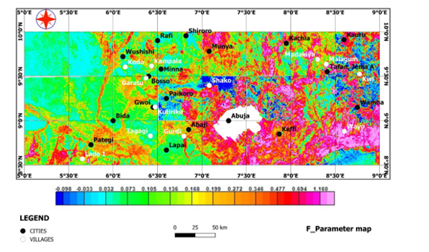
Figure 13: F-parameter map integrating multi-channel radiometric data (K, Th, and U) exhibit pronounced high-intensity zones in the central, northeastern and southeastern portions of the study area (created using the Oasis Montaj and the free and open source QGIS softwares).
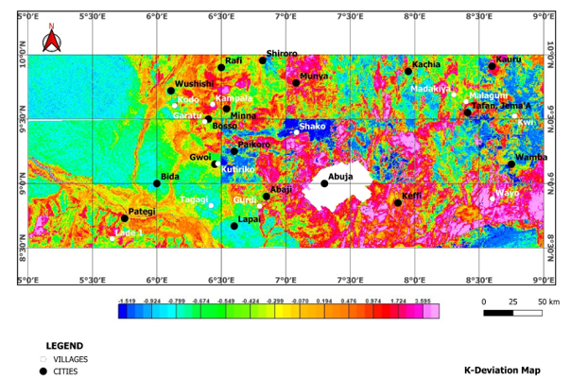
Figure 14: K-deviation map representing the spatial variability of potassium concentration nomalies across the study area (created using the Oasis Montaj and the free and open source QGIS softwares)
The Potassium Ternary Map (Figure 15) combines the concentration of Potassium (K), the K/Th (Potassium-to-Thorium) ratio, and the K/U (Potassium-to-Uranium) ratio to highlight hydrothermal alteration zones across the study area, which are potentially favourable for gold mineralization. The colour composite in ternary triangle, showcases red colour which signifies areas rich in potassium, green regions with elevated K/Th ratios (indicating potassium enrichment possibly due to hydrothermal activity), and blue regions which reflects high K/U ratios (suggestive of potassium mobilization relative to uranium). In the map, hydrothermal alteration zones are represented by dashed white polygons and are distributed across multiple locations including Paikoro, Lapai, Wushishi, Rafi, Munya, Madakiya, Wamba, and Keffi. These zones show a distinct geochemical footprint associated with potassic alteration, which is often linked to gold mineralizing systems, especially in structurally controlled environments such as shears and faults. The map integrates the behaviour of radioactive elements influenced by alteration processes. Areas with strong red and green colorations suggest hydrothermal enrichment of potassium or depletion of thorium and uranium due to leaching or fluid interaction. These processes are characteristic of hydrothermal systems, which commonly transport and deposit gold.
The Ternary map (Figure 16) integrates three key radiometric parameters, Thorium-to-Potassium ratio (Th/K), F-parameter, and Potassium deviation (K_{d}), and provides a composite visualization for identifying hydrothermal alteration zones associated with gold mineralization. The map delineates hydrothermal alteration zones through the combination of radiometric signatures, which are often influenced by mineralizing fluids. In the map, different colours represent varying combinations of the three parameters. Red areas indicate high Th/K ratios, which may reflect thorium enrichment or potassium depletion due to alteration. Green areas correspond to high F-parameter values, which are sensitive indicators of compositional changes typically caused by hydrothermal processes. Blue regions represent high potassium deviation (K_{d}), which may suggest zones of potassic alteration, a known feature in many gold-bearing systems. The overlay of hydrothermal alteration zones using dashed black outlines highlights specific regions where the three indicators converge to suggest significant alteration. These areas include parts of Munya, Wushishi, Paikoro, Kutiriko, Kauru, and Shako, among others. These zones coincide with previously identified structural trends and geological anomalies favourable for gold mineralization.

4.3 Integrated Structural–Radiometric Output
The normalized and weighted integration of radiometric and topographic datasets produced a composite structural–alteration map superimposed on the geology map for the study area (Figure 17). The integration highlighted several high-priority target zones, predominantly clustered in the central and northeastern parts of the study area, and as documented by Lawrence et al., 2025. Comparison with known artisanal mining sites around Minna, and those captured by Ayuba and Abu 2024 at the Abaji axis, more than 70% of these sites fall within or near high-potential zones identified in the integrated map (Figure 17). These high-potential zones are characterized by the convergence of high lineament density (Figure 7), high slope gradients as shown in Figure 3, convex curvature observed in Figure 4, elevated K/Th ratios seen in Figure 10, and significant F-parameter anomalies (Figure 12). Hence, the areas with high lineament density correspond to zones of elevated radiometric anomalies and steep slopes. Such areas are interpreted as structurally prepared and geochemically favourable sites for hydrothermal alteration and possible gold mineralization, validating the effectiveness of the integrated approach.
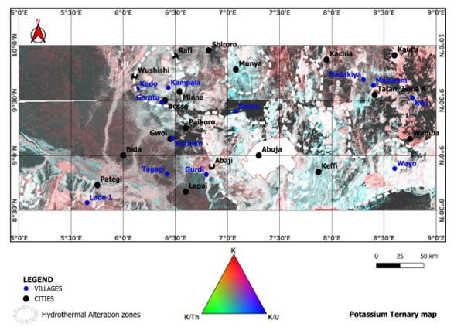
Figure 15: The Potassium Ternary map which combines the concentration of Potassium (K), the K/Th (Potassium-to-Thorium) ratio, and the K/U (Potassium-to-Uranium) ratio to highlight hydrothermal alteration zones across the study area (created using the Oasis Montaj and the free and open source QGIS softwares)
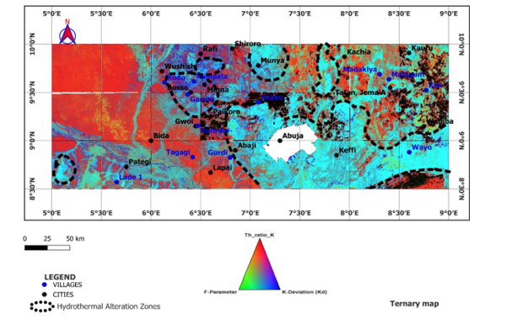
Figure 16: The Ternary map for the study area which integrates three key radiometric parameters, Thorium-to-Potassium ratio (Th/K), F-parameter, and Potassium deviation (K_{d}), and provides a composite visualization for identifying hydrothermal alteration zones (outlined with black dash lines) (created using the Oasis Montaj and the free and open source QGIS softwares)

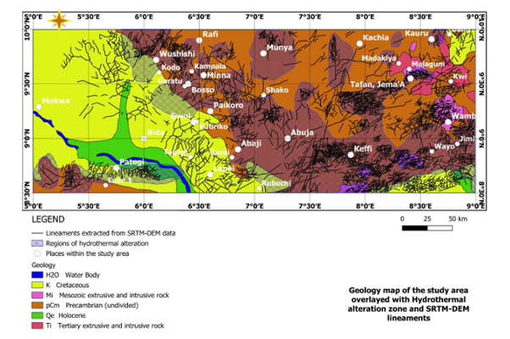
Figure 17: Geology map overlayed with hydrothermal alteration zone and SRTM-DEM lineaments for identification of mineralization target regions (created using the Oasis Montaj, ArcGIS and the free and open source QGIS softwares)
The NE–SW trends, prominent in the region, align with regional tectonic fabrics and are commonly associated with gold-bearing quartz veins in similar geological settings. The results align with recent global trends emphasizing multi-criteria integration in mineral exploration, where topographic, structural, and radiometric proxies are merged to improve target definition accuracy as documented in Karimpouli & Hezarkhani, (2021), and Abubakar et al., (2024).

5. Conclusion
This study demonstrates the effectiveness of integrating topographic and radiometric datasets for enhancing structural mapping in gold exploration within the basement terrain of North-Central Nigeria. Through the analysis of Shuttle Radar Topography Mission (SRTM) derivatives such as slope and curvature, coupled with radiometric data including potassium, thorium, and uranium distributions, the research successfully delineated key structural features and hydrothermal alteration zones. The combined use of lineament mapping, density analysis, and radiometric ratios (K/Th and F-parameter) highlighted zones of structural complexity, which are strongly correlated with known gold occurrences in the study area.
The results revealed that the dominant NE-SW and NW-SE lineament orientations are not only consistent with the regional tectonic framework of the Nigerian basement complex but also play a crucial role in localizing gold mineralization. These orientations correspond with shear zones and fracture systems that act as conduits for hydrothermal fluids, thereby controlling the emplacement of mineral deposits. The radiometric anomalies further emphasized areas of potassic enrichment and hydrothermal alteration, validating their association with gold-bearing zones. By combining topographic and radiometric data, this study provides a cost-effective and efficient approach to identifying priority exploration targets. The findings confirm that integrated geospatial analysis significantly improve the accuracy of structural interpretations, reduce exploration risks, and guide follow-up geophysical and geochemical surveys.
DISCLAIMER (ARTIFICIAL INTELLIGENCE)
Authors hereby declare that NO generative AI technologies such as Large Language Models (ChatGPT, COPILOT, etc) and text-to-image generators have been used during writing or editing of this manuscript.
COMPETING INTERESTS
Authors have declared that they have no known competing financial interests OR non-financial interests, or personal relationships that could have appeared to influence the work reported in this paper.

REFERENCES
Abdelrady, M., Moniem, M. A., Alarfi, S. S., Abdelrady, A., Othman, A., Mohammed M. A. A., & Mohamed, A., (2023). Geophysical investigation for the identification of subsurface features influencing mineralization zones. Journal of King Saud University- Science, 35(7), https://doi.org/10.1016/j.jksus.2023.102809
Abubakar, M. B., Ibrahim, A., & Bello, M. S. (2024). Remote sensing and geophysical integration for mineral exploration in crystalline terrains of West Africa. Ore Geology Reviews, 163, 105612. https://doi.org/10.1016/j.oregeorev.2023.105612
Adekeye, J. I., Lawal, B. A., & Oladipo, M. O. (2023). Petrology and geochemistry of basement rocks in parts of north-central Nigeria. Nigerian Journal of Geosciences, 59(2), 45–61.
Ahmed, A. L., Abubakar, W. M. and Abubakar, A. (2021). Measurement of Radioelements (U, Th and K) concentration using ground radiometric and statistical studies at Gaya North-Western Nigeria. International Journal of Research and Scientific Innovation (IJRSI), VIII(IX), ISSN 2321-2705
Ahmed, S. A., Nuhu, M. W., Hadiza, L. M., Mohammed, A. M., & Apeh, A. G., (2020). Reconnaissance geochemical and geophysical exploration for gold at Iri gold field, North central Nigeria. Scientia Bruneiana, 18(2), pages 19-31.
Akinlalu, A. A. (2023). Radiometric mapping for the identification of hydrothermally altered zones related to gold mineralization in the Ife–Ilesa Schist Belt, Southwestern Nigeria. Indonesian Journal of Earth Sciences / Indonesian Journal of Earth Sciences Knowledge & Applications, 6(3), 153–164. https://doi.org/10.52562/injoes.2023.519
Akinluyi, F. O., Olorunfemi, M. O., & Bayowa, O. (2021). Application of remote sensing, GIS and geophysical techniques for groundwater potential development in the crystalline basement complex of Ondo State, Southwestern Nigeria. Sustainable Water Resources Management, 7(4), 1–15. https://doi.org/10.1007/s40899-020-00486-5
Akintola, A. I., Olorunfemi, M. O., & Ojo, J. S. (2020). Structural trends and mineralization patterns in north-central Nigeria: Insights from geophysical data. Journal of African Earth Sciences, 167, 103888. https://doi.org/10.1016/j.jafrearsci.2020.103888
Anakwuba, E. K., Chinwuko, A. I., Onwuemesi, A. G., & Oha, I. A. (2014). Interpretation of aeromagnetic data over Maiduguri and environs for structural and mineral prospectivity analysis. International Journalof Science and Technology, 3(1), 67–79.
Andarawus, S. A., Alabi, A. A., & Adetona, A. A. (2023). Application of remote sensing and aerogeophysical data in delineating hydrothermal alteration zones for mineral exploration in basement terrains of northwestern Nigeria. Natural Resources Research, 32(3), 1583–1602. https://doi.org/10.1007/s11053-023-10145-4
Arogundade A. B., Awoyemi, M.O., Hammed, O.S. Falade, S.C., & Ajama O. D. (2022). Structural Investigation of Zungeru-Kalangai Fault Zone, Nigeria using Aeromagnetic and Remote Sensing Data. Heliyon, 8(3), e09055. https://doi.org/10.1016/j.heliyon.2022.e09055
Ayuba Bwamba Jonah, & Abu Mallam (2024). Integrated interpretation of Aeromagnetic and Aero-radiometric data to delineate structures and hydrothermal Alteration zones associated with gold Mineralization in parts of North-Central Nigeria. Asian Journal of Geological Research (AJOGER) 7(2): 136-153. https://journalajoger.com/index.php/AJOGER/article/view/161.
Baratoux, D., Fall, M., Meslin, P.-Y., Jessell, M. W., Vanderhaeghe, O., Moyen, J. F., Ndiaye, P. M., Boamah, K., Baratoux, L., & André-Mayer, A. S. (2021). The impact of measurement scale on the univariate statistics of K, Th, and U in the Earth crust. Earth and Space Science, 8, e2021EA001786. https://doi.org/10.1029/2021EA001786
Billings, S. D., Taylor, P. N., & Green, A. A. (2003). The effects of filtering and smoothing on airborne radiometric data. Exploration Geophysics, 34(1), 13–20. https://doi.org/10.1071/EG03013
Bolarinwa, A. T., Oyebanjo, O. A., & Ojo, A. M. (2021). Structural framework and geochemical characteristics of mineralized zones in Nigeria. Minerals, 11(12), 1396. https://doi.org/10.3390/min11121396
Chiozzi, P., Pasquale, V., & Verdoya, M., (2007). Radiometric survey for exploration of hydrothermal alteration in a volcanic area. Journal of Geochemical Exploration, 93(1), pp. 13-20, ISSN 0375-6742, https://doi.org/10.1016/j.gexplo.2006.07.002
Daniel, E., Jimoh, R., & Lawal, K. (2019). Delineation of Gold Mineral Potential Zone Using High Resolution Aeromagnetic Data Over Part of Kano State, Nigeria. 10.35248/2381-8719.464
de Quadros, T. F., Koppe, J. C., Strieder, A. J., & Costa, J. F. C. (2003). Gamma-ray data processing and integration for lode-Au deposits exploration. Natural Resources Research, 12, 57-65.
Ebele, J. E., Ofoegbu, C. O. & Nur, A. (2021). Interpretation of high-resolution aeromagnetic and radiometric data for delineation of mineral potential zones over Abuja and Environs, North-Central Nigeria. Arabian Journal of Geosciences, 14(1947) https://doi.org/10.1007/s12517-021-07915-5. Corpus ID: 237412613
Egbelehulu, P., & Abu, M. (2024). Integration of ground magnetic method and whole-rock analysis for solid mineral prospecting in a part of Abuja, Nigeria. Pakistan Journal of Geology (PJG), 8(1), 67-73. DOI: http://doi.org/10.26480/pjg.01.2024.67.73
Ekwok, S. E., George, A. M., Omori, A. A., Abdelrahman, K., Ugar, S. I., & others. (2024). Unveiling the mineral resources and structural patterns in the Middle Benue Trough: a comprehensive exploration using airborne magnetic and radiometric data. Geocarto International. https://doi.org/10.1080/10106049.2024.2339290
Eldosouky, A. M., Eleraki, M., Mansour, A., Saada, S. A., & Zamzam, S. (2024). Geological controls of mineralization occurrences in the Egyptian Eastern Desert using advanced integration of remote sensing and magnetic data. Scientific Reports, 14(1), Article 16700. https://doi.org/10.1038/s41598-024-66924-y
Hronsky, J. M. A., & Groves, D. I. (2008). Science of targeting: Definition, strategies, targeting and performance measurement. Australian Journal of Earth Sciences, 55(1), 3–12.
Ilugbo, S. O., Edunjobi, H. O., Adewoye, O. E., Alabi, T. O., Aladeboyeje, A. I., Olutomilola, O. O., & Owolabi, D. T. (2020). Structural Analysis Using Integrated Aeromagnetic Data and Landsat Imagery in a Basement Complex Terrain, Southwestern Nigeria. Asian Journal of Geological Research, 3(2), 78-94.
International Atomic Energy Agency (IAEA). (2003). Guidelines for radioelement mapping using gamma ray spectrometry data (IAEA-TECDOC-1363). IAEA, Vienna.
Karimpouli, S., & Hezarkhani, A. (2021). An integrated approach for mineral prospectivity mapping using remote sensing and geophysical data. Natural Resources Research, 30(4), 2769–2786. https://doi.org/10.1007/s11053-021-09871-y
Lawrence, J. O., Abu, M., Nasir, N. A., & Gajere, J. N. (2025). Integrated Gravity and Magnetic Derivative Modelling for Structural Control of Gold Mineralization in North-Central Nigeria. Asian Journal of Geological Research, 8(3), 376-391, 2025; Article no. AJOGER.142813. DOI: https://doi.org/10.9734/ajoger/2025/v8i3205
Lorenz, S., Kidera, A., & Henkel, H. (2018). Integration of airborne geophysical datasets for geological mapping in complex terrains. Journal of Applied Geophysics, 150, 254–266. https://doi.org/10.1016/j.jappgeo.2018.01.014
Mamouch, Y., Attou, A., Miftah, A., Ouchchen, M., Dadi, B., Achkouch, L., Et-tayea, Y., Allaoui, A., Boualoul, M., Randazzo, G., Lanza, S., & Muzirafuti, A. (2022). Mapping of Hydrothermal Alteration Zones in the Kelâat M’Gouna Region Using Airborne Gamma-Ray Spectrometry and Remote Sensing Data: Mining Implications (Eastern Anti-Atlas, Morocco). Applied Sciences, 12(3), 957. https://doi.org/10.3390/app12030957
Mustapha S., Suleman S., Iliyasu S. R., Udensi E. E., Sanusi Y. A., Dahuwa D. and Abba L (2020) Interpretation of Aeromagnetic Data and Landsat Imagery over the Nigerian Younger Granites in and around Kafanchan Area, North-Central Nigeria. FUDMA Journal of Sciences, 4(4), pp 323 – 333. DOI: https://doi.org/10.33003/fjs-2020-0404- 489
NASA Shuttle Radar Topography Mission (SRTM)(2013). Shuttle Radar Topography Mission (SRTM) Global. Distributed by OpenTopography. https://doi.org/10.5069/G9445JDF. Accessed: 2024-06-05
Nigeria Geological Survey Agency (NGSA) (2024). Aeromagnetic data sheets.
Obaje, N. G. (2009). Geology and mineral resources of Nigeria. Springer. https://doi.org/10.1007/978-3-540-92685-6
Ogunmola, J. K., Gajere, E. N., Ayolabi, E. A., Olobaniyi, S. B., Jeb, D. N., & Agene, I. J. (2015). Structural study of Wamba and environs, North-Central Nigeria using aeromagnetic data and NigeriaSat-X image. Journal of African Earth Sciences, 111(1), 307–321. https://doi.org/10.1016/j.jafrearsci.2015.07.028
Ohwo, M. U., & Fadeyi, S. S. (2024). Integration of ASTER and airborne radiometric data in the exploration for hydrothermal alteration zones associated with mineral deposits in Igarra Schist Belt, Nigeria. International Journal of Earth Sciences Knowledge & Applications, 6(2), 220-228. https://doi.org/10.52684/ijeska.2024.1553919
Olatubosun, E. O., Wasiu, O. O., Abel, I. T., Zephaniah, A. F., & Fagbemigun, T. S. (2022). Aeromagnetic Interpretation of Basement Structures and Geometry in Parts of the Middle Benue Trough, North Central, Nigeria. Advances in Geological and Geotechnical Engineering Research, 4(4), 22-40. https://doi.org/10.30564/agger.v4i4.5128
Onyejiuwaka, I. S., & Nkiru, N. C. (2020). Application of Airborne Radiometric Method in Geologic Mapping of Malufashi Area and Environs, Northwestern Nigeria. International Journal of Advanced Geosciences, 8(2), 179-185. https://doi.org/10.14419/ijag.v8i2.31071
Pires, A. C. B. (1995). Identificação geofísica de áreas de alteração hidrotermal, Crixás- Guarinos, Goiás. Brazilian Journal of Geology, 25(1), 61-68.
Rahaman, M. A. (1988). Recent advances in the study of the Basement Complex of Nigeria. In P. O. Oluyide et al. (Eds.), Precambrian geology of Nigeria (pp. 11–41). Geological Survey of Nigeria.
Richter, N. (2024). Advances in multisource geodata harmonization: Projection, resampling, and filtering workflows for geological applications. Remote Sensing, 16(2), 223. https://doi.org/10.3390/rs16020223
Salako, K.A., Adetona, A. A., Rafiu, A. A., Augie, A. I., Jimoh, M. O., Alkali, A., Muriana, R. A. Lawrence, J. O., (2024). Integrated geophysical Investigation for gold mineralization potential over southern parts of Kebbi state and its Environs, northwestern Nigeria. Heliyon 10 (2024) e34093 https://doi.org/10.1016/j.heliyon.2024.e34093.
Saleh, A., Udensi, E. E., Salako, K. A., & Unuevho, C. I. (2022). Delineation of airborne magnetic and radiometric structures associated with gold mineralization of Minna and its environs, north-central Nigeria. Earth Sciences Pakistan (ESP), 6(2), 54–59. https://doi.org/10.26480/esp.02.2022.54.59
Sanusi, S. O., & Amigun, J. O. (2020). Structural and hydrothermal alteration mapping related to orogenic gold mineralization in part of Kushaka schist belt, North‑central Nigeria, using airborne magnetic and gamma‑ray spectrometry data. Springer Nature (SN) Applied Sciences, 2:1591 | https://doi.org/10.1007/s42452-020-03435-1
Saunders D. F., Terry, S. A. & Thompson, C. K. (1987). Test of national uranium resource evaluation gamma-ray spectral data in petroleum reconnaissance. Geophysics 52(11): 1547–1556
Usman, A. A., Okeke, O. C., & Gana, I. A. (2023). Lineament mapping and structural analysis using remote sensing in north-central Nigeria. FUGUS International Journal of Scientific and Geological Studies, 11(1), 66–78.

Yakubu, M., Wulo, I. B., Abdullahi, J., Gazali, A. K., Lawan, Z. A., & Kamale, H. I. (2022). Geomorphometric and terrain analysis of the Nigerian section of the Chad Basin (Bornu Basin), Northeastern Nigeria. Journal of Geography and Geology, 11(4), 1-15. https://doi.org/10.5539/jgg.v11n4p1

