Rice Cultivation Practices at Khweng Village, Meghalaya, India

Absract
This study undertakes an assessment on rice cultivation practices in Khweng village, situated within the Umroi block of Ri Bhoi district, Meghalaya. It examines the rice cultivation practices with the evolving socio-economic pressures and environmental challenges, approach through field surveys, interviews and secondary sources, the research provides comprehensive insights into planting methods, input utilization, yield performance and marketing practices among rice cultivators in the village. Results reveal a dominance of indigenous rice varieties, manual labor-intensive methods, limited mechanization, and a strong dependence on rain-fed irrigation. Despite cultural attachment to traditional practices, farmers face persistent issues such as stagnant yields, price volatility, poor infrastructure, and limited institutional support. The study underscores the need for integrative strategies combining local knowledge with modern agricultural techniques, improved market linkages, and policy interventions tailored to the agro-ecological and socio-cultural realities of the region. Recommendations include promoting sustainable irrigation, enhancing input efficiency, expanding extension services, and fostering cooperative marketing frameworks to ensure the long-term viability of rice cultivation in the area.
Keywords: Rice cultivation, Khweng village, indigenous varieties, agricultural challenges, market access, mechanization, irrigation, rural livelihoods

  - Introduction
  - Background of Rice Cultivation: Global to Local Context
Rice (Oryza sativa) is one of the most vital cereal crops globally, serving as the primary food source for billions of the world’s populations. Its importance is especially pronounced in Asia, which accounts for nearly 90% of global rice production and consumption^{1.} Countries such as China, India, Indonesia, and Vietnam dominate both the production and consumption of rice, underscoring its role in ensuring regional food security. The crop is cultivated across different ecosystems, including irrigated lowlands, uplands, and flood-prone areas, making it adaptable to diverse agro-ecological conditions.
Rice is a staple food in India and plays a crucial role in the rural economy. As the world’s second-largest rice producer, the country cultivates the crop under diverse conditions, ranging from rainfed uplands to a simple traditional irrigated lowlands². Major rice-producing states include West Bengal, Punjab, Uttar Pradesh, and Andhra Pradesh, which together contribute significantly to the national output. Both traditional varieties and high-yielding strains are grown, with cultivation practices varying according to regional environments and farming traditions.
The North Eastern Region (NER) of India, known for its rich biodiversity and traditional farming practices, where many farmers still depend extensively on rice cultivation. Farming in the region primarily follows two methods: shifting cultivation (jhum) in the hilly terrains and settled wet rice farming in the valley areas³. While these practices are deeply rooted in indigenous traditions, they are increasingly facing pressure from ecological degradation, climate change and evolving socio-economic conditions.
In Meghalaya, rice serves not only as a staple food crop but also as an integral part of the people’s socio-cultural identity. Both upland and lowland rice cultivation are practiced, relying on age-old methods passed down through generations and adapted to the region’s unique environment. However, challenges such as minimal mechanization, fragmented landholdings, and dependence on rainfall limit overall productivity⁴.
In the village of Khweng, located in the Umroi block of Meghalaya, traditional rice farming remains dominant. Here, farmers depend on seasonal rains, basic hand tools and indigenous seed varieties. Although ecologically suited to local conditions, this system is increasingly under strain due to shortened fallow cycles, declining soil fertility, and growing demographic pressures⁵. These factors collectively reduce yields and raise concerns about the long-term sustainability of rice cultivation in the region.
Across Asia, rice cultivation has historically evolved through adaptations to diverse ecological settings. Adams (1948) highlighted the wide spectrum of rice-farming systems, ranging from irrigated wetland paddies to dry upland cultivation⁶. In Khweng, as in other parts of the North Eastern Region (NER), these traditional methods have endured largely because of their strong cultural significance. Fujisawa (2019) emphasizes that in many rural societies, rice embodies symbolic and ritual value, extending well beyond its nutritional role⁷. In Khweng, farmers continue to grow indigenous varieties, valued for their flavor and ceremonial importance, even though they often yield less than improved strains. This close integration of culture and cultivation suggests that any agricultural intervention must respect and align with traditional knowledge systems and community preferences.
Rice cultivators in India frequently face challenges arising from volatile market conditions. Early studies, such as that by Yagi (1930), identified price volatility and weak infrastructure as major challenges⁸. Today, smallholder farmers still face obstacles in accessing stable markets, due to inadequate storage, poor transport networks, and limited bargaining power. These constraints are pronounced in remote regions like Meghalaya, where farmers struggle to obtain fair prices or scale their operations profitably.
Chakravarti (1970) highlighted the stark disparities in rice production across Indian states⁹. While regions like Punjab have reaped the benefits of the Green Revolution through modern irrigation and high-input farming, areas like the NER have lagged behind due to infrastructural deficits and dependence on traditional methods. The fragmented nature of landholdings and outdated techniques in Meghalaya further limit productivity gains.
The introduction of high-yielding varieties (HYVs) during the Green Revolution significantly boosted rice production in irrigated zones. However, their performance in rainfed and upland areas has been inconsistent. Seetharaman (1981) observed that such varieties often require intensive inputs and controlled environments—conditions rarely met in Meghalaya¹⁰. Furthermore, the environmental consequences of input-heavy farming have prompted concerns about sustainability. Thus, integrating scientific advances with local practices may offer a balanced approach to improving productivity while maintaining ecological and cultural integrity.
  - Significance of Rice in Agriculture
Rice plays a pivotal role in the agrarian economy of India and Asia at large. It sustains the livelihoods of millions of smallholder farmers and contributes significantly to national GDP in many countries. As a food crop, rice supplies over 20% of the global dietary energy intake¹¹. In India, where agriculture remains the backbone of rural livelihoods, rice is crucial not only for food security but also for employment generation and economic stability¹².
Beyond its economic importance, rice holds deep cultural and social significance. In North East India, including Meghalaya, rice is embedded in festivals, rituals, and social traditions. The continued cultivation of indigenous landraces reflects both a respect for biodiversity and a commitment to preserving cultural heritage. These traditional varieties are often well-suited to the local agro-ecological conditions, offering resilience in the face of climatic variability.
  - Recent Trends in Rice Cultivation
In recent decades, rice cultivation has undergone significant transformation, shaped by climate change, technological innovation, and sustainability concerns. The adoption of improved techniques like the System of Rice Intensification (SRI) has shown promise in enhancing yield while reducing water and input use¹³. Additionally, the development of climate-resilient varieties such as those tolerant to drought, floods, or salinity addresses the increasing vulnerability of rice farming to erratic weather patterns.
In India, there is a growing trend towards digital agriculture and precision farming. Tools like mobile-based advisory services, drone-based monitoring, and GIS mapping are being employed to optimize inputs and improve productivity^{14,19}. In the North East, which has a natural advantage for organic cultivation, there is rising interest in organic rice farming and integrated land-use systems¹⁵.
Government schemes such as PM-KISAN, input subsidies, and capacity-building programs aim to support rice farmers by improving access to finance, technology, and markets. These interventions are particularly relevant in regions like Meghalaya, where farmers need targeted assistance to transition from subsistence to sustainable, market-oriented farming systems.
  - Objective of the Study
This study aims to provide an in-depth analysis of rice cultivation practices in Khweng village, Umroi block, with a focus on traditional farming methods, associated challenges, and market dynamics. By examining the intersection of indigenous practices and contemporary pressures both environmental and economic the research seeks to contribute to a nuanced understanding of rice production in the region. The findings will inform policy and practice by highlighting strategies that enhance productivity while respecting ecological constraints and cultural traditions.
  - Database
Primary and secondary data will both be used to meet the research objectives.
Primary data will be collected from rice‐growing households in Khweng village via a structured questionnaire. It ensures consistency across interviews and facilitates quantitative analysis of cultivation methods and outputs.
Secondary data will be gathered from population census, agricultural census, statistical reports, government publication, maps and land use
  - Methodology
    - Data Collection
A field survey was conducted in Khweng village during the main cultivation season. The questionnaire was mainly closed‐ended questions. Survey data collection was complemented by direct field which will helps validate the self-reported data and provides qualitative insights.
    - Sample Selection and Size
The study target households engaged in rice cultivation within Khweng village. A preliminary village listing (from local headman) help identify all farming households growing rice. To ensure representativeness, a simple random sampling method was used. There are, 12 main cultivators in Khweng and 150 agricultural labourers out of 551 population from 98 total household, a total of 20 sample was collected representing of the agricultural workforce.
    - Data Analysis
After data collection, responses will be entered into Microsoft Excel for analysis. Simple statistical tools such as averages, percentages, tabulation, and cross-tabulation will be used to summarize and interpret the data.
  - Study Area
This study is conducted in Khweng village, situated within the Umroi Community and Rural Development (C&RD) Block of Ri Bhoi District, Meghalaya, in Northeast India. Meghalaya, one of the eight states of the northeastern region, is bordered by Assam to the north and Bangladesh to the south. Ri Bhoi, located in the northern part of the state, is a predominantly agrarian block with a varied topography that includes low-lying plains and hilly terrain. Within this block, Khweng represents a typical rural settlement characterized by its agricultural orientation.
Figure 1 Location Map
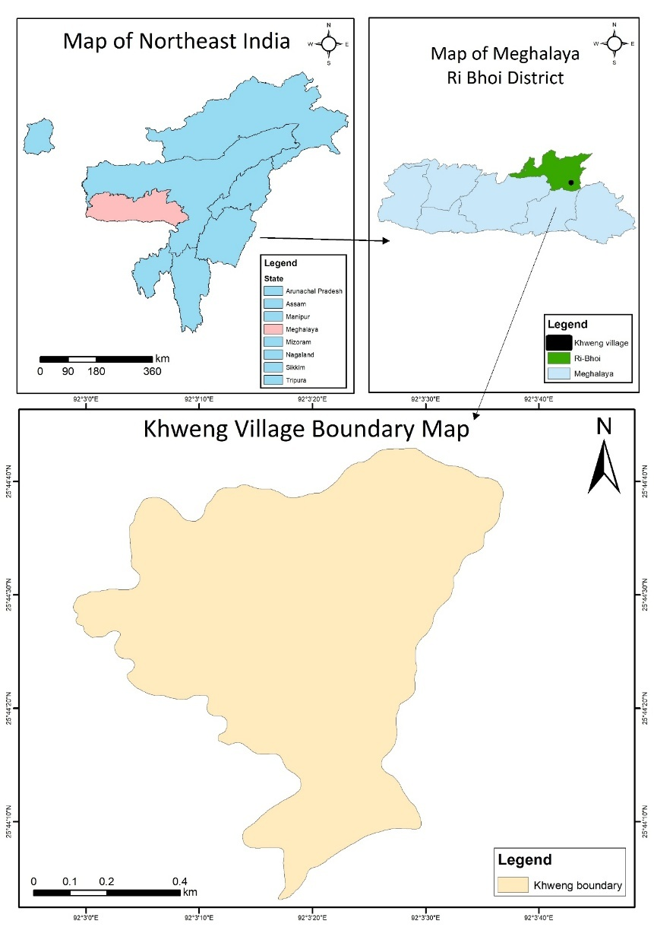
Geographically, Khweng (figure 1) is located approximately between 25°44′0″N to 25°44′52″N latitude and 92°30′0″E to 92°34′0″E longitude, encompassing an estimated area of 204.43 acres. The village's physical environment comprises gently undulating landforms with fertile loamy soils, supported by a subtropical highland climate and abundant rainfall conditions that are highly favorable for paddy cultivation. These agro-climatic factors have sustained rice farming as the principal livelihood activity in the village.
The selection of Khweng as the study area is guided by its relevance as a representative site for examining the interplay between traditional and contemporary rice cultivation practices. Its significance lies in the coexistence of indigenous knowledge systems and evolving agricultural strategies in response to environmental, economic, and institutional factors. Furthermore, the village's relative accessibility and its involvement in regional agricultural development programs make it an appropriate and practical choice for a detailed case study.
Figure 2 Landuse Landcover map
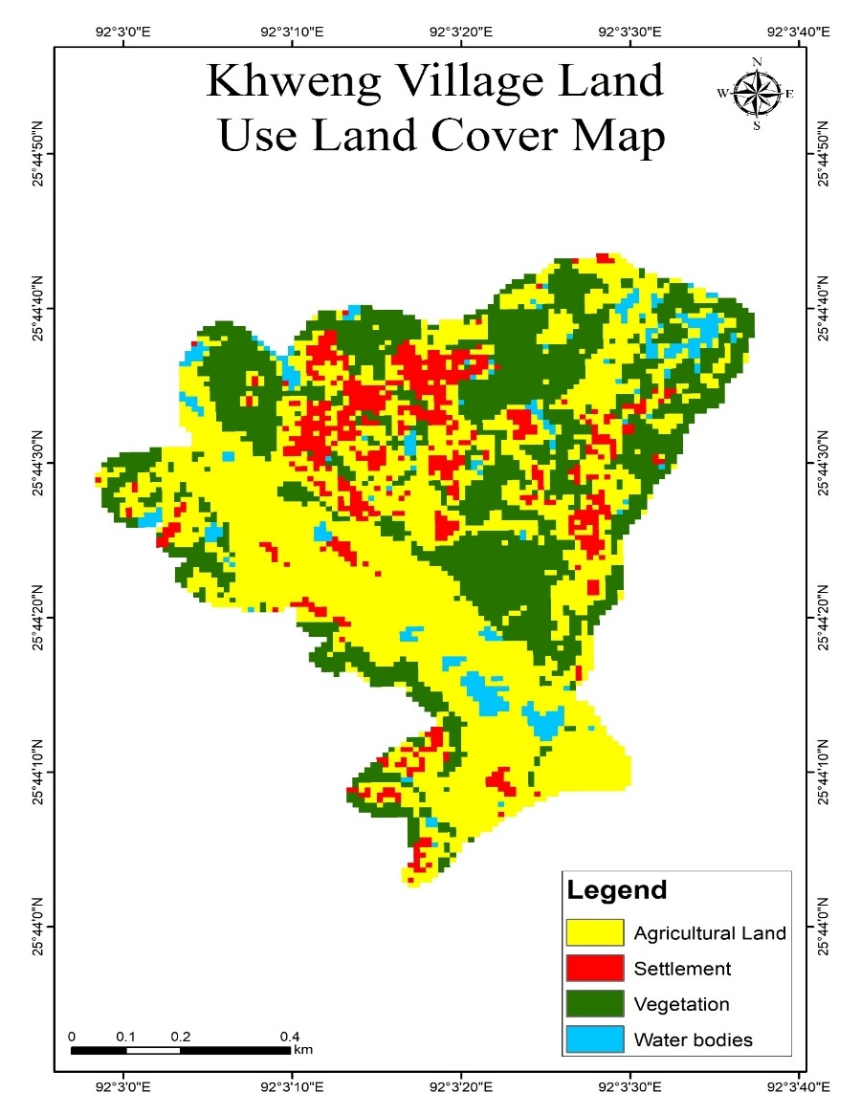

This chapter presents a detailed analysis of rice cultivation methods, input usage, harvesting, marketing strategies, and associated challenges faced by farmers in Khweng village. The findings are based on survey data interpreted from field responses.
Demography
  - Population and literacy
According to the 2011 Census of India (Table 1), the village consists of 98 households, with a total population of 551 individuals, comprising 267 males and 284 females. The data reveals a slightly higher number of females than males, indicating a positive gender ratio that contrasts with the typically male-dominated demographic patterns observed in many parts of rural India. Literacy figures further underscore the village’s progressive social structure, with 340 individuals identified as literate comprising 160 males and 180 females. Conversely, 210 individuals remain illiterate. Remarkably, the number of literate females exceeds that of literate males, suggesting a deviation from traditional gender disparities in educational attainment. The overall literacy rate is calculated to be approximately 61.7 percent, reflecting a moderate level of educational development within the village community.
Table 1 Demography
Household Details
NO of HH | Population |  | Total
NO of HH | Male | Female | Total
98 | 267 | 284 | 551
Literacy
Literate |  | Illiterate
Male | Female | Male | Female
160 | 180 | 107 | 103
Sources: Census of India (2011)
Workforce
Main-worker
Male | Female | Total
108 | 105 | 213
Main Cultivator
Male | Female | Total
9 | 3 | 12
Main Agricultural Labourer
Male | Female | Total
87 | 63 | 150
Sources: Census of India (2011)

  - Workforce
The workforce data (Table 1) indicates that out of the total population, 213 individuals are classified as main workers, including 108 males and 105 females. This near-equal participation rate signifies a substantial involvement of women in the local economy. A disaggregated view of occupational categories reveals that the majority of workers are employed as agricultural labourers, accounting for 150 individuals 87 males and 63 females. In contrast, only 12 individuals (9 males and 3 females) are reported as main cultivators, highlighting a relatively low incidence of land ownership and a reliance on wage-based agricultural employment. The data illustrates a predominantly agrarian economy of 76% (Table 1) which is below the district percentage (80%) of population dependent on agriculture as their livelihood¹⁶ with limited access to landholding, and emphasizes the significant contribution of women not only in literacy but also in productive labour, thereby underscoring their integral role in the socio-economic dynamics of the village.

  - Results and Discussion
    - Rice Variety Preference
85% (n=17) reported cultivating indigenous rice varieties, while only 10% (n=2) grow hybrids, and 5% (n=1) use a combination (Table 1; Fig. 3). Even though there is availability of other hybrid seed people still prefer the indigenous rice.
Table 2 Variety of Rice Grown
Figure 3 Rice variety preferences
Variety of Rice Grown
Indigenous | Hybrid | Both
17 | 2 | 1

Sources: Field Survey

    - Land Preparation:
45% (n=9) of farmers used a simple power tiller, while 55% rely on traditional ploughing (Table 2). Similarly, transplanting is the dominant planting method (85%, n=17), with only 15% practicing direct seeding (Table 3). Land preparation and transplanting are executed manually. One of the major reasons for these labor-intensive practices are due to the constraints of farm size and topography and weed control.
Table 3 Planting Methods
PRIMARY PLANTING METHOD |  |  | PLANTING AND TRANSPLANTING OF SEEDINGS
Transplanting Seedlings | Direct Seeding | Other | By Hand | Using Small Machinery | Other
17 | 3 | 0 | 20 | 0 | 0
Sources: Field Survey
Table 4 Land Preparation and planting
Land Preparation
Manual | Mechanized | Flooded Fields | Dry Land | Other
11 | 9 | 0 | 0 | 0
Sources: Field Survey
    - Irrigation
Rainfall is the principal water source for rice cultivation. Only 50% (n=10) of farmers reported supplementing rainfall with traditional nala-based irrigation (Fig. 4). Traditional stream diversion, however, reflects local ecological knowledge, providing low-cost and low-energy alternatives that contribute to sustainable water governance.
Figure 4 Irrigation

Sources: Field survey
    - Seed Preparation
Seed preparation practices reveal diversity: 45% (n=9) soak seeds before sowing, 5% (n=1) adopt seed coating, and 50% (n=10) use other methods, including sun-drying or indigenous treatments (Table 5). Soaking enhances germination, while indigenous treatments are rooted in local experimentation.
Table 5 Seed Treatment Method
SEED TREATMENT METHOD
SOAKING | COATING | OTHER
9 | 1 | 10
Sources: Field survey

    - Input Use
An overwhelming 90% (n=18) of farmers apply chemical fertilizers, while only 10% (n=2) rely exclusively on organic inputs (Table 6). Such dependence on inorganic fertilizers risks undermining soil ecological balance and long-term sustainability.
Table 6 Inputs
ORGANIC OR CHEMICAL INPUTS
ORGANIC | CHEMICAL | BOTH | NONE
2 |  |  | 18
Sources: Field survey

    - Weed Management
Manual weeding dominates, but 35% (n=7) combine it with herbicides (Table 7)
Table 7 Weed Control
WEED CONTROL
Manual Weeding | Chemical Herbicides | Combined Practices | No Weed Control | Other
16 | 2 |  | 1 | 1
Sources: Field survey
3.1.5. Harvesting Methods
Harvesting remains entirely manual, with 100% of farmers relying on sickles (Table 8). This reflects small plot sizes, fragmented fields.
Yields are modest and relatively stable: 80% (n=16) report 2.6 t/ha, while 5% (n=1) achieved 3.6 t/ha. The remaining 15% experienced no change in yields.
Table 8 Method of Harvesting
METHOD OF HARVESTING
Manual Harvesting | Use Of Sickles | Mechanical Harvesters
18 |  | 2
Sources: Field survey
    - Yields
Yields remain constant for 16 respondents with 2.6 ton/ha, with only one reporting an increase to 3.6 ton/ha.
    - Processing and Sales
Marketing channels remain localized. One-quarter (25%, n=5) of farmers sell rice in local markets, another 25% (n=5) sell directly to consumers, 5% (n=1) supply to traders, while nearly half (45%, n=9) cultivate primarily for household consumption (Table 9).
Table 9 Marketing
SALES OF RICE IN %
Local Markets | Cooperative Societies | Directly To Consumers | Traders | Other
25 | 0 | 25 | 5 | 45
Sources: Field survey

    - Marketing and its Challenges
Table 10 Price Negotiation
PRICE NEGOTIATION
Price Determined by Market Conditions | Price Negotiated with Buyers | Other
9 | 2 | 0
Sources: Field survey
    - Challenges and Constraints in Rice Cultivation:
The agricultural marketing system in Khweng village faces several hurdles (Figure 5) that directly affect farmers’ profitability, decision-making, and long-term sustainability. These challenges include limited market access, price volatility, weak negotiation capacity and external competition from rice producers in other states.
Figure 5 Challenges in Marketing

- Lack of Market Access: Absence of institutional procurement mechanisms leaving farmers in Khweng not integrated with regional rice markets. As a result, farmers are often compelled to sell their produce individually in local markets, where demand remains limited and prices fluctuate. In such settings, middlemen or local aggregators capture a significant share of the value, thereby reducing the net earnings of producers.
- Price Fluctuation and Lack of Negotiating Power: The price of rice in local markets is highly market-driven and varies based on supply volumes, buyer availability and seasonal factors. With urgent cash needs, farmers are often forced to sell even, when prices are at their lowest. This brings Income instability leads to indebtedness and reduced reinvestment in farming. Price swings discourage long-term planning or adoption of high-input rice varieties.
- Competition with other producer from other states: Rice from other states often produced at lower cost using hybrid varieties and mechanized farming is transported into local markets and sold at cheaper rates than locally grown indigenous rice. Impacted the local farmers by outpricing them, consumer preference may shift towards cheaper, high-polish hybrid rice, affecting demand for local varieties.
    - Rice farmers in Khweng village face several interrelated production challenges (Figure 6) that affect yield stability, crop quality and long-term sustainability.
Figure 6 Production Challenges

- Climate change vulnerability Conditions: Climate variability particularly erratic rainfall, untimely monsoons and temperature shifts was one of the significant production constraints, which impacts delays in sowing, incomplete grain filling. Farmers dependent on rainfed systems lack irrigation buffers to mitigate droughts or irregular weather patterns.
- Insect Infestation: Pests and insects, leads to direct crop damage, yield loss and increased reliance on chemical pesticides which increases input costs and environmental risks.
- Water Supply Issues: Rice is a type of crop which requires water at different stages of its growing period, therefore, unreliable access to water, whether from rainfall or traditional irrigation channels, creates stress during key stages of plant growth.
- Crop Failure: A few farmers reported total or near-total crop loss due to a combination climate change phenomenon, pest outbreaks or input shortages. Food insecurity, loss of seasonal income and erosion of resilience.
    - Summary of Findings
Table 11 Summary
Category | Key Observation
Rice Variety | 85% use indigenous varieties
Land Preparation | 45% use mechanized methods
Planting Method | 85% practice transplanting
Irrigation | All use traditional methods
Inputs | 90% rely on chemical fertilizers
Harvesting | 100% manual/sickle use
Yields | 80% report constant yields
Sales | 50% sell directly to consumers
Pricing | 82% accept market-determined prices
Institutional Support | Only 15% received support or training
Marketing/Production Issues | Climate, insects, water, poor transport

Discussion
    - Rice Variety Preferences
The dominance of indigenous rice reflects the traditional knowledge systems, local ecological suitability and seed availability. While hybrids can offer higher yields, farmers still skeptical of their performance under local conditions. This finding aligns with literature highlighting the importance of cultural practices in varietal choice.
    - Land Preparation and Planting
Less mechanization suggests gradual technological adoption, due to the size of the field and terrain using of more advance and heavy machinery is not possible, farmers here simply used power tiller to till the soil. Whereas, most of the farmer still used the simple and manual ploughing using hoe. Transplanting, is the most prevalent method which is a labor-intensive method, but provide better weed control compared to direct seeding. This indicates that despite limited labor availability, the method remains economically viable or culturally preferred.
    - Irrigation:
The reliance on traditional irrigation channels suggests limited infrastructural development in the village. Given that water supply was cited as one of the challenges by the respondents, introducing efficient irrigation systems could significantly benefit yields and resource use.
    - Seed preparation:
While seed treatment is recognized as a good agricultural practice, the diversity and informality of methods indicate inconsistent knowledge or resource access. Training in standardized seed treatment could improve germination rates and early growth.
    - Input Used:
The overwhelming use of chemical inputs suggests an intensification of agriculture, which may be due to climate change or decreasing soil fertility. However, this raise concerns over soil health, input dependency and cost.
    - Weed Management:
Manual weed control also indicates labour intensity and potential productivity losses, due to high cost of labour.
    - Harvesting methods:
Lack of mechanization in harvesting suggests barriers in access to equipment and skilled labour.
    - Yields:
Stagnant yields imply a plateau in productivity, which could be due to soil degradation, climatic factors or limited access to improved technologies.
    - Processing and sales:
The diversity of marketing channels indicates some market integration, but there is a need to increase the range of market other than the local region. Most of the product sold in the local markets and to the trader are processed products.
    - Marketing and its challenges:
The price of the products is mostly market determined prices which reflects weak bargaining power (Table 10). If the farmer cannot negotiate the price in the long run there will be discouragement to continue and practice rice cultivation. Therefore, encouragement of cooperative models and market linkages could help improve price realization.
    - Challenges and Constraints in Rice Cultivation

- Lack of Market Access: Market isolation diminishes the economic incentives for farmers to invest in productivity-enhancing technologies or post-harvest improvements.
- Price Fluctuation and Lack of Negotiating Power: Without mechanisms for price stabilization, smallholders bear the full burden of market risk. Policy interventions are needed to shield farmers from these fluctuations and improve transparency in price-setting.
- Competition from Other States: This inter-state competition illustrates the effects of unequal access to technology, subsidies, and infrastructure. Protecting the uniqueness and quality of local rice through or promoting local consumption through school feeding and government procurement, can help restore market viability for indigenous rice.
    - Production Challenges
Farmers face multiple interlinked constraints that threaten agricultural productivity, climate change-related vulnerabilities viz erratic rainfall, untimely monsoons and temperature fluctuations disrupt and increase production risks. Pest infestations, such as rice stem borers and leaf folders, which cause direct crop damage and yield loss forcing farmers to rely heavily on chemical pesticides. Inconsistent rainfall or poorly maintained traditional irrigation systems hampers plant growth. Together, these factors create a cycle of vulnerability that undermines yield stability.
    - Lack of Skilled Labour for Manual Tilling
Manual tilling using hoes remains widespread, but a shortage of skilled labourers has become a significant issue, most of the younger generation have migrated to nearby city in search of better job and show disinterest in agriculture which reduce the labour on the other hand the cost of experienced skilled labour has increased. Ageing skilled labourers have lower efficiency and increased physical burden. This limits timely cultivation and productivity, especially for smallholders without access to machinery.
    - Primitive Cultivation Methods:
One of the major constraints of rice cultivation in the study area are the continued use of primitive cultivation methods such as manual tilling with hoes, traditional sowing techniques. Moreover, these methods hinder the adoption of modern agronomic practices, making it difficult for farmers to improve yields or scale production beyond subsistence levels.
    - Lack of Institutional Support and Adaptation
There is resistance to change cultivation practices, only few farmers reported receiving any support or training to expose to new modern methods of cultivation while the majority indicated no change in their cultivation practices over time. The lack of support suggests weak institutional reach.
    - Rice Cultivation Calendar in Khweng Village
Rice cultivation in Khweng village adheres to a seasonally structured agricultural calendar that corresponds with the onset and retreat of the southwest monsoon. The cultivation cycle commences in the month of May with land preparation, using simple traditional hoe, including the use simple mechanized implements such as power tillers, followed by levelling the land before sowing in the month of June, primarily through the broadcasting method, wherein seeds are dispersed manually over prepared fields. This practice often coincides with or precedes transplanting, which also takes place in June. Transplanting involves replanting rice seedlings from nurseries into flooded fields, suggesting that both direct-seeded rice and transplanted rice.
Weeding is typically performed in August to eliminate competitive vegetation. The harvesting period, spanning September to November, marks the end of the cultivation cycle. The use of sickles remains predominant for manual harvesting. The spread of harvesting months reflects varietal differences in rice maturity.
SUGGESTIONS AND CONCLUSION
  - Suggestions
Based on the findings from Khweng village: Actionable Recommendations to Improve Rice Cultivation, Marketing, and Farmer Resilience
    - Promote Balanced Varietal Adoption:
Farmers should be motivated to diversify by trying hybrid rice in addition to cultivating traditional indigenous varieties. To support this, participatory varietal trials in collaboration with local agricultural institutions can be introduced to test adaptability, ensure cultural acceptance and build farmer confidence.
    - Improve Access to Mechanization:
Subsidy schemes can be promoted to make agricultural machinery such as tillers which are more affordable and accessible. Establishing village-level equipment rental services would also help smallholders meet seasonal requirements without heavy upfront investment.
    - Develop Sustainable Irrigation Solutions:
Affordable, water-efficient models irrigation should be promoted where they are feasible. Simultaneously, government-supported initiatives to construct and maintain traditional canals will enhance community-level water management systems.
    - Enhance Input Use Efficiency:
Conduct workshops on integrated nutrient management and integrated pest management.
    - Strengthen Market Linkages and Farmer Bargaining Power:
Organizing farmers into cooperatives or producer groups will provide them with collective bargaining strength, enabling bulk marketing and improved price realization. Digital platforms and linkages with government procurement programs can ensure more stable income and reduce market vulnerability.
    - Expand Institutional Outreach and Training:
Agricultural extension services should be made more frequent, relevant and accessible. Partnerships between farmers, NGOs and research organizations can enhance knowledge-sharing, capacity-building, and the introduction of context-specific innovations.
- Conclusion
The study of rice cultivation practices in Khweng village highlights a community firmly rooted in traditional farming systems but constrained by ecological, infrastructural and economic challenges. Although indigenous rice varieties and manual methods continue to dominate, there is also gradual adoption of mechanized practices reflects an openness to change when suitable conditions are present.
However, productivity remains limited due to stagnant yields, insufficient irrigation innovations and a heavy reliance on chemical inputs. Marketing continues to function at the informal level, leaving farmers with limited leverage in price determination. Institutional support is also minimal, with only a few farmers benefiting from formal training or agricultural advisory services.
Achieving sustainable and profitable rice farming in Khweng requires a comprehensive, multi-pronged approach—integrating modern technology, farmer training, climate-resilient practices, and inclusive market systems. Strengthening networks among farmers, government agencies, research institutions, and market actors will play a vital role in unlocking the economic and ecological potential of rice cultivation in Khweng and similar rural communities.
Ethical Statement
The research does not involve any animal subjects or other material that requires ethical approval
Data availability Statement
The manuscript incorporates all datasets produced or examined throughout this research study
Informed Consent Statement
This study did not involve human participants and therefore informed consent was not required.
References
- Food and Agriculture Organization. Rice Production Manual. http://www.fao.org. Accessed May 8, 2025.
- Ministry of Agriculture & Farmers Welfare. Agricultural Statistics at a Glance 2020. Government of India; 2020.
- Roy A. Agricultural Practices and Livelihood Patterns in North East India. New Delhi: Concept Publishing Company; 2018.
- Government of Meghalaya. Agricultural Statistics of Meghalaya 2019–2020. Directorate of Agriculture; 2020.
- Roy A. Traditional Agricultural Systems and Ecological Adaptations in Northeast India. Shillong: North East Hill University Publications; 1981.
- Adams RH. Rural ecology and rice farming systems in Asia. Asian Agric Stud J. 1948;12(2):101-117.
- Fujisawa M. Cultural values and indigenous farming: A study of rice cultivation in Meghalaya, India. Asian Ethnol. 2019;78(1):45-67.
- Yagi K. Rice Marketing and Price Formation in Colonial India. Calcutta: Government Printing Press; 1930.
- Chakravarti AK. India: The Geography of Rice Cultivation. New Delhi: National Book Trust; 1970.
- Seetharaman SR. Green Revolution and Rice Productivity: A Regional Analysis. Hyderabad: Agricultural Economics Research Centre; 1981.
- International Rice Research Institute. Rice Facts. https://www.irri.org. Accessed May 14, 2025.
- Pandey S, Byerlee D, Dawe D, et al. Rice in the Global Economy: Strategic Research and Policy Issues for Food Security. International Rice Research Institute; 2010.
- Uphoff N, Kassam A, Harwood R. System of Rice Intensification (SRI) for enhancing the productivity of land, labor and water. Agric Water Manag. 2011;98(4):471-479. doi: 10.1016/j.agwat.2010.09.005
- Indian Council of Agricultural Research. Annual Report 2020–21. https://icar.org.in. Accessed May 14, 2025.
- North Eastern Council. Vision 2030 for North East Agriculture. Ministry of Development of North Eastern Region; 2019.
- National Bank for Agriculture and Rural Development (NABARD). District Development Plan: Ri-Bhoi. https://www.nabard.org/auth/writereaddata/tender/2511200421MEG_Ri%20Bhoi.pdf. Accessed May 19, 2025.
- Singh R, Das S, Marak B. Traditional and modern practices in rice cultivation: A study of rural Meghalaya. Indian J Agric Sci. 2021;91(3):412-418.
- Food and Agriculture Organization. Rice Market Monitor. https://www.fao.org/economic/est/publications/rice-publications/rice-market-monitor-rmm/en/. Accessed May 8, 2025.
- Indian Council of Agricultural Research. Package of Practices for Kharif Crops. Meghalaya: Krishi Vigyan Kendra; 2020.

