Recycling of Waste Rubber and Its Impact on Modified Concrete: A Review

Abstract
The recycling of waste tires as aggregate in cement concrete offers an effective solution to environmental challenges by reducing waste and conserving natural resources. However, the weak interface between rubber aggregate and cement stone hinders the full utilization of waste tire rubber. This study analyzes over ten modification methods, both physical and chemical, aimed at improving the rubber-cement stone interface. It compares the effects of these techniques on interface properties, mechanical performance, and durability of rubber concrete. By addressing the current limitations, this research proposes solutions to overcome the bottleneck in the recycling and application of waste tire rubber, advancing the utilization of this resource and contributing to the reduction of "black pollution."
Keyword：solid waste resources；Rubber concrete；interface modification；mechanical properties
1. Introduction
Since the start of the 21st century, the global automotive industry has seen rapid growth, resulting in the accumulation of billions of waste tires that require disposal. These tires present a serious environmental threat, as methods such as accumulation, landfilling, and incineration only worsen pollution. Recycling, processing, and reusing waste tires offer the most effective solution, with tire crumb technology being a well-established method for such recycling efforts [1-2]. In this context, the resourceful recycling of waste tires has become a key solution to environmental challenges. The tire crumb technology has matured, enabling the production of rubber powder products with varying particle sizes and purity levels, thus laying a solid foundation for their high-value utilization [20].
Concrete, a cornerstone material in the construction industry for over 180 years, is favored for its high compressive strength, excellent durability, and versatility compared to brick, stone, and wood. Despite these advantages, concrete has several limitations, including low tensile strength, poor crack resistance, high brittleness, and slow setting and hardening. To address these issues, researchers commonly incorporate additives to improve its workability. However, achieving a balance between performance enhancement and cost-effectiveness remains a challenge.
Waste tire rubber powder comes in various types, sourced from different origins and in different forms, offering flexibility in controlling production costs for rubber powder concrete. This material boasts properties such as high fineness, excellent tear strength, low specific gravity, and good flowability. As an elastomer, it also provides superior cushioning effects. Given its considerable economic and social benefits, along with its potential to improve the properties of conventional concrete, the durability of waste tire rubber powder concrete has become a growing area of interest for researchers.
The incorporation of an appropriate amount of rubber powder can improve various properties of concrete and slow its degradation. However, the rubber content is inversely related to compressive strength, with higher rubber content leading to a decrease in strength [3-4]. As a result, rubber concrete generally exhibits lower strength than conventional concrete. To enhance its compressive strength, modifications to the rubber can improve the interfacial bond between the rubber and cement paste. Additionally, the inclusion of polymers, steel fibers, basalt fibers, or synthetic resins can significantly enhance the performance of rubber concrete.
2. Two Methods of Recycling and Processing Waste Rubber
Recycling waste tire rubber as rubber aggregates can improve the toughness and crack resistance of conventional concrete. The addition of rubber particles also enhances impact resistance, and in some mechanical, physical, and durability properties, rubber concrete surpasses regular concrete. However, the weak bond between recycled rubber aggregates and the cement matrix remains a challenge, significantly impacting the overall strength of the concrete.
As a result, both domestic and international researchers have conducted extensive studies and proposed various methods to modify rubber concrete and improve the interface properties. Two commonly used approaches for enhancing rubber performance are physical and chemical treatments of rubber aggregates, as illustrated in Figure 1.
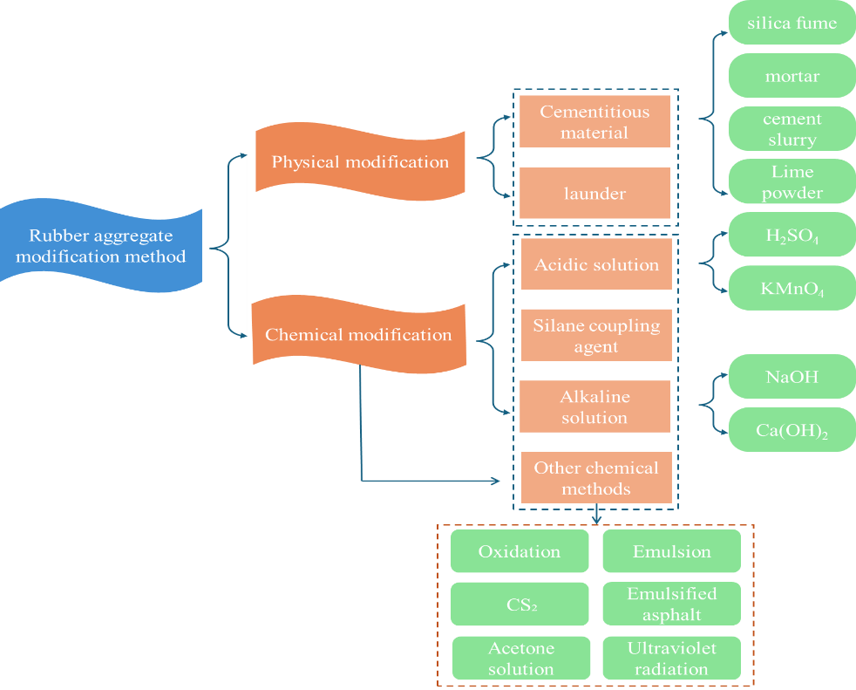
Figure 1 Surface modification methods of rubber aggregates
2.1 The Impact of Physical Treatment on the Performance of Rubber Concrete
The physical treatment of rubber aggregates primarily involves two methods: water washing and pre-coating with binding materials. Water washing helps remove impurities, additives, and organic substances from the rubber surface, improving its hydrophilicity and thereby enhancing the interfacial bond between the rubber aggregates and the cement matrix.
Youssf soaked rubber particles in water for 24 hours, followed by filtration and drying, which resulted in a 15% increase in the compressive strength of rubber concrete [5]. Similarly, Mohammadi employed a soaking treatment to prepare rubber concrete samples, which led to a more uniform distribution of rubber particles within the concrete matrix and reduced trapped air. The compressive strength and flexural strength of the soaked rubber samples increased by 22% and 8%, respectively, with the compressive strength showing a more significant improvement than the flexural strength [6].
The pre-coating of rubber aggregates with binding materials forms a hard shell on the surface, which increases the elastic modulus of the rubber particles and helps reduce stress concentration. The hydrophilic cement shell interacts with the cement matrix, enhancing the interfacial bond between the rubber aggregates and the cement paste. Najim employed various methods, including cement paste and mortar pre-coating, to improve the bond between rubber aggregates and the cement matrix. These treatments significantly enhanced the interfacial bonding, resulting in a 37% increase in compressive strength and a 19% increase in indirect tensile (splitting) strength for the mortar-coated rubber aggregates [7].
Zhai proposed an innovative method for modifying waste rubber powder that combines mechanical-chemical effects, ultrasonic energy accumulation, and modified slurry coating. The results demonstrated a significant improvement in the properties of the modified concrete, with compressive strength and flexural strength increasing by 74.2% and 45.7%, respectively. Furthermore, under the same volume replacement, the wear resistance was also notably enhanced [8].
2.2 The Impact of Chemical Treatment on the Performance of Rubber Concrete
The chemical treatment of rubber aggregates involves methods such as using acid or alkaline solutions, silane coupling agents, partial oxidation, ultraviolet radiation, and latex modification to treat the rubber particles. These treatments help remove oils, dirt, and dust from the rubber surface, while also improving its roughness and hydrophilicity.
Xu employed highly dispersed colloidal nano-SiO₂ (CNS) as an admixture to modify rubber, analyzing its enhancement effects and mechanisms on rubber concrete. The results indicated that, compared to rubber concrete without CNS, the early compressive strength of rubber concrete with CNS increased by 30.3% [9].
An et al. used NaOH and SCA for modification to enhance the hydrophilicity of rubber particles and improve the bonding ability between rubber and concrete. The results demonstrated that the modified rubber particles exhibited improved roughness and hydrophilicity, which resulted in better adhesion between the rubber and the concrete [10].
Lin et al. studied the effect of varying emulsion asphalt (EA) contents on the mechanical properties of rubberized concrete (CRC) and compared it with NaOH-modified CRC. The results showed that EA is an effective method of modification to improve the bond between rubber particles and the cement matrix. This modification allowed the rubber particles to better synergize with the other concrete components, enhancing both the strength and elasticity of the CRC [11].
Kashani employed five surface treatment methods for recycled tire crumb concrete, including cement coating, silica powder coating, sodium hydroxide, potassium permanganate, and sulfuric acid soaking, to mitigate the strength loss of RTC concrete. The results showed that, compared to untreated samples, the compressive strength of all five treated methods increased by 27% to 56% [12].
He et al. proposed a surface modification method that introduces strong polar groups onto the rubber surface. The rubber was first oxidized with KMnO₄ solution and then sulfonated using NaHSO₃ solution. This combination of oxidation and sulfonation significantly reduced the rubber's contact with water, improving the interfacial reaction between the rubber crumbs and the cement matrix. As a result, the bonding performance between the rubber and the cement was significantly enhanced following the surface modification [13].
3. Performance of Fiber-Reinforced Rubber Concrete
Rubber is an elastic material that can help reduce the brittleness of concrete when incorporated, but its addition generally leads to a reduction in concrete strength, which limits its practical engineering applications. Steel fibers, however, provide strengthening and toughening effects. By incorporating steel fibers into rubber concrete, both the strength and failure characteristics can be improved, leading to enhanced overall performance of rubberized concrete.
Yang et al. investigated the mechanical behavior and failure criteria of steel fiber-reinforced rubber concrete (SFRRC) under combined compressive-shear loading. They examined factors such as steel fiber content, rubber powder content, and the compressive-to-shear stress ratio to assess the compression-shear performance of SFRRC. The results showed that under combined compressive and shear stresses, the failure mode of SFRRC shifted from tensile failure to compressive-shear failure. Throughout the failure process, the steel fibers absorbed a significant amount of energy, imparting excellent shear deformation toughness to the SFRRC specimens [14].
Lu et al. found that the addition of waste rubber particles and basalt fiber (BF) not only enhances the performance of the resulting concrete but also helps alleviate the environmental pressure associated with waste tire disposal. Experimental studies were conducted on seven different mixtures, with four levels of BF content (0%, 0.2%, 0.3%, and 0.4%) and three levels of rubber particle content (10%, 15%, and 20%). The results showed that while the compressive strength and elastic modulus decreased with increasing BF content, the peak strain gradually increased with higher BF and rubber particle contents [15].
Feng et al. found that modified PVA fiber rubber concrete exhibits superior deformation performance compared to traditional rubber concrete, offering higher stiffness and strength. When used appropriately, it can maintain or even slightly increase the load-bearing capacity of frame structures. The proper use of this material not only reduces costs but also ensures structural strength. Numerical simulations using Abaqus showed that the application of modified materials in frame structures enhances both bending and load-bearing capacity, improving overall structural strength and deformation performance [16].
4. The impact of rubberized concrete on the interfacial transition zone
The microstructure of the Interfacial Transition Zone (ITZ) in concrete plays a crucial role in determining the strength of cement-based concrete at the microscale. Consequently, both domestic and international researchers have studied the ITZ in rubberized concrete.
Wang et al. used SEM to observe the microstructure of recycled rubber concrete cured under constant temperature and humidity for 28 days. Their study found that the addition of rubber inhibited the degree of cement hydration, reducing the formation of hydration products in the ITZ. Additionally, increasing the rubber content and particle size led to a wider microcrack width in the ITZ [17].
Zhu Xingtong et al. used SEM and EDS techniques to study the microstructure, distribution of hydration products, and ITZ width at the interface between rubber and cement paste in waste tire rubber concrete. Their study found that the interface bond between rubber and cement paste was relatively weak, the ITZ structure was more porous and loose, and the porosity was higher compared to conventional concrete. Additionally, the content of C-S-H gel in the hydration products of the interface zone was lower than that found in ordinary concrete [18].
Mo Qihua et al. used X-ray diffraction (XRD) and mercury intrusion porosimetry to study the effect of rubber content on cement hydration products. Their findings indicated that an increase in rubber content reduced the proportion of calcium silicate hydrate (C-S-H), calcium aluminate silicate hydrate (C-A-S-H), and calcium hydroxide (CH) in the hydration products. This suggests that rubber aggregates inhibited the hydration reaction of cement near the interface [19].
In conclusion, the micro interface properties between rubber and cement paste are critical in determining the mechanical strength and fracture characteristics of rubber concrete materials. However, existing studies, both domestically and internationally, have generally relied on simple SEM observations of micro interface morphology. To date, no comprehensive qualitative or quantitative research methods have been proposed, and the formation mechanisms of the rubber-cement paste micro interface bond require further exploration.
5. Conclusions and Future Work
This paper discusses the resource utilization of waste rubber and its application in modified rubber concrete. The focus is on analyzing the treatment methods for waste tires, the effects of different modification technologies on the performance of rubber concrete, and the role of fiber reinforcement in enhancing the properties of rubberized concrete.
(1) Effect of Modification Techniques: Various modification techniques, such as pre-coating with cementitious materials and chemical treatments, have been explored to improve the surface properties and structure of rubber aggregates. These modifications have led to significant enhancements in the compressive and bending strength of rubberized concrete.
(2) Rubber-Cement Paste Interface Properties: The interface properties between rubber and the cement paste are critical factors influencing the mechanical performance and durability of modified rubber concrete. Enhancing the bond between the rubber and the cement matrix through physical and chemical methods can significantly improve the overall performance of the concrete, making it more durable and structurally resilient.
Current research is still in the early stages, and studies on optimizing the impact of rubber on concrete performance and the resulting improvements remain incomplete. Therefore, systematic research is needed to fully understand the mechanisms through which rubber influences the performance of concrete. This will help in developing more effective methods to enhance the properties of rubberized concrete.
(1) Rubber Modification Techniques: Future research should continue to explore more effective rubber modification methods to improve the mechanical properties and durability of rubberized concrete. A particular focus should be on innovations that enhance the bond between rubber and cement paste at the interface, as this will directly impact the overall performance and strength of the material.
(2) Fiber Reinforcement Technologies: Further investigation into fiber reinforcement technologies, such as steel and basalt fibers, can significantly enhance the performance of rubberized concrete. These fibers not only improve strength and toughness but also help address the environmental challenges posed by waste tire disposal, offering a dual benefit of sustainability and performance enhancement.
(3) Engineering Standards and Specifications: To facilitate the wider adoption of rubberized concrete in engineering, it is crucial to develop appropriate engineering standards and specifications. These guidelines will ensure consistent material performance and provide reliability in engineering projects, thereby promoting the safe and effective use of rubberized concrete in various construction applications.
Conflicts of Interest: The authors declare no conflict of interest.

COMPETING INTERESTS DISCLAIMER:
Authors have declared that they have no known competing financial interests OR non-financial interests OR personal relationships that could have appeared to influence the work reported in this paper.

References
- C., Jia, G., & Zhang, Z. Development of Waste Tire Disposal Methods from the Perspective of Ecological Environmental Protection. China Tire Resource Comprehensive Utilization, 2025(08), 28-30.
- Xian, X. Study on the Impact of Waste Tire Recycling on Ecological Environmental Protection Monitoring. China Tire Resource Comprehensive Utilization, 2025(08), 61-63.
- Khatib, Z.K. and F.M. Bayomy, Rubberized Portland Cement Concrete. Journal of materials in civil engineering, 1999. 11(3): p. 206-213.
- Kashani, A., et al., Effects of surface treatments of recycled tyre crumb on cement-rubber bonding in concrete composite foam. Construction & building materials, 2018. 171: p. 467-473.
- Youssf, O., A. Swilam and A.M. Tahwia, Performance of crumb rubber concrete made with high contents of heat pre-treated rubber and magnetized water. Journal of materials research and technology, 2023. 23: p. 2160-2176.
- MOHAMMADI Iman, KHABBAZ Hadi, VESSALAS Kirk. In-depth assessment of Crumb Rubber Concrete (CRC) prepared by watersoaking treatment method for rigid pavements[J]. Construction and Building Materials,2014,71:456-471.
- Khalid Battal Najim, Matthew Robert Hall. Crumb rubber aggregate coatings/pre-treatments and their effects on interfacial bonding,air entrapment and fracture toughness in self-compacting rubberized concrete (SCRC)[J]. Materials and Structures,2013,46(12):2029-2043.
- Zhai, S., et al., Investigation on the influence of modified waste rubber powder on the abrasion resistance of concrete. Construction & building materials, 2022. 357: p. 129409.
- Xu, Y., et al., Enhanced effect and mechanism of colloidal nano-SiO2 modified rubber concrete. Construction & building materials, 2023. 378: p. 131203.
- An, J., et al., Experimental and simulation study on capillary water absorption of modified crumb rubber concrete with steam-cured. Journal of Building Engineering, 2023. 73: p. 106756.
- Lin, Q., et al., Comprehensive modification of emulsified asphalt on improving mechanical properties of crumb rubber concrete. Construction and Building Materials, 2023. 369.
- Kashani, A., et al., Effects of surface treatments of recycled tyre crumb on cement-rubber bonding in concrete composite foam. Construction & building materials, 2018. 171: p. 467-473.
- He, L., et al., Surface modification of crumb rubber and its influence on the mechanical properties of rubber-cement concrete. Construction & building materials, 2016. 120: p. 403-407.
- Yang, H., et al., Compression-shear performance of steel fiber reinforced rubber concrete. Journal of Building Engineering, 2023. 75: p. 106977.
- LUO Tao, ZHANG Chi, SUN Chao wei, et al. Experimental investigation on the freeze-thaw resistance of steel fibers reinforced rubber concrete[J]. Materials,2020,13(5):1260
- ZHANG Haibo, GOU Mifeng, LIU Xiaoxing,et al. Effect of rubber particle modification on properties of rubberized concrete[J].Journal of Wuhan University of Technology:Mater.Sci.Ed.,2014,29(4):763-768.
- WANG Ruijun,HE Xiaoying,LI Yang.Evaluation of microcracks in the interfacial transition zone of recycled rubber concrete[J].Structural Concrete,2019,20(5):1684-1694.
- Zhu Xingtong, Geng Ou, and Zhu Siyuan, "Experimental Study on the Interfacial Transition Zone Characteristics of Waste Tire Rubber Concrete," Silicate Bulletin, 2021, 40(02): 573-578.
- Mo Qihua, Yang Ruochong, Zhu Tengkuo, "Study on the Effect of Rubber Powder on Cement Hydration and Pore Structure of Cement-Based Materials," Highway Traffic Science & Technology (Applied Technology Edition), 2017, 13(5): 84-87.
- Laftah, W. A., & Abdulrahman, W. A. W. (2025). A Comprehensive Review of Tire Recycling Technologies and Applications. Materials Advances.

