ASSESSING MOLECULAR DIVERSITY OF TROPICAL MAIZE INBRED LINES USING SINGLE NUCLEOTIDE POLYMORPHIC (SNP) MARKERS

ABSTRACT
The present study was conducted to assess the molecular diversity and population structure of 107 tropical maize inbred lines collected from working germplasm programs using SNP markers. A total of 97 genome-wide SNP markers were employed for genotyping through the KASP assay. The polymorphism information content (PIC) values ranged from 0.018 to 0.375 with an overall mean of 0.285, indicating that the majority of markers were moderately informative. Hierarchical clustering grouped the inbred lines into three major clusters, reflecting clear genetic differentiation among the tropical maize inbred lines. Principal component analysis (PCA) further validated these findings by identifying highly divergent lines Viz., AHG-122, CIMMYT-22, BHG-ze20, AHG-110-1. The congruence between UPGMA clustering and PCA confirmed the robustness of the diversity analysis. These findings provide valuable insights into the genetic relationships among tropical maize inbreds and highlight the utility of SNP markers in guiding the selection of parental lines for hybrid development.
Keywords: molecular diversity, polymorphism information content (PIC), SNP markers,
INTRODUCTION
Maize (Zea mays L.) is a well-known cereal crop for its adaptability and importance worldwide. A maize breeding program requires genetically diverse source material. Genetically diverse and complementary elite inbred lines can play a significant role in the development of maize hybrids with maximum expression of heterosis (Adeyemo et al., 2011). Similarly, Menkir et al., (2010) reported that better hybrids can be obtained in crosses of parents from a diverse origin than hybrids formed from lines with the same genetic background. Similarly, accurate characterization of inbred lines using molecular and morphological markers is important for effective breeding (Xu et al., 2013).
Maize is predominantly a cross-pollinated crop showing the highest phenotypic and genotypic variability from generation to generation (Molin et al.,2013; Nyaligwa et al., 2015). The presence of genetic variability allows for further improvement of the crop. The levels of recombination in maize are high (Huihua Fu., 2002) and disparately it shows low levels of linkage disequilibrium (Remington et al., 2001). Maize is an outcrossing species and it has large population sizes (Vigouroux et al., 2002). Therefore, it is important to reduce complexity by making strong selection that could have retained near normal levels of diversity (Wang et al., 1999). This, in turn, minimizes the possibility of detecting false positives, i.e., low diversity can be reported due to unselected genes. However, in maize, a relatively modest effect of domestication bottleneck can be observed as a result of unselected genes retaining high diversity and can be readily eminent from those undermined by selection (Eyre-Walker et al., 1998).
The strength of a hybrid breeding program depends on the genetic diversity of available breeding materials, which in turn reflects the population structure. This enables the assignment of inbred lines to heterotic groups. High-yielding hybrids are produced by crossing inbreds of opposite heterotic groups than inbreds of the same heterotic group (Talabi et al., 2017). Several marker approaches, such as morpho logical, biochemical and molecular markers are frequently used to assess genetic diversity in breeding materials (Badu-Apraku et al., 2017) in order to cluster inbreds into respective diverse groups. Morphological markers are influenced by the environment and do not measure genetic diversity accurately (Nadeem et al., 2018), which can be overcome by DNA based markers. The DNA-based markers like Restriction Fragment Length Polymorphism (RFLP) (Benchimol et al., 2000), Amplified Fragment Length Polymorphism (AFLP) (Hartings et al. 2008), Simple Sequence Repeats (SSR) (Qi-Lun et al.,2008) and Single Nucleotide Polymorphism (SNP) (Zhang et al., 2016) and sequence-related amplified polymorphism (SRAP) (Hassan et al., 2020) are frequently used for accessing of genetic diversity in maize or in other crops. The advancement of next-generation sequencing technologies has further accelerated marker development, particularly high-density SNP markers. Consequently, DNA based markers have become indispensable tools for selecting genetic resources and easy screening of many lines. Many researchers used Simple Sequence Repeats (SSRs) in maize to study the heterosis, assigning the inbred lines to heterotic groups, combining ability and evaluating hybrid performance (Mukri et al., 2022; Mahato et al., 2021; Maruthi et al., 2019). However, the choice of the genetic marker is highly dynamic with the cost, condition and choice of the breeder.
SNP markers have become a marker of choice because of their abundance, low error rate, co-dominance, low cost, amenability for high throughput analysis and locus specificity. Many researchers are routinely investigating the population structure and genetic diversity in maize using SNP markers (Badu-Apraku et al., 2021; Kasoma et al. 2021; Gasura et al., 2021; Yu et al., 2021; Obeng-Bio et al., 2020). The promising results of SNP markers and their wide usage served as a guide for the parent’s selection and hybrids development. In a similar line, understanding the population structure of Indian maize inbreds will help to select outstanding inbred line combinations for hybrid development programs and design the most appropriate product development strategies for successfully harnessing heterosis in maize. Therefore, the present investigation was planned to examine the genetic diversity and population structure of Indian maize inbred lines collected from different locations of India using SNP markers.
MATERIAL AND METHOD
Plant material consisted of 107 tropical maize inbred lines (Table 1) collected from breeding programs for genetic characterization. Young leaves were sampled at the three-week stage following the LGC Genomics protocol, placed in 96-well plates with desiccant and forwarded to CIMMYT-Asia, Patancheru, for DNA extraction. The DNA samples were subsequently sent to LGC Genomics, London, for SNP genotyping using the Competitive Allele-Specific PCR (KASP) assay. This system employs allele-specific primers with fluorescent labeling to detect nucleotide polymorphisms and has been widely applied in maize genotyping (Semagn et al., 2014). Ninety-seven genome-wide SNP markers recommended by the CIMMYT Global Maize Program for quality control were employed, with an average marker density of one SNP per 24.5 Mb across ten chromosomes.
Table 1: List of tropical maize inbred lines used in diversity studies
AHG-17 | AHG-106 | BHG-90 | UASBM-24 | CIMMYT-58
AHG-18 | AHG-108 | BHG-92-1 | UASBM-25 | CIMMYT-61
AHG-29 | AHG-109 | BHG-155 | UASBM-30 | PhD-13
AHG-30 | AHG-111 | HHG-48 | UASBM-31 | PhD-15
AHG-31 | AHG-118 | HHG-77 | UASBM-38 | PhD-16
AHG-32 | AHG-119 | GPM-45 | UASBM-40 | PhD-IHE-1920
AHG-40 | AHG-120 | GPM-06 | UASBM-42 | IM-106711
AHG-50 | AHG-157 | CAL-1426 | UASBM-43 | IM-106712
AHG-66 | AHG-110-1 | CAL-1435 | UASBM-44 | IM-116719
AHG-67 | AHG-110-2 | CAL-1712 | CIMMYT-1 | CML-451
AHG-70 | BHG-04 | CAL-1713 | CIMMYT-2 | DHG-12
AHG-72 | BHG-10 | CAL-1721 | CIMMYT-3 | GB-58
AHG-81 | BHG-11 | CAL-1728 | CIMMYT-4 | HTMA-101
AHG-82 | BHG-13 | CAL-1729 | CIMMYT-6 | BHG-114
AHG-88 | BHG-14 | CAL-17129 | CIMMYT-11 | AHG-150
AHG-93 | BHG-24 | CATL-286 | CIMMYT-19 | UASBM-12
AHG-94 | BHG-36 | CATL-152 | CIMMYT-13 | CIMMYT-21
AHG-95 | BHG-57 | UASBM-01 | CIMMYT-14 | BHG-19
AHG-98 | BHG-58 | UASBM-09 | CIMMYT-22 | AHG-76-1
AHG-99 | BHG-73 | UASBM-11 | CIMMYT-24
AHG-103 | BHG-79 | UASBM-13 | CIMMYT-47
AHG-105 | BHG-83 | UASBM-17 | CIMMYT-52

The raw genotyping dataset was filtered to retain high-quality SNPs. The informativeness of each marker was assessed by calculating the polymorphism information content (PIC) following the formula of Botstein et al. (1980), where higher PIC values indicate greater discriminatory ability of a marker within a population. PIC values were estimated in Microsoft Excel and the final dataset was used for downstream diversity analyses.
Genotypic clustering was performed using the unweighted pair-group method with arithmetic mean (UPGMA) in DARwin software (Perrier and Jacquemoud-Collet, 2006). A dendrogram was constructed based on the SNP marker data to assess the genetic relationships among the inbred lines and the robustness of clustering was evaluated through cophenetic correlation analysis. In addition, principal component analysis (PCA) was carried out to visualize the genetic structure of the inbred lines in two-dimensional space, providing complementary insights into their diversity patterns.
RESULT AND DISCUSSION
Polymorphic Information Content (PIC)
Polymorphic information content (PIC) gives an estimate of the discriminatory ability and effectiveness of molecular markers with respect to the number of alleles that are expressed and their relative frequencies (Abakemal et al.,2015). Lander and Botstein described PIC mean value of >0.50 as highly informative, 0.25–0.50 moderately informative and <0.25 is slightly informative.
The polymorphism information content (PIC) values (Table 2) ranged from 0.018 to 0.375, with an overall mean of 0.285 within the population Most SNPs were moderately informative (0.25 < PIC ≤ 0.5), while a few showed very lower pic values, reflecting limited allelic variation. the SNP markers in this study fall into the moderately and slightly informative ranges (Table 1). Hence, the mean PIC value of 0.375 observed in this study for the inbred lines confirm that the markers used were effective in discriminating the genotypes, reasonably informative and of good quality. some markers showed very low PIC values and remaining markers have intermediate PIC values, indicating moderate levels of polymorphism. The analysis of PIC values demonstrated the varying informativeness of the SNP markers used. The presence of a good number of moderately informative markers ensures the reliability of the genetic diversity and clustering analyses, this value is same side compared to PIC values reported in some of the past related studies. Nyombayire et al. (2018) analyzed 71 maize inbred lines with 92 SNP markers, finding PIC values ranging from 0.1224 to 0.375, with a mean of 0.30. The highest PIC values (0.375) were exhibited by three specific markers. In another study Oliveira et al. (2021) genotyped 293 inbred lines using 5252 SNPs, reporting an average PIC of 0.297. Zawadi et al. (2020) studied 92 inbred lines with 3047 SNP markers, finding over 91% were polymorphic with a mean PIC of 0.36 and gene diversity ranging from 0.35-0.37. The disparity between the mean PIC observed in this study and the findings of earlier scientist could be attributed to differences in the composition of the genetic materials.
Table 2: SNP markers used with their PIC values
Sl.no | SNP Markers | PIC Values | class
 | PZA00770_1 | 0.338131 | Moderately Informative
 | PZA02742_1 | 0.354632 | Moderately Informative
 | PZA03211_6 | 0.366599 | Moderately Informative
 | PZA02436_1 | 0.332433 | Moderately Informative
 | PZA01919_2 | 0.344029 | Moderately Informative
 | PHM4134_8 | 0.249099 | Less Informative
 | PZA01607_1 | 0.359364 | Moderately Informative
 | PHM10621_29 | 0.201114 | Less Informative
 | PZA03322_5 | 0.347632 | Moderately Informative
 | PZA00440_1 | 0.3318 | Moderately Informative
 | PZA00355_2 | 0.117836 | less Informative
 | PZA00175_2 | 0.355713 | Moderately Informative
 | PZA00214_1 | 0.373757 | Moderately Informative
 | PHM3457_6 | 0.372084 | Moderately Informative
 | PZB01658_1 | 0.272684 | Moderately Informative
 | PZA02090_1 | 0.2688 | Moderately Informative
 | PZA02325_4 | 0.063689 | Less Informative
 | PHM3668_12 | 0.374827 | Moderately Informative
 | PHM4165_14 | 0.203497 | Less Informative
 | PZA02741_1 | 0.242583 | Less Informative
 | PZA01462_1 | 0.306751 | Moderately Informative
 | PZA00084_2 | 0.367093 | Moderately Informative
 | PZA03645_1 | 0.271148 | Moderately Informative
 | PHM5181_10 | 0.325766 | Moderately Informative
 | PZA01791_2 | 0.283701 | Moderately Informative
 | PZA01477_3 | 0.374374 | Moderately Informative
 | PZA02269_3 | 0.239198 | Less Informative
 | PZA00527_10 | 0.319958 | Moderately Informative
 | PZA01715_2 | 0.282375 | Moderately Informative
 | PZE0186065237 | 0.018688 | Less Informative
 | PZA03182_5 | 0.354632 | Moderately Informative
 | PZA00495_5 | 0.158359 | Less Informative
 | PZA02174_2 | 0.360121 | Moderately Informative
 | PZA00643_13 | 0.146183 | Less Informative
 | PZA01533_2 | 0.374527 | Moderately Informative
 | PZB01899_1 | 0.321915 | Moderately Informative
 | PZA01447_1 | 0.121376 | Less Informative
 | PZA00399_11 | 0.367959 | Moderately Informative
 | PZA00866_2 | 0.345679 | Moderately Informative
 | lac1_3 | 0.361826 | Moderately Informative
 | PHM229_15 | 0.375 | Moderately Informative
 | PZA02164_16 | 0.367376 | Moderately Informative
 | PZA00352_23 | 0.371171 | Moderately Informative
 | PZA00664_3 | 0.374836 | Moderately Informative
 | PZA03605_1 | 0.172056 | Less Informative
 | PHM1752_36 | 0.079717 | Less Informative
 | PHM7916_4 | 0.340274 | Moderately Informative
 | PHM3466_69 | 0.083012 | Less Informative
 | PHM4752_14 | 0.358387 | Moderately Informative
 | sh1_12 | 0.352438 | Moderately Informative
 | PZB01109_1 | 0.246523 | Less Informative
 | PHM3078_12 | 0.308623 | Moderately Informative
 | PHM2749_10 | 0.372543 | Moderately Informative
 | PZA03536_1 | 0.296996 | Moderately Informative
 | PHM5572_19 | 0.365369 | Moderately Informative
 | PHM12706_14 | 0.311277 | Moderately Informative
 | PHM3922_32 | 0.372558 | Moderately Informative
 | PZA01933_3 | 0.099432 | Less Informative
 | ae1_7 | 0.359771 | Moderately Informative
 | PZA02378_7 | 0.289125 | Moderately Informative
 | PHM2343_25 | 0.3357 | Moderately Informative
 | PHM11114_7 | 0.253261 | Moderately Informative
 | PHM15964_16 | 0.369846 | Moderately Informative
 | PZE-101093951 | 0.018688 | Less Informative
 | PHM1968_22 | 0.371254 | Moderately Informative
 | PZB01062_3 | 0.221074 | Less Informative
 | PHM6111_5 | 0.35403 | Moderately Informative
 | PHM3626_3 | 0.281496 | Moderately Informative
 | PHM13440_13 | 0.340274 | Moderately Informative
 | PHM13360_13 | 0.249423 | Less Informative
 | PZA00667_2 | 0.327571 | Moderately Informative
 | PHM5502_31 | 0.273898 | Moderately Informative
 | PZA02779_1 | 0.369846 | Moderately Informative
 | PZA02358_1 | 0.253261 | Moderately Informative
 | PZA00218_1 | 0.206089 | Less Informative
 | PZA00981_3 | 0.241651 | Less Informative
 | PZA02480_1 | 0.322986 | Moderately Informative
 | PHM4066_11 | 0.071867 | Less Informative
 | PHM4080_15 | 0.137522 | Less Informative
 | PZA03409_1 | 0.262399 | Moderately Informative
 | PZA01427_1 | 0.239198 | Less Informative
 | PZA02462_1 | 0.336232 | Moderately Informative
 | PZA01062_1 | 0.271148 | Moderately Informative
 | PZB01403_1 | 0.370951 | Moderately Informative
 | PZA00413_20 | 0.364069 | Moderately Informative
 | PHM5805_19 | 0.28087 | Moderately Informative
 | PZA02187_1 | 0.332433 | Moderately Informative
 | PHM2350_17 | 0.316073 | Moderately Informative
 | PHM2770_19 | 0.218347 | Less Informative
 | PZA00793_2 | 0.300609 | Moderately Informative
 | PZA03120_1 | 0.348826 | Moderately Informative
 | PZD00022_5 | 0.279316 | Moderately Informative
 | PHM17210_5 | 0.372356 | Moderately Informative
 | PZA00726_10 | 0.236987 | Less Informative
 | PHM662_27 | 0.21309 | Less Informative
 | PZA00498_5 | 0.311883 | Moderately Informative
 | PZA00814_1 | 0.130712 | Less Informative

Hierarchical clustering analysis based on SNP markers
Hierarchical clustering based on their shared attributes or relationships. It typically produces a graphical representation called dendrogram, which illustrates the hierarchical clustering structure, highlighting the relationships between different samples using standard descriptors Hierarchical clustering analysis using the unweighted pair group method with arithmetic mean (UPGMA) grouped the inbred lines into three major clusters. SNP-based hierarchical clustering grouped the 107 tropical maize inbreds lines into three major clusters at ~0.05 dissimilarity (Fig 1). namely cluster A, B and C Cluster. The cluster A was the largest, having 61 maize inbred lines, Cluster B included 45 potentially divergent lines like CIMMYT-34. UASBM-9, BHG-14, while Cluster C consisted of a single distinct inbred AHG-110-2 (Table 3).

Table 3: Hierarchical Clusters of tropical maize inbreds using SNP Markers
Cluster | Sub-Cluster | No of genotypes | Genotypes
A | A₁ | 60 | UASBM-22, CIMMYT-55, CIMMYT-13, UASBM-1, AHG-77, AHG-89, BHG-19, CIMMYT-34, UASBM-12, IM10685, IM1067113, IM106753, AHG-18, BHG-57, BHG-51.BHG-83,AHG-108,AHG-67,AHG-120,AHG-111,AHG-50,AHG-106,BHG-18,AHG-82,BHG-10,AHG-105.GPM-6,CIMMYT-11,CIMMYT-24,CIMMYT-1,CIMMYT-3,CIMMYT-6,CIMMYT-55,CIMMYT-47,UASBM-31,UASBM-38,UASBM-40,UASBM-44,BHG-59,AHG-32, BHG-35,BHG-36,BHG-37,UASBM-27,UASBM-15,BHG-58,UASBM-5,UASBM-25,UASBM-13,PHD-INE-1920,CIMMYT-41,UASBM-42,AHG-13,AHG-29,IM-106710,AHG-94,AHG-88,CIMMYT-11,AHG-150, CAL-1431,CAL-1729
A | A₂ | 1 | PHD-13
B | B₁ | 44 | UASBM-9,BHG-4,CIMMYT-19,UASBM-23, CIMMYT-14,BHG-78,UASBM-40,AHG-110-1,AHG-157,UASBM-39,BHG-14,AHG-95,AHG-109,AHG-72,AHG-30,AHG-7,AHG-17,AHG-118,AHG-31,GPM-45,CIMMYT-61,CIMMYT-52,CIMMYT-3,UASBM-11,PHD-16,BHG-79AHG-99,AHG-66,PHD-15,IM106765,AHG-98,AHG-112,AHG-122,BHG-20,BHG-13,AHG-40,BHG-155,AHG-119,BHG-92-1, CAL-1426  CAL-1427, CAL-1428, CAL-1429, CAL-1430
B | B₂ | 1 | UASBM-24
C |  | 1 | AHG-110-2

Similar SNP studies were reported by Santos de Oliveira et al. (2021) used 5252 SNPs to cluster 293 inbred lines into four groups. Nelson et al. (2008) identified six primary genetic clusters among ex-PVPA inbreds using SNP markers. Josia et al. (2021) partitioned maize lines into three distinct genetic clusters using 92 SNP markers. These studies collectively demonstrate that SNP-based clustering provides information on genetic relationship.

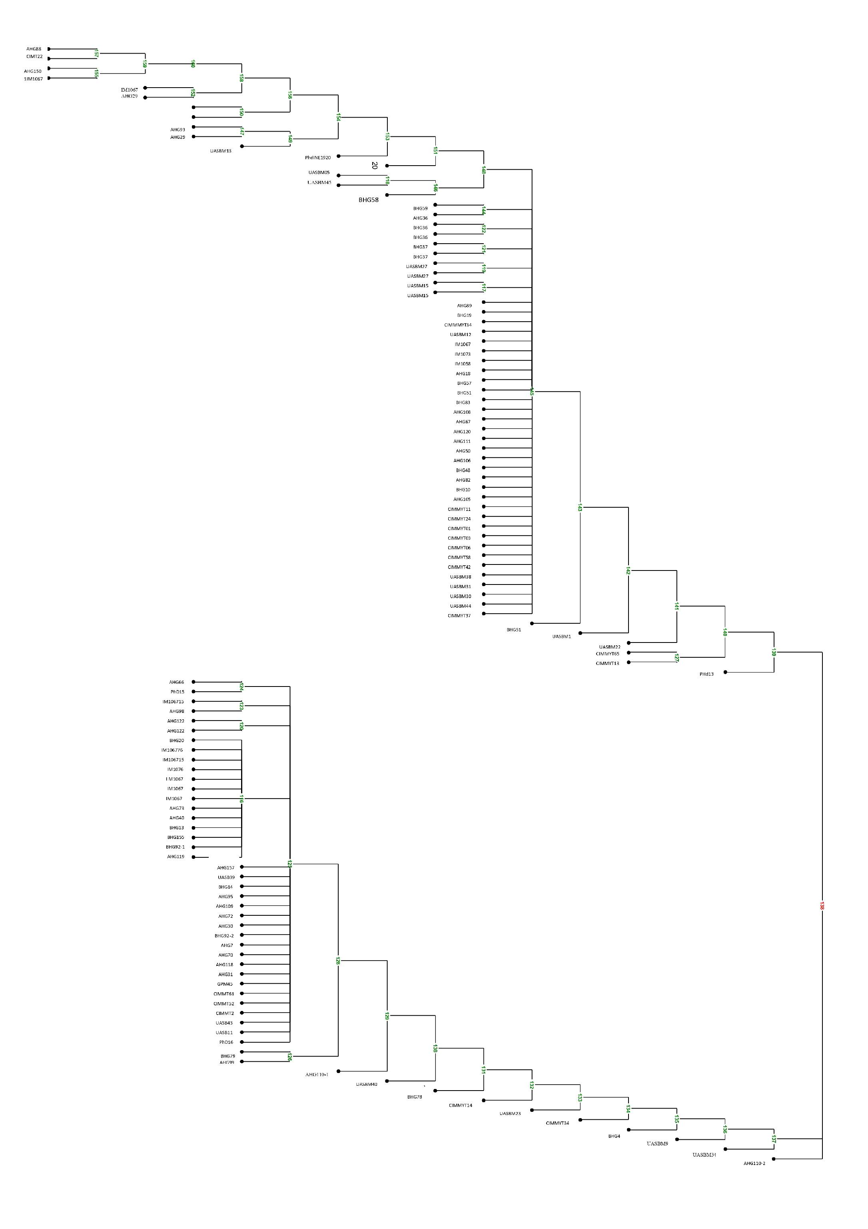
Fig 1; dendrogram containing 107 trophical maize inbred lines
Principal Component Analysis (PCA)
Principal Component Analysis (PCA) is a powerful tool for summarizing molecular diversity by transforming high-dimensional SNP data into a few orthogonal principal components (Jolliffe, 2002). In sweet corn, PCA has been successfully employed to classify germplasm, understand population structure and identify genetically divergent parents for hybrid development (Lu et al., 2009; Yang et al., 2011).
Principal component analysis (PCA) revealed clear genetic structuring among the maize inbred lines. The first two components explained 38.7% (PC1) and 21.4% (PC2) of the total variation, together accounting for 60.1% of the genetic diversity. Most genotypes were clustered near the origin, reflecting a narrow variability and possible common ancestry, while a few lines such as AHG-122, CIMMYT-22 and AHG-110-1 (PC1 positive) and BHG-20 and IM106714 (PC2 negative) were distinct, contributing strongly to the variation.
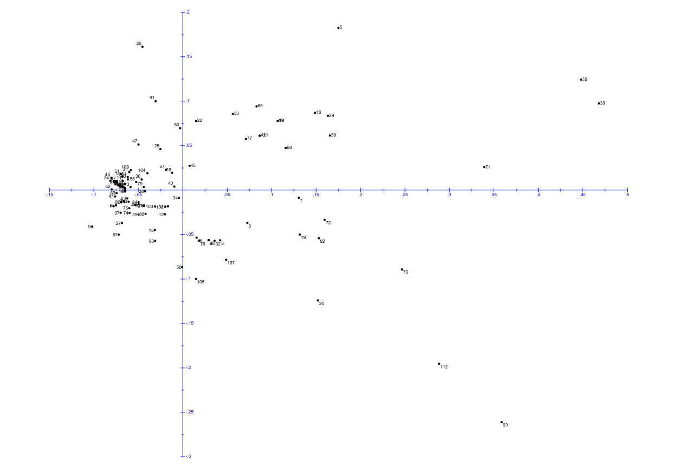

Fig 2: Biplot dispersion graph of 107 trophical maize inbred lines

These divergent genotypes represent valuable parental resources for heterotic group formation and hybrid development, as crossing them with clustered genotypes is likely to maximize heterosis and genetic gain. Similar results were reported by Legesse et al. (2007), Betrán et al. (2003) and Xia et al. (2005), who also observed clustering of most maize inbred lines with a few outliers contributing disproportionately to diversity. Such findings reaffirm that PCA is an effective tool for quantifying genetic divergence and guiding strategic parent selection in maize breeding programs.
CONCLUSION
This study highlighted the efficiency of SNP markers in revealing genetic diversity among tropical maize inbred lines. The mean PIC value (0.285) confirmed that most markers were moderately informative and suitable for genetic discrimination. Hierarchical clustering grouped the lines into three major clusters, indicating both genetic similarity and divergence within the population. PCA supported these results, with PC1 and PC2 explaining 38.7% and 21.4% of the variation, respectively and clearly separating a few divergent genotypes (AHG-122, CIMMYT-22, BHG-20 and AHG-110-1) from the main cluster. These outliers represent valuable parental resources for heterotic group formation and hybrid development. Collectively, the findings demonstrate that SNP-based diversity analysis provides a robust framework for guiding parent selection and exploiting genetic variability in maize improvement programs.

REFERENCES
Abakemal, D., Hussein, S., Derera, J. and Semagn, K., 2015. Genetic purity and patterns of relationships among tropical highland adapted quality protein and normal maize inbred lines using microsatellite markers. Euphytica, 204(1), pp.49-61.
Adeyemo, O.A., Menkir, A., Gedil, M. and Omidiji, O., 2011. Carotenoid and molecular marker-based diversity assessment in tropical yellow endosperm maize inbred lines.
Badu-Apraku B, Garcia-Oliveira AL, Petroli CD, Hearne S, Adewale SA, Gedil M (2021) Genetic diversity and population structure of early and extra-early maturing maize germplasm adapted to sub-Saharan Africa. BMC Plant Biol 21(1):1–5.
Benchimol LL, de Souza Jr CL, Garcia AA, Kono PM, Mangolin CA, Barbosa AM, Coelho AS, De Souza AP (2000) Genetic diversity in tropical maize inbred lines: heterotic group assignment and hybrid performance determined by RFLP markers. Plant Breed ing 119(6):491–496.
Betrán, F.J., Ribaut, J.M., Beck, D. and De León, D.G., 2003. Genetic diversity, specific combining ability, and heterosis in tropical maize under stress and nonstress environments. Crop Science, 43(3), pp.797-806.
Botstein, D., White, R.L., Skolnick, M. and Davis, R.W., 1980. Construction of a genetic linkage map in man using restriction fragment length polymorphisms. American journal of human genetics, 32(3), p.314.
Darkwa, K., Agre, P., Olasanmi, B., Iseki, K., Matsumoto, R., Powell, A., Bauchet, G., De Koeyer, D., Muranaka, S., Adebola, P. and Asiedu, R., 2020. Comparative assessment of genetic diversity matrices and clustering methods in white Guinea yam (Dioscorea rotundata) based on morphological and molecular markers. Scientific Reports, 10(1), p.13191.
Eyre-Walker, A., Gaut, R.L., Hilton, H., Feldman, D.L. and Gaut, B.S., 1998. Investigation of the bottleneck leading to the domestication of maize. Proceedings of the National Academy of Sciences, 95(8), pp.4441-4446.
Fu, H., Zheng, Z. and Dooner, H.K., 2002. Recombination rates between adjacent genic and retrotransposon regions in maize vary by 2 orders of magnitude. Proceedings of the National Academy of Sciences, 99(2), pp.1082-1087.
Gasura E, Nyandoro B, Mabasa S, Setimela PS, Kyalo M, Yao N (2021) Breeding strategy for resistance to striga asiatica based on genetic diversity and population structure of tropical maize lines.
Hartings H, Berardo N, Mazzinelli GF, Valoti P, Verderio A, Motto M (2008) Assessment of genetic diversity and relationships among maize (Zea mays L.) Italian landraces by morphological traits and AFLP profiling. Theor Appl Genet 117(6):831–42
Hassan R, Waheed MQ, Shokat S, Arif MAR, Tariq R, Arif M, Arif A (2020) Estimation of genomic diversity using sequence related amplified polymorphism (SRAP) markers in a mini core collec tion of wheat germplasm from Pakistan. Cereal Res Commun 48:33–44
Jolliffe, I., 2011. Principal component analysis. In International encyclopedia of statistical science (pp. 1094-1096). Springer, Berlin, Heidelberg.
Josia, C., Mashingaidze, K., Amelework, A.B., Kondwakwenda, A., Musvosvi, C. and Sibiya, J., 2021. SNP-based assessment of genetic purity and diversity in maize hybrid breeding. PLoS One, 16(8), p.e0249505.
Kasoma C, Shimelis H, Laing MD, Shayanowako AI, Mathew I (2021) Revealing the genetic diversity of maize (Zea mays L.) popula tions by phenotypic traits and DArTseq markers for variable resist ance to fall armyworm. Genet Resour Crop 68(1)
Lander, E.S. and Botstein, D., 1989. Mapping mendelian factors underlying quantitative traits using RFLP linkage maps. Genetics, 121(1), pp.185-199.
Lu, Y., Yan, J., Guimaraes, C.T., Taba, S., Hao, Z., Gao, S., Chen, S., Li, J., Zhang, S., Vivek, B.S. and Magorokosho, C., 2009. Molecular characterization of global maize breeding germplasm based on genome-wide single nucleotide polymorphisms. Theoretical and applied genetics, 120(1), pp.93-115.
Mahato A, Shahi JP, Singh PK, Kumar M, Singamsetti A (2021) Heter otic grouping of sweet corn (Zea mays var. sachharata) genotypes based on their combining ability and molecular diversity. Indian J Genet 81(3):410–421.
Maruthi RT, Gadag RN, Bhat JS, Karjagi CG (2019) Heterotic group ing of late-maturing maize inbred lines based on combining abil ity and molecular marker studies. J Environ Biol 40(4):705–710
Menkir, A., et al. (2010). Evidence that crosses among parents from diverse genetic origins produce superior maize hybrids compared with crosses among related lines.
Molin, D., Coelho, C.J., Máximo, D.S., Ferreira, F.S., Gardingo, J.R. and Matiello, R.R., 2013. Genetic diversity in the germplasm of tropical maize landraces determined using molecular markers. Genet. Mol. Res, 12(1), pp.99-114.
Mukri G, Patil MS, Motagi BN, Bhat JS, Singh C, Simal-Gandara J (2022) Genetic variability, combining ability and molecular diversity-based parental line selection for heterosis breeding in f ield corn (Zea mays L.). Mol Biol Rep
Nadeem MA, Nawaz MA, Shahid MQ, Doğan Y, Comertpay G, Yıldız M, Hatipoğlu R, Ahmad F, Alsaleh A, Labhane N, Özkan H (2018) DNA molecular markers in plant breeding: current status and recent advancements in genomic selection and genome edit ing. Biotechnol Biotechnol Equip 32(2):261–285. https:// doi. org/ 10. 1080/ 13102 818. 2017. 14004 01
Nelson, P.T., Coles, N.D., Holland, J.B., Bubeck, D.M., Smith, S. and Goodman, M.M., 2008. Molecular characterization of maize inbreds with expired US plant variety protection. Crop Science, 48(5), pp.1673-1685.
Nyaligwa, L., Hussein, S., Amelework, B. and Ghebrehiwot, H., 2015. Genetic diversity analysis of elite maize inbred lines of diverse sources using SSR markers.
Nyombayire, A., Derera, J., Sibiya, J., Gasura, E. and Ngaboyisonga, C., 2016. Genetic diversity among maize inbred lines selected for the mid-altitudes and highlands of Rwanda. Maydica, 61(2), pp.7-13.
Obeng-Bio E (2018) Genetic analysis of grain yield and other traits of early maturing provitamin a-quality protein maize inbred lines under drought and low soil nitrogen conditions. Ph.D. Disserta tion, University of Ghana, Accra, Ghana
Oliveira, L.S.D., Schuster, I., Novaes, E. and Pereira, W.A., 2021. SNP genotyping for fast and consistent clustering of maize inbred lines into heterotic groups. Crop Breeding and Applied Biotechnology, 21, p.e367121110.
Perrier, X. and Jacquemoud-Collet, J.P. (2006) DARwin software: Dissimilarity Analysis and Representation for Windows; tool for distance-based cluster analysis in genetic resources
Qi-Lun Y, Ping F, Ke-Cheng K, Guang-Tang P (2008) Genetic diversity based on SSR markers in maize (Zea mays L.) landraces from Wuling mountain region in China. J Genetics 87(3):287
Remington, D.L., Thornsberry, J.M., Matsuoka, Y., Wilson, L.M., Whitt, S.R., Doebley, J., Kresovich, S., Goodman, M.M. and Buckler IV, E.S., 2001. Structure of linkage disequilibrium and phenotypic associations in the maize genome. Proceedings of the national academy of sciences, 98(20), pp.11479-11484.
Santos de Oliveira, C.M., de Souza, C.L., Pinto, R.J.B., Silva, A.R., Aguiar, C.G., Carlini‐Garcia, L.A. and Garcia, A.A.F., 2021. Genetic structure and relatedness in tropical maize inbred lines assessed by SNP markers. Theoretical and Applied Genetics, 134(8), pp.2467–2482.
Semagn, K., Magorokosho, C., Ogugo, V., Makumbi, D. and Warburton, M.L., 2014. Genetic relationships and structure among open-pollinated maize varieties adapted to eastern and southern Africa using microsatellite markers. Molecular Breeding, 34(3), pp.1423-1435.
Talabi AO, Badu-Apraku B, Fakorede MA (2017) Genetic variances and relationship among traits of an early maturing maize popula tion under drought-stress and low nitrogen environments. Crop Sci 57(2):681–692.
Vigouroux, Y., Jaqueth, J.S., Matsuoka, Y., Smith, O.S., Beavis, W.D., Smith, J.S.C. and Doebley, J., 2002. Rate and pattern of mutation at microsatellite loci in maize. Molecular Biology and Evolution, 19(8), pp.1251-1260.
W. LEGESSE, B., A. MYBURG, A., V. PIXLEY, K. and M. BOTHA, A., 2007. Genetic diversity of African maize inbred lines revealed by SSR markers. Hereditas, 144(1), pp.10-17.
Wang, R.L., Stec, A., Hey, J., Lukens, L. and Doebley, J., 1999. The limits of selection during maize domestication. Nature, 398(6724), pp.236-239.
Xia, X.C., Reif, J.C., Hoisington, D.A., Melchinger, A.E., Frisch, M. and Warburton, M.L., 2004. Genetic diversity among CIMMYT maize inbred lines investigated with SSR markers: I. Lowland tropical maize. Crop Science, 44(6), pp.2230-2237.
Xu, J.I.E., Liu, L.I.N.G., Xu, Y.U.N.B.I., Chen, C.H.U.R.U.N., Rong, T.I.N.G.Z.H.A.O., Ali, F.A.R.H.A.N., Zhou, S., Wu, F., Liu, Y., Wang, J. and Cao, M., 2013. Development and characterization of simple sequence repeat markers providing genome-wide coverage and high resolution in maize. DNA research, 20(5), pp.497-509.
Yang, X., Xu, Y., Shah, T., Li, H., Han, Z., Li, J. and Yan, J., 2011. Comparison of SSRs and SNPs in assessment of genetic relatedness in maize. Genetica, 139(8), pp.1045-1054.
Yu D, Wang H, Gu W, Qin T, Sun P, Lu Y, Shi B, Zheng H (2021) Genetic diversity and population structure of popcorn germplasm resources using genome-wide SNPs through genotyping-by sequencing. Genet Resour Crop Evol 68(6):2379–2389.
Zawadi, M., Sibiya, J., Mashingaidze, K., Amelework, A.B., Kondwakwenda, A. and Musvosvi, C., 2021. Molecular characterization and diversity analysis of selected maize inbred lines using single-nucleotide polymorphism markers. Canadian Journal of Plant Science, 101(2), pp.240-248.
Zhang X, Zhang H, Li L, Lan H, Ren Z, Liu D, Wu L, Liu H, Jaqueth J, Li B, Pan G (2016) Characterizing the population structure and genetic diversity of maize breeding germplasm in Southwest China using genome-wide SNP markers. BMC Genom 17(1):1–6

