PROFILE CHARACTERISTICS OF CUSTOM HIRING CENTER MODELS IN MADHYA PRADESH AND TELANGANA STATES OF INDIA

.
ABSTRACT( in abstract no need of side headings, it should be brief with 100-150 words)

India is a predominantly agricultural country, where major breakthrough in agricultural production has occurred through the agriculture mechanization. The current study aimed to assess the Profile characteristics of custom hiring center models in Madhya Pradesh and Telangana States.

The study was undertaken in Madhya Pradesh and Telangana States. Two erstwhile districts namely Mahabubnagar and Nalgonda districts in Telangana state and Tikamgarh and Guna districts in Madhya Pradesh were selected for the study. The study was undertaken for two years between 2021 to 2023.
The districts were the four selected CHCs models in operation those districts were selected. One CHC representing each model were selected in both the districts thus making a total of 8 CHC in Telangana state and 8 CHCs in Madhya Pradesh state, thus, making a total of 16 CHC for the study
The results of the study indicated that Model I and Model III has highest number of implements in Mahabubnagar district of Telangana state. Model II and Model III have highest number of implements that is 10 implements for serving the farmers in Nalgonda district of Telangana State. Model I has highest number of implements that is 21 implements for serving the farmers in Tikamgarh district of Madhya Pradesh state. Model II has highest number of implements that is 17 implements for serving the farmers in Guna district of Madhya Pradesh state.
Farm mechanization has the potential to significantly revolutionize agriculture in India by providing a means of increasing farm output, bolstering livelihoods, and guaranteeing food
security.

Keywords: Custom Hiring Center, Agricultural mechanization, implements, agricultural machinery.

1. INTRODUCTION

India is a predominantly agricultural country, where major breakthrough in agricultural production has occurred through the agriculture mechanization (Kamboj et al., 2012). The farmers in the state of Madhya Pradesh responded favorably to the "Yantra-doot" program because they needed additional machinery for a number of farm tasks (Anonymous, 2012). In Indian agriculture, custom renting of agricultural machinery was first introduced in the 19th century (Srinivasarao et al., 2013). reported that The majority (63.75%) of the paddy farmers in India had a low level to medium level of adoption of farm machinery (Venkattakumar and Sripal ,2001). The cost of cultivation data shows that labour accounts for more than 40 % of the total variable cost of production for most of the crops (Anonymous, 2011; Laxmi and Mundinamani, 2014). According to a survey on the status of farm mechanization in India, farmers were happy with tractor’s efficient operation, which gave them a better control system (Verma, 2006). It emerged that 62.50 % of farmers used CHS at a medium level, with the remaining respondents making up 21.25 and 16.25 % of the low and high usage, respectively (Kisku, 2020). Moreover, it was shown that a greater proportion (45.33%) fell into the medium adoption category, whereas 38% and 16.67%, respectively, had low and high adoption levels for farm mechanization (Shoba et al., 2018).
A large number of farmers in Punjab's Ludhiana district expressed great pleasure with CHSs provided by cooperative agricultural service organizations (Dash et al., 2019). Furthermore, according to a study on farmer’s perceptions of custom hiring service centers, farmers in Punjab and Uttar Pradesh have considerably positive opinions of these facilities based on aspects like availability, accessibility, efficiency, economic factors, social factors, and environmental factors that are related to CHSCs (Agarwal et al., 2020). Hiring of the farm machines through the Custom Hiring Centers rather owning would provide a viable solution, as they believed it to be the cheaper option.
Custom hiring envisages promoting establishment farm machinery for hiring (Singh et al., 2013). The CHCs offer farm equipment and machinery on rental basis to farmers who cannot afford to purchase high end agriculture machineries and equipment (Singh, 2012). Farmers have positively responded towards the scheme as they need more number of machineries like rotavator and reaper because whenever any other farmer have taken it for his farm it will not be available for others (I-WIN Advisory Services Limited, 2012).
CHCs enhance access to quality tools, implements and machinery services for ensuring quick response and timely operations such as land preparation, sowing, inter-cultivation, other crop management, harvesting and post harvesting specific to existing cropping pattern of the cluster (Uday et al., 2020). It was advocated that custom hiring services have enough scope for providing better implements to their clients at competitive rates (Ranade et al., 2006; Kulkarni, 2006). The largest number of old tractor markets is a common site in the state. Some small farmers even buy a new tractor from the agency to sell them in these tractor markets, to repay any other debt (Singh and Rangi, 2006). The importance of custom hiring centers in India is well recognized , a survey was conducted to study the the Profile characteristics of Custom Hiring Center Models in Madhya Pradesh and Telangana States for better implementation.

2. METHODOLOGY
Descriptive research design was adopted for present investigation. Purposive multi-stage random sampling procedure was used.( It is advised to give more explantion about Descriptive Research design, viz., when, how, where of population, situation etc.) The study was conducted purposively in Telangana and Madhya Pradesh states has Madhya Pradesh state has highest number of Custom Hiring Centers in the country and Telangana state was selected to study the CHCs models. (Fig 1 and Fig 2). Also very few studies with respect to CHCs has been conducted in this region. Based on the review and secondary sources, two erstwhile districts namely Mahabubnagar and Nalgonda districts in Telangana state and Tikamgarh and Guna districts in Madhya Pradesh were selected for the study. The districts were the four selected CHCs models in operation those districts were selected. One CHC representing (Government, FPO, NGO, KVK mode)l were selected in both the districts thus making a total of 8 CHC in Telangana state and 8 CHCs in Madhya Pradesh state, thus, making a total of 16 CHC for the study.(It is advised to include data collection method/procedure to enhance the visibility of the study). The details of Models is given in table.1.
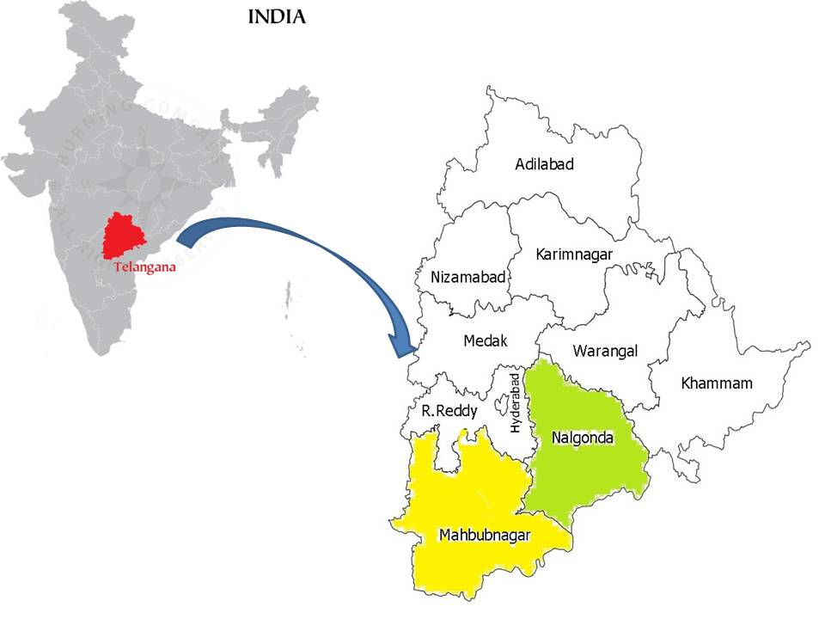
Selected districts in Telangana State, India
Figure 1. Map showing the study area in Telangana State.
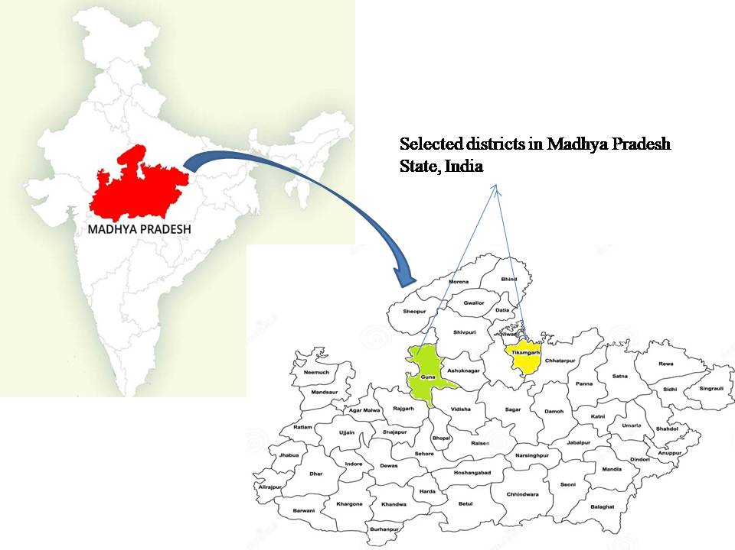
Figure 2. Map showing the study area in Madhya Pradesh state.

S.No | Model | CHCs
1 | Model I | government appointed or subsidized CHCs exclusively for renting to farmers
2 | Model II | NGO CHCs owning farm machinery and equipment for renting to farmers
3 | Model III | KVK CHCs owning agricultural machinery to provide on rental basis
4 | Model IV | FPO CHCs exclusively for renting the machinery to FPO members and farmers
Table.1. Details of Custom Hiring Centers under Different Models
3.RESULTS AND DISCUSSION

. CHCs offer farm machinery and equipment on rental basis to farmers who cannot afford to purchase high end agriculture machineries and equipment. CHCs play a vital role in introducing high technology agricultural machinery to even small farmers with the objective to boost crop production, improve quality, timeliness and efficiency of agriculture operations. The table 2 depicts the farm machinery inventory available in Mahabubnagar district of Telangana State, Model I and Model III has highest number of implements that is 15 implements for serving the farmers followed by Model IV (12) and Model II (9). Model I and Model III were having majority of the farm machinery and equipment to perform tillage operations, planting equipment and plant protection equipment compared to Model II and Model IV. The pattern of cost structure in Model I is Rs. 22,12,000 and Model III is Rs. 14,89,000. The cost structure in Model IV is Rs. 4,94,000 and Model II is Rs. 4,24,000. Due to government support and availability of funds Model I and Model III were able to maintain major farm machinery and equipment at the centers for the benefit of the farmers. Whereas Model IV was having major equipment related to tillage and plant protection equipment and Model II was available with only few types of equipment to perform plant protection equipment. The results are supported by the study conducted by kamboji et al., 2012 and Ranjith, 2017.

The table 3 depicts the farm machinery inventory available in Nalgonda district of Telangana State, Model II and Model III has highest number of implements that is 10 implements for serving the farmers followed by Model I(8) and Model IV(6). Model II and Model III are having majority of the farm machinery and equipment to perform tillage operations and plant protection equipment compared to Model I and Model IV. Due to low capital availability, Model I and Model IV could not able to invest on machineries which are not having required demand from the farmer users. The pattern of cost structure in Model I is Rs. 14,64,174 and Model III is Rs. 6,36,000. The cost structure in Model II is Rs. 3,00,000 and Model IV is Rs. 2,54,000. All CHC models except Model III possess the land development equipment.

The table 4 depicts the farm machinery inventory available in Tikamgarh district of Madhya Pradesh State, Model I has highest number of implements that is CHC has 21 implements for serving the farmers followed by Model III has 10 implements. Model I are having majority of the farm machinery and equipment to perform tillage operations, planting equipment and plant protection equipment compared to other models . The pattern of cost structure in Model I is Rs. 21,01,000 and Model III is Rs. 6,27,000. The cost structure in Model II is Rs. 11,00,000 and Model IV is Rs. 2,00,000. The Table 5 depicts the farm machinery inventory available in Guna district of Madhya Pradesh State, Model II has highest number of implements that is 17 implements for serving the farmers followed by Model III (KVK CHC) has 16 implements. Model I (Government CHC) has 15 implements followed by Model IV (FPO CHC) has 8 implements. The pattern of cost structure in Model I is Rs. 18,39,000 and Model III is Rs. 6,25,000. The cost structure in Model II is Rs. 4,56,000 and Model IV is Rs. 2,98,000.
4.CONCLUSION
The custom hiring is an evolving concept having greater advantages in meeting farm machinery and equipment services to unreached farmers especially to small and marginal farmers. It assures the timely farm operations from reducing the drudgery and labour scarcity in the agricultural production. The results of the study indicated that Model I and Model III has highest number of implements in Mahabubnagar district of Telangana state. Model II and Model III have highest number of implements that is 10 implements for serving the farmers in Nalgonda district of Telangana State. Model I has highest number of implements that is 21 implements for serving the farmers in Tikamgarh district of Madhya Pradesh state. Model II has highest number of implements that is 17 implements for serving the farmers in Guna district of Madhya Pradesh state.
IMPLICATIONS
Custom hiring of agricultural machinery is one of the best institutional interventions introduced in recent years. CHC scheme prioritized the automation of farms to complete farm operations on time, lower cultivation costs, maximize the use of expensive inputs and improve produce quality. Tractors, power tillers, and renewable energy sources must be added in order to increase the amount of land under cultivation and boost production per unit area. To improve rural livelihoods, Custom Hiring Centers (CHCs) should be established in each village with more frequently used machinery in village.
CONSENT FOR PUBLICATION
The authors agreed that the findings of the study shall be published.

Table.2. Farm machinery inventory available with CHC in Mahabubnagar district of Telangana State
S.No | Particulars | Model I (Govt.) |  |  | Model II (NGO) |  |  | Model III (KVK) |  |  | Model IV (FPO)
 | Particulars | No. | Investment cost (₹) | % Share to  total | No. | Investment cost (₹) | % Share to  total | No. | Investment cost (₹) | % Share to  total | No. | Investment cost (₹) | % Share to  total
1 | Land development equipment | - | - | - | - | - | - | - | - | - | - | - | -
2 | Tillage equipment | 9 | 19,62,120 | 88.70 | 1 | 80,000 | 18.87 | 4 | 9,75,000 | 65.48 | 3 | 1,48,000 | 29.96
3 | Sowing and Planting equipment | - | - | - | 2 | 1,80,000 | 42.45 | 3 | 57,000 | 3.83 | 2 | 2,40,000 | 48.58
4 | Intercultivation and weeding equipment | - | - | - | 2 | 1,10,000 | 25.94 | 4 | 2,79,000 | 18.74 | 2 | 56,000 | 11.34
5 | Plant protection equipment | 5 | 14,880 | 0.67 | 8 | 54,000 | 12.74 | 2 | 25,000 | 1.68 | 5 | 50,000 | 10.12
6 | Harvesting equipment | - | - | - | - | - | - | - | - | - | - | - | -
7 | Threshing | - | - | - | - | - | - | 2 | 1,53,000 | 10.27 | - | - | -
8 | Transportation machinery | 1 | 2,35,000 | 10.63 | - | - | - | - | - | - | - | - | -
 | Grand Total | 15 | 22,12,000 | 100 | 9 | 4,24,000 | 100 | 15 | 14,89,000 | 100 | 12 | 4,94,000 | 100

Table .3. Farm machinery inventory available with CHC in Nalgonda district of Telangana State
Sr.No | Particulars | Model I (Govt.) |  |  | Model II (NGO) |  |  | Model III (KVK) |  |  | Model IV (FPO)
 | Particulars | No. | Investment cost (₹) | % Share to  total | No. | Investment cost (₹) | % Share to  total | No. | Investment cost (₹) | % Share to  total | No. | Investment cost (₹) | % Share to  total
1 | Land development equipment | - | - | - | - | - | - | 1 | 80,000 | 12.58 | - | - | -
2 | Tillage equipment | 5 | 8,37,000 | 57.15 | 2 | 1,20,000 | 40.00 | 2 | 1,78,000 | 27.99 | 3 | 1,50,000 | 59.06
3 | Sowing and Planting equipment | 1 | 1,33,714 | 9.13 | 2 | 1,00,000 | 33.33 | 2 | 25,000 | 3.93 | 1 | 5,000 | 1.97
4 | Intercultivation and weeding equipment | - | - | - | 1 | 30,000 | 10.00 | 1 | 25,000 | 3.93 | 1 | 85,000 | 33.46
5 | Plant protection equipment | - | - | - | 5 | 50,000 | 16.67 | - | - | - | 2 | 14,000 | 5.51
6 | Harvesting equipment | 1 | 3,10,000 | 21.16 | - | - | - | 1 | 1,30,000 | 20.44 | - | - | -
7 | Threshing | - | - | - | - | - | - | 3 | 1,98,000 | 31.13 | - | - | -
8 | Transportation machinery | 1 | 1,84,,000 | 12.56 | - | - | - | - | - | - | - | - | -
 | Total | 8 | 14,64,714 | 100 | 10 | 3,00,000 | 100 | 10 | 6,36,000 | 100 | 6 | 2,54,000 | 100

Table .4 . Farm machinery inventory available with CHC in Tikmargh district of Madhya Pradesh State
Sr.No | Particulars | Model I (Govt.) |  |  | Model II (NGO) |  |  | Model III (KVK) |  |  | Model IV (FPO)
 | Particulars | No. | Investment cost (₹) | % Share to  total | No. | Investment cost (₹) | % Share to  total | No. | Investment cost (₹) | % Share to  total | No. | Investment cost (₹) | % Share to  total
1 | Land development equipment | - | - | - | - | - | - | - | - | - | - | - | -
2 | Tillage equipment | 6 | 13,17,000 | 62.68 | 4 | 8,15,000 | 74.09 | 4 | 2,80,000 | 44.66 | 2 | 1,45,000 | 72.50
3 | Sowing and Planting equipment | 3 | 2,00,000 | 9.52 | 1 | 20,000 | 1.82 | 1 | 20,000 | 3.19 | 1 | 13,000 | 6.50
4 | Intercultivation and weeding equipment | - | - | - | 1 | 30,000 | 2.73 | 1 | 30,000 | 4.78 | 2 | 26,000 | 13.00
5 | Plant protection equipment | 10 | 1,00,000 | 4.76 | - | - | - | 1 | 12,000 | 1.91 | 3 | 16,000 | 8.00
6 | Harvesting equipment | 1 | 3,00,000 | 14.28 | 1 | 1,35,000 | 12.27 | 1 | 1,20,000 | 19.14 | - | - | -
7 | Threshing | - | - | - | - | - | - | 2 | 1,65,000 | 26.32 | - | - | -
8 | Transportation machinery | 1 | 1,84,000 | 8.76 | 1 | 1,00,000 | 9.09 | - | - | - | - | - | -
 | Total | 21 | 21,01,000 | 100 | 8 | 11,00,000 | 100 | 10 | 6,27,000 | 100 | 8 | 2,00,000 | 100

Table. 5. Farm machinery inventory available with CHC in Guna district of Madhya Pradesh State
Sr.No | Particulars | Model I (Govt.) |  |  | Model II (NGO) |  |  | Model III (KVK) |  |  | Model IV (FPO)
 | Particulars | No. | Investment cost (₹) | % Share to  total | No. | Investment cost (₹) | % Share to  total | No. | Investment cost (₹) | % Share to  total | No. | Investment cost (₹) | % Share to  total
1 | Land development equipment | - | - | - | - | - | - | - | - | - | - | - | -
2 | Tillage equipment | 6 | 15,38,000 | 83.63 | 2 | 90,000 | 19.73 | 12 | 2,30,000 | 36.80 | 2 | 1,60,000 | 53.69
3 | Sowing and Planting equipment | 1 | 80,000 | 4.35 | 2 | 60,000 | 13.16 | 2 | 2,50,000 | 40.00 | 1 | 30,000 | 10.07
4 | Intercultivation and weeding equipment | - | - | - | 4 | 1,28,000 | 28.07 | 1 | 25,000 | 4.00 | 1 | 98,000 | 32.88
5 | Plant protection equipment | 6 | 18,000 | 0.98 | 8 | 48,000 | 10.53 | - | - | - | 2 | 10,000 | 3.36
6 | Harvesting equipment | 1 | 78,000 | 4.24 | 1 | 1,30,000 | 28.51 | 1 | 1,20,000 | 19.20 | - | - | -
7 | Threshing | 1 | 1,25,000 | 6.80 | - | - | - | - | - | - | - | - | -
8 | Transportation machinery | - | - | - | - | - | - | - | - | - | - | - | -
 | Total | 15 | 18,39,000 | 100 | 17 | 4,56,000 | 100 | 16 | 6,25,000 | 100 | 6 | 2,98,000 | 100

REFERENCES
Agrawal, J., Sharma, JP, Burman, R, R, Venkatesh, P., Biswas, A. and Parray, R. A. (2020). Perception of farmers towards custom hiring service centres. J Community Mob Sustain Dev. 15(1):145-9.
Anonymous, (2011). Crop husbandry, agricultural inputs, demand and supply projections and agricultural statistics for the twelfth five year plan (2012-2017). Planning commission, Government of India New Delhi, 18.
Anonymous, (2012). Evaluation and impact assessment study of yantradoot scheme in Madhya Pradesh. Directorate of Agricultural Engineering, Government of Madhya Pradesh. 23-40.
Dash, S., Kaur P. and Kumar, P., (2019). Satisfaction level of farmers regarding custom hiring services through cooperative agricultural service societies (CASSs) in Ludhiana district of Punjab. Int J Farm Sci. 9(3):32-5. DOI: 10.5958/2250-0499.2019.00066.1
I-WIN Advisory Services Limited, (2012). Evaluation and impact assessment study of
yantradoot scheme in Madhya Pradesh. Directorate of Agricultural Engineering. Government of Madhya Pradesh, India.
Kamboj, P., Khurana, R. and Dixit, A. (2012). Farm machinery services provided by selected cooperative societies. Agric Eng Int: CIGR Journal. 14(4) : 123-133.
Kisku, U. (2020). Perception of Farmers Regarding Custom Hiring Services in Jabalpur District of Madhya Pradesh. Jawaharlal Nehru Krishi Vishwa Vidyalaya., Jabalpur.
Kulkarni, S. D. (2009). Mechanization of Agriculture – Indian Scenario. Proceedings 5th APCAEM TC Meeting & Expert Group Meeting on Application of Agricultural Machinery for Sustainable Agriculture. Philippines.
Laxmi, N. T. and Mundinamani S. M. (2014). Economics of production of major crops in Dharwad district. Karnataka Journal of Agricultural Sciences, 27(2). 165-169.

Ranade, D. H., Chourasia, M. C., Shrivastava, M. K. and Patidar, D. (2006) Improved tools and scope for their custom hiring in Malwa region – A case study. Agricultural Engineering Today, 30 (1-2): 28-31.
Shoba, H., Rajeshwari. N. and Yogeeshappa, H. (2018). A study on farm mechanization level of farmers in North Karnataka, India. Int J Curr Microbiol Appl Sci. 7(2): 652-7.
Singh, K. and P. S. Rangi. (2006). Second Hand tractor markets in Punjab. The Punjab State Farmers Commission.
Singh, R. S. (2012). Custom Hiring and Scope of Entrepreneurship Development in Farm Machinery. Ama, Agricultural Mechanization in Asia, Africa & Latin America. 44(2):26-32.
Singh, S., S. Kingra and Sangeet. (2013). Custom Hiring The Services of Farm Machinery in Punjab: Impact and Policies. Indian Res. J. Ext. Edu.13 (2): 45-50.
Srinivasarao, C., Srinivas, S. D. I., Reddy, B. S., Adake, R. V. and Borkar, S. (2013). Operationalization of custom hiring centres on farm implements in hundred villages in India. Central Research Institute for Dryland Agriculture, Hyderabad, Andhra Pradesh. pp 88-91.
Uday, R. B., Tamhankar, M. B., Saha, K. P. and Bargale P. C. (2020). A business model of custom hiring of agricultural machinery for enhanced farm mechanization in Madhya Pradesh. Indian Farming. 70(01): 18–22.
Venkattakumar, R. and Sripal N. K. B. (2001). People’s participation in watershed. Management, Kurukshetra. 48(11): 22.
Verma, S. R. (2006). Impact of agricultural mechanization on production, productivity, cropping intensity, income generation and employment of labour. In: Status of farm mechanization in India. New Delhi, India: Indian Agricultural Research Institute.133-53.

