Antisocial Personality Disorder Associates with Greater Substance Use Disorder Risk Than Borderline Personality Disorder in Patients With Nicotine Dependence: A Retrospective Study

Abstract
Background: Borderline personality disorder (BPD) and antisocial personality disorder (ASPD) are both associated with substance use disorders (SUDs), yet their comparative risks across specific substances remain unclear, particularly among patients with nicotine dependence.
Methods: We conducted a retrospective cohort study using the TriNetX database, including 48,916 patients with BPD and nicotine dependence and 12,150 patients with ASPD and nicotine dependence. Outcomes included alcohol use disorder, cocaine abuse, opioid abuse, and cannabis abuse. Risk ratios, odds ratios, and Kaplan-Meier survival analyses with Cox proportional hazards models were used to compare substance use incidence between cohorts.
Results: The ASPD cohort exhibited significantly higher risk and odds for all four substance use outcomes compared with the BPD cohort. Risk ratios ranged from 0.405 to 0.668, and odds ratios ranged from 0.343 to 0.591, consistently favoring higher risk in ASPD. Kaplan-Meier analyses confirmed these differences, with hazard ratios (95% CI) of 0.367 (0.350–0.384) for cocaine abuse, 0.568 (0.550–0.587) for alcohol use disorder, 0.630 (0.606–0.655) for opioid abuse, and 0.569 (0.539–0.600) for cannabis abuse.
Conclusions: Among patients with nicotine dependence, ASPD is associated with substantially higher risk of alcohol, cocaine, opioid, and cannabis use disorders compared with BPD. These findings underscore the need for targeted screening and interventions tailored to the ASPD population.

Introduction
Personality disorders are strongly associated with substance use disorders (SUDs), and this comorbidity contributes substantially to morbidity, mortality, and healthcare utilization [1]. Borderline personality disorder (BPD) and antisocial personality disorder (ASPD) are two of the most studied Cluster B personality disorders, both characterized by impulsivity, dysregulated affect, and problematic interpersonal functioning. Despite these shared traits, BPD and ASPD may confer different levels of risk for specific SUDs.
Previous studies have demonstrated that approximately 50–70% of patients with BPD meet criteria for a lifetime SUD, with alcohol, cannabis, and opioids being the most common [2]. Similarly, ASPD has been strongly linked to polysubstance use, with particularly high rates of alcohol use disorder [3]. These associations are not surprising, given that both disorders involve high impulsivity, sensation-seeking, and difficulties with behavioral regulation [4].
Nicotine dependence represents an important potential confounder when studying these populations. Rates of tobacco use in BPD and ASPD are estimated to exceed 70% in some samples, significantly higher than the general population [5]. Nicotine use has been shown to enhance dopaminergic signaling in reward circuits and may increase susceptibility to other addictive substances [6,7]. Without accounting for nicotine, comparisons between BPD and ASPD on risk for other SUDs may be biased by baseline differences in tobacco use.
To address this gap, we conducted a large retrospective cohort study. We restricted our cohorts to patients with documented nicotine dependence and compared the incidence of cocaine, cannabis, opioid, and alcohol abuse/dependence in BPD versus ASPD. We hypothesized that ASPD patients would exhibit higher rates of comorbid substance abuse across all outcomes.

Materials & Methods
We performed a retrospective cohort study using the TriNetX database, a global federated health research network providing access to de-identified electronic health record (EHR) data (diagnoses, procedures, medications, laboratory values, genomic information) across large healthcare organizations (HCOs) [8]. TriNetX allows for real-time analyses of patient populations while ensuring HIPAA compliance and patient privacy. TriNetX data was accessed via connection through Drexel University for this study on June 11, 2025. We limited our search to the set of HCOs called [Deprecated 11-20-2024] COVID-19 Research Network including 95 HCOs spanning records from 2005 to 2025.
Two cohorts were identified utilizing the International Classification of Diseases, 10th Revision (ICD-10) and 9th Revision (ICD-9) codes as inclusion and exclusion criteria. Our study included patients aged 18-80 years old. Our first cohort, which we called the BPD cohort, included patients with BPD and a concomitant diagnosis of nicotine dependence. Our second cohort, which we called the ASPD cohort included patients with ASPD with concomitant diagnosis of nicotine dependence. The index event for each patient was defined as the first recorded diagnosis of BPD and nicotine dependence for the BPD cohort and the first recorded diagnosis of ASPD and nicotine dependence for the ASPD cohort within the study period. For this study, four outcomes were investigated. These outcomes included alcohol use disorder, cocaine abuse, opioid abuse, and cannabis abuse. Specific ICD-10 and ICD-9 codes for the two cohorts and the four outcomes of interest are detailed in Table 1.
Table 1. ICD-10/ICD-9 Codes Used for Cohort Inclusion and Outcomes of Interest
Category | Codes | Description
Cohort Definitions
BPD Cohort | F60.3; F17; F17.2; F17.20; F17.200 | Borderline personality disorder; Nicotine dependence (unspecified, uncomplicated)
ASPD Cohort | F60.2; F17; F17.2; F17.20; F17.200 | Antisocial personality disorder; Nicotine dependence (unspecified, uncomplicated); Exclusion: Borderline personality disorder (F60.3)
Outcome Definitions
Alcohol Use Disorder | F10.1; F10.2; F10.9; ICD-9: 303 | Alcohol abuse; Alcohol dependence; Alcohol use, unspecified; Alcohol dependence syndrome
Cocaine Abuse | F14.1; F14.10; F14.12; F14.120; F14.129 | Cocaine abuse (general, uncomplicated, with intoxication, unspecified)
Cannabis Abuse | F12.2; ICD-9: 305.2 | Cannabis dependence; Cannabis abuse
Opioid Abuse | F11.1; F11.10; F11.2; F11.20 | Opioid abuse (general, uncomplicated); Opioid dependence (general, uncomplicated)
For the two-cohort comparison in this study, measures of association and time-to-event outcomes were analyzed using the TriNetX platform. Cohorts were compared using both risk differences and risk ratios. Time-to-event outcomes were assessed via Kaplan-Meier survival analysis, with statistical significance evaluated using the log-rank test. Cox proportional hazards models were employed to calculate hazard ratios and test the proportionality assumption. Survival probability was defined as the likelihood of remaining free from the outcome of interest throughout the observation period, with higher probabilities indicating fewer patients experiencing the specified outcome (alcohol used disorder, cocaine abuse, opioid abuse, or cannabis abuse). The index event for each cohort was identified based on ICD-10 codes, corresponding to the criteria used for cohort assignment. Outcomes occurring within the time window starting one day after the index event were included in the analysis, and significance was determined at a threshold of p < 0.05.
Results
A total of 61,066 patients met inclusion criteria for the study. Of these, 48,916 were included in the BPD cohort and 12,150 in the ASPD cohort.
The ASPD cohort had an average age of 48.4 years (SD ± 12.3), with 7% (n=880) being female, 89% (n=10,827) being male, and 4% (n=443) being of unknown sex. In regards to race, 56% (n=6,791) of the patients identified as White, 30% (n=3,642) as Black or African American, 1% (n=81) as Asian, 1% (n=102) as American Indian or Alaska Native, and 1% (n=101) as Native Hawaiian or Other Pacific Islander. In this cohort, 3% (n=392) of patients marked their race as Other and 9% (n=1,041) of patients did not have their race documented (Table 2).
Regarding the BPD cohort, the average patient age was 43.7 years (SD ± 13.5), with 74% (n=35,960) being female, 24% (n=11,557) being male, and 3% (n=1,389) being of unknown sex. Regarding race, 76% (n=37,230) of patients were White, 11% (n=5,144) were Black or African American, 1% (n=412) were Asian, 1% (n=478) were American Indian or Alaska Native, and 1% (n=408) were Native Hawaiian or Other Pacific Islander. In this cohort 3% (n=1,390) of patients marked their race as Other and 8% (n=3,874) did not have their race documented (Table 2).

Table 2: Demographic Characteristics by Group
Characteristic | BPD Cohort (n = 48,916) | ASPD Cohort (n = 12,150)
Age, years
Current Age, mean ± SD | 43.7 ± 13.5 | 48.4 ± 12.3
Gender, n (%)
Female | 35,960 (74%) | 880 (7%)
Male | 11,557 (24%) | 10,827 (89%)
Unknown | 1,389 (3%) | 443 (4%)
Ethnicity, n (%)
Hispanic or Latino | 3,974 (8%) | 1,232 (10%)
Not Hispanic or Latino | 35,624 (73%) | 8,952 (74%)
Unknown | 9,318 (19%) | 1,966 (16%)
Race, n (%)
White | 37,230 (76%) | 6,791 (56%)
Black or African American | 5,144 (11%) | 3,642 (30%)
Asian | 412 (1%) | 81 (1%)
American Indian/Alaska Native | 478 (1%) | 102 (1%)
Native Hawaiian/Other Pacific Islander | 408 (1%) | 101 (1%)
Other Race | 1,390 (3%) | 392 (3%)
Unknown | 3,874 (8%) | 1,041 (9%)
BPD = Borderline Personality Disorder, ASPD = Antisocial Personality Disorder
In this analysis, comparing substance use outcomes between individuals with BPD and concomitant nicotine dependence and those with ASPD and concomitant nicotine dependence, all examined conditions showed higher risk and odds in the ASPD cohort (Table 3). Of the 48,916 patients in the BPD cohort, 12,844 had alcohol use disorder, 4,590 had cocaine abuse, 9,176 had opioid abuse, and 4,438 had cannabis abuse, for risks of 0.263, 0.094, 0.188, and 0.091, respectively. Of the 12,150 patients in the ASPD cohort, 4,960 had alcohol use disorder, 2,816 had cocaine abuse, 3,413 had opioid abuse, and 1,857 had cannabis abuse, for risks of 0.408, 0.232, 0.281, and 0.153, respectively. The odds ratio and risk ratio both reflect this result, with the risk ratio being 0.643 (95% CI = 0.627, 0.660) for alcohol use disorder, 0.405 (95% CI = 0.388, 0.422) for cocaine abuse, 0.668 (95% CI = 0.646, 0.691) for opioid abuse, and 0.594 (95% CI = 0.564, 0.624) for cannabis abuse. The odds ratio was 0.516 (95% CI = 0.495, 0.538) for alcohol use disorder, 0.343 (95% CI = 0.326, 0.362) for cocaine abuse, 0.591 (95% CI = 0.565, 0.619) for opioid abuse, and 0.553 (95% CI = 0.522, 0.586) for cannabis abuse.
Table 3: Measures of association: cohort statistics, risk ratio, and odds ratio
Substance Use Outcome | BPD Cohort Risk | ASPD Cohort Risk | Risk Ratio (95% CI) | Odds Ratio (95% CI)
Alcohol Use Disorder | 0.263 (12,844/48,916) | 0.408 (4,960/12,150) | 0.643 (0.627, 0.660) | 0.516 (0.495, 0.538)
Cocaine Abuse | 0.094 (4,590/48,916) | 0.232 (2,816/12,150) | 0.405 (0.388, 0.422) | 0.343 (0.326, 0.362)
Opioid Abuse | 0.188 (9,176/48,916) | 0.281 (3,413/12,150) | 0.668 (0.646, 0.691) | 0.591 (0.565, 0.619)
Cannabis Abuse | 0.091 (4,438/48,916) | 0.153 (1,857/12,150) | 0.594 (0.564, 0.624) | 0.553 (0.522, 0.586)
CI: Confidence Interval
The difference in risk was significant across all four outcomes, utilizing z-tests. For alcohol use disorder, z = -31.618, p < 0.001, 95% CI = (-0.155, -0.136). For cocaine abuse, z = -41.684, p < 0.001, 95% CI = (-0.146, -0.130). For opioid abuse, z = -22.757, p < 0.001, 95% CI = (-0.102, -0.085). For cannabis abuse, z = -20.152, p < 0.001, 95% CI = (-0.069, -0.055) (Table 4).
Table 4: Measures of association: risk difference
Substance Use Outcome | Risk Difference | 95% CI Lower | 95% CI Upper | z | p-value
Alcohol Use Disorder | -0.146 | -0.155 | -0.136 | -31.618 | <0.001
Cocaine Abuse | -0.138 | -0.146 | -0.130 | -41.684 | <0.001
Opioid Abuse | -0.093 | -0.102 | -0.085 | -22.757 | <0.001
Cannabis Abuse | -0.062 | -0.069 | -0.055 | -20.152 | <0.001
CI: Confidence Interval
The expected survival and hazard ratios were calculated via Kaplan-Meier analysis. For the BPD cohort, survival probabilities were 51.24% for alcohol use disorder, 81.68% for cocaine abuse, 66.03% for opioid abuse, and 81.68% for cannabis abuse. For the ASPD cohort, survival probabilities were 35.40%, 58.96%, 52.53%, and 63.00%, respectively (Figure 1).
Figure 1: Kaplan-Meier analysis: survival curves
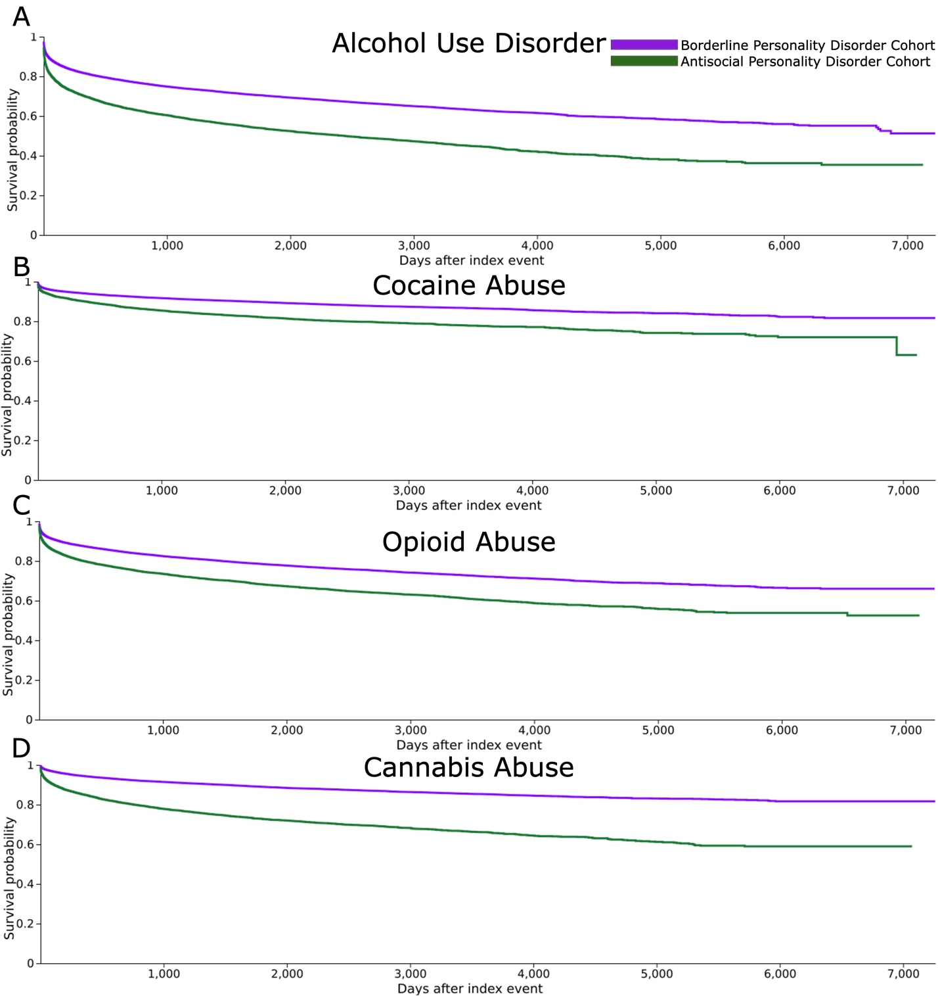
Kaplan-Meier survival curves for each specified substance use disorder outcome (A) alcohol use disorder; (B) cocaine abuse; (C) opioid abuse; (D) cannabis abuse. The index event is the diagnosis of BPD with nicotine dependence or ASPD with nicotine dependence.
Log-rank tests confirmed that the ASPD cohort had a significantly higher expected survival rate for all four outcomes compared to the BPD cohort. For alcohol use disorder, χ² = 1177.561, p < 0.001; for cocaine abuse, χ² = 1906.142, p < 0.001; for opioid abuse, χ² = 541.034, p < 0.001; and for cannabis abuse, χ² = 428.304, p < 0.001 (Table 5).
Table 5: Kaplan-Meier analysis: log-rank test
Substance Use Outcome | χ² | df | p-value
Alcohol Use Disorder | 1177.561 | 1 | <0.001
Cocaine Abuse | 1906.142 | 1 | <0.001
Opioid Abuse | 541.034 | 1 | <0.001
Cannabis Abuse | 428.304 | 1 | <0.001
χ2: Chi-square; df: Degrees of Freedom
Kaplan-Meier analysis with Cox proportional hazards models indicated that the BPD cohort had a significantly different hazard for all four outcomes compared with the ASPD cohort (Table 6). The hazard ratios were 0.568 (95% CI: 0.550–0.587) for alcohol use disorder, 0.367 (95% CI: 0.350–0.384) for cocaine abuse, 0.630 (95% CI: 0.606–0.655) for opioid abuse, and 0.569 (95% CI: 0.539–0.600) for cannabis abuse. Proportionality tests showed that the assumption of constant hazards over time was met for alcohol use disorder (χ² = 0.037, p = 0.848) and cannabis abuse (χ² = 0.349, p = 0.555), but violated for cocaine abuse (χ² = 9.177, p = 0.002) and opioid abuse (χ² = 5.726, p = 0.017), indicating that the hazard ratios for these outcomes may vary over the observation period.
Table 6: Kaplan-Meier analysis: hazard ratio and proportionality
Substance Use Outcome | Hazard Ratio (95% CI) | χ² | df | p-value
Alcohol Use Disorder | 0.568 (0.550, 0.587) | 0.037 | 1 | 0.848
Cocaine Abuse | 0.367 (0.350, 0.384) | 9.177 | 1 | 0.002
Opioid Abuse | 0.630 (0.606, 0.655) | 5.726 | 1 | 0.017
Cannabis Abuse | 0.569 (0.539, 0.600) | 0.349 | 1 | 0.555
CI: Confidence Interval; χ2: Chi-square; df: Degrees of Freedom

Discussion
Our study demonstrates that patients with ASPD and nicotine dependence have significantly greater risk of cocaine, cannabis, opioid, and alcohol abuse/dependence compared to patients with BPD and nicotine dependence. This finding is consistent with prior work showing that ASPD is a robust predictor of polysubstance use and externalizing psychopathology [3,9].
By restricting both cohorts to individuals with nicotine dependence, we were able to control for an important confounder. Nicotine dependence has long been recognized as a marker of heightened vulnerability to SUDs due to its shared neurobiological mechanisms with other substances [6,7,10,11]. Patients with nicotine dependence may exhibit higher impulsivity, reduced inhibitory control, and greater reinforcement sensitivity, all of which can promote progression to additional substance use [12].
The finding that ASPD patients were at higher risk than BPD patients across all four outcomes highlights important clinical distinctions between these disorders. Prior study by Walter et al. found that BPD was more strongly associated with SUDs than other personality disorders; however, they were unable compare BPD to ASPD [13]. Our results are consistent with Stetsiv et al., who reported that individuals with ASPD generally have higher risk of substance use disorders compared with those with BPD. By quantifying these risks in a cohort with nicotine dependence, our study adds comparative data that highlight the differential substance use profiles between ASPD and BPD [14]. While BPD is often characterized by self-injury, affective instability, and chaotic relationships, ASPD is more strongly associated with rule-breaking behavior, criminality, and persistent substance misuse [14]. These differences may explain the broader and more severe substance use profile observed in ASPD patients.
Clinically, these results underscore the importance of systematic screening for SUDs in patients with ASPD, particularly those with nicotine dependence. Interventions tailored to the unique behavioral and psychosocial challenges of ASPD, such as contingency management or intensive substance use treatment programs, may be warranted. For BPD patients, integrated approaches addressing both emotional dysregulation and substance misuse remain essential.
A major strength of our study is the use of the TriNetX database, which provides access to a large, diverse cohort of patients across multiple healthcare organizations. This enhances the external validity of our findings and increases the power of our statistical analyses.
However, several limitations should be acknowledged. This study used observational data, which inherently limits causal inference. Further, diagnoses were derived from EHR data, which may be subject to misclassification. Additionally, unmeasured confounders such as socioeconomic status, psychiatric comorbidities, and environmental exposures were not controlled for. Lastly, we could not assess severity of substance use or treatment outcomes. Future research should address these limitations through more granular prospective study.
Conclusion
In this large retrospective cohort study, among patients with nicotine dependence, ASPD is associated with significantly greater risk of cocaine, cannabis, opioid, and alcohol abuse/dependence compared with BPD. These findings emphasize important clinical differences between ASPD and BPD, highlighting the broader and more severe substance use profile in ASPD. Targeted screening, prevention, and intervention strategies are warranted to address the unique behavioral and psychosocial challenges faced by individuals with ASPD.

References
- Grant BF, Goldstein RB, Saha TD, Chou SP, Jung J, Zhang H, Pickering RP, Ruan WJ, Smith SM, Huang B, Hasin DS. Epidemiology of DSM-5 alcohol use disorder: results from the National Epidemiologic Survey on Alcohol and Related Conditions III. JAMA psychiatry. 2015 Aug 1;72(8):757-66.
- Trull TJ, Sher KJ, Minks-Brown C, Durbin J, Burr R. Borderline personality disorder and substance use disorders: A review and integration. Clinical psychology review. 2000 Mar 1;20(2):235-53.
- Goldstein RB, Compton WM, Pulay AJ, Ruan WJ, Pickering RP, Stinson FS, Grant BF. Antisocial behavioral syndromes and DSM-IV drug use disorders in the United States: results from the National Epidemiologic Survey on Alcohol and Related Conditions. Drug and alcohol dependence. 2007 Oct 8;90(2-3):145-58.
- Fossati A, Barratt ES, Carretta I, Leonardi B, Grazioli F, Maffei C. Predicting borderline and antisocial personality disorder features in nonclinical subjects using measures of impulsivity and aggressiveness. Psychiatry research. 2004 Feb 15;125(2):161-70.
- Zvolensky MJ, Jenkins EF, Johnson KA, Goodwin RD. Personality disorders and cigarette smoking among adults in the United States. Journal of psychiatric research. 2011 Jun 1;45(6):835-41.
- Kutlu MG, Parikh V, Gould TJ. Nicotine addiction and psychiatric disorders. International review of neurobiology 2015 Jan 1 (Vol. 124, pp. 171-208). Academic Press.
- Ren M, Lotfipour S. Nicotine gateway effects on adolescent substance use. Western Journal of Emergency Medicine. 2019 Aug 20;20(5):696.
- TriNetX. Real-world evidence research network. [Online resource].
- Low A, Stiltner B, Nunez YZ, Adhikari K, Deak JD, Pietrzak RH, Kranzler HR, Gelernter J, Polimanti R. Association patterns of antisocial personality disorder across substance use disorders. Translational Psychiatry. 2024 Aug 28;14(1):346.
- Dierker L, Braymiller J, Rose J, Goodwin R, Selya A. Nicotine dependence predicts cannabis use disorder symptoms among adolescents and young adults. Drug and alcohol dependence. 2018 Jun 1;187:212-20.
- Weinberger AH, Platt J, Esan H, Galea S, Erlich D, Goodwin RD. Cigarette smoking is associated with increased risk of substance use disorder relapse: a nationally representative, prospective longitudinal investigation. The Journal of clinical psychiatry. 2017 Feb;78(2):e152.
- Verdejo-García A, Lawrence AJ, Clark L. Impulsivity as a vulnerability marker for substance-use disorders: review of findings from high-risk research, problem gamblers and genetic association studies. Neuroscience & Biobehavioral Reviews. 2008 Jan 1;32(4):777-810.
- Walter M, Gunderson JG, Zanarini MC, Sanislow CA, Grilo CM, McGlashan TH, Morey LC, Yen S, Stout RL, Skodol AE. New onsets of substance use disorders in borderline personality disorder over 7 years of follow‐ups: Findings from the Collaborative Longitudinal Personality Disorders Study. Addiction. 2009 Jan;104(1):97-103.
- Stetsiv K, McNamara IA, Nance M, Carpenter RW. The co-occurrence of personality disorders and substance use disorders. Current psychiatry reports. 2023 Nov;25(11):545-54.

• brief rationale for choosing TriNetX
• Include data on duration of nicotine dependence if available — it could moderate SUD risk.

• Include a limitations paragraph about potential gender and racial imbalance (ASPD cohort heavily male vs. BPD cohort heavily female).

