Biomechanics of jumping and landing: The significance in athletes’ performance – A Scoping Review

ABSTRACT

Aim: To examine the biomechanics of jumping and landing and their significance in athletes’ performance.

Problem Statement: Many athletes still lack a deeper understanding of the fundamental biomechanics of jumping and landing, which hinders their performance during sporting activities.

Significance of Study: A critical analysis of the entire biomechanical parameters of jumping and landing is essential in each phase of developing efficient training programs to minimize non-contact injuries in athletes.

Methodology: This review article was compiled through a structured analysis of published research articles, scientific reports, and authoritative textbooks in the field of biomechanics. Sources were selected to cover both classical and contemporary perspectives on jumping and landing mechanics, with an emphasis on applied sports performance and injury prevention.

Discussion: Jumping and landing biomechanics strongly influence performance and injury risk in sports. Key factors include arm swing, squat depth, toe flexor strength, and non-extension movements [9–12,22–25]. Proper landing mechanics, such as joint angles and force absorption, reduce ACL and lower limb injuries [11,15,22,26]. Two-dimensional and three-dimensional simulation models help analyze forces, joint torques, and muscle activity. Understanding these mechanics allows coaches and athletes to improve training, enhance performance, and prevent injuries.

Conclusion: Effective jumping and landing require coordination, strength, and proper technique. Biomechanical insights can guide safer and more efficient training. Simulation models and motion analysis help optimize performance and reduce injury risk. Future studies should use advanced modeling and sport-specific analyses to refine training strategies.

Keywords: Biomechanics, Landing, Jumping, Athletes’ performance, Musculoskeletal dynamics

- INTRODUCTION
Jumping and landing are fundamental motor skills that underpin performance in a wide range of sports, from track and field to basketball and volleyball. Biomechanically, these tasks require precise coordination of lower-limb musculature to generate, transfer, and absorb forces across the hip, knee, and ankle joints. Efficient execution depends on a combination of concentric, eccentric, and stretch-shortening cycle (SSC) actions, which enable athletes to optimize power output while minimizing energy loss and injury risk [1,2].
Different jumping modalities present distinct biomechanical demands. Vertical jump tasks such as the countermovement jump, squat jump, and drop jump are widely used as standardized measures of lower-limb power and neuromuscular function [3]. In horizontal tasks such as the long jump, performance is determined by the ability to convert sprint velocity into vertical impulse while maintaining forward momentum, controlling angular momentum in flight, and executing technically efficient landings [4,5]. Elite long jumpers typically achieve distances of 8.0–9.0 m in men and 6.5–7.5 m in women, highlighting the extreme performance demands placed on both neuromuscular and technical capacities [6].
In the high jump, athletes use a curved approach run to generate angular momentum, producing inward lean and an optimal take-off angle for bar clearance. Biomechanical studies demonstrate that the take-off phase is extremely brief (0.13–0.18 s), requiring highly efficient SSC actions and coordinated arm and leg swings [7,8]. Unlike sprinting, the high jump emphasizes optimal rather than maximal approach speed, coupled with precise control of body orientation to facilitate the Fosbury flop technique clearance [9].
Landing mechanics are equally critical across vertical and horizontal jumps. Ground reaction forces during landings can reach 6–12 times body weight, placing athletes at significant risk of musculoskeletal injury, particularly in the knee joint. Poor landing technique, characterized by excessive knee valgus or inadequate eccentric control, is strongly linked to anterior cruciate ligament (ACL) injuries and other lower extremity pathologies [10–12]. Thus, advancing our understanding of jumping and landing biomechanics is essential not only for maximizing athletic performance but also for developing evidence-based injury prevention strategies.
Given the breadth of research on jumping and landing, a scoping review is warranted to map the available evidence, identify biomechanical determinants across different sports and movement types, and highlight gaps for future investigation. This article synthesizes findings from empirical studies, review articles, and authoritative biomechanics texts to provide a comprehensive overview of the biomechanical principles underlying jump execution and landing strategies.
- METHODOLOGY
- Framework
This scoping review followed the PRISMA-ScR guidelines to ensure transparency and reproducibility.
- Research Question
What are the key biomechanical mechanisms underlying jumping and landing across different sports, and how do these mechanisms influence performance optimization and injury prevention?"
Search Strategy
A systematic search was conducted in PubMed, Scopus, Web of Science, SPORTDiscus, and Google Scholar from inception to September 2025 using combinations of: “biomechanics” AND “jumping”; “biomechanics” AND “landing”; “vertical jump” OR “long jump” OR “high jump”; “drop jump” OR “countermovement jump”; and “simulation model” AND “jumping.” Reference lists of included studies and relevant reviews were screened for additional sources.
- Eligibility Criteria
Inclusion: Peer-reviewed studies, conference proceedings, or book chapters examining biomechanical aspects of human jumping or landing, including performance optimization, injury prevention, or simulation modeling; English language.
Exclusion: Studies without biomechanical outcomes, non-human research, case reports, or opinion pieces without empirical or modeling evidence.
- Data Synthesis
Data were synthesized narratively and organized thematically into vertical jumping mechanics, landing biomechanics, and simulation modeling, highlighting research gaps and emerging directions.
- VERTICAL jumping elements

Vertical jumping is a critical determinant of performance in sports such as basketball, volleyball, and handball, where the ability to achieve superior jump height often confers a competitive advantage. For example, basketball players rely on maximal vertical jumps for rebounding and shot blocking, while volleyball players depend on jump height for spiking and blocking [14,15]. Although most athletes intuitively understand the general act of jumping, relatively few fully appreciate the biomechanical factors that contribute to optimal jump height. Evidence suggests that non-extension movements, arm swing, squat depth, and toe flexor strength are among the most influential components of vertical jumping performance [16].
- Non-extension movements
Non-extension movements are defined as actions not directly involving lower limb extension, such as twisting, bending, rotation, and swinging motions. Although not traditionally considered central to jump mechanics, several studies demonstrate their importance in enhancing energy generation and transfer during take-off. For instance, biomechanical analyses of one-legged running jumps show that free-leg thigh swing, stance-leg calf action, and pelvic rotation contribute substantially to the vertical and horizontal velocity of the center of mass. Collectively, these movements can increase energy generation by up to 59% during take-off, with the free-leg thigh contributing the most, followed by the stance-leg calf and pelvis [17]. This finding suggests that athletes who optimize non-extension elements may improve efficiency in energy transfer, thereby achieving superior jump performance.
- Arm swing
The arm swing is one of the most extensively studied facilitators of jump height. Research consistently demonstrates that incorporating an arm swing during vertical jumps enhances jump height by increasing ground reaction forces and improving take-off velocity. A seminal study comparing arm-swing versus no-arm-swing conditions found significantly greater jump heights in the arm-swing condition, attributed to enhanced mechanical work and improved coordination between the upper and lower bodies [18,19]. The arm swing also plays an important role in stabilizing posture during flight and redistributing momentum, both of which contribute to overall jump efficiency. Figure 1 illustrates the biomechanics of the arm swing during a countermovement jump.

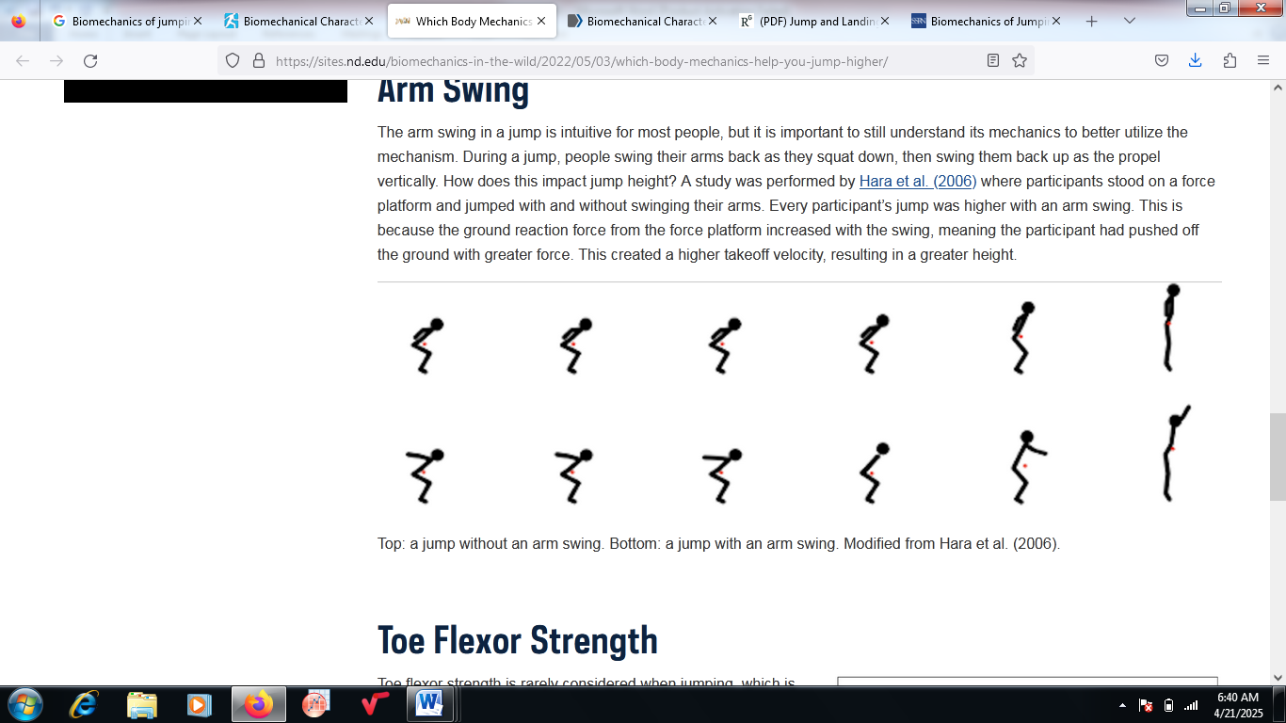
Figure 1: Schematic representation of the biomechanics of arm swing during vertical jumping.
- Squat depth
Squat depth is a critical determinant of force production during vertical jumping. The relationship between knee flexion angles at the initiation of take-off and jump performance has been investigated in controlled experiments. Athletes instructed to perform jumps from three squat depths (>90°, <90°, and self-selected natural depth) achieved their greatest jump height at <90° knee angles, corresponding to the deepest squat condition [20]. This effect is attributed to the enhanced capacity for force development through increased stretch–shortening cycle utilization and optimal alignment of joint angles at take-off. While natural self-selected depth provides moderate results, deeper squats appear to optimize take-off velocity and maximize jump height (Figure 2).
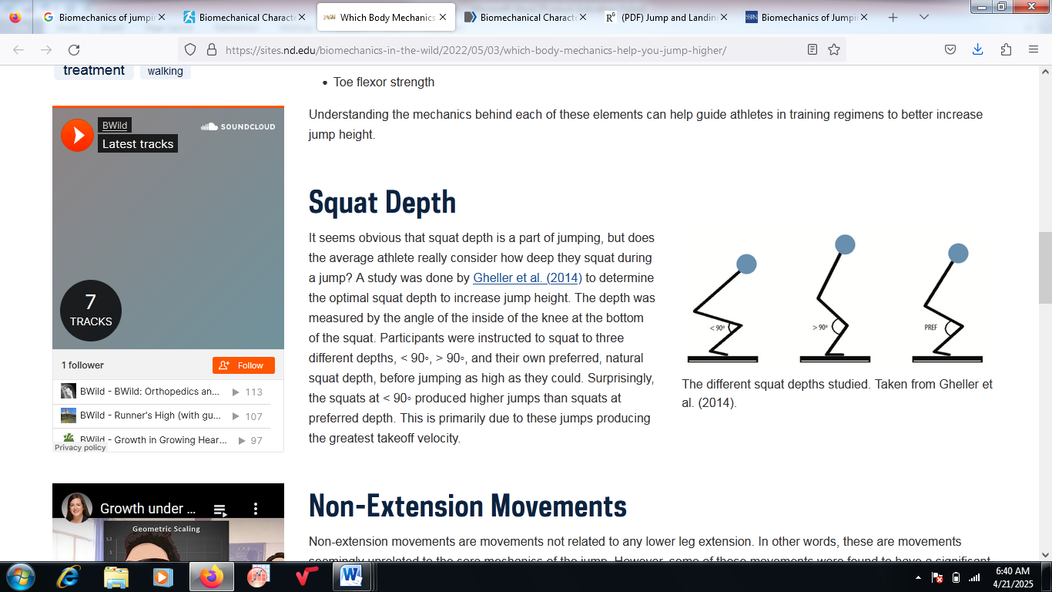
Figure 2: Illustration of three squat depths and their impact on vertical jump performance.
- Toe flexor strength
Although often overlooked, toe flexor strength contributes meaningfully to vertical jumping capacity. Experimental studies using toe grip dynamometry have demonstrated that athletes with stronger toe flexors achieve significantly greater jump heights [21]. This relationship is explained by the role of toe flexors in stabilizing the foot, enhancing propulsion during the terminal push-off phase, and increasing ground reaction force transmission. Training interventions that include targeted toe strengthening have been proposed as a means of improving vertical jump performance, albeit with modest gains relative to larger muscle groups.[22]. Figure 3 depicts the use of a toe grip dynamometer in the assessment of toe flexor strength.
.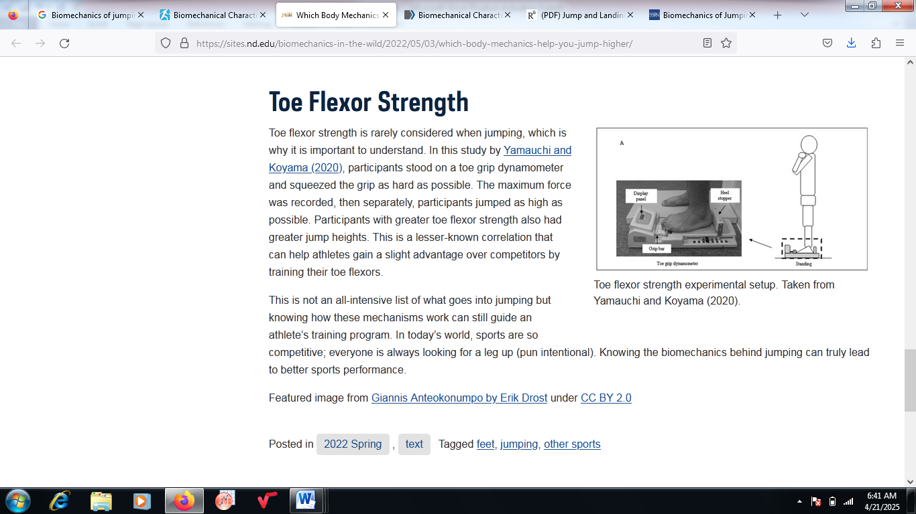
Figure 3: Athlete performing a toe grip dynamometer test for toe flexor strength.
- Synthesis of Evidence
The scoping evidence highlights that vertical jump performance is not solely a function of lower-limb extension strength but is significantly influenced by auxiliary biomechanical factors, including non-extension movements, arm swing, squat depth, and toe flexor strength. While arm swing and squat depth are widely recognized and supported by substantial empirical evidence, non-extension movements and toe flexor contributions remain relatively underexplored and warrant further research. A better understanding of these elements has direct implications for athlete training programs, emphasizing the need for comprehensive approaches that integrate both conventional and less conventional performance determinants.
- Biomechanics of jumping and landing

A comprehensive understanding of the biomechanics of jumping and landing is fundamental for developing accurate simulation models and evidence-based training protocols. Two primary assumptions are often made in biomechanical modeling of jump–land movements: first, that the mechanics of stepping off a box resemble those of a countermovement jump (CMJ), and second, that either task can be analyzed primarily within the sagittal plane [22]. Comparative studies examining joint kinematics and ground reaction forces (GRF) support the notion that these two tasks exhibit substantial biomechanical similarities, particularly during the characterization of the human jump [23]. However, subtle differences emerge, especially in pre-landing mechanics and lower body positioning at ground contact, which may influence injury risk and performance outcomes [24].
Peak GRF tends to occur more rapidly during a drop landing than a countermovement jump, while CMJs are associated with greater joint angular displacement and higher muscle activation at landing [25]. These distinctions imply that CMJ and drop vertical jump protocols may be selected strategically depending on sport-specific demands, particularly where impact attenuation and deceleration of the center of mass are performance-relevant factors [26]. The capacity of these tasks to produce distinct kinematic and kinetic profiles highlights the importance of aligning simulation techniques with the objectives of a given investigation or training program.
The landing phase is typically divided into preparatory, loading (braking), and attenuation (absorption) stages. These phases occur within milliseconds and are most accurately distinguished using synchronized force platform, electromyography (EMG), and motion capture data [27]. Effective landing mechanics rely on energy absorption strategies that attenuate impact forces, with inadequate technique linked to increased anterior cruciate ligament (ACL) injury risk. For example, elevated knee abduction angles during drop jump landings are consistently associated with higher ACL loading [28]. Although drop jump protocols are frequently used to assess landing biomechanics, their ecological validity has been questioned due to differences compared with spontaneous game-related landings [29]. Neuromuscular training, fatigue protocols, and warm-up strategies are among the interventions known to modulate landing biomechanics, thereby influencing ACL injury risk [30].
.

4.1 simulation techniques of jumping

Simulation models are powerful tools for investigating the mechanical determinants of jumping and landing, as well as for exploring performance optimization and injury prevention strategies. These models are generally categorized as two-dimensional (2D) or three-dimensional (3D), depending on the level of anatomical and biomechanical complexity represented.

- Two-dimensional models
2D models typically focus on sagittal-plane analysis and allow for theoretical exploration of how landing techniques influence joint loading and jump performance. Simplified models treat body segments as discrete masses connected by springs and dampers, representing muscle contractions and external forces [31]. More advanced musculoskeletal approaches represent the human body as linked segments actuated by torque generators or muscle models. Such frameworks allow researchers to simulate vertical jump performance under varying initial postures, GRF profiles, and squat depths, offering insights into how technique modifications alter mechanical outputs [32]. Figure 4 illustrates a representative 2D skeletal model for human jumping.
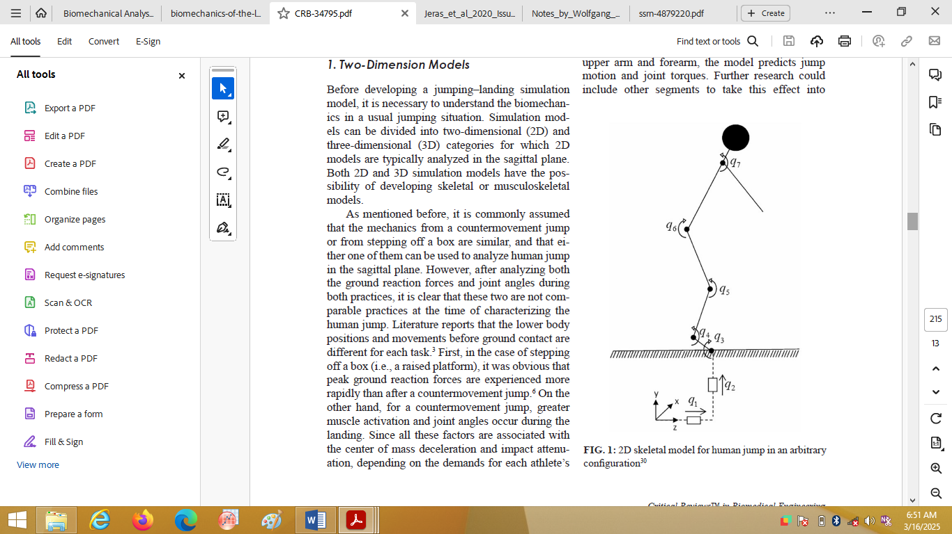
Figure 4: Two-dimensional skeletal model of a human jump in an arbitrary configuration

- Three-dimensional models

3D musculoskeletal simulations provide more comprehensive insights by incorporating multiple degrees of freedom and modeling muscle-tendon dynamics across the full body. Predictive dynamics approaches have been applied to 3D skeletal models with up to 55 degrees of freedom, enabling estimation of joint torques, kinematics, and external forces under varying conditions [33]. These models capture redundancy in joint and muscle space, allowing for more physiologically accurate representations of human movement. Inverse dynamics analyses further extend 3D models by incorporating upper-body contributions, such as arm swing, which substantially enhance vertical displacement of the center of mass [34].
Moreover, 3D approaches permit detailed mapping of muscle attachment sites, activation patterns, and force-length-velocity properties, offering a granular perspective on the interaction between biomechanics and neuromuscular control. This level of detail is particularly relevant for sports where precise technique differentiates elite from sub-elite performers [35].
- DISCUSSION
Jumping and landing biomechanics are among the most critical determinants of both athletic performance and injury risk across a wide range of sports. This review synthesized evidence from experimental studies, motion analyses, and simulation models to highlight key biomechanical principles underlying effective jumping and landing strategies.
The analysis demonstrates that factors such as arm swing, squat depth, toe flexor strength, and non-extension movements significantly influence vertical jump height and takeoff efficiency [9-12,22-25]. Similarly, landing mechanics, including impact absorption, joint angles, and neuromuscular control, play a central role in attenuating forces and reducing the risk of lower limb injuries, particularly to the anterior cruciate ligament (ACL) [11,15,22,26].
Simulation models, both two-dimensional and three-dimensional, offer valuable insights into musculoskeletal dynamics and allow for predictive analyses of athlete-specific adaptations, training interventions, and injury prevention strategies [16-18]. These models bridge the gap between theoretical principles and practical application by enabling detailed examination of joint torques, ground reaction forces, and the interaction of multiple body segments during complex jumping and landing maneuvers.
Overall, understanding these biomechanical mechanisms provides coaches, trainers, and athletes with evidence-based guidance for optimizing training regimens, technique modifications, and injury mitigation strategies. Integrating biomechanical assessment into regular training can enhance performance outcomes while reducing injury incidence, especially in high-impact and competitive sports.
- CONCLUSION
The current scoping review highlights that effective jumping and landing biomechanics are foundational to both athletic performance and injury prevention. Key factors such as limb coordination, joint positioning, muscle strength, and body segment interactions significantly influence jump efficiency and landing safety.
Incorporating biomechanical insights into athlete training, technique refinement, and simulation-based modeling can facilitate safer, more effective performance outcomes. Future research should continue to integrate advanced motion capture, musculoskeletal modeling, and sport-specific analysis to refine training interventions and enhance our understanding of the biomechanical determinants of athletic success. Continuous exploration of these variables, supported by advanced simulation models, is essential for bridging the gap between laboratory-based biomechanical insights and applied sports practice. Future research should prioritize integrating sport-specific contexts, equipment design, and innovative training methodologies to enhance both safety and performance outcomes.
- Competing interests

The authors have declared that no competing interests exist.

- Disclaimer (Artificial intelligence)
The author, Iyanuoluwa Animasaun, affirms that this manuscript was prepared independently, without the use of generative artificial intelligence technologies, including large language models (e.g., ChatGPT, Copilot) or text-to-image generators. All writing, analysis, and editorial decisions reflect the author’s original work, and no AI tools contributed to the intellectual content or presentation of this manuscript.

References

- Lees, A., Vanrenterghem, J., & De Clercq, D. (2004). Understanding How an Arm Swing Enhances Performance in The Vertical Jump. Journal Of Biomechanics, 37(12), 1929–1940.
- Bobbert, M. F., & Van Soest, A. J. (2001). Why Do People Jump the Way They Do? Exercise And Sport Sciences Reviews, 29(3), 95–102.
- Hewett, T. E., Myer, G. D., & Ford, K. R. (2005). Reducing Knee and Anterior Cruciate Ligament Injuries Among Female Athletes: A Systematic Review of Neuromuscular Training Interventions. Journal Of Sports Medicine, 33(6), 427–435.
- Markovic, G., & Mikulic, P. (2010). Neuro-Musculoskeletal and Performance Adaptations to Lower-Extremity Plyometric Training. Sports Medicine, 40(10), 859–895.
- Hay, J. G. (1993). The Biomechanics of Sports Techniques (4th Ed.). Prentice Hall.
- Bridgett, L. A., & Linthorne, N. P. (2006). Changes In Long Jump Take-Off Technique with Increasing Run-Up Speed. Journal Of Sports Sciences, 24(8), 889–897.
- Dapena, J. (1990). Biomechanics Of High Jumping. In: Cavanagh, P. R. (Ed.), Biomechanics of Distance Running. Human Kinetics.
- Schiffer, J. (2009). The Biomechanics of The High Jump: A Review. New Studies in Athletics, 24(1), 41–56.
- Killing, W. (2003). Biomechanical Analyses of High Jump Technique. New Studies in Athletics, 18(2), 29–46.
- Lees A, Vanrenterghem J, De Clercq D. (2004). Understanding How an Arm Swing Enhances Performance in The Vertical Jump. J Biomech, 37(12), 1929–1940.
- McBride Jm, Kirby Tj, Haines Tl, Skinner Jw. (2010). Relationship Between Maximal Squat Strength and Five, Ten-, And Forty-Yard Sprint Times. J Strength Cond Res, 24(1), 295–299. (Used Often to Anchor Squat Depth–Performance Mechanics.)
- Yamauchi J, Koyama K. (2011). Relationship Between Toe Flexor Strength and Jump Performance in Athletes. Eur J Appl Physiol, 111(3), 547–554.
- Fukui T, Kaneoka K, Takahashi H, Shiraishi M, Sumiya T. (2015). Toe Flexor Strength Training for Performance Enhancement: A Randomized Controlled Trial. Sports Health, 7(3), 250–257.
- Sheppard Jm, Cronin Jb. (2008). “Defining Strength and Power Qualities in Sport Performance: A Review.” J Strength Cond Res.
- Ziv G, Lidor R. (2010). “Vertical Jump in Female and Male Basketball Players—A Review of Observational and Experimental Studies.” J Sci Med Sport.
- Bobbert Mf, Van Soest Aj. (2001). “Why Do People Jump the Way They Do? Modeling And Simulation of Vertical Jumping.” Sports Biomech.
- Lees A, Vanrenterghem J, De Clercq D. (2004). “Understanding How an Arm Swing Enhances Performance in The Vertical Jump.” J Biomech.
- Harman Ea, Rosenstein Mt, Frykman Pn, Rosenstein Rm. (1990). “The Effects of Arms and Countermovement on Vertical Jumping.” Med Sci Sports Exercise.
- Hara M, Shibayama A, Takeshita D, Fukashiro S. (2006). “The Effect of Arm Swing on Lower Extremities in Vertical Jumping.” J Biomech.
- Domire Zj, Challis Jh. (2007). “Maximum Height and Minimum Time Vertical Jumping.” J Biomech.
- Yamauchi J, Koyama K. (2011). “Relationship Between Toe Flexor Strength and Jump Performance in Athletes.” Eur J Appl Physiol.
- Fukui T Et Al. (2015). “Toe Flexor Strength Training for Performance Enhancement: A Randomized Controlled Trial.” Sports Health.
- Devita P, Skelly Wa. Effect Of Landing Stiffness on Joint Kinetics and Energetics in The Lower Extremity. Medicine & Science in Sports & Exercise. 1992;24(1):108–115.
- Zhang Sn, Bates Bt, Dufek Js. Contributions Of Lower Extremity Joints to Energy Dissipation During Landings. Medicine & Science in Sports & Exercise. 2000;32(4):812–819.
- McNitt-Gray JL. Kinetics of The Lower Extremities During Drop Landings from Three Heights. Journal Of Biomechanics. 1993;26(9):1037–1046.
- Cowling Ej, Steele Jr, McNair Pj. Effect Of Verbal Instructions on Muscle Activity and Risk of Injury to The Anterior Cruciate Ligament During Landing. British Journal of Sports Medicine. 2003;37(2):126–130.
- Yeow Ch, Lee Pv, Goh Jc. Sagittal Knee Joint Kinematics and Energetics in Response to Different Landing Heights and Techniques. Knee. 2010;17(2):127–131.
- Hewett Te, Myer Gd, Ford Kr. Mechanisms, Prediction, And Prevention of ACL Injuries: Cutting Edge Concepts and Future Directions. British Journal of Sports Medicine. 2016;50(13):837–840.
- Kristianslund E, Faul O, Bahr R, Myklebust G, Krosshaug T. Sidestep Cutting Technique and Knee Abduction Loading: Implications for ACL Prevention Exercises. British Journal of Sports Medicine. 2014;48(9):779–783.
- Gokeler A, Dingenen B, Mouton C, Seil R. Clinical Course and Recommendations for Training After Anterior Cruciate Ligament Reconstruction: A Scoping Review. British Journal of Sports Medicine. 2017;51(13):1060–1066.
- Pandy Mg, Zajac Fe. Optimal Muscular Coordination Strategies for Jumping. Journal Of Biomechanics. 1991;24(1):1–10.
- Anderson Fc, Pandy Mg. Dynamic Optimization of Human Walking. Journal Of Biomechanical Engineering. 2001;123(5):381–390.
- Van Der Krogt Mm, Doorenbosch Ca, Harlaar J. Modelling and Simulation of Jumping Using A 3d Musculoskeletal Model. Journal Of Biomechanics. 2005;38(6):1189–1198.
- Hatze H. A Three-Dimensional Multivariate Model of The Human Locomotor System. International Journal of Sports Medicine. 1981;2(4):245–250.
- Zajac Fe. Muscle And Tendon: Properties, Models, Scaling, And Application to Biomechanics and Motor Control. Critical Reviews in Biomedical Engineering. 1989;17(4):359–411.

