Effect of mechanization combined with organomineral fertilization, soaking and seed coating on the agronomic performance of peanut (Arachis hypogaea) cultivation.

Abstract
In a context of low peanut productivity in Niger, particularly in the Maradi and Zinder regions, this study aims to evaluate the effectiveness of technologies combining mechanization, seed treatment (soaking, coating) and localized fertilization. A randomized complete block experimental design was implemented on 3 sites, comparing five treatments. The study was conducted for two years (2023-2024). The results reveal that treatments integrating mechanization drawn by the Gangaria seeder, localized fertilization and soaking significantly increased grain yields to 56 and 75% respectively for T4 and T5 compared to the control T0. Haulm yield also increased by 61 and 63% respectively for T4 and T5 respectively compared to the control T0. These treatments also reduced the duration of plant maturity from 12 to 11 days respectively for T5 and T4. Labor requirements were reduced by 1.05 and 0.99 d/ha with a workforce of 2 people respectively for T5 and T4 against 11 h/d/ha for manual treatment with microdosing T1. The net margin is 573702 and 479718 FCFA/ha respectively for treatment T5 and T4 against 432860 FCFA/ha for the control T0. These results show the agronomic and economic interest of combining mechanization and innovative technologies to sustainably improve peanut productivity among rural producers.
Keywords: Mechanization, microdosing, soaking, coating, yield
Introduction
Peanut ranks 5th among the world's oilseed crops, after palm oil, soybean, rapeseed and sunflower. Peanut is an important oil, food and fodder legume crop grown in more than 100 countries, covering an area of 25.44 million ha worldwide and generating a total production of 45.22 million tonnes of pods in 2013 (Nterany and David, 2015) . Africa provides about 25% of the production. In West Africa, peanut cultivation is almost exclusively carried out on family farms and on small areas (YAO, 2015) .
In Niger, peanuts are the main cash crop introduced during colonization, mainly to help farmers pay their taxes. The crop benefited from the best land and the produce was bought at a good price, a marketing structure as well as processing plants (shelling plant, Magaria Matameye-Maradi oil mill) in addition to traditional processing. Between 1960 and 1973, peanuts had a very good production (260,200 t in 1972 for 418,500 ha sown) and provided the State, along with livestock and cotton, with the bulk of its agricultural budget revenue (INRAN, 2007) .
Peanut occupies an area of 1,003,762 ha, with a production of 670,613 tons and a yield of 668 kg/ha (MAE, 2023) . Peanut producers face problems of low yields, biotic and abiotic aggressions, poor access to improved varieties, and limited use of mechanization under conditions of labor availability (Nterany and David, 2015) .
Agricultural research over the last twenty years demonstrates the need to combine organic resources and mineral fertilizers to increase soil fertility, improve crop yields and the livelihoods of farmers ( Fairhurst, 2015) . Animal traction contributes to improving human labor productivity and productivity per unit of cultivated area. Human labor productivity is improved through the use of draft animals, which allows for greater efficiency and quality of work, and greater speed of intervention (Philipe et al., 2010) . Mechanization must be combined with improved agricultural technologies to increase its profitability. Seed soaking and treatment and fertilizer microdosing are two technologies compatible with mechanization (Bernt et al., 2020) . The objective of this study is to investigate the effect of the double hopper seeder (seed and fertilizer) combined with seed soaking and coating on the agronomic performance of peanuts.
2. Materials and methods
2.1. Material
- Plant material: the peanut variety JL 24 which has a 90-day cycle and is drought tolerant, but susceptible to Cercospora leaf spot and collar rot. ICRISAT is the breeder and maintainer of the variety (INRAN, 2021) .
- A double hopper seeder (seed and fertilizer) “Gangaria”
- A pair of oxen for traction
- The animal-drawn cultivator for weeding
- NPK Triple 15 Fertilizer
- Compost:
- Fungicide: for seed coating
- Stake: to mark out plots
- 1 decameter: to measure distances
- Long-handled hoe for manual sowing
- Basin for preparing the soaking
2.2. Methods
Seeds for T5 and T4 treatments were soaked in water (Figure 2) for 4 hours and dried in the shade for 2 hours (Figure 3). After drying, the peanut was also treated with a combined fungicide (Calthio D5) at a rate of 4g/kg of seed. The compost was mixed with NPK triple 15 fertilizer in powder form to obtain two doses of organomineral fertilizer (Figure 1). One dose containing 25g of compost + 0.3g of NPK triple 15 and another containing 25g of compost + 0.6g of NPK triple 15.
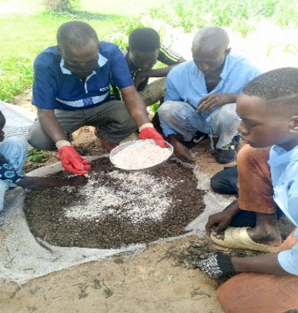
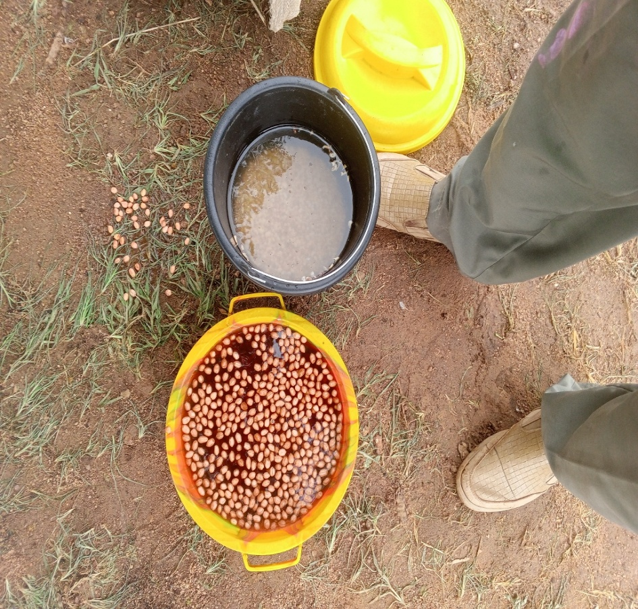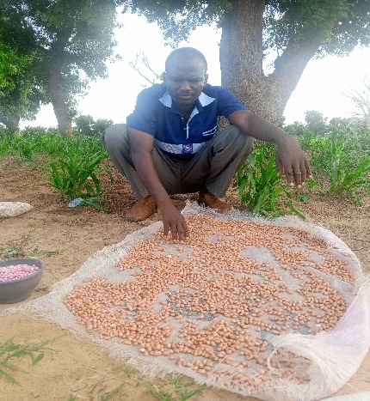
Figure3 : Drying soaked seed
Figure 1 : NPK Triple 15 Fertilizer Compost Mix
Figure2 : Seed soaking

Sowing was carried out using a prototype animal-drawn seed drill called "Gangaria", specifically adapted for peanut cultivation (Figure 6). This seed drill was initially developed in 2018 by the National Institute of Agronomic Research of Niger (INRAN) and manufactured by the Agricultural Equipment Construction Unit (UCOMA) in Zinder, for sowing cereal crops. In 2023, technical modifications were made to this prototype by the Nigerien Metal Fabrication Unit (UNIFAM) in Maradi, with the aim of improving its performance and adapting it to the specific requirements of peanut sowing. The modified seed drill is a single-row type. It is equipped with a double-compartment hopper (Figure 4), one of which is intended for seeds and the other for fertilizers. It also includes a seed coulter coupled with a coulter, two skimmers, two drive wheels, a tracer for marking the sowing lines, a press wheel for closing the furrows, as well as a distribution system consisting of distributor discs mounted on the wheel drive axle. This device allows the simultaneous distribution of seeds and fertilizers (Figure 5). The seed distributor disc, equipped with four cells with a unit volume of 1.35 × 10⁻⁶ m³, deposits one to two peanut seeds every 25 cm. As for the fertilizer distributor disc, it has holes with a volume of 12 × 10⁻⁵ m³, allowing a dose of approximately 25 g of compost enriched with 0.3 to 0.6 g/pocket of mineral fertilizer of the NPK 15-15-15 type to be delivered. The distance between the sowing lines is set at 30 cm using the tracer integrated into the seeder.
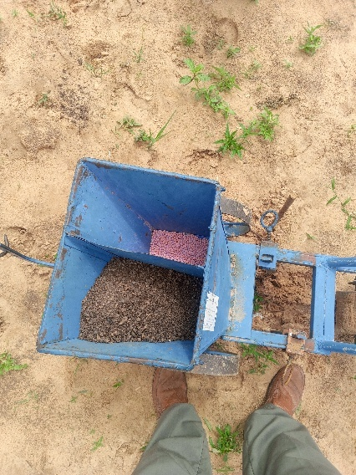
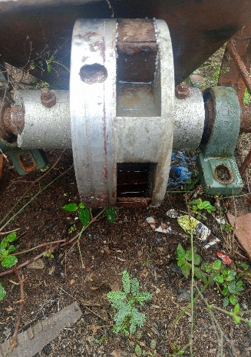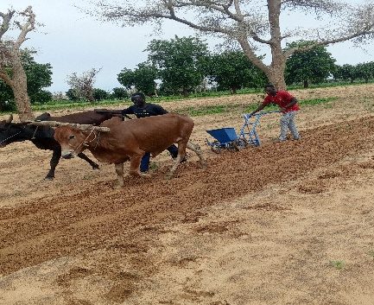
Figure5 : Seed and compost distributor
Figure 6 : Animal-drawn Gangaria seeder
Figure 4 : Double compartment hopper

2.2.1. Experimental Site
The trial was conducted for two years (2023 and 2024) in the Regional Agricultural Research Centers (CERRA) of Maradi and Zinder. The Maradi region is located between latitude 13°30'00'' North and longitude 7°06'06'' East and that of Zinder is located between latitude 13°48'25 '' North and longitude 8°59'17'' East (Figure 7). These two regions constitute the agricultural hub par excellence of the country. They contribute 79% to the national peanut production (Ministry of Agriculture, 2023) . The Maradi and Zinder regions are located in south-central Niger and have predominantly sandy soils. Annual rainfall in these regions varies from 400 to 500 mm (Bakoye et al., 2019) .
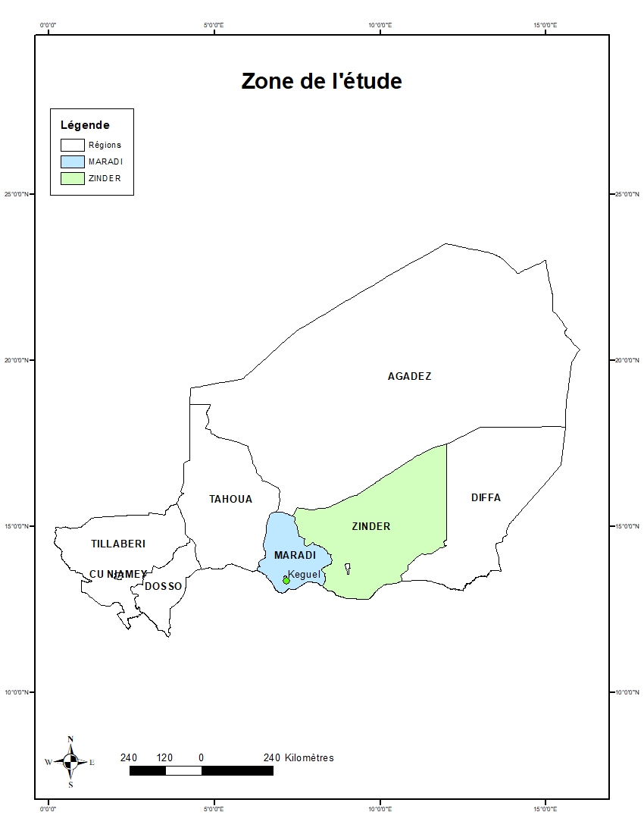
Figure 7: Map of the study area
2.2.2 Experimental device
The experimental device is a Fisher block composed of 2 factors:
- Mechanization
- Fertilization
Mechanization has 2 levels:
- Mechanized activity (mechanized sowing and weeding)
- Non-mechanized activity (manual sowing and weeding)
Fertilization has 3 levels:
- 0g of NPK triple15+0g of compost
- 0.3g/pack of triple NPK 15+25g of compost
- 0.6g/pack of NPK triple 15+ 25g of compost

2.2.4. Description of treatments
- T0: Non-mechanized activity + 0g of triple NPK15 + 0g of compost
- T1: Non-mechanized activity + 0.3g/pocket of triple NPK15 + 25g of compost
- T2: Non-mechanized activity + 0.6g/pack of NPK triple15 + 25g of compost
- T3: Mechanized activity + 0g of triple NPK15 + 0g of compost
- T4: Mechanized activity + 0.3g/pocket of triple NPK 15 + 25g of compost
- T5 : Mechanized activity + 0.6g/pocket of triple NPK 15 + 25g of compost
In a block, each elementary plot has an area of 50m² (5mx10m) and the spacing between plots is 1.5m. The area of a block is 375m². The blocks are spaced 2m apart with 4 repetitions. The total area of the experimental device is 1725m². Sowing was done on July 15 and 18, 2023 respectively in Zinder and Tuesday and on July 5 and 12, 2024 still respectively in Zinder and Maradi. The first and second weeding were done using an animal-drawn weeder.
2.2.5. Chemical characterization of soils from study sites
Soil samples were collected using a diagonal method, using a hand auger, from the topsoil (0–20 cm). At each site, 5 sub-samples (200 g) were homogenized to constitute a composite sample (1 kg), labeled and transported to the INRAN Soil, Water, Plant and Fertilizer Analysis laboratory. In the laboratory, the samples were air-dried, ground and sieved to 2 mm. Analyses included pH (pH-water), electrical conductivity, exchangeable bases (Ca²⁺, Mg²⁺, Na⁺, K⁺), cation exchange capacity (CEC), total organic carbon (C), total nitrogen (N), total and available phosphorus (P) and total potassium (K). pH-water was measured according to ISO 10390:2021. Organic carbon was determined by the method of Walkley and Black (1934). Total nitrogen was determined by Kjeldahl, following the recommendations of Bremner (1996). Available phosphorus was measured by the colorimetric method of Murphy and Riley (1962). Potassium was quantified by emission (flame photometry/AA) on appropriate extracts. Exchangeable compounds were extracted with ammonium acetate at pH 7 and the CEC was calculated by base summation (Clement and Francois, 2009) .
2.2.6. Data collection and analysis
2.2.6. 1. Agronomic variables measured
- The date and rate of lifting
Peanuts emerge when the hypocotyl and cotyledon break through the soil surface. The emergence date is the date the hypocotyl and cotyledon appear on the soil surface and is expressed as the number of days after sowing. The emergence rate is the proportion of seeds emerged compared to the number sown.
- The 50% Maturity Date: this is defined as the number of days after sowing required for half of the plants in a crop to reach physiological maturity.
- The number of pods per plant
- The number of seeds per plant
- The weight of 100 seeds
- The weight of dried leaves

2.2.6.2. Peanut yield development
Peanut yield is the combination of several components. These include the number of plants per unit area, the number of mature pods per plant, the number of dried seeds per pod and the weight of 100 seeds. Each of them is developed during a different phase of the crop cycle. They interact in cascade, under the influence of the environment (climate, soil, cultural practices) The harvest was made in the useful plot (PU) of 41.8 m² placed in each elementary plot. Before harvesting, a sample of 13 pockets contained on 1 m² is collected in each PU for the purposes of analyzing the yield components. The drying of the fresh pod harvest was done for 15 days in the open air. The seed yield per hectare is estimated from the product between (PU seed weight + Standard sample seed weight) and (10,000 m ² / Area in m ² of the PU). The haulm yield per hectare is estimated from the product between (PU haulm weight + Standard sample haulm weight) and (10,000 m ² / Area in m ² of the PU) (ECOWAS, 2021) .
2.2.6. 3. Economic Analysis of the Results
Finally, agricultural income was estimated based on yields and average sales prices observed on local markets for grains and haulms. Gross margin was calculated as the difference between total revenues and operating expenses, while net margin included all costs, including depreciation. The economic evaluation was conducted based on technical and financial data collected from 235 peanut producers located in the Maradi and Zinder regions. These data included input costs (seeds, fertilizers, compost, pesticides), labor costs (land cleaning, sowing, weeding, harvesting), and transportation costs. In addition, fixed costs were included through depreciation of agricultural equipment used (seeder and cultivator), calculated based on their useful life.
2.2.6.4. Classification of production costs
As part of this study, two main categories of costs were identified: variable costs, which vary according to the level of activity, and fixed costs, which are independent of the production volume.
- Variable charges
Variable costs cover all expenses directly related to agricultural production. They include the costs of seeds, fertilizers, plant protection products, labor, and transportation. Each pocket, for treatments T1 and T4, received a dose of 0.3 grams of NPK fertilizer (formulation 15-15-15), mixed with 25 grams of compost. Each pocket for treatments T2 and T5 received a dose of 0.6 g/pocket of NPK fertilizer (formulation 15-15-15), mixed with 25 grams of compost. Regarding seeds, needs vary depending on the sowing method used. Mechanized sowing requires 55 kilograms of seeds per hectare, while manual sowing requires 60 kilograms per hectare. The unit price of seeds is set at 1,000 FCFA per kilogram. Other inputs include pesticides, sold at 350 FCFA per 20-gram bag, NPK triple 15 fertilizer at 360 FCFA per kilogram, and compost, valued at 80 FCFA per kilogram. Packaging includes the cost of purchasing the bags and the labor involved in bagging them.
- Labor costs
The cost of labor is set at 1,500 FCFA per man-day. Two phases are distinguished in the analysis of labor costs:
Non-harvest cultivation operations, ranging from the initial clearing of the land to the final weeding. The labor cost for manual treatment without the addition of fertilizers amounts to 57,000 FCFA/ha. For mechanized cultivation incorporating microdosing of organomineral fertilizers, the cost is estimated at 2,000 FCFA/ha. On the other hand, for manual cultivation requiring the addition of fertilizers, this amount reaches 72,000 FCFA/ha.
The harvesting phase encompasses a series of successive operations including uprooting the plants, piling them into piles, threshing, separating the pods and tops, hulling, and packaging. This stage remains particularly labor-intensive. Among these operations, only hulling benefits from partial mechanization. The labor cost allocated to harvesting varies significantly depending on the treatment method, ranging from 38,400 FCFA/ha for the T0 treatment (manual sowing without fertilization) to 80,500 FCFA/ha for mechanized sowing with localized fertilization (Table 4).
- Transportation costs
Transportation also represents a significant variable cost. The average price for transporting a 100-kilogram bag of peanuts to a weekly market is 300 FCFA. Transportation costs vary depending on production volume and range from 2,796 to 4,257 FCFA/ha (Table 6). The latter is zero for mechanized processing because producers use their carts to transport their agricultural produce.
Fixed charges
Fixed costs mainly concern the depreciation of the equipment used, particularly the seeder and the cultivator. The annual depreciation allowance was calculated by dividing the acquisition cost of each piece of equipment by its average lifespan, estimated at ten years. Thus, the annual depreciation amounts to 15,000 FCFA for the seeder and 11,000 FCFA for the cultivator. The selling prices were determined from a survey conducted in 2023 among 235 peanut producers spread between the Maradi and Zinder regions. The data collected indicate that the average price of a 100 kg bag of shelled peanuts varies between 58,000 and 65,000 FCFA during the year, while that of a 45 kg bag of dried haulm fluctuates between 750 and 2,000 FCFA. Based on these prices, revenues from the sale of peanut grains and haulms were estimated by multiplying the average yields observed during the trial for grains (Table 2) and dried haulms (Table 4) by the corresponding average prices. The collected data were processed using SPSS 26 and Statistic 8.1 software to analyze and compare the averages.
3. Results
3.1. Soil characteristics of the Maradi sites
The soil pH is 4.55 (Table 1), indicating very marked acidity. This level is below the optimal range for nutrient availability, generally between 5.5 and 7.5 (Horneck and Own, 2011) . The electrical conductivity of 0.00 dS/m (Table 1) confirms the absence of saline stress. The cation exchange capacity (CEC) of 0.80 cmol/kg (Table 1) classifies this soil as a very sandy soil, characterized by low nutrient retention and increased susceptibility to leaching (Ciric et al., 2023) . The base saturation rate reaches 82.5%, but the total reserve remains low due to the low CEC. The available phosphorus content is 8.91 ppm (Table 1), a level considered very low (Ray and Brady, 2017) . Organic matter is 0.229% (C ≈ 0.133%) (Table 1) and total nitrogen is 0.00143%, leading to a very high C/N ratio (92.9), indicating slow decomposition and reduced nitrogen availability (Chen et al., 2023) .
3.2. Characteristics of the soil at the Keguel site
The soil pH is 5.33 (Table 1), indicating strong acidity. The electrical conductivity of 0.01 dS/m (Table 1) confirms the absence of saline stress. The CEC of 1.00 cmol/kg (Table 1) classifies this soil as a very sandy soil, with a low nutrient retention capacity and a high sensitivity to acidification ( Ciric et al., 2023). The base saturation rate is 92.0% (Table 1), but the total reserve remains limited by the low CEC. The available phosphorus content is 20.84 ppm, considered adequate (Brady & Weil, 2017). Organic matter is 0.196% (C ≈ 0.114%) and total nitrogen is 0.003% (Table 1), with a C/N ratio of 35.0, indicating more mature organic matter and faster mineralization (Chen et al., 2023) .
3.3. Characteristics of the soil at the Zinder site
The soil pH is 5.63 (Table 1), indicating moderate acidity (Horneck and Own, 2011) . The electrical conductivity of 0.01 dS/m (Table 1) indicates the absence of salinity. The CEC of 0.96 cmol/kg (Table 1) also classifies this soil as sandy, with low nutrient retention capacity and increased sensitivity to acidification (Ciric et al., 2023) . The base saturation rate is 87.5% (Table 1), but the total reserve remains low due to the low CEC. The available phosphorus is 3.93 ppm, indicating a phosphorus deficiency (Ray and Brady, 2017) . Organic matter is 0.189% (C ≈ 0.110%) (Table 1) and total nitrogen is 0.003% (Table 1), leading to a C/N ratio of 34.0 (Chen et al., 2023) .
Table 1: Results of chemical analyses of soils at the study sites
Sample. Soil | pH | THIS | Meq /100g |  |  |  |  |  | ppm | %
Site | Water | ms /cm | Ca ²⁺ | Mg ²⁺ | Na ⁺ | K ⁺ | CEC | AE | Phos. A | Carb | MO | Nitrogen | C/N
Keguel | 5.33 | 0.01 | 0.48 | 0.288 | 0.104 | 0.048 | 1,000 | 0.08 | 20.84 | 0.196 | 0.34 | 0.003 | 35.0.
CERRA Zinder | 5.63 | 0.01 | 0.478 | 0.290 | 0.028 | 0.044 | 0.960 | 0.12 | 3.93 | 0.189 | 0.33 | 0.003 | 34.0
CERRA Maradi | 4.55 | 0 | 0.321 | 0.288 | 0.032 | 0.018 | 0.799 | 0.14 | 8.91 | 0.229 | 0.40 | 0.001 | 92.9.
3.4 . Treatment effect on germination (3.5 days after sowing)
The emergence rate is 86.85 and 30% for treatments T5, T4 and T3 respectively at 3.5 days on average after sowing. On the other hand, it is 40.37 and 21% for treatments T2, T1 and T0. The analysis of the results with Statix 8.1 software shows that there are no significant differences in germination rates between treatments T5 and T4, however, the latter are significantly different from the other treatments. The emergence percentages of treatments T2 and T1 are significantly different not only from T0 but also from T3. The interaction of treatments, site and year also has a highly significant effect ((Table 2).
Table 2: Effect of treatments on the percentage of germination 3.5 days after sowing
Percentage raised (%)
Site | Year | T0 | T1 | T2 | T3 | T4 | T5
Maradi | 2023 | 16 ±1.71d | 32±1.29 b | 34±0.58 b | 24±0.58 c | 83±1.41a | 84 ± 0.58 a
 | 2024 | 26±1.71 d | 42±1.29 b | 44±0.58 b | 34 ±0.58 c | 88 ±1.41 a | 89 ±0.58 a
Zinder | 2023 | 24± 4.99 d | 38± 6.14 bc | 41±0.96 b | 32± 1.83 c | 83 ± 0.50 a | 84 ± 0.50 a
 | 2024 | 19±4.99 d | 36 ±6.14 bc | 41 ± 0.96 b | 32± 1.83c | 88 ± 0.50 a | 89± 0.50 a
Average | 2023 | 20 ±3.70 d | 35 ± 4.14b | 37±1.64b | 28 ±2.25 c | 83 ±0.99a | 84 ±0.52 a
 | 2024 | 23±5.29 d | 39 ± 5.21b | 42 ±1.41 b | 33 ±1.49 c | 88 ±0.99a | 89±0.52 a
Average | 2023-2024 | 21 ± 4.41d | 37±4.61 b | 40 ±1.96b | 30± 2.25c | 85 ±2.75a | 86 ±2.63a
Source |  |  |  |  |  |  | Significance
Site |  |  |  |  |  |  | 0.031
Year |  |  |  |  |  |  | 0.001
Treatment |  |  |  |  |  |  | 0.001
Site *Year |  |  |  |  |  |  | 0.001
Site *Processing |  |  |  |  |  |  | 0.176
Year *Treatment |  |  |  |  |  |  | 0.649
Site *Year *Treatment |  |  |  |  |  |  | 0.001

3.5. Treatment effect on 50% maturity date
The average number of days until the 50% maturity date is 83, 84 and 87 days for T5, T4 and T3 respectively. While it is 85, 85 and 95 days for T2, T1 and T0 respectively. The treatments T5, T4, are not statistically different from each other. On the other hand, they are significantly different from the others of T0 (Table 3).
Table 3: Treatments according to the 50% maturity date
 |  | Date 50% maturity (number of days after sowing)
Sites | Year | T0 | T1 | T2 | T3 | T4 | T5
Maradi | 2023 | 97±3.77 a | 86 ±1.73c | 86±1.73 c | 91±1.73 b | 86±1.73 c | 86±1.73 c
 | 2024 | 95±71 a | 84± 1.29 c | 84± 0.58c | 89 ±0.58b | 84±1.41 c | 84± 0.58c
Zinder | 2023 | 96±0.82 a | 88 ±1.26 b | 88±1.71b | 87± 1.41bc | 86 ± 2.06 bc | 84±2.06 c
 | 2024 | 91± 0.8a | 83 ±1.26b | 82± 1.71b | 82± 1.41bc | 81 ±2.06bc | 79± 2.06c
Average | 2023 | 96± 2.56 a | 87 ±1.85bc | 87 ±2 bc | 89 ± 2.38 b | 86 ± 1.81 c | 85 ± 1.89 c
 | 2024 | 93± 5.29 a | 83 ± 5.21bc | 83± 1.41bc | 85±1.49 b | 82± 0.99 bc | 81±0.52 c
Average | 2023-2024 | 95± 3.34 a | 85 ± 2.42bc | 85±2.53 bc | 87± 3.54b | 84± 2.63c | 83±2.96 c
Source |  |  |  |  |  |  | Significance
Site |  |  |  |  |  |  | 0.48
Year |  |  |  |  |  |  | 0.258
Treatment |  |  |  |  |  |  | 0.006
Site *Year |  |  |  |  |  |  | NS
Site *Processing |  |  |  |  |  |  | NS
Year *Treatment |  |  |  |  |  |  | NS
Site *Year *Treatment |  |  |  |  |  |  | 1

3.6. Effect of treatments on grain yield
The average grain yields are 1628, 1451 and 1390 kg/ha respectively for T5, T4 and T3 against 1419, 1354, and 932 respectively for T2, T1 and T0 respectively. The yield in T5 is significantly different from T3 and T0 (Table 4).
Table 4: Effect of treatments on grain yield
 |  | ^{Grain yield (kg/ha)}
^{Sites} | ^{Year} | ^{T0} | ^{T1} | ^{T2} | ^{T3} | ^{T4} | ^{T5}
^{Maradi} | ²⁰²³ | ^{898± 7d} | ^{1162± 18 b} | ^{1185 ± 10 b} | ^{1093± 39 c} | ^{1187± 27 b} | ^{1397 ± 34 a}
 | ²⁰²⁴ | ^{998 ± 8d} | ^{1291 ± 20 b} | ^{1317± 11 b} | ^{12015± 43 c} | ^{1319 ± 30b} | ^{1552± 37 a}
^{Zinder} | ²⁰²³ | ^{867± 70 d} | ^{1404 ± 21c} | ^{1501±19 b} | ^{1541±13 b} | ^{1563±26 b} | ^{1687± 17 a}
 | ²⁰²⁴ | ^{968 ± 78d} | ^{1283± 23c} | ^{1310 ±21bc} | ^{1301 ±14bc} | ^{1556 ± 29ab} | ^{1580±19 a}
^{Average} | ²⁰²³ | ^{883 ± 49 c} | ^{1283 ± 131b} | ^{1344 ± 171ab} | ^{1317± 241ab} | ^{1375 ± 202ab} | ^{1542±157 a}
 | ²⁰²⁴ | ^{981 ± 54c} | ^{1425± 145b} | ^{1494±190 ab} | ^{1463± 267ab} | ^{1527±225 ab} | ^{1713 ± 174a}
^{Average} | ²⁰²³⁻²⁰²⁴ | ^{932 ± 71c} | ^{1354±152 b} | ^{1419±191 b} | ^{1390 ±257b} | ^{1451 ±221ab} | ^{1628 ±183 a}
^{Source} |  |  |  |  |  |  | ^{Significance}
^{Site} |  |  |  |  |  |  | ^{0.009}
^{Year} |  |  |  |  |  |  | ^{0.02}
^{Treatment} |  |  |  |  |  |  | ^{0.025}
^{Site *Year} |  |  |  |  |  |  | ^{0.01}
^{Site *Processing} |  |  |  |  |  |  | ⁰
^{Year *Treatment} |  |  |  |  |  |  | ^{0.0026}
^{Site *Year *Treatment} |  |  |  |  |  |  | ^{0.886}

3.7. Treatment effect on haulm yield
The haulm yield is 1500, 1478, 1236 Kg/ha for T5, T4 and T3 respectively against 1244, 1219, 920 Kg/ha for T2, T1 and T0 respectively. The T5 treatment does not significantly differ from T4. The T5 and T4 treatments are significantly different from T3 and T0 (Table 5).
Table 5: Treatment effect on yield
 |  |  | Dried haulm yield (Kg/ha)
Sites | Year | T0 | T1 | T2 | T3 | T4 | T5
Maradi | 2023 | 849± 59 d | 1352± 5 c | 1402± 24bc | 1355 ± 26c | 1458 ± 66ab | 1535± 20 a
 | 2024 | 943 ± 66d | 1502 ± 5c | 1558 ± 26bc | 1505±29 c | 1620 ± 73ab | 1701± 22 a
Zinder | 2023 | 894 ± 70 c | 985±15 BC | 955±21 BC | 987 ± 39 b | 1342±9 a | 1307± 46 a
 | 2024 | 993±78 c | 1065±17 BC | 1061 ± 23bc | 1097 ± 43b | 1492± 10a | 1452 ± 51a
Average | 2023 | 871±65 d | 1155 ±211 c | 1179 ± 240bc | 1171±199 BC | 140 ± 76 ab | 1421 ± 126 a
 | 2024 | 981 ± 72c | 1425 ±234 b | 1494±267 ab | 1463 ±221ab | 1528 ±84ab | 1713 ±140a
Average | 2023-2024 | 920±83 c | 1219±225 b | 1244 ± 254b | 1236 ± 214 b | 1478± 112 a | 1500 ± 152a
Source |  |  |  |  |  |  | Significance
Site |  |  |  |  |  |  | 0.022
Year |  |  |  |  |  |  | 0.022
Treatment |  |  |  |  |  |  | 0.062
Site *Year |  |  |  |  |  |  | 0.023
Site *Processing |  |  |  |  |  |  | 0
Year *Treatment |  |  |  |  |  |  | 0.063
Site *Year *Treatment |  |  |  |  |  |  | 0.937

3.8. Farm trial
3.8.1 Treatment effect on grain yield
A trial was set up in a rural environment in the village of Keguel to evaluate grain yield in a real environment. Data analysis shows that grain yield for treatment T5 is equal to 1218 kg / ha compared to 1058 kg / ha for treatment T2, T4 yield is equal to 1086 kg / ha compared to 1013 kg / ha for treatment T1 (Table 6). T3 yield is equal to 1041 kg / ha compared to 698 kg / ha for treatment T0 (Table 6). There is a significant difference between treatments. There is no significant difference between results over two years.
Table 6: Effect of treatment on grain yield in a rural environment
 |  | Grain yield (Kg/ha)
Sites | Year | T0 | T1 | T2 | T3 | T4 | T5
Keguel | 2023 | 698±26 E | 1013 ±10 D | 1058 ±17 BC | 1041 ±15 CD | 1086± 15 B | 1218 ±19 A
 | 2024 | 785±29 E | 1140 ±12D | 1190 ± 19BC | 1171± 16CD | 1222± 17 B | 1371 ± 21A
Average | 2023-2024 | 741 ± 53C | 1077± 69 B | 1124 ±73 B | 1106± 71B | 1154± 74 B | 1295± 84 A

3.8.2. Effect of mechanization on work output in rural areas
The evaluation in the farming environment reveals that the mechanization of sowing operations, carried out with the double hopper seeder "Gangaria", considerably reduces the working time per hectare. Mechanized sowing requires on average 1.05, 0.99 and 0.98 days/ha respectively for T5, T4 and T3. In contrast, manual sowing requires a labor of 11.04, 11.00 and 7.50 man/day/ha respectively for T2, T1 and T0 (Table 7).
Table 7: Sowing work yield as a function of work
 |  | Work performance in the rural environment
Treatment | T0 | T1 | T2 | T3 | T4 | T5
Mobilized workforce | 2 | 3 | 3 | 2 | 2 | 2
Yield (h/d/ha) | 7.5 | 11 | 11.04 | 0.98 | 0.99 | 1.05
d /ha-day/ha
3.9. Effect of treatments on production cost and net margin
The values of the revenues from the sale of peanut production are of the order of 1047049, 937520, 892608 FCFA for treatments T5, T4, and T3 respectively. On the other hand, they are 910690, 869945, 601285 CFA respectively for the Controls T2, T1 and T0 ( Table 8) . Regarding the production cost, it is of the order of 142141, 457802, 473347 FCFA for T3, T4, and T5 respectively. On the other hand, it is 168425, 493087, 508102 FCFA for T0, T1 and T2 respectively. As for the net margin, it is 432860, 376868, 402588 for T0, T1 and T2 respectively. On the other hand, it is 750467, 479718, 573702 CFA francs respectively for T3, T4 and T5 ( Table 8) .

Table 8: Economic analysis of peanut production
Treatment | T0 | T1 | T2 | T3 | T4 | T5
Grain sale | 573180 | 832710 | 872685 | 854850 | 892365 | 1001220
Fane sale | 28105 | 37235 | 38005 | 37758 | 45155 | 45829
Recipes | 601285 | 869945 | 910690 | 892608 | 937520 | 1047049
 |  | Production cost
Seeds | 60000 | 60000 | 60000 | 55000 | 55000 | 55000
Pesticides | 4200 | 4200 | 4200 | 3850 | 3850 | 3850
Chemical Fertilizer | ------- | 14400 | 28800 | --------- | 14400 | 28800
Organic Manure (compost) | -------- | 266666 | 266666 | --------- | 266666 | 266666
Non-Harvest Labor | 57000 | 72000 | 72000 | 2000 | 2000 | 2000
Harvest Labor | 38400 | 63000 | 63000 | 46300 | 80500 | 80500
Packaging | 6029 | 8759 | 9179 | 8991 | 9386 | 10531
Transportation | 2796 | 4062 | 4257 | --------- | ------- | ---------
Seeder Depreciation | ------- | -------- | ------- | 15000 | 15000 | 15000
Cultivator Depreciation | -------- | --------- | -------- | 11000 | 11000 | 11000
Total charge | 168425 | 493087 | 508102 | 142141 | 457802 | 473347
Net margin | 432860 | 376858 | 402588 | 750467 | 479718 | 573702

4. Discussion
4.1. Effect of treatments on germination
The results show that 3.5 days after sowing the emergence rate is 86 and 85% respectively for the T5 and T4 treatments compared to 30% for the T0 treatment. This shows that seed soaking had an effect on reducing the number of days required for emergence. These results are close to those of Bernt et al. (2020) who report that soaking the seeds for 4 hours reduced the germination time from 2 to 1 day, and ensures a more homogeneous population. These results also corroborate the work of (Reche et al., (2018) which highlights that soaked seeds emerge 22% faster than the control. The difference in emergence rate between T0 controls and T1 and T2 treatments shows that microdosing of organomineral fertilization also contributed to reducing germination time. This observation is consistent with the work of YAO, (2015) which confirms the positive effect of these integrated practices of organic fertilizers (manure, compost) with reduced doses of mineral fertilizers which significantly improve germination and seedling vigor.
4.2. Treatment effect on 50% maturity date
The 50% maturity date was reduced by 12 and 11 days respectively in the T5 and T4 treatments compared to the T0 control, this implies that the treatments had a significant effect on the 50% maturity date of the peanut crop. These results are similar to the work of Babacar L, (2024) , which highlights the effect of organomineral fertilization on the agronomic performance of peanut cultivation.
4.3. Effect of treatments on grain yield
The yield of mechanized sowing combined with organomineral fertilization, soaking and coating with pesticides is 1628 and 1451 kg/ha respectively for T5 and T4 against 932 kg/ha for the control (T0). Mechanization combined with improved technologies induced an increase in grain yield of the order of 696 and 519 kg/ha respectively for T5 and T4 compared to the control (T0) corresponding to an improvement of 75 and 56% respectively. The superiority of yields from T5 and T4 treatments compared to T3 treatment shows that mechanization must be combined with other technologies in order to significantly improve the yields of peanut cultivation. This observation confirms the work of Ouédraogo et al., (2024) , which shows that the application of an organomineral fertilizer combined with zaï significantly improves the grain and haulm yield of peanuts. According to Zhang et al., (2024) , the combined application of chemical fertilizer and organic compost significantly increases grain yield and total biomass. These results also confirm the work of Abdelrahman and Jens B., (2011) which shows that soaking peanuts in water and microdose increased peanut pod yield by 18 and 42% respectively in Sudan. According to Reche et al., (2018) soaking contributes to an increase in grain yield of 22 to 28%.
4.4. Effect of treatments on haulm yield
The yield of haulm is 1500, and 1478, Kg/ha respectively for T5, T4 against 920 Kg/ha for the control T0. The increase in yield is 580 and 558 Kg/ha respectively for the treatment T5 and T4 compared to the control T0 corresponding to an improvement of 63 and 60% respectively. The treatment T5 is not significantly different from T4. This result shows that the increase in the dose of NPK triple 15 of 0.3g/pocket did not induce a significant increase in haulm yield.
4.5. Effect of mechanization on work output in rural areas
Comparing mechanized sowing with manual sowing, we see that mechanized sowing of peanuts combined with microdose requires 1.05 h/d with a workforce of 2 men against 11.04 h/d/ha for manual sowing. These results are close to those of Warouma et al., (2021) who show that in the region of Mardi and Zinder the yield in manual sowing of peanuts is 14 men/d/ha against 2 d/ha with animal traction.
4.6. Effect of treatments on production cost and net margin
Treatments T4 and T5 recorded a net margin of around 479718.573702 FCFA respectively against 432860 FCFA for T0. This result shows that treatments T4 and T5 induced an increase in net margin of 46858 and 140842 FCFA respectively compared to the control T0, an improvement of 11 and 33% respectively for T4 and T5. Treatment T3 recorded the highest net margin, this paradox is due to the fact that the compost used has a high cost.
5. Conclusion
The results of this study show that the integration of animal-drawn mechanization through the Gangaria seeder and weeding, combined with seed soaking and coating as well as localized organomineral fertilization, significantly improves the agronomic and economic performance of peanut cultivation in the Maradi and Zinder regions. Mechanized treatments with fertilization (T4 and T5) increased grain and haulm yields, while reducing maturity time and labor costs per hectare. This technological synergy led to an increase in the net margin compared to traditional manual practices, confirming the importance of combining mechanization with technological innovations to strengthen peanut productivity and profitability. These results provide a solid scientific basis for the large-scale dissemination of these technologies, with a view to sustainably increasing the resilience and income of rural producers.

References
Abdelrahman, O., Jens B., A., 2011. Effect of seed priming and micro-dosing of fertilizer on groundnut yield in on-farm trials in Eastern Sudan 47, 431–443. https://doi.org/10.1017/S0014479711000068
Babacar L, P., 2024. Evaluation of the effect of organo-mineral fertilizers on the agronomic performance of peanuts (Arachis hypogaea L.) and the chemical properties of the soil in mid-Casamance (Senegal).
Bakoye, O., Baoua, I., Lawali Sitou, Moctar, MR, Njoroge, AW, Murdock, LL, Baributsa, D., 2019. Peanut production and storage in the Sahel: challenges and opportunities in the Maradi and Zinder regions of Niger. Can. Cent. Sci. Educ. 11, 9.
Bernt, AJ, Asalf, TB, Adama, C., Stig, B., 2020. Agricultural intensification in Mali and Sudan through soil fertility improvement and mechanization A.
ECOWAS, 2021. multi-local development protocol.
Chen, X., Huang, Y., Li, Z., 2023. Soil carbon and nitrogen dynamics: Implications for soil fertility. 432. https://doi.org/10.1016/j.geoderma.2023.116420
Ciric, V., Prekop, N., Seremesic, S., Vojnov, B., Pejic, B., Radovanovic, D., Marinkovic, D., 2023. THE IMPLICATION OF CATION EXCHANGE CAPACITY (CEC) ASSESSMENT FOR SOIL QUALITY MANAGEMENT AND IMPROVEMENT. J. Agric. For. 69. https://doi.org/10.17707/AgricultForest.69.4.08
Clement, M., Francois, P., 2009. Chemical analysis of subsoils. Paris.
Fairhurst, T., 2015. GIFS.
Horneck, S., Own, H., 2011. Soil Test Interpretation Guide.
INRAN, 2021. catalog_of_species_and_varieties_niger.
INRAN, 2007. Report on the State of Plant Genetic Resources for Food and Agriculture (Scientific No. 2). INRAN, Niger.
MAE, 2023. Final report Wintering campaign results.
Nterany, SI, David, B., 2015. Oilseeds and Cowpeas (1).
Ouédraogo, H., Hien, E., Diallo, Y., Yaméogo, PL, Nehren, U., 2024. Assessment of the Influence of zaï, Stone Rows, and Organo-mineral Fertilizer on Soil Properties and Groundnut Yields Performances in Sudan Sahelian Zone of Burkina Faso. Int. J. Approx. Air conditioning. Change 14, 557–570. https://doi.org/10.9734/ijecc/2024/v14i74293
Philipe, L., Michel, H., Eric, V., 2010. Animal traction. Belgium.
Ray, W., Brady, N., 2017. THE NATURE AND PROPERTIES OF SOILS.
Reche, JC, Mario V, Vallejo, Richard S, Q., 2018. Quantifying the potential of on-farm seed soaking to improve crop performance in developing countries. A meta-analysis. 38, 64. https://doi.org/10.1007/s1359301805360
Warouma, A., Chaibou, M., Saley, AL, 2021. Animal Traction and Agricultural Productivity In Niger: 52, 11.
YAO, SA, 2015. Peanut fertilization. 18P. BOBO-DIOULASSO.
Zhang, X., Pengcheng, L., Shuqiang, W., Baoyi, S., Yulan, Z., Yonghuan, W., Zhenhua, C., Hongtu,

