Original Research Article
EFFECT OF POLYTHENE MULCHING ON GROWTH AND FLOWERING OF DIFFERENT VARIETIES OF TUBEROSE (Polianthes tuberosa L) IN SUBTROPICAL ZONE OF WEST BENGAL

ABSTRACT
An investigation was carried out during March to October in the year 2022-2023 and 2023-2024 at Horticulture research station, Bidhan Chandra Krishi Viswavidyalaya, Mondouri, Nadia, West Bengal, India to study the effect of polythene mulching (silver coated, 40 micron) on vegetative growth and flowering behaviour in Tuberose (Polianthes tuberosa L). The experiment was conducted with four leading varieties of tuberose under mulching and non-mulching in Factorial Randomized Complete Block Design each having three replications. Significant difference was noticed among the treatments in terms of vegetative growth and flowering characters. It was found that poly-mulching had positive response on vegetative growth in all the varieties. Early flowering was also noticed in case of poly-mulching. Poly-mulching markedly increased flower yield by 85.56% over non- mulching and it was also noticed that the varieties with poly-mulching recorded 75.05%, 64.75%, 121.78% and 88.55% higher loose flower yield than non-mulch treatments in Bidhan Ujjwal, Phule Rajani, Prajwal and Calcutta Single respectively. Regarding quality of flower production with mulching it was revealed that spike length, floret length and vase life of flowers in tap water were improved in almost all the varieties. Higher potassium and chlorophyll content in leaves was observed in case of mulching treated plant, but the lower level of phosphate and nitrogen was noticed in all the varieties.
Keywords: Silver coated poly-mulching, single tuberose varieties, sub-tropical zone
1. INTRODUCTION

Tuberose (Polianthes tuberosa L) is native of Mexico and belongs to the family Agavaceae, originated in Mexico. It has very important position among commercial flower crops cultivated in India as well as the state of West Bengal. It grows well in tropical and sub-tropical regions in India, mainly in the state of West Bengal, Assam, Karnataka, Andhra Pradesh, Tamil Nadu, Maharashtra, Gujrat and Orissa. Recently All India Coordinated Research Project on Floriculture, ICAR-DFR, Pune has taken initiative for promotion and production of tuberose crop in the others sates. This flower crop has greater importance for cut flower and loose flower production. Now farmers are showing keen interest for cultivation of this crop in paddy field due to more margin of profit. Now this flower is getting more importance due to various value-added products made from it. This flower attracted by the people for its waxy, white, fragrant florets with long spike as well as long post-harvest life. This herbaceous perennial bulbous plant is commercially cultivated in West Bengal since long back and farmers of this state are highlighted several problems in the field of tuberose. Among the major problem, weed management is a serious constrains to cultivate this crop and some farmers are left tuberose cultivation due to excessive labour cost to overcome this problem and they used huge quantity of herbicides. Now production and productivity of this flower in this state is declining continuously due to this reason. Even that, farmers share with us, 40 % of total cost of cultivation involved in weed management practices. Keeping in view this fact, an investigation entitled “Effect of mulching on growth and flowering of tuberose” was carried out with an object to increase productivity as well as quality of flower production. Many scientists have studied the influence of mulching on various growths and flowering aspects of floricultural crop reviewed under mentioned. Bohra et al. (2015) said that mulching in the field improves soil temperature, soil moisture, weed control, reducing leaching of fertilizers and increase the nutrients availability. Organic mulch is very much effective in reduction of nutrient leaching, soil improvement, water retention, temperature regulation and nutrient cycling (Hooks and Johnson, 2003; Muhammad et al., 2009; Sarolia and Bhardwaj, 2013) but it is time taking and much more labour intensive and difficult for standing crop also (Bhardwaj, 2011). That’s why plastic much is being used in different horticultural crops including floricultural crops like tuberose. Similar type of observation noted by Vamaja et al. (2021) in chrysanthemum cv. Ratlam selection with mulching found to be best regarding quality and yield, whereas Sihombing et al. (2017) said that mulch treatment in tuberose gave better yield as well as less mealy bug infestation and more cost effective than treatment without mulch and later on Rathava (2023) opined that silver coated polythene has also beneficial effect on Gallardia plant for flower production. Beside polythene mulching saw dust mulching is also found beneficial effect in terms of growth and yield of flower crop like anthurium reported by Lima et al. (2016). Another mulching material such as Rice Husk Charcoal, when used in Cally Lily had improved flower yield up to 37.8% (Lee et al., 2019).
2. MATERIAL AND METHODS
The experiment was carried out at Horticulture Research Station, Mondauri, Bidhan Chandra Krishi Viswavidyalaya, West Bengal during March to October in the year 2022-2023 and 2023-2024. All plant materials were collected from Bidhan Chandra Krishi Viswavidyalaya, Nadia, West Bengal and planting was done at a spacing of 30 cm × 20 cm. Silver coated black polythene (40 micron) was collected from local market. Experiment was set up in open field and all agro-techniques were adopted as per recommendation of this University. Fully opened blooms were harvested at weekly interval and various parameters on growth and flowering were recorded by using standard methods. The experiment laid out in Factorial Randomized Block Design with two distinct factors including Mulching (M₁) and non-mulching (M₂) under factor 1 and four varieties as factor 2 namely Bidhan Ujjwal (V₁), Phule Rajani (V₂), Prajwal (V₃) and Calcutta Single (V₄) each of which replicated thrice and the statistical analysis of the data was carried out following Fisher’s analysis of Variance Technique as described by Gomez and Gomez (1984). Firmly mature leaves (10 nos.) were collected at vegetative growth stage just before the spike initiation for sampling to estimate NPK as well as chlorophyll content of leaf (Hiscox and Israelstam, 1979) and similarly for soil NPK analysis (Kumari et al., 2014; Olsen et al., 1954; Nguyen et al., 2010) sampling was done from plots after bulb harvesting is over.
3. RESULTS AND DISCUSSION
3.1 Vegetative growth
Data in table-1 clearly showed the effect of mulching on vegetative growth parameters of different varieties of Tuberose (Polianthes tuberosa L) in terms of plant height, number of leaves plant per plant, leaf area and number of bulblets plant per plant depicting considerably significant variation among the treatments. Details of all parameters studied were mentioned here under.
Most luxuriant plant growth in forms of plant height was recorded with the highest in Prajwal variety when plants were treated with mulching (61.00cm) followed by Bidhan Ujjwal with mulching (58.67cm) over other treatments. Regarding leaf production of different varieties of tuberose was remarkably influenced by mulching over non-mulching treatments on different varieties of tuberose. Here it has been found that leaf production of mulched Prajwal (155.67) was maximum followed by Bidhan Ujjwal with mulching (151.67). Mulching in Prajwal brought maximum leaf area (84.05 sq.cm), whereas very thin leaves were produced in Phule Rajani over other varieties in both the condition. Bulblets production was greatly influenced by mulching in all the varieties over non-mulching treatments, but maximum number of bulblets was obtained in Bidhan Ujjwal (12.66 plant⁻¹) with mulching over others varieties.
Table 1: Effects of mulching on vegetative growth of different varieties of tuberose (Polianthes tuberosa L)
Mean M
Treatment | Plant Height (cm) | Number of leaves/plant | Leaf Area (sq.cm) | Number of Sucker | Number of Bulblets/ plant
M₁ | 57.67 | 149.83 | 71.36 | 12 | 11.58
M₂ | 49.08 | 128.25 | 62.46 | 10.75 | 9.67
SE(m) | 0.56 | 1.41 | 0.91 | 0.24 | 0.29
C.D. (5%) | 1.73 | 4.32 | 2.79 | 0.73 | 0.89
Mean V
V₁ | 56.33 | 141.83 | 60.84 | 11.33 | 10.67
V₂ | 49.83 | 136.17 | 54.51 | 11.5 | 10.66
V₃ | 57.00 | 145.33 | 80.85 | 12.33 | 11
V₄ | 50.33 | 132.83 | 71.42 | 10.33 | 10.17
SE(m) | 0.80 | 2.00 | 1.29 | 0.34 | 0.41
C.D. (5%) | 2.45 | 6.12 | 3.96 | 1.04 | N/A
(MxV)
M₁V₁ | 58.67 | 151.67 | 63.75 | 12.33 | 12.66
M₁V₂ | 53.33 | 142.00 | 57.44 | 11.66 | 11
M₁V₃ | 61.00 | 155.67 | 84.05 | 12.67 | 12
M₁V₄ | 57.67 | 150.00 | 80.21 | 11.33 | 10.67
M₂V₁ | 54.00 | 132.00 | 57.94 | 10.34 | 8.67
M₂V₂ | 46.33 | 130.33 | 51.59 | 11.33 | 10.33
M₂V₃ | 53.00 | 135.00 | 77.66 | 12 | 10
M₂V₄ | 43.00 | 115.67 | 62.64 | 9.33 | 9.67
SE(m) | 1.13 | 2.83 | 1.83 | 0.48 | 0.58
C.D. (5%) | 3.46 | 8.65 | 5.59 | N/A | 1.77
M₁: Mulching with silver coated black polythene, M₂: Without mulch, V₁: Bidhan Ujjwal, V₂: Phule Rajani, V₃: Prajwal, V₄: Calcutta Single, MxV- Interaction between effect of mulching and Varieties

All most all the varieties responded very positively on the effect of mulching towards vegetative growth like plant height, leaf number, leaf area, and bulblets plant per plant. However, it revealed a prominent difference on effect of mulching in Bidhan Ujjwal and Prajwal but its influence on Phule Rajani and Calcutta Single variety was very negligible. The present investigation is in compliance with research findings of Sihombing et al. (2017) reported that mulch treatment in tuberose improved plant height and shoot growth, whereas Younis et al. (2012) noticed that black colour polythene mulching enhanced plant growth and development in freesia cv. Aurora and recently Rathava et al. (2023) revealed that maximum plant height obtained in Gaillardia with silver black polythene mulch and they also reported that, this mulch also brought the plant to improve fresh and dry weight.

3.2. Flowering Behavior
Flowering behavior of Tuberose (Polianthes tuberosa L) like days to flowering, number of spikes clump⁻¹ year⁻¹, number of florets spike⁻¹, weight of individual floret (gm), yield (qt ha⁻¹), floret length (cm), floret diameter (cm), spike length (cm), field life of spike (days), vase life in tap water (days) and number of flowers opened in vase life showed significant variation among the treatments. Details of all parameters were summarized as under mentioned in table-2 and 3.
The mulching showed pronounced effect on advanced flower induction i.e. 6.67 days earlier flowering over non-mulching irrespective of varieties. Flower emergence in Bidhan Ujjwal was advanced by 91 days closely followed by Prajwal (96 days) in mulch over other treatments. However, all most all the varieties namely Bidhan Ujjwal, Phule Rajani, Prajwal and Calcutta Single with mulching brought the plants earliness in flowering. The results are also in conformity with research studies of Vamaja et al. (2021) revealed that mulching in chrysanthemum plant brought similar observation also laid by Sinde et al. (2021) that marigold flower emerged out with black poly mulching in Konkan agro-climatic conditions, whereas Singh and Thakur (2022) said white poly mulching of 200 micron in rose plant showed early flowering and similar observation was noted by Patil et al. (2022) in Crossandra.
The spike production clump⁻¹ year⁻¹ was markedly influenced among the treatments where Bidhan Ujjwal with mulching was proved as the best treatment producing about 8.07 number of flower spikes clump⁻¹ year⁻¹. The effect of many other treatments, although statistically significant, was not large enough to be economically appreciable. However, number of spikes per plant in a year was 63.51%, 49.69%, 22.27% and 12.4% more in mulched plants of Calcutta Single, Prajwal, Bidhan Ujjwal and Phule Rajani respectively in comparison to non-mulched plant. The results are also in accordance with the findings of Sihombing et al. (2017) reported that mulching in tuberose increase number of flowers per plant, whereas Patra et al. (2025) revealed that black poly mulching with drip irrigation at 0.8 of pan evaporation in tuberose recorded highest number of inflorescences and recently Patil et al. (2022) said that mulch in Crossandra obtained maximum number of spikes.

Spike length as reflected in Figure.1, was also appreciably increased by mulching up to 6.31% compared to non- mulching where the interaction between the varieties and mulching showed that Prajwal with mulching attained longest spike (100.84 cm) followed by Calcutta.

Single with mulching i.e. 87.44 cm. The dwarf type of spike was observed in Bidhan Ujjwal (64.85 to 72.22 cm) over other varieties. The outcome of current experiment is consistent with the research of Vail et al. (2019) said that tuberose (Polyanthes tuberose L) cv. Sikim Selection planted in the month of May with black plastic mulch found to be best for maximum spike length and later on Patil et al. (2022) said that mulch in Crossandra obtained highest spike length.

The floret production spike⁻¹ of all tuberose varieties was found the maximum (Figure-1), when plants were treated with black polythene mulch over non-mulch treatments, but most remarkable results (57.33 number of florets spike⁻¹) were noted in Bidhan Ujjwal followed by Prajwal (53.00 number of florets spike⁻¹) over other treatments. However, Total number of florets spike⁻¹ under mulched condition is superior over non-mulch situation which increased up to 18.62% in Bidhan Ujjwal, Phule Rajani (13.98%) and Prajwal (12.76%) but very less difference noticed in Calcutta Single. Vail et al. (2019) noted that tuberose (Polyanthes tuberose L) cv. Sikim Selection planted in the month of May with black plastic mulch found to be best for maximum number of flowers per spike, later on Patra et al. (2025) revealed that black poly mulching with drip irrigation in tuberose recorded highest number of flower inflorescences⁻¹.

Weight of individual floret was increased by 23.17% in mulch treatment over non- mulching but the varietal performance was independent of mulching effect. It has been noted that Prajwal with mulching obtained maximum individual floret weight increasing up to 1.14 gm which was followed by Calcutta Single with mulching (1.07 gm), whereas the least weight of floret was recorded in Bidhan Ujjwal over other treatments in both the situations. However, Individual floret weight of a spike greatly improved in Prajwal (31.03%), Phule Rajani (28.2%) and Bidhan Ujjwal (20.28%) in mulching treatment but others are very negligible. Similar findings was reported by Vail et al. (2019) noticed that tuberose (Polyanthes tuberose L) cv. Sikim Selection planted in the month of May with black plastic mulch found to be best for weight of each flower spike. Similar observation laid by Sinde et al. (2021) that marigold fresh flower weight increased with black poly mulching in Konkan agro-climatic conditions.

Table 2: Effects of mulching on flowering behavior of different varieties of tuberose (Polianthes tuberosa L)
Mean M
Treatment | Days to flower | Number of Spikes  clump⁻¹ | Floret Length (cm) | Floret diameter (cm) | Wt. of individual floret(g) | Floret Weight/ spike(g)
M₁ | 105.25 | 4.91 | 5.41 | 4.05 | 1.01 | 52.99
M₂ | 112.08 | 3.79 | 4.87 | 3.95 | 0.82 | 38.63
SE(m) | 1.29 | 0.09 | 0.08 | 0.06 | 0.04 | 2.11
C.D. | 3.96 | 0.28 | 0.24 | N/A | 0.13 | 6.46
Mean V
V₁ | 96 | 7.33 | 4.46 | 3.42 | 0.76 | 40.32
V₂ | 116.5 | 4.03 | 5.4 | 4.22 | 0.89 | 43.45
V₃ | 99 | 4.09 | 5.77 | 4.3 | 1.008 | 50.8
V₄ | 123.17 | 1.95 | 4.93 | 4.06 | 1.002 | 48.68
SE(m) | 1.83 | 0.13 | 0.11 | 0.08 | 0.06 | 2.98
C.D. | 5.61 | 0.39 | 0.33 | 0.25 | 0.19 | N/A
(MxV)
M₁V₁ | 91 | 8.07 | 4.7 | 3.47 | 0.83 | 47.39
M₁V₂ | 112.67 | 4.26 | 5.6 | 4.33 | 1 | 51.59
M₁V₃ | 96 | 4.91 | 5.96 | 4.37 | 1.14 | 60.65
M₁V₄ | 121.33 | 2.42 | 5.37 | 4.03 | 1.07 | 52.37
M₂V₁ | 101 | 6.6 | 4.23 | 3.37 | 0.69 | 33.25
M₂V₂ | 120.33 | 3.79 | 5.2 | 4.11 | 0.78 | 35.32
M₂V₃ | 102 | 3.28 | 5.57 | 4.23 | 0.87 | 40.95
M₂V₄ | 125 | 1.48 | 4.5 | 4.08 | 0.93 | 44.99
SE(m) | 2.59 | 0.18 | 0.15 | 0.11 | 0.09 | 4.22
C.D. | N/A | 0.56 | N/A | N/A | N/A | N/A
M₁: Mulching with silver coated black polythene, M₂: Without mulch, V₁: Bidhan Ujjwal, V₂: Phule Rajani, V₃: Prajwal, V₄: Calcutta Single, MxV- Interaction between effect of mulching and Varieties

The quality of flower like floret length was also improved by use of mulch i.e. 12.32% increase over non- mulch treatments. Among all varieties the highest floret length was noticed in Prajwal with mulching (5.96 cm), whereas flower size was markedly less in Bidhan Ujjwal in both the condition over other varieties. However, Regarding Floret length was extended up to 19.33% more in Calcutta Single, 11.11% in Bidhan Ujjwal, 7.69% in Phule Rajani and little improvement was recorded in Prajwal over non-mulch.

The other parameters of flower quality in terms of flower diameter increased with mulching in all tuberose varieties but differences were very negligible and there a poor performance was recorded in Calcutta Single as well as Bidhan Ujjwal in this aspect in both mulch and non-mulch situations.

Regarding yield of flower (Figure.2), effect of mulching enhanced the average yield by 85.56% while compared to non- mulch treatments depicting that Bidhan Ujjwal brought the maximum improvement in this aspect when plants
were treated with black polythene mulch i.e. 566.19 qt ha⁻¹ and very poor performance was noticed in Calcutta Single without mulching (99.003 qt/ha) over other treatments. The present investigation is in compliance with research findings of Kumar et al. (2010) said that rose plant improve flower diameter, when it grows under black polythene mulching, whereas Sihombing et al. (2017) reported that mulching in tuberose increase flower diameter.

Average longevity of flower spike in the field significantly varied among different varieties of tuberose but the effect of mulching on it was negligible. All the varieties performed independent of mulching and the maximum duration (25.33 days) was found in Bidhan Ujjwal. Tuberose Var. Calcutta Single treated with mulch results the lowest field life of the spike by 19.00 days. Laboratory experiment through dipping spikes into the plane tap water for studying post-harvest life showed that mulching treatment increased the vase life of all the varieties by 9.98% over non- mulching treatments. Here, Prajwal with mulch was found to bring the highest vase life (10 days) followed by non- mulched (9 days), but among the other treatments the differences were recorded very negligible except Calcutta Single although they have significantly differed. Regarding number of flowers opened in vase life situation, though varietal performance was independent of mulching treatments, all most all the varieties considerably increased number of opened flowers under vase life in tap water when plants were treated with black poly-mulch. The highest number of flowers opened up to 23.67 number of florets spike⁻¹ in Phule Rajani with mulching followed by Prajwal (with mulching) up to 23.67 number of florets spike⁻¹ in comparison to other treatments. The results are also in accordance with the findings of Sihombing et al. (2017) reported that silver coated poly mulching in China aster increase duration of flowering. Later on Vail et al. (2019) said that tuberose (Polyanthes tuberose L) cv. Sikim Selection planted in the month of May with black plastic mulch found to be best for long duration of flowering. Similar observation laid by Singh and Thakur (2022) in rose (black colour polythene mulching of 200 microns brought the rose plant long duration flowering) plant and Patil et al. (2022) said that mulch in Crossandra plant extended long duration of flowering.

Table 3: Effects of mulching on field life and vase life of spike of different varieties of tuberose (Polianthes tuberosa L)
Mean M
Treatment | Duration of Spike in Field (days) | Vase life (Days) | Vase life (Floret open/ spike)
M₁ | 23.08 | 8.26 | 19.75
M₂ | 22.25 | 7.51 | 17.42
SE(m) | 0.39 | 0.06 | 0.48
C.D. (5%) | N/A | 0.18 | 1.48
Mean V
V₁ | 25.33 | 7.50 | 17.17
V₂ | 21.17 | 7.02 | 21.67
V₃ | 24.17 | 9.50 | 21.17
V₄ | 20.00 | 7.52 | 14.33
SE(m) | 0.56 | 0.08 | 0.68
C.D. (5%) | 1.67 | 0.26 | 2.09
(MxV)
M₁V₁ | 26.33 | 8.00 | 18.67
M₁V₂ | 22.00 | 8.00 | 23.67
M₁V₃ | 25.00 | 10.00 | 21.67
M₁V₄ | 19.00 | 7.03 | 15.00
M₂V₁ | 24.33 | 7.00 | 15.67
M₂V₂ | 20.33 | 6.03 | 19.70
M₂V₃ | 23.33 | 9.00 | 20.67
M₂V₄ | 21.00 | 8.00 | 13.70
SE(m) | 0.77 | 0.12 | 0.96
C.D. (5%) | N/A | 0.36 | N/A
M₁: Mulching with silver coated black polythene, M₂: Without mulch, V₁: Bidhan Ujjwal, V₂: Phule Rajani, V₃: Prajwal, V₄: Calcutta Single, MxV- Interaction between effect of mulching and Varieties

3.3. Effects of N, P, K and Chlorophyll content in leaf of Tuberose (Polianthes tuberosa L)
Leaf samples were collected when the plants started flowering and were analyzed to know the NPK status of the leaves as affected by mulching and non-mulching treatments in different varieties of Tuberose (Table 4). Here, the leaf content varied widely i.e. N (1.96-3.31%), P (0.033-0.103%) and K (1.75-2.84%). The plants without mulching showed maximum content of NPK in all most all varieties of tuberose. The better performing varieties irrespective of mulching were Bidhan Ujjwal and Prajwal with content of NPK in terms of percentage recorded 2.14-0.068-2.78 and 3.19-0.05-2.22 respectively. All most all the varieties brought reduced N level in leaves with mulching (Phule Rajani: 25.51%, Bidhan Ujjwal: 7.76%, and Prajwal: 7.46%) with a reverse effect in Calcutta Single. The phosphorus level in the leaves reduced in tuberose varieties of Phule Rajani (212.12%), Prajwal (32.55%) and Calcutta Single (28.33%), Bidhan Ujjwal (15.87%), when plants were treated with mulch. Likewise, potassium level increased in the mulched tuberose plant by 4.41% in Bidhan Ujjwal and reduced by 41.75%, 34.28% and 8.37% in Prajwal, Phule Rajani and Calcutta Single respectively over non-mulched plants.
The total chlorophyll content of leaf samples ranges from 0.12 to 0.2 mg g⁻¹ and the highest chlorophyll content in leaf (0.2 mg g⁻¹) was found in Bidhan Ujjwal (with mulching), whereas chlorophyll content was the lowest (0.12 mg g⁻¹) in Calcutta Single (without mulching). All the varieties brought increased total chlorophyll content in leaves, when plants were treated with black poly-mulch (Phule Rajani: 38.48%, Bidhan Ujjwal: 17.64%, Calcutta Single 16.66% and Prajwal: 13.33%).

Table 4: Level of chlorophyll content of leaf, NPK in the leaf as well as in soil among different varieties of tuberose (Polianthes tuberosa L) as affected by mulching
Mean M
Treatment | Total chlorophyll (mg/g) | NPK content in leaf (%) |  |  | NPK content in soil (kg/ha)
Treatment | Total chlorophyll (mg/g) | N | P | K | N | P | K
M₁ | 0.17 | 2.36 | 0.05 | 2.11 | 166.39 | 66.81 | 297.804
M₂ | 0.14 | 2.56 | 0.08 | 2.46 | 170.24 | 76.74 | 303.222
SE(m) | 0.002 | 0.01 | 0.003 | 0.009 | 0.98 | 0.61 | 1.735
C.D. (5%) | 0.005 | 0.03 | 0.009 | 0.028 | 3.02 | 1.88 | 5.313
Mean V
V₁ | 0.18 | 2.14 | 0.068 | 2.78 | 164.83 | 81.4 | 311.91
V₂ | 0.15 | 2.21 | 0.068 | 2.05 | 166.65 | 83.64 | 307.28
V₃ | 0.16 | 3.19 | 0.05 | 2.2 | 164.77 | 74.65 | 288.062
V₄ | 0.13 | 2.3 | 0.068 | 2.12 | 177.01 | 47.41 | 294.8
SE(m) | 0.002 | 0.015 | 0.004 | 0.013 | 1.39 | 0.87 | 2.453
C.D. (5%) | 0.008 | 0.045 | 0.013 | 0.039 | 4.26 | 2.66 | 7.514
(MxV)
M₁V₁ | 0.2 | 2.06 | 0.063 | 2.84 | 157.13 | 63.94 | 302.84
M₁V₂ | 0.18 | 1.96 | 0.033 | 1.75 | 163.29 | 99.86 | 277.35
M₁V₃ | 0.17 | 3.08 | 0.043 | 1.82 | 160.36 | 53.02 | 292.81
M₁V₄ | 0.14 | 2.34 | 0.06 | 2.03 | 184.8 | 50.43 | 318.21
M₂V₁ | 0.17 | 2.22 | 0.073 | 2.72 | 172.53 | 98.86 | 320.97
M₂V₂ | 0.13 | 2.46 | 0.103 | 2.35 | 170.003 | 67.42 | 337.21
M₂V₃ | 0.15 | 3.31 | 0.057 | 2.58 | 169.2 | 96.27 | 283.31
M₂V₄ | 0.12 | 2.26 | 0.077 | 2.20 | 169.21 | 44.39 | 271.39
SE(m) | 0.003 | 0.021 | 0.006 | 0.018 | 1.97 | 1.23 | 3.47
C.D. (5%) | 0.011 | 0.063 | 0.019 | 0.056 | 6.03 | 3.76 | 10.63
M₁: Mulching with silver coated black polythene, M₂: Without mulch, V₁: Bidhan Ujjwal, V₂: Phule Rajani, V₃: Prajwal, V₄: Calcutta Single, MxV- Interaction between effect of mulching and Varieties
3.4. Effect of mulching on N, P and K content in soil of the tuberose field
Soil samples were collected when the bulbs were harvested and were analyzed to know the NPK status of the soil as affected by mulching and non-mulched treatments in different varieties of tuberose (Table 4). Here, it has been found that all the mulched varieties except Calcutta Single reduced nitrogen level in the soil. In case of the phosphorus level in the soil with mulching increase phosphorus level in Phule Rajani and Calcutta Single, whereas other two varieties reduced this nutrient in the soil. Regarding Potassium level in the soil, tuberose varieties of Prajwal and Calcutta Single were grown in the soil with mulching increased potassium level, whereas reverse effect was found in Bidhan Ujjwal and Phule Rajani. The better performing varieties like Bidhan Ujjwal (with mulching) and Prajwal (with mulching) when growing in the soil found NPK content of 157.13-63.94-302.84 and 160.36-53.02-292.81 kg ha⁻¹ respectively. Similarly mulch also influence in soil to maximum take up of nutrients by the different varieties of tuberose. All most all the varieties brought reduced N level in soil with mulching (Bidhan Ujjwal: 9.8%, Phule Rajani: 4.11%, Prajwal: 5.52%). The phosphorus level in the soil reduced by the tuberose varieties of Bidhan Ujjwal (54.62%) and Prajwal (81.59%) but other varieties increased phosphorus level with mulching as compared to non-mulch (Calcutta Single: 11.98%, Phule Rajani: 32.48%). Regarding potassium level in soil, increased by 3.2% and 14.71% in Prajwal and Calcutta Single respectively, whereas this nutrient reduced in the field of Bidhan Ujjwal (5.98%) and Phule Rajani (21.58%).
4. CONCLUSION
All most all the varieties of tuberose showed positive response in mulching. Its benefit reflected on vegetative growth and quantity as well as quality flower improvement of all three varieties. The reason behind of success was due to less weed population in the field and uptake of nutrients much more from the soil. However, during cultivation of tuberose for loose flower in West Bengal situation with Bidhan Ujjwal, Phule Rajani, Prajwal and Calcutta Single varieties might be recommended with black poly-mulch (40micron) for obtaining higher yield.
COMPETING INTERESTS
Authors have declared that no competing interests exist.
REFERENCES
Bhardwaj, S. & Raju, L. (2013). Effect of mulching on crop production under rainfed condition-a review. Agricultural Reviews, 34(3),188-97.

Bhardwaj, R. L. (2011). Bench mark survey on effect of mulching material on crop production. Krishi Vigyan Kendra, Sirohi, MPUAT Udaipur, 12-15.

Bohra, M., Kumar, S., Singh, C. P. (2015). Effect of mulch materials on growth parameters of rose (Rose spp.) cv. Laher. International Journal of Basic and Applied Agricultural Research, 13(2), 156-161.

Gomez, K. A. & Gomez, A. A. (1984). Statistical Procedures for agricultural Research (Second edition). John Wiley & Sons, New York, USA.

Hiscox, J. D. & Israelstam, G. F. (1979). A method for the extraction of chlorophyll from leaf tissue without maceration. Canadian Journal of Botany, 57, 1332-1334.

Hooks, C. R. R. & Johnson, M. W. (2003). Impact of agricultural diversification on the insect community of cruciferous crops. Crop Protection, 22, 223-238.

Kumar, S., Chakraborty, B. & Singh, N. (2010). Effect of different mulching materials in rose (Rose spp. L) cv. Laher. Journal of Ornamental Horticulture, 13(2), 95-100.

Kumari, A., Goyal, R. K., Choudhary, M. & Sindhu, S. S. (2014). Effect of different nitrogen levels and biofertilizers on growth, yield and nutrient content of Chrysanthemum. Annals Agricultural Research - New Series, 35(2), 156-163.

Lee, J.J., Jin, S.Y.,Cheong, D, C., Kim, J.M. & Guak, S.H. (2019). Effect of different mulching materials on growth, flowering, bulbs yields and soft rot incidence of Calla Lily (Zantedeschia aethiopica), Acta Horticulture, 1255.

Lima, J.D., Zanetti, S., Nomura, E.S., Fuzitani, E.J., Rozane, D.E. & Iroi, P. (2016). Growth and yield of anthurium in response to sawdust mulching, Ciencia Rural, 46(3), 440-446.

Muhammad, A. P. Muhammad, I. Khuram, S. & Anwar-UL-Hassan. (2009). Effect of mulch on soil physical properties and NPK concentration in Maize (Zea mays) shoots under two tillage system. International Journal of Agriculture & Biology, 11, 120-124.

Nguyen, P. H. M., Kwee, E. M. & Niemeyer, E. D. (2010). Potassium rate alters the antioxidant capacity concentration of and basil phenolic (Ocimum basilicum L.) leaves. Food Chemistry, 123, 1235-1241.
Olsen, S. R., Cole, C.V., Watanabe, F. S. & Dean, L. A. (1954). Estimation of available phosphorus in soils by extraction with sodium bicarbonate. USDA Circular 939, US Government Printing Office, Washington DC.

Patil, L., Biradar, M.S., Jeevitha, D. & Chimmalagi, U. (2022). Assessment of plant spacing and mulching for various parameters in Crossandra (C. undulaefolia Salisb.) Varieties. The Pharma Innovation Journal, 11(4), 680-682.

Patra, S.K., Pailan, E., Sen, A. & Poddar, R. (2025). Response of Drip-Based Deficit Irrigation Scheduling and Plastic Mulching on Tuberose Growth, Flowering Characteristics, Yield, Water Productivity, and Water-Nutrient Dynamics in a Humid Sub-Tropical Climate. Journal of Soil Science and Plant Nutrition, 22, 1-21.

Rathava, K.N., Bhatt, D., Tank, R.V., Patil, H.M. & Chawla, S.L. (2023). Effect of different levels of saline water irrigation and mulching on growth of Gallardia under claysoil. The Pharma Innovation Journal, 12(10), 1187-1189.

Sihombing, D. & Handayati, W. (2017). Effect of Mulch on the Growth and Yield of Polianthes tuberosa L. KnE Life Sciences, 26, 579-86.

Singh, R. & Thakur, T. (2022). Mulching effect on soil temperature, weed management, growth and flower yield in rose (Rosa hubrida L). Journal of Agrometerology, 24(1), 103-15.

Vamaja, S.M., Bhatt, D.S., Bhatt, S.T., Chawla, S.L., Patel, M.A. & Patel, S.M., (2021). Effect of mulching on growth, flowering and yield of Chrysanthemum (Chrysanthemum morifolium Ramat.) cv. Ratlam selection. Journal of Crop and Weed, 17(3), 233-236.
Younis, A., Bhatti, M.Z.M., Riaz, A., Tariq, U., Arfan, M., Nadeem, M. & Ahsan, M., (2012). Effect of different types of mulching on growth and flowering of Freesia alba cv.'Aurora'. Pakistan Journal of Agricultural Sciences, 49(4), 429-433.

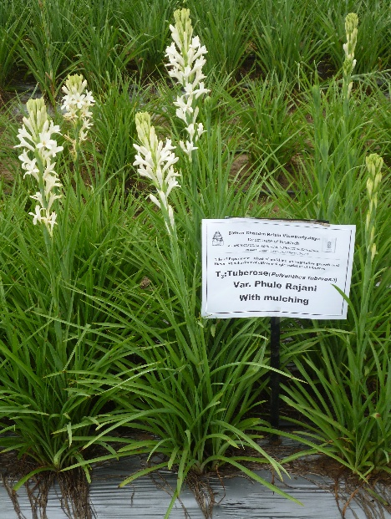
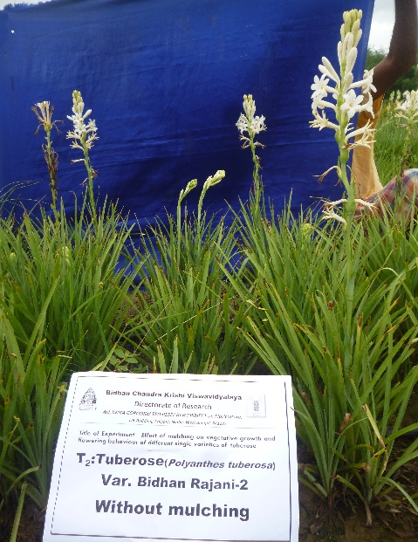
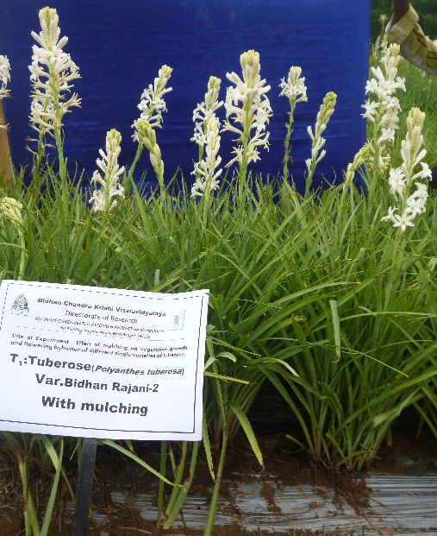
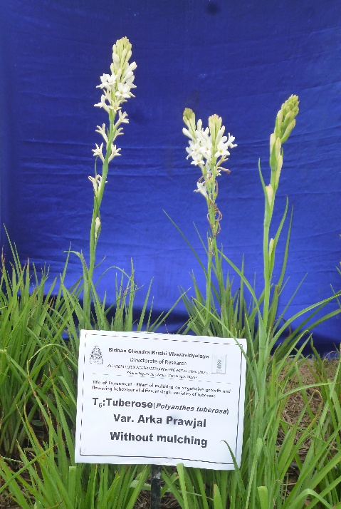
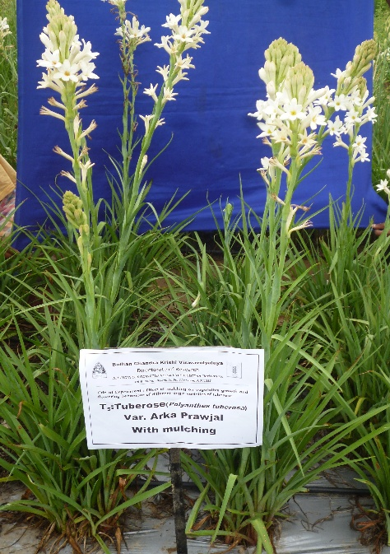
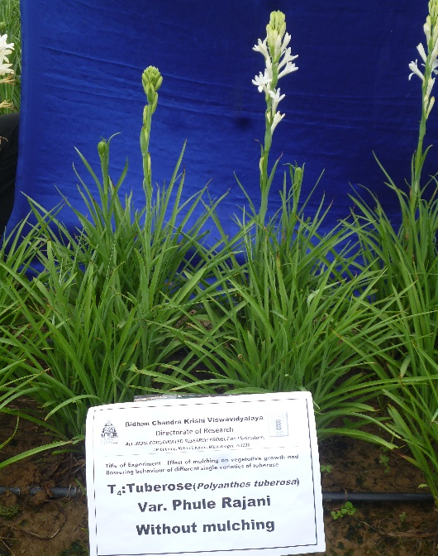
Picture 1 : showing the effect of mulch on growth and flowering of different varieties of single tuberose
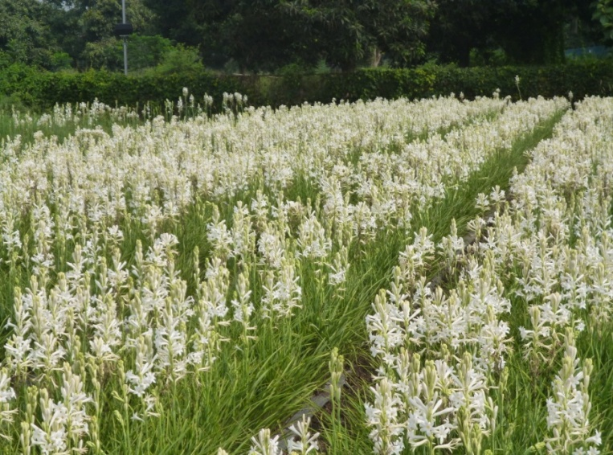
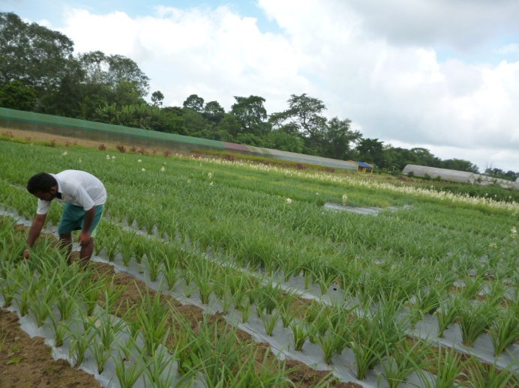
Standing crop of tuberose Var. ‘Bidhan Ujjwal’ with silver coated black polythene mulch

Research plot view after 60 days of planting

