Review Article
Leveraging Haplotype-Based Genomic Selection for Precision Plant Breeding: A Review
Abstract
Haplotype-based genomic selection (GS) represents a transformative evolution in the field of precision plant breeding. This methodology integrates haplotypes defined as blocks of DNA variations inherited together with advanced genomic selection frameworks to improve the prediction of complex traits, such as yield and stress resilience. By capturing local epistatic interactions and reducing genotyping costs through efficient marker selection, haplotype-based Genomic selection enhances prediction accuracy and accelerates breeding cycles. This review discusses the foundational principles, methodologies, applications, and future prospects of haplotype-based Genomic selection, emphasizing its critical role in modern plant breeding programs aimed at addressing global food security challenges.
Keywords: Haplotypes, Genomic selection, Breeding value, Tag SNPs, Genomic prediction
Introduction
Global agriculture faces mounting challenges, including increasing population demands, climate change, and resource constraints. The world’s population is expected to reach 9 billion by 2050, necessitating a 70% rise in food production. Conventional breeding approaches, while historically effective, struggle to meet these demands due to their extended timelines and limitations in addressing complex traits such as drought tolerance and disease resistance (Varshney et al., 2021ª).
Genomics-assisted breeding (GAB) has emerged as a foundation of modern plant breeding for it leverages advances in molecular genetics with computational biology to accelerate genetic improvements. Varshney et al. (2021b) state genomic selection is now important because it can predict breeding values using genome-wide markers within GAB. GS was initially conceptualized by Meuwissen et al. in 2001. This method makes use of genomic estimated breeding values (GEBVs) so that it can expedite the breeding cycle, especially for traits governed by multiple quantitative trait loci (QTLs). Single nucleotide polymorphism (SNP)-based GS is standard, but limitations in capturing epistatic interactions and complex genetic architectures led people to adopt haplotype-based GS, a method aggregating multiple SNPs into haplotype blocks for improved precision. The goal of developing “tailor-made” high-yielding varieties, particularly in major crops like rice, is highlighting of the precision advantage of this methodology (Li et al., 2024).
Limitations of Using SNPs Directly for Genomic Selection
The use of single nucleotide polymorphisms (SNPs) in genomic selection faces several challenges. First, SNPs have reduced power to capture complex traits, as many agronomic traits are polygenic and influenced by numerous small-effect alleles, limiting predictive accuracy (Browning & Browning, 2011; Abed et al., 2019; Alemu et al., 2023). Second, SNP-based models often overlook epistatic interactions by assuming additivity, thereby missing important gene–gene and linkage disequilibrium effects. Haplotype-based models, however, better capture such interactions and improve prediction (Jiang et al., 2018; He et al., 2023).
Third, SNPs may lead to low accuracy of genomic estimated breeding values (GEBVs) due to limited marker density, sampling bias, and genotyping errors. Studies show that haplotype aggregation enhances robustness and predictive power (Yang et al., 2010). Fourth, SNP arrays are prone to false positives and negatives, particularly with rare variants that are poorly represented and error-prone, while haplotype approaches improve detection by utilizing LD structures (Manrai et al., 2016).
Finally, SNP-based models often fail to account for population structure and environmental effects, reducing reliability across diverse settings. Haplotype-based methods address these issues more effectively, offering better stability and accuracy (Abed et al., 2019; He et al., 2023). To address these limitations, haplotype-based GS aggregates multiple SNPs into haplotype blocks, improving the capture of genetic interactions and variations (Bhat et al., 2021).

HAPLOTYPE BASED GENOMIC SELECTION
Haplotype-based genomic selection (GS) is an approach where multiple adjacent SNPs in strong linkage disequilibrium are grouped into haplotype blocks, which are then used as predictors instead of individual SNPs. This method captures not only additive effects but also local epistatic interactions and rare variants that single SNPs often miss, thereby improving the accuracy of genomic estimated breeding values (GEBVs). Jiang et al. (2018) demonstrated that haplotype-based prediction models (HGBLUP) exploit local epistatic interactions among markers and outperform SNP-based models in scenarios where epistasis plays an important role. Similarly, Alemu et al. (2023) showed that haplotype-tagged SNPs improved genomic prediction accuracy for Fusarium head blight resistance and yield-related traits in wheat compared to using SNPs alone.

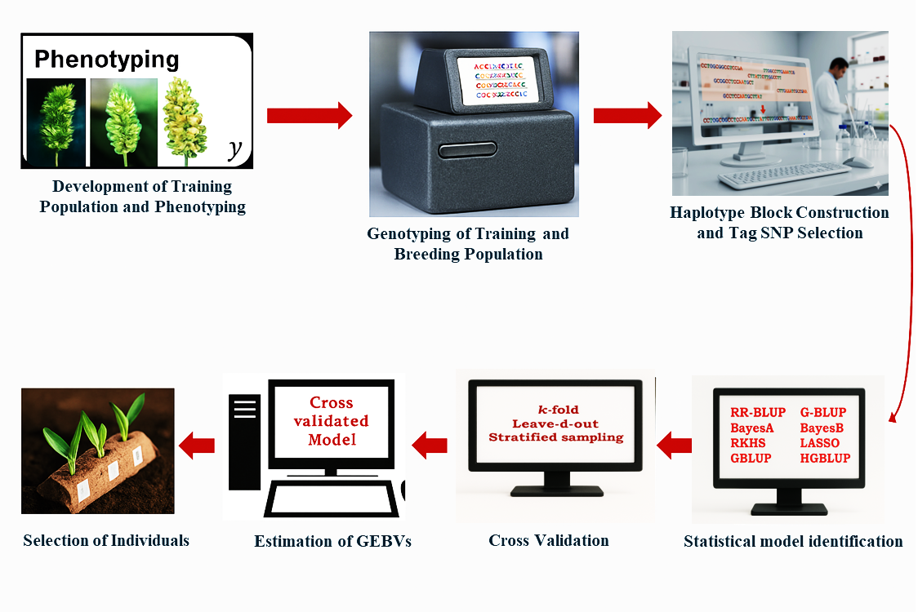
Fig.1: Steps involved in haplotype based Genomic Selection. (Source?)
The basic steps involved in Haplotype based Genomic selection (Fig.1) are as follows

- Development of Training Population
A robust training population (TP) is essential for effective genomic selection. TPs can include genetically diverse natural populations or designed populations such as recombinant inbred lines (RILs), double haploids (DH), multi-parent advanced generation intercross (MAGIC), and Nested Association Mapping (NAM) populations. These populations capture wide allelic and haplotypic diversity, which enhances the accuracy of genomic predictions (Bonnin et al., 2020). The size, diversity, and genetic relationship of the TP with the breeding population strongly influence predictive ability. For example, Juliana et al. (2020) showed in wheat that optimizing TP design significantly improves prediction accuracy. Similarly, Akdemir, Sanchez, and Jannink (2015) demonstrated that using genetic algorithms to select TP individuals can enhance predictive accuracy compared with random sampling.
- Genotyping Training and Breeding Populations
Genotyping forms the foundation of genomic selection, with co-dominant markers preferred over dominant ones for greater accuracy of genomic estimated breeding values (GEBVs). SNP markers are abundant and cost-efficient but often rely on short-read next-generation sequencing (NGS), which requires indirect haplotype construction. Third-generation sequencing (TGS) technologies such as PacBio HiFi and Oxford Nanopore Technologies (ONT) offer longer reads that enable more direct haplotype construction and phasing. Wenger et al. (2019) showed that PacBio HiFi reads improve variant detection and haplotype resolution in genome assemblies. More recently, Sarashetti et al. (2024) quantified the data requirements for generating chromosome-scale haplotype-resolved assemblies, emphasizing the need for long-read coverage combined with scaffolding data to ensure accurate haplotype phasing.
3. Haplotype Block Construction and Tag SNP Selection
3.1 Haplotypes
A haplotype is a set of DNA variations, such as SNPs or alleles, that are inherited together due to their proximity on the chromosome, minimizing recombination. Haplotypes can span single genes, multiple genes, or intergenic regions, reflecting inherited DNA segments (Wall and Pritchard, 2003).
3.2 Haplotype Blocks
Haplotype blocks are contiguous genomic regions with low haplotype diversity and minimal recombination. These blocks, typically inherited identically by descent, are often used to map genetic variation within populations.
3.2.1 Methods to Define Haplotype Blocks
Defining haplotype blocks is a critical step in haplotype-based genomic selection, as it groups single nucleotide polymorphisms (SNPs) into meaningful clusters that represent inherited genomic regions. SNPs are the most abundant type of genetic variation in organisms, play a crucial role in linking genetic markers to phenotypic traits. These haplotype blocks simplify genomic data and enable efficient association studies, marker-assisted selection, and genomic predictions (Al Bkhetan et al., 2019). Comparative studies are essential to evaluate the efficacy and performance of these different block partitioning methods across various genetic datasets (Saad et al., 2018). Key methods for defining haplotype blocks are discussed below.
    - LD Threshold Approach
This method groups markers with linkage disequilibrium (LD) values (measured by r²) exceeding a predefined threshold. SNPs are iteratively grouped into blocks until the LD between adjacent markers drops below the threshold. This approach is widely used for its simplicity and its ability to capture SNP clusters with strong genetic correlations. However, it may overlook population-specific LD patterns.
    - Fixed Windows (Markers/Base Pairs)
Blocks are defined based on a fixed number of adjacent markers or a predefined genomic span (in base pairs). This method provides flexibility to adjust block size according to the complexity of the trait under study. It is particularly useful in balancing computational efficiency and biological relevance, especially when analyzing traits influenced by both narrow and broad genomic regions.
    - HaploBlocker Algorithm
Unlike traditional LD-based methods, the HaploBlocker algorithm identifies blocks by leveraging linkage patterns observed in the population. It is designed to account for population-specific variations and admixtures, ensuring that haplotype blocks are tailored to subgroups. This method is powerful for uncovering haplotypes that might be critical in diverse genetic backgrounds, making it especially valuable in genomic selection programs for mixed populations.
    - Confidence Interval Test
This method uses the LD statistic D′ along with confidence intervals to define blocks. Blocks are established where no more than 5% of SNP pairs exhibit weak LD. The confidence interval test is rigorous in ensuring the structural integrity of blocks, enhancing the reliability of haplotypes for downstream applications.
    - Four-Gamete Test
The four-gamete test groups SNPs into blocks that exhibit no more than three gametes (combinations of alleles). This test assumes that the presence of four gametes indicates historical recombination events. By identifying blocks devoid of recombination, this method helps pinpoint haplotypes with a clear evolutionary or functional relationship, facilitating their use in trait prediction.
    - Solid Spine of LD
This method defines a block where the first and last SNP exhibit strong LD (D′ > 0.8) with each other, regardless of the LD among intermediate SNPs. It effectively identifies tightly linked SNPs while accommodating recombination events within blocks. This approach is useful for detecting functional regions with strong genetic associations.
The resulting haplotype blocks generated by these various construction methods have been rigorously evaluated and shown to consistently improve genomic prediction accuracy across diverse crop species (Weber et al., 2023).
3.2.2 Tag SNPs
Tag SNPs are a strategic subset of SNPs that capture the genetic diversity of a genomic region, reducing genotyping costs while retaining analytical power. This strategy often involves algorithms that select the optimal set of Tag SNPs without needing to first define discrete haplotype blocks (Halldorsson et al., 2004). The example of genomic prediction in winter wheat demonstrates the importance of tagSNPs in haplotype-based genomic selection (GS). By pre-selecting SNP markers using LD-based haplotype-tagging, prediction accuracy for traits like Fusarium Head Blight and Single Plant Weight improved significantly (0.07 and 0.092, respectively) compared to models without marker pre-selection (Alemu et al., 2023). Weak LD thresholds (r² < 0.5) were optimal for some traits, enhancing prediction precision while reducing marker redundancy. This approach not only optimizes genomic selection but also offers a cost-effective path for developing tailored genotyping platforms targeting essential haplotypes, making GS more efficient and accessible (Ding and Kullo, 2007).
Methods to Select Tag SNPs
- Shannon Entropy: Measures haplotype diversity; lower entropy indicates fewer tagging SNPs are needed.
- Principal Component Analysis (PCA): Selects SNPs contributing most to variance.
- LD-Based Metrics: Uses r² thresholds to identify SNPs with strong pairwise correlations.
- Bipartite Graphs: Identifies minimal SNP sets representing haplotypes via graph optimization.
- LD Bins: Groups SNPs into LD clusters and selects a representative tag SNP for each bin.
3.2.3 Tagging Quality Assessment
- Prediction Accuracy: Evaluates how well tag SNPs reflect haplotype diversity.
- Tagging Consistency: Measures agreement of tag SNPs across methods or populations.
- Tagging Efficiency: Quantifies cost and effort savings by genotyping only tag SNPs.
- Statistical model identification
Statistical model identification is key to accurate genomic selection, enabling effective utilization of genotypic and phenotypic data to predict genetic values. Common models include Genomic Best Linear Unbiased Prediction (GBLUP), Bayesian methods, and machine learning approaches.
- GBLUP: Assumes a linear relationship between genetic markers and traits, offering simplicity and reliability.
- Bayesian methods: Incorporate prior knowledge, handle non-linear relationships, and are suited for complex traits influenced by multiple genes and environmental interactions.
- Machine learning: Models like Random Forests and support vector machines capture non-linear interactions and epistasis, enhancing prediction accuracy for traits with intricate genetic architectures.
Model selection depends on trait complexity, population structure, and computational resources, with performance evaluated through cross-validation. Haplotype-based models improve genomic selection by aggregating SNPs into haplotypes, capturing local epistatic interactions and collective genetic effects, offering greater precision than individual SNP-based approaches (Abed and Belzile, 2019; Anilkumar et al., 2022).
Table 1: Statistical models used for Genomic selection
Additive Models | Models assuming a normal distribution of marker effects | Ridge regression best linear predictors (RR-BLUP) | Assumes that all the markers used have equal variances
Additive Models | Models assuming a normal distribution of marker effects | Genomic best linear unbiased prediction (G-BLUP) | Considers a genomic relationship matrix to estimate additive effects
Epistatic Models | Models assuming a normal distribution of marker effects | EGBLUP | Exploits epistasis b/w any pair of SNPs/markers
Bayesian Models | Models assuming markers with a higher probability of large effects | BayesA | All marker effects shrinks close to zero but not zero  Uses inverted chi-square to regress the marker variance towards zero
Bayesian Models | Models assuming markers with zero effects | BayesB | Allows some markers to have zero effects; while other markers may have effects more than zero
Machine Learning Models | Nonparametric methods | Random Kernel Hilbert Space (RKHS) | Utilizes the mathematical concept of RKHS, often applied in kernel methods like Support Vector Machines (SVMs)
Machine Learning Models | Nonparametric methods | Random forest | Ensemble learning method that constructs multiple decision trees and outputs the mode of classes or mean prediction

4.1 Advantages of Haplotype-Based Models
- Capturing Local Epistasis: Haplotype-based models detect local epistatic interactions among linked markers, improving trait predictions beyond single-marker approaches (Jiang et al., 2018).
- Higher Prediction Accuracy: They outperform marker-based models in scenarios with complex local epistasis, as demonstrated in crops like maize (Schrag et al., 2007) and specifically for major traits, in barley (Abed and Belzile, 2019). More broadly, exploring and harnessing haplotype diversity is fundamental to improving complex, agronomically critical traits such as yield stability in crops (Qian et al., 2017).
- Preservation of Beneficial Haplotypes: These models maintain advantageous haplotypes, including additive-by-additive effects, across generations, enhancing the efficiency of genomic selection in breeding programs.
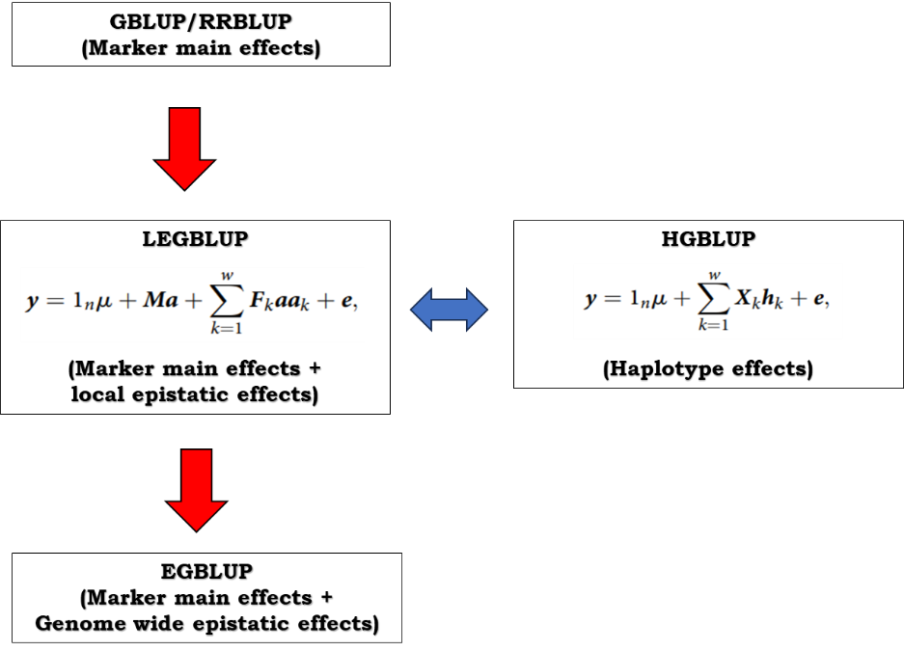
Fig.2: Characteristics and relationships of genomic prediction models. (Source?)
- Cross validation of Model
Validating the accuracy of prediction estimates in genomic selection programs is crucial to ensure the model's reliability and avoid overfitting. This process involves dividing the population into training and validation sets, conducting cross-validation experiments, and evaluating prediction accuracy through various methods.
- Validation Population and Training Population
In a cross-validation experiment, the population is divided into two sets:
- Training Set (TP): This set is used to develop the genomic prediction model. It is genotyped -and phenotyped to create a model that estimates genomic estimated breeding values (GEBVs).
- Validation Set (VP): This set is used to validate the prediction model. The validation population is genotyped and phenotyped, and GEBVs for the validation population are estimated using the model developed from the training set.
- Estimating Prediction Accuracy:
The accuracy of the predicted GEBVs is evaluated by correlating the predicted GEBVs with the true breeding values of the candidates in the validation set. Since true breeding values are often not directly estimable, the correlation between the estimated GEBVs and the phenotypic values of the validation set is used instead. This correlation is then adjusted using the following formula to estimate prediction accuracy:
Accuracy of predicted GEBVs is computed as $\frac{PA}{√h}$= r_{ĝg} =$\frac{r\text{ŷ}y}{√h}$
where $r\text{ŷ}y$ ​is the correlation between estimated GEBVs and phenotypic values, and $h$ is the heritability of the trait.
- Cross-Validation Methods:
  - k-Fold Cross-Validation:
- The population is divided into k equal subsets.
- The model is trained k times, each time using k-1 subsets as the training data and the remaining subset as the validation data (Table 2).
- This process ensures that each subset is used as the validation set once, providing a comprehensive evaluation of the model's performance. The prediction accuracy is averaged over the k iterations to obtain a reliable estimate.
Table 2: k-fold cross-validation.
Fold | Training Set | Validation Set
1 | Data from 2 to k | Data 1
2 | Data 1 and from 3 to k | Data 2
3 | Data 1 and 2 and from 4 to k | Data 3
... | ... | ...
k | Data 1 to k-1 | Data k
- Leave- d-Out Cross-Validation:
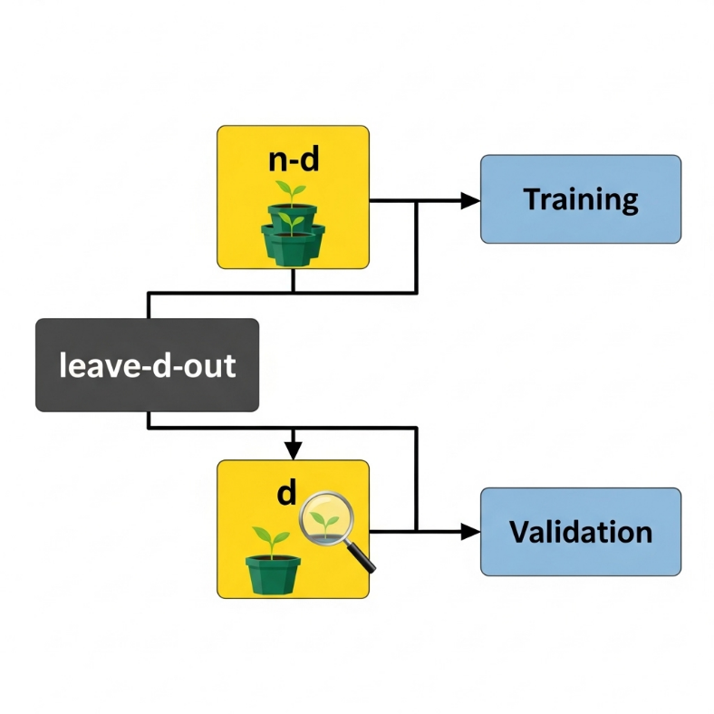
Fig.3: Leave- d-Out Cross-Validation.
  - In this method, d individuals are left out of the training set, and the model is trained on the remaining individuals.
  - The left-out individuals are then used as the validation set.
  - This process is repeated multiple times, each time with a different set of d individuals left out.
  - This method provides a robust estimate of prediction accuracy, especially for small datasets.
- Stratified Sampling:
Stratified sampling ensures that each subset used in cross-validation is representative of the entire population. The population is divided into subgroups based on specific characteristics (e.g., genetic diversity, phenotypic traits). Samples are then drawn from each subgroup to form the training and validation sets, ensuring that each set reflects the population's overall structure. This approach improves the model's generalizability and reduces bias in prediction accuracy estimates.
- GEBVs estimation for the genotyped breeding population
Estimating genomic estimated breeding values (GEBVs) for the breeding population involves using genomic data to predict the genetic potential of individuals (Fig.3). This process incorporates genotyping information, typically from tag SNPs, to construct haplotypes or directly use SNP data. Statistical models are then applied to relate genetic markers to phenotypic traits, resulting in GEBVs that reflect the breeding values based on genetic makeup. This approach enhances selection accuracy and accelerates genetic improvement in breeding programs.
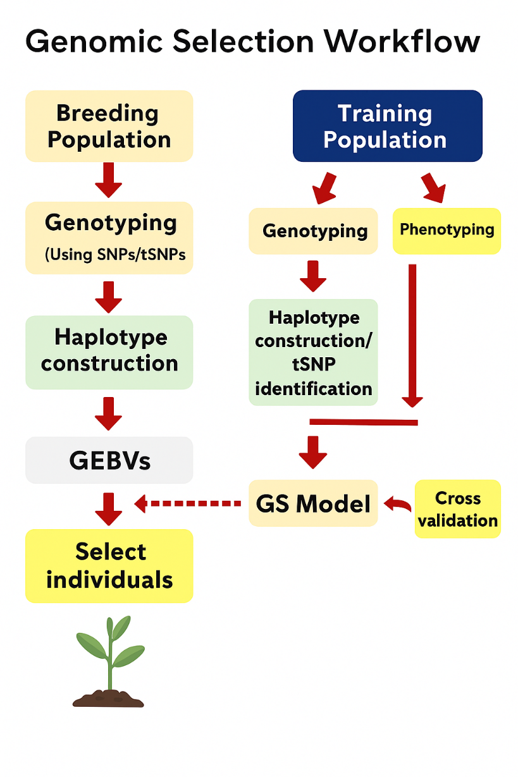
Fig.4: Haplotype based Genomic prediction. (Source?)

- Selection of superior individuals from Breeding population
Selection of superior individuals from the breeding population involves identifying and choosing those with the highest genomic estimated breeding values (GEBVs) (Fig.4).
FACTORS AFFECTING PREDICTION ACCURACY
1. Training Population (TP) Composition:
The size and genetic relationship of the TP to the target breeding population are critical. A larger, more diverse TP generally leads to higher prediction accuracy due to better linkage disequilibrium (LD) coverage. Specifically, optimizing the training population structure alongside the use of multi-allelic haplotype prediction has been shown to significantly improve prediction accuracy in wheat (Sallam et al., 2020).
- The size and genetic structure of the TP significantly impact prediction accuracy.
- Larger and genetically diverse TPs generally provide higher accuracy.
- TP should ideally consist of individuals with known pedigrees or closely related genetic backgrounds.
2. Marker Density:
- Higher marker density increases prediction accuracy but reaches a plateau beyond an optimal point.
- The required marker density depends on the genetic structure and linkage disequilibrium (LD) of the population.
3. Relationship Between Training and Breeding Population (BP):
- Closer genetic relationships between TP and BP enhance prediction accuracy.
- Including more closely related crosses in TP is more beneficial than increasing TP size with unrelated individuals.
4. Genetic Architecture of the Trait:
- Traits with higher heritability tend to have more accurate genomic predictions.
- For low heritability traits, larger TP sizes and high-density genotyping platforms improve prediction accuracy.
5. Genetic Model Used:
- The choice of genetic model influences the prediction accuracy by accounting for marker effects and genetic relationships.
- Models need to be optimized and regularly updated with new data for better accuracy.
6. Precision of Marker Genotyping:
- High-quality and precise genotyping of markers play a crucial role in improving genomic prediction accuracy.
- Systematic selection or elimination of markers based on their effects can impact prediction outcomes.
7. Population Structure and Diversity:
- The genetic diversity within TP affects the prediction accuracy, necessitating careful sampling and clustering.
- Populations with high LD require fewer markers to achieve accurate predictions compared to those with low LD.
8. Environmental Factors and Genotype-Environment Interaction (GEI):
- Including environmental components in the prediction model and selecting TP individuals with low GEI can enhance accuracy.
- Diverse environmental conditions in the TP help in better capturing the GEI effects.

9. Optimization and Resampling of TP:
- Regular updating and optimization of TP based on new data and genetic relationships are essential for maintaining high prediction accuracy.
- Re-sampling TP to include diverse genetic backgrounds and environmental conditions improves model robustness.

ADVANTAGES OF USING HAPLOTYPES IN GENOMIC SELECTION
- Increased Allelic Diversity: Haplotypes encompass multiple alleles, allowing for a finer resolution of genetic variation compared to individual SNPs. This multiallelic nature provides a more comprehensive view of genetic diversity within a population (Bhat et al., 2021).
- Enhanced Polymorphic Information Content: Haplotypes exhibit higher polymorphic information content (PIC) than individual SNPs. Leveraging haplotype associations enables researchers to harness the maximum potential of SNP genotyping data, thus enhancing the accuracy and robustness of genomic analyses (Hamblin and Jannink, 2011).
- Identification of Rare Alleles: Haplotypes facilitate the identification and analysis of rare alleles within a population. These rare alleles may hold significant implications for traits of interest, and their detection can contribute valuable insights into genetic variation and trait inheritance.
- Capture of Multigenic Effects: Many complex traits are influenced by multiple genetic factors, and gene function may depend on the interaction of multiple SNPs. Utilizing haplotypes that incorporate multiple SNPs allows for a more comprehensive assessment of the combined effects of these genetic variants on trait expression.
- Improved Control of False Positives and Negatives: Combining SNPs into haplotypes enables better control of false positive and negative associations in genomic analyses. By reducing the number of statistical tests conducted and focusing on haplotypes, researchers can minimize the risk of spurious associations and increase the reliability of genetic findings.
- Capture of Epistatic Interactions: Epistasis, or the interaction between genes, plays a crucial role in shaping complex traits. Haplotypes capture the combined effects of alleles at multiple loci, making it possible to detect and analyze epistatic interactions more effectively. This facilitates a deeper understanding of the genetic architecture underlying complex traits.
- Improved Relationship Matrix for Genomic Predictions: Constructing relationship matrices using haplotypes instead of single SNPs can lead to more accurate genomic predictions. By considering haplotypes, which represent combinations of alleles inherited together, the relationship matrix more accurately reflects the true genetic relatedness between individuals, thereby enhancing the accuracy of genomic predictions for breeding and selection programs.

GENOMIC PREDICTION USING PANGENOME HAPLOTYPE GRAPHS
The practical haplotype graph (PHG) approach offers a promising avenue for genomic selection in plant breeding programs. By representing the entire set of haplotypes within a population, PHGs provide a comprehensive view of genetic variation, enabling breeders to identify and utilize superior haplotypes in their breeding programs. This approach shifts the focus from individual genotypes to haplotypes, thereby capturing the combined effects of multiple genetic variants on phenotypic traits. Jensen et al. (2020) demonstrated the practical application of PHGs in genomic selection through their work on Sorghum bicolor. They developed a Sorghum bicolor PHG pangenome database to store haplotypes and variant information, and subsequently utilized it to sequence and analyze progenies from a genomic selection training population. Their study highlighted the effectiveness of PHGs in imputing SNPs from low-coverage sequence data, leading to improved prediction accuracy and reduced false positive rates for calling minor alleles. Additionally, the PHG approach showed promise in lowering genotyping costs by reducing sequence input requirements. Jensen et al.'s work underscores the potential of PHGs to revolutionize genomic selection strategies and accelerate crop improvement efforts.
Challenges and Future Prospects
Despite its advantages, haplotype-based GS faces several challenges:
- Standardization of Methods: Developing universal guidelines for haplotype construction across diverse species and populations.
- Computational Demands: Advanced algorithms and large datasets require significant computational resources.
- Environmental Variability: Addressing genotype-environment interactions remains complex, particularly for low-heritability traits.
Future advancements will likely focus on integrating haplotype-based GS with complementary technologies, such as:
- High-Throughput Phenotyping: Rapid data collection for large-scale phenotyping.
- Gene Editing: Incorporation of CRISPR and related technologies to validate and utilize beneficial haplotypes.
- Speed Breeding: Accelerating the breeding cycle to capitalize on genomic predictions.
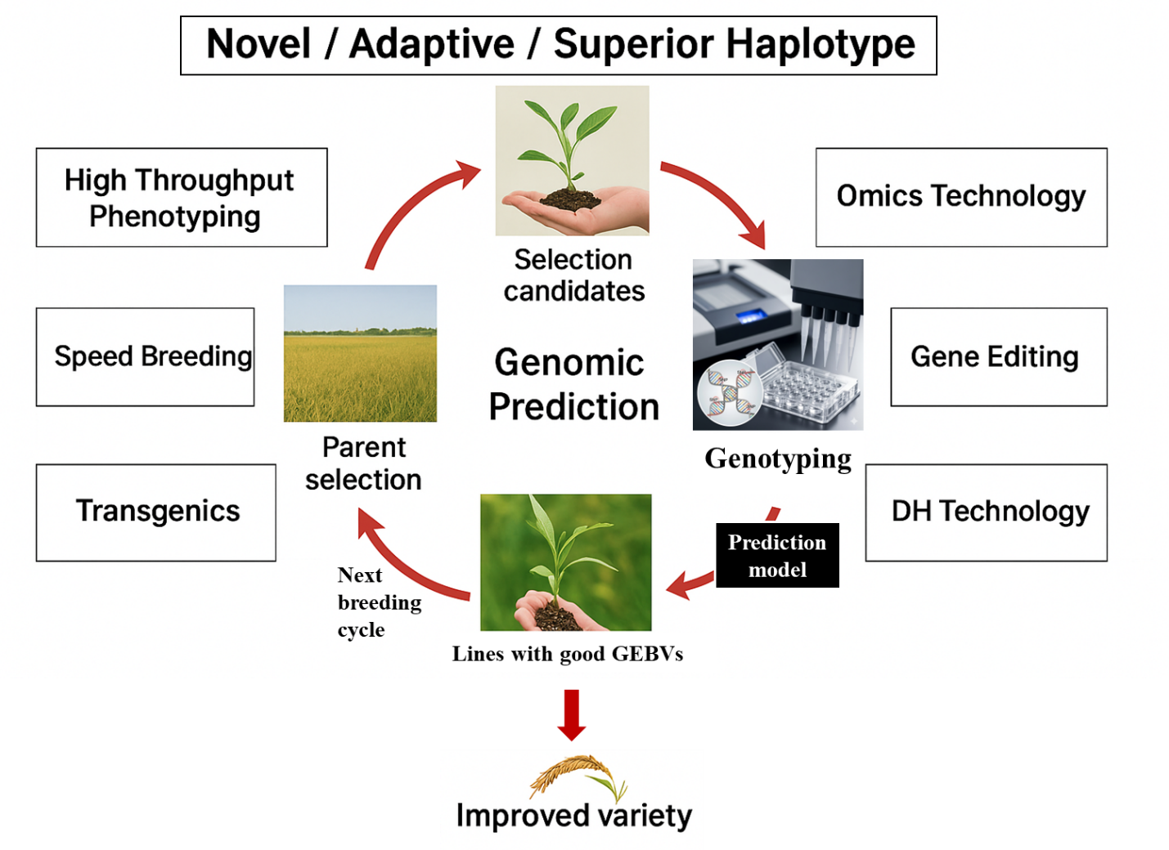
Fig.5: Future prospects of haplotype based Genomic selection. (Source?)

CONCLUSION
Haplotype-based genomic selection enhances precision in plant breeding by accurately estimating genomic estimated breeding values (GEBVs), effectively addressing the limitations of SNP biallelic issues, and reducing genotyping costs through the selection of tag SNPs. This approach allows for a more comprehensive understanding of genetic variations and their effects on phenotypic traits. In the future, combining haplotype-based genomic selection with high-throughput phenotyping, omics technologies, gene editing, doubled haploid (DH) technology, transgenics, and speed breeding will significantly accelerate the development of climate-resilient crops (Fig.5). These integrated strategies will enable breeders to achieve rapid genetic gains, ensuring sustainable and efficient crop improvement in the face of global climate challenges.
REFERENCES
Abed, A., & Belzile, F. (2019). Comparing single-SNP, multi-SNP, and haplotype-based approaches in association studies for major traits in barley. Plant Genome, 12(3), 190036. https://doi.org/10.3835/plantgenome2019.05.0036
Akdemir, D., Sanchez, J. I., & Jannink, J.-L. (2015). Optimization of genomic selection training populations with a genetic algorithm. Genetics Selection Evolution, 47, 38. https://doi.org/10.1186/s12711-015-0116-6
Al Bkhetan, Z., Zobel, J., Kowalczyk, A., Verspoor, K., & Goudey, B. (2019). Exploring effective approaches for haplotype block phasing. BMC Bioinformatics, 20(1), 1–14. https://doi.org/10.1186/s12859-019-3095-8
Alemu, A., Batista, L., Singh, P. K., Ceplitis, A., & Chawade, A. (2023). Haplotype-tagged SNPs improve genomic prediction accuracy for Fusarium head blight resistance and yield-related traits in wheat. Theoretical and Applied Genetics, 136(4), 92. https://doi.org/10.1007/s00122-023-04352-8
Anilkumar, C., Sunitha, N. C., Harikrishna, Devate, N. B., & Ramesh, S. (2022). Advances in integrated genomic selection for rapid genetic gain in crop improvement: A review. Planta, 256(5), 87. https://doi.org/10.1007/s00425-022-03996-y
Bhat, J. A., Yu, D., Bohra, A., Ganie, S. A., & Varshney, R. K. (2021). Features and applications of haplotypes in crop breeding. Communications Biology, 4(1), 1266. https://doi.org/10.1038/s42003-021-02782-y
Bonnin, I., Bonnefoi, J., & Le Cunff, L. (2020). Multi-parent populations in crops: A toolbox integrating genomics. Heredity, 125, 396–408. https://doi.org/10.1038/s41437-020-0336-6
Browning, S. R., & Browning, B. L. (2011). Haplotype phasing: Existing methods and new developments. Nature Reviews Genetics, 12(10), 703–714. https://doi.org/10.1038/nrg3054
Ding, K., & Kullo, I. J. (2007). Methods for the selection of tagging SNPs: A comparison of tagging efficiency and performance. European Journal of Human Genetics, 15, 228–236. https://doi.org/10.1038/sj.ejhg.5201755
Halldorsson, B. V., Bafna, V., Lippert, R., Schwartz, R., Francisco, M., Clark, A. G., et al. (2004). Optimal haplotype block-free selection of tagging SNPs for genome-wide association studies. Genome Research, 14(8), 1633–1640. http://www.genome.org/cgi/doi/10.1101/gr.2570004
Hamblin, M. T., & Jannink, J. L. (2011). Factors affecting the power of haplotype markers in association studies. Plant Genome, 4(2), 1–10. https://doi.org/10.3835/plantgenome2011.03.0008
He, S., Liang, S., Meng, L., Cao, L., & Ye, G. (2023). Sparse phenotyping and haplotype-based models for genomic prediction in rice. Rice, 16(1), 27. https://doi.org/10.1186/s12284-023-00643-2
Jensen, S. E., Charles, J. R., Muleta, K., Bradbury, P. J., Casstevens, T., Deshpande, S. P., et al. (2020). A sorghum practical haplotype graph facilitates genome-wide imputation and cost-effective genomic prediction. Plant Genome, 13(1), 20009. https://doi.org/10.1002/tpg2.20009
Jiang, Y., Schmidt, R. H., & Reif, J. C. (2018). Haplotype-based genome-wide prediction models exploit local epistatic interactions among markers. G3: Genes, Genomes, Genetics, 8(5), 1687–1699. https://doi.org/10.1534/g3.117.300548
Juliana, P., Poland, J., Huerta-Espino, J., Shrestha, S., Crossa, J., Crespo-Herrera, L., et al. (2019). Improving grain yield, stress resilience and quality of bread wheat using large-scale genomic prediction. Nature Genetics, 51(10), 1530-1539. https://doi.org/10.1038/s41588-019-0496-6
Li, J., Zhang, H., Zhu, Q., Xia, Y., Duan, Z., Wen, J., & Chen, L. (2024). Tailor-made rice: Using haplotype analysis to design high-yielding varieties. Molecular Plant Breeding, 15, 1–10. http://dx.doi.org/10.5376/mpb.2024.15.0028
Manrai, A. K., Funke, B. H., Rehm, H. L., Olesen, M. S., Maron, B. A., Szolovits, P., & Kohane, I. S. (2016). Genetic misdiagnoses and the potential for health disparities. New England Journal of Medicine, 375(7), 655–665. https://doi.org/10.1056/NEJMsa1507092
Qian, L., Hickey, L. T., Stahl, A., Werner, C. R., Hayes, B., Snowdon, R. J., & Voss-Fels, K. P. (2017). Exploring and harnessing haplotype diversity to improve yield stability in crops. Frontiers in Plant Science, 8, 1534. https://doi.org/10.3389/fpls.2017.01534
Saad, M. N., Mabrouk, M. S., Eldeib, A. M., & Shaker, O. G. (2018). Comparative study for haplotype block partitioning methods: Evidence from chromosome 6 of the North American rheumatoid arthritis consortium (NARAC) dataset. PLoS ONE, 13(12), e0209603. https://doi.org/10.1371/journal.pone.0209603
Sallam, A. H., Conley, E., Prakapanka, D., Da, Y., & Anderson, J. A. (2020). Improving prediction accuracy using multi-allelic haplotype prediction and training population optimization in wheat. G3: Genes, Genomes, Genetics, 10(7), 2265–2273. https://doi.org/10.1534/g3.120.401165
Sarashetti, P., Lipovac, J., Tomas, F., Šikić, M., & Liu, J. (2024). Evaluating data requirements for high-quality haplotype-resolved genomes for creating robust pangenome references. Genome Biology, 25, 312. https://doi.org/10.1186/s13059-024-03452-y
Schrag, T. A., Maurer, H. P., Melchinger, A. E., Piepho, H. P., Peleman, J., & Frisch, M. (2007). Prediction of single-cross hybrid performance in maize using haplotype blocks associated with QTL for grain yield. Theoretical and Applied Genetics, 114, 1345–1355. https://doi.org/10.1007/s00122-007-0521-5
Varshney, R. K., Bohra, A., Roorkiwal, M., Barmukh, R., Cowling, W. A., Chitikineni, A., et al. (2021a). Fast-forward breeding for a food-secure world. Trends in Genetics, 37(12), 1124–1136. https://doi.org/10.1016/j.tig.2021.08.002
Varshney, R. K., Bohra, A., Yu, J., Graner, A., Zhang, Q., & Sorrells, M. E. (2021b). Designing future crops: Genomics-assisted breeding comes of age. Trends in Plant Science, 26(6), 631–649. https://doi.org/10.1016/j.tplants.2021.03.010
Wall, J. D., & Pritchard, J. K. (2003). Haplotype blocks and linkage disequilibrium in the human genome. Nature Reviews Genetics, 4, 558–569. https://doi.org/10.1038/nrg1123
Weber, S. E., Frisch, M., Snowdon, R. J., & Voss-Fels, K. P. (2023). Haplotype blocks for genomic prediction: A comparative evaluation in multiple crop datasets. Frontiers in Plant Science, 14, 1217589. https://doi.org/10.3389/fpls.2023.1217589
Wenger, A. M., Peluso, P., Rowell, W. J., Chang, P.-C., Hall, R. J., Concepcion, G. T., et al. (2019). Accurate circular consensus long-read sequencing improves variant detection and assembly of a human genome. Nature Biotechnology, 37, 1155–1162. https://doi.org/10.1038/s41587-019-0217-9
Yang, J., Benyamin, B., McEvoy, B. P., Gordon, S., Henders, A. K., Nyholt, D. R., & Visscher, P. M. (2010). Common SNPs explain a large proportion of the heritability for human height. Nature Genetics, 42(7), 565–569. https://doi.org/10.1038/ng.608

Add atleast 02 references of year 2024 or 2025

