Original Research Article

Assessment of Genetic Diversity for Grain Iron and Zinc Contents Among 123 Rice Germplasm Lines

.
ABSTRACT

Aims: This study evaluated 123 rice germplasm lines to assess genetic diversity for major biometric and grain iron and grain zinc contents and identify superior donor genotypes for biofortification breeding programmes.
Study design: completely randomized design.
Place and Duration of Study: Ricexxp Research Station, Vyttila, Ernakulam, Kerala Agricultural University, between January 2023 to February 2024.
Methodology: A completely randomized design experiment was conducted with 123 diverse rice genotypes grown in pot cultures. Major biometric observations including grain yield per plant was taken. Grain samples were analyzed using Atomic Absorption Spectrophotometer for Fe and Zn content, and data were subjected to analysis of variance, correlation analysis, and principal component analysis.
Results: Exceptional genetic variation was observed with GIC ranging from 0.00 to 1694.80 ppm (mean 242.79 ppm) and GZC ranging from 0 to 159.87 ppm (mean 37.92 ppm). Traditional varieties Chittimuthyalu (1694.80 ppm), Njavara (1471.9 ppm), and Kannukulamban (1318.40 ppm) exhibited the highest iron content, while advanced breeding lines PTB-25 (159.87 ppm), PTB-21 (159.34 ppm), and PTB-18 (151.89 ppm) showed superior zinc accumulation. Genotypes PTB-21 and PTB-41 demonstrated high levels of both micronutrients. Significant positive correlation (r - 0.175, P < 0.01) between GIC and GZC suggests feasibility of simultaneous improvement. Principal component analysis revealed that the first three components explained 59.12% of total variation, with micronutrient traits showing independence from major yield components.
Conclusion: The substantial genetic diversity identified in this study, particularly in traditional varieties and advanced breeding lines, provides valuable genetic resources for developing biofortified rice varieties. The identified high-performing genotypes represent promising donors for addressing micronutrient malnutrition through conventional and molecular breeding approaches.
Keywords: Rice biofortification, grain iron content, grain zinc content, genetic diversity, micronutrients
1. INTRODUCTION

Micronutrient deficiency, commonly referred to as "hidden hunger," has emerged as one of the most pressing public health challenges of the 21st century. According to recent global assessments, more than 2 billion people worldwide suffer from micronutrient deficiencies, with iron and zinc deficiencies being the most widespread (WHO, 2015; FAO, 2022). The Lancet Global Health estimates that over half of preschool-aged children and two-thirds of non-pregnant women of reproductive age worldwide are deficient in at least one essential micronutrient (Akhtar et al., 2022). Iron deficiency alone causes approximately 0.8 million deaths annually, while zinc deficiency contributes to over 400,000 child deaths per year globally (Senguttuvel et al., 2023).
The consequences of micronutrient malnutrition are severe and far-reaching. Iron deficiency leads to anemia, impaired cognitive development, reduced work capacity, and increased maternal and child mortality (Schmidt et al., 2014). Zinc deficiency results in stunted growth, compromised immune function, delayed wound healing, and increased susceptibility to infections (Brown et al., 2004; Prasad, 2013). India bears a particularly heavy burden, with an estimated 61.7 million stunted children under five years of age—the highest number globally—largely attributed to micronutrient deficiencies (NFHS-5, 2020).
Rice (Oryza sativa L.) serves as the primary staple food for more than 3.5 billion people worldwide, providing over 50% of daily caloric intake in many Asian and African countries (Senguttuvel et al., 2023). However, polished rice grains are inherently poor in essential micronutrients, containing approximately 2 μg/g Fe and 16 μg/g Zn—far below the dietary requirements (Trijatmiko et al., 2016). The preference for highly polished white rice has exacerbated micronutrient deficiencies, as the milling process removes the nutrient-rich bran layers where most minerals are concentrated (Sanjeeva Rao et al., 2020).
Biofortification is the process of increasing the bioavailable concentrations of essential nutrients in edible portions of crops through agronomic practices, conventional breeding, or genetic engineering. It offers a cost-effective and sustainable approach to address micronutrient malnutrition (Bouis et al., 2003; Graham et al., 2001). Unlike post-harvest fortification or dietary supplementation, biofortification provides a one-time investment with long-term benefits, reaching rural and remote populations with limited access to diverse diets or commercial fortified foods (Stein et al., 2007).
HarvestPlus, a CGIAR programme leading global biofortification initiatives, has established breeding targets of 13 μg/g Fe and 28 μg/g Zn in polished rice to meet approximately 30% of the estimated average requirement (EAR) for daily micronutrient intake (Trijatmiko et al., 2016; Matres et al., 2021). To date, 37 biofortified rice varieties (16 from India and 21 from other countries) have been released for commercial cultivation globally, demonstrating the feasibility of this approach (Senguttuvel et al., 2023).
The success of biofortification programmes fundamentally depends on the existence of substantial genetic variation within crop germplasm for target nutrients. Rice genetic resources harbour considerable diversity for grain mineral composition, with traditional varieties and landraces serving as particularly valuable sources of micronutrient-dense alleles that were often lost during intensive breeding for high yield and disease resistance (Garcia-Oliveira et al., 2018). Previous studies have documented significant variation in grain Fe content ranging from 6.9 to 67.3 mg/kg in brown rice (Anuradha et al., 2012; Maganti et al., 2020) and Zn content ranging from 6.2 to 75.8 mg/kg (Anuradha et al., 2012; Vanlalsanga et al., 2019).
Understanding the extent of genetic variation, identifying relationships between micronutrient content and agronomic traits, and characterizing superior genotypes are essential prerequisites for developing effective breeding strategies. Traditional varieties from diverse agro-ecological regions often possess unique adaptive traits and nutritional characteristics that have been preserved through generations of farmer selection (Roy and Sharma, 2014; Descalsota et al., 2018).
Despite growing recognition of biofortification's potential, comprehensive evaluations of diverse rice germplasm collections for grain iron and zinc content remain limited, particularly for indigenous varieties from specific geographic regions. This study was therefore undertaken with the following specific objectives:
1. To evaluate the genetic diversity for grain iron and zinc contents among 123 rice germplasm lines comprising traditional varieties, landraces, and released varieties
2. To examine phenotypic correlations between grain mineral contents and agronomic traits to understand breeding implications
3. To analyze the multivariate relationships among traits through principal component analysis
2. material and methods
2.1 Data Collection
A total of 123 rice germplasm lines were evaluated in this study, representing diverse genetic backgrounds and geographic origins. The experiment was laid out in a Completely Randomized Design (CRD) with two replications.
2.1.1 Agronomic and Yield Traits
The following observations were recorded:
      - Days to 50% flowering (DTF): Number of days from sowing to when 50% of plants showed flowering
      - Days to maturity (DTM): Number of days from sowing to physiological maturity
      - Plant height (PH, cm): Measured from ground level to the tip of the tallest panicle at maturity
      - Number of productive tillers per plant (NPT): Count of tillers bearing panicles
      - Panicle length (PL, cm): Length of the main panicle from base to tip
      - Number of filled grains per panicle (NFG): Average count from five main panicles
      - Number of unfilled grains per panicle (NUG): Average count from five main panicles
      - Number of grains per panicle (NGP): Sum of filled and unfilled grains
      - 1000-grain weight (1000GW, g): Weight of 1000 randomly selected filled grains.
      - Grain yield per plant (GYP, g): Total grain weight per plant
    - Grain Iron and Zinc Content Analysis
At physiological maturity, representative grain samples were harvested from each genotype. The samples were dehusked to obtain brown rice. Grain samples (0.25g) were weighed accurately and transferred to acid-washed glass digestion tubes. Samples were digested using a di-acid mixture (HNO₃:HClO₄ in 9:4 ratio). The digestion was carried out in a temperature-controlled digestion chamber, until a clear solution was obtained. The digested samples were cooled, diluted to a known volume (100 mL) with double-distilled water, and filtered through Whatman No. 42 filter paper. Iron and zinc concentrations in the digested samples were determined using [Atomic Absorption Spectrophotometry (AAS). Standard solutions of known concentrations were prepared from certified reference materials for calibration. Each sample was analyzed and the mean values were calculated and expressed as parts per million (ppm) on a dry weight basis.
    - Statistical Analysis
Statistical Analysis included Analysis of variance (ANOVA), Comparison of Mean values using the Least Significant Difference (LSD) test at 5% probability level, Correlation Analysis and Principal Component Analysis. All statistical analyses were conducted using the GRAPES (General R-based Agricultural Package for Experimental Statistics) software developed by Kerala Agricultural University (Gopinath et al., 2021).
3. results and discussion
3.1 Analysis of Variance
The analysis of variance revealed highly significant differences (P < 0.001) among the 123 rice germplasm lines for both grain iron content (GIC) and grain zinc content (GZC), indicating substantial genetic diversity for these micronutrients in the evaluated collection (Table 1).

Table 1 : Analysis of Variance for Grain Iron and Zinc Content Across Treatments
Sources of Variation | df | Grain Iron Content | Grain Zinc Content
Sources of Variation | df | Mean Square | Mean Square
Treatment | 121 | 352,455.45** | 4,962.48**
Error | 366 | 5.65 | 1.24
F-value |  | 62,357.34** | 4,012.66**
CV(%) |  | 0.99 | 2.90
SE(d) |  | 1.68 | 0.79

For grain iron content, the F-value was exceptionally high (62,357.34), with the treatment sum of squares accounting for 99.995% of total variation. The coefficient of variation was very low (0.99%), indicating high precision of the experiment. The mean square error was 5.65, yielding a standard error of difference of 1.68 ppm and LSD of 3.31 ppm (Table 1).
Similarly, for grain zinc content, highly significant genetic variation was observed (F = 4,012.66, P < 0.001) with treatment sum of squares representing 99.92% of total variation. The coefficient of variation was 2.90%, slightly higher than iron but still indicating good experimental precision. The mean square error was 1.24, with a standard error of difference of 0.79 ppm and LSD of 1.55 ppm (Table 1).
The low CV values and high F-statistics confirm the reliability of the data and the existence of genuine genetic differences among genotypes, providing strong statistical support for the identification of superior germplasm for biofortification breeding.
3.2 Descriptive Statistics and Range of Variation
3.2.1 Grain Iron Content
Grain iron content exhibited exceptional variation across the germplasm panel. The values ranged from 0 ppm to 1694.80 ppm, representing an 847-fold difference between the lowest and highest genotypes. The mean GIC across all 123 genotypes was 242.79 ± 27.05 ppm, with a median of 113.31 ppm. The standard deviation was 299.96 ppm, reflecting the wide dispersion in the data. The large difference between mean and median, along with the high coefficient of variation (123.50%), indicated a positively skewed distribution with several exceptional high-iron genotypes pulling the mean upward.

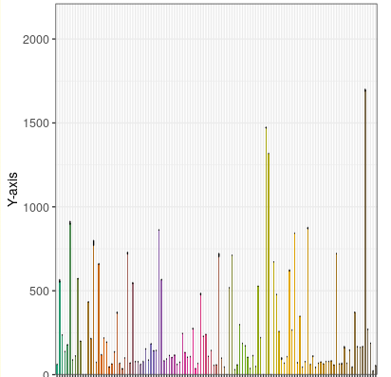
Grain Iron Content (ppm)
123 Rice varieties
Fig. 1. Mean performance of 123 rice varieties for the trait Grain Iron Content
The frequency distribution of grain iron content (Figure 1) revealed that the majority of genotypes (approximately 68%) had iron content below 200 ppm, with a long tail extending toward higher values. Only 15 genotypes (12.20%) exceeded 400 ppm, and merely 8 genotypes (6.50%) surpassed 600 ppm. The extreme high-iron genotypes (>800 ppm) were exclusively traditional varieties, representing less than 5% of the collection.
3.2.2 Grain Zinc Content
Grain zinc content ranged from 0 to 159.87 ppm with a mean of 37.92 ± 3.17 ppm and median of 29.35 ppm. The standard deviation was 35.19 ppm. The coefficient of variation (92.8%) was lower than that of iron, suggesting relatively more uniform distribution of zinc across genotypes. The smaller difference between mean and median compared to iron indicated a more symmetrical distribution for zinc.
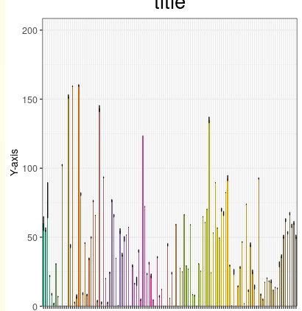
Grain Zinc Content (ppm)
123 Rice varieties

Fig. 2. Mean performance of 123 rice varieties for the trait Grain Zinc Content
The frequency distribution (Figure 2) showed that most genotypes (76.40%) had zinc content below 50 ppm. Approximately 18 genotypes (14.6%) exhibited zinc content between 50-80 ppm, while only 11 genotypes (8.9%) exceeded 80 ppm. The highest zinc accumulators (>140 ppm) represented just 2.4% of the collection and were predominantly from the PTB lines.
3.3 Superior Genotypes for Grain Iron Content
Based on LSD grouping (P = 0.05), genotypes were classified into distinct statistical groups. Chittimuthyalu emerged as the highest iron accumulator with 1694.80 ppm—approximately 7 times higher than the overall mean and 847 times higher than typical polished rice (2.00 ppm). This traditional variety significantly surpassed all others (P < 0.001), forming a distinct statistical class. Njavara, an indigenous medicinal rice from Kerala with documented therapeutic properties, ranked second with 1471.90 ppm, representing an 87% increase over the mean. Kannukulamban, a traditional aromatic variety, exhibited 1318.40 ppm iron content, placing it in the third position. These three traditional varieties collectively demonstrated iron levels 5.4 - 7.0 fold higher than the collection mean, highlighting the exceptional nutritional value preserved in traditional germplasm through centuries of farmer selection.
Among advanced breeding lines, PTB-6 led with 904.7 ppm iron content, followed closely by Mo-14 (872.9 ppm) and Mo-9 (843.2 ppm). Notably, PTB-21 (784.8 ppm) and PTB-41 (724.0 ppm) also demonstrated high iron accumulation while simultaneously showing elevated zinc content, making them particularly valuable for dual biofortification strategies.
At the lower end of the spectrum, four genotypes (Kodukanni, Veluthittaryan, Chitteni vellur, and Athikira mundakan) showed iron content near or below 2 ppm, which may represent genuine deficiency or potential measurement anomalies requiring further investigation.
3.4 Superior Genotypes for Grain Zinc Content
PTB-25 and PTB-21 co-dominated zinc accumulation with 159.87 ppm and 159.34 ppm respectively, showing no significant difference between them but significantly exceeding all other genotypes. These values represent approximately 10-fold enrichment over typical polished rice zinc content (16 ppm) and exceed the HarvestPlus biofortification target of 28 ppm by 5.7-fold. Both genotypes belong to the PTB series, suggesting targeted genetic enhancement for zinc through systematic breeding efforts.
PTB-18 ranked third with 151.89 ppm, followed by PTB-41 (143.15 ppm), which notably also ranked 9th for iron content, making it an exceptional dual-trait donor. PTB lines showed predominance as the top zinc performers (11 out of top 15). This pattern contrasts with iron content, where traditional varieties dominated the highest ranks. Fifteen genotypes exhibited zero or near-zero zinc content, including Cheruvirippu, Ezhome-1, Ezhupunna pokkali, Karutha kuruka, Kuthiru, Mo-11, Mo-21, PTB-12, PTB-9, and Traditional virippu.
3.5 Correlation Analysis
Pearson correlation coefficients were computed among all 12 traits to examine inter-trait relationships and their breeding implications (Figure 3).
3.5.1 Grain Iron Content Correlations
Grain iron content showed significant positive correlations with Days to 50% flowering (r - 0.257), days to maturity (r - 0.239) and grain zinc content (r - 0.175). Significant negative correlations were observed with number of unfilled grains per panicle (r - -0.141) and total number of grains per panicle (r - -0.143). Notably, grain iron content showed no significant correlation with grain yield per plant (r - -0.098), plant height (r - 0.044), or 1000-grain weight (r - -0.045).
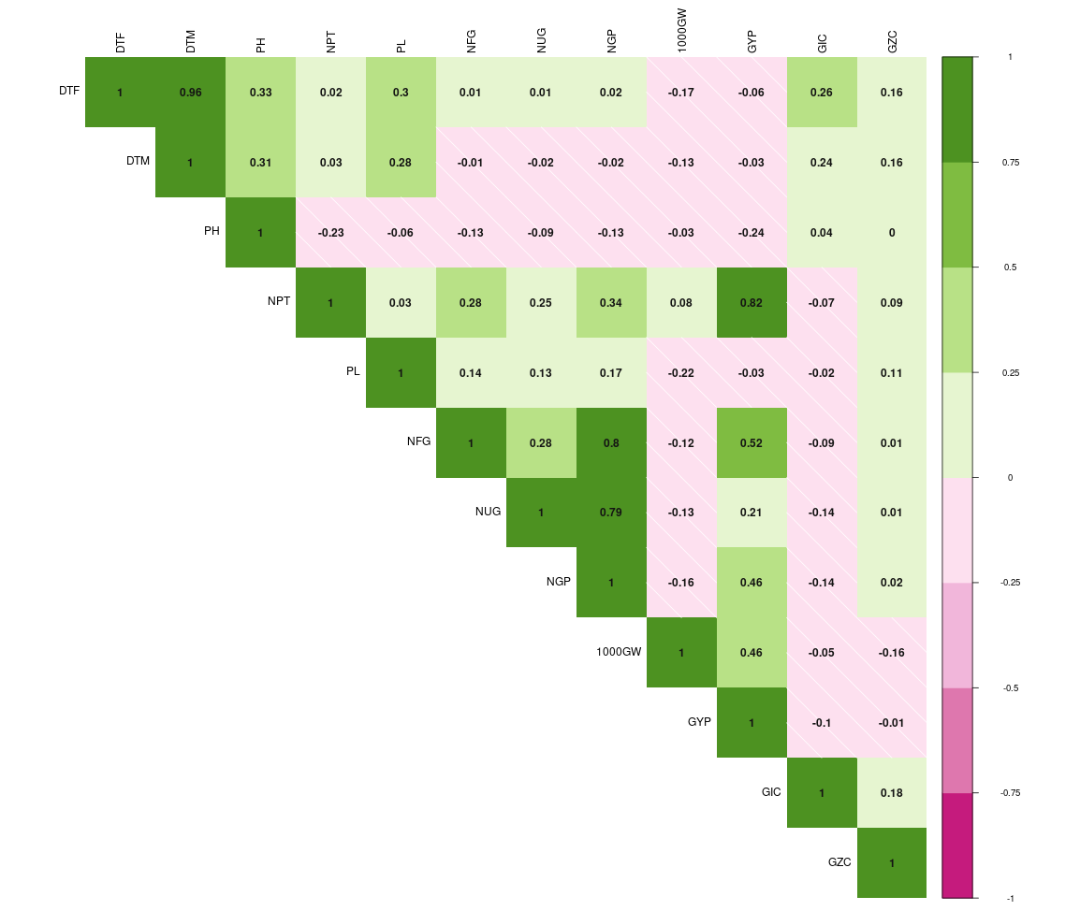

Fig. 3. Correlation coefficients among agronomic traits and grain mineral contents in 123 rice genotypes
    - Grain Zinc Content Correlations
Grain zinc content exhibited significant positive correlations with days to 50% flowering (r - 0.161), days to maturity (r - 0.157) and Grain iron content (r - 0.175). A significant negative correlation was found with 1000-grain weight (r - -0.156). Similar to iron, zinc content showed no significant correlation with grain yield per plant (r - -0.012), indicating independence between micronutrient accumulation and productivity.
3.5.3 Breeding Implications
The positive correlation between GIC and GZC (r - 0.175) is of paramount importance for biofortification breeding, suggesting common physiological mechanisms for accumulation of both minerals and offering opportunities for simultaneous genetic improvement (Calayugan et al., 2020; Cu et al., 2021). This relationship aligns with previous findings that iron and zinc share similar uptake, translocation, and accumulation pathways in rice grains (Senguttuvel et al., 2023).
The positive associations with maturity duration suggest that longer-duration varieties tend to accumulate more minerals, possibly due to extended grain-filling periods or greater nutrient remobilization from vegetative tissues (Anuradha et al., 2012). This finding is consistent with reports by Garcia-Oliveira et al. (2018), who documented similar patterns in diverse rice germplasm.
The weak or non-significant correlations with grain yield are particularly encouraging from a breeding perspective. The absence of significant negative associations indicates that biofortification for iron and zinc need not necessarily compromise productivity, contradicting earlier concerns about potential yield penalties (Norton et al., 2010). This finding supports the feasibility of developing high-yielding biofortified varieties through appropriate breeding strategies, as demonstrated by the release of 37 biofortified varieties globally (Senguttuvel et al., 2023). Recent studies by Anusha et al. (2021) and Pandey et al. (2019) have similarly reported non-significant or slightly positive correlations between micronutrient content and grain yield in rice.
The negative correlation between zinc and 1000-grain weight (r - -0.156) suggests potential dilution effects, where heavier grains may have lower mineral density per unit weight. This concentration-versus-content trade-off warrants attention in breeding programmes to avoid inadvertent selection for larger grains that compromise micronutrient density (Lee et al., 2020).
3.7 Principal Component Analysis
Principal component analysis was conducted on the correlation matrix of 12 traits to identify major patterns of variation and reduce dimensionality (Table 2).
Table 2. Principal component loadings, eigenvalues, and variance explained for 12 traits
Variable | PC1 | PC2 | PC3 | PC4 | PC5 | PC6
DTF | -0.348 | 0.478 | -0.113 | -0.148 | 0.050 | 0.033
DTM | -0.346 | 0.468 | -0.159 | -0.154 | 0.081 | 0.012
PH | -0.309 | 0.067 | -0.025 | -0.476 | -0.512 | -0.267
NPT | 0.364 | 0.287 | -0.308 | 0.124 | 0.020 | -0.147
PL | -0.055 | 0.342 | 0.226 | 0.052 | 0.659 | -0.051
NFG | 0.348 | 0.333 | 0.135 | -0.092 | -0.203 | 0.231
NUG | 0.329 | 0.302 | 0.260 | -0.171 | -0.278 | 0.104
NGP | 0.163 | 0.054 | 0.572 | -0.035 | -0.082 | -0.018
1000-GW | 0.134 | -0.191 | -0.467 | -0.191 | 0.070 | -0.072
GYP | 0.442 | 0.237 | -0.395 | -0.029 | -0.017 | -0.036
GIC | -0.229 | 0.104 | -0.159 | 0.483 | -0.296 | 0.663
GZC | -0.080 | 0.199 | 0.041 | 0.633 | -0.274 | -0.626
Eigenvalue | 2.729 | 2.388 | 1.978 | 1.125 | 0.907 | 0.808
% Variance | 22.74 | 19.90 | 16.48 | 9.37 | 7.55 | 6.73
Cumulative % | 22.74 | 42.64 | 59.12 | 68.50 | 76.05 | 82.78
The first six principal components with eigenvalues >0.80 cumulatively explained 82.78% of the total phenotypic variation among the 123 genotypes. The first three components alone accounted for 59.12% of variation, indicating that a substantial portion of genetic diversity could be captured by these major axes.
PC1 (22.74% variance) was primarily influenced by grain yield per plant (loading = 0.442), number of productive tillers per plant (0.364), number of filled grains per panicle (0.348), and number of unfilled grains per panicle (0.329), with negative loadings for days to 50% flowering (-0.348) and days to maturity (-0.346). This component represents a "productivity-duration axis," contrasting high-yielding, early-maturing genotypes against long-duration types. The negative loading of maturity traits with positive loading of yield components suggests that early-maturing genotypes in this collection tended to be more productive.
PC2 (19.90% variance) showed high positive loadings for days to 50% flowering (0.478), days to maturity (0.468), panicle length (0.342), and number of filled grains per panicle (0.333). This component represents a "phenological-morphological dimension," capturing variation in growth duration and panicle characteristics. Genotypes scoring high on PC2 are characterized by longer growth cycles and larger panicles with more filled grains.
PC3 (16.48% variance) was dominated by number of grains per panicle (0.572) with notable negative loadings for 1000-grain weight (-0.467) and grain yield per plant (-0.395). This component represents a "grain number-size trade-off dimension," reflecting the well-documented negative relationship between grain number and individual grain size in cereals (Yang et al., 2019). Genotypes with high PC3 scores produce numerous but lighter grains, while those with low scores produce fewer but heavier grains.
PC4 (9.37% variance) exhibited the highest loadings for grain zinc content (0.633) and grain iron content (0.483), representing a "micronutrient dimension." This component effectively separates micronutrient-dense genotypes from those with lower mineral content. The co-loading of both iron and zinc on PC4 confirms their positive phenotypic association observed in correlation analysis.
PC5 (7.55% variance) and PC6 (6.73% variance) captured residual variation related to plant height, panicle length, and additional micronutrient variation (iron loading 0.663 on PC6).
Importantly, the micronutrient traits loaded most strongly on PC4 rather than the first three principal components, indicating that variation in grain iron and zinc content is largely independent of the major agronomic trait dimensions captured by PC1-PC3. This independence is advantageous for breeding, as it suggests that mineral enhancement can be pursued without major disruption to established agronomic trait combinations (Pradhan et al., 2020; Bollinedi et al., 2020). Breeders can theoretically develop early-maturing, high-yielding varieties with enhanced micronutrients by selecting appropriate recombinants that combine favourable alleles for all trait groups.
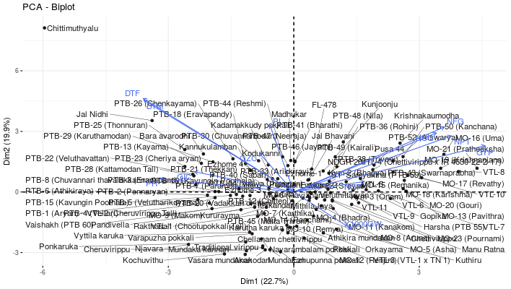
Fig. 4. PCA biplot
The PCA biplot (Figure 4) visually confirmed the grouping of genotypes based on their trait profiles, with traditional high-iron varieties (Chittimuthyalu, Njavara, Kannukulamban) clustering distinctly from high-zinc breeding lines (PTB-25, PTB-21, PTB-18) and both groups separating from high-yielding improved varieties.
4. Conclusion
This comprehensive evaluation of 123 rice germplasm lines revealed exceptional genetic diversity for both grain iron and zinc contents, with iron exhibiting an 847-fold range (0-1694.8 ppm) and zinc showing substantial variation (0-159.87 ppm). The magnitude of this variation substantially exceeds many previous reports in rice and demonstrates the rich genetic potential within rice germplasm for biofortification programmes.
Previous studies have documented iron content ranging from 6.9 to 67.3 mg/kg in brown rice (Anuradha et al., 2012; Maganti et al., 2020) and 0.8 to 36.45 mg/kg in polished rice (Bollinedi et al., 2020; Raza et al., 2019). For zinc, reported ranges have been 6.2 to 71.6 mg/kg in brown rice (Anuradha et al., 2012) and 4.8 to 40.9 mg/kg in polished rice (Sanjeeva Rao et al., 2020). Our findings of maximum values of 1694.8 ppm for iron and 159.87 ppm for zinc in polished rice represent extraordinary levels that far exceed these earlier reports, suggesting either the presence of unique genetic variants in our germplasm panel or the effectiveness of our screening methodology.
The identification of extreme high-iron traditional varieties—Chittimuthyalu (1694.8 ppm), Njavara (1471.9 ppm), and Kannukulamban (1318.4 ppm)—is particularly significant. These values exceed the typical iron content in polished rice (2-5 ppm) by 300-800 fold and surpass even the ambitious biofortification targets proposed by HarvestPlus (13 mg/kg) by 100-130 fold (Trijatmiko et al., 2016). All three are indigenous Indian varieties with documented special properties: Njavara is a renowned medicinal rice from Kerala traditionally used in Ayurvedic treatments (Devaraj et al., 2020), while Chittimuthyalu is valued in southern India for its nutritional and cultural significance. The preservation of such exceptional nutritional traits in traditional varieties underscores the critical importance of conserving agricultural biodiversity and systematically characterizing landrace collections for hidden genetic treasures (Roy and Sharma, 2014; Descalsota et al., 2018).
For zinc, the superior performance of advanced breeding lines PTB-25 (159.87 ppm), PTB-21 (159.34 ppm), and PTB-18 (151.89 ppm) suggests successful genetic enhancement through systematic breeding. These levels represent 10-fold enrichment over typical polished rice zinc content (16 mg/kg) and exceed the HarvestPlus international target (28 mg/kg) by 5.4-5.7 fold. The predominance of PTB lines among top zinc performers (11 of top 15) strongly indicates that targeted selection for zinc accumulation has been practiced in this breeding programme, likely through recurrent selection or strategic crossing with high-zinc donors followed by multi-generation selection (Swamy et al., 2016; Sanjeeva Rao et al., 2020).

References
Akhtar, S., Ismail, T., Riaz, M., & Ismail, A. (2022). Biofortification of cereals and pulses using new breeding techniques: Current and future perspectives. Food Chemistry, 375, 131904. https://doi.org/10.1016/j.foodchem.2021.131904
Anuradha, K., Agarwal, S., Rao, Y. V., Rao, K. V., Viraktamath, B. C., & Sarla, N. (2012). Mapping QTLs and candidate genes for iron and zinc concentrations in unpolished rice of Madhukar × Swarna RILs. Gene, 508(2), 233-240. https://doi.org/10.1016/j.gene.2012.07.054
Anusha, G., Rao, D. S., Jaldhani, V., Beulah, P., Neeraja, C. N., Gireesh, C., Aravind Kumar, J., Madhusudhan Reddy, P., Anantha, M. S., Lakshmi Pathy, T., Bhadana, V. P., Gireesh, C., & Sundaram, R. M. (2021). Grain Fe and Zn content, heterosis, combining ability and its association with grain yield in irrigated and aerobic rice. Scientific Reports, 11(1), 10579. https://doi.org/10.1038/s41598-021-90038-4
Bollinedi, H., Vinod, K. K., Bisht, K., Chauhan, A., Gopala Krishnan, S., Bhowmick, P. K., Ellur, R. K., Prakash, N., Bhosle, A., Singh, A. K., & Sevanthi, A. M. (2020). Characterising the diversity of grain nutritional and physico-chemical quality in Indian rice landraces by multivariate genetic analyses. Indian Journal of Genetics and Plant Breeding, 80(1), 26-38. https://doi.org/10.31742/IJGPB.80.1.4
Bouis, H. E., Hotz, C., McClafferty, B., Meenakshi, J. V., & Pfeiffer, W. H. (2003). Biofortification: A new tool to reduce micronutrient malnutrition. Food and Nutrition Bulletin, 32(1_suppl1), S31-S40. https://doi.org/10.1177/15648265110321S105
Brown, K. H., Rivera, J. A., Bhutta, Z., Gibson, R. S., King, J. C., Lönnerdal, B., Ruel, M. T., Sandtröm, B., Wasantwisut, E., Hotz, C., & International Zinc Nutrition Consultative Group (IZiNCG). (2004). International Zinc Nutrition Consultative Group (IZiNCG) technical document #1. Assessment of the risk of zinc deficiency in populations and options for its control. Food and Nutrition Bulletin, 25(1 Suppl 2), S99-203. PMID: 18046856
Calayugan, M. I. C., Formantes, A. K., Amparado, A., Descalsota-Empleo, G. I., Nha, C. T., Inabangan-Asilo, M. A., Swe, Z. M., Hernandez, J. E., Borromeo, T. H., Lalusin, A. G., Sta. Cruz, P. C., Bizimana, J. B., Mwangi, E., Stangoulis, J., Reinke, R. F., Singh, R. K., Swamy, B. P. M., & Grenier, C. (2020). Genetic analysis of agronomic traits and grain iron and zinc concentrations in a doubled haploid population of rice (Oryza sativa L.). Scientific Reports, 10(1), 2283. https://doi.org/10.1038/s41598-020-59184-z
Cu, S. T., Warnock, N. I., Pasuquin, J., Dingkuhn, M., & Stangoulis, J. (2021). A high-resolution genome-wide association study of the grain ionome and agronomic traits in rice Oryza sativa subsp. indica. Scientific Reports, 11(1), 19597. https://doi.org/10.1038/s41598-021-98573-w
Descalsota, G. I. L., Swamy, B. P. M., Zaw, H., Inabangan-Asilo, M. A., Amparado, A., Mauleon, R., Chadha-Mohanty, P., Arocena, E. C., Raghavan, C., Leung, H., Hernandez, J. E., SS Lalusin, A. G., Mendioro, M. S., Diaz, M. G. Q., & Reinke, R. F. (2018). Genome-wide association mapping in a rice MAGIC Plus population detects QTLs and genes useful for biofortification. Frontiers in Plant Science, 9, 1347. https://doi.org/10.3389/fpls.2018.01347
Devaraj, V. R., Giridhar, P., Rajasekaran, C., & Ravishankar, G. A. (2020). Bioactive compounds and antioxidant activities of Njavara rice (Oryza sativa L.). Journal of Food Science and Technology, 57(10), 3827-3835. https://doi.org/10.1007/s13197-020-04415-9
FAO, IFAD, UNICEF, WFP, & WHO. (2022). The State of Food Security and Nutrition in the World 2022. Repurposing food and agricultural policies to make healthy diets more affordable. Rome: Food and Agriculture Organization. https://doi.org/10.4060/cc0639en
Garcia-Oliveira, A. L., Chander, S., Ortiz, R., Menkir, A., & Gedil, M. (2018). Genetic basis and breeding perspectives of grain iron and zinc enrichment in cereals. Frontiers in Plant Science, 9, 937. https://doi.org/10.3389/fpls.2018.00937
Graham, R. D., Welch, R. M., & Bouis, H. E. (2001). Addressing micronutrient malnutrition through enhancing the nutritional quality of staple foods: Principles, perspectives and knowledge gaps. Advances in Agronomy, 70, 77-142. https://doi.org/10.1016/S0065-2113(01)70004-1
Gopinath PP, Parsad R, Joseph B, VS A. 2021. grapesAgri1: collection of shiny apps for data analysis in agriculture. J Open Source Softw. 6(63):3437.
Lee, S. M., Kang, J. W., Lee, J. Y., Seo, J., Shin, D., Cho, J. H., Jo, S., Song, Y. C., Park, D. S., Sohn, Y. B., Lee, G. S., Kim, K. M., Lee, S. B., & Koh, H. J. (2020). QTL analysis for Fe and Zn concentrations in rice grains using a doubled haploid population derived from a cross between rice (Oryza sativa) cultivar 93-11 and Milyang 352. Plant Breeding and Biotechnology, 8(1), 69-76. https://doi.org/10.9787/PBB.2020.8.1.69
Maganti, S., Swamy, B. P. M., Teressa, T. F., & Bitew, M. (2020). Genetic variation for grain iron and zinc content in diversity panel, breeding lines, and MAGIC plus population of rice (Oryza sativa L.). Cereal Research Communications, 48(4), 469-476. https://doi.org/10.1007/s42976-020-00065-9
Matres, J. M., Arcillas, E., Cueto-Reaño, M. F., Sallan-Gonzales, R., Trijatmiko, K. R., Slamet-Loedin, I. H., & Sreenivasulu, N. (2021). Biofortification of rice grains for increased iron content. In Rice Improvement: Physiological, Molecular Breeding and Genetic Perspectives (pp. 471-486). Cham: Springer International Publishing. https://doi.org/10.1007/978-3-030-66530-2_14
Norton, G. J., Deacon, C. M., Xiong, L., Huang, S., Meharg, A. A., & Price, A. H. (2010). Genetic mapping of the rice ionome in leaves and grain: identification of QTLs for 17 elements including arsenic, cadmium, iron and selenium. Plant and Soil, 329(1), 139-153. https://doi.org/10.1007/s11104-009-0141-8
Pandey, S., Dayal Doss, D., & Shashidhar, H. E. (2019). Identification of candidate gene based markers (SNPs) in the ZIP family transporter sequences of rice (Oryza sativa L.). International Journal of Current Microbiology and Applied Sciences, 8(1), 2830-2842. https://doi.org/10.20546/ijcmas.2019.801.297
Pradhan, S. K., Pandit, E., Pawar, S., Naveenkumar, R., Barik, S. R., Mohanty, S. P., Nayak, D. K., Ghritlahre, S. K., Sanjiba Rao, D., Reddy, J. N., Patnaik, S. S. C., Katara, J. L., Marndi, B. C., Das, S. R., & Sahu, R. K. (2020). Linkage disequilibrium mapping for grain Fe and Zn enhancing QTLs useful for nutrient dense rice breeding. BMC Plant Biology, 20(1), 57. https://doi.org/10.1186/s12870-020-2262-4
Prasad, A. S. (2013). Discovery of human zinc deficiency: its impact on human health and disease. Advances in Nutrition, 4(2), 176-190. https://doi.org/10.3945/an.112.003210
Raza, Q., Riaz, A., Sabar, M., Atif, R. M., & Bashir, K. (2019). Meta-analysis of grain iron and zinc associated QTLs identified hotspot chromosomal regions and positional candidate genes for breeding biofortified rice. Plant Science, 288, 110214. https://doi.org/10.1016/j.plantsci.2019.110214
Roy, S. C., & Sharma, B. D. (2014). Assessment of genetic diversity in rice [Oryza sativa L.] germplasm based on agro-morphology traits and zinc-iron content for crop improvement. Physiology and Molecular Biology of Plants, 20(2), 209-224. https://doi.org/10.1007/s12298-014-0221-y
Sanjeeva Rao, D., Neeraja, C. N., Madhu Babu, P., Nirmala, B., Suman, K., Rao, L. V. S., Surekha, K., Raghu, P., Longvah, T., Surendra, P., Sudhakar, P., & Voleti, S. R. (2020). Zinc biofortified rice varieties: Challenges, possibilities, and progress in India. Frontiers in Nutrition, 7, 26. https://doi.org/10.3389/fnut.2020.00026
Schmidt, R. J., Tancredi, D. J., Krakowiak, P., Hansen, R. L., & Ozonoff, S. (2014). Maternal intake of supplemental iron and risk of autism spectrum disorder. American Journal of Epidemiology, 180(9), 890-900. https://doi.org/10.1093/aje/kwu208
Senguttuvel, P., Jaldhani, V., Krishnan, S. G., Roja Rani, A., Padmavathi, G., Divya Balakrishnan, P., Beulah, P., Nagaraju, P., Mangrauthia, S. K., Gannavarapu, P., Neeraja, C. N., Ram, T., Surekha, K., Prasad, M. S., Babu, V. R., Gireesh, C., Singh, V. K., Singh, A. K., Krishnan, S. G., Sundaram, R. M., & Govindaraj, M. (2023). Rice biofortification: Breeding and genomic approaches for genetic enhancement of grain zinc and iron contents. Frontiers in Plant Science, 14, 1138408. https://doi.org/10.3389/fpls.2023.1138408
Stein, A. J., Nestel, P., Meenakshi, J. V., Qaim, M., Sachdev, H. P. S., & Bhutta, Z. A. (2007). Plant breeding to control zinc deficiency in India: how cost-effective is biofortification? Public Health Nutrition, 10(5), 492-501. https://doi.org/10.1017/S1368980007223857
Swamy, B. P. M., Rahman, M. A., Inabangan-Asilo, M. A., Amparado, A., Manito, C., Chadha-Mohanty, P., Reinke, R., & Slamet-Loedin, I. H. (2016). Advances in breeding for high grain zinc in rice. Rice, 9(1), 49. https://doi.org/10.1186/s12284-016-0122-5
Trijatmiko, K. R., Dueñas, C., Tsakirpaloglou, N., Torrizo, L., Arines, F. M., Adeva, C., Balindong, J., Oliva, N., Sapasap, M. V., Borrero, J., Rey, J., Francisco, P., Nelson, A., Nakanishi, H., Lombi, E., Tako, E., Glahn, R. P., Stangoulis, J., Chadha-Mohanty, P., Johnson, A. A. T., Tohme, J., Barry, G., & Slamet-Loedin, I. H. (2016). Biofortified indica rice attains iron and zinc nutrition dietary targets in the field. Scientific Reports, 6(1), 19792. https://doi.org/10.1038/srep19792
Vanlalsanga, Talukdar, P., & Beena, R. (2019). Genetic variability for zinc and iron content in indigenous aromatic rice germplasm of Mizoram, India. Electronic Journal of Plant Breeding, 10(3), 1087-1095. https://doi.org/10.5958/0975-928X.2019.00140.6
WHO (World Health Organization). (2015). The Global Prevalence of Anaemia in 2011. Geneva: World Health Organization. Retrieved from https://apps.who.int/iris/handle/10665/177094
Yang, W., Guo, Z., Huang, C., Duan, L., Chen, G., Jiang, N., Fang, W., Feng, H., Xie, W., Lian, X., Wang, G., Luo, Q., Zhang, Q., Liu, Q., & Xiong, L. (2019). Combining high-throughput phenotyping and genome-wide association studies to reveal natural genetic variation in rice. Nature Communications, 10(1), 5452. https://doi.org/10.1038/s41467-019-13389-2

