LD Slag as a Soil Amendment and Nutrient Source in Sustainable Agriculture: A Review
ABSTRACT
The steel industry has grown rapidly, leading to the production of large quantities of steel slag, a by-product from processes like basic oxygen, electric arc, and ladle furnaces. Once seen as an industrial waste, steel slag is now valued in agriculture as a soil enhancer and nutrient source. This review highlights the benefits of using steel slag in sustainable farming, focusing on its nutrient content, environmental safety, and influence on crop productivity. It is rich in essential plant nutrients such as calcium, silicon, magnesium, and phosphorus, along with micronutrients like iron and manganese. Its alkaline nature helps to reduce soil acidity, improve nutrient availability, and support microbial activity in the soil. Steel slag also has the ability to reduce the mobility of harmful metals like cadmium, arsenic, and lead, lowering the risk of heavy metal contamination in crops. Its application improves crop growth, enhances stress tolerance, and boosts yield. Moreover, it helps to reduce methane and nitrous oxide emissions in flooded rice fields by altering soil microbial dynamics and redox conditions. When combined with materials like biochar, slag enhances carbon retention and microbial health, supporting long-term soil fertility. This review compiles recent research on various types of slag used in farming, emphasizing their role in improving soil properties, limiting toxic metal uptake, and supporting sustainable crop production. It also addresses safety and regulatory considerations for practical use in agriculture.
Key words- steel slag, characterization, soil amendment, adsorbent, sequestration
Introduction
With the rapid growth of the steel industry, the production of steel slag waste material generated during the transformation of iron into steel in basic oxygen, electric arc, or induction furnaces has increased significantly. This material was traditionally considered as an industrial waste, posing environmental risks due to its volume and potential to contain heavy metals. However, recent research has shown that steel slag can serve as a valuable soil amendment and an alternative fertilizer in agriculture (Proctor et al., 2000; Hemalatha, 2013; Mamatha et al., 2018).
Steel slag contains important plant nutrients such as calcium (Ca), silicon (Si), phosphorus (P), and magnesium (Mg), along with trace elements like iron (Fe), manganese (Mn), and molybdenum (Mo). These components are essential for plant growth and maintaining soil health. Due to its alkaline pH (ranging from 8 to 12), slag can effectively neutralize acidic soils, making nutrients more available to crops and improving yield. It also supports beneficial soil microbes and helps reduce the mobility of harmful elements like cadmium (Cd), arsenic (As), and lead (Pb). Beyond its benefits for soil and plants, steel slag also contributes to climate-resilient agriculture. Studies have shown that its application reduces emissions of greenhouse gases like methane (CH₄) and nitrous oxide (N₂O), especially in rice-growing systems, by influencing soil microbes and redox conditions. Silicon from slag also strengthens plant tissues, helping crops withstand abiotic stress such as drought, salinity, metal toxicity, and fungal diseases like brown spot in rice (O’Connor et al., 2021).
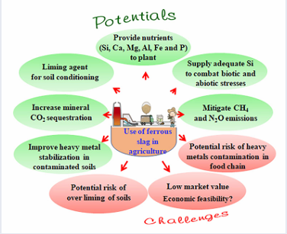
Considering its wide availability, low cost, and multiple advantages, steel slag offers a promising solution for sustainable farming. This review aims to summarize key findings on how steel slag affects soil chemistry, nutrient dynamics, microbial interactions, and crop performance, while also addressing safety and practical considerations for its use in agriculture.
Figure 1. Slag properties
Steel Slag Formation
Steel slag is a by-product produced during steel manufacturing and is mainly generated from three types of furnaces: basic oxygen furnaces (BOF), electric arc furnaces (EAF), and induction furnaces (IF). Among these, slag from induction furnaces is produced in smaller quantities due to limited industrial use. The primary components of steel slag include oxides such as calcium oxide (CaO), silicon dioxide (SiO₂), aluminium oxide (Al₂O₃), magnesium oxide (MgO), manganese oxide (MnO), ferric oxide (Fe₂O₃), and phosphorus pentoxide(P₂O₅), which are formed when impurities in molten steel react with oxygen during steelmaking (Wang et al., 2018).
Steel slag is categorized based on the furnace used:
- BOF slag is generated when molten iron (80–90%) is combined with scrap steel (10–20%), which also helps to cool the furnace. Fluxing agents like lime and dolomite are added during the process to remove impurities, resulting in BOF slag.
- EAF slag is produced by melting scrap metal in electric arc furnaces.
- Ladle slag, also known as white slag, forms during the secondary refining of steel in ladles.
The fluxes added during melting mainly lime (CaO) and dolomite help to bind unwanted elements, which are then removed with the slag. This process not only purifies the steel but also leads to the formation of chemically rich slag, which holds potential for agricultural use.
Composition of Slag
Steel slag is mainly composed of mixed metal oxides, including silicon, sulphur, phosphorus, and aluminium, which result from the interaction of molten metals with furnace linings and added fluxes like limestone. These materials are rich in beneficial compounds such as magnesia (MgO), phosphoric acid(P₂O₅), silicic acid (SiO₂), lime (CaO), manganese (Mn), and iron (Fe), all of which are useful for plant nutrition (Ito, 2015).
In several countries especially China, Korea, and Japan slag from blast furnaces and steelmaking has long been used to produce agricultural fertilizers. There are four main types of slag-based fertilizers:
- Iron matter fertilizers
- Slag phosphate fertilizers
- Lime-based fertilizers
- Slag silicate fertilizers
The chemical composition of basic oxygen furnace slag (BOFS) and electric arc furnace slag (EAFS) varies, as shown in research (Yi et al., 2012). BOFS generally contains higher levels of calcium oxide (45–60%), while EAFS may contain more aluminium oxide (10–18%) and magnesium oxide (8–13%). The concentration of nutrients in each slag type depends on several factors such as raw materials used, type of furnace, and steel production process. Different types of slag including steel, stainless steel, blast furnace, and ladle furnace slags have all been tested for agricultural purposes. These nutrient-rich slags enhance soil microbial activity, which is essential for ecosystem functions and long-term soil health (Das et al., 2019). This makes slag a valuable input for sustainable agriculture by improving both nutrient supply and biological conditions in the soil.
Table 1. Chemical compositions of BOFS and EAFS (wt., %) (Yi et al., 2012)
Slag type | CaO | SiO2 | Al2O3 | MgO | MnO | Fe2O3 | P2O5
BOFS | 45-60 | 10-15 | 1-5 | 3-13 | 2-6 | 3-9 | 1-4
EAFS | 30-50 | 11-20 | 10-18 | 8-13 | 5-10 | 5-6 | 2-5
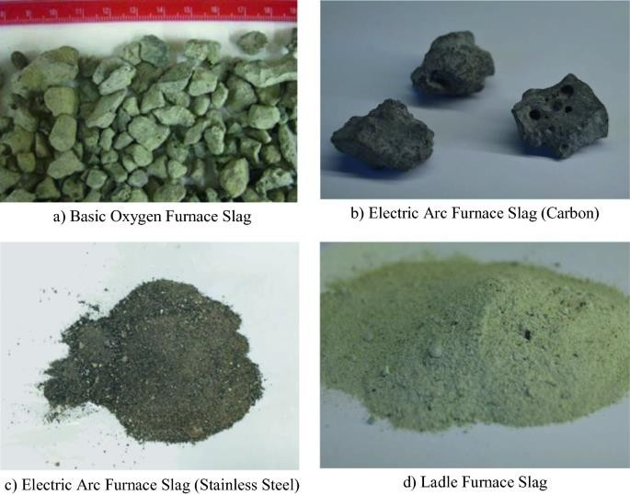
Figure 2. Different types of slags (Deus et al., 2018)
Chemical and Physical Characterization of Slag
Chand et al. (2015) compared the chemical composition of different types of steel slag with wollastonite, a naturally occurring silicate mineral commonly used in agriculture. In agricultural applications, soil amendments are often evaluated based on their neutralization power (NP) and the levels of calcium (CaO) and magnesium (MgO), which help reduce soil acidity. According to Brazilian soil amendment regulations, materials must meet certain thresholds, such as at least 60% effective CaCO₃ and 30% combined CaO and MgO to qualify as soil acidity correctives. The slags (stainless steel slag, steel slag, ladle slag) meet these criteria and can thus be used as substitutes for lime in managing acidic soils.
Additionally, the concentration of silicon (Si) and phosphorus (P₂O₅) varies across different slags. For example, ladle slag (LS) contains the most silicon, while steel slag (SS) has the highest phosphorus content. These differences may enhance the availability of these nutrients in the soil and benefit crop growth. Another important consideration is the presence of micronutrients and heavy metals. Deus et al. (2018) present data on elements such as copper (Cu), iron (Fe), manganese (Mn), zinc (Zn), cadmium (Cd), nickel (Ni), lead (Pb), chromium (Cr), and mercury (Hg). Each slag type varies in nutrient and heavy metal content. For instance, steel slag is rich in iron, while blast furnace slag contains higher levels of manganese. Although some heavy metals are present, their levels are generally within safe limits for agricultural use. Therefore, slag can be applied to soils without posing environmental risks, provided its composition is properly assessed beforehand.

Table 2. Chemical and physical characterization of different slags (Chand et al., 2015)
Materials | CaO | MgO | NP | RR | ECC | Si | P2O5 | K2O
% | % | % | % ECaCO3 | % | % | g kg⁻¹ | g kg⁻¹ | g kg⁻¹
SSS | 37.65 | 9.55 | 84 | 71 | 60 | 13.6 | 3.5 | 0.3
SS | 28.13 | 6.10 | 70 | 71 | 50 | 14.2 | 11 | 0.3
LS | 36.10 | 5.76 | 77 | 80 | 62 | 21.6 | 2.5 | 0.3
W | 30.00 | 3.00 | 60 | 100 | 60 | 16.0 | 1.5 | 0.1

SSS, stainless steel slag; SS, steel slag; LS, ladle slag; W, wollastonite; NP, neutralization power; RR, reactivity rate, expresses the percentage of corrective material that reacts in 3 months; ECC, effective calcium carbonate.
Table 3. Micronutrients and heavy metal contents in different slags (Deus et al., 2018)
Materials | Cu  mg kg⁻¹ | Fe  mg kg⁻¹ | Mn  mg kg⁻¹ | Zn  mg kg⁻¹ | Cd  mg kg⁻¹ | Ni  mg kg⁻¹ | Pb  mg kg⁻¹ | Cr  mg kg⁻¹ | Hg  mg kg⁻¹
SSS | 20 | 38.000 | 5.300 | 50 | 3.1 | 53.6 | 12.6 | 990 | <0.1
SS | 30 | 193.500 | 21.500 | 70 | 14.5 | 3.0 | <0.5 | 941 | <0.1
BFS | 20 | 17.400 | 51.000 | 50 | 1.8 | 1.4 | <0.5 | 104 | <0.1
LS | 20 | 28.600 | 3.700 | 50 | 1.6 | 1.1 | <0.5 | 126 | <0.1
W | 10 | 600 | 100 | 40 | <0.03 | 0.3 | <0.5 | 0.5 | <0.1
SSS, stainless steel slag; SS, steel slag; LS, ladle slag; BFS, blast furnace slag;
As a Soil Amendment
One of the key physical traits of steel slag is its particle size, which influences how effectively it neutralizes soil acidity. To be suitable for agricultural use as a liming material, about 90% of the slag should pass through a 20-mesh sieve (900 microns). Compared to traditional agricultural lime, steel slag has a higher density and specific gravity, mainly due to its higher metal content. For reference, steel slag’s bulk density ranges from 1.6 to 1.9 g/cm³, while lime typically ranges from 1.4 to 1.5 g/cm³. The specific gravity of slag is between 3.2 and 3.6 g/cm³, while that of lime is between 2.7 and 2.9 g/cm³ (NSA, 2021). Steel slag is particularly useful in paddy fields, as it can reduce greenhouse gas emissions (CH₄ and N₂O) without increasing harmful heavy metal concentrations. It also serves as a cost-effective alternative to limestone for managing soil acidity.
- Soil Chemistry
Studies have shown that steel slag application improves soil chemistry by:
- Raising pH in acidic soils
- Increasing availability of nutrients like phosphorus (P), calcium (Ca), and magnesium (Mg)
- Enhancing crop productivity.
The initial soil condition must be known before application to determine the correct dosage. Uniform application and thorough mixing into the soil are also important for the best results.
The chemical reaction behind slag’s ability to reduce acidity involves silicate (SiO₃²⁻) ions in slag reacting with water to release hydroxide ions (OH⁻), which neutralize soil acidity:
- CaSiO₃ + H₂O → Ca²⁺ + SiO₃²⁻
- MgSiO₃ + H₂O → Mg²⁺ + SiO₃²⁻
- SiO₃²⁻ + H₂O → HSiO₃⁻ + OH⁻
- HSiO₃⁻ + H₂O → H₂SiO₃ + OH⁻
- OH⁻ + H⁺ → H₂O
- OH⁻ + Al³⁺ → Al (OH)₃
These reactions help neutralize acidity and immobilize toxic metals like aluminium.
- Soil Properties
Soil pH greatly affects the availability of nutrients like calcium, magnesium, and phosphorus, as well as the activity of beneficial soil microbes. Applying steel slag, which is highly alkaline (pH ~12.5), helps correct this problem by raising the soil pH and improving its overall quality.
The effect of slag on soil pH, conductivity, and salinity depends on the proportion mixed with soil. For example, mixing soil with slag in different ratios (1:1, 1:3, or 3:1) showed an increase in pH and conductivity, shifting the soil toward a weakly alkaline condition. As the amount of slag increased, so did these properties, indicating improved chemical conditions for plant growth.
A study by Wang et al. (2018) further confirmed that combining steel slag with biochar in paddy fields raised soil pH by 14.2% and salinity by 98% compared to untreated soil. This increase in pH is attributed to the gradual release of alkaline nutrients such as calcium, silicon, and potassium from the slag and biochar mixture. These improvements in soil chemistry can lead to better nutrient availability and enhanced crop performance.
Table 4. The physical–chemical characteristics of soil and slag solutions
Sample | Parameters
Sample | pH | Conductivity[mS/cm] | Salinity [ppt]
Soil solution | 5.2 | 0.29 | 0.2
Slag solution | 12.5 | 6.38 | 3.6
Soil-slag 1 | 8.02 | 2.55 | 1.3
Soil-slag 2 | 8.53 | 5.65 | 2.1
Soil-slag 3 | 7.78 | 0.82 | 0.4
- Soil Heavy Metals
Researchers used X-ray fluorescence (XRF) analysis to examine the chemical composition of soil mixed with steel slag in different ratios (1:1, 1:3, and 3:1). These samples were tested for elements like iron (Fe), titanium (Ti), manganese (Mn), and potentially toxic elements (PTEs) such as arsenic (As), zinc (Zn), copper (Cu), and cobalt (Co). Among these, cobalt was found to be the most prominent element in untreated soil.
When slag was added at a 1:1 ratio, the concentration of zinc and other PTEs in the soil was reduced. As the proportion of slag increased (for example, at a 3:1 ratio), the levels of essential elements in the soil rose, indicating that slag can enrich soil with beneficial nutrients while reducing harmful substances. The results suggest that increasing the amount of slag used in contaminated soils can help remove or stabilize toxic elements. According to a study by Chand et al. (2015), applying steel slag to soil lowered the accumulation of heavy metals to within safe limits, making the practice a more environmentally sustainable option for agricultural use.
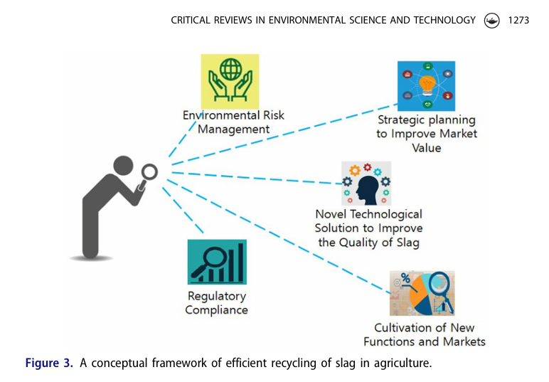
Figure 3. A conceptual framework for efficient recycling of slag in agriculture.
- As low-cost adsorbents
Steel slag has gained attention as a low-cost adsorbent due to its unique chemical and physical features. The efficiency of slag in capturing harmful substances depends on several factors, including its chemical makeup, surface structure, particle size, porosity, and the presence of reactive functional groups on its surface. These characteristics determine how well slag can bond with and hold contaminants from the surrounding environment (Piatak et al., 2019; Dimitrova et al., 1996).
For example, the solubility of free lime in slag influences the pH of solutions, which affects how dissolved cations behave. Additionally, hydrolysis reactions involving different slag minerals can affect how slag binds with toxic substances. Slags with more porous structures and smaller particle sizes tend to have higher internal surface areas, which improve their ability to adsorb potentially toxic elements (PTEs). The presence of micro and mesopores creates more space for these pollutants to attach.
Several factors impact how well slag performs in adsorption:
- Experimental conditions such as temperature, shaking speed, and the ratio of solid to liquid
- Solution properties like pH, ion concentration, types of contaminants, and competing substances. (Ahmaruzzaman et al., 2011).
Together, these elements determine how effectively slag can trap and retain harmful compounds. This section reviews current scientific knowledge about how various slags interact with PTEs and other contaminants, demonstrating their potential use in environmental clean-up and soil improvement.
- Interaction with potentially toxic elements in soils
Potentially toxic elements (PTEs) such as cadmium (Cd), lead (Pb), and arsenic (As) are increasingly accumulating in agricultural soils due to industrial activities like mining, pesticide and fertilizer use, sewage irrigation, and coal burning (Qin et al., 2021). Among these, irrigation with untreated sewage water is one of the most serious contributors to soil contamination. For instance, a national survey in China showed that out of 55 polluted locations, 39 had been irrigated with sewage, with heavy titanium (Ti) pollution found in Guangdong Province (Jiang et al., 2013).
The application of steel slag to soil can help reduce the mobility and toxicity of these harmful elements. Slag works by altering soil properties such as pH, cation exchange capacity, and microbial activity. It can also immobilize PTEs through processes like:
- Adsorption (binding to slag surfaces),
- Precipitation (forming stable compounds),
- Ion exchange (swapping with less harmful ions).
As a result, elements like arsenic (As), copper (Cu), cadmium (Cd), lead (Pb), and zinc (Zn) become less available for plant uptake. Masud et al. (2014) noted that applying slag improves soil pH, enhances calcium and magnesium availability, and boosts crop productivity.
Specific mechanisms include:
- Phosphorus reacts with lead and zinc to form stable compounds
- Iron hydroxides in the soil bind arsenic
- Chromium (VI), a highly toxic form, is reduced to less harmful Cr (III).
Using slag also increases silicon availability in the soil, which helps reduce arsenic uptake by plants (Gale et al., 2012). Other amendments, like hydrous manganese oxide or iron ores, can work alongside slag to reduce heavy metal absorption in crops (Ali et al., 2009). For example, Thomas basic slag (TBS) has been shown to lower lead levels in ryegrass shoots and improve soil fertility and crop growth (Das et al., 2019).
To effectively use slag-based fertilizers in soils polluted with harmful elements, it's important to understand how slag interacts with these contaminants at both the soil and plant levels. Slag has been widely recognized for its ability to detoxify potentially toxic elements (PTEs), but practical use requires knowledge of the mechanisms behind this detoxification process. At the soil level, slag helps immobilize PTEs, improves pH balance, and enhances both chemical and biological properties of the soil. These changes reduce the movement of harmful metals and prevent them from reaching plant roots. At the plant level, slag reduces the transfer of PTEs from roots to shoots and strengthens the plant’s internal defence systems. The mechanisms by which slag immobilizes PTEs are similar to those of other soil amendments like lime, biochar, zeolite (Bashir et al., 2019), and certain beneficial microbes (Singh et al., 2014; Tang et al., 2020). Slag contains silicates, ferrites, and calcium oxides that play a key role in trapping harmful metal ions. These materials release silicon (SiO₄⁴⁻), iron oxides (Fe₂O₃), and hydroxide ions (OH⁻), which react with PTEs to stabilize them and prevent uptake by plants (Yang et al., 2017).
Some harmful ions also become immobilized within the slag structure, while others bind to its surface through ion exchange (Chen et al., 2019). As slag raises soil pH, metal ions may also form stable bonds with soil organic matter. Furthermore, increased organic matter due to slag use helps bind PTEs, making them less mobile. In short, slag can act both as a chemical barrier and as a source of stabilizing materials that prevent toxic metals from entering the food chain.
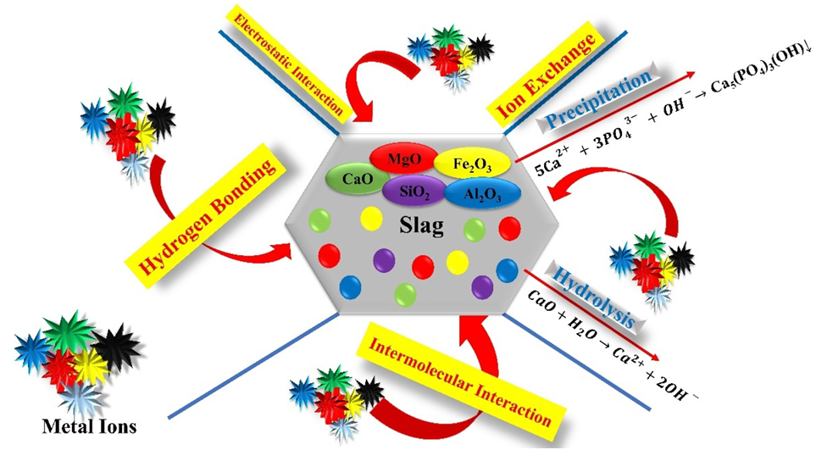
Figure 4. Mechanism of slag-based fertilizers in the soil
Interaction with potentially toxic elements in plants
Protecting plant growth and productivity is a top priority in sustainable farming. However, contamination of soils with potentially toxic elements (PTEs) has become a serious concern, as it affects plant health and poses risks to human safety (Rai et al., 2019). The degree to which plants absorb these harmful elements depends on their availability in the soil (Wu et al., 2020). Generally, the more stable the PTE forms in soil, especially those bound to minerals, the less likely plants are to take them up (Xu et al., 2016). The most dangerous are the acid-soluble forms, which are easily absorbed but can be stabilized through the use of soil amendments like slag.
Studies have shown that applying various types of slag can immobilize the acid-soluble portion of harmful metals such as arsenic (As) (Liu et al., 2020). Additionally, changes in redox conditions as the soil matures, such as those in flooded paddy fields, can enhance the ability of slag to bind PTEs (Wang et al., 2018). When slag was added to cadmium (Cd) Cd-contaminated soils during two different crop stages, the bioavailability of Cd decreased. Although some metal forms in soil may still fluctuate due to environmental changes, slag consistently reduced its plant uptake. In particular, slags raised the soil pH, shifting toxic metals like Cd and As into less mobile, oxidized forms (Qi et al., 2014). In one study, slag application reduced Cd content in rice roots by 40% and in shoots by 38% (Liu et al., 2020). The negative effects of potentially toxic elements (PTEs) on plants are closely linked to their bioavailability, which helps indicate the level of pollution in contaminated environments (Wu et al., 2020).
Besides lowering PTE absorption, slag fertilizers provide essential nutrients such as calcium, magnesium, and phosphorus, which support healthy plant growth (Castro et al., 2013). Calcium and magnesium form stable compounds with other minerals present in the slag. Fan et al. (2018) showed that applying slag to acidic soils decreased concentrations of chromium (Cr), copper (Cu), lead (Pb), and zinc (Zn) in plants. Their findings also suggested that slag fertilization does not pose a threat to crops or surrounding soils. However, more long-term research is needed to fully understand how slag compares to traditional chemical fertilizers in managing metal-contaminated fields.
Plant Nutrition
The main goal of applying steel slag as a fertilizer is to enhance plant nutrition. Slag naturally contains macronutrients like calcium (Ca) and magnesium (Mg) which are needed in large quantities by plants as well as micronutrients such as iron (Fe) and manganese (Mn). However, because slag contains very low levels of nitrogen (N) and potassium (K), and only moderate phosphorus (P), it is most effective when used together with N-P-K fertilizers to meet full plant nutrient requirements (Ito, 2015; Das et al., 2020).
Among slag-based fertilizers, silicate slag fertilizers are gaining popularity, particularly in rice cultivation. Research shows that applying silicate slag to lowland rice fields can increase yields by 0.16–47.2%, depending on factors like soil type, application rate, and farming practices. For example, Ali et al. (2009) found that silicate fertilizer boosted rice yields significantly under no-tillage, flooded conditions. This benefit is largely due to silicon (Si), which gets deposited in plant cell walls, especially in leaf and sheath tissues, where it strengthens the plant and helps it resist stress from drought, salinity, pests, and disease (Luyckx et al., 2017). In addition to silicate, lime-based slag fertilizers are also useful in acidic soils, helping to neutralize acidity and improve the availability of other nutrients.
Pooja et al. (2023) observed that combining LD slag (2 tons/ha) with biochar (1 ton/ha) improved wheat growth and yield. Specifically, it increased leaf area, chlorophyll content, photosynthetic rate, stomatal conductance, and transpiration. This bioaugmented treatment led to 25–27% higher yields compared to standard recommended fertilizer (RDF) use alone.
According to current fertilizer regulations, several products that use ferrous slag as a raw material are officially recognized. These include slag silicate fertilizers, slag phosphate fertilizers, lime-based fertilizers, and special fertilizers containing iron (Ito, 2015). Ferrous slag is composed of a mix of oxides, mainly calcium (Ca), silicon (Si), magnesium (Mg), aluminium (Al), and iron (Fe), along with smaller amounts of other nutrients like manganese (Mn), potassium (K), and sodium (Na).
Most of the minerals found in slag are beneficial for plants and can be easily absorbed when applied to soil. These nutrients not only support plant growth and development but also improve soil structure and fertility. As a result, ferrous slag has significant potential as a low-cost, nutrient rich fertilizer, particularly in soils that are acidic or deficient in essential minerals.
Soil Microbial Interaction
The type of slag used in agriculture, such as silicate, phosphate, lime-based, or iron-based fertilizers can significantly influence soil microbial communities and their functions. These fertilizers not only improve soil nutrient levels but also alter the soil environment, which in turn affects the diversity and activity of soil microorganisms.
There are several ways in which slag fertilizers support beneficial microbial activity:
- Nutrient Supply: Slag fertilizers provide key nutrients not only to plants but also to soil microbes, supporting their growth and metabolic activity.
- Soil pH Improvement: Many slags are alkaline and help raise soil pH, creating favourable conditions for microbial processes (Gwon et al., 2018).
- Enhanced Root Activity: Silicate fertilizers have been shown to boost plant photosynthesis (Detmann et al., 2012), which increases root exudate organic compounds released by roots that feed soil microbes.
- Heavy Metal Stabilization: Steel slag can immobilize toxic metals in the soil (Ning et al., 2016), reducing their harmful effects on microbial communities.
In addition, the use of slag fertilizers often increases soil enzyme activities that are important for nutrient cycling, such as carbon and nitrogen mineralization, phosphorus solubilization, and nitrogen fixation. These enzymes are closely linked with microbial dynamics and are essential for maintaining soil health. Slag applications have also been found to boost microbial biomass, enrich copiotrophic bacterial groups (which thrive in nutrient-rich environments), and enhance the soil’s capacity to support crop growth (Das et al., 2020). As a result, slag fertilizers help build a more productive and resilient soil ecosystem.
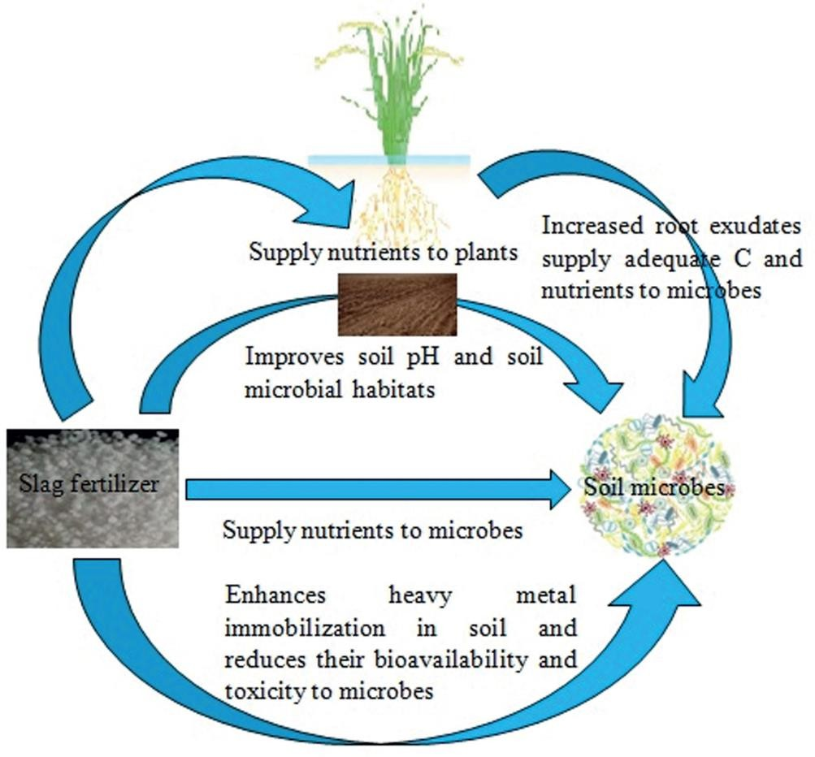
Fig.5. Slag-microbe interactions in soil

Crop yield enhancement
In response, the use of slag fertilizers has gained popularity worldwide. Slag is especially helpful in rice cultivation, where silicon depletion from repeated cropping reduces yields and soil health (Branca et al., 2012). Since silicon is vital for plant strength and resistance, adding silicate-rich slag improves soil quality and helps restore productivity (Das et al., 2019).
Multiple studies confirm that silicate slags can increase rice yields, although the degree of improvement depends on slag type, soil condition, application rate, and farming practices. Ali et al. (2009) reported that adding silicate fertilizers to submerged rice paddies boosted crop yields by up to 47.3%. The silicon in slag reinforces the plant cell wall, making crops more resistant to stress and disease (Luyckx et al., 2017). Lime-based slags are also applied to acidic soils to correct pH and improve nutrient availability. Phosphate-rich slag fertilizers enhance early root development and overall plant vigour. Additionally, calcium in slag strengthens root systems and promotes potassium (K) uptake, further supporting plant growth (Yang et al., 2017).
Calcium silicate slags can also improve the bioavailability of phosphorus (P), silicon (Si), and calcium (Ca) while reducing soil acidity (Crusciol et al., 2016). Application of blast furnace slag has been shown to improve soil fertility and increase rice growth, biomass, and grain yield (Ning et al., 2016). In Brazilian sugarcane fields, the use of both calcite and basic slags had a positive effect on ratoon sugarcane yield, increased base saturation, and reduced soil acidity (Yip et al., 2008). In specific cases, slag combined with fungicides has been effective in managing soil-borne diseases like clubroot in canola (Hwang et al., 2011). In Brazil, the use of LD slag on pasture soils improved pH, reduced toxic elements like aluminium (Al) and manganese (Mn), and increased crop yields (Moraes et al., 2017). Overall, the increase in crop productivity after slag application is closely linked to enhanced microbial activity, which improved nutrient cycling and plant nutrition (Das et al., 2019). Understanding the role of soil microbes is essential to maximising the agricultural benefits of slag.
Disease Resistance
Silicon (Si) is the second most abundant element in the Earth's crust and plays a crucial role in strengthening plants, even though it is not classified as an essential nutrient. Studies have shown that Si can improve plant growth, grain yield, and resistance to abiotic stresses (such as drought, salinity, and heavy metal toxicity) and biotic stresses (such as diseases and insect attacks).
Rice is a well-known silicon-accumulating crop, with up to 10% silicon content in its shoots on a dry weight basis. Plants absorb silicon in the form of soluble silicic acid (H₄SiO₄) from the soil. However, in tropical and subtropical regions, the availability of plant usable Si is low due to weathering and frequent rice monoculture. As a result, Si deficiency has become a limiting factor for rice productivity, with rice removing 230–470 kg/ha of Si from the soil to yield 5,000 kg/ha of grain. To overcome this, the external application of silicon, especially from slag-based fertilizers is an effective and sustainable solution. One of the most destructive diseases in rice is brown spot, caused by the fungus Bipolaris oryzae. While fungicides are typically used to control it, the nutrient status of the soil also influences disease severity, particularly levels of potassium, calcium, magnesium, manganese, iron, and silicon.
Silicon fertilization using steel or iron slag has been shown to improve disease resistance and boost rice growth. Greenhouse studies found that slag-based fertilizers not only improved plant health but also significantly reduced the occurrence of brown spot (Ning et al., 2014)
Microscopy (SEM and TEM) analysis revealed that slag-treated rice leaves had:
- More silica cells,
- Thicker cell walls (due to silicification),
- Less fungal damage.
Untreated leaves showed fungal invasion and degradation of mesophyll cells, while slag-treated leaves had more intact cell structures and enhanced resistance. Thus, applying slag-based silicon fertilizer to Si-deficient paddy fields can simultaneously improve rice yield and resistance to fungal infections, such as brown spot. The deposited silicon in cell walls acts as a physical barrier, while soluble silicon in cells enhances the plant’s internal defence mechanisms.
Greenhouse Gas Emission
Greenhouse gas emissions from soils, especially methane (CH₄) and nitrous oxide (N₂O), are largely influenced by soil microbes. Methane is produced by methanogens (CH₄-producing archaea) and consumed by methanotrophs (CH₄-oxidizing bacteria), while N₂O is generated during nitrification and denitrification by bacteria (Singh et al., 2014). Adding steel slag to the soil can help reduce methane emissions. This is because slag contains iron, which supports iron-reducing bacteria that compete with methanogens for resources. As a result, methane production is suppressed (Gwon et al., 2018). For instance, 4 moles of Fe³⁺ can prevent the formation of 1 mole of CH₄ (Ali et al., 2009).
Additionally, silicate slag fertilizers improve root growth and the development of aerenchyma (air channels) in rice plants. This boosts the flow of oxygen to roots, reducing methane production and promoting its oxidation (Liang et al., 2007). Field studies from Bangladesh, China, Japan, Indonesia, and Korea have shown that slag fertilizer can reduce methane emissions from rice fields by 0.6% to 56% depending on factors like soil type, slag composition, and application rate.
In China, Wang et al. (2018) reported that applying 8 tons/ha of slag and biochar reduced methane emissions by 38.6% in early rice cultivation. In a separate study, Wang et al. (2016) found that using silicate fertilizer under intermittent irrigation reduced nitrous oxide emissions by up to 99%. The reduction in N₂O is likely due to improved iron availability, which alters microbial nitrogen processing. In anoxic (oxygen-limited) soils, iron can serve as an electron acceptor, favouring full denitrification to N₂ gas instead of N₂O, which helps lower emissions. Slag amendments also reduced the activity of genes (nirS and nirK) responsible for denitrification, indicating lower potential for N₂O production (Song et al., 2021).
Carbon Sequestration
Steel slag can help improve carbon sequestration in agricultural soils, mainly because of its alkaline nature and its richness in silicate minerals. When applied to farmland, slag can replace traditional lime for soil pH correction, offering the added benefit of lowering CO₂ emissions. This is because limestone (CaCO₃), when dissolved, releases CO₂, whereas slag reduces this release. An enzyme called carbonic anhydrase (CA) also plays a role in the natural capture of CO₂. It aids in silicate weathering and promotes the formation of carbonate compounds, contributing to long-term carbon storage in soil (Bose & Satyanarayana, 2017).
In a study by Wang et al. (2018), applying steel slag and biochar to subtropical paddy fields improved soil carbon storage:
- Total organic carbon (TOC) increased by 36.6% with biochar and 28.7% with the combined slag + biochar treatment.
- Labile organic carbon (LOC), the easily decomposable carbon, decreased by 30.1% (slag) and 25.8% (slag + biochar), indicating better carbon stabilization.
- Dissolved organic carbon (DOC) increased by 28.5% (slag) and 50.3% (slag + biochar), enhancing soil carbon dynamics.
- Soil microbial biomass carbon (MBC) rose by 56.8% (slag), 48.9% (biochar), and 43% (slag + biochar), showing healthier microbial communities.
Moreover, the carbon-to-nitrogen (C: N) ratio increased in slag-treated soils. Higher C: N ratios often reduce nitrogen availability for microbes, which can slow down organic matter breakdown and CO₂ release, resulting in greater carbon retention in the soil. In summary, combining slag with biochar not only supported plant growth but also helped to trap more carbon in the soil, contributing to climate change mitigation.
CONCLUSION
Steel slag, once seen as an industrial waste, is now recognized as a useful material for improving soil health and supporting crop growth. It contains important nutrients like calcium, magnesium, silicon, and phosphorus, which help to improve soil fertility and plant health. Slag also reduces soil acidity, making it more suitable for crops, and supports beneficial soil microbes. In addition to improving soil and plant growth, slag can reduce the harmful metals in soil and lower greenhouse gas emissions, especially in rice fields. When used with materials like biochar, it has been found to store more carbon in the soil, supporting efforts to fight climate change. Research has shown that slag use can increase crop yields, improve plants' resistance to stress and diseases, and make farming more sustainable. However, to use it safely and effectively, more long-term studies are inevitable. With proper management, steel slag can be a low-cost, eco-friendly option to improve soil quality and support sustainable agriculture.
REFERENCES
Ahmaruzzaman, M., 2011. Industrial wastes as low-cost potential adsorbents for the treatment of wastewater laden with heavy metals. Adv. in colloid and interface sci. 166(1-2):36-59.
Ali, M.A., Lee, C.H., Lee, Y.B. and Kim, P.J., 2009. Silicate fertilization in no-tillage rice farming for mitigation of methane emission and increasing rice productivity. Agric.ecosyst. and environ. 132(1-2):16-22.
Bashir, S., Salam, A., Rehman, M., Khan, S., Gulshan, A.B., Iqbal, J., Shaaban, M., Mehmood, S., Zahra, A. and Hu, H., 2019. Effective role of biochar, zeolite and steel slag on leaching behaviour of Cd and its fractionations in soil column study. Bull. of environ. contamination and toxicol. 102:567-572.
Branca, T.A. and Colla, V., 2012. Possible uses of steelmaking slag in agriculture: an overview. Mater. recycling–Trends and perspectives. pp.335-356.
Castro, G.S.A. and Crusciol, C.A.C., 2013. Effects of superficial liming and silicate application on soil fertility and crop yield under rotation. Geoderma. 195:234-242.
Chand, S., Paul, B. and Kumar, M., 2015. An overview of use of Linz-Donawitz (LD) steel slag in agriculture. Curr. World Environ. 10(3): 975.
Chen, G., Yang, L., Chen, J., Miki, T., Li, S., Bai, H. and Nagasaka, T., 2019. Competitive mechanism and influencing factors for the simultaneous removal of Cr (III) and Zn (II) in acidic aqueous solutions using steel slag: Batch and column experiments. J. of Cleaner Prod. 230:69-79.
Crusciol, C.A., Artigiani, A.C., Arf, O., Carmeis Filho, A.C., Soratto, R.P., Nascente, A.S. and Alvarez, R.C., 2016. Soil fertility, plant nutrition, and grain yield of upland rice affected by surface application of lime, silicate, and phosphogypsum in a tropical no-till system. Catena 137:87-99.
Das, S., Galgo, S.J., Alam, M.A., Lee, J.G., Hwang, H.Y., Lee, C.H. and Kim, P.J., 2020. Recycling of ferrous slag in agriculture: Potentials and challenges. Criti. Rev. in Environ. Sci. and Technol. 52(8):1247-1281.
Das, S., Gwon, H.S., Khan, M.I., Jeong, S.T. and Kim, P.J., 2020. Steel slag amendment impacts on soil microbial communities and activities of rice (Oryza sativa L.). Sci. Rep.10(1): 6746.
Das, S., Kim, G.W., Hwang, H.Y., Verma, P.P. and Kim, P.J., 2019. Cropping with slag to address soil, environment, and food security. Frontiers in Microbiol. 10:1320.
Detmann, K.C., Araújo, W.L., Martins, S.C., Sanglard, L.M., Reis, J.V., Detmann, E., Rodrigues, F.Á., Nunes‐Nesi, A., Fernie, A.R. and DaMatta, F.M., 2012. Silicon nutrition increases grain yield, which, in turn, exerts a feed‐forward stimulation of photosynthetic rates via enhanced mesophyll conductance and alters primary metabolism in rice. New Phytologist. 196(3):752-762.
Deus, A.C.F., de Almeida Bertani, R.M., Meirelles, G.C., Soares, A.D.A.V.L., Moreira, L.L.Q., Büll, L.T. and Fernandes, D.M., 2018. The comprehensive utilization of steel slag in agricultural soils. Recovery and utilis. of metallurgical solid waste. pp.1-10.
Dimitrova, S.V., 1996. Metal sorption on blast-furnace slag. Water res. 30(1):228-232.
Du, Y., Hu, X.F., Wu, X.H., Shu, Y., Jiang, Y. and Yan, X.J., 2013. Affects of mining activities on Cd pollution to the paddy soils and rice grain in Hunan province, Central South China. Environ. Monitoring and Assess. 185:9843-9856.
Fan, Y., Li, Y., Li, H. and Cheng, F., 2018. Evaluating heavy metal accumulation and potential risks in soil-plant systems applied with magnesium slag-based fertilizer. Chemosphere. 197:382-388.
Gale, H.F. and Hu, D., 2012. Food safety pressures push integration in China's agricultural sector. Am. J. of Agric. Econ. 94(2):483-488.
Ghisman, V., Muresan, A.C., Buruiana, D.L. and Axente, E.R., 2022. Waste slag benefits for correction of soil acidity. Sci. Rep. 12(1): 16042
Hemalatha, B., 2013. Utilization of industrial slag as a soil amendment and source of nutrients in acid soil (Doctoral dissertation, University of Agricultural Sciences GKVK, Bangalore).
Hwang, S.F., Strelkov, S.E., Gossen, B.D., Turnbull, G.D., Ahmed, H.U. and Manolii, V.P., 2011. Soil treatments and amendments for amelioration of clubroot of canola. Can. J. of Plant Sci. 91(6):999-1010.
Ito K (2015). Steelmaking slag for fertilizer usage. Nippon Steel & Sumitomo Metal Technical Report No. 109: 130-136.
Jiang, J. and Xu, R.K., 2013. Application of crop straw derived biochars to Cu (II) contaminated Ultisol: evaluating role of alkali and organic functional groups in Cu (II) immobilization. Bioresource Technol. 133:537-545.
Liang, Y., Sun, W., Zhu, Y.G. and Christie, P., 2007. Mechanisms of silicon-mediated alleviation of abiotic stresses in higher plants: a review. Environ. pollut. 147(2):422 428.
Liu, G., Meng, J., Huang, Y., Dai, Z., Tang, C. and Xu, J., 2020. Effects of carbide slag, lodestone and biochar on the immobilization, plant uptake and translocation of As and Cd in a contaminated paddy soil. Environ. Pollut. 266:115194.
Luyckx, M., Hausman, J.F., Lutts, S. and Guerriero, G., 2017. Silicon and plants: current knowledge and technological perspectives. Frontiers in plant sci. 8: 411.
Mamatha, D., Gowda, R.C. and Shivakumara, M.N., 2018. Effect of basic slag on yield, nutrient status and uptake by paddy in acid soils of Karnataka, India. Int. J. Curr. Microbiol. Appl. Sci. 7:2286-2292.
Masud, M.M., Jiu-Yu, L.I. and Ren-Kou, X.U., 2014. Use of alkaline slag and crop residue biochars to promote base saturation and reduce acidity of an acidic Ultisol. Pedosphere. 24(6):791-798.
Moraes, J.C.B., Tashima, M.M., Akasaki, J.L., Melges, J.L.P., Monzó, J., Borrachero, M.V., Soriano, L. and Payá, J., 2017. Effect of sugar cane straw ash (SCSA) as solid precursor and the alkaline activator composition on alkali-activated binders based on blast furnace slag (BFS). Construction and Building Mater. 144:214-224.
Ning, D., Liang, Y., Liu, Z., Xiao, J. and Duan, A., 2016. Impacts of steel-slag-based silicate fertilizer on soil acidity and silicon availability and metals-immobilization in a paddy soil. PloS one. 11(12): e0168163.
Ning, D., Song, A., Fan, F., Li, Z. and Liang, Y., 2014. Effects of slag-based silicon fertilizer on rice growth and brown-spot resistance. PloS one. 9(7): e102681.
NSA [National Slag Association]. 2021. A guide for the use of steel slag in agriculture and for reclamation of acidic lands [online. Available: http://www.nationalslag.org/ sites/nationalslag/files/ag_guide909.pdf) [11 July 2024].
O’Connor, J., Nguyen, T.B.T., Honeyands, T., Monaghan, B., O’Dea, D., Rinklebe, J., Vinu, A., Hoang, S.A., Singh, G., Kirkham, M.B. and Bolan, N., 2021. Production, characterisation, utilisation, and beneficial soil application of steel slag: A review. J. of Hazardous Mater. 419:126478.
Piatak, N.M., Seal, R.R., Hoppe, D.A., Green, C.J. and Buszka, P.M., 2019. Geochemical characterization of iron and steel slag and its potential to remove phosphate and neutralize acid. Minerals. 9(8):468.
Pooja, D., Prasad, S., Singh, B., Shrivastava, M., Babu, S., Vashisth, A. and Avinash, C., 2024. Effect of bioaugmented Linz-Donawitz slag and biochar on physiological and yield attributes of wheat (Triticum aestivum). The Ind. J. of Agric. Sci. 94(1): 021-025.
Proctor, D.M., Fehling, K.A., Shay, E.C., Wittenborn, J.L., Green, J.J., Avent, C., Bigham, R.D., Connolly, M., Lee, B., Shepker, T.O. and Zak, M.A., 2000. Physical and chemical characteristics of blast furnace, basic oxygen furnace, and electric arc furnace steel industry slags. Environ. Sci. & technol. 34(8):1576-1582.
Qi, Y., Huang, B. and Darilek, J.L., 2014. Effect of drying on heavy metal fraction distribution in rice paddy soil. PLoS One. 9(5):97327.
Qin, G., Niu, Z., Yu, J., Li, Z., Ma, J. and Xiang, P., 2021. Soil heavy metal pollution and food safety in China: Effects, sources and removing technology. Chemosphere. 267:129205.
Rai, P.K., Lee, S.S., Zhang, M., Tsang, Y.F. and Kim, K.H., 2019. Heavy metals in food crops: Health risks, fate, mechanisms, and management. Environ. Int. 125:365-385.
Singh, J. and Kalamdhad, A.S., 2014. Effect of carbide sludge (lime) on bioavailability and leachability of heavy metals during rotary drum composting of water hyacinth. Chem. Speciation & Bioavailability.26(2):76-84.
Song, Q., Guo, M.Z., Wang, L. and Ling, T.C., 2021. Use of steel slag as sustainable construction materials: A review of accelerated carbonation treatment. Resources, Conserv. and Recycling. 173:105740.
Tang, J., Zhang, L., Zhang, J., Ren, L., Zhou, Y., Zheng, Y., Luo, L., Yang, Y., Huang, H. and Chen, A., 2020. Physicochemical features, metal availability and enzyme activity in heavy metal-polluted soil remediated by biochar and compost. Sci. of the Total Environ. 701:134751.
Wang, W., Lai, D.Y.F., Abid, A.A., Neogi, S., Xu, X. and Wang, C., 2018. Effects of steel slag and biochar incorporation on active soil organic carbon pools in a subtropical paddy field. Agron. 8(8):135.
Wang, W., Sardans, J., Wang, C., Zeng, C., Tong, C., Bartrons, M. and Penuelas, J., 2018. Steel slag amendment increases nutrient availability and rice yield in a subtropical paddy field in China. Exp. agric. 54(6): 842-856.
Wu, C., Dun, Y., Zhang, Z., Li, M. and Wu, G., 2020. Foliar application of selenium and zinc to alleviate wheat (Triticum aestivum L.) cadmium toxicity and uptake from cadmium-contaminated soil. Ecotoxicology and Environ. Safety. 190:110091.
Xu, D., Gao, B., Gao, L., Zhou, H., Zhao, X. and Yin, S., 2016. Characteristics of cadmium remobilization in tributary sediments in Three Gorges Reservoir using chemical sequential extraction and DGT technology. Environ. Pollut. 218:1094-1101.
Yang, X., Xia, L., Li, J., Dai, M., Yang, G. and Song, S., 2017. Adsorption of As (III) on porous hematite synthesized from goethite concentrate. Chemosphere. 169:188-193.
Yi, H., Xu, G., Cheng, H., Wang, J., Wan, Y. and Chen, H., 2012. An overview of utilization of steel slag. Procedia Environ. Sci. 16:791-801.
Yip, C.K., Lukey, G.C., Provis, J.L. and Van Deventer, J.S., 2008. Effect of calcium silicate sources on geopolymerisation. Cement and Concrete Res. 38(4):554-564.

