Genetic diversity analysis in mungbean (Vigna radiata L.) genotypes using SSR markers

ABSTRACT
Background: Nineteen genotypes of mungbean [Vigna radiata (L.) Wilczek] were evaluated for genetic diversity through simple sequence repeats (SSR) markers.
Methods: In the present study, twenty six pairs of SSR primers were used to study genetic diversity. PCR amplicons were scored using binary system and this information was utilized in the calculation of Jackard’s similarity matrix using NTSYS-pc version 2.1. Dendrogram was constructed using Unweighted pair Group Method with Arithmetic mean (UPGMA) analysis.
Results: Out of 26 markers, eleven markers have shown scorable polymorphism, while 13 markers exhibited monomorphic banding pattern and remaining 2 markers showed no banding pattern. Genetic similarity among the genotypes ranged from 0.22 to 1.00 with an average of 0.61. Genotypes SML-668 and MGG-551 had maximum genetic similarity of 1.00 while lowest value of 0.3 was observed between Tarm-18 and GP-2-57 which indicates that they are genetically more distant from other genotypes and can be utilized in crossing programmes. The present study revealed that microsatellites can be successfully utilized for assessment of genetic diversity to establish relationships among the germplasm lines of mungbean.

Keywords: Dendrogram, genetic diversity, microsatellite markers, mungbean, polymorphism.

I. INTRODUCTION
Pulse crops are major components of production systems which are resilient to climatic changes. Pulses are also responsible for yielding large financial gains by amounting for a large part of exports. Mungbean (Vigna radiata (L.) R. Wilczek) is one of the important pulse crops grown in India. Because of its rich source of cholesterol reducing fibre, considerable amounts of anti-oxidants, folic acid, vitamin B6 and magnesium mungbean plays an important role in human consumption. Mungbean is regarded as quality pulse due its rich protein (25-28%) and excellent digestibility (Mahalingam 2018). Apart from nutritional benefits, it has ability to fix atmospheric nitrogen through bacteria (rhizobium) and increase the fertility of soil (Shiv et al. 2017). Morphological data obtained from the field includes environmental effects. So, the data has to be verified to confirm that the variability available in germplasm is at genotypic level. Molecular markers are commonly used because they are non-sensitive to environment which enables the analysis of genetic diversity (Nath et al. 2017). Markers are proven to be a powerful tool, which can yield significant information that can enhance the scope of utilizing germplasm in the crop improvement programmes (Sanghani et al. 2015). Therefore, an attempt was made to investigate molecular diversity in the germplasm considered for present study. Simple sequence repeats (SSR) are more specific as they can distinguish closely related genotypes due to their high degree of variability (Kaur et al. 2018). Microsatellite markers are informative, highly polymorphic, easily reproducible and can be successfully utilized for molecular characterization of crop species belonging to Vigna species (Panigrahi et al. 2020). SSRs are very useful in identifying markers that are associated with any desirable trait of interest.
II. MATERIAL AND METHODS
Plant materials and DNA Isolation: In the present study, nineteen elite genotypes of mungbean were used for molecular diversity analysis (Table 1). The experimental material was sown during Rabi, 2020 at B-block of Regional Agricultural Research Station (RARS), Warangal. Molecular analysis was performed at Biotechnology Laboratory at RARS, Warangal. For isolation of genomic DNA, young leaves of 21-28 days were selected. The standard protocol as described by Lin et al. (2001) was followed with few modifications.
SSR-PCR Amplification: Twentysix SSR primers were screened in the nineteen genotypes of mungbean, out of which eleven primers generated polymorphic and reproducible banding pattern. The concentration of 30 ng/µl of genomic DNA was used for SSR-PCR (Eppendorf) amplification. PCR amplification was performed with reaction conditions programmed as Initial denaturation at 94⁰ C for 4 minutes, followed by 35 cycles of denaturation for 1 minute at 94⁰ C. Annealing temperature (as standardized in the present study, (Table 2).) for 1 min and extension at 72⁰ C for 1 min. A final extension was performed at 72⁰ C for 7 min and storage at 4ºC. The PCR amplified products obtained were loaded on 4% agarose gel which was prepared with 1X TAE buffer as well as ethidium bromide (10mg/ml). SYNGENE system was used for documentation of the gel.
Data Analysis: DNA bands generated from PCR amplification were subjected to binary system where twenty six SSR markers were scored for presence (1) or absence (0) of band. Such data was used to calculate Jackard’s similarity matrix using NTSYS-pc version 2.1. Similarity matrix were organized for all pairs of accessions with the help of Jackard’s similarity coefficient and dendrogram for genetic diversity was constructed using UPGMA (unweighted pair-group method with arithmetic mean analysis).
III. RESULTS AND DISCUSSION
In the present study, polymorphism among the genotypes was analysed using twenty six SSR primers pairs out of which, eleven primers have shown polymorphism. Amplification of genomic DNA using twenty-six primers produced 29 alleles. Number of alleles in eleven primers ranged from 2 (CEDG-044) to 3 (CEDG-008) per locus with an average of 2.63 alleles. Polymorphic information content (PIC) was estimated for all these markers to study the ability of marker to detect polymorphism within the germplasm, on the basis of allelic frequency and number of alleles for that marker. PIC value among 11 polymorphic SSR markers ranged from a minimum of 0.54 (CEDG-225) to maximum of 0.88 (CEDG-067) with an average of 0.76, which indicates the polymorphic nature of these markers. Gel profiling of mungbean genotypes for marker CEDG-141 was given in Figure 1. Jaccard’s similarity values ranged from 0.22 to 1.00 (average: 0.61). Molecular polymorphism was 42.30% with 26 primers indicating the presence of less variable SSR loci for these markers among the genotypes studied. Similar results were reported by Wang et al. (2018). Moderate to low level of genetic diversity among self-pollinated members of mungbean germplasm from the genus Vigna indicates that moderate genetic base might be due to the accumulation of novel gene combinations in response to the dynamic pressures of natural selection (Kaur et al., 2016). Genotypes SML-668 and MGG-551 had maximum genetic similarity of 100% while least similarity was observed between Tarm-18 and GP-2-57 which indicates that they are genetically more distant from other genotypes.
NTSYS software and UPGMA (unweighted pair-group method with arithmetic mean analysis) were used to construct dendrogram (Fig. 2). Nineteen genotypes were grouped into three major clusters at the Jaccard’s similarity coefficient of 0.40. Cluster I appeared at 42% of genetic of similarity with eight genotypes (IPM-205-7, GAM-5, VGG-17-002, VGG-17-048, Pusabold, GP-3-11, MGG-295, WGG-42.). Cluster I was subdivided into cluster I-A and I-B. Sub-cluster I-A comprised of 5 genotypes; IPM-205-7, GAM-5, VGG-17-002, VGG-17-048 and Pusabold while subcluster I-B comprised of 3 genotypes; GP-3-11, MGG-295 and WGG-42. Cluster II was formed at 48% of genetic of similarity with maximum (9) number of genotypes (SML-668, WGG-37, MGG-551, MGG-351, MGG-385, MGG-399, Vamban-2, IC-249570, IC-436528). Cluster II was subdivided into II-A and II-B where II-A comprised of 6 genotypes; SML-668, WGG-37, MGG-551, MGG-399, MGG-351 and MGG-385 where SML-668 and MGG-551 had a similarity value of 1.00. Cluster II-B comprised of 3 genotypes; Vamban-2, IC-249570 and IC-436528 with similarity value of 0.70. Cluster III appeared at 30% of similarity with minimum (2) number of genotypes (GP-2-57 and Tarm-18 respectively). Similar findings were reported by Singh et al. (2012) and Kumararathna et al. (2013). Present study indicates that SSR markers can be successfully employed in assessment of molecular diversity in mungbean genotypes. The potentiality of SSR markers was also reported by Honglin et al. 2015, Prathap et al. (2015), Kaur et al. (2016), Singh et al. (2017), Kanavi et al. (2019) and Tabasum et al. (2020).
Ⅳ. CONCLUSION
SSR markers can be successfully utilized for assessment of genetic diversity to establish relationships among the germplasm lines of mungbean. In the present study, assessment of genetic diversity was successfully accomplished using SSR markers. Results obtained from the current investigation revealed the existence of moderate to low genetic similarity between genotypes which indicates the presence of less variable SSR loci for these markers among the genotypes studied. Genotypes SML-668 and MGG-551 had maximum genetic similarity of 1.00 while minimum value of 0.3 was observed between Tarm-18 and GP-2-57 which indicates that these genotypes were divergent when compared to other genotypes and can be utilized in crossing programmes. The marker data generated in present study is of great significance to plant breeders and can be utilized in marker assisted breeding programmes.

REFERENCES
- Chen, H., Wang, L., Wang, S., Liu, C., Blair, M.W and Cheng, X. (2015). Transcriptome Sequencing of mung bean (Vigna radiata L.) genes and the identification of EST-SSR Markers. PLoS ONE. 10(4): e0120273
- Kanavi, M.S.P., Rangaiah, S and Krishnaprasad, B.T. (2019). Molecular Characterization and Genetic Diversity Analysis through SSR Markers in Germplasm Lines of Greengram [Vigna radiata (L.) Wilczek]. International Journal of Bio-Resource and Stress Management. 10(3): 298-305.
- Kaur, G., Joshi, A and Jain, D. (2018). SSR-Marker Assisted Evaluation of Genetic Diversity in Mungbean (Vigna radiata (L.) Wilczek) Genotypes. Brazilian Archives of Biology and Technology. 61.
- Kaur, G., Joshi, A., Jain, D., Choudary, R and Vyas, D. (2016). Diversity analysis of greengram (Vigna radiata (L.) Wilczek) through morphological and molecular markers. Turkish Journal of Agriculture and Forestry. 40: 229-240.
- Kumararathna, M.J.M.P., Kumar, W.M.R., Perera, A.M and Ariyawansha, S. (2013). Estimation of phenotypic diversity of local and exotic mungbean (Vigna radiata (L.) Wilczek) germplasm in Srilanka. Annals of Srilanka. 15: 273-282.
- Lin., Rong-Cheng, Zai-Song Ding., Liang-Bi Li., Ting-Yun Kung. (2001). A rapid and efficient DNA mini preparation suitable for screening transgenic plants. Plant Molecular Biology Reporter. 19(4): 379-379.
- Mahalingam, A. (2018). Genetic divergence among greengram (Vigna radiata (L.) Wilczek) germplasm collections. Electronic Journal of Plant Breeding. 9(1): 350-354
- Nath, A., Maloo, S.R., Barman, K.K., Meena, B.L., Devi, G., Yadav, G.S., and Tak, S. (2017). Molecular characterization of green gram (Vigna radiata (L.) Wilczek) for future breeding programme. International Journal of Current Microbiology and Applied Sciences. 6(6): 1385-1398.
- Panigrahi, K.K., Panigrahi. P., Mohanty, A., Mandanl, P and Satapathy, B. (2020). Development of new microsatellite markers for DNA fingerprinting pattern of blackgram (Vigna mungo L. Hepper) and greengram (Vigna radiata L. Wilczek). Genetika. 52(3): 1161-1179.
- Prathap, A., Malviya, N., Tomar, R., Maurya, R.K., Singh, N.P., John, J and Madhavan, L. (2015). Genome scanning of Asiatic Vigna species for discerning population genetic structure based on microsatellite variation. Molecular Breeding. 8(2): 172- 178.
- Sanghani, J.M., Golakiya, B.A., Dhedhi K.K and Patel S.V. (2015). Molecular characterization of mungbean (Vigna radiata L.) genotypes through RAPD, ISSR and SSR markers. Legume Research-An International Journal. 38(4): 452-456.
- Shiv, A., Ramtekey, V., Vadodariya, G.D., Modha, K.G and Patel, R.K. (2017). Genetic Variability, Heritability and Genetic Advance in F3 Progenies of Mungbean [Vigna radiata (L.) Wilczek]. International Journal of Current Microbiology and Applied Sciences. 6(12): 3086-3094.
- Singh, S.K., Lavanya, R.G., Bhat, K.V., Babu, G.S., Arya, L., Verma, M., Hussain, Z., Roy, S., Rathi, R.S and Mishra, A.K. (2012). Microsatellite markers revealed genetic diversity in mungbean mutant lines. Indian Journal of Hill Farming. 25(1):38-43.
- Singh, V., Yadav, R.K., Yadav, N.R., Yadav, R., Malik, R.S and Singh, J. (2017). Identification of genomic Regions/genes for high iron and zinc content and cross transferability of SSR markers in mungbean (Vigna radiata L.). Legume Research-An International Journal. 40(6): 1004-1011.
- Tabasum, A., Hameed, A and Asghar, M.J. (2020). Exploring the Genetic Divergence in Mungbean (Vigna radiata L.) Germplasm Using Multiple Molecular Marker Systems. Molecular Biotechnology. 62(11): 547-556.
- Wang, L., Bai, P., Yuarf, X., Chen, H., Wang, S., Wang, S., Chen, X and Cheng, X. (2018). Genetic diversity assessment of a set of introduced mung bean accessions (Vigna radiata L.). The Crop Journal 6: 207–213.

Figure 1. PCR amplification of 19 genotypes with SSR marker CEDG 141. The lane numbers written on the gel corresponds to the list of mungbean genotypes as given in table 1.

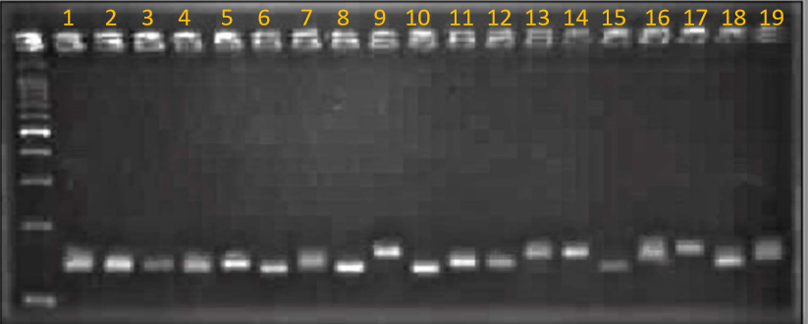

S. No | Entry | Source
1 | IPM-205-7 | IIPR, Kanpur
2 | GAM-5 | PRS, Vadodara, Gujarat
3 | VGG-17-002 | NPRC, Vamban, Tamil Nadu
4 | VGG-17-048 | NPRC, Vamban, Tamil Nadu
5 | Pusa bold | IIPR, Kanpur
6 | GP-3-11 | IIPR, Kanpur
7 | SML- 668 | PAU, Ludhiana, Punjab
8 | WGG-42 | RARS, Warangal
9 | WGG-37 | RARS, Warangal
10 | MGG-295 | ARS, Madhira
11 | MGG-351 | ARS, Madhira
12 | MGG-551 | ARS, Madhira
13 | MGG-399 | ARS, Madhira
14 | MGG-385 | ARS, Madhira
15 | GP-2-57 | IIPR, Kanpur
16 | TARM-18 | BARC, Mumbai
17 | Vamban-2 | NPRC, Vamban, Tamil Nadu
18 | IC-436528 | NBPGR, New Delhi
19 | IC-249570 | NBPGR, New Delhi
Table 1. List of 19 mungbean varieties used for molecular diversity analysis

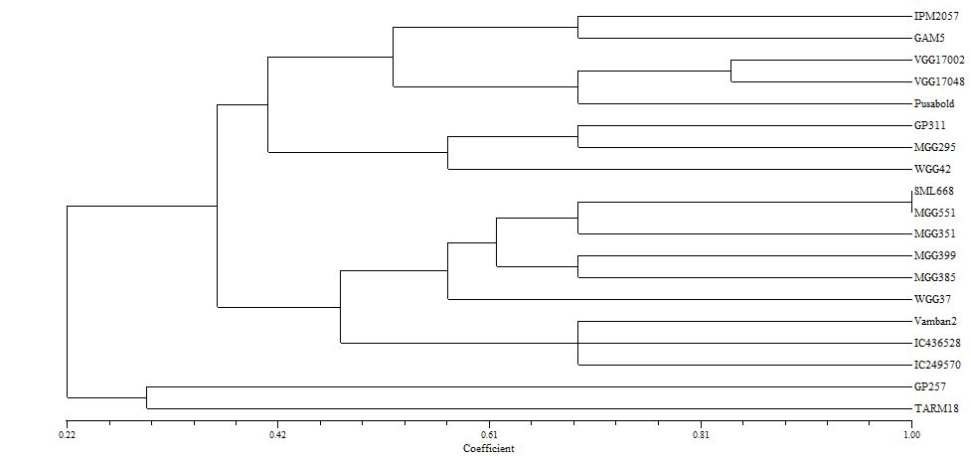
III
II
I
Figure 2. Dendrogram of 19 genotypes using SSR markers

Table 2. List of primers and their Tm used in the present study
S. No | Primer Name | Primer Sequence | Annealing temp in º C
1 | CEDG 204 F | CCTTGGTTGGAGCAGCAGC | 60
1 | CEDG 204 R | CACAGACACCCTCGCGATG | 60
2 | CEDG 139 F | CAAACTTCCGATCGAAAGCGCTTG | 65
2 | CEDG 139 R | GTTTCTCCTCAATCTCAAGCTCCG | 65
3 | CEDG 268 F | CATCTCCCTGAAACTTGTG | 55
3 | CEDG 268 R | GCTATCAATCGAGTGCAG | 55
4 | CEDG 030 F | TGAGGGAATGGGAGAGAGGC | 60
4 | CEDG 030 R | TCCGCAGATAGAGGCTCACG | 60
5 | CEDG 092 F | TCTTTTGGTTGTAGCAGGATGAAC | 65
5 | CEDG 092 R | TACAAGTGATATGCAACGGTTAGG | 65
6 | CEDG 022 F | AGGAATGTGAGATTTG | 55
6 | CEDG 022 R | AATCGCTTCAAGGTCAAGCC | 55
7 | CEDG 024 F | CATCTTCCTCACCTGCATTC | 60
7 | CEDG 024 R | TTTGGTGAAGATGACAGCCC | 60
8 | CEDG 198 F | CAAGGAAGATGGAGAGAATC | 60
8 | CEDG 198 R | CCTTCTAAGAACAGTGACATG | 60
9 | CEDG 133 F | GCATACATAATGTGGTGAGATG | 60
9 | CEDG 133 R | GTCTCGTGCCTTTCACAC | 60
10 | CEDG 141 F | CCAGGCATCCATGATGACC | 65
10 | CEDG 141 R | GAAGTTGTTGGTAATGGTTGCCTC | 65
11 | CEDG 225 F | GAGGAAGTGTTGCAGCACC | 60
11 | CEDG 225 R | GTAGACTCTGCAGAGGGATG | 60
12 | CEDG 284 F | GGTGCTAACGTTGGAAACTGAG | 65
12 | CEDG 284 R | CACTCCATTCTGAGGATCAATCC | 65
13 | CEDG 077 F | ATCCCGTGACCCTTCTTCCT | 60
13 | CEDG 077 R | GCTCAAGCGAAAACCCAGCA | 60
14 | CEDG 127 F | GGTTAGCATCTGAGCTTCTTCGTC | 65
14 | CEDG 127 R | CTCCTCACTTGGTCTGAAACTC | 65
15 | CEDG 014 F | GCTTGCATCACCCATGATTC | 60
15 | CEDG 014 R | AAGTGATACGGTCTGGTTCC | 60
16 | CEDG 020 F | TATCCATACCCAGCTCAAGG | 60
16 | CEDG 020 R | GCCATACCAAGAAAGAGG | 60
17 | CEDG 067 F | AGACTAAGTTACTTGGGCAACCAG | 65
17 | CEDG 067 R | TGACGGCCCGGCTCTCC | 65
18 | CEDG 059 F | AGAAAAGGGTGGCCTCGTTG | 60
18 | CEDG 059 R | GCAGGCATTTCCATCGCAG | 60
19 | CEDG 112 F | GCAATATTCGCATTATTCATTCA | 60
19 | CEDG 112 R | GTGTTTCAAAGCACTATACTTAA | 60
20 | CEDG 269 F | CTGTTACGGCACCTGGAAAG | 65
20 | CEDG 269 R | GCAGAGACACACCTTAACCTTG | 65
21 | CEDC 011 F | GTCCGACTTTATGTGTGGAG | 60
21 | CEDC 011 R | TTTCTAGTTCCAGCCCCGAC | 60
22 | CEDG 056 F | TTCCATCTATAGGGGAAGGGAG | 65
22 | CEDG 056 R | GCTATGATGGAAGAGGGCATGG | 65
23 | CEDG 180 F | GGTATGGAGCAAAACAATC | 55
23 | CEDG 180 R | GTGCGTGAAGTTGTCTTATC | 55
24 | CEDG 044 F | TCAGCAACCTTGCATTGCAG | 60
24 | CEDG 044 R | TTTCCCGTCACTCTTCTAGG | 60
25 | CEDG 104 F | TATGGCCCGAGCAAACCTTG | 60
25 | CEDG 104 R | CCGTTCGGTCTTCGGTTGAA | 60
26 | CEDG 008 F | GCTCAAGCGAAAACCCAGCA | 60
26 | CEDG 008 R | CTCCTCACTTGGTCTGAAACTC | 60

