Original Research Article
Exploring Genetic Variability for Yield Attributes in Groundnut (Arachis hypogaea L.) Cross Combinations

Abstract
Groundnut (Arachis hypogaea L.) is a key oilseed crop valued for its high-quality oil and protein-rich kernels, playing an important role in food security and farmers’ livelihoods. The present study was conducted during the kharif 2023 and 2024 at the Research Farm, Department of Genetics and Plant Breeding, College of Agriculture, RVSKVV, Gwalior, Madhya Pradesh, India, to assess genetic variability, heritability and genetic advance for morphological, physiological and yield attributing traits of groundnut genotypes and their segregating generations. Six parental genotypes including three males and three females were used to develop F₁, F₂, BC₁ and BC₂ populations, that, along with the parents, were evaluated in a randomized block design with three replications. Fourteen traits were recorded, including days to 50% flowering, days to maturity, plant height, number of branches per plant, number of pods per plant, pod yield per plant, kernel yield per plant, shelling percentage, sound mature kernel percentage, 100-kernel weight, biological yield per plant, dry weight per plant, harvest index and chlorophyll content. Analysis of variance revealed significant differences among genotypes for all the traits, indicating presence of substantial genetic variability. High genotypic and phenotypic coefficients of variation, heritability and genetic advance were evident for pod and kernel yield per plant and number of pods per plant, identifying them as key traits for selection. The investigation provides a framework for selecting superior genotype (s) and to develop high-yielding, adaptable groundnut cultivar (s), thereby enhancing productivity and supporting sustainable groundnut cultivation.
Keywords: Genetic advance, Genetic variability, Groundnut, Heritability, Morphological traits, Physiological traits, Segregating generations.
1. Introduction
Groundnut (Arachis hypogaea L.) also known as peanut, pindar, mokey nut and goober pea belonging to family Fabaceae, is one of the most important oilseed crops in India highly valued for both their nutritional and economic worth and extensively cultivated for its edible oil (45-55%), protein-rich kernels (25-30%) and diverse applications in food, feed and industrial sectors (Pramanik et al., 2019; Tomar et al., 2022; Sharma et al., 2023a). The crop is valued not only for its high nutritional content, including essential amino acids, unsaturated fatty acids and bioactive compounds, but also for its economic importance as a cash crop (Akram et al., 2018; Sharma et al., 2019; Çiftçi & Suna, 2022; Rajput et al., 2024a; Sravanti et al., 2024). Groundnut is an allotetraploid species (2n = 4x = 40), believed to have originated from a hybridization event between two diploid progenitors, Arachis duranensis (AA genome) and Arachis ipaensis (BB genome), followed by chromosome duplication (Zhang et al., 2016; Lu et al., 2018). Globally, it is cultivated on approximately 28 million hectares with an annual production of over 47 million tonnes, with major producing countries including China, India, Nigeria and the United States (Konate et al., 2020; Pramanik et al., 2022; Rajput et al., 2024b). After China, India ranks second in the global groundnut economy, with a production of 10.11 million tonnes from approximately 5.75 million hectares, contributing 17% of the world’s cultivation area and 16% of global production. In terms of productivity, India ranks fourth, with an average yield of 1.75 t/ha, following the United States, China and Argentina (Rana et al., 2023). First, in terms of area and second in terms of production after soybean, it contributes significantly to farmers’ livelihoods, particularly in semi-arid and arid regions of states such as Gujarat, Maharashtra, Karnataka and Madhya Pradesh (Bhavani et al., 2025).
The success of any crop improvement programme largely depends on the availability of genetic variability, the nature of gene action governing important traits and the efficiency of selection strategies (Mishra et al., 2024a; Jain et al., 204a; Jain et al., 2024b; Paliwal et al., 2024; Puri et al., 2025). Genetic variability studies, supported by statistical tools such as genotypic and phenotypic coefficients of variation (GCV and PCV), heritability and genetic advance, provide critical insights into the extent of genetic divergence and the relative contributions of genetic and environmental factors to trait expression (Sharma et al., 2023b; Sharma et al., 20023c; Jhariya et al., 2025; Bisoriya et al., 2025; Gautam et al., 2025). High heritability coupled with high genetic advance indicates the predominance of additive gene action, which can be exploited effectively through direct selection, whereas traits with low heritability and low genetic advance often require alternative approaches such as recurrent selection, hybridization or molecular breeding for improvement (Bhawar et al., 2020; Yadav et al., 2023; Rajpoot et al., 2025; Mishra et al., 2025; Sharma et al., 2025).
Yield in groundnut is a complex trait influenced by multiple morphological, physiological and biochemical characters. Therefore, understanding the genetic parameters of yield and its components is essential for devising effective breeding strategies (Makwana et al., 2023; Amarasinghe et al., 2024; Yami & Abtew, 2025). Hybridization, involving crosses between selected male and female parents, followed by evaluation of segregating generations (F₁, F₂, BC₁, BC₂), provides an opportunity to create and exploit new genetic combinations. Analysis of these segregating populations allows breeders to identify superior genotypes, estimate genetic variability and determine the inheritance pattern of key traits, thereby guiding selection decisions (Lakshmi et al., 2021; Mishra et al., 2024b). Keeping these considerations in view, the present study was undertaken to assess the variability, heritability and genetic advance for a set of morphological, physiological and yield- attributing traits in groundnut genotypes and their segregating generations.
2. Material & Methods
2.1 Experimental site
The present investigation was carried out at the Research Farm, Department of Genetics and Plant Breeding, College of Agriculture, RVSKVV, Gwalior, Madhya Pradesh, India, during the kharif 2023 and 2024. The experimental site lies within a hot arid agro-climatic zone, characterized by pronounced seasonal fluctuations in temperature. Maximum temperatures are generally recorded in June, reaching up to 48°C, whereas the winter months may witness a decline to as low as 4°C. The annual temperature variation at the location ranges from approximately 2°C to 50°C. The region receives an average annual rainfall of 750–800 mm, predominantly concentrated during the southwest monsoon, extending from late June to September, with occasional light showers occurring during the winter months.
2.2 Experimental details
Planting material for the present study was obtained from the All India Coordinated Research Project on Groundnut, ICAR–Indian Institute of Groundnut Research (IIGR), Junagadh, Gujarat, comprising six diverse genotypes including three male and three female parents used as hybridization sources (Table 1). Through the AICRP hybridization programme on groundnut at RVSKVV, Gwalior, several segregating generations were developed, including F₁, F₂, BC₁ and BC₂, resulting in 8 F₁’s, 8 F₂’s, 8 BC₁’s and 8 BC₂’s (Table 2). The experimental material consisted of a total of 38 entries, including the six parents and their derived generations. Evaluation was conducted employing a randomized block design (RBD) with three replications. For each cross, two rows were allotted to the parental lines (P₁ and P₂), F₁, BC₁ and BC₂ generations, while four rows were allotted to the F₂ generation. Each row measured 3.0 m in length with a spacing of 30 cm between rows and 10 cm between plants. Standard agronomic practices and recommended plant protection measures were followed to ensure proper crop establishment and healthy growth throughout the experimental period.
Table 1 Pedigree of the male and female parents involved in hybridization, producing generations
S. No. | Name of Genotype/Variety | Parental Status | Pedigree
1. | TG – 86 | I Female Parent | Gamma (γ) ray irradiation of TG-66
2. | NITYA HARITA | II Female Parent | Cross between TAG-24 × Jyoti followed by pedigree selection
3. | DGRMB – 32 | III Female Parent | Pure line selection from TG 37-A
4. | KDG – 128 | I Male Parent | From ICGV-020059-SSU-SSD-P37-B1
5. | GPBD – 4 | II Male Parent | Cross between KRG 1 × CS 16(ICGV 86855)
6. | SUNOLEIC - 95R | III Male Parent | Cross between F435-2-3-B-2-1-b4-B-3-b3-1-B × Sun runner (F519-9)

S. No. | Name of Genotype/Variety | Parental Status | Pedigree
1. | TG – 86 | I Female Parent | Gamma (γ) ray irradiation of TG-66
2. | NITYA HARITA | II Female Parent | Cross between TAG-24 × Jyoti followed by pedigree selection
3. | DGRMB – 32 | III Female Parent | Pure line selection from TG 37-A
4. | KDG – 128 | I Male Parent | From ICGV-020059-SSU-SSD-P37-B1
5. | GPBD – 4 | II Male Parent | Cross between KRG 1 × CS 16(ICGV 86855)
6. | SUNOLEIC - 95R | III Male Parent | Cross between F435-2-3-B-2-1-b4-B-3-b3-1-B × Sun runner (F519-9)

Table 2 List of crosses of different generations derived via hybridization
S.No. | Name of cross combination | Generation
7. | TG 86 × GPBD – 4 | F₁
8. | TG 86 × SUNOLEIC - 95R | F₁
9. | NITYA HARITA × KDG – 128 | F₁
10. | NITYA HARITA × GPBD – 4 | F₁
11. | NITYA HARITA × SUNOLEIC -95R | F₁
12 | DGRMB 32 × KDG – 128 | F₁
13. | DGRMB 32 × GPBD – 4 | F₁
14. | DGRMB 32 × SUNOLEIC -95R | F₁
15. | TG 86 × GPBD – 4 | F₂
16. | TG 86 × SUNOLEIC - 95R | F₂
17. | NITYA HARITA × KDG – 128 | F₂
18. | NITYA HARITA × GPBD – 4 | F₂
19. | NITYA HARITA × SUNOLEIC -95R | F₂
20. | DGRMB 32 × KDG – 128 | F₂
21. | DGRMB 32 × GPBD – 4 | F₂
22. | DGRMB 32 × SUNOLEIC -95R | F₂
23. | (TG 86 × GPBD – 4) × TG 86 | BC ₁
24. | (TG 86 × SUNOLEIC - 95R) × TG 86 | BC ₁
25. | (NITYA HARITA × KDG – 128) × NITYA HARITA | BC ₁
26. | (NITYA HARITA × GPBD – 4) × NITYA HARITA | BC ₁
27. | (NITYA HARITA × SUNOLEIC -95R) × NITYA HARITA | BC ₁
28. | (DGRMB 32 × KDG – 128) × DGRMB 32 | BC ₁
29. | (DGRMB 32 × GPBD – 4) × DGRMB 32 | BC ₁
30. | (DGRMB 32 × SUNOLEIC - 95R) × DGRMB 32 | BC ₁
31. | (TG 86 × GPBD – 4) × GPBD 4 | BC ₂
32. | (TG 86 × SUNOLEIC - 95R) × SUNOLEIC 95R | BC ₂
33. | (NITYA HARITA × KDG – 128) × KDG 128 | BC ₂
34. | (NITYA HARITA × GPBD – 4) × GPBD 4 | BC ₂
35. | (NITYA HARITA × SUNOLEIC -95R) × SUNOLEIC 95 R | BC ₂
36. | (DGRMB 32 × KDG – 128) × KDG 128 | BC ₂
37. | ((DGRMB 32 × GPBD – 4) × GPBD 4 | BC ₂
38. | DGRMB 32 × SUNOLEIC - 95R) × SUNOLEIC 95R | BC ₂
2.3 Statistical analysis
Data were recorded on 14 morphological traits, viz., days to 50% flowering, days to maturity, plant height, number of branches per plant, number of pods per plant, pod yield per plant, kernel yield per plant, shelling percentage (%), sound mature kernel percentage (%), 100-kernel weight (g), biological yield per plant (g), dry weight per plant (g), harvest index (%) and chlorophyll content (%). Mean values for each trait were subjected to analysis of variance (ANOVA) to assess the presence of significant genotypic differences among the entries, following the method described by Panse and Sukhatme (1954). Genotypic and phenotypic variances were estimated using the formula proposed by Burton (1953). The heritability formula given by Hanson et al. (1956) and Johnson et al. (1955) was used to estimate heritability and genetic advance estimates, respectively. These analyses were carried out to quantify the extent of genetic variability and to evaluate the potential for genetic improvement among the studied genotypes.
3. Results & Discussion
3.1. Analysis of Variance
The analysis of variance (ANOVA) for 14 morphological traits (Table 3) revealed highly significant differences (p ≤ 0.05) among the genotypes for all the investigated characters, indicating the presence of considerable genetic variability within the experimental material. The mean sum of squares due to treatments was consistently higher than that of error across all traits, confirming the reliability of the observed variation. Traits such as number of pods per plant (MS = 200.467), pod yield per plant (MS = 194.847), kernel yield per plant (MS = 114.439), biological yield per plant (MS = 3112.981) and dry weight per plant (MS = 464.015) recorded the highest mean sum of squares, signifying a wide range of genetic diversity and substantial potential for selection. Similarly, traits including shelling percentage, sound mature kernel percentage and 100-kernel weight also exhibited significant variation, reflecting genetic divergence among the evaluated genotypes.
The significant variability observed in yield-contributing characters suggested that these traits can serve as important selection criteria in groundnut improvement programmes. High variation in pod yield per plant, kernel yield per plant and biological yield per plant highlights their direct contribution to overall productivity, while indirect contributors such as number of pods per plant and 100-kernel weight further enhance yield potential (Korale et al., 2022; Hariharan et al., 2025; Vaghasiya et al., 2025). Moreover, significant differences in physiological traits like chlorophyll content point to variability in photosynthetic efficiency, which may play an important role in sustaining yield under diverse conditions (Zhou et al., 2023; Gao et al., 2024; Croce et al., 2024). The results are in agreement with earlier studies by Suthar et al. (2023), Sravanti et al. (2024), Danalakoti et al. (2024) and Yami & Abtew (2025), who also found substantial genetic variability in groundnut for yield and its component traits, indicating that the present genetic material possesses ample scope for further crop improvement.
Table 3 ANOVA for 14 morphological characters
Character/Source of Variation | MS Replication | MS Treatment | MS Error
df | 2 | 37 | 74
DTF | 0.262 | 14.716** | 0.345
DM | 0.847 | 59.966** | 6.33
PH | 5.384 | 122.125** | 5.661
NBPP | 0.01 | 4.119** | 0.097
NDPP | 0.03 | 200.467** | 0.714
PYPP | 1.893 | 194.847** | 0.636
KYPP | 0.661 | 114.439** | 0.339
SHP | 13.562 | 116.833** | 25.82
HKW | 7.137 | 143.88** | 8.037
SMKP | 0.068 | 86.889** | 0.637
BYPP | 81.905 | 3112.981** | 74.937
DWT | 1.961 | 464.015** | 5.118
HI | 5.075 | 34.784** | 17.27
CHP | 0.61 | 57.59** | 0.641

3.2. Genetic parameters
The estimates of mean performance, range, genotypic coefficient of variation (GCV), phenotypic coefficient of variation (PCV), heritability (H²b), genetic advance (GA) and genetic advance as percent of mean (GAM) for 14 morphological traits are presented in Table 4 and Figure 1 and 2. Substantial variability was observed among the traits investigated, as reflected by the wide ranges and high variability estimates. High GCV and PCV values were obtained for pod yield per plant (52.52% and 52.77%, respectively), kernel yield per plant (60.31% and 60.58%), number of pods per plant (39.92% and 40.14%), biological yield per plant (29.88% and 30.97%) and dry weight per plant (30.10% and 30.60%). The narrow differences between GCV and PCV for these traits proposed that the variability is predominantly genetic with minimal environmental influence, highlighting their suitability for direct selection in breeding programmes. As suggested by Chavadhari et al., (2017), Vinithashri et al. (2019) and Chacko et al. (2023).
Heritability estimates were generally high for most of the characters, with kernel yield per plant (99.12%), pod yield per plant (99.03%), number of pods per plant (98.94%) and sound mature kernel percentage (97.83%) exhibiting near-complete heritable control. This suggests the predominance of additive gene action, thereby ensuring effective response to simple selection strategies (Aparna et al., 2018; Vaishali et al., 2023; Rajanna et al., 2024). Conversely, harvest index recorded low heritability (25.26%) coupled with low GAM (6.42%), reflecting strong environmental influence and signifying that direct selection for this trait would be less efficient (Wadikar et al., 2018; Korale et al., 2021; Poojitha et al., 2024).
Genetic advance as percent of mean (GAM) was highest for kernel yield per plant (123.69%), tracked by pod yield per plant (107.66%) and number of pods per plant (81.80%). These high GAM values, in combination with high heritability, clearly indicate the presence of additive genetic variance and signify that these traits can be successfully improved through direct selection (Kumari et al., 2019; Chauhan et al., 2022; Rajput et al., 2024). Traits such as biological yield (59.40 %) and dry weight per plant (61.00 %) also demonstrated moderate to high GAM, indicating their potential as secondary selection criteria. On the other hand, traits like days to maturity, shelling percentage and harvest index exhibited lower GAM, suggesting that their improvement may require alternative breeding approaches such as recurrent selection or multi-environment testing to stabilize their performance (Veer & Kumar, 2021; John et al., 2021; Umadevi et al., 2025).
Similar results have also been reported by Chauhan et al. (2022), Yadav et al. (2023), Wang et al. (2023), Khalid et al. (2024), Patel et al. (2024) and Behera et al. (2025). From a breeding perspective, traits with high heritability and high GAM e.g., kernel yield, pod yield and number of pods per plant should be prioritized for direct selection to achieve rapid genetic gain (Raza et al., 2019; Rajput et al., 2024a; Poojitha et al., 2024; Hariharan et al., 2025). Physiological traits such as chlorophyll content and morphological traits like number of branches per plant, which showed high heritability with moderate GAM, could be incorporated as indirect selection indices to enhance yield potential (Roy et al., 2018; Tamilselvi et al., 2020; Harika et al., 2025; Hariharan et al., 2025). Traits with low heritability and GAM, particularly harvest index, may be improved through population improvement strategies such as recurrent selection, biparental mating or exploitation of heterosis in hybrid breeding programmes (Vasanthi et al., 2015; Bhargavi et al., 2017; Oppong-Sekyere et al., 2019; Abubakar et al., 2024). Overall, the study underscores that kernel yield per plant, pod yield per plant and number of pods per plant are the most promising traits for selection in groundnut breeding. Integrating these traits into breeding pipelines, alongside recurrent selection strategies for traits with low heritability, could accelerate the development of high-yielding and stable groundnut varieties adapted to diverse environments.
Table 4 Estimates of genetic variability parameters for various traits
Character/Source of Variation | Mean | Range |  | GCV% | PCV% | H²b (%) | GA @ 5% | GAM%
Character/Source of Variation | Mean | Min. | Max.
DTF | 27.50 | 24.00 | 32.00 | 7.96 | 8.24 | 93.28 | 4.35 | 15.83
DM | 97.50 | 89.00 | 107.00 | 4.34 | 5.05 | 73.85 | 7.49 | 7.68
PH | 35.79 | 18.93 | 52.81 | 17.41 | 18.64 | 87.27 | 11.99 | 33.51
NBPP | 6.08 | 3.41 | 8.57 | 19.05 | 19.73 | 93.29 | 2.30 | 37.91
NDPP | 20.44 | 10.00 | 45.53 | 39.92 | 40.14 | 98.94 | 16.72 | 81.80
PYPP | 15.32 | 4.10 | 38.93 | 52.52 | 52.77 | 99.03 | 16.49 | 107.66
KYPP | 10.23 | 3.06 | 31.03 | 60.31 | 60.58 | 99.12 | 12.65 | 123.69
SHP | 65.65 | 50.73 | 79.71 | 8.39 | 11.41 | 54.02 | 8.34 | 12.70
HKW | 84.33 | 70.00 | 95.33 | 7.98 | 8.66 | 84.93 | 12.78 | 15.15
SMKP | 30.56 | 20.52 | 48.68 | 17.55 | 17.74 | 97.83 | 10.93 | 35.75
BYPP | 106.49 | 49.34 | 176.79 | 29.88 | 30.97 | 93.11 | 63.26 | 59.40
DWT | 41.09 | 18.26 | 67.41 | 30.10 | 30.60 | 96.76 | 25.06 | 61.00
HI | 38.95 | 30.85 | 46.52 | 6.20 | 12.34 | 25.26 | 2.50 | 6.42
CHP | 27.83 | 20.86 | 38.92 | 15.66 | 15.92 | 96.74 | 8.83 | 31.72

Figure 1: Diagram depicting range of various genetic parameters

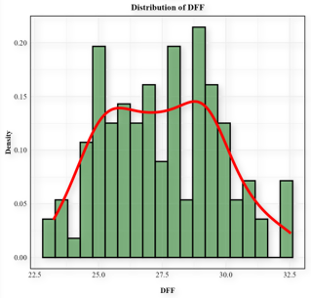(a) | 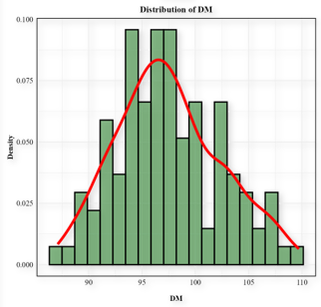(b) | 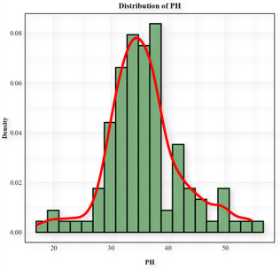(c) | 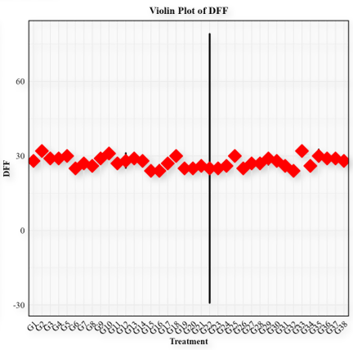  (a) | 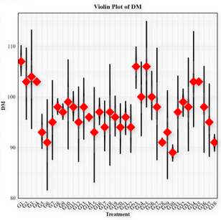 (b) | 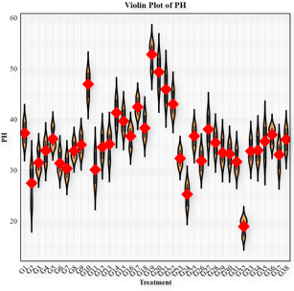 (c)
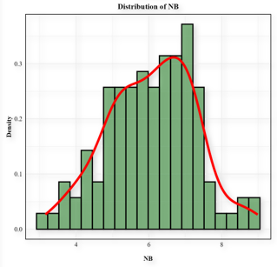(d) | 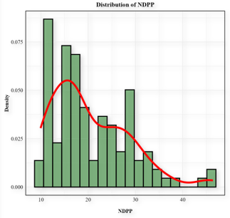(e) | 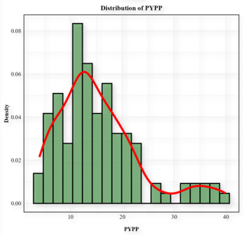(f) | 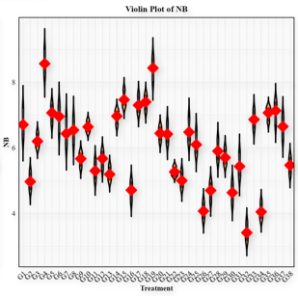 (d) | 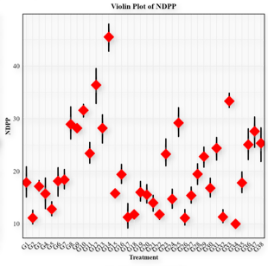 (e) | 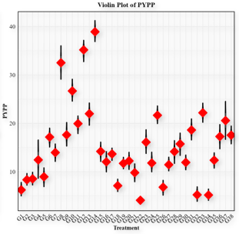 (f)
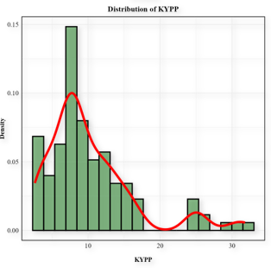(g) | 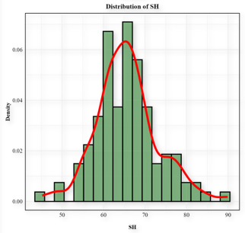(h) | 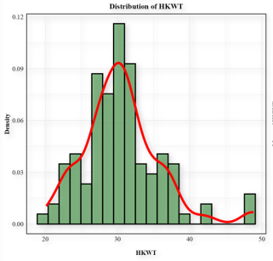(i) | 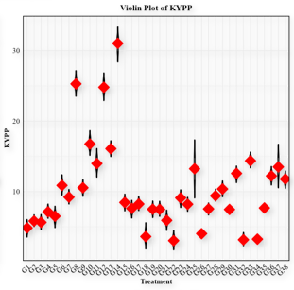 (g) | 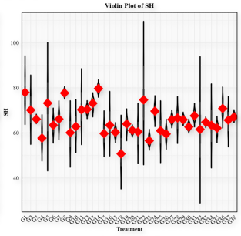 (h) | 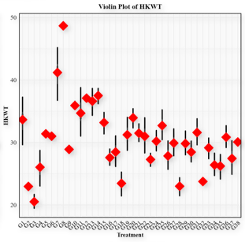 (i)
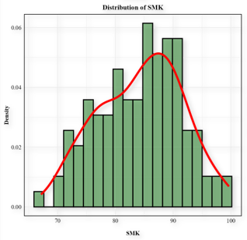(j) | 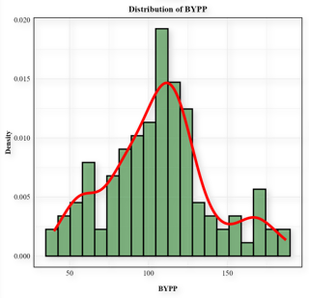(k) | 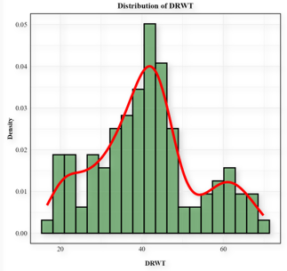 (l) | 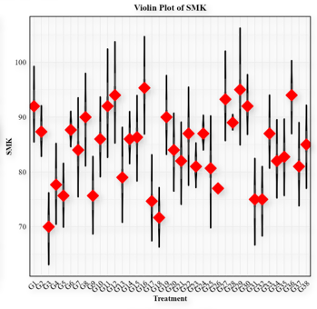 (j) | 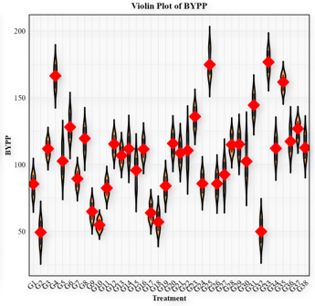 (k) | 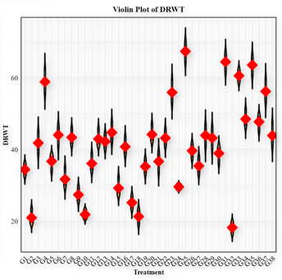 (l)
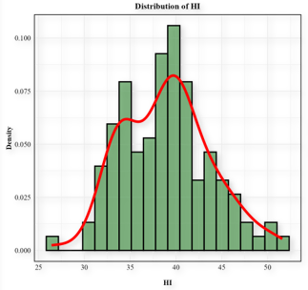(m) | 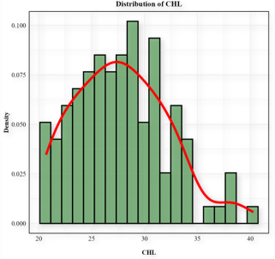(n) |  | 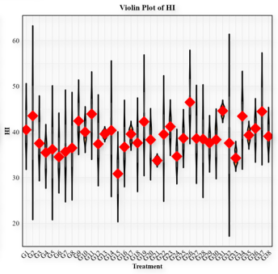 (m) | 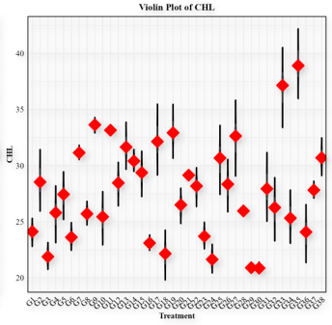 (n)
(A) |  |  | (B)
Figure 2: Diagram depicting comparison of variability among 14 traits using histograms (A) representing frequency distribution and violin plots (B) explaining distribution density for various characters viz., (a) DTF :Days to 50 % flowering, (b) DM: Days to maturity, (c) PH: Plant height, (d) NBPP : Number of branches per plant, (e) NDPP :Number of pods per plant, (f) PYPP :Pod yield per plant, (g) KYPP :Kernel yield per plant, (h) SHP : Shelling per cent (%)), (i) SMKP : Sound mature kernel percent (%)), (j) HKW: 100- kernel weight (gm)), (k) BYPP : Biological yield per plant (gm)), (l) DWT: (Dry weight per plant (gm)), (m) HI: (Harvest index (%), (n) CHP: (Chlorophyll content percent (%)), across different treatments (generations) i.e., P₁, P₂, F₁, F₂, BC₁, and BC₂ cross combinations.

Conclusion
The present study demonstrated presence of significant genetic variability among groundnut genotypes and their segregating generation populations for morphological, physiological and yield-related traits. Traits such as pod yield per plant, kernel yield per plant and number of pods per plant exhibited high genotypic and phenotypic variability, along with high heritability and genetic advance, indicating their strong potential for improvement through direct selection. Other traits, including biological yield, dry weight and chlorophyll content, also showed moderate to high heritability and genetic advance, suggesting their utility as secondary selection criteria. Conversely, traits with low heritability, such as harvest index, may require alternative breeding strategies, including recurrent selection or hybridization, for effective improvement. Overall, the study identifies key traits and superior genotypes that can be utilized in groundnut breeding programmes to develop high-yielding, adaptable cultivars, thereby enhancing productivity and contributing to sustainable oilseed production.
Disclaimer (Artificial Intelligence)
Author(s) hereby declares that no generative AI technologies such as Large Language Models (ChatGPT, COPILOT, etc.) and text-to-image generators have been used during the writing or editing of this manuscript.
Competing Interests
Authors have declared that no competing interests exist.
References
- Abubakar, U., Sani, L. A., Mayaki, B. M., Mohammed, J. S., & Muhammed, N. (2024). Genetic variability, heritability, and genetic advance estimates in selected groundnut genotypes (Arachis hypogaea L.) for agro-morphological and yield traits. Dutse Journal of Pure and Applied Sciences, 10(3a), 278–291. https://doi.org/10.4314/dujopas.v10i3a.26
- Akram, N. A., Shafiq, F., & Ashraf, M. (2018). Peanut (Arachis hypogaea L.): A prospective legume crop to offer multiple health benefits under changing climate. Comprehensive Reviews in Food Science and Food Safety, 17(5), 1325–1338. https://doi.org/10.1111/1541-4337.12383
- Amarasinghe, Y. P. J., Jeewani, D. G. C., Rasara, A. G. H. C., Wijesinghe, G., & Pushpakumara, R. W. (2024). Genetic variability character association and heritability of advanced breeding lines of groundnut (Arachis hypogaea L.). Journal of Agro-Technology and Rural Sciences, 4(1), 21–27. https://doi.org/10.4038/atrsj.v4i1.58
- Aparna, P., Shanthi Priya, M., Mohan Reddy, D., & Latha, P. (2018). Estimation of genetic parameters in groundnut (arachis hypogaea l.) for yield and it’s contributing characters under inorganic fertilizer managements. International Journal of Current Microbiology and Applied Sciences, 7(04), 1559–1565. https://doi.org/10.20546/ijcmas.2018.704.175
- Behera, P. P., Deshmukh, D., Vemula, A. K., Bangaru, K., Bagudam, R., Mathew, A., Purohit, A., Vishnumolakala, A., Wankhade, A. P., Kounain, S., Guguloth, N., Variath, M. T., Kurva, M., Potupureddi, G., Muragesan, S., Raman, A., & Pasupuleti, J. (2025). Realized genetic gain for yield and yield attributes in groundnut breeding at ICRISAT from an ERA trial. Frontiers in Plant Science, 16. https://doi.org/10.3389/fpls.2025.1640041
- Bhargavi, G., Rao, V. S., & Rao, K. L. N. (2017). Genetic analysis for morphological, physiological, yield and yield attributes in groundnut (Arachis hypogaea L.). Indian Journal of Agricultural Research, 51(04). https://doi.org/10.18805/ijare.v51i04.8431
- Bhawar, P. C., Tiwari, S., Tripathi, M.K., Tomar, R.S. & Sikarwar, R.S. (2020). Screening of groundnut germplasm for foliar fungal diseases and population structure analysis using gene based SSR markers. Current Journal of Applied Science and Technology, 39 (2):75-84.
- Bhavani, G., & Koghare, D. T. (2025). Groundnut production and marketing constraint as perceived by the farmers of Wanaparthy district Telangana. International Journal of Economic Plants, 12(Jan, 1), 01–05. https://doi.org/10.23910/2/2025.5863b
- Bisoriya, A., Tripathi, M. K., Mishra, R., Sharma, S., Rajpoot, S. S., & Solanki, R. (2025). Dissecting yield determinants through genetic parameters analysis in diverse restorer lines of pearl millet. Journal of Scientific Research and Reports, 31(7), 881–898. https://doi.org/10.9734/jsrr/2025/v31i73307
- Burton, G. W. (1952). Quantitative inheritance in grasses. Proc. 6th Int. Grassld. Cong. 1:277.
- Chauhan, S., Savithramma, D. L., & Kundu, S. (2022). Genetic variability, heritability and genetic advance for yield and its related traits in BC₁F₁, BC₁F₂, and BC₁F₃ backcross generations of two crosses of groundnut (Arachis hypogaea L.). The Pharma Innovation Journal, 11(8), 314–320.
- Chavadhari, R. M., Kachhadia, V. H., Vachhani, J. H., & Virani, M. B. (2017). Genetic variability studies in groundnut (Arachis hypogaea L.). Electronic Journal of Plant Breeding, 8(4), 1288. https://doi.org/10.5958/0975-928X.2017.00184.3
- Çiftçi, S., & Suna, G. (2022). Functional components of peanuts (Arachis Hypogaea L.) and health benefits: A review. Future Foods, 5, 100140. https://doi.org/10.1016/j.fufo.2022.100140
- Croce, R., Carmo-Silva, E., Cho, Y. B., Ermakova, M., Harbinson, J., Lawson, T., McCormick, A. J., Niyogi, K. K., Ort, D. R., Patel-Tupper, D., Pesaresi, P., Raines, C., Weber, A. P. M., & Zhu, X.-G. (2024). Perspectives on improving photosynthesis to increase crop yield. The Plant Cell, 36(10), 3944–3973. https://doi.org/10.1093/plcell/koae132
- Danalakoti, K., Dubey, N., Darvhankar, M., Avinashe, H., Kumar, D. M., Sharadhi, G. P., & Ghosh, S. (2024). Assessment of Groundnut (Arachis hypogaea L.) Cultivars on yield and yield contributing traits using principal component analysis. Agricultural Science Digest - A Research Journal, Of. https://doi.org/10.18805/ag.D-5805
- Gao, F., Guo, J., & Shen, Y. (2024). Advances from chlorophyll biosynthesis to photosynthetic adaptation, evolution and signalling. Plant Stress, 12, 100470. https://doi.org/10.1016/j.stress.2024.100470
- Gautam, Y., Tripathi, M. K., Mishra, R., Mohbe, G., Sharma, A., Sharma, S., Singh, J., & Bishnoi, L. (2025). Genetic Evaluation and trait association analysis for yield enhancement in soybean (Glycine max L. Merrill). Archives of Current Research International, 25(6), 589–603. https://doi.org/10.9734/acri/2025/v25i61304
- Hariharan, K., Vanitha, J., Mahendran, R., Satheeskumar, K., Malini, B., & Kaviyarasan, S. S. (2025). Variability and association analysis in groundnut germplasm lines for yield and yield attributing traits. Agricultural Science Digest, https://doi.org/10.18805/ag.D-6309
- Hanson, G.H., Robinson, H.F. & Comstock, R.E. (1956). Biometrical studies on yield in segregating population. Agron. J. 268-272.
- Harika, P., Reddy, B. R. K., Gayathri, N. K., & Fareeda, G. (2025). Genetic variability and breeding potential for yield and quality enhancement in groundnut (Arachis hypogaea L.). Journal of Advances in Biology & Biotechnology, 28(2), 647–653. https://doi.org/10.9734/jabb/2025/v28i22024
- Jain, N., Sikarwar, R.S., Tripathi, M.K. & Tiwari S. (2024a). evaluation of genetic parameters for yield and its attributing traits in green gram [Vigna radiata (L.) Wilczek]. International Journal of Environment and Climate Change, 14 (2):482-487.
- Jain, N., Sikarwar, R.S., Tripathi, M.K., Tiwari, S., Rahangdale, S. & A. Barela (2024b). Assessment of genetic variability, heritability and genetic advance for seed yield and its contributing traits in greengram [Vigna radiata (L.) Wilczek]. International Journal of Environment and Climate Change, 14 (3):250-256.
- Jhariya, R., Tripathi, M. K., Mishra, R., Sharma, S., Sikarwar, R. S., & Solanki, R. (2025). Investigation of genetic variability and character connotation for yield augmentation in soybean (Glycine max [L.] Merrill). Journal of Experimental Agriculture International, 47(7), 85–98. https://doi.org/10.9734/jeai/2025/v47i73549
- John, K., Prasanthi, P., & Latha, P. (2021). Evaluation of groundnut genotypes for nutritional and yield traits. International Journal of Current Microbiology and Applied Sciences, 10(6), 613–619. https://doi.org/10.20546/ijcmas.2021.1006.067
- Johnson, H.W., Robinson, H.F. & Comstock, H.S. (1955). Estimation of genetic and environmental variability in soybean. Agron. J.; 47:314-318.
- Khalid, S., Jahanzaib, M., Khurshid, H., Khalid, R., Waqar, S., Siddique, F., Marwat, F. Y. S., & Akram, Z. (2024). Exploring the effect of phenotypic variability on genetic gain in groundnut (Arachis hypogaea L.) yield under semi-drought conditions. Pakistan Journal of Agricultural Research, 37(3), 300–313. https://dx.doi.org/10.17582/journal.pjar/2024/37.3.300.313
- Konate, M., Sanou, J., Miningou, A., Okello, D. K., Desmae, H., Janila, P., & Mumm, R. H. (2020). Past, present and future perspectives on groundnut breeding in Burkina Faso. Agronomy, 10(5), 704. https://doi.org/10.3390/agronomy10050704
- Korale, O. D., Dhuppe, M. V., Bhosle, G. B., & Sargar, P. R. (2021). Assessment of genetic variability, heritability, and genetic advance for yield and yield-contributing characters in groundnut (Arachis hypogaea L.). Multilogic in Science, XII(XXXX), 123–126.
- Korale, O. D., Dhuppe, M. V., Patil, S. S., Gite, N. G., & Mirkad, S. B. (2022). Correlation and path analysis for yield and yield contributing characters in groundnut (Arachis hypogaea L.). International Journal of Theoretical & Applied Sciences, 14(1), 22–25.
- Kumari, E. A., John, K., Mohan Reddy, D., & Latha, P. (2019). Studies on genetic variability for yield, yield attributing traits, physiological and quality traits in groundnut [Arachis hypogaea L.]. International Journal of Current Microbiology and Applied Sciences, 8(07), 393–400. https://doi.org/10.20546/ijcmas.2019.807.048
- Lakshmi, R. M. G., Muthuswamy, A., & Preethi, M. (2021). Genetic variability studies in segregating populations (f2 and f3 generations) in green gram (Vigna radiata (L.) Wilczek.). International Journal of Current Microbiology and Applied Sciences, 10(6), 40–52. https://doi.org/10.20546/ijcmas.2021.1006.004
- Lu, Q., Li, H., Hong, Y., Zhang, G., Wen, S., Li, X., Zhou, G., Li, S., Liu, H., Liu, H., Liu, Z., Varshney, R. K., Chen, X., & Liang, X. (2018). Genome sequencing and analysis of the peanut B-genome progenitor (Arachis ipaensis). Frontiers in Plant Science, 9. https://doi.org/10.3389/fpls.2018.00604
- Makwana, K., Tiwari, S., Tripathi, M.K. & Patel V. (2023). Morphological diversity analysis of foxtail millet (Sateria Italica (L.) Beauv.) using qualitative and quantitative traits. Scientist.2(2): 319-326.DOI: https://doi.org/10.5281/zenodo.7654168
- Mishra, R., Shrivastava, M. K., Tripathi, M. K., Amrate, P. K., Singh, Y., Solanki, R., Sharma, S., & Shukla, S. (2025). Unravelling soybean yield potential: Exploring trait synergy, impact pathways, multidimensional patterns and biochemical insights. Plant Science Today, 12(2), 1–10. https://doi.org/10.14719/pst.6401
- Mishra, R., Tripathi, M. K., Shrivastava, M. K., & Amrate, P. K. (2024a). Genetic diversity in crop improvement: A cornerstone for sustainable agriculture and global food security. In M. K. Tripathi & N. Tripathi (Eds.), Advances in Plant Biotechnology (Vol. 1, pp. 1–21). Cornous Publications LLP. https://doi.org/https://doi.org/10.37446/volbook032024/1-21
- Mishra, R., Tripathi, M. K., Shrivastava, M. K., Amrate, P. K., Singh, J., & Singh, Y. (2024). From Conventional to Modern Plant Breeding: How Far have We Come? In M. K. Tripathi & R. Mishra (Eds.), Recent Advances in Plant Breeding (Vol. 1, pp. 1–20). Cornous Publications LLP. https://doi.org/10.37446/volbook102024/1-20
- Oppong-Sekyere, D., Akromah, R., Ozias-Akins, P., Laary, J. K., & Gimode, D. (2019). Heritability studies of drought tolerance in groundnuts using the North Carolina design II fashion and variance component method. Journal of Plant Breeding and Crop Science, 11(9), 234–253. https://doi.org/10.5897/JPBCS2018.0781
- Paliwal, S., Tripathi, M. K., Sikarwar, R. S. & Sharma, S. (2024). Study of genetic variability and path analysis for yield attributing traits in linseed (Linum usitatissimum L.). International Journal of Plant & Soil Science, 36 (7):20-29.
- Panse, V. G., & Sukhatme, P. V. (1967). Statistical methods for agricultural workers (2nd ed.). Indian Council of Agricultural Research.
- Patel, J. K., Sapara, G. K., Parmar, R. S., & Riya. (2024). Genetic variability, heritability and genetic advance for pod yield and its related traits in F₃ populations of spanish bunch groundnut (Arachis hypogaea L.). Asian Research Journal of Agriculture, 17(4), 1072–1082. https://doi.org/10.9734/arja/2024/v17i4621
- Poojitha, P., Singh, L., Kasirao, G., Nath, R., Perli, H., & Shiva, B. (2024). Assessment of variability, heritability and genetic advance in groundnut (Arachis hypogaea L.). Environment and Ecology, 42(2A), 703–707. https://doi.org/10.60151/envec/GMBJ9705
- Pramanik, A., Tiwari, S., Tomar, R. S., Tripathi, M.K. & Singh, A.K. (2019). Molecular characterization of groundnut (Arachis hypogaea L.) germplasm lines and varietal set for yield and yield attributing traits. Indian Journal of Genetics and Plant Breeding, 79 (01): 56-65. DOI: https://doi.org/10.31742/IJGPB.79.1.8
- Pramanik, A., Tiwari, S., Tripathi, M.K. Mandloi, S. & Tomar, R.S. (2022). Identification of groundnut germplasm lines for foliar disease resistance and high oleic traits using SNP and gene-based markers and their morphological characterization. Legume Research, 45(3): 305-310.doi: 10.18805/LR-4666
- Puri, Pooja Ramgiry, S., Tripathi, M., Solanki, R. & Tare S. (2025).Assessment of genetic variability, correlation and path coefficient analysis for yield associated traits in wheat (Triticum aestivum L.). International Journal of Plant & Soil Science, 37 (2):188-199.
- Rajanna, B., Divya, K., Lokesh, G., Shivakumar, K., & Chavan, S. S. (2024). Genetic variability studies in groundnut (Arachis hypogaea L.) germplasm. International Journal of Advanced Biochemistry Research, 8(8S), 252–256. https://doi.org/10.33545/26174693.2024.v8.i8Sd.1778
- Rajpoot, S. S., Tripathi, M. K., Mishra, R., Payasi, D. K., Pandey, A., Tomar, S. S., Sharma, S., & Singh, J. (2025). Delineation of Genetic diversity in chickpea employing multivariate techniques. Journal of Experimental Agriculture International, 47(9), 460–478. https://doi.org/10.9734/jeai/2025/v47i93767
- Rajput, L. S., Sikarwar, R.S., Ingle, S. V., Tripathi, M.K., Prajapati, P.K. & Yadav, R.K. (2024a). Principal component analysis for groundnut yield and seed attributes (Arachis hypogaea L.). International Journal of Research in Agronomy SP-7(5): 194-197. DOI: https://doi.org/10.33545/2618060X.2024.v7.i5Sc.781
- Rajput, L. S., Sikarwar, R., Tripathi, M., Tiwari, S., Prajapati, P., & Yadav, R. (2024b). Assessment of variability, heritability and genetic advance in peanut [Arachis hypogaea (L.)]. International Journal of Advanced Biochemistry Research, 8(5), 1029–1031. https://doi.org/10.33545/26174693.2024.v8.i5l.1235
- Rana, A. K., Vyas, P., Sharma, S., & Sardana, V. (2023). Groundnut harbours non-nodulating non-rhizobial plant growth-promoting bacterial endophytes. 3 Biotech, 13(12), 420. https://doi.org/10.1007/s13205-023-03837-z
- Raza, M., Sekhar, M. R., Priya, M. S., Prasad, T. N. V. K. V., & Rajarajeswari, V. (2018). Genetic variability studies for pod yield and component traits in groundnut. Electronic Journal of Plant Breeding, 9(4), 1436. https://doi.org/10.5958/0975-928X.2018.00178.3
- Roy, A., Ahmed, L. M., Amaravathi, Y., Viswanath, K., Prasad Babu, J. D., & Sreekanth, B. (2018). Genetic variability, heritability and genetic advance of yield and yield attributes in groundnut (Arachis hypogaea L.). The Andhra Agricultural Journal, 65(1), 88–91.
- Sharma, N., Tiwari, S., Tripathi, M.K., Gupta, N., Singh, S.& Sikarwar, R.S. (2023a). Selection of groundnut germplasm lines based on yield, nutritional, antinutritional and antioxidant parameters. Scientist. 2(1): 96-105.DOI: https://doi.org/10.5281/zenodo.7536324
- Sharma, S., Tripathi, M.K., Tiwari, S., Solanki, R.S., Chauhan, S., Tripathi, N., Dwivedi, N. & Kandalkar, V.S. (2023b). The exploitation of genetic variability and trait association analysis for diverse quantitative traits in bread wheat (Triticum aestivum L.). Curr. J. Appl. Sci. Technol., 42 (8):19-33.
- Sharma, S. Tripathi, M.K., Tiwari, S., Solanki, R.S., Chauhan, S., Tripathi, N., Dwivedi, N. & Tiwari, P N. (2023c).Discriminant function analysis for yield improvement in bread wheat (Triticum aestivum L.). The Pharma Innovation Journal, 12(5):224-232.
- Sharma, A., Tripathi, M. K., Dangi, D., Mishra, R., Solanki, R., Tomar, S. S., Yadav, R., Tomar, S. S., Kumar, O., Gautam, Y., & Singh, J. (2025). Genetic analysis for yield improvement in Brassica species: Insights from variability and trait relationships. Journal of Scientific Research and Reports, 31(8), 749–766. https://doi.org/10.9734/jsrr/2025/v31i83418
- Sharma, S., Brar, K. S., & Sandhu, S. K. (2019). Profiling of groundnut (Arachis hypogaea L.) genotypes for seed quality traits. Indian Journal of Plant Genetic Resources, 32(1), 72. https://doi.org/10.5958/0976-1926.2019.00010.X
- Sravanti, K., Reddy, V. R., Mamatha, K., Shankar, M., Rani, V. D., Sujatha, M., & Goverdhan, M. (2024). Variability studies for yield and related traits in groundnut (Arachis hypogea L.) genotypes. International Journal of Advanced Biochemistry Research, 8(12S), 1377–1381. https://doi.org/10.33545/26174693.2024.v8.i12Sq.3509
- Suthar, D. M., Patel, D. G., Patel, P. R., & Soni, N. V. (2023). Studies on variability for yield and yield attributing traits in groundnut (Arachis hypogaea L.). Biological Forum – An International Journal, 15(11), 520–525.
- Tamilselvi, C., Vaidyanathan, R., & Chitra, M. (2020). Morphological and physiological characterization of groundnut (Arachis hypogea. L) genotypes for higher translocation efficiency and yield. International Journal of Chemical Studies, 8(4), 1826–1830. https://doi.org/10.22271/chemi.2020.v8.i4s.9892
- Tomar, Y.S., Tiwari, S., Tripathi, M.K. & Singh, R. (2022). Genetic diversity assessment and cluster analysis of morphological yield attributing traits of groundnut (Arachis hypogaea L.). The Pharma Innovation, 11(6): 1444-1450.
- Umadevi, M., Vanitha, K., Mythili, S. R., Shanthi, P., Kavithamani, D., & Arulselvi, S. (2025). Genetic analysis of groundnut (Arachis hypogaea L.) genotypes for yield and oil quality parameters. Plant Science Today. https://doi.org/10.14719/pst.4442
- Vaghasiya, D. R., Dholariya, N. D., Mungala, M. P., Chaudhary, Y. J., & Jambukiya, R. M. (2025). Correlation and path coefficient analysis in Spanish bunch groundnut (Arachis hypogaea L.). Plant Archives, 25(Special Issue, ICTPAIRS-JAU, Junagadh), 291–296. https://doi.org/10.51470/PLANTARCHIVES.2025.SP.ICTPAIRS-044
- Vaishali, G., Saravanan, S., Arumugam Pillai, M., Sheela, J., Kavitha Pushpam, A., & Jerish, J. R. (2023). Genetic variability and heritability studies in groundnut (Arachis hypogaea L.) germplasm. The Pharma Innovation Journal, 12(9), 970–973.
- Vasanthi, R. P., Suneetha, N., & Sudhakar, P. (2015). Genetic variability and correlation studies for morphological, yield and yield attributes in groundnut (Arachis hypogaea L.). Legume Research - An International Journal, 38(1), 9. https://doi.org/10.5958/0976-0571.2015.00002.8
- Veer, A., & Kumar, V. (2021). Assessment of genetic variability, heritability and genetic advance among groundnut (Arachis hypogaea L.) genotypes. Indian Journal of Pure & Applied Biosciences, 9(1), 214–218. https://doi.org/10.18782/2582-2845.8577
- Vinithashri, G., Manivannan, N., Viswanathan, PL., & Selvakumar, T. (2019). Genetic variability, heritability and genetic advance of yield and related traits in F₃ generation of groundnut (Arachis hypogaea L.). Electronic Journal of Plant Breeding, 10(3), 1292. https://doi.org/10.5958/0975-928X.2019.00165.0
- Wadikar, P. B., Dake, A. D., Chavan, M. V., & Thorat, G. S. (2018). Character association and variability studies of yield and its attributing characters in groundnut (Arachis hypogaea L.). International Journal of Current Microbiology and Applied Sciences, Special Issue-6, 924–929.
- Wang, Z., Zhang, Y., Yan, L., Chen, Y., Kang, Y., Huai, D., Wang, X., Liu, K., Jiang, H., Lei, Y., & Liao, B. (2023). Correlation and variability analysis of yield and quality related traits in different peanut varieties across various ecological zones of China. Oil Crop Science, 8(4), 236–242. https://doi.org/10.1016/j.ocsci.2023.12.001
- Yadav, S., Tiwari, S., Tripathi M.K., Gupta , N., Singh, S., Tripathi N. (2023). Phenotypic and molecular evaluation of Arachis hypogaea L. against foliar fungal diseases. Crop Design, doi: https://doi.org/10.1016/j.cropd.2023.100036
- Yadav, G. L., Rajput, S. S., Gothwal, D. K., & Jakhar, M. L. (2021). Genetic variability, character association and path analysis for pod yield and its component characters in groundnut [Arachis hypogaea (L.)]. Legume Research. https://doi.org/10.18805/LR-4694
- Yami, A. S., & Abtew, W. G. (2025). Assessment of genetic variability for yield and yield‐contributing traits in groundnut (Arachis hypogaea L.) genotypes. Journal of Food Quality, 2025(1). https://doi.org/10.1155/jfq/3370389
- Zhang, L., Yang, X., Tian, L., Chen, L., & Yu, W. (2016). Identification of peanut (Arachis hypogaea) chromosomes using a fluorescence in situ hybridization system reveals multiple hybridization events during tetraploid peanut formation. New Phytologist, 211(4), 1424–1439. https://doi.org/10.1111/nph.13999
- Zhou, Z., Struik, P. C., Gu, J., van der Putten, P. E. L., Wang, Z., Yin, X., & Yang, J. (2023). Enhancing leaf photosynthesis from altered chlorophyll content requires optimal partitioning of nitrogen. Crop and Environment, 2(1), 24–36. https://doi.org/10.1016/j.crope.2023.02.001

