Original Research Article

Physicochemical and Anatomical Characteristics for assessment of Wood quality of Azadirachta indicaA.Juss.

ABSTRACT

The Evaluation of Physicochemical and Anatomical Characteristics for assessment of Wood quality of AzadirachtaindicaA.Juss. was carried out in the department of Forest products and utilisation,College of Forestry, Odisha University of Agriculture and Technology, Bhubaneswar.Sample tree was harvested at stump height and the harvested logs were air dried for 1month from which wood disc of 2 cm thicknesswas transversely cut. From sapwood and heartwood portion of the disc, sample cuboids were prepared and taken for estimation of density,specific gravity(s)and moisture content. The colour of wood was studied on basis of visual interpretation where the heart wood found to be Reddish to Reddish brown and the sapwood found to be light yellow in colour. The heartwood percentage was very high about 90.1% and moisture content of the air dried heartwood sample wood found to be 27.91% with respect to its oven dry weight. The air dry and standard specific gravity of the heartwood found to be high and can categorised under class of moderately Heavy–Heavy. The species contains higher Holocellulosecontent (58.73%-63.04%), Cellulose content (32.34%-38.03%)and Lignin content (28.98%-30.79%) favours its utilisation for composite and improved woods , pulp and paper, furniture etc. The species found to be fast growing on basis number of growth rings per unit radius length. As the number of anatomic features affects the density, durability and other quality of wood, the parenchyma and vessels number observed in cross-sectional, radial and tangential section of wood found to favour higher density and durability of the wood.

Introduction
Azadirachtaindica A.Juss.commonly known as Neem is a fast growing tree belonging to family Meliaceae distributed widely in evergreen, moist deciduous and dry deciduous forest areas. The tree grows and naturally regenerates well in conditions prevailing from Coastal area to drier tracts because of its wide adaptability to different climatic and edaphic conditions. The species reported to be native to India, Bhutan and Countries of South-east Asian region (Roshan & Verma, 2015). The tree is also found growing profusely in west Africa, planted in Caribbean (Couletal.,1990) and Central America countries like Mexico (Roshan & Verma, 2015). In India Neem is distributed naturally in the states under the Peninsular region below 24ºN latitude but has been introduced in most of the states as a potential multipurpose fast growing tree in urban and wasteland plantations.
A.indicais a large tree which generally attain a height of 15-20m and rarely 30-35m known for its multiple utilisations as aNTFPs like seed oil, biopesticides, seed cakes as fertilisers, soil conditioner, active principles from different parts having anti-carcinogenic, anti-pyretic, anti-oxidants, anti-inflammatory, antifungal, anti-gastric, anti-diabetic,diuretic etc. (Islas et al., 2020 ; Singh,2019 and Roshan &Verma,2015).Besides thatas a major forest produce its timber has been used for the manufacture of plywood, block board, window anddoor frames, shutters, wagon and carriage, furnitures, cabinets, boat and ships, agricultural implements, match splints, decorative flooring and wall panelling because of its durability, moderate weight, proper strength, dimensional stability, easy workability and better finishing qualities with appealing colour, grain and texture (Deoreetal.,2020). The wood also havingmedicinal and pesticidal value. Activated charcoal prepared from it act as an efficient adsorbents in removal of heavy metals, dyes and other organic pollutants from effluent (Sing et al., 2024). Neem wood are also reported to be used for pulp and paper making (Sinha,2008) and recent uses in wood polymer composites (Yadav etal.,2024&Nagamadhuet al.,2020)).In Odisha, traditionally the Neem wood is being used for making deities of Lord Jagannath, Balabhadra and Subhadra since the inception of the Shree Jagannath Temple at Puriway 12th Century back and it is being replaced maximum after 19 yrs. This also supports the nativeness of the species in India,easy workability and also its durability. The mechanical, electrical, thermal, acoustic property of wood decides the proper utilisation of wood and these properties of wood depends either directly or indirectly on its physical, chemical and anatomical characters.These characteristics of wood varybetween different species as well as with in the individuls of a species from one locality to another which ultimately affects the quality of the final product derived from it.The physical, chemical and anatomical characters also vary in heartwood and sapwood of same tree.The tree wood was collected from Balasore which is a Coastal district of Odisha where it grows and regenerates naturally in forests and wastelands, planted in Urban plantations and farmlands.The present study emphasises on assessment of basic Physical, Chemical and Anatomical characteristics of Heartwood and Sapwood of A.indicafor better utilisation in future.

2.Materials and Methods
2.1 Site Description and Sample collection
Balasore is one of the Coastal Districts of Odisha located at 20.48-21.59 North Latitude and 86.16 - 87.29 East Longitude.It’s climate is generally hot and humid with May as the hottest month and December the coolest. Monsoon arrives every year in the district from mid Junewith average rainfall of the District is 156.84 cm with 62 rainy days per year from June--December accounting75% of the total rainfall. The wood samples wascollected from one month air dried felled tree of KurudaVillage underBalasoreblock of the district. The wooden disc was cut at the basal portion of the felled tree rom which 6 cuboid shaped wood blocks were cut each for Heartwood and Sapwood. The wood samples were further treated and evaluated in the Laboratory of Department of Forest Products and Utilisation, College of Forestry, OUAT, Bhubaneswar, Odisha.

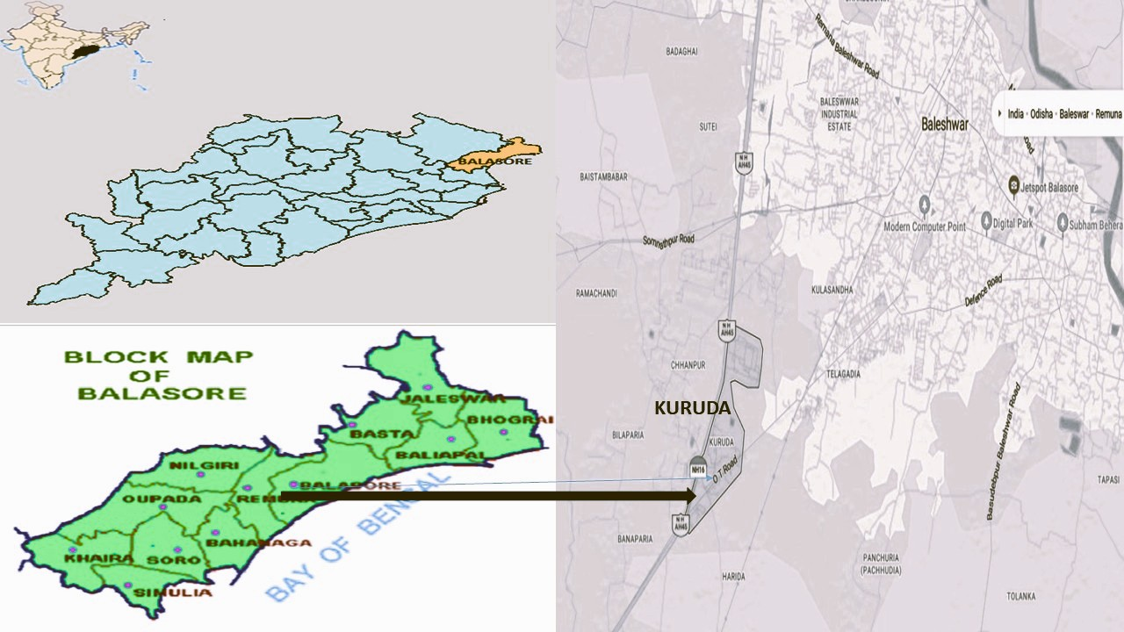
Figure-1:Place of Collection (Kuruda in Balasore District and Wood Disc of Azadirachtaindica

2.2 Observations recorded regarding physical characters
The cuboid length, breadth and height were taken respectively in Longitudinal, Tangential and Radial direction of the tree log from which the disc is cut.Observations was recorded from Sample disc like mid diameter (cm) usingmeasurement scale and no. of growth rings were counted on basis of which the growth rate of plant was analysed. Length (cm), Breadth(cm), Height(cm), Green biomass (g), air dry biomass (g), oven dry biomass (g) were recorded from the sample cuboids of Sapwood and Heartwood from which volume, Density and Specific Gravity were estimated.

2.2.1Fresh and Oven dried weight
Fresh weight of the Heartwood and Sapwood cuboids were recorded using the digital weighing machines which were then dried at oven conditions at 102ºC till constant weight is achieved. The oven dried weight of Heartwood and Sapwood samples were recorded from which moisture content in each case was calculated.
Moisture content (%) Oven dry wt. basis = (Air dried weight of cuboid –Oven dried weight) x100/ Oven dried weight
Moisture content (%) Airdry wt. basis = (Air dried weight of cuboid –Oven dried weight) x100/ Air dried weight

2.2.2 Density & Specific Gravity Estimation
Length (cm), breadth(cm), height(cm) cuboids measured by Vernier calliper for each sample block of Heartwood and Sapwood and Volume was calculated.
Density of wood (Air dried Wood) = Mass of Air dry wood /Volume inAir dry condition
Density of wood (Oven Dry Wood) = Mass of Oven dry wood /Volume in oven dry condition
Specific gravity estimation was carried out separately for both Sapwood and Heartwood by water displacement method. Specific gravity like Specific gravity in Air drycondition, Specific gravity in Oven dry condition and Standard Specific gravity were determined for each cuboid from sapwood and heartwood.
Specific Gravity at Air Dry Condition = Weight of the wood sample at Air dry condition / Weight of equal volume of water displaced by the Air drywood sample at 4°C.
Specific Gravity at Oven Dry Condition = Weight of the wood sample at Oven dry condition / Weight of equal volume of water displaced by the oven dry wood sample at 4°C.
Standard Specific Gravity =Weight of the wood sample at Oven Dry condition / Weight of equal volume of water displaced by the Fresh wood sample at 4°C.

Basing on Standard specific gravity/Density/Specific gravity , the wood was categorised as Lighter, Moderately heavy, Heavy as per the classification by the book Indian Forest utilisation Volume-I by FRI and Mehta (2008).

2.2.3 Sapwood and Heart Proportion in Wood Disc
As the disc was not a perfect circular shape the diameter was measured from different directions and the average diameter was calculated from which average radius estimated and used for calculation of Total Area of Wood disc, Area of Heartwood and Sapwood.
Total area of the Wood disc = πR²
Total area of Heartwood = πr²
Area of Sapwood = π (R²- r²)

Sapwood: Heart wood Proportion on basis of area = π (R²-r²) / πr²
Where R = Average radius of the wood Disc.
r = Average radius of the Heartwood portion of the Disc.

2.3 Cellulose, Hemicellulose and Lignin content of Wood sample
Cellulose, Hemicellulose and Lignin content of Wood sample was estimatedbymodified method ofMoubasheret al.(1982). 2g of saw dust kept in a Thimble was extractedbySoxhlet apparatus using Solvent system Ethanol-Toluene (2:1) for 6 hours till solvent in the extractor becomes colourless. The extracted wood dust was washed thoroughly and kept in Oven at 65°C overnight and weight was recorded.The oven dried wood dust was then divided into two equal parts of which one part is considered as A fraction.Second part of residue was treated with 24% KOH for 4hrs at room temperature, washed thoroughly with distilled water dried at 80°C over night and the dry weight taken as B fraction. The same samples again treated with 72% H₂SO₄ for 3hrs to hydrolyse the cellulose and then further refluxed with 5% H₂SO₄ for 2hrs. The Lignin obtained was filtered using a weighed filter paper and H₂SO₄ was removed completely by washing it with distilled water. The filter paper containing lignin dried at 80°C in oven for overnight and dry weight of lignin determined [(Wt.of Filter paper+ Lignin) - Wt. of filter paper] and recorded as C fraction. From the above taken weights Cellulose, Hemicellulose and Lignin were calculated as follows
Cellulose = B-C
Hemicellulose-A-B

Lignin-C

2.4 AnatomicalProperties of Wood samples of Azadirachtaindica

For estimation of Anatomical features, wood blocks were to be macerated in distilled water for 10 days till it gets soft , from which radial, cross sectional and tangential sections were prepared. It were then dehydrated with 50% ethanol followed by staining with Safranin for 1 minute, washing with 50% ethanol to remove excess Safranin stain , further stained with Fast green for 30 seconds and finally washed with distilled water to remove excess fast green stain. The sample is then assembled in a slide using glycerol. Images were captured using digital microscope connected to a computer. Anatomical observations recorded were Vessel no. /mm² area andRay Parenchyma no. /mm². in Radial, Cross sectional and Tangential sections .
Vessels in Crossectional area are categorised under different class as
Scanty-<2.5/mm² ; Moderately Numerous-2.5-20/mm² and Very Numerous->20/mm²

Ray parenchyma are categorised as

ApotrachealType (Terminal/Initial, Diffuse, Retculate/Net like)

Paratracheal (Vasicentric,Aliform/Eyelet, Banded)
Categorised as per Numbers: 1. Few-< 5 Rays/mm 2. Numerous->10 rays/mm

3.Results and Discussion

3.1 Physical Properties of Wood Samples of Azadirachtaindica

The Physical properties of A.indicawood collected fromKuruda of Balasore district of Odishawere recorded for Sapwood and Heartwood. The colour of wood was studied on basis of visual interpretation where the Heartwood found to be Reddish to Reddish brown where as the Sapwood found to be light yellow in colour (Figure-2). The findings are in accordance with the Colour of Heartwood and Sapwood of A. indica mentioned by Deoreet al. (2020). The dark Colour of Heartwood may be due to deposition and /or oxidation of chemicals present in it. Total no. of Growth ring recorded to be 43 and average no. of Growth ring present /centimetre found to be 0.91 which indicates the tree growth rate is fast as the average of each ring width is between 0.5-2.5cm. Heartwood and Sapwood area was determined from the Cross section of the disc cut from the basal portion of the stem. The ratio was found 9.18:1 indicating 90.1 % Heartwood and 9.9% Sapwood.

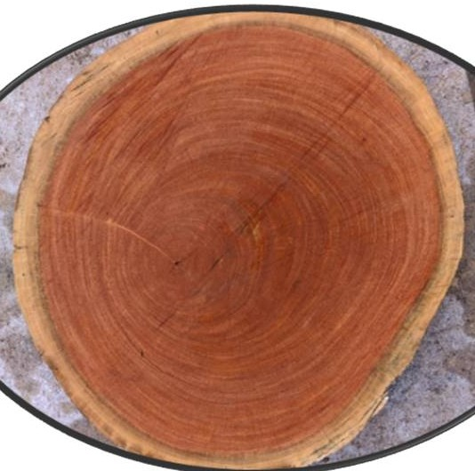
Figure-2: Wood Disc of Azadirachtaindica

The weight of the Sapwood andHeartwoodcuboids differs in both air dried and ovendry conditions (Table-1).The average air driedweight of Heartwood Cuboid sample (29.10g) was 7.18% more than that of Fresh weight of Sapwood which may be due to higher deposition of chemical in Heartwood.However, the average Ovendry weight of Heartwood (22.75g) is 0.306 % less than Sapwood which may be mainly due to degradation and /or loss of chemicals in Heartwood along with the moisture present in Heartwood during heating at higher temperature.Moisture content in Heartwood on air dry and oven dry weight (21.82%and 27.91%) is 36.88% and 47.12% respectivelyhigher than that of Sapwood. However, it may be because of moisture absorbed binds to deposited gums, dyes and other polar phytochemicals tissues and forming complex structure which disables to evaporate water even at oven temperature fromHeart wood (Table-1).

Table-1: Weight and Moisture Content(%) inAir DryWood samples
Air Dried Wood  Sample | Air Dry Weight (g) | Oven Dry Weight (g) | Moisture content(%) on Air DryWeight Basis | Moisture content(%) on Oven Dry WeightBasis
Sap Wood | 27.15 | 22.82 | 15.94 | 18.97
Heart Wood | 29.1 | 22.75 | 21.82 | 27.91
MEAN | 28.12 | 22.78 | 18.88 | 23.44

In air dried wood samples, Density of Heartwood (1.1) found to be 48.65% higher than density of Sapwood, whereas, for Oven dried wood samples, density of Heartwood (0.93) found to be 50% higher than that of Density of Sapwood. Considering Sapwood, the average density for air dried samples (0.74) found to be 16.21% more than its density in oven dry condition (0.62). Similarly, for Heartwood, the average density in air dry condition (1.1) was found to be 15.45% more than its Oven dry condition (0.93) (Figure-3). The higher density in Heartwood may be more depositions of phytochemicals and higher cell thickening. WoodDensity is a major character on which the utilisation of the wood are decided which acts a good indicator for strength, stiffness and dimensional stability (Josue.2004; Oyagade&Fabiyi, 2002; Akpan & Olufemi,2007; Pokuet al. 2001&Oluwadare&Somorin, 2007). Density of A.indica in both sapwood - heart wood ranges from 0.62 g/cm³- 0.93g/cm³ whichwere in close to findings of average density (0.56-0.85) recorded by Koul et al. (1990). The higher density may be broadly attributed to the genotypic and environmental conditions. Similar studies also carried out with average density (0.64 g/cm³ – 0.70 g/cm³) by Sotannde (2010) and average density (0.63 g/cm³ – 0.70 g/cm³) by Akpan & Olufemi (2007).

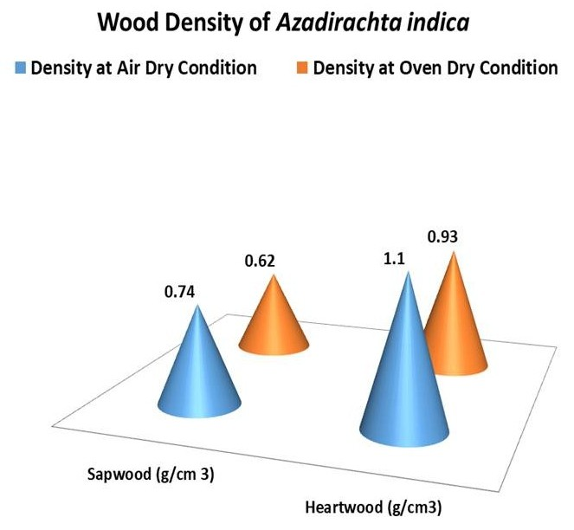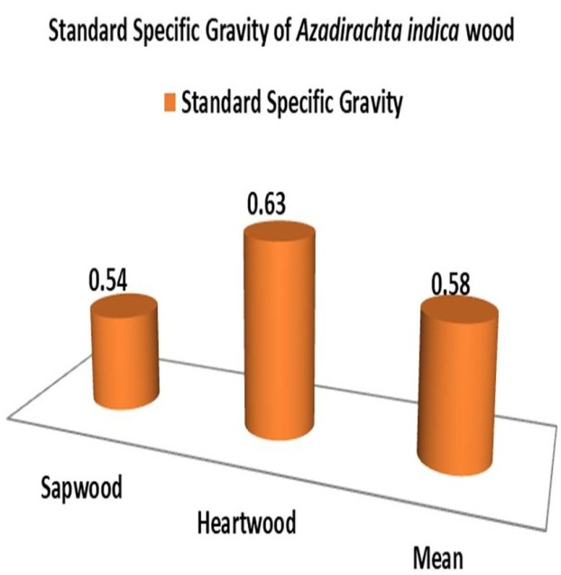
Figure-4: Standard Specific Gravity of Heartwood and Sapwood of Azadirachtaindica
Figure-3: Density of Heartwood and Sapwood of Azadirachtaindica

Table -2: Specific Gravity of Heartwood and Sapwood of Azadirachtaindica
Specific Gravity of Wood | Sapwood | Heartwood | Mean
Air Dry Specific gravity | 0.78 | 0.87 | 0.82
Oven Dry Specific gravity | 0.69 | 0.97 | 0.83

Specific gravity is a similar measure as density of wood.Specific gravity of air driedheartwood (0.87) which was found to be 11.53% more than the Specific gravity of air dried Sap wood, whereas, Specific gravity of Ovendry Heart wood (0.97) was 40.58% higher than Oven dried Sap wood. Considering Sapwood, the average specific gravity in air dried condition (0.78) was found to be 13.04% more than its specific gravity in oven dry condition. Similarly, for Heartwood, the average specific gravity in air driedcondition (0.97) was found to be 15.45% more than its Oven dry condition (Table-2). The Standard Specific gravity of heartwood found to be 16.66% higher in heartwood (0.63) than Sap wood (Figure-4).

As the Standard specific gravity of Sapwood and Heartwood ranges between 0.54-0.63, it can be considered under the category range of Moderately Heavy-Heavy. The species can be utilised for furniture makings, veneer wood for peeling and slicing, sheet making and lining, artifacts and parquets.

Shrinkage takes place during the process of drying or seasoning of timber. Wood shrinks at different rate in along length (Longitudinal), breadth (Tangential) and height (radial) of cuboidsamplesevaluated fromSapwood and Heartwood. Incase of Both Sapwood and Heartwood, Least Shrinkage was occurred alongLongitudinal direction (Figure-5), followed by Radial direction (Figure-6) and Maximum Shrinkage along Tangential direction (Figure-5) . The pattern of result is also inconformity with the findings of shrinkage test on A. indiciareported bySotanndeet al.(2010). Similar type of work is also done by Wang et al.(2018) on Pinus radiata. In case of sapwood cuboids, Shrinkageoccurred inLongitudinal(0.7%) and Tangential (5.71%) were found to be 40% and 44.55% respectively higher than Heart wood.However, Shrinkage recorded in Radialfor Heart wood cuboid (3.21%) found to be 23.07% more than Sapwood. The volumetric shrinkage is 12.85% in Sapwood which is87.31% more than volumetric shrinkage of Heartwood(Figure-5) which not much affects the properties of wood. This unequal shrinkage in different directions attributed to the anisotropic behaviour of wood which affects mainly the mechanical property of wood. The higher density of hardwood found to have low shrinkage than Sapwood and this finding also matches the finding of Sotanndeet al.(2010).

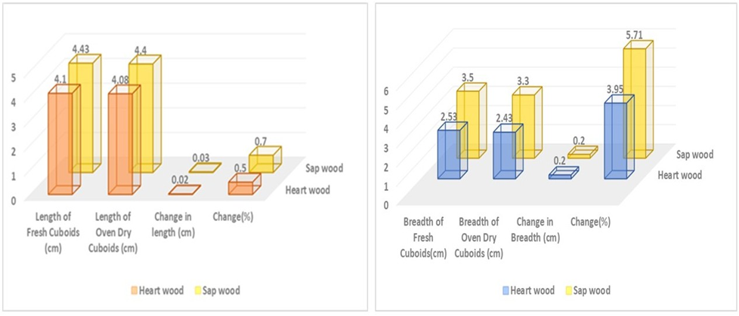

Figure 5: Shrinkage(%)inLength (Longitudinal)and Breadth (Tangential)of Sapwood and Heart wood
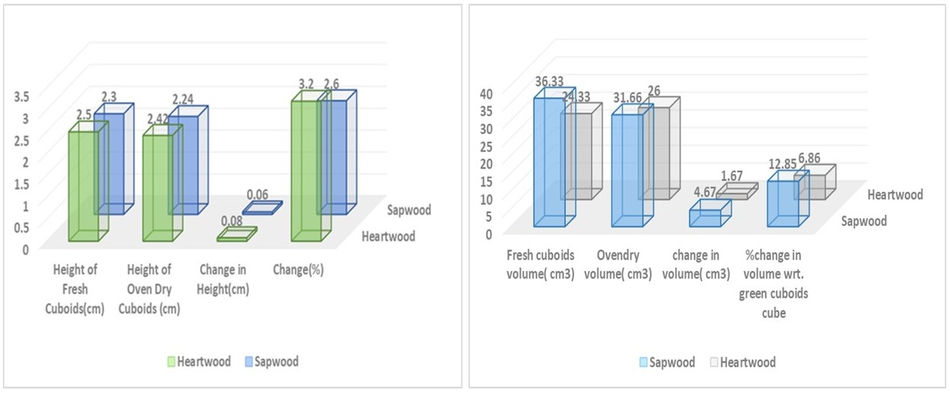

Figure-6: Shrinkage (%) in Height (Radial)and Volume of Sap wood and Heart wood

3.2 Chemical Properties of Wood Samples of Azadirachtaindica

The Alcohol-Toluene extract from the Heartwood (10.48%) found to be 31.33%more than that of Sapwood(Figure-7 & 8) which is because of more deposition of phytochemicals like gum, tannin, dyes, phenols etc in heart wood than sapwood which also enhances the durability of wood by its insecticidal, fungicidal, microbial and antioxidant properties.Higher heartwood extractives than Sapwood are reported by Wei etal.(2022) in Dalbergiaoliveri ,Li et al.(2019) in Cunninghamialanceolata and Morais& Pereira(2012) in Eucalyptus globulus.The Hemicellulose content of the Heartwood (26.39%) found to be 5.52% more than that of Sapwood whereas the lignin content of the Heartwood (30.79%) found to be 6.25% more than that of Sapwood (Figure-7 & 8). Higher Hemicellulose in Heartwood than Sapwood has been reported by Li et al. (2019) in Cunninghamialanceolata. Higher lignin content in Heartwood than Sapwood reported in Mazriet al. (2022) in Fraxinus, Jia et al. (2017) in Oak, Lourenço(2015) in Tectonagrandis, Dünischet al.(2010) in RobiniapseudoacaciaandPiceaabies by Bertaud (2004). However, the Cellulose (38.03%)and Holocellulose content (63.04%) of the Sapwood wood found to be 17.59% and 7.34% respectively higher than Heartwood.Dzurendaet al, (2023) reported Higher Holocellulose and Cellulose in Sapwood of Fagus sylvatica, higherHolocellulose content in Sapwood by Wei et al.(2022) in Dalbergiaoliveri.

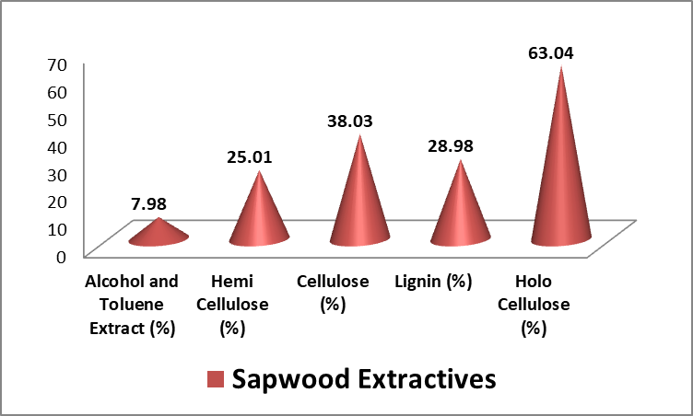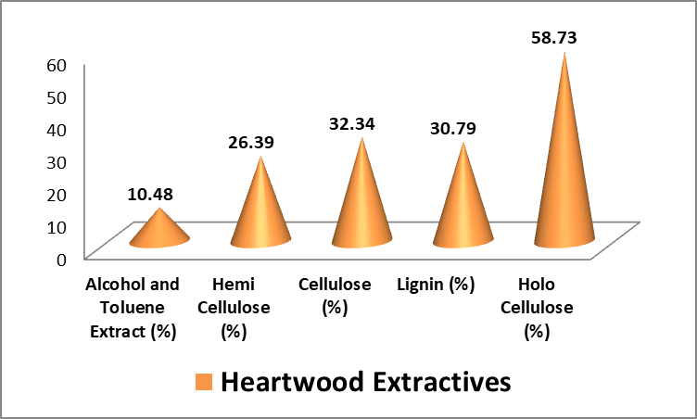Figure-7:Sapwood Extractives(%) of A.indicaFigure-8:Heartwood Extractives(%) of A. indica

3.3 Anatomical Properties of Wood Samples of Azadirachtaindica
The anatomical study of Heartwood and Sapwood revealed the following major anatomical features in Cross-sectional, Radial and Tangential Section.Incase of Heartwood ,theaverage number of Vessels foundto be 5.73, 2.12 and 3.38per mm² whereasRay Parenchyma 1.06, 2.86 and 4.48 per mm² in cross section , Radial section and Tangential section respectively.However, in case of Sapwood, the average number of Vessels found to be 4.35, 4.45 and 1.59 per mm²,whereas Ray Parenchyma were recorded 2.55,1.05 and 3.18 per mm² in Cross-sectional, Radial and Tangential section respectively (Figure-9).The average vessel number in Cross-sectional area of Heartwood and Sapwood samples categorises it under class of moderately numerous whereas number of rays can be classed under few widely spaced.
The cross sectional features of the wood showed diffuseporuspattern,Vessels are mostly circular with lumen size varies from small to large, are solitary or in radial multiples of 2or3. Axial Parenchyma is Vascicentric or Banded Paratracheal type. Ray cells are Uniseriate to Multiseriate (2-3) (Figure-10).The findings were also in lieu with the anatomical features findings in A.indica by Nair (1998).
Martı´nez-Cabrera et al. (2009) revealed that low density wood from wet sites have high proportion of Rays than dry sites. Here, the site is not wet and cross-section has few (1.66-2.55) rays and no. of pores in cross-section are moderately numerous favouring higher density of wood under category of Moderately Heavy. Normally, Fibres provides mechanical support to the tree while Vessels helps in conduction and Parenchyma in both storage and conduction. But in a study carried out by Zhang et al.(2023) revealed that strong wall vessels helps in mechanical support, blunt cracking and seizes horizontal cracking whereas the ray cells helps in arresting the axial cracking.
Parenchyma amounting 40% of wood volume withhigh variation among different species and within individual of same species (Spicer, 2014; Morris et al., 2016 ; Fontiet al.2015; vonArxet al.,2017).Physiological role played by Parenchyma includes storage and transport of non-structuralcarbohydrates (Johnson et al., 2012; Plavcováet al., 2016),vessel refilling after clotting and regulating hydraulic flow (De Boer & Volkov, 2003; Secchi et al., 2017), and accumulation secondary metabolites and active principles of antimicrobial, disease and pest resistance nature and development of heartwood (Spicer, 2005; Morris et al., 2016).Again the functionality within parenchyma depends upon the orientation and connectivity of parenchyma cells as radially arranged ray cells or axially arrangement related to vessels like Apotracheal or Paratracheal (Carlquist, 2001). This not only helps in Taxonomic classification point of view but also variation in Appearance, Chemical and Mechanical properties of wood.
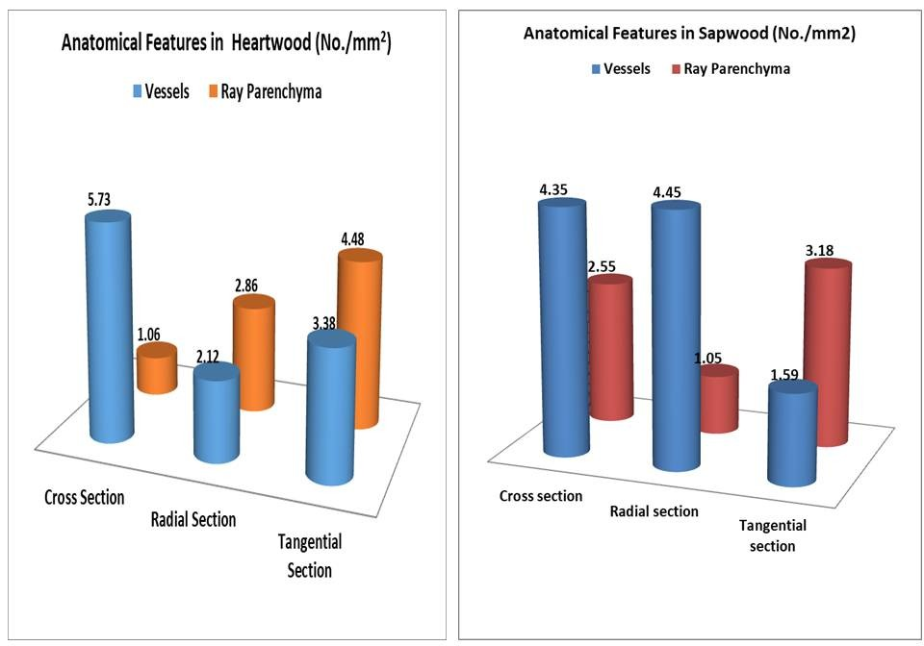
Figure- 9: Anatomical Features of Heartwood and Sapwood of A.indica
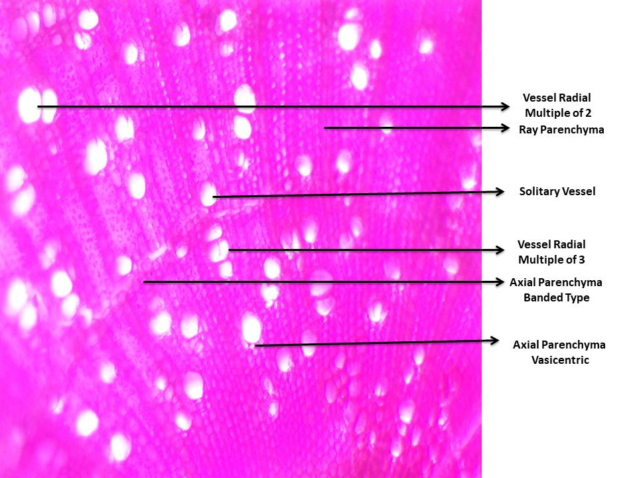
Figure- 10: Cross-sectional Features of A.indica Wood

4. Conclusion
AzadirchtaindicaA.Juss. timber evaluated found to be a fast growing species with higher proportion of Heartwood and under moderately heavy–heavy category based on its Density or Specific gravity.Although it shows an anisotropic behaviour but the volume shrinkage is very low which may not affect the wood properties to a greater extent. The moderate number conducting tissues like vessel and less ray parenchyma found in such wood growing conditions may increased its density/specific gravity. The Holocellulose content of the sample tree found to be high and can be used for making Pulp and Paper and modified woods. Proper Lignin content and higher wood extractive present in the wood will make it more durable and diversified construction purposes. The species evaluated from this locality can be utilised for construction purposes, furniture makings, veneer wood for peeling and slicing, sheet making and lining, artifacts and parquets. Similar type studies can be taken up selecting trees from different edaphic, climatic and altitudinal variations to identify the changes in Physicochemical and Anatomical Characteristics which will be helpful in differentiating the quality of wood growing in different conditions.

6. Disclaimer (Artificial Intelligence)
Author(s) hereby declare that NO generative AI technologies such as Large Language Models (ChatGPT, COPILOT, etc.) and text-to-image generators have been used during the writing or editing of this manuscript

7. References

- Akpan, M.&Olufemi,, B. (2007). Quantitative studies on density of neem (Azadirachtaindica A. Juss.) wood for utilization as timber in northeastern Nigeria. University of District Colobia UDC 630*33/.35/669. 1-7p
- Bertaud, Frédérique&Holmbom, Bjarne. (2004). Chemical composition of earlywood and latewood in Norway spruce heartwood, sapwood and transition zone wood.Wood Science and Technology, 38: 245-256.
- Carlquist, S. (2001). Comparative wood anatomy: systematic, ecological, and evolutionary aspects of dicotyledon wood (Berlin, Heidelberg: Springer) 448 pg.
- De Boer, A. H.& Volkov, V. (2003). Logistics of water and salt transport through the plant: structure and functioning of the xylem. Plant Cell Environment, 26: 87–101.
- Deore C.R., Jadhav H.S., Patil M.S., Thakur A.M. & Bhavsar A.M.(2020). anatomical variation of timber wood forest product in some common species of angiosperm and their systimaticenumieration useful for taxonomic significance, Plant Archives ,20 ( 2) : 3399-3404
- Duenisch, O., Richter, H.G. & Koch, G. (2010) Wood properties of juvenile and mature heartwood in RobiniapseudoacaciaL..Wood Science and Technology, 44: 301- 313.
- Dzurenda, Ladislav&Dudiak, Michal &Kučerová, Viera. (2023). Differences in Some Physical and Chemical Properties of Beechwood with False Heartwood, Mature Wood and Sapwood. Forests,14(6): 1123.
- Fonti, P., Tabakova, M. A., Kirdyanov, A. V., Bryukhanova, M. V.& von Arx, G. (2015). Variability of ray anatomy of Larixgmelinii along a forest productivity gradient in Siberia. Trees, 29: 1165–1175.
- Islas, J. F., Acosta, E. and Zuca&G. et al. (2020). “An Overview of Neem (Azadirachtaindica) and Its Potential Impact on Health.” Journal of Functional Foods ,74: 104171.
- Johnson, D. M., McCulloh, K. A., Woodruff, D. R.&Meinzer, F. C. (2012). Hydraulic safety margins and embolism reversal in stems and leaves: why are conifers and angiosperms so different? Plant Science, 195: 48–53.
- Josue, J., (2004). Some wood properties of Xyliaxylocarpaplanted in Sabah. Sepilok Bulletin 1: 1-15.
- Koul, O., Isman, M. B., &Ketkar, C. M. (1990). Properties and uses of neem, Azadirachtaindica. Can. J. Bot. 68:1-1 1.
- Lourenço, A., Neiva, D.M.&Gominho, J. et al(2015). Characterization of lignin in heartwood, sapwood and bark from Tectonagrandis using Py–GC–MS/FID. Wood Sci Technol, 49: 159–175.
- Martínez-Cabrera H.I., Jones C.S., Espino S. & Schenk H.J.(2009). Wood anatomy and wood density in shrubs: Responses to varying aridity along transcontinental transects. American Journal of Botany, 96(8):1388-1398.
- Morris, H., Plavcová, L., Cvecko, P., Fichtler, E., Gillingham, M. A. F., Martínez-Cabrera, H. I., et al. (2016). A global analysis of parenchyma tissue fractions in secondary xylem of seed plants. NewPhytologist, 209: 1553–1565.
- Moubasher, A.H., Hafez, S. I I. ,. Aboelfattah,H. M. &Moharrarh, A. M. (1982). Fungi of wheat and broad bean straw compost. II. Thermophilic fungi. Mycopathologia, 783:169-176.
- Nagamadhu M., Vijay Kumar S., Ravi Kumar S., Suraj R.& Mohan Kumar, G. C.(2020). Materials Today: Proceedings,24 : 2265–2273.
- Nair, M. N. B.(1988). Wood anatomy and heartwood formation in Neem (Azadirachtaindica A. Juss.), Botanical Journal of the Linnean Society, 97(1) : 79–90.
- Oluwadare, A.O.&Somorin,O.A.(2007). Preliminary reports on utilization potential of Gliricidiasepiumfor timber. Research J. of Foestry: 1(2): 80-85.
- Oyagade, A.O.&Fabiyi,J.S.( 2002). Density variation in plantation grown Naucleadiderrichii. J. Trop. For. Resources, 18(1): 26-34.
- Plavcová, L., Hoch, G., Morris, H., Ghiasi, S.& Jansen, S. (2016). The amount of parenchyma and living fibers affects storage of nonstructural carbohydrates in young stems and roots of temperate trees. American. Journal of Botany, 103: 603–612.
- Poku, K., Wut, Q.&Vlosky,R.(2001). Wood properties and their variations within the tree stem of lesser-used species of tropical hardwood from Ghana. Wood and Fibre Science, 33(2): 284-291.
- Roshan, A. & Verma, N.K. (2015) A Brief Study on A. Indica and Its Application: A Review. Research Journal of Phytomedicine, 1: 1-3.
- Secchi, F., Pagliarani, C.&Zwieniecki, M. A. (2017). The functional role of xylem parenchyma cells and aquaporins during recovery from severe water stress. Plant Cell Environ., 40: 858–871.
- Singh , P., Sharma, S., Singh, K., Singh, P. K., Chowdhury, F .I., Yahya, M. Z .A., Yusuf, S.N.F., Diantoro, M. Latif, F.A. & Singh, N .B. (2024). Recent development on neem (Azadirachtaindica) biomass absorbent: Surface modifications and its applications in water remediation. Chemical Physics Impact, 9 : 100773 (1-23).
- 26. Singh, R. K.(2019). Ethnomedicinal properties of Azadirachtaindica. (Neem Tree), Research Review International Journal of Multidisciplinary, 4 (3):2586-2592.
- Sinha, A. S. K.. (2008). Neem (Azadirachtaindica) as alternative wood fibre source with environmental advantages & medicinal properties for pulp & paper industries. TAPPI Press - Paper Conference and Trade Show, PaperCon '08. 5. 3314-3326.
- Sotannde, O.A., Oluyege, A.O., Adeogun, P.F. &Maina, S.B.(2010). Variation in Wood Density, Grain Orientation and Anisotropic Shrinkage of Plantation Grown Azadirachta Indica.Journal of Applied Sciences Research, 6(11): 1855-1861
- Spicer, R. (2005). “Senescence in Secondary Xylem: Heartwood Formation as an Active Developmental Progra006D,” in Physiological Ecology. Eds. Holbrook, N. M., Zwieniecki, M. A. (Burlington: Academic Press), 457–475.
- Spicer, R. (2014). Symplasmic networks in secondary vascular tissues: parenchyma distribution and activity supporting long-distance transport. Journal of. Experimental Botany, 65: 1829–1848.
- Yadav J., Ramkumar,P.L. &Ajit Kumar Parwani, A.K.(2024). Characterization of Azadirachtaindica Natural Cellulosic Fibre and Its Polymer Composites. Arabian Journal for Science and Engineering,50:13635–13647.
- von Arx, G., Arzac, A., Fonti, P., Frank, D., Zweifel, R., Rigling, A., et al. (2017). Responses of sapwood ray parenchyma and non-structural carbohydrates of Pinus sylvestris to drought and long-term irrigation. Funct. Ecol., 31: 1371–1382.
- Wei, Liuming& Ma, Ruoke& Fu, Yunlin. (2022). Differences in Chemical Constituents between Dalbergiaoliveri Heartwood and Sapwood and Their Effect on Wood Color. Molecules, 27: 7978.
- Zhang,H., Zhu,P., Wang,Z., Fucheng Ma, Hongmei Ji&Xiaowu Li,.(2023). Combined effect of rays and vessels to achieve high strength and toughness in balsa wood, Materials Letters, (352):1-4, 135137.

