In-vitro efficacy of fungicides against Colletotrichum truncatum causing anthracnose of Soybean

ABSTRACT: The study assessed the effectiveness of various single and combination fungicides against C. truncatum, the pathogen responsible for soybean anthracnose, using the poisoned food technique under laboratory conditions. In total a set of twelve fungicides comprising six single-molecule formulations and six combinations were evaluated at concentrations of 100, 250 and 500 ppm. Results showed significant differences in inhibition of test pathogen among different treatments. Among the single fungicides, carbendazim (50 WP) and tebuconazole (25.9% EC) achieved complete mycelial growth inhibition (100%) at 500 ppm. The mixture of carbendazim (25%) + mancozeb (50% WS) proved most effective overall, fully suppressing fungal growth at both 250 and 500 ppm. Strobilurin-based combinations like metiram + pyraclostrobin and penflufen + trifloxystrobin also demonstrated strong inhibition rates (>80%) at higher doses, whereas carboxin + thiram was the least effective, showing only 49.59% inhibition at 100 ppm. Overall, antifungal activity increased with concentration, with carbendazim + mancozeb standing out as a promising candidate for integrated management strategies, meriting further validation under field conditions.
KEYWORDS: Soybean, Anthracnose, Colletotrichum truncatum, Fungicides,
INTRODUCTION: Soybean (Glycine max) is a vital global oilseed crop, highly valued for its nutritional content and wide industrial uses. It contains roughly 42% protein and 20% oil, along with beneficial compounds like isoflavones, dietary fiber, and omega-3 fatty acids, making it a digestible and cost-effective plant-based protein source (Masuda and Goldsmith, 2009; Guzeler and Yildirim, 2016). In India, large-scale soybean farming started in the early 1970s and has since become a key part of the agricultural economy. Despite its importance, soybean is highly susceptible to anthracnose, mainly caused by the fungus Colletotrichum truncatum, recognized as one of the most damaging diseases. Reported yield losses range from 16 to 26% (Beckman et al., 1982), and even a 1% increase in disease incidence can lower yields by almost 90 kg/ha (Dias et al., 2016). This disease, first identified in Korea in 1917 (Latunde, 2001) and later in India by Srivastava and Nene (1971), is now widespread. It spreads via seeds and can infect soybeans at any growth stage, with pod blight causing the most severe damage (Vyas et al., 1997). Symptoms include dead lesions, early leaf drop, and seeds that are shrivelled or moldy (Yang and Hartman, 2015). Disease development is favoured by warm, humid conditions around 35°C (Sharma et al., 2020).
While chemical fungicides are commonly used to control anthracnose, their prolonged use raises concerns about resistance, environmental impact, and human health. Developing resistant soybean varieties is seen as the best alternative, but no cultivar has achieved complete immunity, and resistance often fails within a few years (Dias et al., 2018). Given these challenges, fungicide applications appears to be the most widely adopted and direct approach for managing anthracnose in soybean,
METHODOLOGY: The poisoned food technique (Nene and Thapliyal, 1993) was employed to evaluate the efficacy of fungicides against C. truncatum under laboratory conditions. A total of twelve fungicides, comprising six single-compound formulations and six combinations, were tested at concentrations of 100, 250, and 500 ppm by incorporating the required amount into molten PDA. The single-compound fungicides included propiconazole 25% EC, hexaconazole 5% SC, tebuconazole 25.9% w/w EC, carbendazim 50% WP, mancozeb 75% WP and pyraclostrobin 20% WG. The combination fungicides consisted of metiram 55% + pyraclostrobin 5% WG, carboxin 37.5% + thiram 37.5% WS, carbendazim 25% + mancozeb 50% WS, thiophanate methyl 450 + pyraclostrobin 50 G/L (w/v) FS, penflufen 13.28% w/w + trifloxystrobin 13.28% w/w FS and azoxystrobin 11% + tebuconazole 18.3% SC. Mycelial discs (5 mm) from 10 day old cultures of C. truncatum were placed at the centre of the amended plates, while plates without fungicide served as control. Each treatment was replicated thrice in a Completely Randomized Design (CRD). The inoculated plates were incubated at 27 ± 2°C and radial mycelial growth was recorded on the 3rd, 5th and 7th day. Per cent inhibition of mycelial growth over control was calculated using Vincent’s formula (1947).
$$PI=\frac{C -T}{C} × 100$$
Where,
PI | = | Per cent inhibition
C | = | Colony diameter in check plate (mm)
T | = | Colony diameter in treatments (mm)
RESULTS AND DISCUSSION:
All the tested fungicides exhibited significant inhibitory effects on the mycelial growth of Colletotrichum truncatum under in vitro conditions compared to the untreated control, indicating their potential in the chemical management of soybean anthracnose. Among the single fungicides, carbendazim (50 WP) and tebuconazole (25.9% EC) demonstrated the highest efficacy, achieving complete inhibition (100%) of fungal growth at 500 ppm and maintaining over 90% inhibition even at 250 ppm. These results suggest strong fungistatic activity even at relatively lower concentrations. On the other hand, mancozeb (75% WP) exhibited the lowest efficacy among the single fungicides at 100 ppm (51.76%), although its inhibitory effect improved significantly with increasing concentrations, underscoring a clear dose-response relationship.
Strobilurin fungicides, such as pyraclostrobin, also showed pronounced antifungal activity, achieving over 80% inhibition at higher concentrations, whereas propiconazole and hexaconazole produced moderate levels of suppression across all tested doses. This variability in performance highlights inherent differences in the modes of action and potency of fungicidal groups against C. truncatum.
In the case of combination fungicides, carbendazim (25%) + mancozeb (50% WS) was the most effective, recording complete inhibition (100%) at both 250 and 500 ppm. This was followed by metiram + pyraclostrobin and penflufen + trifloxystrobin, which achieved inhibition levels of 85.88% and 84.71%, respectively, at 500 ppm. In contrast, carboxin + thiram exhibited the weakest antifungal activity among the combinations, with only 49.59% inhibition at 100 ppm. Across all fungicides, a consistent increase in inhibition with rising concentrations confirmed a dose-dependent response, indicating that higher doses enhance fungicidal efficacy against C. truncatum.
The observed variation in fungicidal performance is closely associated with differences in their biochemical modes of action. Benzimidazoles such as carbendazim disrupt microtubule assembly, leading to mitotic arrest (Gawade & Suryavanshi, 2009; Bankoliya et al., 2022), whereas triazoles including tebuconazole, hexaconazole, and propiconazole inhibit ergosterol biosynthesis, compromising fungal cell membrane integrity (Nagaraj, 2013; Gujar et al., 2021). Strobilurins, such as pyraclostrobin, trifloxystrobin, and azoxystrobin, act by blocking electron transfer at the cytochrome bc1 complex, thereby halting mitochondrial respiration (Shashikumara et al., 2020). In contrast, dithiocarbamates like mancozeb act as multi-site inhibitors, interfering with multiple enzymatic pathways simultaneously.
The superior performance of carbendazim and tebuconazole highlights the advantage of target-specific fungicides with potent systemic activity. Furthermore, the exceptional efficacy of carbendazim + mancozeb demonstrates the synergistic effect of combining systemic and contact fungicides, enhancing both curative and protective action (Rajashree et al., 2020). The pronounced dose-dependent inhibition observed across all treatments further emphasizes the necessity of applying fungicides at optimal concentrations to achieve effective suppression of soybean anthracnose (Patel et al., 2020).
So far, numerous biocontrol agents, particularly species of Trichoderma, have been extensively explored and recommended for the management of plant diseases across a wide range of crops (Kumar et al., 2009; Kumar et al., 2013; Kumar et al., 2014a, 2014b, 2015; Kumar and Sahu, 2015; Jain et al., 2017; Kharte et al., 2022; Parihar et al., 2024a, 2024b). These beneficial fungi are known for their antagonistic mechanisms, including mycoparasitism, competition for nutrients and space, production of cell wall–degrading enzymes, and induction of systemic resistance in host plants. Despite their well-documented potential, the field performance of biocontrol agents has often been inconsistent, primarily due to variability in environmental conditions, soil microbiota, and pathogen pressure, which can significantly influence their efficacy.
Given these challenges, an integrated approach involving judicious use of compatible fungicides in combination with potent biocontrol agents offers a promising strategy for effective disease suppression. Such integration should be preceded by detailed morphological and cultural characterization of the bioagents as well as compatibility assessments to ensure that the chemical treatments do not adversely affect the growth, sporulation, or antagonistic activity of beneficial microorganisms (Kumar et al., 2014b; Kumar et al., 2016; Bansal et al., 2021; Dinkwar et al., 2023; Singh et al., 2023). The development of such synergistic combinations could substantially enhance the reliability and consistency of disease control under diverse agro-ecological conditions. Moreover, integrating biocontrol agents with chemical fungicides not only broadens the spectrum and durability of disease management but also allows for the dual exploitation of their plant growth-promoting attributes (Kumar and Sahu, 2014; Kumar et al., 2019). Trichoderma spp., for instance, are known to enhance root growth, improve nutrient uptake, and stimulate plant defense responses, thereby contributing to improved crop vigor and yield. Thus, designing disease management strategies that harness both the curative and protective efficacy of fungicides and the ecological and growth-promoting benefits of bioagents represents a sustainable, eco-friendly, and future-oriented approach to managing soybean anthracnose and similar fungal diseases.
CONCLUSION
This study demonstrated that all tested fungicides suppressed the mycelial growth of Colletotrichum truncatum, with efficacy increasing at higher concentrations. Among single fungicides, carbendazim and tebuconazole showed complete inhibition, while the combination of carbendazim + mancozeb proved most effective overall. Strobilurin-based mixtures also performed well, though carboxin + thiram was least effective. These findings highlight carbendazim + mancozeb as a promising option for integrated management of soybean anthracnose, warranting further field validation.
REFERENCES
- Backman, P. A., Williams, J. C., & Crawford, M. A. (1982). Yield losses in soybean from anthracnose caused by Colletotrichum truncatum. Plant Disease, 66(11), 1032–1034.
- Bankoliya, M., Yadav, V. K., Kumar, A., Amrate, P., & Bhatt, J. (2022). The resistance screening and in-vitro efficacy of fungicides for the management of dry root rot of chickpea caused by Rhizoctonia bataticola. Environment Conservation Journal, 23(3), 8–13.
- Bansal, R., Pachauri, S., Gururajaiah, D., Sherkhane, P. D., Khan, Z., Gupta, S., Banerjee, K., Kumar, A., & Mukherjee, P. K. (2021). Dual role of a dedicated GAPDH in the biosynthesis of volatile and non-volatile metabolites: Novel insights into the regulation of secondary metabolism in Trichoderma virens. Microbiological Research, 253, 126862.
- Dias, M. D., Fonseca, M. E. N., Dias-Neto, J. J., Santos, M. D., Pandolfo, G. M., Boiteux, L. S., & Café-Filho, A. C. (2018). Biology, pathogenicity, and haplotype analyses of Colletotrichum cliviae: A novel soybean anthracnose agent in warm tropical areas. Tropical Plant Pathology, 43(5), 439–451.
- Dias, M. D., Pinheiro, V. F., & Café-Filho, A. C. (2016). Impact of anthracnose on the yield of soybean subjected to chemical control in the north region of Brazil. Summa Phytopathologica, 42(1), 18–23.
- Dinkwar, G. T., Yadav, V. K., Kumar, A., Nema, S., & Mishra, S. (2023). Compatibility of fungicides with potent Trichoderma isolates. International Journal of Plant & Soil Science, 35(18), 1934–1948.
- Dinkwar, G. T., Yadav, V. K., Kumar, A., Nema, S., & Mishra, S. (2023). Compatibility of fungicides with potent Trichoderma isolates. International Journal of Plant & Soil Science, 35(16), 1934–1946.
- Gawade, D. B., & Suryawanshi, A. P. (2009). In vitro evaluation of fungicides, botanicals and bioagents against Colletotrichum truncatum soybean anthracnose. Plant Disease Research, 24(2), 120–123.
- Gujar, P. D., Borkar, S. G., & Raut, B. T. (2021). Evaluation of fungicides and bioagents against Colletotrichum truncatum, the incitant of anthracnose of soybean. Journal of Pharmacognosy and Phytochemistry, 10(4), 1155–1158.
- Güzeler, N., & Yıldırım, Ç. (2016). The utilization and processing of soybean and soybean products. International Journal of Food Science and Nutrition Engineering, 6(2), 21–27.
- Jain, A. K., Kumar, A., Chouhan, S. S., & Tripathi, S. K. (2017). Cultural characteristics and evaluation of Trichoderma isolates against Rhizoctonia solani Kühn causing banded leaf and sheath blight of little millet. Annals of Plant Protection Sciences, 25(1), 140–143.
- Kharte, S., Kumar, A., Sharma, S., Ramakrishnan, R. S., Kumar, S., Malvi, S., Singh, Y., & Kurmi, S. (2022). In vitro evaluation of fungicides and bio-agents for the management of lentil wilt caused by Fusarium oxysporum f. sp. lentis. Biological Forum – An International Journal, 14(4), 489–495.
- Kharte, S., Kumar, A., Sharma, S., Ramakrishnan, R. S., Kumar, S., Malvi, S., & Kurmi, S. (2022). In vitro evaluation of fungicides and bio-agents for the management of lentil wilt caused by Fusarium oxysporum f. sp. lentis. Biological Forum – An International Journal, 14(4), 489–495.
- Kumar, A., & Sahu, T. K. (2014). Studies on substrate evaluation for mass multiplication of Trichoderma species and their plant growth promotion activity in tomato. International Journal of Plant Protection, 7(2), 382–388.
- Kumar, A., & Sahu, T. K. (2015). Use of local isolates of Trichoderma from Madhya Pradesh against Rhizoctonia solani causing wet root rot of chickpea. Environment and Ecology, 33(4), 1553–1557.
- Kumar, A., Govil, M., Singh, S., Sharma, K. K., Tripathi, S. K., Tiwari, R. K., Tripathi, A. N., & Singh, S. (2015). Role of micro-organisms in bioremediation: A comprehensive model using Trichoderma spp. In A. K. Sharma, S. Wahab, & R. Srivastava (Eds.), Handbook of research on uncovering new methods for ecosystem management through bioremediation (pp. 29–50). IGI Global.
- Kumar, A., Jain, A. K., Sahu, T. K., Singh, T. K., & Shivcharan, S. (2013). Exploration of potential biocontrol agent Trichoderma spp. from Madhya Pradesh against Fusarium oxysporum f. sp. ciceris causing wilt of chickpea. Environment and Ecology, 31(2B), 877–882.
- Kumar, A., Jain, A. K., Singh, J., Tripathi, S. K., & Tiwari, R. K. (2016). In vitro studies on cultural characterization of a repository of local isolates of Trichoderma spp. from Madhya Pradesh. Indian Phytopathology, 69(4s), 482–485.
- Kumar, A., Kumar, S., Srivastava, R., & Sharma, A. K. (2009). Fungal biocontrol agents (BCAs) and their metabolites. In A. K. Sharma, S. Wahab, & R. Srivastava (Eds.), Agricultural diversification: Problems and prospects (pp. 44–56). I. K. International, New Delhi.
- Kumar, A., Patel, A., Singh, S. N., & Tiwari, R. K. (2019). Effect of Trichoderma spp. in plant growth promotion in chilli. International Journal of Current Microbiology and Applied Sciences, 8(3), 1574–1581.
- Kumar, A., Sahu, T. K., Bhalla, A., & Solanki, S. (2014a). Influence of Trichoderma spp. against Ustilaginoidea virens inciting false smut of rice. Environment and Ecology, 32(1), 163–168.
- Kumar, A., Sahu, T. K., Bhalla, A., & Jain, A. K. (2014b). Morphological characterization of Trichoderma harzianum from Madhya Pradesh. Annals of Plant Protection Sciences, 22(1), 190–239.
- Latunde-Dada, A. O. (2001). Colletotrichum: Tales of forcible entry, stealth, transient confinement and breakout. Molecular Plant Pathology, 2(4), 187–198.
- Masuda, T., & Goldsmith, P. D. (2009). World soybean production: Area harvested, yield, and long-term projections. International Food and Agribusiness Management Review, 12(4), 143–161.
- Nagaraj, B. T. (2013). Studies on soybean anthracnose caused by Colletotrichum truncatum (Schw.) Andrus and Moore (Master’s thesis, University of Agricultural Sciences, Dharwad).
- Nene, Y. L., & Srivastava, S. S. L. (1971). Outbreaks and new records. Plant Protection Bulletin (FAO), 19(2), 66–73.
- Nene, Y. L., & Thapliyal, P. N. (1993). Fungicides in plant disease control (3rd ed.). Oxford & IBH Publishing Co. Pvt. Ltd.
- Parihar, S., Saxena, H. O., Kumar, A., & Singh, S. (2024b). In-vitro antagonistic activity of Trichoderma spp. isolated from forest soils of central India against Macrophomina phaseolina for identification of potential strain. Vegetos, 38, 1643–1649.
- Parihar, S., Saxena, H. O., Singh, S., Kumar, A., & Chauhan, P. S. (2024a). Characterisation and antagonistic potential of Trichoderma species isolated from forest soils of central India against Rhizoctonia solani. Tropical Agriculture, 101(2), 161–167.
- Rajashree, G., Patil, M. B., Aswathanarayana, D. S., Mallikarjun, K., & Sreenivas, A. G. (2020). Effect of different fungicides and bioagents against Colletotrichum truncatum (Schw.) causing anthracnose of greengram [Vigna radiata (L.) Wilczek] in vitro. Journal of Pharmacognosy and Phytochemistry, 9(2), 1168–1175.
- Sharma, A. (2020). Molecular identification and variability of Colletotrichum truncatum isolates infecting soybean in India. Journal of Pharmacognosy and Phytochemistry, 9(3), 1510–1514.
- Shashikumara, B., Rajeswari, B., Uma Devi, G., Sridevi, G., & Somashekhar, K. (2020). In vitro evaluation of fungicides, botanicals and bioagents against Colletotrichum truncatum. International Journal of Current Microbiology and Applied Sciences, 9(7), 551–556.
- Singh, Y., Bhatt, J., Yadav, V. K., Kumar, A., Kharte, S., & Malempati, S. S. S. (2023). In vitro management of fusarium wilt of linseed using phytoextract, fungicides and bioagents. Environment Conservation Journal, 24(4), 96–105.
- Srivastava, S. S. L., & Nene, Y. L. (1971). Outbreaks and new records. Plant Protection Bulletin (FAO), 19(2), 66–73.
- Varsha, K., & Solanki, S. G. (2014). Management of blossom blight and leaf anthracnose of mango using fungicides. International Journal of Plant Protection, 7(2), 453–455.
- Vincent, J. M. (1947). The esters of 4-hydroxybenzoic acid and related compounds. Part I. Methods for the study of their fungistatic properties. Journal of the Society of Chemical Industry, 66(5), 149–155.
- Vyas, S. C., Vyas, S., & Shroff, V. N. (1997). Diseases of soybean. SOPA: The Soybean Producers Association of India.
- Yang, H. C., & Hartman, G. L. (2015). Methods and evaluation of soybean genotypes for resistance to Colletotrichum truncatum. Plant Disease, 99(2), 143–148.

Table 1: In vitro efficacy of single compound fungicides against C. truncatum
Treatment  number | Treatments detail | Mycelial radial growth after 7 days (in mm) and percent inhibition in growth of the test fungus
Treatment  number | Treatments detail | 100 ppm |  | 250 ppm |  | 500 ppm
Treatment  number | Treatments detail | Mycelial  growth (mm) | Percent  inhibition (%) | Mycelial  growth (mm) | Percent  inhibition (%) | Mycelial  growth (mm) | Percent  inhibition (%)
T1 | Propiconazole 25% | 30.00 | 64.71 | 25.33 | 70.19 | 17.67 | 79.21
T2 | Hexaconazole 5% | 38.05 | 55.233 | 35.00 | 58.82 | 30.00 | 64.70
T3 | Tebuconazole25.9% | 10.00 | 88.24 | 8.00 | 90.59 | 0.00 | 100
T4 | Carbendazim (50 WP) | 11.55 | 86.413 | 8.00 | 90.58 | 0.00 | 100
T5 | Mancozeb 75 WP | 41.00 | 51.76 | 18.33 | 78.43 | 8.17 | 90.39
T6 | Pyraclostrobin 20% | 19.00 | 77.65 | 18.00 | 78.823 | 14.00 | 83.53
T7 | Control | 85.00 | - | 85.00 | - | 85.00 | -
 | C.D. (5%) | 0.55 | 0.702 | 1.63 | 2.101 | 1.94 | 2.506
 | SE(m)± | 0.18 | 0.225 | 0.53 | 0.674 | 0.63 | 0.804

Table 2: In vitro efficacy of combination of fungicides against C. truncatum
Treatments  Number | Treatment detail | Mycelial radial growth after 7 days (in mm) and percent inhibition in growth of the test fungus
Treatments  Number | Treatment detail | 100 ppm |  | 250 ppm |  | 500 ppm
Treatments  Number | Treatment detail | Mycelial  growth (mm) | Percent  inhibition (%) | Mycelial  growth (mm) | Percent  inhibition (%) | Mycelial  growth (mm) | Percent  inhibition (%)
T1 | Metiram 55% + Pyraclostrobin 5% WG | 16.90 | 80.12 | 14.00 | 83.53 | 12.00 | 85.88
T2 | Carboxin37.5% + Thiram 37.5% | 42.85 | 49.59 | 24.10 | 71.647 | 16.40 | 80.707
T3 | Carbendazim25%+ Mancozeb 50% | 10.00 | 88.24 | 0.00 | 100 | 0.00 | 100
T4 | Thiophanate Methyl 450 + Pyraclostrobin 50 G/L (W/V) FS | 30.00 | 64.71 | 19.70 | 76.823 | 18.05 | 78.763
T5 | Penflufen13.28% + Trifloxystrobin 13.28% | 24.20 | 71.53 | 17.60 | 79.297 | 13.00 | 84.71
T6 | Azoxystrobin11% + Tebuconazole 18.3% SC | 32.10 | 62.237 | 27.50 | 67.65 | 20.00 | 76.47
T7 | Control | 85.00 | - | 85.00 | - | 85.00 | -
 | C.D. (5%) | 1.61 | 2.085 | 0.84 | 1.086 | 1.23 | 1.584
 | SE(m)± | 0.53 | 0.669 | 0.27 | 0.349 | 0.40 | 0.508

Figure 1: Effect of different single compound fungicides on percent inhibition of the test fungus after seven days of incubation at 100, 250 and 500 ppm concentrations

Figure 2: Effect of different fungicidal combinations on percent inhibition of the test fungus after seven days of incubation period at 100, 250 and 500 ppm concentrations
100 ppm | 250 ppm | 500 ppm
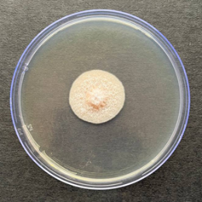  T1 | 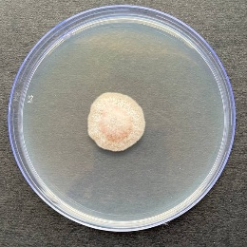 | 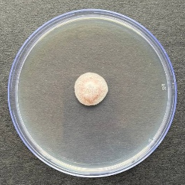
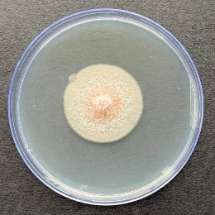  T2 | 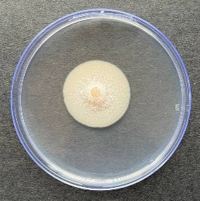 | 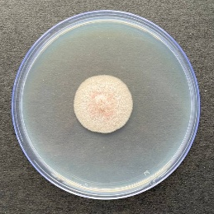
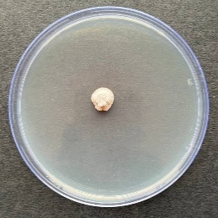  T3 | 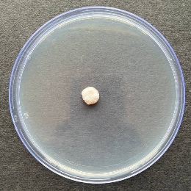 | 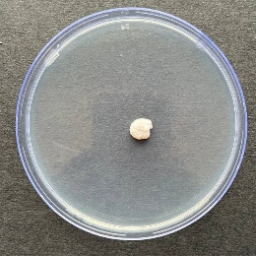
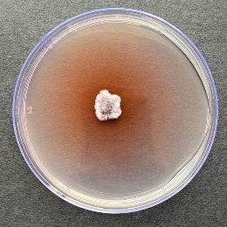  T4 | 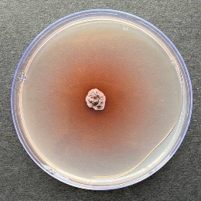 | 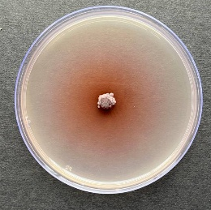
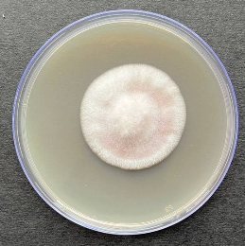  T5 | 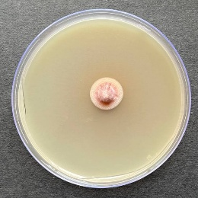 | 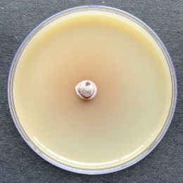
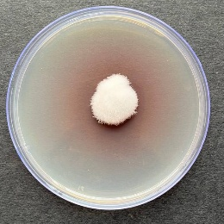  T6 | 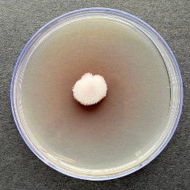  T7 | 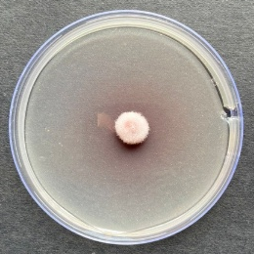
 | 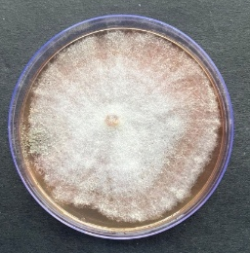

Plate 1: Evaluation of different single compound fungicides against Colletotrichum truncatum at different concentration.
100 ppm |  | 250 ppm |  | 500 ppm
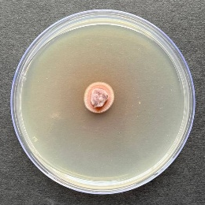  T2  T1 |  | 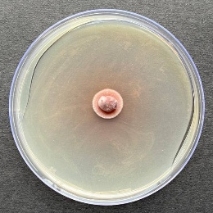 |  | 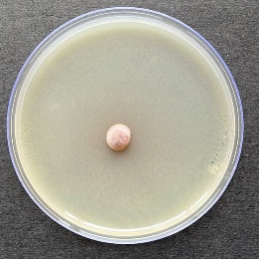
 | 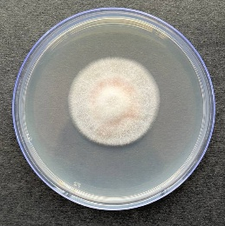 |  | 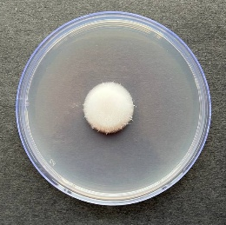 |  | 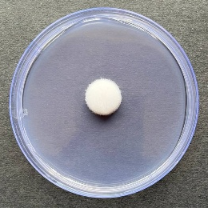
 | 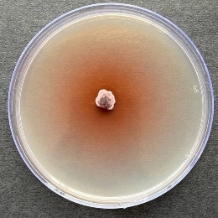  T3 |  | 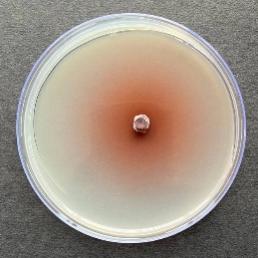 |  | 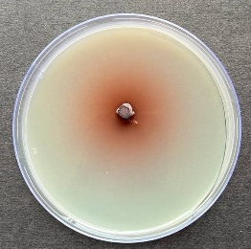
 | 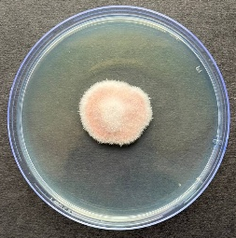  T5  T4 |  | 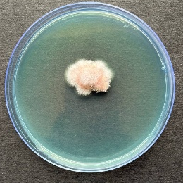 |  | 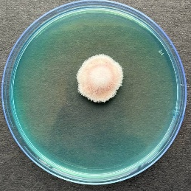
 | 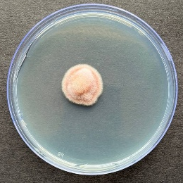  T6 |  | 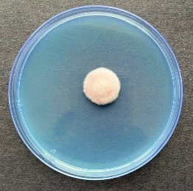 |  | 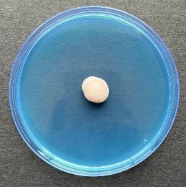
 | 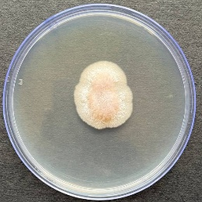  T7 |  | 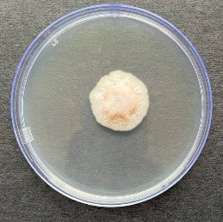 |  | 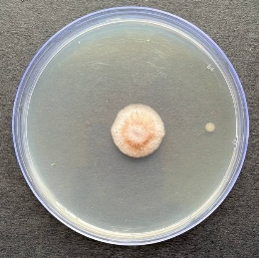
Plate 2: Evaluation of different combination of fungicide against Colletotrichum truncatum at different concentrations.

