Original Research Article

GADC 3 (Wagad Gaurav): A Newly Developed High-Yielding Desi Cotton (G. herbaceum) Variety through Pedigree Method

Abstract:
A high yielding herbaceum cotton variety Gujarat Anand Desi Cotton 3 (GADC 3: Wagad Gaurav) tested as GVhv 767 was developed by Regional Cotton Research Station, Anand Agricultural University, Viramgam and released in the year of 2019. It was notified during the year 2020 for the North West Agroclimatic Zone - V and Bhal and Coastal Agroclimatic Zone-VIII of Gujarat. It is a variety derivative of the intraspecific varietal cross between GVhv 104 and GVhv 504. GADC 3 is semi open boll type in nature with determinant growth habit and smooth boll surface. The variety GADC 3 (Wagad Gaurav) had produced average seed cotton yield of 2150 kg/ha. This variety gave 34.02, 15.01 and 27.54% higher seed cotton yield and 34.87, 26.67 and 27.28% higher lint yield over check varieties G. Cot.21, ADC 1 and GADC 2, respectively in the rainfed condition of Gujarat state. The ginning out turn (%) of GADC 3 is 44.8% which is equivalent with check variety G. Cot. 21 (44.2%) and higher than ADC 1 (42.2%) and GADC 2 (43.8%). Seeds contain 14.9 % oil. GADC 3 has recorded fibre length (upper half mean) of 22.7 mm, fibre fineness of 5.1µg/inch and bundle strength of 22.5 g/tex in HVI mode of fibre quality testing. The genotype GADC 3 was moderate tolerant to root rot, bacterial leaf blight, alternaria leaf blight and wilt as well as major pests including sucking pests and boll worm complex under field conditions.
Key words: Gossypium herbaceum, Desi Cotton variety, GADC 3, High Yielding
Introduction:
Cotton is an important fibre crop for the textile industry and has contributed significantly to civilization. Cotton was first cultivated as a fabric in the Indus river valley in 3000 B.C. The word cotton is derived from the Arabic word “quotn” (Lee and Fang 2015) has a place with Gossypium variety, which was additionally derived from the Arabic word “goz” (Gledhill 2008) meaning a delicate material.
India remains the leading country in terms of area under cotton cultivation and raw cotton production in the world. Due to research and development activities, there have been many fold improvements in production and productivity without a virtual increase in the cultivated area. Now, India holds a prominent position in the global cotton market, with the largest cotton area of 114.47 lakh hectares, 294.25 lakh bales production and productivity of 437 kg/ha (Anonymous, 2025). Gujarat produces approximately 71.34 lakh bales of cotton lint from 23.92 lakh hectares, with a productivity of 507.02 kg/ha (Anonymous, 2025).
Cotton is the leading natural fibre crop. It belongs to the genus Gossypium and family Malvaceae which has extensively phenotypic diversity among the approximately 50 species representing this genus (Campbell et al. 2010). Currently, Gossypium includes 50 species, among these 44 are diploids, 2 are wild tetraploid and only four species are cultivated (Percival and Kohel, 1990). Out of these four cultivated species G. hirsutum and G. barbadense commonly known as ‘New World Cotton’ which are allotetraploids (2n = 2x = 52), whereas G. arboreum and G. herbaceum are diploid (2n = 2x = 26) and commonly called as ‘Old World Cotton’. Most of the global cotton production comes from two allotetraploid species, G. hirsutum and G. barbadense (Wendel et al. 1992).
The released varieties of G. herbaceum particularly in Gujarat viz., G. Cot. 21 and GADC 2 are often possess yield potential of nearly 700 kg/ha lint as against national average of 501 kg/ha. G. Cot. 21 is the most popular variety among the farmers particularly for high yield potential under rainfed condition. Variety GADC 2 released in recent past having high yield potential and good fibre qualities than the other released varieties, but mature late than G. Cot. 21. Whereas, newly released variety GADC 3 has high yield potential of 964 kg/ha lint yield and early maturity than the G. Cot. 21 and GADC 2. Therefore, new variety GADC 3 has been released for the cultivation under rainfed condition in Agro-climatic zone V and VIII of the Gujarat State.
Material and Method:
The breeding efforts were initiated from 2013-14 to 2018-19 at Regional Cotton Research Station, Anand Agricultural University, Viramgam (Gujarat) with a view to develop improved cotton variety having high yield potential and resistant to major biotic and abiotic stresses under rainfed desi cotton area of the Gujarat. The crosses were attempted between GVhv 104 and GVhv 504. Pedigree method of selection was followed from F₂ to F₆ generations under rainfed condition for development of high yielding genotypes. The superior segregants with high seed cotton yield were isolated in F₂ population and advanced up to F₆ generation to reach homozygosity. Further, the genotype was evaluated in preliminary evaluation trial (PET) as GVhv 767 during 2013-14. Based on the performance in PET, the cotton genotype GVhv 767 was promoted for large scale testing and forwarded to multi location trials and tested at different research stations of SAU’s of Gujarat over five years during 2014-15 to 2018-19. Simultaneously, the performance of the genotype GVhv 767 was evaluated in initial evaluation trial (IET-32b) of AICCIP (Central Zone) during 2017-18. As a result, the variety GADC 3 was identified and evaluated for its potentiality in comparison to checks G. Cot. 21, ADC 1 and GADC 2. The recommended packages of practices were followed to raise cotton crop for conducting the trials. The data were statistically analyzed by methods developed by Panse and Sukhatme (1985).
Result and Discussion:
Seed yield: Under rainfed condition during 2013-14 to 2018-19, the yield performance of the variety GADC 3 on the basis of weighted mean performance, it had produced average seed cotton yield of 2150 kg/ha at different stations and state trials, which was higher over the check varieties, viz. G. Cot.21, ADC 1 and GADC 2 to the magnitude of 34.02, 15.01 and 27.54 %, respectively (Table 1). This variety was tested at 05 different locations across the Gujarat state. Similar findings have been reported earlier for development of cotton varieties, new varieties performed better than the check varieties (Haidar and Aslam, 2016; Khan et al., 2006; Tariq et al., 2003).
Lint yield: The variety GADC 3 was tested at three different locations (Viramgam, Dhandhuka and Kukda) for lint yield during 2013-14 to 2018-19. This variety gave average cotton lint yield of 964 kg/ha. This was 34.87, 26.67 and 27.28 % higher than the check varieties G. Cot.21, ADC 1 and GADC 2, respectively (Table 2).
AICCIP trial: The entry was tested in IET (Initial Evaluation Trial) trial of AICCIP in the year 2017-18 at three different locations i.e., Viramgam, Kukda and Bharuch across the Gujarat state and found 14.99 % higher seed cotton yield and 17.7 % lint yield over the local check ADC 1 (Table 3).
Ginning outturn: The ginning out turn (%) of GADC 3 is 44.8 %, which is almost similar with check variety G. Cot. 21 (44.2 %) and higher than ADC 1 (42.2 %) and GADC 2 (43.8 %) (Table 5).
Traits comparison: GADC 3 produced 8.2% more bolls/plant than G. Cot. 21 (42.0 vs. 38.8) and 11% more than GADC 2 (42.0 vs. 37.8), while maintaining a comparable boll weight (2.4 g) and seed index (7.4). It matured 7 days earlier than G. Cot. 21 (170 vs. 177 days) and 15 days earlier than GADC 2 (170 vs. 185 days), indicating earliness with wide adaptability. Plant height was moderate (137 cm), which is 8.7% shorter than G. Cot. 21 and 11% shorter than ADC 1, making it suitable for better agronomic management. Cotton recovery (76.4%) was on par with checks, while oil content (14.9%) was close to ADC 1 and competitive with G. Cot. 21 and GADC 2. Overall, GADC 3 combines earliness (7–15 days), higher boll production (8–11%), and desirable plant stature (9–11% shorter), making it a promising desi cotton variety with improved adaptability and yield stability (Table 4).
Quality parameters: The full spinning report of variety GADC 3 sample no. F-192082 exhibited an upper half mean length of 22.2 mm, uniformity index of 79%, micronaire value of 4.8 reflecting medium-fine fiber and tenacity of 20.5 g/tex under HVI and mode of testing at CIRCOT, Mumbai. The CSP value for nominal count of 16 Ne and 20 Ne were recorded as 1665 and 1531, respectively indicating good fibre strength suitable for textile industries (Table 6).
The variety GADC 3 has recorded average fibre length (upper half mean length) of 22.7 mm, fibre fineness of 5.1 µg/inch and bundle strength of 22.5 g/tex tested under several trial (Table 7). The variety GADC 3 was found moderate tolerant to root rot, bacterial leaf blight, alternaria leaf blight and wilt as well as major pests including sucking pests and boll worm complex in field conditions (Table 8 & 9).
Morphological description:
All four cotton genotypes were generally similar in morphological and fibre characteristics, showing uniformity in leaf, stem, floral, seed, and most boll traits. The only notable differences were observed for boll surface, which was smooth in GADC 3 but pitted in the other check varieties (Photo 1), and fibre length, which was medium in GADC 3 and G. Cot. 21, while ADC 1 and GADC 2 exhibited medium-long fibres (Table 10).
DNA fingerprinting profile of cotton varieties generated by AFLP marker system showed that variety GADC 3 is genetically distinct from its checks i.e. G Cot 21, ADC 1 and GADC 2. (Photo 2).

Conclusion:
The desi cotton variety GADC 3 (Wagad Gaurav) outperformed the check varieties in North West Agroclimatic Zone-V and Bhal and Coastal Zone-VIII, achieving a seed cotton yield of 2150 kg/ha, which is 15–34% higher than existing varieties. It also exhibited very high got of 44.8% and fibre qualities is 22.7 mm upper half mean length, 5.1 micronaire, and 22.5 g/tex tenacity under HVI mode of testing. These results indicate that GADC 3 is well-suited for cultivation in Agro-climatic Zones V and VIII of Gujarat.
Table 1: Performance of cotton variety GADC 3 in comparison to checks in different trials in the state
Comparison | GADC 3 | G. Cot. 21 (a) | ADC 1  (b) | GADC 2  (c) | % Increase of GADC 3
Overall Mean | 2150 | - | - | - | -
Over G. Cot. 21 (7 trials) | 2233 | 1666 | - | - | +34.02%
Over ADC 1  (5 trials) | 2200 | - | 1913 | - | +15.01%
Over GADC 2 (4 trials) | 1854 | - | - | 1453 | +27.54%
Frequency in top groups | 9/9 | 1/6 | 3/4 | 0/4 | -

Table 2: Performance of cotton variety GADC 3 in comparison to checks in different trials in the state
Comparison | GADC 3 | G. Cot. 21 (a) | ADC 1  (b) | GADC 2  (c) | % Increase of GADC 3
Overall Mean | 964 | - | - | - | -
Over G. Cot. 21 (7 trials) | 1002 | 743 | - | - | +34.87%
Over ADC 1  (5 trials) | 998 | - | 788 | - | +26.67%
Over GADC 2  (4 trials) | 815 | - | - | 641 | +27.28%
Frequency in top groups | 9/9 | 2/6 | 3/4 | 0/4 | -

Table 3 : Yield performance of GADC 3 in the AICCIP Trial (Br. 32b)

Year/ Season | Name of  Trial | Variety | Seed Cotton Yield (kg/ha) | % Increase over Check | Frequency in Top Group
2017-18 | IET | GADC 3 | 1396 | – | 1/1
2017-18 | IET | GN. Cot. 25 | – | +14.99 | –
2017-18 | IET | ADC 1 (LC) | 1214 | – | 0/1
2017-18 | IET | G. Cot. 23 (ZC) | 1532 | – | 1/1
2017-18 | IET | Lint Yield (kg/ha)
2017-18 | IET | GADC 3 | 593 | – | -
2017-18 | IET | GN. Cot. 25 | – | - | -
2017-18 | IET | ADC 1 (LC) | 504 | +17.7 | -
2017-18 | IET | G. Cot. 23 (ZC) | 612 | – | -
Table 4 : Major yield contributing and other ancillary observation characters of proposed variety along with checks:
Traits | GADC 3 | G. Cot. 21 (C) | ADC1 (C) | GADC 2 (C)
Bolls/plant | 42.0 (27–57.9) | 38.8 (28.5–47.8) | 38.1 (25.4–55.5) | 37.8 (29.5–46.6)
Boll weight (g) | 2.4 (2.1–2.8) | 2.4 (2.1–3.2) | 2.3 (2.1–2.5) | 2.4 (2.2–2.5)
Seeds/boll | 20.0 (19.5–21.6) | 19.1 (19.1–19.8) | 21.0 (20.7–21.3) | 21.7 (21.4–21.9)
Days to maturity | 170 (155-192) | 177 (163-189) | 161 (152-170) | 185 (166-203)
Days to 50% flowering | 84 (75-103) | 83 (70-107) | 75 (74-76) | 98 (87-108)
No. of sympodia | 7.8 (6.4-8.4) | 7.4 (6.5-8.1) | 9.3 (9.1-9.6) | 7.9 (7.9-7.9)
No. of monopodia | 3.6 (2.6-5.0) | 3.5 (2.6-4.9) | 5.0 (4.1-5.9) | 2.8 (2.3-3.3)
Pl. height (cm) | 137 (122-153) | 150 (130-162) | 154 (137-171) | 129 (119-138)
Seed index | 7.4 (7.1-7.8) | 7.4 (7.2-7.5) | 7.4 (7.2-7.6) | 7.2 (7.1-7.3)
Cotton recovery (%) | 76.4 (76.3-76.5) | 76.8 (76.4-77.1) | - | 75.4 (75.1-75.6)
Oil content (%) | 14.9 (14.5-15.2) | 16.6 | 14.7 | 16.9

Table 5 : Ginning Out Turn (%) of GADC 3 along with checks:

No. of trials | Genotype | Mean Value | Range | Remarks
Nine (09) | GADC 3 | 44.8 | 42.4 – 47.0 | Consistently stable across years
Nine (09) | G. Cot. 21 | 44.2 | 42.8 – 47.6 | Comparable to GADC 3
Nine (09) | ADC 1 | 42.2 | 37.9 – 44.0 | Lower than checks
Nine (09) | GADC 2 | 43.8 | 41.8 – 46.5 | Close to GADC 3
Nine (09) | G. Cot. 23 | 40.0 | - | Lowest performer
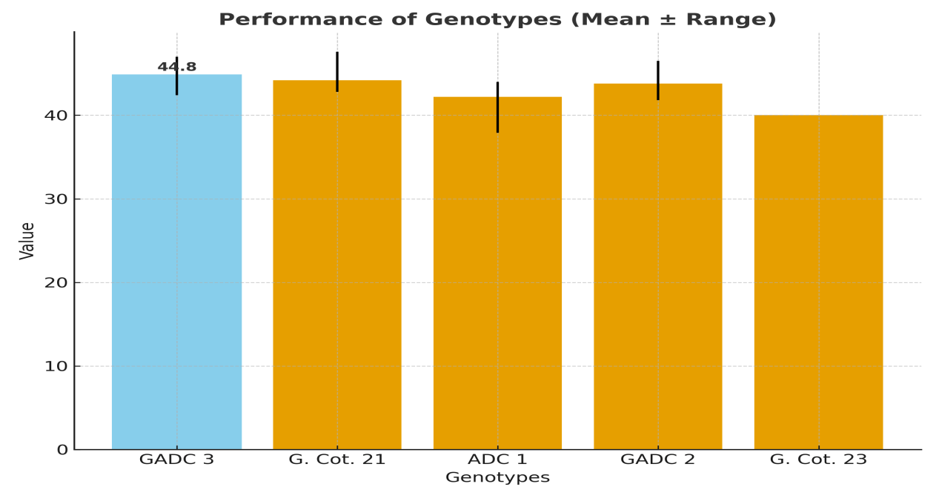
Fig. 1. Performance of genotypes (mean ± Range)

Table 6: Full Spinning Test Report
Sr.  No. | Institute sample No. | Marked as | HVI (HVI mode)  ASTM D 5867: 2005 |  |  |  | Full Spinning (CIRCOT method)
Sr.  No. | Institute sample No. | Marked as | UHML  (mm) | UI (%) | Mic | Tenacity (g/tex) | Nominal Count (Ne) | Actual |  | C.S.P.
 |  |  |  |  |  |  |  | Count (Ne) | Strength  (lb) | C.S.P.
1 | F -192082 | GADC 3 | 22.2 | 79 | 4.8 | 20.5 | 16.0 | 16.2 | 102.8 | 1665
 |  |  |  |  |  |  | 20.0 | 19.5 | 78.5 | 1531

Table 7: Fibre quality parameters of GADC 3 along with check varieties:
No. of trials | Upper Half Mean Length (mm)
No. of trials | Genotype | Mean Value | Range | Remarks
Seven (07) | GADC 3 | 22.7 | 20.6 – 24.5 | Stable across years, moderate length
Seven (07) | G. Cot. 21 | 22.6 | 21.6 – 24.8 | Similar to GADC 3, consistent
Seven (07) | Micronaire value (µg/inch)
Seven (07) | GADC 3 | 5.1 | 4.4 - 5.8 | Moderate strength; stable across years
Seven (07) | G. Cot. 21 | 5.6 | 5.0 - 6.0 | Highest mean; consistent performance
Seven (07) | Bundle strength (g/tex)
Seven (07) | GADC 3 | 22.5 | 18.6–25.7 | Stable, moderate strength
Seven (07) | G. Cot. 21 | 21.8 | 19.0–25.2 | Slightly lower than GADC 3

Table 8: Incidence of root rot diseases (%) at Viramgam:
Year/Name of Variety | GADC 3 | G. Cot. 21 | ADC 1 | GADC 2
2014-15 | 0.00 | 0.00 | 0.00 | -
2015-16 | 1.02 | - | 0.60 | -
2016-17 | 0.00 | 0.00 | - | 0.00
2017-18 | 0.00 | 0.00 | - | 0.00
Range | 0.00-1.02 | 0.00 | 0.00-0.60 | 0.00
There was no incidence of BLB, Wilt, Alternaria Blight and Grey mildew in the experimental field during four years.
Table 9: Infestation of insect-pests at Viramgam:
Particular | Year | GADC 3 | G. Cot. 21 | ADC 1 | GADC 2
Bollworm damage at Square stage (%) | 2015-16  to  2017-18 | 0.96–1.53 | 0.89–1.12 | 0.85 | 0.66–0.89
Bollworm damage at Bud stage (%) | 2015-16  to  2017-18 | 0.84–1.43 | 0.63–1.19 | 0.64 | 0.93–1.12
Bollworm damage at Green Boll stage (%) | 2015-16  to  2017-18 | 1.13–1.34 | 0.91–1.49 | 1.18 | 0.87–1.04
Bollworm damage at Open Boll stage (%) | 2015-16  to  2017-18 | 1.51–2.39 | 2.19–2.42 | 2.68 | 1.82–1.85
Whitefly / 3 leaves | 2015-16  to  2017-18 | 0.38–0.88 | 0.46–0.48 | 0.58 | 0.42–0.43
Aphid / 3 leaves | 2015-16  to  2017-18 | 0.28–0.68 | 0.18–0.42 | 0.21 | 0.28–0.52
Leaf hopper / 3 leaves | 2015-16  to  2017-18 | 0.38–0.55 | 0.25–0.46 | 0.18 | 0.25–0.44

Table: 10 The DUS characters for GADC 3 (GVhv 767) with checks
SN | Characteristics | GADC 3 | G. Cot. 21 | ADC 1 | GADC 2
 | Hypocotyl pigmentation | Absent | Absent | Absent | Absent
 | Leaf: Colour | Light Green | Light Green | Light Green | Light Green
 | Leaf: Pubescence | Medium | Medium | Medium | Medium
 | Leaf:nectarines | Present | Present | Present | Present
 | Leaf: Petiole Pigmentation | Absent | Absent | Absent | Absent
 | Leaf: shape | Palmate (Normal) | Palmate  (Normal) | Palmate (Normal) | Palmate (Normal)
 | Plant : stem hairiness | Dense | Dense | Dense | Dense
 | Plant: stem pigmentation | Present | Present | Present | Present
 | Plant: time of flowering | Late | Late | Late | Late
 | Flower: Petal colour | Yellow | Yellow | Yellow | Yellow
 | Flower: Petal Spot | Present | Present | Present | Present
 | Flower: Stigma | Exerted | Exerted | Exerted | Exerted
 | Flower: Anther Filament Colouration | Absent | Absent | Absent | Absent
 | Flower: pollen colour | Yellow | Yellow | Yellow | Yellow
 | Flower: Male sterility | Absent | Absent | Absent | Absent
 | Boll: Colour | Green | Green | Green | Green
 | Boll: shape | Ovate | Ovate | Ovate | Ovate
 | Boll: Surface | Smooth | Pitted | Pitted | Pitted
 | Boll: Prominence of Tip | Pointed | Pointed | Pointed | Pointed
 | Boll: Opening | Semi-open | Semi-open | Semi-open | Semi-open
 | Boll: weight of seed cotton / boll (g) | Medium | Medium | Medium | Medium
 | Seed: Density of fuzz | Dense | Dense | Dense | Dense
 | Seed: Fuzz colour | Grey | Grey | Grey | Grey
 | Seed: index (100 seed Weight in gm) | Medium | Medium | Medium | Medium
 | Ginning % | Very high | Very high | Very high | Very high
 | Fibre: Colour | White | White | White | White
 | Fibre: Length (Upper Half Mean Length) mm | Medium | Medium | Medium long | Medium long
 | Fibre: Strength (g/tex) | Weak | Weak | Weak | Weak
 | Fibre: Fineness (Micronaire value) | Medium | Medium | Medium | Medium
 | Fibre: Uniformity (%) | Average | Average | Average | Average
 | Fibre: Maturity Index (MI) | Very good | Very good | Very good | Very good

References:
GADC 2
Anonymous (2025) Cotton Advisory Board/COCPC, (https://caionline.in/news_reports/ cab_area_production).
Campbell, B. T., Saha, S., Percy, R., Frelichowski, J., Jenkins, J. N. and Park, W. (2010). Status of the global cotton germplasm resources. Crop Science. 50(4):1161-1179.
Gledhill, D. (2008) The name of plants. Cambridge: Cambridge University Press.
Haidar, S. and M. Aslam. (2016). A new high yielding and long staple cotton mutant developed through pollen irradiation technique. International journal of Agricultural Biology. 18(4): 866-872.
Khan, N. I., Shah, R. A., Asad, M. N., Shah, S. M., Ali, S. and Zafar, M. (2006). A high yielding and early maturing variety of cotton (Gossypium hirsutum L.). Science and Technology Division. 25: 13-18.
Lee, J. A. and Fang, D. D. (2015) Cotton as world crop: origin, history, and current status. In: Fang DD, Percy RG, editors. Cotton. Madison: ASA, CSSA, SSSA. p.1-23.
Panse, V. G. and Sukhatme, P. V. (1985). Statistical Methods for Agricultural Workers. ICAR, New Delhi, India.
Percival, A. E. and Kohel, R. J. (1990) Distribution, collection and evaluation of Gossypium. In: Brady NC, editor. Advances in Agronomy. San Diego: Academic Press. p. 255-256.
Tariq, M. A., Rana, S. A., Shah, R. A., Shah, S. M., Ali, S., Zafar, M. and Akhtar, L. H. (2003). A new cotton variety released for general cultivation in southern Punjab. Sci. Tech. Dev. 22: 15-19.
Wendel, J. F., Brubaker, C. L. and Percival, A. E. (1992) Genetic diversity in Gossypium hirsutum and the origin of upland cotton. American journal of botany. 79(11):1291-1310.

BOLL: SURFACE
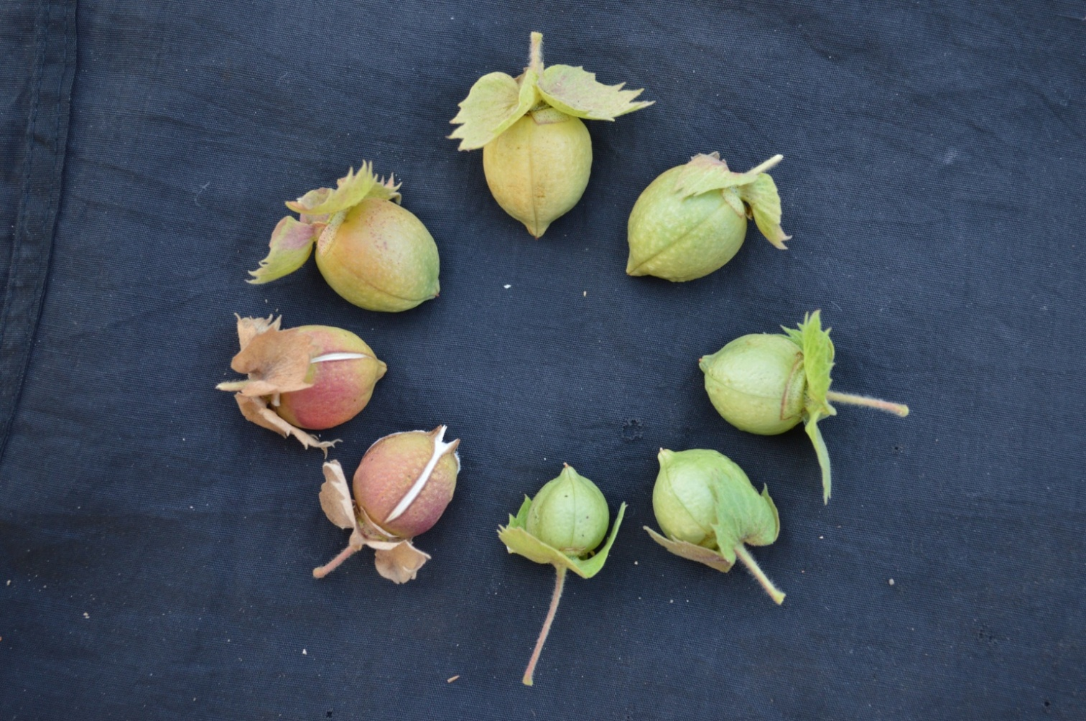 | 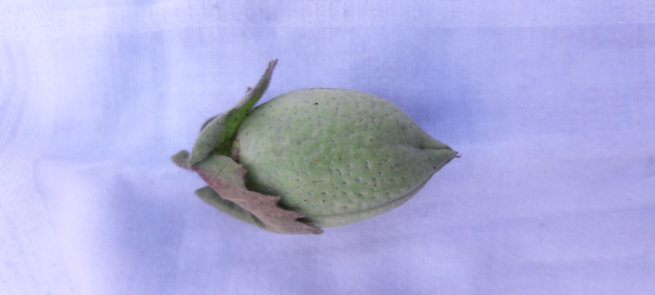
GVhv 767 (Smooth) | G. Cot. 21 (Pitted)
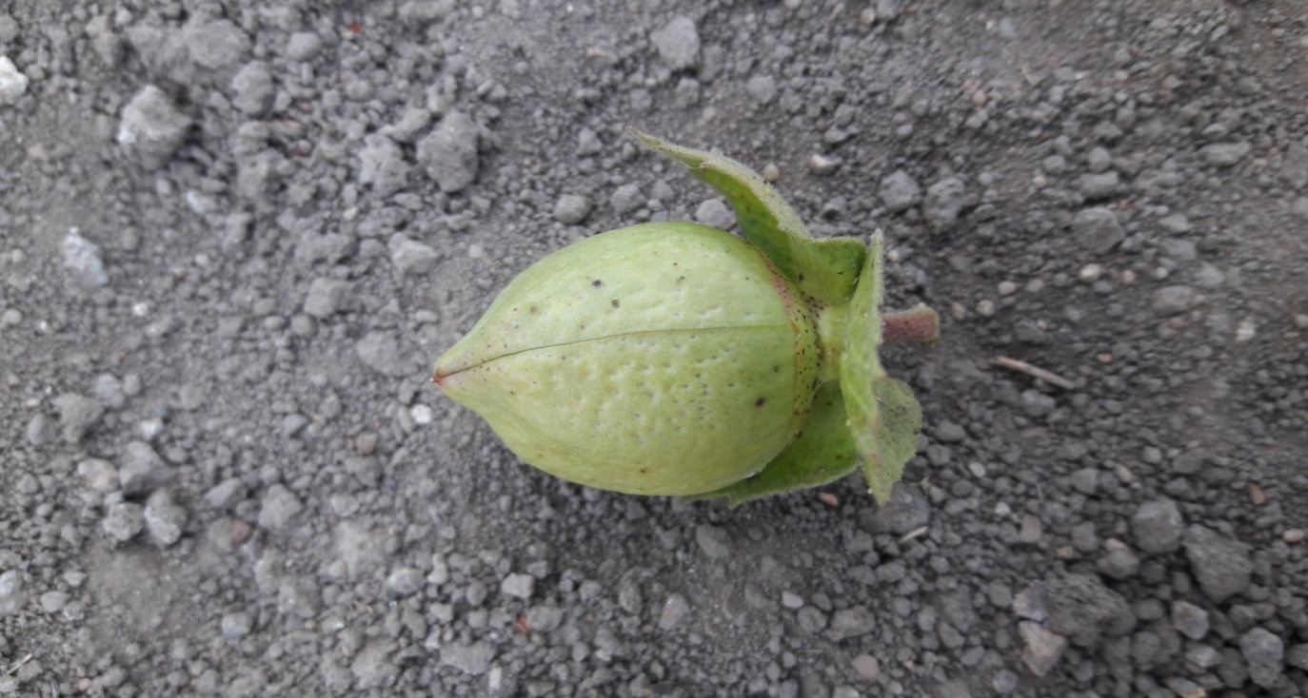 | 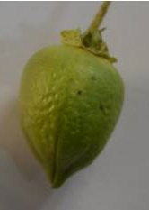
ADC 1 (Pitted) | GADC 2 (Pitted)
Photo 1: Boll surface of GADC 3 in compare with checks:

Photo 2: DNA fingerprinting profile of variety GADC 3 along with checks generated by AFLP marker
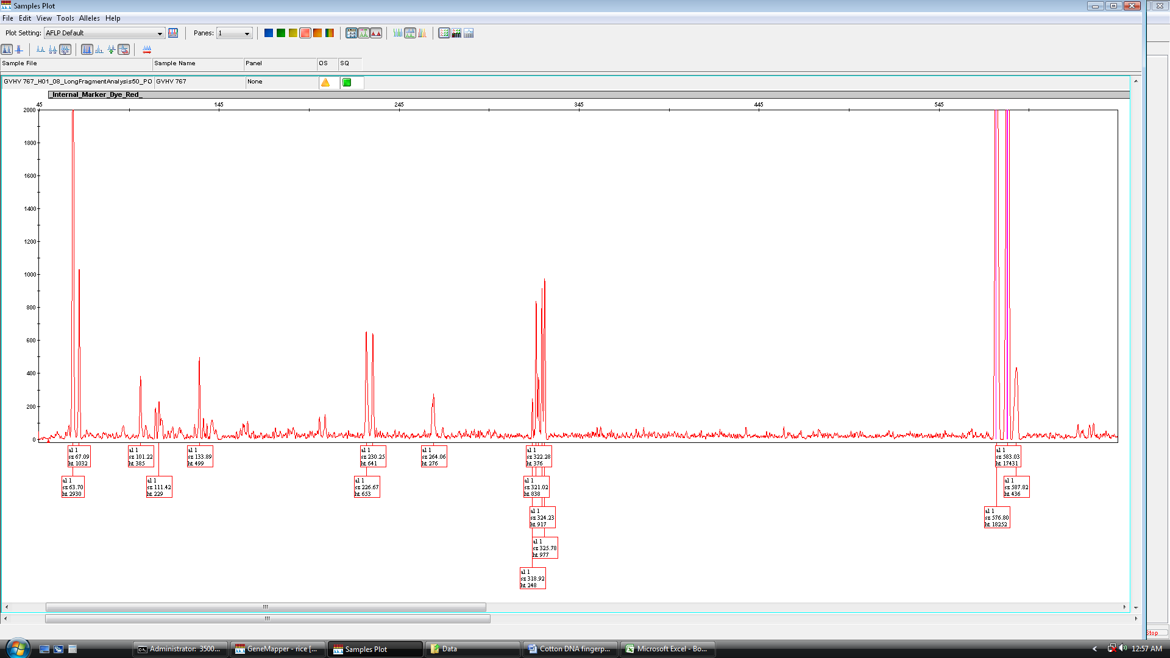
GADC 3
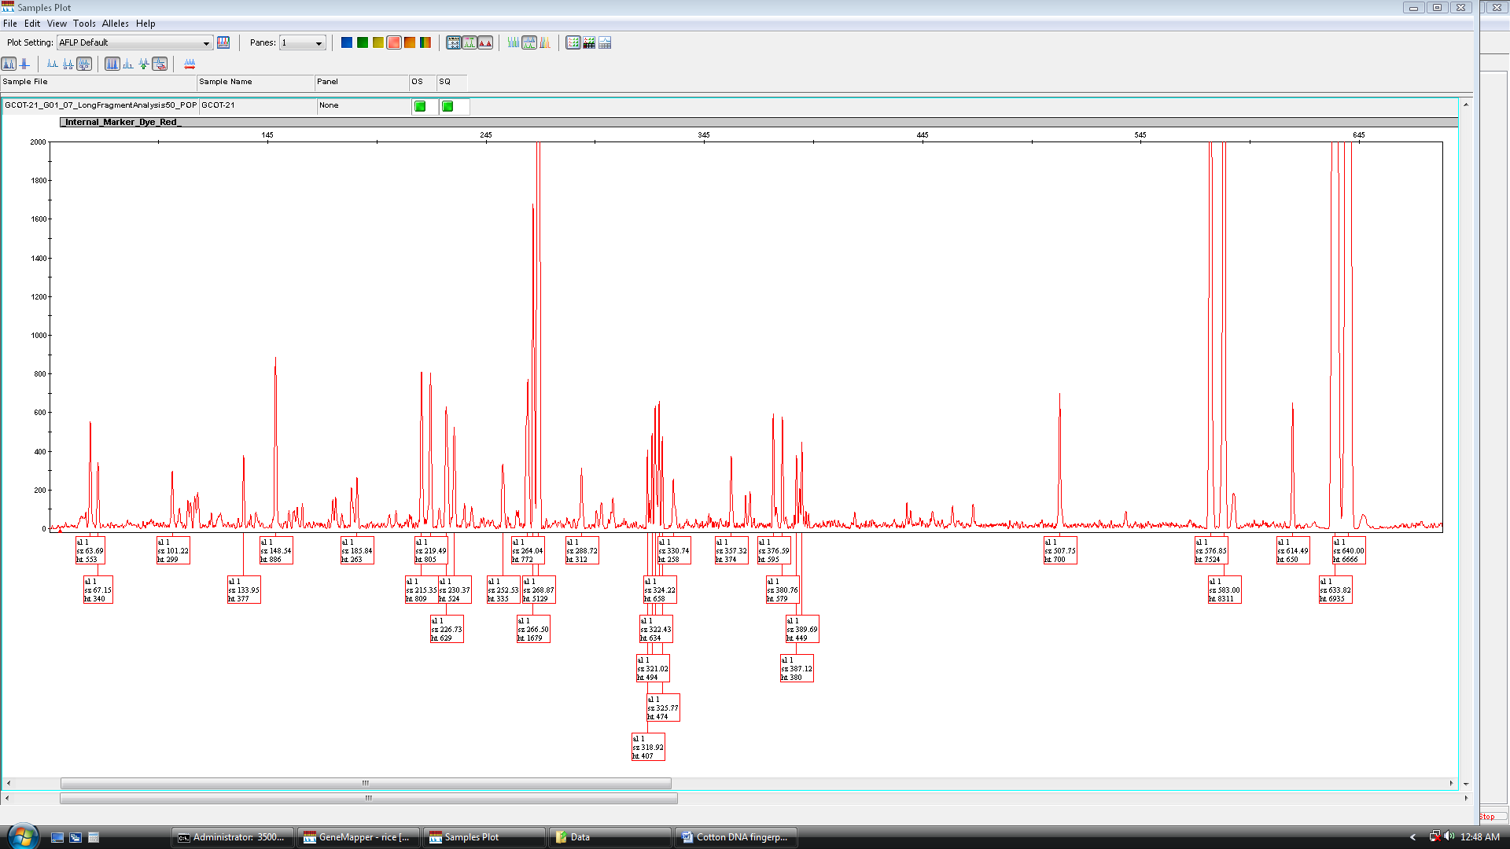
G Cot 21
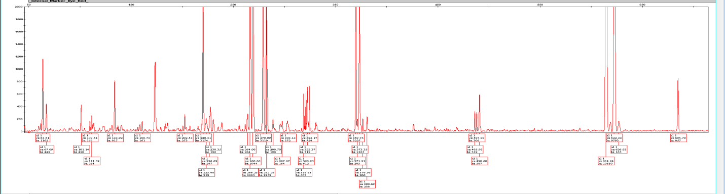
ADC 1
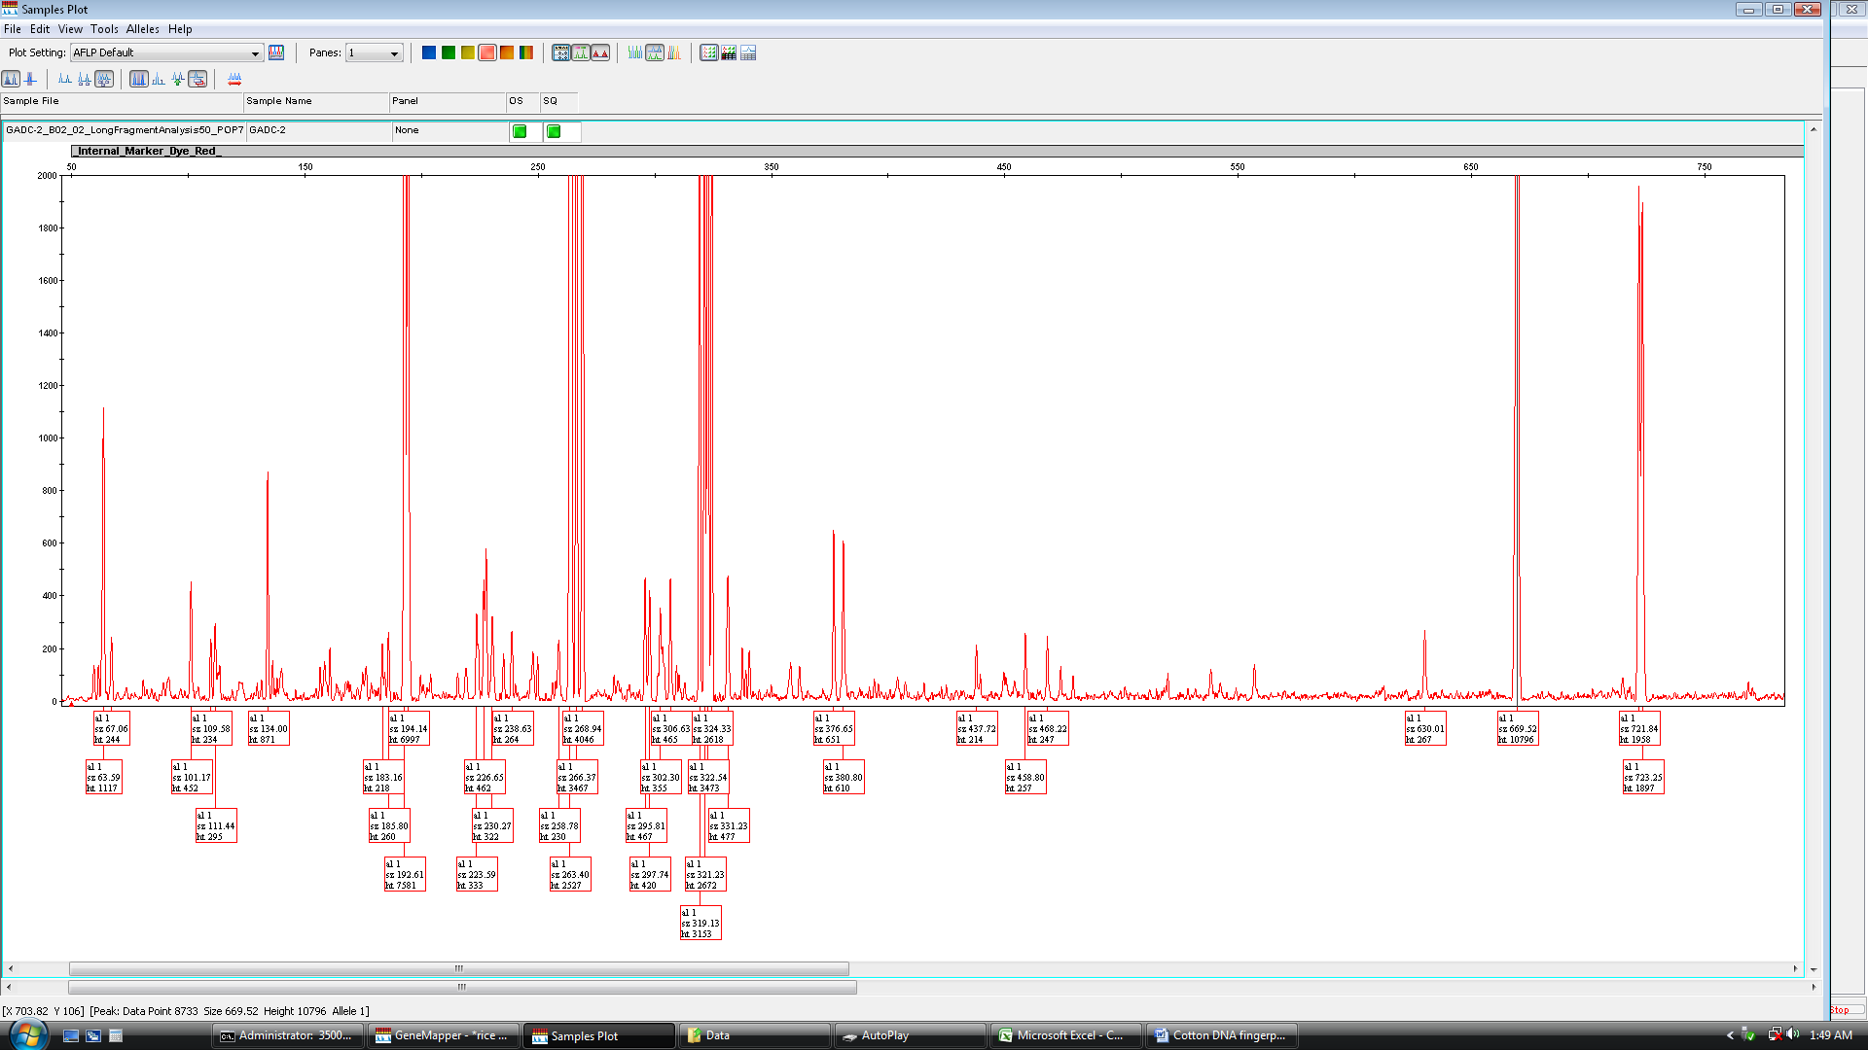
GADC 2

