Original Research Article
In-vitro regeneration studies in Red Banana
(Musa acuminata) var. Lal Velchi

ABSTRACT
The present study focused on the in-vitro regeneration of Red Banana (Musa acuminata var. Lal Velchi) using shoot tip culture to standardize suitable growth media for establishment, multiplication, rooting, and hardening. Healthy suckers were collected from a mother block nursery and experiments was conducted at the Tissue Culture Unit, Biotechnology Laboratory, Botany Division, College of Agriculture, Pune.
Banana, a key tropical fruit crop from the genus Musa (family Musaceae), is believed to have originated in Southeast Asia. It ranks as the second most important fruit crop in India after mango and fourth globally, appreciated for its year-round availability, affordability, varietal diversity, taste, and nutritional value. Red Banana, in particular, is valued for its economic and health benefits but suffers from limited large-scale cultivation due to a lack of disease-free, quality planting material. Since it is seedless and propagated vegetatively through suckers, there is a high risk of transmitting soil-borne diseases and viral infections such as Banana Bunchy Top Virus (BBTV), which lowers productivity. Additionally, the production rate of suckers is low (10–12 per plant per year), with inconsistent growth. Tissue culture offers an efficient alternative for mass multiplication of genetically uniform and disease-free plantlets using shoot tip explants.
The study aimed to identify the most effective media combinations for shoot and root induction and to evaluate the success rate during hardening. Four sub-experiments—establishment, shoot proliferation, rooting, and hardening—were conducted in a completely randomized design (CRD) with appropriate replications, and data was analyzed as per Snedecor and Cochran (1972). The sterilization protocol included sequential treatments with Bavistin, Tween-20, citric and ascorbic acids, sodium hypochlorite, and mercuric chloride, achieving the lowest contamination rate of 20%. The best results for shoot initiation (82.22% establishment in 24.24 days) and shoot multiplication (average of 6.98 shoots per explant) were obtained using Murashige and Skoog (MS) medium supplemented with 2.0 mg/L BAP, 60 mg/L adenine sulfate, and 20 mg/L ascorbic acid. Rooting was most successful (95.56%) in MS medium containing 2.0 mg/L IBA and 1.0 mg/L IAA, with roots developing in 2–3 weeks after inoculation. Well-rooted plantlets were washed, treated with 0.1% Bavistin, and hardened for acclimatization in polybags filled with a 1:1:1 mixture of red soil, vermicompost, and sand. Covered with transparent polythene to maintain humidity, was achieved a 90% survival rate during the hardening period in May and June.

Keywords: Sucker explants, inoculation, MS media, rooting, hardening

1. INTRODUCTION

Banana (Musa spp.), a major tropical fruit crop belonging to the family Musaceae, is believed to have originated in the hot and humid regions of Southeast Asia (Simmonds and Shepherd,1955; Simmonds, 1962). It holds significant economic importance as the second most important fruit crop in India after mango and the fourth most important globally. Banana is widely preferred due to its affordability, year-round availability, appealing taste, and high nutritional and medicinal value. It also has strong export potential, particularly in Gulf countries. In India, banana ranks first in production and third in cultivated area among fruit crops, contributing around 13% of the total fruit-growing area and 33% of overall fruit production. Maharashtra leads in banana production with 3,924.1 thousand tonnes, followed by Tamil Nadu with 3,543.8 thousand tonnes, and has the highest productivity at 65.70 metric tonnes per hectare compared to the national average of 30.5 metric tonnes per hectare. Other key producing states include Karnataka, Gujarat, Andhra Pradesh, and Assam (National Horticulture Board, 2001–02). Conventionally, banana is propagated through suckers, with a plant typically producing few suckers annually. Currently, around 70% of Indian farmers rely on sucker-based propagation, while only 30% use tissue culture-derived plantlets (NHB). However, sucker propagation poses risks of transmitting soil-borne and viral diseases such as Banana Bunchy Top Virus (BBTV), often resulting in uneven growth and reduced yield. Tissue culture technology presents a reliable alternative for producing disease-free, genetically uniform planting material on a large scale. India has a substantial capacity to produce tissue culture raised planting material with an installed production capacity of 650 million plantlets annually. However, the current supply stands at 455 million plantlets per year. India's annual requirement for banana planting material is estimated at 3436 million suckers or plantlets (APAARI, 2019). This gap highlights the potential for expanding tissue culture operations to meet rising demand and improve crop productivity. Varieties like Grand Naine (G9) have gained widespread commercial popularity due to well-established protocols, accounting for 17% of the total banana cultivation area, with nearly 5 million tissue culture plantlets planted in a single year. In contrast, Red Banana remains backfoot in commercial micropropagation due to the lack of optimized in-vitro regeneration protocols and standardized media compositions. The Red banana has a leathery red peel, creamy texture, strong aroma, low calories, and a low glycemic index (45), contains anthocyanin pigment where in contrast, the G9 variety is parrot green, soft in texture, mildly aromatic, high in calories, with a higher glycemic index (51) and lacks extra pigment. Red Banana, valued for its nutritional richness and unique market appeal, has yet to achieve comparable success in tissue culture propagation. Studies have shown that cytokinins such as benzylaminopurine (BAP), in combination with adenine sulfate, play a crucial role in shoot induction from banana explants (Babu P., 2019). The present research aimed to develop a reliable micropropagation protocol for Red Banana using apical shoot explants and standardizing such a protocol is expected to significantly enhance the commercial cultivation of Red Banana through optimizing media components and scalable tissue culture techniques by making available healthy plantlets to farmers.

2. material and methods
Sterilized glasswares and equipments were used with the analytical grade chemical. For the in vitro regeneration of Red banana, Murashige and Skoog (MS) medium was used throughout the research. For easy measurements, stock solutions of the individual components were prepared first and then required concentration is prepared to formulate the medium, by checking the final concentrations whether properly balanced. Stock Solutions of plant growth harmones were prepared by dissolving the required amount of cytokinins (BAP), auxins (IAA and IBA), in 10 mL of 1N NaOH. The final volumes were adjusted by adding double distilled water to bring the total to 1 liter. Later stock solution stored in the refrigerator and used within 15 days for respective experiment. Adjustment of pH from 5.5 to 5.8 of the fortified medium is done using 1N NaOH or 1N HCl before autoclaving. Borosilicate glassware was used throughout the study. Cleaning of glasswares was done with Tween 20 biodegradable detergent, followed by washing with tap water to remove any detergent residues. Finally, the glassware was rinsed with distilled water and sterilized in an oven at 160–180 °C for 3-4 hours.

2.1 Autoclaving- Autoclave gives the platform for the sterilization of media combination, distilled water and glassware. Autoclaving the culture media contained in glass containers were carried out at 15 psi. pressure and 121 °C temperature for about 15- 40 minutes. Exposure time for autoclaving is dependent on volume of liquid which is needed to be sterilized. Maximum care was taken during the procedure. After the media is autoclaved, it was stored in dark environment for 48 hours at 25±2 °C.

2.2 Culture room sterilization and transfer area – Initially aseptic condition was maintained by cleaning of culture rooms was done by gently washing the floors and walls by using a detergent soap and then cleansing with phenyls daily. Sterilization of transfer area was done by exposing it to UV light. Installation of HEPA filter ventilation unit checked that aseptic condition of transfer area is maintained. Sterilization of laminar airflow hoods was done by wiping the working surface using 70% ethyl alcohol.

2.3 Sterilization of ex-plant – Obtaining sterilized explants is important process because during the sterilization, biological activity of living material should be maintained and only the fungal and bacterial contaminant needs to be destroyed. Various surface sterilization agents were used for sterilization of explants. Sword suckers of 3-4 month old were taken and used as explants for studying. Trimming of the collected explants to desired sizes with sterile knife and later with scalpel blade for precise cutting was done. Once the explants were cut to suitable size, they were washed well in the running tap water to remove the soil and dirt attached along the suckers and then they were treated with surface sterilants to check microbial pathogens.

2.4 Inoculation of explants - Inoculation of the explants on culture media aseptically was done after sterilization process. For doing inoculation, the explants were shifted to large sterilized glass petri plates by using sterile forceps done under strict aseptic conditions. These explants were then inoculated vertically to culture bottles which contain MS medium added with different plant growth hormones. Once the explants are vertically inoculated in culture by keeping the node above medium, the culture bottle’s mouth was quickly flamed and closed with cap.

2.5 Culture conditions - All the cultures were incubated at a temperature of 25±2 °C under fluorescent light in 16: 8 hours photoperiod and light intensity of 2500 lux.

2.6 Effect of Media on Explants: - Murashige and Skoog media were tested for direct shoot formation from shoot tip explants at most responsive level of different plant growth regulators. The basal initiation and multiplication media was prepared by enriching the MS media with 20 mg/L ascorbic acid and 60 mg/L adenine sulphate each of 1 litre MS media. Different hormone combinations are combined in basal multiplication media as follows: BAP added singly in 1 L medium.
BAP (0.5 mgL-1, 1.0 mgL-1, 1.5 mgL-1, 2.0 mgL-1, 2.5 mgL-1, 3.0 mgL-1)

2.7 Observations recorded - Each combination of treatments was replicated 3 times for getting unbiased results. Observation of cultures were done periodically and following observations recorded:
1) Number of days required for establishment of explant.
2) Number of multiple shoots developed per explant.
3) Shoot establishment percentage.
4) Number of days required for root induction of shoots.
5) Percentage of rooted shoots (%).
6) Survival of plantlets in hardening
Completely randomized design was used for conducting the experiment and data collected was analysed for mean and standard error as given by Snedecor and Cochran (1972).

3. results and discussion

The experiment entitled “In-vitro regeneration studies in Red Banana (Musa acuminata) var. Lal Velchi” was carried out in a Tissue Culture Unit, Biotechnology Laboratory, Botany Division, College of Agriculture, Pune during the year 2023-2025.
The development of an efficient in vitro regeneration protocol of Red banana using shoot tip for mass multiplication was objective of the experiment. The shoot tips were taken from the healthy mother plant from mother block nursery. The process of explant sterilization, inoculation and multiplication with further rooting and hardning was done according to methodology provided in point materials and methods

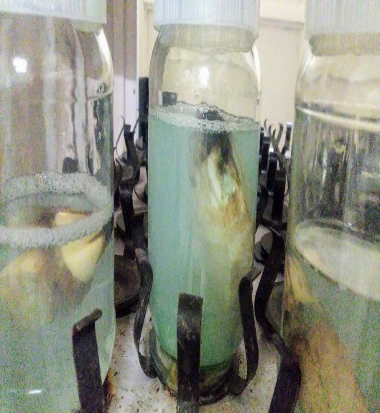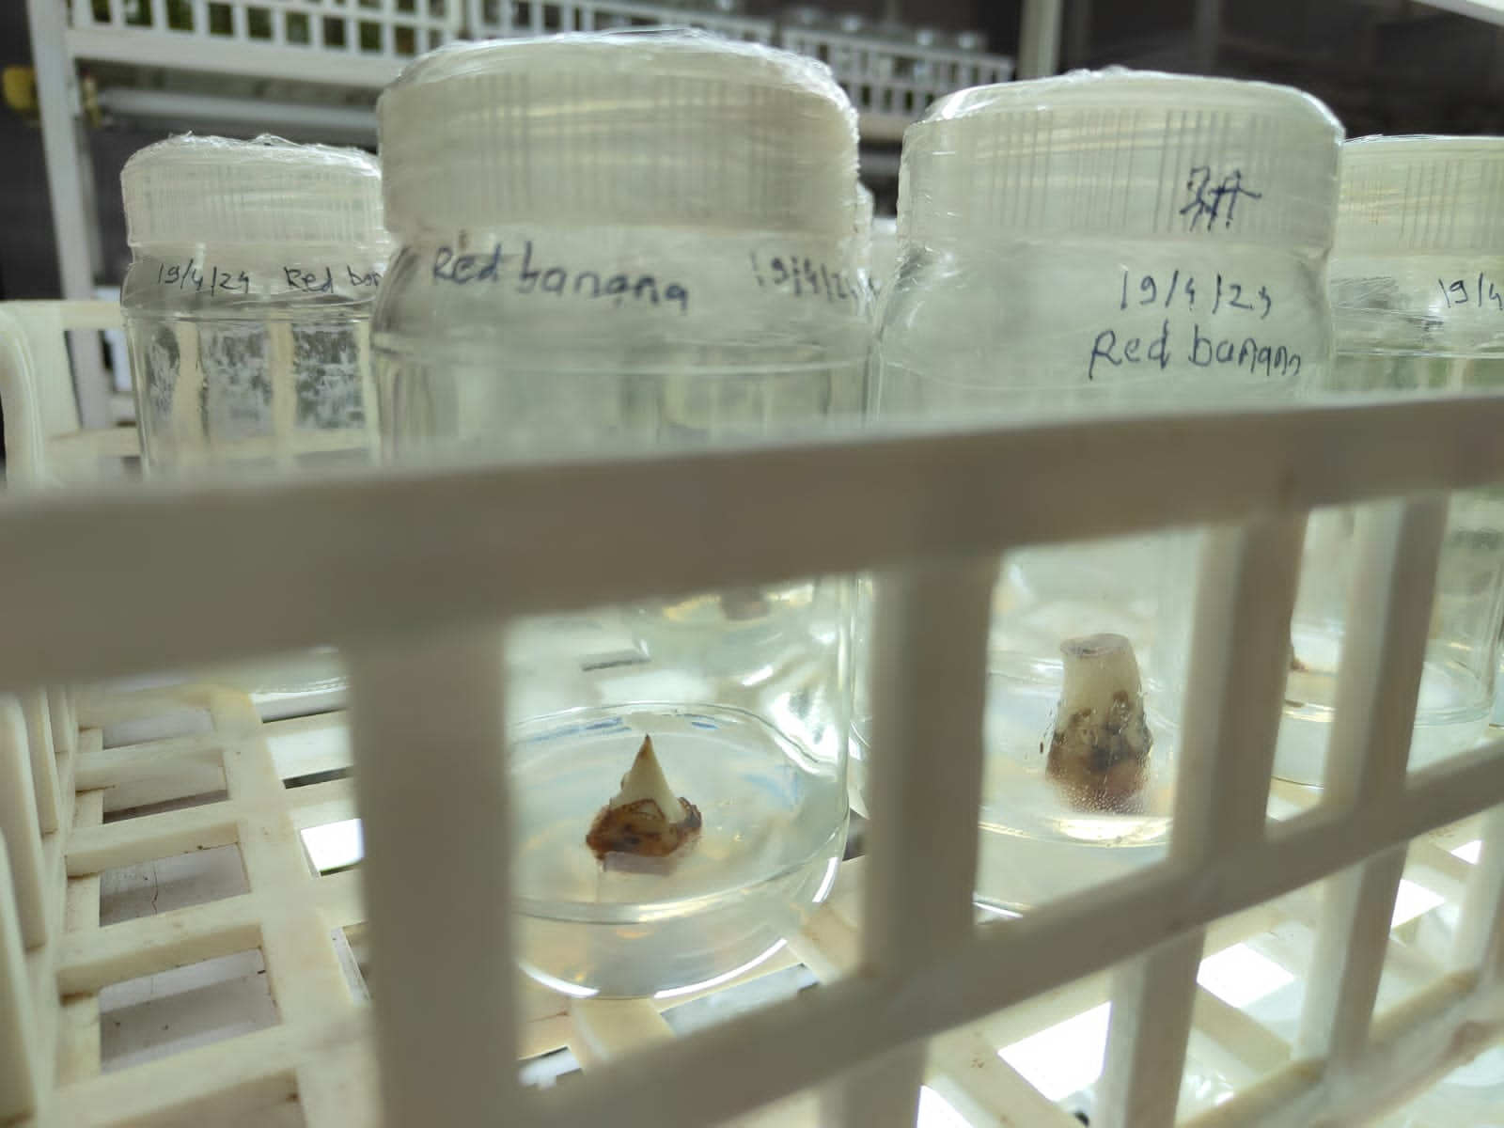
Plate 1: Surface sterilization and Inoculation explants on MS medium and supplements

.
3.1 Effect of Media combinations on Shoot Initiation and Establishment – Total six combination were used to perform initiation and its establishment. At early stage the inoculated explant looks dormant with pinkish white in color. It took 2 weeks for the explant becoming globular and green which shows the breaking of dormant stage and growth towards the shooting. Different media combinations showed different results for the establishment (showed in table 1). Where the T4 showed the maximum establishment percentage (82.22 %) and T1 showed least establishment percentage (42.22 %).
Similar result is seen in the experiment carried out by Hegde, A. K., et al (2018) i.e. 80 % establishment using 2 mgL-1 BAP + 4 mgL-1 Adenine sulphate + 0.5 mgL-1 IAA. Similarly Rajoriya et al., (2018) exhibited that 70 % establishment in of explant with 2 mgL-1 BAP of Red Banana, where experiment carried by Prabhuling G et al., (2017) in Ney Poovan (AB) gave 100% initiation using 2 mgL-1 BAP in MS media. However, Vidhya and Nair (2002) reported that high BAP concentrations in the culture medium of Red Bananas (AAA) can cause somaclonal variation which is unfavorable for commercial marketing and farm productions.
Table 1 Effect of media combinations on percent establishment of Red Banana Shoot
tip explant on MS medium

Tr. No. | Media combinations | Percent establishment
T1 | MS + 0.5 mgL-1 BAP + 60 mgL-1 Adenine sulphate + 20 mgL-1 Ascorbic acid | 42.22ª  (40.48)
T2 | MS + 1 mgL-1 BAP + 60 mgL-1 Adenine sulphate + 20 mgL-1 Ascorbic acid | 60.00^{c}  (50.81)
T3 | MS + 1.5 mgL-1 BAP + 60 mgL-1 Adenine sulphate + 20 mgL-1 Ascorbic acid | 71.11e  (57.52)
T4 | MS + 2 mgL-1 BAP + 60 mgL-1 Adenine sulphate + 20 mgL-1 Ascorbic acid | 82.22^{f}  (65.15)
T5 | MS + 2.5 mgL-1 BAP + 60 mgL-1 Adenine sulphate + 20 mgL-1 Ascorbic acid | 68.89^{d}  (56.42)
T6 | MS + 3 mgL-1 BAP + 60 mgL-1 Adenine sulphate + 20 mgL-1 Ascorbic acid | 57.78^{b}  (49.48)
 | S.E. (m)± | 2.67
 | C.D. at 5% | 8.22
(Figures in parenthesis are arcsine transformed values)
Note – i) Treatment means having common super script are statistically Non-significant.
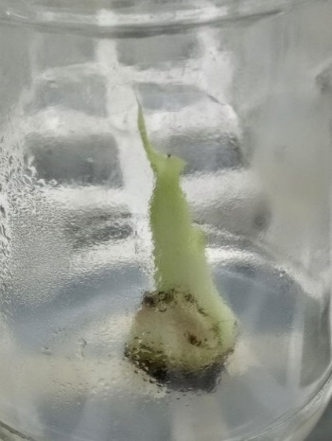
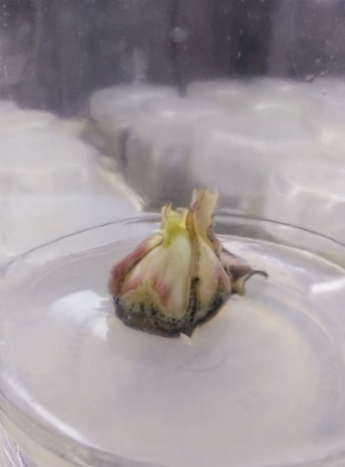
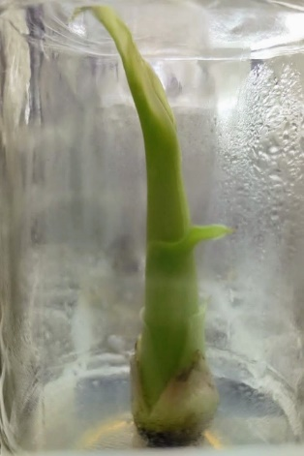
ii) Treatment means having different super script are statistically significant.
Plate no 2.a Inoculation
MS + 1 mgL⁻¹ BAP + 60 mgL⁻¹ adenine sulphate + 20 mgL⁻¹ ascorbic acid
Plate no 2.c Initiation
MS + 2 mgL⁻¹ BAP + 60
mgL⁻¹ adenine sulphate + 20 mgL⁻¹ ascorbic acid
Plate no 2.b Initiation
MS + 1 mgL⁻¹ BAP + 60 mgL⁻¹ adenine sulphate + 20 mgL⁻¹ ascorbic acid

Plate 2(a,b,c): Initiation of explants on MS medium and supplements

3.2
Effect of media combinations for no. of days required to shoot establishment

Observations were recorded on the six different combinations of BAP and supplements were presented in table 2. It revealed that the significant differences were noticed for the number of days required for shoot establishment. The significantly minimum number of days for shoot establishment was recorded by the treatment T4 (24.24 days) which was at par with T5 (25.13 days). The significant maximum days required for shoot establishment was noticed by treatment T1 (30 days). This might be due to the lower Cytokinin concentration present in treatment T1.
Similar results were seen in the experiment carried out by Babu (2019) in Banana var. Nanjangudu rasabale i.e. 21.66 days for shoot establishment using 2 mgL-1 BAP.

Table 2 Effect of BAP for no. of days required for shoot establishment

Tr. No. | Media combinations | No. of days to establishment
T1 | MS + 0.5 mgL-1 BAP + 60 mgL-1 Adenine sulphate + 20 mgL-1 Ascorbic acid | 30.00^{c}
T2 | MS + 1 mgL-1 BAP + 60 mgL-1 Adenine sulphate + 20 mgL-1 Ascorbic acid | 28.15^{b}
T3 | MS + 1.5 mgL-1 BAP + 60 mgL-1 Adenine sulphate + 20 mgL-1 Ascorbic acid | 27.81^{b}
T4 | MS + 2 mgL-1 BAP + 60 mgL-1 Adenine sulphate + 20 mgL-1 Ascorbic acid | 24.24ª
T5 | MS + 2.5 mgL-1 BAP + 60 mgL-1 Adenine sulphate + 20 mgL-1 Ascorbic acid | 25.13ª
T6 | MS + 3 mgL-1 BAP + 60 mgL-1 Adenine sulphate + 20 mgL-1 Ascorbic acid | 28.00^{b}
 | S.E. (m)± | 0.35
 | C.D. at 5% | 1.09
Note – i) Treatment means having common super script are statistically Non-significant.
ii) Treatment means having different super script are statistically significant.

3.3 Effect of BAP combinations on multiple shoot induction.

After first precise subculturing of the established culture, shoots got developed as the combination of BAP with the adenine sulphate results the shoot to multiply into numbers. Six different media combination were tested as shown in table 3. Maximum shoots frequency is recorded with the treatment T4 as it gave average of 6.93 shoots where the treatment T1 gave the least multiples of only 1.93.
Similar result was seen in the experiment carried out by Hegde, A. K et al., (2018) i.e. average 5 shoots using 2 mgL-1 BAP + 4 mgL-1 adenine sulphate + 0.5 mgL-1 IAA. Similarly Oumar Silué et al., (2018) obtained 5.25 ± 0.95 shoots using 50 mgL-1 adenine sulphate, also Prabhuling G et al., (2017) in Ney Poovan (AB) concluded average 6.27 using BAP 2.0 mgL-1 + NAA 0.25 mgL-1. Reddy et al., found that the best shoot induction, shoot growth and multiple shootings of Grand nine (Musa spp) plantlets were obtained on medium supplemented with 2.0 mgL-1 6-BAP.

Table 3 Effect of BAP combination on multiple shoot induction.

Tr. No. | Media combinations | No. of Shoots regenerated
T1 | MS + 0.5 mgL-1 BAP + 60 mgL-1 Adenine sulphate + 20 mgL-1 Ascorbic acid | 2.00ª  (1.74)
T2 | MS + 1 mgL-1 BAP + 60 mgL-1 Adenine sulphate + 20 mgL-1 Ascorbic acid | 2.78^{b}  (1.96)
T3 | MS + 1.5 mgL-1 BAP + 60 mgL-1 Adenine sulphate + 20 mgL-1 Ascorbic acid | 4.65^{c}  (2.40)
T4 | MS + 2 mgL-1 BAP + 60 mgL-1 Adenine sulphate + 20 mgL-1 Ascorbic acid | 6.98e  (2.85)
T5 | MS + 2.5 mgL-1 BAP + 60 mgL-1 Adenine sulphate + 20 mgL-1 Ascorbic acid | 5.83^{d}  (2.64)
T6 | MS + 3 mgL-1 BAP + 60 mgL-1 Adenine sulphate + 20 mgL-1 Ascorbic acid | 4.78^{c}  (2.43)
 | S.E. (m)± | 0.033
 | C.D. at 5% | 0.46
(Figures in parenthesis are square root transformed values)
Note – i) Treatment means having common super script are statistically Non-significant.
ii) Treatment means having different super script are statistically significant.

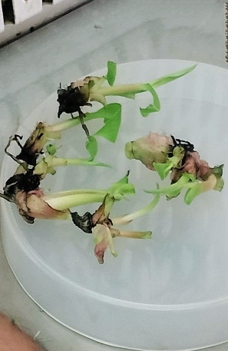
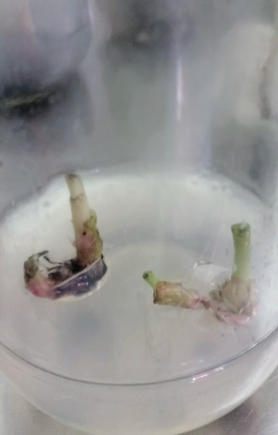
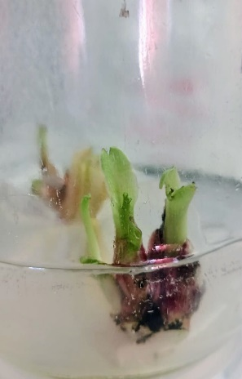
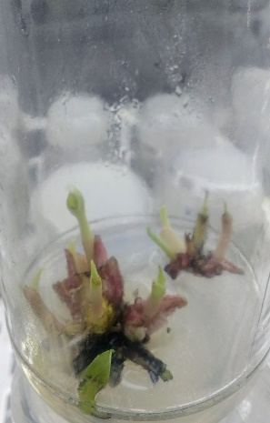
Plate no 3a Multiplication
MS + 0.5 mgL⁻¹ BAP + 60 mgL⁻¹ adenine sulphate + 20 mgL⁻¹ ascorbic acid
Plate no 3c Multiplication
MS + 2 mgL⁻¹ BAP + 60 mgL⁻¹ adenine sulphate + 20 mgL⁻¹ ascorbic acid
Plate no 3d Multiplication
MS + 3 mgL⁻¹ BAP + 60 mgL⁻¹ adenine sulphate + 20 mgL⁻¹ ascorbic acid
Plate no 3b Multiplication
MS + 1 mgL⁻¹ BAP + 60 mgL⁻¹ adenine sulphate + 20 mgL⁻¹ ascorbic acid

Plate 3(a,b,c,d): Effect of BAP and supplements combination on multiple shoot induction

3.4 Effect of PGRs on rooting and hardening

Last stage for the developed shoot is to develop the roots. Auxins IBA and IAA in combination give the good viable roots in few days. Shoots with good height and broad leaves were selected for transferring in rooting media. In this experiment, total six treatments was given as shown in the 4.5. Media is again blended with 20 mgL-1 Ascorbic acid for checking the oxidation effect of the shoot base. In those treatments T5 gave 95.56% rooting within 15 days. Where 44.44% of rooting was observed in T1 after 23 days. T1 took maximum days for rooting.
Similar result is seen in the experiment carried out by Rajoriya, et al (2018) in Red banana that 100% rooting within 2 to 3 weeks of culture using 2 mgL-1 IBA + 1 mgL-1 IAA.

Table 4 Effect of Different Growth Regulators Combination for Rooting

Tr.  No. | Treatment Details | Percent rooting | No. Of  Days to rooting
T1 | MS + 0.5 mgL-1 IBA + 0.5 mgL-1 IAA+ 20 mgL-1 Ascorbic acid | 44.44ª  (41.80) | 23.10^{f}
T2 | MS + 1 mgL-1 IBA + 0.5 mgL-1 IAA+ 20 mgL-1 Ascorbic acid | 60.00^{b}  (50.81) | 20.59e
T3 | MS + 1 mgL-1 IBA + 1 mgL-1 IAA + 20 mgL-1 Ascorbic acid | 77.78^{c}  (61.93) | 19.09^{d}
T4 | MS + 2 mgL-1 IBA + 0.5 mgL-1 IAA + 20 mgL-1 Ascorbic acid | 84.44^{c}  (66.87) | 16.16^{b}
T5 | MS + 2 mgL-1 IBA + 1 mgL-1 IAA+ 20 mgL-1 Ascorbic acid | 95.56^{d}  (80.02) | 15.33ª
T6 | MS + 0.5 mgL-1 IBA + 1 mgL-1 IAA+ 20 mgL-1 Ascorbic acid | 53.33^{b}  (46.92) | 18.08^{c}
 | S.E. (m)± | 2.64 | 0.22
 | C.D. at 5% | 8.13 | 0.67
(Figures in parenthesis are arcsine transformed values)
Note – i) Treatment means having common super script are statistically Non-significant.
ii) Treatment means having different super script are statistically significant.
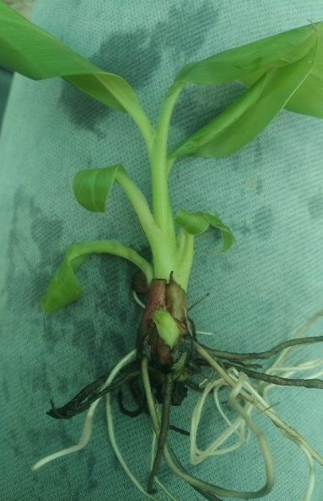
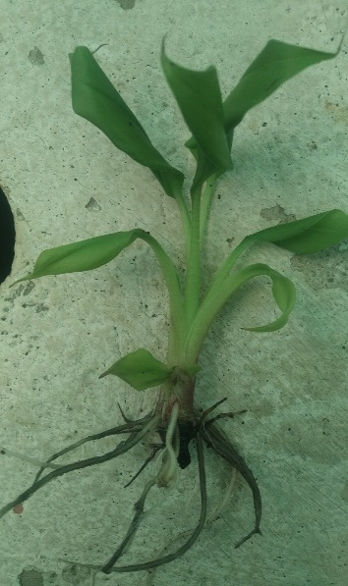
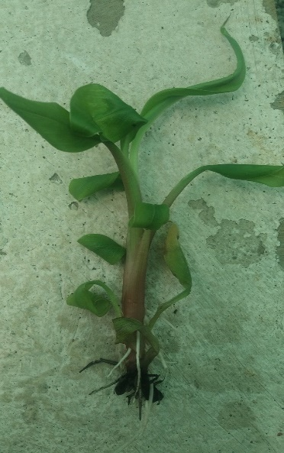
Plate no 4.c Rooting
MS + 2 mgL⁻¹ IBA + 1 mgL⁻¹ IAA
Plate no 4.b Rooting
MS + 1 mgL⁻¹ IBA + 1 mgL⁻¹ IAA
Plate no 4a Rooting
MS + 1 mgL⁻¹ IBA + 0.5 mgL⁻¹ IAA

Plate 4(a,b,c): Effect of Different Media Combinations on Rooting

3.5 Effect of different potting mixtures on hardening of Red banana plantlets

Best rooted shoots were transferred to the potting mixtures after washing it with the fresh water such that the media gel is removed completely. Cleaned plants were planted in mixtures containing Red Soil, Vermicompost and Sand with different proportion and their observations are presented in Table 5. After transferring to the potting mixtures, drenching of Bavistin fungicide @ 2gmL-1 at plantlet base is done for checking the fungal growth. After the proper root establishment, another drenching of Humic acid with Amino micro nutrient is done for uniform, stressless growth.
Maximum plantlets survived (90 %) in potting mixture containing all the three component in equal proportion (1:1:1) while in the (1:0:1) gave less (30%) survivability.
Similar result was seen in the experiment carried out by Keskar et al., (2019) i.e. 90% plantings survived in potting mixture containing all the three component Soil: FYM: Sand in equal proportion (1:1:1).

Table 5 Effect of different potting mixtures on hardening of Red banana plantlets
Treatment | Potting Mixture | Survivability (%)
T1 | Red Soil + vermicompost + Sand (1:0:1) | 30
T2 | Red Soil + vermicompost + Sand (1:1:0) | 45
T3 | Red Soil + vermicompost + Sand(1:1:1) | 90
T4 | Red Soil + vermicompost + Sand(1:0:0) | 50

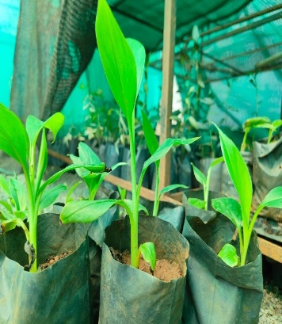
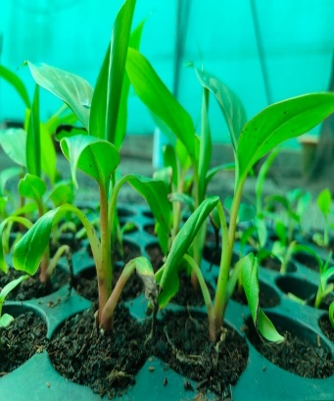
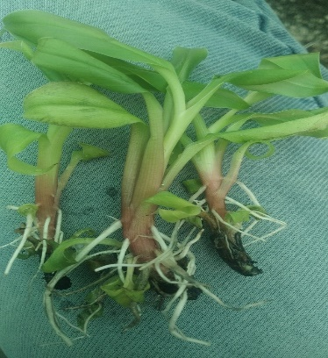
Hardening of plantlets on potting mixture sand:soil:FYM (1:1:1)
Plantlets in cocopit
Cleaning the rooted plantlets

Plate 5: Effect of Different Media Combinations on Rooting

Conclusion
The current study discovered an effective protocol for in vitro development of Red banana. In vitro cultures of Red banana were developed by using shoot tip as an explant and with different combinations of plant growth regulators and supplements with MS basal medium for shoot induction, multiplication, and rooting. For shoot tip explant sterilization, the procedure involves 1% bavistin for 15 min, later shaking explant with 1% Bavistin (25 min) followed by Tween 20 (20 min) + citric acid and ascorbic acid (10 min) then 5% NaOCl (5 min) + 0.1% HgCl₂ ( 15 min) in Laminar air flow, yielded lowest contamination percentage of 20% compared to other treatments. This method was subsequently adopted for all explant sterilizations in the research. For shoot establishment and initiation, MS medium supplemented with 2.0 mg/l BAP with 60 mgL-1 Adenine sulphate and 20 mgL-1 Ascorbic acid yielded the best results, with 80% of explants establishment as early as 23.5 days after inoculation. Similarly in some combination after subculturing gave maximum shoots was observed, with a mean of 6.93 shoots per explant. After shoot proliferation, the shoots are separated and placed on rooting media. New root growth typically begins around 2-3 weeks. The MS medium supplemented with 2.0 mg/l IBA, 1.0 mg/l IAA, resulted highest rooting percentage of 100% among all tested combinations. Later for hardening, maximum plantlets survived (90 %) in potting mixture containing all the three component in equal proportion (1:1:1).

References

Babu, P. (2019). An efficient protocol for in vitro regeneration of banana var. Nanjangudu rasabale (Musa spp. AAB). International Journal of Current Microbiology and Applied Sciences, 8(6), 3392–3402.https://doi.org/10.20546/ijcmas.2019.806.402
Hegde, A. K., Hegde, V. K., & Hegde, V. (2018). Studies on micropropagation of banana cv. Bargibale. Journal of Cell and Tissue Research, 18(1), 6397–6400.
Merina, S., Prem Kumari, M., Saravanan, S., & Pillai, A. (2020). In vitro propagation of medicinally valuable traditional banana cultivar, Musa acuminata cv. Matti by shoot tip culture. International Journal of Current Microbiology and Applied Sciences, 9(8), Article 257. https://doi.org/10.20546/ijcmas.2020.908.257
Koli, N., Sawardekar, S., Gokhale, N., & Patil, D. (2014). Optimization of in-vitro sterilization technique in local cv. (Safed Velchi) along with Grand Naine of banana. International Journal of Biotechnology and Biosciences, 4, 224–230.
Oumar, S., Kouassi, M., Kouablan, K., Eugene, K., & Severin, A. (2017). Effect of adenine sulphate, casein hydrolysate and spermidine on in vitro shoot multiplication of two banana varieties (FHIA-21 and PITA-3). African Journal of Biotechnology, 16(41), 2152–2159. https://doi.org/10.5897/AJB2017.16247
Vidhya, R., & Nair, A. (2002). Molecular analysis of somaclonal variation in Musa acuminata (AAA) cv. Red. Phytomorphology: An International Journal of Plant Morphology, 52, 293–300.
Prabhuling, G., Rashmi, H., & Babu, A. G. (2017). Protocol for tissue culture propagation of banana cv. Ney Poovan (AB). International Journal of Science and Nature, 8(4), 882–887.
Rajoriya, P., Singh, V. K., Jaiswal, N., & Lall, R. (2018). Optimizing the effect of plant growth regulators on in vitro micropropagation of Indian red banana (Musa acuminata). Journal of Pharmacognosy and Phytochemistry, 7(Special Issue 1), 628–634.
Reddy, D. R., Reddy, D., Suvarna, D., & Rao, D. (2014). Effects of 6-benzyl amino purine (6-BAP) on in vitro shoot multiplication of Grand Naine (Musa sp.). International Journal of Advanced Biotechnology and Research, 5(1), 36–42.

